**Fundamentals of Materials Science Homework 8**

**Name: Xiao，Liyang Date: 03/11/2017 Student #: 15090215**

**Homework Problems:**

***Point Coordinates***

1. **List the point coordinates of the titanium, barium, and oxygen ions for a unit cell of the perovskite crystal structure (Figure shown below).**

Z

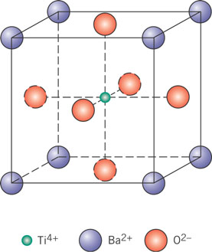

Y

X

**Solution:**

the point coordinates of the **titanium** :



the point coordinates of the **barium** :



the point coordinates of the **oxygen** :



***Crystallographic directions***

1. **Sketch the following directions in unit cells. One unit cell for one direction!**

**(a) ; (b) ; (c) **

**Solution:**

z

z

**a.**  **b.**

y

b/2

y

x

x

z

z

**c.**

a/6

b/3

c/2

y

x

1. **Determine the indices for the directions shown in the following cubic unit cell:**

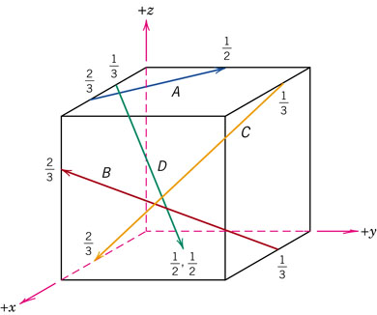

**Solution:**

|  |  |  |  |
| --- | --- | --- | --- |
| **A** | ***x*** | ***y*** | ***z*** |
| Projections | -2a/3 | b/2 | 0c |
| Projections in terms of a, b, and c | -2/3 | 1/2 | 0 |
| Reductions to integers | -4 | 3 | 0 |
| Enclosure |  | | |
| B | ***x*** | ***y*** | ***z*** |
| Projections | 2a/3 | -b | 2c/3 |
| Projections in terms of a, b, and c | 2/3 | -1 | 2/3 |
| Reductions to integers | 2 | -3 | 2 |
| Enclosure |  | | |
| C | ***x*** | ***y*** | ***z*** |
| Projections | a/3 | -b | -c |
| Projections in terms of a, b, and c | 1/3 | -1 | -1 |
| Reductions to integers | 1 | -3 | -3 |
| Enclosure |  | | |
| D | ***x*** | ***y*** | ***z*** |
| Projections | a/6 | b/2 | -c |
| Projections in terms of a, b, and c | 1/6 | 1/2 | -1 |
| Reductions to integers | 1 | 3 | -6 |
| Enclosure |  | | |

1. **Convert the [100] and [111] directions into the four-index Miller–Bravais scheme for hexagonal unit cells.**

**Solution:**

**[1 0 0]**

** ; **

** ;  **

**[111]**

** ; **

** ;  **

1. **Determine indices for the directions shown in the following hexagonal unit cells:**

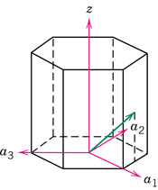 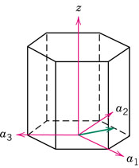

**(a) (b)**

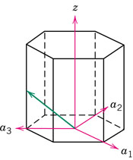 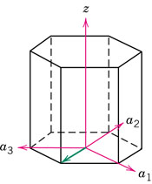

**(c) (d)**

**Solution:**

|  |  |  |  |
| --- | --- | --- | --- |
| (a) | ***x*** | ***y*** | ***z*** |
| Projections | a | a/2 | c/2 |
| Projections in terms of a and c | 1 | 1/2 | 1/2 |
| Reductions to integers | 2 | 1 | 1 |
| Enclosure | [2 1 1] | | |
| (b) | ***x*** | ***y*** | ***z*** |
| Projections | a/2 | a | 0 |
| Projections in terms of aand c | 1/2 | 1 | 0 |
| Reductions to integers | 1 | 2 | 0 |
| Enclosure | [1 2 0] | | |
| (c) | ***x*** | ***y*** | ***z*** |
| Projections | 0 | -a | c/2 |
| Projections in terms of aand c | 0 | -1 | 1/2 |
| Reductions to integers | 0 | -2 | 1 |
| Enclosure |  | | |
| (d) | ***x*** | ***y*** | ***z*** |
| Projections | 0 | -a | 0 |
| Projections in terms of a and c | 0 | -1 | 0 |
| Reductions to integers | 0 | -1 | 0 |
| Enclosure |  | | |

1. **[2 1 1]**

** ; **

** ;  **

**(b) [1 2 0]**

** ; **

** ;  **

**(c)** 

** ; **

** ;  **

**(d)** 

** ; **

** ;  **

***Crystallographic planes***

1. **Sketch the following planes. One plane in one unit cell.**
2. **; (b) ; (c) **

**Solution:**

(a) (b) (c)

`

1. **Determine the Miller indices for the planes shown in the following unit cell:**

**[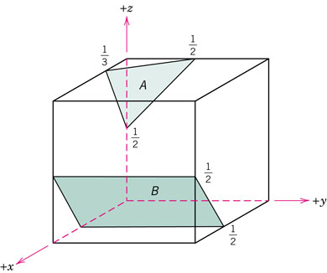](http://www.wiley.com/college/callister/0470505869/img_gallery/ch03/pages/figun_03_p87c.htm)**

**Solution:**

|  |  |  |  |
| --- | --- | --- | --- |
| A | ***x*** | ***y*** | ***z*** |
| Intercepts*(A,B,C)* | a/3 | b/2 | -c/2 |
| Intercepts in terms of a and c | 1/3 | 1/2 | -1/2 |
| Reductions to integers | 3 | 2 | -2 |
| Enclosure |  | | |
| B | ***x*** | ***y*** | ***z*** |
| Projections | -a/2 | ∞b | c/2 |
| Projections in terms of a, b, and c | -1/2 | ∞ | 1/2 |
| Reductions to integers | -1 | 0 | 1 |
| Enclosure |  | | |

***Equivalent Directions and Planes***

1. **Sketch the atomic packing of (a) the (100) plane for the BCC crystal structure, and (b) the (201) plane for the FCC crystal structure. Examples of such drawings are shown below.**

**Examples: Atomic packing of (110) plane in FCC and BCC unit cell.**

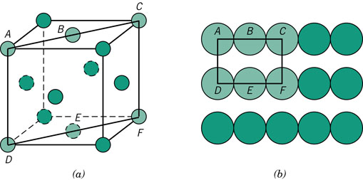 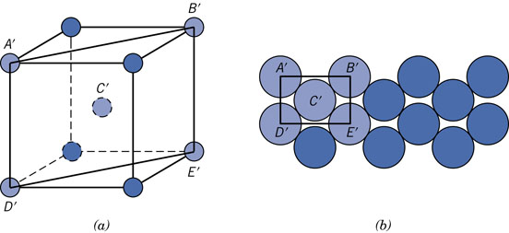

**Solution:**

***(a) BCC:***

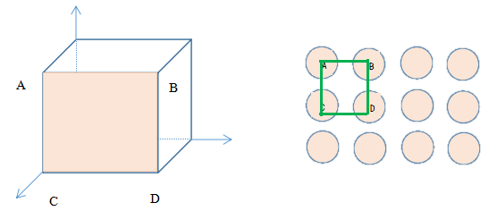 ***(b) FCC:***

