**Fundamentals of Materials Science Homework 9**

**Name: Xiao，Liyang Date: 03/15/2017 Student #: 15090215**

**Homework Problems:**

1. **Determine the *Miller-Bravais* indices for the planes shown in the following unit cells:**

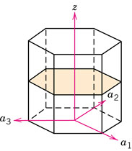 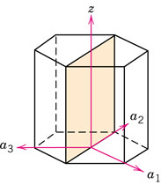

**(a) (b)**

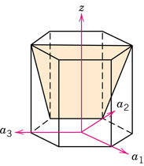 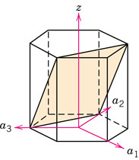

**(c) (d)**

**Solution:**

1. 





1. 





1. 





1. 





1. **Determine the *Miller-Bravais* indices for the planes shown in the following unit cells:**

** **

1. **(b)**

**Solution:**

(a)





(b)





1. **Sketch theandplanes in a hexagonal unit cell.**

**Solution:**

** **

1. **Cite the indices of the direction that results from the intersection of each of the following pairs of planes within a cubic crystal: (a) the  and  planes, (b) the  and  planes, (c) the  and  planes.**

**Solution:**

**(a) (b) (c)**

1. **For the HCP crystal structure, show that the ideal c/a ratio is 1.633. Calculate the atomic packing fraction for the hexagonal close-packed crystal structure for which . Remember that the base of the unit cell is a parallelogram.**

**Solution:**



1. **Zirconium has an HCP crystal structure and a density of 6.51 g/cm3.**

**(a) What is the volume of its unit cell in cubic meters?**

**(b) If the *c*/*a* ratio is 1.593, compute the values of *c* and *a*.**

**Solution:**

1. Atomic weight of Zr : 91.22amu

Density of Zr : 6.51g/cm3

Zirconium has an HCP crystal structure;n=6



(b) 





1. **Rhodium has an atomic radius of 0.1345 nm (1.345Å) and a density of 12.41 g/cm3. Determine whether it has an FCC or BCC crystal structure.**

**Solution:**

Atomic weight of Rh : 102.91amu

Density of Rh : 12.41g/cm3

atomic radius : 0.1345nm

1. FCC:
2. BCC:

So it has FCC crystal structure.

1. **Beryllium (Be) has an HCP unit cell for which the ratio of the lattice parameters c/a is 1.568. If the radius of the Be atom is 0.1143 nm, (a) determine the unit cell volume, and (b) calculate the theoretical density of Be and compare it with the literature value.**

**Solution:**

(a)



(b)

the theoretical density of Be is 1.845g/mol

the literature value is 1.85g/mol

1. **Calculate and compare the linear densities for the <100>, <110> and <111> directions in a BCC unit cell. Which direction is the most close-packed (dense)?**

**Solution:**

**<1 1 0>**

**<1 0 0>**

**<1 1 1>**

****<111>is the most close-packed (dense).

**10. Calculate and compare the linear densities for the <100>, <110> and <111> directions in a FCC unit cell. Which direction is the most close-packed (dense)?**

**Solution:**

**<1 1 0>**

**<1 0 0>**

**<1 1 1>**

****<110>is the most close-packed (dense).

1. **Suppose that FCC rhodium is produced as a 1-mm thick sheet, with the (111) plane parallel to the surface of the sheet. How many (111) interplanar spacings *d111* thick is the sheet? See Appendices in your textbook for necessary data.**

**Solution:**

Lattice parameter:0.38044nm





1. **Determine the minimum radius of an atom that will just fit into (a) the tetrahedral interstitial site in FCC nickel; and (b) the octahedral interstitial site in BCC lithium.**

**Solution:**

1. ∵Ni is tetrahedralin FCC ∴Coordination number is 4

∴rc/ra range:0.225~0.414

Lattice parameter of Ni is 0.35236nm





1. ∵Li is octahedral in BCC ∴Coordination number is 8

∴rc/ra range:0.414~0.732

Lattice parameter of Ni is 0.35089nm





1. **The atomic packing fraction for the FCC crystal structure is 0.74. This is the densest arrangement of atoms achievable in three dimensions when all atoms have the same radius *R*. If atoms in the hard sphere model occupy 74% of the volume of the unit cell, then the other 26% is empty space. Imagine that the empty spaces located at the center of each edge and at the body–centered position of the FCC unit cell are filled with smaller spheres of radius *r* such that *r* = 0.414*R*. The smaller atoms fit perfectly in between the atoms of radius *R*. (a) By counting in the usual way, how many atoms of radius *r* are there per FCC unit cell? (b) What are the coordinates of these atoms of radius *r*? Do not double count atoms. Provide the same number of coordinates as the number of atoms of radius *r* per unit cell. (c) What is the atomic packing fraction for this structure?**

**Solution:**

1. The number of atoms of radius r in per FCC unit cell:
2. the coordinates of these atoms of radius *r:*



(c)

1. **The Figure below shows the results of an x-ray diffraction experiment in the form of the intensity of the diffracted peak versus the 2*θ* diffraction angle. If x-rays with a wavelength of 0.07107 nm are used, determine (a) the crystal structure of the metal; (b) the indices of the planes that produce each of the peaks; and (c) the lattice parameter of the metal.**

**Solution:???**

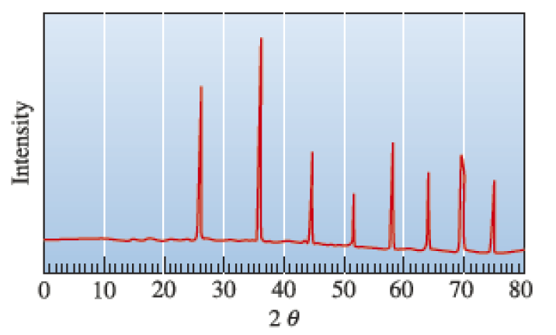

**(a)**

**(b)**

**(c)**