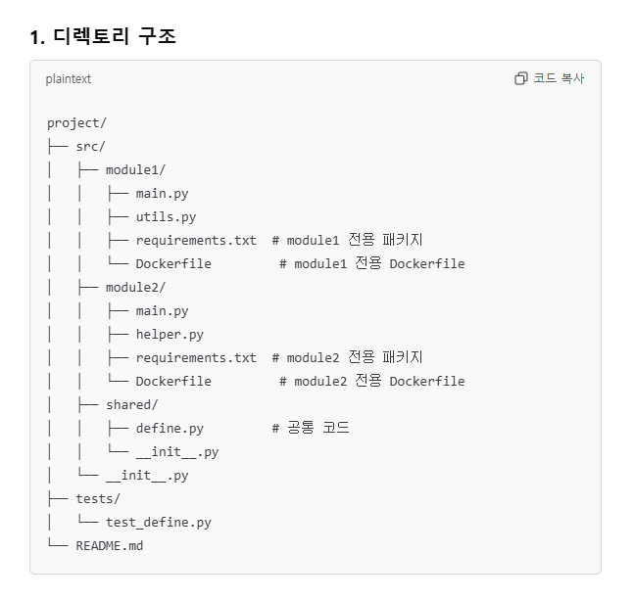

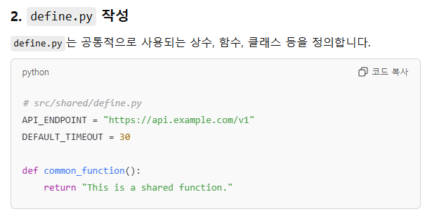

--------------------------------------------------------------------------------------------------------------

# src/shared/define.py

API_ENDPOINT = "https://api.example.com/v1"

DEFAULT_TIMEOUT = 30

def common_function():

return "This is a shared function."

--------------------------------------------------------------------------------------------------------------

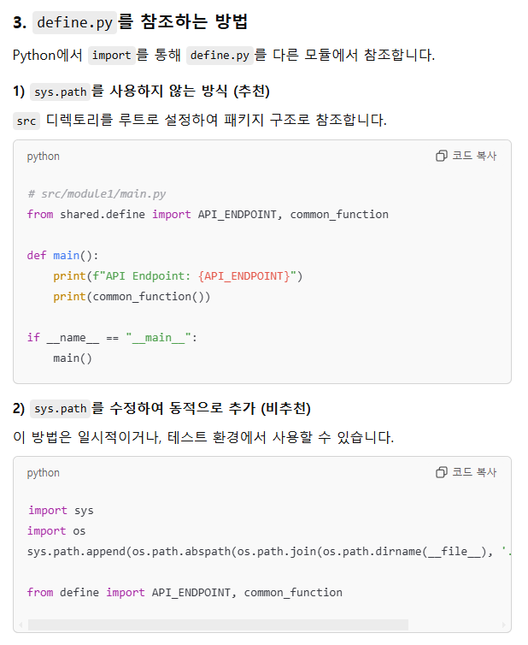

--------------------------------------------------------------------------------------------------------------

# src/module1/main.py

from shared.define import API_ENDPOINT, common_function

def main():

print(f"API Endpoint: {API_ENDPOINT}")

print(common_function())

if __name__ == "__main__":

main()

--------------------------------------------------------------------------------------------------------------

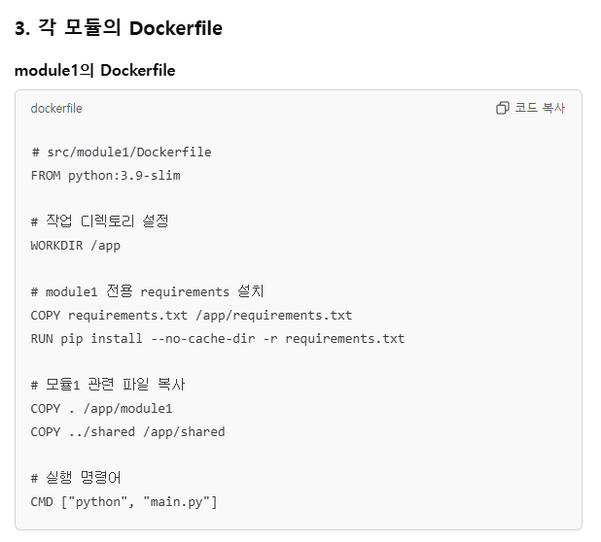

--------------------------------------------------------------------------------------------------------------

# src/module1/Dockerfile

FROM python:3.9-slim

# 작업 디렉토리 설정

WORKDIR /app

# module1 전용 requirements 설치

COPY requirements.txt /app/requirements.txt

RUN pip install --no-cache-dir -r requirements.txt

# 모듈1 관련 파일 복사

COPY . /app/module1

COPY ../shared /app/shared

# 실행 명령어

CMD ["python", "main.py"]

--------------------------------------------------------------------------------------------------------------

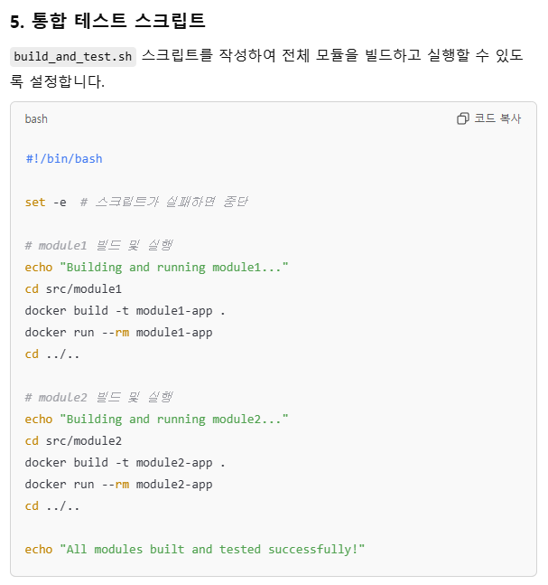

--------------------------------------------------------------------------------------------------------------

#!/bin/bash

set -e # 스크립트가 실패하면 중단

# module1 빌드 및 실행

echo "Building and running module1..."

cd src/module1

docker build -t module1-app .

docker run --rm module1-app

cd ../..

# module2 빌드 및 실행

echo "Building and running module2..."

cd src/module2

docker build -t module2-app .

docker run --rm module2-app

cd ../..

echo "All modules built and tested successfully!"

--------------------------------------------------------------------------------------------------------------