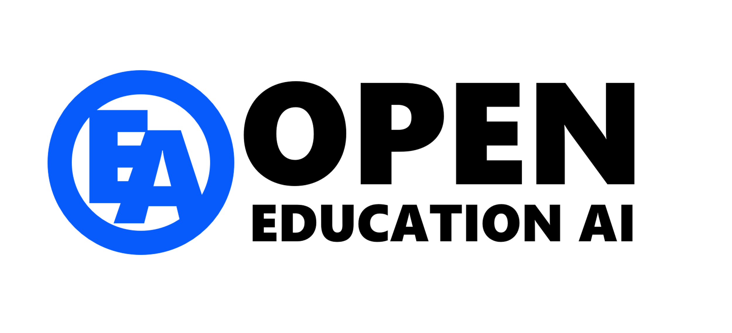

Open Education AI & [Your Trust Name]

[Name of this Education Use Case]

The Education Use Case *Template*

Published by [Your Trust Name on Date] based on OEAI Template v1 published 6th January 2024

*The information contained in this document represents the current view of Open Education AI on the issues discussed as of the date of publication. It should not be interpreted as a commitment on the part of Open Education AI, and Open Education AI cannot guarantee the accuracy of any information presented after the date of publication. This Education Use Case Template has been based on the ‘Open Education Analytics Use Case Template v3’ by Microsoft and available at https://github.com/microsoft/OpenEduAnalytics/blob/main/docs/use_cases/Open_Education_Analytics_Use_Case_Template_v3.docx*

***This template is for informational purposes only. Open Education AI makes no warranties, express or implied, in this document. Complying with all applicable copyright laws is the responsibility of the user.***

Contents

*Template guidance* 3

Executive summary 4

The problem or opportunity 5

Stakeholders 6

Research evidence and existing works 8

Outcomes 9

Methodology 10

Responsible AI 11

*Remember to update the table of contents last before you publish the document.*

# *Template guidance*

*This entire page should be deleted before the publication of your use case. This section provides information about the use of this template which guides you through constructing your own Education Use Case to use with the Open Education AI (OEAI) framework.*

[All text in blue inside square brackets is for you to amend to your own Trust details and context]

*All green italics text is for guidance only and should be deleted before publication.*

*Based on the principles behind Microsoft’s Open Education Analytics program, OEAI is a community of Multi Academy Trusts in the UK who commit to openly sharing their experience and assets we create to build capacity and capability across the sector, significantly reduce costs related to development, and to achieve outcomes that would be impossible alone.*

*This collaborative approach allows for Trusts with variable capability and budgets to engage in the way that makes most sense for them. As our technical outputs will be shared open source, these will be available free of charge for any organisation to ‘DIY’. Those that would like support from OEAI can do so on a cost basis and collaborate with other MATs to build new developments by sharing these costs. Options exist to engage with dedicated commercial partner support, in a ‘Center of Excellence’ model, and soon, via a standalone ‘App’ offering a low-cost standardised approach for small MATs and schools who do not require or cannot maintain their own data lake.*

*The ability to make the most of this initiative is grounded in having a prescribed data, analytics and AI model which includes at its foundation a Microsoft Fabric data lake and related resources. This model is governed by Founding Partner MATs and panel members from sector organisations and industry to ensure it is fit for purpose for the sector and will be contributed to on an ongoing basis by the entire OEAI community.*

*Completing this use case can help prevent many common problems in data projects such as:*

* *Asking the wrong questions or not fully understanding the problem to be solved with data.*
* *Using the wrong type of data or too much data to solve the problem of the use case.*
* *Making incorrect assumptions about the data and how it maps to the problem.*
* *Developing a data solution that is not utilized by key groups for its intended purpose (e.g., not used to make decisions by schools, educators, students, families).*

*The final section is used to operationalise and document decisions made for each of the principles of Responsible AI. This section is especially important when a use case involves the development of a machine learning model or a predictive algorithm, as these have the potential to cause unintentional harm to students.*

# Executive summary

*Complete this section last. It is expected to be 3-5 paragraphs and up to a page maximum in length.*

*A summary of the problem or opportunity, and the objectives of the use case.*

*Summarise the stakeholders who are necessary to include for success.*

*Provide a brief summary of the methodology to achieve the objective(s), and how you have incorporated the principles of responsible AI.*

[Provide your response here]

# The problem or opportunity

*What problem does this use case seek to solve, or what opportunity is it looking to leverage?*

[Provide your response here]

# Stakeholders

*Who is required to be able to deliver on the problem or opportunity identified?*

*Considering the benefits of a use case – and its potential harms - requires the consideration of different stakeholders and their points of view. Stakeholders typically include the people who are responsible for, will use, or will be affected by the use case. Stakeholders are defined by their role: their duties, contextual identity, or circumstances in relationship to the use case.*

*• Direct stakeholders interact with the data from a use case directly and make decisions or take actions based on results. They include data users, system developers, and even data system maintenance staff.*

*• Indirect stakeholders are affected by the use case data system but, unlike direct stakeholders, they do not have a role that requires them to use or maintain the system. Indirect stakeholders can include groups who may be affected by the downstream effects of the system, such as parents, students, or future employers.*

*• Malicious actors include hackers and others who may intentionally misuse the system. Considering malicious actors is important to supporting safe and reliable data systems.*

### Who are the stakeholder groups for this use case, and how are they involved in its development?

|  |  |  |
| --- | --- | --- |
| Stakeholder Group | Relationship to Use Case | Involvement in Use Case |
| [Students] | [Indirect Stakeholders] | [Students been asked permission to use their data] |
| [Parents or Guardians] |  |  |
| [Educators (Teachers and Support Staff)] |  |  |
| [School or Department Leaders] |  |  |
| [School System or Institutional Leaders] |  |  |
| [Researchers] |  |  |
| [Future Employers of Learners] |  |  |
| [Potential Malicious Actors] |  |  |

*Including stakeholders in the early thinking and conceptualisation of an education use case is a good way to ensure that the use case output will be accepted, trusted, and used by key stakeholders. For example, conducting interviews or focus groups with representatives of each stakeholder group can provide early insights into the conceptual model framing the use case and the appropriateness of specific data sources to be used. At a later stage in the project, involving key stakeholder groups in designing the use case outputs (such as a dashboard or notification) can be essential to that product’s eventual effective use.*

## Outline how stakeholders will be involved in the development in different stages of the use case development.

Early Stages: Defining the use case problem, developing the local theory or conceptual model of the problem, identifying key data sources to include in the use case in the local context:

[Provide your response here]

Reviewing and Designing Outputs Stages: Testing validity of the use case results, developing dashboard designs or set of interventions based on the use case results:

[Provide your response here]

# Research evidence and existing works

*For most common education use cases, prior research has already been conducted or a theory of the problem developed. For example, extensive research identifies the key data elements that best predict at-risk students. Another example is a model for school improvement that defines different theoretical constructs or categories to consider when improving or evaluating a school. This type of research, theory or model can help identify the most relevant data sources for a specific use case. The actual data analysis may show that the data identified in the theoretical construct does not ‘fit’ well in the local use case context, or that the analytical patterns are not the same as in prior research, but it provides a starting place for identifying key data sources.*

## For this use case, what prior research or conceptual model frames your theory of the problem?

List or cite the research, theories, or conceptual models that inform data selection for this use case, identifying the categories of data relevant to the use case problem.

*Sources of education research can include:*

* *Local or national education agencies and their research organizations*
* *Local, national, or international education policy documents*
* *Education research databases: ERIC - Education Resources Information Center*
* *Google Scholar: Google Scholar*

[Provide your response here]

# Outcomes

*Given the problem or opportunity, describe what the successful outcome(s) for this use case looks like.*

[Provide your response here]

# Methodology

*This section should lay out how you are going to approach Given the problem or opportunity, describe what the successful outcome(s) for this use case looks like.*

The methodology follows the OEAI framework. The framework uses building blocks, starting with your chosen cloud vendor infrastructure and then deploying the modules to source the identified data and packages that transform this data into actionable insight for identified audiences.

## Cloud Infrastructure

*In broad, non-technical terms, describe the infrastructure that may be required to achieve these objectives. Are the data required available inside the Trust or will you need third party agreement?*

[Provide your response here]

## Modules

*Modules are the building blocks that extract data from source systems and deposit it in your data lake in a raw form. Are there existing OEAI modules that you could use? Will you need to build new Modules to get data from other source systems? If you are using an existing module, does it cover the data fields you require, or will you need to extend the module? If it is a new module, does the vendor have a public API and documentation?*

[Provide your response here]

## Packages

*Packages consume the data from one or more modules, and deliver the use case outcomes, such as predictive machine learning routines, or visualisations and dashboards. Describe in as much detail as possible the specific routines that will be required to turn the Module data into actionable insight.*

[Provide your response here]

## Schema

*There is a published OEAI schema. Can this Use Case be delivered within the existing Schema, or will new schema extensions be proposed? Provide a data model.*

[Provide your response here]

## Change Management and Implementation

*Briefly describe how outcomes may be realised in practice, following the creation of the required packages. Are the audience central Trust users, or is it more widespread use across schools? How will you create change champions or integrate the new capability within the required teams?*

[Provide your response here]

# Responsible AI

## Fairness principle

*AI systems should treat everyone in a fair and balanced manner and not affect similarly situated groups of people in different ways. Human decision makers are susceptible to many forms of prejudice and bias, such as those rooted in gender and racial stereotypes. To ensure AI models are trained in a way that does not embed or re-enforce those biases, models must be tested for fairness. Microsoft has developed an open-source toolkit to support this called Fairlearn, which can be applied within the Azure analytical services used in the OEA reference architecture.*

[Provide your response here]

## Reliability and Safety Principle

*Systems should operate reliably and safely when they function in the world. AI systems must be designed with a view to the potential benefits and risks to different stakeholders and undergo rigorous testing to ensure they respond safely to unanticipated situations and do not evolve in ways that are inconsistent with the original shared purpose.*

[Provide your response here]

## Transparency Principle

*Transparency requires visibility into all levels of decision-making and design of an AI system. Designers should clearly document their goals, definitions, and design choices, and any assumptions they have made. Those who build and use AI systems should be forthcoming about when, why, and how they choose to build and deploy them, as well as their data and systems' limitations. Information should be readily available on the quality of the predictions and recommendations the AI system makes. Transparency also encompasses intelligibility, which means that people (in this case, educators, parents, students, etc.) should be able to understand, monitor, and respond to the technical behaviour or recommendations of AI systems.*

[Provide your response here]

## Privacy and Security

*Private or personal data should not be collected or incorporated in analytics or AI products for education unless all groups have agreed this data is necessary to achieve the shared purpose of a specific analytics or AI project. Additionally, the people providing the data need to give permission for the data to be used for this purpose, such as through school policy at enrolment. Ideally, data providers should directly understand the value that they will receive because of sharing their data. Finally, the security of that data must be protected, guidelines or policies developed for which roles can access which data, and the level of anonymization needed for specific use case purposes defined.*

[Provide your response here]

## Accountability

*Accountability requires that people who develop and deploy AI systems be held responsible for how they operate. AI systems should never be left to operate unchecked, irrespective of the degree to which they may be capable of acting autonomously. This is what is meant by the phrase “humans in the loop.” A part of this is ensuring documentation of the decisions made during the AI system development. This document can be used for that purpose.*

[Provide your response here]

## Inclusion

*The datasets used in learning analytics and AI determine the insights and predictions produced. If those datasets do not represent the whole population of learners, if the data quality is poor, or if certain types of data are not included in the models, it will decrease the accuracy, validity, and inclusiveness of the insights. Similarly, if the way the insights are acted upon by the system do not include all groups (e.g., students with disabilities), it can reinforce exclusion from learning opportunities.*

[Provide your response here]