- (Tested on Papercut NG 16.3.37858 and 17.1.2 on Centos 7.2 but should work OS Independent.

- Install the Zabbix agent on the papercut server

- Make sure the Zabbix agent works in Active / Passive Mode

- Make sure SeLinux is disabled DURING the installation if your OS makes use of SeLinux. When everything works enable again and configure if needed. (check with getenforce, the output should be disabled or permissive during the installation)

- Create 2 Macros on the Papercut host in Zabbix (Configuration –- Hosts –- papercut-server –- Macros)
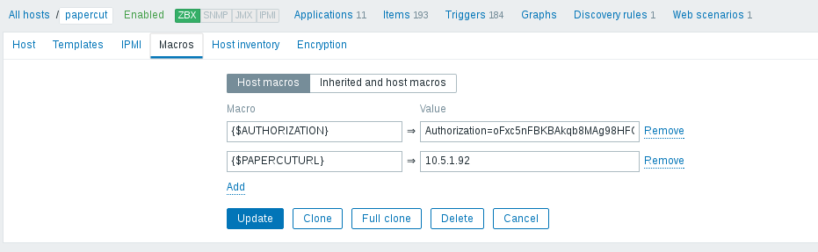
- Download code from : https://github.com/Open-Future-Belgium/zabbix-papercut

- From the folder “template” import the template in Zabbix (Configuration – Zabbix –- Templates – Import)

- Copy all the other files to the folder /etc/zabbix

- Edit the papercut.conf file and add the correct Authorization token and papercut server ip.

- In the Zabbix-Agent configuration enable support for Unsupported parameters (we need this as there are “/” in the printer names)

- Restart the Zabbix-Agent so that it picks up the new configuration files.

- Check the latest data page to see if it works

