Model center and Analysis center – Evaluation Report
Date: 2012-10-29
Authors: F. Koch, M. Mueller, B. Sedghi

Evaluation case study
ESO maintains a variety of models which are either created in house or part of the deliverables of contracts. At the opto-mechanical-control level, the delivered models are used to analyse the design of contracts. ESO does less design on opto-mechanical items but more on the control system related part. For opto-mechanical items ESO typically writes-up specification for construction by industry. The types of models, associated tools and their relations are shown in Figure 1
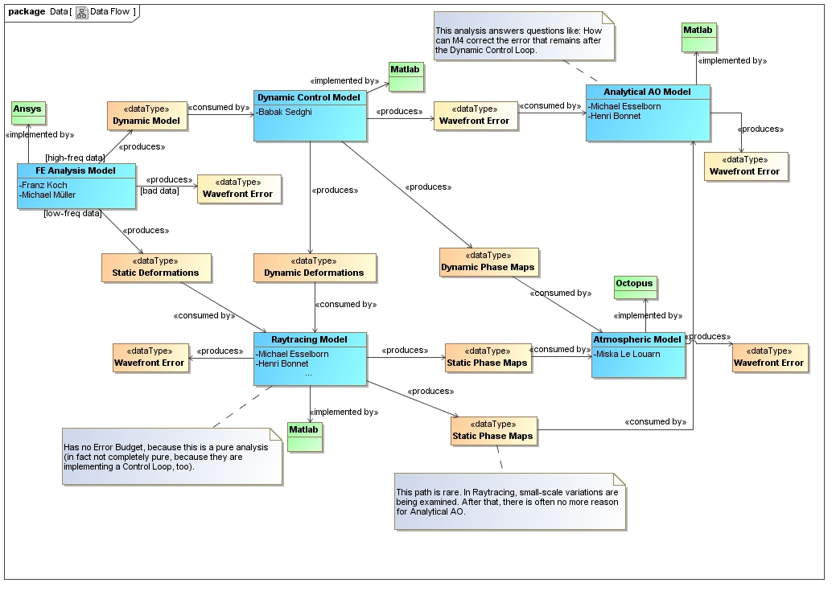
Figure 1 Model Ontology
For the evaluation we have implemented the parametric analysis of the effect of some important design parameters onto the pointing error due to the local wind load on the E-ELT M2 unit. We have implemented a case study which was already finished using our established approach and without Model Center (MC).
The parametric study selected analyses the impact of M2 unit design parameters onto the M2 contribution to the EELT pointing error due to external wind loads.
The six selected M2 unit design parameters are:
hexapod stiffness, lateral support stiffness, axial support stiffness, frame stiffness, thickness of the meniscus mirror and the crown stiffness.
(The real problem could/would additionally contain the hexapod orientation and the interface between main structure and M2 unit, where constraints for the geometry like design volume and no load reversal under operation conditions would apply.)
1. Ansys: To analyse the effect, we have to modify the existing Ansys model (according to the modified parameters) and run a modal analysis (with about 200 modes, to cover the frequency range up to 20Hz).
2. Matlab: Using the modal results, we generated a modal ss model in Matlab with the dynamic properties and right inputs and outputs.
3. For the performance analysis we apply the wind load time series to the dynamic model. The telescope deflection results in the pointing error which is feed into the feed stabilization loop. Final resulting numbers are currently pointing rms errors in both directions before and after field stabilization (i.e. 4 outputs).
The parameter space is 3^{^2}, i.e. 2 dimensional with 3 values per dimension; we have selected the most important parameters, which are hexapod stiffness and axial support stiffness
With more computing power it would be n^{^6}; n to be chosen reasonably, but >=2
Per analysis we run 1x Ansys + 2 x Matlab.
In the following the experiment and the observations using the MC program is discussed:
- The way MC is working
  - Parameters:
    - Works with scalar and string parameters
    - Allows to apply these parameters to models
    - Allows to receive parameters from models
    - Allows to link parameters, compute sensitivities, optimize
    - Visualization of relationships between these parameters. Many plot types are predefined, which easily can be selected for better understanding of results.
  - Models:
    - Consist of a program (Matlab/ANSYS), input/output files, run directory and a command to run the program (e.g. for ANSYS).
- Interfacing with other programs: Matlab and ANSYS
  - Matlab: easy to include predefined Matlab code and commands just by defining the input and output parameters or variables via either a header or manually through the MC GUI. The way we have implemented is to use a fix directory structure where the pre-written Matlab code loads data and models and runs scripts (e.g. wind load time series, controller parameters, optical sensitivity matrix model, Simulink models etc.)
  - ANSYS: Input parameters can be selected from ASCII APDL files. Output parameters can be selected from ASCII files as "name value pair" or taken from binary results files. Using the binary results files seems to be difficult for a model of typical size. To run ANSYS the command including input and output file names and run directory are required.
- Problems, Open/unclear issues:
  - Models are platform dependent (ANSYS: Windows and Linux require different commands). Could lead to redundant models. The user has to type the command to launch Ansys in “QuickWrap” of MC. Specifying I/O files in this command is different on unix ( > output < input ) and windows (-i input –o output).
  - Our approach uses a fix directory path and for ANSYS even fixed file names: i) One can’t run the same model simultaneously for ANSYS (parallelization), ii) One cannot easily move to a different computer with an analysis server, i.e. because the model needs to be accessible by the machine where AS runs. Some of this problem could be solved maybe by using environment variables instead of hard-coding the directory path? But this seems to be intrinsic to any situation where parallel execution is required, independently of MC.
  - Only when the input parameters change MC assumes that the model is changed and so not executed otherwise. Difficult for debugging and in case a process without generating a different output included in the run process of the model. The workaround of this problem was to generating a random number to force the input parameter to change => This was not clarified with the support

  - We could not find an immediate solution to include vectors (time history) as output parameter => This was not clarified with the support

  - It is not clear how MC would help for Version control of models and codes? However, MC should help in tracing results across different simulation domains (understand which input is related to which output). It is not meant for version control.
  - MC help didn’t allow to easily find answers to the questions and issues: e.g. what is the meaning of the sensitivity number in the Design of Experiment (DOE) analysis. How to run in parallel the model for DOE and how to use the analysis server.
- Our typical work vs. MC:
  - In our example it was not much effort to adjust Matlab and ANSYS code to MC.
  - But in our typical applications we don’t have parametric FEM models (we are not doing often ANSYS design) and an initial manual intervention to adjust the models to our needs is required.
  - In control simulation parts the manual intervention consists of designing the controllers and deriving the proper control parameters guaranteeing certain performance and stability criteria. In the case study example the change of mechanical structure parameters had no effect on the design and stability of the servo loops. However, it is not clear how one should proceed if the change of structure parameters requires redesigning the controllers. In such case the process cannot be easily automatized without the human intervention for each change in model parameter.
  - If we perform parametric analysis the parameter space grow gradually. In this case MC would need new model blocks (FEM part for example or changing a control parameter in the Matlab part) and a new run on the full space again.
  - We have tried to combine the results of different DOEs (runs) and we didn’t succeed => This was not clarified with the support
- Running Analysis Server and MC on the ESO infrastructure (some are due to particularities of it):
  - Problems with licenses and Matlab versions
  - Problems with network/computer stability. Twice the large run was interrupted when MC on laptop and Server on a personal computer. With a total failure of results: we had to restart from scratch.
  - Debugging and setting up the models was possible working only on the machine with analysis server, i.e. a personal computer. => it was not clarified with support if this is the correct way of using the tool (e.g because of using a shared network folder for AS and MC?)
- What interfaces do we (typically BSE and MMU) have:
  - From ANSYS (FE-Analysis):
    - Input: one or several models (or designs), which require manual intervention (connect models, provide interfaces, etc.)
    - Input: perturbations (e.g. wind), configurations …
    - Output: ASCII-result tables for reports + plots (which include deformations of the structure with Rigid Body Motions (RBM) of optics, deformation of optics, loads on bearings, stress, buckling, …, model properties (number of elements and DOFs, mass, ….), dynamic properties (eigenfrequencies + mode shapes, transfer functions, …)
    - Output: ASCII-result tables for optics + WFC simulations for different perturbations
    - Output: deformation grids (mirror deformations + Act. Opt.)
      - Matlab: grid tables
      - Zemax: grid sag data (Zemax ASCII-format)
      - CodeV: *.int data (CodeV format)
    - Output: data for dynamic models (ASCII tables defining inputs and outputs, modal data, some static results)
  - From Matlab (control) simulations:
    - Input: Dynamic system models (ANSYS + sometimes manual adjustment (e.g. non-linear parts)
    - Input: Controller design (+ analysis) (manual intervention)
    - Input: Perturbation models + parameters
    - Output: reports with: Design description + properties + performance numbers (with tables and plots)
    - Output: time histories for WFC simulations, AO simulations, subunit simulations, …
- Summary of findings
  - Advantages
    - MC can be beneficial for parametric, multidisciplinary, cross-coupled models
    - simulation process can be automated and visualized
    - using black boxes for simulations allows non-specialists to use MC only in the first place.
    - available predefined plotting tools ease post-processing and results evaluation
    - availability of many different optimization algorithms
  - Disadvantages
    - some overhead required to stay familiarized with MC and use it efficiently
    - additional debugging and verification of the MC application required
    - less flexible as interfaces between models are fixed.
      - Necessary to run the complete MC model chain if a parameter is added because they are parametrically connected
      - Interfaces between components are clear but parameters are not planned in advance
      - Models (on disk) are exchanged from one MC component to another and not results.
      - Typically, changes in one model requires changes in the subsequent chain (e.g. Mechanical change implies change in the model for Control). It is no obvious how that could be automated.
    - a clear definition and knowledge of the parameters is needed beforehand. The concept of e.g. DOE is define the space and then run the complete set of analyses. Interactively, you just add parameter space sequentially.
    - typical ESO Engineering simulations require only few optimization applications
    - MC requires more licenses (e.g. multi processor license in ANSYS). The idea of MC is to analyze relationships between parameters. This is not done by checking a database of results, but by running simulations for the different parameters. This means performing somehow a certain number of analyses.
    - MC requires very powerful computers as a consequence of the previous point.
    - difficult to find answers in MC help tool
  - Equality with current established approach
    - definition of interface data, e.g. input and output scripts, requires the same effort
    - models' verification requires the same effort
    - manual intervention requires the same effort, e.g. model combination of MS and M2 Unit (ANSYS), controller design
    - Structural optimization can be performed with ANSYS and Matlab with the same effort
    - Our principle is to limit the complexity of our simulations in order to avoid additional error sources, unnecessary couplings and difficult debugging, e.g. ray-tracing often not required for certain simulations.
    - the detailed documentation of the models, the interfaces and results is the same effort
Due to the fact, that we rarely develop and optimize a design in house, It is not clear how it would help to use MC for our applications.

Appendix - Screenshots of the model used for evaluation.

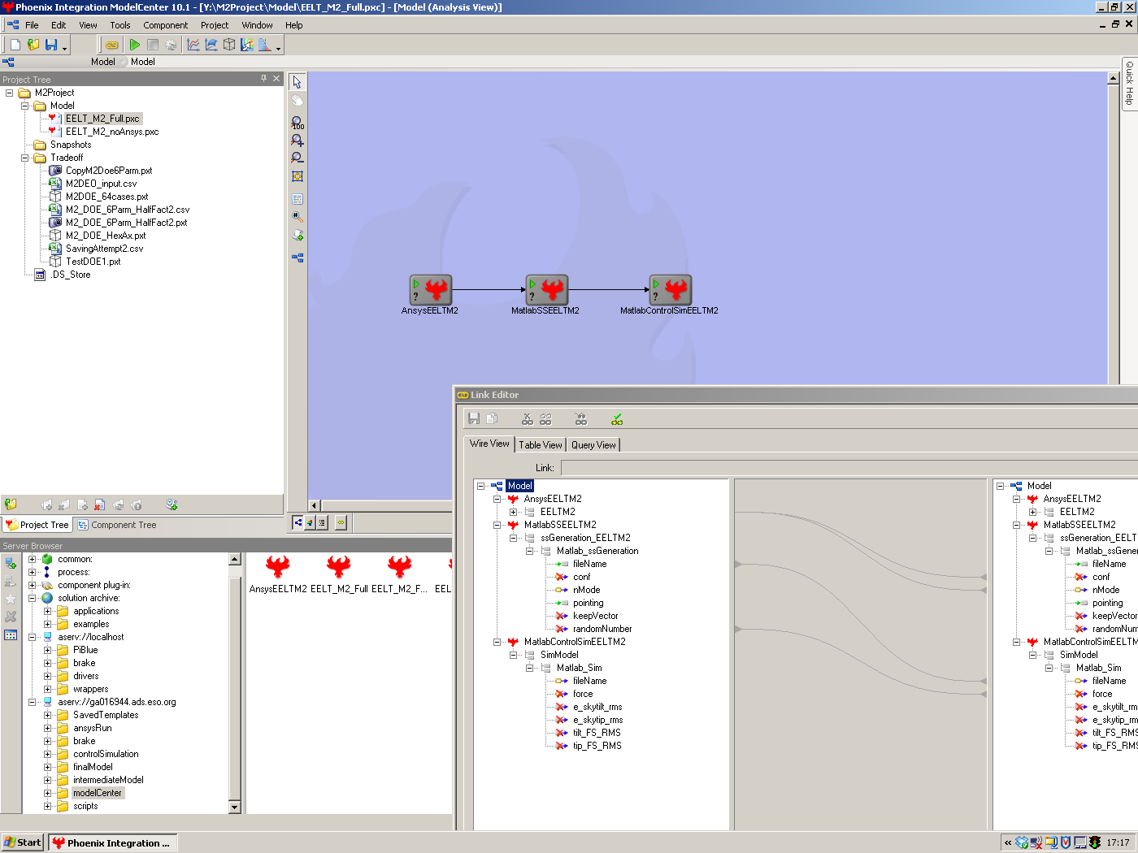
Figure 2 A snap shot of the project model with three main blocks and some links

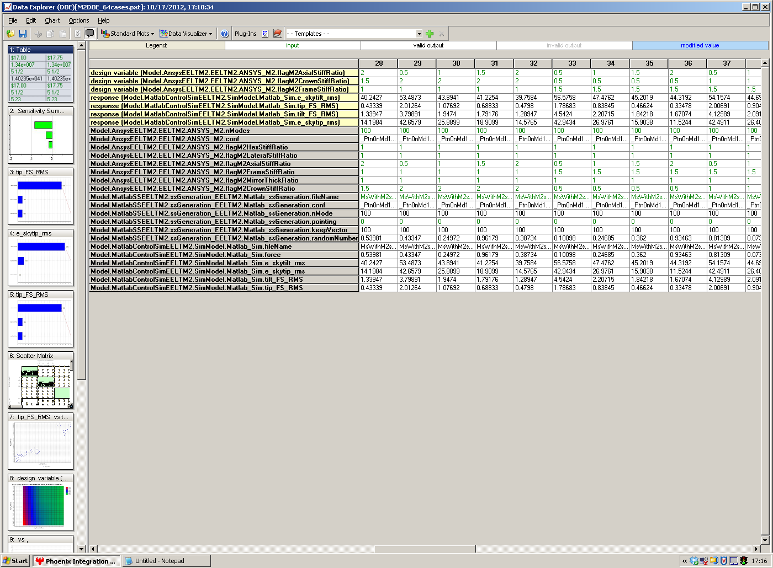
Figure 3 Numerical results of the parametric analysis study case: data explorer

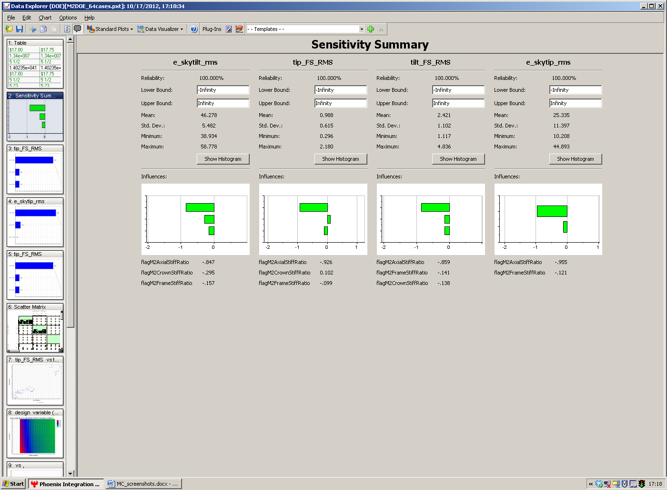
Figure 4 Sensitivity Summary: four output variables and the three varied parameters

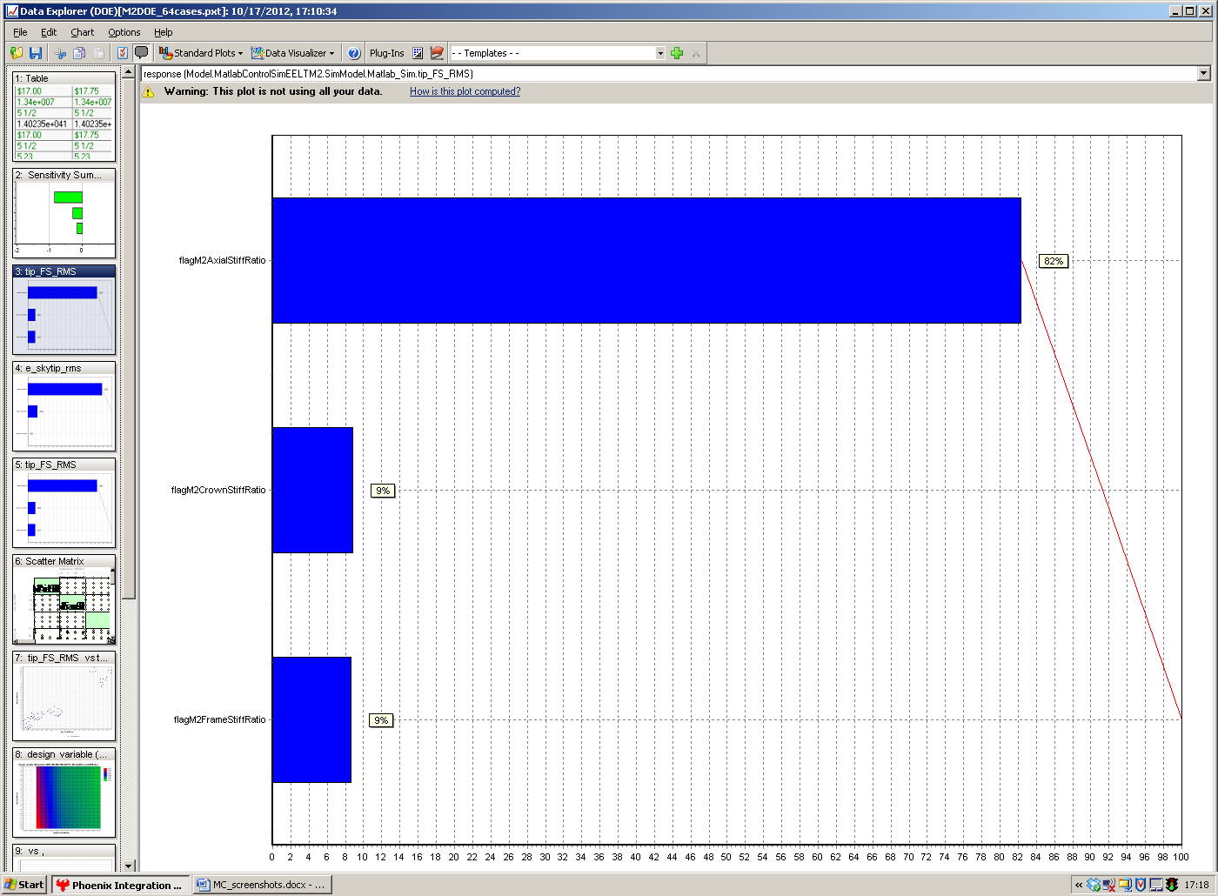
Figure 5 Contribution of three parameters to the final error: tilt on sky after field stabilization

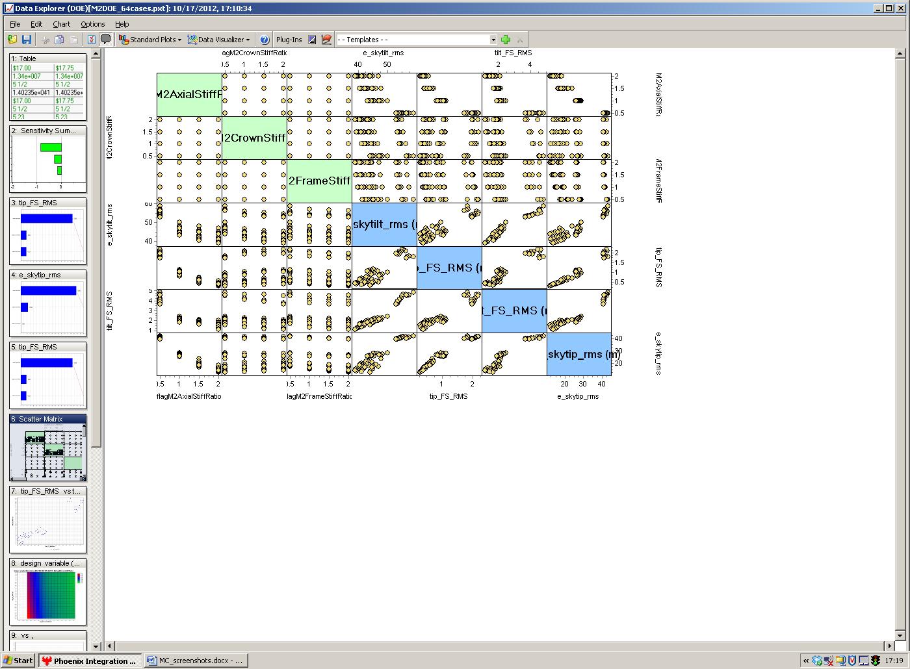
Figure 6 Scatter Matrix chart

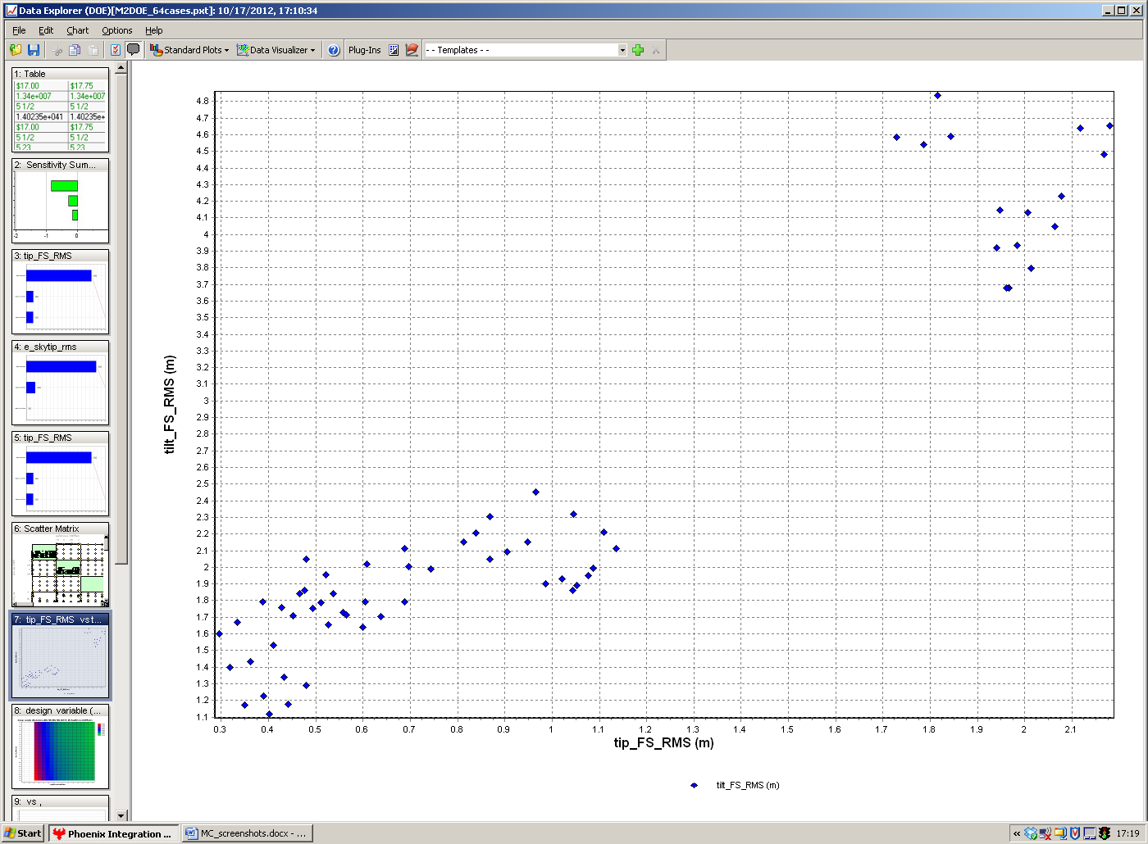
Figure 7 Scatter matrix result: tip and tilt after field stabilization for all combination of parameters (zoom to one of the previous figure blocks)

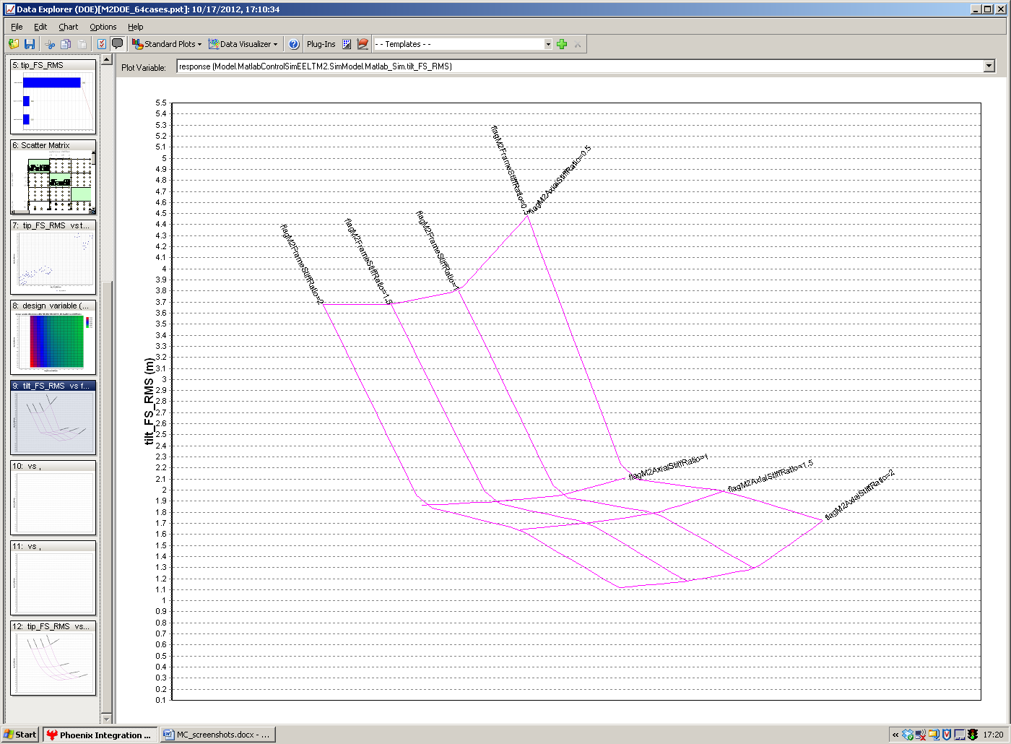
Figure 8 Tilt on sky after field stabilization: tendency of variation two design parameters

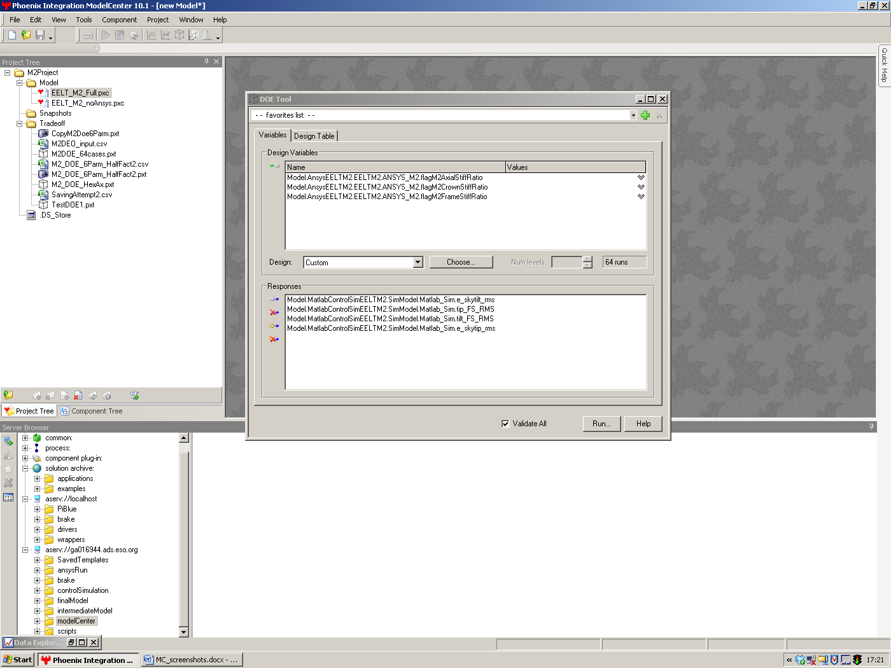
Figure 9 Tradeoff analysis: DOE tool main menu: selection of desired parameters and output variables

150000 nodes, 250000 elements, 17000 nodes M2 surface. Our number of outputs from Ansys = inputs to Matlab we use are (in this example): 100 (-1000) modes x 6DOFs per node x (M2 surface nodes + M1 surface (~10000 nodes)+ (M3+M4+M5+Ins+...+Drives, encoders+ nodes for wind loads = a few thousand nodes) ) = ~ 2e7-2e8 numbers.

