MAT 221 Lab 01 Example Answers

Here are the frequency table and the histogram for the data.
Class | Frequency
(0, 1000] | 13
(1000, 2000] | 10
(2000, 3000] | 10
(3000, 4000] | 7
(4000, 5000] | 2
(5000, 6000] | 3
(6000, 7000] | 2
 | 47

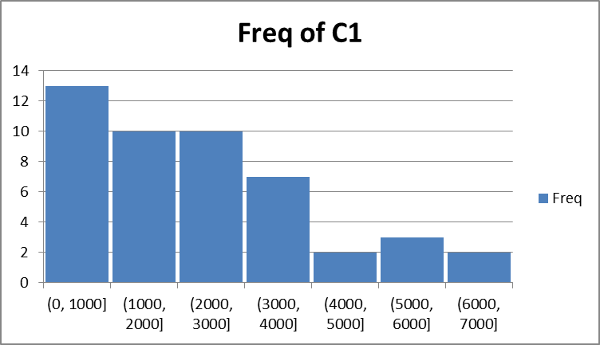

The summary statistics for the data set are:
mean | 2273.915
median | 2100
std | 1738.719
Q1 | 980
Q3 | 3150

The data set is skewed to the right, with the modal class for 0 to 1000. There seem to be two mild outliers, 6770 and 6850, which both cause the mean to be greater than the median. About 66% (31/47) of the observations fall within 1 standard deviation of the mean.

