## Streaming model

This document provides information of the TAPI streaming model.

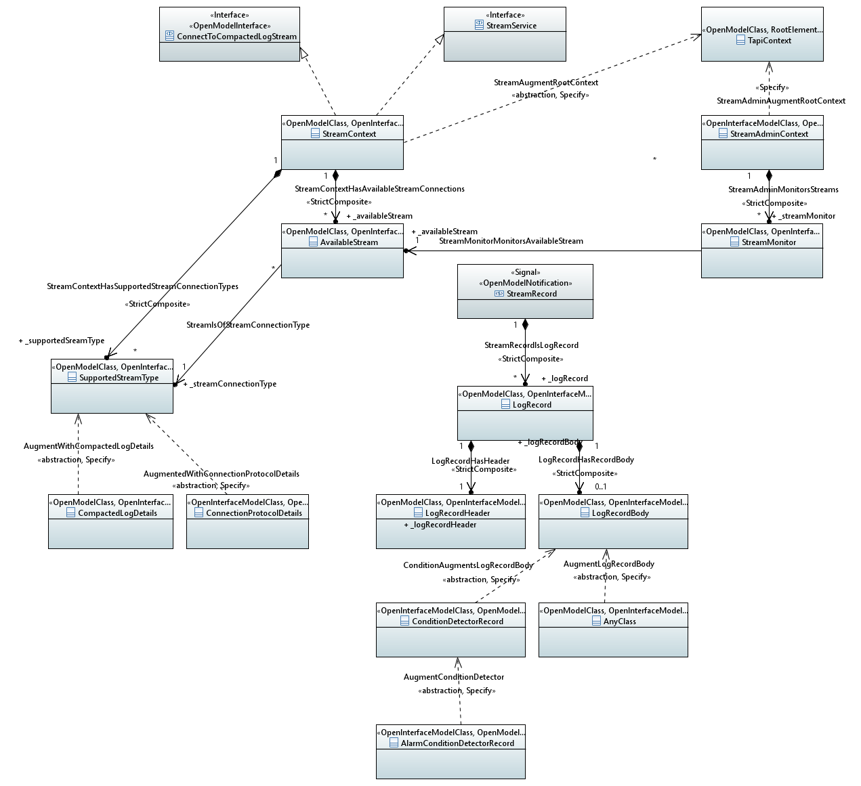

CoreModel diagram: StreamSkeleton

Figure 6-2 Basic stream structure

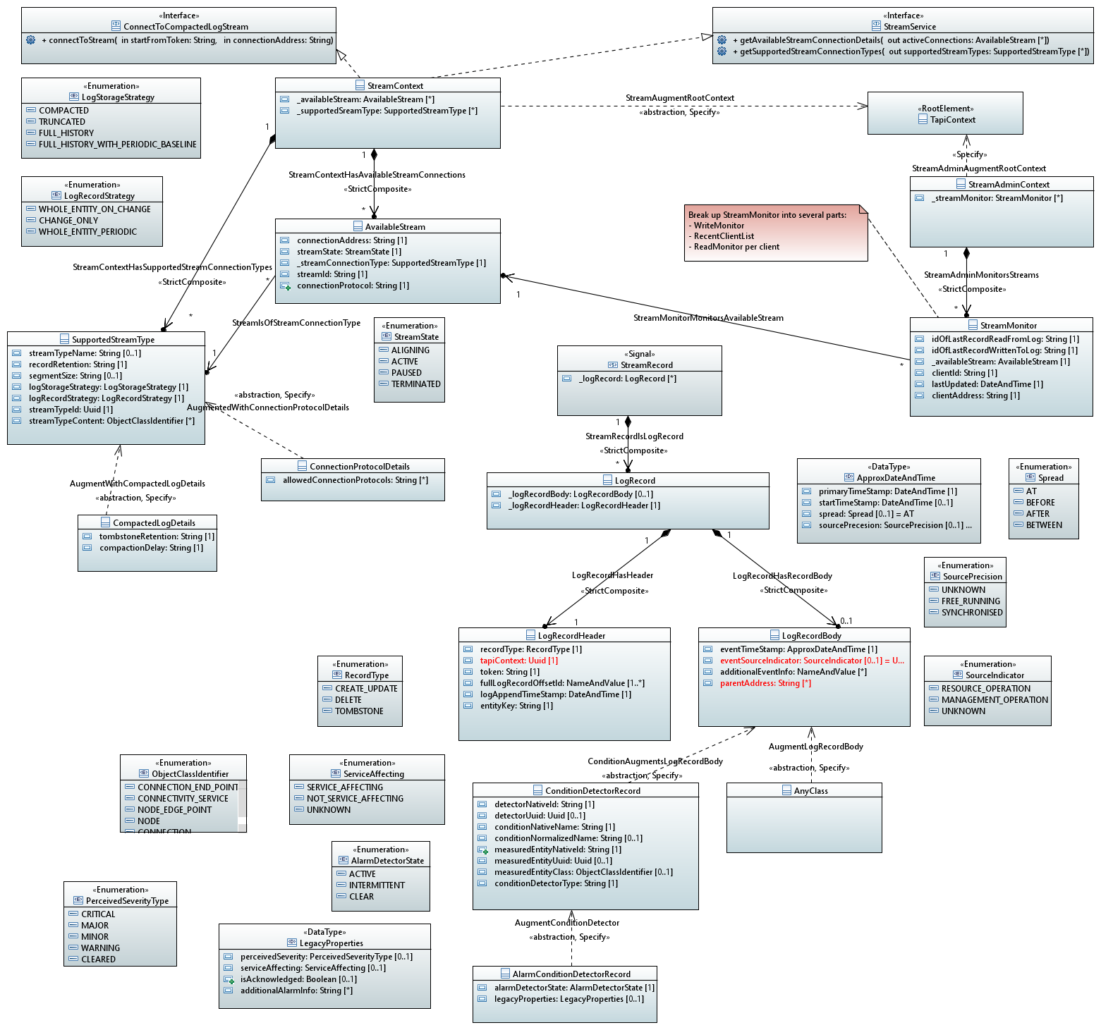

CoreModel diagram: StreamDetail

Figure 6-2 Detailed view of streaming model

## Model data dictionary

### Classes

#### AlarmConditionDetectorRecord

Qualified Name: TapiStreaming::ObjectClasses::AlarmConditionDetectorRecord

A record of the state of a detector where that detector has two underling states taht are of asymmetric importance.

Applied stereotypes:

* OpenInterfaceModelClass
  + objectCreationNotification: NA
  + objectDeletionNotification: NA
* OpenModelClass
  + support: MANDATORY

Table 1: Attributes for AlarmConditionDetectorRecord

|  |  |  |  |  |  |
| --- | --- | --- | --- | --- | --- |
| **Attribute Name** | **Type** | **Multiplicity** | **Access** | **Stereotypes** | **Description** |
| alarmDetectorState | AlarmDetectorState | 1 | R | OpenInterfaceModelAttribute   * AVC: NA   OpenModelAttribute   * valueRange: no range constraint * support: MANDATORY | The state of the detector. The detector state accounts for the time characteristics of the detected condition. |
| legacyProperties | LegacyProperties | 0..1 | R | OpenInterfaceModelAttribute   * AVC: NA   OpenModelAttribute   * valueRange: no range constraint * support: MANDATORY | Alarm systems of the 20th century were based primarily on local lamps (initially filament bulbs) and bells. Lamps can only be on or off, and bells sounding or not sounding, so alarms were boolean in nature. Where a detctor was essentially multi-state it was converted into multiple boolean statements. The management of the equipments was essentially human only and local only (there were rarely remote systems). The device with the problem was the only possible indicator of importance and it had only three distinct bulbs to illuminate (filament bulbs tend to fail requiring costly replacement). The devices were relatively simple in function and analysis of the detectors was crude. There was only the device to indicate severity The device also could provide the best view as to whether a service was impacted, although clearly it had almost no knowledge. In a modern solution with well connected remote systems that increasingly analyse problems and where there is increasingly "lights out" building operation, the device's guess at severity etc. is irrelavant. In addition with sophisticated resilience mechanisms, the device cannot make any relevant statement on whether the customer service has been impacted. Likewise, in a world where there were no remote systems and local management was the only practice, alarms had to be locally "acknowledged".  Where there are remote systems, per alarm acknowleged is burdensome. However, many solutions and operational practices continue to use the historic schemes. On that basis, the schemes are supported but relegated to optional. |

#### AnyClass

Qualified Name: TapiStreaming::ObjectClasses::AnyClass

In the final version all classes that can stream will be explicitly associated with the AppendLogRecordBody

Applied stereotypes:

* OpenInterfaceModelClass
  + objectCreationNotification: NA
  + objectDeletionNotification: NA
* OpenModelClass
  + support: MANDATORY

#### AvailableStream

Qualified Name: TapiStreaming::ObjectClasses::AvailableStream

Details of stream a stream that can be connected to by a client application.

Applied stereotypes:

* OpenInterfaceModelClass
  + objectCreationNotification: NA
  + objectDeletionNotification: NA
* OpenModelClass
  + support: MANDATORY

Table 1: Attributes for AvailableStream

|  |  |  |  |  |  |
| --- | --- | --- | --- | --- | --- |
| **Attribute Name** | **Type** | **Multiplicity** | **Access** | **Stereotypes** | **Description** |
| connectionAddress | String | 1 | R | OpenInterfaceModelAttribute   * AVC: NA   OpenModelAttribute   * valueRange: no range constraint * support: MANDATORY | Provides the address for the connection.  The format of the address and attachment mechnism will depend on the connection protocol defined in another attribute of this class. |
| streamState | StreamState | 1 | R | OpenInterfaceModelAttribute   * AVC: NA   OpenModelAttribute   * valueRange: no range constraint * support: MANDATORY | The state of the stream. |
| _streamConnectionType | SupportedStreamType | 1 | R | OpenInterfaceModelAttribute   * AVC: NA   OpenModelAttribute   * valueRange: no range constraint * support: MANDATORY | Identifies the type of stream that is available for connection. |
| streamId | String | 1 | R | OpenInterfaceModelAttribute   * AVC: NA   OpenModelAttribute   * valueRange: no range constraint * support: MANDATORY | The id of the stream. |
| connectionProtocol | String | 1 | R | OpenInterfaceModelAttribute   * AVC: NA   OpenModelAttribute   * valueRange: no range constraint * support: MANDATORY | Names the connection protocol for this particular available stream. The connection protocol is chosen from the lost of connecion protocols identified in the referenced SupportedStreamType. |

#### CompactedLogDetails

Qualified Name: TapiStreaming::ObjectClasses::CompactedLogDetails

Details relevant for a CompactedLog.  
The essential Compacted Log strategy is to remove historic records about a particular thing such that only the latest record about each thing exists in the log.  
The essental strategy is refined by the paramters of this structure.

Applied stereotypes:

* OpenInterfaceModelClass
  + objectCreationNotification: NA
  + objectDeletionNotification: NA
* OpenModelClass
  + support: MANDATORY

Table 1: Attributes for CompactedLogDetails

|  |  |  |  |  |  |
| --- | --- | --- | --- | --- | --- |
| **Attribute Name** | **Type** | **Multiplicity** | **Access** | **Stereotypes** | **Description** |
| tombstoneRetention | String | 1 | R | OpenInterfaceModelAttribute   * AVC: NA   OpenModelAttribute   * valueRange: no range constraint * support: MANDATORY | Time in minutes. The time period for which a Tombstone record will be held in the log from when it was logged.  This provides an adjustment to the essential Compaction strategy such that after the tombstoneRetention period there will be no records about a particular thing that existed but no longer exists. Tombstone retention overrides recordRetention for Tombstones. Key word "FOREVER" means that Tombstone records will never be removed from the log. Can be adjusted by an administrator (via a separate view) through the life of the stream. |
| compactionDelay | String | 1 | R | OpenInterfaceModelAttribute   * AVC: NA   OpenModelAttribute   * valueRange: no range constraint * support: MANDATORY | Time in minutes.  The delay between logging the record and making the record available for compaction. This provides an adjustment to the essential Compaction strategy such that there may be several distinct records for the same thing in the where those records are not older than the Compaction Delay. Can be adjusted by an administrator (via a separate view) through the life of the stream. |

#### ConditionDetectorRecord

Qualified Name: TapiStreaming::ObjectClasses::ConditionDetectorRecord

ConditionDetector represents any monitoring component that assesses properties of something and determines from those properties what conditions are associated with the thing.  
For example, a thing might be "too hot" or might be "unreliable".  
The monitor may a multi-state output.   
The ConditionDetector lifecycle depends upon the lifecycle of the thing it is monitoring (this is a general OAM model consideration).  
The entityKey in the AppendLogRecordHeader for a ConditionDetector record is the nativeDetector Id which may be derived from other ids (most robustly, nativeOwningEntityName (to which the detector is associated) + natveConditionName).

Applied stereotypes:

* OpenInterfaceModelClass
  + objectCreationNotification: NA
  + objectDeletionNotification: NA
* OpenModelClass
  + support: MANDATORY

Table 1: Attributes for ConditionDetectorRecord

|  |  |  |  |  |  |
| --- | --- | --- | --- | --- | --- |
| **Attribute Name** | **Type** | **Multiplicity** | **Access** | **Stereotypes** | **Description** |
| conditionNativeName | String | 1 | R | OpenInterfaceModelAttribute   * AVC: NA   OpenModelAttribute   * valueRange: no range constraint * support: MANDATORY | The name used for the Condition by the source of the information. |
| measuredEntityUuid | Uuid | 0..1 | R | OpenInterfaceModelAttribute   * AVC: NA   OpenModelAttribute   * valueRange: no range constraint * support: MANDATORY | The Uuid of the TAPI entity that represents the entity measured at source. If the TAPI entity can not be identified as it cannot be mapped, then this property can be ommitted. |
| measuredEntityNativeId | String | 1 | R | OpenInterfaceModelAttribute   * AVC: NA   OpenModelAttribute   * valueRange: no range constraint * support: MANDATORY | The identifier (invariant over the life) of the instance of the measured entity at the source. |
| conditionNormalizedName | String | 0..1 | R | OpenInterfaceModelAttribute   * AVC: NA   OpenModelAttribute   * valueRange: no range constraint * support: MANDATORY | It is often the case that there is a Condition Name that is commonly used or even standardised that has not been used by the source of the condition.  If this is the case then that common/standard name is provided in via this property. |
| measuredEntityClass | ObjectClassIdentifier | 0..1 | R | OpenInterfaceModelAttribute   * AVC: NA   OpenModelAttribute   * valueRange: no range constraint * support: MANDATORY | The TAPI class of the measured entity.  If the class can not be identified as it cannot be mapped, then this property can be ommitted. |
| detectorUuid | Uuid | 0..1 | R | OpenInterfaceModelAttribute   * AVC: NA   OpenModelAttribute   * valueRange: no range constraint * support: MANDATORY | The Uuid of the TAPI entity that represents the detector. If the TAPI entity can not be identified as it cannot be mapped, then this property can be ommitted. Where the detector is not modelled independently, but instead is a part of the measured entity such that it is identified by a "local id" built from the UUID of the measured entity and the condition name, then this property may be ommitted. |
| detectorNativeId | String | 1 | R | OpenInterfaceModelAttribute   * AVC: NA   OpenModelAttribute   * valueRange: no range constraint * support: MANDATORY | The identifier (invariant over the life) of the instance of the detector at the source. |
| conditionDetectorType | String | 1 | R | OpenInterfaceModelAttribute   * AVC: NA   OpenModelAttribute   * valueRange: no range constraint * support: MANDATORY | Identifies the type of detector. This drives the conditional augmentation.  Some types of detector may not need specific augmentation. The strings will be controlled. Valid values: - AlarmConditionDetector |

#### ConnectionProtocolDetails

Qualified Name: TapiStreaming::ObjectClasses::ConnectionProtocolDetails

Details of the connection protocols available for the specific stream.

Applied stereotypes:

* OpenInterfaceModelClass
  + objectCreationNotification: NA
  + objectDeletionNotification: NA
* OpenModelClass
  + support: MANDATORY

Table 1: Attributes for ConnectionProtocolDetails

|  |  |  |  |  |  |
| --- | --- | --- | --- | --- | --- |
| **Attribute Name** | **Type** | **Multiplicity** | **Access** | **Stereotypes** | **Description** |
| allowedConnectionProtocols | String | 0..* | R | OpenInterfaceModelAttribute   * AVC: NA   OpenModelAttribute   * valueRange: no range constraint * support: MANDATORY | Name of the allowed protocol. |

#### LogRecord

Qualified Name: TapiStreaming::ObjectClasses::LogRecord

A specific atomic entry in a log.

Applied stereotypes:

* OpenInterfaceModelClass
  + objectCreationNotification: NA
  + objectDeletionNotification: NA
* OpenModelClass
  + support: MANDATORY

Table 1: Attributes for LogRecord

|  |  |  |  |  |  |
| --- | --- | --- | --- | --- | --- |
| **Attribute Name** | **Type** | **Multiplicity** | **Access** | **Stereotypes** | **Description** |
| _logRecordHeader | LogRecordHeader | 1 | R | OpenInterfaceModelAttribute   * AVC: NA   OpenModelAttribute   * valueRange: no range constraint * support: MANDATORY | The header of the log record providing general parameters of the record common to all records. |
| _logRecordBody | LogRecordBody | 0..1 | R | OpenInterfaceModelAttribute   * AVC: NA   OpenModelAttribute   * valueRange: no range constraint * support: MANDATORY | The body of the log record providing specific logged details. |

#### LogRecordBody

Qualified Name: TapiStreaming::ObjectClasses::LogRecordBody

The specific details of the Record.

Applied stereotypes:

* OpenInterfaceModelClass
  + objectCreationNotification: NA
  + objectDeletionNotification: NA
* OpenModelClass
  + support: MANDATORY

Table 1: Attributes for LogRecordBody

|  |  |  |  |  |  |
| --- | --- | --- | --- | --- | --- |
| **Attribute Name** | **Type** | **Multiplicity** | **Access** | **Stereotypes** | **Description** |
| eventTimeStamp | ApproxDateAndTime | 1 | R | OpenInterfaceModelAttribute   * AVC: NA   OpenModelAttribute   * valueRange: no range constraint * support: MANDATORY | Time of the event at the origin of the event that triggered the generation of the record.  The structure allows for time uncertainty. |
| eventSourceIndicator | SourceIndicator | 0..1 | R | OpenInterfaceModelAttribute   * AVC: NA   OpenModelAttribute   * valueRange: no range constraint * support: MANDATORY | Indicates whether the source is controlled or potentially chaotic. The time characteristic of the source may be determined from the metadata describing the detector. Where there is an alternative (and probably more detailed) source of information on time characteristic this attribute can be ommitted. |
| additionalEventInfo | NameAndValue | 0..* | R | OpenInterfaceModelAttribute   * AVC: NA   OpenModelAttribute   * valueRange: no range constraint * support: MANDATORY | Addition information related to the event such as change reason where changeReason would be the name and the value text would provide information on the reason for change. |
| parentAddress | String | 0..* | R | OpenInterfaceModelAttribute   * AVC: NA   OpenModelAttribute   * valueRange: no range constraint * support: MANDATORY | Gives the position of the entity in the address tree (usually containment) that is raising the event by providing the name/id values in the address of the parent. Is the sequence of named levels in the tree up to but excluding the entity of the notification.  It includes the NE id. |

#### LogRecordHeader

Qualified Name: TapiStreaming::ObjectClasses::LogRecordHeader

The header of the log record providing general parameters of the record common to all records.

Applied stereotypes:

* OpenInterfaceModelClass
  + objectCreationNotification: NA
  + objectDeletionNotification: NA
* OpenModelClass
  + support: MANDATORY

Table 1: Attributes for LogRecordHeader

|  |  |  |  |  |  |
| --- | --- | --- | --- | --- | --- |
| **Attribute Name** | **Type** | **Multiplicity** | **Access** | **Stereotypes** | **Description** |
| tapiContext | Uuid | 1 | R | OpenInterfaceModelAttribute   * AVC: NA   OpenModelAttribute   * valueRange: no range constraint * support: MANDATORY | The identifier of the context. |
| token | String | 1 | R | OpenInterfaceModelAttribute   * AVC: NA   OpenModelAttribute   * valueRange: no range constraint * support: MANDATORY | A coded (and compact) form of the fullLogRecordOffsetId. This property is used to request streaming from a particular point (e.g., the last correctly handled record). |
| fullLogRecordOffsetId | NameAndValue | 1..* | R | OpenInterfaceModelAttribute   * AVC: NA   OpenModelAttribute   * valueRange: no range constraint * support: MANDATORY | In a complex log solution there may be various parts to the log. The record token is a compressed form of log record reference. This property provides the verbose form  Fore example it may include: - stream id - topic - partition - partition offset - sequence number ( the offset is essentially the sequence number associated with the partition) |
| logAppendTimeStamp | DateAndTime | 1 | R | OpenInterfaceModelAttribute   * AVC: NA   OpenModelAttribute   * valueRange: no range constraint * support: MANDATORY | The time when the record was appended to the log. |
| entityKey | String | 1 | R | OpenInterfaceModelAttribute   * AVC: NA   OpenModelAttribute   * valueRange: no range constraint * support: MANDATORY | The identifier of the entity that is used in a Compacted log as the compaction key. The entityKey value, where appropriate, may be based upon the identifiers from the event source. It can be built from some specific detail combination that meets the necessary uniqueness and durability requirements. entityKey is the value used during compaction. Ideally it is a UUID format, if this can be formed from the source identifier. |
| recordType | RecordType | 1 | R | OpenInterfaceModelAttribute   * AVC: NA   OpenModelAttribute   * valueRange: no range constraint * support: MANDATORY | The type of the record. Can be used to understand which elements of the record will be present. |

#### StreamAdminContext

Qualified Name: TapiStreaming::ObjectClasses::StreamAdminContext

Context providing access to stream administration functionality.

Applied stereotypes:

* OpenInterfaceModelClass
  + objectCreationNotification: NA
  + objectDeletionNotification: NA
* OpenModelClass
  + support: MANDATORY

Inherits properties from:

* GlobalClass

Table 1: Attributes for StreamAdminContext

|  |  |  |  |  |  |
| --- | --- | --- | --- | --- | --- |
| **Attribute Name** | **Type** | **Multiplicity** | **Access** | **Stereotypes** | **Description** |
| _streamMonitor | StreamMonitor | 0..* | R | OpenInterfaceModelAttribute   * AVC: NA   OpenModelAttribute   * valueRange: no range constraint * support: MANDATORY | The list of available stream monitors. |
| uuid  Inherited | Uuid | 1 | RW | OpenInterfaceModelAttribute   * AVC: NA   OpenModelAttribute   * valueRange: no range constraint * support: MANDATORY | UUID: An identifier that is universally unique within an identifier space, where the identifier space is itself globally unique, and immutable. An UUID carries no semantics with respect to the purpose or state of the entity. UUID here uses string representation as defined in RFC 4122. The canonical representation uses lowercase characters. Pattern: [0-9a-fA-F]{8}-[0-9a-fA-F]{4}-[0-9a-fA-F]{4}-' + '[0-9a-fA-F]{4}-[0-9a-fA-F]{12}  Example of a UUID in string representation: f81d4fae-7dec-11d0-a765-00a0c91e6bf6 |
| name  Inherited | NameAndValue | 0..* | RW | OpenInterfaceModelAttribute   * AVC: NA   OpenModelAttribute   * valueRange: no range constraint * support: MANDATORY | List of names. This value is unique in some namespace but may change during the life of the entity. A name carries no semantics with respect to the purpose of the entity. |

#### StreamContext

Qualified Name: TapiStreaming::ObjectClasses::StreamContext

All streams relevant to the specific TapiContext.

Applied stereotypes:

* OpenInterfaceModelClass
  + objectCreationNotification: NA
  + objectDeletionNotification: NA
* OpenModelClass
  + support: MANDATORY

Table 1: Attributes for StreamContext

|  |  |  |  |  |  |
| --- | --- | --- | --- | --- | --- |
| **Attribute Name** | **Type** | **Multiplicity** | **Access** | **Stereotypes** | **Description** |
| _availableStream | AvailableStream | 0..* | R | OpenInterfaceModelAttribute   * AVC: NA   OpenModelAttribute   * valueRange: no range constraint * support: MANDATORY | See referenced class |
| _supportedSreamType | SupportedStreamType | 0..* | R | OpenInterfaceModelAttribute   * AVC: NA   OpenModelAttribute   * valueRange: no range constraint * support: MANDATORY | See referenced class |

#### StreamMonitor

Qualified Name: TapiStreaming::ObjectClasses::StreamMonitor

Information on the monitoring of the use of a specific AvailableStream.

Applied stereotypes:

* OpenInterfaceModelClass
  + objectCreationNotification: NA
  + objectDeletionNotification: NA
* OpenModelClass
  + support: MANDATORY

Table 1: Attributes for StreamMonitor

|  |  |  |  |  |  |
| --- | --- | --- | --- | --- | --- |
| **Attribute Name** | **Type** | **Multiplicity** | **Access** | **Stereotypes** | **Description** |
| idOfLastRecordReadFromLog | String | 1 | R | OpenInterfaceModelAttribute   * AVC: NA   OpenModelAttribute   * valueRange: no range constraint * support: MANDATORY | The id/key of the last record read from the log by the client stream. The analysis of this value needs to account for stream buffering in the comms layer. |
| idOfLastRecordWrittenToLog | String | 1 | R | OpenInterfaceModelAttribute   * AVC: NA   OpenModelAttribute   * valueRange: no range constraint * support: MANDATORY | The id/key of the last record written to the log.  This is the same value for all clients of the stream. |
| _availableStream | AvailableStream | 1 | R | OpenInterfaceModelAttribute   * AVC: NA   OpenModelAttribute   * valueRange: no range constraint * support: MANDATORY | See referenced class |
| clientId | String | 1 | R | OpenInterfaceModelAttribute   * AVC: NA   OpenModelAttribute   * valueRange: no range constraint * support: MANDATORY | The id of the connected client. |
| lastUpdated | DateAndTime | 1 | R | OpenInterfaceModelAttribute   * AVC: NA   OpenModelAttribute   * valueRange: no range constraint * support: MANDATORY | The date/time when the values provided were recorded. |
| clientAddress | String | 1 | R | OpenInterfaceModelAttribute   * AVC: NA   OpenModelAttribute   * valueRange: no range constraint * support: MANDATORY | The address of the connected client that is being monitored. |

#### SupportedStreamType

Qualified Name: TapiStreaming::ObjectClasses::SupportedStreamType

Definition of a supported stream type.

Applied stereotypes:

* OpenInterfaceModelClass
  + objectCreationNotification: NA
  + objectDeletionNotification: NA
* OpenModelClass
  + support: MANDATORY

Table 1: Attributes for SupportedStreamType

|  |  |  |  |  |  |
| --- | --- | --- | --- | --- | --- |
| **Attribute Name** | **Type** | **Multiplicity** | **Access** | **Stereotypes** | **Description** |
| streamTypeName | String | 0..1 | R | OpenInterfaceModelAttribute   * AVC: NA   OpenModelAttribute   * valueRange: no range constraint * support: MANDATORY | Name of the stream type.  Name of the stream type. |
| recordRetention | String | 1 | R | OpenInterfaceModelAttribute   * AVC: NA   OpenModelAttribute   * valueRange: no range constraint * support: MANDATORY | Time in minutes. Statement of retention time and/or retention capacity in bytes. Key word "FOREVER" means that records will never be removed from the log. May be overridden for particular cases of specific LogStorageStrategy (via augment). |
| segmentSize | String | 0..1 | R | OpenInterfaceModelAttribute   * AVC: NA   OpenModelAttribute   * valueRange: no range constraint * support: MANDATORY | Size of substructuring of the log. |
| streamTypeContent | ObjectClassIdentifier | 0..* | RW | OpenInterfaceModelAttribute   * AVC: NA   OpenModelAttribute   * valueRange: no range constraint * support: MANDATORY | Identifies the classes that are supported through the stream.  The list may be a subset of the classes within the context. |
| logStorageStrategy | LogStorageStrategy | 1 | R | OpenInterfaceModelAttribute   * AVC: NA   OpenModelAttribute   * valueRange: no range constraint * support: MANDATORY | Indicates the storage characteristics of the log supporting the stream. |
| logRecordStrategy | LogRecordStrategy | 1 | R | OpenInterfaceModelAttribute   * AVC: NA   OpenModelAttribute   * valueRange: no range constraint * support: MANDATORY | Indicates the type of content of each log record. |
| streamTypeId | Uuid | 1 | R | OpenInterfaceModelAttribute   * AVC: NA   OpenModelAttribute   * valueRange: no range constraint * support: MANDATORY | The identifier for the stream type. |

### Signal

#### StreamRecord

Qualified Name: TapiStreaming::ObjectClasses::StreamRecord

The stream content.

Applied stereotypes:

* OpenModelNotification
  + triggerConditionList: invalid
  + support: MANDATORY

Table 1: Attributes for StreamRecord

|  |  |  |  |  |  |
| --- | --- | --- | --- | --- | --- |
| **Attribute Name** | **Type** | **Multiplicity** | **Access** | **Stereotypes** | **Description** |
| _logRecord | LogRecord | 0..* | R | OpenInterfaceModelAttribute   * AVC: NA   OpenModelAttribute   * valueRange: no range constraint * support: MANDATORY | Each stream record may include a number of log records. |

### Data Types

#### ApproxDateAndTime

Qualified Name: TapiStreaming::TypeDefinitions::ApproxDateAndTime

Allows for recording of an aspect of imprecise time.

Applied stereotypes:

No stereotypes applied

Table 1: Attributes for ApproxDateAndTime

|  |  |  |  |  |  |
| --- | --- | --- | --- | --- | --- |
| **Attribute Name** | **Type** | **Multiplicity** | **Access** | **Stereotypes** | **Description** |
| primaryTimeStamp | DateAndTime | 1 | R | OpenInterfaceModelAttribute   * AVC: NA   OpenModelAttribute   * valueRange: no range constraint * support: MANDATORY | Time of the event at the origin where known precisely. Where the event is known to be before particular time, this field records that time. Where the event is known to be after a particular time, this field records that time (this is an unusual case where there is no proposed before time). Where the event is known to have occurred in a time window, this field records the end time (the time before which the event must have occurred). |
| startTimeStamp | DateAndTime | 0..1 | R | OpenInterfaceModelAttribute   * AVC: NA   OpenModelAttribute   * valueRange: no range constraint * support: MANDATORY | The time after which the event is known to have occurred when the event is known to have occurred between two times. The primaryTimeStamp provides the end time. |
| spread | Spread | 0..1 | R | OpenInterfaceModelAttribute   * AVC: NA   OpenModelAttribute   * valueRange: no range constraint * support: MANDATORY | Indicates the knowledge of the time of occurence of the event. |
| sourcePrecesion | SourcePrecision | 0..1 | R | OpenInterfaceModelAttribute   * AVC: NA   OpenModelAttribute   * valueRange: no range constraint * support: MANDATORY | To be provided |

#### LegacyProperties

Qualified Name: TapiStreaming::TypeDefinitions::LegacyProperties

At this point in the evolution of control solutions LegacyProperties are probably mandatory, however, it is anticipated that as control solutions advance the LegacyProperties will become irrelevant.

Applied stereotypes:

No stereotypes applied

Table 1: Attributes for LegacyProperties

|  |  |  |  |  |  |
| --- | --- | --- | --- | --- | --- |
| **Attribute Name** | **Type** | **Multiplicity** | **Access** | **Stereotypes** | **Description** |
| perceivedSeverity | PerceivedSeverityType | 0..1 | RW | OpenInterfaceModelAttribute   * AVC: NA   OpenModelAttribute   * valueRange: no range constraint * support: MANDATORY | A device will provide an indication of importance for each alarm.  This property indicates the importance. In some cases the severity may change through the life of an active alarm. |
| serviceAffecting | ServiceAffecting | 0..1 | RW | OpenInterfaceModelAttribute   * AVC: NA   OpenModelAttribute   * valueRange: no range constraint * support: MANDATORY | Some devices will indicate, from its very narrow viewpoint, whether service has been impacted or not. This property carries this detail. |
| isAcknowledged | Boolean | 0..1 | RW | OpenInterfaceModelAttribute   * AVC: NA   OpenModelAttribute   * valueRange: no range constraint * support: MANDATORY | Devices offer a capability to acknowledge alarms (to stop the bells ringing). Often an EMS will offer a similar capability. This property reflects the current acknowledge state. |
| additionalAlarmInfo | String | 0..* | RW | OpenInterfaceModelAttribute   * AVC: NA   OpenModelAttribute   * valueRange: no range constraint * support: MANDATORY | Often, alarms raised by devices have additional information.  This property can be used to convey this. |

### Enumeration Types

#### AlarmDetectorState

Qualified Name: TapiStreaming::TypeDefinitions::AlarmDetectorState

The state of the processed boolean alarm detector.  
The source applies some analysis to the raw detector to determine the state.  
The processing by the source my vary.

Applied stereotypes:

No stereotypes applied

Contains Enumeration Literals:

* ACTIVE:
  + The detector is indicating the operation of the monitored entity is not within acceptable bounds with respect to the specific condition measured.  
    If INTERMITTENT is supported there may be a requirement for persisted unacceptable operation after a problem occurs before ACTIVE is declared as an alternative may be to declare INTERMITTENT.  
    Where INTERMITTENT is supported, ACTIVE indicates the stable presence of a problem.
* INTERMITTENT:
  + The detector is indicating the operation of the monitored entity is intermittently not within acceptable bounds with respect to the specific condition measured.  
    INTERMITTENT support is optional. Where it is supported there may be a requirement for persisted unacceptable operation after a problem occurs before ACTIVE or INTERMITTENT is declared.
* CLEAR:
  + The detector is indicating the operation of the monitored entity is within acceptable bounds with respect to the specific condition measured.  
    There may be a requirement for persisted acceptable operation after a problem before clear is declared etc.  
    For a Compacted Log solution a CLEAR alarm will be considered as a DELETE ChangeType in the RecordBody.  
    Hence a CLEAR will also cause a Tombstone record in a Compacted Log solution.

#### LogRecordStrategy

Qualified Name: TapiStreaming::TypeDefinitions::LogRecordStrategy

Defines the different approaches for logging information about an event covering the log trigger and the log content.

Applied stereotypes:

No stereotypes applied

Contains Enumeration Literals:

* WHOLE_ENTITY_ON_CHANGE:
  + A record provides a snapshot of a whole entity and a snapshot is taken on each change.  
    The record includes all properties and values whether they have changed or not.
* CHANGE_ONLY:
  + Each record only provides a view of the changes that have occurred (on a per entity change basis).  
    E.g., the log only includes the attribute that has changed and not other attributes that have not changed.
* WHOLE_ENTITY_PERIODIC:
  + A snapshot of an entity is recorded periodically regardess of whether there has been change or not.

#### LogStorageStrategy

Qualified Name: TapiStreaming::TypeDefinitions::LogStorageStrategy

Defines the storage (record retention) approach.

Applied stereotypes:

No stereotypes applied

Contains Enumeration Literals:

* COMPACTED:
  + The log uses some mechanism to remove noisey detail whilst enabling the client to achieve eventual consistency (alignment) with current state.
* TRUNCATED:
  + The log only maintains recent records and disposes of old records.   
    This log does not alone enable the client to achieve alignment with current state.
* FULL_HISTORY:
  + Maintains a history from system initiation with no missing records.   
    Provides initial state at the begining of the history
* FULL_HISTORY_WITH_PERIODIC_BASELINE:
  + Provides a history with initial state and perioidic/occasional statements of current state at a particular point in time.

#### ObjectClassIdentifier

Qualified Name: TapiStreaming::TypeDefinitions::ObjectClassIdentifier

The list of TAPI Global Object Class types on which Notifications can be raised.

Applied stereotypes:

No stereotypes applied

Contains Enumeration Literals:

* NODE:
* CONNECTION:
* LINK:
* CONNECTION_END_POINT:
* CONNECTIVITY_SERVICE:
* INTER_RULE_GROUP:
* MAINTENANCE_ENTITY:
* MAINTENANCE_ENTITY_GROUP:
* MEG_END_POINT:
* MEG_INTERMEDIATE_POINT:
* NODE_EDGE_POINT:
* OAM_JOB:
* PATH:
* NODE_RULE_GROUP:
* PATH_COMPUTATION_SERVICE:
* ROUTE:
* RULE:
* SERVICE_INTERFACE_POINT:
* SWITCH:
* SWITCH_CONTROL:
* TOPOLOGY:
* VIRTUAL_NETWORK_SERVICE:

#### PerceivedSeverityType

Qualified Name: TapiStreaming::TypeDefinitions::PerceivedSeverityType

The values for importance of an ACTIVE, INTERMITTENT or CLEAR alarm.

Applied stereotypes:

No stereotypes applied

Contains Enumeration Literals:

* CRITICAL:
  + The higherst severity of ACTIVE/INTERMITTENT alarm.
* MAJOR:
  + The middle severity of ACTIVE/INTERMITTENT alarm.
* MINOR:
  + The lowest severity of ACTIVE/INTERMITTENT alarm.
* WARNING:
  + An extremely low importance ACTIVE/INTERMITTENT alarm (lowere than MINOR).
* CLEARED:
  + The severity of a CLEAR where no other severity information is available.

#### RecordType

Qualified Name: TapiStreaming::TypeDefinitions::RecordType

The type of the record.  
Used to understand what log content will be present and how to interpret it.  
For some record types there is special encoding.  
A ACTIVE alarm and an INTERMITTENT alarm are CREATE_UPDATE.  
A CLEAR alarm is DELETE with an adjacent TOMBSTONE record.

Applied stereotypes:

No stereotypes applied

Contains Enumeration Literals:

* CREATE_UPDATE:
  + The record includes a create or update.  
    Where there is an update in a non-compacted log the information with be sparse (e.g., a single atttrinbute) and about an entity that is already known.
* DELETE:
  + The record is about a delete.  
    The record may have a LogRecordHeader and a LogRecordBody but no augmented content.  
    The entityKey should be sufficient to identify the entity to be deleted.  
    Under certain circumstances there may be class content in the LogRecordBody.
* TOMBSTONE:
  + Used in a Compacted log to remove old records and truncate deletion history.  
    Is only a LogRecordHeader with no LogRecordBody.

#### ServiceAffecting

Qualified Name: TapiStreaming::TypeDefinitions::ServiceAffecting

Indicates whether the device considers the condition to be impacting service.  
Note that the detected condition along with knowledge of the topology and protection provide a more suitable approach.

Applied stereotypes:

No stereotypes applied

Contains Enumeration Literals:

* SERVICE_AFFECTING:
  + The condition is believed to impact service.
* NOT_SERVICE_AFFECTING:
  + The condition is believed to not impact service.
* UNKNOWN:
  + The service impact of the condition is not known.

#### SourceIndicator

Qualified Name: TapiStreaming::TypeDefinitions::SourceIndicator

Source of the event.  
Use to give some idea of the time characteristics of the event source.

Applied stereotypes:

No stereotypes applied

Contains Enumeration Literals:

* RESOURCE_OPERATION:
  + The event is from the operation of the network resources.  
    The event source has a relatively fast time characteristic.
* MANAGEMENT_OPERATION:
  + Event is from a Management operation (slow control).  
    The event source has a relatively slow time characteristic.
* UNKNOWN:
  + The origin of the event is not known.

#### SourcePrecision

Qualified Name: TapiStreaming::TypeDefinitions::SourcePrecision

Alternative statements about timing precision at the event source.

Applied stereotypes:

No stereotypes applied

Contains Enumeration Literals:

* UNKNOWN:
* FREE_RUNNING:
  + The clock at the event source is free-running.  
    The view of time of day at the source may be significantly different from that at other sources.
* SYNCHRONISED:
  + The state of the clock at the event source is not known.  
    The view of time of day at the source is suspect.
  + The clock at the event source is appropriately synchronised to the timing master.  
    The view of time of day at the source should be essentially the same as that at other time-synchronized sources.

#### Spread

Qualified Name: TapiStreaming::TypeDefinitions::Spread

The alterntive time of occurrence statements.

Applied stereotypes:

No stereotypes applied

Contains Enumeration Literals:

* AT:
  + The event occurred at a particular time.
* BEFORE:
  + The event occurred before a particular time.
* AFTER:
  + The event occurred after a particular time.
* BETWEEN:
  + The event occurred between two stated times.

#### StreamState

Qualified Name: TapiStreaming::TypeDefinitions::StreamState

The state of the available stream.

Applied stereotypes:

No stereotypes applied

Contains Enumeration Literals:

* ALIGNING:
  + The log that underpins the stream is aligning with other backend services and hence may not be providing full service.  
    If events are provided they will be completely valid.
* ACTIVE:
  + The stream is operating such that if a client connects records will be provided as per back pressure etc.
* PAUSED:
  + Although the stream is available it has been paused by the administrator such that the records are being appended to the log but a new client will not receive any events whilst the stream is paused.
* TERMINATED:
  + The stream is essentially no longer available. It will be removed from the AvailableStreams list shortly.

### Primitive Types

**END OF DOCUMENT**