

UML Modeling Guidelines



TR-514 v1.3-info

July 2018

Work in progress!

**Disclaimer**

THIS SPECIFICATION IS PROVIDED “AS IS” WITH NO WARRANTIES WHATSOEVER, INCLUDING ANY WARRANTY OF MERCHANTABILITY, NONINFRINGEMENT, FITNESS FOR ANY PARTICULAR PURPOSE, OR ANY WARRANTY OTHERWISE ARISING OUT OF ANY PROPOSAL, SPECIFICATION OR SAMPLE.

Any marks and brands contained herein are the property of their respective owners.

Open Networking Foundation

1000 El Camino Real, Suite 100, Menlo Park, CA 94025

[www.opennetworking.org](http://www.opennetworking.org)

©2018 Open Networking Foundation. All rights reserved.

Open Networking Foundation, the ONF symbol, and OpenFlow are registered trademarks of the Open Networking Foundation, in the United States and/or in other countries. All other brands, products, or service names are or may be trademarks or service marks of, and are used to identify, products or services of their respective owners.

**Important note**

This Technical Recommendations has been approved by the OIMT Project TST but has not been approved by the ONF board. This Technical Recommendation has been approved under the ONF publishing guidelines for 'Informational' publications that allow Project technical steering teams (TSTs) to authorize publication of Informational documents. The designation of '-info' at the end of the document ID also reflects that the project team (not the ONF board) approved this TR.

Table of Contents

1 Introduction 9

2 References 9

3 Abbreviations 9

4 Overview 10

4.1 Documentation Overview 10

4.2 Modeling approach 11

4.3 General Requirements 12

4.4 General Information on the UML Model 12

5 UML Artifact Descriptions 13

5.1 Structural/behavioral features 13

5.2 Classes 14

5.2.1 Description 14

5.2.2 Class Notation 14

5.2.3 Class Properties 15

5.3 Attributes in Classes 18

5.3.1 Description 18

5.3.2 Attribute Notation 18

5.3.3 Attribute Properties 18

5.3.4 Attribute Setability 23

5.4 Relationships 25

5.4.1 Description 25

5.4.2 Relationship Notation 26

5.4.3 Relationship Properties 33

5.5 Interfaces 37

5.5.1 Description 37

5.5.2 «Interface» Notation 37

5.5.3 «Interface» Properties 38

5.6 Interface Operations 39

5.6.1 Description 39

5.6.2 Operation Notation 39

5.6.3 Operation Properties 39

5.7 Operation Parameters 42

5.7.1 Description 42

5.7.2 Parameter Notation 42

5.7.3 Parameter Properties 42

5.8 Notifications 44

5.8.1 Description 44

5.8.2 Notification Notation 44

5.8.3 Notification Properties 44

5.9 Data Types 46

5.9.1 Description 46

5.9.2 Type Notation 46

5.9.3 Type Properties 47

5.9.4 UML Primitive Types 48

5.9.5 Pre-defined Data Types 49

5.10 Qualifiers and Conditions 52

5.11 Use Cases 53

5.12 Activities 54

5.13 State Machines 55

6 UML Profile Definitions 55

6.1 UML Profile Structure 55

6.2 Additional Properties for the General Information on the UML Model 56

6.3 Additional Common Properties for individual UML Model artifacts 56

6.4 Additional Interface related Properties for individual UML Model artifacts 61

6.5 Additional Properties for all UML artifacts 63

6.5.1 Description 63

6.5.2 LifecycleState Property 63

6.5.3 Profile LifecycleState Property 65

6.5.4 Reference Property 68

6.5.5 Example Property 69

7 Recommended Modeling Patterns 69

7.1 File Naming Conventions 69

7.2 Model Structure 69

7.2.1 Generic Model Structure 69

7.2.2 Model Structure 70

7.3 Flexible Attribute Assignment to Classes 71

7.4 Use of Conditional Packages 72

7.5 Use of XOR 73

7.5.1 Description 73

7.5.2 Examples 73

7.5.3 Name style 76

7.5.4 «Choice» (Obsolete) 77

7.6 Proxy Class Modeling 78

7.7 «LifecycleAggregate» Aggregation Usage 79

7.8 Diagram Guidelines 82

7.8.1 Generic Diagram Guidelines 82

7.8.2 Using Colors 82

7.8.3 Style Sheets 82

8 Main Changes between Releases 83

8.1 Summary of main changes between version 1.0 and 1.1 83

8.2 Summary of main changes between version 1.1 and 1.2 83

8.3 Summary of main changes between version 1.2 and 1.3 84

List of Figures

Figure 4.1: Specification Architecture 11

Figure 5.1: Structural/Behavioral Features in UML 2.5 Metamodel 13

Figure 5.2: Graphical Notation for Classes 14

Figure 5.3: Graphical Notation for Classes without Attributes Compartment 14

Figure 5.4: Graphical Notation for Classes with Attributes and Deprecated Operations Compartment 15

Figure 5.5: «OpenModelClass» Stereotype 16

Figure 5.6: «OpenInterfaceModelClass» Stereotype (obsolete) 16

Figure 5.7: Potential Choice Annotation for Classes (obsolete) 17

Figure 5.8: Optional RootElement Annotation for Classes 17

Figure 5.9: Graphical Notation for Classes with Attributes 18

Figure 5.10: «OpenModelAttribute» Stereotype 20

Figure 5.11: uniqueSet usage example 20

Figure 5.12: «OpenInterfaceModelAttribute» Stereotype 21

Figure 5.13: Bit Definition Properties 22

Figure 5.14: Potential Annotations for Attributes 23

Figure 5.15: Example Modeling of a Bit Set Data Type 23

Figure 5.16: Actors setting the Attribute Value 24

Figure 5.17: Metaclass Diagram of used Relationships 26

Figure 5.18: Bidirectional Association Relationship Notations 26

Figure 5.19: Unidirectional Association Relationship Notation 27

Figure 5.20: – Non-navigable Association Relationship Notation 27

Figure 5.21: – Reference Pointer to Classes with more than one Composition Aggregation Association Relationship Notation 28

Figure 5.22: Aggregation Association Relationship Notation 28

Figure 5.23: «LifecycleAggregate» Aggregation Association Relationship Notation 29

Figure 5.24: Composite Aggregation Association Relationship Notation 30

Figure 5.25: «StrictComposite» Aggregation Association Relationship Notation 30

Figure 5.26: «ExtendedComposite» Aggregation Association Relationship Notation 30

Figure 5.27: Generalization Relationship Notation (normal, conditional and example) 31

Figure 5.28: Dependency Relationship Notation (normal and naming) 31

Figure 5.29: Usage Dependency Notation 32

Figure 5.30: Abstraction Dependency Notation 32

Figure 5.31: Conditional «Specify» Abstraction Relationship Example 33

Figure 5.32: Realization Dependency Notation 33

Figure 5.33: Owner of a navigable Member End 34

Figure 5.34: Potential Annotations for Associations 37

Figure 5.35: Graphical Notation for «Interface» 38

Figure 5.36: Graphical Notation for «Interface» without Attributes Compartment 38

Figure 5.37: «OpenModelInterface» Stereotype 39

Figure 5.38: Graphical Notation for «Interface» with Operations 39

Figure 5.39: «OpenModelOperation» Stereotype 41

Figure 5.40: Graphical Notation for «Interface» with Operations and Parameters 42

Figure 5.41: «OpenModelParameter» Stereotype 43

Figure 5.42: «PassedByReference» Stereotype 44

Figure 5.43: Graphical Notation for «Signal» 44

Figure 5.44: «OpenModelNotification» Stereotype 45

Figure 5.45: Notification Trigger Condition List 45

Figure 5.46: Trigger Condition List Pop-up 45

Figure 5.47: Graphical Notation for «DataType» 46

Figure 5.48: Graphical Notation for «Enumeration» 46

Figure 5.49: Graphical Notation for «PrimitiveType» 47

Figure 5.50: Defining an Integer Value for a Literal 47

Figure 5.51: Potential Annotations for Data Types 48

Figure 5.52: Primitive Types provided by Papyrus 48

Figure 5.53: Common Data Types Grouping 50

Figure 5.54: Core and Implementation Common Data Types 50

Figure 5.55: Conditional Class Example 53

Figure 5.56: Conditional Attributes Example 53

Figure 5.57: Example of Use Case Diagram 54

Figure 5.58: Example Business Process Modeling 55

Figure 6.1: UML Profile Structure 56

Figure 6.2: OpenModelStatement Required «Stereotype» 56

Figure 6.3: OpenModel Profile: Required «Stereotypes» 57

Figure 6.4: OpenModel Profile: Optional «Stereotypes» 58

Figure 6.5: OpenInterfaceModel Profile: Required «Stereotypes» 61

Figure 6.6: OpenInterfaceModel Profile: Optional «Stereotypes» 62

Figure 6.7: Lifecycle «Stereotypes» 65

Figure 6.8: Profile Lifecycle «Stereotypes» 67

Figure 6.9: Lifecycle and ProfileLifecycle LifecycleState State Machine 68

Figure 6.10: Reference «Stereotype» 69

Figure 6.11: Example «Stereotype» 69

Figure 7.1: Core Model and SubModels 70

Figure 7.2: Model Structure (snapshot) 71

Figure 7.3: Pre-defined Packages at the Bottom Level of each UML Model (Example) 71

Figure 7.4: Flexible Attribute Assignment to Classes 72

Figure 7.5: Enhancing Classes Using Conditional Packages 73

Figure 7.6: {xor} Alternative Example 74

Figure 7.7: {xor} Probable Cause Type Example 74

Figure 7.8: {xor} Parent / Child Example 75

Figure 7.9: Multi Level {xor} Example 76

Figure 7.10: Information Model Element Example Using «Choice» Notation 77

Figure 7.11: Operations Model Element Example Using «Choice» Notation 78

Figure 7.12: Sink/Source/Bidirectional Termination Points Example Using «Choice» Notation 78

Figure 7.13: Proxy Class Modeling Example 79

Figure 7.14: Usage Example for «LifecycleAggregate» Aggregation Association 80

Figure 7.15: Instance Example for «LifecycleAggregate» Aggregation Association 81

List of Tables

Table 5.1: Table 11.1/[3] – Collection Types for Properties 19

Table 5.2: Allowed combinations of isInvariant and writeAllowed 25

Table 6.1: OpenModel Profile: Complex «Stereotypes» 58

Table 6.2: OpenInterfaceModel Profile: Complex «Stereotypes» 62

Document History

|  |  |  |
| --- | --- | --- |
| **Version** | **Date** | **Description of Change** |
| 1.0 | March 13, 2015 | Initial version |
| 1.1 | Nov. 30, 2015 | Version 1.1 A summary of main changes between version 1.0 and 1.1 is contained in section 8.1. |
| 1.2 | Sept. 20, 2016 | Version 1.2 A summary of main changes between version 1.1 and 1.2 is contained in section 8.2. |
| 1.3 | July 2018 | Version 1.3 A summary of main changes between version 1.2 and 1.3 is contained in section 8.3. |

# Introduction

This Technical Recommendation has been developed within IISOMI (**I**nformal **I**nter-**S**DO **O**pen **M**odel **I**nitiative) and is published by ONF.

IISOMI is an open source project founded by UML model designers from various SDOs like ETSI NFV, ITU-T, MEF, ONF and TM Forum.  
The goal is to develop guidelines and tools for a harmonized modeling infrastructure that is not specific to any SDO, technology or management protocol and can then be used by all SDOs.  
The deliverables are developed in an open source community under the “Creative Commons Attribution 4.0 International Public License”.

This document defines the guidelines that have to be taken into account during the creation of a protocol-neutral UML (Unified Modeling Language) information model. These UML Modeling Guidelines are not specific to any SDO, technology or management protocol.

UML defines a number of basic model elements (UML artifacts). In order to assure consistent and harmonious information models, only a selected subset of these artifacts is used in the UML model guidelines in this document. The semantic of the selected artifacts is defined in [2].

The guidelines of each basic model artifact are divided into three parts:

1. Short description

2. Graphical notation examples

3. Properties

The guidelines have been developed using the Papyrus open source UML tool [1].

Note:  
This version of the guidelines is still work in progress! Known open issues are marked in yellow and described by comments.

# References

1. Papyrus Eclipse UML Modeling Tool [(https://www.eclipse.org/papyrus/)](https://www.eclipse.org/papyrus/)
2. Unified Modeling Language® (UML®) Resource Page (<http://www.uml.org/>)
3. OMG Unified Modeling Language® (UML®), Version 2.5 (<http://www.omg.org/spec/UML/2.5/>)
4. 3GPP/TM Forum Model Alignment JWG: FMC Model Repertoire [(ftp://ftp.3gpp.org/TSG_SA/WG5_TM/Ad-hoc_meetings/Multi-SDO_Model_Alignment/S5eMA20139.zip)](ftp://ftp.3gpp.org/TSG_SA/WG5_TM/Ad-hoc_meetings/Multi-SDO_Model_Alignment/S5eMA20139.zip)

# Abbreviations

CORBA Common Object Request Broker Architecture

DS Data Schema

FMC Fixed-Mobile Convergence

HTTP Hypertext Transfer Protocol

IM Information Model

JMS Java Message Service

JSON JavaScript Object Notation

JWG Joint Working Group (TM Forum, 3GPP)

LCC Lower Camel Case

LTP Logical Termination Point

NA Not Applicable

OMG Object Management Group

PM Performance Monitoring

SDO Standards Developing Organization

UCC Upper Camel Case

UML Unified Modeling Language

XML Extensible Markup Language

WG Working Group

# Overview

## Documentation Overview

This document is part of a suite of guidelines. The location of this document within the documentation architecture is shown in Figure 4.1 below:



Figure 4.1: Specification Architecture

## Modeling approach

The information model is split into a structural part and a behavioral part; i.e., data model (structural/static) is decoupled from operations model (behavioral/dynamic).

**Important note:**It is important to understand that the UML class diagrams always show only parts of the underlying model. E.g., classes shown without attributes do not mean that the class has no attribute, i.e., attributes could be hidden in a diagram. The full model can be viewed in its entirety through the UML tool (i.e., Papyrus; XMI codes in the .uml file) and a view of key details is provided in a data dictionary.

Also note that in this document, use of the term “Class” refers to a UML class, unless otherwise specified.

## General Requirements

* UML 2.5 (Unified Modeling Language) is used for specifying the model.
* The model shall be management/control protocol-neutral, i.e., not reflect any middleware protocol-specific characteristics (like e.g., CORBA, HTTP, JMS).
* The model shall be map-able to various protocol-specific interfaces.  
  It is recommended to automate this mapping supported by tools.
* To ensure proper working of the mapping tools, the model designer shall only use the modeling patterns defined in these guidelines. Use of other UML patterns is at the own risk of the model designer.
* It shall be possible to separate UML artifact properties which are only required for interface related (purpose specific) models.
* Traceability from each modeling construct back to requirements and use cases shall be provided whenever possible.

## General Information on the UML Model

The following general information on the model shall be set/defined:

* Namespace  
  A unique and persistent namespace for the identifiers in the model.
* Organization  
  A human friendly written name of the SDO/OpenSource Project defining the model.
* Contact  
  Detailed information on the project and editor which have developed the model.
  + Project web site  
    The URL of the project web site.
  + Project email address  
    The e-mail address of the project.
  + Editor name  
    The name of the model editor (optional). It is recommended that editor name be a persistent role name instead or a personal name because of the possibility of the person’s role change.
  + Editor email address  
    The e-mail address of the model editor (optional). It is recommended that editor email address be a persistent address instead of a personal email address because of the possibility of the person’s role change.
* Description  
  A brief description of the model content; 1 line (optional).
* Copyright  
  The copyright notice for the model.
* License  
  The license statement for the model.
* Revision  
  Detailed information on this revision of the model. Each revision of the model should add an additional revision statement.
  + Date  
    The date of the revision.
  + Version  
    The project and the version of the revision.
  + Description  
    An additional specific description of the revision (optional).
  + Change log pointer  
    A link to a github UML change log (optional).
  + Additional changes  
    A list of additional manual changes (optional).
  + Reference  
    A list of referenced documents in the revision (optional).

# UML Artifact Descriptions

## Structural/behavioral features

The UML 2.5 specification [3] distinguishes between structural and behavioral features. The structural modeling is using Attributes (Properties) contained in Classes and the behavioral modeling is using Operations contained in Interfaces.

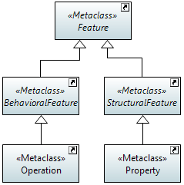

Figure 5.1: Structural/Behavioral Features in UML 2.5 Metamodel

The decoupling of attributes and operations allows a model designer to provide individual operations (specific parameter lists) for different views/managers.

## Classes

### Description

Classes are used to convey a structural (often called static)[1] representation of an entity, including properties and attributes; i.e., data model, the structural part of the model.

### Class Notation

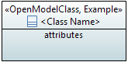

Figure 5.2: Graphical Notation for Classes

As highlighted in Figure 5.2, a class is represented with a name compartment and an attributes compartment. It is recommended that the name compartment contains also the assigned lifecycle stereotypes. The attributes compartment can be set in a diagram to not expose the attributes or to expose some or all of the attributes.

In some diagrams the attributes are hidden to reduce clutter, in others only a subset of the attributes is exposed to focus attention on those attributes. It is also possible to hide the attribute compartment of a class in the class diagrams where a large number of classes need to be shown, as depicted in Figure 5.3.



Figure 5.3: Graphical Notation for Classes without Attributes Compartment

It is recommended that the name compartment also show stereotypes for the class where relevant. When showing stereotypes, the compartment may include the stereotype «OpenModelClass» (as all classes in the model have this stereotype by default) and may also include other stereotypes.

In the general UML definition, a class may have name, attribute and operation compartments, as shown in Figure 5.4, but since the structural part and the behavioral part of the model are decoupled, the operation compartment, is not used and always hidden.

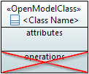

Figure 5.4: Graphical Notation for Classes with Attributes and Deprecated Operations Compartment

### Class Properties

A class  has the following properties:

* Name  
  Follows Upper Camel Case style (UCC). Each class in the model has a unique name. An example of Upper Camel Case: SubNetworkConnection.
* Documentation  
  Contains a short definition. The documentation is carried in the “Applied comments” field in Papyrus; i.e., the “Owned comments” field shall not be used. The complete documentation should be written in a single comment; i.e., at most one “Applied comment”.  
    
  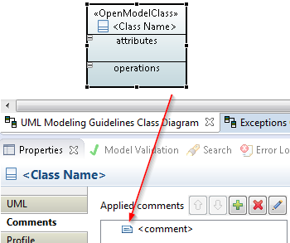[2]
* Superclass(es)  
  Inheritance and multiple inheritance may be used to deal with shared properties.
* Abstract  
  Indicates if the object class can be instantiated or is just used for inheritance; i.e., abstract classes will not be instantiated.
* Is Leaf  
  Indicates that the object class must not be extended (Is Leaf = true); default = false.
* Additional properties are defined in the «OpenModelClass» stereotype which extends  
  () by default (required) the «metaclass» Class:

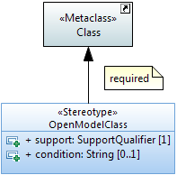

Figure 5.5: «OpenModelClass» Stereotype

* support  
  This property qualifies the support of the class class at the management interface. See definition in clause 5.10.
* condition  
  This property contains the condition for the condition-related support qualifiers.
* Obsolete  
  Additional interface related properties (only relevant in the purpose-specific models of the information model; see Figure 4.1) are defined in the «OpenInterfaceModelClass» stereotype which extends  
  () by default (required) the «metaclass» Class:

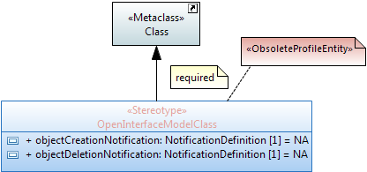

Figure 5.6: «OpenInterfaceModelClass» Stereotype (obsolete)

* objectCreationNotification  
  Defines whether an object creation notification has to be sent when the instance is created.
* objectDeletionNotification  
  Defines whether an object deletion notification has to be sent when the instance is deleted.
* Other properties:
* Choice (obsolete)  
  This optional stereotype identifies a class as a choice between different alternatives.

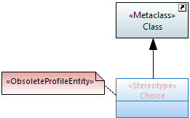

Figure 5.7: Potential Choice Annotation for Classes (obsolete)

* RootElement  
  This optional stereotype is only relevant in interface related (purpose-specific) models and identifies the associated object class as the root element when mapped to a tree structured data model.  
  The name property specifies the name for the root instance.  
  The multiplicity property defines the constraint of the number of root elements in the data model. The format is similar to the UML multiplicity; i.e., <lower bound>..<upper bound>. E.g., "0..*", "2..3", "1..*".  
  The optional description property will be mapped e.g., in YANG to the presence statement.

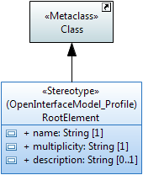

Figure 5.8: Optional RootElement Annotation for Classes

The following UML defined class properties are not used:

* Is active (default = false)
* Visibility (default = public)

## Attributes in Classes

### Description

Attributes contain the properties[3] of a class. Note that the roles of navigable association ends become an attribute in the class at the other associated end when this association end is owned by the classifier; see also “Role Type” property in clause 5.4.3.  
Note: The association end can also be owned by the association itself in which case it does not become an attribute.

### Attribute Notation

The notation is:

|«<list of stereotypes>»| <visibility> <attribute name> : <attribute type> [<multiplicity>] = <default value>

Note: When no default is relevant or no default is defined, the “=” is not shown.

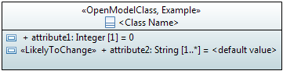

Figure 5.9: Graphical Notation for Classes with Attributes

Note: It is recommended to display either no attributes or all attributes of the object classes in given class diagram.  
It is also permissible to display only a subset of the attributes (e.g., to allow the drawing of a class diagram displaying only the required attributes of a specific feature) BUT in this case, it is recommended to warn the reader of such a class diagram by an appropriate note.

### Attribute Properties

An attribute has the following properties:

* Name  
  Follows Lower Camel Case (LCC) style and is unique across all attribute names within the inheritance tree. An example of Lower Camel Case: subNetworkConnectionIdentifier.  
  It is recommended that all Boolean typed attribute names start with ‘is’ (e.g., ‘isAbstract’), ‘must’ or a verb such as ‘has’ and the whole attribute name shall be composed in a way that it is possible to answer it by "true" or "false".
* Documentation  
  Contains a short definition. The documentation is carried in the “Applied comments” field in Papyrus; i.e., the “Owned comments” field shall not be used. The complete documentation should be written in a single comment; i.e., at most one “Applied comment”.
* Ordered  
  For a multi-valued multiplicity; this specifies whether the values in an instantiation of this attribute are sequentially ordered; default is false.
* Unique  
  For a multi-valued multiplicity, this specifies if the values of this attribute instance are unique (i.e., no duplicate attribute values); default is true.  
    
  *Excerpt from [3]: When Unique is true (the default), the collection of values may not contain duplicates. When Ordered is true (false being the default) the collection of values is ordered. In combination these two allow the type of a property to represent a collection in the following way:*

Table 5.1: Table 11.1/[3] – Collection Types for Properties

|  |  |  |
| --- | --- | --- |
| **Ordered** | **Unique** | **Collection type** |
| false | true | Set |
| true | true | OrderedSet |
| false | false | Bag |
| true | false | Sequence |

* Is Leaf  
  Indicates if the attribute definition is either fully consolidated (Is Leaf = true) or is not fully consolidated / cannot be consolidated (Is Leaf = false). E.g., in case of an Enumeration typed attribute, because the associated set of Literals is known to be open (or has to be left open) for future yet not known or not consolidated extensions.  
  Default = false.
* Type  
  Refers to a data type; see clause 5.9.
* Default Value  
  Provides the value that the attribute has to start with in case the value is not provided during creation, or already defined because of a system state.
* Multiplicity (*, 1, 1..*, 0..1, …)  
  Defines the number of values the attribute can simultaneously have.  
   * is a list attribute with 0, one or multiple values;  
   1 attribute has always one value;  
   1..* is a list attribute with at least one value;  
   0..1 attribute may have no or at most one value;  
  Default value is 1.  
  Other values are possible; e.g., “2..17”.
* Additional properties are defined in the «OpenModelAttribute» stereotype which extends  
  () by default (required) the «metaclass» Property:

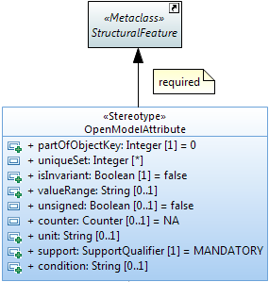

Figure 5.10: «OpenModelAttribute» Stereotype

* partOfObjectKey  
  This property indicates if the attribute is part of the object key or not.  
  Value = 0 (default) means the attribute is not part of the object key.  
  Values > 0 indicate that the attribute is part of the object key and the value defines the order of the attribute in case the key is composed of more than one attribute.  
  Attributes which are used as a key shall be invariant (i.e., property isInvariant = true), shall not be optional (i.e., the multiplicity shall be [1] or [1..x]) and the multiplicity shall be [1] after the Pruning&Refactoring process; i.e., a UML to Data Schema mapping tool shall not get a list attribute which is part of the object identifier.
* uniqueSet  
  This property defines if the attribute is part of a set of attributes which together (i.e., their values) have to be unique among all instances within a defined context.  
  No value means no uniqueness constraint.  
  An integer value identifies the uniqueness set.  
  An attribute may participate in more than one uniqueness sets.

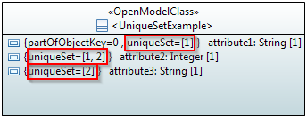

Figure 5.11: uniqueSet usage example

* isInvariant  
  This property identifies if the value of the attribute can be changed after it has been created; see also section 5.3.4.
* valueRange  
  This property identifies the allowed values for the attribute.
* unsigned  
  This optional property indicates if the attribute type is unsigned (value = true) or signed (value = false); if applicable, otherwise ignored.
* counter  
  This optional property defines the counter type of the attribute type; if applicable.
* unit  
  This optional property contains a textual definition of the unit associated with the attribute value.  
  The spelling of the unit, including the ones beyond SI scope, shall be in accordance to the NIST Publication 811 “Guide for the Use of the International System of Units (SI)” (http://www.nist.gov/pml/pubs/sp811/index.cfm), clause 9 “Rules and Style Conventions for Spelling Unit Names” as modified by the ISO/IEC 80000 series documents (<https://www.iso.org/committee/46202.html>).
* support  
  This property qualifies the support of the attribute at the management interface. See definition in clause 5.10
* condition  
  This property contains the condition for the condition-related support qualifiers.
* Additional interface related properties (only relevant in the purpose-specific models of the information model; see Figure 4.1) are defined in the «OpenInterfaceModelAttribute» stereotype which extends  
  () by default (required) the «metaclass» Property:

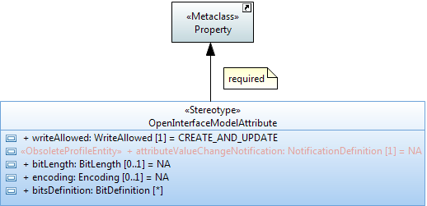

Figure 5.12: «OpenInterfaceModelAttribute» Stereotype

* writeAllowed  
  This property defines when the CLIENT is allowed to set the attribute value; see also section 5.3.4.
* attributeValueChangeNotification (obsolete)  
  This property defines whether a notification has to be raised when the attribute changes its value or not.
* bitLength  
  This optional property defines the bit length of the attribute type; if applicable.
* encoding  
  This optional property defines the encoding of the attribute type; if applicable.
* bitsDefinition (preliminary solution 1)  
  This optional property defines the bits (flags) of a Bits typed attribute. Each bit is further defined by its name, position, support and an optional description. The default setting of each bit is defined in the default value of the Bits typed attribute; i.e., all bits contained in the default value are set to “1”.

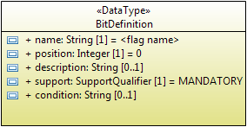

Figure 5.13: Bit Definition Properties

* Other properties:
* «PassedByReference»  
  This stereotype shall only be applied to attributes that have a class defined as their type; i.e., association member ends owned by the class which became attributes. The stereotype is applied on a case by case basis.  
  The property defines that the attribute contains only the reference (name, identifier, address) of the referred instance(s) when being transferred across the interface.  
  Otherwise the attribute contains the complete information of the instance(s) when being transferred across the interface.
* «Bit» (preliminary solution2)  
  This optional stereotype defines the position of a bit typed attribute in a «Bits» annotated data type.

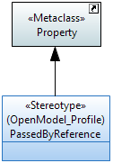 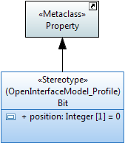

Figure 5.14: Potential Annotations for Attributes

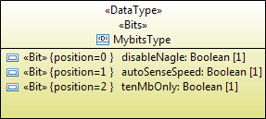

Figure 5.15: Example Modeling of a Bit Set Data Type

The following UML defined attribute properties are not used:

* Is read only (default value = false)
* Is derived (default = false)
* Is derived union (default = false)
* Is static (default = false)
* Visibility (default = public)

### Attribute Setability

UML model designers need to be able to define the “setability” of attribute values. Standard UML provides a Boolean property called “readOnly”. Since this is not enough to describe all required cases “readOnly” is not used and two additional properties isInvariant and writeAllowed are defined.

From information model point of view (context) an attribute value can be set by two different actors (a) directly by the client or (b) from elsewhere.



Figure 5.16: Actors setting the Attribute Value

Legend:

* Red arrow  
  Setting of attribute is initiated directly by the client; i.e., setAttribute().
* Blue arrow  
  Setting of the attribute value has not been initiated directly by the client; i.e., is set from elsewhere (e.g., indirectly by the client, other clients, server, underlying system).

Client, Server and Underlying System in the figure are at one level of recursion. There may be many other levels below the Underlying System or above the Client.

One extreme example is the entire operator’s business represented by the Server. Another extreme example is when the Server represents a thin mediator on top of the traffic functions (Underlying System).

The isInvariant property identifies (system wide) if the value of the attribute can be changed after it has been created (isInvariant = false) or not (isInvariant = true).

The writeAllowed property defines (from the client point of view only) when the client is directly allowed to set the attribute value. This can be {only during creation | only after creation | during and after creation | at no time}; all values are mutually exclusive.

The properties isInvariant and writeAllowed are related. The following table shows the allowed combinations and their meaning:

Table 5.2: Allowed combinations of isInvariant and writeAllowed

|  |  |  |  |
| --- | --- | --- | --- |
| **#** | **isInvariant (system wide)** | **writeAllowed (client view)** | **meaning** |
| 1. | false | WRITE_NOT_ALLOWED | e.g., operationalState |
| 2. | false | UPDATE_ONLY | initial value provided by the system |
| 3. | false | CREATE_ONLY | e.g., ODUflex with HAO |
| 4. | false | CREATE_AND_UPDATE | unrestricted read/write |
| 5. | true | WRITE_NOT_ALLOWED | e.g., identifier provided by the system |
| 6. | ~~true~~ | ~~UPDATE_ONLY~~ | Not allowed If isInvariant=true 🡪 set after creatin not possible |
| 7. | true | CREATE_ONLY | e.g., fixed size ODU, identifier provided by the client |
| 8. | ~~true~~ | ~~CREATE_AND_UPDATE~~ | Not allowed If isInvariant=true 🡪 set after creatin not possible |

## Relationships

### Description

Relationships are defined between classes. Their relationship ends specify the role that the class at that end performs.

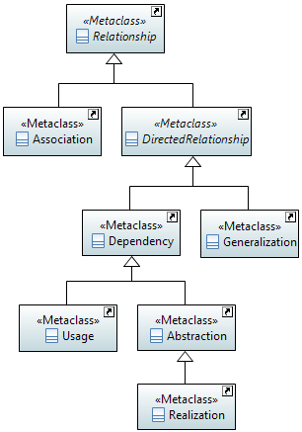

Figure 5.17: Metaclass Diagram of used Relationships

### Relationship Notation

The following examples show the different kinds of relationships that are used in the model.

#### Association Notation

Figure 5.18 shows a bi-directional navigable association where each class has a pointer to the other. The association end role name becomes the name of the corresponding attribute. I.e., in the example: ClassA will have an attribute named “_classB” pointing to ClassB and vice versa.

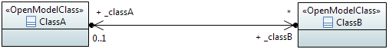



Figure 5.18: Bidirectional Association Relationship Notations

Both ways of displaying navigable association end role names are allowed in class diagrams; i.e., as role names (top of Figure 5.18) and as attributes (bottom of Figure 5.18).  
It is not recommended to use both ways in a single class diagram since it provides redundant information.

Figure 5.19 shows a unidirectional association (shown with an open arrow at the target class) where only the source class has a pointer to the target class and not vice-versa.

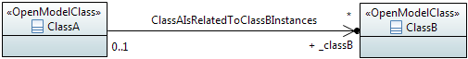

Figure 5.19: Unidirectional Association Relationship Notation

Figure 5.20 shows a non-navigable association where none of the classes have a pointer to the other; i.e., such associations are just for illustration purposes. Non-navigable associations should have a name.

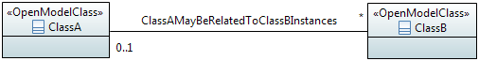

Figure 5.20: – Non-navigable Association Relationship Notation

A **reference pointer** is a navigable association to a class. Such a class may be instantiated in more than one naming path/tree. In order to identify the specific naming path/tree for a reference pointer a “REFERENCE_DEPENDENCY” constraint is added (context is the reference pointer). This constraint relates the reference pointer to an individual «StrictComposite» composition aggregation association.

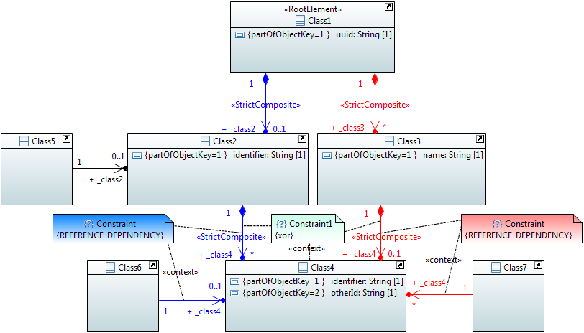

Figure 5.21: – Reference Pointer to Classes with more than one Composition Aggregation Association Relationship Notation

A shared **aggregation** is a special type of association in which objects are assembled or configured together to create a more complex object. Aggregation protects the integrity of an assembly of objects by defining a single point of coordination called aggregate, in the object that represents the assembly.

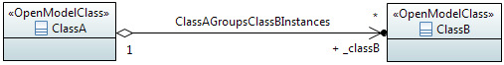

Figure 5.22: Aggregation Association Relationship Notation

A **«LifecycleAggregate»** aggregation is a shared aggregation which indicates a lifecycle dependency between a grouping instance and its shared part instances; similar to the lifecycle dependency of a composite aggregation.

This option is intended to be used **only** when the shared part object class has another stronger lifecycle dependency (such as composition).

The multiplicity at the grouping side of the «LifecycleAggregate» relationship defines the mode: single = exclusive mode, one or more = shared mode.  
In *exclusive mode*, a shared part object instance must not be aggregated by more than one grouping instance via a **«**LifecycleAggregate» relationship.  
In *shared mode*, a shared part object instance can be aggregated by more than one grouping instance via a **«**LifecycleAggregate» relationship.

A shared part instance has to have at all times a containing composite instance AND a single (in case of exclusive mode) or at least one (in case of shared mode) aggregating grouping instance.

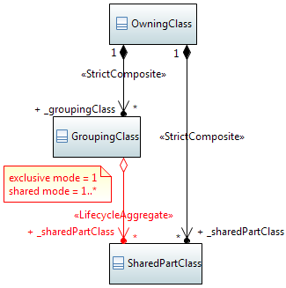

Figure 5.23: «LifecycleAggregate» Aggregation Association Relationship Notation

Note: The «LifecycleAggregate» association cannot define the operational behavior which can be seen from containing or contained class point of view. Four deletion policies can be distinguished:

1. Deletion of containing OwningClass instance deletes all contained instances
2. Deletion of containing GroupingClass instance deletes aggregated instances
3. Containing OwningClass instance must not be deleted as long as contained instances exist
4. Containing GroupingClass instance must not be deleted as long as contained instances exist

See also usage example in section 7.7.

A **composite** aggregation association is a strong form of aggregation that requires a part instance be included in at most one composite at a time. If a composite is deleted, all of its parts are deleted as well; i.e., the lifecycle of all instances of ClassB related to an instance classA is tied to the lifecycle of the classA instance. It is possible for the part instance to move from one parent instance to another.

Note: In the example below, ClassA also names ClassB instances; defined by the «Names» stereotype.



Figure 5.24: Composite Aggregation Association Relationship Notation

A **«StrictComposite»** aggregation association is a composite aggregation where it is NOT possible for the part instance to move from one parent instance to another (as is allowed in regular compositions).

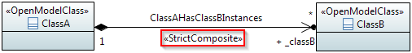

Figure 5.25: «StrictComposite» Aggregation Association Relationship Notation

An **«ExtendedComposite»** aggregation is a more restrictive form of a «StrictComposite» aggregation where the extending classes will never be explicitly instantiated (i.e., are abstract), but that the attributes defined by the extending class will be transferred to the class being extended at runtime, much like the UML Generalization relationship. In other words, the extending classes are essentially carrying attributes of the extended class in a grouping-pack. The extending class has a multiplicity of 0..1.

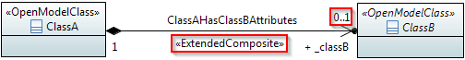

Figure 5.26: «ExtendedComposite» Aggregation Association Relationship Notation

Association classes are not used.

#### Generalization Notation

A generalization indicates a relationship in which one class (the child) inherits from another class (the parent). A generalization relationship may be conditional, identified by the «Cond» stereotype.

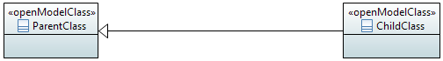  
  
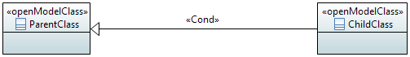  
  
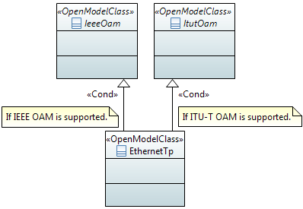

Figure 5.27: Generalization Relationship Notation (normal, conditional and example)

#### Dependency Notation

“*A dependency is a relationship that signifies that a single or a set of model elements requires other model elements for their specification or implementation. This means that the complete semantics of the depending elements is either semantically or structurally dependent on the definition of the supplier element(s)...*“, an extract from [2].  
A dependency relationship may define naming identified by the «NamedBy» stereotype.

  
  


Figure 5.28: Dependency Relationship Notation (normal and naming)

The **usage** dependency relationship along with the relationship name indicates the dependency between an Interface and the object class the Interface is working on.

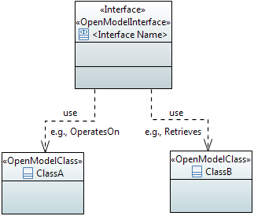

Figure 5.29: Usage Dependency Notation

The **abstraction** dependency relationship can be annotated by the «Specify» stereotype to indicate that the definition of the more abstract entity class in the abstraction relationship is augmented by the "specification" class definition at runtime. See also the definition in section 5.4.3 below.

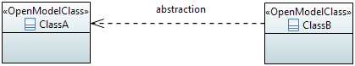  
  
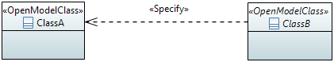

Figure 5.30: Abstraction Dependency Notation

«Specify» annotated abstraction relationships must be started from abstract classes.

It is also possible to condition the «Specify» abstraction relationship based on attribute values. The conditioning attribute and its value(s) is defined in a {constraint} attached to the «Specify» relationship. It has to be set at creation time and needs to be invariant. The condition could also be a list of attributes (e.g., attribute1 + attribute2) and need not be in the object class to be specified.

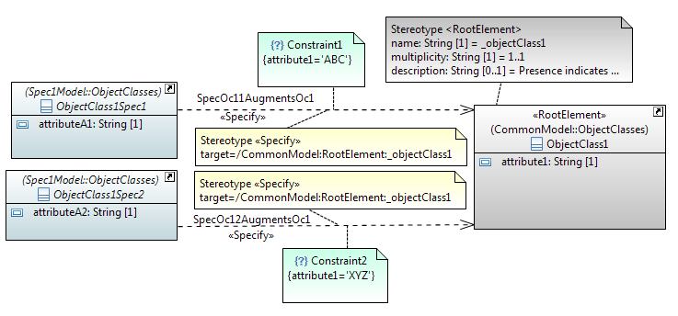

Figure 5.31: Conditional «Specify» Abstraction Relationship Example

The **realization** dependency relationship indicates the relationship between a base class and it’s realizing class.

The **realization** dependency relationship along with the «PruneAndRefactor» stereotype indicates the relationship between a Base Model class/relationship and the cloned/pruned/refactored Purpose Specific Model class/relationship.

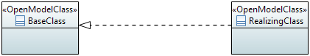

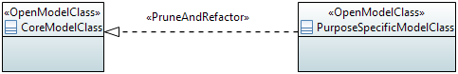

Figure 5.32: Realization Dependency Notation

### Relationship Properties

A relationship has the following properties:

* Name  
  Follows Upper Camel Case (UCC) style and is unique across all relationship names defined in the whole model.  
  The format for associations is "<Class1Name><VerbPhrase><Class2Name>" where the verb phrase creates a sequence that is readable and meaningful. In case of a long class name, it is also allowed to use a short form of the name.
* Documentation  
  Contains a short definition. The documentation is carried in the “Applied comments” field in Papyrus; i.e., the “Owned comments” field shall not be used. The complete documentation should be written in a single comment; i.e., at most one “Applied comment”.
* Abstract (only association)  
  Associations which are just for explanation to the reader of the model are defined as "abstract" (Note: In Papyrus, the abstract property is defined in the Advanced tab of the Properties view). Their ends are not navigable and have no role names. Abstract associations shall not be taken into account in a protocol specific implementation.
* Type  
  The following types are used:
* simple association,
* composition association,
* aggregation association,
* generalization,
* dependency,
* usage dependency,
* abstraction dependency,
* realization dependency.
* Role Name (only associations)  
  Follows Lower Camel Case (LCC) style with an underscore “_” prefix and identifies the role that the object plays at this end (Member End) of the association.  
  Only navigable Member Ends have role names and follow the definitions made for attributes in clause 5.3.
* Role Type (only association)  
  The type of the role is fixed to the class attached to the association end. Therefore, it is important to define the type as “passed by reference” or “passed by value”. Pointer and shared aggregation associations are per default passed by reference (i.e., contain only the reference (name, identifier, address) to the referred instance(s) when being transferred across the interface). The composition aggregation, «StrictComposite» and «ExtendedComposite» associations are always passed by value (i.e., contain the complete information of the instance(s) when being transferred across the interface).

Note: The Owner of a navigable Member End has to be the Classifier to become an attribute in the class.

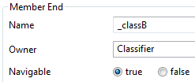

Figure 5.33: Owner of a navigable Member End

* Role Multiplicity (only association)  
  Identifies the number of class instances that can participate in an instance of the association.
* Additional optional properties:
* «Names» (only association)  
  The «Names» stereotype identifies that the association is used to define the naming.
* «NamedBy» (only dependency)  
  The «NamedBy» stereotype identifies that a dependency relationship is used to define naming.
* «Cond» (all relationships)  
  The «Cond» stereotype identifies that the relationship is conditional. The condition is also provided.
* «StrictComposite» (only association)  
  The «StrictComposite» stereotype can only be applied to associations with a composite end (i.e., composite aggregation association). It means that the content of the “parts” classes is part of the “composed” parent class and has no opportunity for independent lifecycle. In this case although an instance of the "parts" classes can be created and deleted anytime, it has to be in the context of the "composed" parent class. In other words, the parent class instance has to exist and it is NOT possible for the "part" instance to move from one parent instance to another (allowed in regular composition).  
  Whereas in an association with a composite end that is not «StrictComposite» the composed class is a part that has a restricted independent lifecycle. In this case an instance of the composed class can be created and deleted in the context of the parent class and should be represented as a separate instance from the parent in an implementation. This is especially true where there is a recursive composition. It is possible that in some cases the composed instance could move from one parent to another so long as it exists with one parent only at all points of the transaction. This move is not meaningful for a class associated via a «StrictComposite» association.
* «ExtendedComposite» (only association)  
  The «ExtendedComposite» stereotype indicates a more restrictive form of "StrictComposite" where the "extending" classes will never be explicitly instantiated, but that the attributes defined by the “extending” class will be transferred to the class being “extended” at runtime, much like the UML “Generalization” relationship (with the difference, that in the «ExtendedComposite» case the “extended” class is instantiated and in the “Generalization” case the subclass is instantiated). In other words, the "extending” classes are strictly composed, they are essentially carrying attributes of the “extended” class in a grouping-pack and often referred to as "_Pacs".
* «LifecycleAggregate» (only shared aggregation association)  
  A «LifecycleAggregate» aggregation is a shared aggregation which indicates a lifecycle dependency between a grouping instance and its shared part instances; similar to the lifecycle dependency of a composite aggregation.  
  The «LifecycleAggregate» aggregation can only be used jointly with another stronger lifecycle dependency (such as composition) to the same part instance; i.e., must not be used alone.
* «PruneAndRefactor» (only realization)  
  The «PruneAndRefactor»stereotype identifies that a realization association is used to identify pruning and refactoring.
* «Specify» (only abstraction)  
  The «Specify» stereotype is applied on the UML “Abstraction” relationship to indicate that the definition of the more abstract entity class in the abstraction relationship is augmented by the "specification" class definition at runtime. Furthermore, there is a potential for an entity class definition to be augmented by more than one "specification" class definitions. In other words, one of the specification classes adds-to and expands the runtime-definition of the entity class. This also implies that the entity class cannot be aware of the existence of specification classes at design time. Since the “Specify” relationship is defined to support runtime code/schema generation and dependency injection, a stereotype-property “target” is defined to point to the actual node being augmented within the object/instance schema. The "target" value should be in the following format:  
  [/<ModelName>:<ClassName>]+:<AttributeName>.  
  Example: TopologyContext in TapiTopology augments Context in TapiCommon  
  target=/TapiCommon:Context:_context  
  Example: NodeEdgePointLpSpec in TapiOdu specifies LayerProtocol definition for NodeEdgePoint in TapiTopology  
  target=/TapiTopology:TopologyContext/TapiTopology:Topology/TapiTopology:Node/Tapi:Topology:NodeEdgePoint/_layerProtocol.

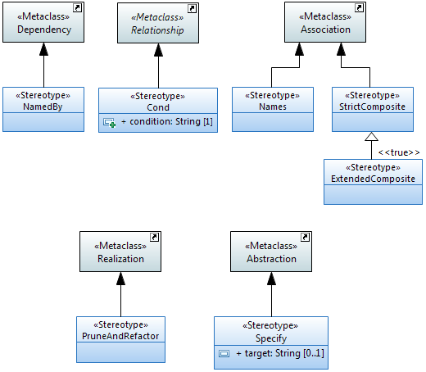

Figure 5.34: Potential Annotations for Associations

The following UML defined role/attribute properties are not used:

* Visibility (default = public)

## Interfaces

### Description

An «Interface» is used to group operations, i.e., models the dynamic part of the model. Groupings of operations can be used to modularize the functionalities of the specification.

Note: Interfaces (and operations) may only be defined in the purpose-specific models of the information model; see Figure 4.1.

### «Interface» Notation

Interfaces are identified by the stereotype «Interface».

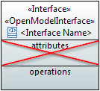

Figure 5.35: Graphical Notation for «Interface»

«Interfaces» usually have name, attributes and operations compartments. The structural part and the behavioral part of the model are decoupled. Therefore, the attributes compartment is not used and always empty. It is also possible to hide the attributes compartment in the interface diagrams.

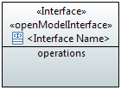

Figure 5.36: Graphical Notation for «Interface» without Attributes Compartment

Note: The graphical notation of an «Interface» may show an empty operation compartment so as to reduce clutter even if the «Interface» has operations.

### «Interface» Properties

An «Interface»  has the following properties:

* Name  
  Follows Upper Camel Case (UCC) style and is unique across all «Interface» names in the model.
* Documentation  
  Contains a short definition. The documentation is carried in the “Applied comments” field in Papyrus; i.e., the “Owned comments” field shall not be used. The complete documentation should be written in a single comment; i.e., at most one “Applied comment”.
* Superinterface(s)  
  Inheritance and multiple inheritance may be used.
* Abstract  
  Indicates if the «Interface» can be instantiated or is just used for inheritance.
* Additional properties are defined in the «OpenModelInterface» stereotype which extends  
  () by default (required) the «metaclass» Interface:

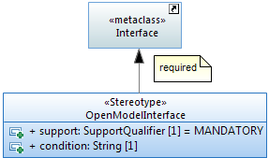

Figure 5.37: «OpenModelInterface» Stereotype

* support  
  This property qualifies the support of the «Interface» at the management interface. See definition in clause 5.10.
* condition  
  This property contains the condition for the condition-related support qualifiers.

The following UML defined interface properties are not used:

* Is leaf (default = false)
* Visibility (default = public)

## Interface Operations

### Description

Operations  can be defined within an «Interface». An «Interface» shall have at least one operation.

Note: Operations may only be defined in the purpose-specific models of the information model; see Figure 4.1.

### Operation Notation

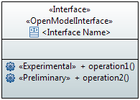

Figure 5.38: Graphical Notation for «Interface» with Operations

### Operation Properties

An operation has the following properties:

* Name  
  Follows Lower Camel Case (LCC) style and is unique across all operation names defined in the whole model.
* Documentation  
  Contains a short definition. The documentation is carried in the “Applied comments” field in Papyrus; i.e., the “Owned comments” field shall not be used. The complete documentation should be written in a single comment; i.e., at most one “Applied comment”.
* Pre-condition(s)  
  This property defines the conditions that have to be true before the operation can be started (i.e., if not true, the operation will not be started at all and a general “precondition not met” error will be returned, i.e., exception is raised).
* Post-condition(s)  
  This property defines the state of the system after the operation has been executed (if successful, or if not successful, or if partially successful).  
  Note that partially successful post-condition(s) can only be defined in case of non-atomic operations.  
  Note that when an exception is raised, it should not be assumed that the post-condition(s) are satisfied.
* Parameter(s)  
  See clause 5.7.
* Operation Exceptions  
  Lists the allowed exceptions for the operation.  
  The model uses predefined exceptions which are split in 2 types:  
  - generic exceptions which are associated to all operations by default  
  - common exceptions which needs to be explicitly associated to the operation.  
    
  Note: These exceptions are only relevant for a protocol neutral information model. Further exceptions may be necessary for a protocol specific information model.

Generic exceptions:

* Internal Error: The server has an internal error.
* Unable to Comply: The server cannot perform the operation. Use Cases may identify specific conditions that will result in this exception.
* Comm Loss: The server is unable to communicate with an underlying system or resource, and such communication is required to complete the operation.
* Invalid Input: The operation contains an input parameter that is syntactically incorrect or identifies an object of the wrong type or is out of range (as defined in the model or because of server limitation).
* Not Implemented: The entire operation is not supported by the server or the operation with the specified input parameters is not supported.
* Access Denied: The client does not have access rights to request the given operation.

Common exceptions:

* Entity Not Found: Is thrown to indicate that at least one of the specified entities does not exist.
* Object In Use: The object identified in the operation is currently in use.
* Capacity Exceeded: The operation will result in resources being created or activated beyond the capacity supported by the server.
* Not In Valid State: The state of the specified object is such that the server cannot perform the operation. In other words, the environment or the application is not in an appropriate state for the requested operation.
* Duplicate: Is thrown if an entity cannot be created because an object with the same identifier/name already exists.
* Additional properties are defined in the «OpenModelOperation» stereotype which extends  
  () by default (required) the «metaclass» Operation:

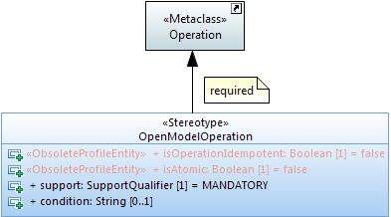

Figure 5.39: «OpenModelOperation» Stereotype

* isOperationIdempotent (Boolean) (obsolete)  
  This property defines if the operation is idempotent (true) or not (false).  
  Example: When an operation is going to create an instance which does already exist, an idempotent operation would return success and a non-idempotent operation would return an exception.
* isAtomic (Boolean) (obsolete)  
  This property identifies if the operation is best effort or is successful / not successful as a whole.
* support  
  This property qualifies the support of the operation at the management interface. See definition in clause 5.10.
* condition  
  This property contains the condition for the condition-related support qualifiers.

The following UML defined operation properties are not used:

* Is leaf (default = false)
* Is query (default = false)
* Is static (default = false)

## Operation Parameters

### Description

Parameters define the input and output signals of an operation.

Note: Operations and their parameters may only be defined in the purpose-specific models of the information model; see Figure 4.1.

### Parameter Notation

The notation is:

<visibility> <direction> <parameter name> : <parameter type> [<multiplicity>] = <default value>

Note: When no default is relevant or no default is defined, the “=” is not shown

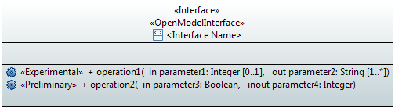

Figure 5.40: Graphical Notation for «Interface» with Operations and Parameters

### Parameter Properties

A parameter has the following properties:

* Name  
  Follows Lower Camel Case (LCC) style
* Documentation  
  Contains a short definition. The documentation is carried in the “Applied comments” field in Papyrus; i.e., the “Owned comments” field shall not be used. The complete documentation should be written in a single comment; i.e., at most one “Applied comment”.
* Direction  
  Parameters can be defined as:  
  - input parameters  
  - output parameters  
  - in out parameters
* Type  
  Refers to a data type.  
  Note that a list of parameters can also be combined in a complex data type.
* Default Value  
  Defines the value that the parameter has in case the value is not provided. If it is mandatory to provide a value, the default value is set to NA.
* Is Ordered  
  Defines for a multi-valued parameter that the order of the values is significant.
* Multiplicity  
  Defines the number of values the parameter can simultaneously have.
* Additional properties are defined in the «OpenModelParameter» stereotype which extends  
  () by default ({required}) the «metaclass» Parameter:

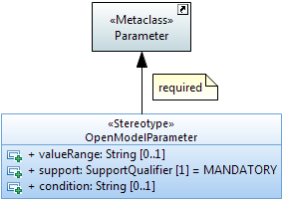

Figure 5.41: «OpenModelParameter» Stereotype

* valueRange  
  Identifies the allowed values for the parameter.
* support  
  This property qualifies the support of the parameter at the management interface. See definition in clause 5.10.
* condition  
  This property contains the condition for the condition-related support qualifiers.
* Other properties:
* PassedByReference  
  This property is only relevant in interface related (purpose-specific) models and shall only be applied to parameters that have an object class defined as their type; i.e., on a case by case basis.  
  The property defines if the attribute contains only the reference (name, identifier, address) to the referred instance(s) when being transferred across the interface.  
  Otherwise the parameter contains the complete information of the instance(s) when being transferred across the interface.

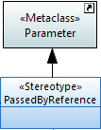

Figure 5.42: «PassedByReference» Stereotype

The following UML defined parameter properties are not used:

* Is exception (default = false)
* Is stream (default = false)
* Is unique (default = true)
* Visibility (default = public)

## Notifications

### Description

Note: Notifications may only be defined in the purpose-specific models of the information model; see Figure 4.1.

The UML «Signal» artifact is used to define the content of a notification. The information is defined in the attributes of the «Signal».

### Notification Notation

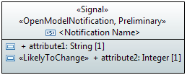

Figure 5.43: Graphical Notation for «Signal»

### Notification Properties

A notification/signal  has the following properties:

* Name  
  Follows Upper Camel Case (UCC) style. Each notification/signal in the model has a unique name. An example of Upper Camel Case: ObjectCreationNotification.
* Documentation  
  Contains a short definition. The documentation is carried in the “Applied comments” field in Papyrus; i.e., the “Owned comments” field shall not be used. The complete documentation should be written in a single comment; i.e., at most one “Applied comment”.
* Superclass(es)  
  Inheritance and multiple inheritance may be used to deal with shared properties.
* Abstract  
  Indicates if the notification/signal can be instantiated or is just used for inheritance.
* Additional properties are defined in the «OpenModelNotification» stereotype which extends () by default (required) the «metaclass» Signal:

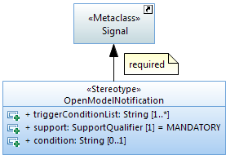

Figure 5.44: «OpenModelNotification» Stereotype

* triggerConditionList  
  This property contains the triggering conditions that cause the notification. Create one element in the trigger condition list per trigger as shown on the figure below:

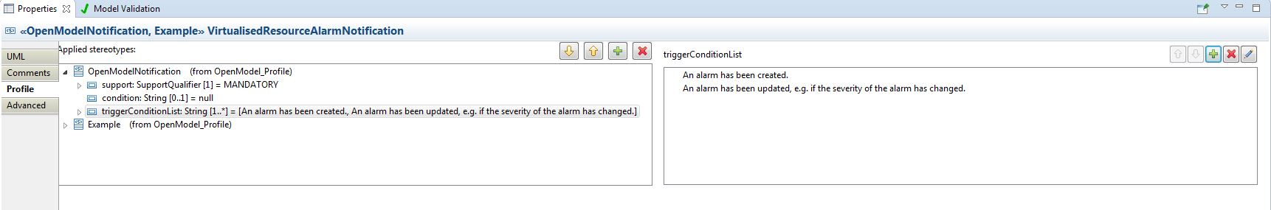

Figure 5.45: Notification Trigger Condition List

Use the green + button to create a new element in the list:

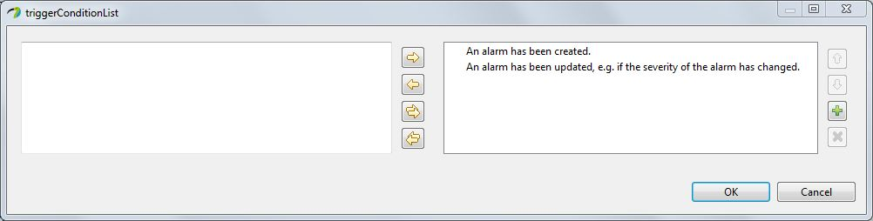

Figure 5.46: Trigger Condition List Pop-up

* support  
  This property qualifies the support of the notification/signal at the management interface. See definition in clause 5.10.
* condition  
  This property contains the condition for the condition-related support qualifiers.

The following UML defined class properties are not used:

* Is leaf (default = false)
* Visibility (default = public)

## Data Types

### Description

Data Types are used as type definitions of attributes and parameters.

Data Types are divided into 3 categories:

* (Complex) Data Types (further structured; e.g., Host which combines ipAddress and domainName)
* Primitive Types (not further structured; e.g., Integer, MAC address).
* Enumerations

### Type Notation

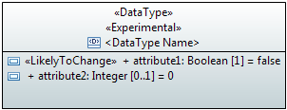

Figure 5.47: Graphical Notation for «DataType»

Note: Default values may not be shown in all class diagrams.

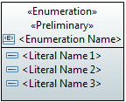

Figure 5.48: Graphical Notation for «Enumeration»



Figure 5.49: Graphical Notation for «PrimitiveType»

### Type Properties

A type has the following properties:

* Category  
  Three categories are used in the model:  
  - dataType  
  - enumeration  
  - primitive
* Name  
  Follows Upper Camel Case (UCC) style and is unique across all data type names defined in the whole model.
* Documentation  
  Contains a short definition. The documentation is carried in the “Applied comments” field in Papyrus; i.e., the “Owned comments” field shall not be used. The complete documentation should be written in a single comment; i.e., at most one “Applied comment”.
* Specific Data Type attribute properties (only relevant for Data Types)  
  Follow the definitions made for attributes in clause 5.3 with the following exceptions:  
  - the isInvariant property can be ignored and is fixed to "true"  
  - the notification property can be ignored and is fixed to "NA".
* Specific Enumeration properties (only relevant for Enumerations)  
  The literal name contains only upper case characters where the words are separated by "_".  
  It is possible to add an integer value to each literal.

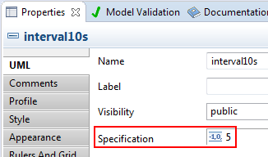

Figure 5.50: Defining an Integer Value for a Literal

The property “isLeaf” is used to define if the list of literals is fixed or is open for enhancement in future releases. isLeaf = true 🡪 fixed literal list; isLeaf = false 🡪 literal list may be enhanced.

* Additional properties
* «Choice» (obsolete)  
  This stereotype identifies a data type as a choice between different alternatives; see also clause 7.5.
* «Exception»  
  This stereotype defines a data type used for an operation exception.
* «Bits» (preliminary solution 2)  
  This optional stereotype defines a data type used for defining a bit set. Each bit is defined as an attribute of the data type; see also Figure 5.15.

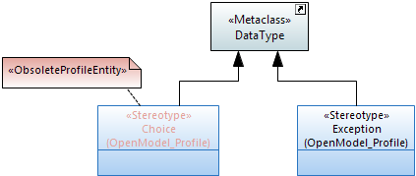 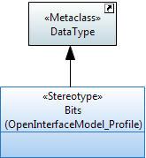

Figure 5.51: Potential Annotations for Data Types

The following UML defined attribute properties are not used:

* Is abstract (default = false)
* Is leaf (default = false)

### UML Primitive Types

Papyrus already provides the following UML primitive types:

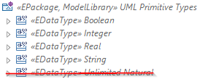

Figure 5.52: Primitive Types provided by Papyrus

Notes:  
The “Unlimited Natural” Primitive data type shall not be used.  
Papyrus also exposes the internal Eclipse eCore primitives which are not to be used in models.

The UML Primitive Types can be further restricted by the annotation of the following properties contained in the OpenModelAttribute stereotype (see definitions in clause 5.3.3):

* bitLength  
  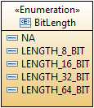
* unsigned
* encoding  
  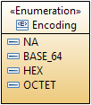
* counter  
  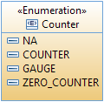

For example: «UNSIGNED, LENGTH_8_BIT» Integer or «HexEncoded» String.

Note that common floating point types ‘float’ and ‘double’ are represented using the profile as below:

* Float (single-precision, 32-bit IEEE 754 floating point): «LENGTH_32_BIT»Real
* Double (double-precision, 64-bit IEEE 754 floating point): «LENGTH_64_BIT»Real.

### Pre-defined Data Types

Additional common data types are defined in two separate model libraries which are imported to every UML model. The CoreCommonDataTypes should be used for models before pruning&refactoring and the ImplementationCommonDataTypes should be used for models after pruning&refactoring.

Note that model projects should not create their own primitive types. Requests for new primitive types should be made to the IISOMI team so they can be included in the standard Papyrus files and then available to all modeling teams.

Similar data types are grouped together to ease the search of the adequate data type by the model designer. The following groupings and containing data types are under discussion at the time of publication of these guidelines.

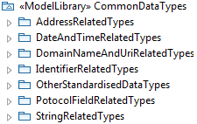

Figure 5.53: Common Data Types Grouping

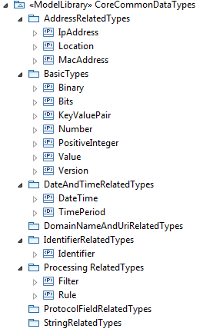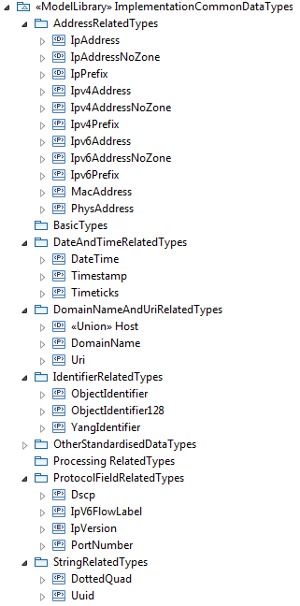

Figure 5.54: Core and Implementation Common Data Types

Address related Types

* IpAddress  
  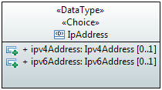
* Ipv4Address
* Ipv6Address
* IpAddressNoZone  
  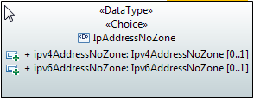
* Ipv4AddressNoZone
* Ipv6AddressNoZone
* Ipv4Prefix
* Ipv6Prefix
* IpPrefix  
  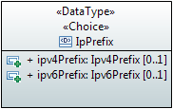
* MacAddress  
  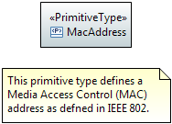

Date and Time related Types

* DateTime

Domain Name and URI related Types

* DomainName  
  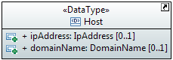
* Uri

Identifier related Types

* ObjectIdentifier
* ObjectIdentifier128

Protocol Field related Types

* Dscp
* IpVersion  
  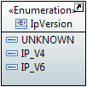
* IpV6FlowLabel
* PortNumber

String related Types

* DottedQuad
* Uuid

## Qualifiers and Conditions

This clause defines the qualifiers applicable for model elements specified in this document, e.g., the «OpenModelClass» (see clause 5.2.3), and the «OpenModelAttribute» (see clause 5.3.3). The qualifications are M, O, CM, CO and C. Their meanings are specified in this clause. This type of qualifier is called Support Qualifier.

* Definition of M (Mandatory) qualification:  
  The model element shall be supported.
* Definition of O (Optional) qualification:  
  The model element may, but needs not to, be supported.
* Definition of CM (Conditional-Mandatory) qualification:  
  The model element shall be supported under certain conditions. If the specified conditions are met then the model element shall be supported.
* Definition of CO (Conditional-Optional) qualification:  
  The model element may, but needs not to, be supported under certain conditions. If the specified conditions are met then the model element may, but needs not to, be supported. If the specified conditions are not met then the model element shall be supported.
* Definition of C (Conditional) qualification:  
  Used for model elements that have multiple constraints. Each constraint is worded as a condition for one kind of support, such as mandatory support, optional support or "no support". All constraints shall be related to the same kind of support. Specifically:  
  Each model element with C qualification shall have the corresponding multiple constraints defined in the specification. If all specified constraints are met and are related to mandatory, then the model element shall be supported. If all the specified constraints are met and are related to optional, then the model element may, but needs not to, be supported. If all the specified constraints are met and are related to "no support", then the model element shall not be supported.

The condition property contains the condition for the condition-related support qualifiers (CM, CO, C). Often different conditional UML artifacts share the same condition. It is therefore recommended to group such conditions within a model based on the supported features. The grouping is provided by the first line of the condition string which shall contain the name of the group; i.e., all condition strings of the UML artifacts which share the same condition have the same text in their first line. The second and further lines may contain an explanation of the condition.

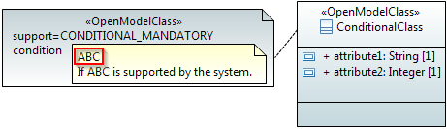

Figure 5.55: Conditional Class Example

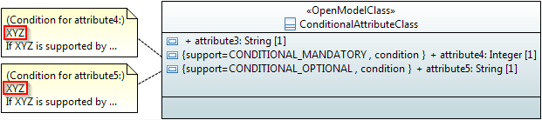

Figure 5.56: Conditional Attributes Example

## Use Cases

Use case diagrams define actors in a system and the defined behavior over a specific interface. The actor is the entity that is invoking the behavior over the interface. In the diagram below, the actor is a stick figure representing a business application that is given a “name” which shall be specified in Upper Camel Case (UCC). The use cases, or the defined behavior invoked over an interface, are defined in the “ovals” and specified in their “names” in Upper Camel Case (UCC) also. The tabular format which defines the input, output, description, etc. of a use case is only found in the Interface Profile Specification and is not present in the UML model.

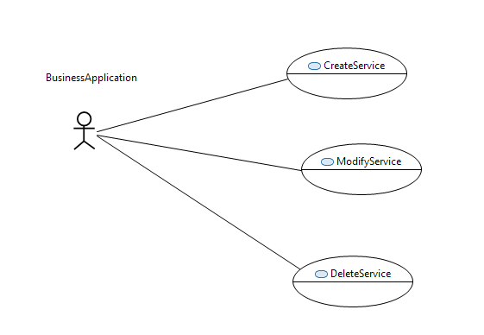

Figure 5.57: Example of Use Case Diagram

## Activities

Activities defined in UML are used for business process modeling. The primary artifacts used in modeling business processes are as follows:

* Activity Compartment Defines the boundary of the process being defined
* Activity Partition Defines a partitioning boundary of the process
* Initial Node Defines the start of the business process
* Opaque Action Defines an individual process within an activity
* Control Flow Defines the flow control between processes
* Decision Node Defines a decision point between processes
* Flow Final Node Defines the endpoint of a process flow
* Accept Event Action Defines the received event from another component
* Data Store Node Defines the information owned by the component that run this  
   activity

Other artifacts may be required based upon the business process being defined. The following diagram illustrates as an example the overall Product Lifecycle and Service Lifecycle processes as defined in MEF 50.

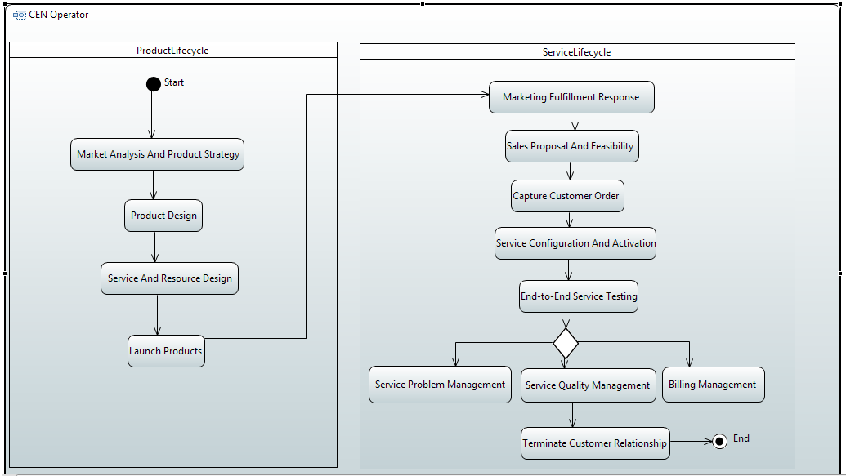

Figure 5.58: Example Business Process Modeling

## State Machines

State machines define state transitions and triggers that shall occur for the transitions to take place. The primary artifacts used in modeling state machines are as follows:

* State Machine Compartment Defines the boundary of the state machine
* Region Defines a region within a state machine
* Initial State Defines the initial state
* Transition Defines the trigger for a state transition to occur
* State Defines a given state within the state machine
* Final State Defines the final, or end state

Other artifacts may be required based upon the state machine being defined.

As an example, see the state machine of the Lifecycle Stereotypes in Figure 6.9.

# UML Profile Definitions

## UML Profile Structure

The additional properties for the UML Model artifacts and UML Profile artifacts are defined in UML Profiles. The structure is defined in the figure below:



Figure 6.1: UML Profile Structure

## Additional Properties for the General Information on the UML Model

Clause 4.4 describes the additional general information on a UML Model. These properties are defined in the OpenModelStatement stereotype as shown in Figure 6.2 below.

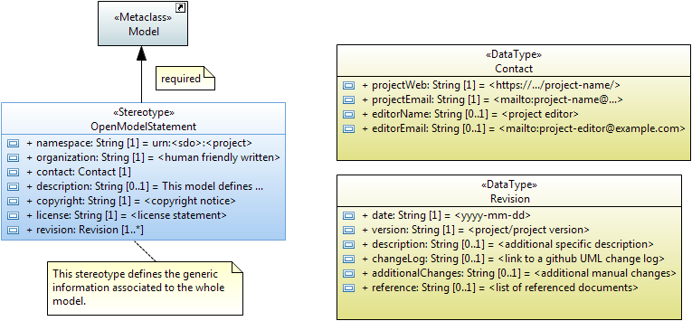

Figure 6.2: OpenModelStatement Required «Stereotype»

Details are provided in Table 6.1.

## Additional Common Properties for individual UML Model artifacts

Clause 5 has already described the additional properties for each UML Model artifact. All defined stereotypes are shown as an overview in Figure 6.3 and Figure 6.4 below.

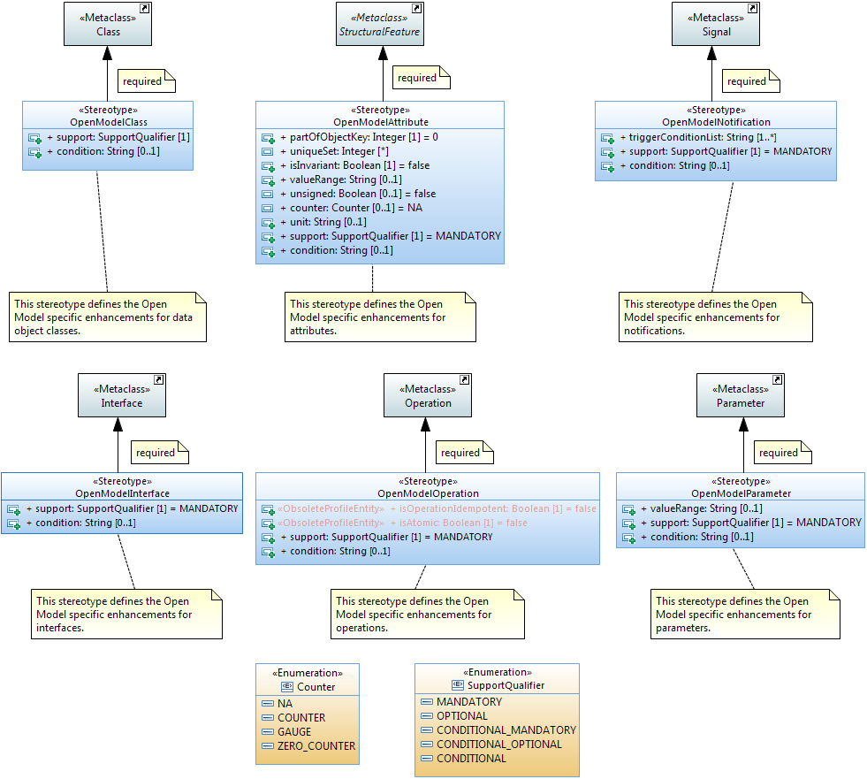

Figure 6.3: OpenModel Profile: Required «Stereotypes»

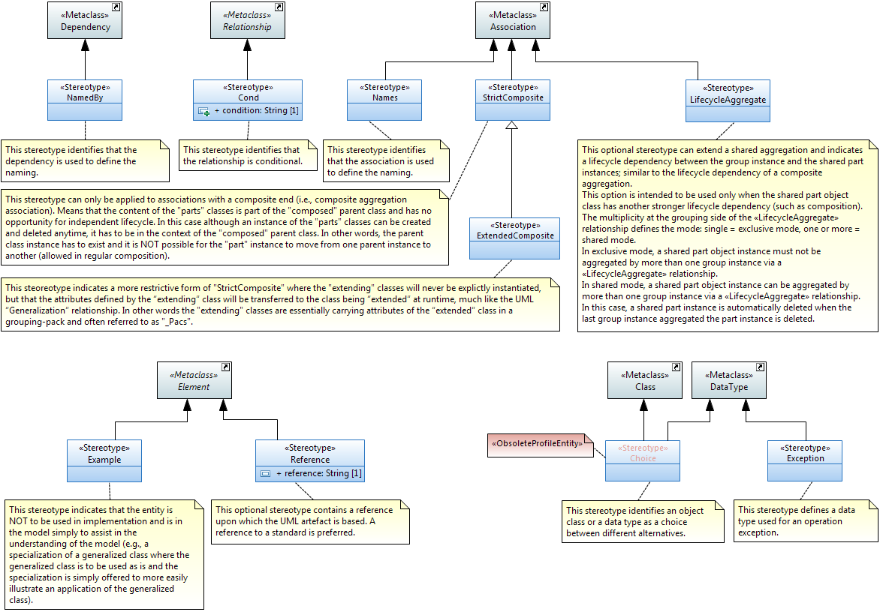  
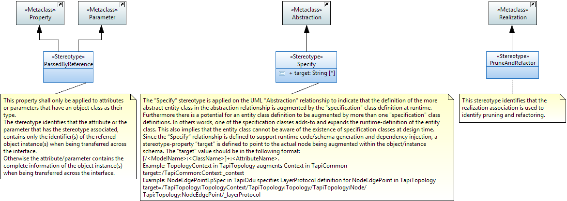

Figure 6.4: OpenModel Profile: Optional «Stereotypes»

Table 6.1: OpenModel Profile: Complex «Stereotypes»

| Stereotype | Name of property | Type | Allowed values | Default value | Associated to metaclass |
| --- | --- | --- | --- | --- | --- |
| OpenModel Statement | namespace | String | urn |  | Model |
| organization | String |  |  |
| contact | Contact |  |  |
| projectWeb | String | URL |  |
| projectEmail | String | Email address |  |
| editorName | String |  |  |
| editorEmail | String | Email address |  |
| description | String |  |  |
| copyright | String |  |  |
| license | String |  |  |
| revision | Revision |  |  |
| date | String | yyyy-mm-dd |  |
| version | String |  |  |
| description | String |  |  |
| changeLog | String | URL |  |
| additionalChanges | String |  |  |
| reference | String |  |  |
| OpenModel Class | support | Enumeration | MANDATORY OPTIONAL CONDITIONAL_ MANDATORY CONDITIONAL_ OPTIONAL CONDITIONAL | MANDATORY | Class |
|  | condition | String |  |  |  |
| OpenModel Attribute | partOfObjectKey | Integer | 0,1,2,3,... | 0 | Property |
| uniqueSet | Integer | 0,1,2,3,... |  |
| isInvariant | Boolean | true/false | false |
| valueRange | String |  | NA |
| unsigned | Boolean | true/false | false |
| counter | Counter | NA COUNTER GAUGE ZERO_COUNTER | NA |
| unit | String |  |  |
| support | Enumeration | MANDATORY OPTIONAL CONDITIONAL_ MANDATORY CONDITIONAL_ OPTIONAL CONDITIONAL | MANDATORY |
| condition | String |  |  |
| OpenModel Interface | support | Enumeration | MANDATORY OPTIONAL CONDITIONAL_ MANDATORY CONDITIONAL_ OPTIONAL CONDITIONAL | MANDATORY | Interface |
| condition | String |  |  |
| OpenModel Operation | isOperationIdempotent (obsolete) | Boolean | true/false | false | Operation |
| isAtomic (obsolete) | Boolean | true/false | false |
| support | Enumeration | MANDATORY OPTIONAL CONDITIONAL_ MANDATORY CONDITIONAL_ OPTIONAL CONDITIONAL | MANDATORY |
| condition | String |  |  |
| OpenModel Parameter | valueRange | String |  | NA | Parameter |
| support | Enumeration | MANDATORY OPTIONAL CONDITIONAL_ MANDATORY CONDITIONAL_ OPTIONAL CONDITIONAL | MANDATORY |
| condition | String |  |  |
| OpenModel Notification | triggerConditionList | String |  |  | Signal |
| support | Enumeration | MANDATORY OPTIONAL CONDITIONAL_ MANDATORY CONDITIONAL_ OPTIONAL CONDITIONAL | MANDATORY |
| condition | String |  |  |
| Cond | condition | String |  |  | Relationship |
| Reference | reference | String |  |  | Element |
| Specify | target | String |  |  | Abstraction |

## Additional Interface related Properties for individual UML Model artifacts

Clause 5 has already described the additional properties for each UML Model artifact. All defined stereotypes related to an interface model are shown as an overview in Figure 6.5 and Figure 6.6 below.

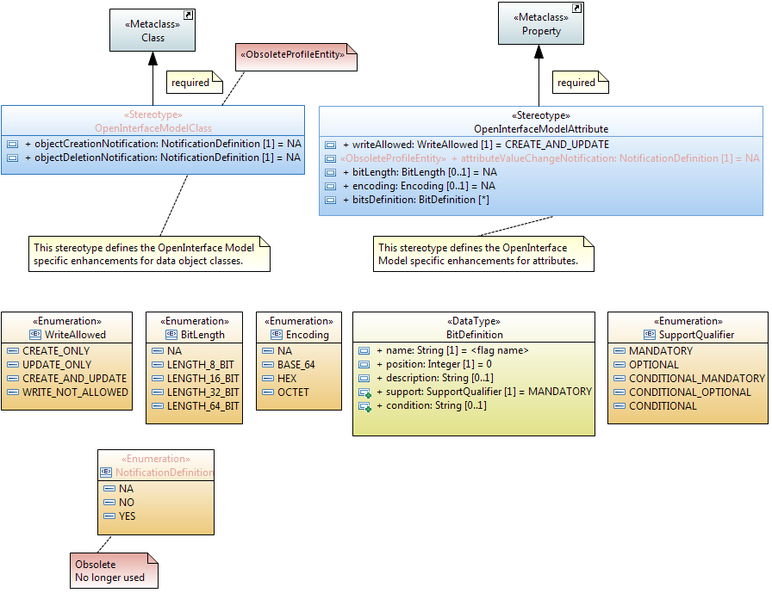

Figure 6.5: OpenInterfaceModel Profile: Required «Stereotypes»

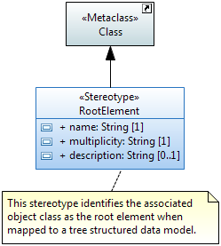

Figure 6.6: OpenInterfaceModel Profile: Optional «Stereotypes»

Table 6.2: OpenInterfaceModel Profile: Complex «Stereotypes»

| Stereotype | Name of property | Type | Allowed values | Default value | Associated to metaclass |
| --- | --- | --- | --- | --- | --- |
| OpenInterfaceModelClass (obsolete) | objectCreation Notification | Enumeration | NO YES NA | NA | Class |
| objectDeletion Notification | Enumeration | NO YES NA | NA |
| OpenInterfaceModelAttribute | writeAllowed | Enumeration | CREATE_ONLY UPDATE_ONLY CREATE_AND_UPDATE WRITE_NOT_ALLOWED | CREATE_AND_ UPDATE | Property |
| attributeValueChange Notification (obsolete) | Enumeration | NO YES NA | NA |
| bitLength | BitLength | NA LENGTH_8_BIT LENGTH_16_BIT LENGTH_32_BIT LENGTH_64_BIT | NA |
| encoding | Encoding | NA BASE_64 HEX OCTET | NA |
| bitsDefinition | BitDefinition |  |  |
| name | String |  |  |
| position | Integer |  | 0 |
| description | String |  |  |
| support | Enumeration | MANDATORY OPTIONAL CONDITIONAL_ MANDATORY CONDITIONAL_ OPTIONAL CONDITIONAL | MANDATORY |
| condition | String |  |  |
| RootElement | name | String |  |  | Class |
| multiplicity | String | <lower bound>.. <upper bound> | 1..1 |
| description | String |  |  |

## Additional Properties for all UML artifacts

### Description

This clause defines the additional properties that may be associated to

* all UML Model artifacts and
* all UML Profile artifacts.

### LifecycleState Property

All UML Model artifacts (packages, classes, attributes, interfaces, operations, parameters, data types, associations and generalizations) may be appended with one of the following lifecycle states:

* Deprecated  
  This stereotype indicates that the entity may become obsolete in the near future. It may still be used in new implementation.  
  The entity should be kept in this state for at least one further release. The team has to decide on a case by case basis when to move it to Obsolete.
* Experimental  
  This stereotype indicates that the entity is at a very early stage of development and will almost certainly change. The entity is NOT mature enough to be used in implementation.
* Faulty  
  This stereotype indicates that the entity should not be used in new implementation and that attempts should be made to remove it from existing implementation as there is a problem with the entity. An update to the model with corrections will be released.
* LikelyToChange  
  This stereotype indicates that although the entity may be mature, work in the area has indicated that change will be necessary (e.g., there are new insights in the area or there is now perceived benefit to be had from further rationalization). The entity can still be used in implementation but with caution.
* Mature  
  This stereotype indicates that the entity is fully developed and can be used in implementations without any constraints.
* Obsolete  
  This stereotype indicates that the entity should not be used in new implementation and that attempts should be made to remove it from existing implementation.  
  The entity should be kept in the model at least for one further release. The team has to decide on a case by case basis when to remove it from the model.
* Preliminary  
  This stereotype indicates that the entity is at a relatively early stage of development and is likely to change but is mature enough to be used in implementation.

**Rules:**One and only one lifecycle state has to be associated to every UML artifact.  
It is recommended that every new UML artifact is initially annotated with the “Experimental” lifecycle stereotype.

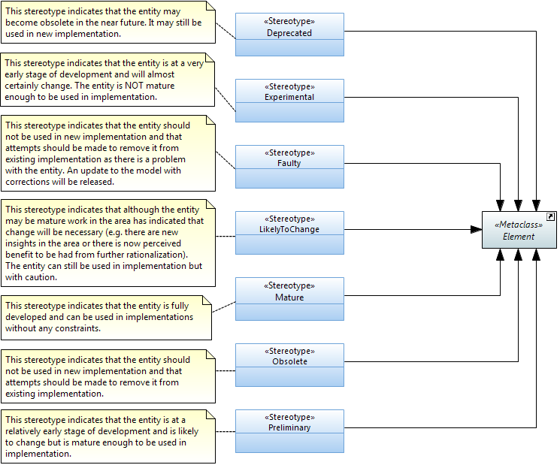

Figure 6.7: Lifecycle «Stereotypes»

### Profile LifecycleState Property

All UML Profile artifacts (stereotypes and properties) may be appended with one of the following lifecycle states:

* DeprecatedProfileEntity  
  This stereotype indicates that the profile entity may become obsolete in the near future. It may still be used in new implementation.  
  The profile entity should be kept in this state for at least one further release. The team has to decide on a case by case basis when to move it to ObsoleteProfileEntity.
* ExperimentalProfileEntity  
  This stereotype indicates that the profile entity is at a very early stage of development and will almost certainly change. The entity is NOT mature enough to be used in implementation.
* FaultyProfileEntity  
  This stereotype indicates that the profile entity should not be used in new implementation and that attempts should be made to remove it from existing implementation as there is a problem with the entity. An update to the model with corrections will be released.
* LikelyToChangeProfileEntity  
  This stereotype indicates that although the profile entity may be mature, work in the area has indicated that change will be necessary (e.g., there are new insights in the area or there is now perceived benefit to be had from further rationalization). The entity can still be used in implementation but with caution.
* MatureProfileEntity  
  This stereotype indicates that the profile entity is fully developed and can be used in implementations without any constraints.
* ObsoleteProfileEntity  
  This stereotype indicates that the profile entity should not be used in new implementation and that attempts should be made to remove it from existing implementation.
* PreliminaryProfileEntity  
  This stereotype indicates that the profile entity is at a relatively early stage of development and is likely to change but is mature enough to be used in implementation.

**Rules:**One and only one profile lifecycle state has to be associated to every UML profile artifact.  
It is recommended that every new UML profile artifact is initially annotated with the “Experimental” lifecycle stereotype.

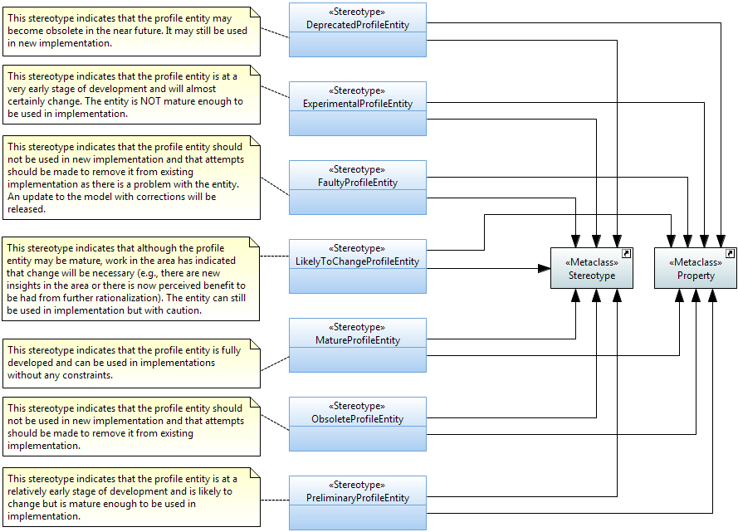

Figure 6.8: Profile Lifecycle «Stereotypes»

The following state machine diagram shows the defined state transitions for both, the lifecycle and the profile lifecycle stereotypes.

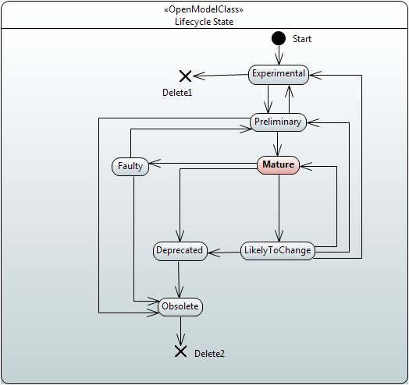

Figure 6.9: Lifecycle and ProfileLifecycle LifecycleState State Machine

### Reference Property

A reference can be defined for all UML artifacts. This is an optional property which contains a reference upon which the artifact is based. A reference to a standard is preferred.

The reference property is defined in the Reference stereotype and extent the Element Metaclass.

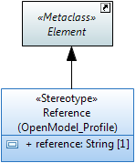

Figure 6.10: Reference «Stereotype»

### Example Property

This is an optional property which can be defined for all UML artifacts  
It is defined as a stereotype and indicates that the entity is NOT to be used in implementation and is in the model simply to assist in the understanding of the model (e.g., a specialization of a generalized class where the generalized class is to be used as is and the specialization is simply offered to more easily illustrate an application of the generalized class).

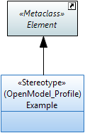

Figure 6.11: Example «Stereotype»

# Recommended Modeling Patterns

## File Naming Conventions

tba

## Model Structure

### Generic Model Structure

Figure 7.1 shows a generic Information Model containing a core model and various sub-models A, B, C structured by packages:

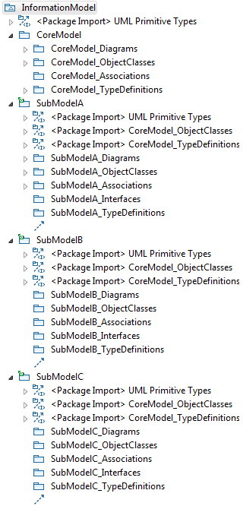 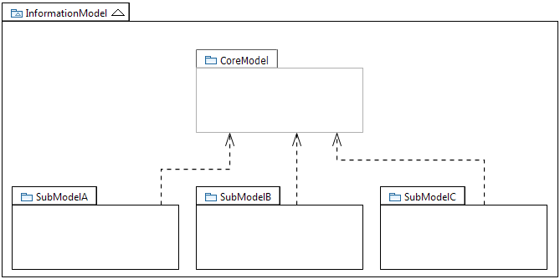

Figure 7.1: Core Model and SubModels

Note:  
Figure 7.1 shows only the schematic structure of the core and submodels as necessary for these guidelines.

Each Model can be optionally organized into multiple submodels. Each Model or each of its constituent submodels is further divided – at the bottom level of the hierarchy – into packages containing associations, diagrams, imports, object classes, rules and type definitions. Submodels may contain in addition packages for (UML-) interfaces (and their operations) and notifications.

### Model Structure

The Information Model is structured into a Common Information Model and additional Specific Views which are based on the Core Model. Specific models may also be added by other SDOs. A Core Modeling team (with members from many SDOs) defines and maintains the generic functions in the Core Model.



Figure 7.2: Model Structure (snapshot)

In order to reduce clutter, the UML artefacts are grouped in pre-defined packages instead of having all kinds of the various artefacts mashed up at the same level. This provides a human friendly structure for the model. This structure accelerates the manual search for specific kinds of artefacts.

Note: Not all pre-defined packages need to be established in a particular model instance. Additional packages can be added when needed. Figure 7.3 shows the pre-defined packages at the bottom level of the CoreNetworkModel.



Figure 7.3: Pre-defined Packages at the Bottom Level of each UML Model  
(Example)

## Flexible Attribute Assignment to Classes

Since it is not possible to add attributes once an instance has been created, it is necessary to differentiate case (a) where attributes are assembled before the instance is created, and case (b) where further attributes (functions) are added after the instance is created.

For case (a), attributes are grouped in classes called “Pacs” and are associated to the base class using a conditional composition association (see clause 7.4 below).

An example for (a) is a specific LTP instance which has specific Pacs associated, based on the functions that this LTP supports. Once the LTP is created, it is no longer possible to add further attributes or remove attributes.

🡪 Instances are (automatically) created as an assembly of the base object plus a list of Pacs (depending on the supported functionality).

For case (b), attributes are grouped in “normal” classes and are associated to the base class using a composition association.

An example for (b) is a specific, already existing LTP instance which will be configured to do performance monitoring (PM). In this case an additional PM instance (created on the basis of the corresponding class (i.e., not Pac)) is separately instantiated and associated to the already existing LTP. Note that it is also possible to remove the PM instance from the LTP afterwards without impacting the life cycle of the base LTP instance.

🡪 Instances are created on an explicit request and associated to already existing instances (depending on the requested additional functionality).

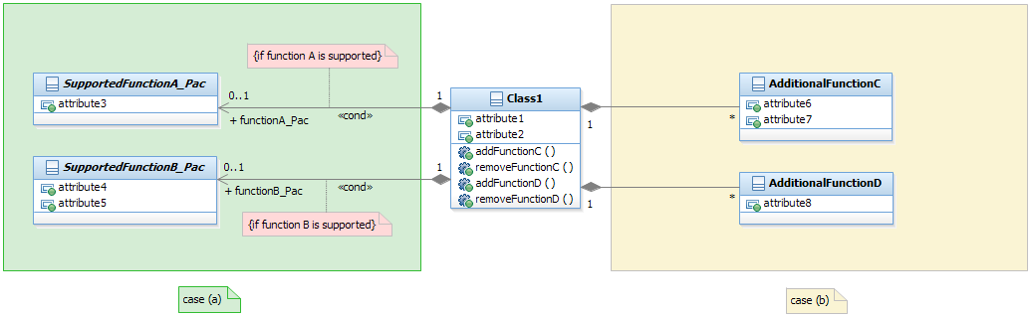

Figure 7.4: Flexible Attribute Assignment to Classes

## Use of Conditional Packages

Conditional packages are used to enhance (core) classes / interfaces with additional attributes / operations on a conditional basis. The attributes / operations are defined in special classes called packages.

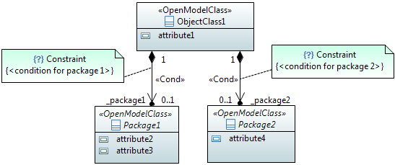

Figure 7.5: Enhancing Classes Using Conditional Packages

Package names follow the same rules as defined for classes; i.e., UCC.  
The role name of the navigable end pointing to the package follows the same rules as defined for role names in section 5.4.3; i.e., LCC with an “_” prefix.

## Use of XOR

### Description

The UML Constraint artefact is used to model “Exclusive Or” (xor) restrictions between a set of associations. Only one of the associations is active in the instantiated model at given point in time. One end of all related associations need to be assigned to a common artefact (e.g., object class, data type) which is the «context» of the Constraint.

The xor choice can either be defined directly attached to the containing class/data type (see Choice3Choice in Figure 7.9) or indirectly by attaching the choice to a separate data type (see Choice1DataType in Figure 7.9) which makes it usable in many places of the model.  
The default choice can be defined by adding the Boolean typed default value “true” to the default navigable attribute (see Choice1DataType in Figure 7.9).

### Examples

The figures below shows various examples on how the {xor} constraint can be used.

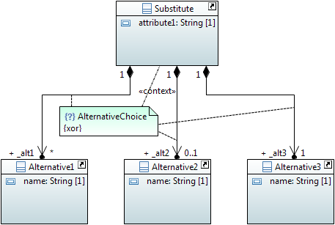

Figure 7.6: {xor} Alternative Example

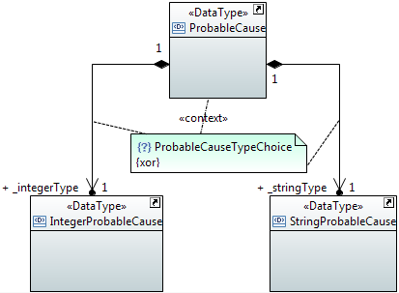

Figure 7.7: {xor} Probable Cause Type Example

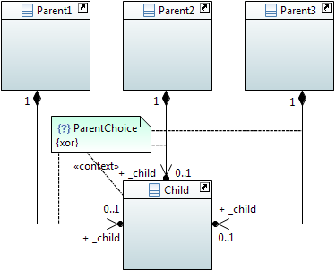

Figure 7.8: {xor} Parent / Child Example

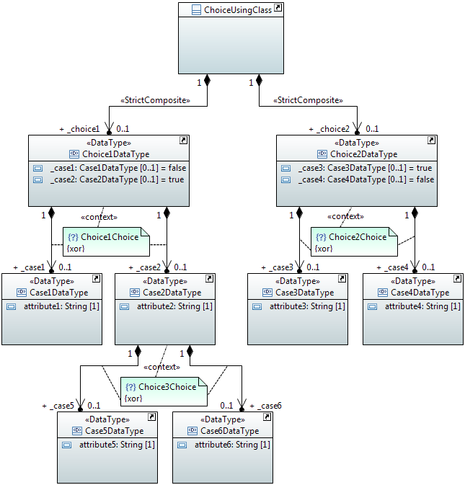

Figure 7.9: Multi Level {xor} Example

### Name style

The name of the {xor} constraint is written in UCC and appended by “Choice”.

### «Choice» (Obsolete)

#### Description

The «Choice» stereotype represents one of a set of classes (when used as an information model element) or one of a set of data types (when used as an operations model element).

This stereotype property, e.g., one out of a set of possible alternatives, is identical to the {xor} constraint (see 7.5).

#### Example

Sometimes the specific kind of class cannot be determined at model specification time. In order to support such scenario, the specification is done by listing all possible classes.

The following diagram lists 3 possible classes. It also shows a « Choice, OpenModelClass, InformationObjectClass» named SubstituteObjectClass. This scenario indicates that only one of the three classes named Alternative1ObjectClass, Alternative2ObjectClass, Alternative3ObjectClass shall be realized.

The «Choice» stereotype represents one of a set of classes when used as an information model element.

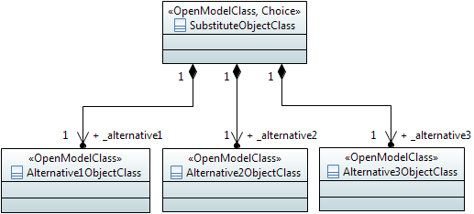

Figure 7.10: Information Model Element Example Using «Choice» Notation

Sometimes the specific kind of data type cannot be determined at model specification time. In order to support such scenario, the specification is done by listing all possible data types.

The following diagram lists 2 possible data types. It also shows a «Choice» named ProbableCause. This scenario indicates that only one of the two «DataType» named IntegerProbableCause, StringProbableCause shall be realized.

The «Choice» stereotype represents one of a set of data types when used as an operations model element.

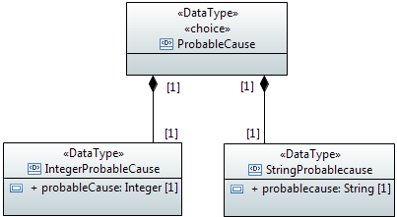

Figure 7.11: Operations Model Element Example Using «Choice» Notation

Sometimes models distinguish between sink/source/bidirectional termination points. A generic class which comprises these three specific classes can be modeled using the «Choice» stereotype.

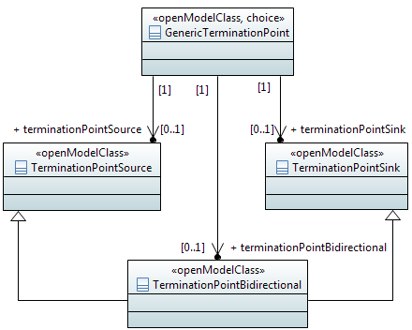

Figure 7.12: Sink/Source/Bidirectional Termination Points Example Using «Choice» Notation

#### Name style

For «Choice» name, use the same style as «OpenModelClass» (see 5.2.3).

## Proxy Class Modeling

There are cases where an attribute or parameter may contain different kinds of classes. This would require an attribute/parameter per kind of class. In order to reduce the number of attributes/parameters it is recommended to define a proxy class and let a single attribute/parameter point to this class. The different kinds of classes shall be inherited from the proxy class. All real subclasses inheriting from the abstract superclass (proxy) shall have the same object key.

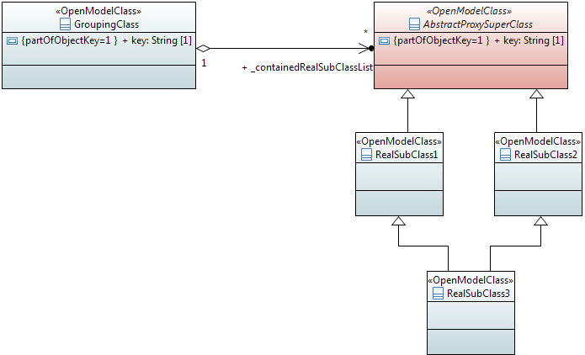

Figure 7.13: Proxy Class Modeling Example

## «LifecycleAggregate» Aggregation Usage

This section explains the impact of the «LifecycleAggregate» association based on a model example, a corresponding instance diagram and the lifecycle dependency when grouping instances are deleted.

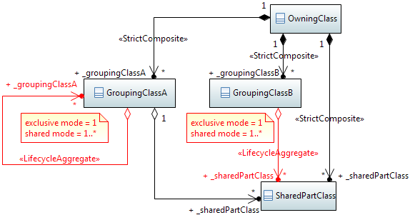

Figure 7.14: Usage Example for «LifecycleAggregate» Aggregation Association



Figure 7.15: Instance Example for «LifecycleAggregate» Aggregation Association

The example model in Figure 7.14 and the corresponding instance diagram in Figure 7.15 define the following behavior when grouping instances are deleted:

1. Deletion of OwningClass instance deletes all GroupingClass and SharedPartClass instances
2. Deletion of GroupingClassA instance 2 deletes no SharedPartClass instances
3. Deletion of GroupingClassA instance 1 deletes GroupingClassA instance 2 but no SharedPartClass instances

In exclusive mode (SharedPartClass instances 10 and 12 are not allowed):

1. Deletion of GroupingClassB instance 1 deletes SharedPartClass instances 3, 4 and 9
2. Deletion of GroupingClassB instance 2 deletes SharedPartClass instances 5, 6, 11 and 13

In shared mode (SharedPartClass instances 10 and 12 are allowed):

1. Deletion of GroupingClassB instance 1 deletes SharedPartClass instances 3, 4 and 9
2. Deletion of GroupingClassB instance 2 deletes SharedPartClass instances 5, 6, 11 and 13
3. Deletion of GroupingClassB instance 1 deletes 3, 4 and 9; and when GroupingClassB instance 2 is deleted afterwards, then SharedPartClass instances 5, 6, 10, 11, 12 and 13 are deleted.

## Diagram Guidelines

### Generic Diagram Guidelines

Classes and their relationships shall be presented in class diagrams.

Interfaces and their operations shall be presented in class diagrams.

Only applied optional stereotypes should be made visible in class diagrams.

If complex stereotypes need to be made visible in class diagrams, then they should be shown in a comment.

It is recommended to create:

* An overview class diagram containing all classes related to a specific management area:  
  - The class name compartment should contain the location of the class definition (e.g. "Qualified Name").  
  The class attributes should show the "Signature" (see clause 7.3.45 of [2] for the signature definition).
* A separate inheritance class diagram in case the overview diagram would be overcrowded when showing the inheritance structure (Inheritance Class Diagram).
* A class diagram containing the user defined data types (Type Definitions Diagram).
* Additional class diagrams to show specific parts of the specification in detail.
* State diagrams for complex state attributes.
* State transition diagrams for attributes with defined value transitions.
* Activity diagrams for operations with high complexity.

### Using Colors

Using colors for the model artifacts has the benefit of distinguishing the types of the artifacts. For example, color the artifacts that are imported from other models or which are new in this release.

Further recommendations are to be provided.

### Style Sheets

The graphic depiction of the class diagrams can be aligned using style sheets. These guidelines define the following constraints:

* Mandatory stereotypes (e.g., «OpenInterfaceModelClass», «OpenModelClass», «OpenModelAttribute», …) should not be shown.  
  Note: Stereotypes which are specifically added – like e.g., «RootElement» – must be explicitly shown in the object class structure.  
  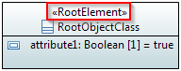
* Classes should not show the "nestedclassifiers" and "operations" compartments.
* Interfaces should not show the "nestedclassifiers" and "attributes" compartments.
* Data Types should not show the "operations" compartment.
* Primitive Types should not show any compartments.
* Attributes should only show name, type, multiplicity and defaultValue.
* Attributes should not show the stereotypes «OpenModelAttribute» and «OpenInterfaceModelAttribute».

The use of the ClassDiagramStyleSheet.css style sheet implements these requirements:  


The latest version of the style sheet can be downloaded from here:  
<https://github.com/OpenNetworkingFoundation/EAGLE-Open-Model-Profile-and-Tools/tree/ToolChain/UmlProfiles>

# Main Changes between Releases

## Summary of main changes between version 1.0 and 1.1

The following guidelines have been added:

* isAtomic property on operations
* «OpenModelNotification» stereotype
* realization association along with the «PruneAndRefactor» stereotype
* «Deprecated» lifecycle stereotype.

The requirement to use “Ref” and “List” in attribute/parameter/role names has been deprecated since the “Ref” property is already defined by the «PassedByReference» property and the “List” property is already defined by the multiplicity property.

The Guidelines are no longer ONF dependent; i.e, they can now be used as is by other SDOs.

## Summary of main changes between version 1.1 and 1.2

* Document moved to Open Source SDN
* Using UML Version 2.5 as basis.
* Further properties added to OpenModelAttribute stereotype:
  + partOfObjectKey
  + bitLength
  + unsigned
  + encoding
  + counter.
* Table 5.2 on attribute property dependencies added.
* Clauses on Use Cases (5.11), Activities (5.12) and State Machines (5.13) added.
* Clause 7.8.3 on style sheets for class diagrams added.
* Clause 7.6 on proxy class modeling added.
* Element metaclass extended by an optional reference stereotype.

## Summary of main changes between version 1.2 and 1.3

* Adapted to ETSI drafting rules.
* Interface model related properties separated from OpenModelProfile and new OpenInterfaceModelProfile added in new section 6.4.
* Attribute setability properties added in new section 5.3.4 and attribute property readOnly no longer used.
* uniqueSet property added in section 5.3.3.
* Metaclass Diagram (Figure 5.17) of used relationships added.
* usage and abstraction dependency relationships added in section 5.4.2.
* «ExtendedComposite», «StrictComposite», «LifecycleAggregate» and «Specify» stereotypes added.
* IsLeaf property added to class and attribute.
* Stereotype «PassedByReference» moved from OpenInterfaceModelProfile to OpenModelProfile.
* Properties settingTime and settingActor removed from OpenModelAttribute stereotype.
* Scope of «Cond» stereotype enhanced; it extends now the relationship metaclass.
* Core and Implementation CommonDataTypes added.
* New sections 4.4 and 6.2 on “General Information on the UML Model” added.
* Bits encoding defined in section 5.3.3.
* Reference pointer dependency added in section 5.4.2.1.
* Made «Choice» stereotype obsolete.
* Made «OpenInterfaceModelClass» stereotype obsolete.
* Made OpenModelOperation::isOperationIdempotent property obsolete.
* Made OpenModelOperation::isAtomic property obsolete.
* Made OpenInterfaceModelAttribute::attributeValueChangeNotification property obsolete.

1. Not about operations acting on the entity.
2. Because of Papyrus tool reasons, you shall not create comments directly in the class diagram and attach it by a link to the class. Such comments appear in applied comments field too, BUT they don’t appear in the gendoc output.
3. In Papyrus an attribute is a property.