CubeSat Orbital Heat Transfer Model

Mech 544 Advanced Heat Transfer, End of Year Project
Prepared by: Conner Harte, Parker Orth
Prepared for: Dr. Bret Windom
Table of Contents
1.0 Introduction 2
1.1 Motivation and Background 2
1.2 Objectives 2
1.3 Scope 2
2.0 Theory and Governing Equations 2
2.1 Radiation Heat Transfer Fundamentals 2
2.2 Radiation Sources (solar, Earth IR, albedo) 2
2.3 Earth View Factor 3
2.4 Transient Conduction and Finite Difference Discretization 3
2.5 Lumped Capacitance and Biot Number 3
3.0 Computational Setup 4
3.1 Geometry, Mesh and parameters. 4
3.2 Material Properties 4
3.3 Orbital Parameters and Propagation 4
3.4 Boundary Conditions 4
3.5 Solver 4
4.0 Results 5
4.1 Average Temperature History 5
4.2 Face Heat Flux Summary 5
Figure 3: CubeSat Average Temperature vs Time — 48 Hour Simulation 5
4.3 Temperature Envelope 5
4.4 Effective Radiation h and Biot Number 8
5.0 Discussion 9
5.1 Physical Interpretation 9
5.2 Assumptions and Limitations 9
5.3 Sources of Uncertainty 10
6.0 Conclusion 10
References 11

1.0 Introduction

1.1 Motivation and Background
A CubeSat in low Earth orbit cycles between direct sunlight and Earth's shadow roughly every 90 minutes, driving repeated swings in surface temperature. Without active thermal control, the satellite's temperature is governed entirely by the balance between incoming radiation and heat radiated to deep space. Understanding this balance is important for ensuring onboard components stay within safe operating limits.

1.2 Objectives
This project builds a computational thermal model of a 1U CubeSat orbiting Earth over 48 hours. The model accounts for direct solar radiation, Earth's infrared emission, and reflected solar albedo as heat inputs, and emission to deep space as the only output. A lumped capacitance model is developed alongside as an analytical comparison.

1.3 Scope
The satellite is modeled as a hollow aluminum cube, 10 cm per side with 5 mm walls. The orbit is defined by a Two Line Element set and propagated using the SGP4 algorithm. Convection does not exist in space and internal heat generation is assumed negligible, so radiation and conduction through the shell are the only heat transfer mechanisms considered.

2.0 Theory and Governing Equations

2.1 Radiation Heat Transfer Fundamentals
All surfaces above absolute zero emit thermal radiation. The heat emitted by a real surface is described by the Stefan-Boltzmann law:
$$\begin{aligned}Q_{emit}=εσAT^{4} \#\left(1\right)\end{aligned}$$

where ε is emissivity, σ = 5.67×10−8W/m²K⁴, A is surface area, and T is surface temperature. When radiation strikes a surface, the fraction absorbed is defined by the absorptivity α. For this model, the surface is treated as a gray body, meaning α=ε, which allows all three incoming radiation sources to be summed linearly.

2.2 Radiation Sources (solar, Earth IR, albedo)
Three external heat inputs act on the satellite at any given time. Direct solar flux strikes sunlit faces at a median value of 1366 W/m². Earth infrared emission, the thermal radiation re-emitted by Earth after absorbing sunlight, contributes 237 W/m² and is present even in eclipse. Solar albedo is sunlight reflected off Earth back toward the satellite, computed using an albedo factor of 0.3. The total absorbed heat on any face is:
$$\begin{aligned}Q_{abs}​=αA\left(G_{s}​F_{SS}​+G_{IR}​F_{SE}​+G_{s}​⋅a⋅F_{SA}​\right)\#\left(2\right)\end{aligned}$$

Figure 1 illustrates the three radiation sources and the emission pathway acting on the satellite at any point in its orbit.
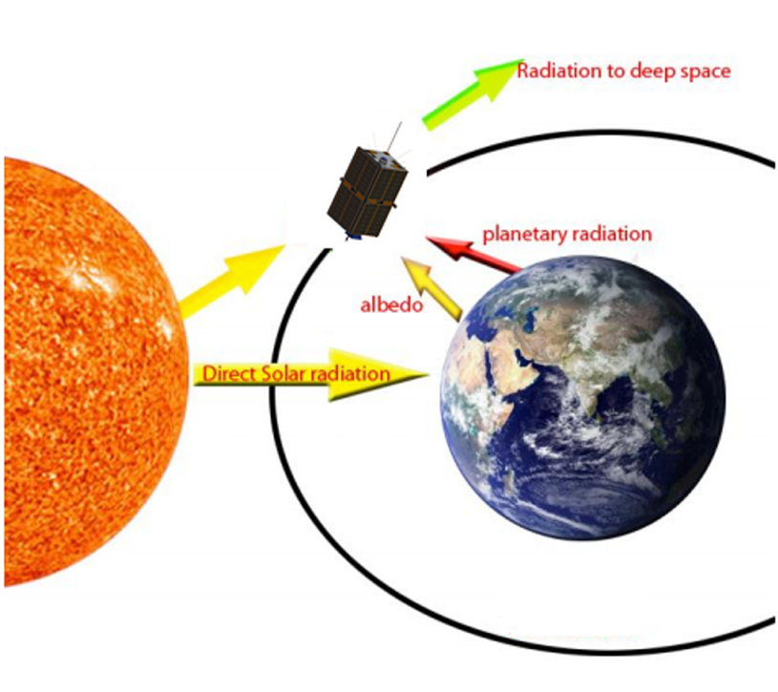
Figure 1:Radiation heat transfer sources acting on the CubeSat in low Earth orbit. [1].

2.3 Earth View Factor
The fraction of Earth's radiation intercepted by a satellite face depends on orbital geometry. Following Gilmore [1], the view factor $F_{SE}$from a flat plate to Earth is computed in three regions based on $δ$, the angle between the face normal and the nadir direction, and $k=R_{⊕}/r_{sat}$:
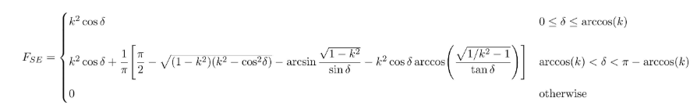
Figure 2: Equation 3 - View factor $F_{SE}$from a flat plate surface to Earth as a function of nadir angle $δ$and orbital geometry parameter $k=R_{⊕}/r_{sat}$[1].

2.4 Transient Conduction and Finite Difference Discretization
Heat conduction through the shell is governed by:
$$\begin{aligned}ρc_{p}\frac{dT}{dt}=k∇^{2}T \#\left(4\right)\end{aligned}$$
This is discretized using an explicit forward Euler finite difference scheme. Each cell updates as:
$$\begin{aligned}T_{n}^{n+1}=T_{i}^{n}-\frac{∆t}{ρc_{p}∆V}Q_{net,i }\#\left(5\right)\end{aligned}$$

where $Q_{net}$is the sum of conductive and radiative fluxes on that cell.

2.5 Lumped Capacitance and Biot Number
When spatial temperature gradients are small, the entire body can be treated as a single uniform temperature node. Since there is no convection in space, an effective radiation heat transfer coefficient is defined as:
$$\begin{aligned}h_{rad}​=εσ\left(T_{2}+T_{space}^{2}​\right)\left(T+T_{space}​\right)\#\left(6\right)\end{aligned}$$

The Biot number is then:
$$\begin{aligned}Bi=\frac{h_{rad}L_{c}}{k_{alum}} \#\left(7\right)\end{aligned}$$

where $L_{c}$is the wall thickness. When $Bi≪0.1$the lumped assumption is valid. The lumped temperature is solved from:
$$\begin{aligned}{mc}_{p}\frac{​dt}{dT}​=Q_{abs}​\left(t\right)-εσA_{total}​T^{4}\#\left(8\right)\end{aligned}$$

3.0 Computational Setup

3.1 Geometry, Mesh and parameters.
The CubeSat is modeled as a hollow aluminum cube, 10 cm per side with 5 mm wall thickness. The domain is discretized into 2.5 mm cubic cells, giving a 40×40×40 grid. Interior cells are empty and excluded from the solver, leaving only the shell cells active. Perfect thermal contact is assumed between all adjacent cells with no contact resistance. This results in roughly 49,000 active cells representing the physical aluminum structure.

3.2 Material Properties
The shell is modeled as Aluminum 6061-T6 with the following thermal properties. Thermal conductivity k = 167 W/m·K, density ρ = 2700 kg/m³, specific heat $c_{p}$= 896 J/kg·K, emissivity ε = 0.05, and absorptivity α = 0.05. Internal heat generation is neglected. The surface is treated as a gray diffuse body meaning absorptivity and emissivity are equal and wavelength independent.

3.3 Orbital Parameters and Propagation
The satellite orbit is defined using a Two Line Element set [2] from the International Space Station, epoch December 9, 2019 at approximately 550 km altitude. The SGP4 propagator [3] advances the orbital state forward in time, outputting the satellite position and velocity vectors in the Geocentric Celestial Reference System at each timestep. Sun position is computed at each timestep using the Astropy library. Earth IR emission and solar radiation magnitude are both treated as constant throughout the simulation. Solar rays are assumed parallel.

3.4 Boundary Conditions
Each face of the CubeSat is assigned a normal direction relative to the orbital frame: nadir, zenith, velocity, anti-velocity, cross-track, and anti-cross-track. These normals are used to compute the view factor and solar incidence angle at each timestep. Outer faces exchange heat with the space environment through radiation. Inner faces of the shell exchange heat by conduction with adjacent cells. Deep space is treated as a radiation sink at 3 K.

3.5 Solver
The radiation table is precomputed by sampling orbital geometry every 20 seconds over the full 48 hour window and interpolated at each timestep. The finite difference solver advances temperature using explicit forward Euler time stepping at dt = 0.01 s. Temperature snapshots are saved every 10,000 steps for post-processing.

4.0 Results

4.1 Average Temperature History
The satellite begins at 265 K and warms over the first several orbits before reaching a quasi-steady oscillating state near 281 K by the end of the 48 hour window. Each orbit produces a visible temperature rise during sunlit phases and a small drop during eclipse. The satellite never fully cools back to its initial temperature between orbits, which drives the gradual upward trend seen in the first 1500 minutes.

4.2 Face Heat Flux Summary
The absorbed heat flux on each face cycles with every orbit. The zenith face consistently absorbs the most heat from direct solar flux, while the nadir face receives a lower but steadier contribution from Earth IR even during eclipse. The cross-track faces absorb the least due to their orientation relative to the sun vector. The net absorbed panel shows that the satellite is almost always in a net gain state, with absorption exceeding emission throughout most of each orbit. This net gain is what drives the long term temperature rise seen in Figure 3.

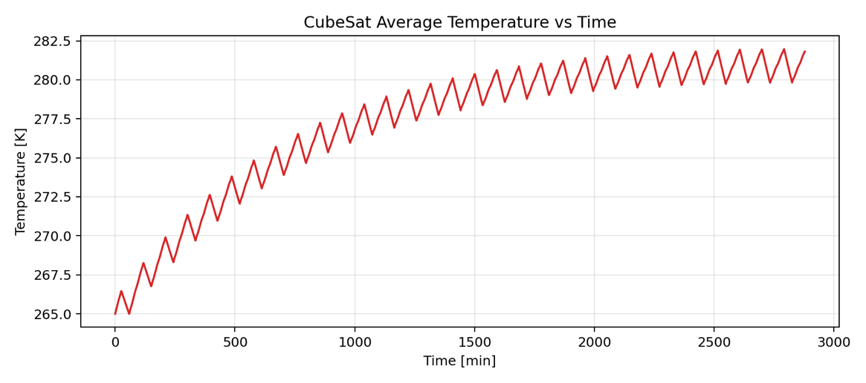

Figure 3: CubeSat Average Temperature vs Time — 48 Hour Simulation

4.3 Temperature Envelope
The temperature envelope over a single orbit, initialized at 300 K, shows that the spatial spread across the shell is very small, with the min and max remaining within a fraction of a Kelvin of the mean throughout the orbit. The satellite cools from 300 K down to approximately 297.4 K during the eclipse phase before partially recovering as sunlight returns. This tight banding confirms that the aluminum shell equilibrates quickly and maintains near-uniform temperature spatially, which is consistent with the high thermal conductivity of Aluminum 6061-T6.

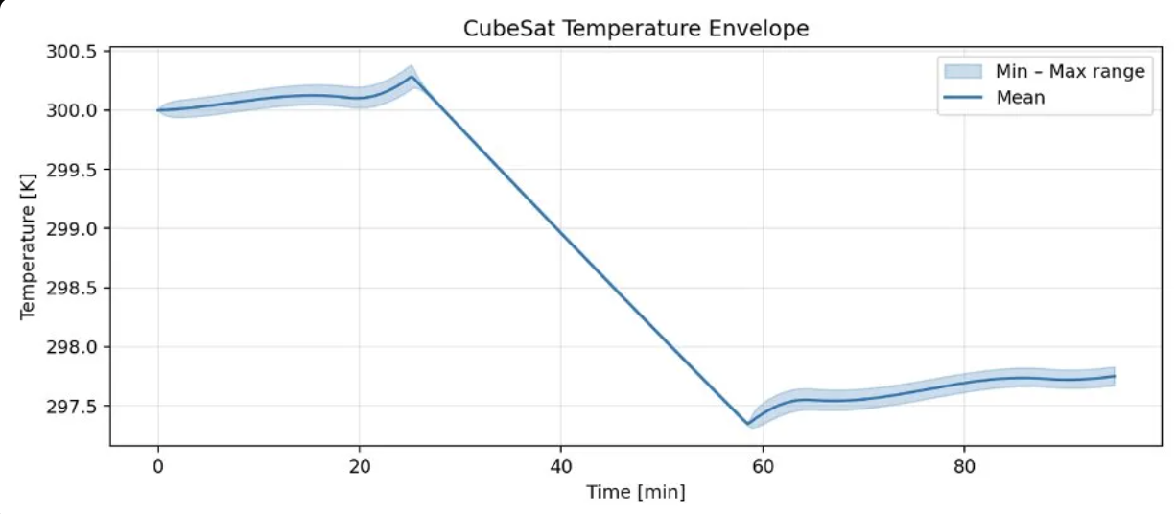
Figure 4: Absorbed heat flux per face 48hr

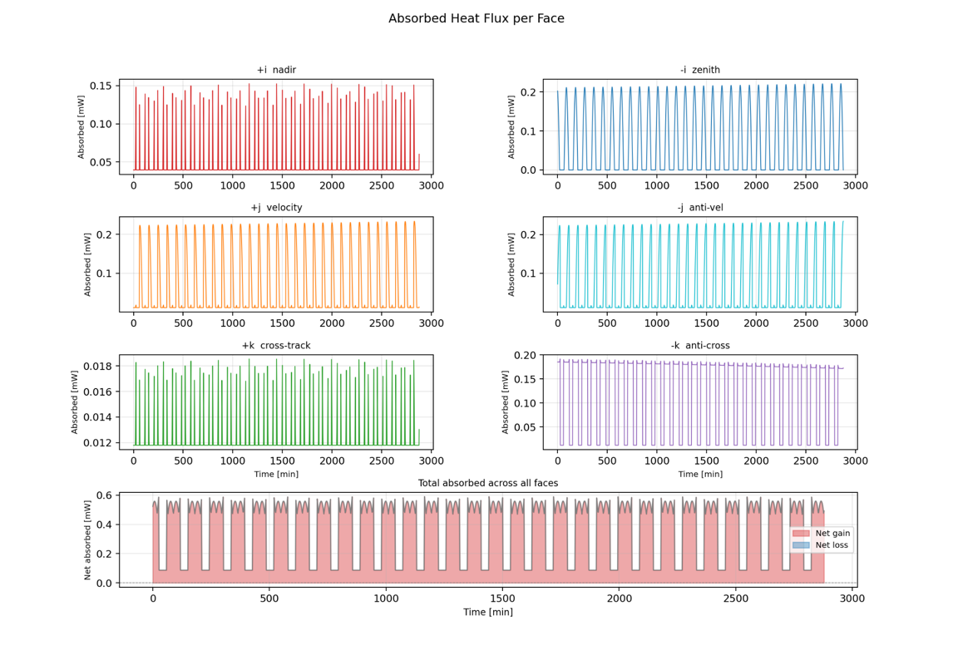
Figure 5: Absorbed Heat Flux per Face — 48 Hour Overview
The single orbit zoom shows the eclipse transition clearly. Around minute 25 direct solar flux drops to zero on the sunlit faces while Earth IR continues. The net absorbed panel shows the brief period of net loss during deep eclipse before sunlight returns around minute 60.

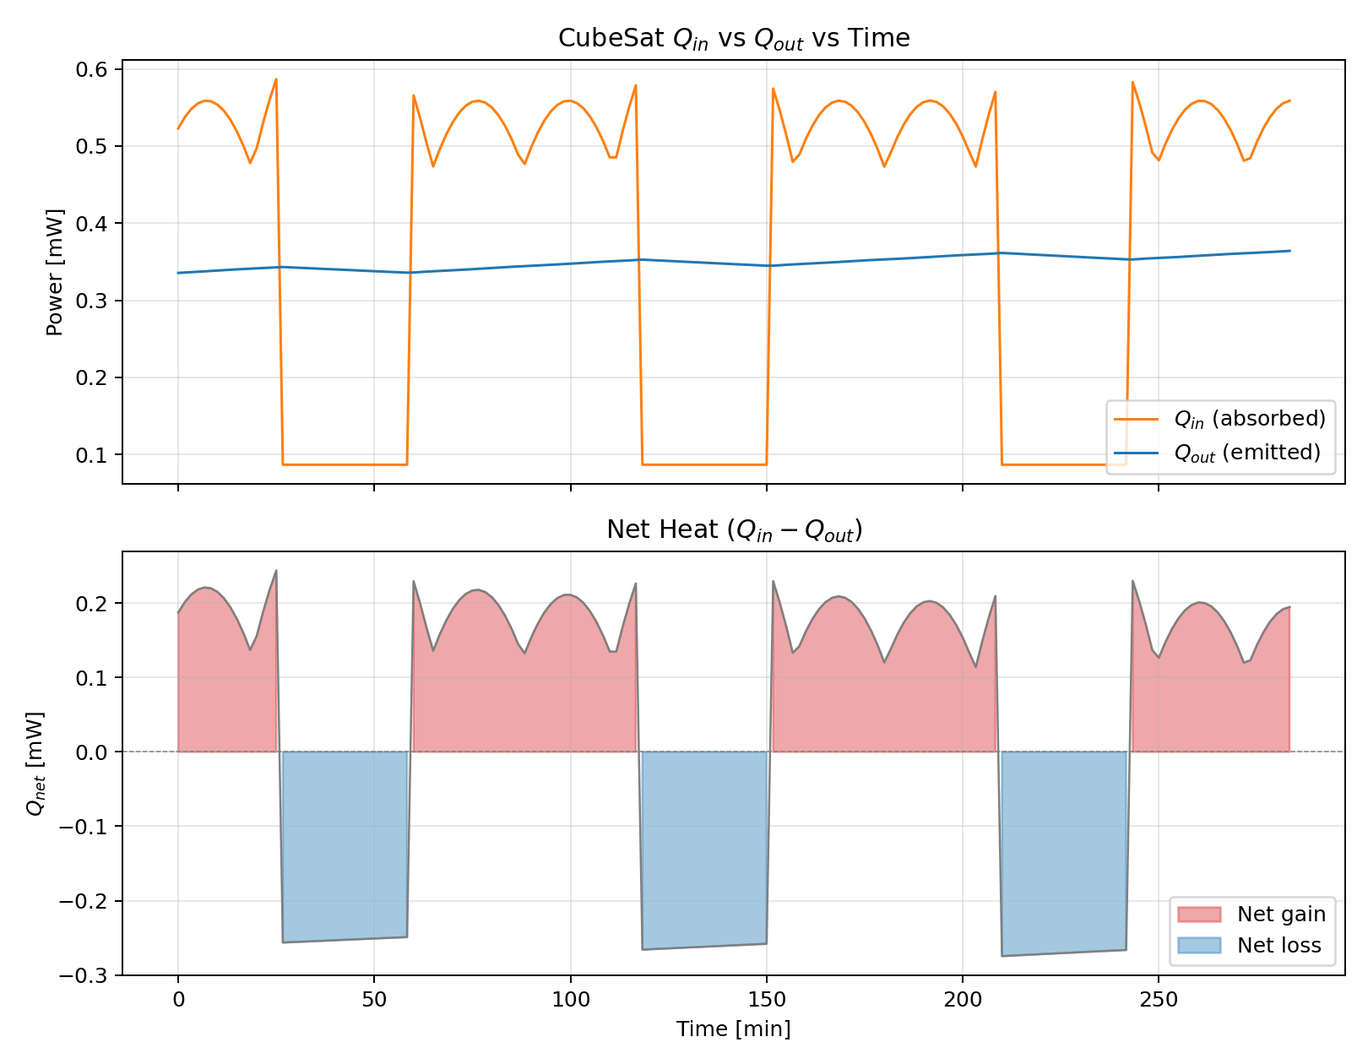
Figure 6: CubeSat $Q_{in}$vs $Q_{out}$ and Net Heat Transfer vs Time across 3 orbits

Figure 6 shows the absorbed and emitted heat directly overlaid. During sunlit phases absorbed heat peaks near 0.55 mW while emission holds steady near 0.33 mW, producing a net gain. During eclipse absorption drops to roughly 0.10 mW from Earth IR alone, putting the satellite in a net loss state. The orbit averaged net is positive, which accounts for the gradual temperature rise over the 48 hour window.
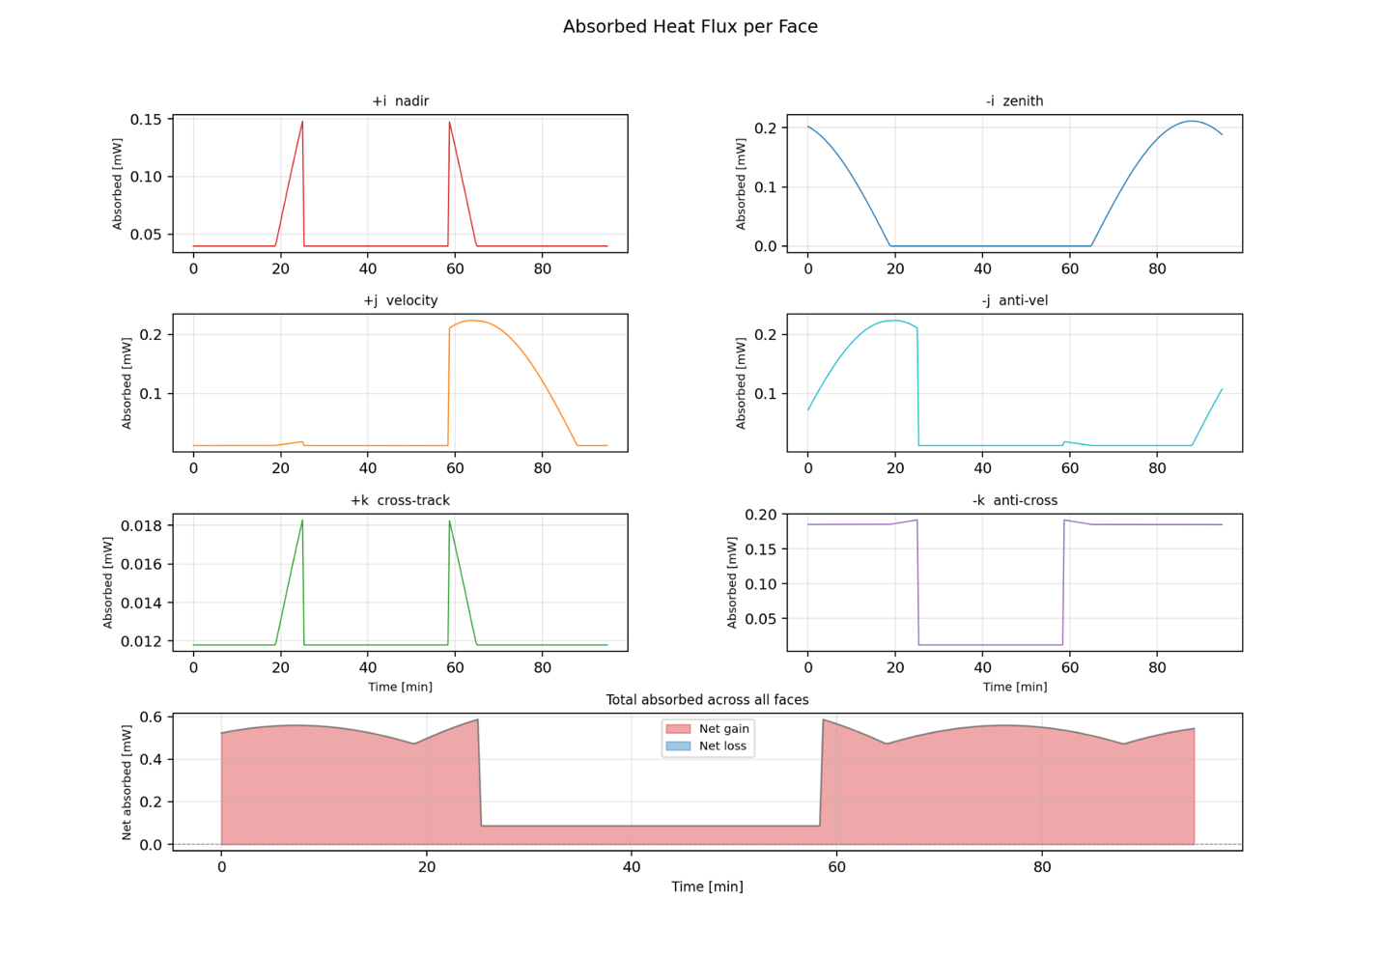Figure 7: Absorbed Heat Flux per Face — Single Orbit Detail

4.4 Effective Radiation h and Biot Number
The effective radiation heat transfer coefficient remains nearly constant near 0.0775 W/m²K throughout the simulation, dropping slightly during eclipse as the surface cools. Using a characteristic length equal to the wall thickness of 5 mm and k = 167 W/m·K for Aluminum 6061-T6, the Biot number remains approximately $2.3×{10}^{-6}$across the entire simulation, roughly four orders of magnitude below the 0.1 threshold. This confirms that spatial temperature gradients within the shell are negligible and that a lumped capacitance approach would be fully valid for this geometry and material.
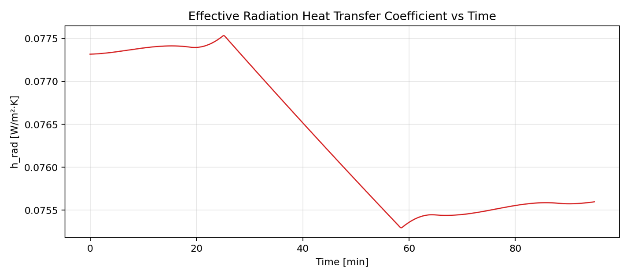
Figure 8: Effective Radiation Heat Transfer Coefficient vs Time

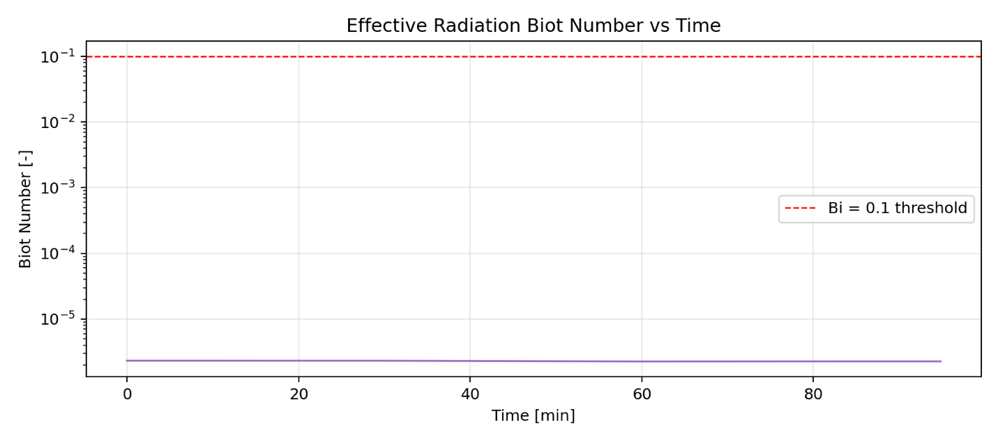Figure 9: Effective Radiation Biot Number vs Time

5.0 Discussion

5.1 Physical Interpretation
The satellite temperature rises gradually over the 48 hour simulation before approaching a quasi-steady oscillating state near 281 K. This behavior is driven by the orbit averaged net heat gain shown in Figure 5. During each sunlit pass the satellite absorbs significantly more than it emits, and while the eclipse phase partially recovers this deficit, the net per orbit remains positive until emission grows enough at higher temperatures to balance absorption. The zenith and velocity faces dominate heat input due to their exposure to direct solar flux, while the nadir face provides a steady lower level contribution from Earth IR throughout the orbit including during eclipse.

5.2 Assumptions and Limitations
The model assumes a gray diffuse surface meaning absorptivity and emissivity are constant across all wavelengths. In reality aluminum coatings behave differently at solar versus infrared wavelengths which could meaningfully affect the energy balance. Internal heat generation from electronics is neglected which would raise equilibrium temperatures in a real mission. Solar flux and Earth IR are held constant ignoring seasonal and atmospheric variability.

ould5.3 Sources of Uncertainty
The TLE used is from December 2019 meaning the orbital parameters do not reflect a real 2026 mission scenario. Material properties are assumed uniform and constant with temperature. The radiation table is sampled every 20 seconds and interpolated between samples which introduces small errors during rapid eclipse transitions.

6.0 Conclusion
This project developed a three dimensional transient finite difference thermal model of a 1U CubeSat in low Earth orbit over a 48 hour simulation window. The model captures all three external radiation sources, direct solar flux, Earth infrared emission, and solar albedo, and resolves heat conduction through the aluminum shell at each timestep. Starting from 265 K the satellite warms to a quasi-steady oscillating state near 281 K driven by a positive orbit averaged net heat gain shown in Figure 5.
The Biot number analysis confirms that spatial temperature gradients within the aluminum shell remain approximately four orders of magnitude below the 0.1 threshold throughout the simulation, validating the lumped capacitance assumption for this geometry and material. This provides a physically grounded analytical basis for the finite difference results.
The key takeaway is that even a simple uncontrolled aluminum shell in LEO reaches a predictable thermal equilibrium driven entirely by orbital geometry and surface radiative properties. The combination of SGP4 orbital propagation, geometry dependent view factor calculations, and cell level finite difference resolution demonstrates how classical heat transfer theory extends directly to the spacecraft thermal environment.

References
[1] Gilmore, D.G. (Ed.). Spacecraft Thermal Control Handbook, Volume I: Fundamental Technologies. 2nd ed. The Aerospace Press, El Segundo, California, 2002.
[2] "Two-line element set." Wikipedia. https://en.wikipedia.org/wiki/Two-line_element_set
[3] Rhodes, B. sgp4 Python Library. https://pypi.org/project/sgp4/

