Reverse Loop Modules
There are various reverse loop modules available for solving the well-known reverse loop problem. Personally, I find most of these modules extremely expensive, while the solution itself can be quite simple and inexpensive.
Before I go further. There is a huge difference between analog and digital layouts when it comes to solving the turning loop problem. In digital layouts you switch the turning loop section, for analog layout syou would need to switch the rest of the tracks. The analog section can be found in the bottom of this document.

The Problem
The principle is quite straightforward. At the top section of the track, you can see the blue and red rails coming together. Normally, if you connect these rails directly, you create a short circuit — this is the infamous reverse loop problem.
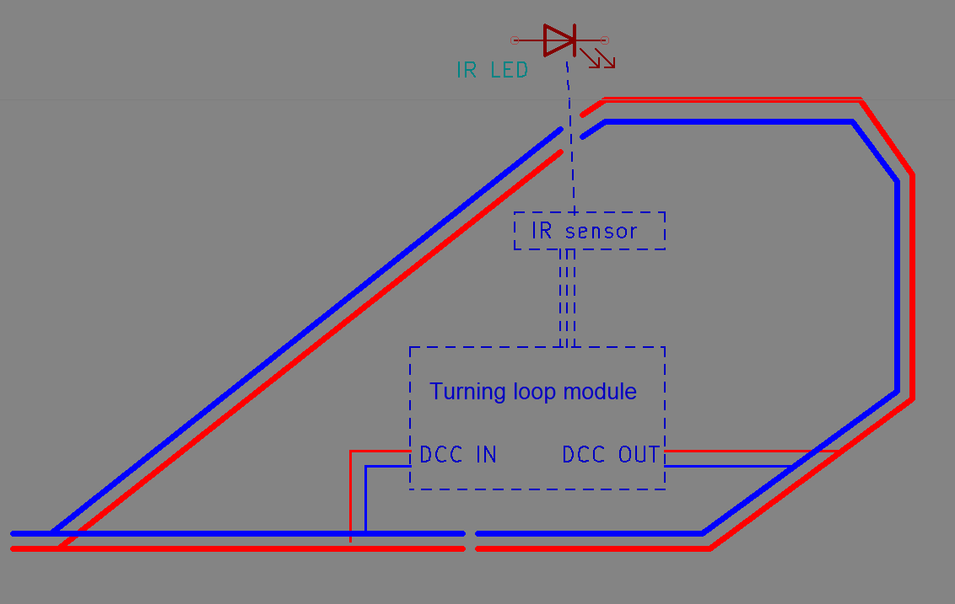Figure 1: A reverse loop module in idle state

The Solution for digital layouts.
This problem can be solved using a reverse loop module. There are many types available, and they all work differently, but I will not go into those details here.
The simplest, most robust, and cheapest method to build a reverse loop module is undoubtedly the relay method combined with a light barrier.
When a train passes through the light barrier, the isolated reverse loop section is immediately polarized to match the adjoining track, using a relay. Because the reverse loop section now has the same polarity as the connected rail section, the train can pass smoothly without causing a short circuit — regardless of which direction it is traveling.
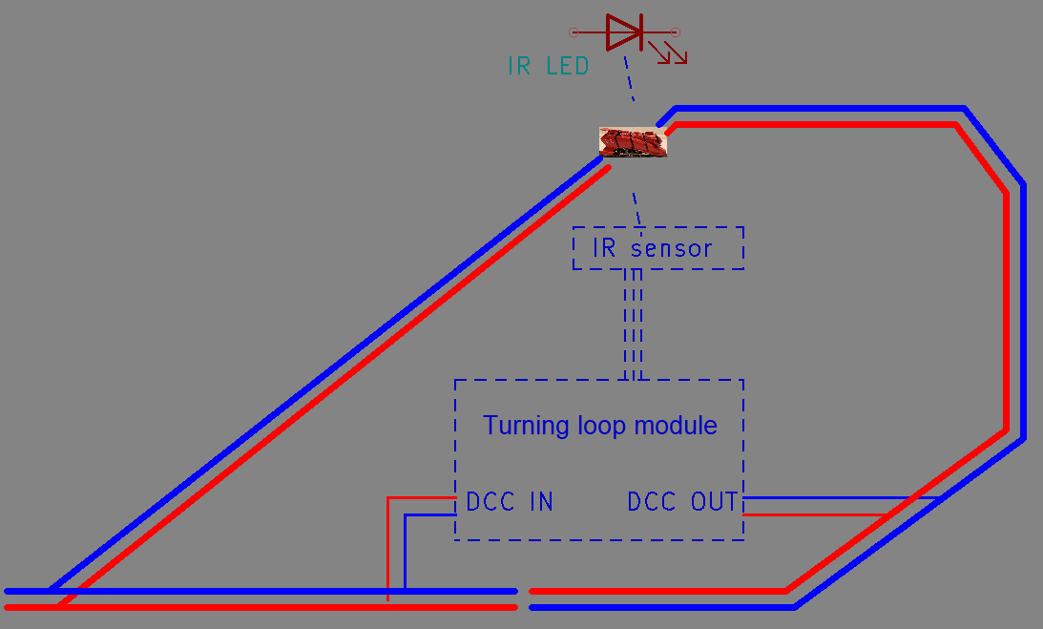Figure 2: The same module with a train in the loop

Once the train has completely left the light barrier, the relay returns to its idle state. By the time the train reaches the lower section, the reverse loop section has once again been matched to the polarity of the lower track.
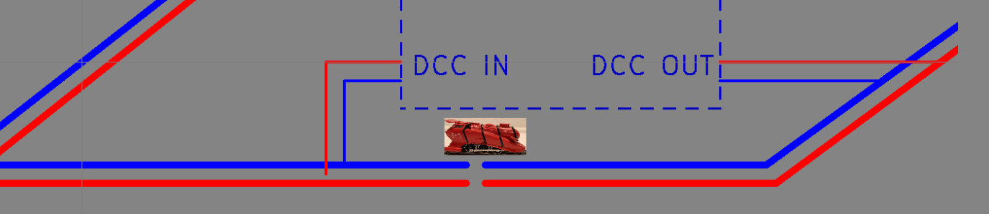Figure 3: Idle state — the train can pass freely
As with any reverse loop module, it is essential that your trains are shorter than the isolated reverse loop section.
The beauty of this system is that it is self-operating — you don’t need to do anything from your layout control system. It’s truly plug & play.

Advantages and disadvantages
There are reasons to why a relay and light barrier have been used. These are the main advantages
- KISS, keep it stupid stimple. The turning loop module is self operating and 100% fail-safe.
- Wiring. With either 4 or even 0 wires. This modules uses the bare minimum connections.
- Price. People spend anywhere between €30 and €100 to solve the turning loop problem. All kinds of overpriced modules are out there. But the problem can be solved with less then €10
The light barrier also come with 2 disadvantages
- The light barrier itself is visible
- There is no occupancy built in.
The occupancy itself can be solved by simply adding detection sections outside of the turning loop. You will lose some length, as the block will be slightly longer.

