Ordering a PCB from JLCPCB
Ordering a printed circuit board (PCB) from JLCPCB is one of the easiest things a person can do.

Step 1:
Go to JLCPCB.com

Step 2 – Download the Gerber files
To place an order, you need to provide the Gerber files of the PCB.
These files are already prepared for you — you don’t have to create or modify anything yourself.
On the organization’s front page, click on the Releases link of the project you want to order.
Inside that release section, you will find several downloadable files.
You have two options:
- Download the “Source code (zip)” file — it contains everything, including the Gerber files, documentation, and firmware.
- Or, if you only need the PCB data, click directly on the file named GERBERS_xxxx.zip.
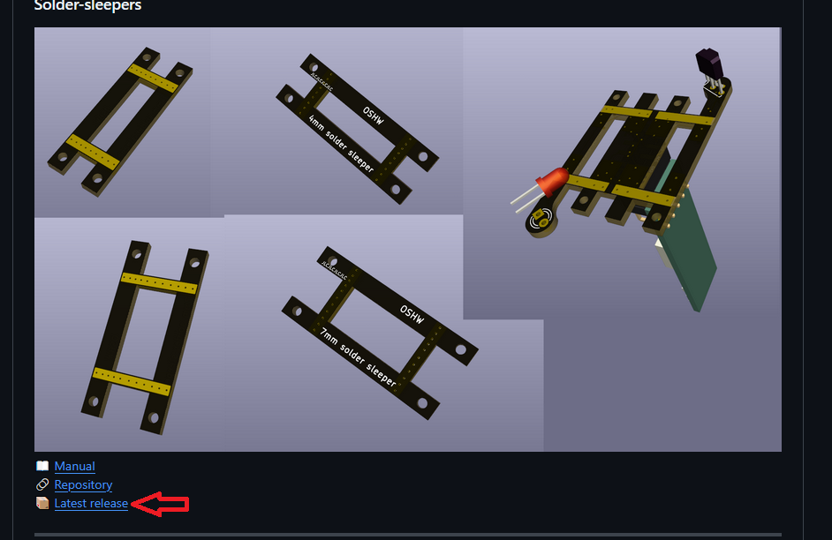
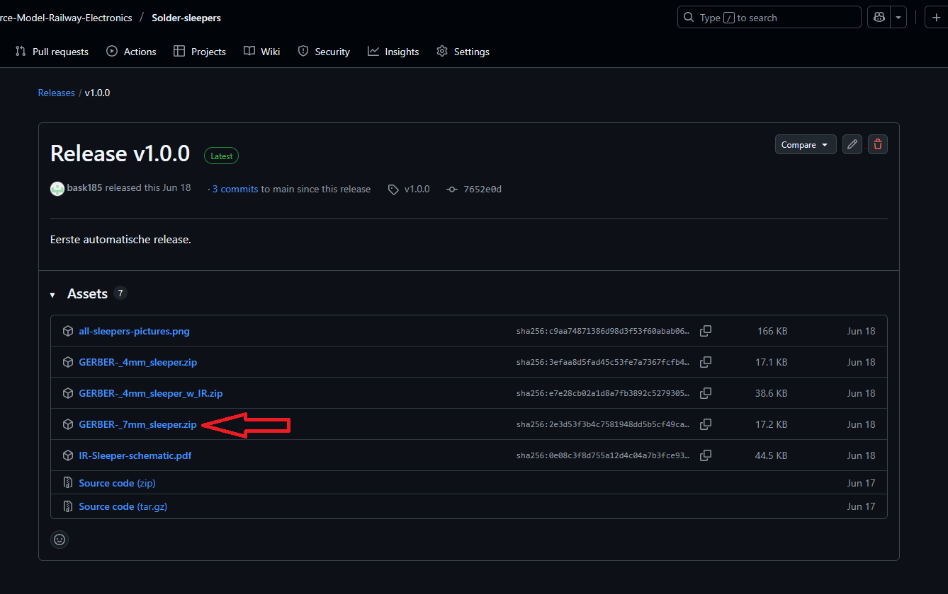

Once you have downloaded the ZIP file, go to JLCPCB.com click “Add Gerber file”, and select the ZIP you just downloaded.
It may take a few seconds to upload.
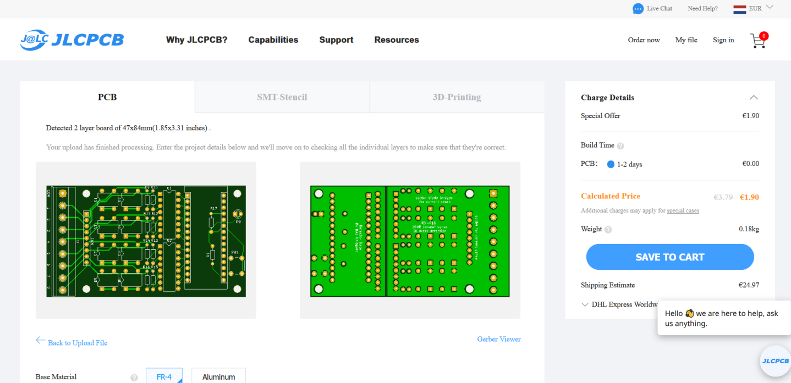
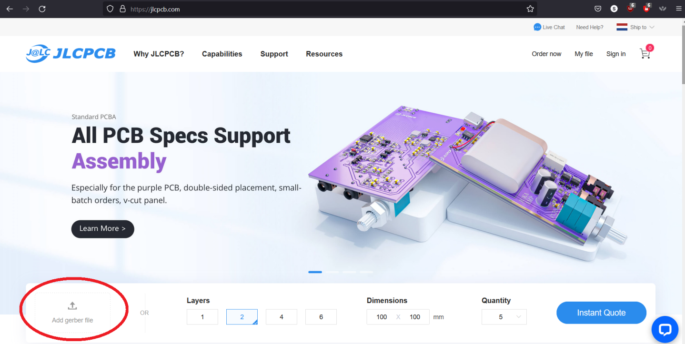
After uploading, the website will display a preview of your PCB.
If the board looks correct in the preview, everything is fine.
The first five PCBs you order cost about $2 in total.
If you order more, the price per board becomes lower.

Step 3:
On the same page you can change several options such as board thickness, copper thickness, and material type.
By default, all settings are already suitable for hobby projects.
The only things you might want to change are the quantity and the color of the boards.
And sometimes you also want to adjust the board thickness. Default thickness is 1.6mm, but sometimes you want thinner board
(led strips and sometimes you want thinker boards (solder sleepers).
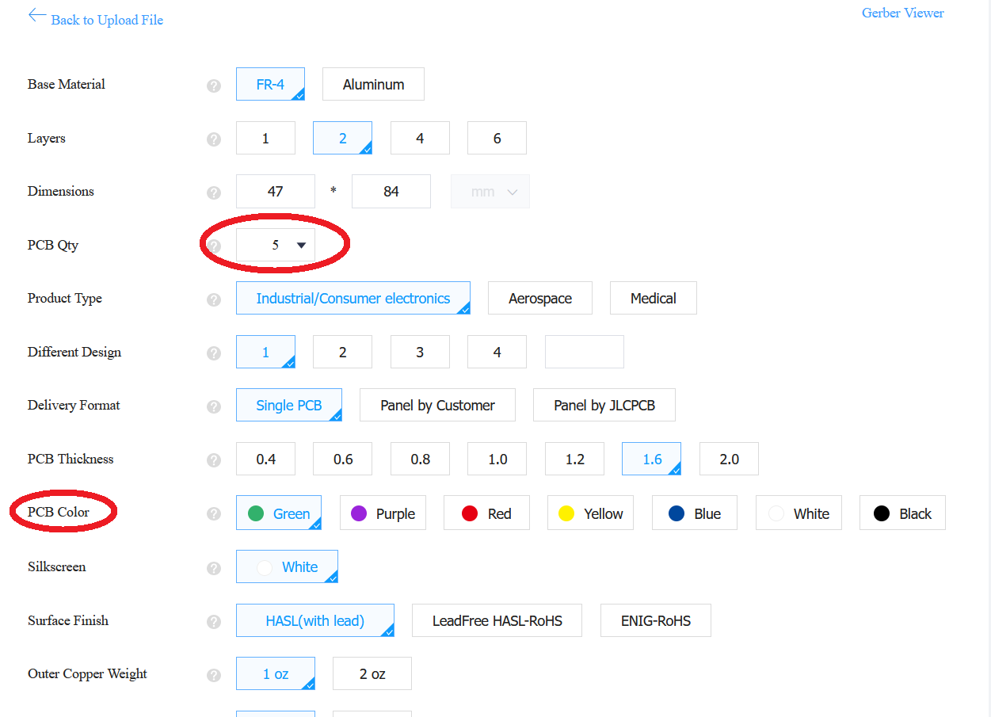
All colors are the same price; only non-green colors usually take two extra production days.
For example, purple has recently been added and looks great.
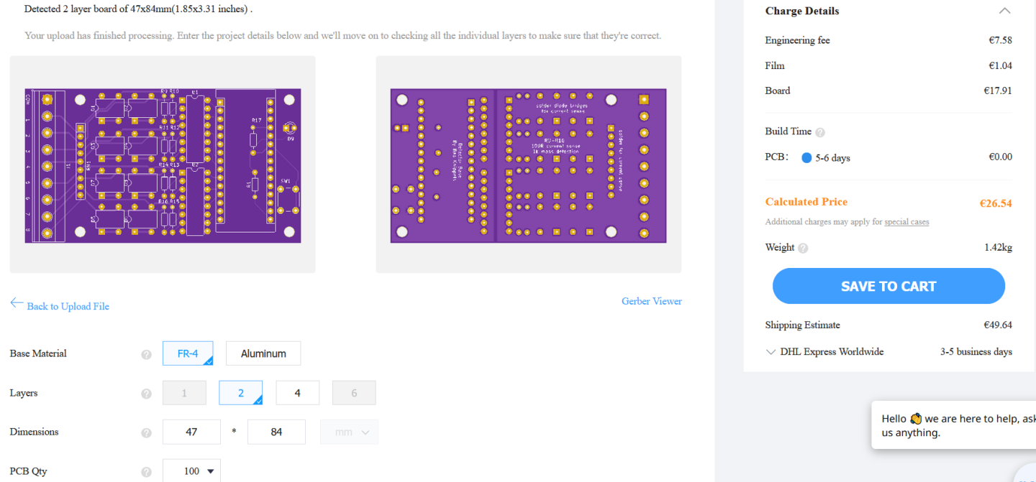
Every change you make immediately updates the displayed price and the 3D preview.

Step 4:
When you are satisfied with the settings, click “Save to cart.”
You will need a free JLCPCB account — it’s useful because they keep your files, so you can reorder the same PCB later without uploading again.
From your cart you can add more designs or go directly to checkout.
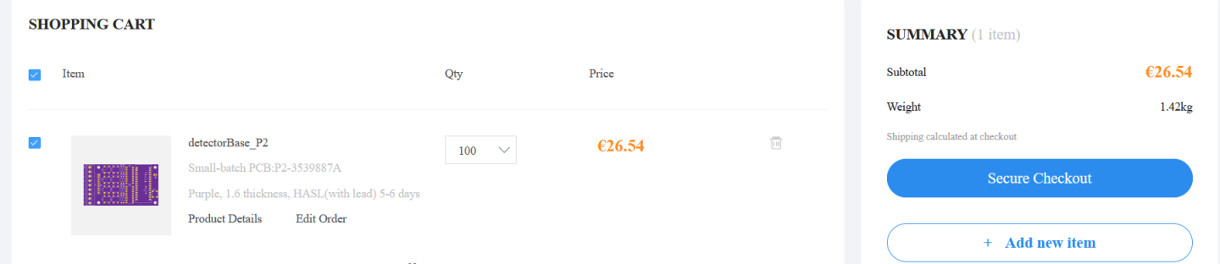

Step 5:
At checkout, choose your shipping method, enter your address once, and proceed to payment. You can pay by credit card or PayPal.
Delivery normally takes about 1–3 weeks depending on the chosen carrier.
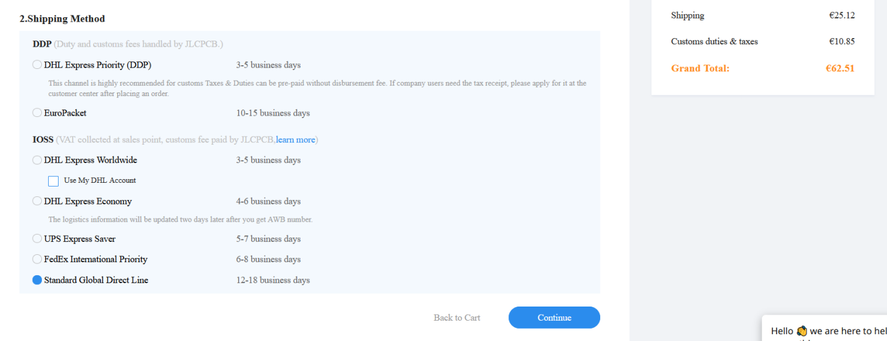

Step 6:
Once your PCBs arrive, solder the parts, get your project running, and enjoy it!

