# Making Monitoring Multitools with the Full Spectrum Laser

## Setting up the laser

1. Roll the laser cart near the fume hood with the laser’s exhaust port nearest to the fume hood.
2. Plug in the white power-strip plug and the computer’s power supply to the outlet on the right side of the fume hood.
3. Hook the laser’s exhaust hose into the glass doors of the fume hood so that the doors stay approximately 4” apart.
4. Turn on the power strip. This will start the exhaust fan, air compressor, and water pump.
5. Look into the laser and see if there are air bubbles circulating through the water jacket in the laser tube. *DO NOT OPERATE THE LASER IF THERE ARE LARGE AIR BUBBLES IN THE WATER JACKET. THIS CAN BURN OUT THE LASER TUBE.*
6. Push down and turn the red knob on the laser to turn on the laser. The laser will take a few minutes to boot up and acquire an IP address.

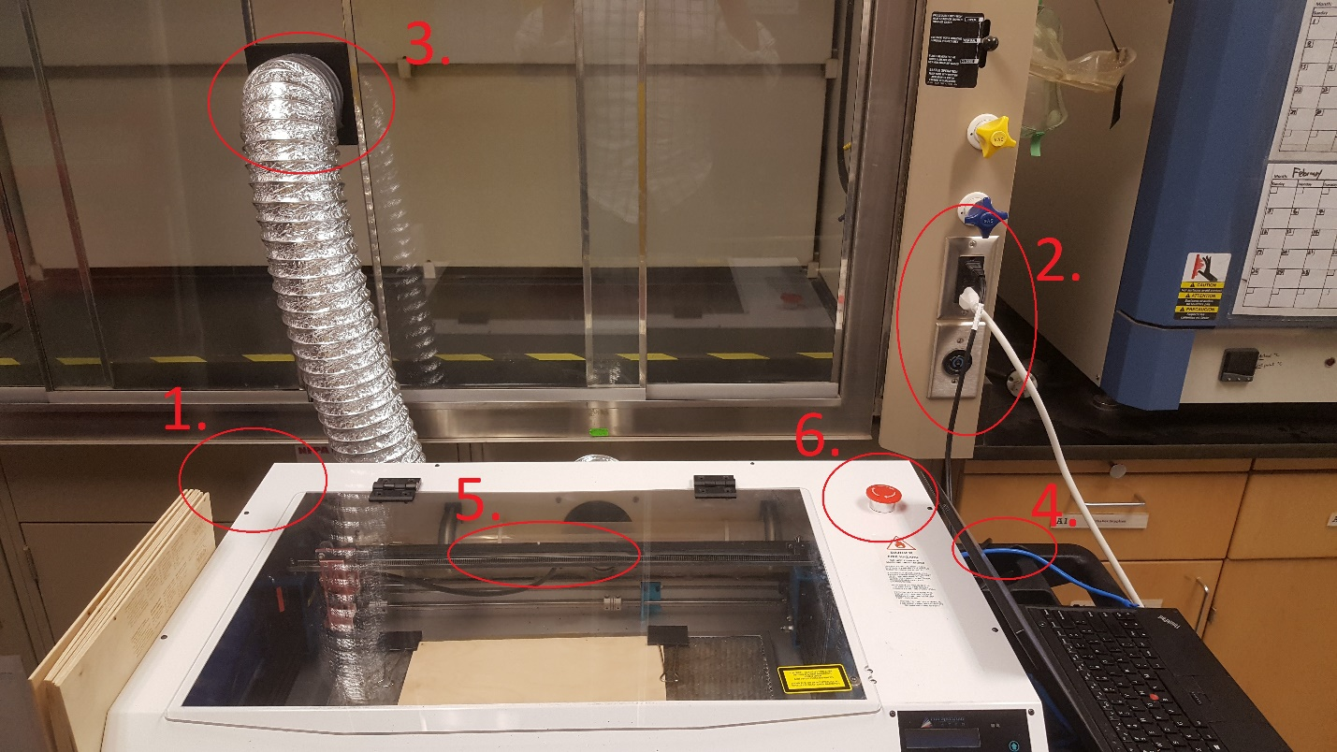

## Laser Controls

For normal operations, there are two buttons on the laser’s control panel that are useful.

1. The lock/unlock button – frees or locks the laser’s stepper motors. When the motors are free you can move the lens carriage around easily by hand. This is useful for focusing the laser. Lock the motors when you’re finished moving the carriage.
2. The Home button – returns the carriage to the home position.

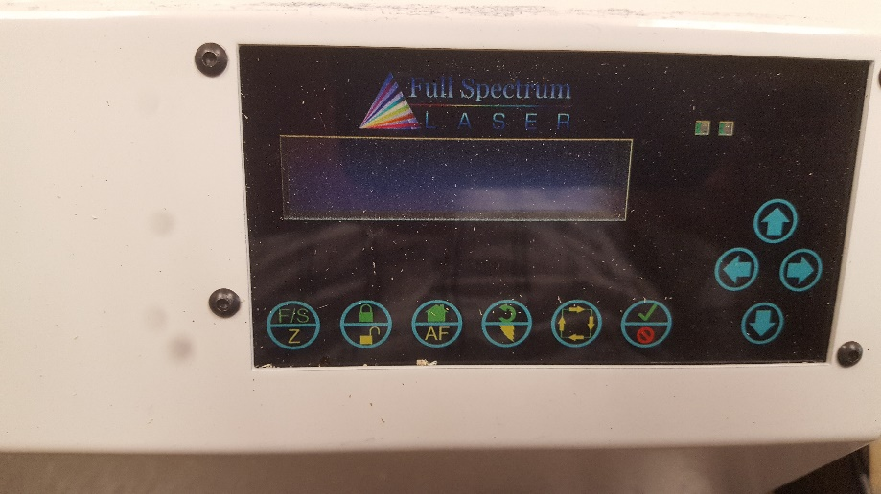

## Preparing wood for engraving and cutting

1. Monitoring Multitools are cut out 12”x12” pieces of 1/8” plywood.
2. Secure a piece of plywood to the aluminum honeycomb tray using the black binder clips, and either fold down the handles of the binder clips or remove them so they do not interfere with the movement of the lens carriage in the laser. 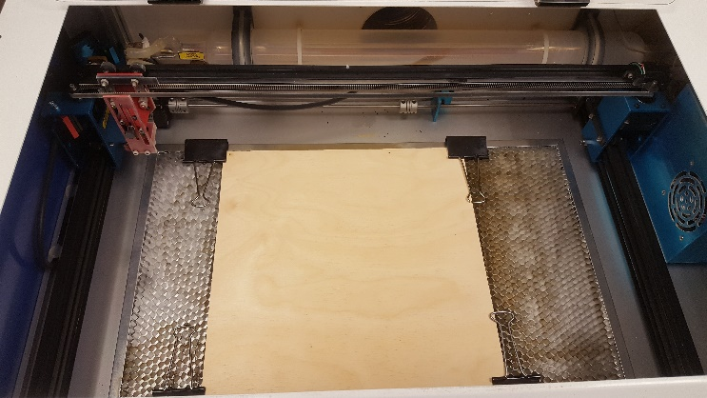
3. Try to keep the binder clips at close to the edge of the plywood as possible. This will allow for the multitools to be cut close to the edge and maximize the amount of leftover plywood that may be used for other project.

## Engraving/Cutting Monitoring Multitools from RetinaEngrave

1. Double-click on the RetinaEngrave Icon to start the application. Once started, look at the bottom-left corner of the screen and wait until RetinaEngrave connects to the laser and shows the laser’s IP address. Verify that the IP address listed matches the one shown on the laser’s control panel.

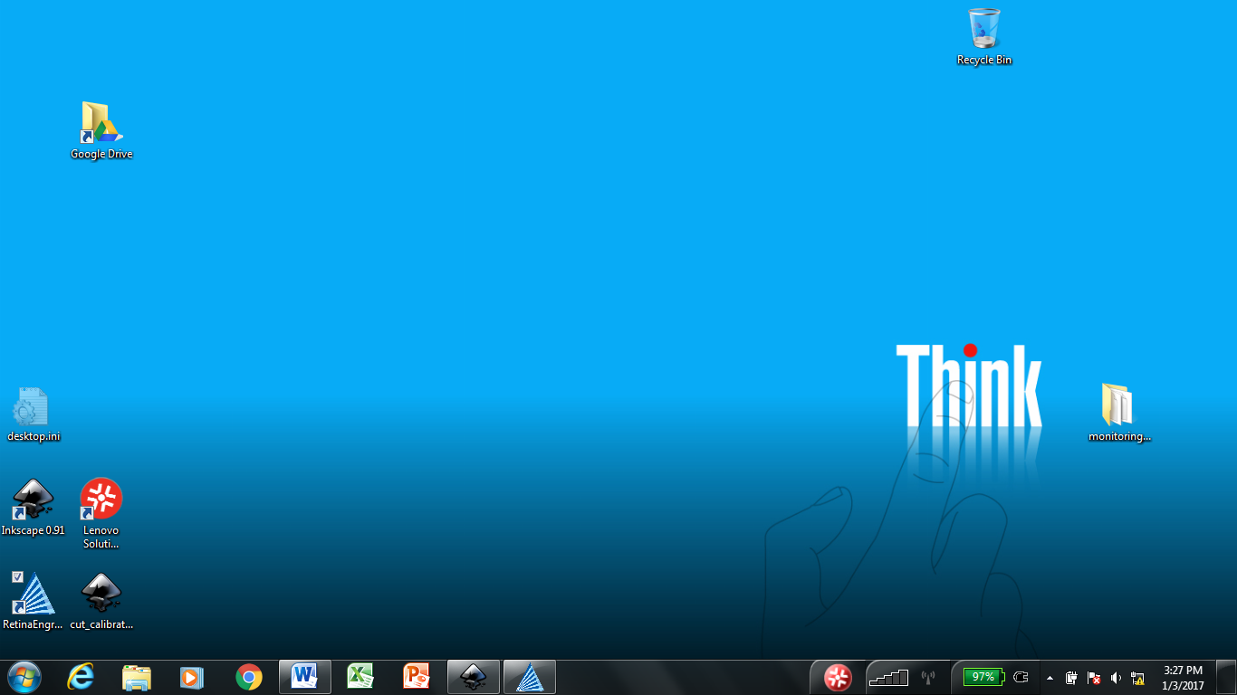  
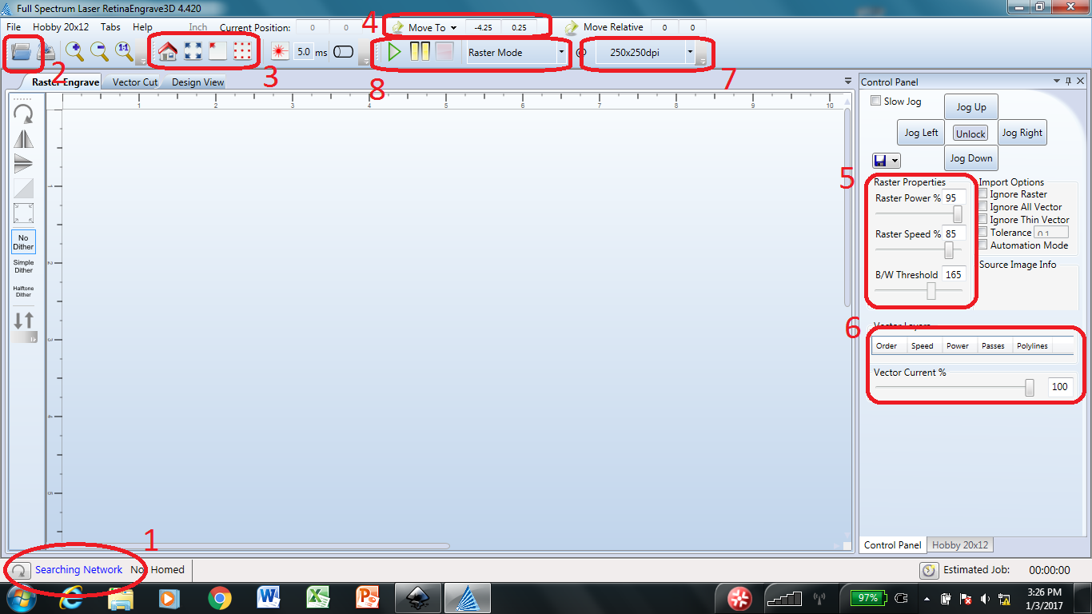

1. Click the Open icon to open the job file. Select the appropriate ***.set*** file and click **Open**. This will load the cut file and settings into RetinaEngrave. During the load process, you may encounter a message about loading a large raster job. Click **Yes** to continue.

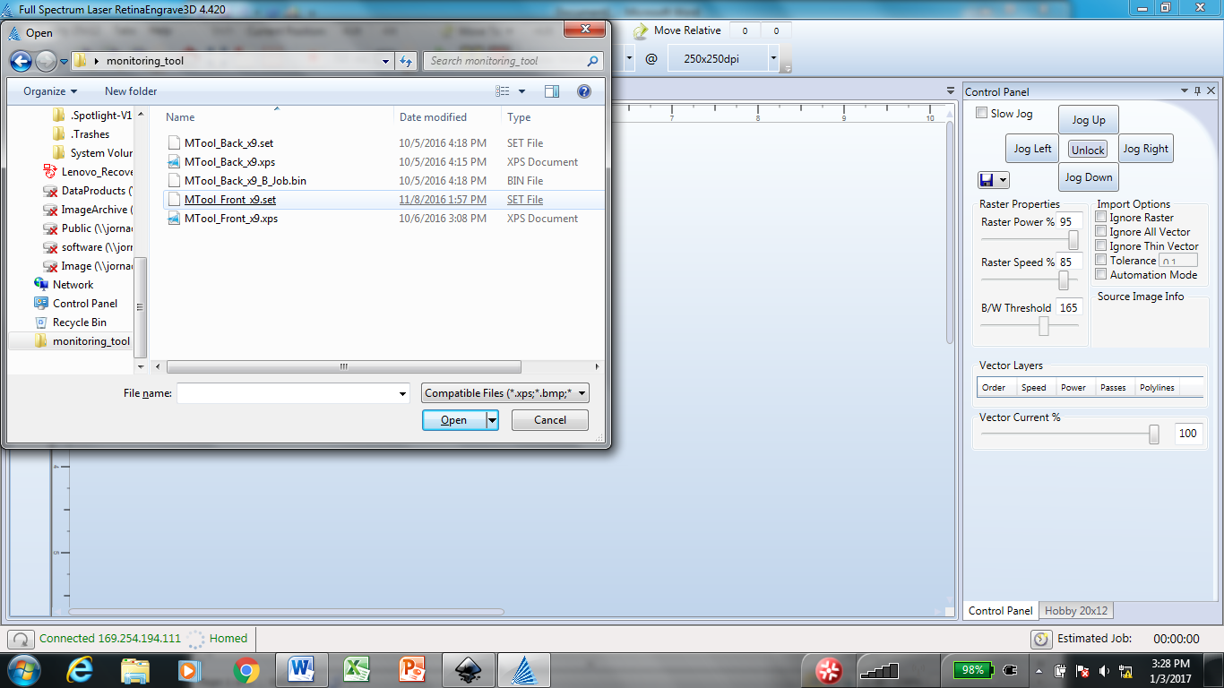 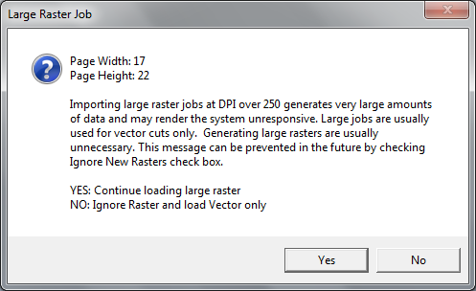

1. Use the arrow controls on the laser control panel to move the lens (red laser dot) to the upper-left corner of the plywood.  
     
   Once the red laser dot is in the correct starting location, use the extent buttons in RetinaEngrave to automatically move the laser lens to the maximum cut extent to ensure that the entire cut stays within the plywood area.  
   
2. You can also move the laser lens from within RetinaEngrave using the Move To button and specifying a location coordinate in inches.  
   
3. Set the raster engrave properties. Raster engrave properties control the intensity and speed of the engraving as well as the color threshold for engraving. Features above the color threshold will not be engraved. Refer to the green stickers on the laptop for optimal settings for engraving either front or back of the multitools.  
   
4. Set the vector cut properties. This controls the intensity of the laser during cutting, the speed at which the lens travels, and the number of cutting passes required. Each color in the original cut file will be included as a different cut line. In this way, you can cut only certain features of the object. Be sure to set the number of passes for objects like multitool text to 0. Again, refer to the green stickers on the laptop for optimal cut settings.  
   
5. Confirm that the raster engrave resolution is correctly set. Some operations in RetinaEngrave can cause this value to be reset. Refer to the green stickers on the laptop for the correct resolution for engraving the multitools.  
   
6. Confirm that the mode is set to **Raster then Vector**. This tells RetinaEngrave to first engrave the text for the multitools and then to subsequently cut them out. Once the wood and lens are properly aligned, and the correct properties in RetinaEngrave are set, click the **Play button (green triangle)** to begin engraving/cutting.  
   

## Engraving/Cutting Monitoring Multitools from the Laser Control Panel

The laser saves the last job that it ran. This means that you can rerun the previous job directly from the laser without needing the laptop or RetinaEngrave. This is useful when you need to cut a lot of multitools as you can simply switch out the wood, align it, and start the next batch. This will even work if the laser has been turned off. Once the laser has been turned back on and finished its boot cycle, you can reprint directly from the laser.

1. Follow the steps above for setting up the laser and preparing a piece of wood for cutting.
2. Use the laser control panel arrows to position the lens (red pointer dot) in the upper left corner of the wood.  
   
3. Push the F/S button once, then push the down-arrow button.  
   
4. The LCD display should show, “Run Previous Job?”. Use the down arrow to select “Y”, then press the green checkmark button.  
   

## General Tips and Troubleshooting

The laser is generally very robust and should operate without much problem. The following tips, however, are useful.

* Keep the laptop on and plugged in. The battery in the laptop is old and doesn’t hold a charge. If the laptop is turned off, it takes a long time to boot it back up.
* If the laser is turned off while RetinaEngrave is open, the laser may acquire a different IP address when it boots back up. You can either close and reopen RetinaEngrave or within RetinaEngrave, click on the network refresh button to find the laser again.  
  
* The laser must be properly focused to engrave and cut effectively. If the height of the wood changes, the lens will need to be refocused. Also, the lens will slowly come of out focus over time. Refer to the laser’s operation manual for how to focus the laser. It is easy to do.
* Occasionally wipe down the laser tube and other parts inside the laser using a damp paper towel (wet with water or vinegar solution). Smoke residue builds up inside the laser case.
* Also, occasionally vacuum out the inside of the laser case to keep wood dust and pieces to a minimum. Having a lot of debris in the laser case can be a fire hazard.