

**AUTOMATIC PLANT WATERING SYSTEM**

[RESEARCH PROJECT]



2017-2018

RAM LAL ANAND COLLEGE, UNIVERSITY OF DELHI

**AUTOMATIC PLANT WATERING SYSTEM**

**(Technique to automate watering of plants/crops in large areas)**

**Team Members**

|  |  |  |
| --- | --- | --- |
| **RAHUL BHATIA** |  | **PUSHKAR GOSH** |
| 4158441004 |  | 4158441030 |
| Bhatiarahul51@gmail.com |  | pukoongosh@gmail.com |

University of Delhi

*A Final Year Project Report*

*Submitted in Partial Fulfilment of the Requirements of*

*Award of Degree of*

*Computer Science and Engineering*

*By*

**Name Roll No.**

RAHUL BHATIA 4158441004

PUSHKAR GOSH 4158441030

*Under the Esteemed Guidance of*

**Prof** **Barkha Chawla**

**Prof Shikha Verma**

 **RAM LAL ANAND COLLEGE**

**(UNIVERSITY OF DELHI)**

**Address:** Benito Juarez Marg, New Delhi, Delhi 110021

**Phones:**011 2411 2557

**Founded: 1964**

**Department of Computer Science**

**CERTIFICATE**

This is to certify that the Final Year Project report entitled “**AUTOMATIC PLANT WATERING SYSTEM”** is beingsubmitted by the following student (s) in partial fulfilment of the requirements for the award of degree of **Bachelor of Technology** in **Computer Science and Engineering** from **Ram Lal Anand College, Delhi University**, New Delhi is record of bonafide work carried out during the academic year of 2016.

Rahul Bhatia 4158441004

Pushkar Gosh 4158441030

Under the supervision and guidance of

Internal Guides Head of the Department

**Prof Barkha Chawla Dr. Neeraj Sharma**

**Prof Shikha Verma**

**ACKNOWLEDGEMENT**

With great pleasure we want to take this opportunity to express our heartfelt gratitude to all the people who helped in making our final year project work a grand success.

We express our deep sense of gratitude to **Dr. Neeraj Sharma** for his constant guidance throughout our mini project work.

We are grateful to **Prof Barkha Chawla, Prof Shikha Verma** for their valuable suggestions and guidance during the execution of this project work.

We would like to thank the **Teaching & Non- Teaching staff** **of Computer Science Department** for sharing their knowledge with us. They have been great sources of inspiration to us and we thank them from the bottom of our hearts.

Last but not the least we express our sincere thanks to our friends and classmates for all the thoughtful and mind stimulating discussions we had, which prompted us to think beyond the obvious.

RAHUL BHATIA

PUSHKAR GOSH

Table of Contents

Abstract 1

Chapter 1: Introduction 1

Chapter 2: Problem Analysis 1

2.1 Problem Type 1 1

2.2 Problem Type 2 1

Chapter 3: Requirement Specification 1

Chapter 4: Design Specifications 1

Chapter 5: Development of Remote System 1

5.1 Stage 1 1

5.2 Stage 2 1

5.3 Integration of Parts of Code 1

5.4 Final Working website 1

Chapter 6: Testing against the specifications 1

6.1 User 1 Test 1

6.2 User 2 Test 1

6.3 User 3 Test 1

Chapter 7: Evaluation / Results 1

7.1 Tabular data 1

Chapter 7: Conclusion (Scope of the Project) 1

Bibliography 1

Abstract

This project is based on the idea to produce a product that solves the problem of water wastage as well as watering plants/crops with the help of smartphones.

Smartphones nowadays are readily available and can be used to do almost anything automatically that is why we used this technology.

The given prototype will enhance the user typically a farmer functionality to water plants or crops on large fields through a network of plastic pipes/straws.

**INTRODUCTION**

The main aim of this project is to build a system that will automate watering functionality through a smartphone that will enhance the functionality of humans to reach and water the crops or plants present on large surface areas such as fields or large botanical gardens etc.

Hence, we decided to do a thorough research on this topic and develop an AUTOMATIC WATERING SYSTEM which will be controlled by Bluetooth system from android smartphone.

It will contain features like: -

1. Can be controlled by any android smartphone using Bluetooth
2. Can be easily assembled on site
3. Lowest cost possible for making
4. Accurate in every move possible
5. Can reach large areas
6. Can be used in any field or garden
7. Can be used in remote areas where there is no electricity

This System will help you to irrigate your**backyard Garden or your Indoor Garden automatically** and you need not worry about watering your favorite plants in your busy schedule.

We will be using these components for the project: -

**REQUIREMENT SPECIFICATIONS**

* **Arduino Uno**

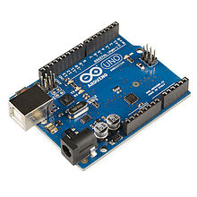

**Arduino** is an open-source project that created microcontroller-based kits for building digital devices and interactive objects that can sense and control physical devices. [1]

The project is based on microcontroller board designs, produced by several vendors, using various microcontrollers. These systems provide sets of digital and analog input/output (I/O) pins that can interface to various expansion boards (termed *shields*) and other circuits. The boards feature serial communication interfaces, including Universal Serial Bus (USB) on some models, for loading programs from personal computers. For programming the microcontrollers, the Arduino project provides an integrated development environment (IDE) based on a programming language named *Processing*, which also supports the languages C and C++.

* **Bluetooth module**

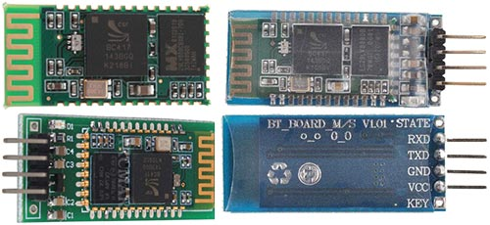

As a Bluetooth module uses cheap Chinese module HC-06, which has been described in this article.

* **Motor Driver**

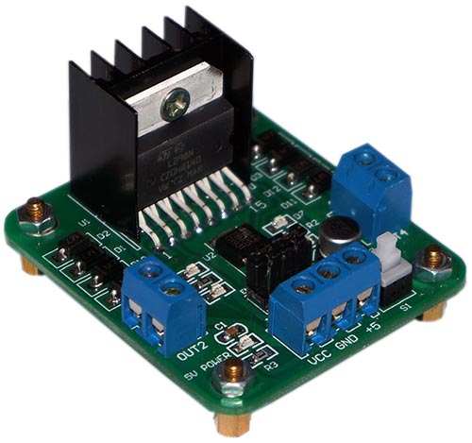

**To send the data to and fro from the Arduino.**

* **MOTOR PUMP**

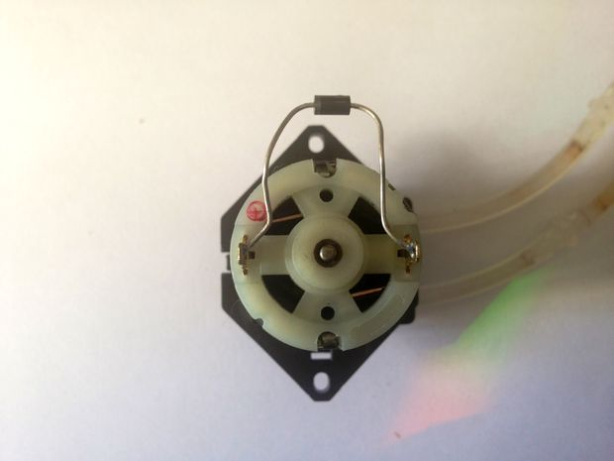

**OPTIONAL Product soil moisture sensor for measuring soil sensitivity:**

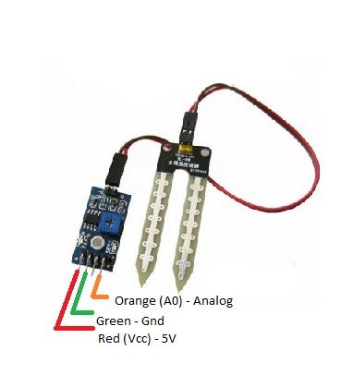

**OBJECTIVE AND SCOPE OF THE PROJECT**

The objective and scope of the project to build a finalized version of a sytem that later on can be used by the farmers or gardeners on their smartphones.

By the end of the project the prototype should meet the specifications that are:

* Able to be establish a connection between users’ phone and system.
* Able to run on any type of surface.
* Able to run accurately as commanded by the user.

**Theory**

All calculations are performed in the Android-application, and immediately calculate the values of the PWM for the left and right motor. Application has flexible settings, such as the range of the PWM, the sensitivity of tilt, the minimum threshold for the PWM and other. Example commands transmitted by Bluetooth:  
**L-255\rR-120\r**  
L – the command to the left engine, R – for the right  
A dash means the motor rotation to move back  
255 – PWM value (for Arduino is the maximum speed of rotation)  
\r – end of command.  
On this command RC car will move forward and slightly rotated to the right, as right engine rotates slowly left.

**L255\rR-255\r**  
On this command the left engine will rotate back and forward right, forcing a car to rotate around its axis counterclockwise.

**H1\r**  
Command is an additional channel to which you can connect for example lights, sound, etc.

Symbols command L, R and H can be defined in the settings of Android-applications.

In the MCU control program provides a timer that shuts off the engine if the last command was received more than n-seconds ago. The data are stored in the EEPROM memory of the controller and can be changed from Android device. The range of this setting is from 0.1 seconds to 99.9 seconds. This setting can be disabled. To work with EEPROM provides commands: **Fr** – reading values and **Fw**– record values.

Some of the simulation prototypes at the beginning:-

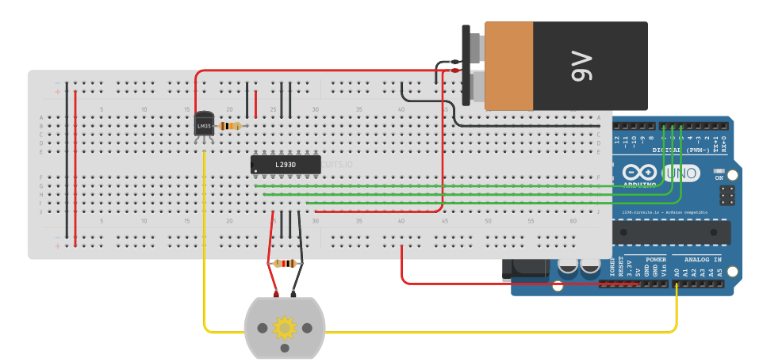

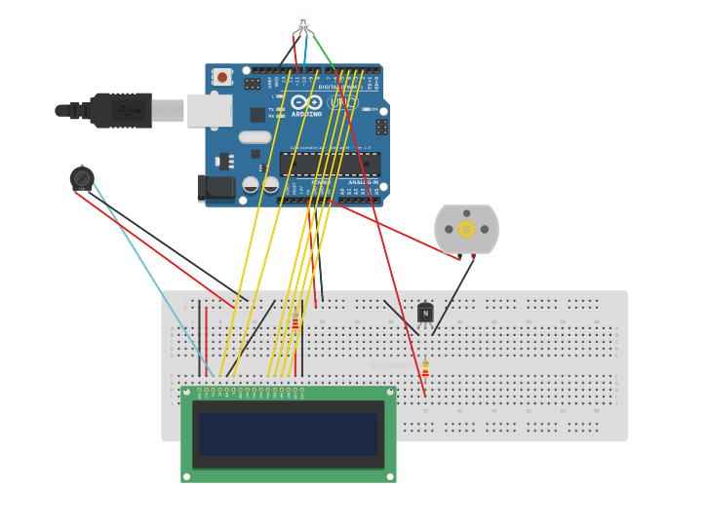

**DESIGN SPECIFICATION**

**WHY IS THE PARTICULAR TOPIC CHOSEN?**

We have worked on this topic before and it can be done with the knowledge we possess. The Project takes the knowledge of embedded system, Arduino programming and android programming. The skills that are required by this project are present on the team members. The mentor and the mentee can collaborate and can share their knowledge on the project that surely will lead to the final completion of the project.

We have worked on several android and hardware projects which enables us to make this project a reality.

The project is distributing in 3 phases

1. **Hardware phase**

The project will have required hardware tools in hardware phase where all things are assembled and connected to each other:

Arduino Uno or similar

Motor Driver for giving direction

Pumps and motors

Android smartphone

Bluetooth communicator module

Batteries

Wires

1. **Arduino Programming**

Arduino programming where the Arduino is specifically programmed to meet the project specifications stated above.

1. **Android Programming**

Android programming will contain compiling an app that can establish a connection between system and phone to enable the movement of pump from the user.

**TESTING AND EVALUATING RESULTS**

Testing of car on the surface and whether the Bluetooth is working or not?

Here is the picture of testing the module of the car: -

Results are satisfactory it works on all surfaces and commands are receiving properly through the phone.

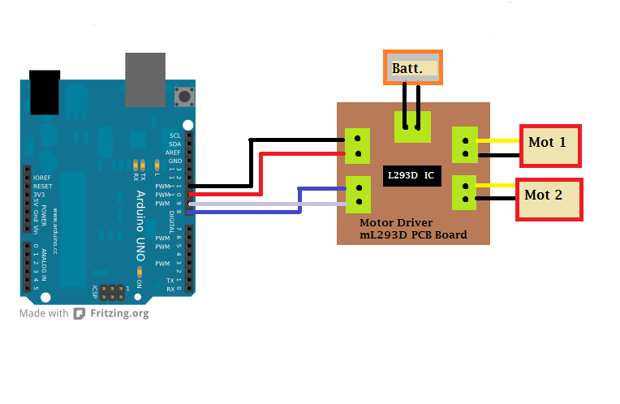

Arduino satisfied all results:

PC RESULTS

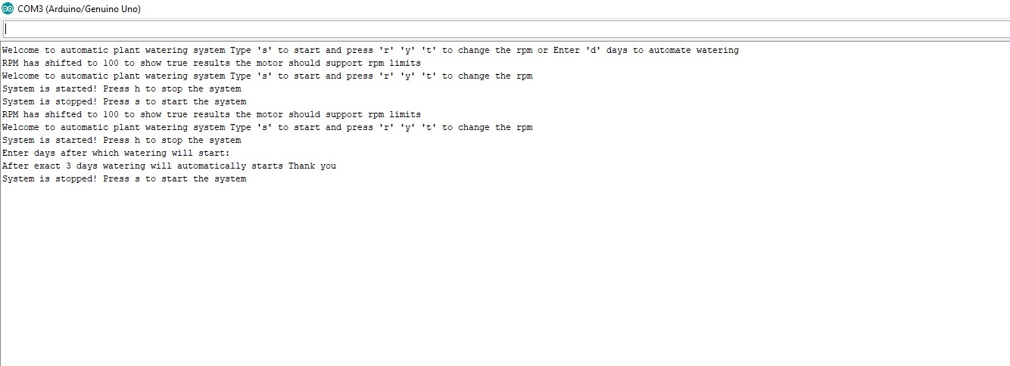

SMARTPHONE RESULTS:

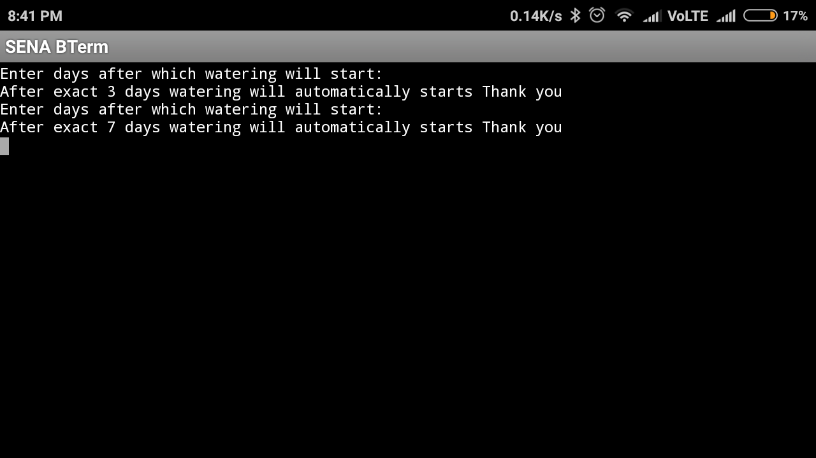

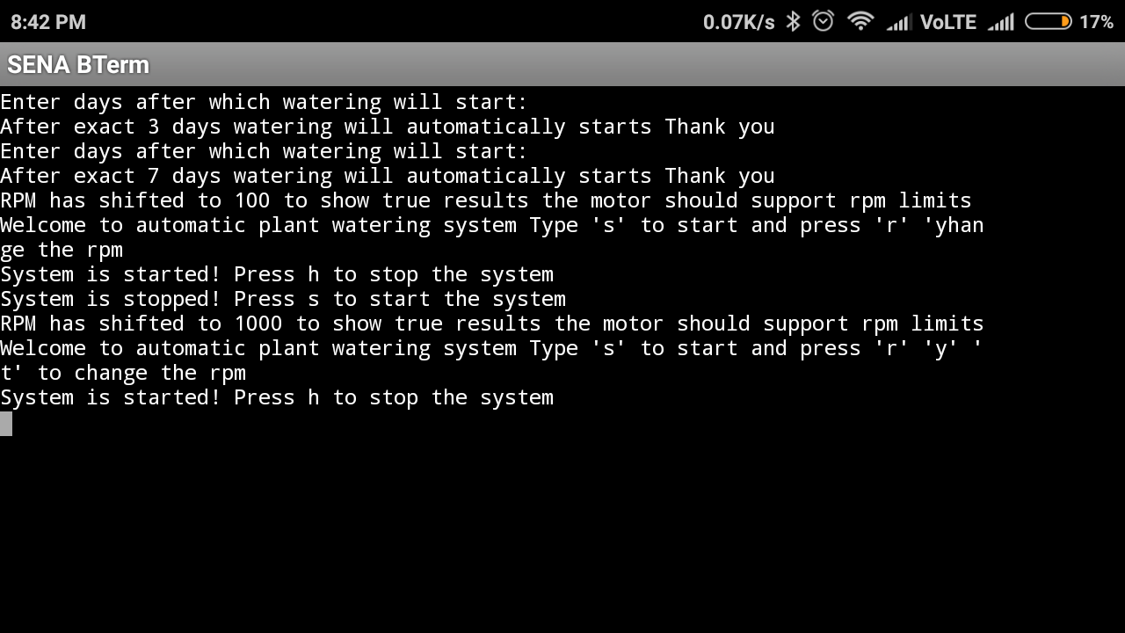

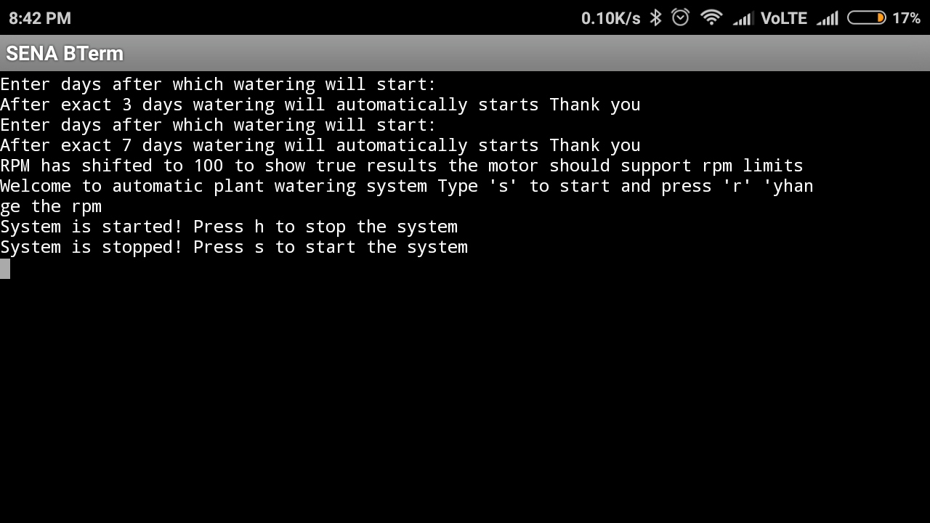

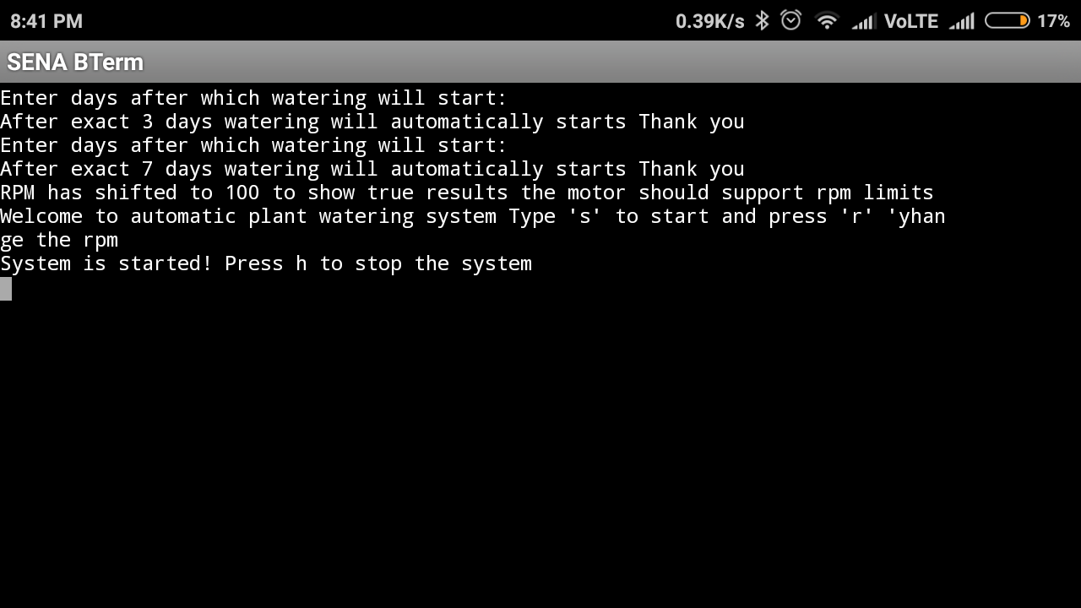

FUTURE OF THE PROJECT

We intend to add the functionality of soil moisture but it can become costly so we halted the purchase of the module and focused more on automation through user and time constraint.

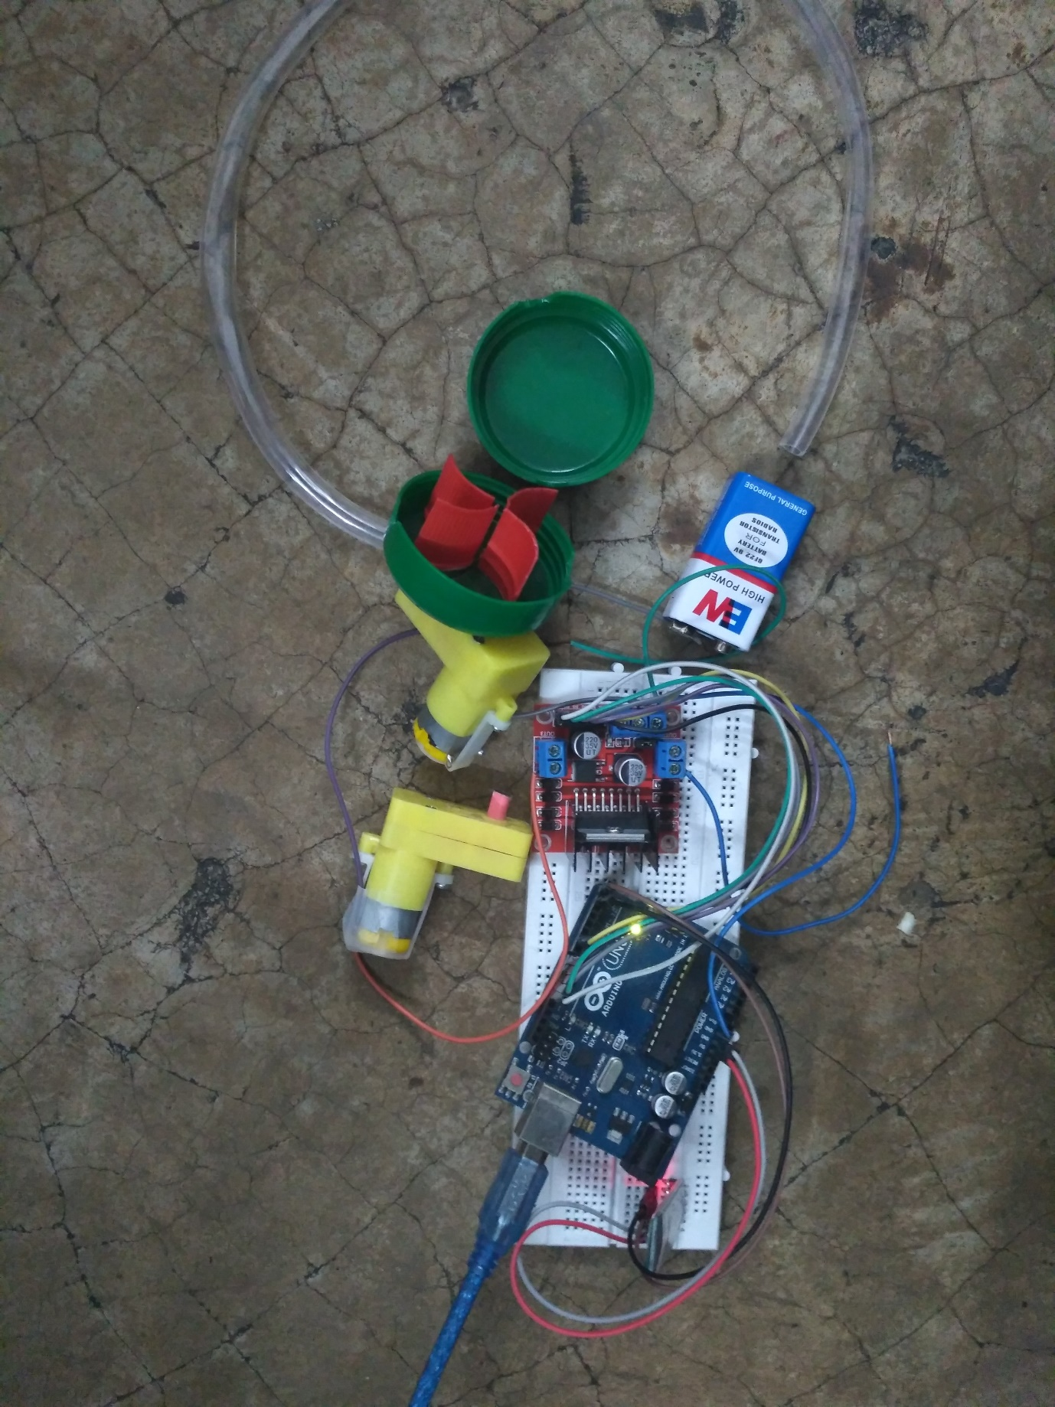

**CONCLUSION**

We have made this system cost and productivity efficient using the research already done by author of the research paper but with more effectiveness and susceptibility using android as a platform tool which are nowadays common in every field. And improved the research paper guidelines and effectivity in the product. We thank all the teachers of computer science department for mentoring us for this project. We hope that not only small farmers and gardeners but also common people will get benefit of this project. Thank you

**BIBILIOGRAPHY**

Research Paper:-

Automated Plant Watering System Through Personal Computer

Drashti Divani

Computer Engineering,

SIES Graduate School of

Technology

Pallavi Patil

Computer Engineering,

SIES Graduate School of

Technology

Prof. Sunil K. Punjabi

Assistant Professor

SIES Graduate School of

Technology

Navi Mumbai, India

drashtidivani@gmail.com

Navi Mumbai, India

pallavi24895patil@gmail.com

Navi Mumbai, India

sunil.punjabi@siesgst.ac.in