* 1. Sensitivity Analysis

# 1. Sensitivity Analysis

Figure 1: Sensitivity of C_max of Organism|VenousBlood|Plasma|Raltegravir|Concentration for individuals at percentiles 0.25, 0.5, 0.75 in simulation sets ‘ral’.

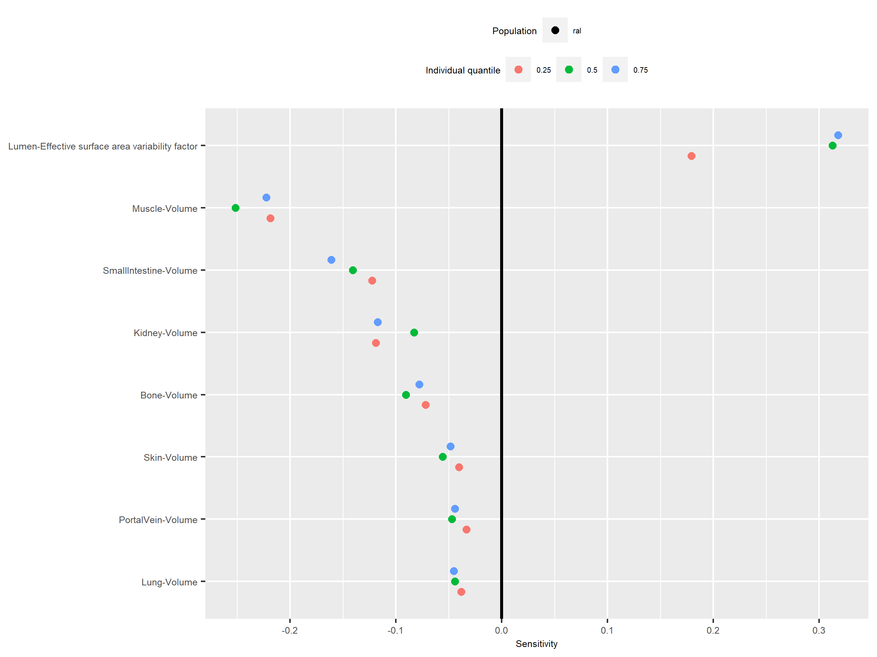

Figure 2: Sensitivity of t_max of Organism|VenousBlood|Plasma|Raltegravir|Concentration for individuals at percentiles 0.25, 0.5, 0.75 in simulation sets ‘ral’.

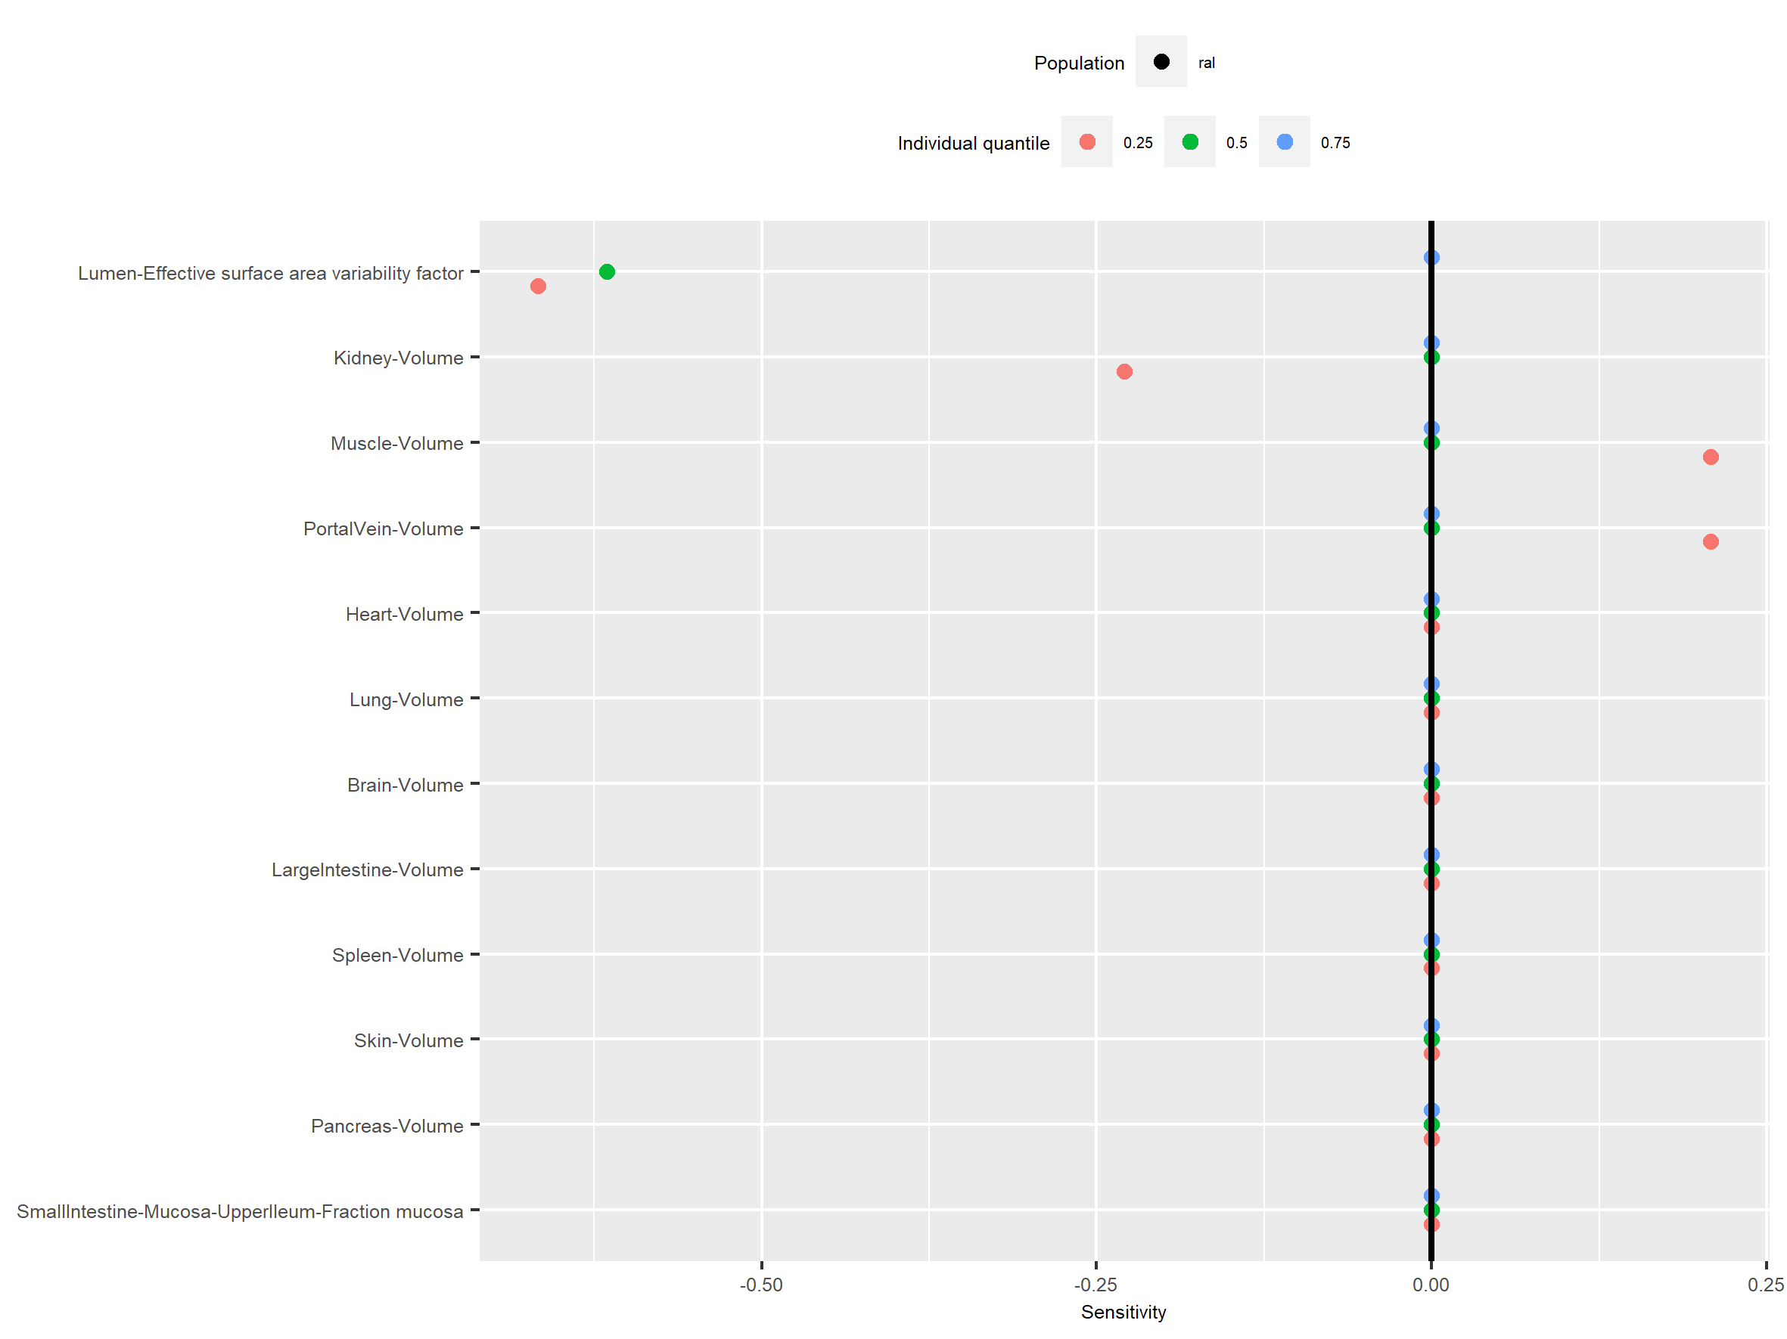

Figure 3: Sensitivity of C_tEnd of Organism|VenousBlood|Plasma|Raltegravir|Concentration for individuals at percentiles 0.25, 0.5, 0.75 in simulation sets ‘ral’.

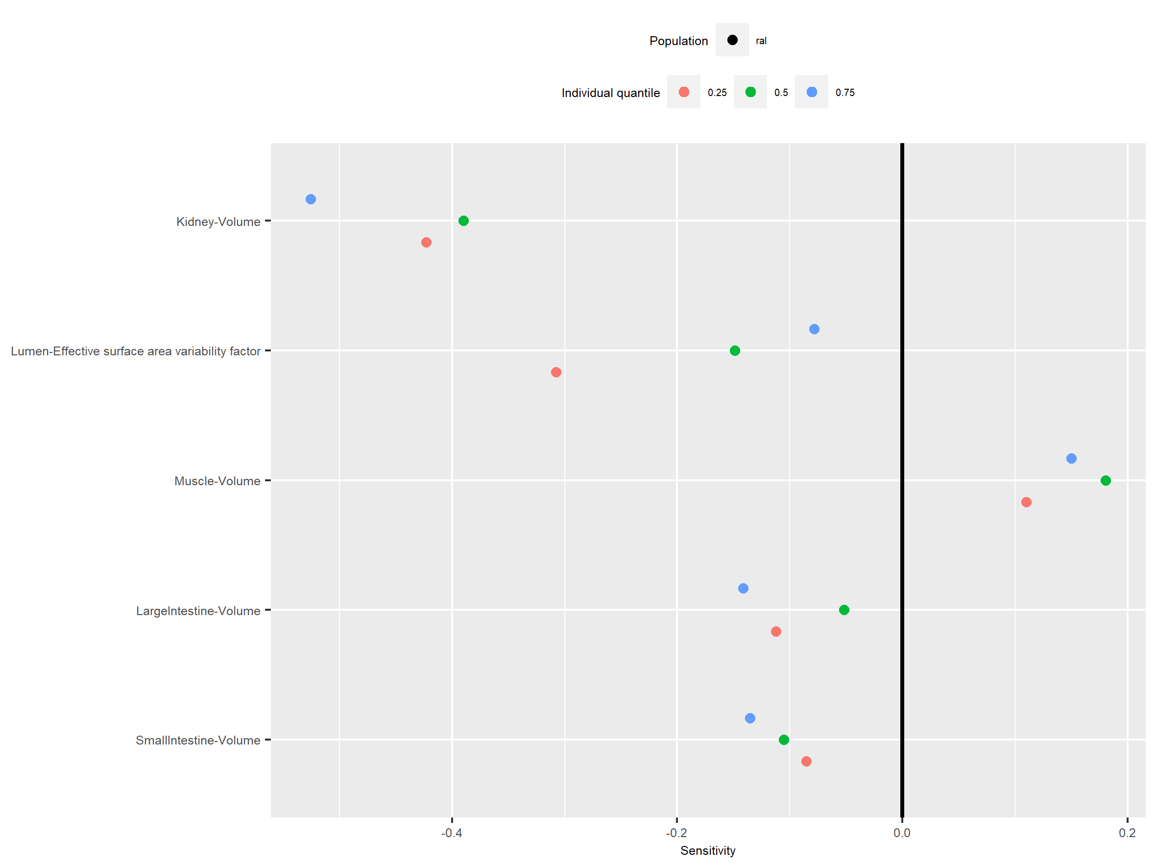

Figure 4: Sensitivity of AUC_tEnd of Organism|VenousBlood|Plasma|Raltegravir|Concentration for individuals at percentiles 0.25, 0.5, 0.75 in simulation sets ‘ral’.

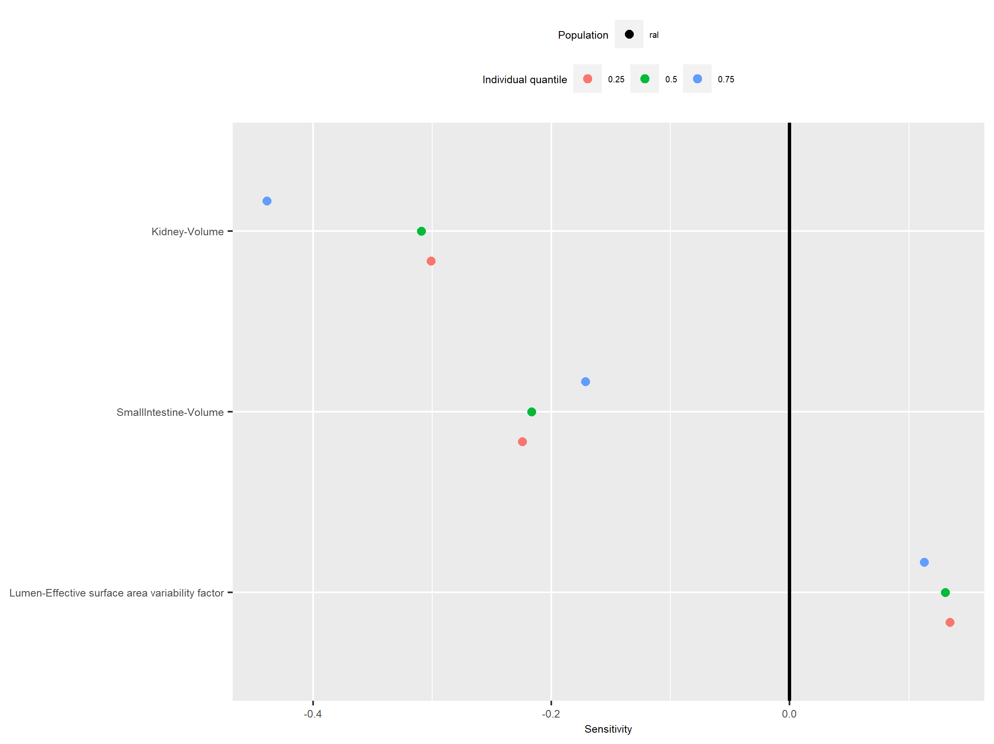

Figure 5: Sensitivity of AUC_inf of Organism|VenousBlood|Plasma|Raltegravir|Concentration for individuals at percentiles 0.25, 0.5, 0.75 in simulation sets ‘ral’.

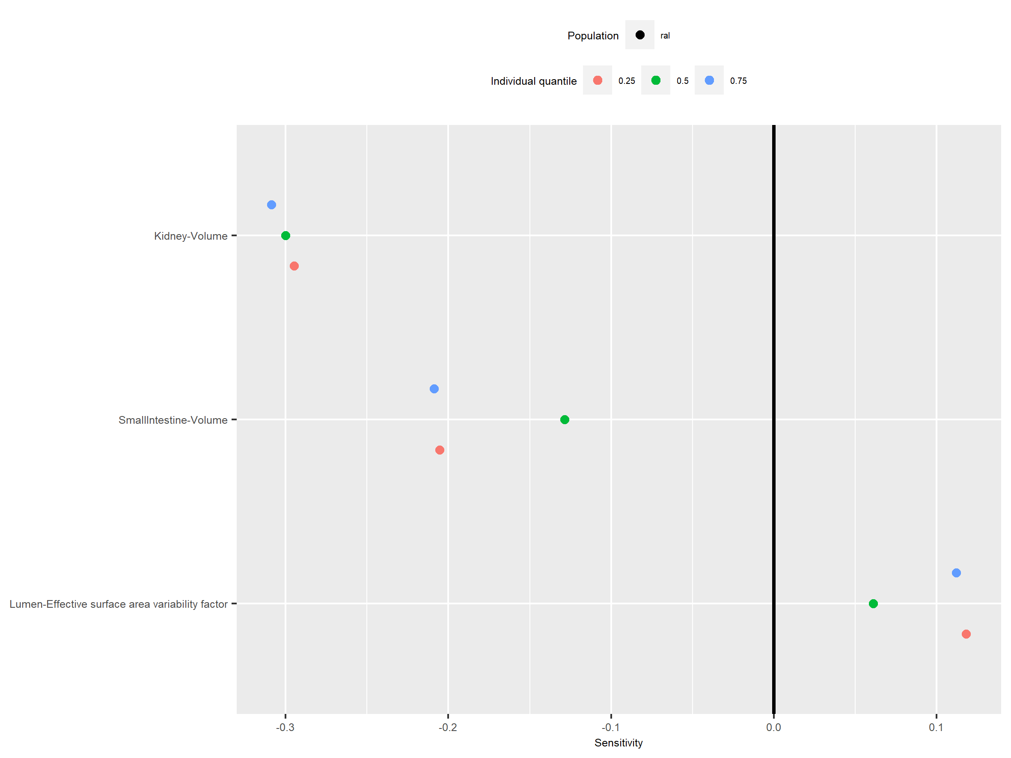

Figure 6: Sensitivity of MRT of Organism|VenousBlood|Plasma|Raltegravir|Concentration for individuals at percentiles 0.25, 0.5, 0.75 in simulation sets ‘ral’.

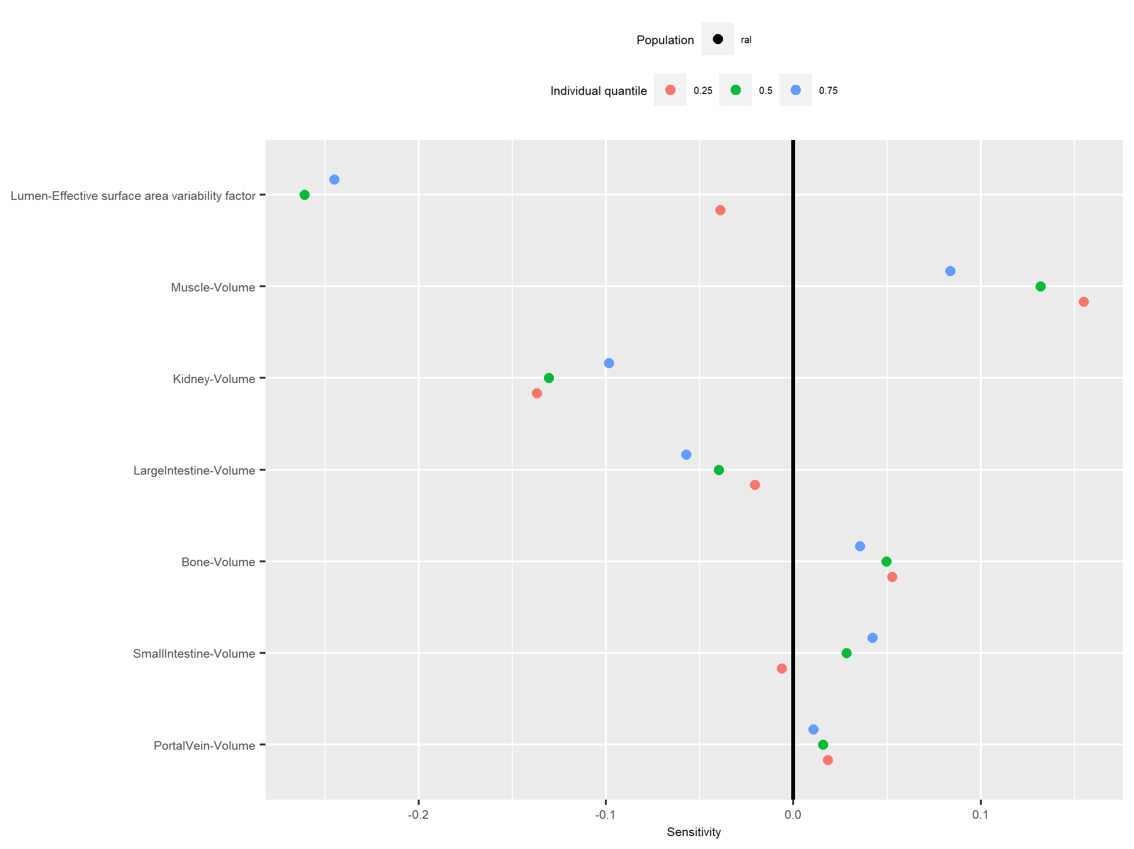

Figure 7: Sensitivity of Thalf of Organism|VenousBlood|Plasma|Raltegravir|Concentration for individuals at percentiles 0.25, 0.5, 0.75 in simulation sets ‘ral’.

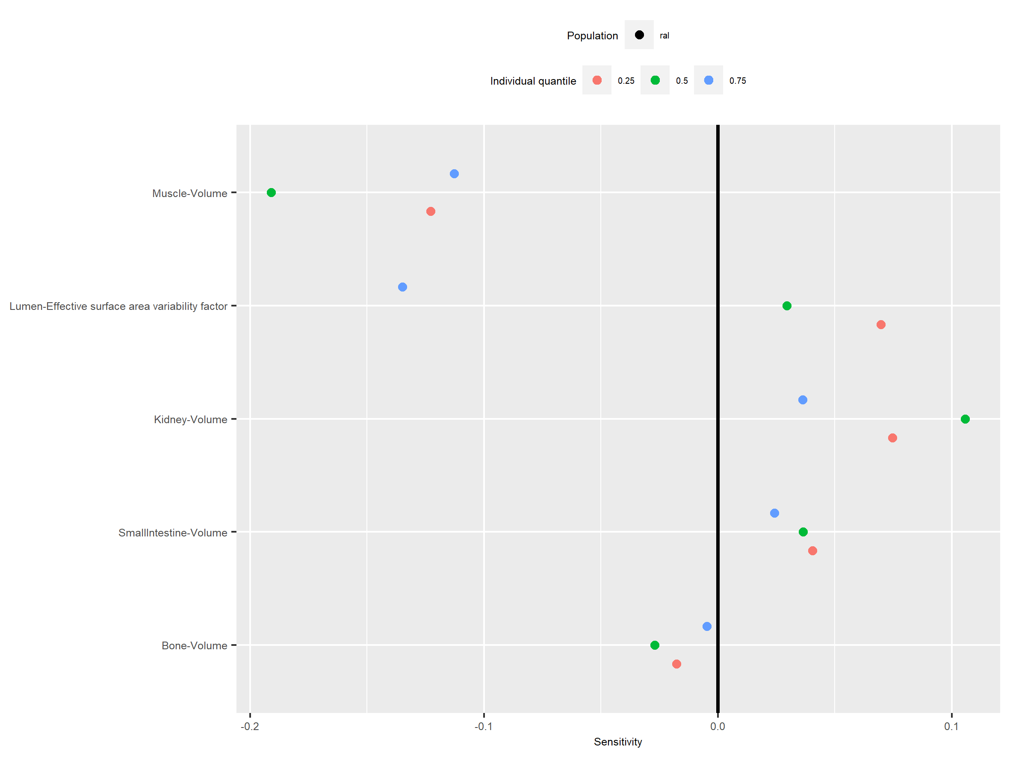

Figure 8: Sensitivity of FractionAucLastToInf of Organism|VenousBlood|Plasma|Raltegravir|Concentration for individuals at percentiles 0.25, 0.5, 0.75 in simulation sets ‘ral’.

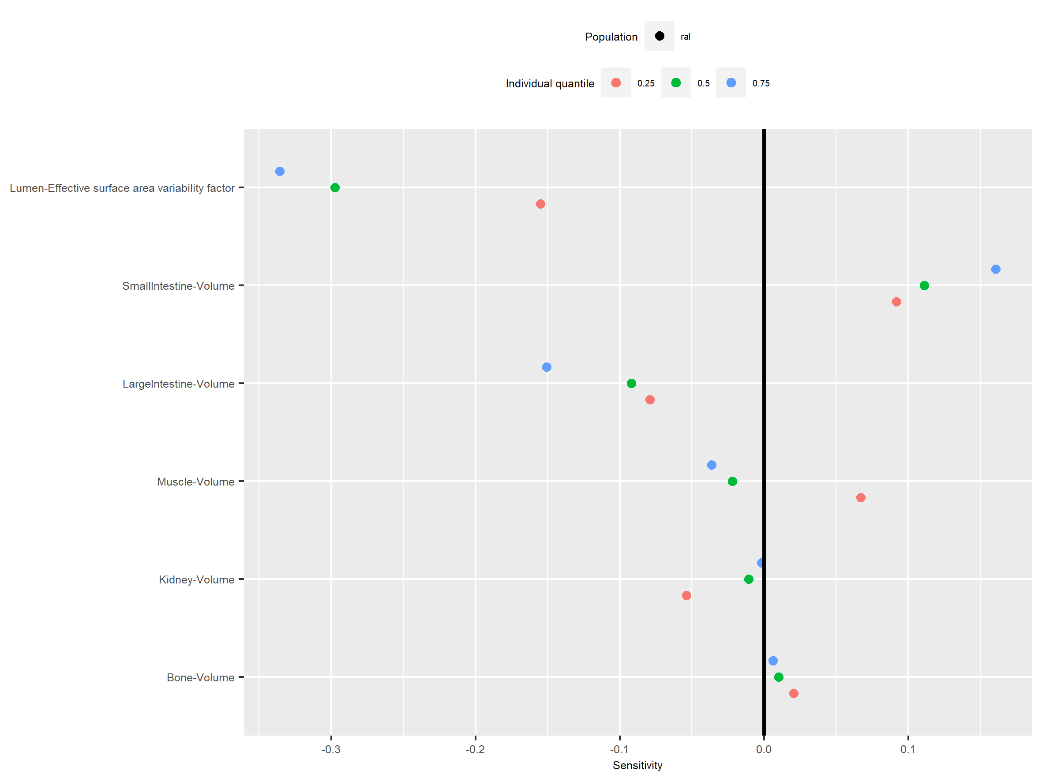

Figure 9: Sensitivity of CL of Organism|VenousBlood|Plasma|Raltegravir|Concentration for individuals at percentiles 0.25, 0.5, 0.75 in simulation sets ‘ral’.

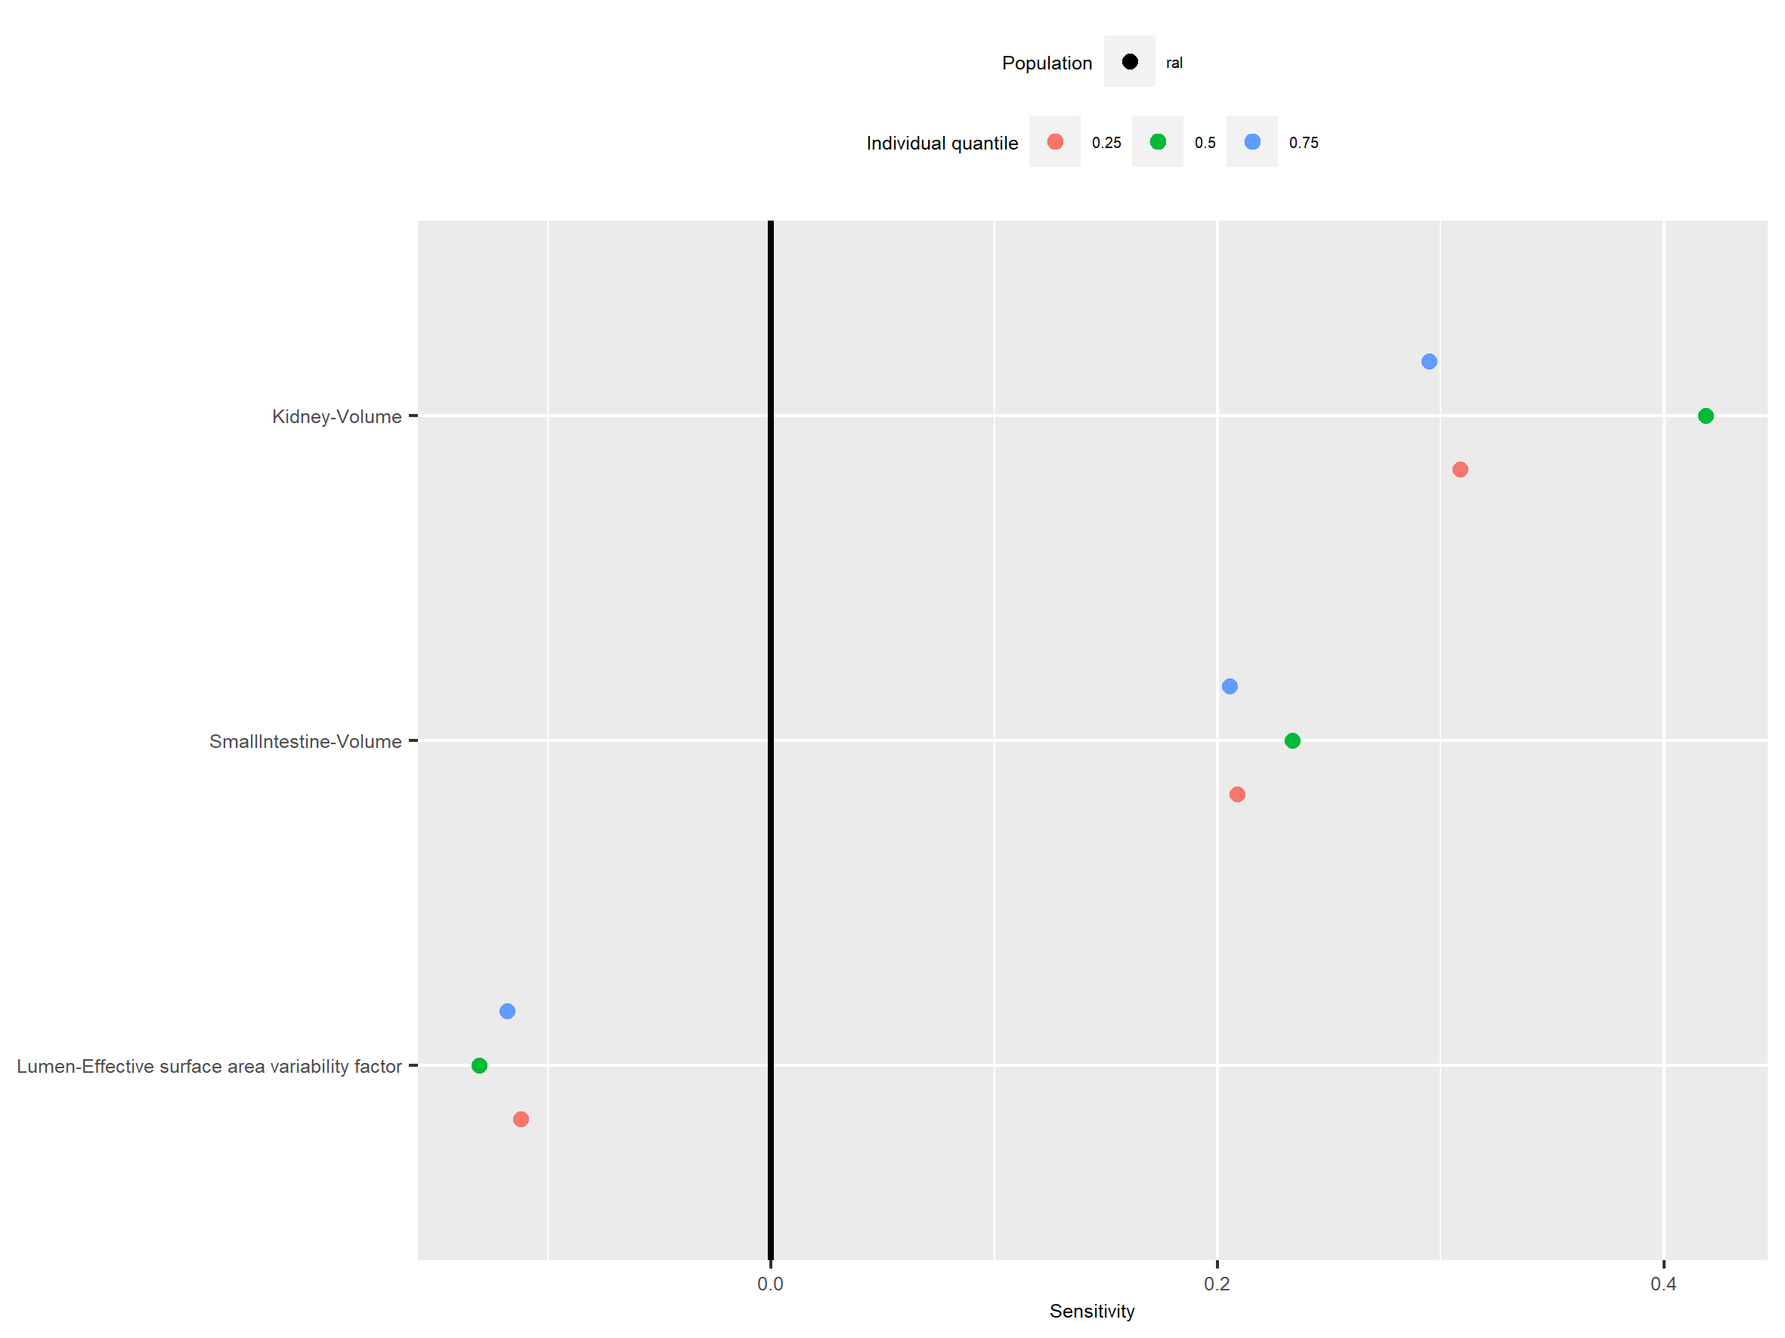

Figure 10: Sensitivity of Vss of Organism|VenousBlood|Plasma|Raltegravir|Concentration for individuals at percentiles 0.25, 0.5, 0.75 in simulation sets ‘ral’.

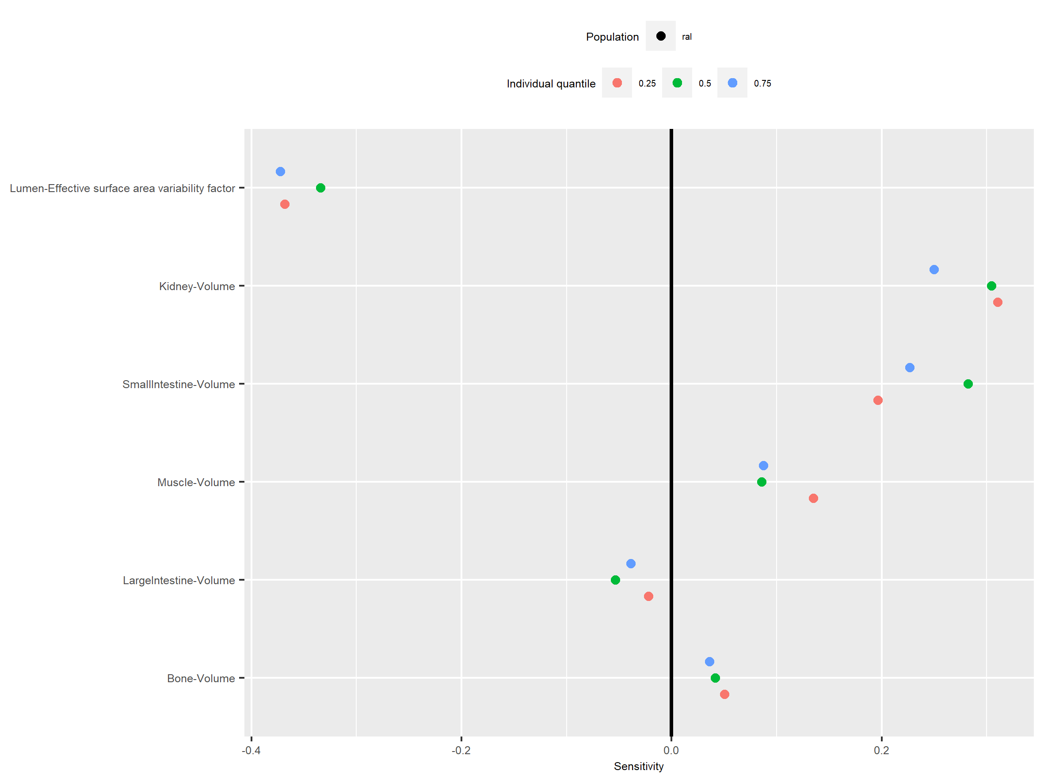

Figure 11: Sensitivity of Vd of Organism|VenousBlood|Plasma|Raltegravir|Concentration for individuals at percentiles 0.25, 0.5, 0.75 in simulation sets ‘ral’.

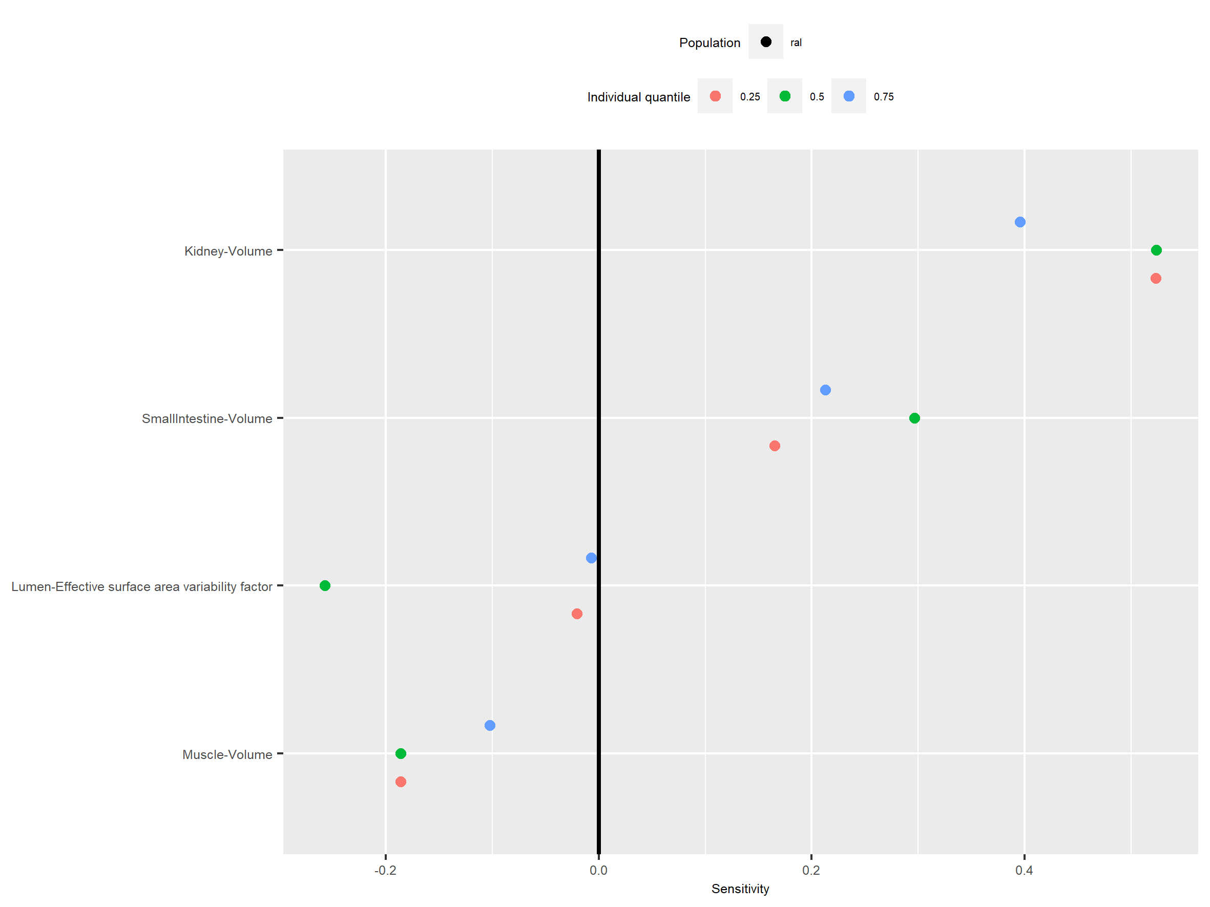

Figure 12: Sensitivity of t_max of Organism|ArterialBlood|Plasma|Raltegravir|Concentration for individuals at percentiles 0.25, 0.5, 0.75 in simulation sets ‘ral’.

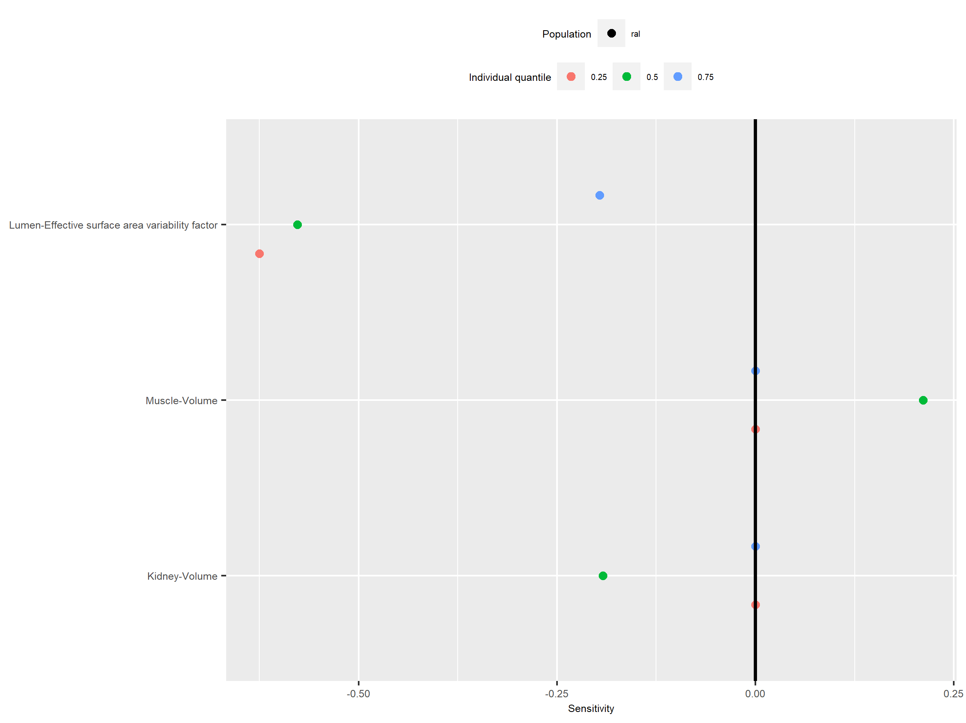

Figure 13: Sensitivity of AUC_tEnd of Organism|ArterialBlood|Plasma|Raltegravir|Concentration for individuals at percentiles 0.25, 0.5, 0.75 in simulation sets ‘ral’.

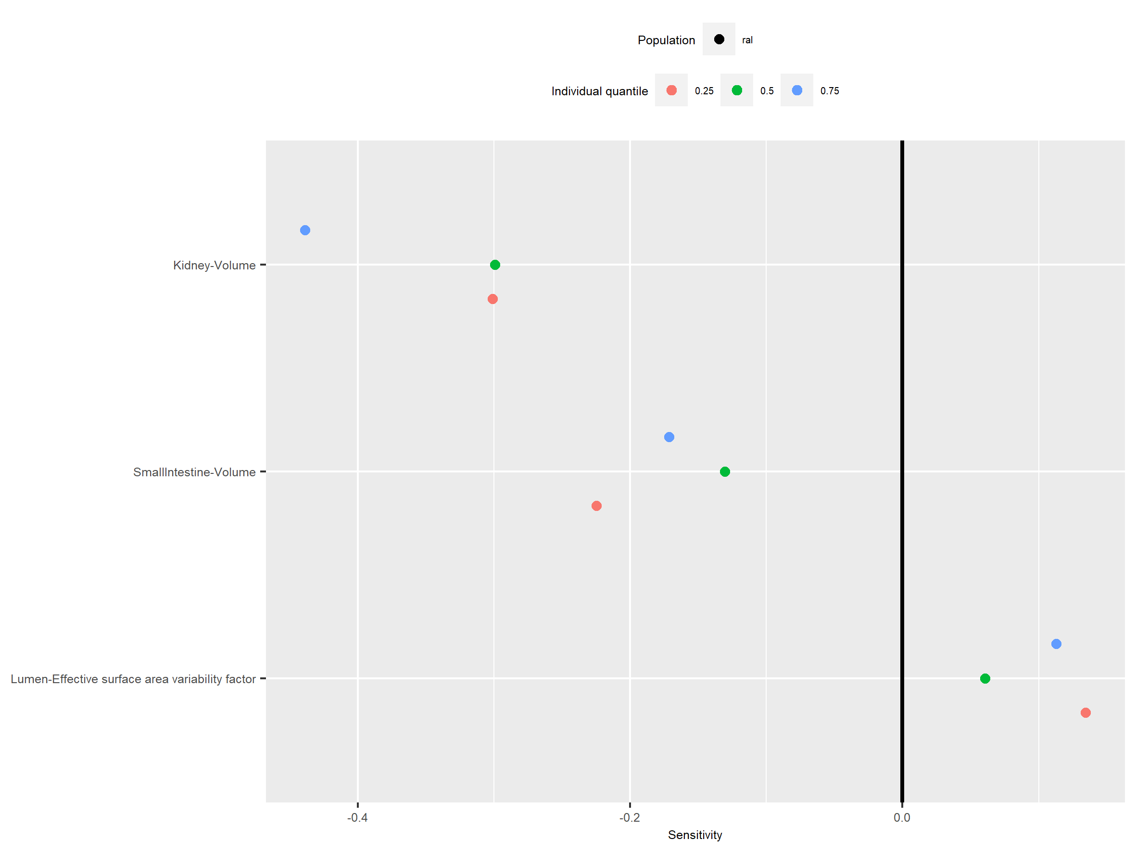

Figure 14: Sensitivity of C_max of Organism|Lung|Interstitial|Raltegravir|Concentration for individuals at percentiles 0.25, 0.5, 0.75 in simulation sets ‘lar’, ‘ral’.

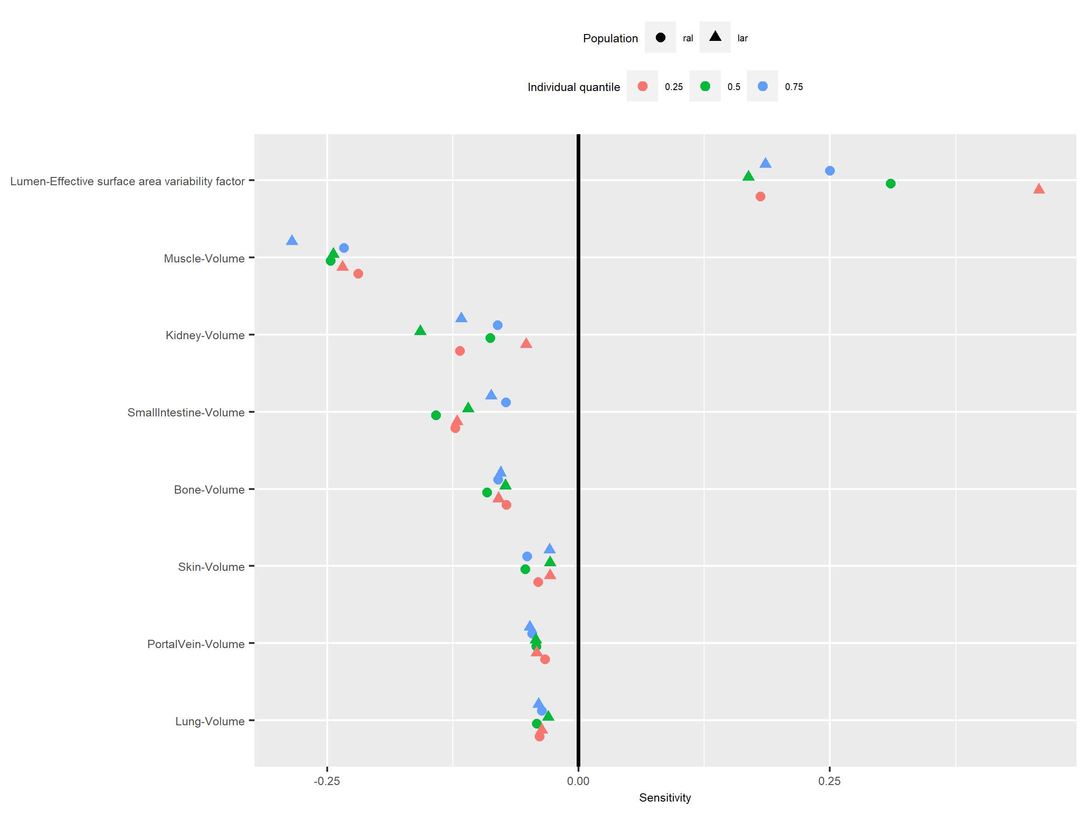

Figure 15: Sensitivity of MRT of Organism|Lung|Interstitial|Raltegravir|Concentration for individuals at percentiles 0.25, 0.5, 0.75 in simulation sets ‘ral’, ‘lar’.

