Table of Contents

# 1. Sensitivity Analysis

## 1.1. Sensitivity Analysis for ral

Figure 1: Most sensitive parameters for new_t_max of op2.

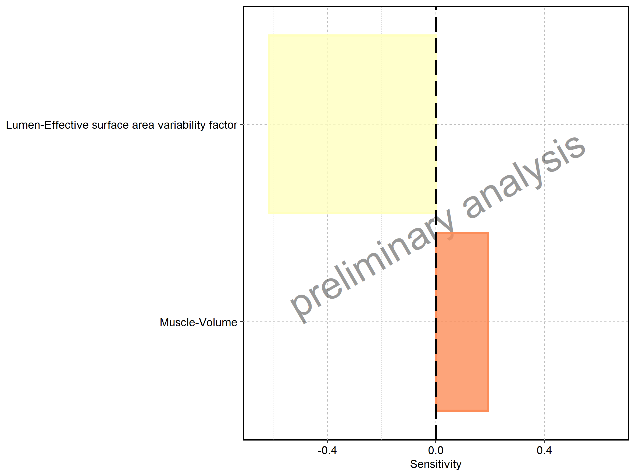

Figure 2: Most sensitive parameters for new_AUC_tEnd of op2.

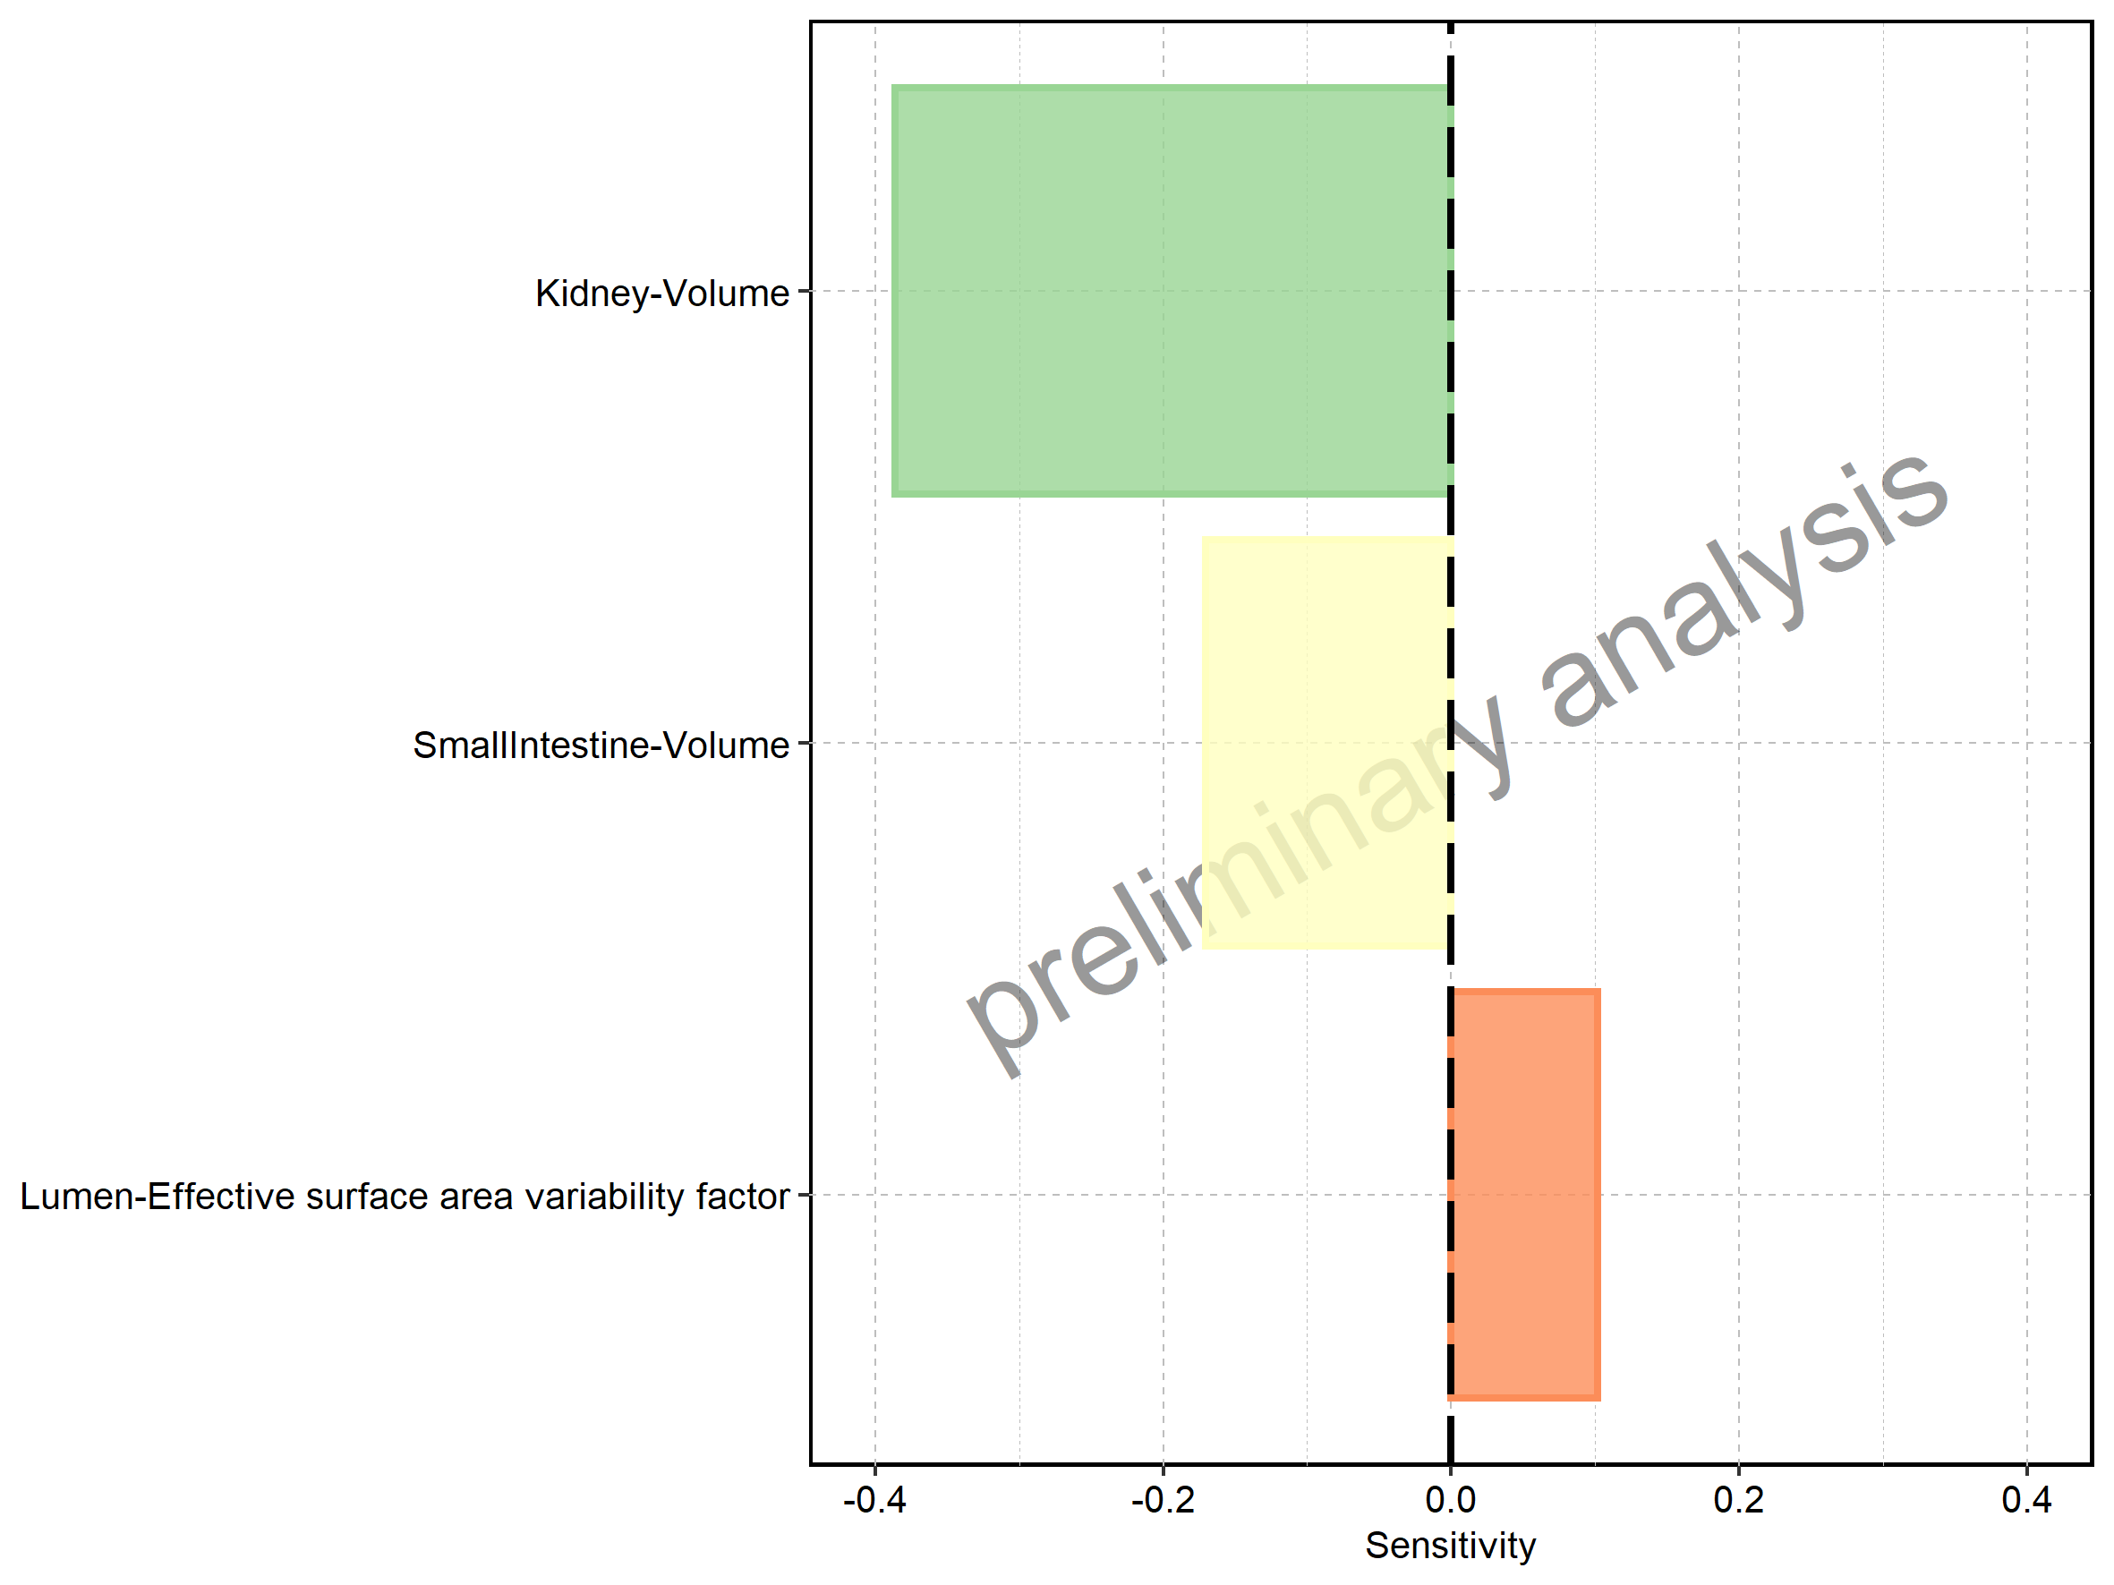

Figure 3: Most sensitive parameters for new_C_max of op3.

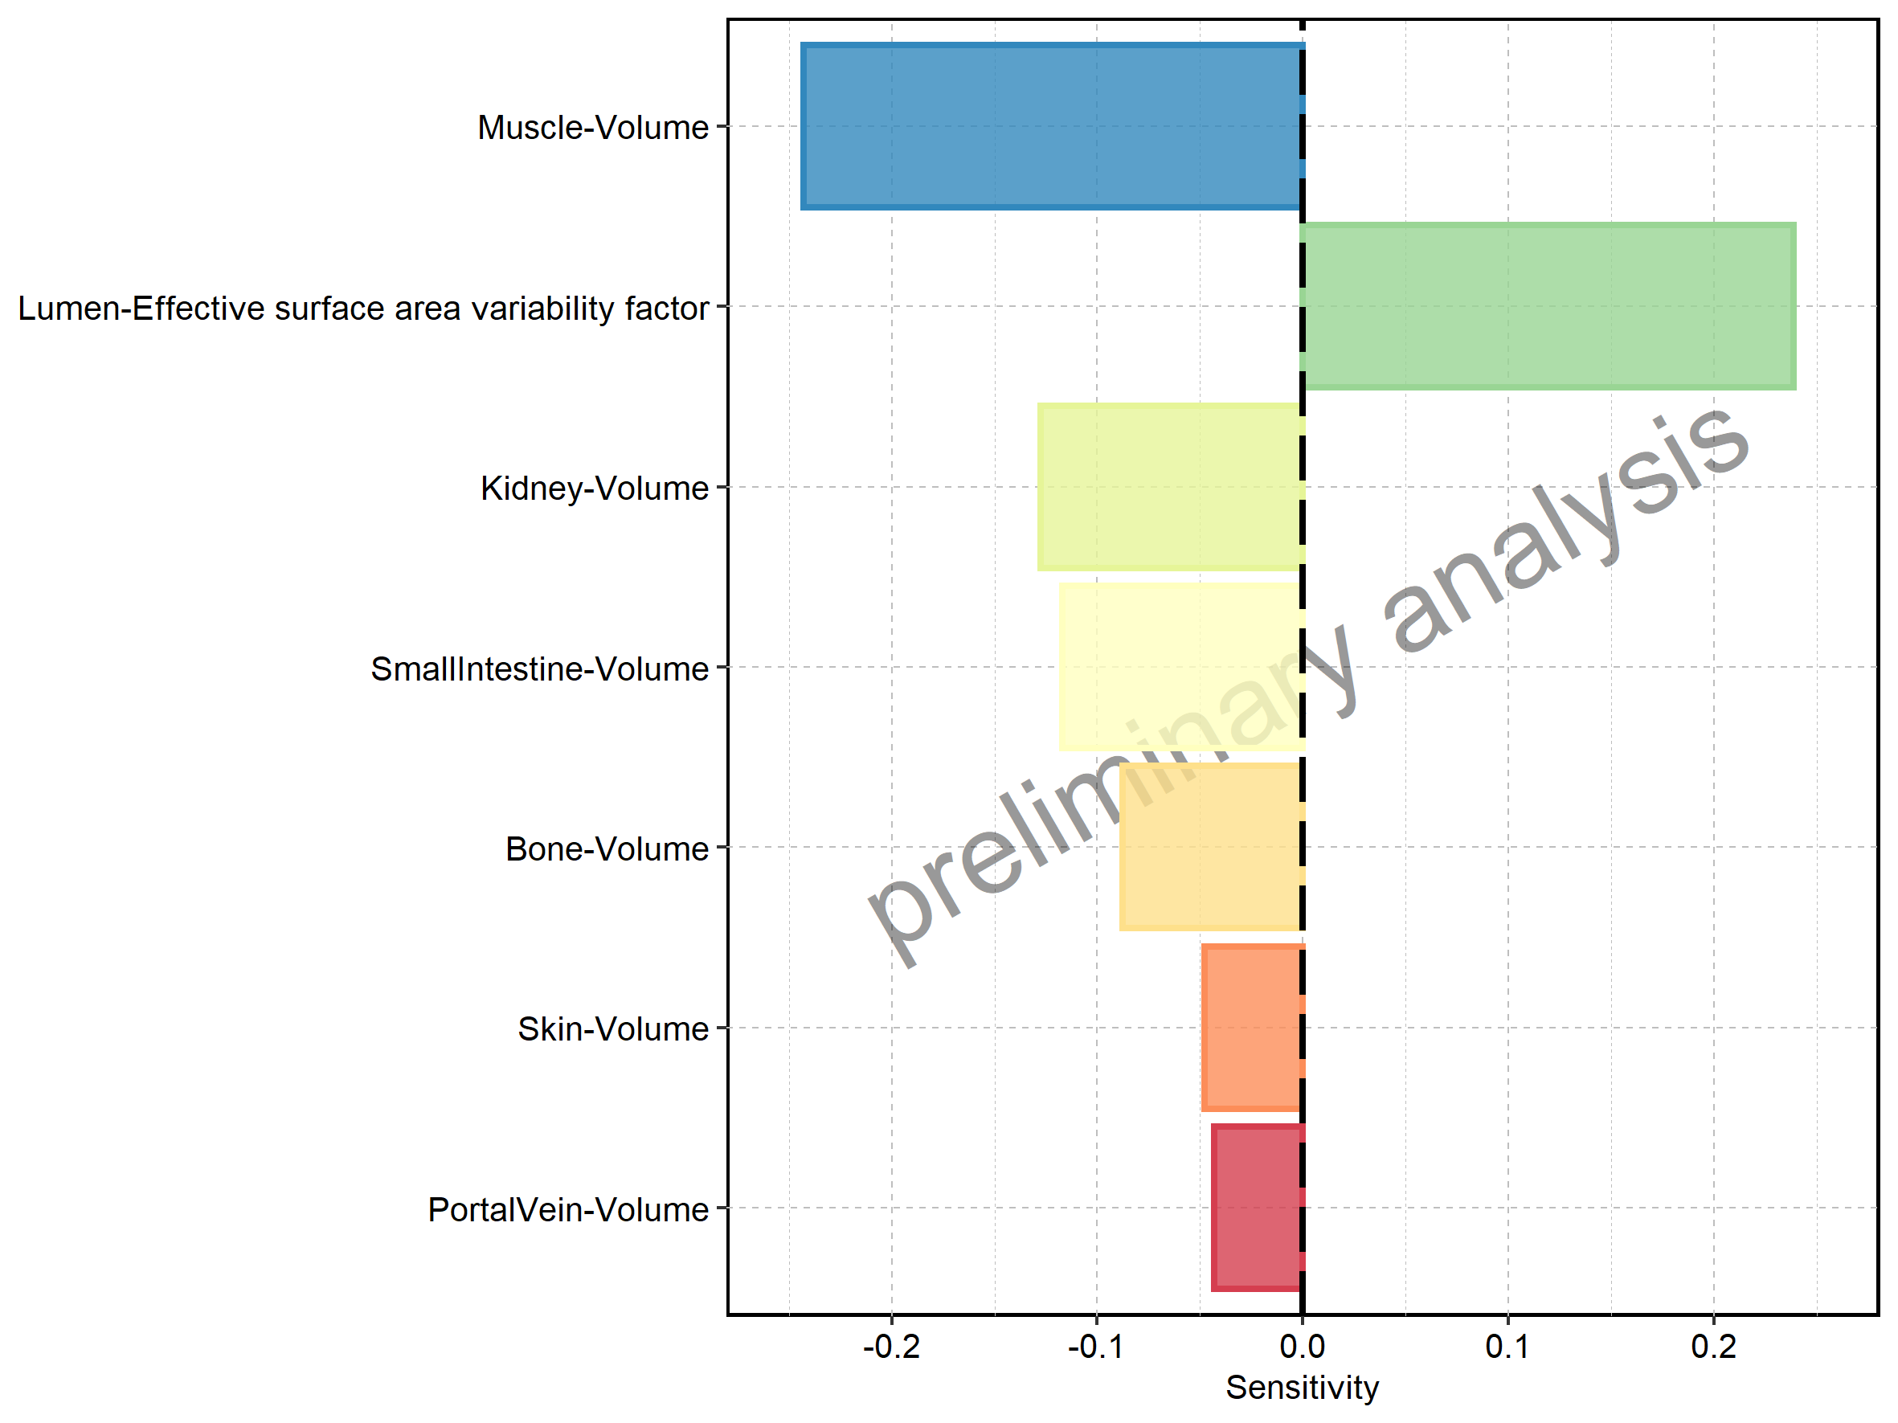

Figure 4: Most sensitive parameters for new_MRT of op3.

