Plots generated by tutorial

# Concentration time profiles

## Setting Up the Project and Basic Simulations

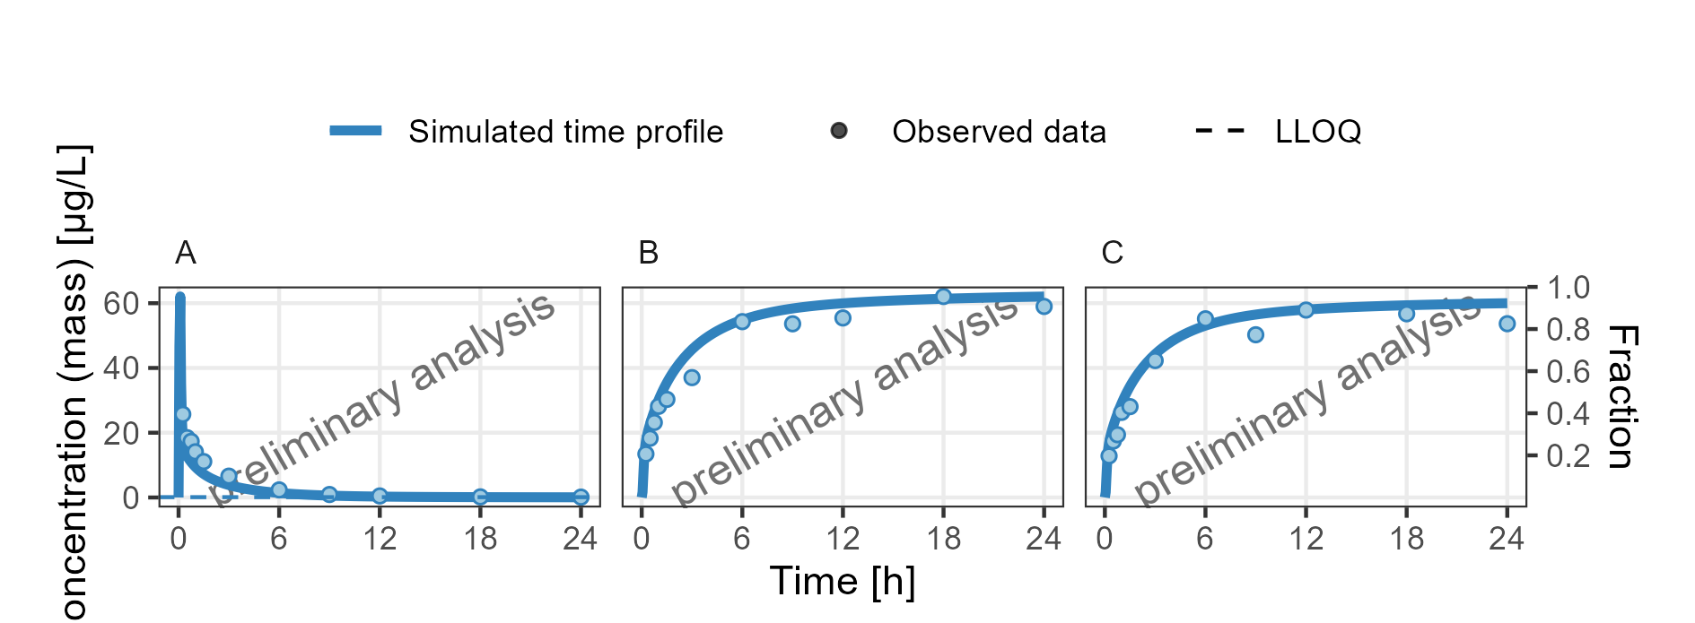

**Figure 1: Concentration-time profiles for drugX plasma concentration (A), drugX metabolized by CYP3A4 (B) and drugX metabolized by CYP3A4 in liver (C) for simulation of an 1mg iv application for individual id 13 study 1234 on a linear y-scale. DrugX was administered as a 1mg Iv application with an infusion time of 5 minutes.**

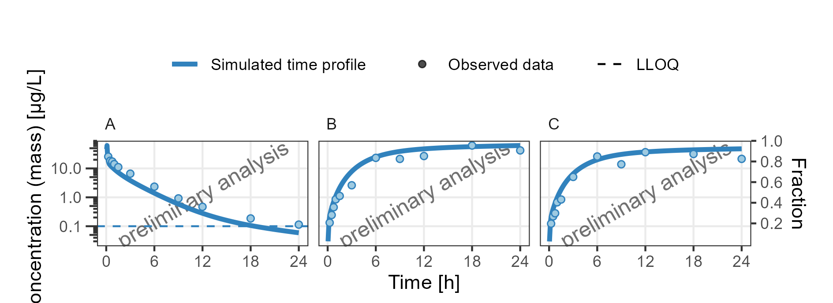

**Figure 2: Concentration-time profiles for drugX plasma concentration (A), drugX metabolized by CYP3A4 (B) and drugX metabolized by CYP3A4 in liver (C) for simulation of an 1mg iv application for individual id 13 study 1234 on a logarithmic y-scale. DrugX was administered as a 1mg Iv application with an infusion time of 5 minutes.**

## Adding Virtual Twin Populations

### filtered individual

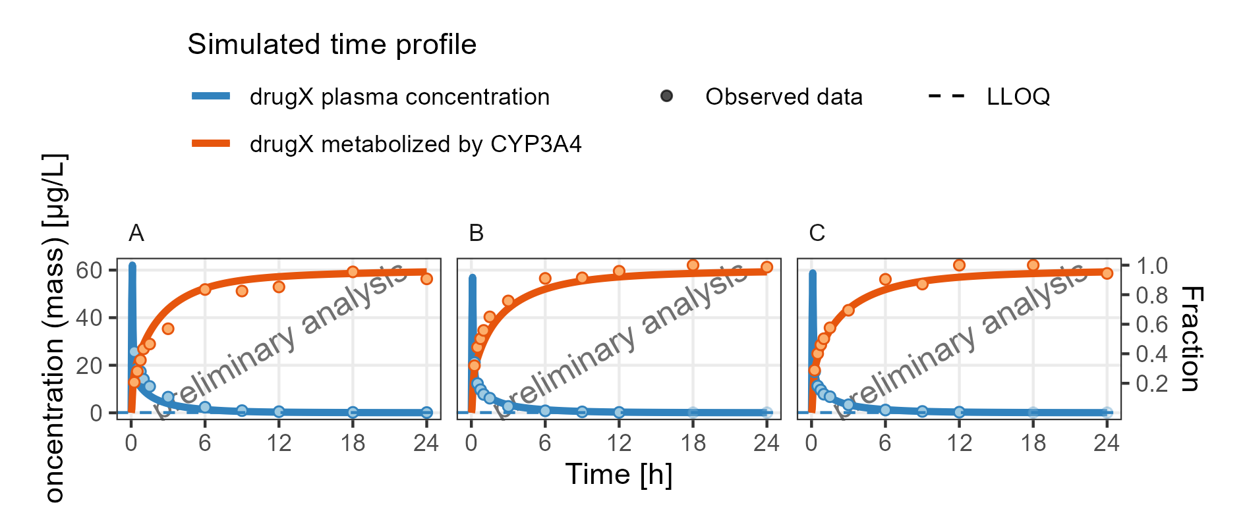

**Figure 3: Concentration-time profiles for drugX metabolized by CYP3A4 and drugX plasma concentration for simulation of an 1mg iv application for individuals of study 1234 for subject I123413 (A), I123430 (B) and I123441 (C) on a linear y-scale. DrugX was administered as a 1mg Iv application with an infusion time of 5 minutes.**

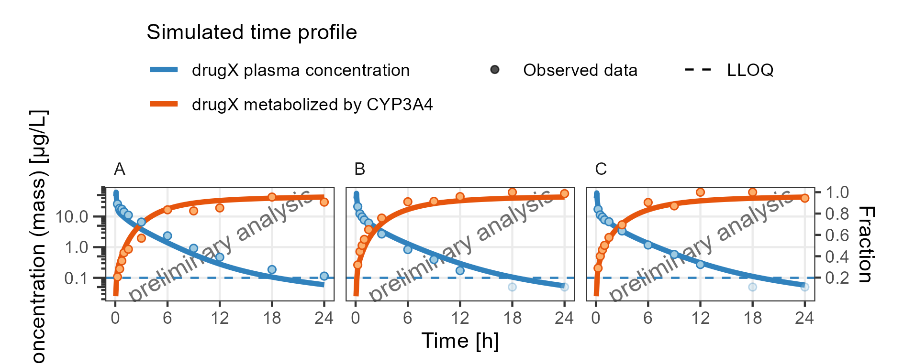

**Figure 4: Concentration-time profiles for drugX metabolized by CYP3A4 and drugX plasma concentration for simulation of an 1mg iv application for individuals of study 1234 for subject I123413 (A), I123430 (B) and I123441 (C) on a logarithmic y-scale. DrugX was administered as a 1mg Iv application with an infusion time of 5 minutes.**

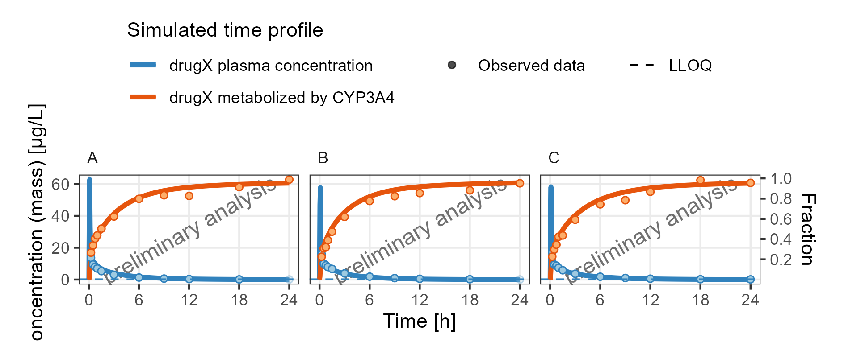

**Figure 5: Concentration-time profiles for drugX metabolized by CYP3A4 and drugX plasma concentration for simulation of an 1mg iv application for individuals of study 1234 for subject I123450 (A), I123466 (B) and I123478 (C) on a linear y-scale. DrugX was administered as a 1mg Iv application with an infusion time of 5 minutes.**

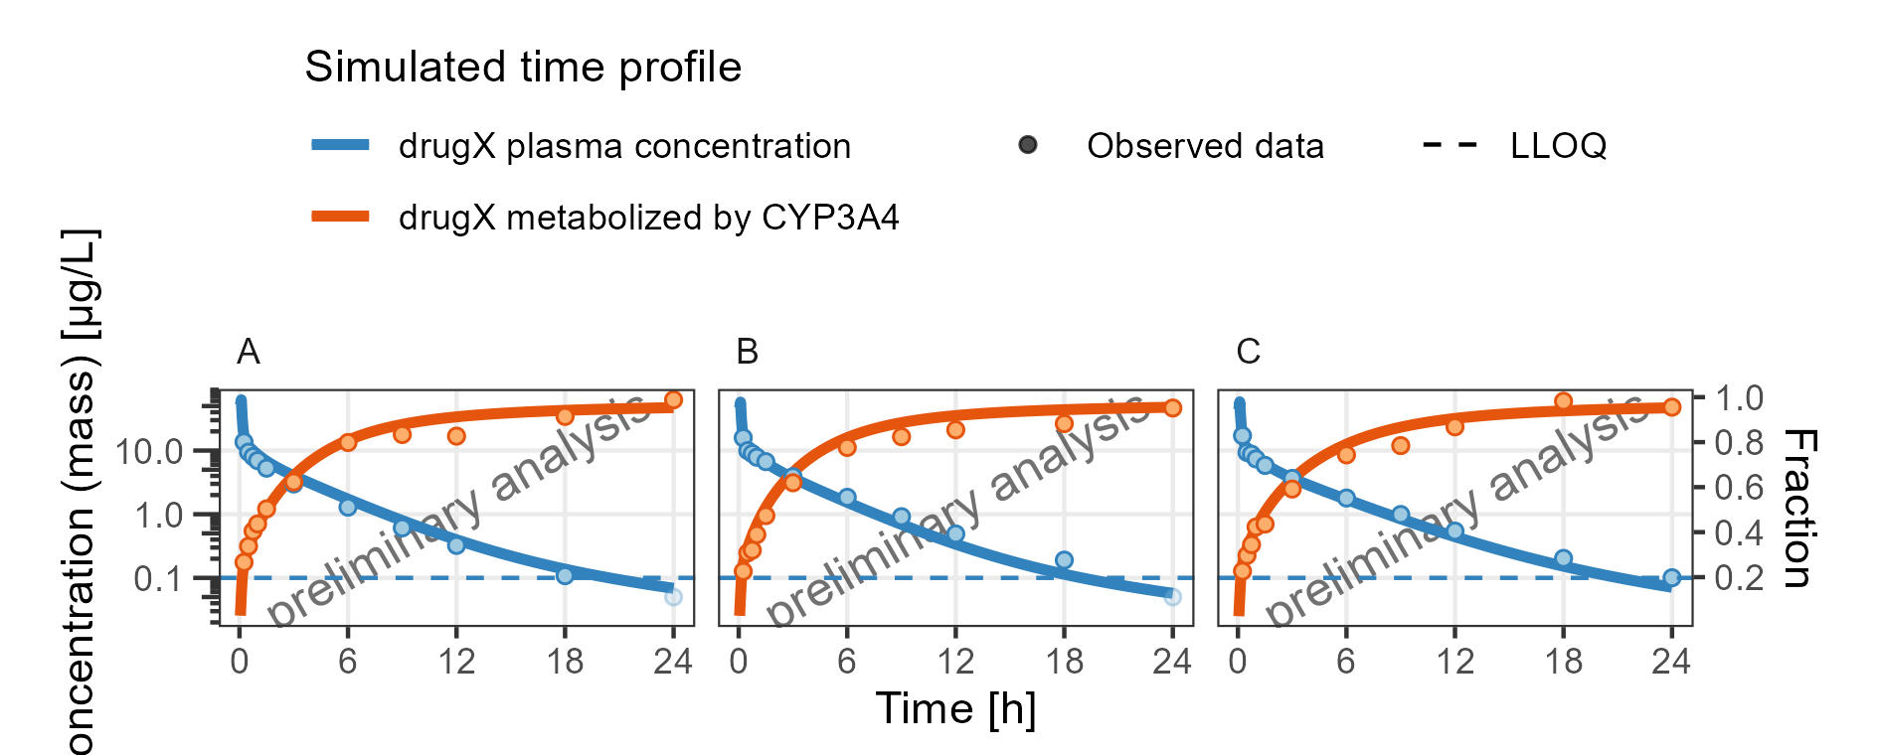

**Figure 6: Concentration-time profiles for drugX metabolized by CYP3A4 and drugX plasma concentration for simulation of an 1mg iv application for individuals of study 1234 for subject I123450 (A), I123466 (B) and I123478 (C) on a logarithmic y-scale. DrugX was administered as a 1mg Iv application with an infusion time of 5 minutes.**

### shortcut for individual filter

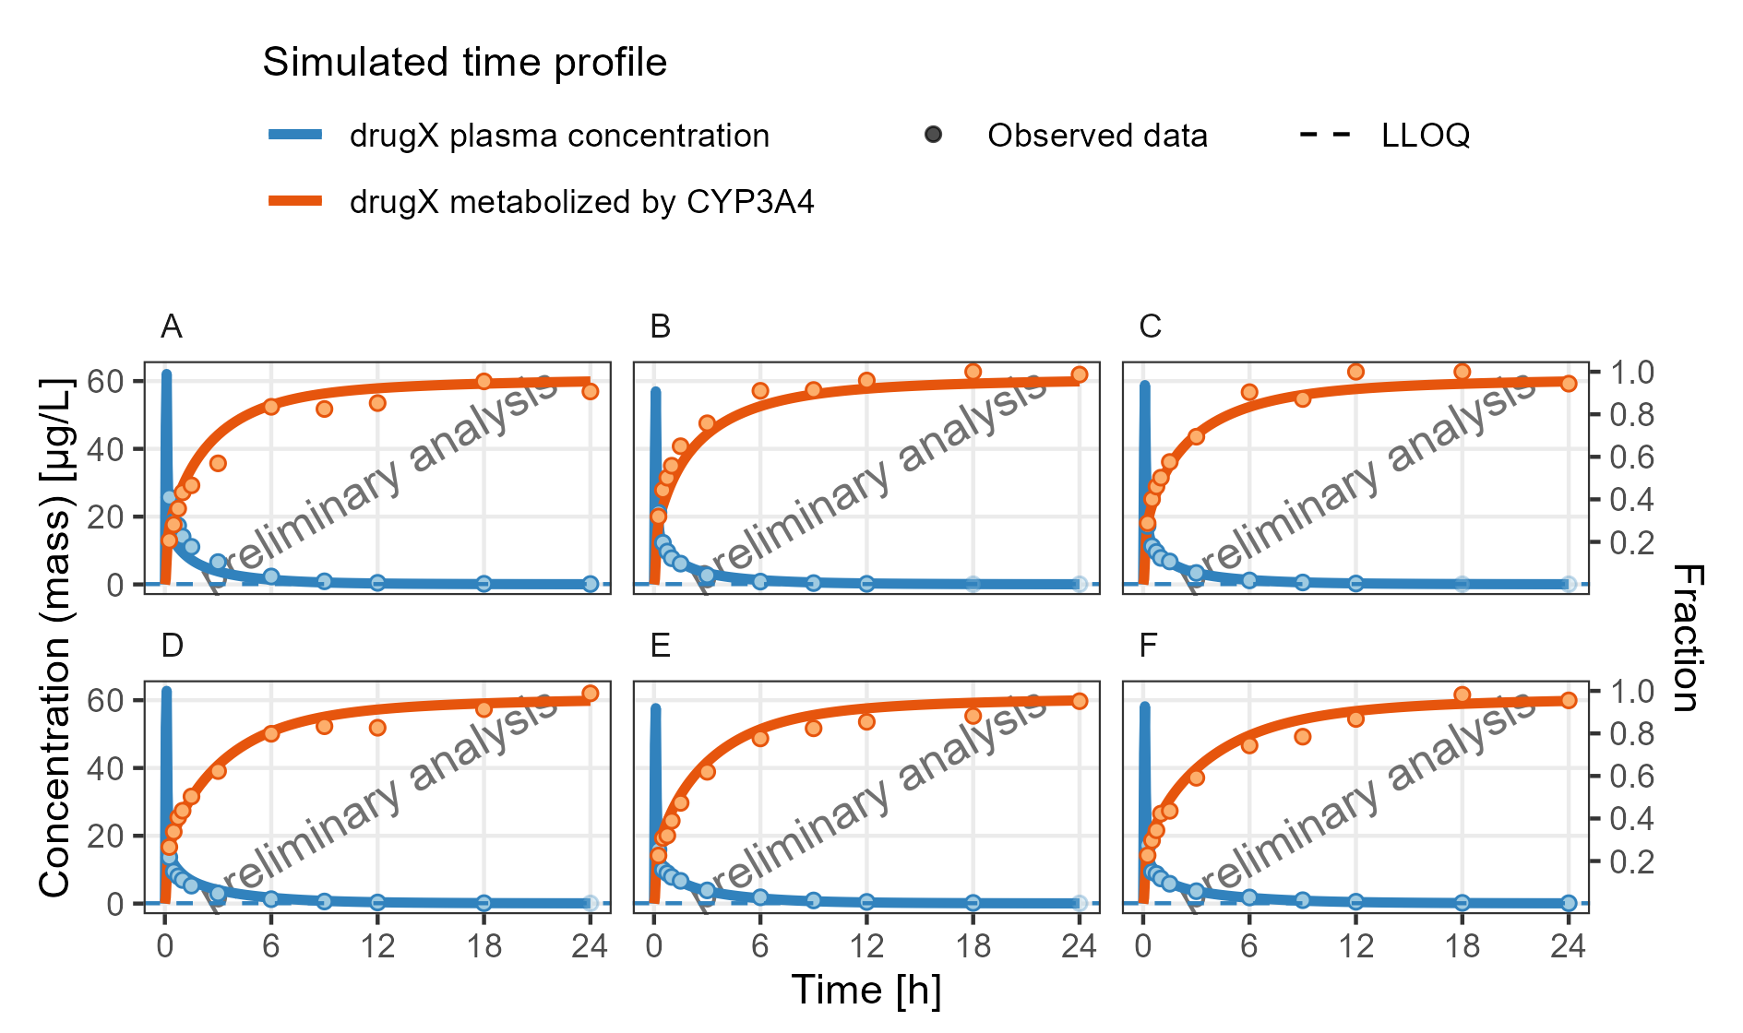

**Figure 7: Concentration-time profiles for drugX metabolized by CYP3A4 and drugX plasma concentration for simulation of an 1mg iv application for individuals of study 1234 for subject I123413 (A), I123430 (B), I123441 (C), I123450 (D), I123466 (E) and I123478 (F) on a linear y-scale. DrugX was administered as a 1mg Iv application with an infusion time of 5 minutes.**

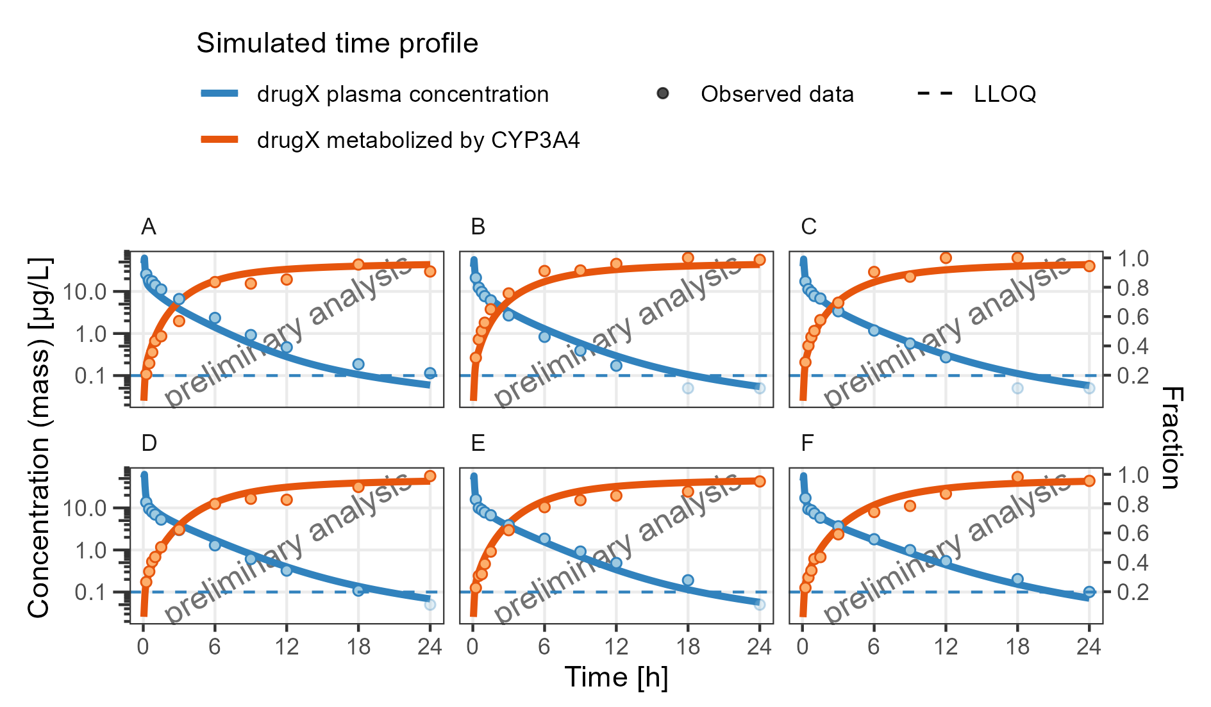

**Figure 8: Concentration-time profiles for drugX metabolized by CYP3A4 and drugX plasma concentration for simulation of an 1mg iv application for individuals of study 1234 for subject I123413 (A), I123430 (B), I123441 (C), I123450 (D), I123466 (E) and I123478 (F) on a logarithmic y-scale. DrugX was administered as a 1mg Iv application with an infusion time of 5 minutes.**

## Adding Random Populations and use of aggregated data

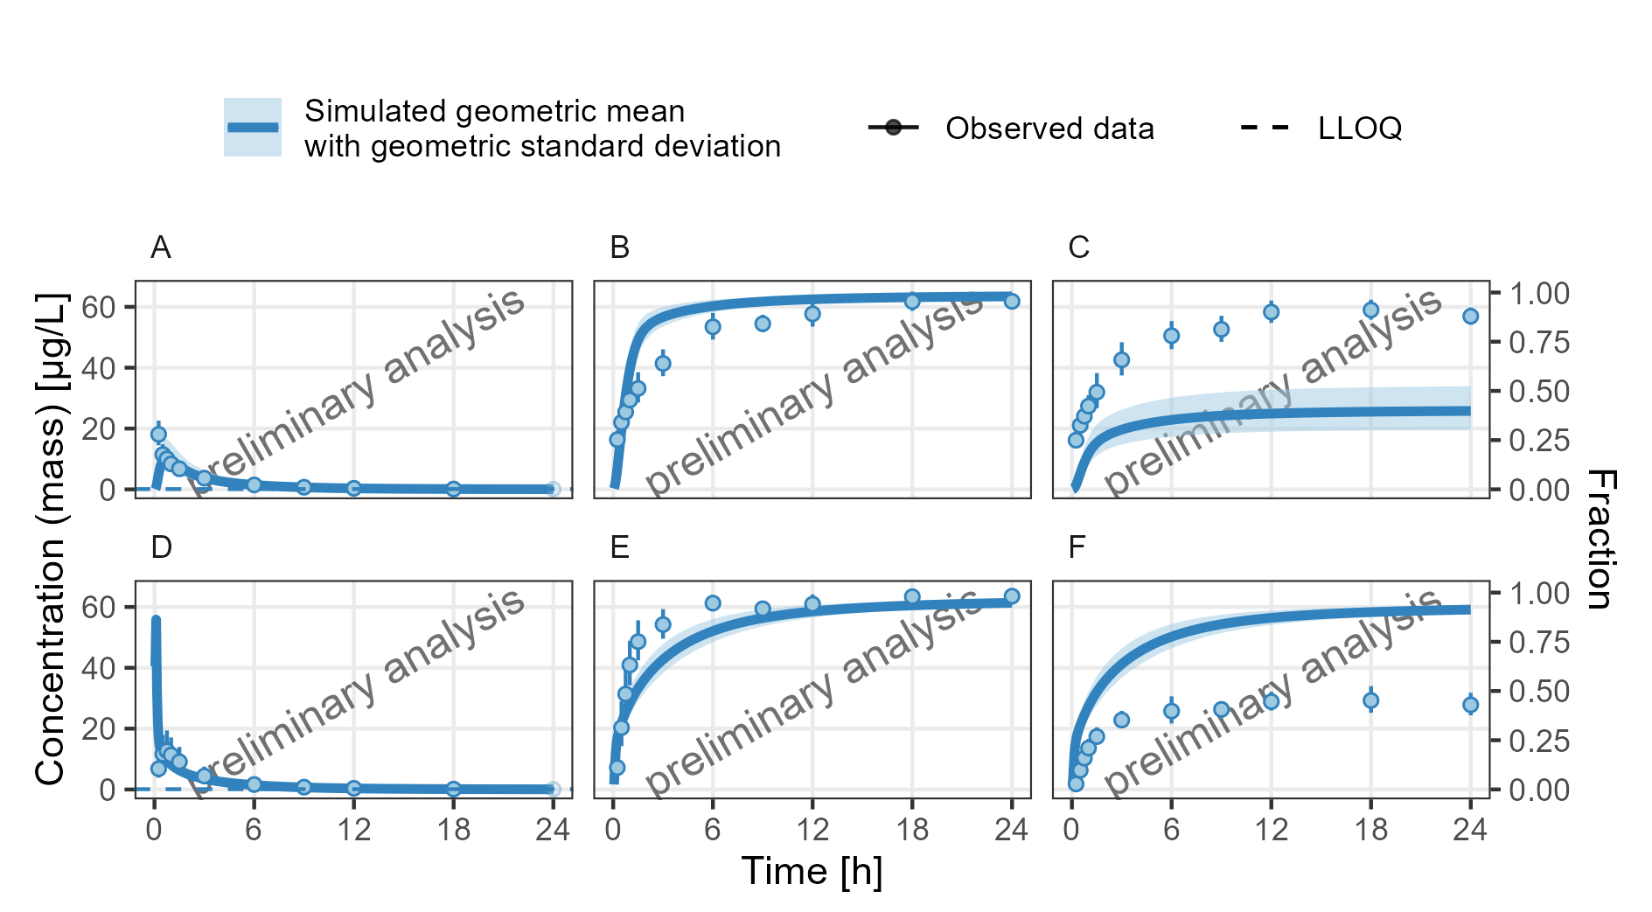

Observed data is displayed as geometric mean and geometric standard deviation  
**Figure 9: Concentration-time profiles for drugX plasma concentration (A, D), drugX metabolized by CYP3A4 (B, E) and drugX metabolized by CYP3A4 in liver (C, F) for simulation of an 1mg iv application for an adult population (A, B, C) and simulation of an 5mg oral application for an adult population (D, E, F) on a linear y-scale.**

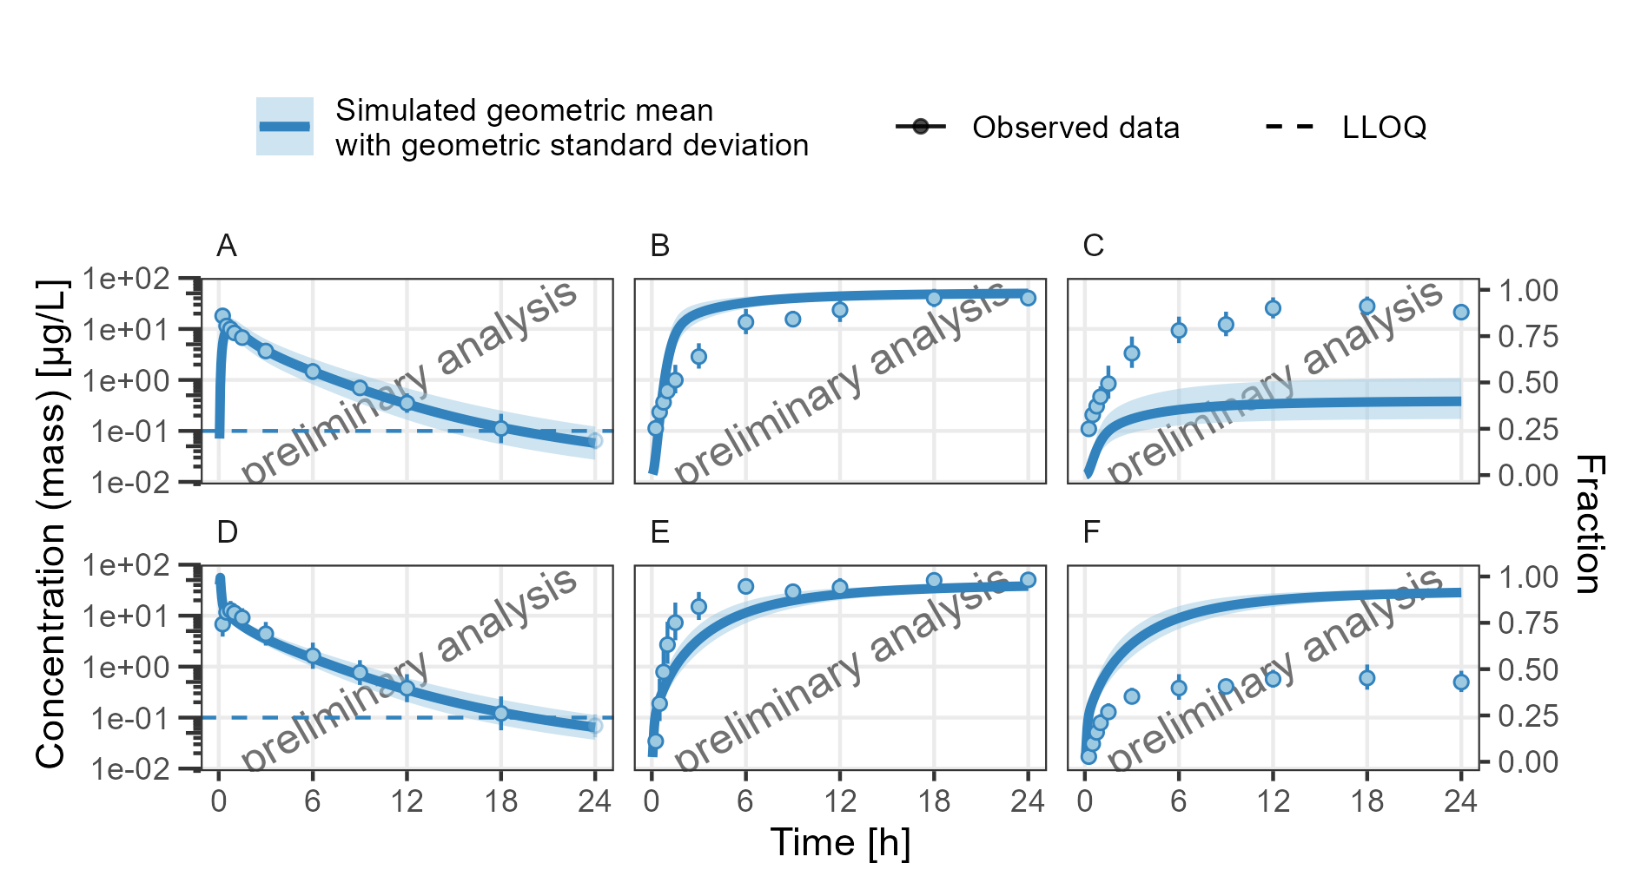

Observed data is displayed as geometric mean and geometric standard deviation  
**Figure 10: Concentration-time profiles for drugX plasma concentration (A, D), drugX metabolized by CYP3A4 (B, E) and drugX metabolized by CYP3A4 in liver (C, F) for simulation of an 1mg iv application for an adult population (A, B, C) and simulation of an 5mg oral application for an adult population (D, E, F) on a logarithmic y-scale.**

## Adding Reference Populations

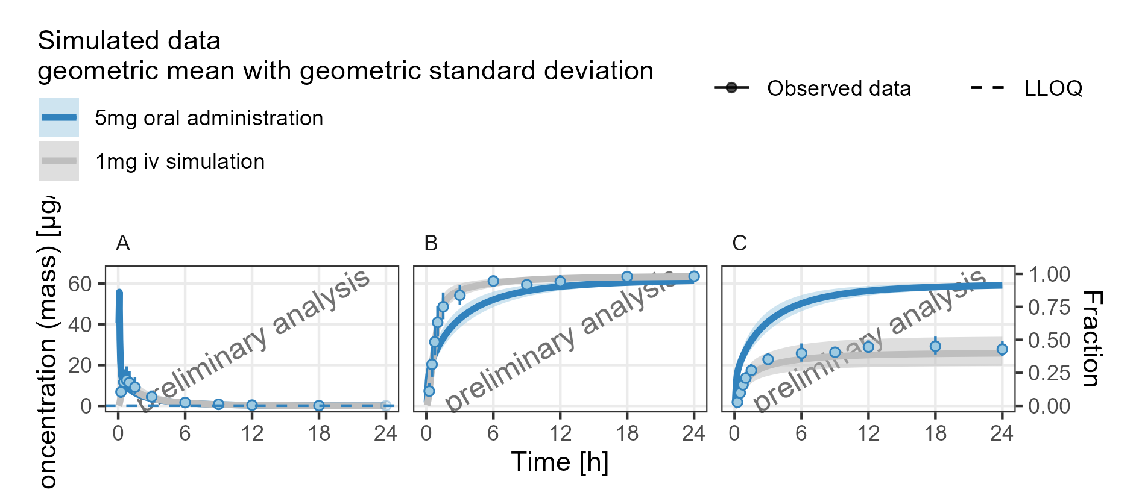

Observed data is displayed as geometric mean and geometric standard deviation  
**Figure 11: Concentration-time profiles for drugX plasma concentration (A), drugX metabolized by CYP3A4 (B) and drugX metabolized by CYP3A4 in liver (C) for simulation of a 5mg oral administration vs 1mg iv simulation on a linear y-scale.**

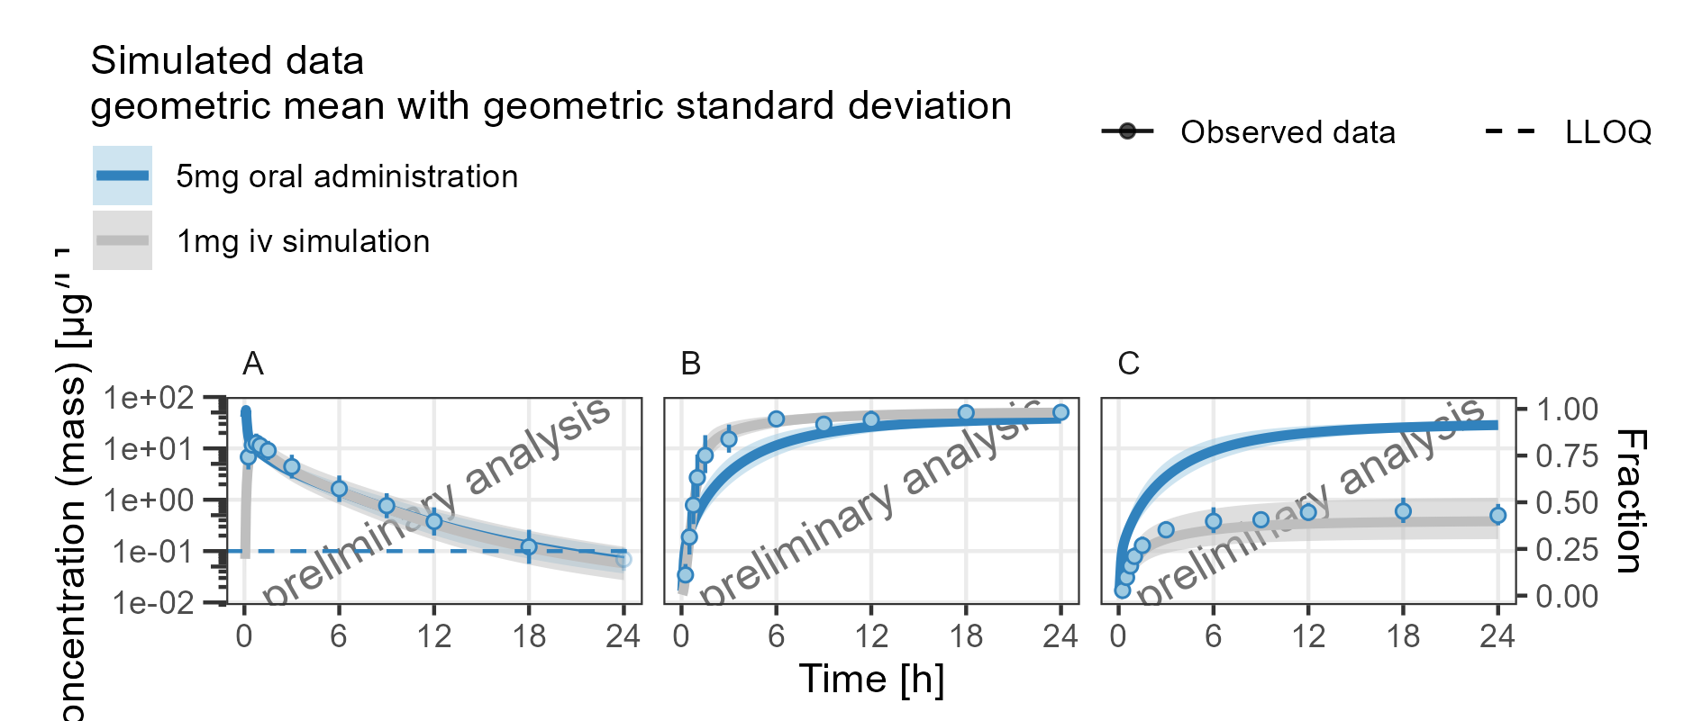

Observed data is displayed as geometric mean and geometric standard deviation  
**Figure 12: Concentration-time profiles for drugX plasma concentration (A), drugX metabolized by CYP3A4 (B) and drugX metabolized by CYP3A4 in liver (C) for simulation of a 5mg oral administration vs 1mg iv simulation on a logarithmic y-scale.**

## Adding Plots with different Time Ranges

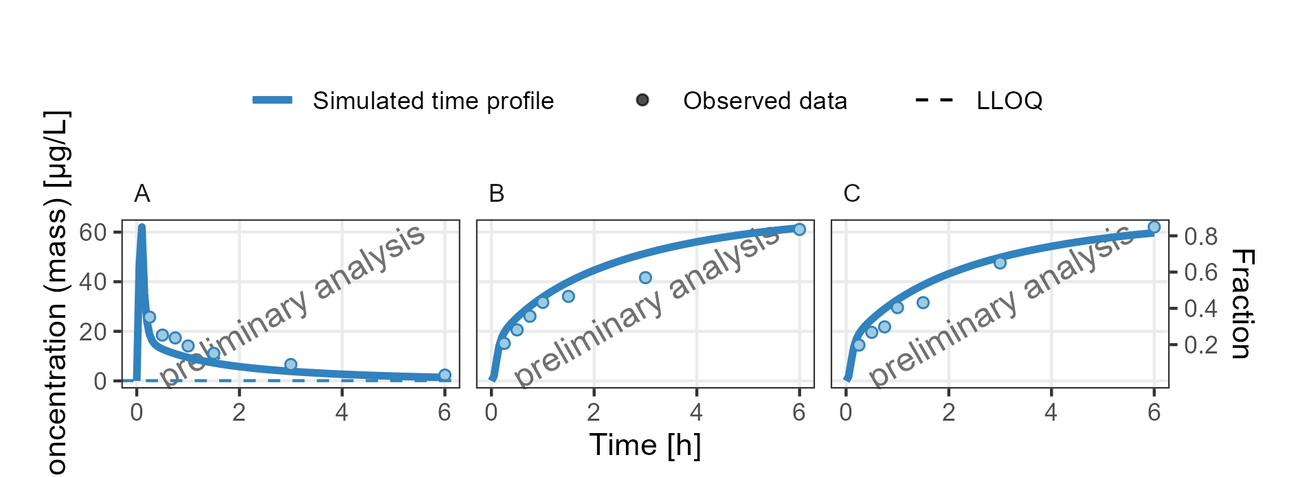

**Figure 13: Concentration-time profiles for drugX plasma concentration (A), drugX metabolized by CYP3A4 (B) and drugX metabolized by CYP3A4 in liver (C) for simulation of an 1mg iv application for individual id 13 study 1234 on a linear y-scale. Zoom on first 6 hours. DrugX was administered as a 1mg Iv application with an infusion time of 5 minutes.**

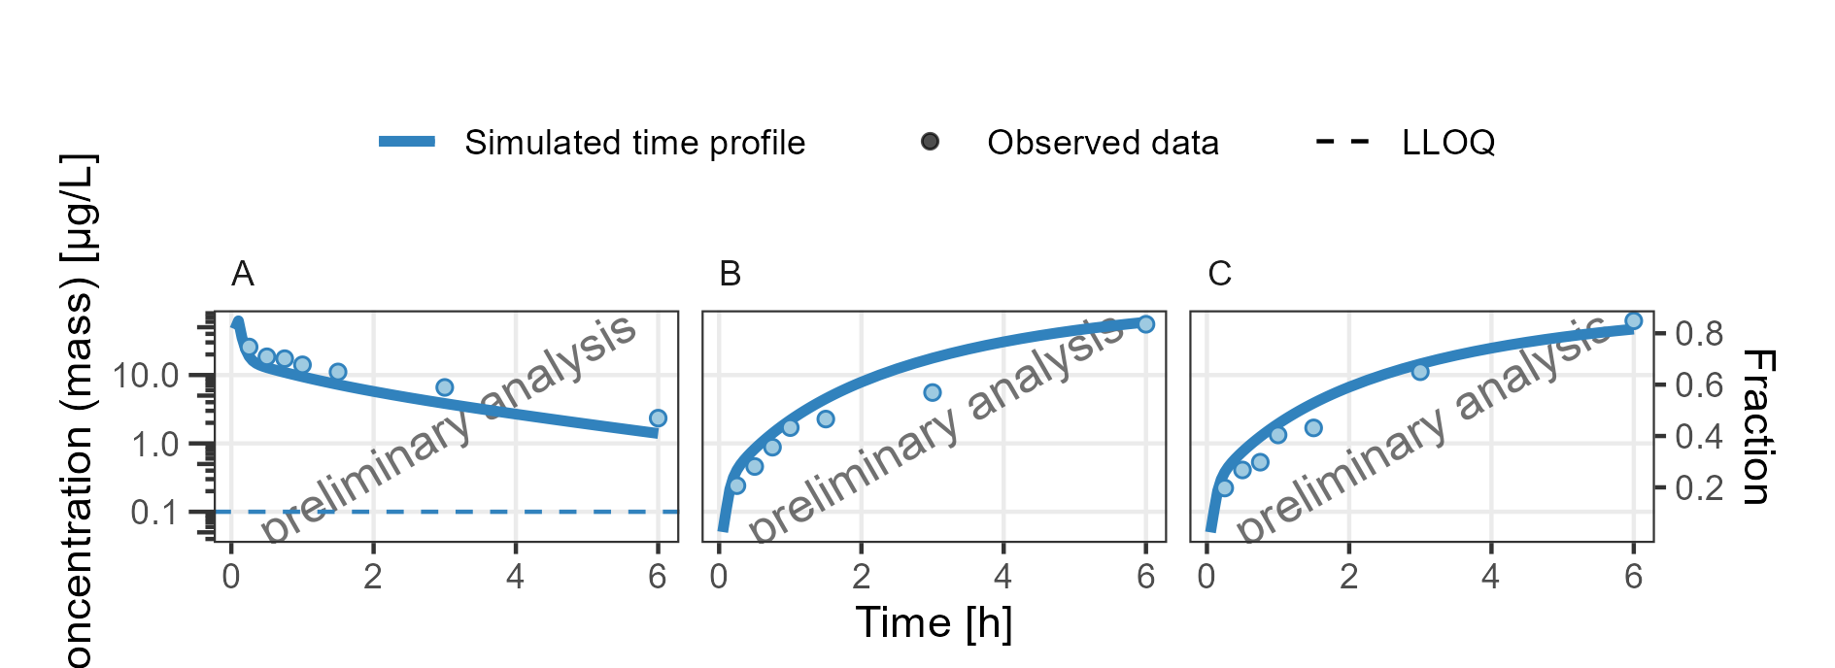

**Figure 14: Concentration-time profiles for drugX plasma concentration (A), drugX metabolized by CYP3A4 (B) and drugX metabolized by CYP3A4 in liver (C) for simulation of an 1mg iv application for individual id 13 study 1234 on a logarithmic y-scale. Zoom on first 6 hours. DrugX was administered as a 1mg Iv application with an infusion time of 5 minutes.**

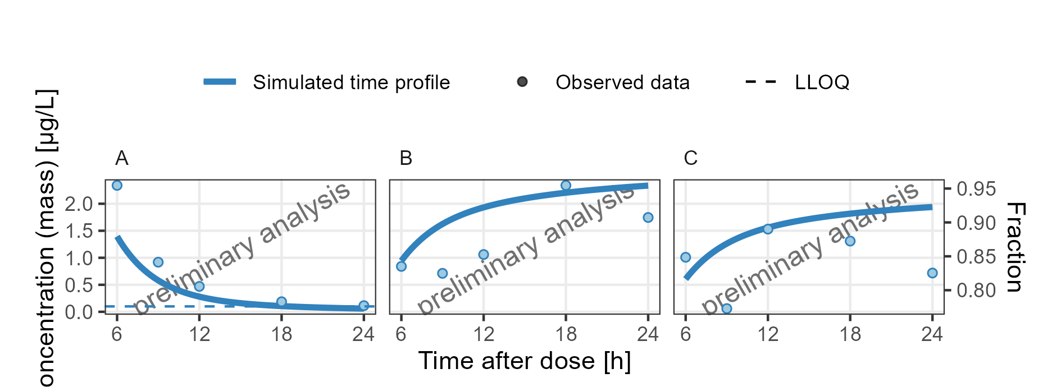

**Figure 15: Concentration-time profiles for drugX plasma concentration (A), drugX metabolized by CYP3A4 (B) and drugX metabolized by CYP3A4 in liver (C) for simulation of an 1mg iv application for individual id 13 study 1234 on a linear y-scale. Zoom on time range 6 to 24 hours. DrugX was administered as a 1mg Iv application with an infusion time of 5 minutes.**

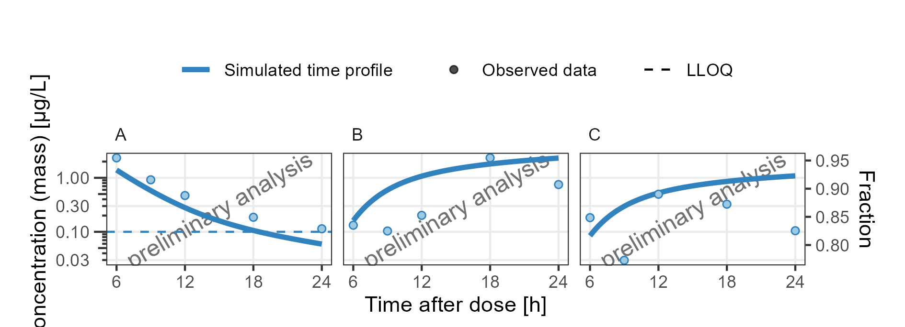

**Figure 16: Concentration-time profiles for drugX plasma concentration (A), drugX metabolized by CYP3A4 (B) and drugX metabolized by CYP3A4 in liver (C) for simulation of an 1mg iv application for individual id 13 study 1234 on a logarithmic y-scale. Zoom on time range 6 to 24 hours. DrugX was administered as a 1mg Iv application with an infusion time of 5 minutes.**

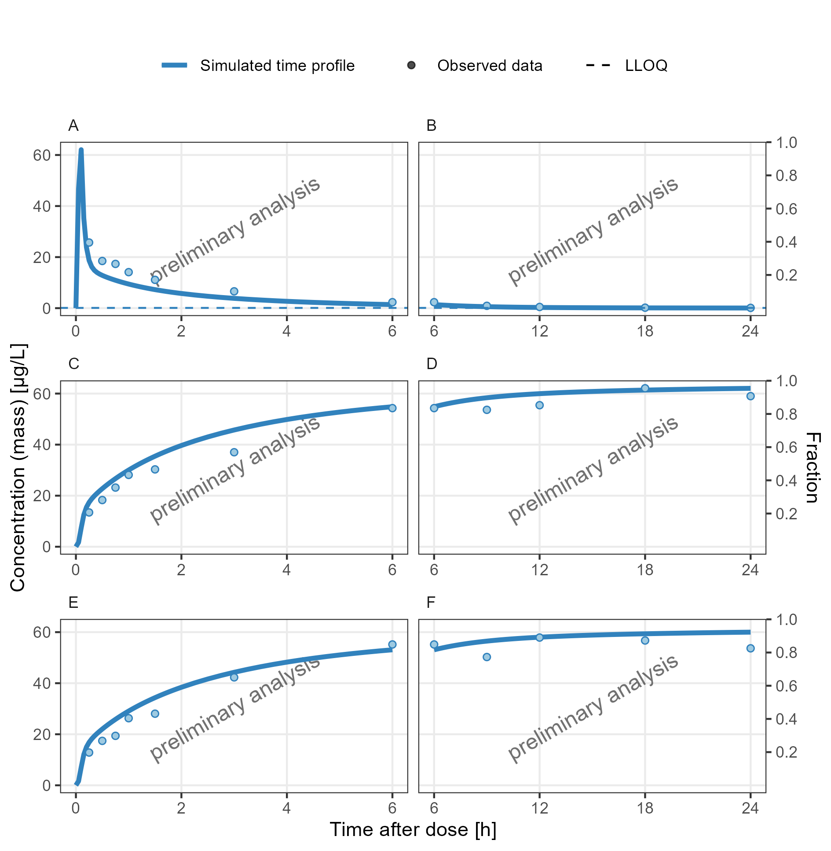

**Figure 17: Concentration-time profiles for drugX plasma concentration (A, B), drugX metabolized by CYP3A4 (C, D) and drugX metabolized by CYP3A4 in liver (E, F) for simulation of an 1mg iv application for individual id 13 study 1234 on a linear y-scale. Zoom on first 6 hours (A, C, E) and Zoom on time range 6 to 24 hours (B, D, F). DrugX was administered as a 1mg Iv application with an infusion time of 5 minutes.**

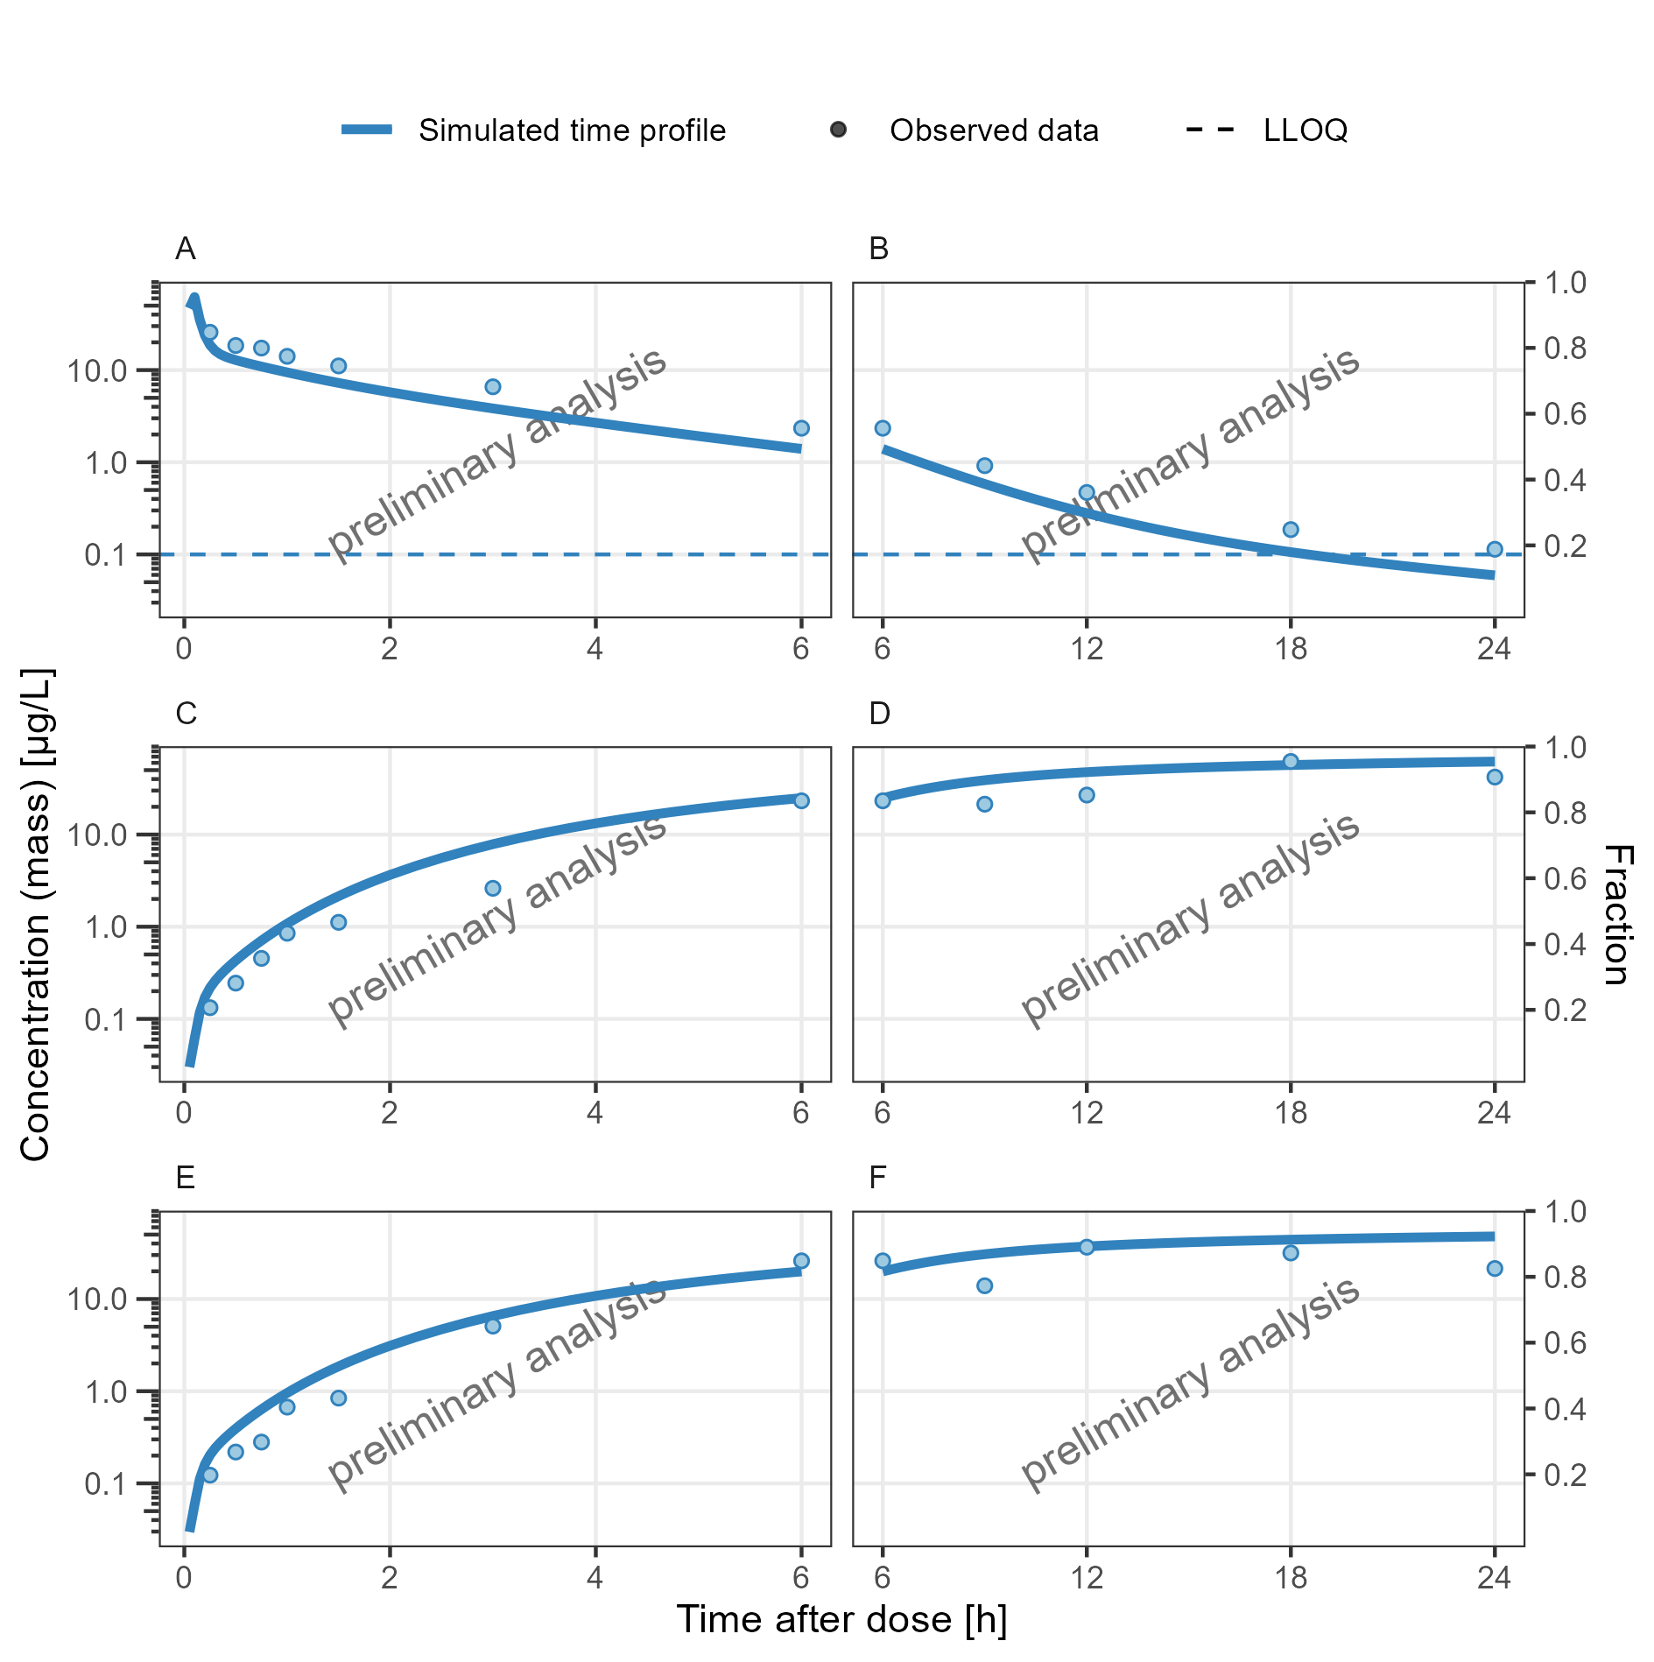

**Figure 18: Concentration-time profiles for drugX plasma concentration (A, B), drugX metabolized by CYP3A4 (C, D) and drugX metabolized by CYP3A4 in liver (E, F) for simulation of an 1mg iv application for individual id 13 study 1234 on a logarithmic y-scale. Zoom on first 6 hours (A, C, E) and Zoom on time range 6 to 24 hours (B, D, F). DrugX was administered as a 1mg Iv application with an infusion time of 5 minutes.**