Physiology

Demography of Larson 2013 8y-18y 400mg FCT meal vs. simulated virtual pediatric population

Figure 1: Age-dependence of age for simulated virtual pediatric population in comparison to simulated Healthy Adult Population.
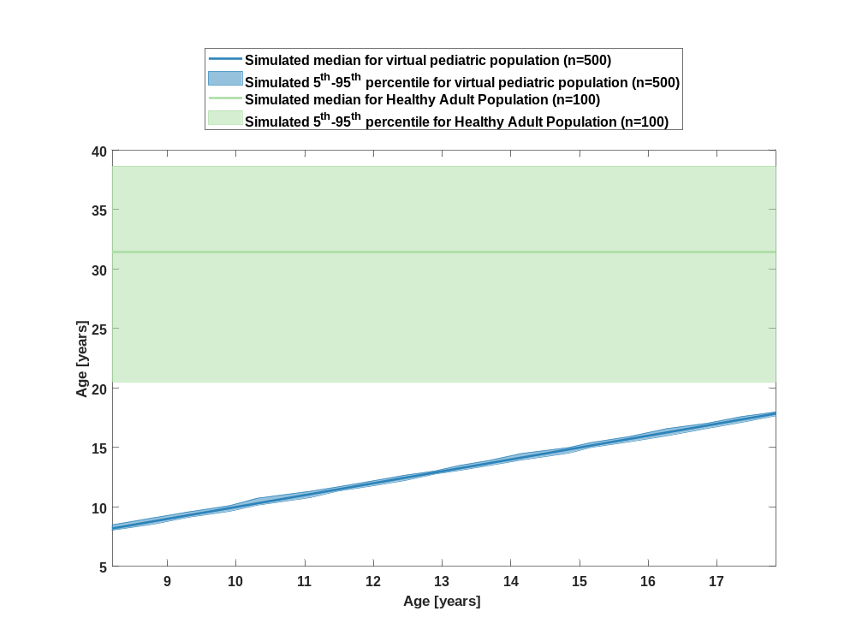

Figure 2: Age-dependence of body weight for simulated virtual pediatric population in comparison to simulated Healthy Adult Population.
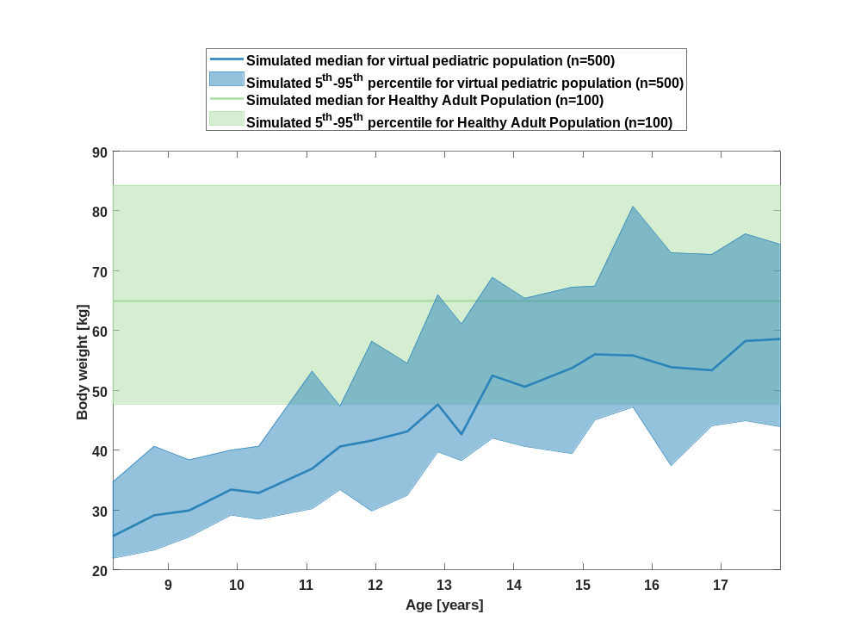

Figure 3: Age-dependence of body height for simulated virtual pediatric population in comparison to simulated Healthy Adult Population.
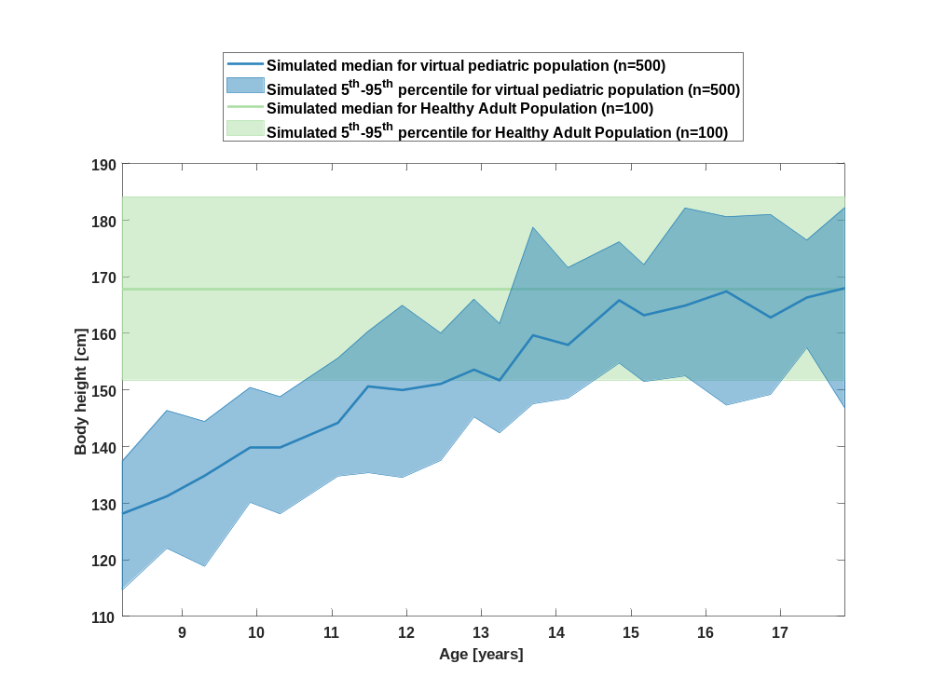

Figure 4: Age-dependence of BMI for simulated virtual pediatric population in comparison to simulated Healthy Adult Population.
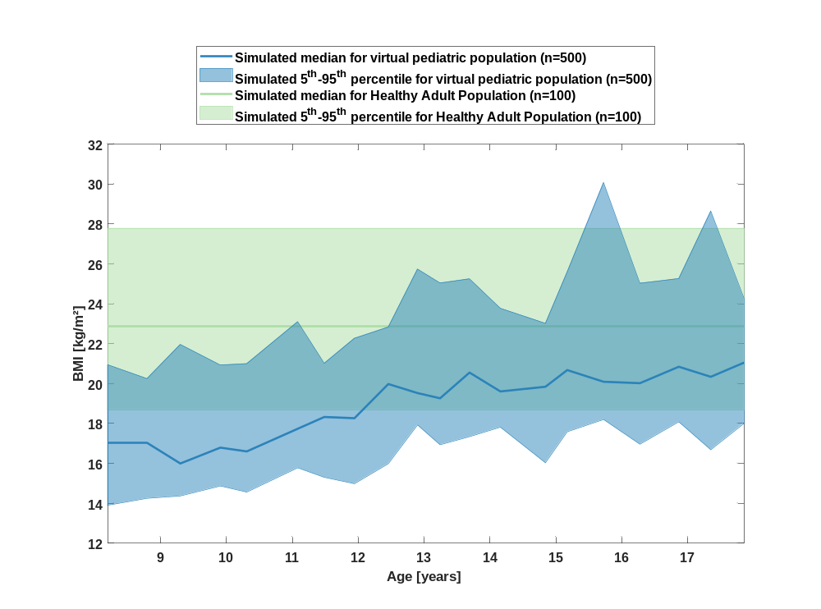

Figure 5: Age-dependence of body surface area for simulated virtual pediatric population in comparison to simulated Healthy Adult Population.
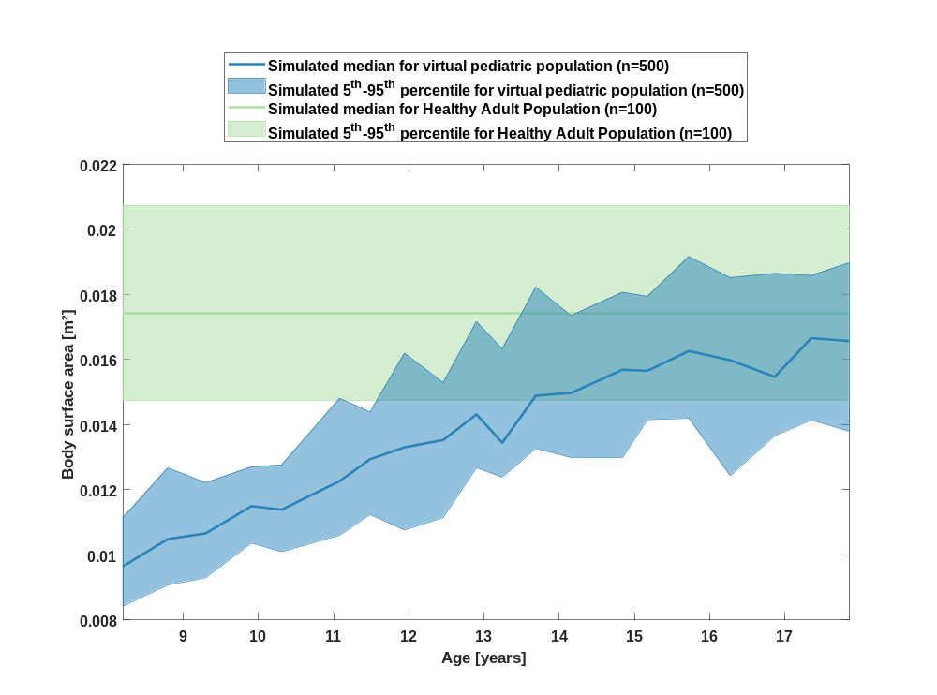

Figure 6: Distribution of gender for simulated virtual pediatric population in comparison to observed data Observed_Raltegravir 10 mg (lactose formulation).
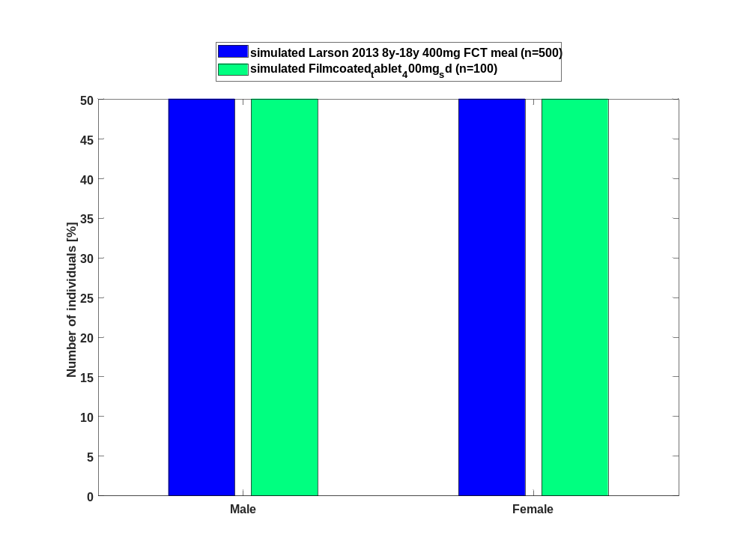

Figure 7: Age-dependence of Ontogeny factor (albumin) for simulated virtual pediatric population in comparison to simulated Healthy Adult Population.
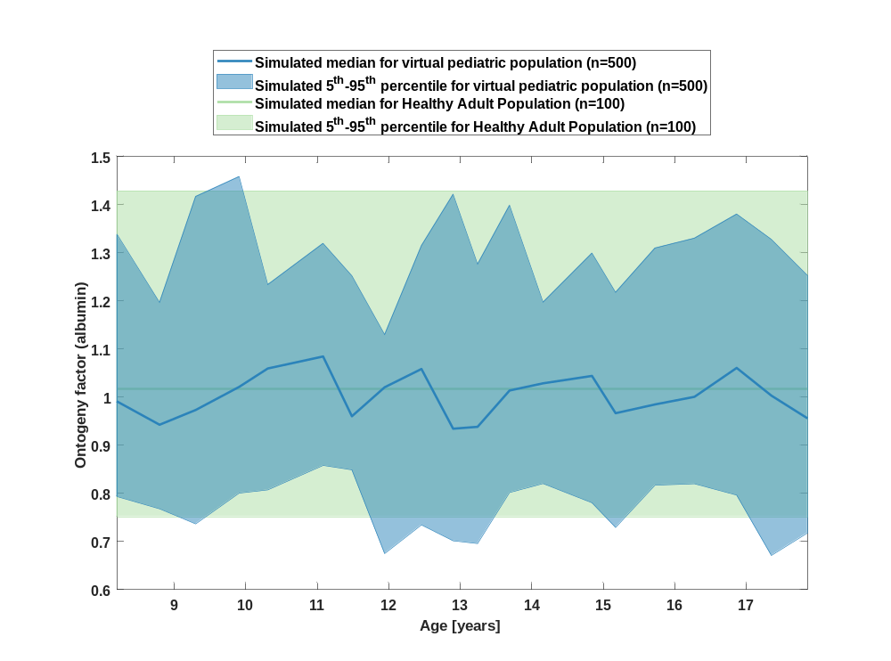

Figure 8: Age-dependence of Ontogeny factor (alpha1-acid glycoprotein) for simulated virtual pediatric population in comparison to simulated Healthy Adult Population.
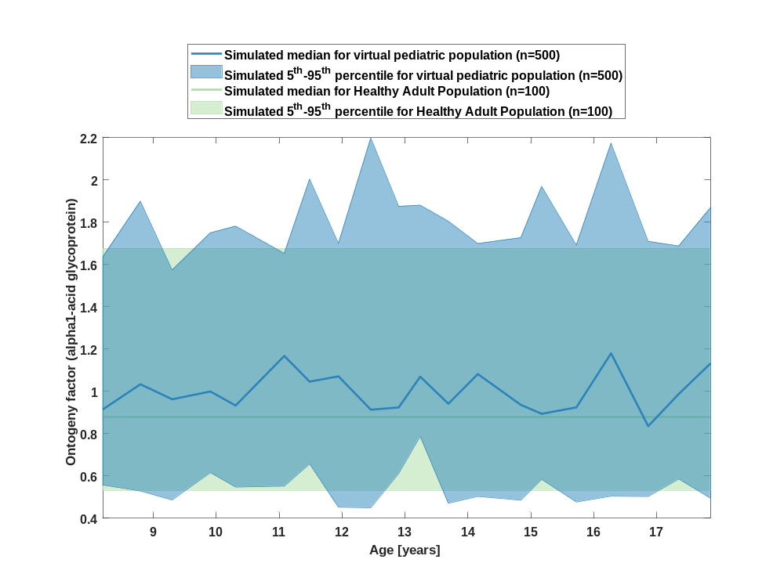

Figure 9: Age-dependence of Ontogeny factor CYP3A4 for simulated virtual pediatric population in comparison to simulated Healthy Adult Population.
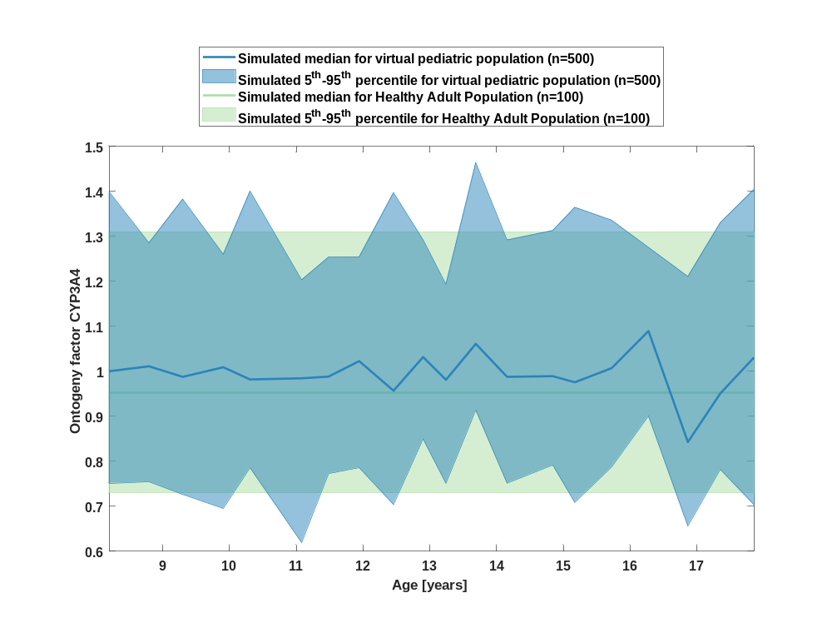

Figure 10: Age-dependence of Ontogeny factor GI CYP3A4 for simulated virtual pediatric population in comparison to simulated Healthy Adult Population.
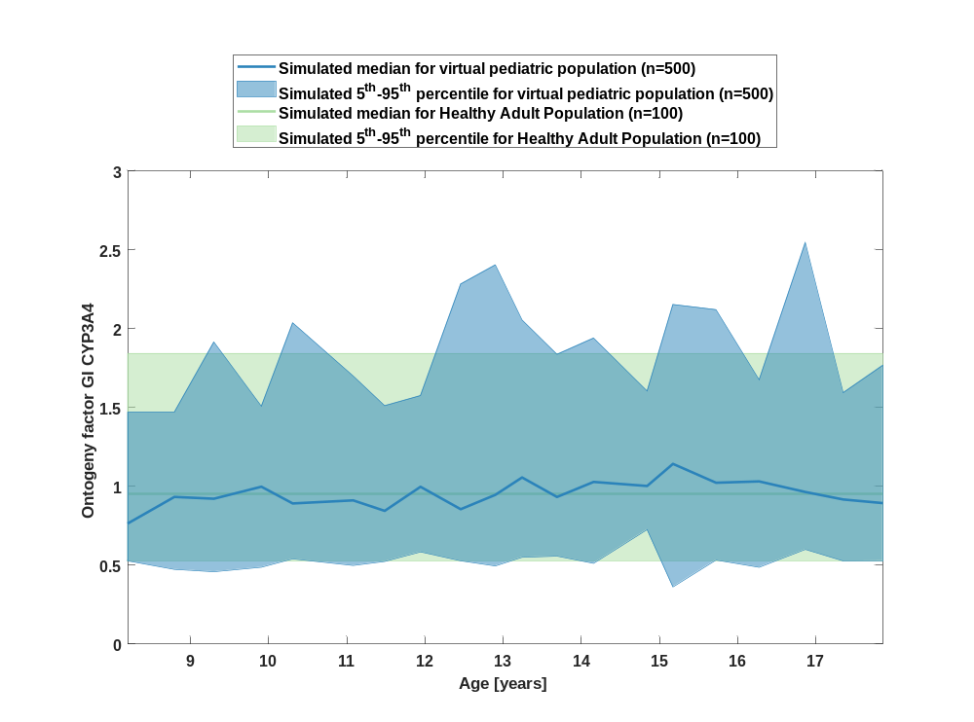

Figure 11: Age-dependence of Ontogeny factor CYP3A5 for simulated virtual pediatric population in comparison to simulated Healthy Adult Population.
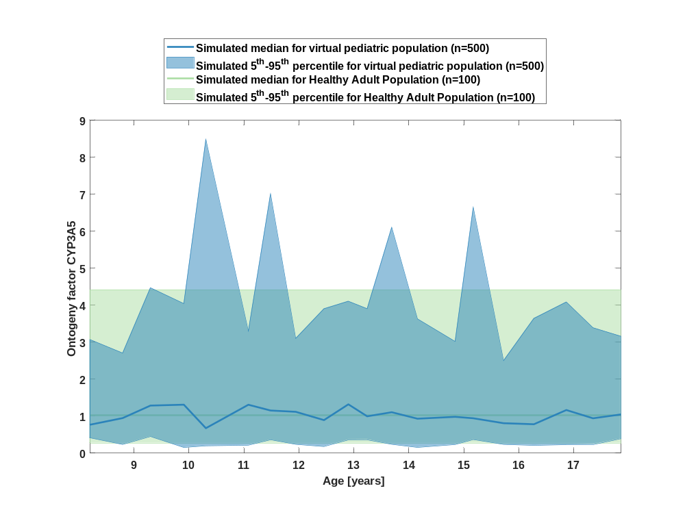

Figure 12: Age-dependence of Ontogeny factor GI CYP3A5 for simulated virtual pediatric population in comparison to simulated Healthy Adult Population.
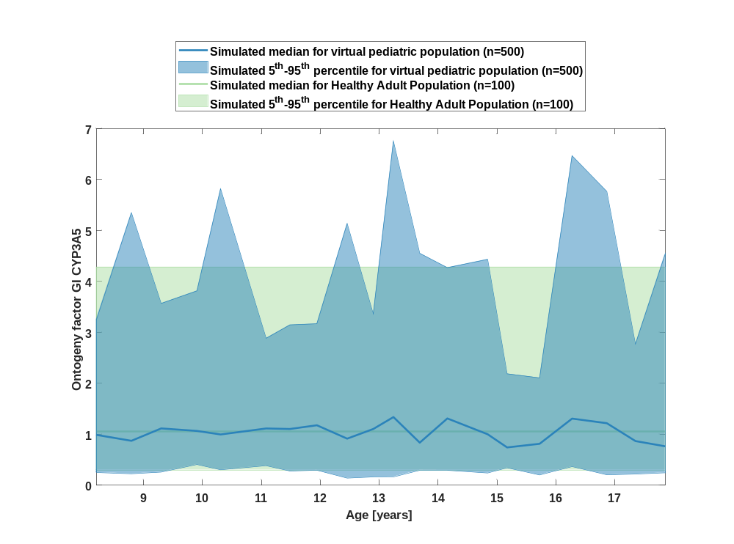

Figure 13: Age-dependence of Ontogeny factor CYP3A7 for simulated virtual pediatric population in comparison to simulated Healthy Adult Population.
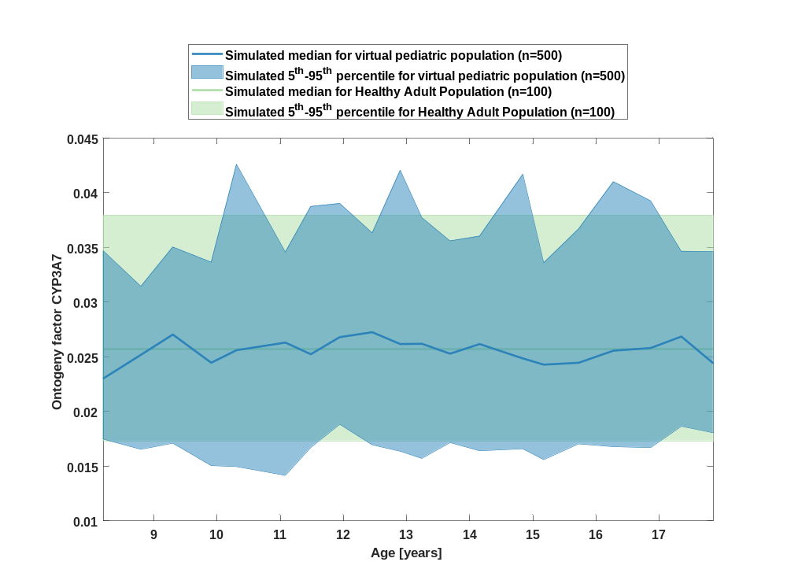

Figure 14: Age-dependence of Ontogeny factor GI CYP3A7 for simulated virtual pediatric population in comparison to simulated Healthy Adult Population.
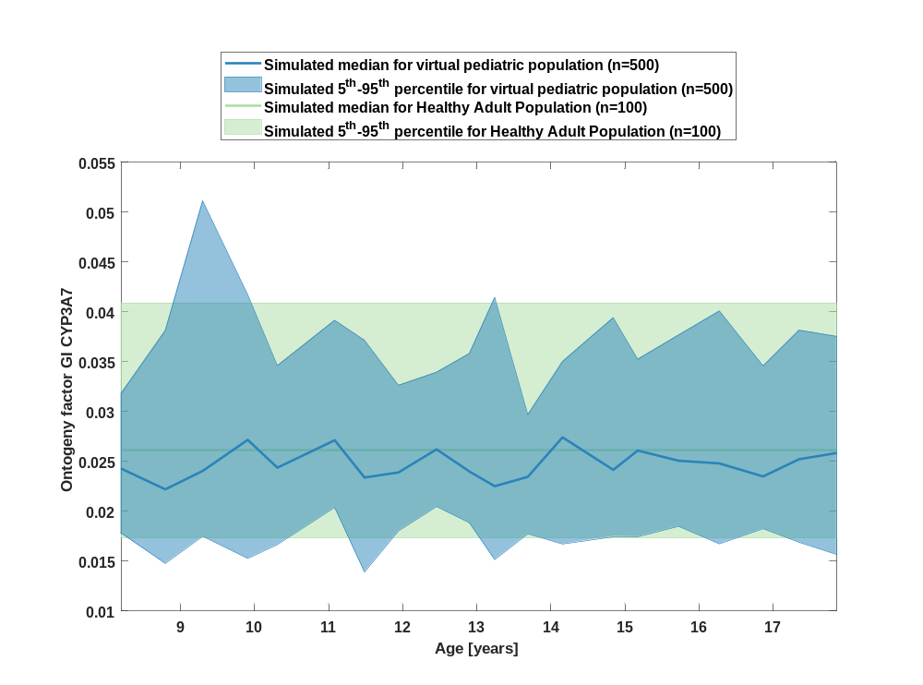

Figure 15: Age-dependence of Ontogeny factor CYP1A2 for simulated virtual pediatric population in comparison to simulated Healthy Adult Population.
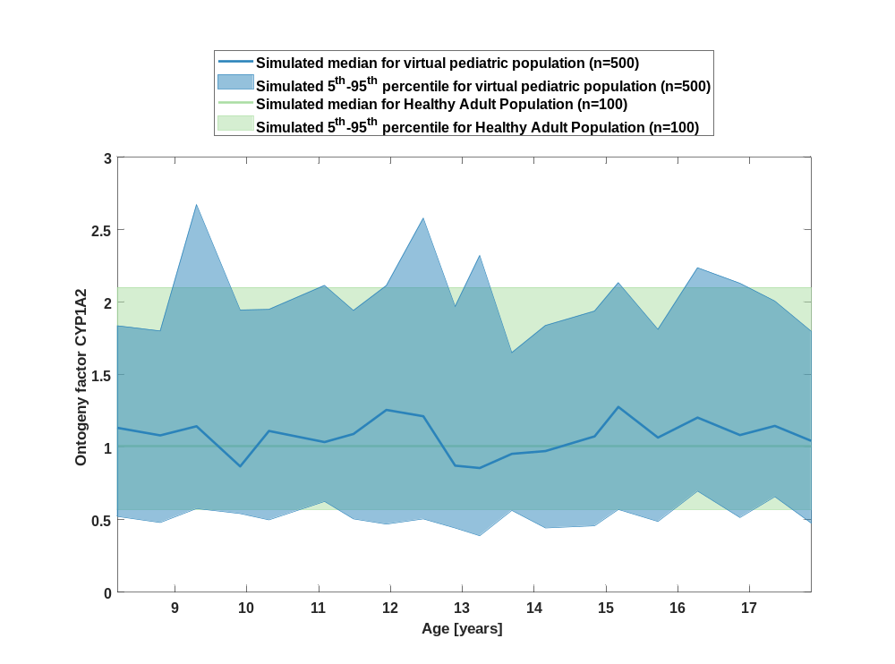

Figure 16: Age-dependence of Ontogeny factor GI CYP1A2 for simulated virtual pediatric population in comparison to simulated Healthy Adult Population.
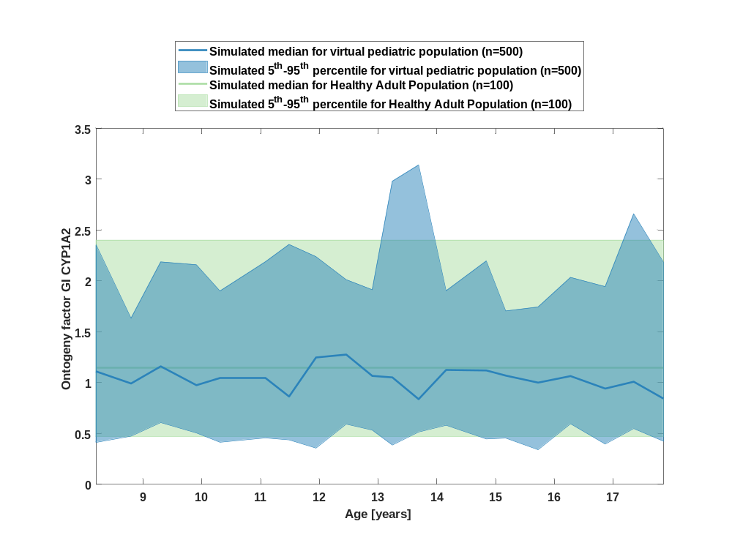

Figure 17: Age-dependence of Ontogeny factor CYP2C18 for simulated virtual pediatric population in comparison to simulated Healthy Adult Population.
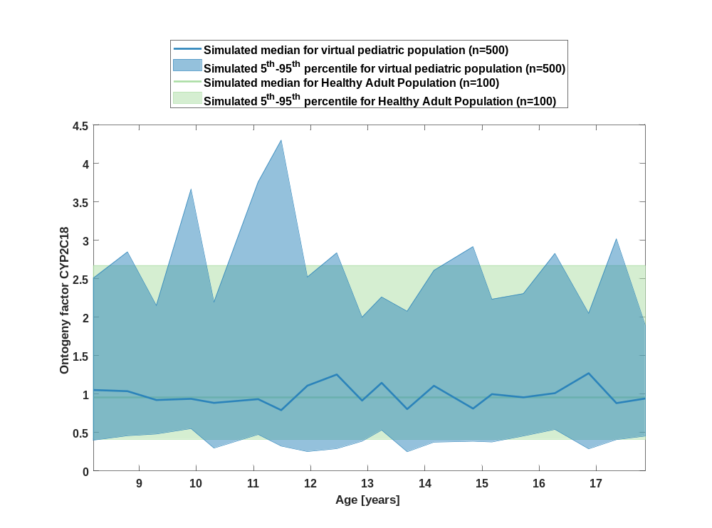

Figure 18: Age-dependence of Ontogeny factor GI CYP2C18 for simulated virtual pediatric population in comparison to simulated Healthy Adult Population.
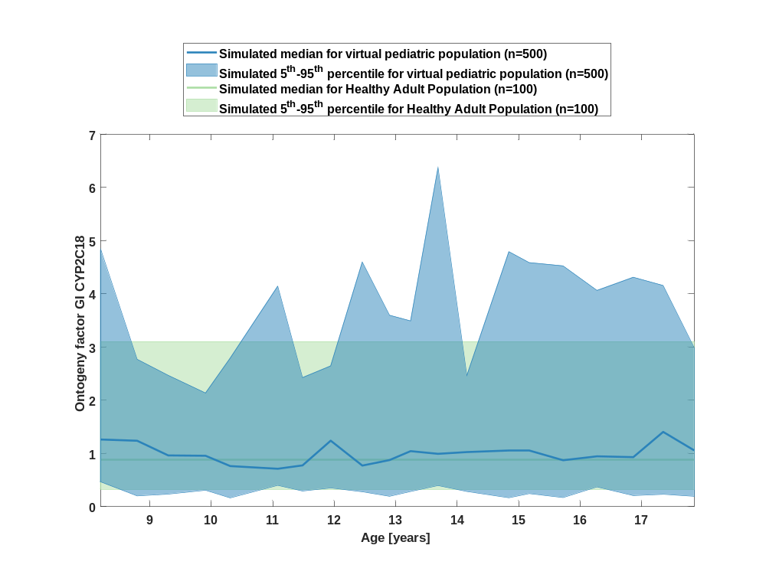

Figure 19: Age-dependence of Ontogeny factor CYP2C19 for simulated virtual pediatric population in comparison to simulated Healthy Adult Population.
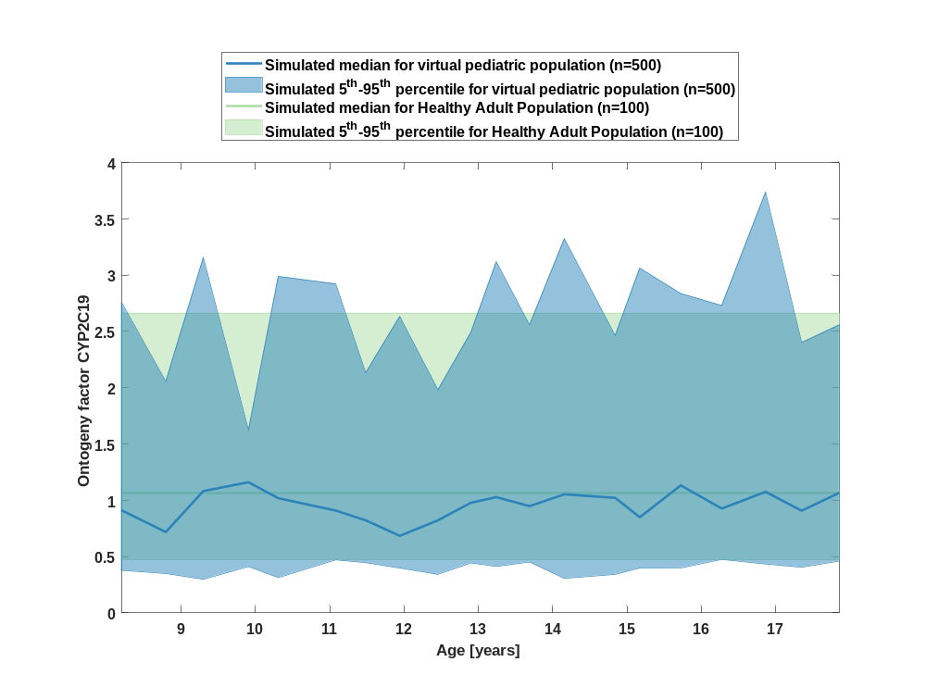

Figure 20: Age-dependence of Ontogeny factor GI CYP2C19 for simulated virtual pediatric population in comparison to simulated Healthy Adult Population.
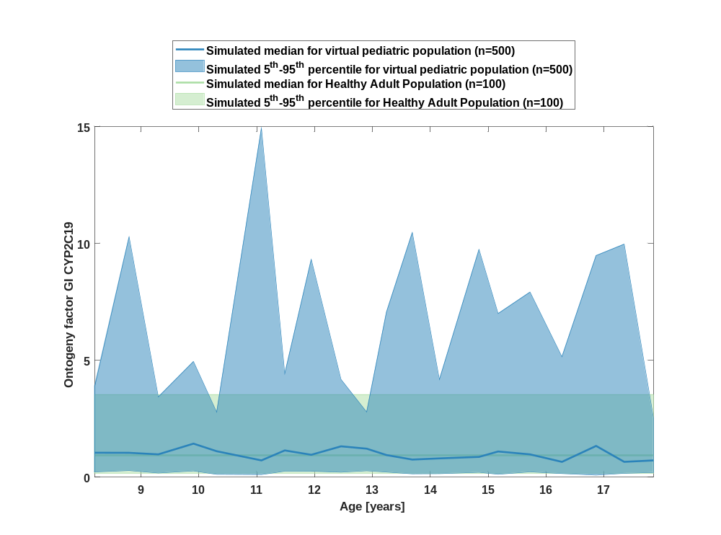

Figure 21: Age-dependence of Ontogeny factor CYP2D6 for simulated virtual pediatric population in comparison to simulated Healthy Adult Population.
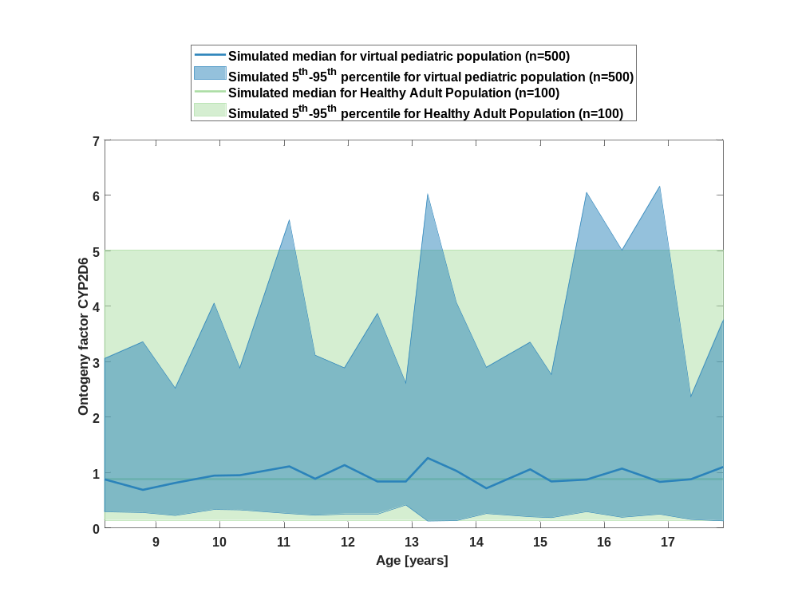

Figure 22: Age-dependence of Ontogeny factor GI CYP2D6 for simulated virtual pediatric population in comparison to simulated Healthy Adult Population.
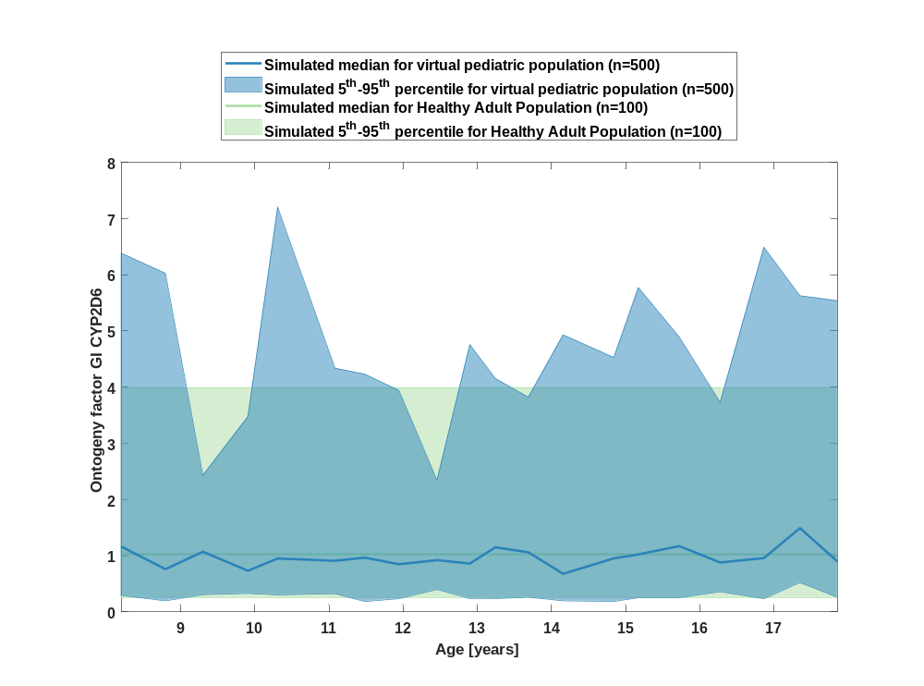

Figure 23: Age-dependence of Ontogeny factor CYP2E1 for simulated virtual pediatric population in comparison to simulated Healthy Adult Population.
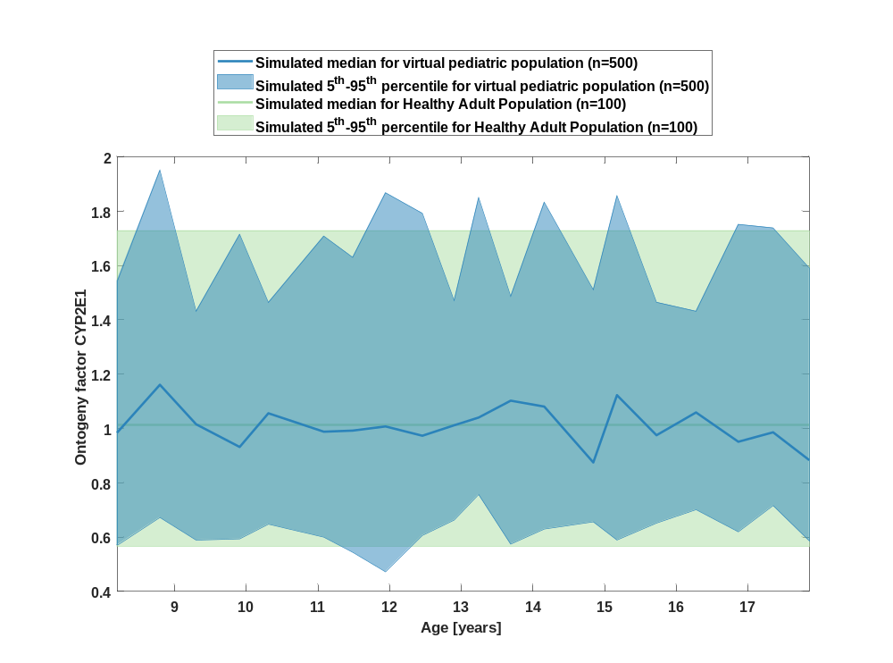

Figure 24: Age-dependence of Ontogeny factor GI CYP2E1 for simulated virtual pediatric population in comparison to simulated Healthy Adult Population.
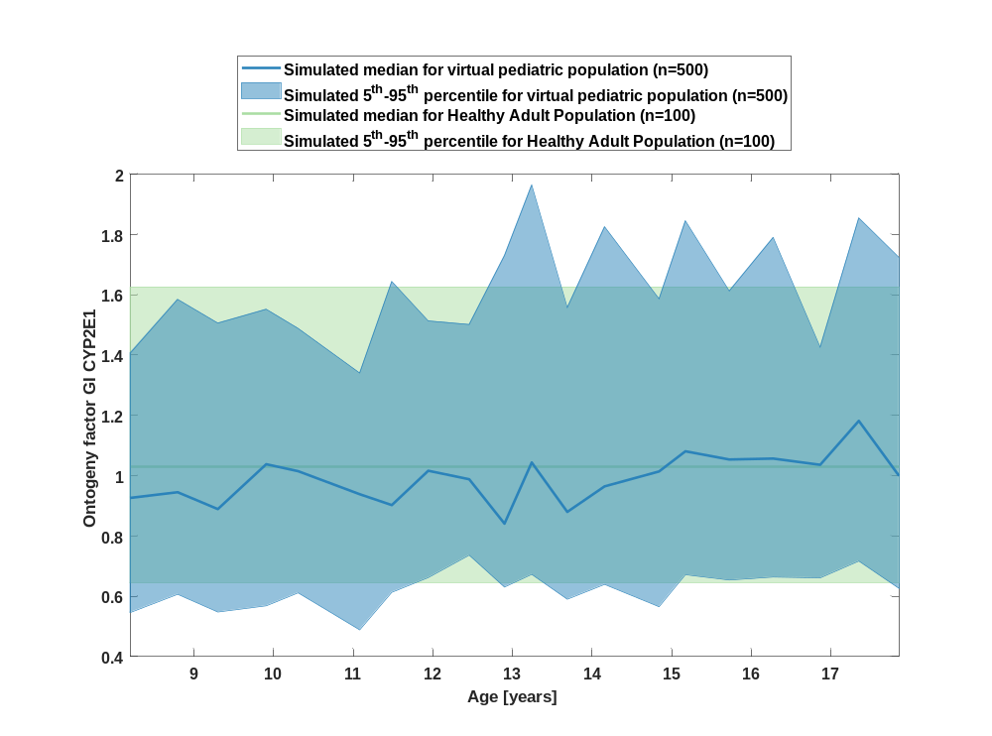

Figure 25: Age-dependence of Ontogeny factor UGT1A1 for simulated virtual pediatric population in comparison to simulated Healthy Adult Population.
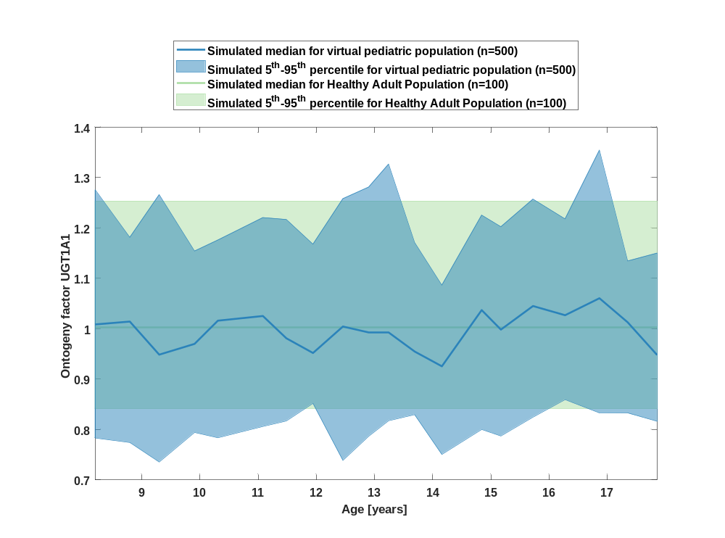

Figure 26: Age-dependence of Ontogeny factor GI UGT1A1 for simulated virtual pediatric population in comparison to simulated Healthy Adult Population.
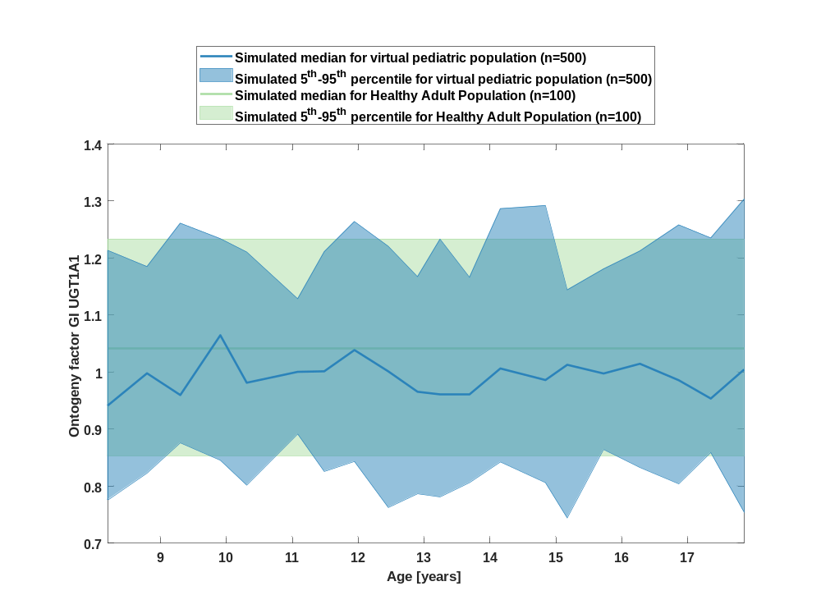

Figure 27: Age-dependence of Ontogeny factor UGT1A4 for simulated virtual pediatric population in comparison to simulated Healthy Adult Population.
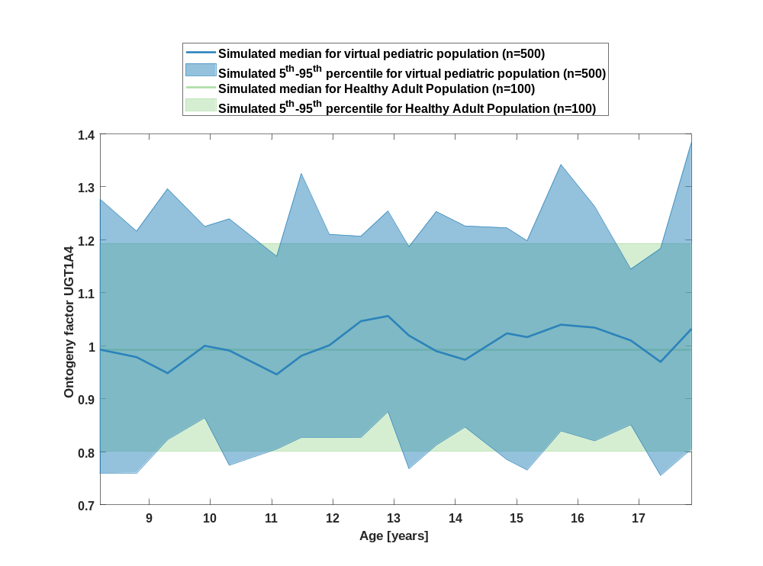

Figure 28: Age-dependence of Ontogeny factor GI UGT1A4 for simulated virtual pediatric population in comparison to simulated Healthy Adult Population.
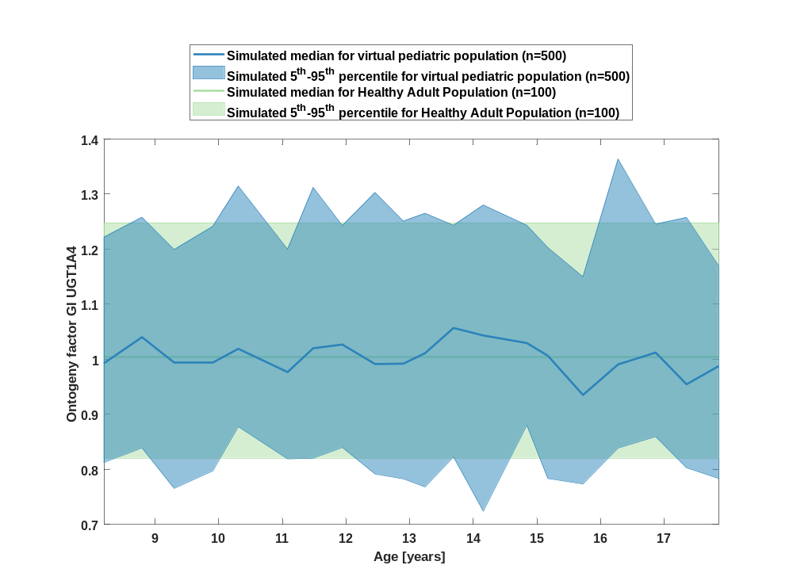

Figure 29: Age-dependence of Ontogeny factor UGT1A6 for simulated virtual pediatric population in comparison to simulated Healthy Adult Population.
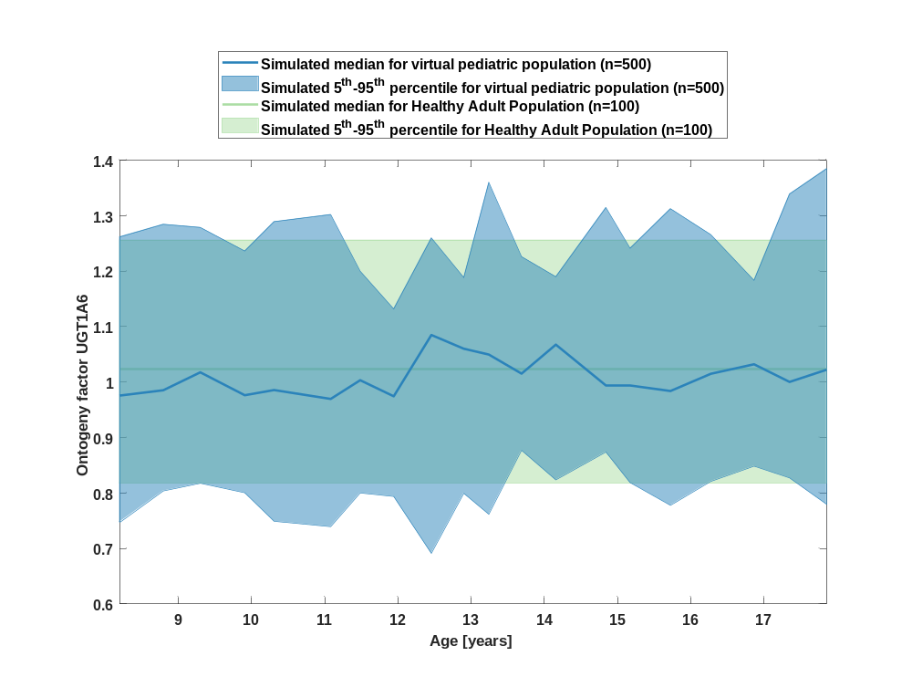

Figure 30: Age-dependence of Ontogeny factor GI UGT1A6 for simulated virtual pediatric population in comparison to simulated Healthy Adult Population.
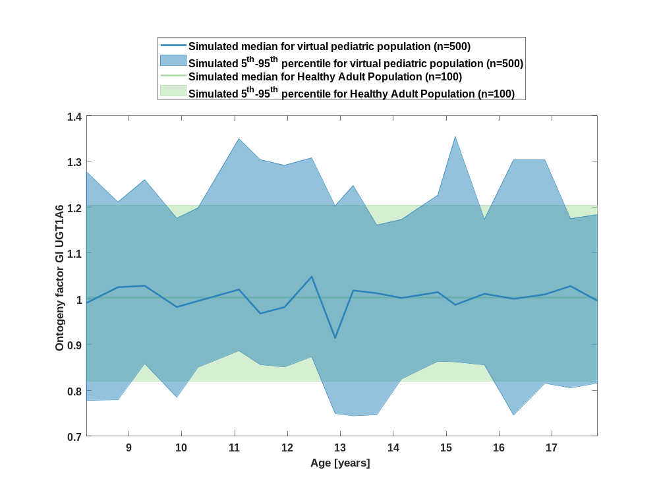

Figure 31: Age-dependence of Ontogeny factor UGT1A9 for simulated virtual pediatric population in comparison to simulated Healthy Adult Population.
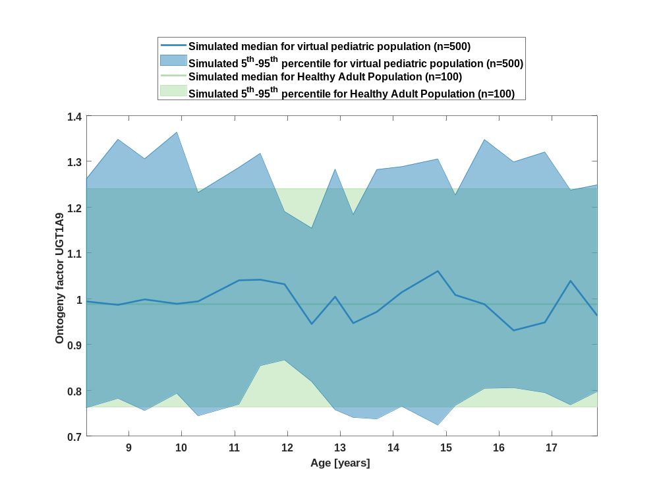

Figure 32: Age-dependence of Ontogeny factor GI UGT1A9 for simulated virtual pediatric population in comparison to simulated Healthy Adult Population.
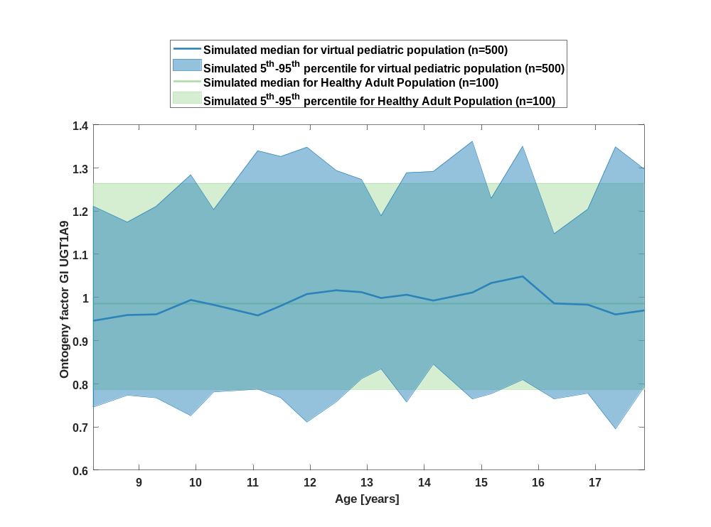

Figure 33: Age-dependence of Ontogeny factor UGT2B4 for simulated virtual pediatric population in comparison to simulated Healthy Adult Population.
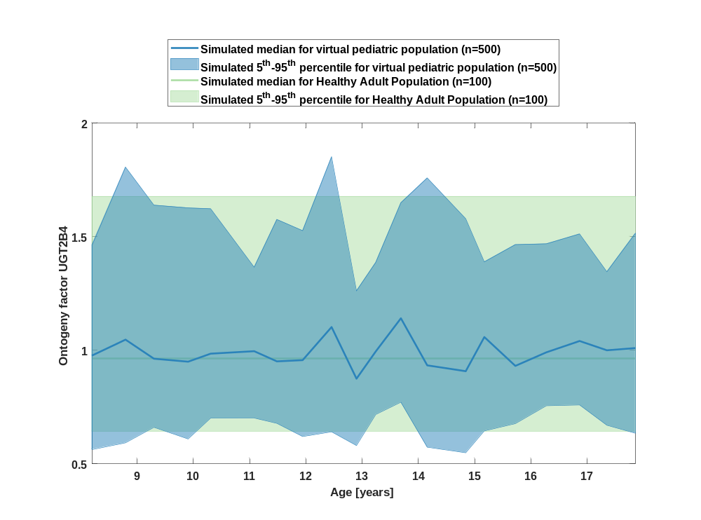

Figure 34: Age-dependence of Ontogeny factor GI UGT2B4 for simulated virtual pediatric population in comparison to simulated Healthy Adult Population.
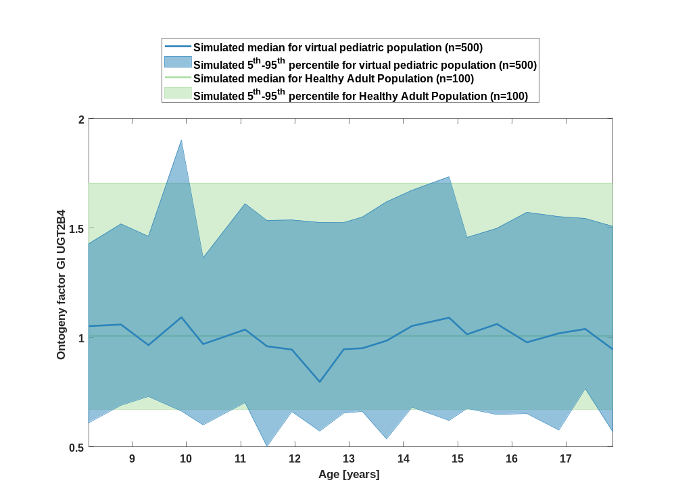

Figure 35: Age-dependence of Ontogeny factor UGT2B7 for simulated virtual pediatric population in comparison to simulated Healthy Adult Population.
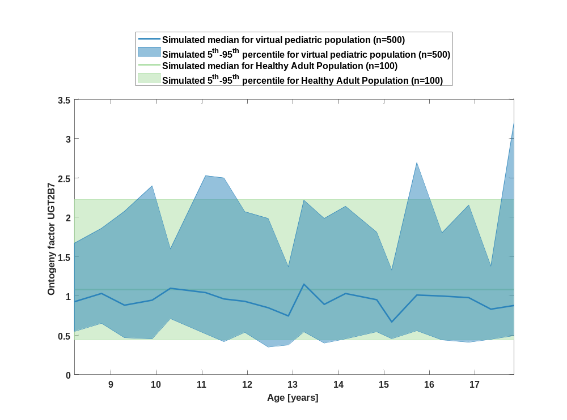

Figure 36: Age-dependence of Ontogeny factor GI UGT2B7 for simulated virtual pediatric population in comparison to simulated Healthy Adult Population.
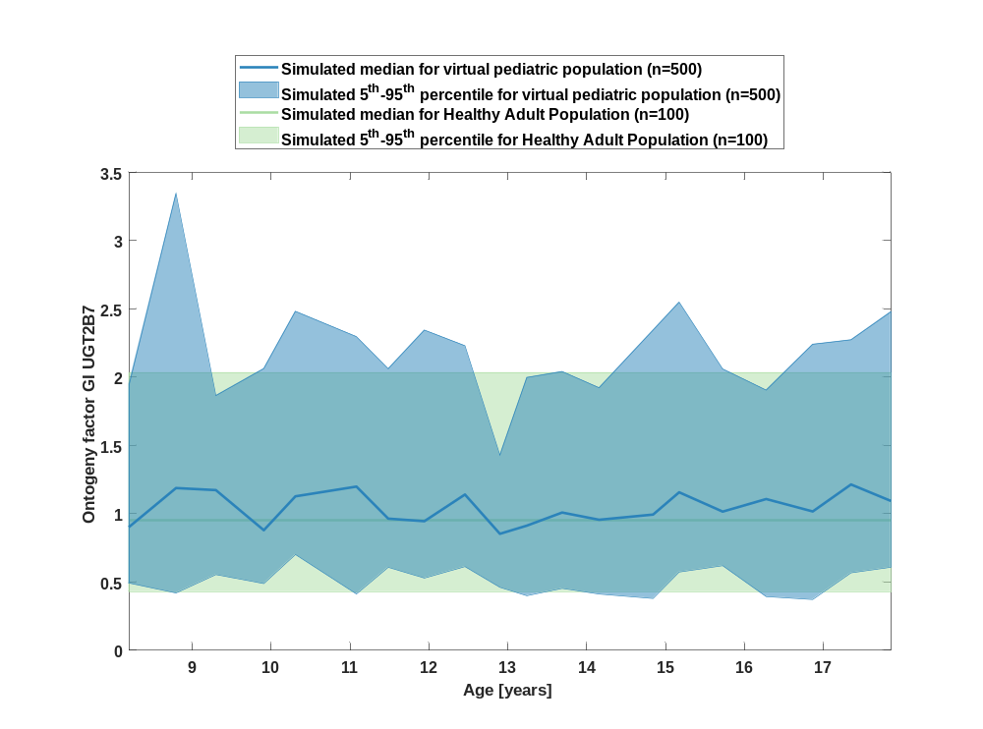

Figure 37: Age-dependence of Ontogeny factor CYP1A1 for simulated virtual pediatric population in comparison to simulated Healthy Adult Population.
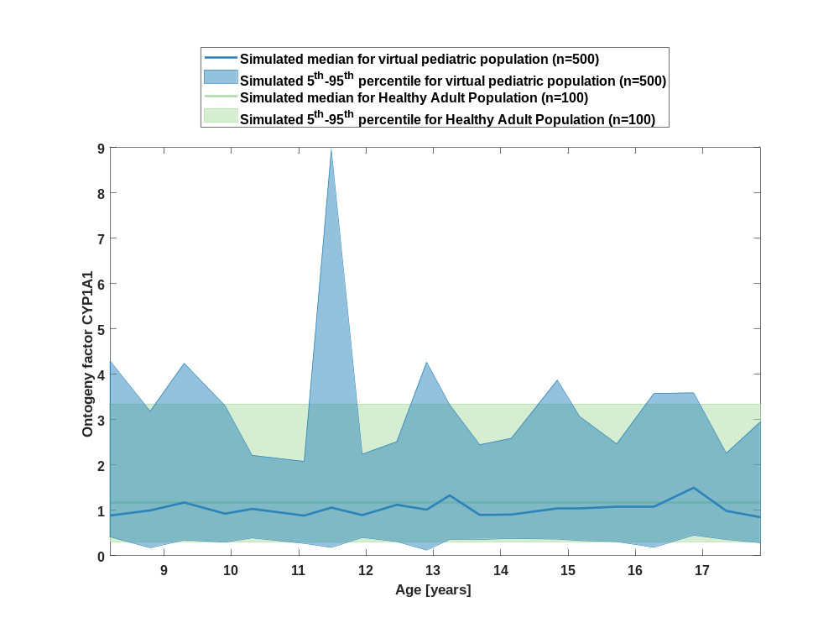

Figure 38: Age-dependence of Ontogeny factor GI CYP1A1 for simulated virtual pediatric population in comparison to simulated Healthy Adult Population.
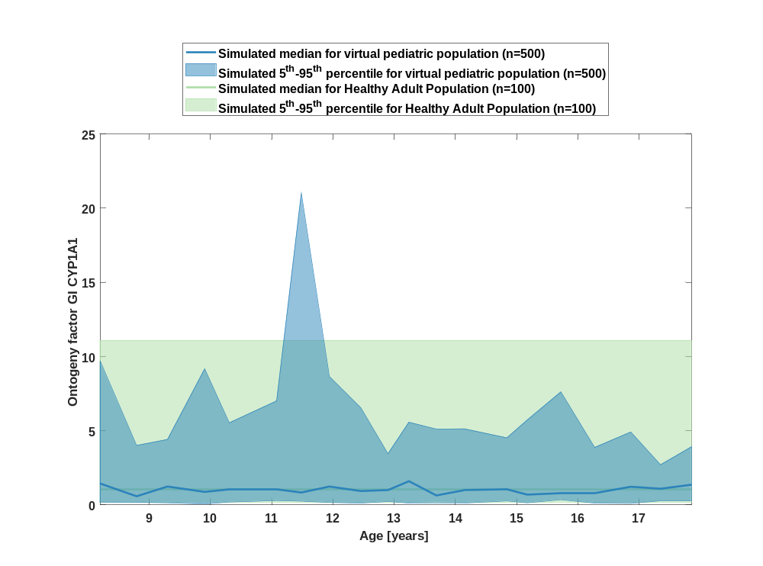

Figure 39: Age-dependence of Ontogeny factor ABCG2 (BCRP) for simulated virtual pediatric population in comparison to simulated Healthy Adult Population.
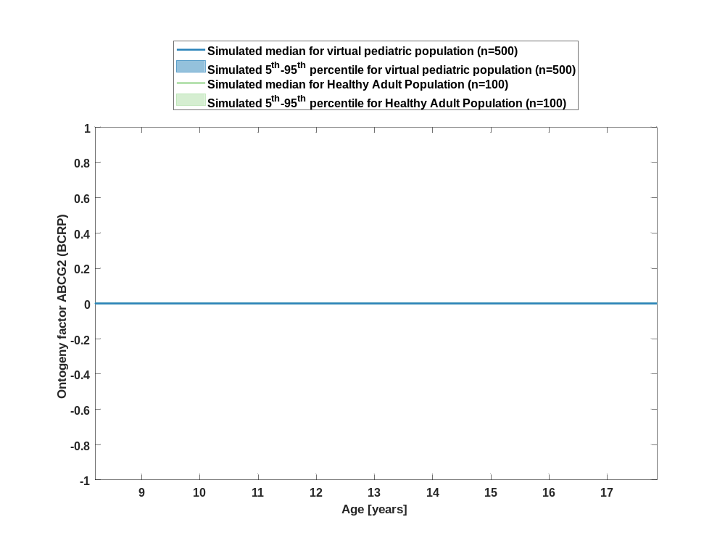

Figure 40: Age-dependence of Ontogeny factor GI ABCG2 (BCRP) for simulated virtual pediatric population in comparison to simulated Healthy Adult Population.
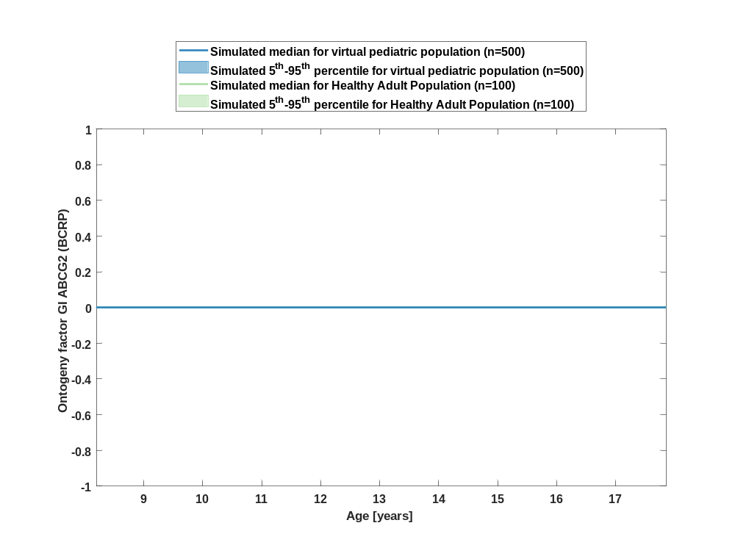

Figure 41: Age-dependence of Ontogeny factor ABCB1 (P-gp) for simulated virtual pediatric population in comparison to simulated Healthy Adult Population.
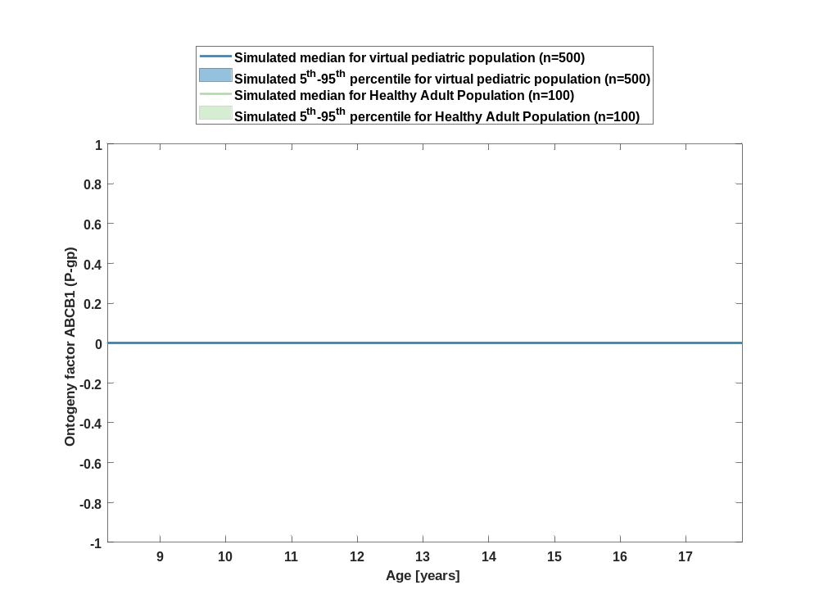

Figure 42: Age-dependence of Ontogeny factor GI ABCB1 (P-gp) for simulated virtual pediatric population in comparison to simulated Healthy Adult Population.
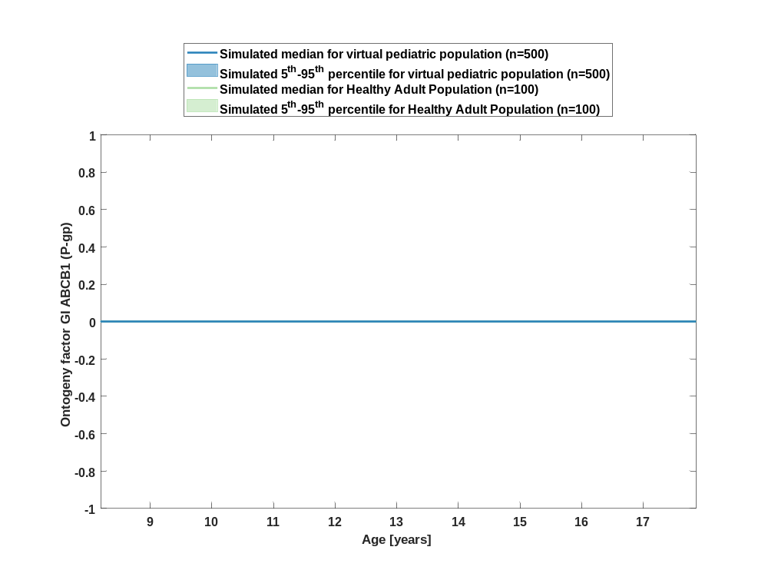

Pkparameter

Age-dependence of Raltegravir

C_{max}

Figure 1: age dependency of C_{max} Raltegravir for simulated virtual pediatric population in comparison to simulated Filmcoated_tablet_400mg_sd in a linear scale.
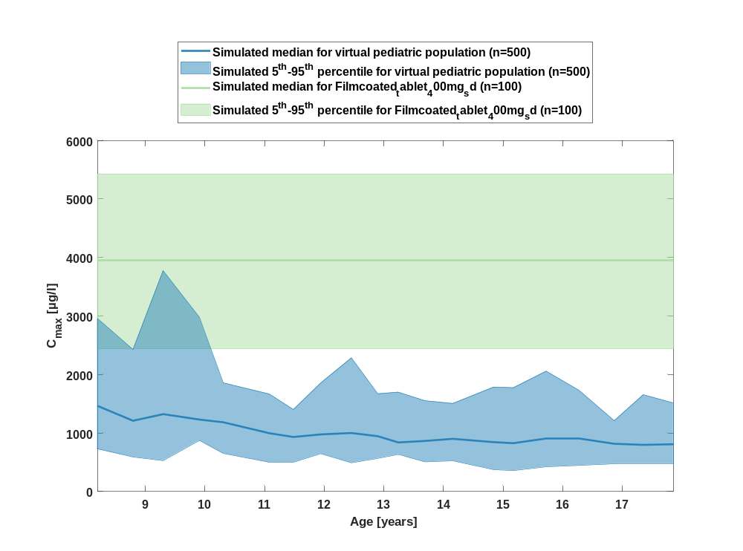

Figure 2: age dependency of C_{max} Raltegravir for simulated virtual pediatric population in comparison to simulated Filmcoated_tablet_400mg_sd in a logarithmic scale.
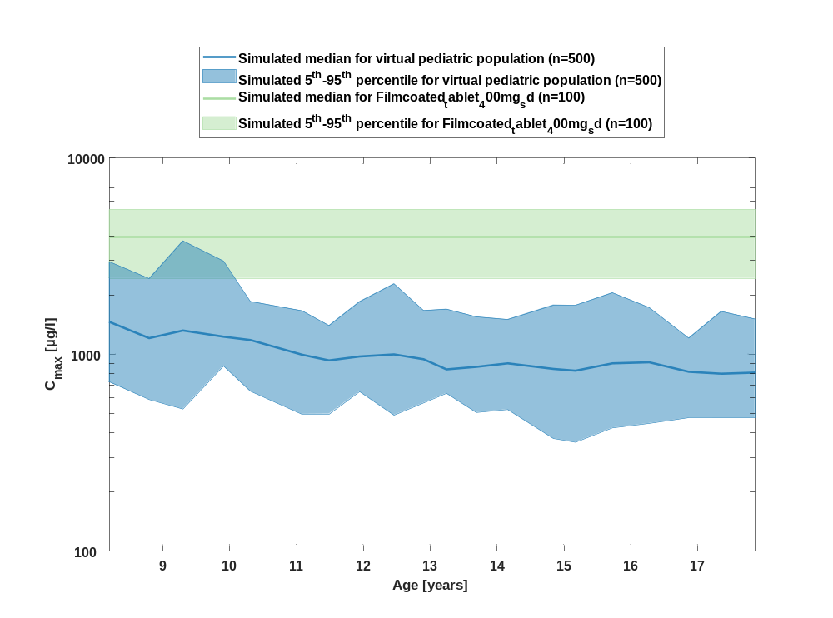

Table 1-1:age dependency of C_{max} Raltegravir for simulated virtual pediatric population in comparison to simulated Filmcoated_tablet_400mg_sd
Age [years] | C_{max} [µg/l]
Range of age | Median of age | 5th percentile | median | 95th percentile | N individuals
8-8.53 | 8.20 | 723 | 1470 | 2960 | 25
8.53-9.09 | 8.80 | 590 | 1210 | 2430 | 25
9.09-9.6 | 9.30 | 528 | 1320 | 3770 | 25
9.6-10.1 | 9.91 | 873 | 1230 | 2980 | 25
10.1-10.8 | 10.30 | 650 | 1180 | 1860 | 25
10.8-11.3 | 11.10 | 497 | 996 | 1670 | 25
11.3-11.7 | 11.50 | 498 | 932 | 1400 | 25
11.7-12.2 | 11.90 | 647 | 976 | 1860 | 25
12.2-12.7 | 12.50 | 491 | 1000 | 2290 | 25
12.7-13 | 12.90 | 567 | 945 | 1670 | 25
13-13.5 | 13.20 | 634 | 839 | 1700 | 25
13.5-13.9 | 13.70 | 507 | 865 | 1550 | 25
13.9-14.5 | 14.20 | 525 | 901 | 1500 | 25
14.5-15 | 14.80 | 374 | 844 | 1780 | 25
15-15.4 | 15.20 | 358 | 826 | 1770 | 25
15.4-16 | 15.70 | 423 | 901 | 2060 | 25
16-16.6 | 16.30 | 446 | 912 | 1730 | 25
16.6-17.1 | 16.90 | 476 | 816 | 1210 | 25
17.1-17.6 | 17.30 | 476 | 798 | 1650 | 25
17.6-18 | 17.90 | 476 | 808 | 1510 | 25
reference values: | 2440 | 3950 | 5430

C_{max} norm

Figure 3: age dependency of C_{max} norm Raltegravir for simulated virtual pediatric population in comparison to simulated Filmcoated_tablet_400mg_sd in a linear scale.
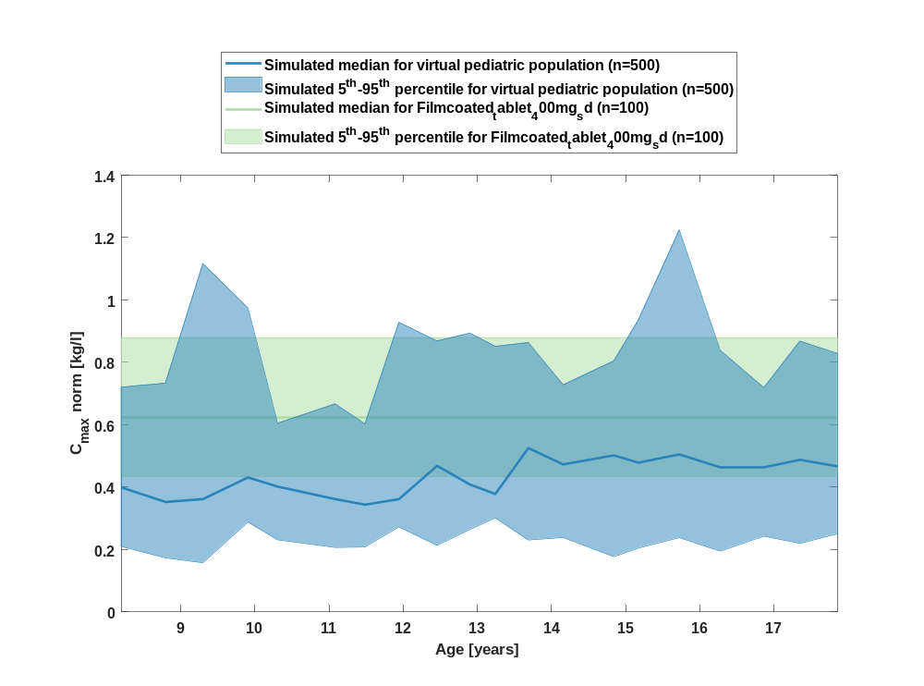

Figure 4: age dependency of C_{max} norm Raltegravir for simulated virtual pediatric population in comparison to simulated Filmcoated_tablet_400mg_sd in a logarithmic scale.
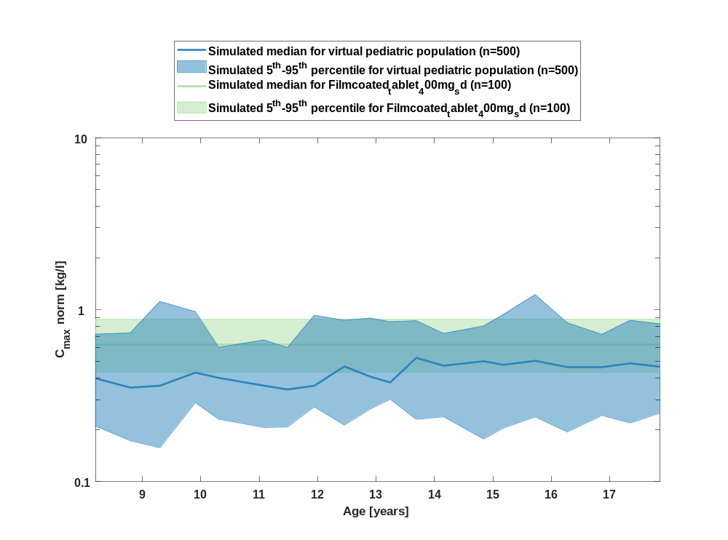

Table 1-2:age dependency of C_{max} norm Raltegravir for simulated virtual pediatric population in comparison to simulated Filmcoated_tablet_400mg_sd
Age [years] | C_{max} norm [kg/l]
Range of age | Median of age | 5th percentile | median | 95th percentile | N individuals
8-8.53 | 8.20 | 0.21 | 0.40 | 0.72 | 25
8.53-9.09 | 8.80 | 0.17 | 0.35 | 0.73 | 25
9.09-9.6 | 9.30 | 0.16 | 0.36 | 1.12 | 25
9.6-10.1 | 9.91 | 0.29 | 0.43 | 0.97 | 25
10.1-10.8 | 10.30 | 0.23 | 0.40 | 0.61 | 25
10.8-11.3 | 11.10 | 0.21 | 0.36 | 0.67 | 25
11.3-11.7 | 11.50 | 0.21 | 0.34 | 0.60 | 25
11.7-12.2 | 11.90 | 0.27 | 0.36 | 0.93 | 25
12.2-12.7 | 12.50 | 0.21 | 0.47 | 0.87 | 25
12.7-13 | 12.90 | 0.26 | 0.41 | 0.89 | 25
13-13.5 | 13.20 | 0.30 | 0.38 | 0.85 | 25
13.5-13.9 | 13.70 | 0.23 | 0.53 | 0.86 | 25
13.9-14.5 | 14.20 | 0.24 | 0.47 | 0.73 | 25
14.5-15 | 14.80 | 0.18 | 0.50 | 0.80 | 25
15-15.4 | 15.20 | 0.21 | 0.48 | 0.94 | 25
15.4-16 | 15.70 | 0.24 | 0.51 | 1.22 | 25
16-16.6 | 16.30 | 0.20 | 0.46 | 0.84 | 25
16.6-17.1 | 16.90 | 0.24 | 0.46 | 0.72 | 25
17.1-17.6 | 17.30 | 0.22 | 0.49 | 0.87 | 25
17.6-18 | 17.90 | 0.25 | 0.47 | 0.83 | 25
reference values: | 0.43 | 0.63 | 0.88

t_{max}

Figure 5: age dependency of t_{max} Raltegravir for simulated virtual pediatric population in comparison to simulated Filmcoated_tablet_400mg_sd in a linear scale.
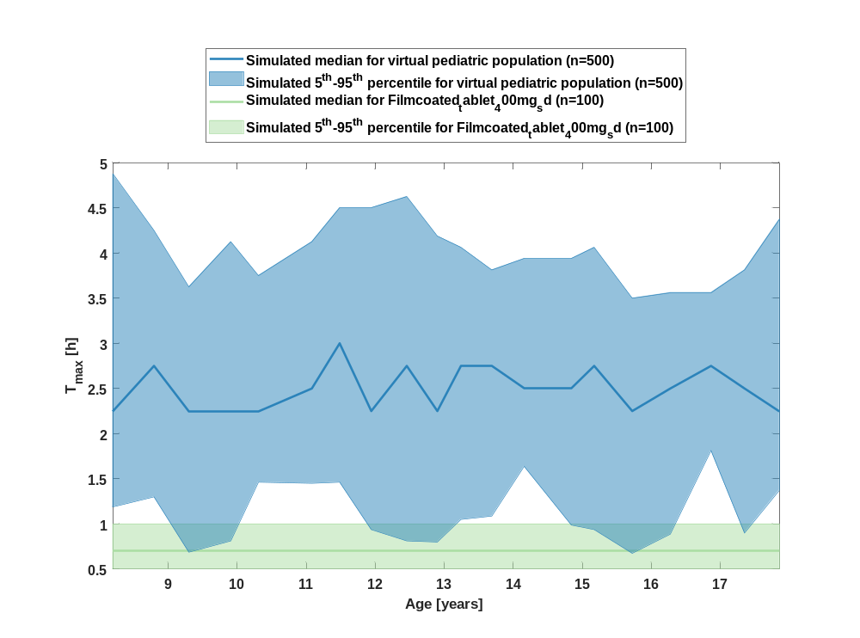

Figure 6: age dependency of t_{max} Raltegravir for simulated virtual pediatric population in comparison to simulated Filmcoated_tablet_400mg_sd in a logarithmic scale.
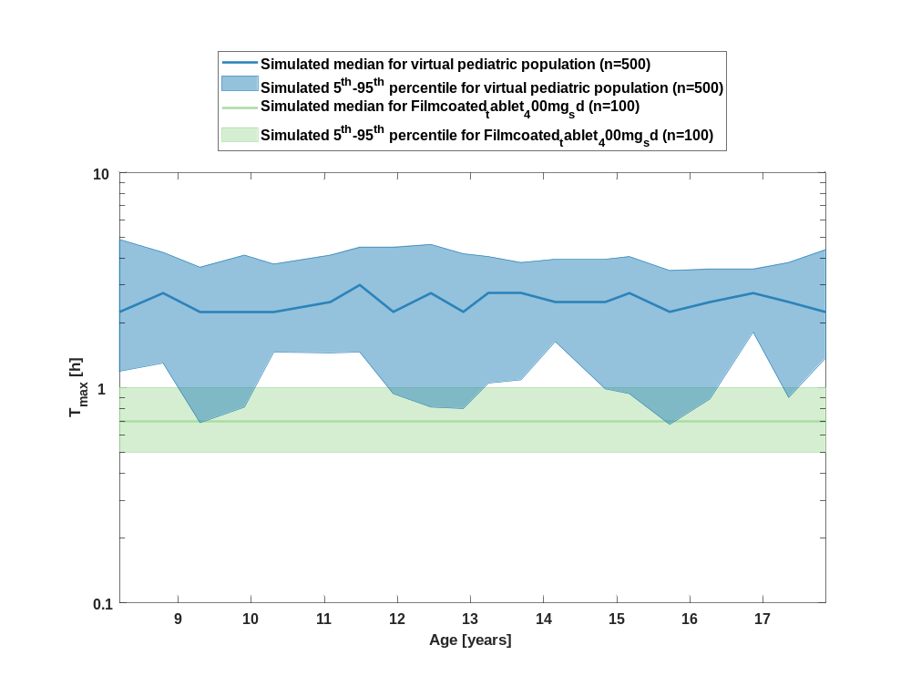

Table 1-3:age dependency of t_{max} Raltegravir for simulated virtual pediatric population in comparison to simulated Filmcoated_tablet_400mg_sd
Age [years] | T_{max} [h]
Range of age | Median of age | 5th percentile | median | 95th percentile | N individuals
8-8.53 | 8.20 | 1.19 | 2.25 | 4.88 | 25
8.53-9.09 | 8.80 | 1.30 | 2.75 | 4.25 | 25
9.09-9.6 | 9.30 | 0.69 | 2.25 | 3.63 | 25
9.6-10.1 | 9.91 | 0.81 | 2.25 | 4.13 | 25
10.1-10.8 | 10.30 | 1.46 | 2.25 | 3.75 | 25
10.8-11.3 | 11.10 | 1.45 | 2.50 | 4.13 | 25
11.3-11.7 | 11.50 | 1.46 | 3 | 4.50 | 25
11.7-12.2 | 11.90 | 0.94 | 2.25 | 4.50 | 25
12.2-12.7 | 12.50 | 0.81 | 2.75 | 4.63 | 25
12.7-13 | 12.90 | 0.80 | 2.25 | 4.19 | 25
13-13.5 | 13.20 | 1.05 | 2.75 | 4.06 | 25
13.5-13.9 | 13.70 | 1.09 | 2.75 | 3.81 | 25
13.9-14.5 | 14.20 | 1.64 | 2.50 | 3.94 | 25
14.5-15 | 14.80 | 0.99 | 2.50 | 3.94 | 25
15-15.4 | 15.20 | 0.94 | 2.75 | 4.06 | 25
15.4-16 | 15.70 | 0.68 | 2.25 | 3.50 | 25
16-16.6 | 16.30 | 0.89 | 2.50 | 3.56 | 25
16.6-17.1 | 16.90 | 1.81 | 2.75 | 3.56 | 25
17.1-17.6 | 17.30 | 0.90 | 2.50 | 3.81 | 25
17.6-18 | 17.90 | 1.38 | 2.25 | 4.38 | 25
reference values: | 0.50 | 0.70 | 1

C_{tEnd}

Figure 7: age dependency of C_{tEnd} Raltegravir for simulated virtual pediatric population in comparison to simulated Filmcoated_tablet_400mg_sd in a linear scale.
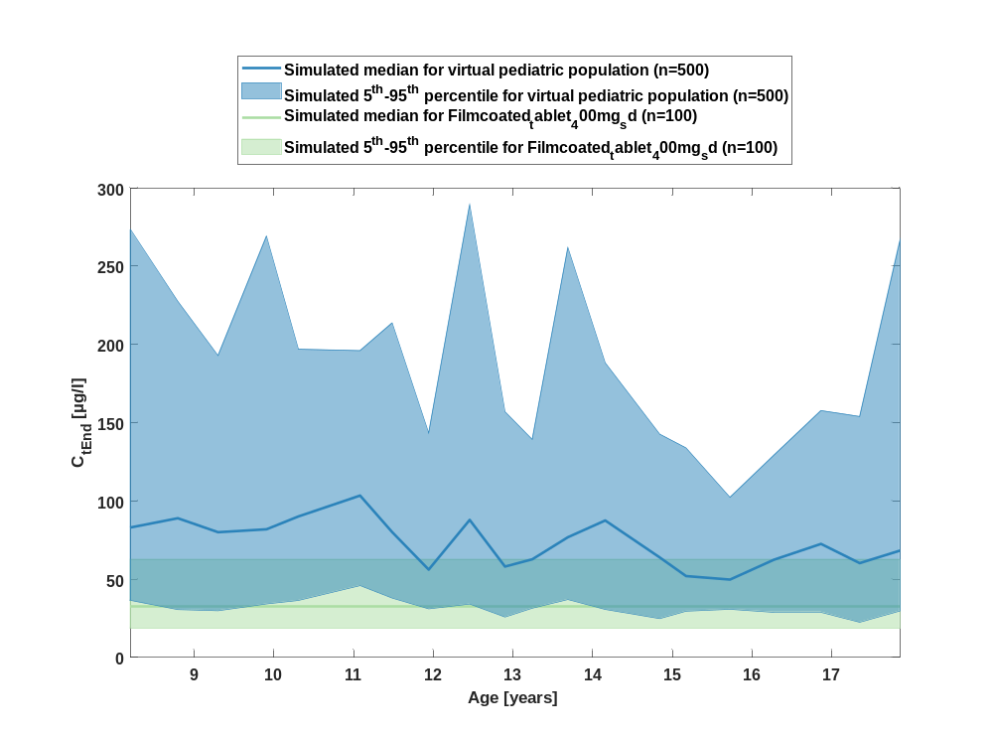

Figure 8: age dependency of C_{tEnd} Raltegravir for simulated virtual pediatric population in comparison to simulated Filmcoated_tablet_400mg_sd in a logarithmic scale.
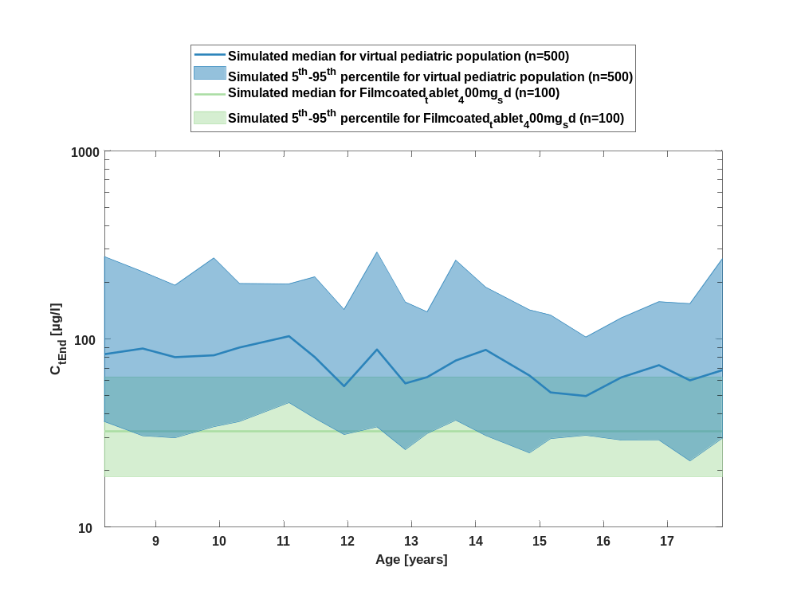

Table 1-4:age dependency of C_{tEnd} Raltegravir for simulated virtual pediatric population in comparison to simulated Filmcoated_tablet_400mg_sd
Age [years] | C_{tEnd} [µg/l]
Range of age | Median of age | 5th percentile | median | 95th percentile | N individuals
8-8.53 | 8.20 | 36.30 | 83 | 273 | 25
8.53-9.09 | 8.80 | 30.60 | 89 | 228 | 25
9.09-9.6 | 9.30 | 29.90 | 80 | 193 | 25
9.6-10.1 | 9.91 | 34.20 | 81.90 | 269 | 25
10.1-10.8 | 10.30 | 36.40 | 90.10 | 197 | 25
10.8-11.3 | 11.10 | 45.90 | 103 | 196 | 25
11.3-11.7 | 11.50 | 37.90 | 80.10 | 214 | 25
11.7-12.2 | 11.90 | 31.10 | 56.10 | 143 | 25
12.2-12.7 | 12.50 | 34.10 | 87.90 | 289 | 25
12.7-13 | 12.90 | 25.80 | 58.10 | 157 | 25
13-13.5 | 13.20 | 31.50 | 62.70 | 139 | 25
13.5-13.9 | 13.70 | 37 | 76.80 | 262 | 25
13.9-14.5 | 14.20 | 30.70 | 87.50 | 188 | 25
14.5-15 | 14.80 | 24.80 | 63.90 | 143 | 25
15-15.4 | 15.20 | 29.60 | 52 | 134 | 25
15.4-16 | 15.70 | 30.80 | 49.70 | 102 | 25
16-16.6 | 16.30 | 29 | 62.40 | 129 | 25
16.6-17.1 | 16.90 | 29.10 | 72.50 | 158 | 25
17.1-17.6 | 17.30 | 22.50 | 60.30 | 154 | 25
17.6-18 | 17.90 | 29.70 | 68.30 | 267 | 25
reference values: | 18.60 | 32.30 | 62.80

AUC_{last}

Figure 9: age dependency of AUC_{last} Raltegravir for simulated virtual pediatric population in comparison to simulated Filmcoated_tablet_400mg_sd in a linear scale.
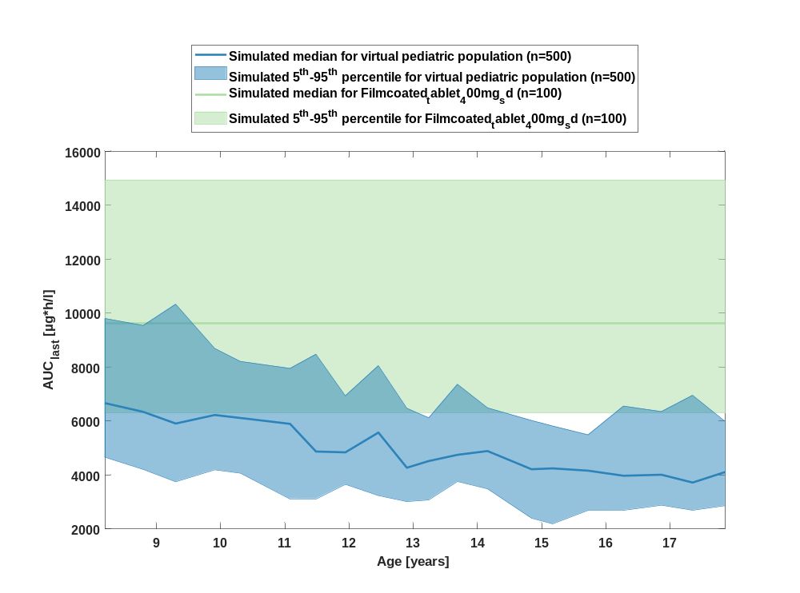

Figure 10: age dependency of AUC_{last} Raltegravir for simulated virtual pediatric population in comparison to simulated Filmcoated_tablet_400mg_sd in a logarithmic scale.
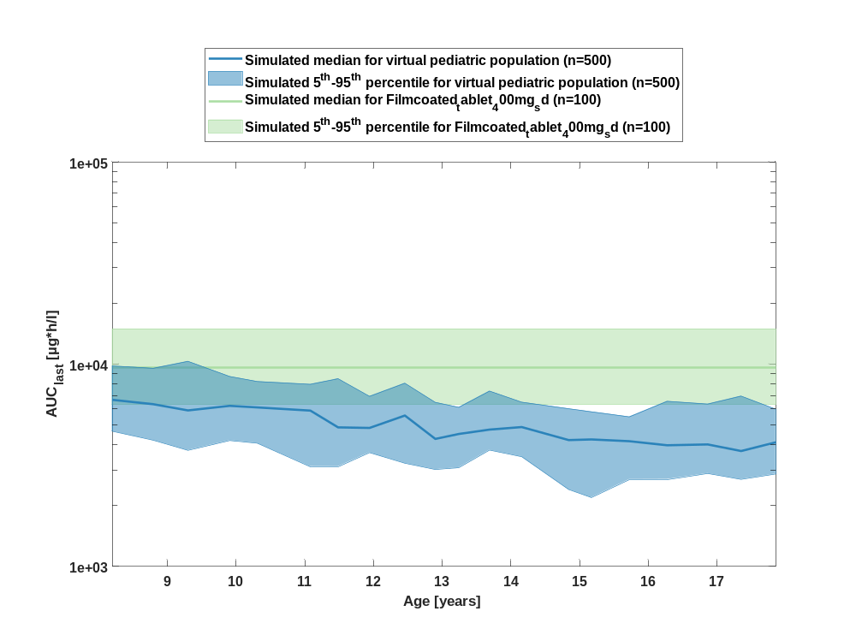

Table 1-5:age dependency of AUC_{last} Raltegravir for simulated virtual pediatric population in comparison to simulated Filmcoated_tablet_400mg_sd
Age [years] | AUC_{last} [µg*h/l]
Range of age | Median of age | 5th percentile | median | 95th percentile | N individuals
8-8.53 | 8.20 | 4660 | 6670 | 9800 | 25
8.53-9.09 | 8.80 | 4210 | 6340 | 9540 | 25
9.09-9.6 | 9.30 | 3750 | 5910 | 10300 | 25
9.6-10.1 | 9.91 | 4190 | 6220 | 8690 | 25
10.1-10.8 | 10.30 | 4070 | 6110 | 8210 | 25
10.8-11.3 | 11.10 | 3120 | 5900 | 7950 | 25
11.3-11.7 | 11.50 | 3110 | 4870 | 8480 | 25
11.7-12.2 | 11.90 | 3650 | 4840 | 6930 | 25
12.2-12.7 | 12.50 | 3240 | 5570 | 8050 | 25
12.7-13 | 12.90 | 3020 | 4270 | 6470 | 25
13-13.5 | 13.20 | 3080 | 4520 | 6120 | 25
13.5-13.9 | 13.70 | 3760 | 4750 | 7360 | 25
13.9-14.5 | 14.20 | 3490 | 4890 | 6490 | 25
14.5-15 | 14.80 | 2400 | 4210 | 6020 | 25
15-15.4 | 15.20 | 2190 | 4250 | 5810 | 25
15.4-16 | 15.70 | 2690 | 4160 | 5490 | 25
16-16.6 | 16.30 | 2690 | 3970 | 6550 | 25
16.6-17.1 | 16.90 | 2880 | 4010 | 6350 | 25
17.1-17.6 | 17.30 | 2690 | 3720 | 6950 | 25
17.6-18 | 17.90 | 2870 | 4110 | 5990 | 25
reference values: | 6300 | 9640 | 14900

AUC_{last} norm

Figure 11: age dependency of AUC_{last} norm Raltegravir for simulated virtual pediatric population in comparison to simulated Filmcoated_tablet_400mg_sd in a linear scale.
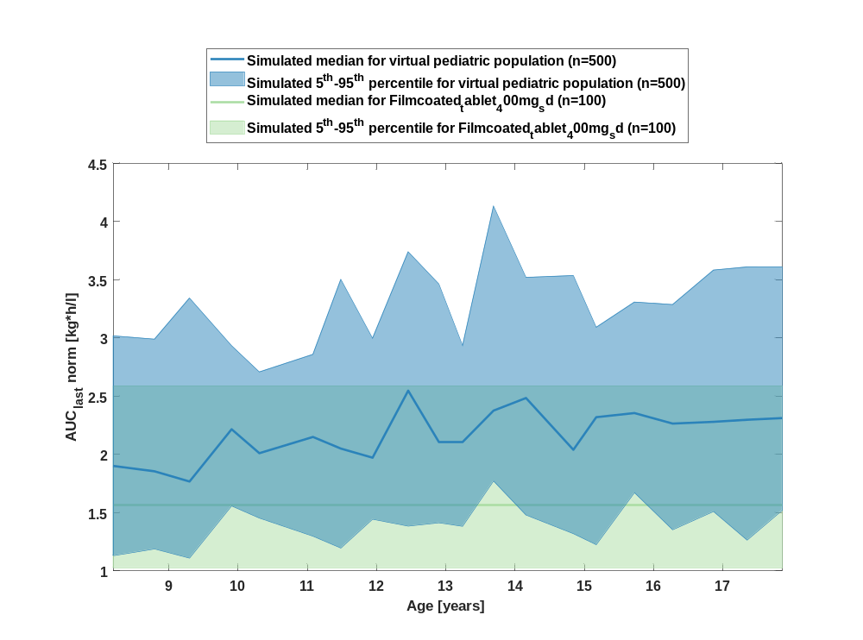

Figure 12: age dependency of AUC_{last} norm Raltegravir for simulated virtual pediatric population in comparison to simulated Filmcoated_tablet_400mg_sd in a logarithmic scale.
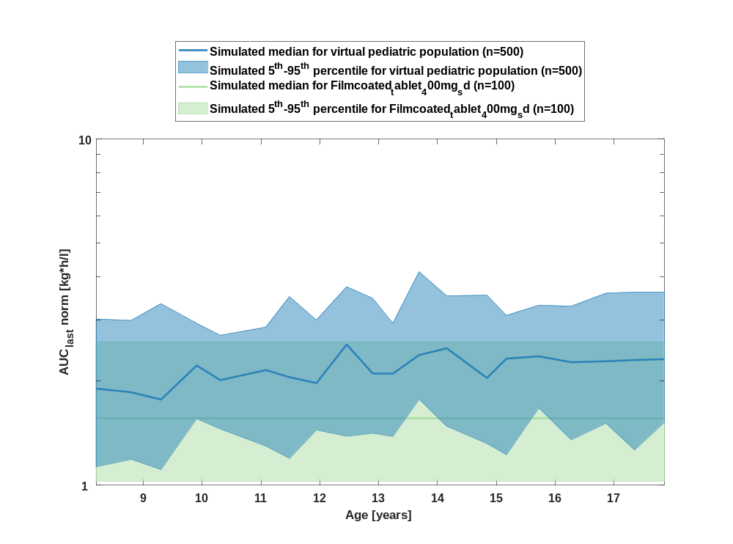

Table 1-6:age dependency of AUC_{last} norm Raltegravir for simulated virtual pediatric population in comparison to simulated Filmcoated_tablet_400mg_sd
Age [years] | AUC_{last} norm [kg*h/l]
Range of age | Median of age | 5th percentile | median | 95th percentile | N individuals
8-8.53 | 8.20 | 1.13 | 1.90 | 3.02 | 25
8.53-9.09 | 8.80 | 1.19 | 1.86 | 2.99 | 25
9.09-9.6 | 9.30 | 1.11 | 1.77 | 3.34 | 25
9.6-10.1 | 9.91 | 1.56 | 2.22 | 2.93 | 25
10.1-10.8 | 10.30 | 1.45 | 2.01 | 2.71 | 25
10.8-11.3 | 11.10 | 1.30 | 2.15 | 2.86 | 25
11.3-11.7 | 11.50 | 1.20 | 2.05 | 3.50 | 25
11.7-12.2 | 11.90 | 1.44 | 1.97 | 3 | 25
12.2-12.7 | 12.50 | 1.38 | 2.55 | 3.74 | 25
12.7-13 | 12.90 | 1.41 | 2.11 | 3.46 | 25
13-13.5 | 13.20 | 1.38 | 2.10 | 2.93 | 25
13.5-13.9 | 13.70 | 1.77 | 2.38 | 4.13 | 25
13.9-14.5 | 14.20 | 1.48 | 2.48 | 3.52 | 25
14.5-15 | 14.80 | 1.32 | 2.04 | 3.54 | 25
15-15.4 | 15.20 | 1.22 | 2.32 | 3.09 | 25
15.4-16 | 15.70 | 1.67 | 2.36 | 3.31 | 25
16-16.6 | 16.30 | 1.35 | 2.26 | 3.29 | 25
16.6-17.1 | 16.90 | 1.51 | 2.28 | 3.58 | 25
17.1-17.6 | 17.30 | 1.26 | 2.30 | 3.61 | 25
17.6-18 | 17.90 | 1.52 | 2.31 | 3.61 | 25
reference values: | 1.03 | 1.56 | 2.59

AUC_{inf}

Figure 13: age dependency of AUC_{inf} Raltegravir for simulated virtual pediatric population in comparison to simulated Filmcoated_tablet_400mg_sd in a linear scale.
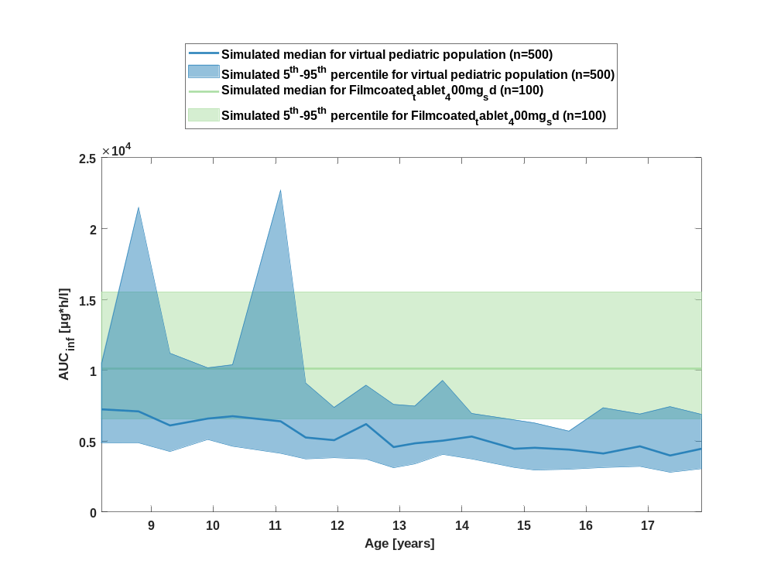

Figure 14: age dependency of AUC_{inf} Raltegravir for simulated virtual pediatric population in comparison to simulated Filmcoated_tablet_400mg_sd in a logarithmic scale.
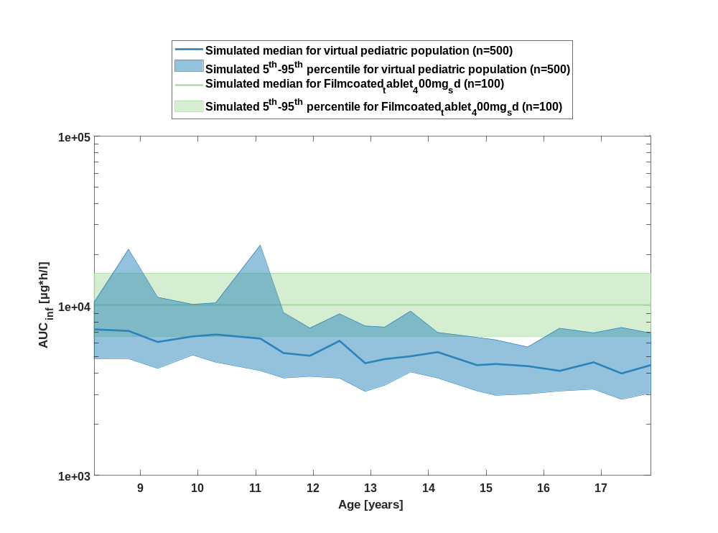

Table 1-7:age dependency of AUC_{inf} Raltegravir for simulated virtual pediatric population in comparison to simulated Filmcoated_tablet_400mg_sd
Age [years] | AUC_{inf} [µg*h/l]
Range of age | Median of age | 5th percentile | median | 95th percentile | N individuals
8-8.53 | 8.20 | 4870 | 7250 | 10500 | 25
8.53-9.09 | 8.80 | 4880 | 7100 | 21500 | 25
9.09-9.6 | 9.30 | 4270 | 6110 | 11200 | 25
9.6-10.1 | 9.91 | 5120 | 6600 | 10200 | 25
10.1-10.8 | 10.30 | 4640 | 6760 | 10400 | 25
10.8-11.3 | 11.10 | 4140 | 6400 | 22700 | 25
11.3-11.7 | 11.50 | 3750 | 5260 | 9100 | 25
11.7-12.2 | 11.90 | 3830 | 5070 | 7380 | 25
12.2-12.7 | 12.50 | 3740 | 6210 | 8950 | 25
12.7-13 | 12.90 | 3130 | 4580 | 7590 | 25
13-13.5 | 13.20 | 3400 | 4850 | 7480 | 25
13.5-13.9 | 13.70 | 4070 | 5040 | 9290 | 25
13.9-14.5 | 14.20 | 3750 | 5330 | 6950 | 25
14.5-15 | 14.80 | 3150 | 4470 | 6500 | 25
15-15.4 | 15.20 | 2960 | 4540 | 6280 | 25
15.4-16 | 15.70 | 3020 | 4410 | 5710 | 25
16-16.6 | 16.30 | 3140 | 4130 | 7360 | 25
16.6-17.1 | 16.90 | 3220 | 4640 | 6910 | 25
17.1-17.6 | 17.30 | 2810 | 3990 | 7440 | 25
17.6-18 | 17.90 | 3060 | 4460 | 6890 | 25
reference values: | 6560 | 10100 | 15500

AUC_{inf} norm

Figure 15: age dependency of AUC_{inf} norm Raltegravir for simulated virtual pediatric population in comparison to simulated Filmcoated_tablet_400mg_sd in a linear scale.
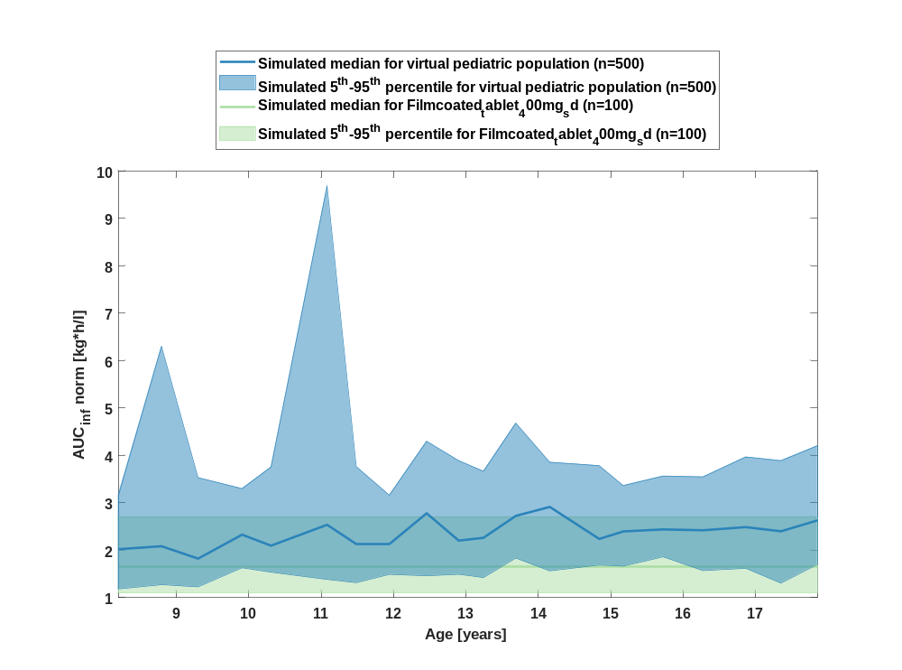

Figure 16: age dependency of AUC_{inf} norm Raltegravir for simulated virtual pediatric population in comparison to simulated Filmcoated_tablet_400mg_sd in a logarithmic scale.
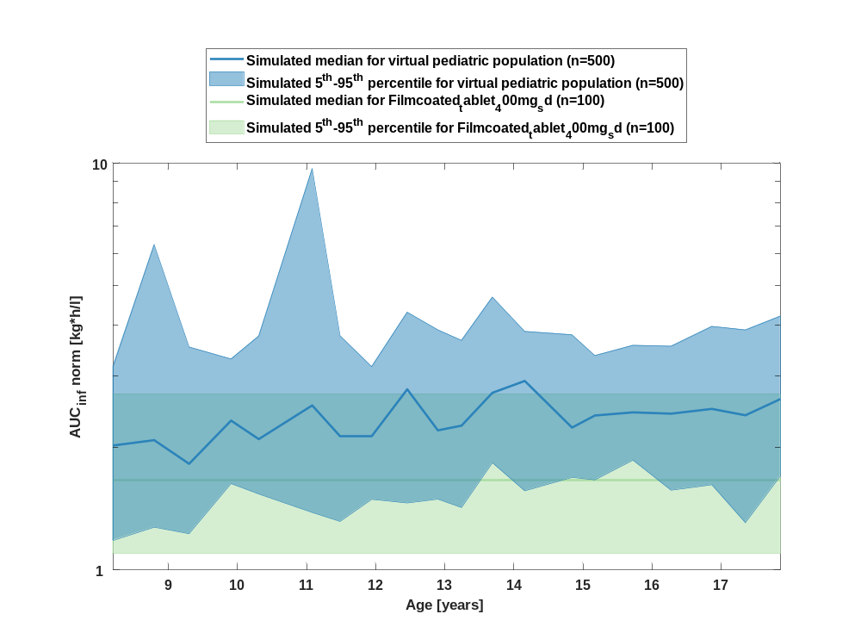

Table 1-8:age dependency of AUC_{inf} norm Raltegravir for simulated virtual pediatric population in comparison to simulated Filmcoated_tablet_400mg_sd
Age [years] | AUC_{inf} norm [kg*h/l]
Range of age | Median of age | 5th percentile | median | 95th percentile | N individuals
8-8.53 | 8.20 | 1.18 | 2.02 | 3.16 | 25
8.53-9.09 | 8.80 | 1.27 | 2.08 | 6.30 | 25
9.09-9.6 | 9.30 | 1.23 | 1.82 | 3.53 | 25
9.6-10.1 | 9.91 | 1.63 | 2.33 | 3.30 | 25
10.1-10.8 | 10.30 | 1.54 | 2.10 | 3.76 | 25
10.8-11.3 | 11.10 | 1.38 | 2.54 | 9.68 | 25
11.3-11.7 | 11.50 | 1.32 | 2.14 | 3.76 | 25
11.7-12.2 | 11.90 | 1.49 | 2.13 | 3.16 | 25
12.2-12.7 | 12.50 | 1.46 | 2.78 | 4.30 | 25
12.7-13 | 12.90 | 1.49 | 2.20 | 3.89 | 25
13-13.5 | 13.20 | 1.42 | 2.26 | 3.67 | 25
13.5-13.9 | 13.70 | 1.83 | 2.72 | 4.68 | 25
13.9-14.5 | 14.20 | 1.57 | 2.91 | 3.86 | 25
14.5-15 | 14.80 | 1.69 | 2.24 | 3.78 | 25
15-15.4 | 15.20 | 1.67 | 2.40 | 3.36 | 25
15.4-16 | 15.70 | 1.86 | 2.44 | 3.56 | 25
16-16.6 | 16.30 | 1.57 | 2.42 | 3.55 | 25
16.6-17.1 | 16.90 | 1.62 | 2.49 | 3.97 | 25
17.1-17.6 | 17.30 | 1.31 | 2.40 | 3.89 | 25
17.6-18 | 17.90 | 1.70 | 2.63 | 4.20 | 25
reference values: | 1.10 | 1.66 | 2.70

MRT

Figure 17: age dependency of MRT Raltegravir for simulated virtual pediatric population in comparison to simulated Filmcoated_tablet_400mg_sd in a linear scale.
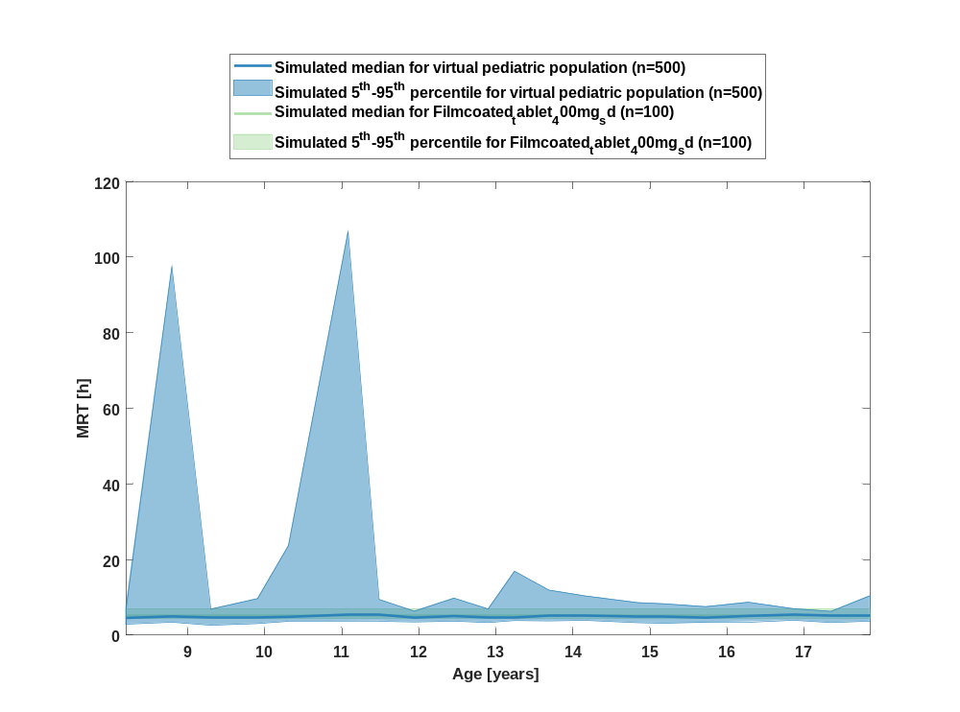

Figure 18: age dependency of MRT Raltegravir for simulated virtual pediatric population in comparison to simulated Filmcoated_tablet_400mg_sd in a logarithmic scale.
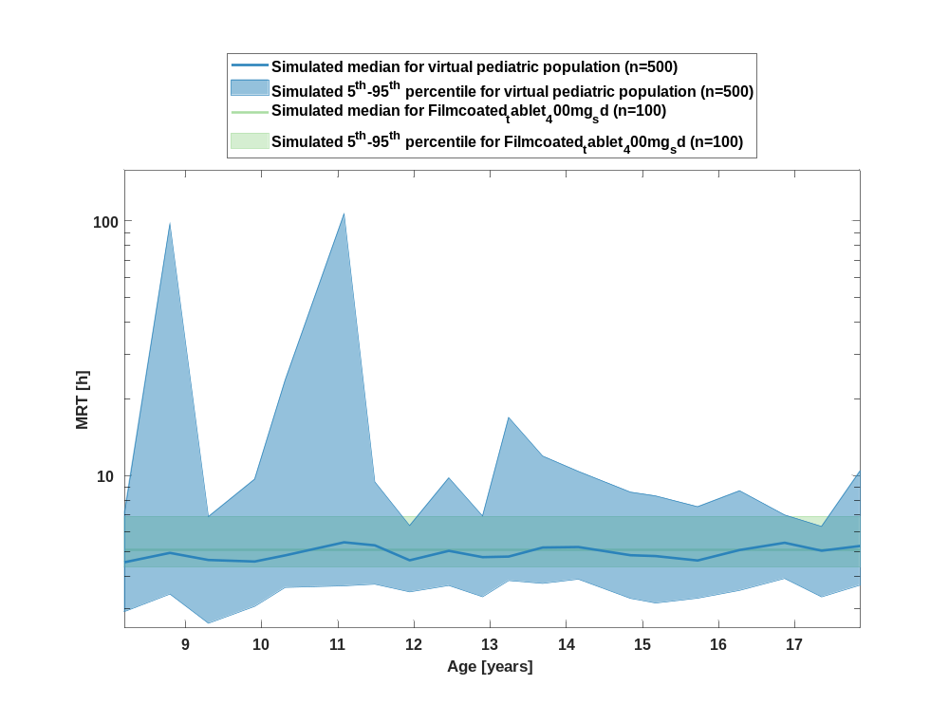

Table 1-9:age dependency of MRT Raltegravir for simulated virtual pediatric population in comparison to simulated Filmcoated_tablet_400mg_sd
Age [years] | MRT [h]
Range of age | Median of age | 5th percentile | median | 95th percentile | N individuals
8-8.53 | 8.20 | 2.90 | 4.55 | 7.17 | 25
8.53-9.09 | 8.80 | 3.41 | 4.96 | 97.50 | 25
9.09-9.6 | 9.30 | 2.62 | 4.65 | 6.88 | 25
9.6-10.1 | 9.91 | 3.06 | 4.59 | 9.66 | 25
10.1-10.8 | 10.30 | 3.63 | 4.85 | 23.70 | 25
10.8-11.3 | 11.10 | 3.68 | 5.46 | 107 | 25
11.3-11.7 | 11.50 | 3.73 | 5.31 | 9.43 | 25
11.7-12.2 | 11.90 | 3.48 | 4.64 | 6.35 | 25
12.2-12.7 | 12.50 | 3.69 | 5.05 | 9.78 | 25
12.7-13 | 12.90 | 3.33 | 4.77 | 6.92 | 25
13-13.5 | 13.20 | 3.86 | 4.80 | 16.90 | 25
13.5-13.9 | 13.70 | 3.76 | 5.21 | 11.90 | 25
13.9-14.5 | 14.20 | 3.91 | 5.23 | 10.40 | 25
14.5-15 | 14.80 | 3.28 | 4.85 | 8.59 | 25
15-15.4 | 15.20 | 3.15 | 4.82 | 8.30 | 25
15.4-16 | 15.70 | 3.29 | 4.63 | 7.53 | 25
16-16.6 | 16.30 | 3.53 | 5.09 | 8.70 | 25
16.6-17.1 | 16.90 | 3.93 | 5.43 | 6.99 | 25
17.1-17.6 | 17.30 | 3.33 | 5.06 | 6.30 | 25
17.6-18 | 17.90 | 3.70 | 5.28 | 10.40 | 25
reference values: | 4.35 | 5.11 | 6.88

Thalf

Figure 19: age dependency of Thalf Raltegravir for simulated virtual pediatric population in comparison to simulated Filmcoated_tablet_400mg_sd in a linear scale.
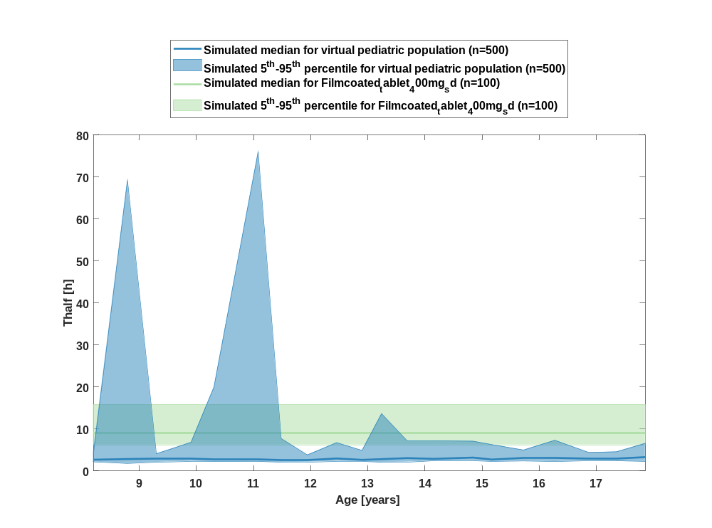

Figure 20: age dependency of Thalf Raltegravir for simulated virtual pediatric population in comparison to simulated Filmcoated_tablet_400mg_sd in a logarithmic scale.
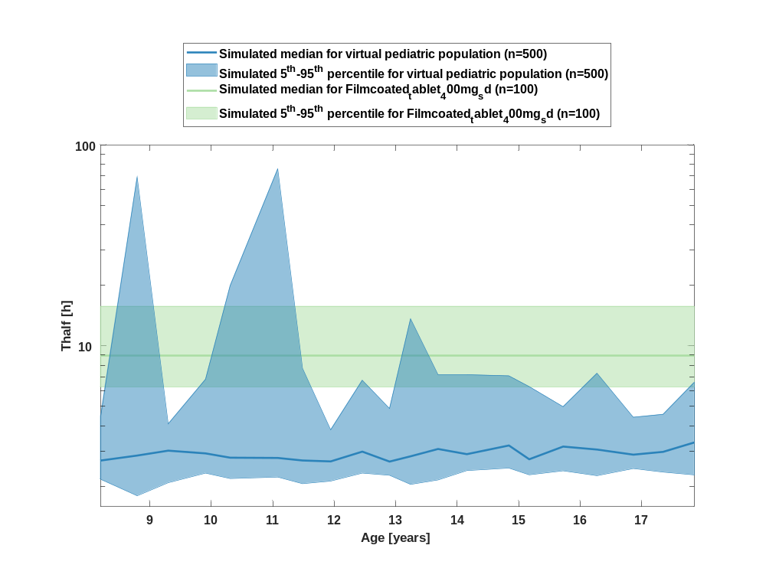

Table 1-10:age dependency of Thalf Raltegravir for simulated virtual pediatric population in comparison to simulated Filmcoated_tablet_400mg_sd
Age [years] | Thalf [h]
Range of age | Median of age | 5th percentile | median | 95th percentile | N individuals
8-8.53 | 8.20 | 2.17 | 2.69 | 4.45 | 25
8.53-9.09 | 8.80 | 1.80 | 2.85 | 69.20 | 25
9.09-9.6 | 9.30 | 2.09 | 3.01 | 4.09 | 25
9.6-10.1 | 9.91 | 2.33 | 2.92 | 6.82 | 25
10.1-10.8 | 10.30 | 2.19 | 2.78 | 19.90 | 25
10.8-11.3 | 11.10 | 2.23 | 2.77 | 75.90 | 25
11.3-11.7 | 11.50 | 2.06 | 2.69 | 7.73 | 25
11.7-12.2 | 11.90 | 2.13 | 2.66 | 3.82 | 25
12.2-12.7 | 12.50 | 2.33 | 2.98 | 6.74 | 25
12.7-13 | 12.90 | 2.27 | 2.66 | 4.88 | 25
13-13.5 | 13.20 | 2.05 | 2.82 | 13.60 | 25
13.5-13.9 | 13.70 | 2.15 | 3.07 | 7.18 | 25
13.9-14.5 | 14.20 | 2.40 | 2.89 | 7.18 | 25
14.5-15 | 14.80 | 2.47 | 3.19 | 7.09 | 25
15-15.4 | 15.20 | 2.28 | 2.73 | 6.27 | 25
15.4-16 | 15.70 | 2.39 | 3.16 | 4.98 | 25
16-16.6 | 16.30 | 2.26 | 3.05 | 7.30 | 25
16.6-17.1 | 16.90 | 2.45 | 2.88 | 4.41 | 25
17.1-17.6 | 17.30 | 2.36 | 2.97 | 4.57 | 25
17.6-18 | 17.90 | 2.28 | 3.31 | 6.59 | 25
reference values: | 6.23 | 8.98 | 15.70

CL

Figure 21: age dependency of CL Raltegravir for simulated virtual pediatric population in comparison to simulated Filmcoated_tablet_400mg_sd in a linear scale.
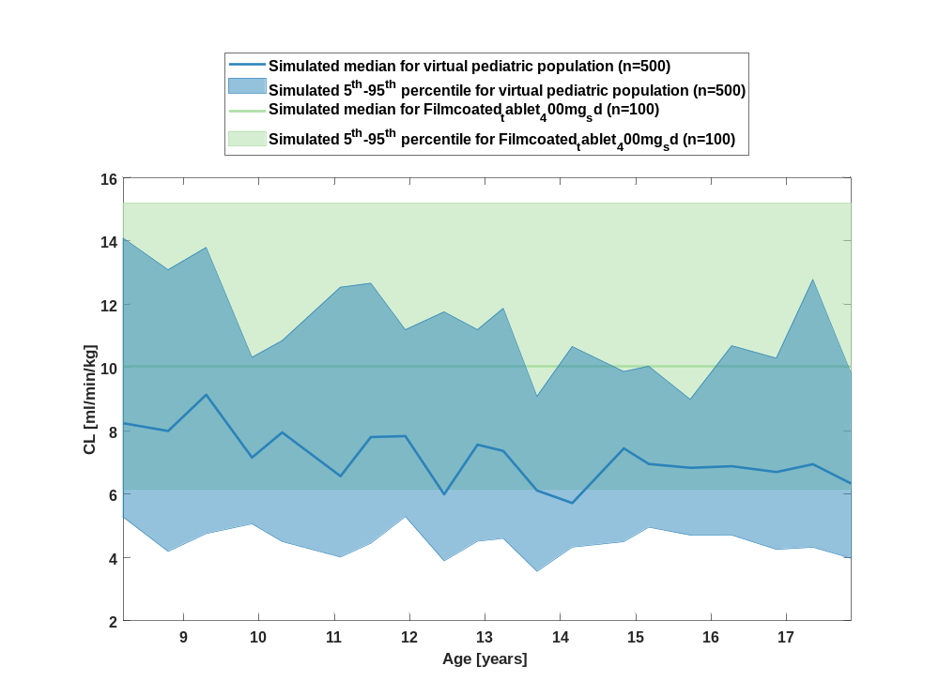

Figure 22: age dependency of CL Raltegravir for simulated virtual pediatric population in comparison to simulated Filmcoated_tablet_400mg_sd in a logarithmic scale.
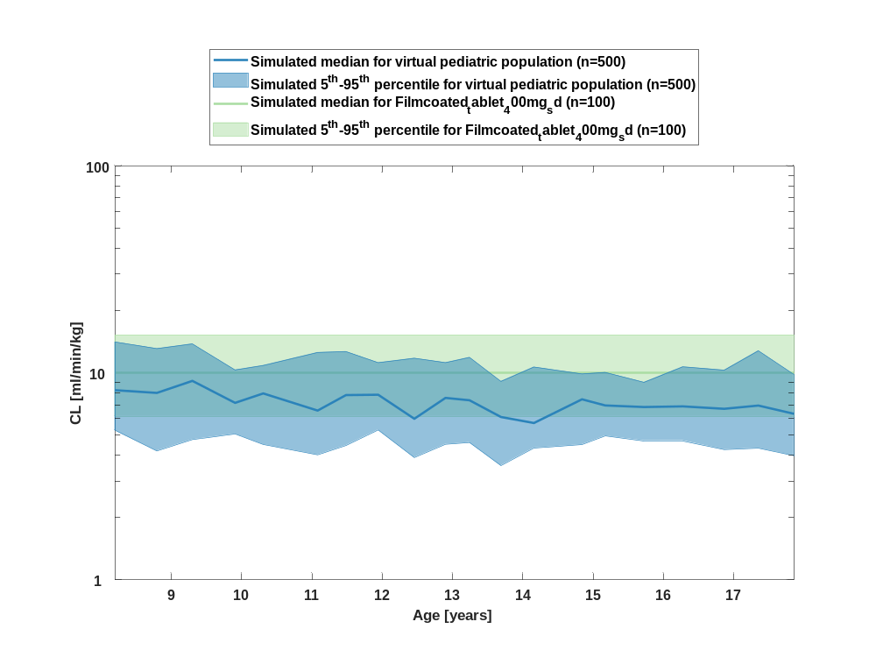

Table 1-11:age dependency of CL Raltegravir for simulated virtual pediatric population in comparison to simulated Filmcoated_tablet_400mg_sd
Age [years] | CL [ml/min/kg]
Range of age | Median of age | 5th percentile | median | 95th percentile | N individuals
8-8.53 | 8.20 | 5.27 | 8.24 | 14.10 | 25
8.53-9.09 | 8.80 | 4.19 | 7.99 | 13.10 | 25
9.09-9.6 | 9.30 | 4.76 | 9.14 | 13.80 | 25
9.6-10.1 | 9.91 | 5.06 | 7.16 | 10.30 | 25
10.1-10.8 | 10.30 | 4.50 | 7.95 | 10.80 | 25
10.8-11.3 | 11.10 | 4.01 | 6.57 | 12.50 | 25
11.3-11.7 | 11.50 | 4.45 | 7.80 | 12.70 | 25
11.7-12.2 | 11.90 | 5.29 | 7.83 | 11.20 | 25
12.2-12.7 | 12.50 | 3.89 | 6 | 11.80 | 25
12.7-13 | 12.90 | 4.51 | 7.56 | 11.20 | 25
13-13.5 | 13.20 | 4.60 | 7.37 | 11.90 | 25
13.5-13.9 | 13.70 | 3.56 | 6.12 | 9.09 | 25
13.9-14.5 | 14.20 | 4.33 | 5.72 | 10.70 | 25
14.5-15 | 14.80 | 4.50 | 7.45 | 9.87 | 25
15-15.4 | 15.20 | 4.96 | 6.95 | 10 | 25
15.4-16 | 15.70 | 4.69 | 6.83 | 8.99 | 25
16-16.6 | 16.30 | 4.70 | 6.88 | 10.70 | 25
16.6-17.1 | 16.90 | 4.26 | 6.70 | 10.30 | 25
17.1-17.6 | 17.30 | 4.32 | 6.95 | 12.80 | 25
17.6-18 | 17.90 | 3.98 | 6.34 | 9.81 | 25
reference values: | 6.16 | 10 | 15.20

Vss

Figure 23: age dependency of Vss Raltegravir for simulated virtual pediatric population in comparison to simulated Filmcoated_tablet_400mg_sd in a linear scale.
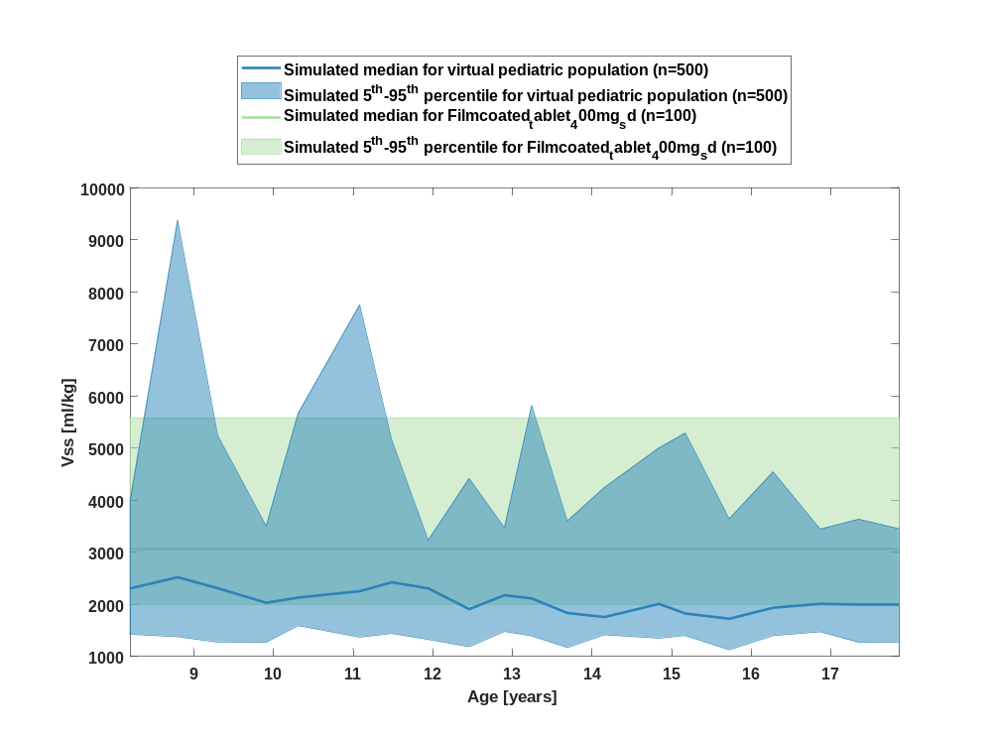

Figure 24: age dependency of Vss Raltegravir for simulated virtual pediatric population in comparison to simulated Filmcoated_tablet_400mg_sd in a logarithmic scale.
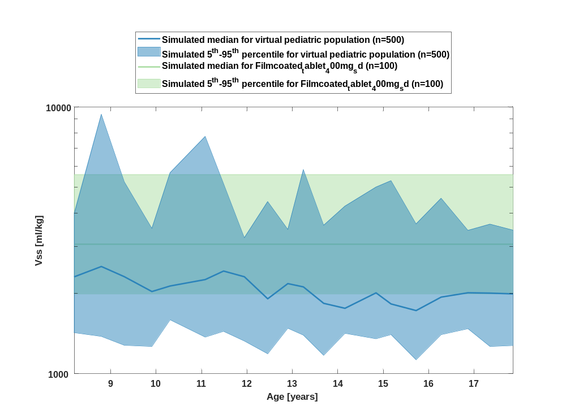

Table 1-12:age dependency of Vss Raltegravir for simulated virtual pediatric population in comparison to simulated Filmcoated_tablet_400mg_sd
Age [years] | Vss [ml/kg]
Range of age | Median of age | 5th percentile | median | 95th percentile | N individuals
8-8.53 | 8.20 | 1420 | 2310 | 4000 | 25
8.53-9.09 | 8.80 | 1380 | 2520 | 9370 | 25
9.09-9.6 | 9.30 | 1280 | 2310 | 5240 | 25
9.6-10.1 | 9.91 | 1270 | 2030 | 3500 | 25
10.1-10.8 | 10.30 | 1590 | 2130 | 5670 | 25
10.8-11.3 | 11.10 | 1370 | 2250 | 7750 | 25
11.3-11.7 | 11.50 | 1440 | 2430 | 5160 | 25
11.7-12.2 | 11.90 | 1330 | 2310 | 3230 | 25
12.2-12.7 | 12.50 | 1190 | 1910 | 4420 | 25
12.7-13 | 12.90 | 1480 | 2180 | 3470 | 25
13-13.5 | 13.20 | 1400 | 2120 | 5820 | 25
13.5-13.9 | 13.70 | 1170 | 1840 | 3600 | 25
13.9-14.5 | 14.20 | 1420 | 1760 | 4250 | 25
14.5-15 | 14.80 | 1350 | 2010 | 5010 | 25
15-15.4 | 15.20 | 1400 | 1830 | 5290 | 25
15.4-16 | 15.70 | 1130 | 1730 | 3640 | 25
16-16.6 | 16.30 | 1400 | 1940 | 4540 | 25
16.6-17.1 | 16.90 | 1470 | 2010 | 3440 | 25
17.1-17.6 | 17.30 | 1270 | 2010 | 3630 | 25
17.6-18 | 17.90 | 1280 | 1990 | 3450 | 25
reference values: | 1990 | 3060 | 5580

Vd

Figure 25: age dependency of Vd Raltegravir for simulated virtual pediatric population in comparison to simulated Filmcoated_tablet_400mg_sd in a linear scale.
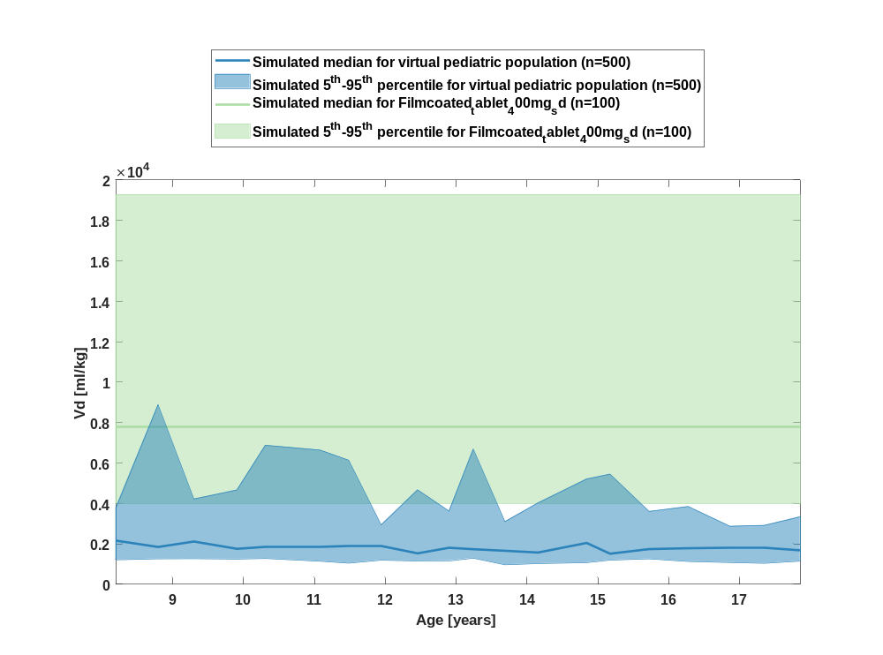

Figure 26: age dependency of Vd Raltegravir for simulated virtual pediatric population in comparison to simulated Filmcoated_tablet_400mg_sd in a logarithmic scale.
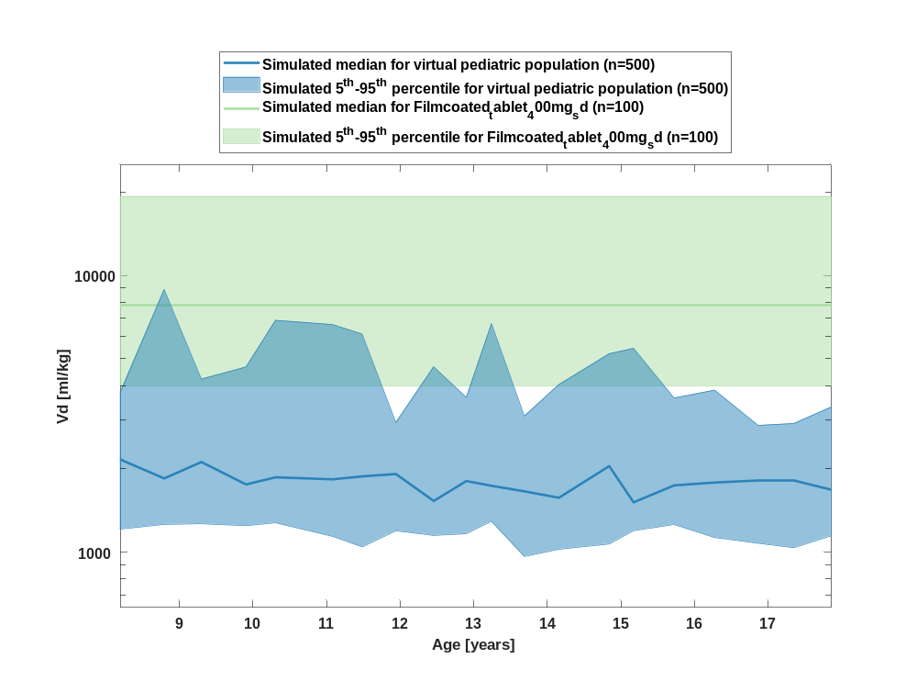

Table 1-13:age dependency of Vd Raltegravir for simulated virtual pediatric population in comparison to simulated Filmcoated_tablet_400mg_sd
Age [years] | Vd [ml/kg]
Range of age | Median of age | 5th percentile | median | 95th percentile | N individuals
8-8.53 | 8.20 | 1210 | 2160 | 3790 | 25
8.53-9.09 | 8.80 | 1260 | 1850 | 8880 | 25
9.09-9.6 | 9.30 | 1270 | 2120 | 4220 | 25
9.6-10.1 | 9.91 | 1250 | 1760 | 4670 | 25
10.1-10.8 | 10.30 | 1280 | 1860 | 6880 | 25
10.8-11.3 | 11.10 | 1140 | 1830 | 6640 | 25
11.3-11.7 | 11.50 | 1040 | 1880 | 6140 | 25
11.7-12.2 | 11.90 | 1190 | 1920 | 2940 | 25
12.2-12.7 | 12.50 | 1150 | 1530 | 4670 | 25
12.7-13 | 12.90 | 1170 | 1810 | 3620 | 25
13-13.5 | 13.20 | 1290 | 1740 | 6690 | 25
13.5-13.9 | 13.70 | 964 | 1660 | 3100 | 25
13.9-14.5 | 14.20 | 1020 | 1570 | 4030 | 25
14.5-15 | 14.80 | 1070 | 2050 | 5210 | 25
15-15.4 | 15.20 | 1190 | 1510 | 5450 | 25
15.4-16 | 15.70 | 1260 | 1740 | 3600 | 25
16-16.6 | 16.30 | 1130 | 1780 | 3850 | 25
16.6-17.1 | 16.90 | 1080 | 1820 | 2870 | 25
17.1-17.6 | 17.30 | 1040 | 1810 | 2920 | 25
17.6-18 | 17.90 | 1150 | 1680 | 3340 | 25
reference values: | 3980 | 7800 | 19300

Body weight-dependence of Raltegravir

C_{max}

Figure 27: body weight dependency of C_{max} Raltegravir for simulated virtual pediatric population in comparison to simulated Filmcoated_tablet_400mg_sd in a linear scale.
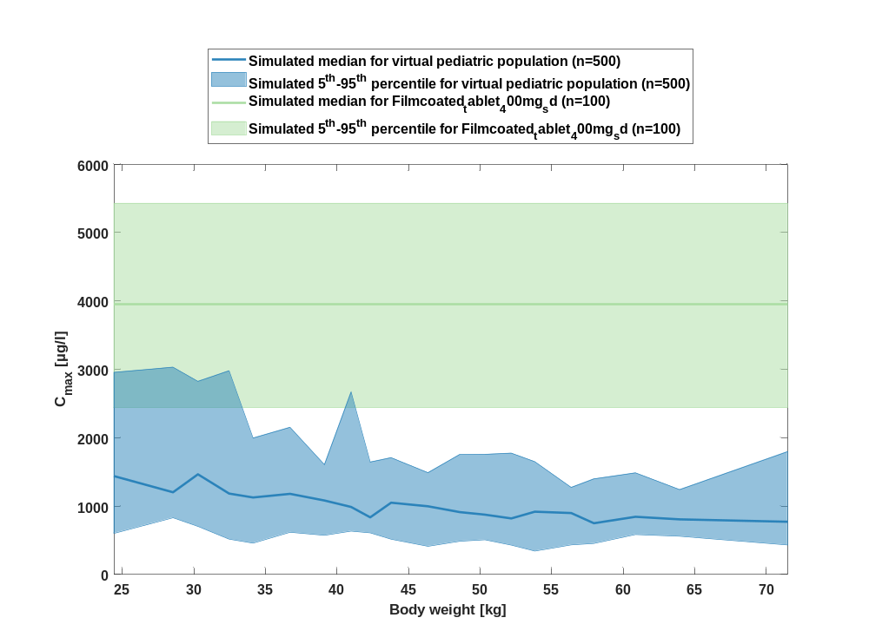

Figure 28: body weight dependency of C_{max} Raltegravir for simulated virtual pediatric population in comparison to simulated Filmcoated_tablet_400mg_sd in a logarithmic scale.
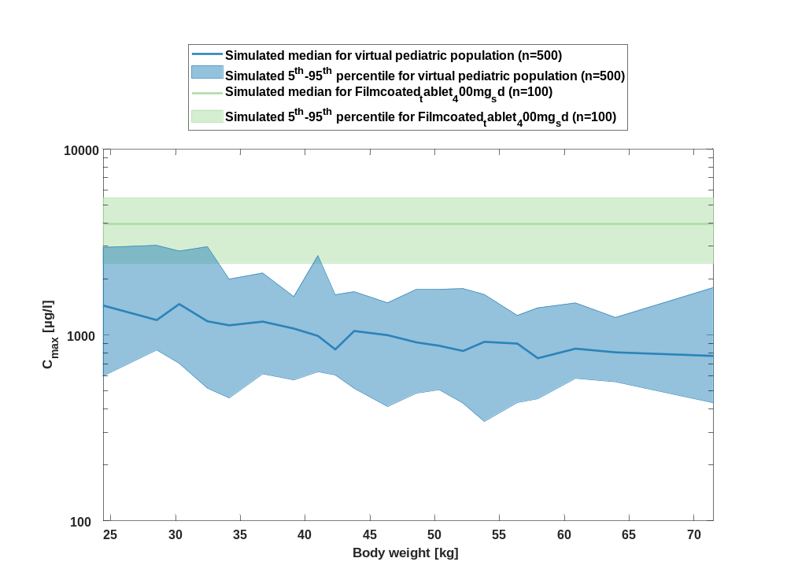

Table 1-14:body weight dependency of C_{max} Raltegravir for simulated virtual pediatric population in comparison to simulated Filmcoated_tablet_400mg_sd
Body weight [kg] | C_{max} [µg/l]
Range of body weight | Median of body weight | 5th percentile | median | 95th percentile | N individuals
21-26.9 | 24.40 | 600 | 1440 | 2960 | 25
26.9-29.8 | 28.50 | 830 | 1200 | 3030 | 25
29.8-30.9 | 30.30 | 703 | 1470 | 2820 | 25
30.9-33.3 | 32.50 | 517 | 1180 | 2980 | 25
33.3-35.8 | 34.10 | 458 | 1130 | 1990 | 25
35.8-37.8 | 36.70 | 617 | 1180 | 2150 | 25
37.8-40.1 | 39.10 | 573 | 1080 | 1610 | 25
40.1-41.5 | 41 | 634 | 988 | 2670 | 25
41.5-43.2 | 42.30 | 609 | 836 | 1640 | 25
43.2-45.4 | 43.80 | 516 | 1050 | 1710 | 25
45.4-47.7 | 46.40 | 412 | 997 | 1490 | 25
47.7-49.4 | 48.60 | 486 | 912 | 1750 | 25
49.4-51 | 50.30 | 507 | 875 | 1760 | 25
51-52.9 | 52.20 | 429 | 820 | 1770 | 25
52.9-55.3 | 53.80 | 342 | 918 | 1650 | 25
55.3-57.2 | 56.40 | 433 | 899 | 1270 | 25
57.2-59.4 | 57.90 | 454 | 750 | 1400 | 25
59.4-62.1 | 60.90 | 584 | 844 | 1490 | 25
62.1-67.1 | 63.90 | 559 | 806 | 1240 | 25
67.1-89 | 71.50 | 431 | 771 | 1800 | 25
reference values: | 2440 | 3950 | 5430

C_{max} norm

Figure 29: body weight dependency of C_{max} norm Raltegravir for simulated virtual pediatric population in comparison to simulated Filmcoated_tablet_400mg_sd in a linear scale.
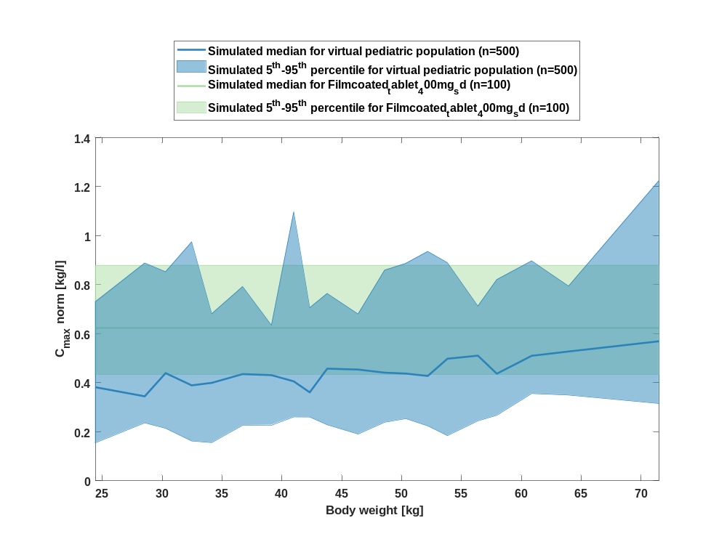

Figure 30: body weight dependency of C_{max} norm Raltegravir for simulated virtual pediatric population in comparison to simulated Filmcoated_tablet_400mg_sd in a logarithmic scale.
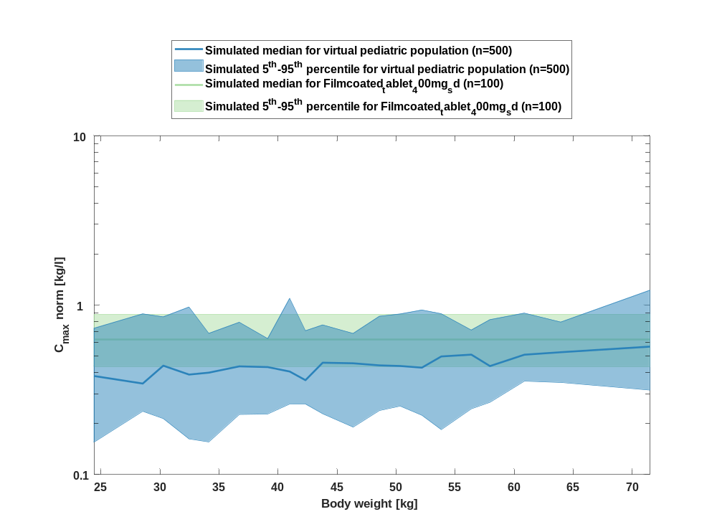

Table 1-15:body weight dependency of C_{max} norm Raltegravir for simulated virtual pediatric population in comparison to simulated Filmcoated_tablet_400mg_sd
Body weight [kg] | C_{max} norm [kg/l]
Range of body weight | Median of body weight | 5th percentile | median | 95th percentile | N individuals
21-26.9 | 24.40 | 0.16 | 0.38 | 0.73 | 25
26.9-29.8 | 28.50 | 0.24 | 0.34 | 0.89 | 25
29.8-30.9 | 30.30 | 0.21 | 0.44 | 0.85 | 25
30.9-33.3 | 32.50 | 0.16 | 0.39 | 0.97 | 25
33.3-35.8 | 34.10 | 0.16 | 0.40 | 0.68 | 25
35.8-37.8 | 36.70 | 0.23 | 0.44 | 0.79 | 25
37.8-40.1 | 39.10 | 0.23 | 0.43 | 0.63 | 25
40.1-41.5 | 41 | 0.26 | 0.41 | 1.10 | 25
41.5-43.2 | 42.30 | 0.26 | 0.36 | 0.71 | 25
43.2-45.4 | 43.80 | 0.23 | 0.46 | 0.76 | 25
45.4-47.7 | 46.40 | 0.19 | 0.45 | 0.68 | 25
47.7-49.4 | 48.60 | 0.24 | 0.44 | 0.86 | 25
49.4-51 | 50.30 | 0.25 | 0.44 | 0.89 | 25
51-52.9 | 52.20 | 0.22 | 0.43 | 0.94 | 25
52.9-55.3 | 53.80 | 0.18 | 0.50 | 0.89 | 25
55.3-57.2 | 56.40 | 0.24 | 0.51 | 0.71 | 25
57.2-59.4 | 57.90 | 0.27 | 0.44 | 0.82 | 25
59.4-62.1 | 60.90 | 0.36 | 0.51 | 0.90 | 25
62.1-67.1 | 63.90 | 0.35 | 0.53 | 0.79 | 25
67.1-89 | 71.50 | 0.32 | 0.57 | 1.22 | 25
reference values: | 0.43 | 0.63 | 0.88

t_{max}

Figure 31: body weight dependency of t_{max} Raltegravir for simulated virtual pediatric population in comparison to simulated Filmcoated_tablet_400mg_sd in a linear scale.
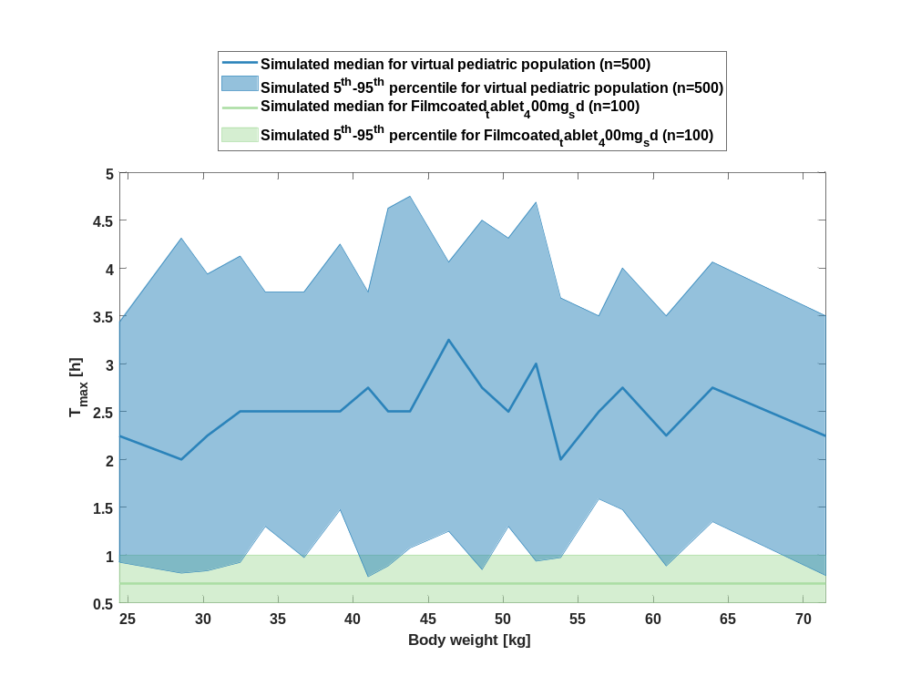

Figure 32: body weight dependency of t_{max} Raltegravir for simulated virtual pediatric population in comparison to simulated Filmcoated_tablet_400mg_sd in a logarithmic scale.
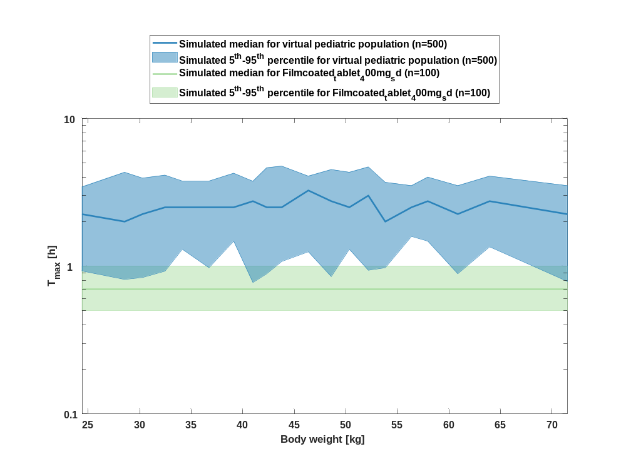

Table 1-16:body weight dependency of t_{max} Raltegravir for simulated virtual pediatric population in comparison to simulated Filmcoated_tablet_400mg_sd
Body weight [kg] | T_{max} [h]
Range of body weight | Median of body weight | 5th percentile | median | 95th percentile | N individuals
21-26.9 | 24.40 | 0.93 | 2.25 | 3.44 | 25
26.9-29.8 | 28.50 | 0.81 | 2 | 4.31 | 25
29.8-30.9 | 30.30 | 0.84 | 2.25 | 3.94 | 25
30.9-33.3 | 32.50 | 0.93 | 2.50 | 4.13 | 25
33.3-35.8 | 34.10 | 1.30 | 2.50 | 3.75 | 25
35.8-37.8 | 36.70 | 0.98 | 2.50 | 3.75 | 25
37.8-40.1 | 39.10 | 1.47 | 2.50 | 4.25 | 25
40.1-41.5 | 41 | 0.78 | 2.75 | 3.75 | 25
41.5-43.2 | 42.30 | 0.89 | 2.50 | 4.63 | 25
43.2-45.4 | 43.80 | 1.08 | 2.50 | 4.75 | 25
45.4-47.7 | 46.40 | 1.25 | 3.25 | 4.06 | 25
47.7-49.4 | 48.60 | 0.85 | 2.75 | 4.50 | 25
49.4-51 | 50.30 | 1.30 | 2.50 | 4.31 | 25
51-52.9 | 52.20 | 0.94 | 3 | 4.69 | 25
52.9-55.3 | 53.80 | 0.98 | 2 | 3.69 | 25
55.3-57.2 | 56.40 | 1.59 | 2.50 | 3.50 | 25
57.2-59.4 | 57.90 | 1.47 | 2.75 | 4 | 25
59.4-62.1 | 60.90 | 0.89 | 2.25 | 3.50 | 25
62.1-67.1 | 63.90 | 1.35 | 2.75 | 4.06 | 25
67.1-89 | 71.50 | 0.79 | 2.25 | 3.50 | 25
reference values: | 0.50 | 0.70 | 1

C_{tEnd}

Figure 33: body weight dependency of C_{tEnd} Raltegravir for simulated virtual pediatric population in comparison to simulated Filmcoated_tablet_400mg_sd in a linear scale.
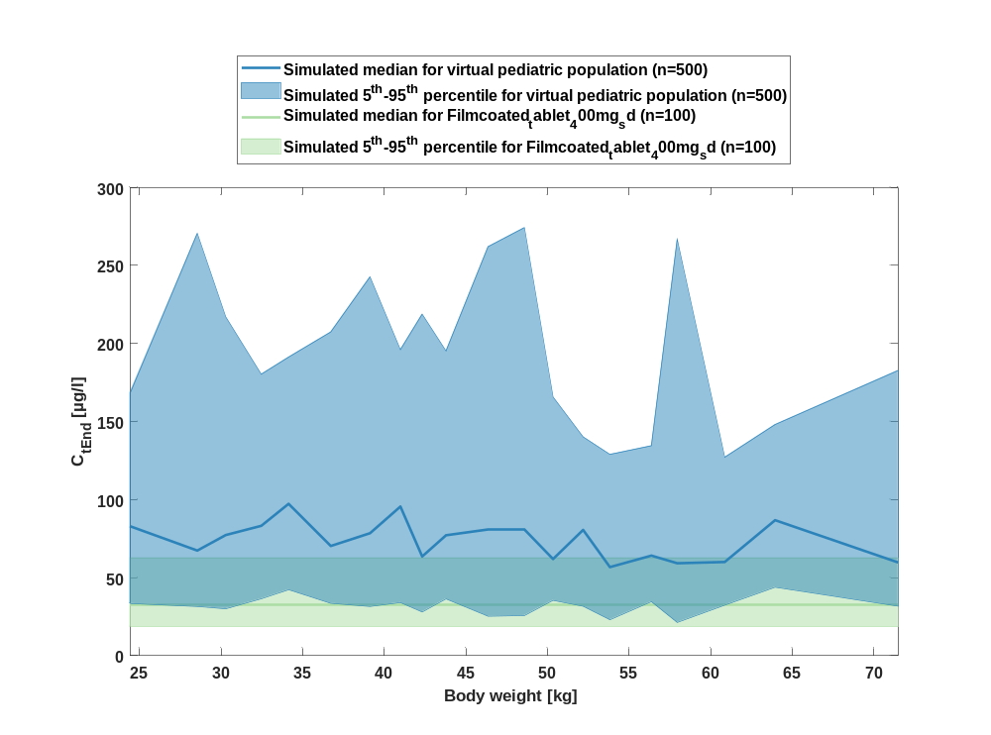

Figure 34: body weight dependency of C_{tEnd} Raltegravir for simulated virtual pediatric population in comparison to simulated Filmcoated_tablet_400mg_sd in a logarithmic scale.
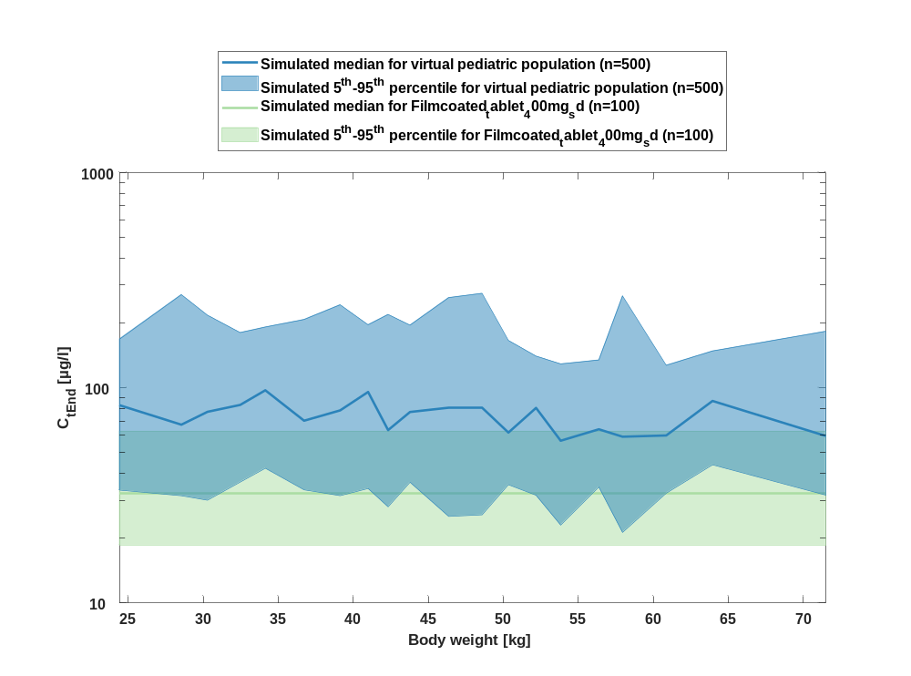

Table 1-17:body weight dependency of C_{tEnd} Raltegravir for simulated virtual pediatric population in comparison to simulated Filmcoated_tablet_400mg_sd
Body weight [kg] | C_{tEnd} [µg/l]
Range of body weight | Median of body weight | 5th percentile | median | 95th percentile | N individuals
21-26.9 | 24.40 | 33.40 | 83 | 168 | 25
26.9-29.8 | 28.50 | 31.50 | 67.30 | 271 | 25
29.8-30.9 | 30.30 | 30 | 77.30 | 217 | 25
30.9-33.3 | 32.50 | 36.40 | 83.20 | 180 | 25
33.3-35.8 | 34.10 | 42.30 | 97.30 | 191 | 25
35.8-37.8 | 36.70 | 33.60 | 70.30 | 207 | 25
37.8-40.1 | 39.10 | 31.50 | 78.50 | 243 | 25
40.1-41.5 | 41 | 34 | 95.50 | 196 | 25
41.5-43.2 | 42.30 | 28 | 63.50 | 219 | 25
43.2-45.4 | 43.80 | 36.40 | 77.10 | 195 | 25
45.4-47.7 | 46.40 | 25.30 | 80.60 | 262 | 25
47.7-49.4 | 48.60 | 25.70 | 80.90 | 274 | 25
49.4-51 | 50.30 | 35.40 | 61.90 | 166 | 25
51-52.9 | 52.20 | 31.70 | 80.60 | 140 | 25
52.9-55.3 | 53.80 | 23 | 56.70 | 129 | 25
55.3-57.2 | 56.40 | 34.60 | 64.10 | 135 | 25
57.2-59.4 | 57.90 | 21.30 | 59.20 | 267 | 25
59.4-62.1 | 60.90 | 32.40 | 60 | 127 | 25
62.1-67.1 | 63.90 | 43.80 | 86.80 | 148 | 25
67.1-89 | 71.50 | 31.70 | 59.70 | 183 | 25
reference values: | 18.60 | 32.30 | 62.80

AUC_{last}

Figure 35: body weight dependency of AUC_{last} Raltegravir for simulated virtual pediatric population in comparison to simulated Filmcoated_tablet_400mg_sd in a linear scale.
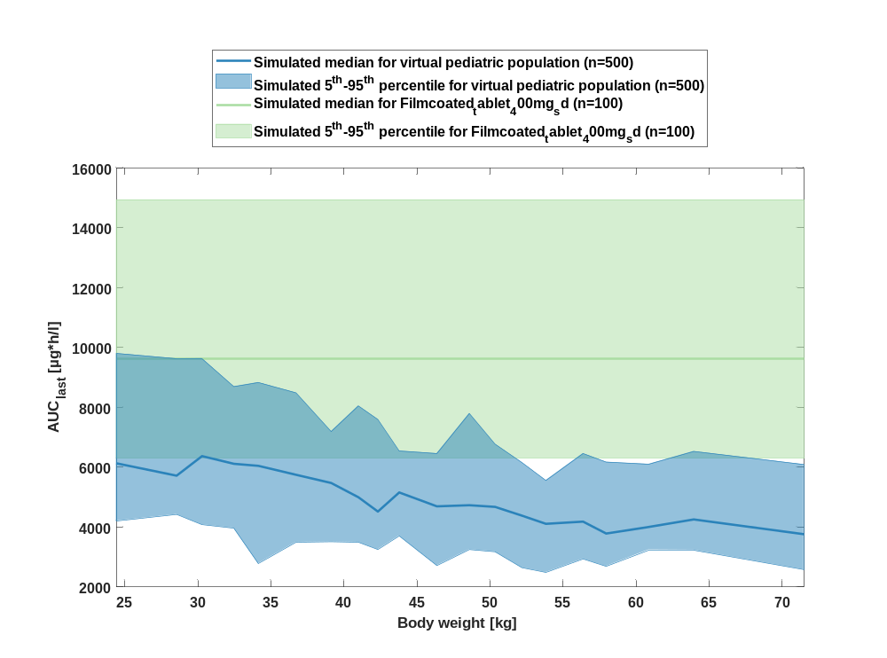

Figure 36: body weight dependency of AUC_{last} Raltegravir for simulated virtual pediatric population in comparison to simulated Filmcoated_tablet_400mg_sd in a logarithmic scale.
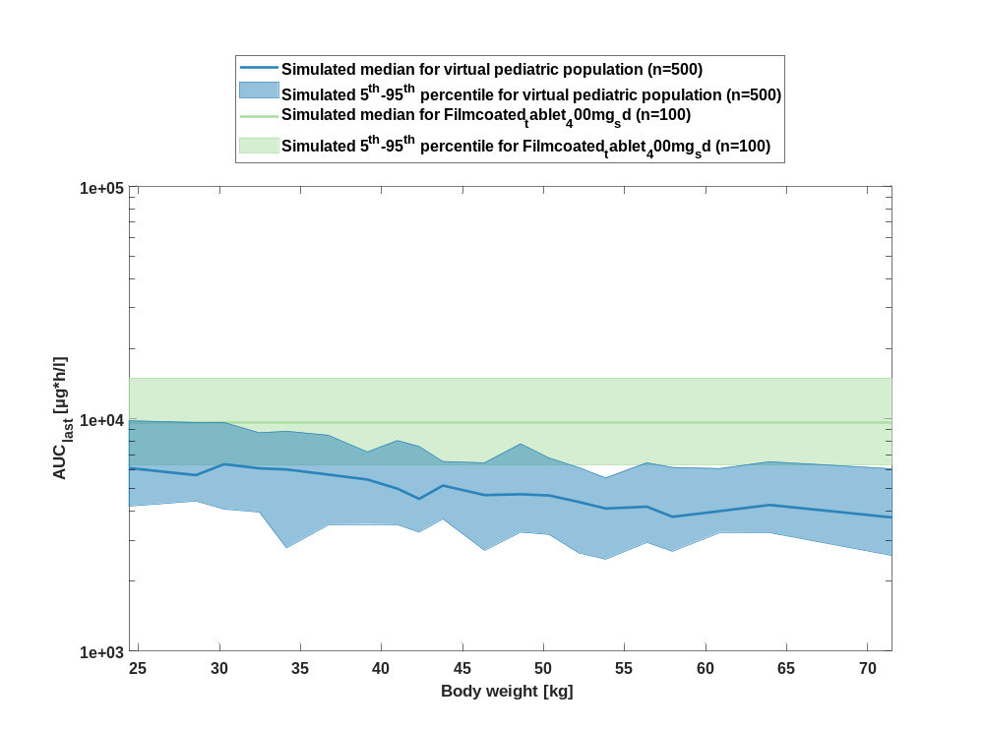

Table 1-18:body weight dependency of AUC_{last} Raltegravir for simulated virtual pediatric population in comparison to simulated Filmcoated_tablet_400mg_sd
Body weight [kg] | AUC_{last} [µg*h/l]
Range of body weight | Median of body weight | 5th percentile | median | 95th percentile | N individuals
21-26.9 | 24.40 | 4200 | 6130 | 9800 | 25
26.9-29.8 | 28.50 | 4420 | 5720 | 9620 | 25
29.8-30.9 | 30.30 | 4080 | 6370 | 9630 | 25
30.9-33.3 | 32.50 | 3960 | 6110 | 8690 | 25
33.3-35.8 | 34.10 | 2780 | 6050 | 8830 | 25
35.8-37.8 | 36.70 | 3490 | 5750 | 8480 | 25
37.8-40.1 | 39.10 | 3510 | 5470 | 7190 | 25
40.1-41.5 | 41 | 3490 | 5000 | 8050 | 25
41.5-43.2 | 42.30 | 3250 | 4520 | 7590 | 25
43.2-45.4 | 43.80 | 3700 | 5160 | 6540 | 25
45.4-47.7 | 46.40 | 2710 | 4690 | 6460 | 25
47.7-49.4 | 48.60 | 3250 | 4730 | 7790 | 25
49.4-51 | 50.30 | 3180 | 4670 | 6770 | 25
51-52.9 | 52.20 | 2640 | 4380 | 6160 | 25
52.9-55.3 | 53.80 | 2490 | 4110 | 5560 | 25
55.3-57.2 | 56.40 | 2930 | 4180 | 6460 | 25
57.2-59.4 | 57.90 | 2690 | 3780 | 6170 | 25
59.4-62.1 | 60.90 | 3240 | 4000 | 6100 | 25
62.1-67.1 | 63.90 | 3230 | 4260 | 6530 | 25
67.1-89 | 71.50 | 2580 | 3760 | 6090 | 25
reference values: | 6300 | 9640 | 14900

AUC_{last} norm

Figure 37: body weight dependency of AUC_{last} norm Raltegravir for simulated virtual pediatric population in comparison to simulated Filmcoated_tablet_400mg_sd in a linear scale.
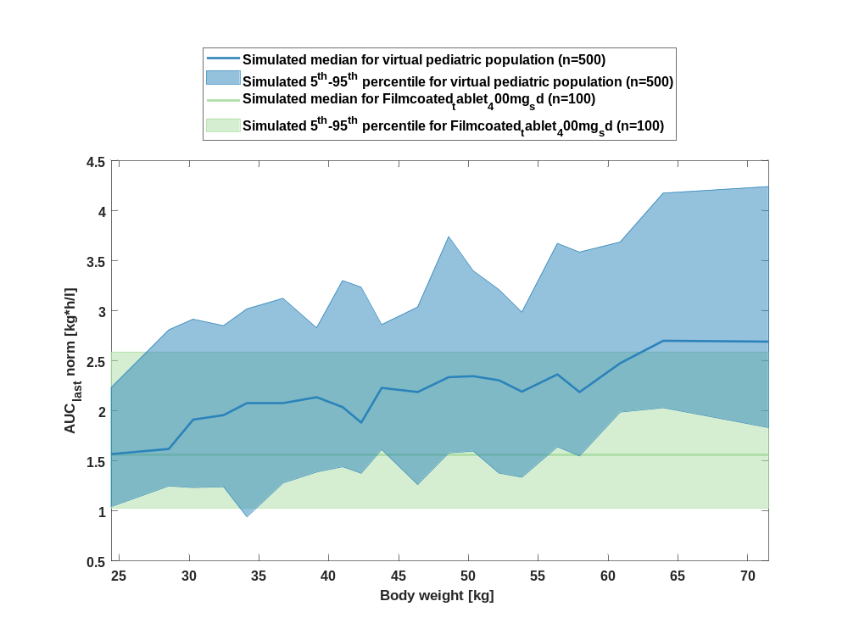

Figure 38: body weight dependency of AUC_{last} norm Raltegravir for simulated virtual pediatric population in comparison to simulated Filmcoated_tablet_400mg_sd in a logarithmic scale.
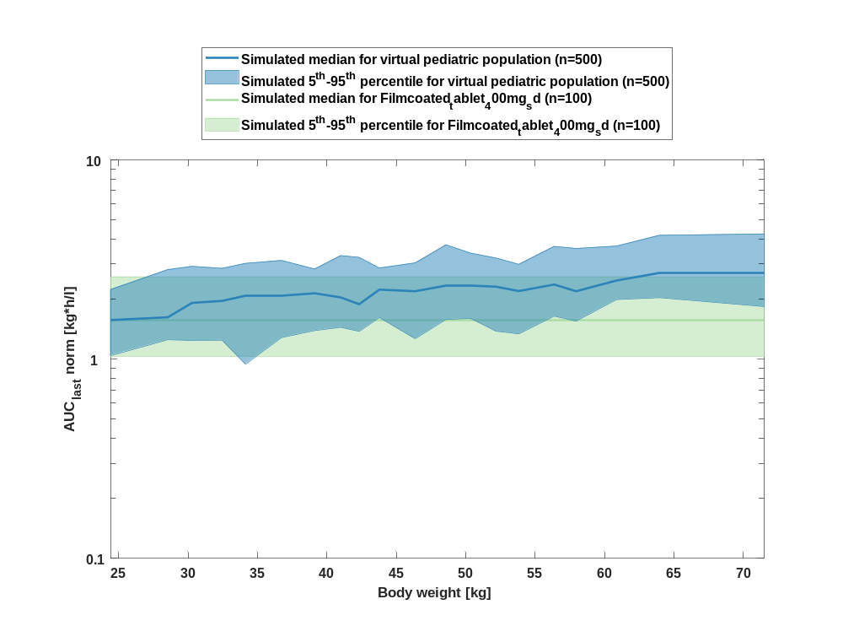

Table 1-19:body weight dependency of AUC_{last} norm Raltegravir for simulated virtual pediatric population in comparison to simulated Filmcoated_tablet_400mg_sd
Body weight [kg] | AUC_{last} norm [kg*h/l]
Range of body weight | Median of body weight | 5th percentile | median | 95th percentile | N individuals
21-26.9 | 24.40 | 1.04 | 1.57 | 2.23 | 25
26.9-29.8 | 28.50 | 1.25 | 1.62 | 2.81 | 25
29.8-30.9 | 30.30 | 1.23 | 1.91 | 2.91 | 25
30.9-33.3 | 32.50 | 1.24 | 1.96 | 2.85 | 25
33.3-35.8 | 34.10 | 0.94 | 2.08 | 3.02 | 25
35.8-37.8 | 36.70 | 1.28 | 2.08 | 3.12 | 25
37.8-40.1 | 39.10 | 1.39 | 2.14 | 2.83 | 25
40.1-41.5 | 41 | 1.44 | 2.04 | 3.30 | 25
41.5-43.2 | 42.30 | 1.38 | 1.88 | 3.23 | 25
43.2-45.4 | 43.80 | 1.61 | 2.23 | 2.86 | 25
45.4-47.7 | 46.40 | 1.26 | 2.19 | 3.04 | 25
47.7-49.4 | 48.60 | 1.58 | 2.34 | 3.74 | 25
49.4-51 | 50.30 | 1.60 | 2.35 | 3.40 | 25
51-52.9 | 52.20 | 1.38 | 2.30 | 3.21 | 25
52.9-55.3 | 53.80 | 1.34 | 2.19 | 2.99 | 25
55.3-57.2 | 56.40 | 1.64 | 2.36 | 3.67 | 25
57.2-59.4 | 57.90 | 1.55 | 2.19 | 3.58 | 25
59.4-62.1 | 60.90 | 1.99 | 2.48 | 3.68 | 25
62.1-67.1 | 63.90 | 2.03 | 2.70 | 4.17 | 25
67.1-89 | 71.50 | 1.83 | 2.69 | 4.24 | 25
reference values: | 1.03 | 1.56 | 2.59

AUC_{inf}

Figure 39: body weight dependency of AUC_{inf} Raltegravir for simulated virtual pediatric population in comparison to simulated Filmcoated_tablet_400mg_sd in a linear scale.
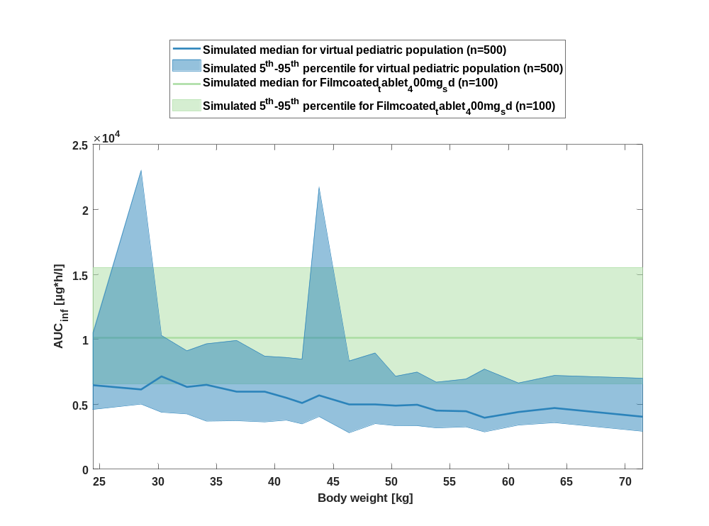

Figure 40: body weight dependency of AUC_{inf} Raltegravir for simulated virtual pediatric population in comparison to simulated Filmcoated_tablet_400mg_sd in a logarithmic scale.
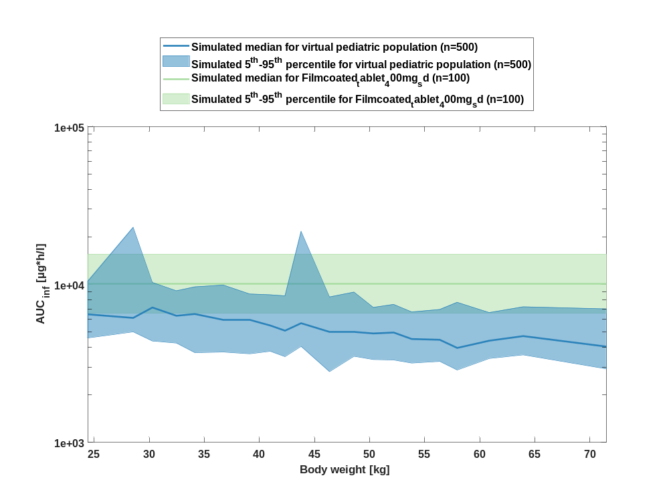

Table 1-20:body weight dependency of AUC_{inf} Raltegravir for simulated virtual pediatric population in comparison to simulated Filmcoated_tablet_400mg_sd
Body weight [kg] | AUC_{inf} [µg*h/l]
Range of body weight | Median of body weight | 5th percentile | median | 95th percentile | N individuals
21-26.9 | 24.40 | 4580 | 6470 | 10500 | 25
26.9-29.8 | 28.50 | 5010 | 6140 | 23000 | 25
29.8-30.9 | 30.30 | 4390 | 7150 | 10300 | 25
30.9-33.3 | 32.50 | 4260 | 6340 | 9120 | 25
33.3-35.8 | 34.10 | 3700 | 6500 | 9650 | 25
35.8-37.8 | 36.70 | 3740 | 5970 | 9910 | 25
37.8-40.1 | 39.10 | 3640 | 5950 | 8700 | 25
40.1-41.5 | 41 | 3780 | 5500 | 8600 | 25
41.5-43.2 | 42.30 | 3490 | 5100 | 8470 | 25
43.2-45.4 | 43.80 | 4060 | 5690 | 21700 | 25
45.4-47.7 | 46.40 | 2810 | 5000 | 8330 | 25
47.7-49.4 | 48.60 | 3510 | 5010 | 8950 | 25
49.4-51 | 50.30 | 3350 | 4900 | 7160 | 25
51-52.9 | 52.20 | 3330 | 4960 | 7480 | 25
52.9-55.3 | 53.80 | 3180 | 4520 | 6700 | 25
55.3-57.2 | 56.40 | 3260 | 4470 | 6940 | 25
57.2-59.4 | 57.90 | 2870 | 3970 | 7710 | 25
59.4-62.1 | 60.90 | 3400 | 4410 | 6640 | 25
62.1-67.1 | 63.90 | 3580 | 4710 | 7220 | 25
67.1-89 | 71.50 | 2920 | 4040 | 7000 | 25
reference values: | 6560 | 10100 | 15500

AUC_{inf} norm

Figure 41: body weight dependency of AUC_{inf} norm Raltegravir for simulated virtual pediatric population in comparison to simulated Filmcoated_tablet_400mg_sd in a linear scale.
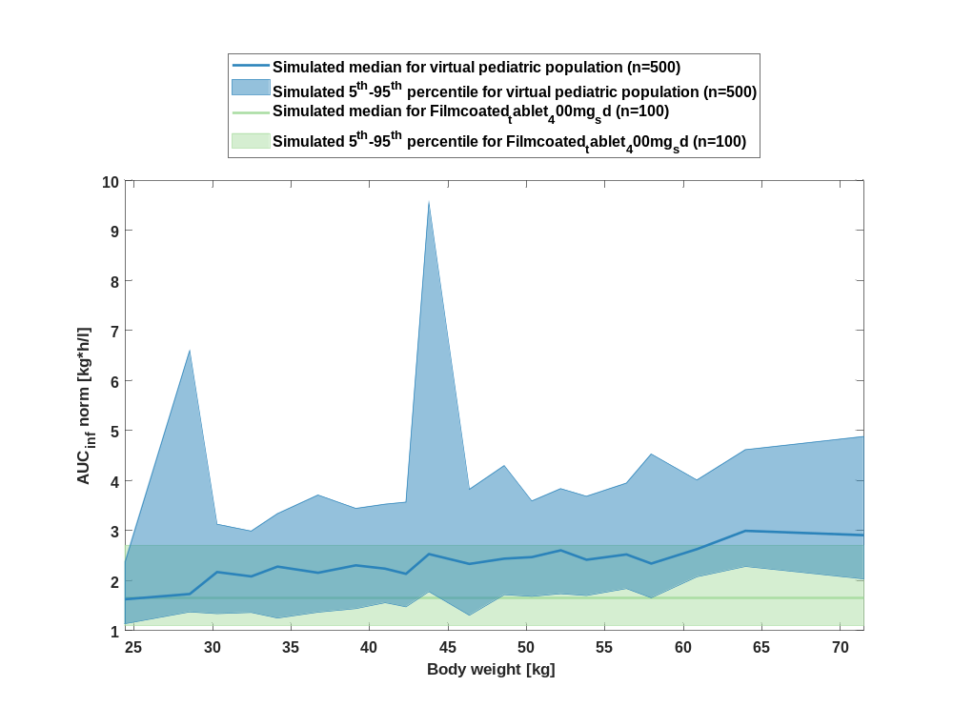

Figure 42: body weight dependency of AUC_{inf} norm Raltegravir for simulated virtual pediatric population in comparison to simulated Filmcoated_tablet_400mg_sd in a logarithmic scale.
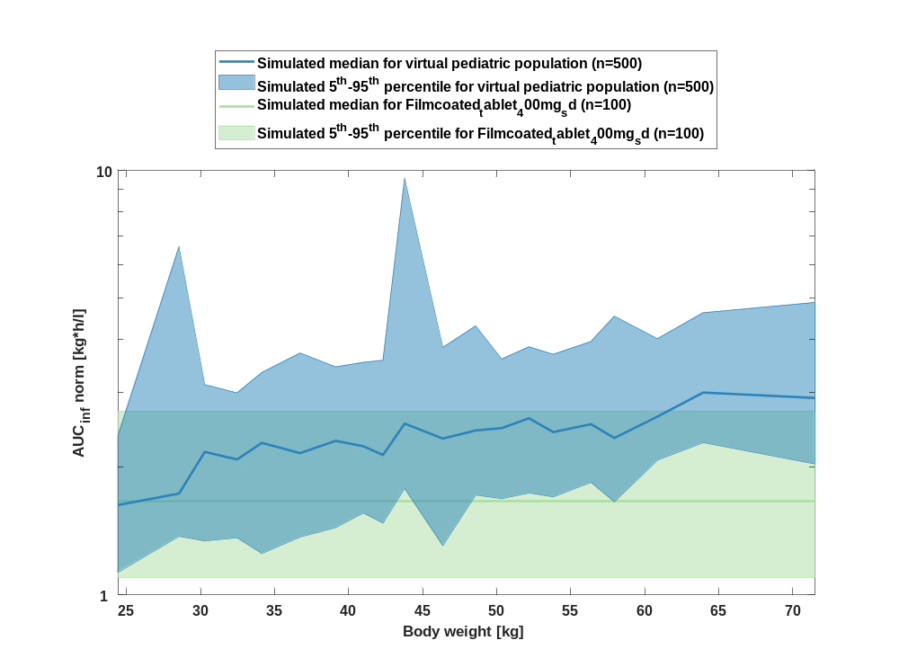

Table 1-21:body weight dependency of AUC_{inf} norm Raltegravir for simulated virtual pediatric population in comparison to simulated Filmcoated_tablet_400mg_sd
Body weight [kg] | AUC_{inf} norm [kg*h/l]
Range of body weight | Median of body weight | 5th percentile | median | 95th percentile | N individuals
21-26.9 | 24.40 | 1.13 | 1.63 | 2.37 | 25
26.9-29.8 | 28.50 | 1.37 | 1.73 | 6.60 | 25
29.8-30.9 | 30.30 | 1.34 | 2.17 | 3.13 | 25
30.9-33.3 | 32.50 | 1.36 | 2.08 | 2.99 | 25
33.3-35.8 | 34.10 | 1.25 | 2.28 | 3.34 | 25
35.8-37.8 | 36.70 | 1.37 | 2.16 | 3.71 | 25
37.8-40.1 | 39.10 | 1.44 | 2.31 | 3.44 | 25
40.1-41.5 | 41 | 1.56 | 2.24 | 3.53 | 25
41.5-43.2 | 42.30 | 1.48 | 2.14 | 3.57 | 25
43.2-45.4 | 43.80 | 1.78 | 2.53 | 9.55 | 25
45.4-47.7 | 46.40 | 1.31 | 2.33 | 3.82 | 25
47.7-49.4 | 48.60 | 1.72 | 2.44 | 4.30 | 25
49.4-51 | 50.30 | 1.69 | 2.47 | 3.59 | 25
51-52.9 | 52.20 | 1.74 | 2.61 | 3.84 | 25
52.9-55.3 | 53.80 | 1.70 | 2.42 | 3.68 | 25
55.3-57.2 | 56.40 | 1.84 | 2.52 | 3.95 | 25
57.2-59.4 | 57.90 | 1.66 | 2.34 | 4.53 | 25
59.4-62.1 | 60.90 | 2.08 | 2.63 | 4.01 | 25
62.1-67.1 | 63.90 | 2.28 | 3 | 4.62 | 25
67.1-89 | 71.50 | 2.03 | 2.91 | 4.88 | 25
reference values: | 1.10 | 1.66 | 2.70

MRT

Figure 43: body weight dependency of MRT Raltegravir for simulated virtual pediatric population in comparison to simulated Filmcoated_tablet_400mg_sd in a linear scale.
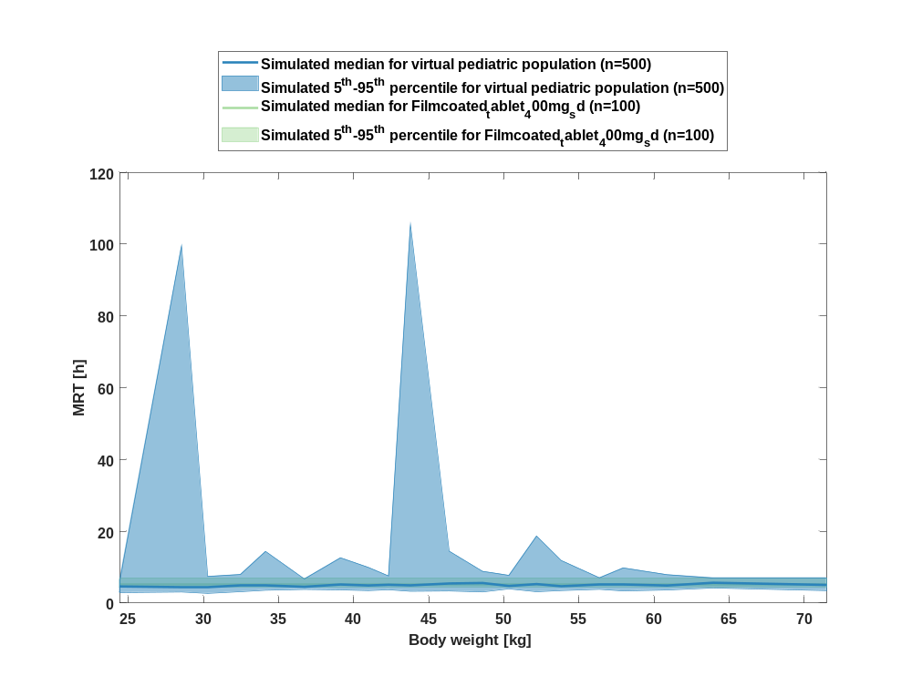

Figure 44: body weight dependency of MRT Raltegravir for simulated virtual pediatric population in comparison to simulated Filmcoated_tablet_400mg_sd in a logarithmic scale.
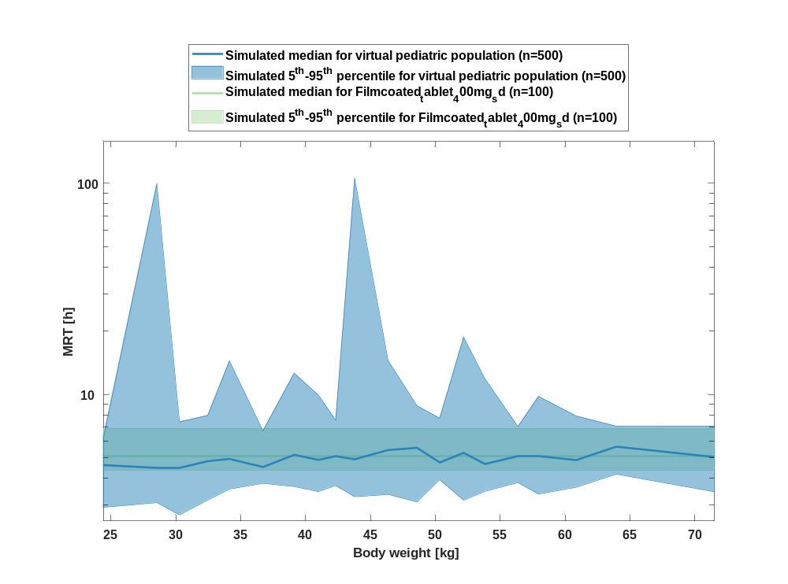

Table 1-22:body weight dependency of MRT Raltegravir for simulated virtual pediatric population in comparison to simulated Filmcoated_tablet_400mg_sd
Body weight [kg] | MRT [h]
Range of body weight | Median of body weight | 5th percentile | median | 95th percentile | N individuals
21-26.9 | 24.40 | 2.90 | 4.62 | 6.27 | 25
26.9-29.8 | 28.50 | 3.07 | 4.50 | 99.60 | 25
29.8-30.9 | 30.30 | 2.68 | 4.48 | 7.40 | 25
30.9-33.3 | 32.50 | 3.15 | 4.82 | 7.95 | 25
33.3-35.8 | 34.10 | 3.56 | 4.94 | 14.40 | 25
35.8-37.8 | 36.70 | 3.78 | 4.53 | 6.71 | 25
37.8-40.1 | 39.10 | 3.66 | 5.17 | 12.60 | 25
40.1-41.5 | 41 | 3.46 | 4.89 | 9.91 | 25
41.5-43.2 | 42.30 | 3.70 | 5.09 | 7.55 | 25
43.2-45.4 | 43.80 | 3.27 | 4.92 | 105 | 25
45.4-47.7 | 46.40 | 3.35 | 5.45 | 14.50 | 25
47.7-49.4 | 48.60 | 3.09 | 5.58 | 8.83 | 25
49.4-51 | 50.30 | 3.94 | 4.76 | 7.70 | 25
51-52.9 | 52.20 | 3.15 | 5.28 | 18.70 | 25
52.9-55.3 | 53.80 | 3.47 | 4.68 | 11.80 | 25
55.3-57.2 | 56.40 | 3.82 | 5.10 | 7.03 | 25
57.2-59.4 | 57.90 | 3.37 | 5.09 | 9.78 | 25
59.4-62.1 | 60.90 | 3.63 | 4.88 | 7.89 | 25
62.1-67.1 | 63.90 | 4.18 | 5.65 | 7.06 | 25
67.1-89 | 71.50 | 3.45 | 5.05 | 7.06 | 25
reference values: | 4.35 | 5.11 | 6.88

Thalf

Figure 45: body weight dependency of Thalf Raltegravir for simulated virtual pediatric population in comparison to simulated Filmcoated_tablet_400mg_sd in a linear scale.
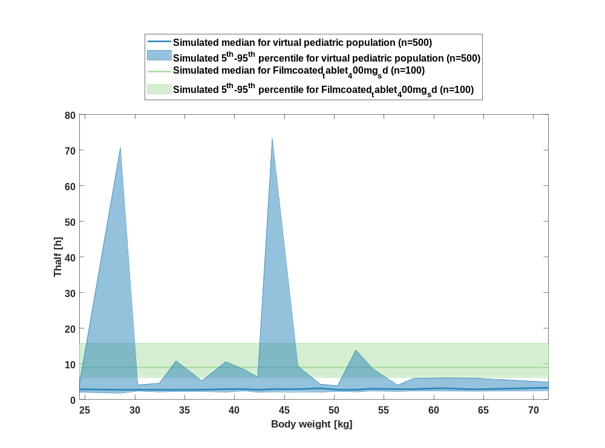

Figure 46: body weight dependency of Thalf Raltegravir for simulated virtual pediatric population in comparison to simulated Filmcoated_tablet_400mg_sd in a logarithmic scale.
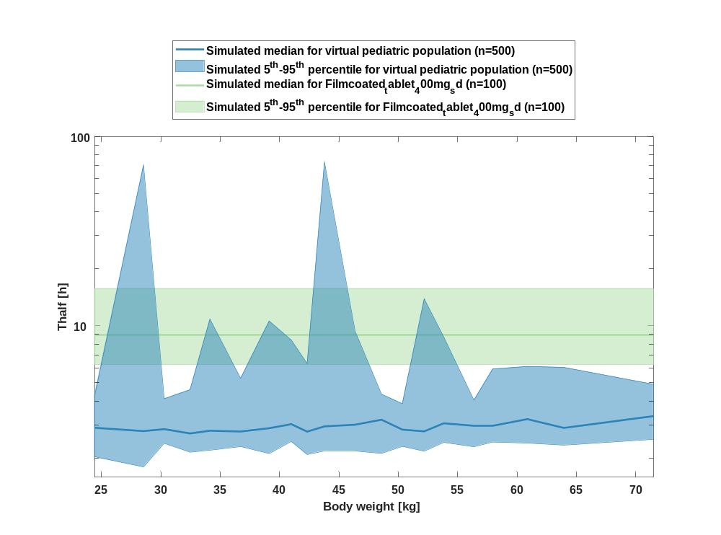

Table 1-23:body weight dependency of Thalf Raltegravir for simulated virtual pediatric population in comparison to simulated Filmcoated_tablet_400mg_sd
Body weight [kg] | Thalf [h]
Range of body weight | Median of body weight | 5th percentile | median | 95th percentile | N individuals
21-26.9 | 24.40 | 2.02 | 2.89 | 4.30 | 25
26.9-29.8 | 28.50 | 1.80 | 2.78 | 70.60 | 25
29.8-30.9 | 30.30 | 2.39 | 2.85 | 4.12 | 25
30.9-33.3 | 32.50 | 2.15 | 2.70 | 4.59 | 25
33.3-35.8 | 34.10 | 2.20 | 2.79 | 10.80 | 25
35.8-37.8 | 36.70 | 2.30 | 2.76 | 5.28 | 25
37.8-40.1 | 39.10 | 2.11 | 2.88 | 10.60 | 25
40.1-41.5 | 41 | 2.45 | 3.02 | 8.41 | 25
41.5-43.2 | 42.30 | 2.09 | 2.76 | 6.31 | 25
43.2-45.4 | 43.80 | 2.19 | 2.94 | 73.10 | 25
45.4-47.7 | 46.40 | 2.18 | 3 | 9.36 | 25
47.7-49.4 | 48.60 | 2.12 | 3.19 | 4.35 | 25
49.4-51 | 50.30 | 2.31 | 2.83 | 3.88 | 25
51-52.9 | 52.20 | 2.18 | 2.77 | 13.90 | 25
52.9-55.3 | 53.80 | 2.42 | 3.05 | 8.73 | 25
55.3-57.2 | 56.40 | 2.30 | 2.96 | 4.05 | 25
57.2-59.4 | 57.90 | 2.43 | 2.95 | 5.91 | 25
59.4-62.1 | 60.90 | 2.40 | 3.21 | 6.10 | 25
62.1-67.1 | 63.90 | 2.34 | 2.89 | 6.03 | 25
67.1-89 | 71.50 | 2.51 | 3.33 | 4.91 | 25
reference values: | 6.23 | 8.98 | 15.70

CL

Figure 47: body weight dependency of CL Raltegravir for simulated virtual pediatric population in comparison to simulated Filmcoated_tablet_400mg_sd in a linear scale.
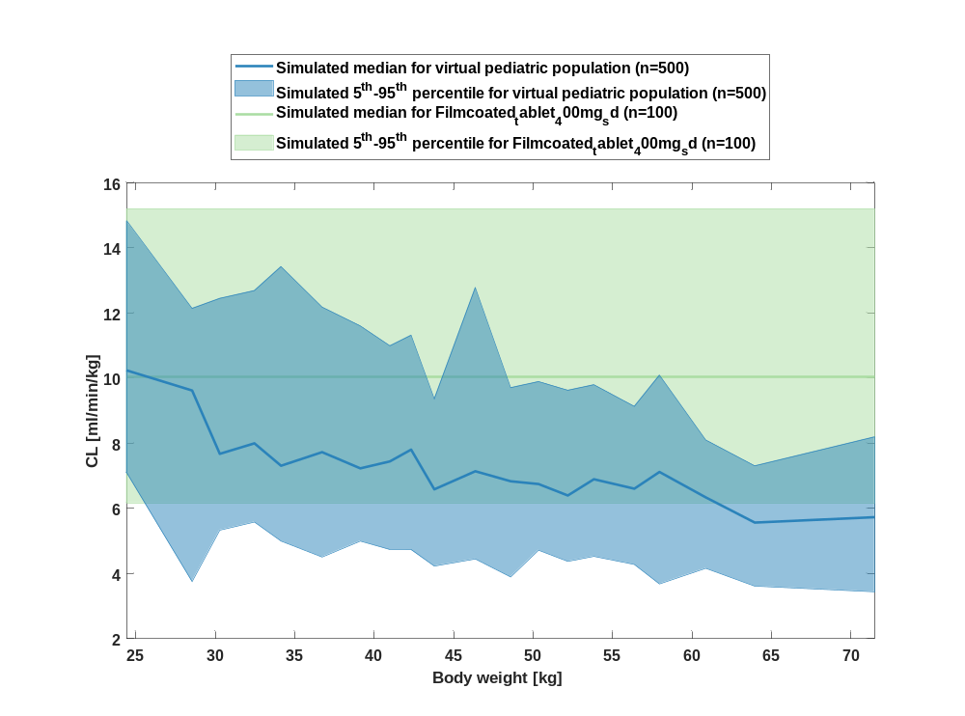

Figure 48: body weight dependency of CL Raltegravir for simulated virtual pediatric population in comparison to simulated Filmcoated_tablet_400mg_sd in a logarithmic scale.
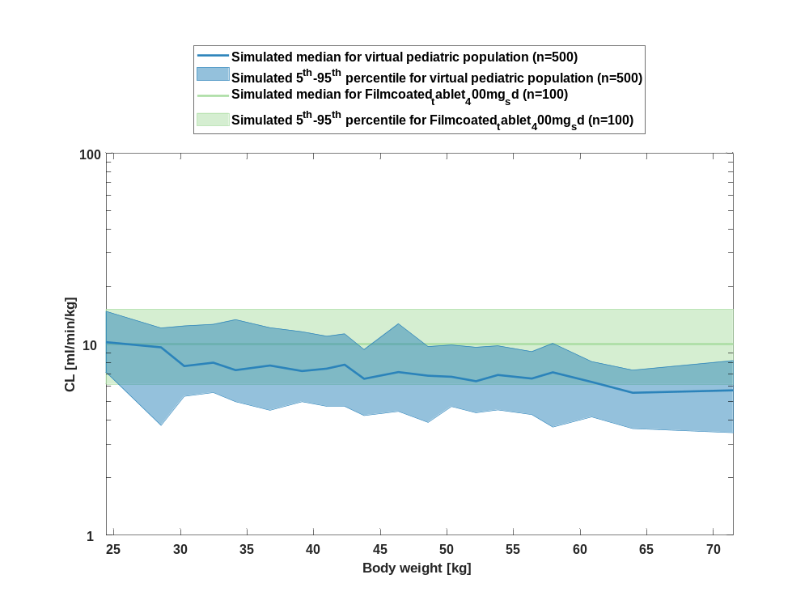

Table 1-24:body weight dependency of CL Raltegravir for simulated virtual pediatric population in comparison to simulated Filmcoated_tablet_400mg_sd
Body weight [kg] | CL [ml/min/kg]
Range of body weight | Median of body weight | 5th percentile | median | 95th percentile | N individuals
21-26.9 | 24.40 | 7.09 | 10.20 | 14.80 | 25
26.9-29.8 | 28.50 | 3.75 | 9.62 | 12.10 | 25
29.8-30.9 | 30.30 | 5.33 | 7.67 | 12.40 | 25
30.9-33.3 | 32.50 | 5.58 | 8 | 12.70 | 25
33.3-35.8 | 34.10 | 5 | 7.31 | 13.40 | 25
35.8-37.8 | 36.70 | 4.51 | 7.73 | 12.20 | 25
37.8-40.1 | 39.10 | 5 | 7.23 | 11.60 | 25
40.1-41.5 | 41 | 4.73 | 7.44 | 11 | 25
41.5-43.2 | 42.30 | 4.72 | 7.80 | 11.30 | 25
43.2-45.4 | 43.80 | 4.23 | 6.58 | 9.36 | 25
45.4-47.7 | 46.40 | 4.45 | 7.14 | 12.80 | 25
47.7-49.4 | 48.60 | 3.89 | 6.83 | 9.70 | 25
49.4-51 | 50.30 | 4.72 | 6.75 | 9.89 | 25
51-52.9 | 52.20 | 4.37 | 6.40 | 9.62 | 25
52.9-55.3 | 53.80 | 4.53 | 6.89 | 9.80 | 25
55.3-57.2 | 56.40 | 4.28 | 6.60 | 9.13 | 25
57.2-59.4 | 57.90 | 3.68 | 7.12 | 10.10 | 25
59.4-62.1 | 60.90 | 4.16 | 6.34 | 8.10 | 25
62.1-67.1 | 63.90 | 3.61 | 5.56 | 7.31 | 25
67.1-89 | 71.50 | 3.44 | 5.73 | 8.20 | 25
reference values: | 6.16 | 10 | 15.20

Vss

Figure 49: body weight dependency of Vss Raltegravir for simulated virtual pediatric population in comparison to simulated Filmcoated_tablet_400mg_sd in a linear scale.
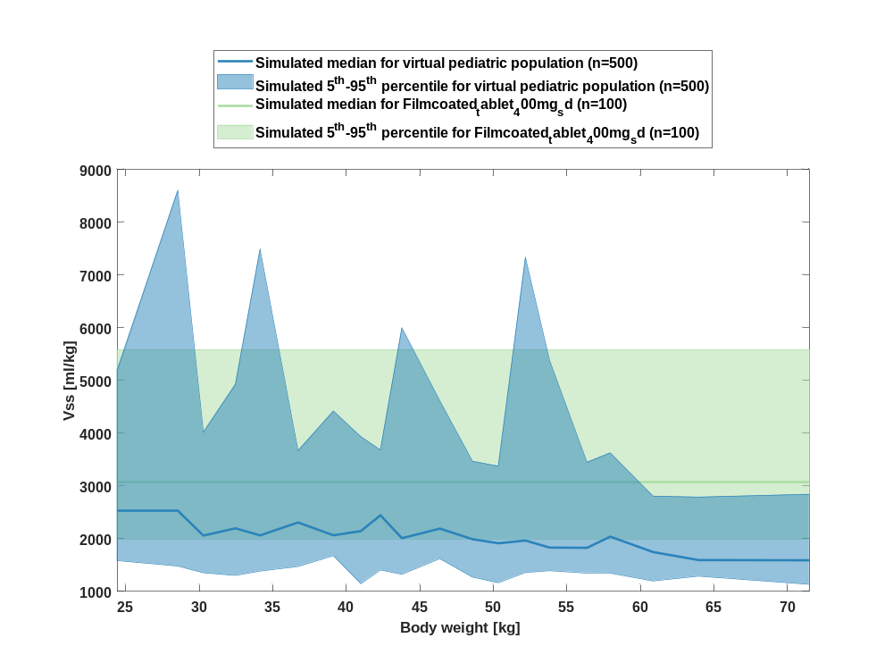

Figure 50: body weight dependency of Vss Raltegravir for simulated virtual pediatric population in comparison to simulated Filmcoated_tablet_400mg_sd in a logarithmic scale.
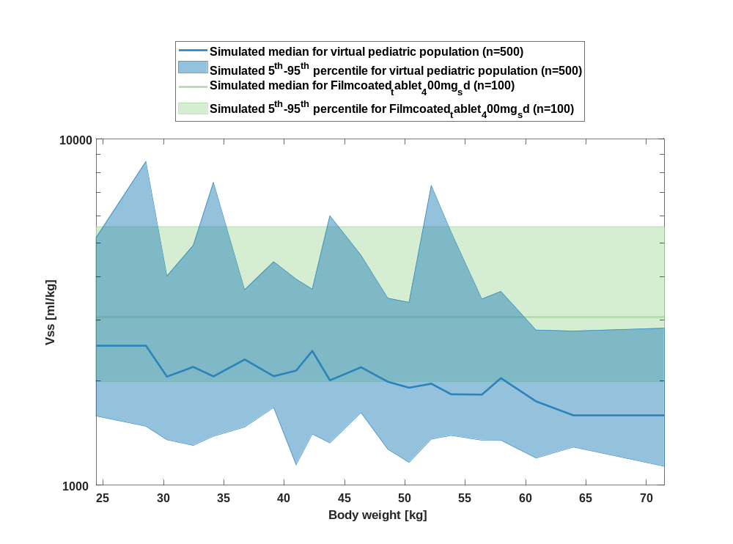

Table 1-25:body weight dependency of Vss Raltegravir for simulated virtual pediatric population in comparison to simulated Filmcoated_tablet_400mg_sd
Body weight [kg] | Vss [ml/kg]
Range of body weight | Median of body weight | 5th percentile | median | 95th percentile | N individuals
21-26.9 | 24.40 | 1580 | 2520 | 5190 | 25
26.9-29.8 | 28.50 | 1480 | 2530 | 8590 | 25
29.8-30.9 | 30.30 | 1350 | 2060 | 4010 | 25
30.9-33.3 | 32.50 | 1300 | 2200 | 4920 | 25
33.3-35.8 | 34.10 | 1380 | 2060 | 7480 | 25
35.8-37.8 | 36.70 | 1470 | 2310 | 3660 | 25
37.8-40.1 | 39.10 | 1680 | 2060 | 4420 | 25
40.1-41.5 | 41 | 1150 | 2140 | 3930 | 25
41.5-43.2 | 42.30 | 1410 | 2440 | 3680 | 25
43.2-45.4 | 43.80 | 1320 | 2010 | 5990 | 25
45.4-47.7 | 46.40 | 1620 | 2190 | 4610 | 25
47.7-49.4 | 48.60 | 1270 | 1990 | 3460 | 25
49.4-51 | 50.30 | 1160 | 1910 | 3370 | 25
51-52.9 | 52.20 | 1360 | 1960 | 7330 | 25
52.9-55.3 | 53.80 | 1390 | 1830 | 5380 | 25
55.3-57.2 | 56.40 | 1350 | 1830 | 3450 | 25
57.2-59.4 | 57.90 | 1350 | 2040 | 3620 | 25
59.4-62.1 | 60.90 | 1200 | 1750 | 2800 | 25
62.1-67.1 | 63.90 | 1290 | 1590 | 2790 | 25
67.1-89 | 71.50 | 1130 | 1590 | 2840 | 25
reference values: | 1990 | 3060 | 5580

Vd

Figure 51: body weight dependency of Vd Raltegravir for simulated virtual pediatric population in comparison to simulated Filmcoated_tablet_400mg_sd in a linear scale.
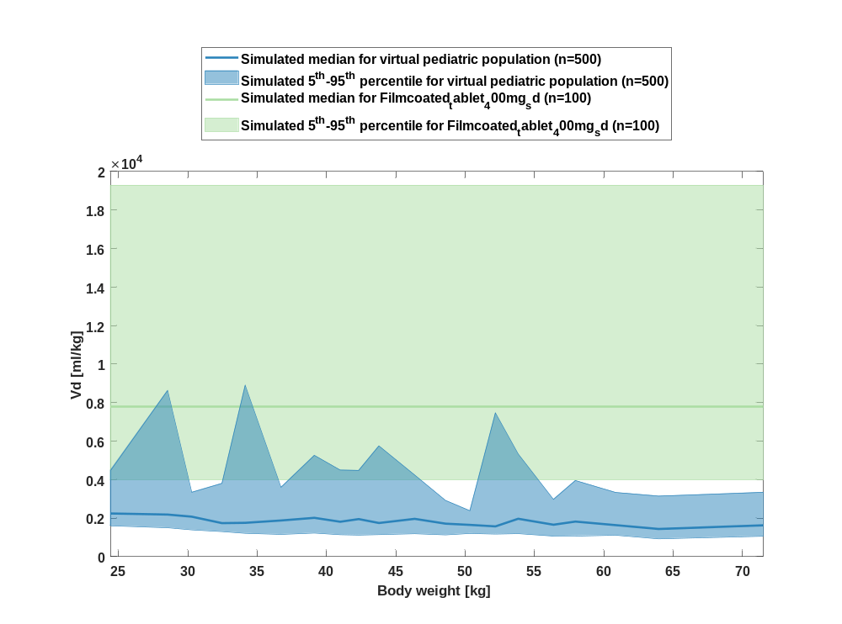

Figure 52: body weight dependency of Vd Raltegravir for simulated virtual pediatric population in comparison to simulated Filmcoated_tablet_400mg_sd in a logarithmic scale.
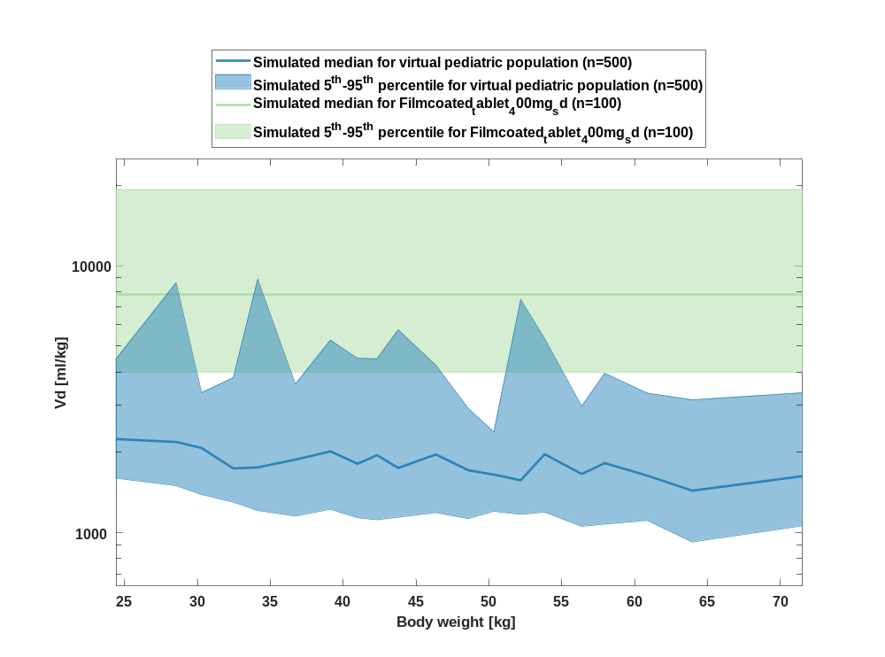

Table 1-26:body weight dependency of Vd Raltegravir for simulated virtual pediatric population in comparison to simulated Filmcoated_tablet_400mg_sd
Body weight [kg] | Vd [ml/kg]
Range of body weight | Median of body weight | 5th percentile | median | 95th percentile | N individuals
21-26.9 | 24.40 | 1600 | 2240 | 4480 | 25
26.9-29.8 | 28.50 | 1500 | 2190 | 8630 | 25
29.8-30.9 | 30.30 | 1390 | 2080 | 3340 | 25
30.9-33.3 | 32.50 | 1300 | 1740 | 3800 | 25
33.3-35.8 | 34.10 | 1210 | 1760 | 8900 | 25
35.8-37.8 | 36.70 | 1150 | 1880 | 3600 | 25
37.8-40.1 | 39.10 | 1220 | 2020 | 5260 | 25
40.1-41.5 | 41 | 1140 | 1810 | 4500 | 25
41.5-43.2 | 42.30 | 1120 | 1950 | 4480 | 25
43.2-45.4 | 43.80 | 1140 | 1750 | 5750 | 25
45.4-47.7 | 46.40 | 1190 | 1960 | 4240 | 25
47.7-49.4 | 48.60 | 1130 | 1710 | 2920 | 25
49.4-51 | 50.30 | 1200 | 1650 | 2380 | 25
51-52.9 | 52.20 | 1170 | 1570 | 7460 | 25
52.9-55.3 | 53.80 | 1190 | 1970 | 5330 | 25
55.3-57.2 | 56.40 | 1060 | 1660 | 2970 | 25
57.2-59.4 | 57.90 | 1080 | 1820 | 3950 | 25
59.4-62.1 | 60.90 | 1110 | 1640 | 3330 | 25
62.1-67.1 | 63.90 | 923 | 1440 | 3140 | 25
67.1-89 | 71.50 | 1060 | 1630 | 3340 | 25
reference values: | 3980 | 7800 | 19300

Age-dependence of Raltegravir as fraction of Filmcoated_tablet_400mg_sd

C_{max}

Figure 53: age dependency of C_{max} Raltegravir for simulated virtual pediatric population as fraction of median of simulated Filmcoated_tablet_400mg_sd in a linear scale.
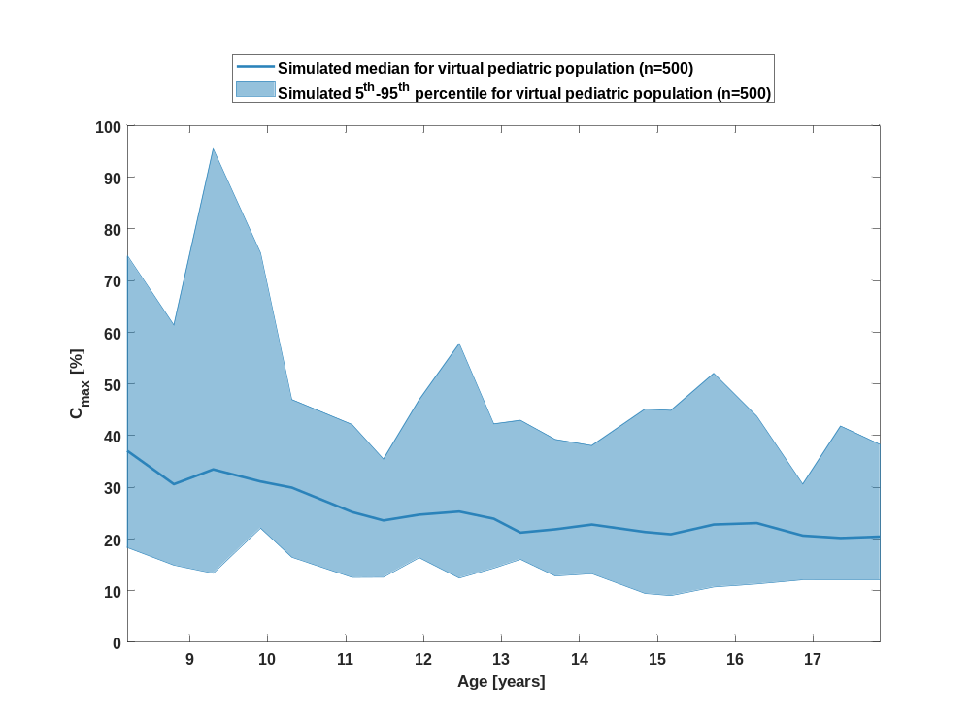

Figure 54: age dependency of C_{max} Raltegravir for simulated virtual pediatric population as fraction of median of simulated Filmcoated_tablet_400mg_sd in a logarithmic scale.
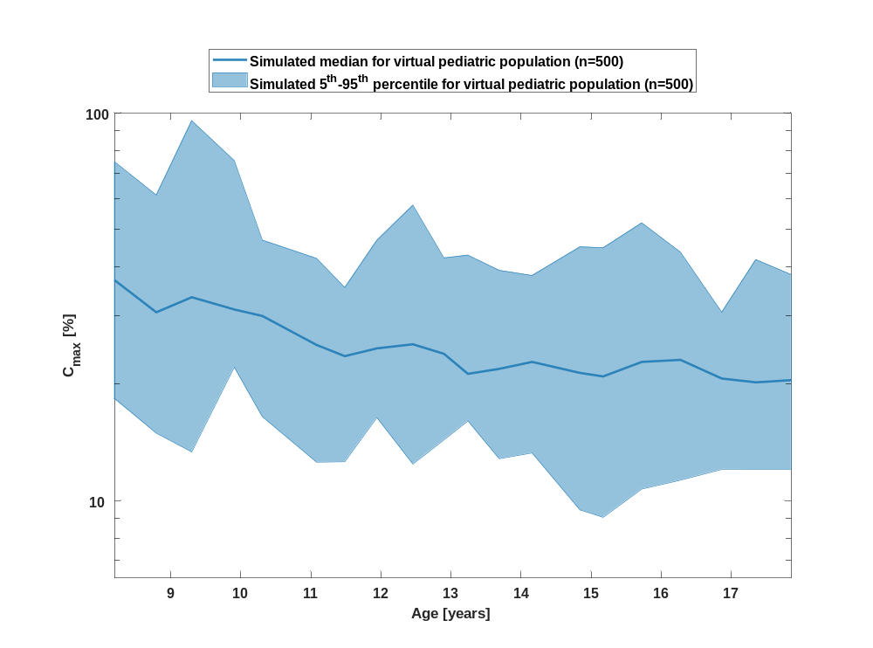

Table 1-27:age dependency of C_{max} Raltegravir for simulated virtual pediatric population as fraction of median of simulated Filmcoated_tablet_400mg_sd
Age [years] | C_{max} [%]
Range of age | Median of age | 5th percentile | median | 95th percentile | N individuals
8-8.53 | 8.20 | 18.30 | 37 | 74.70 | 25
8.53-9.09 | 8.80 | 14.90 | 30.60 | 61.40 | 25
9.09-9.6 | 9.30 | 13.30 | 33.50 | 95.50 | 25
9.6-10.1 | 9.91 | 22.10 | 31.10 | 75.30 | 25
10.1-10.8 | 10.30 | 16.40 | 29.90 | 47 | 25
10.8-11.3 | 11.10 | 12.60 | 25.20 | 42.10 | 25
11.3-11.7 | 11.50 | 12.60 | 23.60 | 35.40 | 25
11.7-12.2 | 11.90 | 16.40 | 24.70 | 46.90 | 25
12.2-12.7 | 12.50 | 12.40 | 25.30 | 57.80 | 25
12.7-13 | 12.90 | 14.30 | 23.90 | 42.30 | 25
13-13.5 | 13.20 | 16 | 21.20 | 42.90 | 25
13.5-13.9 | 13.70 | 12.80 | 21.90 | 39.20 | 25
13.9-14.5 | 14.20 | 13.30 | 22.80 | 38.10 | 25
14.5-15 | 14.80 | 9.45 | 21.30 | 45.10 | 25
15-15.4 | 15.20 | 9.05 | 20.90 | 44.90 | 25
15.4-16 | 15.70 | 10.70 | 22.80 | 52 | 25
16-16.6 | 16.30 | 11.30 | 23.10 | 43.70 | 25
16.6-17.1 | 16.90 | 12 | 20.60 | 30.60 | 25
17.1-17.6 | 17.30 | 12 | 20.20 | 41.80 | 25
17.6-18 | 17.90 | 12 | 20.40 | 38.30 | 25

C_{max} norm

Figure 55: age dependency of C_{max} norm Raltegravir for simulated virtual pediatric population as fraction of median of simulated Filmcoated_tablet_400mg_sd in a linear scale.
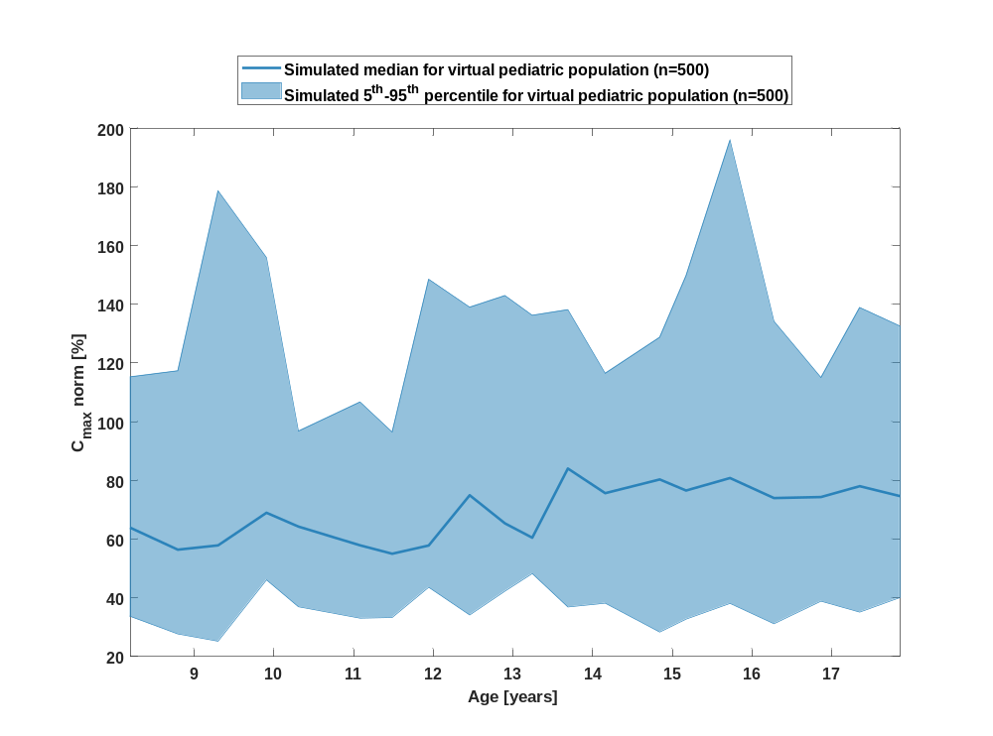

Figure 56: age dependency of C_{max} norm Raltegravir for simulated virtual pediatric population as fraction of median of simulated Filmcoated_tablet_400mg_sd in a logarithmic scale.
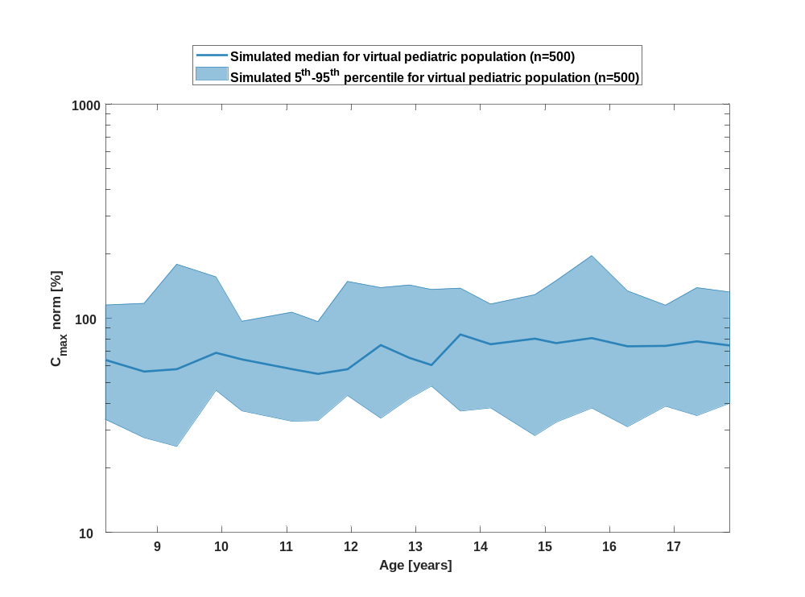

Table 1-28:age dependency of C_{max} norm Raltegravir for simulated virtual pediatric population as fraction of median of simulated Filmcoated_tablet_400mg_sd
Age [years] | C_{max} norm [%]
Range of age | Median of age | 5th percentile | median | 95th percentile | N individuals
8-8.53 | 8.20 | 33.60 | 63.90 | 115 | 25
8.53-9.09 | 8.80 | 27.70 | 56.40 | 117 | 25
9.09-9.6 | 9.30 | 25.20 | 57.90 | 179 | 25
9.6-10.1 | 9.91 | 46.10 | 69 | 156 | 25
10.1-10.8 | 10.30 | 37 | 64.30 | 96.80 | 25
10.8-11.3 | 11.10 | 33.10 | 57.90 | 107 | 25
11.3-11.7 | 11.50 | 33.30 | 55 | 96.50 | 25
11.7-12.2 | 11.90 | 43.60 | 57.80 | 149 | 25
12.2-12.7 | 12.50 | 34.20 | 75 | 139 | 25
12.7-13 | 12.90 | 42.30 | 65.40 | 143 | 25
13-13.5 | 13.20 | 48.30 | 60.50 | 136 | 25
13.5-13.9 | 13.70 | 36.90 | 84.10 | 138 | 25
13.9-14.5 | 14.20 | 38.20 | 75.70 | 116 | 25
14.5-15 | 14.80 | 28.30 | 80.30 | 129 | 25
15-15.4 | 15.20 | 32.70 | 76.60 | 150 | 25
15.4-16 | 15.70 | 38.10 | 80.80 | 196 | 25
16-16.6 | 16.30 | 31.20 | 74 | 134 | 25
16.6-17.1 | 16.90 | 38.90 | 74.30 | 115 | 25
17.1-17.6 | 17.30 | 35.10 | 78 | 139 | 25
17.6-18 | 17.90 | 40.10 | 74.70 | 133 | 25

t_{max}

Figure 57: age dependency of t_{max} Raltegravir for simulated virtual pediatric population as fraction of median of simulated Filmcoated_tablet_400mg_sd in a linear scale.
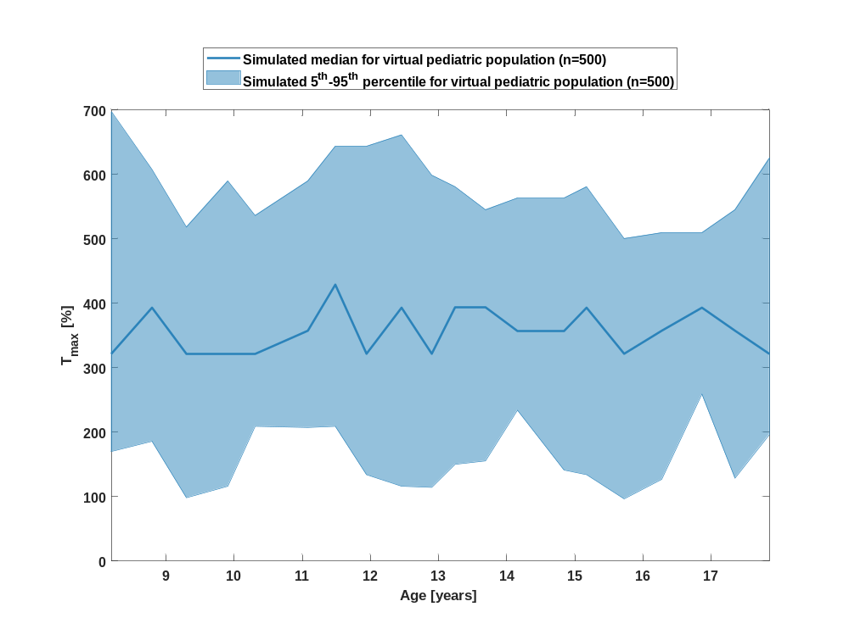

Figure 58: age dependency of t_{max} Raltegravir for simulated virtual pediatric population as fraction of median of simulated Filmcoated_tablet_400mg_sd in a logarithmic scale.
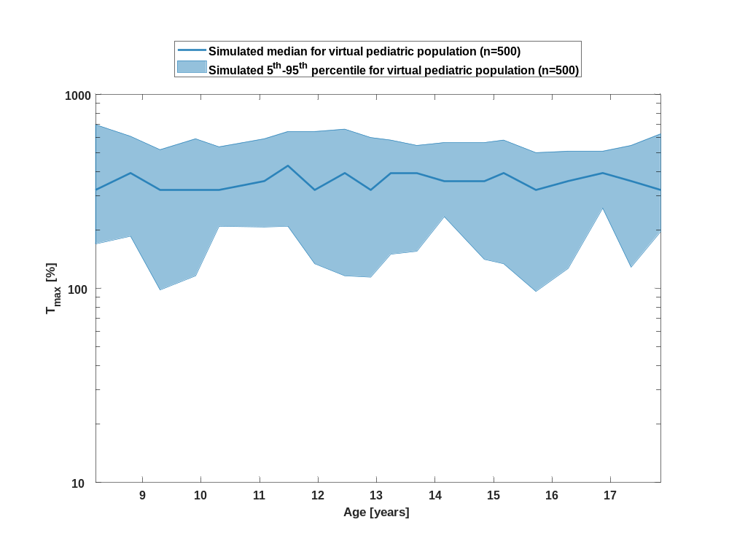

Table 1-29:age dependency of t_{max} Raltegravir for simulated virtual pediatric population as fraction of median of simulated Filmcoated_tablet_400mg_sd
Age [years] | T_{max} [%]
Range of age | Median of age | 5th percentile | median | 95th percentile | N individuals
8-8.53 | 8.20 | 170 | 321 | 696 | 25
8.53-9.09 | 8.80 | 186 | 393 | 607 | 25
9.09-9.6 | 9.30 | 98.20 | 321 | 518 | 25
9.6-10.1 | 9.91 | 116 | 321 | 589 | 25
10.1-10.8 | 10.30 | 209 | 321 | 536 | 25
10.8-11.3 | 11.10 | 207 | 357 | 589 | 25
11.3-11.7 | 11.50 | 209 | 429 | 643 | 25
11.7-12.2 | 11.90 | 134 | 321 | 643 | 25
12.2-12.7 | 12.50 | 116 | 393 | 661 | 25
12.7-13 | 12.90 | 114 | 321 | 598 | 25
13-13.5 | 13.20 | 150 | 393 | 580 | 25
13.5-13.9 | 13.70 | 155 | 393 | 545 | 25
13.9-14.5 | 14.20 | 234 | 357 | 563 | 25
14.5-15 | 14.80 | 141 | 357 | 563 | 25
15-15.4 | 15.20 | 134 | 393 | 580 | 25
15.4-16 | 15.70 | 96.40 | 321 | 500 | 25
16-16.6 | 16.30 | 127 | 357 | 509 | 25
16.6-17.1 | 16.90 | 259 | 393 | 509 | 25
17.1-17.6 | 17.30 | 129 | 357 | 545 | 25
17.6-18 | 17.90 | 196 | 321 | 625 | 25

C_{tEnd}

Figure 59: age dependency of C_{tEnd} Raltegravir for simulated virtual pediatric population as fraction of median of simulated Filmcoated_tablet_400mg_sd in a linear scale.
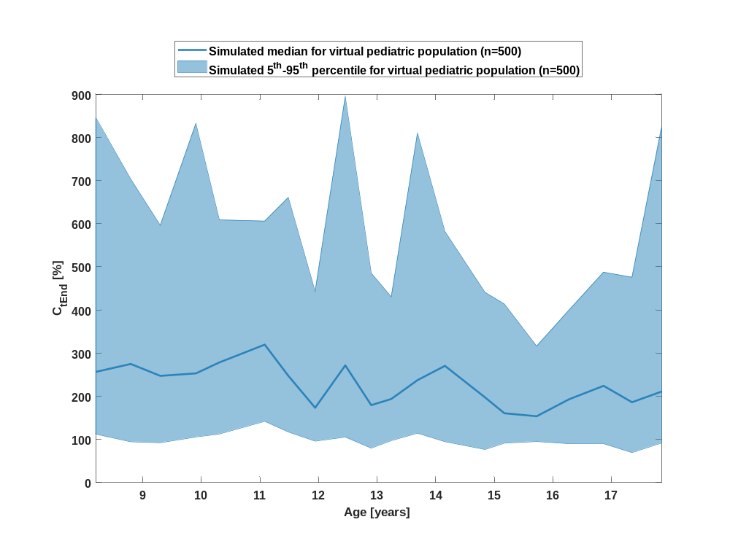

Figure 60: age dependency of C_{tEnd} Raltegravir for simulated virtual pediatric population as fraction of median of simulated Filmcoated_tablet_400mg_sd in a logarithmic scale.
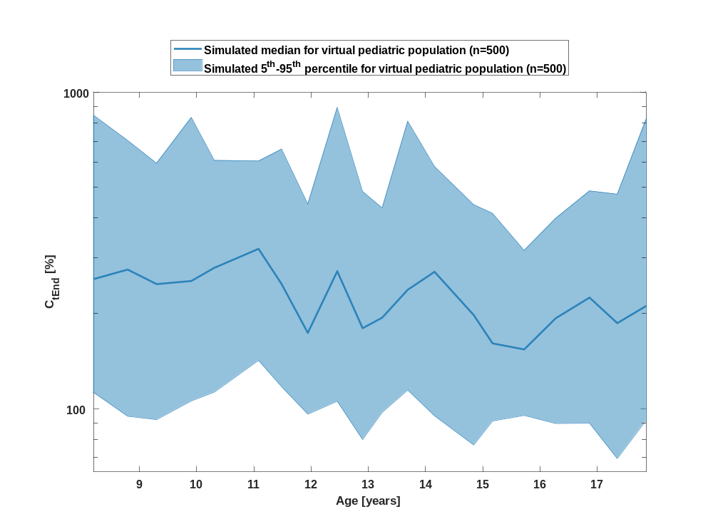

Table 1-30:age dependency of C_{tEnd} Raltegravir for simulated virtual pediatric population as fraction of median of simulated Filmcoated_tablet_400mg_sd
Age [years] | C_{tEnd} [%]
Range of age | Median of age | 5th percentile | median | 95th percentile | N individuals
8-8.53 | 8.20 | 112 | 257 | 845 | 25
8.53-9.09 | 8.80 | 94.50 | 275 | 703 | 25
9.09-9.6 | 9.30 | 92.30 | 247 | 596 | 25
9.6-10.1 | 9.91 | 106 | 253 | 832 | 25
10.1-10.8 | 10.30 | 113 | 279 | 609 | 25
10.8-11.3 | 11.10 | 142 | 320 | 606 | 25
11.3-11.7 | 11.50 | 117 | 248 | 661 | 25
11.7-12.2 | 11.90 | 96 | 173 | 443 | 25
12.2-12.7 | 12.50 | 105 | 272 | 895 | 25
12.7-13 | 12.90 | 79.80 | 180 | 485 | 25
13-13.5 | 13.20 | 97.30 | 194 | 431 | 25
13.5-13.9 | 13.70 | 114 | 237 | 810 | 25
13.9-14.5 | 14.20 | 94.80 | 271 | 582 | 25
14.5-15 | 14.80 | 76.70 | 198 | 441 | 25
15-15.4 | 15.20 | 91.40 | 161 | 414 | 25
15.4-16 | 15.70 | 95.10 | 154 | 316 | 25
16-16.6 | 16.30 | 89.70 | 193 | 400 | 25
16.6-17.1 | 16.90 | 89.90 | 224 | 488 | 25
17.1-17.6 | 17.30 | 69.50 | 186 | 476 | 25
17.6-18 | 17.90 | 91.90 | 211 | 825 | 25

AUC_{last}

Figure 61: age dependency of AUC_{last} Raltegravir for simulated virtual pediatric population as fraction of median of simulated Filmcoated_tablet_400mg_sd in a linear scale.
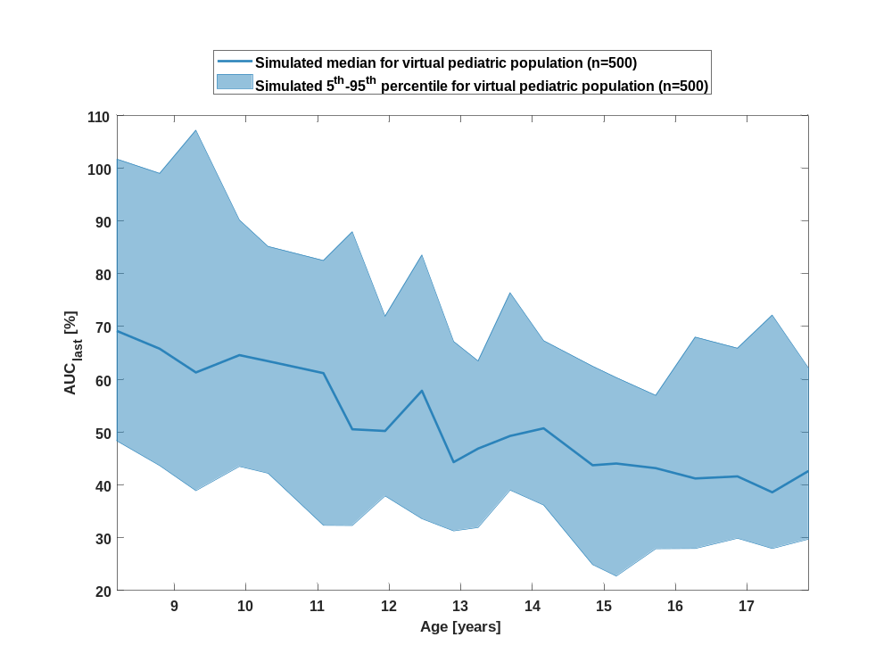

Figure 62: age dependency of AUC_{last} Raltegravir for simulated virtual pediatric population as fraction of median of simulated Filmcoated_tablet_400mg_sd in a logarithmic scale.
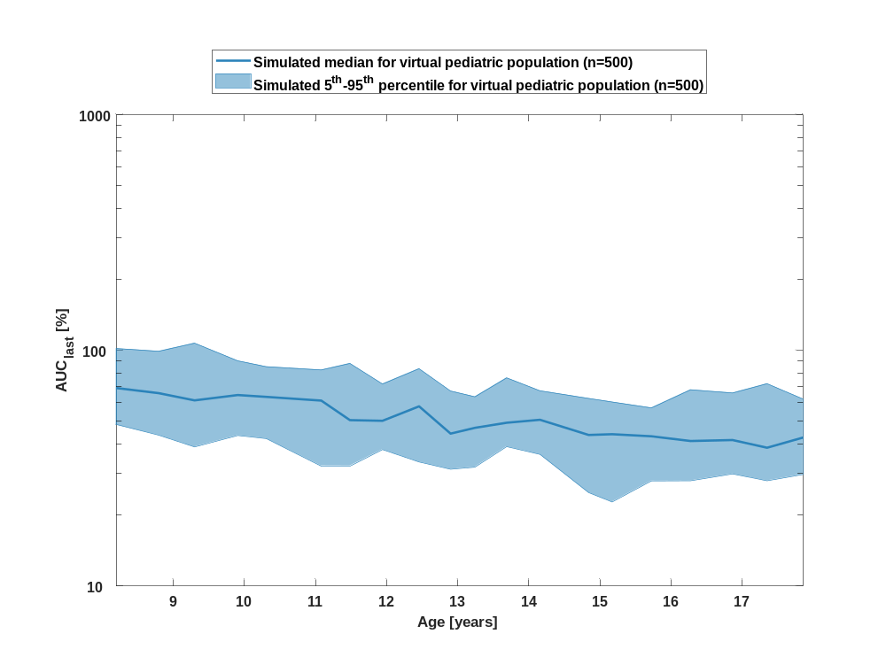

Table 1-31:age dependency of AUC_{last} Raltegravir for simulated virtual pediatric population as fraction of median of simulated Filmcoated_tablet_400mg_sd
Age [years] | AUC_{last} [%]
Range of age | Median of age | 5th percentile | median | 95th percentile | N individuals
8-8.53 | 8.20 | 48.30 | 69.20 | 102 | 25
8.53-9.09 | 8.80 | 43.70 | 65.80 | 99 | 25
9.09-9.6 | 9.30 | 38.90 | 61.30 | 107 | 25
9.6-10.1 | 9.91 | 43.50 | 64.60 | 90.20 | 25
10.1-10.8 | 10.30 | 42.20 | 63.40 | 85.20 | 25
10.8-11.3 | 11.10 | 32.30 | 61.20 | 82.50 | 25
11.3-11.7 | 11.50 | 32.30 | 50.50 | 87.90 | 25
11.7-12.2 | 11.90 | 37.90 | 50.20 | 71.90 | 25
12.2-12.7 | 12.50 | 33.60 | 57.80 | 83.50 | 25
12.7-13 | 12.90 | 31.30 | 44.30 | 67.20 | 25
13-13.5 | 13.20 | 31.90 | 46.90 | 63.50 | 25
13.5-13.9 | 13.70 | 39 | 49.30 | 76.40 | 25
13.9-14.5 | 14.20 | 36.20 | 50.70 | 67.30 | 25
14.5-15 | 14.80 | 24.90 | 43.70 | 62.50 | 25
15-15.4 | 15.20 | 22.70 | 44.10 | 60.30 | 25
15.4-16 | 15.70 | 27.90 | 43.20 | 57 | 25
16-16.6 | 16.30 | 28 | 41.20 | 68 | 25
16.6-17.1 | 16.90 | 29.90 | 41.60 | 65.90 | 25
17.1-17.6 | 17.30 | 28 | 38.60 | 72.20 | 25
17.6-18 | 17.90 | 29.70 | 42.60 | 62.10 | 25

AUC_{last} norm

Figure 63: age dependency of AUC_{last} norm Raltegravir for simulated virtual pediatric population as fraction of median of simulated Filmcoated_tablet_400mg_sd in a linear scale.
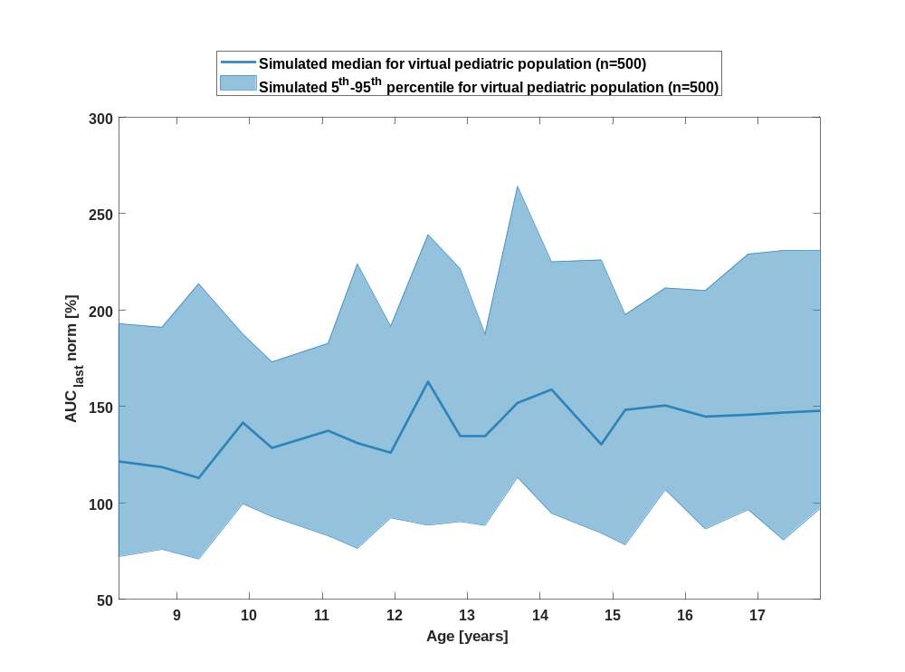

Figure 64: age dependency of AUC_{last} norm Raltegravir for simulated virtual pediatric population as fraction of median of simulated Filmcoated_tablet_400mg_sd in a logarithmic scale.
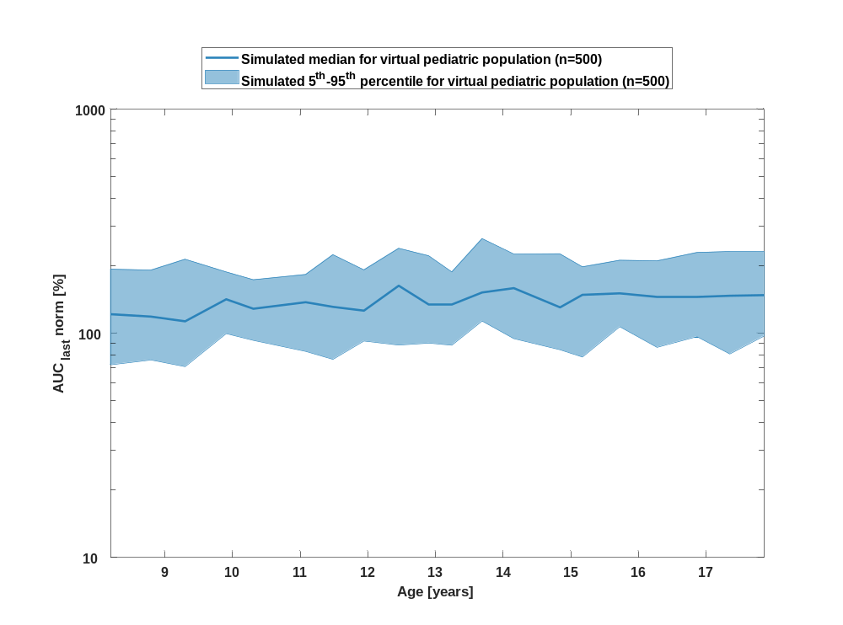

Table 1-32:age dependency of AUC_{last} norm Raltegravir for simulated virtual pediatric population as fraction of median of simulated Filmcoated_tablet_400mg_sd
Age [years] | AUC_{last} norm [%]
Range of age | Median of age | 5th percentile | median | 95th percentile | N individuals
8-8.53 | 8.20 | 72.30 | 122 | 193 | 25
8.53-9.09 | 8.80 | 76 | 119 | 191 | 25
9.09-9.6 | 9.30 | 70.90 | 113 | 214 | 25
9.6-10.1 | 9.91 | 99.60 | 142 | 188 | 25
10.1-10.8 | 10.30 | 92.90 | 129 | 173 | 25
10.8-11.3 | 11.10 | 83 | 137 | 183 | 25
11.3-11.7 | 11.50 | 76.50 | 131 | 224 | 25
11.7-12.2 | 11.90 | 92.30 | 126 | 192 | 25
12.2-12.7 | 12.50 | 88.50 | 163 | 239 | 25
12.7-13 | 12.90 | 90.30 | 135 | 221 | 25
13-13.5 | 13.20 | 88.40 | 135 | 188 | 25
13.5-13.9 | 13.70 | 113 | 152 | 264 | 25
13.9-14.5 | 14.20 | 94.60 | 159 | 225 | 25
14.5-15 | 14.80 | 84.40 | 130 | 226 | 25
15-15.4 | 15.20 | 78.30 | 148 | 198 | 25
15.4-16 | 15.70 | 107 | 151 | 211 | 25
16-16.6 | 16.30 | 86.50 | 145 | 210 | 25
16.6-17.1 | 16.90 | 96.50 | 146 | 229 | 25
17.1-17.6 | 17.30 | 80.80 | 147 | 231 | 25
17.6-18 | 17.90 | 97.20 | 148 | 231 | 25

AUC_{inf}

Figure 65: age dependency of AUC_{inf} Raltegravir for simulated virtual pediatric population as fraction of median of simulated Filmcoated_tablet_400mg_sd in a linear scale.
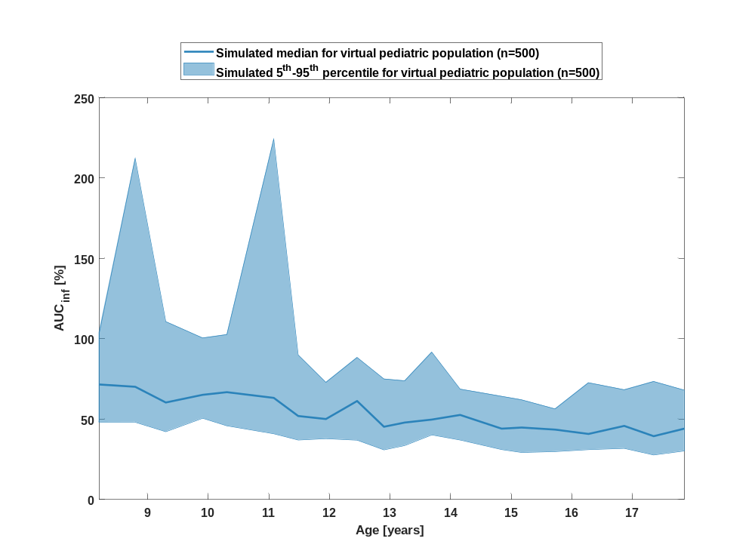

Figure 66: age dependency of AUC_{inf} Raltegravir for simulated virtual pediatric population as fraction of median of simulated Filmcoated_tablet_400mg_sd in a logarithmic scale.
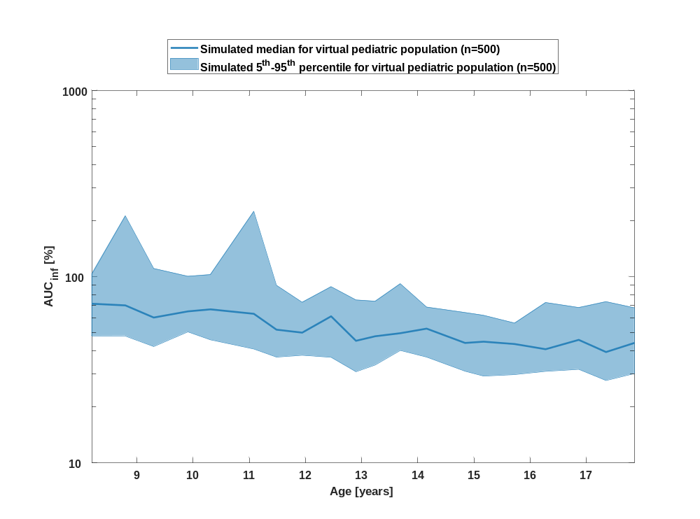

Table 1-33:age dependency of AUC_{inf} Raltegravir for simulated virtual pediatric population as fraction of median of simulated Filmcoated_tablet_400mg_sd
Age [years] | AUC_{inf} [%]
Range of age | Median of age | 5th percentile | median | 95th percentile | N individuals
8-8.53 | 8.20 | 48.10 | 71.60 | 104 | 25
8.53-9.09 | 8.80 | 48.10 | 70.10 | 212 | 25
9.09-9.6 | 9.30 | 42.20 | 60.40 | 111 | 25
9.6-10.1 | 9.91 | 50.60 | 65.10 | 100 | 25
10.1-10.8 | 10.30 | 45.80 | 66.80 | 103 | 25
10.8-11.3 | 11.10 | 40.90 | 63.20 | 224 | 25
11.3-11.7 | 11.50 | 37 | 52 | 89.90 | 25
11.7-12.2 | 11.90 | 37.90 | 50.10 | 72.90 | 25
12.2-12.7 | 12.50 | 36.90 | 61.30 | 88.40 | 25
12.7-13 | 12.90 | 30.90 | 45.30 | 75 | 25
13-13.5 | 13.20 | 33.60 | 47.90 | 73.80 | 25
13.5-13.9 | 13.70 | 40.20 | 49.70 | 91.70 | 25
13.9-14.5 | 14.20 | 37 | 52.60 | 68.70 | 25
14.5-15 | 14.80 | 31.10 | 44.10 | 64.20 | 25
15-15.4 | 15.20 | 29.30 | 44.80 | 62 | 25
15.4-16 | 15.70 | 29.80 | 43.50 | 56.40 | 25
16-16.6 | 16.30 | 31 | 40.80 | 72.60 | 25
16.6-17.1 | 16.90 | 31.80 | 45.80 | 68.30 | 25
17.1-17.6 | 17.30 | 27.70 | 39.40 | 73.40 | 25
17.6-18 | 17.90 | 30.20 | 44.10 | 68 | 25

AUC_{inf} norm

Figure 67: age dependency of AUC_{inf} norm Raltegravir for simulated virtual pediatric population as fraction of median of simulated Filmcoated_tablet_400mg_sd in a linear scale.
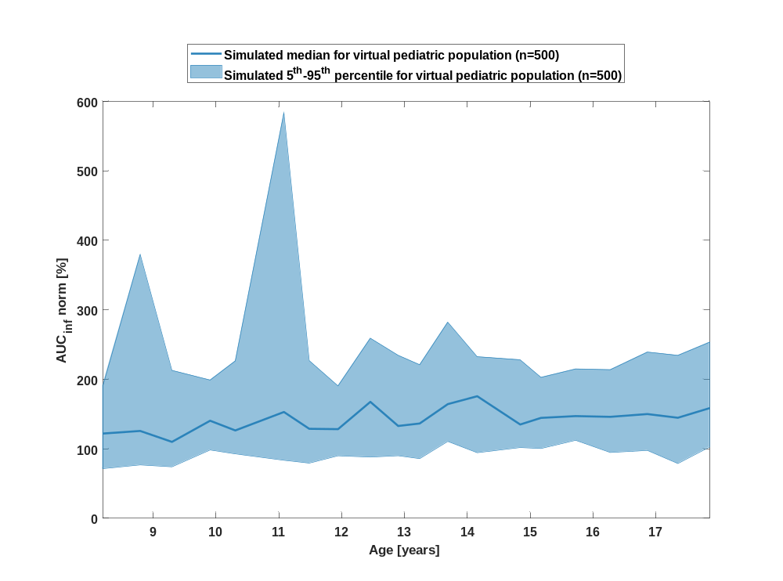

Figure 68: age dependency of AUC_{inf} norm Raltegravir for simulated virtual pediatric population as fraction of median of simulated Filmcoated_tablet_400mg_sd in a logarithmic scale.
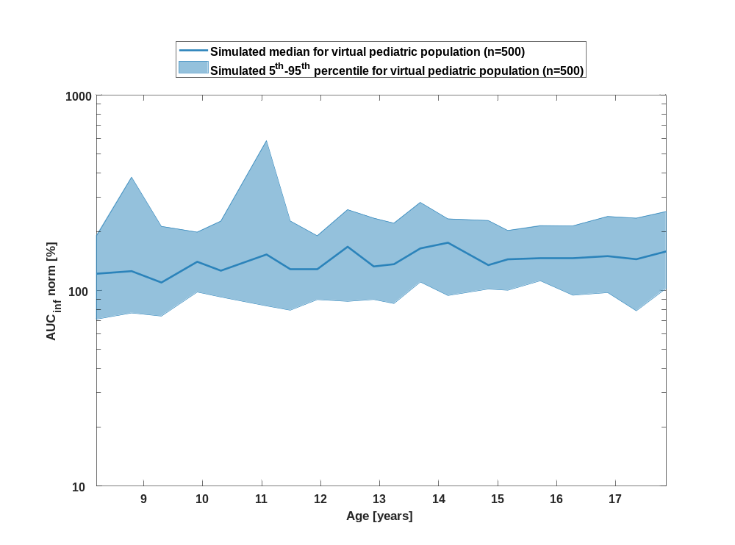

Table 1-34:age dependency of AUC_{inf} norm Raltegravir for simulated virtual pediatric population as fraction of median of simulated Filmcoated_tablet_400mg_sd
Age [years] | AUC_{inf} norm [%]
Range of age | Median of age | 5th percentile | median | 95th percentile | N individuals
8-8.53 | 8.20 | 71.30 | 122 | 191 | 25
8.53-9.09 | 8.80 | 76.80 | 126 | 380 | 25
9.09-9.6 | 9.30 | 74 | 110 | 213 | 25
9.6-10.1 | 9.91 | 98.30 | 140 | 199 | 25
10.1-10.8 | 10.30 | 92.60 | 126 | 226 | 25
10.8-11.3 | 11.10 | 83.40 | 153 | 583 | 25
11.3-11.7 | 11.50 | 79.30 | 129 | 227 | 25
11.7-12.2 | 11.90 | 89.90 | 128 | 190 | 25
12.2-12.7 | 12.50 | 88.10 | 167 | 259 | 25
12.7-13 | 12.90 | 90 | 133 | 234 | 25
13-13.5 | 13.20 | 85.80 | 136 | 221 | 25
13.5-13.9 | 13.70 | 111 | 164 | 282 | 25
13.9-14.5 | 14.20 | 94.30 | 176 | 232 | 25
14.5-15 | 14.80 | 102 | 135 | 228 | 25
15-15.4 | 15.20 | 100 | 144 | 203 | 25
15.4-16 | 15.70 | 112 | 147 | 215 | 25
16-16.6 | 16.30 | 94.60 | 146 | 214 | 25
16.6-17.1 | 16.90 | 97.60 | 150 | 239 | 25
17.1-17.6 | 17.30 | 78.80 | 145 | 234 | 25
17.6-18 | 17.90 | 103 | 158 | 253 | 25

MRT

Figure 69: age dependency of MRT Raltegravir for simulated virtual pediatric population as fraction of median of simulated Filmcoated_tablet_400mg_sd in a linear scale.
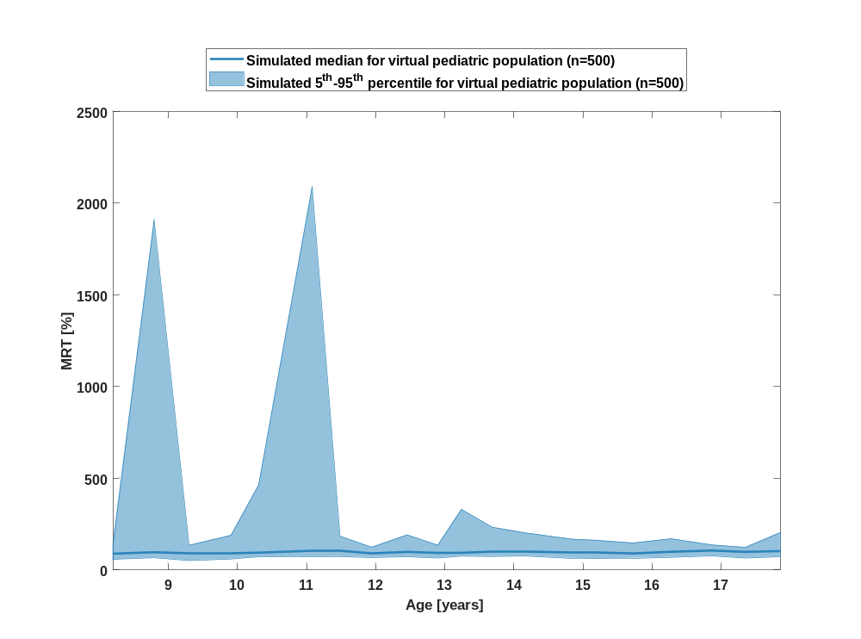

Figure 70: age dependency of MRT Raltegravir for simulated virtual pediatric population as fraction of median of simulated Filmcoated_tablet_400mg_sd in a logarithmic scale.
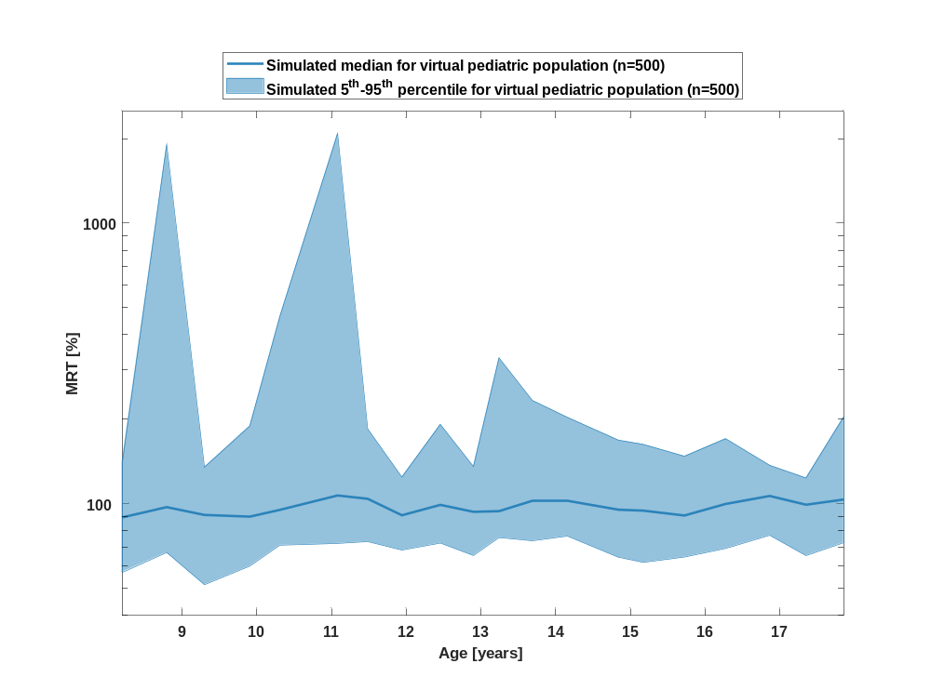

Table 1-35:age dependency of MRT Raltegravir for simulated virtual pediatric population as fraction of median of simulated Filmcoated_tablet_400mg_sd
Age [years] | MRT [%]
Range of age | Median of age | 5th percentile | median | 95th percentile | N individuals
8-8.53 | 8.20 | 56.80 | 89.10 | 140 | 25
8.53-9.09 | 8.80 | 66.80 | 97 | 1910 | 25
9.09-9.6 | 9.30 | 51.30 | 91 | 135 | 25
9.6-10.1 | 9.91 | 59.80 | 89.70 | 189 | 25
10.1-10.8 | 10.30 | 70.90 | 94.80 | 464 | 25
10.8-11.3 | 11.10 | 72 | 107 | 2090 | 25
11.3-11.7 | 11.50 | 73.10 | 104 | 185 | 25
11.7-12.2 | 11.90 | 68.10 | 90.70 | 124 | 25
12.2-12.7 | 12.50 | 72.20 | 98.80 | 191 | 25
12.7-13 | 12.90 | 65.20 | 93.30 | 135 | 25
13-13.5 | 13.20 | 75.50 | 93.80 | 331 | 25
13.5-13.9 | 13.70 | 73.60 | 102 | 233 | 25
13.9-14.5 | 14.20 | 76.40 | 102 | 203 | 25
14.5-15 | 14.80 | 64.20 | 95 | 168 | 25
15-15.4 | 15.20 | 61.60 | 94.20 | 162 | 25
15.4-16 | 15.70 | 64.30 | 90.60 | 147 | 25
16-16.6 | 16.30 | 69.10 | 99.60 | 170 | 25
16.6-17.1 | 16.90 | 76.90 | 106 | 137 | 25
17.1-17.6 | 17.30 | 65.10 | 98.90 | 123 | 25
17.6-18 | 17.90 | 72.40 | 103 | 204 | 25

Thalf

Figure 71: age dependency of Thalf Raltegravir for simulated virtual pediatric population as fraction of median of simulated Filmcoated_tablet_400mg_sd in a linear scale.
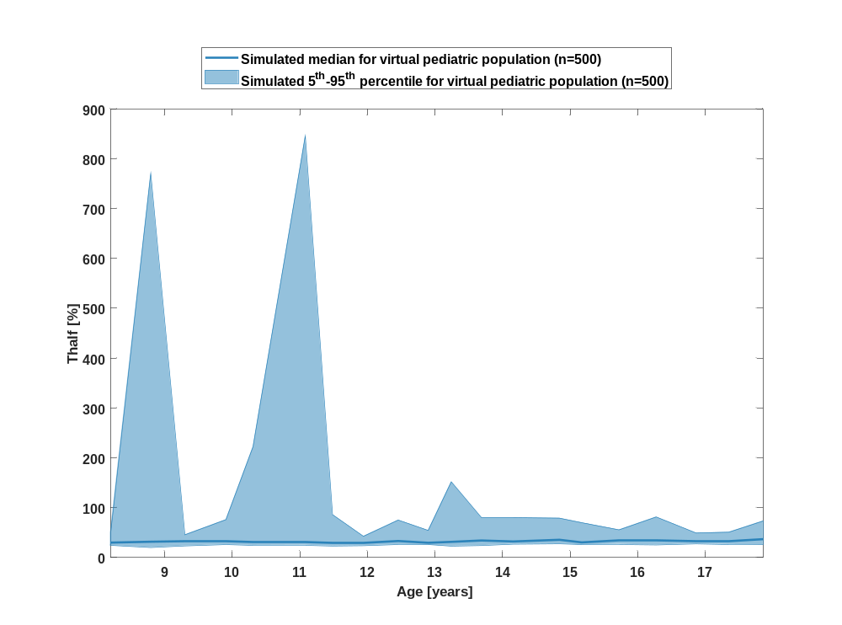

Figure 72: age dependency of Thalf Raltegravir for simulated virtual pediatric population as fraction of median of simulated Filmcoated_tablet_400mg_sd in a logarithmic scale.
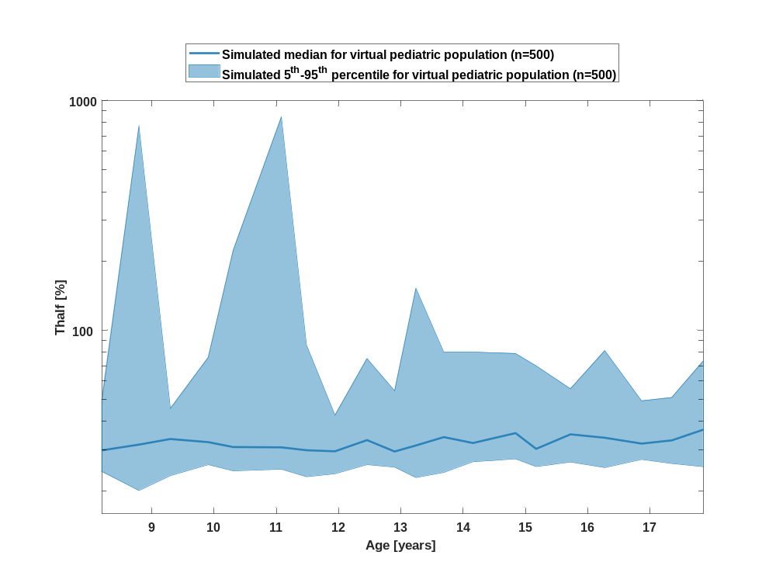

Table 1-36:age dependency of Thalf Raltegravir for simulated virtual pediatric population as fraction of median of simulated Filmcoated_tablet_400mg_sd
Age [years] | Thalf [%]
Range of age | Median of age | 5th percentile | median | 95th percentile | N individuals
8-8.53 | 8.20 | 24.20 | 29.90 | 49.60 | 25
8.53-9.09 | 8.80 | 20 | 31.70 | 771 | 25
9.09-9.6 | 9.30 | 23.20 | 33.50 | 45.60 | 25
9.6-10.1 | 9.91 | 25.90 | 32.50 | 76 | 25
10.1-10.8 | 10.30 | 24.40 | 31 | 222 | 25
10.8-11.3 | 11.10 | 24.80 | 30.90 | 846 | 25
11.3-11.7 | 11.50 | 23 | 30 | 86.10 | 25
11.7-12.2 | 11.90 | 23.70 | 29.70 | 42.60 | 25
12.2-12.7 | 12.50 | 25.90 | 33.20 | 75.10 | 25
12.7-13 | 12.90 | 25.30 | 29.60 | 54.40 | 25
13-13.5 | 13.20 | 22.80 | 31.40 | 152 | 25
13.5-13.9 | 13.70 | 24 | 34.20 | 80 | 25
13.9-14.5 | 14.20 | 26.70 | 32.20 | 80 | 25
14.5-15 | 14.80 | 27.50 | 35.60 | 79 | 25
15-15.4 | 15.20 | 25.40 | 30.40 | 69.90 | 25
15.4-16 | 15.70 | 26.60 | 35.20 | 55.50 | 25
16-16.6 | 16.30 | 25.20 | 34 | 81.40 | 25
16.6-17.1 | 16.90 | 27.30 | 32 | 49.20 | 25
17.1-17.6 | 17.30 | 26.20 | 33.10 | 50.90 | 25
17.6-18 | 17.90 | 25.40 | 36.80 | 73.40 | 25

CL

Figure 73: age dependency of CL Raltegravir for simulated virtual pediatric population as fraction of median of simulated Filmcoated_tablet_400mg_sd in a linear scale.
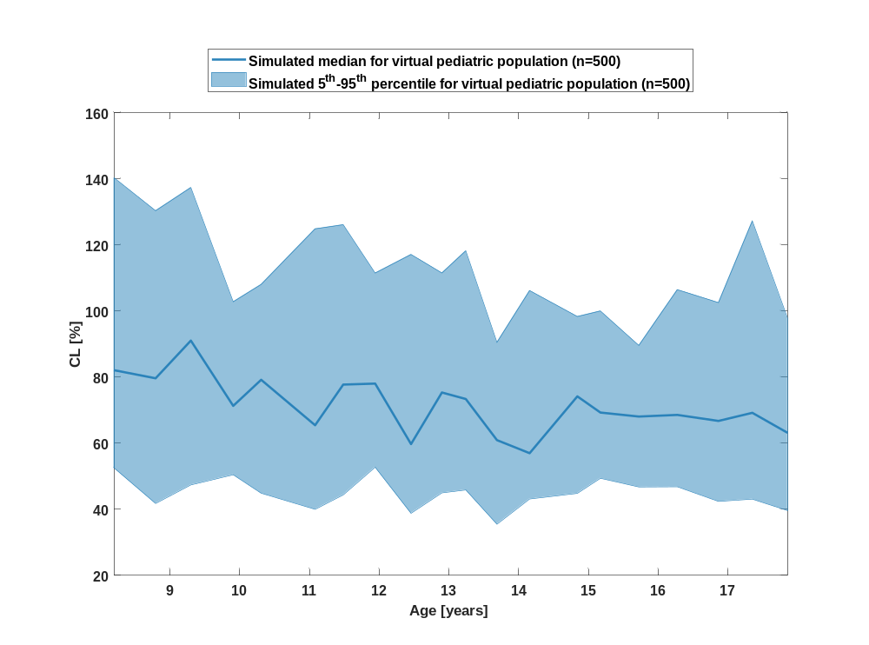

Figure 74: age dependency of CL Raltegravir for simulated virtual pediatric population as fraction of median of simulated Filmcoated_tablet_400mg_sd in a logarithmic scale.
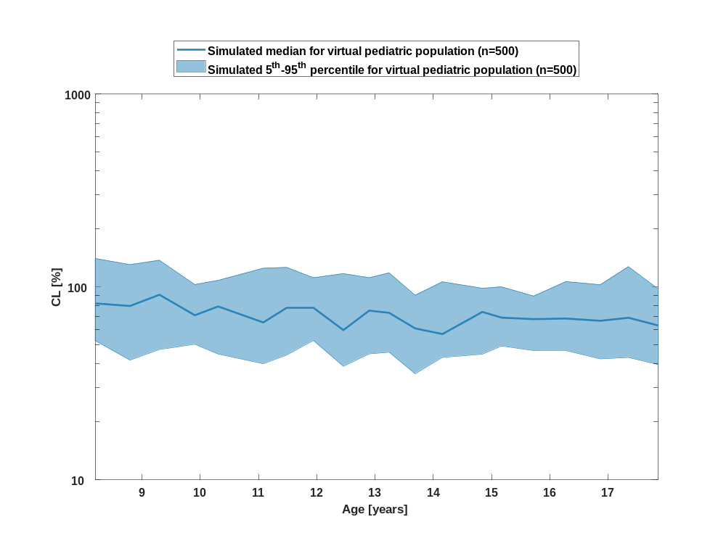

Table 1-37:age dependency of CL Raltegravir for simulated virtual pediatric population as fraction of median of simulated Filmcoated_tablet_400mg_sd
Age [years] | CL [%]
Range of age | Median of age | 5th percentile | median | 95th percentile | N individuals
8-8.53 | 8.20 | 52.50 | 82 | 140 | 25
8.53-9.09 | 8.80 | 41.70 | 79.60 | 130 | 25
9.09-9.6 | 9.30 | 47.30 | 91 | 137 | 25
9.6-10.1 | 9.91 | 50.40 | 71.30 | 103 | 25
10.1-10.8 | 10.30 | 44.80 | 79.10 | 108 | 25
10.8-11.3 | 11.10 | 40 | 65.40 | 125 | 25
11.3-11.7 | 11.50 | 44.30 | 77.70 | 126 | 25
11.7-12.2 | 11.90 | 52.70 | 78 | 111 | 25
12.2-12.7 | 12.50 | 38.80 | 59.70 | 117 | 25
12.7-13 | 12.90 | 44.90 | 75.30 | 111 | 25
13-13.5 | 13.20 | 45.80 | 73.30 | 118 | 25
13.5-13.9 | 13.70 | 35.50 | 60.90 | 90.50 | 25
13.9-14.5 | 14.20 | 43.10 | 56.90 | 106 | 25
14.5-15 | 14.80 | 44.80 | 74.10 | 98.30 | 25
15-15.4 | 15.20 | 49.30 | 69.20 | 100 | 25
15.4-16 | 15.70 | 46.70 | 68 | 89.50 | 25
16-16.6 | 16.30 | 46.80 | 68.50 | 106 | 25
16.6-17.1 | 16.90 | 42.40 | 66.70 | 102 | 25
17.1-17.6 | 17.30 | 43 | 69.20 | 127 | 25
17.6-18 | 17.90 | 39.60 | 63.10 | 97.60 | 25

Vss

Figure 75: age dependency of Vss Raltegravir for simulated virtual pediatric population as fraction of median of simulated Filmcoated_tablet_400mg_sd in a linear scale.
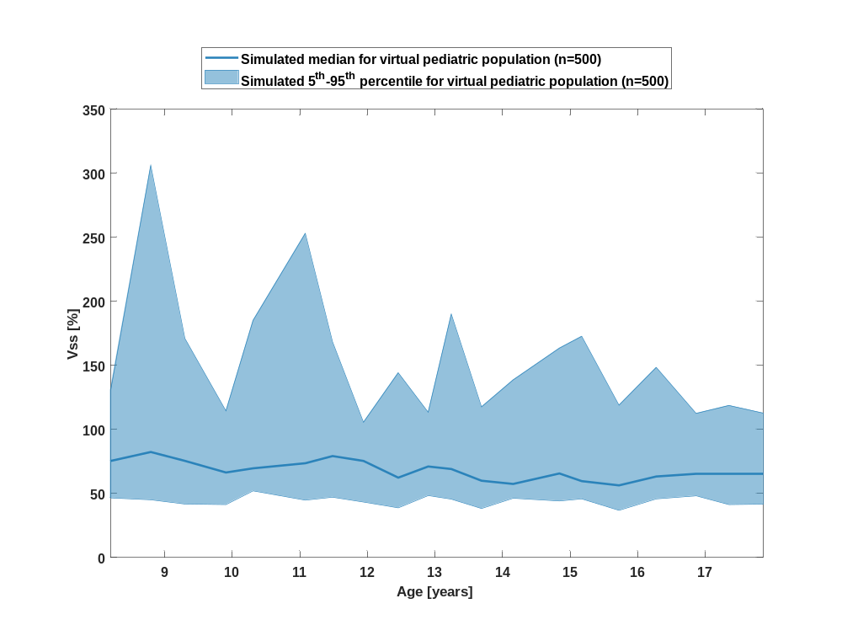

Figure 76: age dependency of Vss Raltegravir for simulated virtual pediatric population as fraction of median of simulated Filmcoated_tablet_400mg_sd in a logarithmic scale.
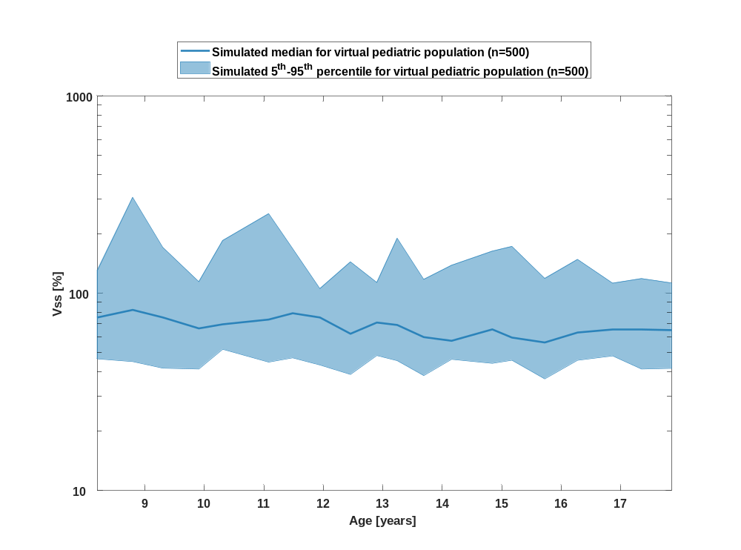

Table 1-38:age dependency of Vss Raltegravir for simulated virtual pediatric population as fraction of median of simulated Filmcoated_tablet_400mg_sd
Age [years] | Vss [%]
Range of age | Median of age | 5th percentile | median | 95th percentile | N individuals
8-8.53 | 8.20 | 46.50 | 75.30 | 130 | 25
8.53-9.09 | 8.80 | 45 | 82.30 | 306 | 25
9.09-9.6 | 9.30 | 41.70 | 75.40 | 171 | 25
9.6-10.1 | 9.91 | 41.30 | 66.30 | 114 | 25
10.1-10.8 | 10.30 | 52 | 69.60 | 185 | 25
10.8-11.3 | 11.10 | 44.80 | 73.60 | 253 | 25
11.3-11.7 | 11.50 | 47.10 | 79.20 | 168 | 25
11.7-12.2 | 11.90 | 43.30 | 75.40 | 106 | 25
12.2-12.7 | 12.50 | 38.80 | 62.30 | 144 | 25
12.7-13 | 12.90 | 48.30 | 71 | 113 | 25
13-13.5 | 13.20 | 45.50 | 69.10 | 190 | 25
13.5-13.9 | 13.70 | 38.30 | 59.90 | 118 | 25
13.9-14.5 | 14.20 | 46.30 | 57.40 | 139 | 25
14.5-15 | 14.80 | 44.10 | 65.60 | 163 | 25
15-15.4 | 15.20 | 45.80 | 59.60 | 173 | 25
15.4-16 | 15.70 | 36.80 | 56.30 | 119 | 25
16-16.6 | 16.30 | 45.70 | 63.20 | 148 | 25
16.6-17.1 | 16.90 | 48.10 | 65.60 | 112 | 25
17.1-17.6 | 17.30 | 41.30 | 65.40 | 119 | 25
17.6-18 | 17.90 | 41.60 | 65 | 113 | 25

Vd

Figure 77: age dependency of Vd Raltegravir for simulated virtual pediatric population as fraction of median of simulated Filmcoated_tablet_400mg_sd in a linear scale.
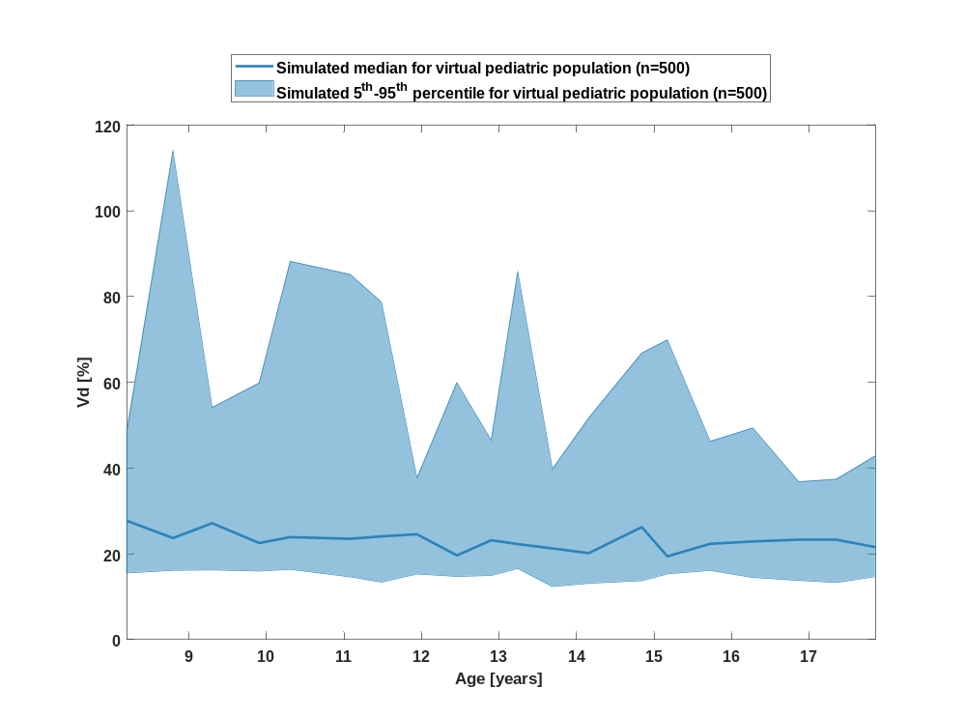

Figure 78: age dependency of Vd Raltegravir for simulated virtual pediatric population as fraction of median of simulated Filmcoated_tablet_400mg_sd in a logarithmic scale.
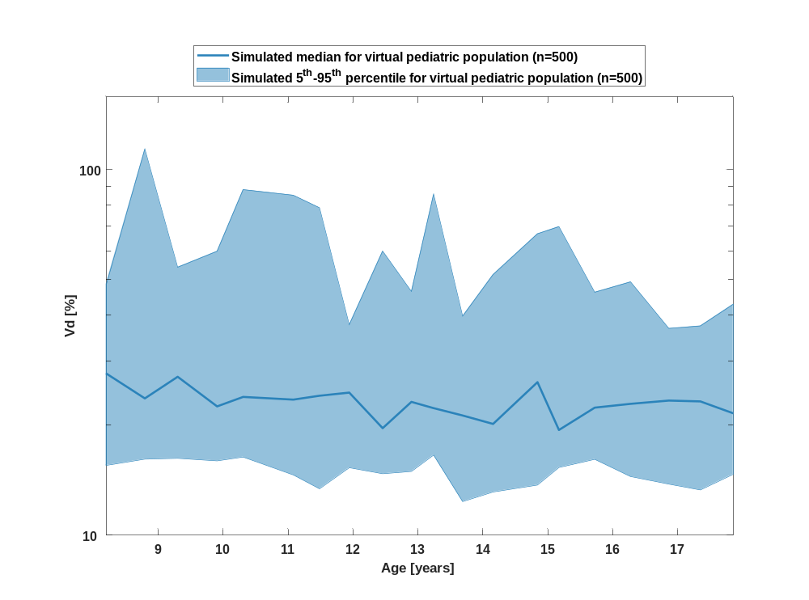

Table 1-39:age dependency of Vd Raltegravir for simulated virtual pediatric population as fraction of median of simulated Filmcoated_tablet_400mg_sd
Age [years] | Vd [%]
Range of age | Median of age | 5th percentile | median | 95th percentile | N individuals
8-8.53 | 8.20 | 15.50 | 27.70 | 48.60 | 25
8.53-9.09 | 8.80 | 16.10 | 23.70 | 114 | 25
9.09-9.6 | 9.30 | 16.20 | 27.10 | 54.10 | 25
9.6-10.1 | 9.91 | 16 | 22.50 | 59.80 | 25
10.1-10.8 | 10.30 | 16.40 | 23.90 | 88.20 | 25
10.8-11.3 | 11.10 | 14.60 | 23.50 | 85.10 | 25
11.3-11.7 | 11.50 | 13.40 | 24.10 | 78.70 | 25
11.7-12.2 | 11.90 | 15.30 | 24.60 | 37.70 | 25
12.2-12.7 | 12.50 | 14.70 | 19.60 | 59.90 | 25
12.7-13 | 12.90 | 14.90 | 23.20 | 46.50 | 25
13-13.5 | 13.20 | 16.60 | 22.30 | 85.70 | 25
13.5-13.9 | 13.70 | 12.40 | 21.30 | 39.80 | 25
13.9-14.5 | 14.20 | 13.10 | 20.20 | 51.60 | 25
14.5-15 | 14.80 | 13.70 | 26.20 | 66.80 | 25
15-15.4 | 15.20 | 15.30 | 19.40 | 69.90 | 25
15.4-16 | 15.70 | 16.10 | 22.30 | 46.20 | 25
16-16.6 | 16.30 | 14.50 | 22.90 | 49.30 | 25
16.6-17.1 | 16.90 | 13.80 | 23.40 | 36.80 | 25
17.1-17.6 | 17.30 | 13.30 | 23.20 | 37.40 | 25
17.6-18 | 17.90 | 14.70 | 21.60 | 42.90 | 25

Body weight-dependence of Raltegravir as fraction of Filmcoated_tablet_400mg_sd

C_{max}

Figure 79: body weight dependency of C_{max} Raltegravir for simulated virtual pediatric population as fraction of median of simulated Filmcoated_tablet_400mg_sd in a linear scale.
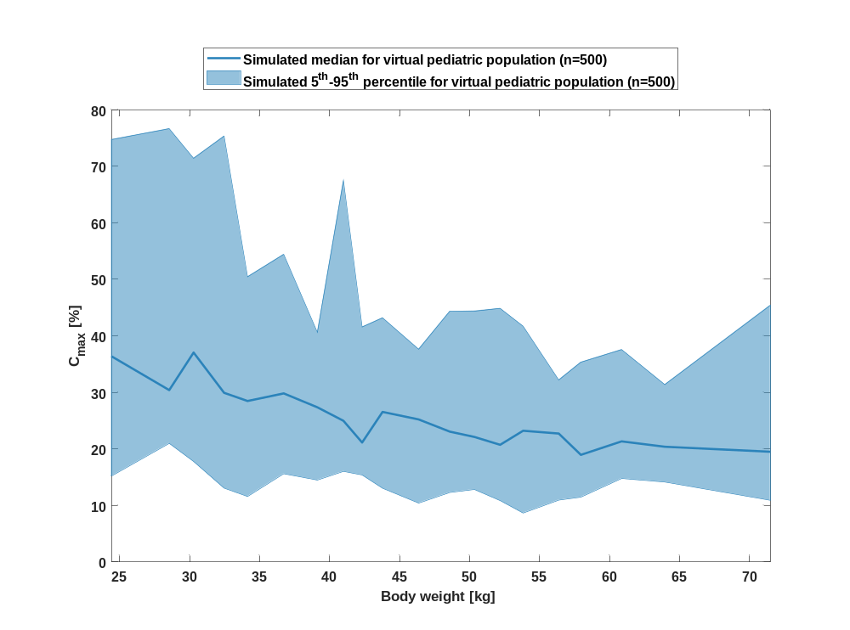

Figure 80: body weight dependency of C_{max} Raltegravir for simulated virtual pediatric population as fraction of median of simulated Filmcoated_tablet_400mg_sd in a logarithmic scale.
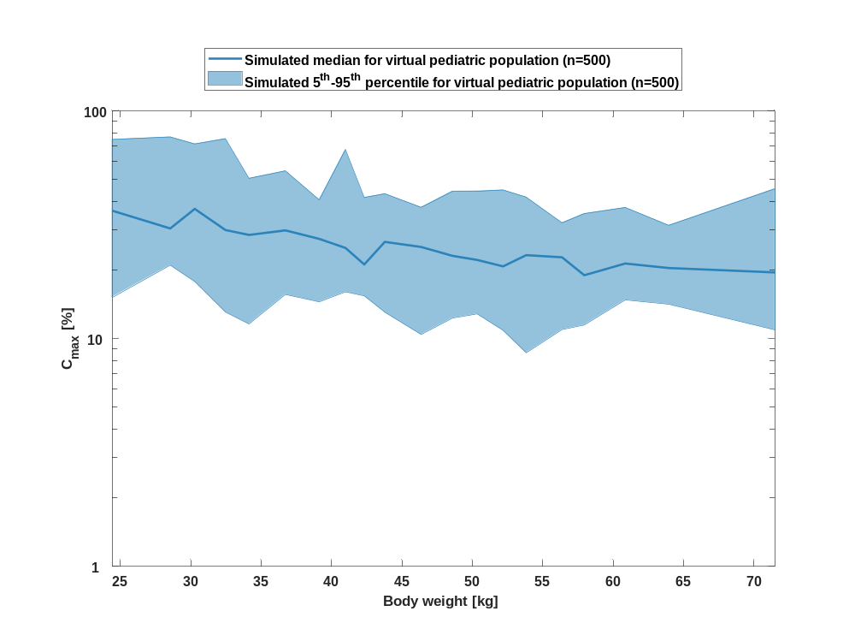

Table 1-40:body weight dependency of C_{max} Raltegravir for simulated virtual pediatric population as fraction of median of simulated Filmcoated_tablet_400mg_sd
Body weight [kg] | C_{max} [%]
Range of body weight | Median of body weight | 5th percentile | median | 95th percentile | N individuals
21-26.9 | 24.40 | 15.20 | 36.40 | 74.70 | 25
26.9-29.8 | 28.50 | 21 | 30.40 | 76.70 | 25
29.8-30.9 | 30.30 | 17.80 | 37 | 71.40 | 25
30.9-33.3 | 32.50 | 13.10 | 29.90 | 75.30 | 25
33.3-35.8 | 34.10 | 11.60 | 28.50 | 50.40 | 25
35.8-37.8 | 36.70 | 15.60 | 29.80 | 54.40 | 25
37.8-40.1 | 39.10 | 14.50 | 27.40 | 40.60 | 25
40.1-41.5 | 41 | 16 | 25 | 67.50 | 25
41.5-43.2 | 42.30 | 15.40 | 21.10 | 41.60 | 25
43.2-45.4 | 43.80 | 13 | 26.50 | 43.20 | 25
45.4-47.7 | 46.40 | 10.40 | 25.20 | 37.60 | 25
47.7-49.4 | 48.60 | 12.30 | 23.10 | 44.30 | 25
49.4-51 | 50.30 | 12.80 | 22.10 | 44.40 | 25
51-52.9 | 52.20 | 10.90 | 20.70 | 44.90 | 25
52.9-55.3 | 53.80 | 8.66 | 23.20 | 41.70 | 25
55.3-57.2 | 56.40 | 10.90 | 22.70 | 32.20 | 25
57.2-59.4 | 57.90 | 11.50 | 19 | 35.30 | 25
59.4-62.1 | 60.90 | 14.80 | 21.30 | 37.60 | 25
62.1-67.1 | 63.90 | 14.10 | 20.40 | 31.40 | 25
67.1-89 | 71.50 | 10.90 | 19.50 | 45.40 | 25

C_{max} norm

Figure 81: body weight dependency of C_{max} norm Raltegravir for simulated virtual pediatric population as fraction of median of simulated Filmcoated_tablet_400mg_sd in a linear scale.
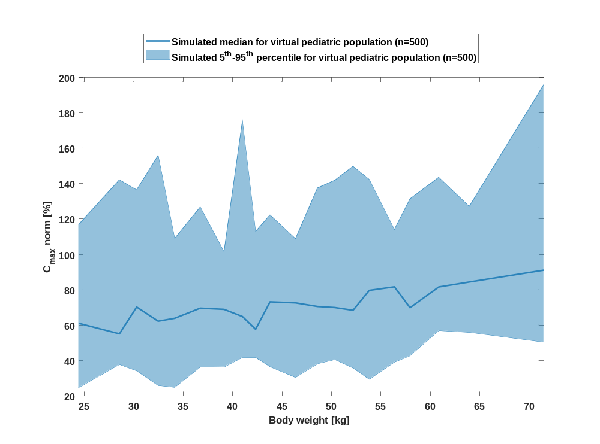

Figure 82: body weight dependency of C_{max} norm Raltegravir for simulated virtual pediatric population as fraction of median of simulated Filmcoated_tablet_400mg_sd in a logarithmic scale.
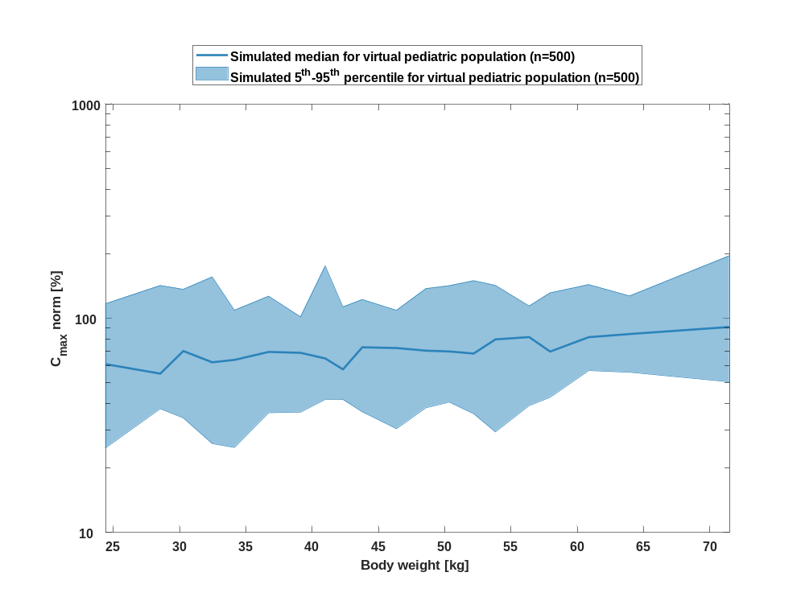

Table 1-41:body weight dependency of C_{max} norm Raltegravir for simulated virtual pediatric population as fraction of median of simulated Filmcoated_tablet_400mg_sd
Body weight [kg] | C_{max} norm [%]
Range of body weight | Median of body weight | 5th percentile | median | 95th percentile | N individuals
21-26.9 | 24.40 | 24.80 | 61.10 | 117 | 25
26.9-29.8 | 28.50 | 37.80 | 55.20 | 142 | 25
29.8-30.9 | 30.30 | 34.20 | 70.30 | 136 | 25
30.9-33.3 | 32.50 | 26 | 62.30 | 156 | 25
33.3-35.8 | 34.10 | 24.90 | 63.90 | 109 | 25
35.8-37.8 | 36.70 | 36.20 | 69.70 | 127 | 25
37.8-40.1 | 39.10 | 36.50 | 69 | 102 | 25
40.1-41.5 | 41 | 41.70 | 64.90 | 175 | 25
41.5-43.2 | 42.30 | 41.60 | 57.70 | 113 | 25
43.2-45.4 | 43.80 | 36.60 | 73.20 | 122 | 25
45.4-47.7 | 46.40 | 30.50 | 72.60 | 109 | 25
47.7-49.4 | 48.60 | 38.20 | 70.60 | 138 | 25
49.4-51 | 50.30 | 40.60 | 70 | 142 | 25
51-52.9 | 52.20 | 35.80 | 68.50 | 150 | 25
52.9-55.3 | 53.80 | 29.50 | 79.70 | 142 | 25
55.3-57.2 | 56.40 | 39.10 | 81.70 | 114 | 25
57.2-59.4 | 57.90 | 42.70 | 69.90 | 131 | 25
59.4-62.1 | 60.90 | 57 | 81.60 | 144 | 25
62.1-67.1 | 63.90 | 56 | 84.40 | 127 | 25
67.1-89 | 71.50 | 50.50 | 91.10 | 196 | 25

t_{max}

Figure 83: body weight dependency of t_{max} Raltegravir for simulated virtual pediatric population as fraction of median of simulated Filmcoated_tablet_400mg_sd in a linear scale.
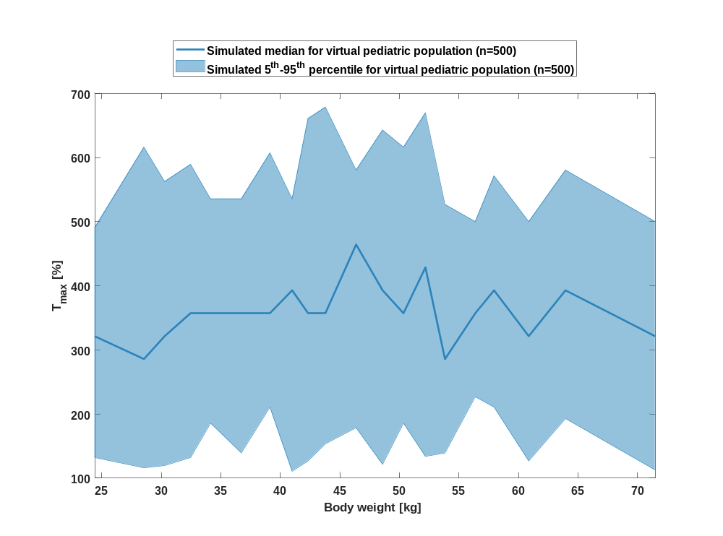

Figure 84: body weight dependency of t_{max} Raltegravir for simulated virtual pediatric population as fraction of median of simulated Filmcoated_tablet_400mg_sd in a logarithmic scale.
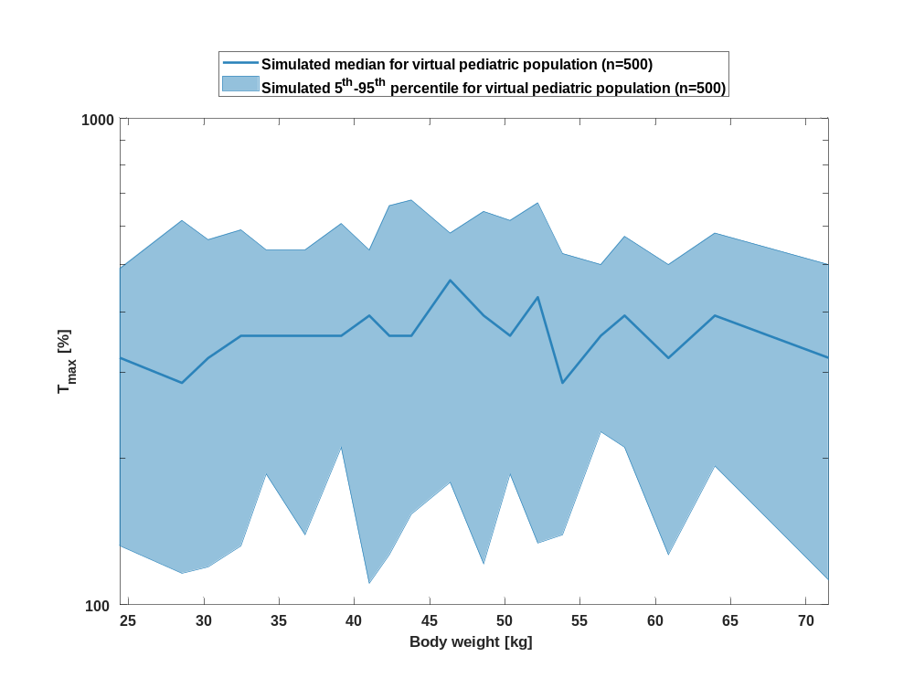

Table 1-42:body weight dependency of t_{max} Raltegravir for simulated virtual pediatric population as fraction of median of simulated Filmcoated_tablet_400mg_sd
Body weight [kg] | T_{max} [%]
Range of body weight | Median of body weight | 5th percentile | median | 95th percentile | N individuals
21-26.9 | 24.40 | 132 | 321 | 491 | 25
26.9-29.8 | 28.50 | 116 | 286 | 616 | 25
29.8-30.9 | 30.30 | 120 | 321 | 563 | 25
30.9-33.3 | 32.50 | 132 | 357 | 589 | 25
33.3-35.8 | 34.10 | 186 | 357 | 536 | 25
35.8-37.8 | 36.70 | 139 | 357 | 536 | 25
37.8-40.1 | 39.10 | 211 | 357 | 607 | 25
40.1-41.5 | 41 | 111 | 393 | 536 | 25
41.5-43.2 | 42.30 | 127 | 357 | 661 | 25
43.2-45.4 | 43.80 | 154 | 357 | 679 | 25
45.4-47.7 | 46.40 | 179 | 464 | 580 | 25
47.7-49.4 | 48.60 | 121 | 393 | 643 | 25
49.4-51 | 50.30 | 186 | 357 | 616 | 25
51-52.9 | 52.20 | 134 | 429 | 670 | 25
52.9-55.3 | 53.80 | 139 | 286 | 527 | 25
55.3-57.2 | 56.40 | 227 | 357 | 500 | 25
57.2-59.4 | 57.90 | 211 | 393 | 571 | 25
59.4-62.1 | 60.90 | 127 | 321 | 500 | 25
62.1-67.1 | 63.90 | 193 | 393 | 580 | 25
67.1-89 | 71.50 | 113 | 321 | 500 | 25

C_{tEnd}

Figure 85: body weight dependency of C_{tEnd} Raltegravir for simulated virtual pediatric population as fraction of median of simulated Filmcoated_tablet_400mg_sd in a linear scale.
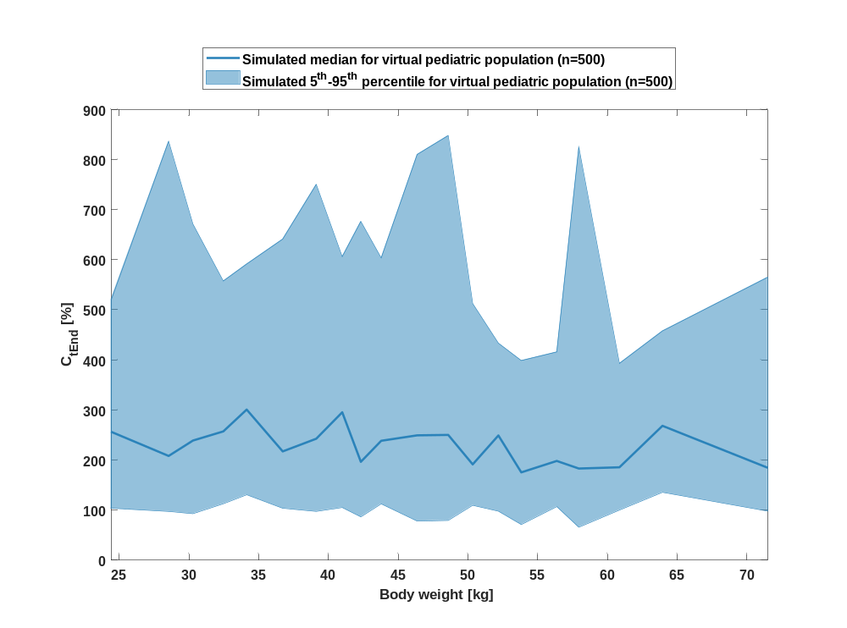

Figure 86: body weight dependency of C_{tEnd} Raltegravir for simulated virtual pediatric population as fraction of median of simulated Filmcoated_tablet_400mg_sd in a logarithmic scale.
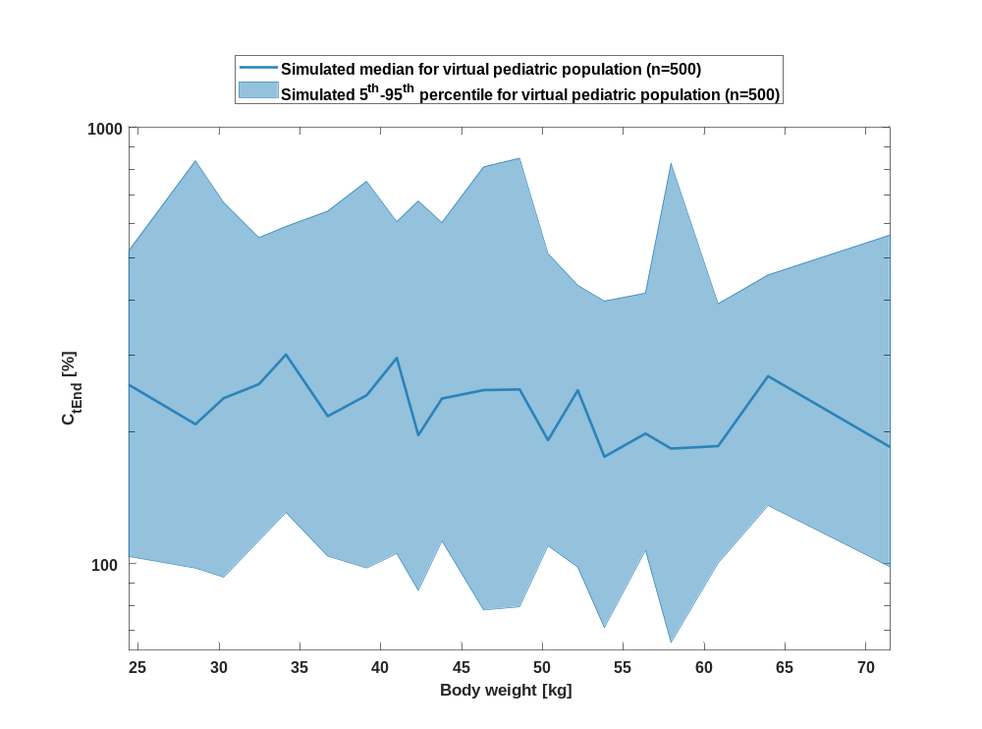

Table 1-43:body weight dependency of C_{tEnd} Raltegravir for simulated virtual pediatric population as fraction of median of simulated Filmcoated_tablet_400mg_sd
Body weight [kg] | C_{tEnd} [%]
Range of body weight | Median of body weight | 5th percentile | median | 95th percentile | N individuals
21-26.9 | 24.40 | 103 | 257 | 520 | 25
26.9-29.8 | 28.50 | 97.40 | 208 | 836 | 25
29.8-30.9 | 30.30 | 92.80 | 239 | 671 | 25
30.9-33.3 | 32.50 | 113 | 257 | 557 | 25
33.3-35.8 | 34.10 | 131 | 301 | 591 | 25
35.8-37.8 | 36.70 | 104 | 217 | 641 | 25
37.8-40.1 | 39.10 | 97.40 | 243 | 750 | 25
40.1-41.5 | 41 | 105 | 295 | 606 | 25
41.5-43.2 | 42.30 | 86.50 | 196 | 676 | 25
43.2-45.4 | 43.80 | 112 | 238 | 603 | 25
45.4-47.7 | 46.40 | 78.10 | 249 | 810 | 25
47.7-49.4 | 48.60 | 79.40 | 250 | 848 | 25
49.4-51 | 50.30 | 110 | 191 | 512 | 25
51-52.9 | 52.20 | 97.90 | 249 | 433 | 25
52.9-55.3 | 53.80 | 71.20 | 175 | 399 | 25
55.3-57.2 | 56.40 | 107 | 198 | 416 | 25
57.2-59.4 | 57.90 | 65.80 | 183 | 825 | 25
59.4-62.1 | 60.90 | 100 | 186 | 393 | 25
62.1-67.1 | 63.90 | 136 | 268 | 458 | 25
67.1-89 | 71.50 | 98 | 185 | 565 | 25

AUC_{last}

Figure 87: body weight dependency of AUC_{last} Raltegravir for simulated virtual pediatric population as fraction of median of simulated Filmcoated_tablet_400mg_sd in a linear scale.
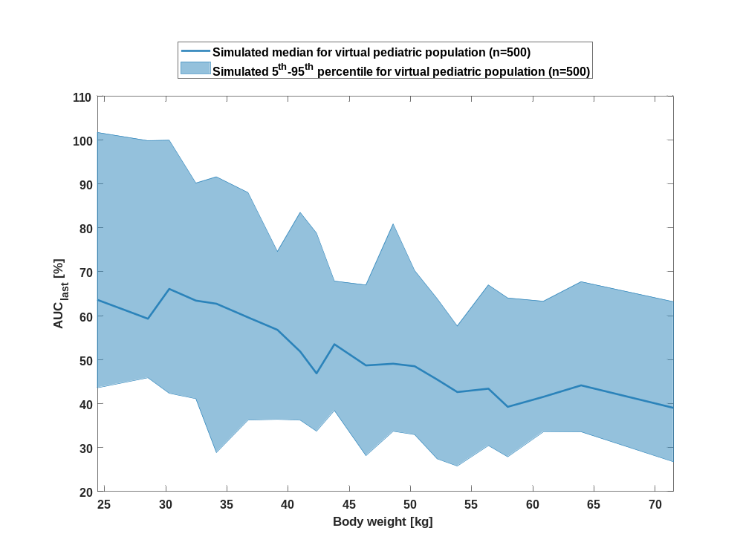

Figure 88: body weight dependency of AUC_{last} Raltegravir for simulated virtual pediatric population as fraction of median of simulated Filmcoated_tablet_400mg_sd in a logarithmic scale.
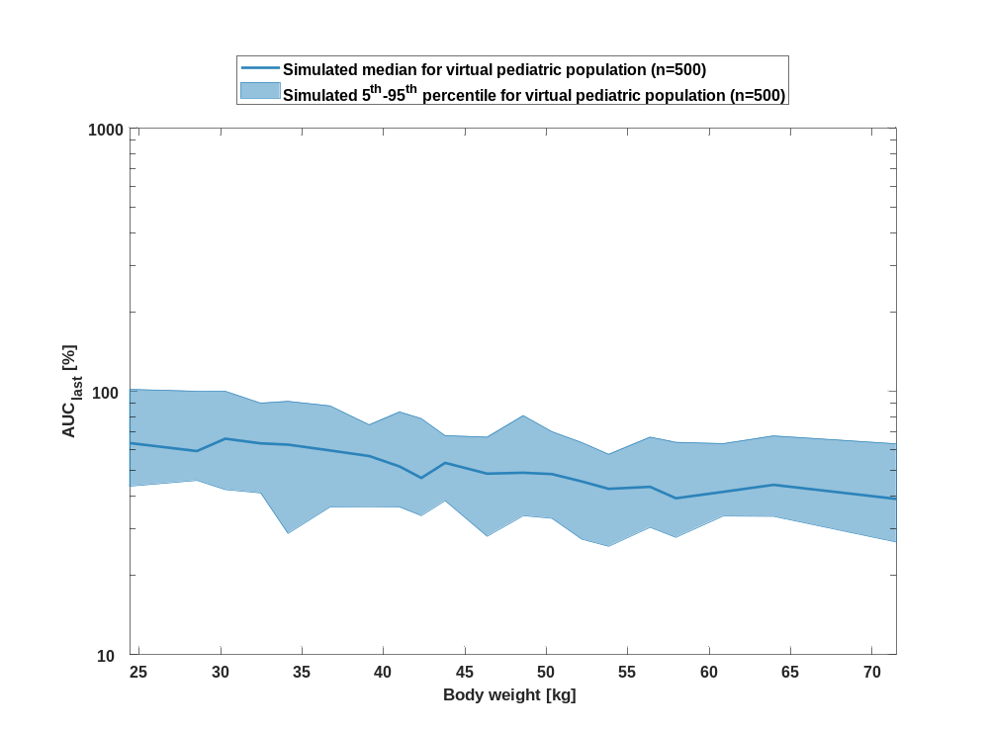

Table 1-44:body weight dependency of AUC_{last} Raltegravir for simulated virtual pediatric population as fraction of median of simulated Filmcoated_tablet_400mg_sd
Body weight [kg] | AUC_{last} [%]
Range of body weight | Median of body weight | 5th percentile | median | 95th percentile | N individuals
21-26.9 | 24.40 | 43.60 | 63.60 | 102 | 25
26.9-29.8 | 28.50 | 45.90 | 59.30 | 99.80 | 25
29.8-30.9 | 30.30 | 42.30 | 66.10 | 99.90 | 25
30.9-33.3 | 32.50 | 41.10 | 63.40 | 90.20 | 25
33.3-35.8 | 34.10 | 28.90 | 62.70 | 91.60 | 25
35.8-37.8 | 36.70 | 36.30 | 59.60 | 88 | 25
37.8-40.1 | 39.10 | 36.40 | 56.80 | 74.60 | 25
40.1-41.5 | 41 | 36.20 | 51.80 | 83.50 | 25
41.5-43.2 | 42.30 | 33.70 | 46.90 | 78.80 | 25
43.2-45.4 | 43.80 | 38.40 | 53.50 | 67.90 | 25
45.4-47.7 | 46.40 | 28.20 | 48.70 | 67 | 25
47.7-49.4 | 48.60 | 33.70 | 49.10 | 80.90 | 25
49.4-51 | 50.30 | 32.90 | 48.50 | 70.30 | 25
51-52.9 | 52.20 | 27.40 | 45.50 | 63.90 | 25
52.9-55.3 | 53.80 | 25.80 | 42.60 | 57.70 | 25
55.3-57.2 | 56.40 | 30.50 | 43.40 | 67 | 25
57.2-59.4 | 57.90 | 27.90 | 39.30 | 64 | 25
59.4-62.1 | 60.90 | 33.60 | 41.50 | 63.30 | 25
62.1-67.1 | 63.90 | 33.50 | 44.20 | 67.70 | 25
67.1-89 | 71.50 | 26.80 | 39 | 63.20 | 25

AUC_{last} norm

Figure 89: body weight dependency of AUC_{last} norm Raltegravir for simulated virtual pediatric population as fraction of median of simulated Filmcoated_tablet_400mg_sd in a linear scale.
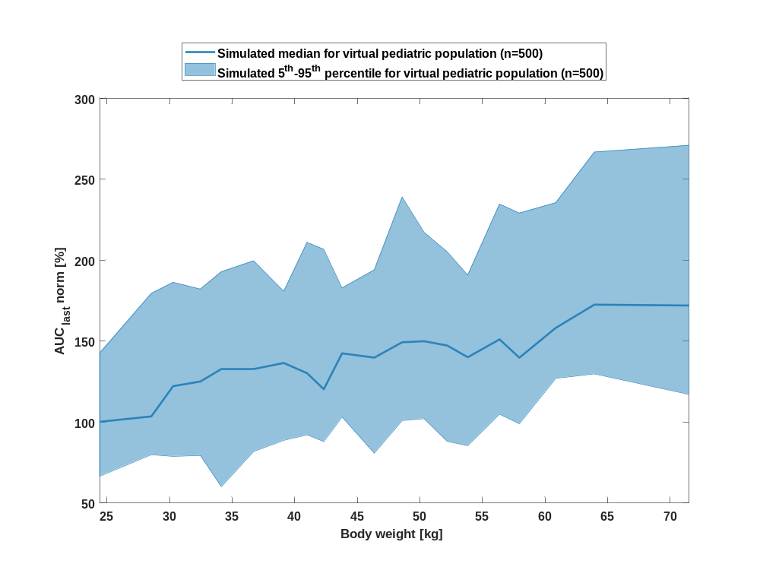

Figure 90: body weight dependency of AUC_{last} norm Raltegravir for simulated virtual pediatric population as fraction of median of simulated Filmcoated_tablet_400mg_sd in a logarithmic scale.
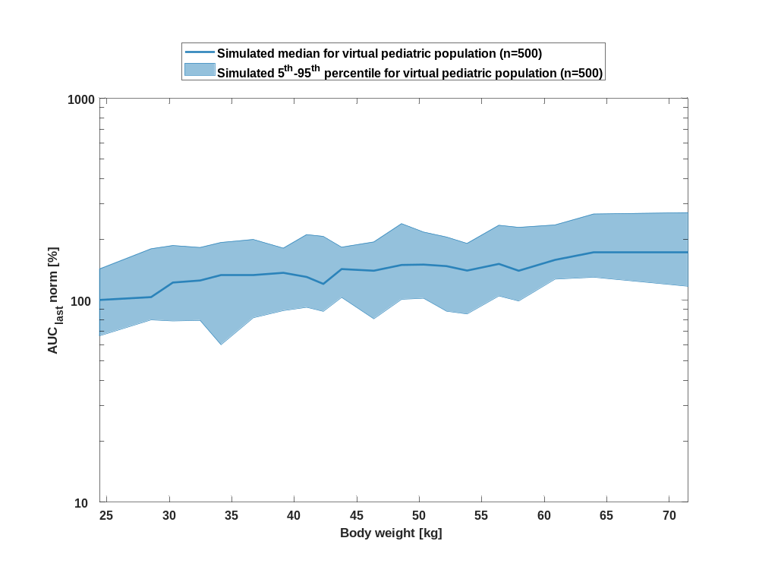

Table 1-45:body weight dependency of AUC_{last} norm Raltegravir for simulated virtual pediatric population as fraction of median of simulated Filmcoated_tablet_400mg_sd
Body weight [kg] | AUC_{last} norm [%]
Range of body weight | Median of body weight | 5th percentile | median | 95th percentile | N individuals
21-26.9 | 24.40 | 66.60 | 100 | 143 | 25
26.9-29.8 | 28.50 | 79.90 | 104 | 179 | 25
29.8-30.9 | 30.30 | 78.90 | 122 | 186 | 25
30.9-33.3 | 32.50 | 79.40 | 125 | 182 | 25
33.3-35.8 | 34.10 | 60.10 | 133 | 193 | 25
35.8-37.8 | 36.70 | 81.80 | 133 | 200 | 25
37.8-40.1 | 39.10 | 88.80 | 137 | 181 | 25
40.1-41.5 | 41 | 92.20 | 130 | 211 | 25
41.5-43.2 | 42.30 | 88 | 120 | 207 | 25
43.2-45.4 | 43.80 | 103 | 142 | 183 | 25
45.4-47.7 | 46.40 | 80.80 | 140 | 194 | 25
47.7-49.4 | 48.60 | 101 | 149 | 239 | 25
49.4-51 | 50.30 | 102 | 150 | 217 | 25
51-52.9 | 52.20 | 88.10 | 147 | 205 | 25
52.9-55.3 | 53.80 | 85.40 | 140 | 191 | 25
55.3-57.2 | 56.40 | 105 | 151 | 235 | 25
57.2-59.4 | 57.90 | 99 | 140 | 229 | 25
59.4-62.1 | 60.90 | 127 | 158 | 236 | 25
62.1-67.1 | 63.90 | 130 | 173 | 267 | 25
67.1-89 | 71.50 | 117 | 172 | 271 | 25

AUC_{inf}

Figure 91: body weight dependency of AUC_{inf} Raltegravir for simulated virtual pediatric population as fraction of median of simulated Filmcoated_tablet_400mg_sd in a linear scale.
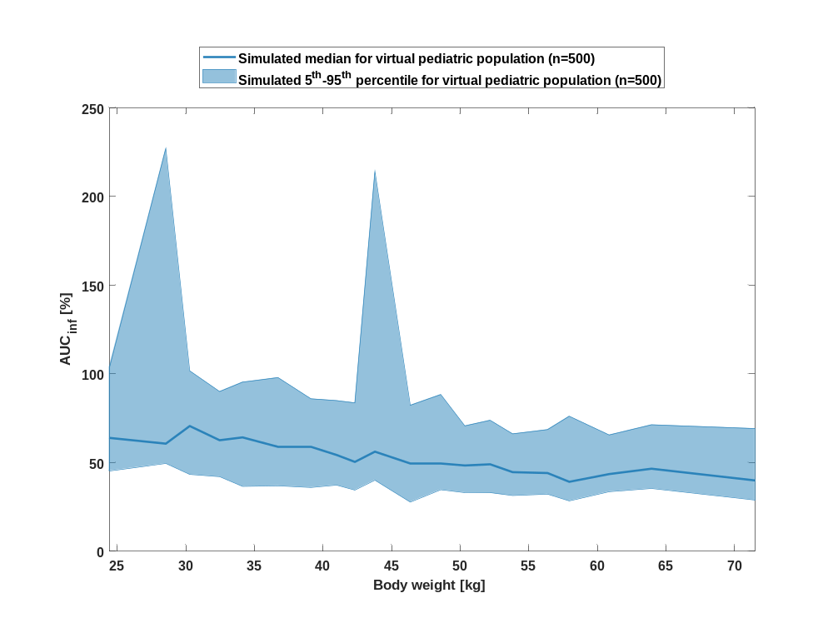

Figure 92: body weight dependency of AUC_{inf} Raltegravir for simulated virtual pediatric population as fraction of median of simulated Filmcoated_tablet_400mg_sd in a logarithmic scale.
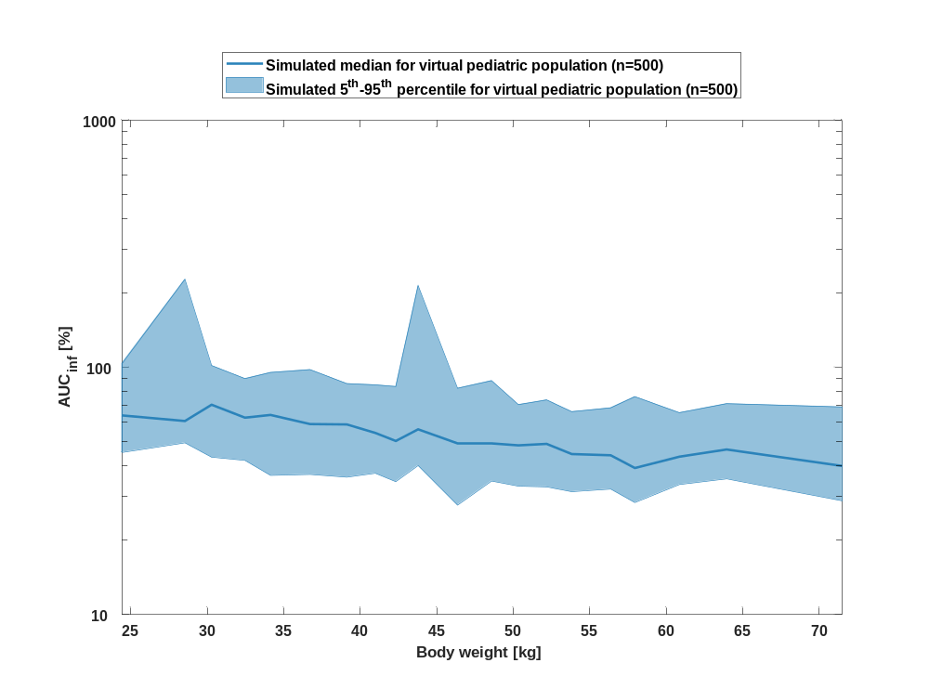

Table 1-46:body weight dependency of AUC_{inf} Raltegravir for simulated virtual pediatric population as fraction of median of simulated Filmcoated_tablet_400mg_sd
Body weight [kg] | AUC_{inf} [%]
Range of body weight | Median of body weight | 5th percentile | median | 95th percentile | N individuals
21-26.9 | 24.40 | 45.30 | 63.90 | 104 | 25
26.9-29.8 | 28.50 | 49.50 | 60.70 | 227 | 25
29.8-30.9 | 30.30 | 43.30 | 70.60 | 102 | 25
30.9-33.3 | 32.50 | 42 | 62.60 | 90 | 25
33.3-35.8 | 34.10 | 36.60 | 64.20 | 95.30 | 25
35.8-37.8 | 36.70 | 36.90 | 59 | 97.90 | 25
37.8-40.1 | 39.10 | 36 | 58.80 | 85.90 | 25
40.1-41.5 | 41 | 37.30 | 54.30 | 84.90 | 25
41.5-43.2 | 42.30 | 34.50 | 50.40 | 83.60 | 25
43.2-45.4 | 43.80 | 40.10 | 56.10 | 214 | 25
45.4-47.7 | 46.40 | 27.70 | 49.40 | 82.30 | 25
47.7-49.4 | 48.60 | 34.70 | 49.40 | 88.30 | 25
49.4-51 | 50.30 | 33.10 | 48.40 | 70.70 | 25
51-52.9 | 52.20 | 32.80 | 49 | 73.80 | 25
52.9-55.3 | 53.80 | 31.40 | 44.60 | 66.20 | 25
55.3-57.2 | 56.40 | 32.20 | 44.10 | 68.60 | 25
57.2-59.4 | 57.90 | 28.40 | 39.20 | 76.10 | 25
59.4-62.1 | 60.90 | 33.60 | 43.50 | 65.50 | 25
62.1-67.1 | 63.90 | 35.40 | 46.50 | 71.30 | 25
67.1-89 | 71.50 | 28.90 | 39.90 | 69.10 | 25

AUC_{inf} norm

Figure 93: body weight dependency of AUC_{inf} norm Raltegravir for simulated virtual pediatric population as fraction of median of simulated Filmcoated_tablet_400mg_sd in a linear scale.
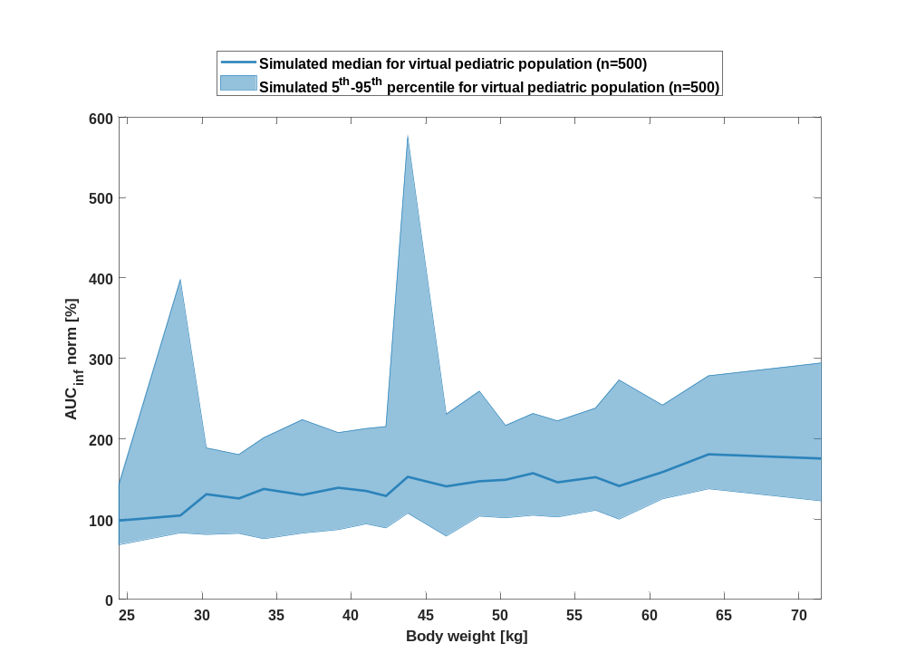

Figure 94: body weight dependency of AUC_{inf} norm Raltegravir for simulated virtual pediatric population as fraction of median of simulated Filmcoated_tablet_400mg_sd in a logarithmic scale.
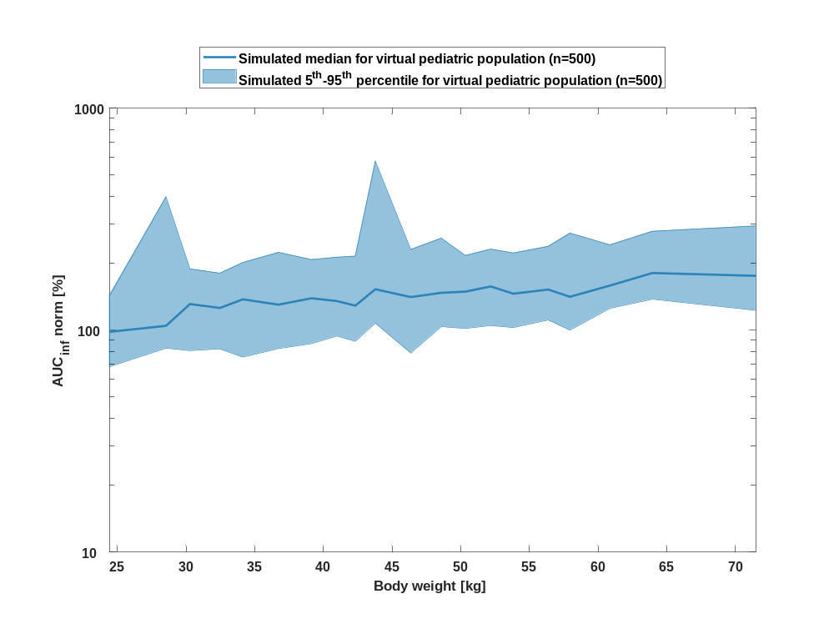

Table 1-47:body weight dependency of AUC_{inf} norm Raltegravir for simulated virtual pediatric population as fraction of median of simulated Filmcoated_tablet_400mg_sd
Body weight [kg] | AUC_{inf} norm [%]
Range of body weight | Median of body weight | 5th percentile | median | 95th percentile | N individuals
21-26.9 | 24.40 | 68.20 | 98.10 | 143 | 25
26.9-29.8 | 28.50 | 82.80 | 104 | 398 | 25
29.8-30.9 | 30.30 | 80.80 | 131 | 188 | 25
30.9-33.3 | 32.50 | 82.20 | 126 | 180 | 25
33.3-35.8 | 34.10 | 75.50 | 137 | 201 | 25
35.8-37.8 | 36.70 | 82.50 | 130 | 224 | 25
37.8-40.1 | 39.10 | 86.80 | 139 | 207 | 25
40.1-41.5 | 41 | 94 | 135 | 213 | 25
41.5-43.2 | 42.30 | 89 | 129 | 215 | 25
43.2-45.4 | 43.80 | 107 | 153 | 576 | 25
45.4-47.7 | 46.40 | 78.80 | 141 | 230 | 25
47.7-49.4 | 48.60 | 104 | 147 | 259 | 25
49.4-51 | 50.30 | 102 | 149 | 216 | 25
51-52.9 | 52.20 | 105 | 157 | 231 | 25
52.9-55.3 | 53.80 | 103 | 146 | 222 | 25
55.3-57.2 | 56.40 | 111 | 152 | 238 | 25
57.2-59.4 | 57.90 | 99.80 | 141 | 273 | 25
59.4-62.1 | 60.90 | 125 | 158 | 242 | 25
62.1-67.1 | 63.90 | 138 | 181 | 278 | 25
67.1-89 | 71.50 | 123 | 175 | 294 | 25

MRT

Figure 95: body weight dependency of MRT Raltegravir for simulated virtual pediatric population as fraction of median of simulated Filmcoated_tablet_400mg_sd in a linear scale.
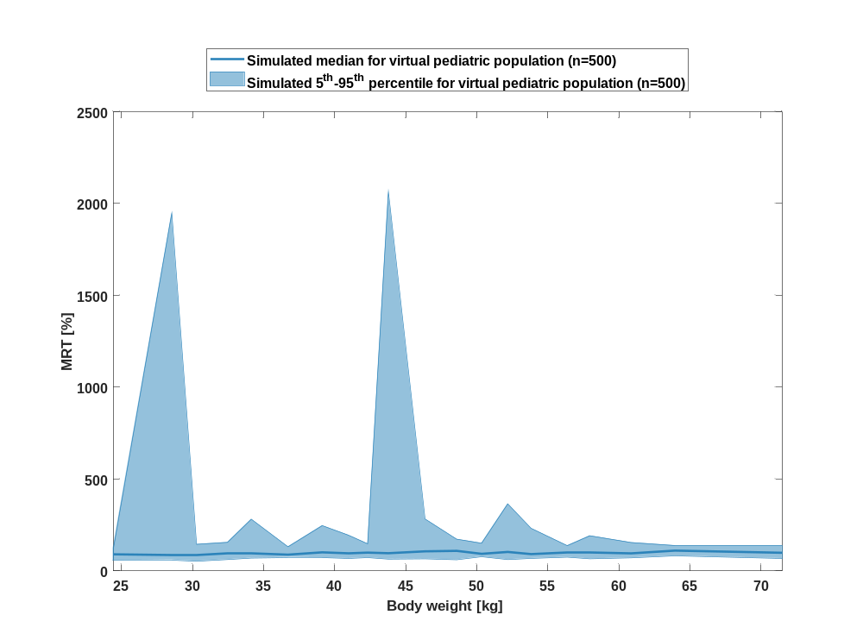

Figure 96: body weight dependency of MRT Raltegravir for simulated virtual pediatric population as fraction of median of simulated Filmcoated_tablet_400mg_sd in a logarithmic scale.
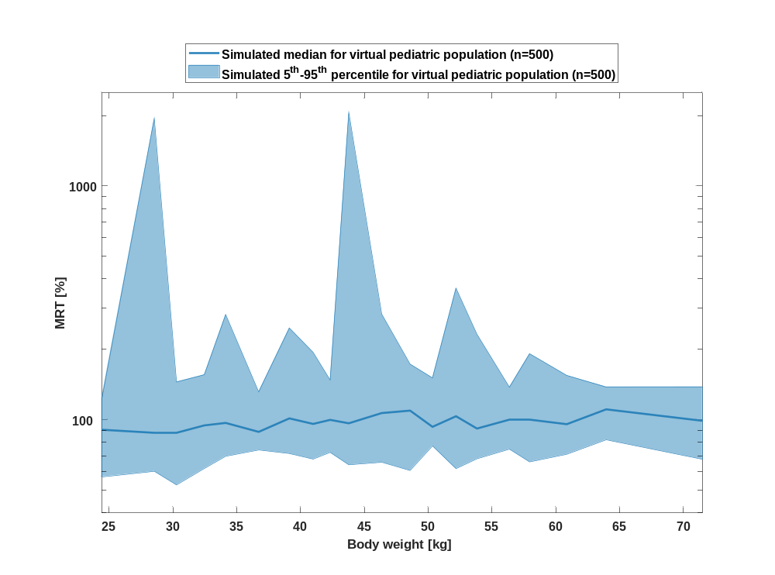

Table 1-48:body weight dependency of MRT Raltegravir for simulated virtual pediatric population as fraction of median of simulated Filmcoated_tablet_400mg_sd
Body weight [kg] | MRT [%]
Range of body weight | Median of body weight | 5th percentile | median | 95th percentile | N individuals
21-26.9 | 24.40 | 56.80 | 90.40 | 123 | 25
26.9-29.8 | 28.50 | 60 | 88 | 1950 | 25
29.8-30.9 | 30.30 | 52.50 | 87.60 | 145 | 25
30.9-33.3 | 32.50 | 61.70 | 94.40 | 155 | 25
33.3-35.8 | 34.10 | 69.60 | 96.70 | 281 | 25
35.8-37.8 | 36.70 | 74 | 88.50 | 131 | 25
37.8-40.1 | 39.10 | 71.50 | 101 | 247 | 25
40.1-41.5 | 41 | 67.70 | 95.70 | 194 | 25
41.5-43.2 | 42.30 | 72.30 | 99.60 | 148 | 25
43.2-45.4 | 43.80 | 64 | 96.30 | 2060 | 25
45.4-47.7 | 46.40 | 65.60 | 107 | 283 | 25
47.7-49.4 | 48.60 | 60.50 | 109 | 173 | 25
49.4-51 | 50.30 | 77.10 | 93 | 151 | 25
51-52.9 | 52.20 | 61.60 | 103 | 365 | 25
52.9-55.3 | 53.80 | 67.90 | 91.50 | 232 | 25
55.3-57.2 | 56.40 | 74.60 | 99.70 | 138 | 25
57.2-59.4 | 57.90 | 65.80 | 99.60 | 191 | 25
59.4-62.1 | 60.90 | 71 | 95.50 | 154 | 25
62.1-67.1 | 63.90 | 81.90 | 111 | 138 | 25
67.1-89 | 71.50 | 67.50 | 98.80 | 138 | 25

Thalf

Figure 97: body weight dependency of Thalf Raltegravir for simulated virtual pediatric population as fraction of median of simulated Filmcoated_tablet_400mg_sd in a linear scale.
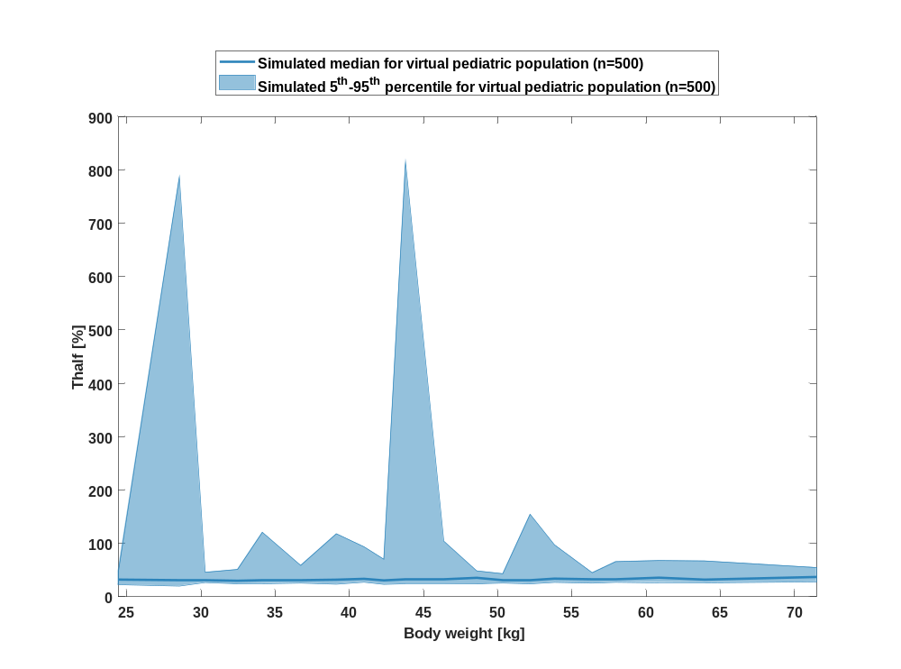

Figure 98: body weight dependency of Thalf Raltegravir for simulated virtual pediatric population as fraction of median of simulated Filmcoated_tablet_400mg_sd in a logarithmic scale.
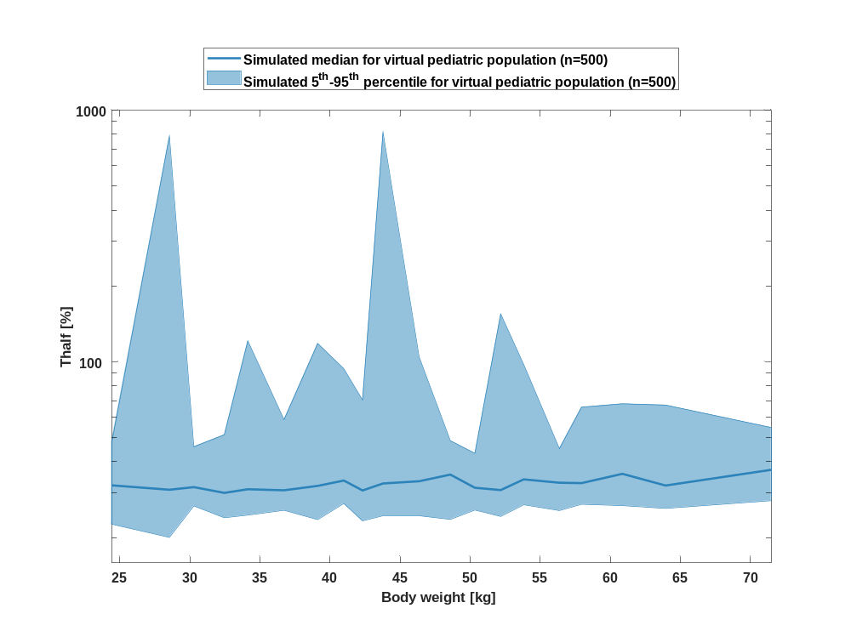

Table 1-49:body weight dependency of Thalf Raltegravir for simulated virtual pediatric population as fraction of median of simulated Filmcoated_tablet_400mg_sd
Body weight [kg] | Thalf [%]
Range of body weight | Median of body weight | 5th percentile | median | 95th percentile | N individuals
21-26.9 | 24.40 | 22.60 | 32.20 | 47.90 | 25
26.9-29.8 | 28.50 | 20 | 31 | 787 | 25
29.8-30.9 | 30.30 | 26.70 | 31.70 | 45.90 | 25
30.9-33.3 | 32.50 | 24 | 30.10 | 51.20 | 25
33.3-35.8 | 34.10 | 24.50 | 31.10 | 121 | 25
35.8-37.8 | 36.70 | 25.60 | 30.80 | 58.80 | 25
37.8-40.1 | 39.10 | 23.50 | 32.10 | 118 | 25
40.1-41.5 | 41 | 27.30 | 33.70 | 93.70 | 25
41.5-43.2 | 42.30 | 23.30 | 30.70 | 70.40 | 25
43.2-45.4 | 43.80 | 24.40 | 32.80 | 815 | 25
45.4-47.7 | 46.40 | 24.30 | 33.50 | 104 | 25
47.7-49.4 | 48.60 | 23.60 | 35.60 | 48.50 | 25
49.4-51 | 50.30 | 25.70 | 31.50 | 43.20 | 25
51-52.9 | 52.20 | 24.20 | 30.90 | 155 | 25
52.9-55.3 | 53.80 | 27 | 34 | 97.30 | 25
55.3-57.2 | 56.40 | 25.60 | 33 | 45.10 | 25
57.2-59.4 | 57.90 | 27.10 | 32.90 | 65.90 | 25
59.4-62.1 | 60.90 | 26.80 | 35.80 | 67.90 | 25
62.1-67.1 | 63.90 | 26.10 | 32.20 | 67.20 | 25
67.1-89 | 71.50 | 28 | 37.10 | 54.70 | 25

CL

Figure 99: body weight dependency of CL Raltegravir for simulated virtual pediatric population as fraction of median of simulated Filmcoated_tablet_400mg_sd in a linear scale.
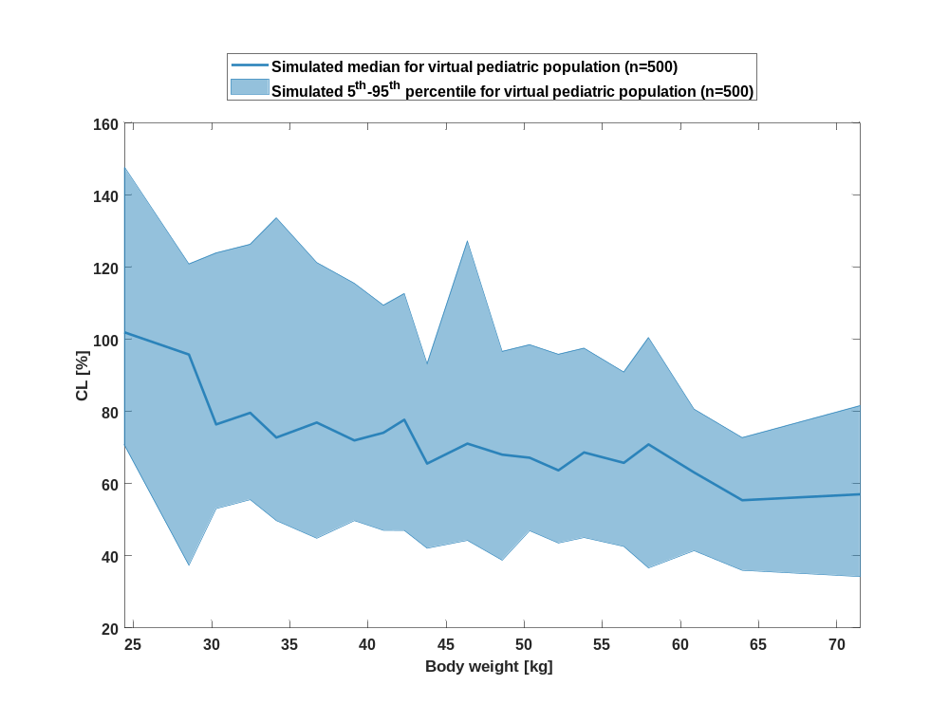

Figure 100: body weight dependency of CL Raltegravir for simulated virtual pediatric population as fraction of median of simulated Filmcoated_tablet_400mg_sd in a logarithmic scale.
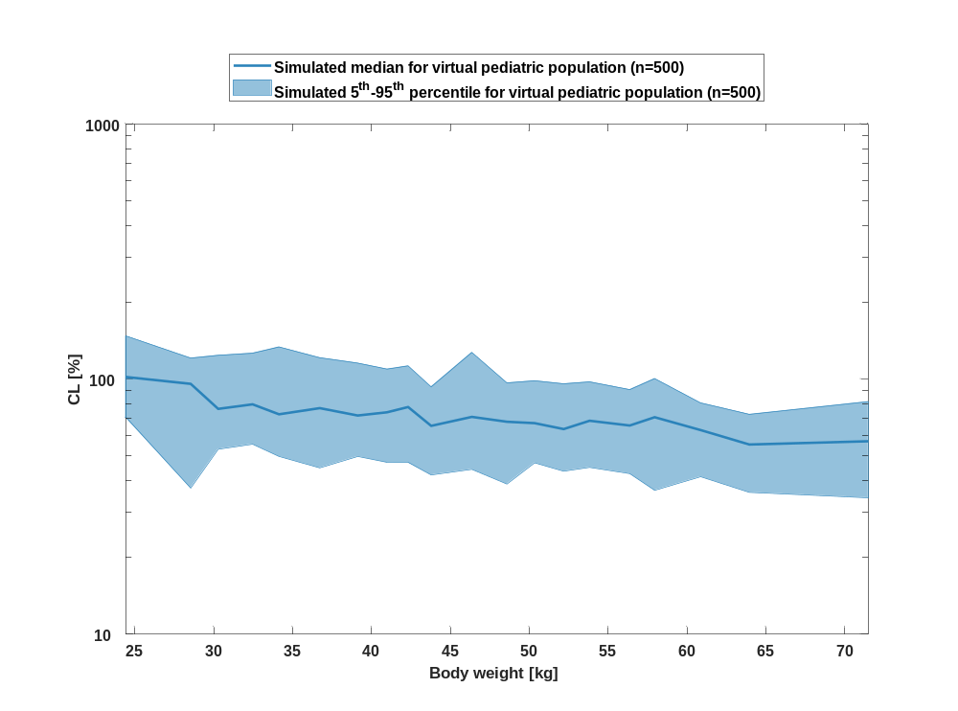

Table 1-50:body weight dependency of CL Raltegravir for simulated virtual pediatric population as fraction of median of simulated Filmcoated_tablet_400mg_sd
Body weight [kg] | CL [%]
Range of body weight | Median of body weight | 5th percentile | median | 95th percentile | N individuals
21-26.9 | 24.40 | 70.60 | 102 | 148 | 25
26.9-29.8 | 28.50 | 37.40 | 95.80 | 121 | 25
29.8-30.9 | 30.30 | 53.10 | 76.40 | 124 | 25
30.9-33.3 | 32.50 | 55.60 | 79.60 | 126 | 25
33.3-35.8 | 34.10 | 49.70 | 72.80 | 134 | 25
35.8-37.8 | 36.70 | 44.90 | 76.90 | 121 | 25
37.8-40.1 | 39.10 | 49.70 | 72 | 115 | 25
40.1-41.5 | 41 | 47.10 | 74.10 | 109 | 25
41.5-43.2 | 42.30 | 47 | 77.70 | 113 | 25
43.2-45.4 | 43.80 | 42.10 | 65.60 | 93.20 | 25
45.4-47.7 | 46.40 | 44.30 | 71.10 | 127 | 25
47.7-49.4 | 48.60 | 38.80 | 68 | 96.60 | 25
49.4-51 | 50.30 | 46.90 | 67.20 | 98.50 | 25
51-52.9 | 52.20 | 43.50 | 63.70 | 95.80 | 25
52.9-55.3 | 53.80 | 45.10 | 68.60 | 97.50 | 25
55.3-57.2 | 56.40 | 42.60 | 65.80 | 90.90 | 25
57.2-59.4 | 57.90 | 36.60 | 70.90 | 100 | 25
59.4-62.1 | 60.90 | 41.40 | 63.10 | 80.60 | 25
62.1-67.1 | 63.90 | 36 | 55.40 | 72.70 | 25
67.1-89 | 71.50 | 34.20 | 57 | 81.60 | 25

Vss

Figure 101: body weight dependency of Vss Raltegravir for simulated virtual pediatric population as fraction of median of simulated Filmcoated_tablet_400mg_sd in a linear scale.
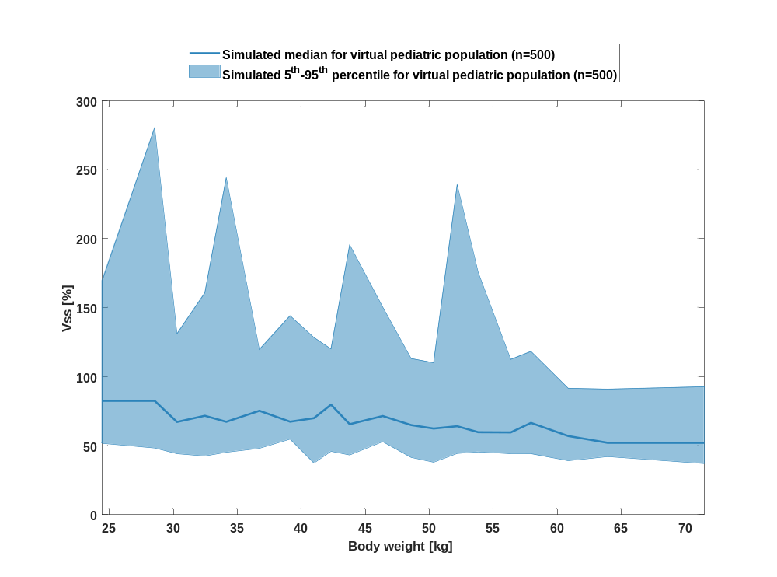

Figure 102: body weight dependency of Vss Raltegravir for simulated virtual pediatric population as fraction of median of simulated Filmcoated_tablet_400mg_sd in a logarithmic scale.
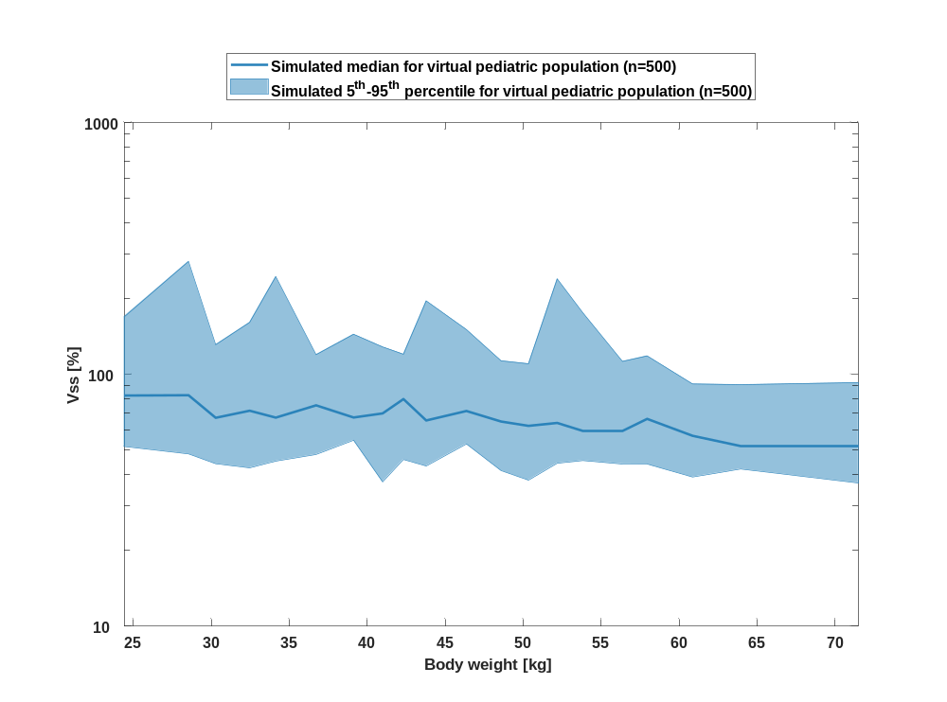

Table 1-51:body weight dependency of Vss Raltegravir for simulated virtual pediatric population as fraction of median of simulated Filmcoated_tablet_400mg_sd
Body weight [kg] | Vss [%]
Range of body weight | Median of body weight | 5th percentile | median | 95th percentile | N individuals
21-26.9 | 24.40 | 51.60 | 82.30 | 169 | 25
26.9-29.8 | 28.50 | 48.30 | 82.60 | 280 | 25
29.8-30.9 | 30.30 | 44.10 | 67.20 | 131 | 25
30.9-33.3 | 32.50 | 42.50 | 71.70 | 161 | 25
33.3-35.8 | 34.10 | 45.20 | 67.30 | 244 | 25
35.8-37.8 | 36.70 | 48 | 75.30 | 120 | 25
37.8-40.1 | 39.10 | 54.70 | 67.40 | 144 | 25
40.1-41.5 | 41 | 37.40 | 69.90 | 128 | 25
41.5-43.2 | 42.30 | 45.90 | 79.70 | 120 | 25
43.2-45.4 | 43.80 | 43.20 | 65.50 | 196 | 25
45.4-47.7 | 46.40 | 52.90 | 71.50 | 150 | 25
47.7-49.4 | 48.60 | 41.40 | 64.90 | 113 | 25
49.4-51 | 50.30 | 38 | 62.40 | 110 | 25
51-52.9 | 52.20 | 44.30 | 64.10 | 239 | 25
52.9-55.3 | 53.80 | 45.40 | 59.70 | 175 | 25
55.3-57.2 | 56.40 | 44.10 | 59.60 | 112 | 25
57.2-59.4 | 57.90 | 44 | 66.50 | 118 | 25
59.4-62.1 | 60.90 | 39.10 | 57 | 91.50 | 25
62.1-67.1 | 63.90 | 42.10 | 52 | 90.90 | 25
67.1-89 | 71.50 | 37 | 51.90 | 92.70 | 25

Vd

Figure 103: body weight dependency of Vd Raltegravir for simulated virtual pediatric population as fraction of median of simulated Filmcoated_tablet_400mg_sd in a linear scale.
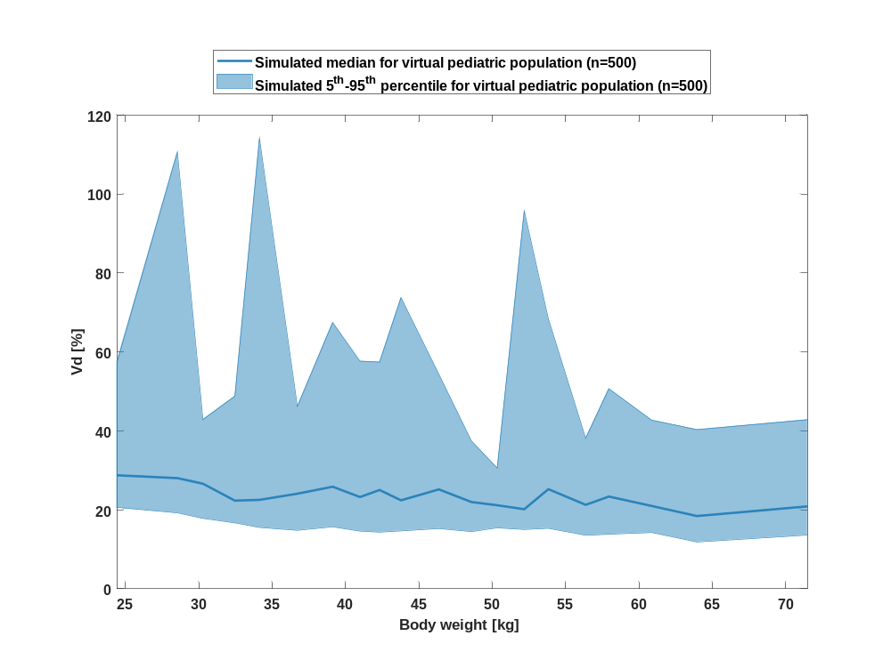

Figure 104: body weight dependency of Vd Raltegravir for simulated virtual pediatric population as fraction of median of simulated Filmcoated_tablet_400mg_sd in a logarithmic scale.
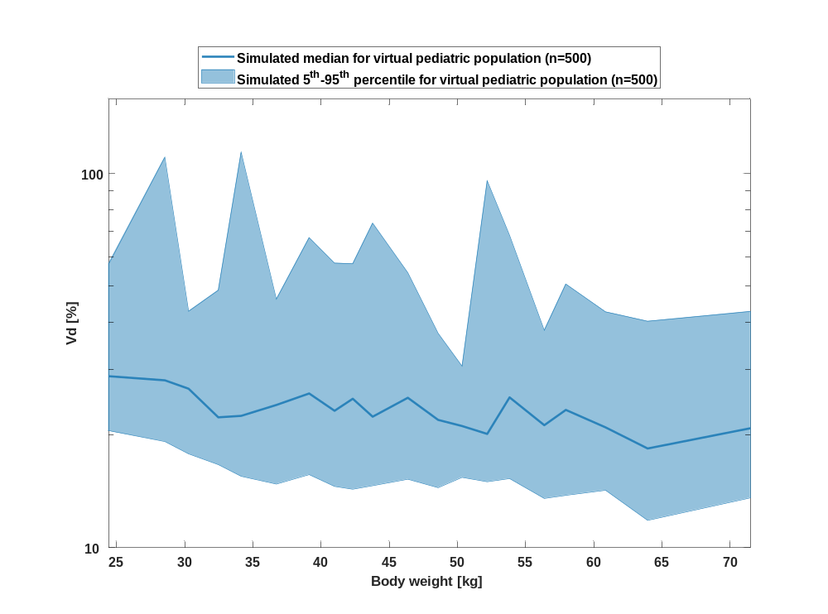

Table 1-52:body weight dependency of Vd Raltegravir for simulated virtual pediatric population as fraction of median of simulated Filmcoated_tablet_400mg_sd
Body weight [kg] | Vd [%]
Range of body weight | Median of body weight | 5th percentile | median | 95th percentile | N individuals
21-26.9 | 24.40 | 20.50 | 28.70 | 57.40 | 25
26.9-29.8 | 28.50 | 19.20 | 28 | 111 | 25
29.8-30.9 | 30.30 | 17.80 | 26.60 | 42.90 | 25
30.9-33.3 | 32.50 | 16.70 | 22.30 | 48.80 | 25
33.3-35.8 | 34.10 | 15.50 | 22.50 | 114 | 25
35.8-37.8 | 36.70 | 14.80 | 24.10 | 46.20 | 25
37.8-40.1 | 39.10 | 15.70 | 25.80 | 67.40 | 25
40.1-41.5 | 41 | 14.60 | 23.20 | 57.70 | 25
41.5-43.2 | 42.30 | 14.30 | 25 | 57.40 | 25
43.2-45.4 | 43.80 | 14.60 | 22.40 | 73.70 | 25
45.4-47.7 | 46.40 | 15.20 | 25.20 | 54.30 | 25
47.7-49.4 | 48.60 | 14.50 | 22 | 37.40 | 25
49.4-51 | 50.30 | 15.40 | 21.10 | 30.60 | 25
51-52.9 | 52.20 | 15 | 20.10 | 95.70 | 25
52.9-55.3 | 53.80 | 15.30 | 25.20 | 68.40 | 25
55.3-57.2 | 56.40 | 13.50 | 21.30 | 38.10 | 25
57.2-59.4 | 57.90 | 13.80 | 23.40 | 50.70 | 25
59.4-62.1 | 60.90 | 14.20 | 21 | 42.70 | 25
62.1-67.1 | 63.90 | 11.80 | 18.40 | 40.30 | 25
67.1-89 | 71.50 | 13.60 | 20.90 | 42.80 | 25

PK parameter of Raltegravir

C_{max}

Figure 105: C_{max} of Raltegravir shown as box whisker plot, which indicate the 5th, 25th, 50th, 75th, and 95th percentiles in a linear scale.
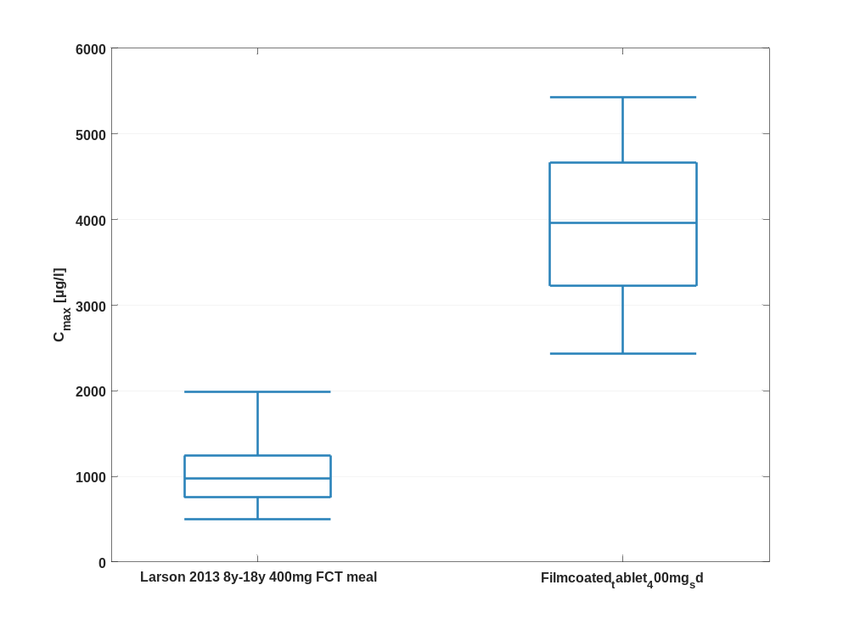

Figure 106: C_{max} of Raltegravir shown as box whisker plot, which indicate the 5th, 25th, 50th, 75th, and 95th percentiles in a logarithmic scale.
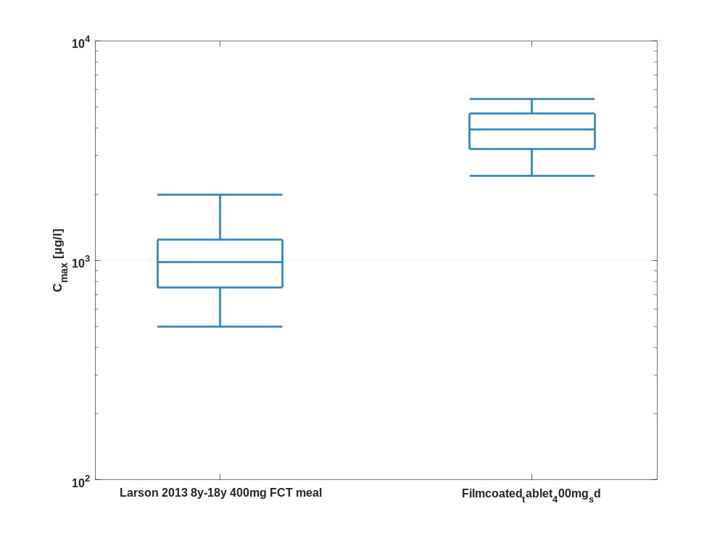

Table 1-53:Percentile of C_{max} of Raltegravir.
C_{max} [µg/l]
 | 5th prctl. | 25th prctl. | 50th prctl. | 75th prctl. | 95th prctl. | arith. mean | std | geo. mean | geo. CV
Larson 2013 8y-18y 400mg FCT meal | 497.77 | 753.26 | 979.74 | 1243.07 | 1987.41 | 1075.70 | 510.35 | 981.60 | 0.44
Filmcoated_tablet_400mg_sd | 2436.15 | 3222.34 | 3954.54 | 4665.16 | 5427.50 | 3940.92 | 908.89 | 3833.70 | 0.24

C_{max} norm

Figure 107: C_{max} norm of Raltegravir shown as box whisker plot, which indicate the 5th, 25th, 50th, 75th, and 95th percentiles in a linear scale.
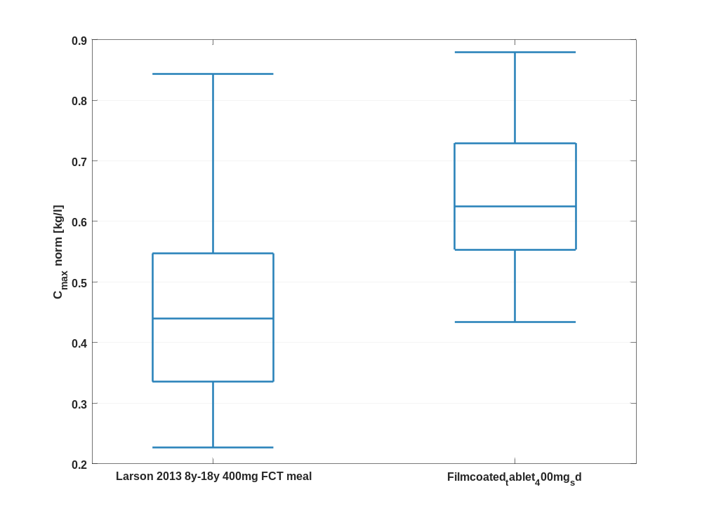

Figure 108: C_{max} norm of Raltegravir shown as box whisker plot, which indicate the 5th, 25th, 50th, 75th, and 95th percentiles in a logarithmic scale.
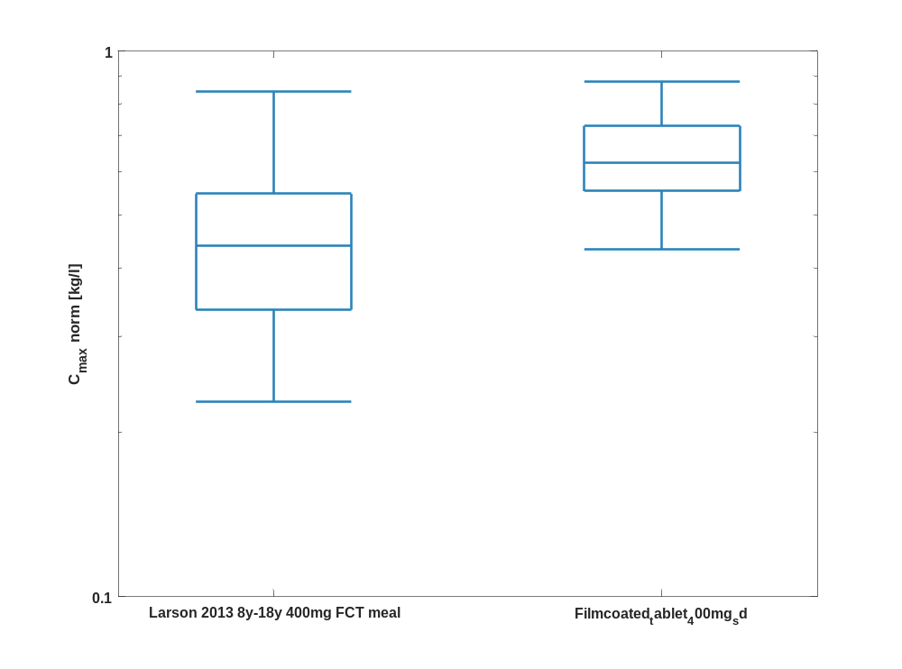

Table 1-54:Percentile of C_{max} norm of Raltegravir.
C_{max} norm [kg/l]
 | 5th prctl. | 25th prctl. | 50th prctl. | 75th prctl. | 95th prctl. | arith. mean | std | geo. mean | geo. CV
Larson 2013 8y-18y 400mg FCT meal | 0.23 | 0.34 | 0.44 | 0.55 | 0.84 | 0.47 | 0.19 | 0.43 | 0.41
Filmcoated_tablet_400mg_sd | 0.43 | 0.55 | 0.62 | 0.73 | 0.88 | 0.64 | 0.13 | 0.62 | 0.22

t_{max}

Figure 109: t_{max} of Raltegravir shown as box whisker plot, which indicate the 5th, 25th, 50th, 75th, and 95th percentiles in a linear scale.
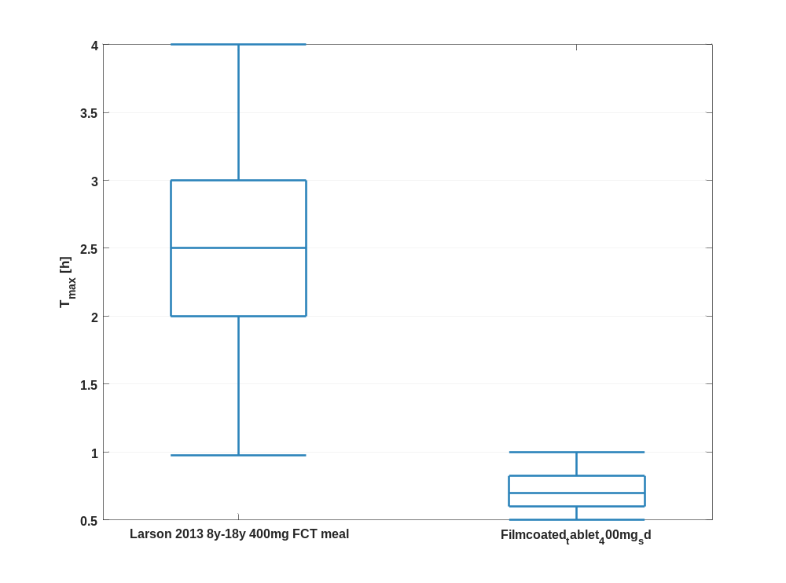

Figure 110: t_{max} of Raltegravir shown as box whisker plot, which indicate the 5th, 25th, 50th, 75th, and 95th percentiles in a logarithmic scale.
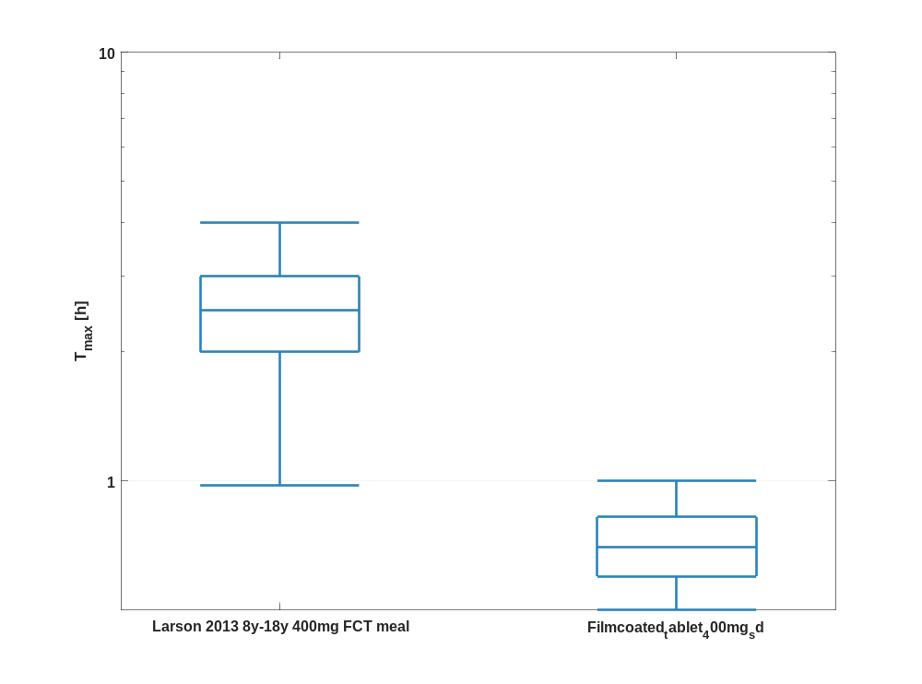

Table 1-55:Percentile of t_{max} of Raltegravir.
T_{max} [h]
 | 5th prctl. | 25th prctl. | 50th prctl. | 75th prctl. | 95th prctl. | arith. mean | std | geo. mean | geo. CV
Larson 2013 8y-18y 400mg FCT meal | 0.98 | 2 | 2.50 | 3 | 4 | 2.52 | 0.88 | 2.35 | 0.41
Filmcoated_tablet_400mg_sd | 0.50 | 0.60 | 0.70 | 0.83 | 1 | 0.73 | 0.15 | 0.71 | 0.21

C_{tEnd}

Figure 111: C_{tEnd} of Raltegravir shown as box whisker plot, which indicate the 5th, 25th, 50th, 75th, and 95th percentiles in a linear scale.
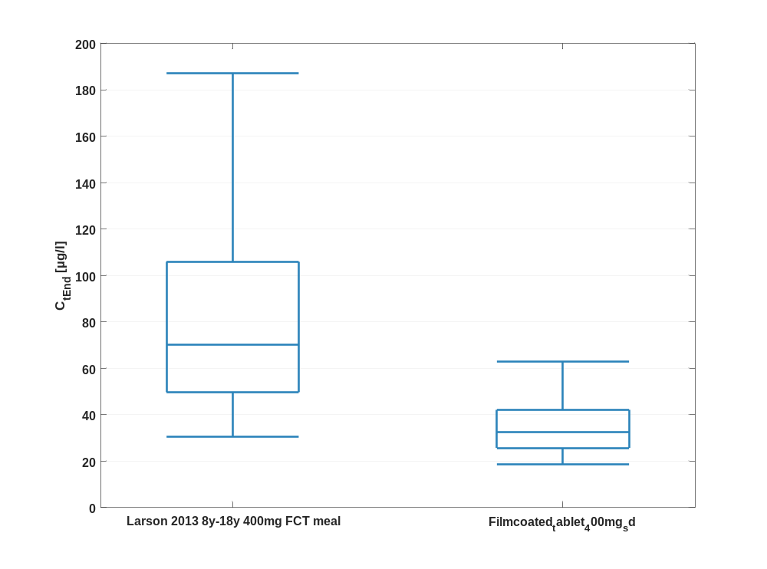

Figure 112: C_{tEnd} of Raltegravir shown as box whisker plot, which indicate the 5th, 25th, 50th, 75th, and 95th percentiles in a logarithmic scale.
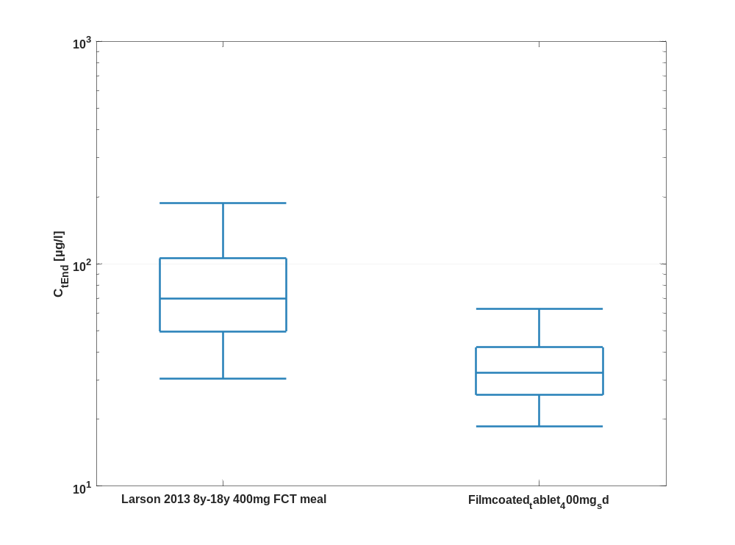

Table 1-56:Percentile of C_{tEnd} of Raltegravir.
C_{tEnd} [µg/l]
 | 5th prctl. | 25th prctl. | 50th prctl. | 75th prctl. | 95th prctl. | arith. mean | std | geo. mean | geo. CV
Larson 2013 8y-18y 400mg FCT meal | 30.52 | 49.73 | 70.04 | 105.90 | 187.01 | 85.37 | 55.06 | 72.76 | 0.60
Filmcoated_tablet_400mg_sd | 18.56 | 25.72 | 32.35 | 42.12 | 62.76 | 35.39 | 14.21 | 33.01 | 0.38

AUC_{last}

Figure 113: AUC_{last} of Raltegravir shown as box whisker plot, which indicate the 5th, 25th, 50th, 75th, and 95th percentiles in a linear scale.
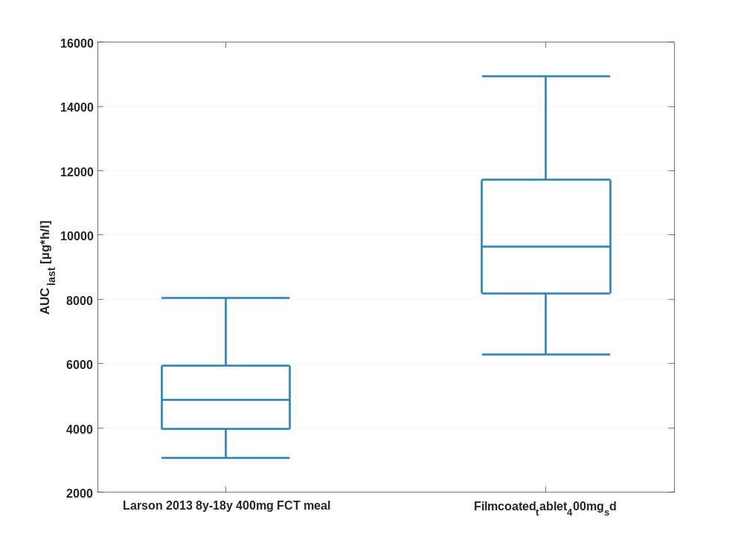

Figure 114: AUC_{last} of Raltegravir shown as box whisker plot, which indicate the 5th, 25th, 50th, 75th, and 95th percentiles in a logarithmic scale.
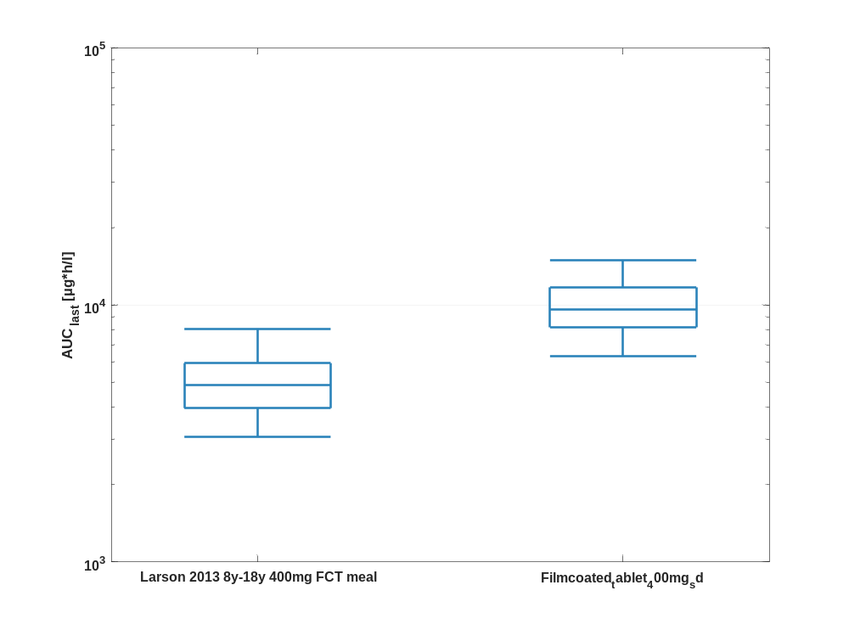

Table 1-57:Percentile of AUC_{last} of Raltegravir.
AUC_{last} [µg*h/l]
 | 5th prctl. | 25th prctl. | 50th prctl. | 75th prctl. | 95th prctl. | arith. mean | std | geo. mean | geo. CV
Larson 2013 8y-18y 400mg FCT meal | 3066.62 | 3970.38 | 4871.80 | 5936.62 | 8052.07 | 5102.98 | 1545.30 | 4883.25 | 0.30
Filmcoated_tablet_400mg_sd | 6298.92 | 8188.95 | 9637.51 | 11718.01 | 14928.85 | 10129.70 | 2672.29 | 9784.56 | 0.27

AUC_{last} norm

Figure 115: AUC_{last} norm of Raltegravir shown as box whisker plot, which indicate the 5th, 25th, 50th, 75th, and 95th percentiles in a linear scale.
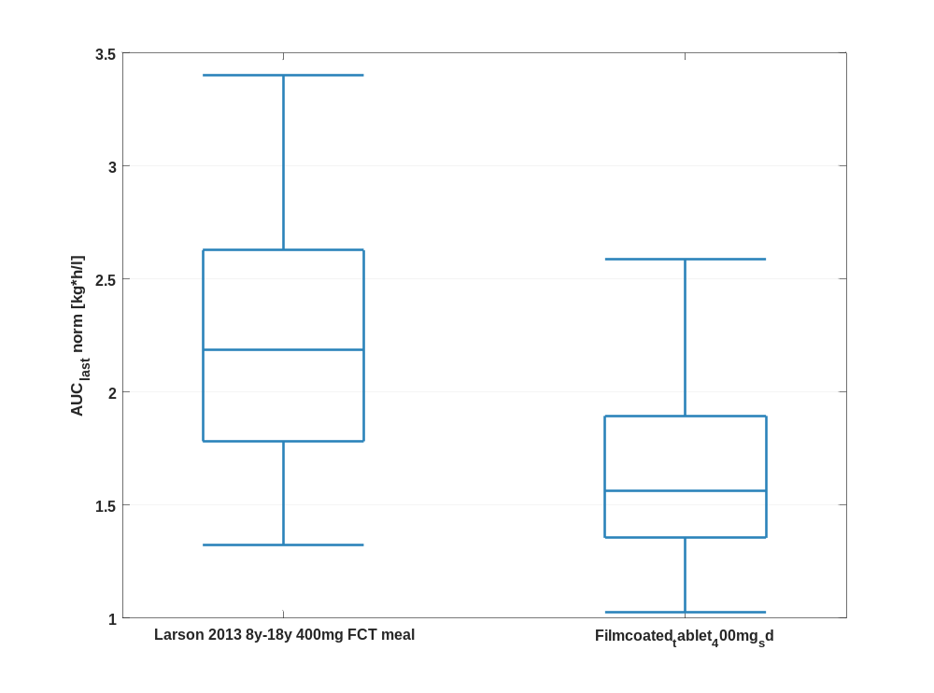

Figure 116: AUC_{last} norm of Raltegravir shown as box whisker plot, which indicate the 5th, 25th, 50th, 75th, and 95th percentiles in a logarithmic scale.
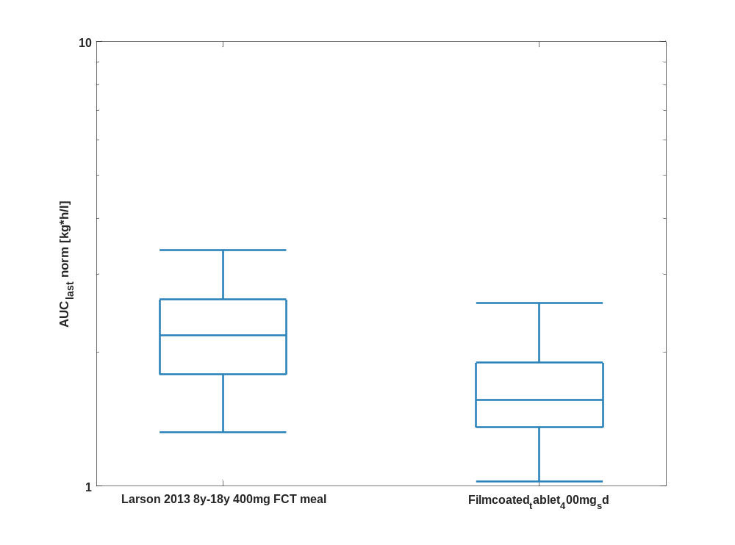

Table 1-58:Percentile of AUC_{last} norm of Raltegravir.
AUC_{last} norm [kg*h/l]
 | 5th prctl. | 25th prctl. | 50th prctl. | 75th prctl. | 95th prctl. | arith. mean | std | geo. mean | geo. CV
Larson 2013 8y-18y 400mg FCT meal | 1.32 | 1.78 | 2.19 | 2.63 | 3.40 | 2.24 | 0.63 | 2.15 | 0.29
Filmcoated_tablet_400mg_sd | 1.03 | 1.36 | 1.56 | 1.89 | 2.59 | 1.66 | 0.51 | 1.59 | 0.29

AUC_{inf}

Figure 117: AUC_{inf} of Raltegravir shown as box whisker plot, which indicate the 5th, 25th, 50th, 75th, and 95th percentiles in a linear scale.
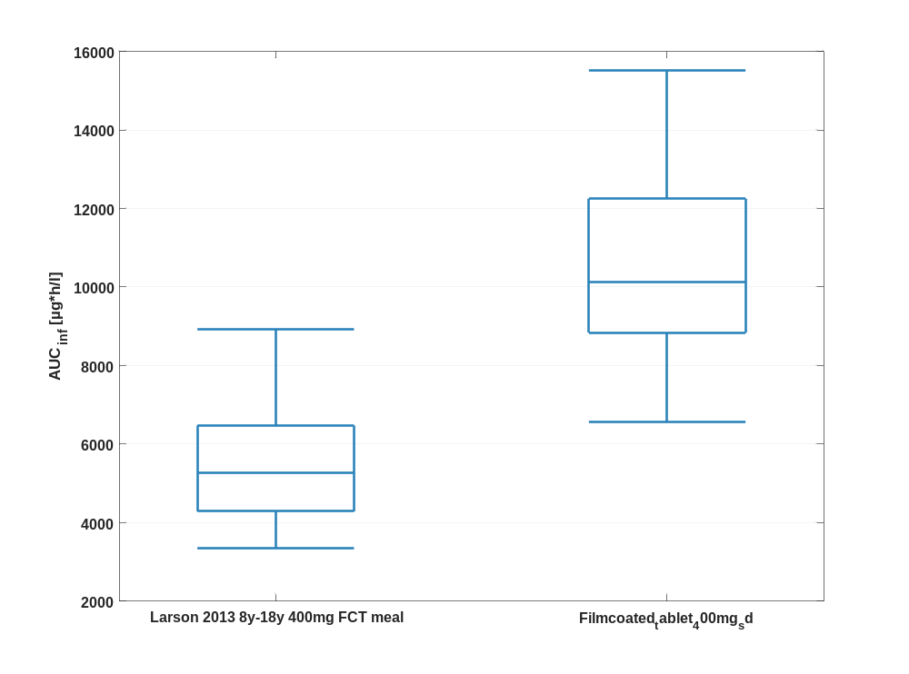

Figure 118: AUC_{inf} of Raltegravir shown as box whisker plot, which indicate the 5th, 25th, 50th, 75th, and 95th percentiles in a logarithmic scale.
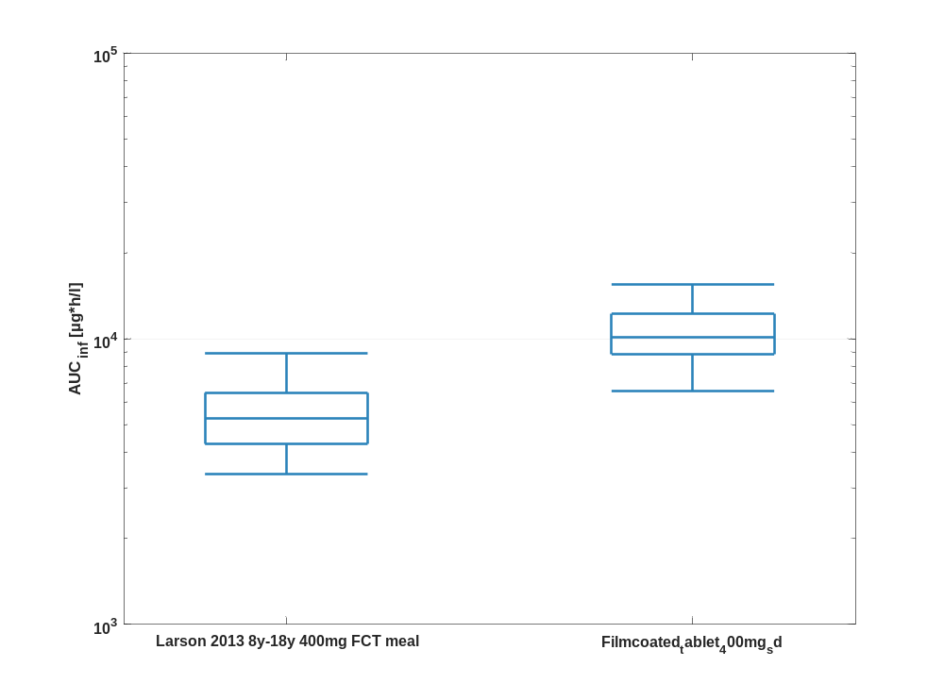

Table 1-59:Percentile of AUC_{inf} of Raltegravir.
AUC_{inf} [µg*h/l]
 | 5th prctl. | 25th prctl. | 50th prctl. | 75th prctl. | 95th prctl. | arith. mean | std | geo. mean | geo. CV
Larson 2013 8y-18y 400mg FCT meal | 3361.93 | 4289.02 | 5278.27 | 6473.61 | 8915.72 | 5782.47 | 3881.04 | 5372.55 | 0.34
Filmcoated_tablet_400mg_sd | 6561.32 | 8838.60 | 10126.54 | 12248.26 | 15521.29 | 10623.47 | 2747.71 | 10273.88 | 0.27

AUC_{inf} norm

Figure 119: AUC_{inf} norm of Raltegravir shown as box whisker plot, which indicate the 5th, 25th, 50th, 75th, and 95th percentiles in a linear scale.
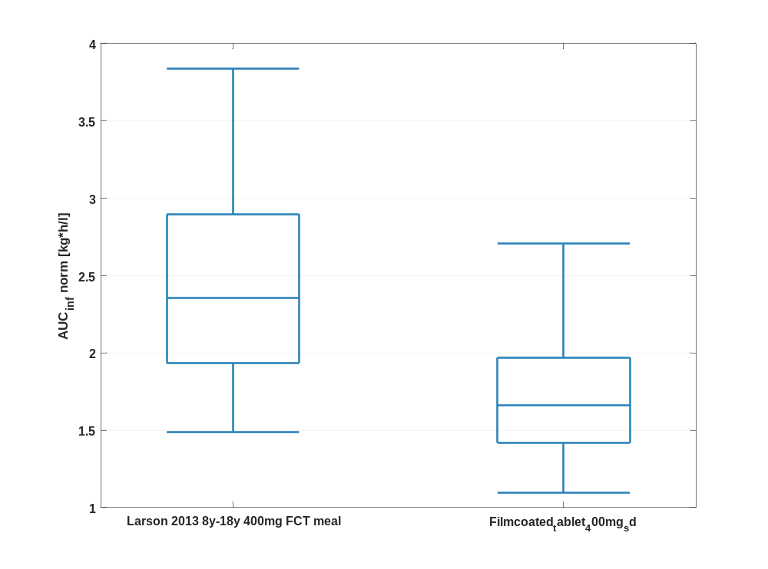

Figure 120: AUC_{inf} norm of Raltegravir shown as box whisker plot, which indicate the 5th, 25th, 50th, 75th, and 95th percentiles in a logarithmic scale.
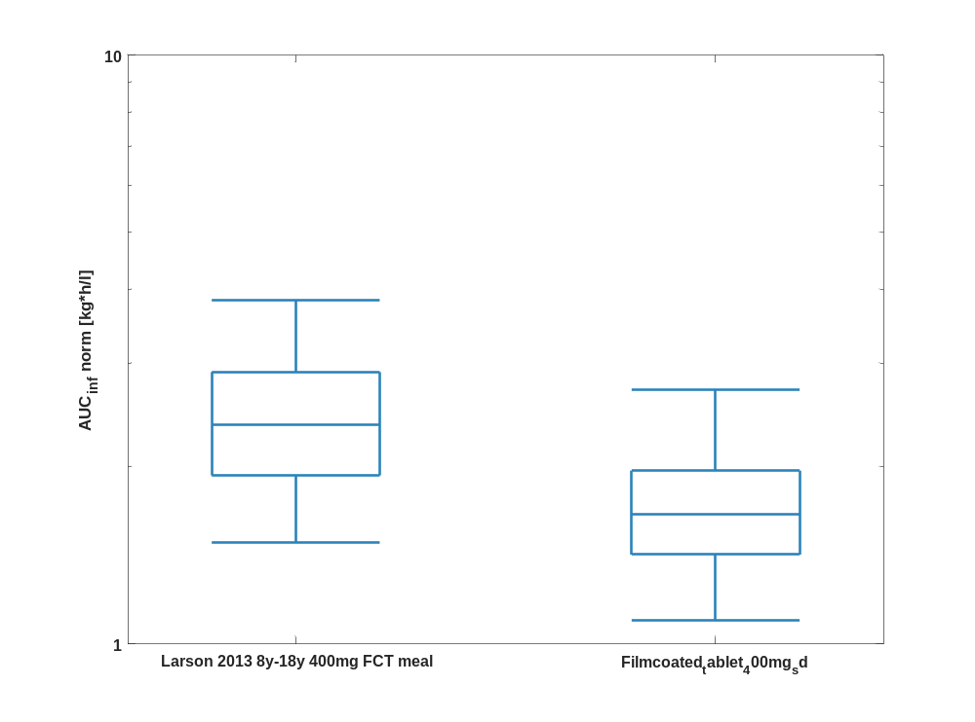

Table 1-60:Percentile of AUC_{inf} norm of Raltegravir.
AUC_{inf} norm [kg*h/l]
 | 5th prctl. | 25th prctl. | 50th prctl. | 75th prctl. | 95th prctl. | arith. mean | std | geo. mean | geo. CV
Larson 2013 8y-18y 400mg FCT meal | 1.49 | 1.93 | 2.36 | 2.90 | 3.84 | 2.53 | 1.51 | 2.37 | 0.33
Filmcoated_tablet_400mg_sd | 1.10 | 1.42 | 1.66 | 1.97 | 2.70 | 1.74 | 0.52 | 1.67 | 0.29

MRT

Figure 121: MRT of Raltegravir shown as box whisker plot, which indicate the 5th, 25th, 50th, 75th, and 95th percentiles in a linear scale.
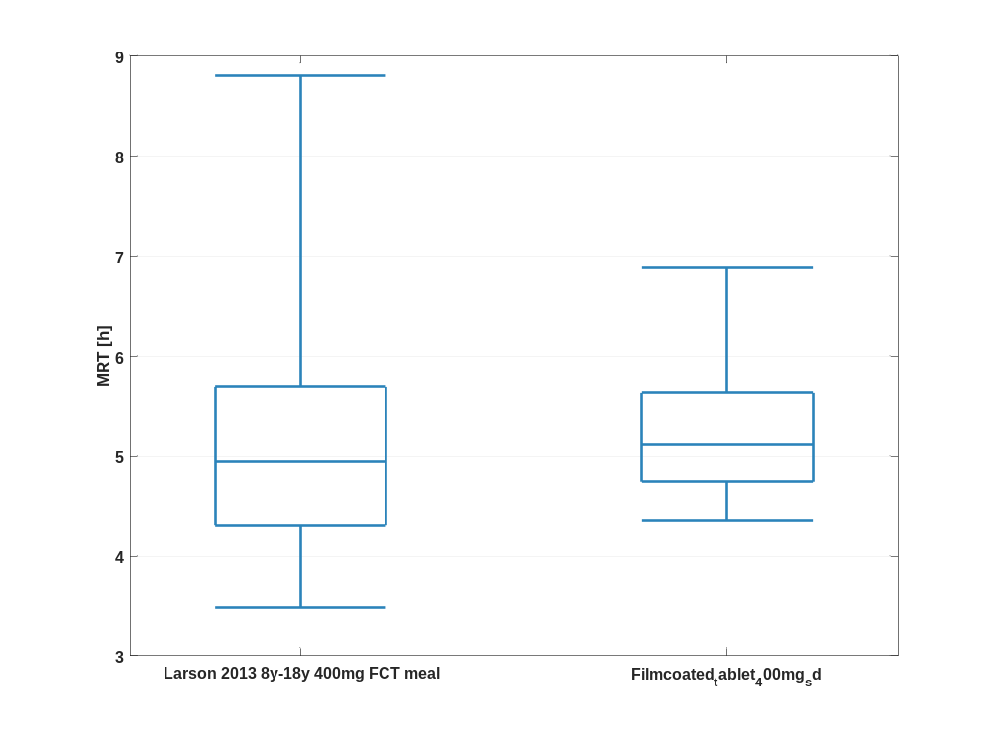

Figure 122: MRT of Raltegravir shown as box whisker plot, which indicate the 5th, 25th, 50th, 75th, and 95th percentiles in a logarithmic scale.
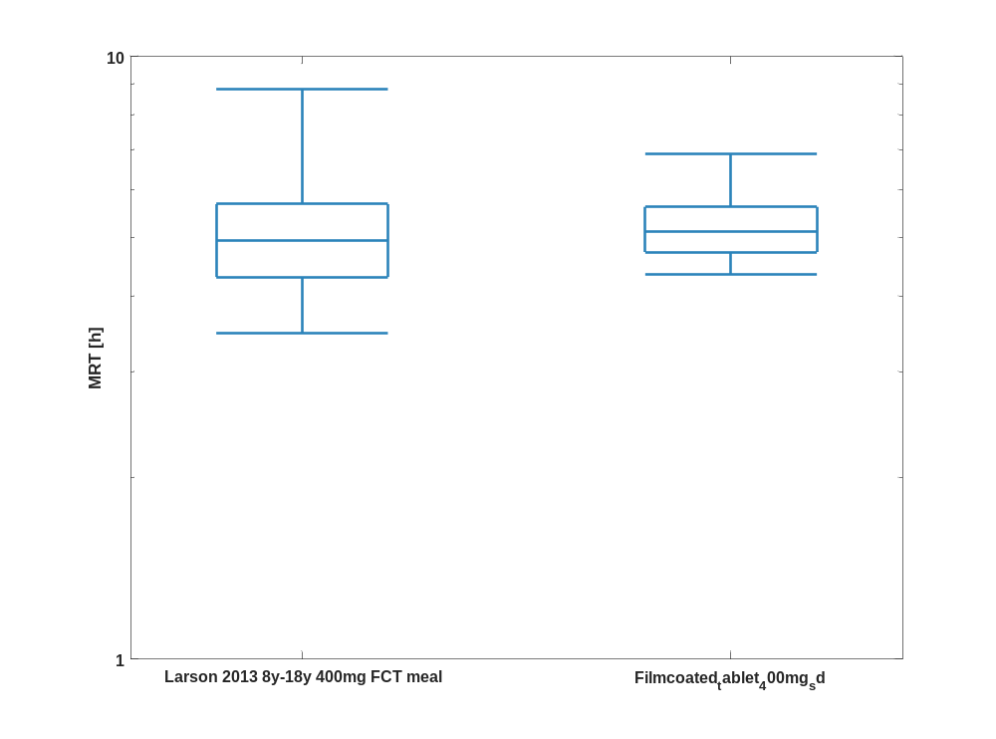

Table 1-61:Percentile of MRT of Raltegravir.
MRT [h]
 | 5th prctl. | 25th prctl. | 50th prctl. | 75th prctl. | 95th prctl. | arith. mean | std | geo. mean | geo. CV
Larson 2013 8y-18y 400mg FCT meal | 3.48 | 4.31 | 4.94 | 5.69 | 8.81 | 6.85 | 23.69 | 5.16 | 0.42
Filmcoated_tablet_400mg_sd | 4.35 | 4.74 | 5.11 | 5.63 | 6.88 | 5.43 | 1.77 | 5.29 | 0.20

Thalf

Figure 123: Thalf of Raltegravir shown as box whisker plot, which indicate the 5th, 25th, 50th, 75th, and 95th percentiles in a linear scale.
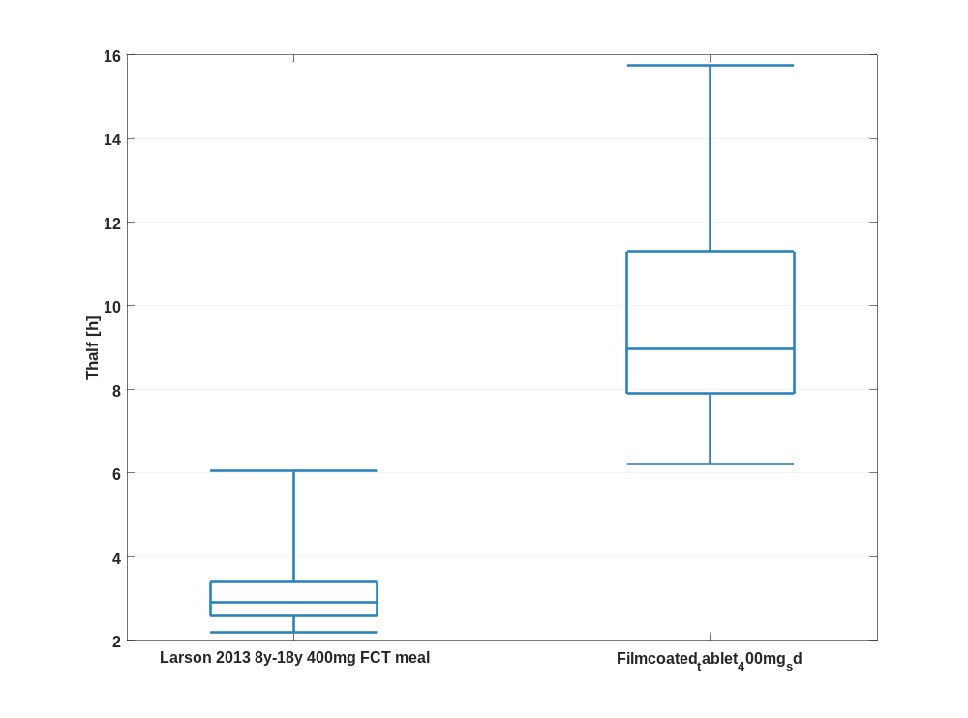

Figure 124: Thalf of Raltegravir shown as box whisker plot, which indicate the 5th, 25th, 50th, 75th, and 95th percentiles in a logarithmic scale.
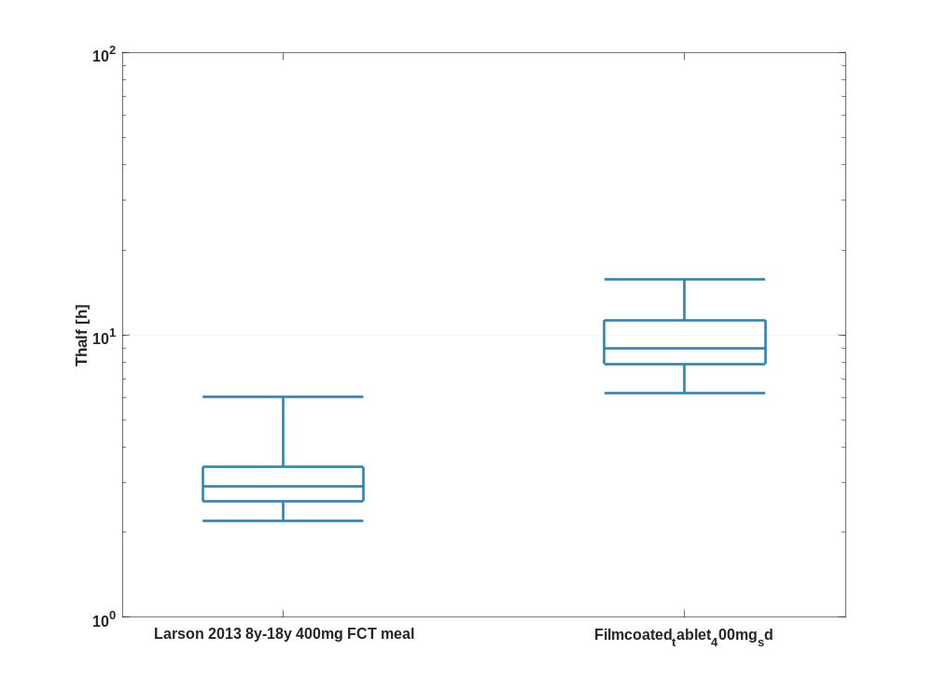

Table 1-62:Percentile of Thalf of Raltegravir.
Thalf [h]
 | 5th prctl. | 25th prctl. | 50th prctl. | 75th prctl. | 95th prctl. | arith. mean | std | geo. mean | geo. CV
Larson 2013 8y-18y 400mg FCT meal | 2.19 | 2.58 | 2.90 | 3.41 | 6.06 | 4.42 | 17.04 | 3.17 | 0.45
Filmcoated_tablet_400mg_sd | 6.23 | 7.90 | 8.98 | 11.30 | 15.74 | 9.79 | 3.12 | 9.37 | 0.30

CL

Figure 125: CL of Raltegravir shown as box whisker plot, which indicate the 5th, 25th, 50th, 75th, and 95th percentiles in a linear scale.
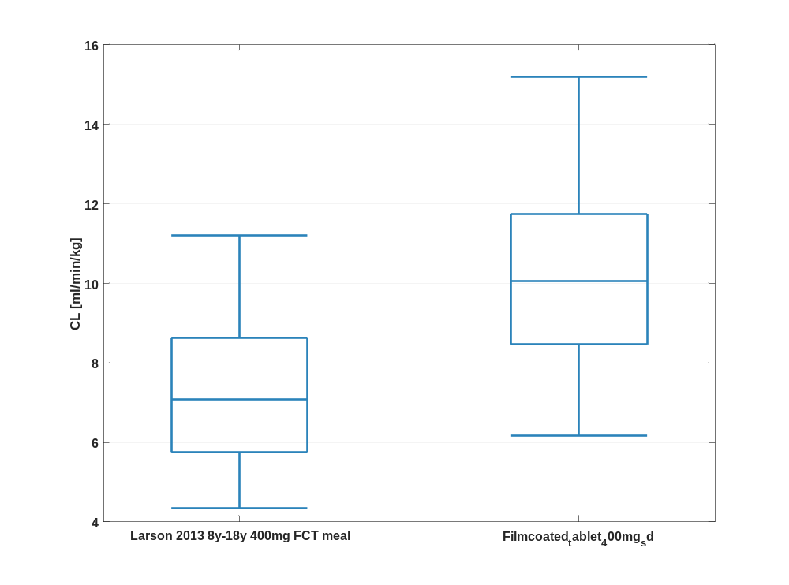

Figure 126: CL of Raltegravir shown as box whisker plot, which indicate the 5th, 25th, 50th, 75th, and 95th percentiles in a logarithmic scale.
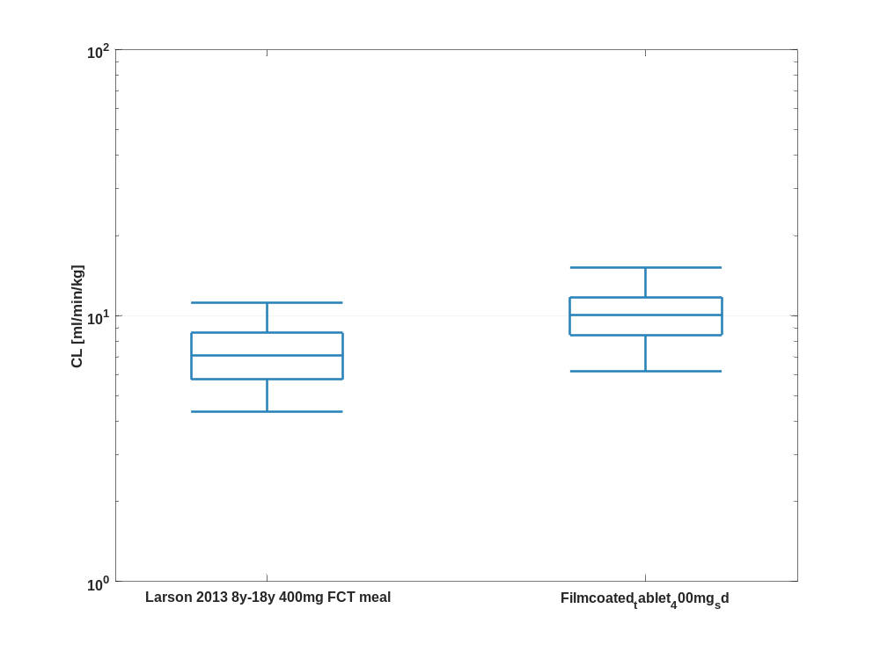

Table 1-63:Percentile of CL of Raltegravir.
CL [ml/min/kg]
 | 5th prctl. | 25th prctl. | 50th prctl. | 75th prctl. | 95th prctl. | arith. mean | std | geo. mean | geo. CV
Larson 2013 8y-18y 400mg FCT meal | 4.34 | 5.76 | 7.07 | 8.62 | 11.21 | 7.38 | 2.24 | 7.04 | 0.33
Filmcoated_tablet_400mg_sd | 6.16 | 8.46 | 10.04 | 11.75 | 15.18 | 10.36 | 2.82 | 9.98 | 0.29

Vss

Figure 127: Vss of Raltegravir shown as box whisker plot, which indicate the 5th, 25th, 50th, 75th, and 95th percentiles in a linear scale.
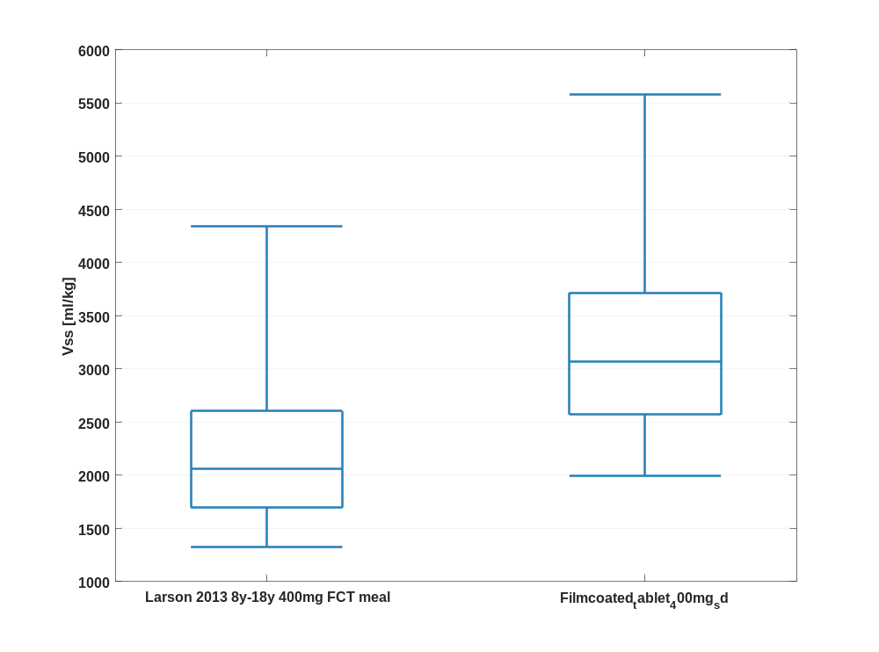

Figure 128: Vss of Raltegravir shown as box whisker plot, which indicate the 5th, 25th, 50th, 75th, and 95th percentiles in a logarithmic scale.
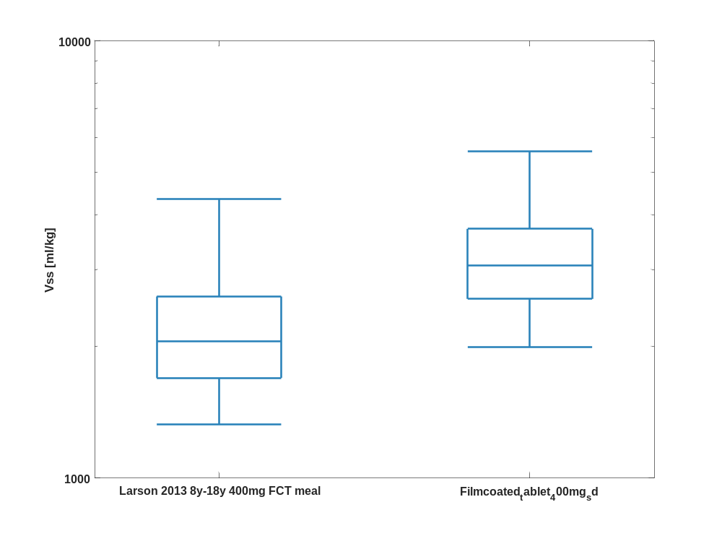

Table 1-64:Percentile of Vss of Raltegravir.
Vss [ml/kg]
 | 5th prctl. | 25th prctl. | 50th prctl. | 75th prctl. | 95th prctl. | arith. mean | std | geo. mean | geo. CV
Larson 2013 8y-18y 400mg FCT meal | 1329.10 | 1694.66 | 2058.49 | 2602.03 | 4342.90 | 2379.33 | 1444.16 | 2180.94 | 0.39
Filmcoated_tablet_400mg_sd | 1993.72 | 2569.40 | 3064.18 | 3715.72 | 5578.21 | 3384.53 | 1669.90 | 3164.71 | 0.35

Vd

Figure 129: Vd of Raltegravir shown as box whisker plot, which indicate the 5th, 25th, 50th, 75th, and 95th percentiles in a linear scale.
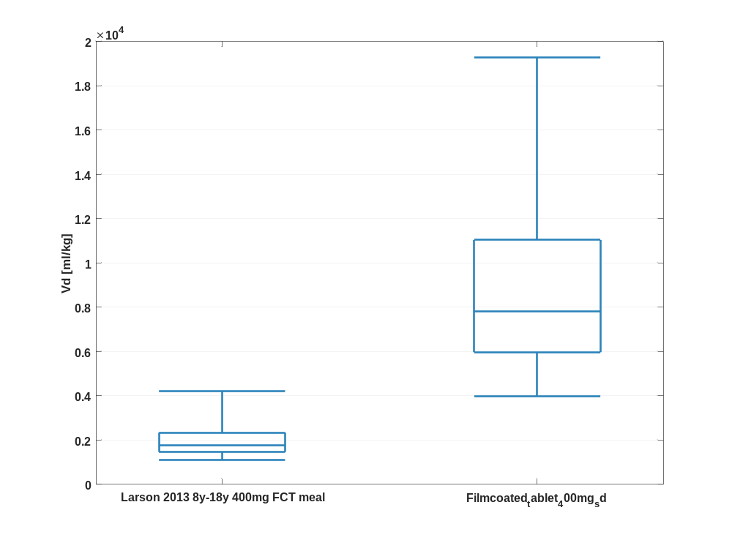

Figure 130: Vd of Raltegravir shown as box whisker plot, which indicate the 5th, 25th, 50th, 75th, and 95th percentiles in a logarithmic scale.
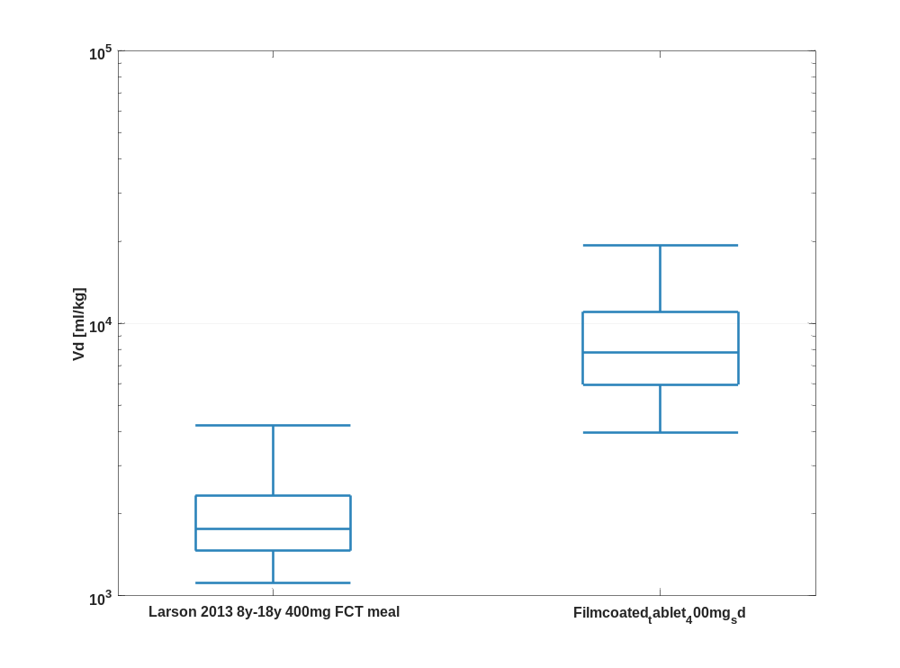

Table 1-65:Percentile of Vd of Raltegravir.
Vd [ml/kg]
 | 5th prctl. | 25th prctl. | 50th prctl. | 75th prctl. | 95th prctl. | arith. mean | std | geo. mean | geo. CV
Larson 2013 8y-18y 400mg FCT meal | 1114.82 | 1465.37 | 1760.07 | 2335.93 | 4224.66 | 2165.98 | 1567.95 | 1933.65 | 0.44
Filmcoated_tablet_400mg_sd | 3976.69 | 5967.97 | 7799.05 | 11034.18 | 19279.74 | 9049.15 | 4704.92 | 8095.66 | 0.49

Timeprofile

Time profiles for Filmcoated_tablet_400mg_sd

Time profiles of Raltegravir

Figure 1: Time profiles of Raltegravir for Filmcoated_tablet_400mg_sd. Data source: Observed_Raltegravir 400mg filmcoated tablet. Time profiles are plotted in a linear scale.
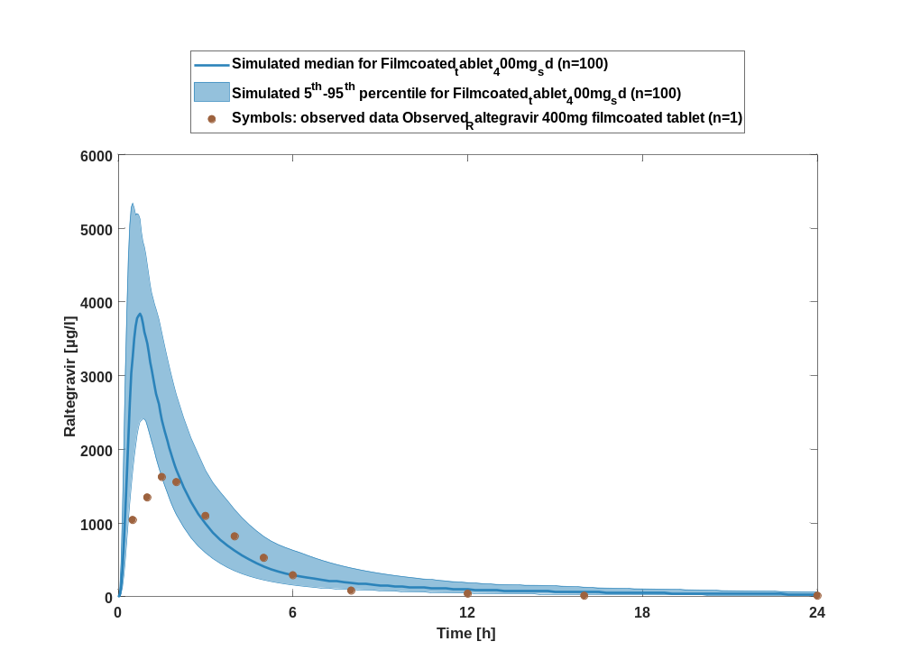

Figure 2: Time profiles of Raltegravir for Filmcoated_tablet_400mg_sd. Data source: Observed_Raltegravir 400mg filmcoated tablet. Time profiles are plotted in a logarithmic scale.
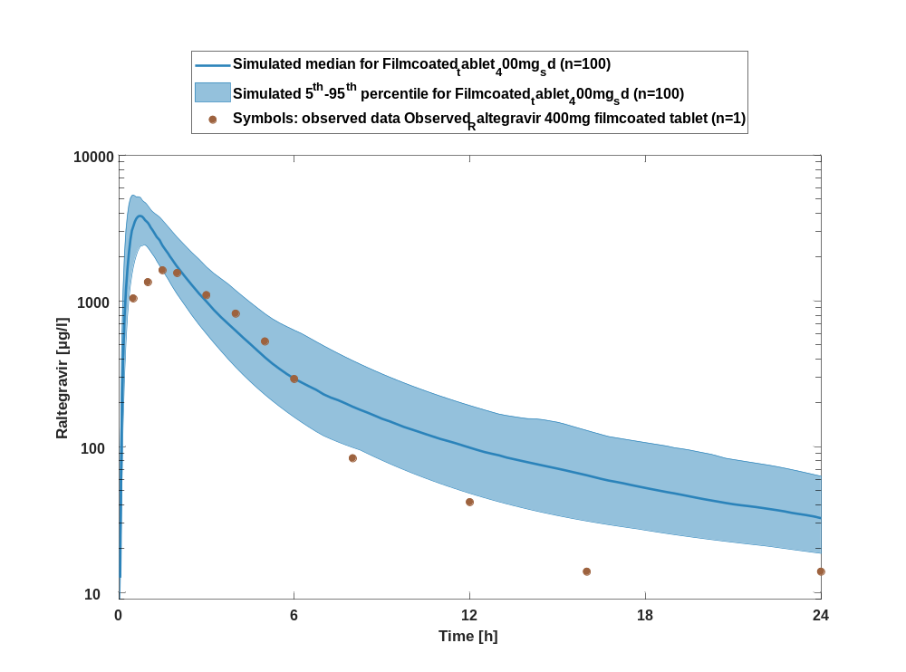

Figure 3: Predicted vs observed of Raltegravir for Filmcoated_tablet_400mg_sd. Data source: Observed_Raltegravir 400mg filmcoated tablet. Prediction and observations are plotted in a logarithmic scale.
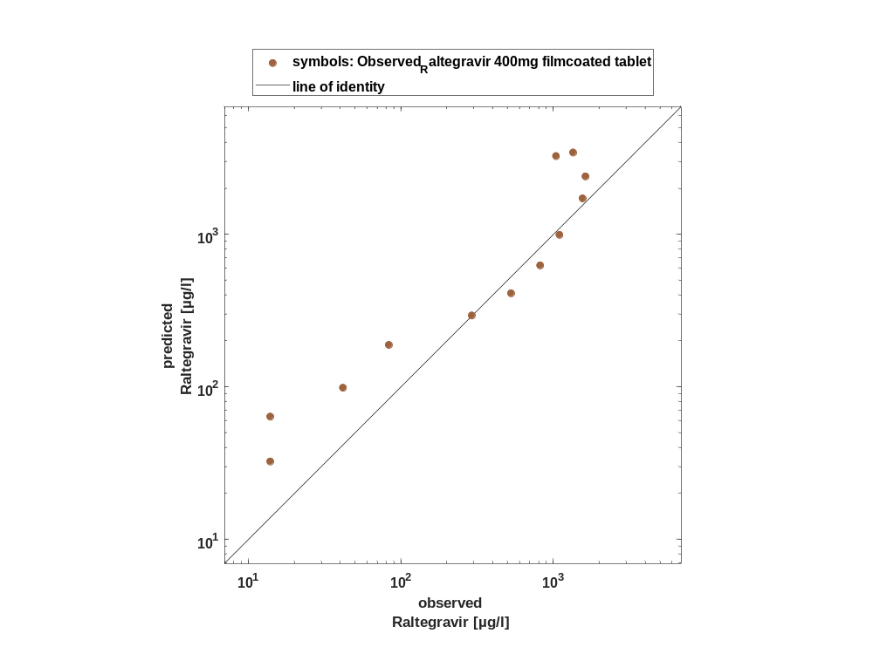

Figure 4: Logarithmic residuals vs time of Raltegravir for Filmcoated_tablet_400mg_sd. Data source: Observed_Raltegravir 400mg filmcoated tablet.
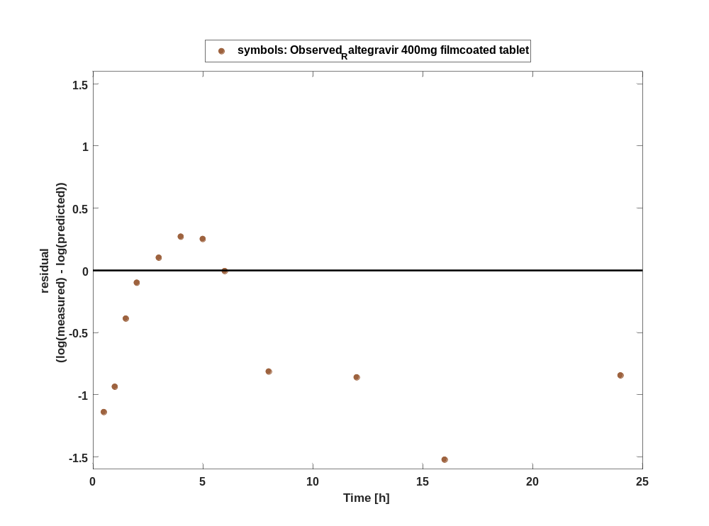

Figure 5: Logarithmic residuals vs predicted values of Raltegravir for Filmcoated_tablet_400mg_sd. Data source: Observed_Raltegravir 400mg filmcoated tablet.
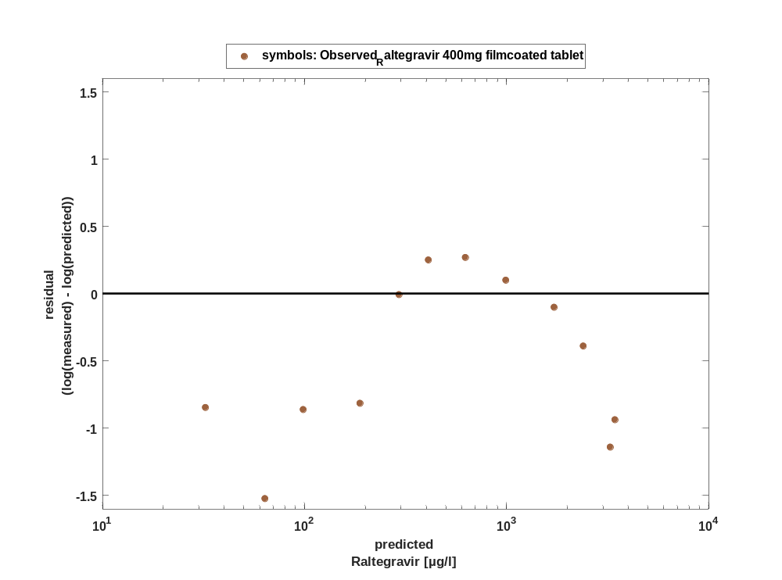

Overview on all residuals

Figure 6: Distribution of residuals for Filmcoated_tablet_400mg_sd
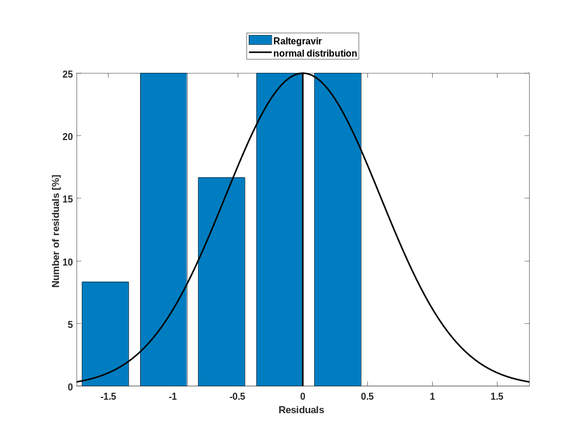

Figure 7: Residuals for Filmcoated_tablet_400mg_sd as quantile-quantile plot.
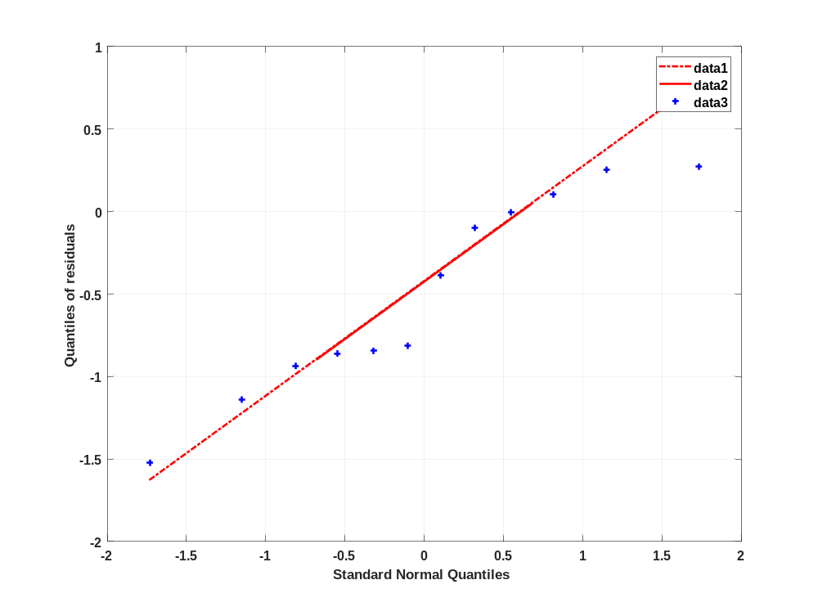

Time profiles for Larson 2013 8y-18y 400mg FCT meal

Time profiles of Raltegravir

Figure 8: Time profiles of Raltegravir for Larson 2013 8y-18y 400mg FCT meal compared to simulated Raltegravir for Filmcoated_tablet_400mg_sd. Data source: Observed_Raltegravir 10 mg (lactose formulation). Time profiles are plotted in a linear scale.
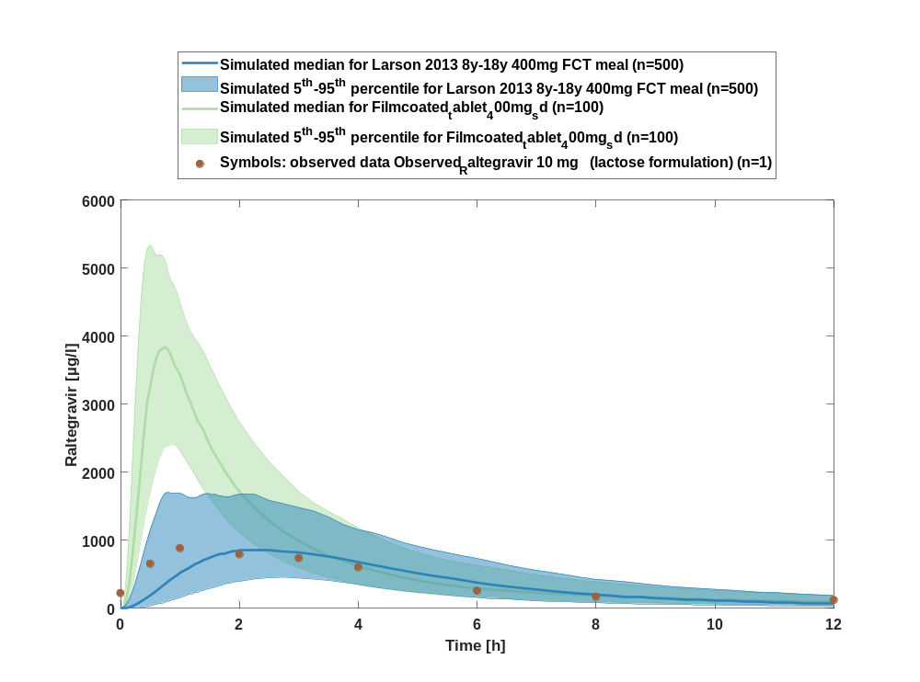

Figure 9: Time profiles of Raltegravir for Larson 2013 8y-18y 400mg FCT meal compared to simulated Raltegravir for Filmcoated_tablet_400mg_sd. Data source: Observed_Raltegravir 10 mg (lactose formulation). Time profiles are plotted in a logarithmic scale.
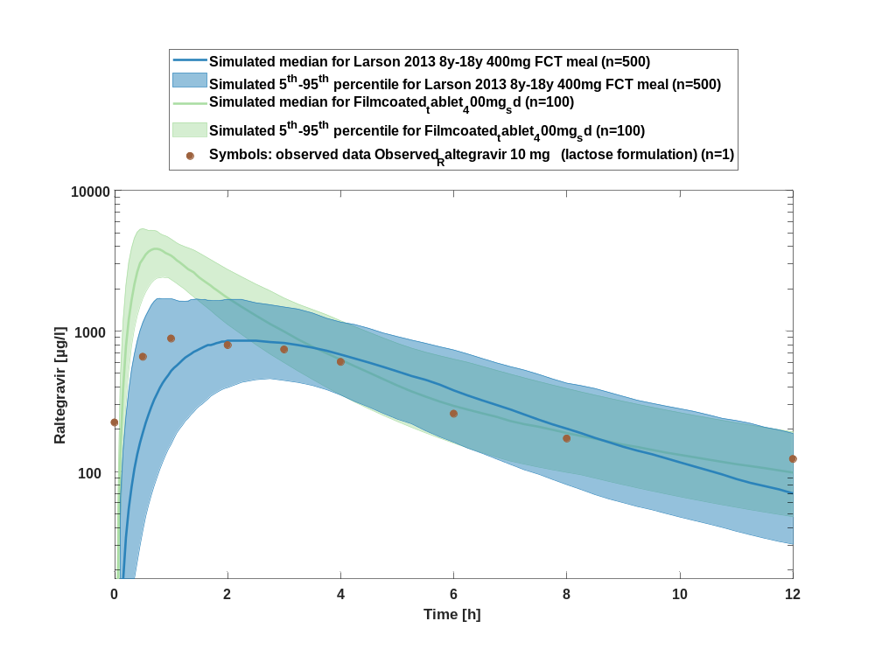

Figure 10: Predicted vs observed of Raltegravir for Larson 2013 8y-18y 400mg FCT meal. Data source: Observed_Raltegravir 10 mg (lactose formulation). Prediction and observations are plotted in a logarithmic scale.
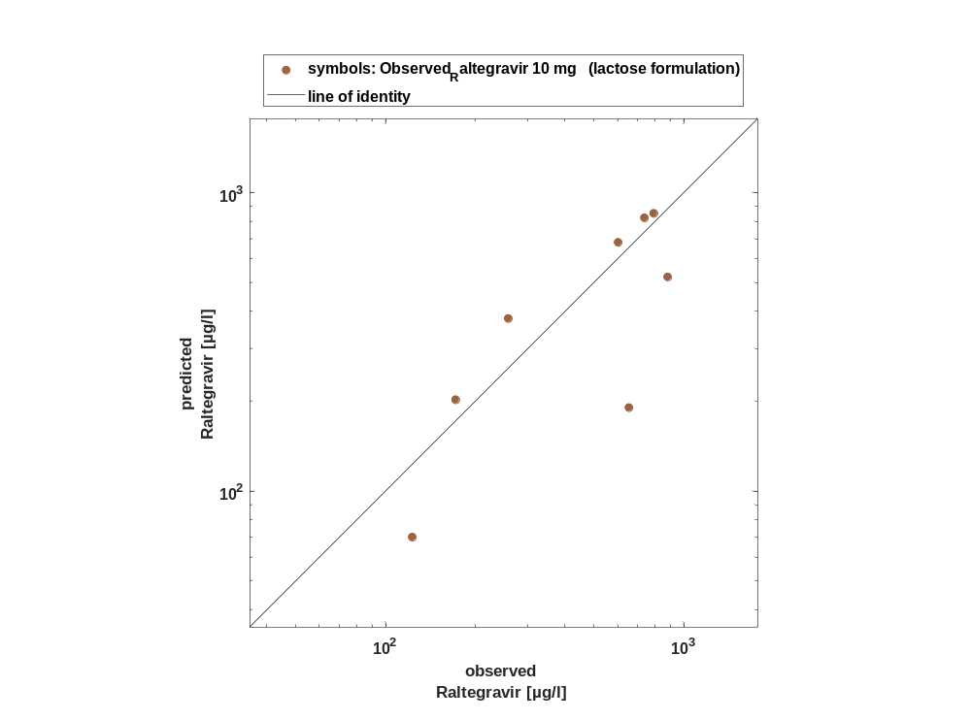

Figure 11: Logarithmic residuals vs time of Raltegravir for Larson 2013 8y-18y 400mg FCT meal. Data source: Observed_Raltegravir 10 mg (lactose formulation).
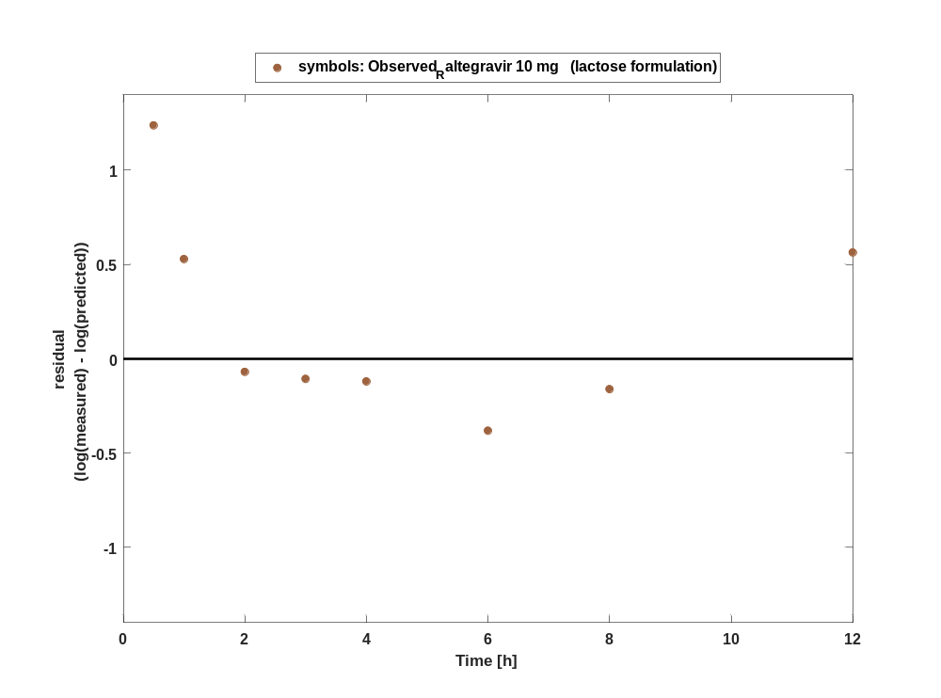

Figure 12: Logarithmic residuals vs predicted values of Raltegravir for Larson 2013 8y-18y 400mg FCT meal. Data source: Observed_Raltegravir 10 mg (lactose formulation).
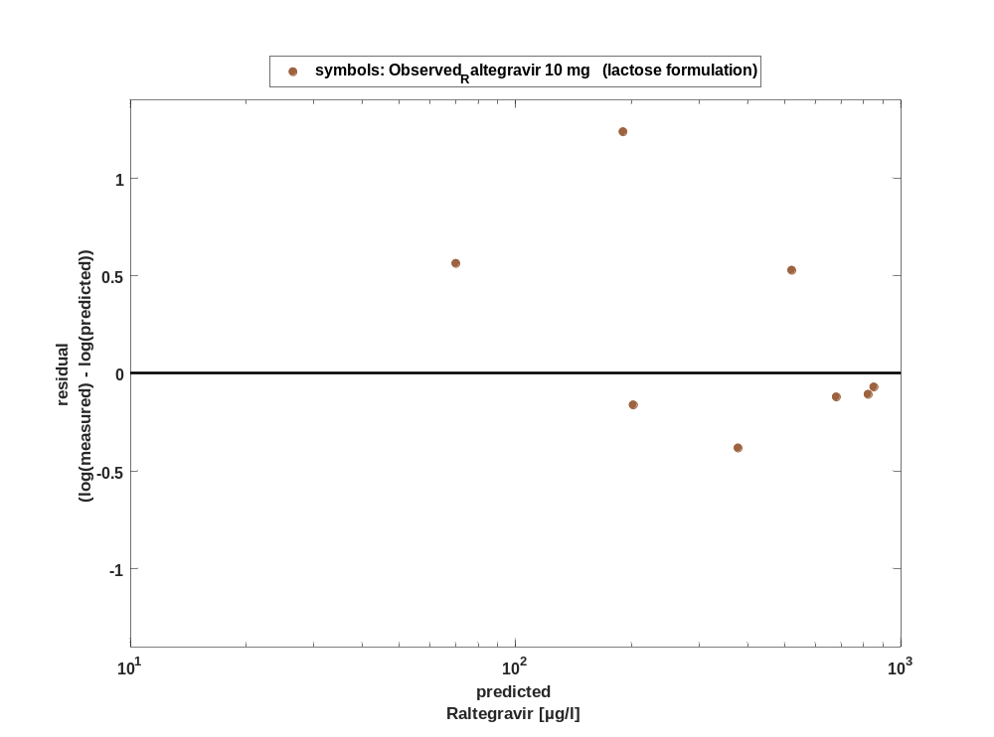

Overview on all residuals

Figure 13: Distribution of residuals for Larson 2013 8y-18y 400mg FCT meal
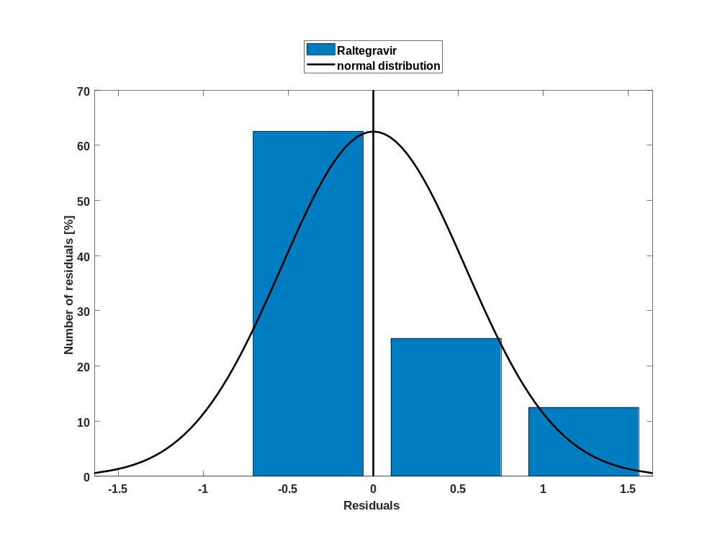

Figure 14: Residuals for Larson 2013 8y-18y 400mg FCT meal as quantile-quantile plot.
