Timeprofile

Time profiles for Raltegravir 10 mg (lactose formulation)

Time profiles of Raltegravir

Figure 1: Time profiles of Raltegravir for Raltegravir 10 mg (lactose formulation). Data source: Observed_Raltegravir 10 mg (lactose formulation). Time profiles are plotted in a linear scale.
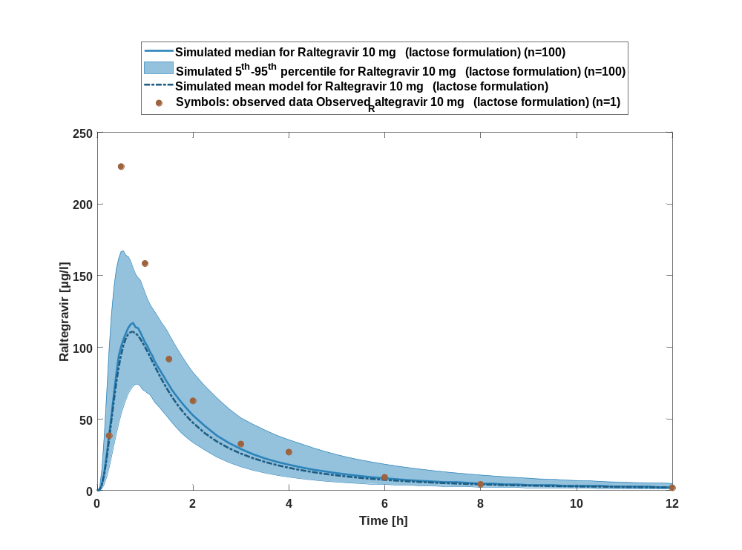

Figure 2: Time profiles of Raltegravir for Raltegravir 10 mg (lactose formulation). Data source: Observed_Raltegravir 10 mg (lactose formulation). Time profiles are plotted in a logarithmic scale.
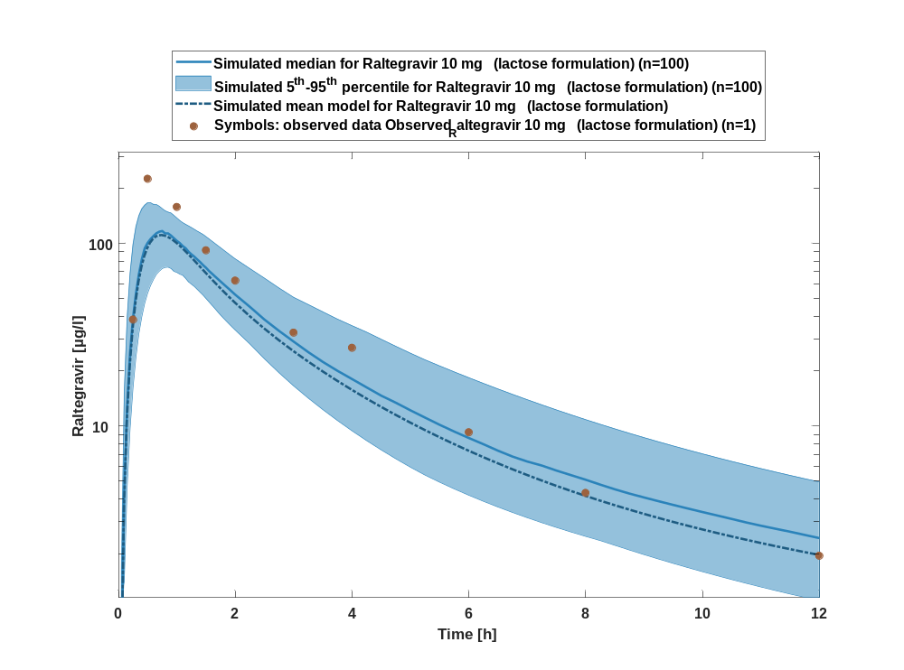

Figure 3: Predicted vs observed of Raltegravir for Raltegravir 10 mg (lactose formulation). Data source: Observed_Raltegravir 10 mg (lactose formulation). Prediction and observations are plotted in a logarithmic scale.
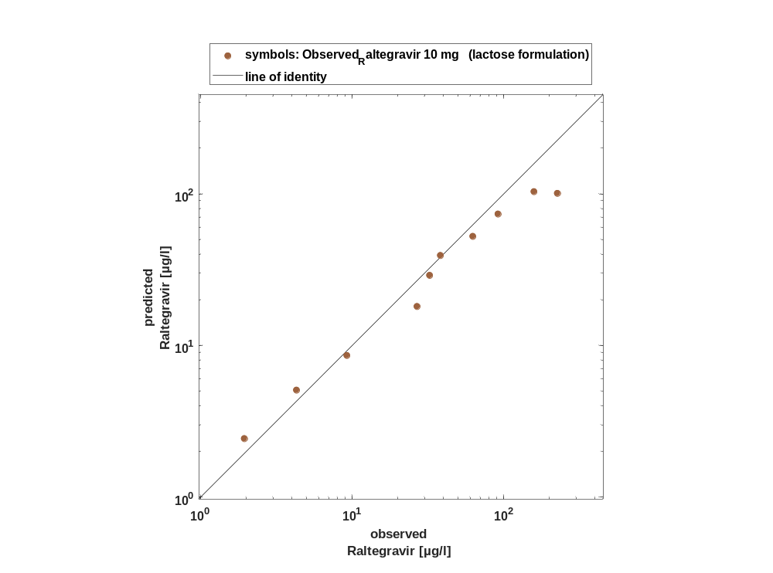

Figure 4: Logarithmic residuals vs time of Raltegravir for Raltegravir 10 mg (lactose formulation). Data source: Observed_Raltegravir 10 mg (lactose formulation).
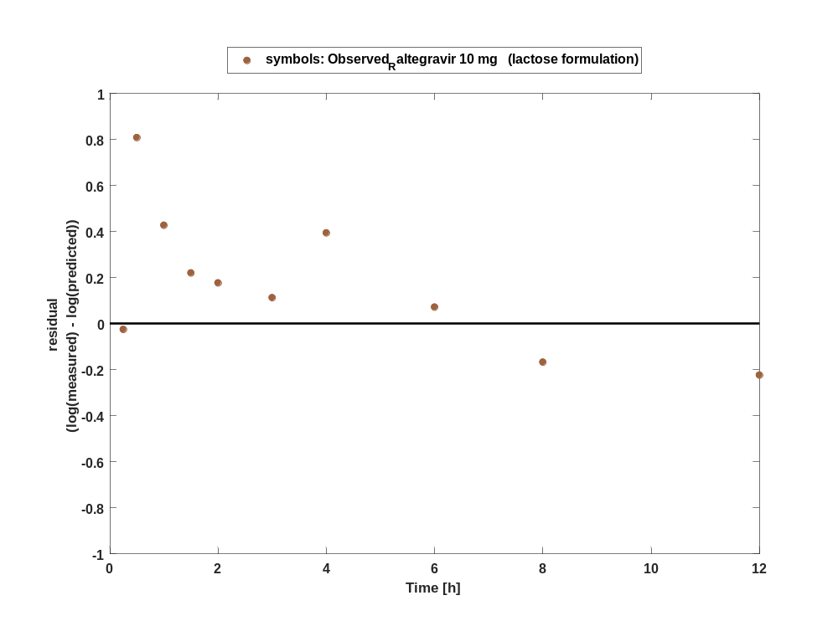

Figure 5: Logarithmic residuals vs predicted values of Raltegravir for Raltegravir 10 mg (lactose formulation). Data source: Observed_Raltegravir 10 mg (lactose formulation).
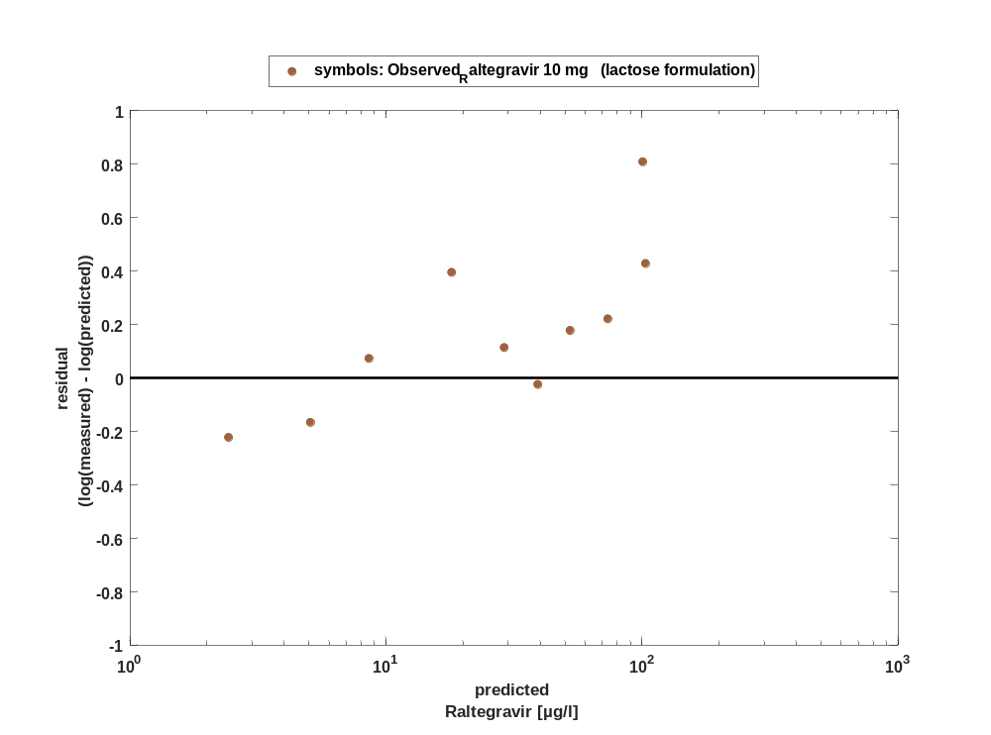

Overview on all residuals

Figure 6: Distribution of residuals for Raltegravir 10 mg (lactose formulation)
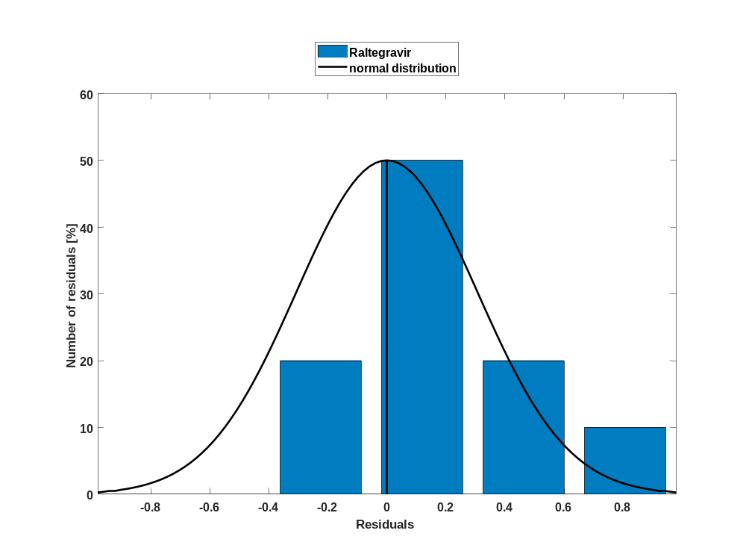

Figure 7: Residuals for Raltegravir 10 mg (lactose formulation) as quantile-quantile plot.
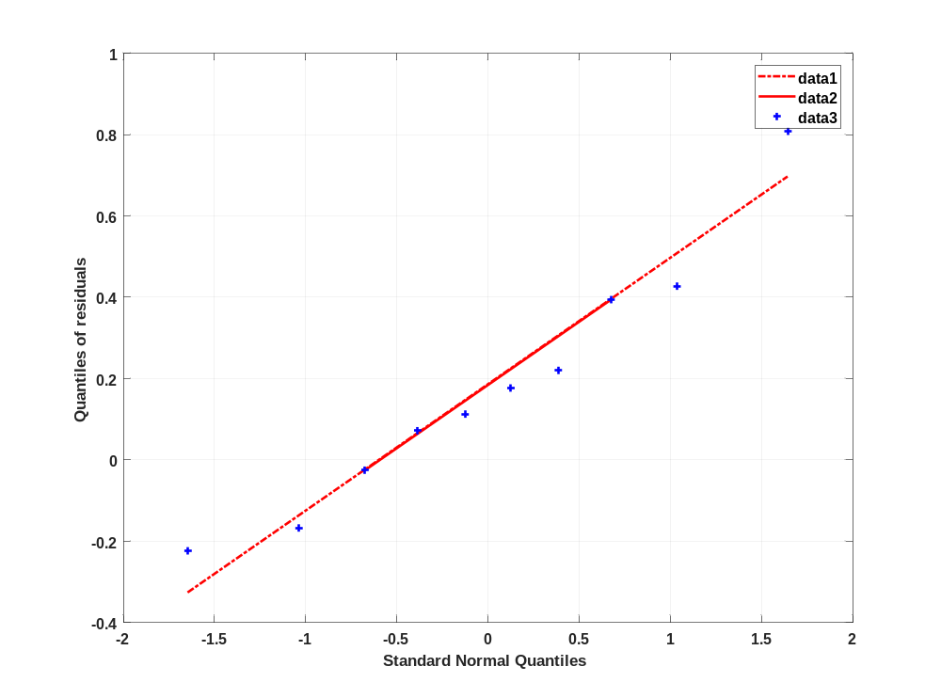

Time profiles for Raltegravir 25 mg (lactose formulation)

Time profiles of Raltegravir

Figure 8: Time profiles of Raltegravir for Raltegravir 25 mg (lactose formulation). Data source: Observed_Raltegravir 25 mg (lactose formulation). Time profiles are plotted in a linear scale.
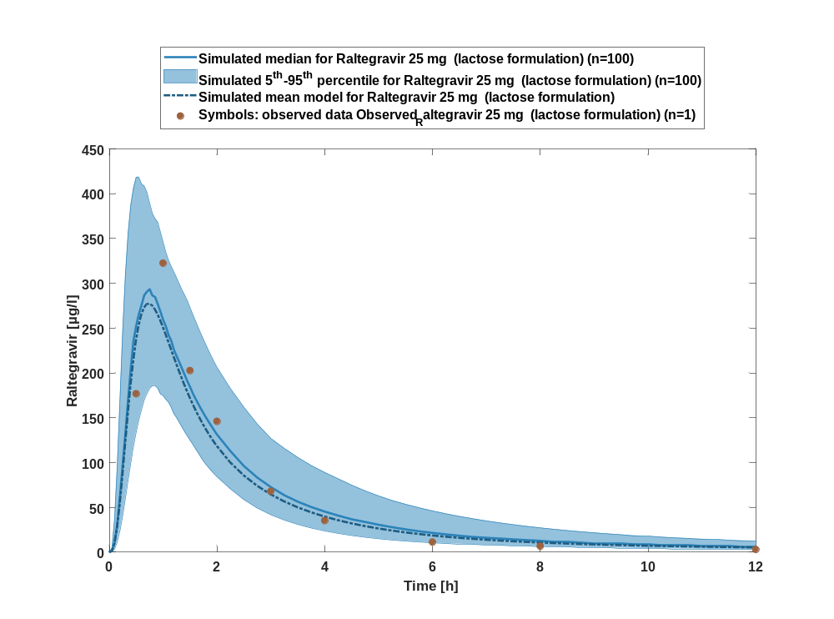

Figure 9: Time profiles of Raltegravir for Raltegravir 25 mg (lactose formulation). Data source: Observed_Raltegravir 25 mg (lactose formulation). Time profiles are plotted in a logarithmic scale.
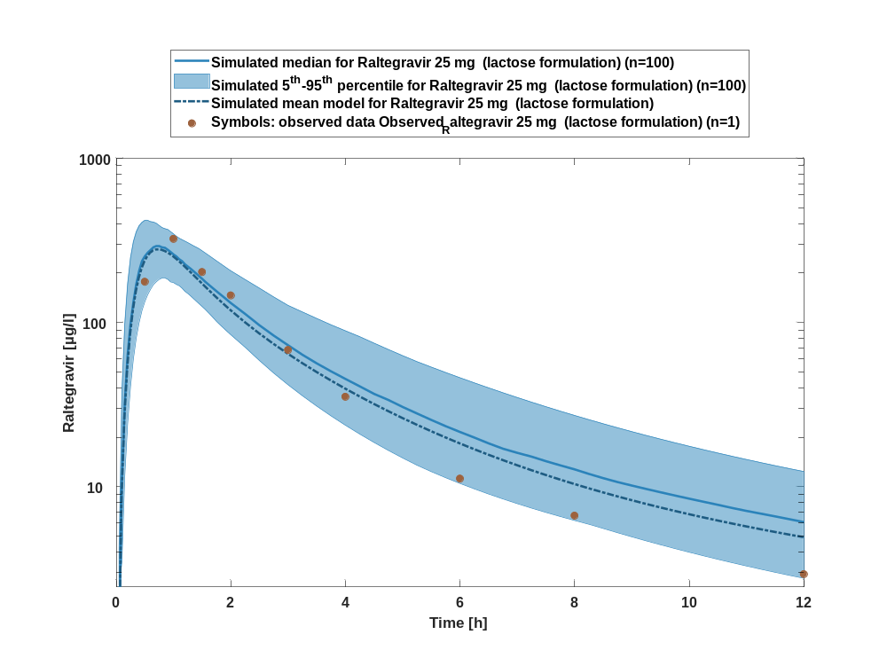

Figure 10: Predicted vs observed of Raltegravir for Raltegravir 25 mg (lactose formulation). Data source: Observed_Raltegravir 25 mg (lactose formulation). Prediction and observations are plotted in a logarithmic scale.
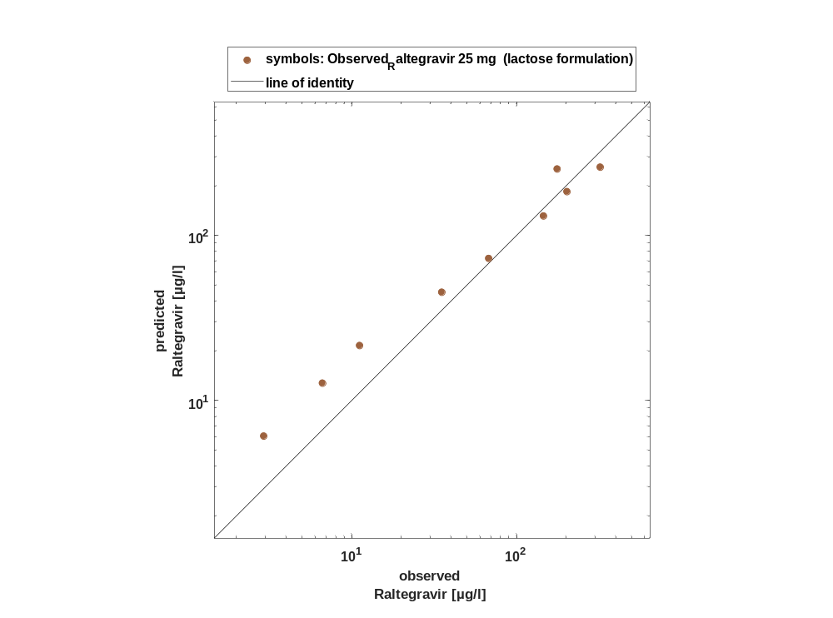

Figure 11: Logarithmic residuals vs time of Raltegravir for Raltegravir 25 mg (lactose formulation). Data source: Observed_Raltegravir 25 mg (lactose formulation).
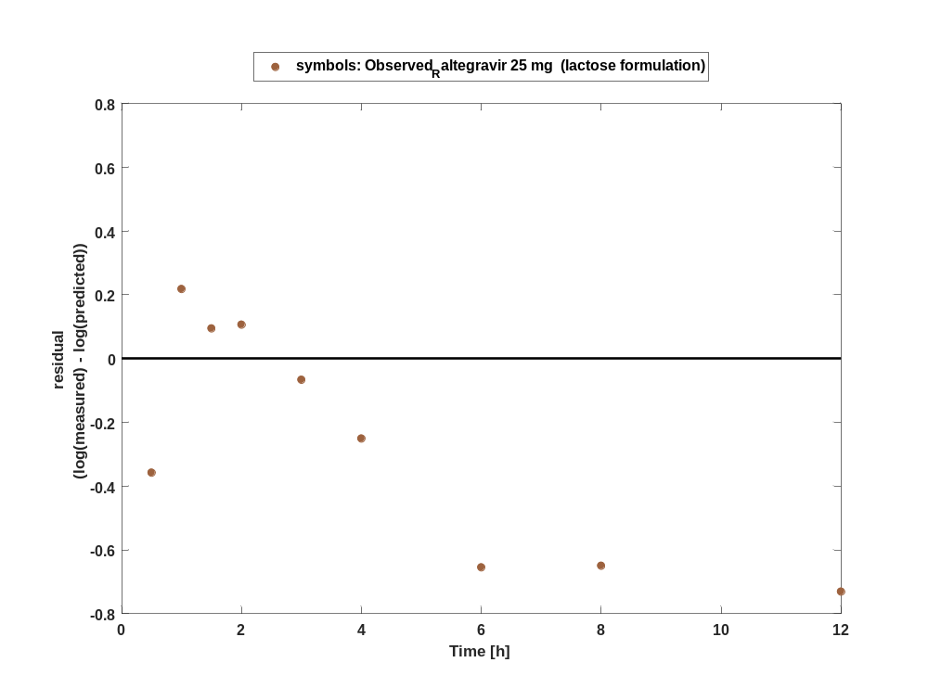

Figure 12: Logarithmic residuals vs predicted values of Raltegravir for Raltegravir 25 mg (lactose formulation). Data source: Observed_Raltegravir 25 mg (lactose formulation).
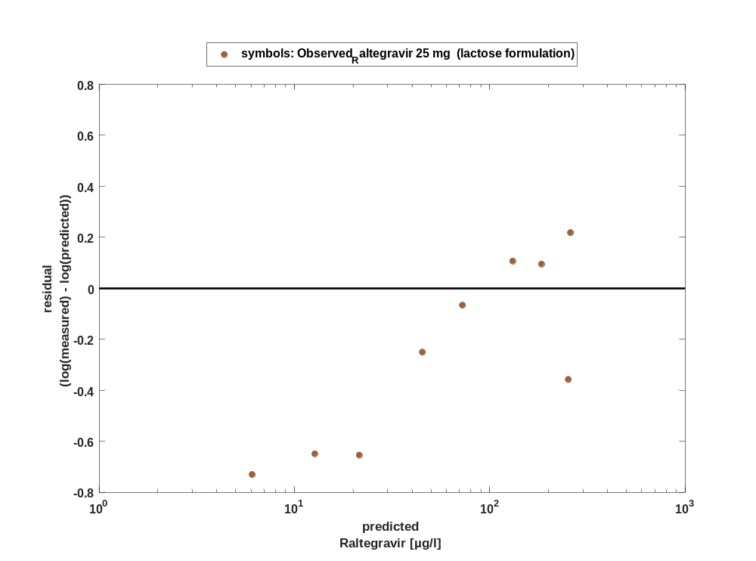

Overview on all residuals

Figure 13: Distribution of residuals for Raltegravir 25 mg (lactose formulation)
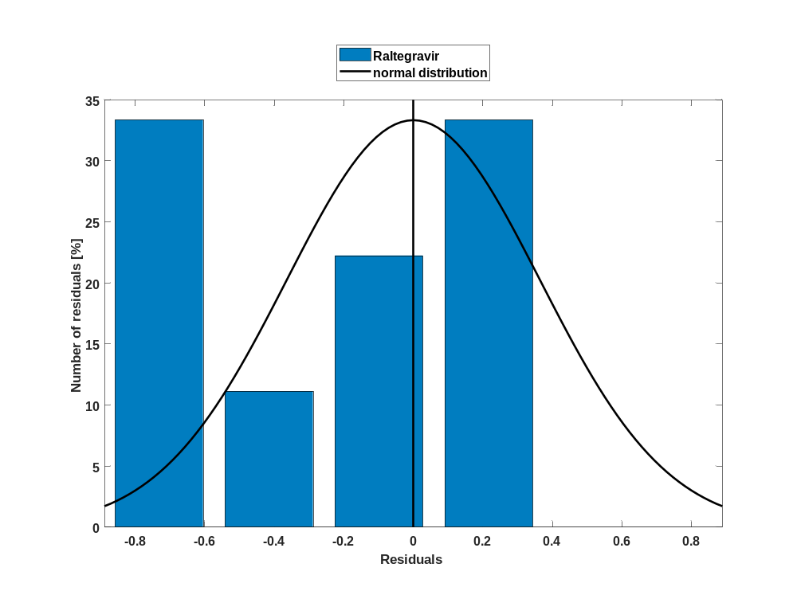

Figure 14: Residuals for Raltegravir 25 mg (lactose formulation) as quantile-quantile plot.
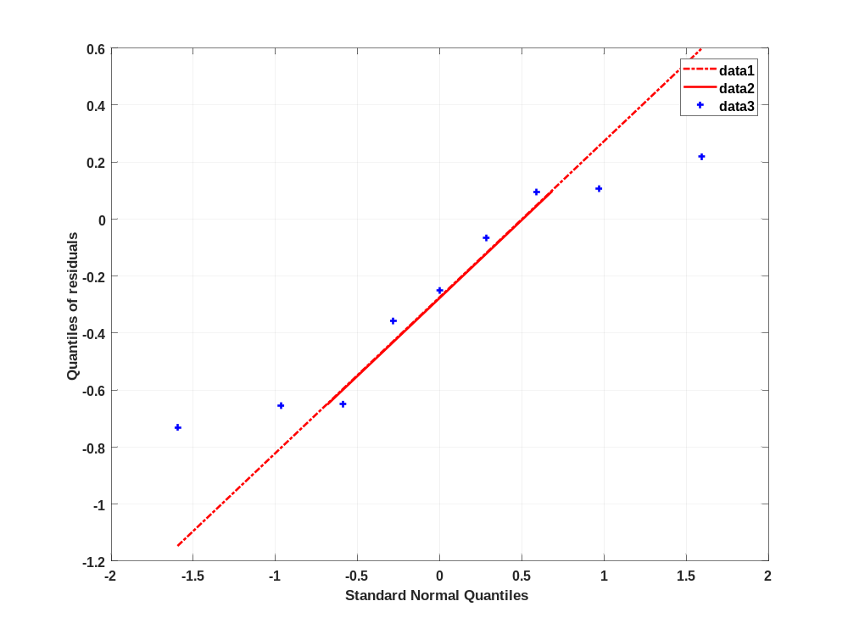

Time profiles for Raltegravir 50 mg (lactose formulation)

Time profiles of Raltegravir

Figure 15: Time profiles of Raltegravir for Raltegravir 50 mg (lactose formulation). Data source: Observed_Raltegravir 50 mg (lactose formulation). Time profiles are plotted in a linear scale.
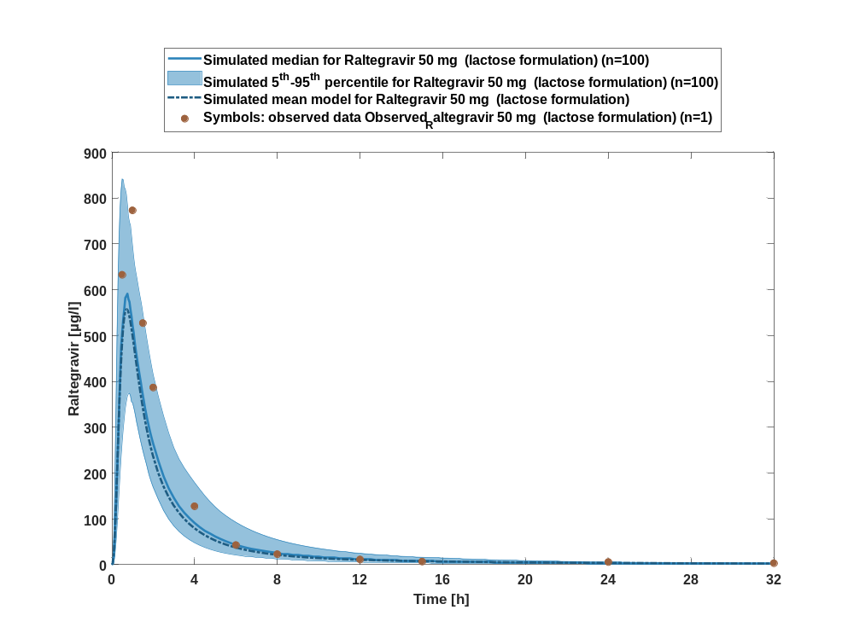

Figure 16: Time profiles of Raltegravir for Raltegravir 50 mg (lactose formulation). Data source: Observed_Raltegravir 50 mg (lactose formulation). Time profiles are plotted in a logarithmic scale.
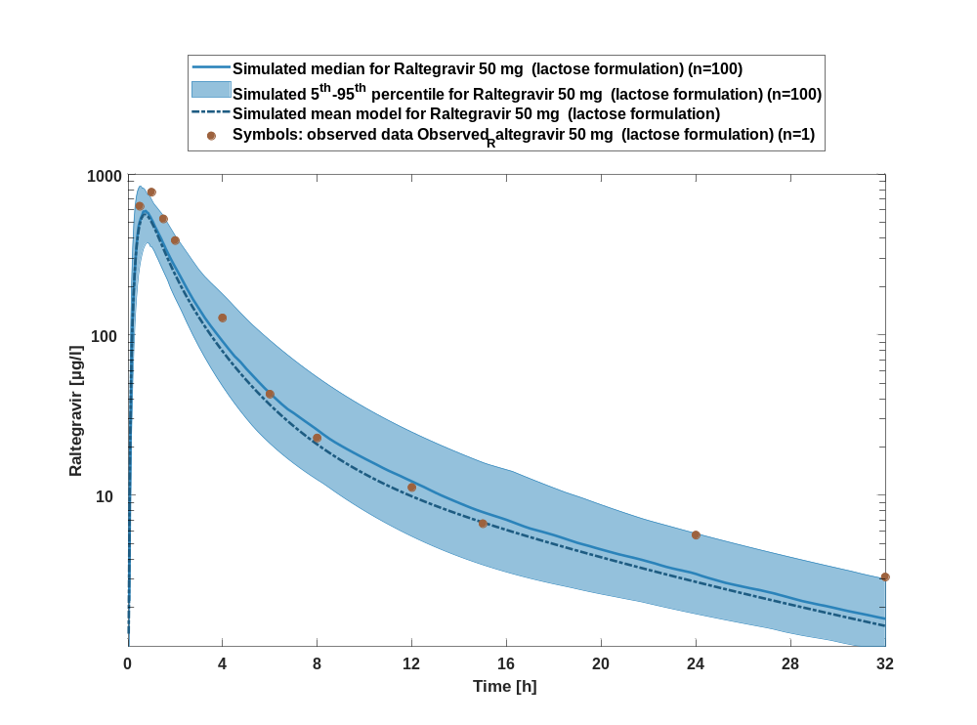

Figure 17: Predicted vs observed of Raltegravir for Raltegravir 50 mg (lactose formulation). Data source: Observed_Raltegravir 50 mg (lactose formulation). Prediction and observations are plotted in a logarithmic scale.
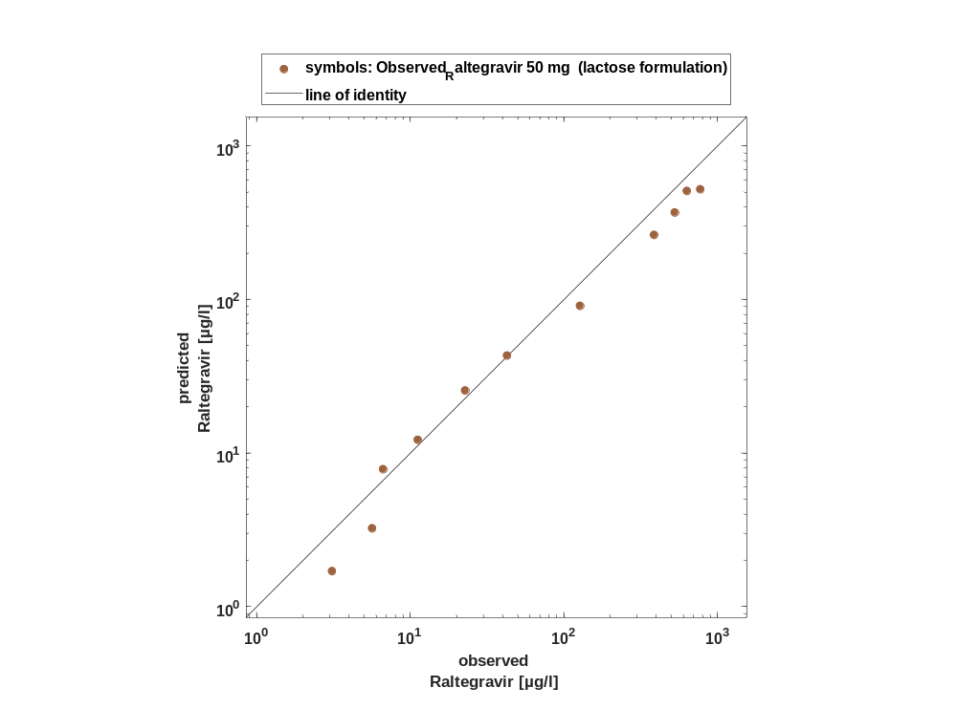

Figure 18: Logarithmic residuals vs time of Raltegravir for Raltegravir 50 mg (lactose formulation). Data source: Observed_Raltegravir 50 mg (lactose formulation).
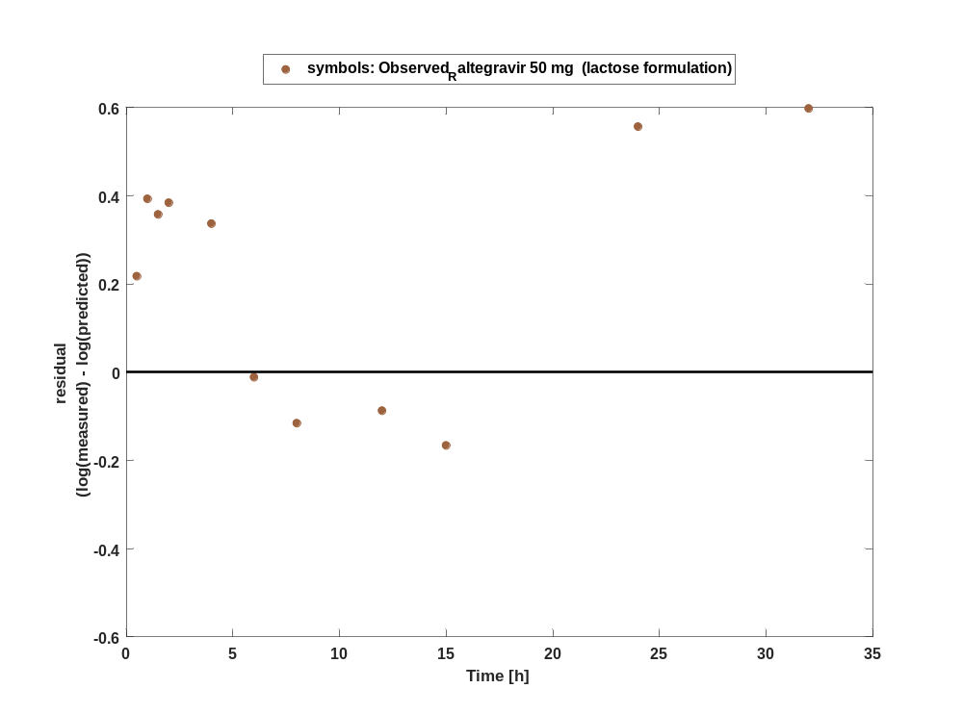

Figure 19: Logarithmic residuals vs predicted values of Raltegravir for Raltegravir 50 mg (lactose formulation). Data source: Observed_Raltegravir 50 mg (lactose formulation).
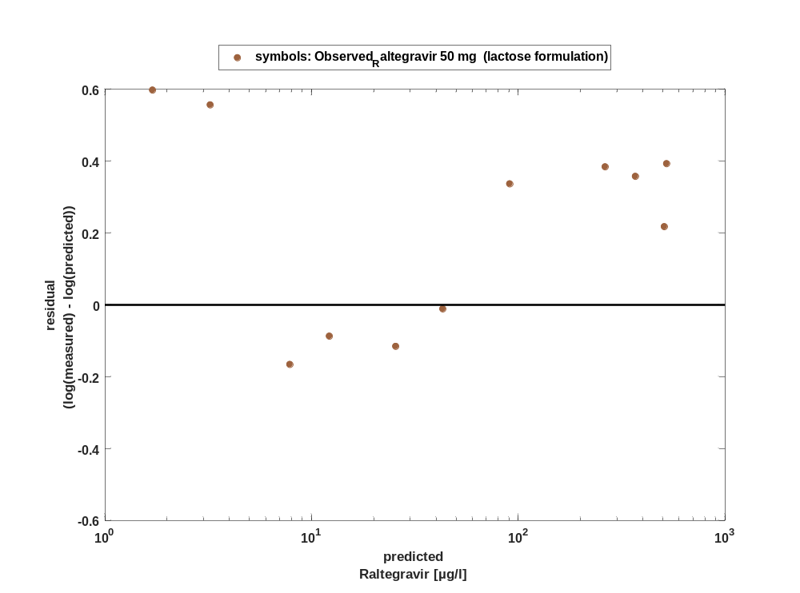

Overview on all residuals

Figure 20: Distribution of residuals for Raltegravir 50 mg (lactose formulation)
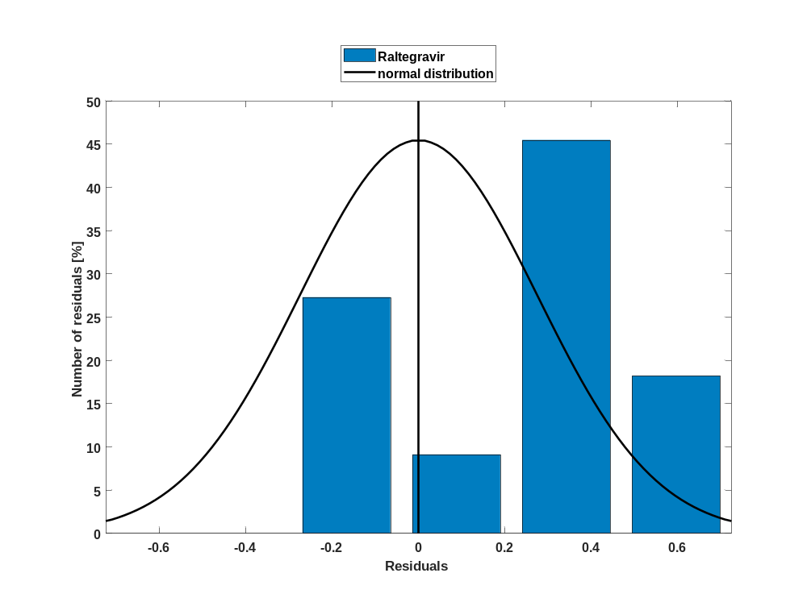

Figure 21: Residuals for Raltegravir 50 mg (lactose formulation) as quantile-quantile plot.
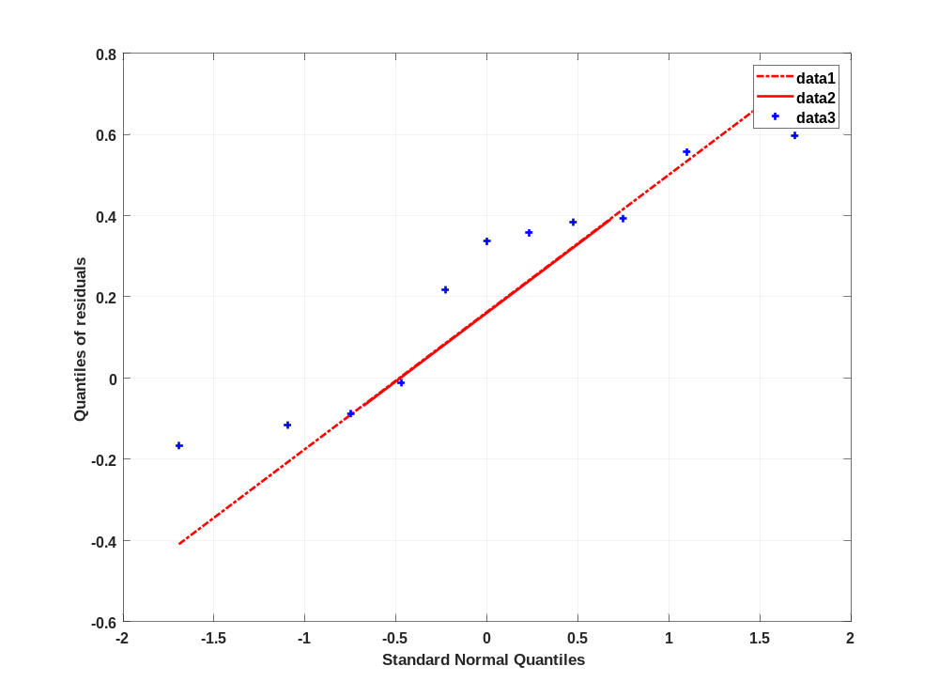

Time profiles for Raltegravir 100 mg (lactose formulation)

Time profiles of Raltegravir

Figure 22: Time profiles of Raltegravir for Raltegravir 100 mg (lactose formulation). Data source: Observed_Raltegravir 100 mg (lactose formulation). Time profiles are plotted in a linear scale.
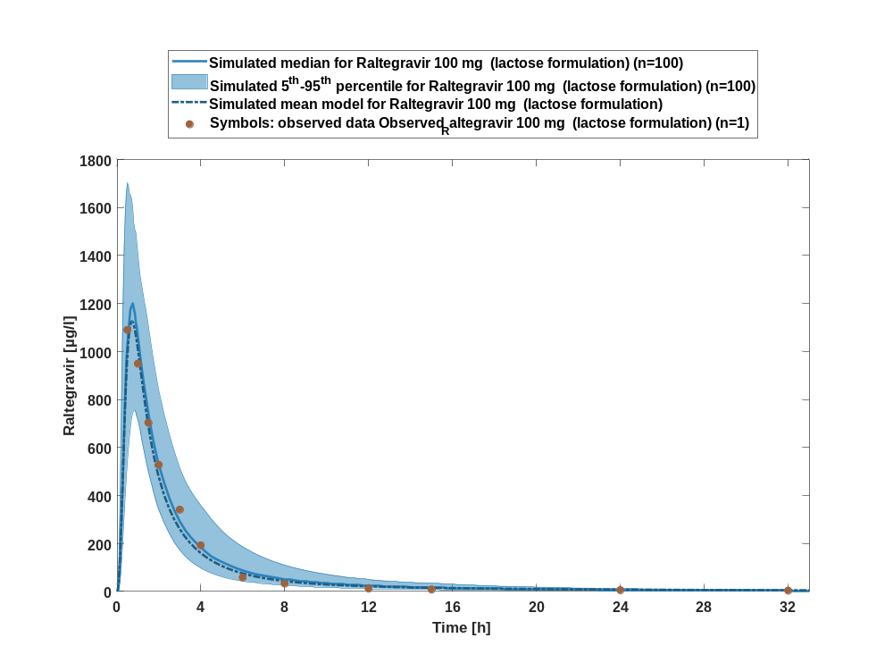

Figure 23: Time profiles of Raltegravir for Raltegravir 100 mg (lactose formulation). Data source: Observed_Raltegravir 100 mg (lactose formulation). Time profiles are plotted in a logarithmic scale.
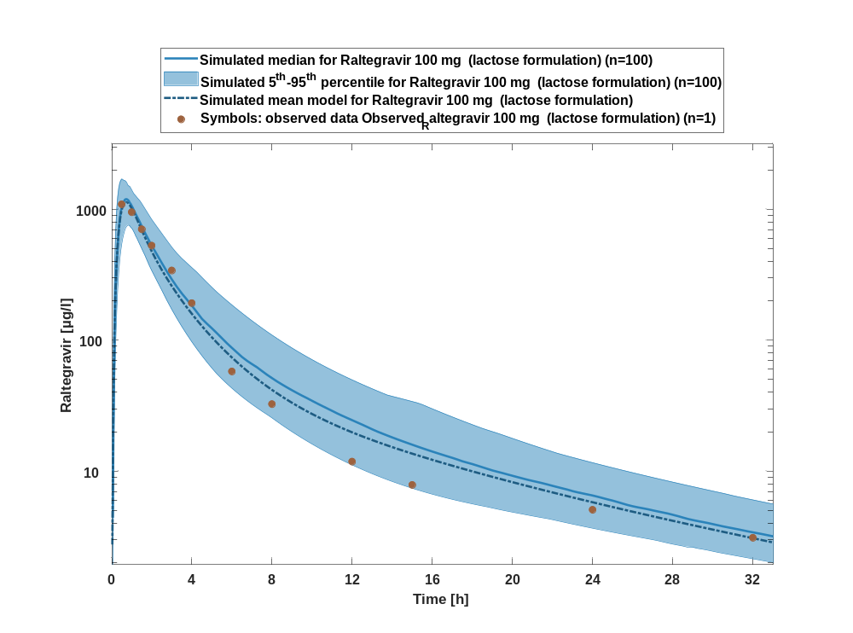

Figure 24: Predicted vs observed of Raltegravir for Raltegravir 100 mg (lactose formulation). Data source: Observed_Raltegravir 100 mg (lactose formulation). Prediction and observations are plotted in a logarithmic scale.
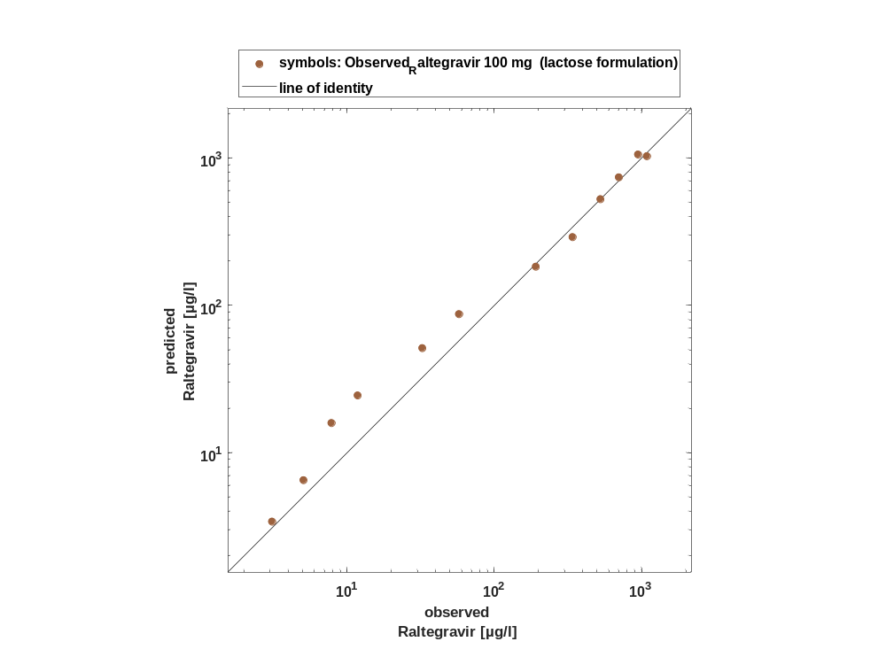

Figure 25: Logarithmic residuals vs time of Raltegravir for Raltegravir 100 mg (lactose formulation). Data source: Observed_Raltegravir 100 mg (lactose formulation).
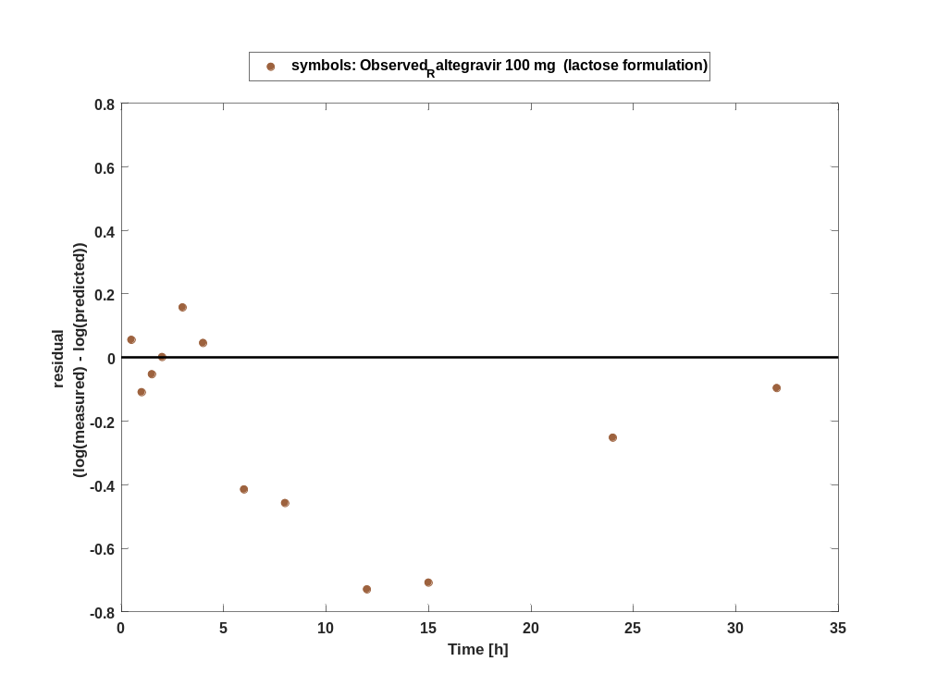

Figure 26: Logarithmic residuals vs predicted values of Raltegravir for Raltegravir 100 mg (lactose formulation). Data source: Observed_Raltegravir 100 mg (lactose formulation).
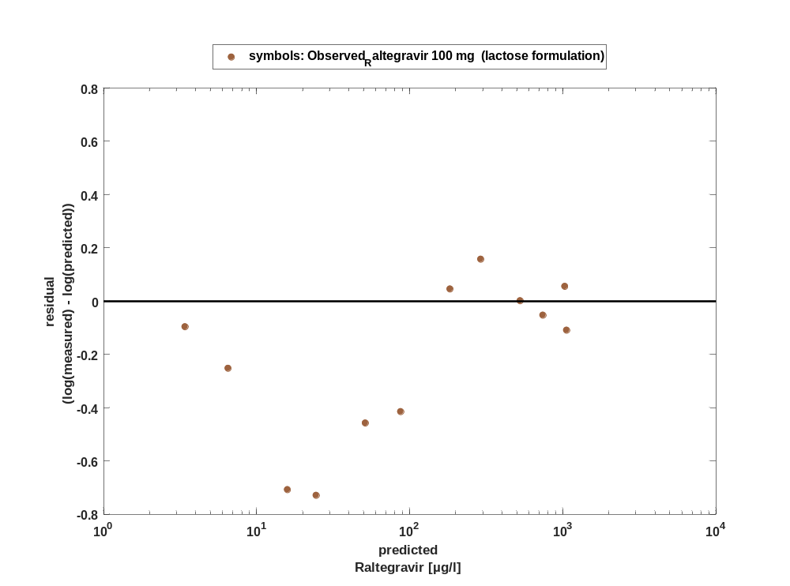

Overview on all residuals

Figure 27: Distribution of residuals for Raltegravir 100 mg (lactose formulation)
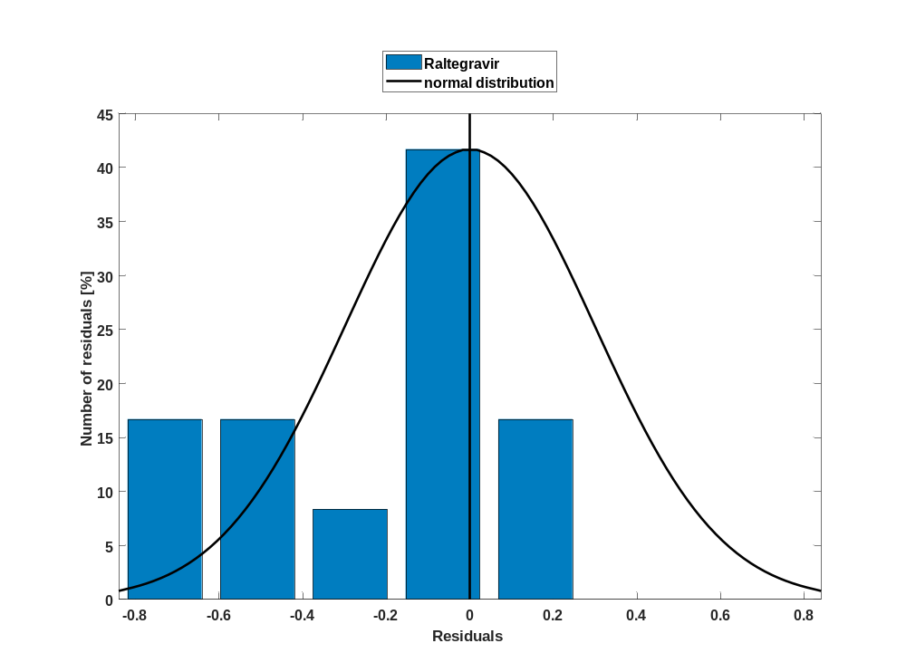

Figure 28: Residuals for Raltegravir 100 mg (lactose formulation) as quantile-quantile plot.
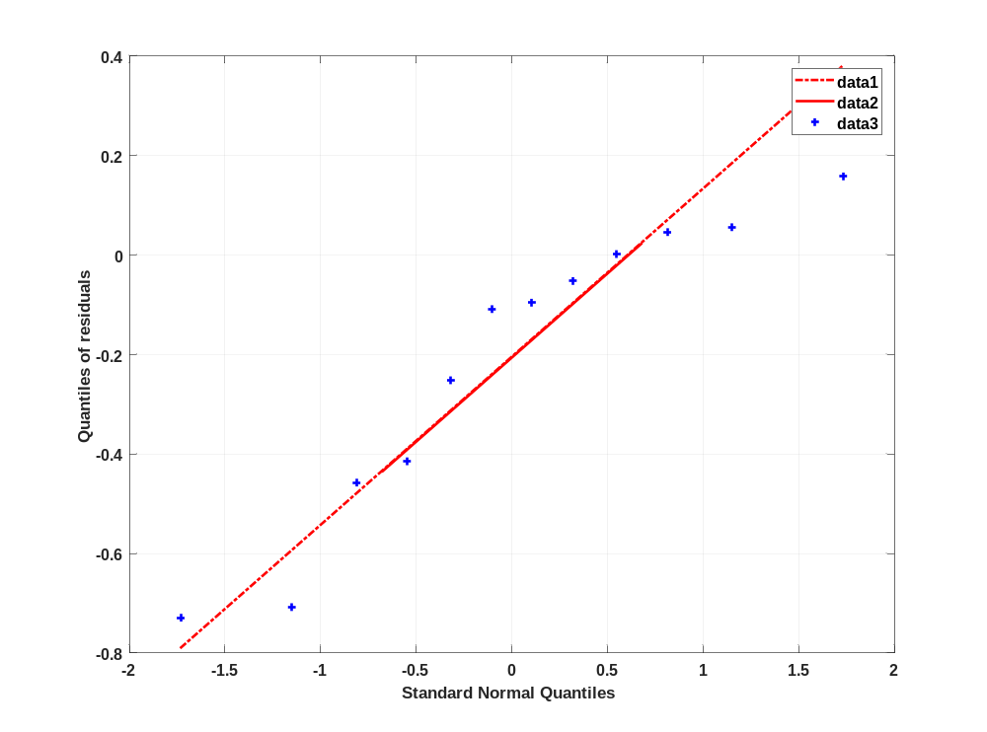

Time profiles for Raltegravir 200 mg (lactose formulation)

Time profiles of Raltegravir

Figure 29: Time profiles of Raltegravir for Raltegravir 200 mg (lactose formulation). Data source: Observed_Raltegravir 200 mg (lactose formulation). Time profiles are plotted in a linear scale.
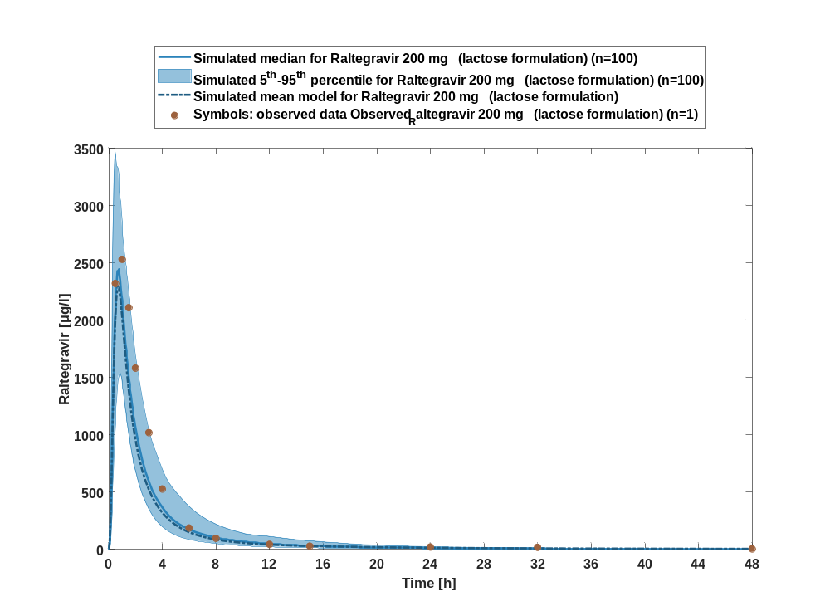

Figure 30: Time profiles of Raltegravir for Raltegravir 200 mg (lactose formulation). Data source: Observed_Raltegravir 200 mg (lactose formulation). Time profiles are plotted in a logarithmic scale.
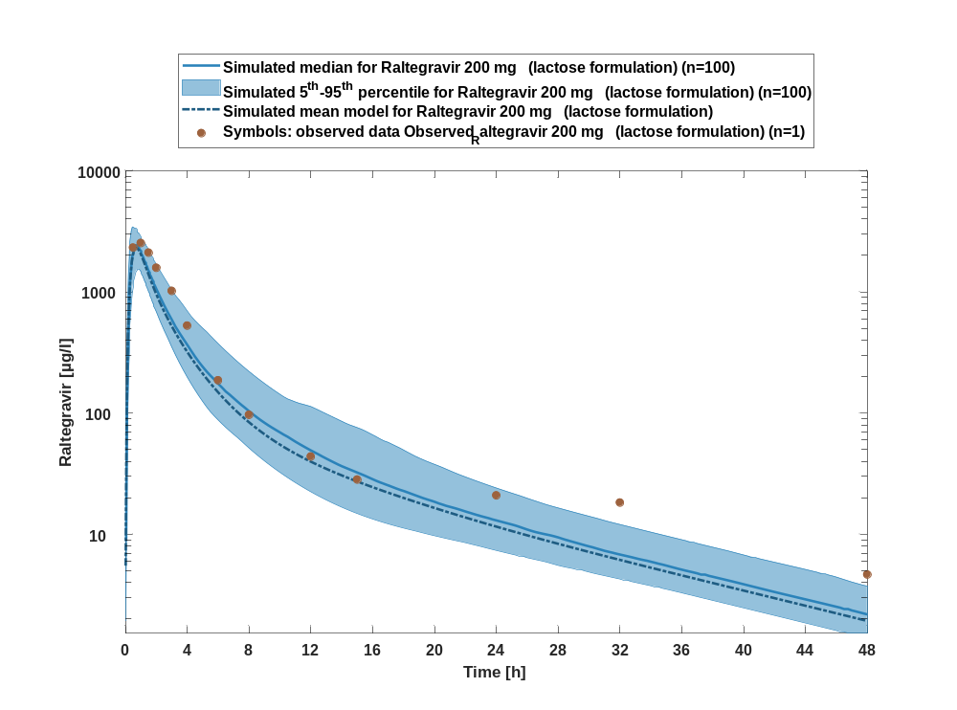

Figure 31: Predicted vs observed of Raltegravir for Raltegravir 200 mg (lactose formulation). Data source: Observed_Raltegravir 200 mg (lactose formulation). Prediction and observations are plotted in a logarithmic scale.
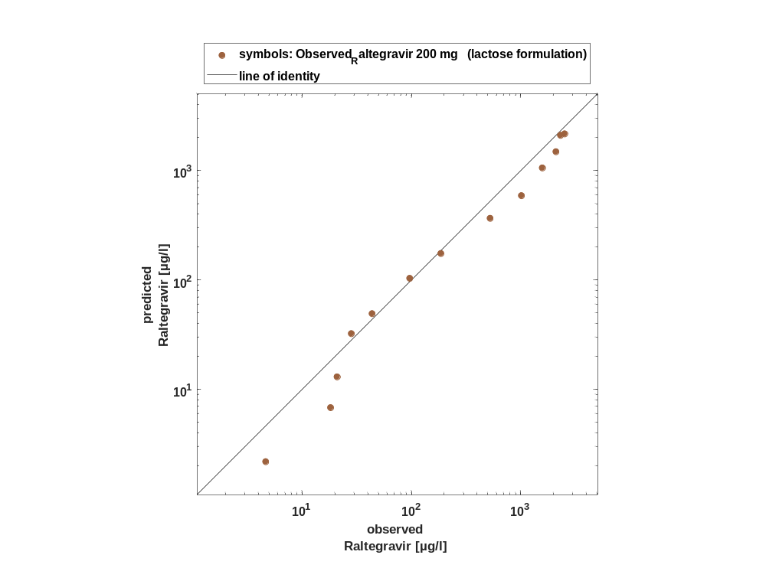

Figure 32: Logarithmic residuals vs time of Raltegravir for Raltegravir 200 mg (lactose formulation). Data source: Observed_Raltegravir 200 mg (lactose formulation).
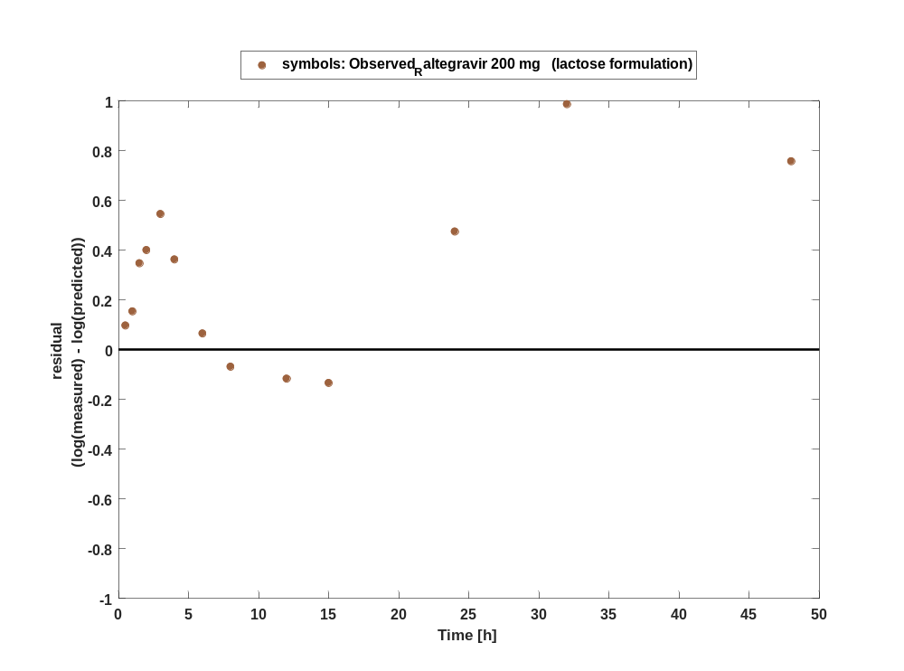

Figure 33: Logarithmic residuals vs predicted values of Raltegravir for Raltegravir 200 mg (lactose formulation). Data source: Observed_Raltegravir 200 mg (lactose formulation).
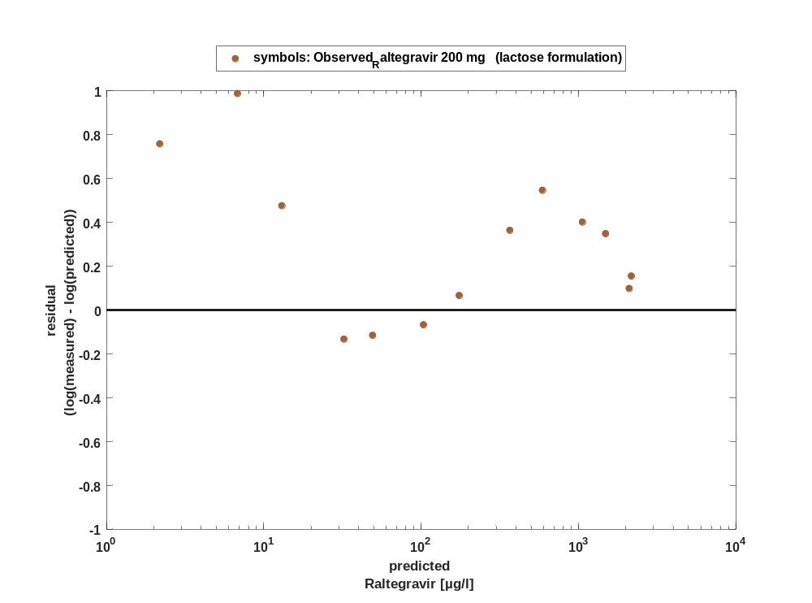

Overview on all residuals

Figure 34: Distribution of residuals for Raltegravir 200 mg (lactose formulation)
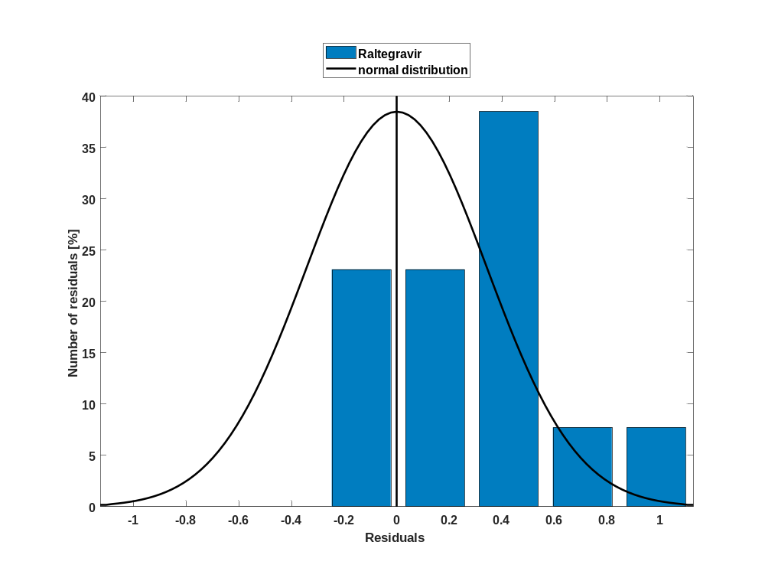

Figure 35: Residuals for Raltegravir 200 mg (lactose formulation) as quantile-quantile plot.
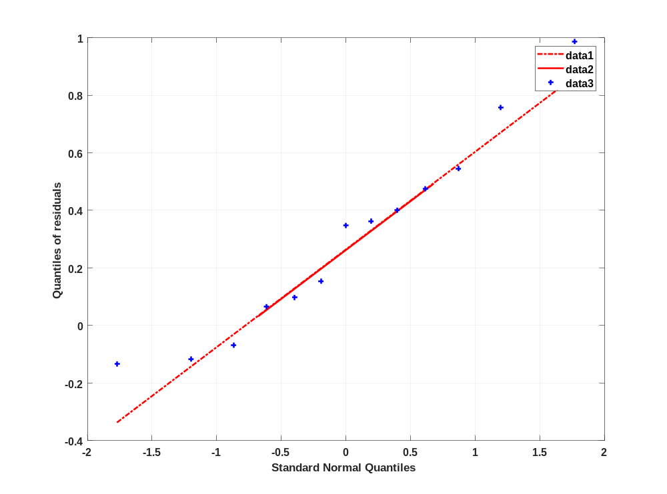

Time profiles for Raltegravir 400mg (lactose formulation)

Time profiles of Raltegravir

Figure 36: Time profiles of Raltegravir for Raltegravir 400mg (lactose formulation). Data source: Observed_Raltegravir 400mg (lactose formulation). Time profiles are plotted in a linear scale.
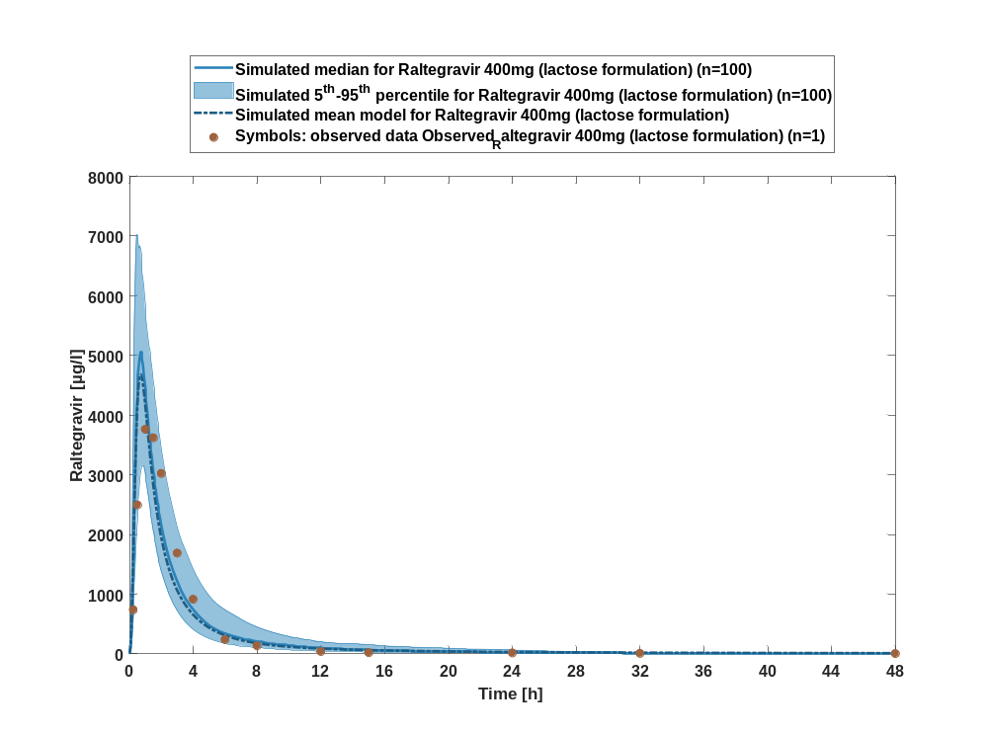

Figure 37: Time profiles of Raltegravir for Raltegravir 400mg (lactose formulation). Data source: Observed_Raltegravir 400mg (lactose formulation). Time profiles are plotted in a logarithmic scale.
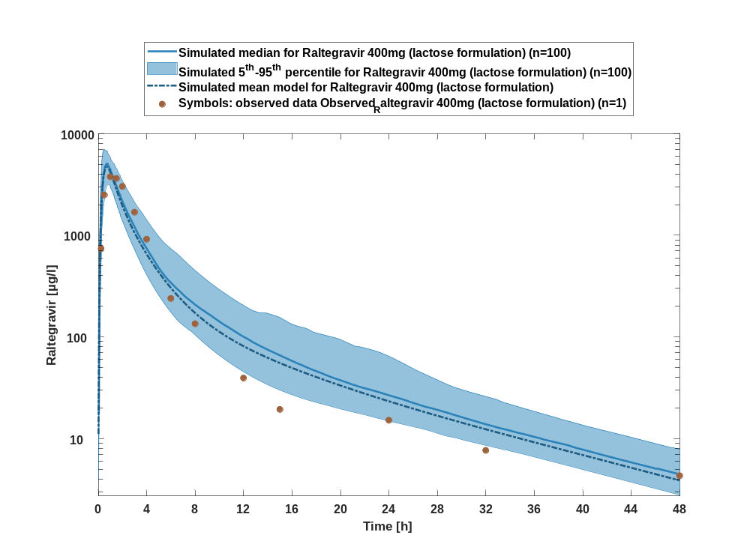

Figure 38: Predicted vs observed of Raltegravir for Raltegravir 400mg (lactose formulation). Data source: Observed_Raltegravir 400mg (lactose formulation). Prediction and observations are plotted in a logarithmic scale.
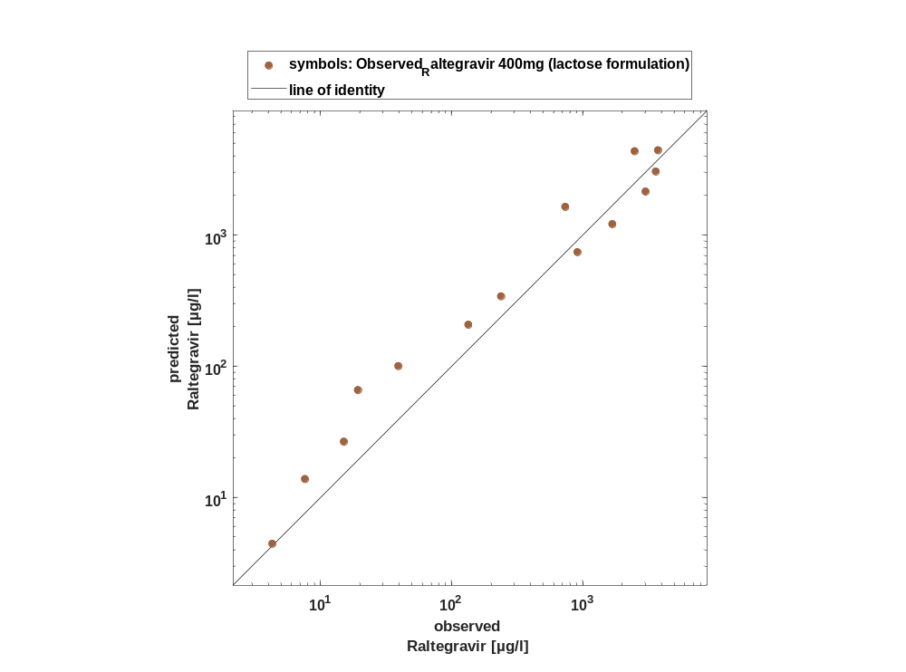

Figure 39: Logarithmic residuals vs time of Raltegravir for Raltegravir 400mg (lactose formulation). Data source: Observed_Raltegravir 400mg (lactose formulation).
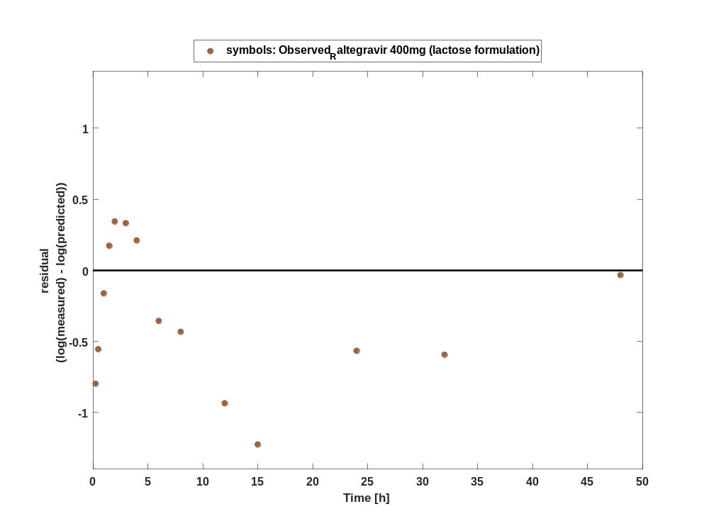

Figure 40: Logarithmic residuals vs predicted values of Raltegravir for Raltegravir 400mg (lactose formulation). Data source: Observed_Raltegravir 400mg (lactose formulation).
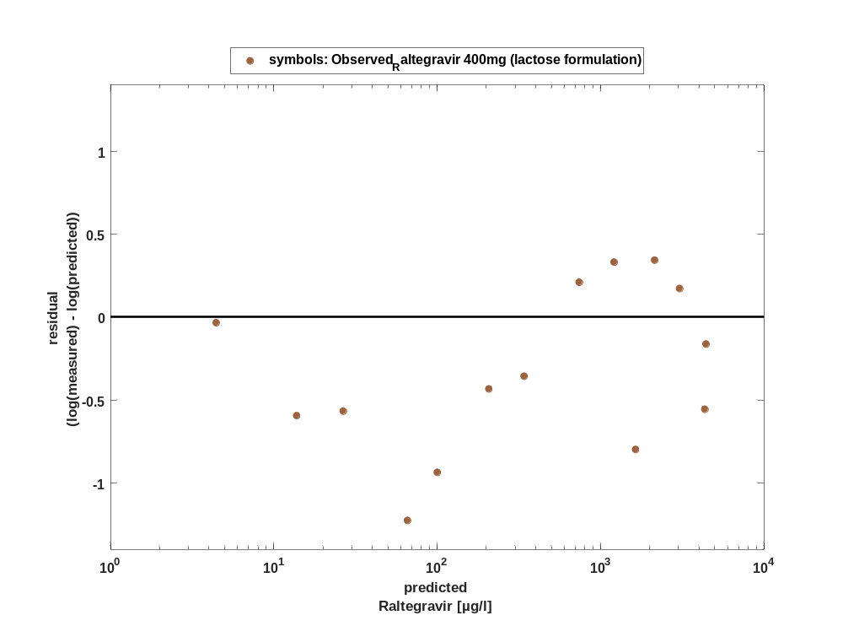

Overview on all residuals

Figure 41: Distribution of residuals for Raltegravir 400mg (lactose formulation)
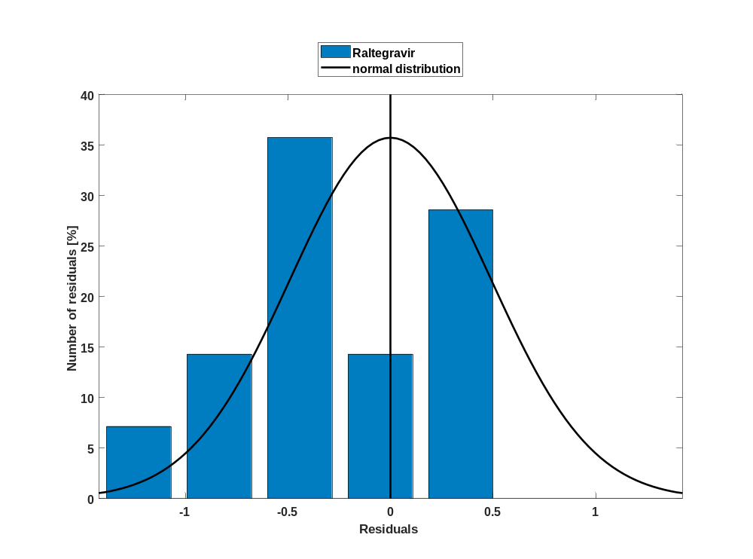

Figure 42: Residuals for Raltegravir 400mg (lactose formulation) as quantile-quantile plot.
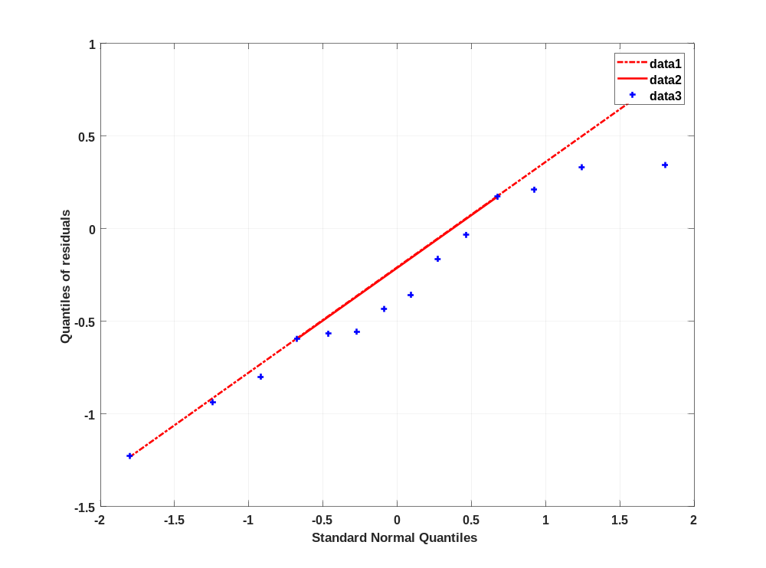

Time profiles for Raltegravir 800 mg (lactose formulation)

Time profiles of Raltegravir

Figure 43: Time profiles of Raltegravir for Raltegravir 800 mg (lactose formulation). Data source: Observed_Raltegravir 800 mg (lactose formulation). Time profiles are plotted in a linear scale.
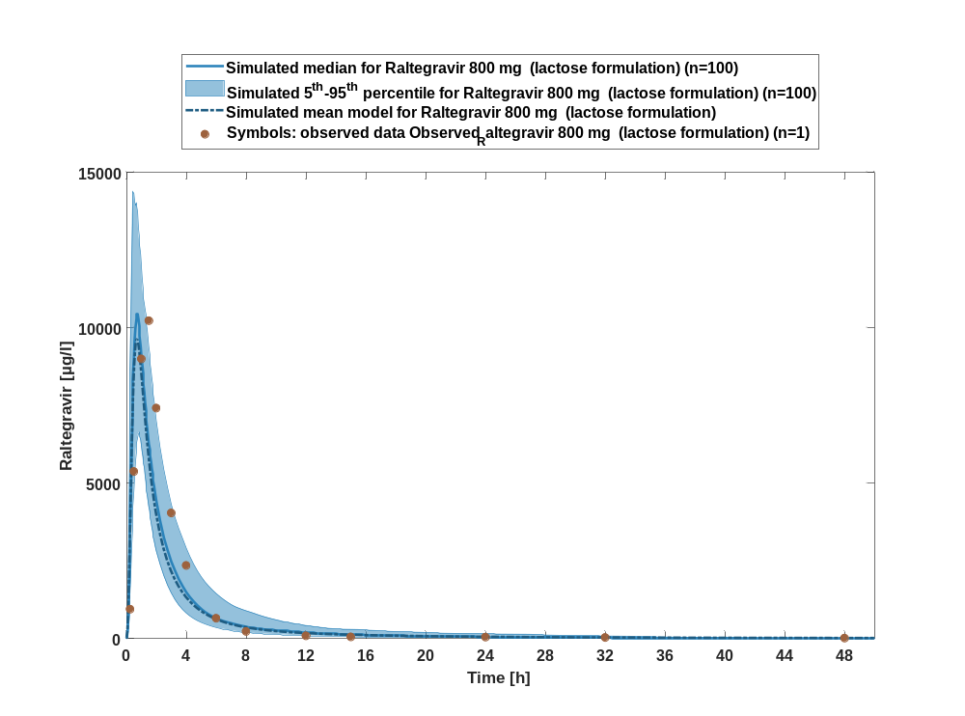

Figure 44: Time profiles of Raltegravir for Raltegravir 800 mg (lactose formulation). Data source: Observed_Raltegravir 800 mg (lactose formulation). Time profiles are plotted in a logarithmic scale.
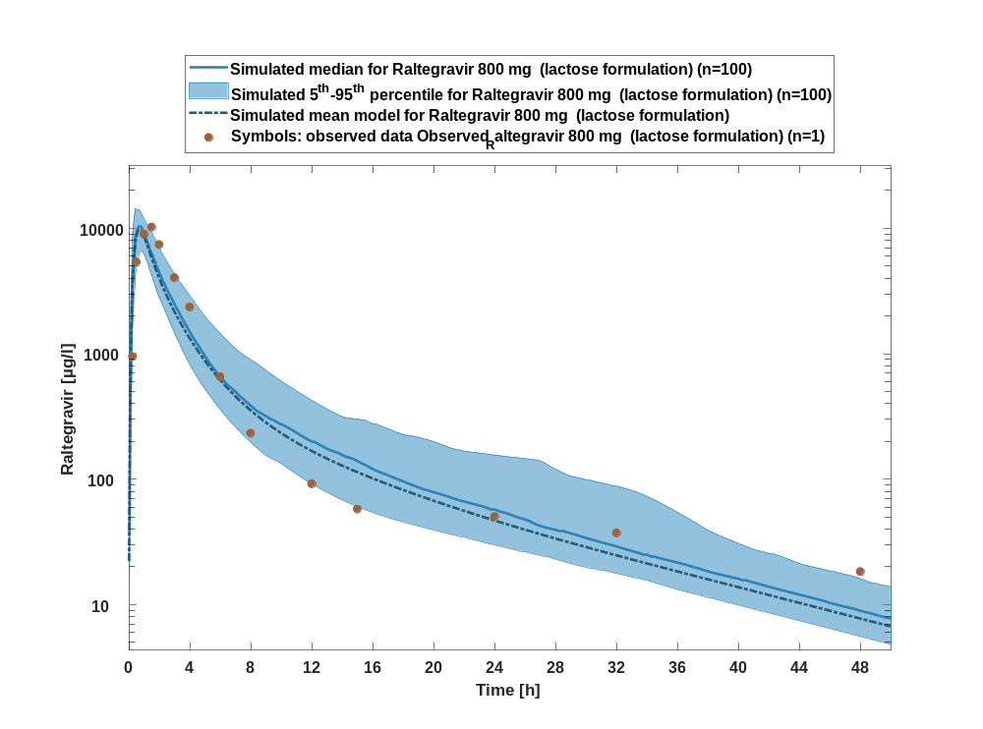

Figure 45: Predicted vs observed of Raltegravir for Raltegravir 800 mg (lactose formulation). Data source: Observed_Raltegravir 800 mg (lactose formulation). Prediction and observations are plotted in a logarithmic scale.
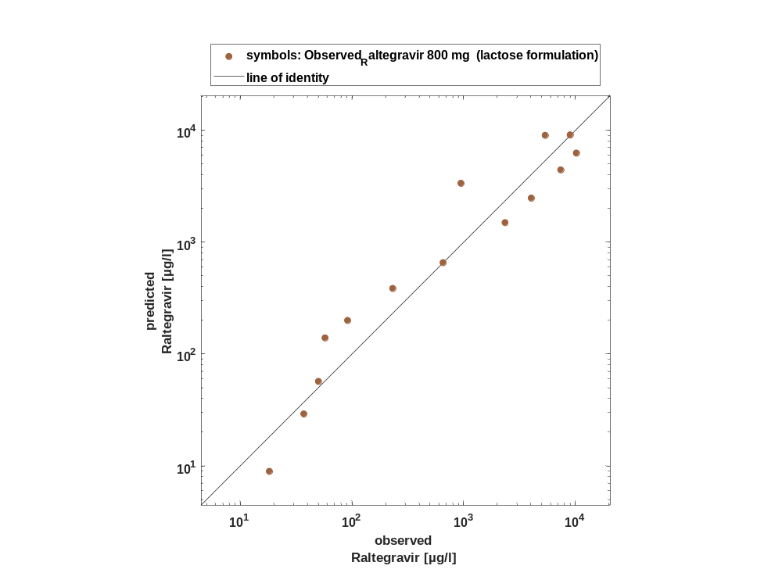

Figure 46: Logarithmic residuals vs time of Raltegravir for Raltegravir 800 mg (lactose formulation). Data source: Observed_Raltegravir 800 mg (lactose formulation).
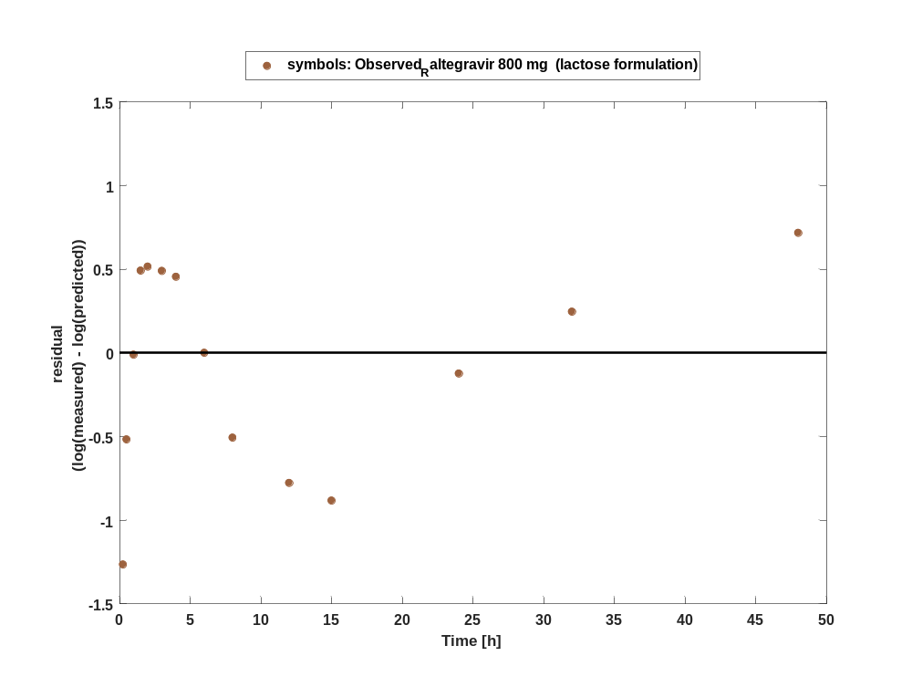

Figure 47: Logarithmic residuals vs predicted values of Raltegravir for Raltegravir 800 mg (lactose formulation). Data source: Observed_Raltegravir 800 mg (lactose formulation).
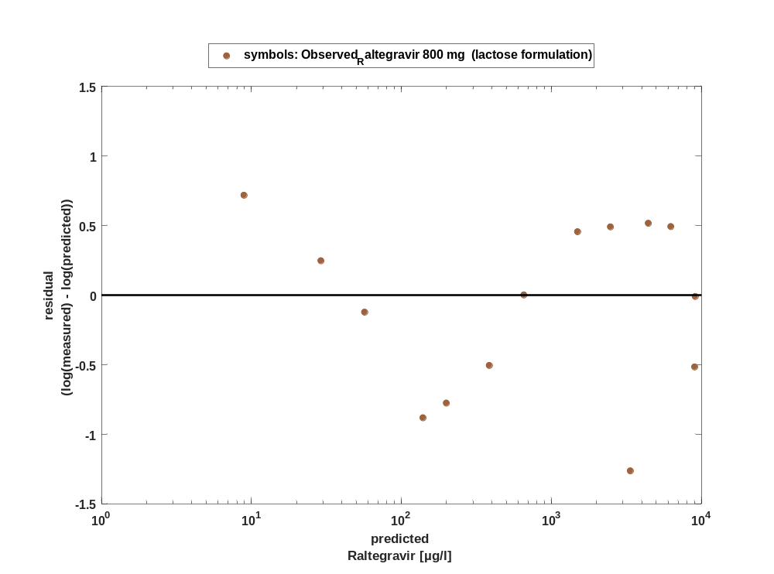

Overview on all residuals

Figure 48: Distribution of residuals for Raltegravir 800 mg (lactose formulation)
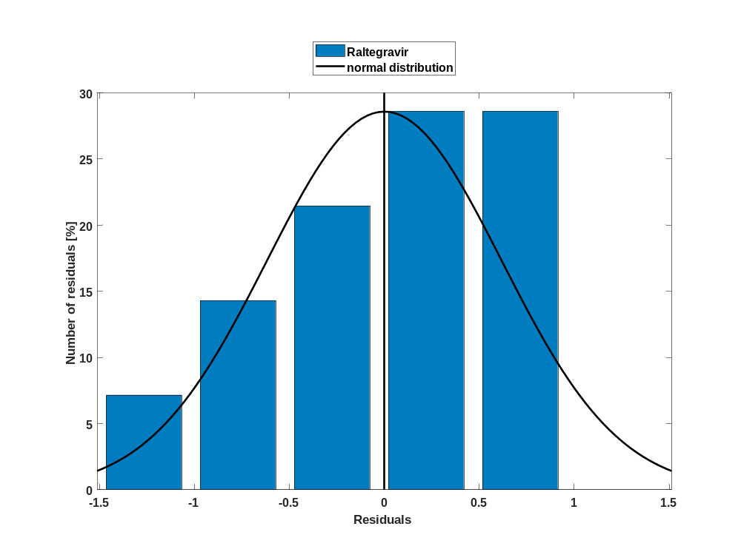

Figure 49: Residuals for Raltegravir 800 mg (lactose formulation) as quantile-quantile plot.
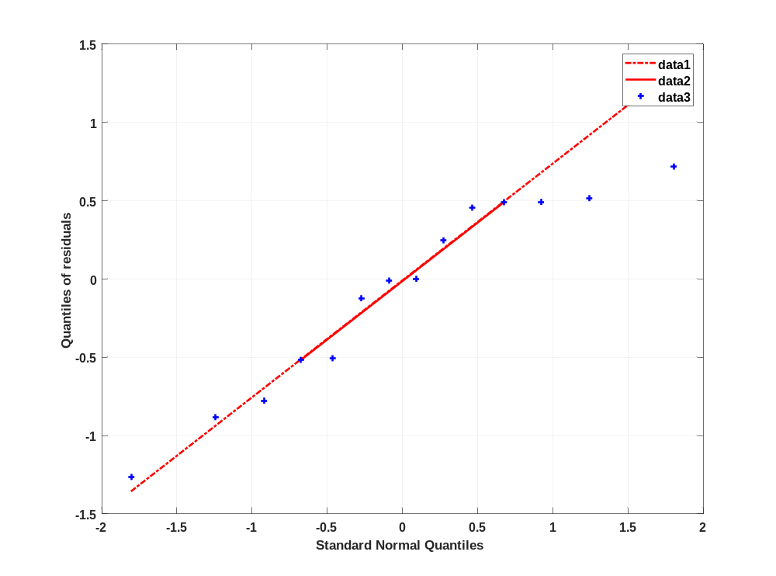

Time profiles for Raltegravir 1200 mg (lactose formulation)

Time profiles of Raltegravir

Figure 50: Time profiles of Raltegravir for Raltegravir 1200 mg (lactose formulation). Data source: Observed_Raltegravir 1200 mg (lactose formulation). Time profiles are plotted in a linear scale.
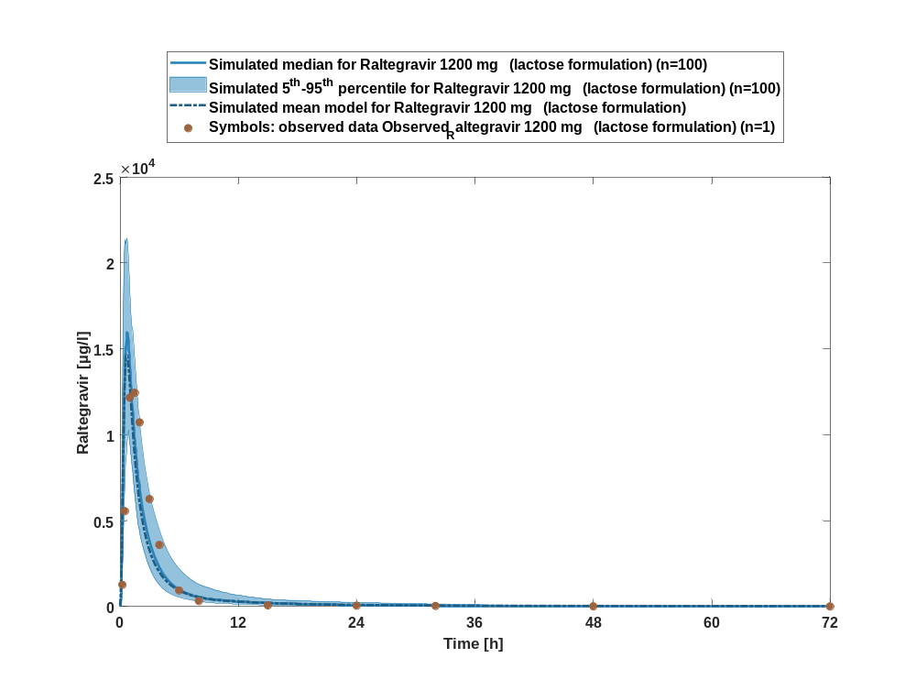

Figure 51: Time profiles of Raltegravir for Raltegravir 1200 mg (lactose formulation). Data source: Observed_Raltegravir 1200 mg (lactose formulation). Time profiles are plotted in a logarithmic scale.
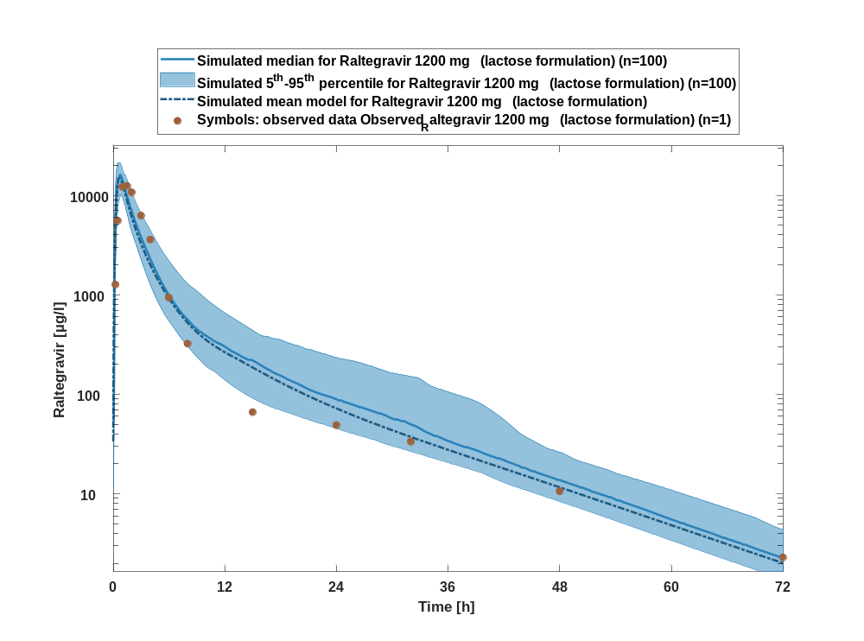

Figure 52: Predicted vs observed of Raltegravir for Raltegravir 1200 mg (lactose formulation). Data source: Observed_Raltegravir 1200 mg (lactose formulation). Prediction and observations are plotted in a logarithmic scale.
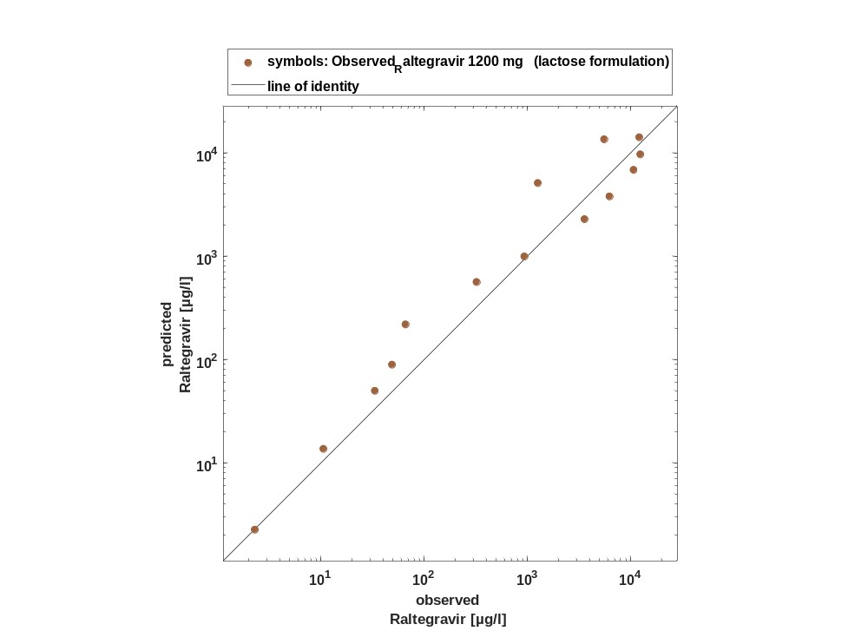

Figure 53: Logarithmic residuals vs time of Raltegravir for Raltegravir 1200 mg (lactose formulation). Data source: Observed_Raltegravir 1200 mg (lactose formulation).
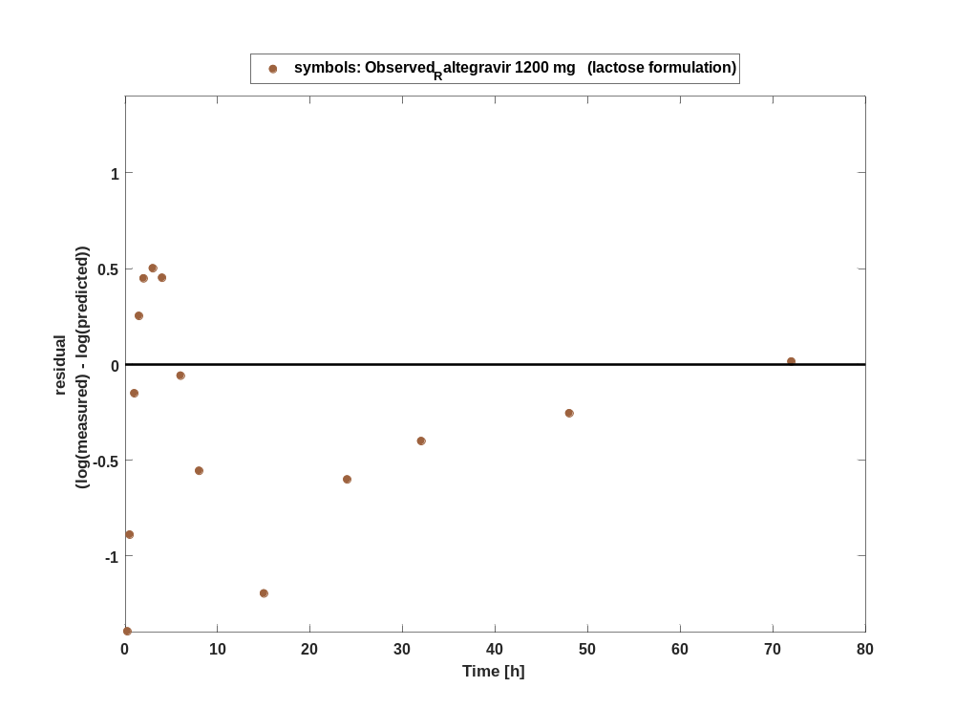

Figure 54: Logarithmic residuals vs predicted values of Raltegravir for Raltegravir 1200 mg (lactose formulation). Data source: Observed_Raltegravir 1200 mg (lactose formulation).
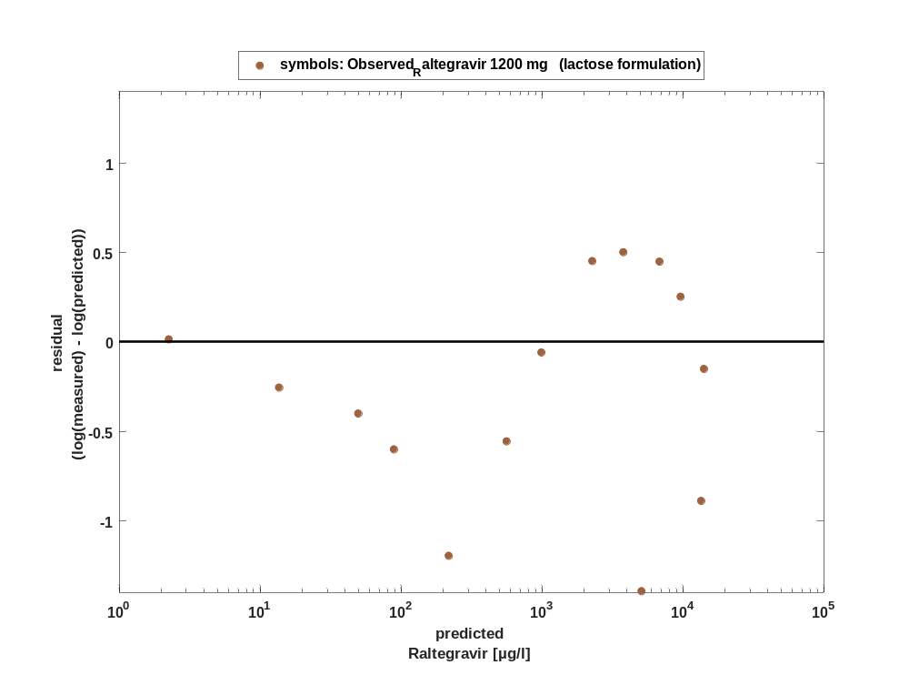

Overview on all residuals

Figure 55: Distribution of residuals for Raltegravir 1200 mg (lactose formulation)
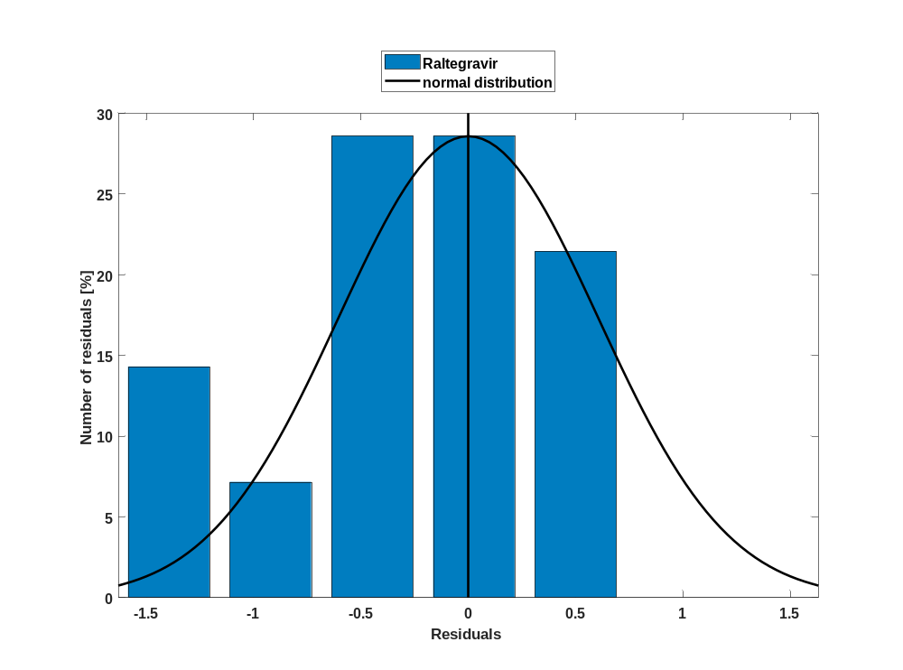

Figure 56: Residuals for Raltegravir 1200 mg (lactose formulation) as quantile-quantile plot.
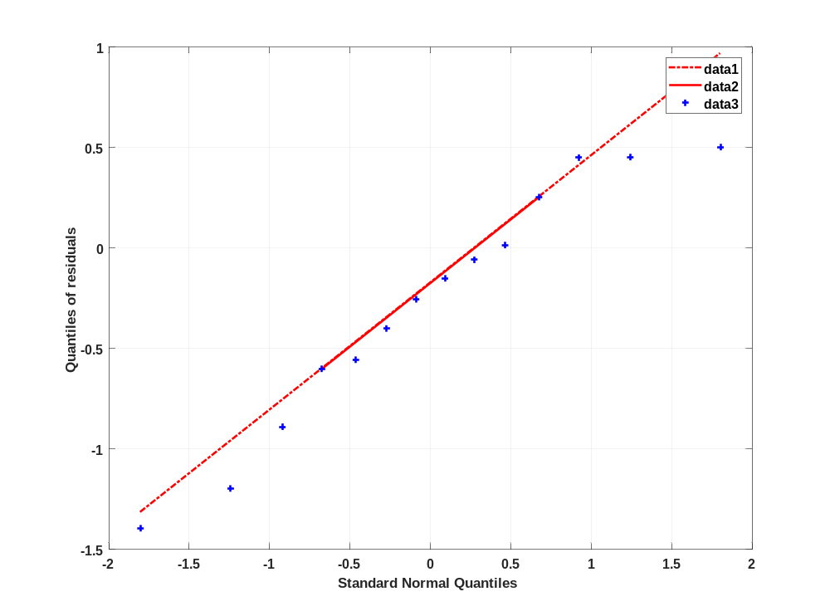

Time profiles for Raltegravir 1600 mg (lactose formulation)

Time profiles of Raltegravir

Figure 57: Time profiles of Raltegravir for Raltegravir 1600 mg (lactose formulation). Data source: Observed_Raltegravir 1600 mg (lactose formulation). Time profiles are plotted in a linear scale.
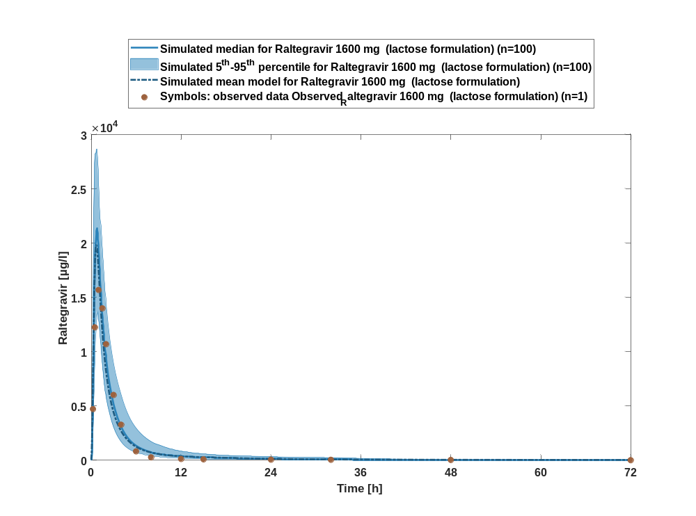

Figure 58: Time profiles of Raltegravir for Raltegravir 1600 mg (lactose formulation). Data source: Observed_Raltegravir 1600 mg (lactose formulation). Time profiles are plotted in a logarithmic scale.
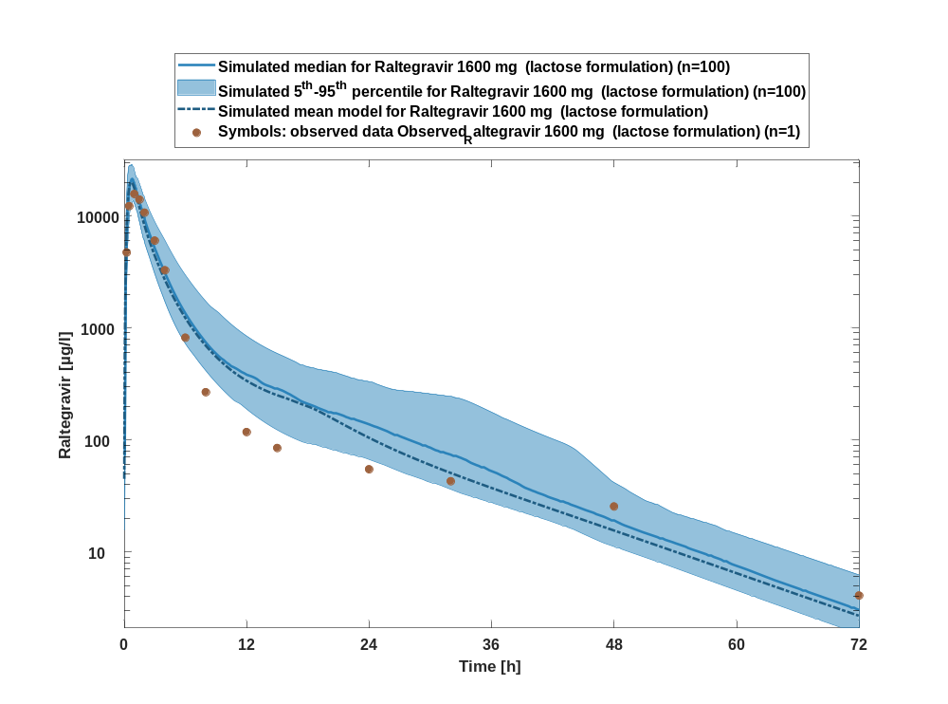

Figure 59: Predicted vs observed of Raltegravir for Raltegravir 1600 mg (lactose formulation). Data source: Observed_Raltegravir 1600 mg (lactose formulation). Prediction and observations are plotted in a logarithmic scale.
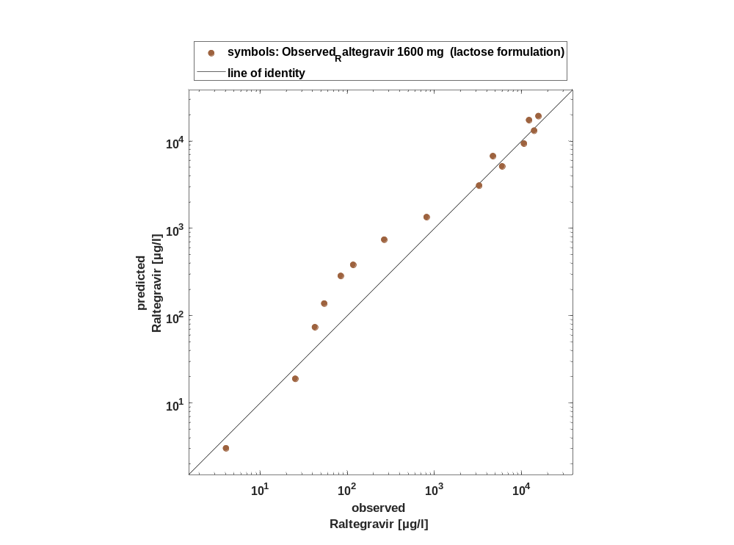

Figure 60: Logarithmic residuals vs time of Raltegravir for Raltegravir 1600 mg (lactose formulation). Data source: Observed_Raltegravir 1600 mg (lactose formulation).
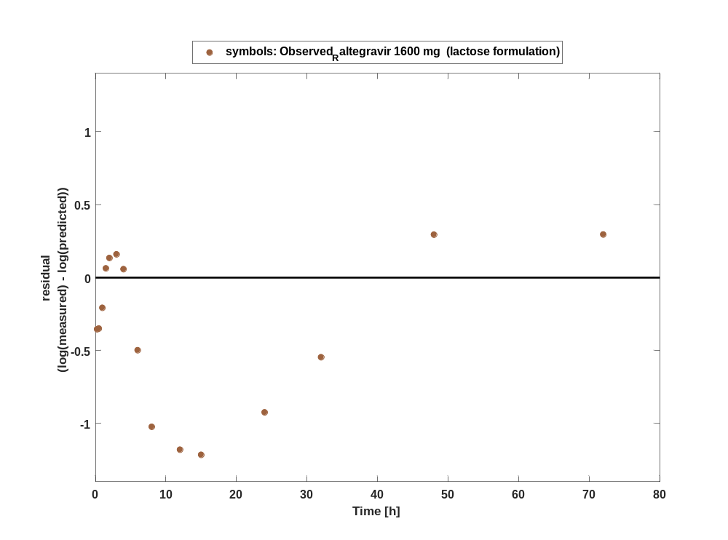

Figure 61: Logarithmic residuals vs predicted values of Raltegravir for Raltegravir 1600 mg (lactose formulation). Data source: Observed_Raltegravir 1600 mg (lactose formulation).
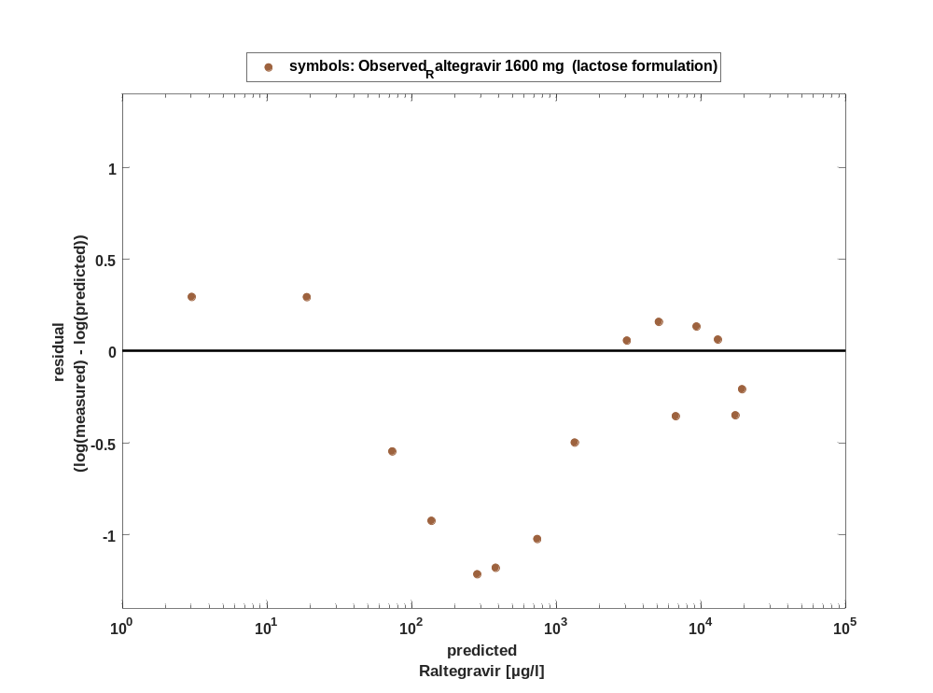

Overview on all residuals

Figure 62: Distribution of residuals for Raltegravir 1600 mg (lactose formulation)
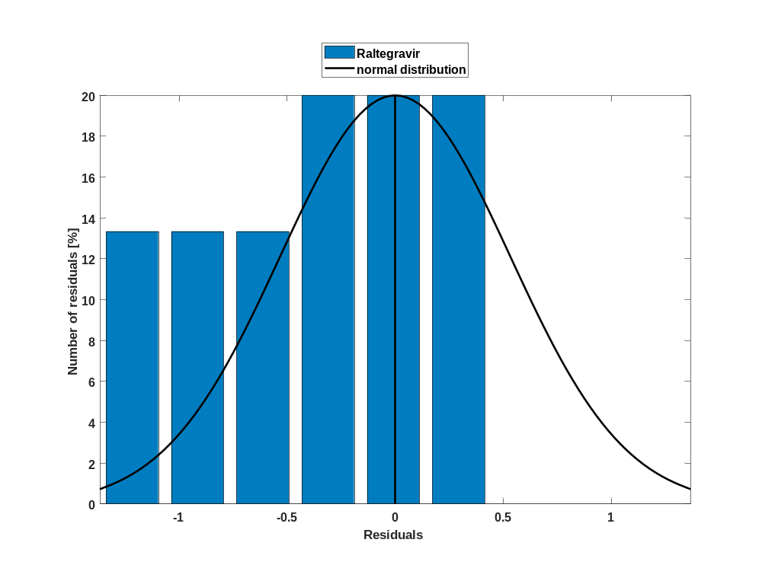

Figure 63: Residuals for Raltegravir 1600 mg (lactose formulation) as quantile-quantile plot.
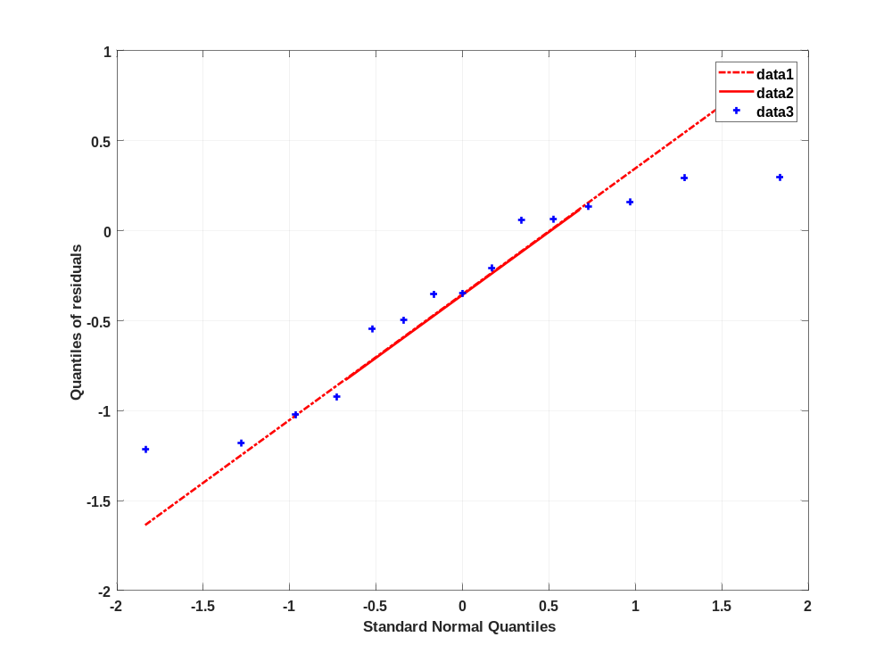

Time profiles for Raltegravir 100 mg filmcoated tablet md

Time profiles of Raltegravir

For total simulation time range

Figure 64: Time profiles of Raltegravir for Raltegravir 100 mg filmcoated tablet md for total simulation time range. Data source: Observed_Raltegravir 100 mg filmcoated tablet md. Time profiles are plotted in a linear scale.
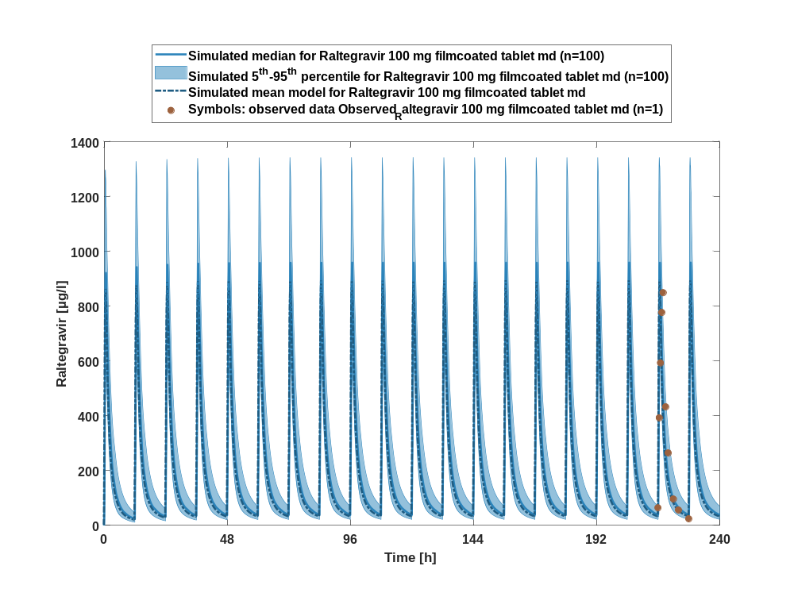

Figure 65: Time profiles of Raltegravir for Raltegravir 100 mg filmcoated tablet md for total simulation time range. Data source: Observed_Raltegravir 100 mg filmcoated tablet md. Time profiles are plotted in a logarithmic scale.
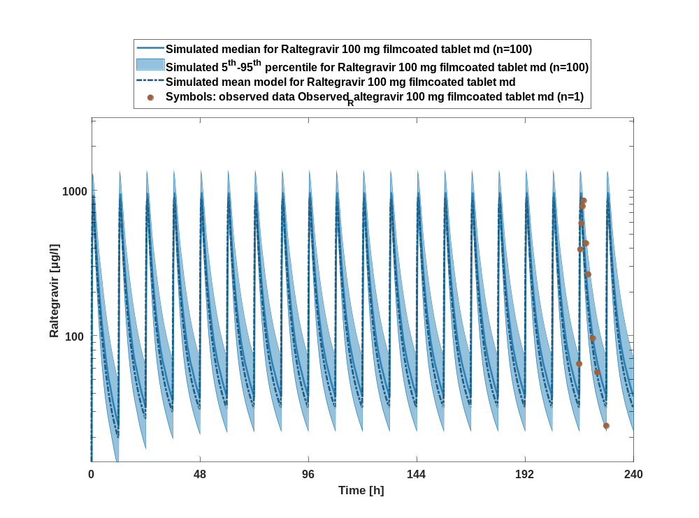

Figure 66: Predicted vs observed of Raltegravir for Raltegravir 100 mg filmcoated tablet md. Data source: Observed_Raltegravir 100 mg filmcoated tablet md. Prediction and observations are plotted in a logarithmic scale.
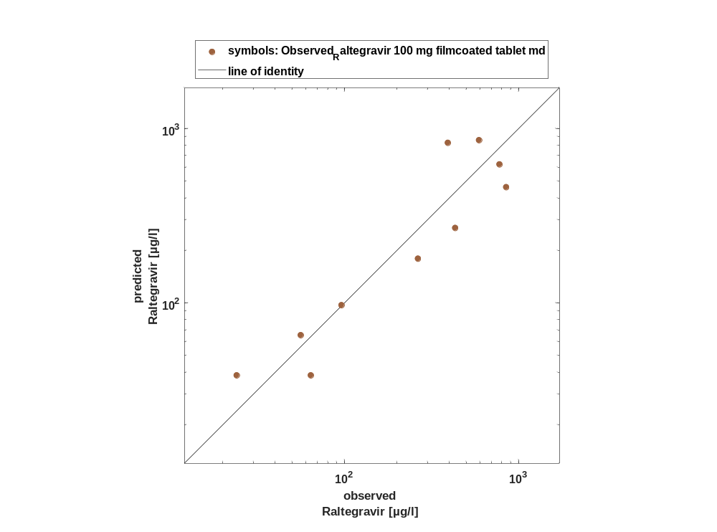

Figure 67: Logarithmic residuals vs time of Raltegravir for Raltegravir 100 mg filmcoated tablet md. Data source: Observed_Raltegravir 100 mg filmcoated tablet md.
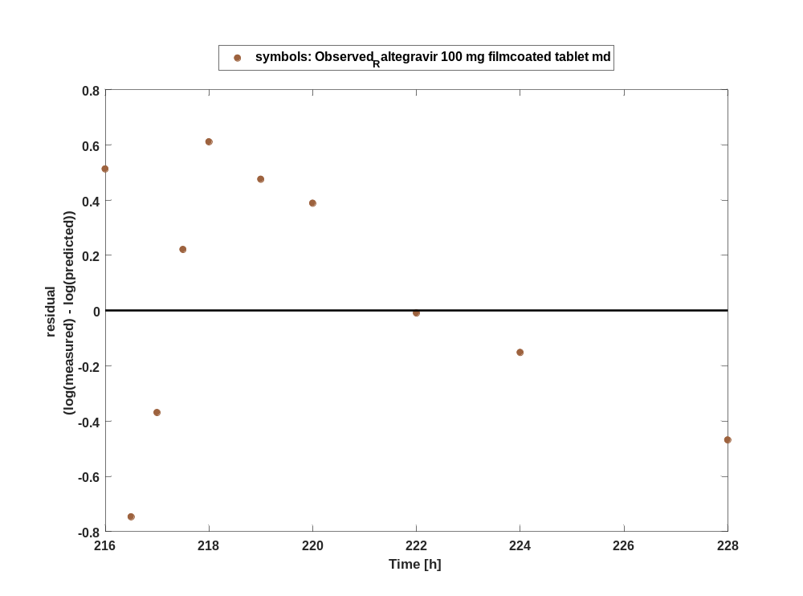

Figure 68: Logarithmic residuals vs predicted values of Raltegravir for Raltegravir 100 mg filmcoated tablet md. Data source: Observed_Raltegravir 100 mg filmcoated tablet md.
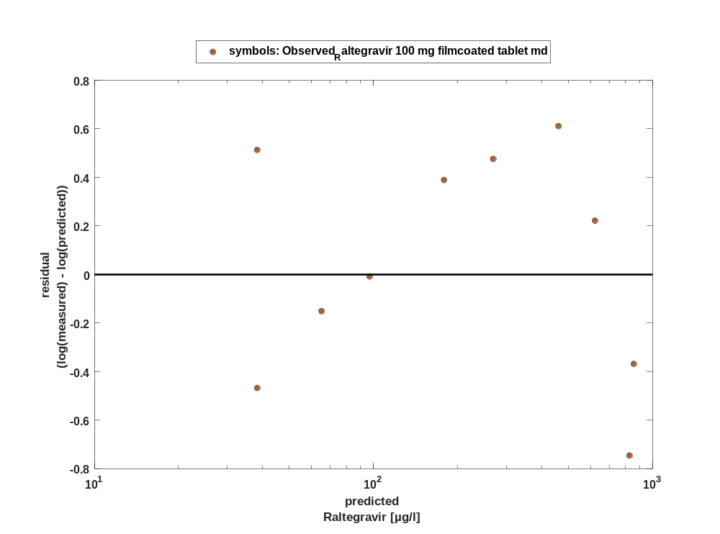

For first application range

Figure 69: Time profiles of Raltegravir for Raltegravir 100 mg filmcoated tablet md for first application range. Data source: Observed_Raltegravir 100 mg filmcoated tablet md. Time profiles are plotted in a linear scale.
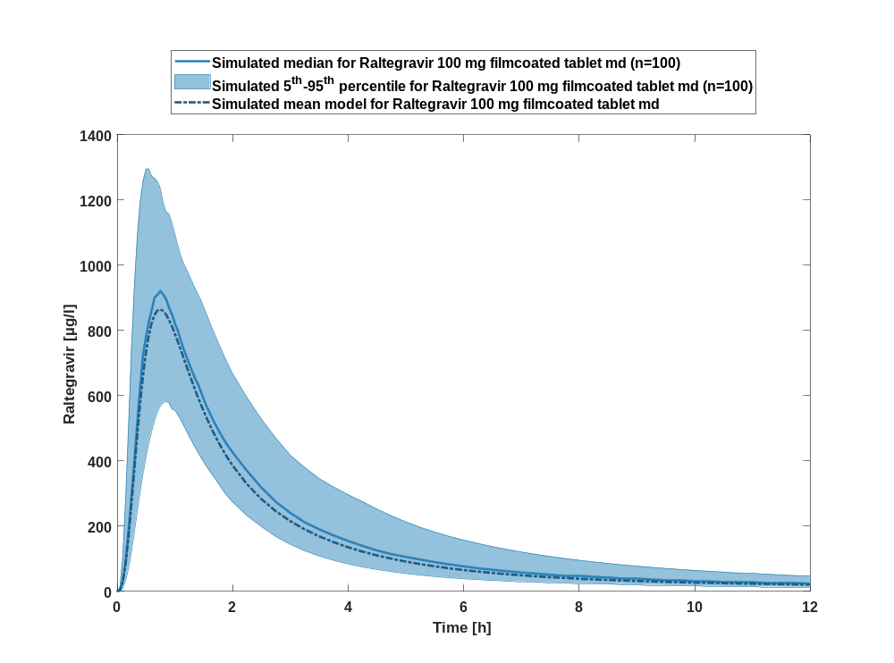

Figure 70: Time profiles of Raltegravir for Raltegravir 100 mg filmcoated tablet md for first application range. Data source: Observed_Raltegravir 100 mg filmcoated tablet md. Time profiles are plotted in a logarithmic scale.
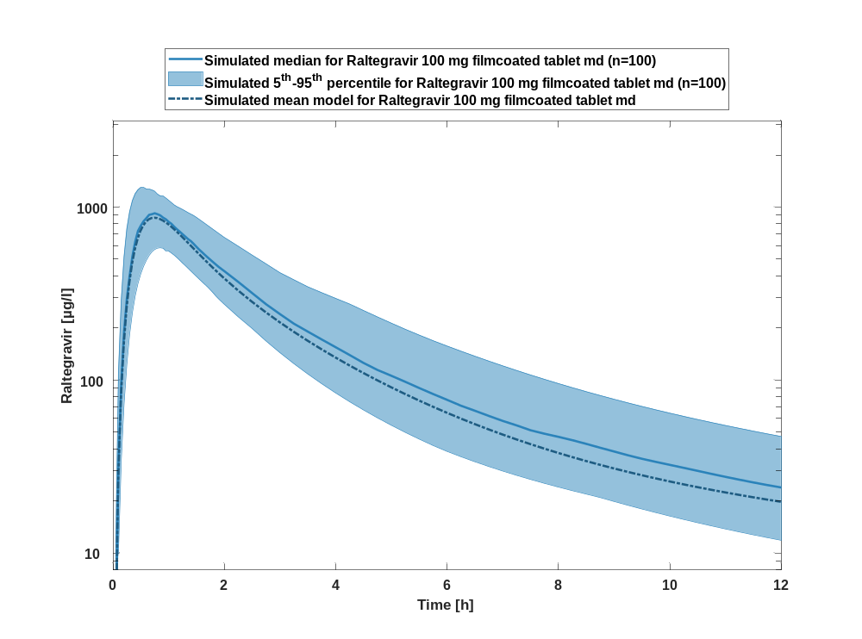

For last application range

Figure 71: Time profiles of Raltegravir for Raltegravir 100 mg filmcoated tablet md for last application range. Data source: Observed_Raltegravir 100 mg filmcoated tablet md. Time profiles are plotted in a linear scale.
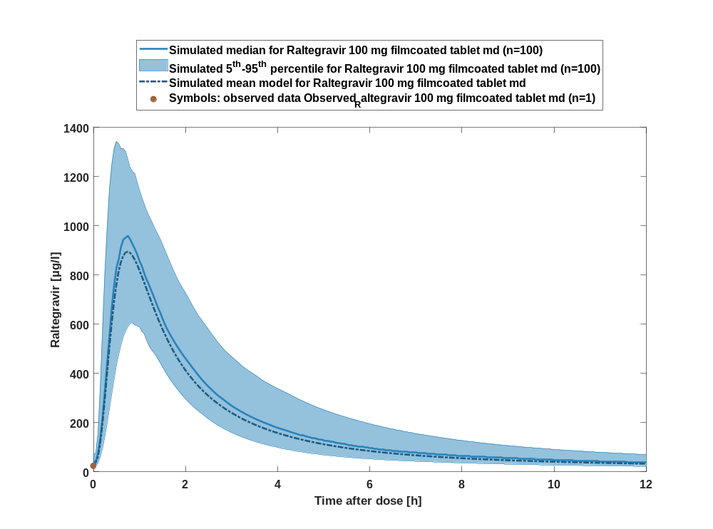

Figure 72: Time profiles of Raltegravir for Raltegravir 100 mg filmcoated tablet md for last application range. Data source: Observed_Raltegravir 100 mg filmcoated tablet md. Time profiles are plotted in a logarithmic scale.
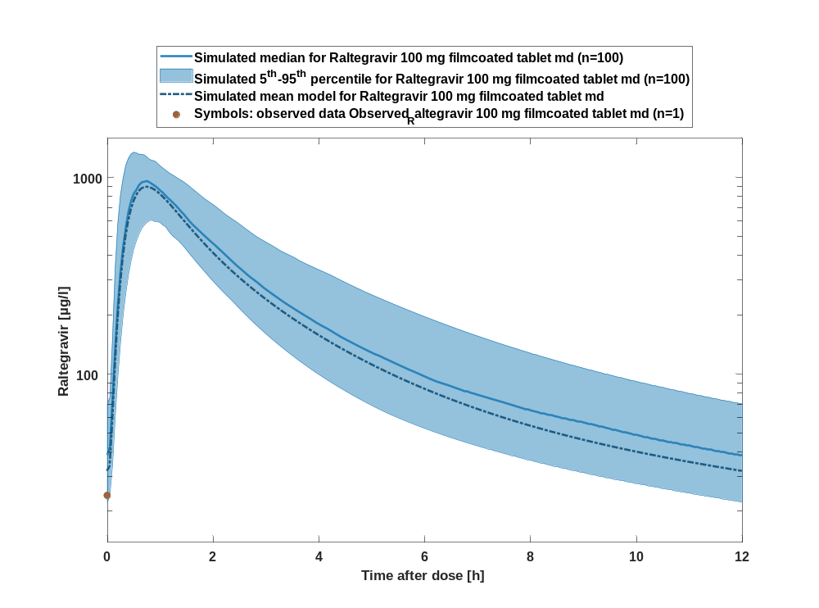

Figure 73: Predicted vs observed of Raltegravir for Raltegravir 100 mg filmcoated tablet md. Data source: Observed_Raltegravir 100 mg filmcoated tablet md. Prediction and observations are plotted in a logarithmic scale.
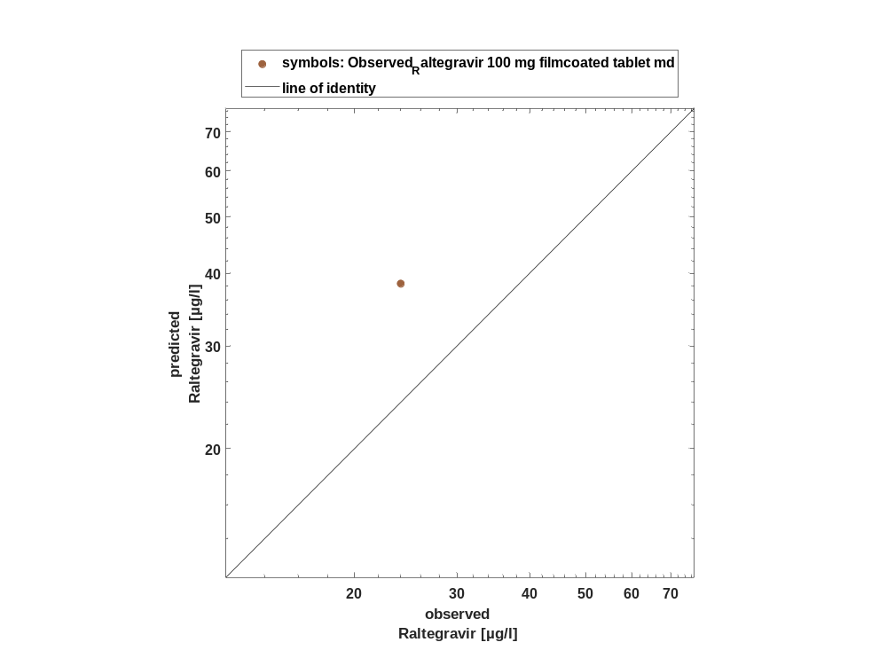

Figure 74: Logarithmic residuals vs time of Raltegravir for Raltegravir 100 mg filmcoated tablet md. Data source: Observed_Raltegravir 100 mg filmcoated tablet md.
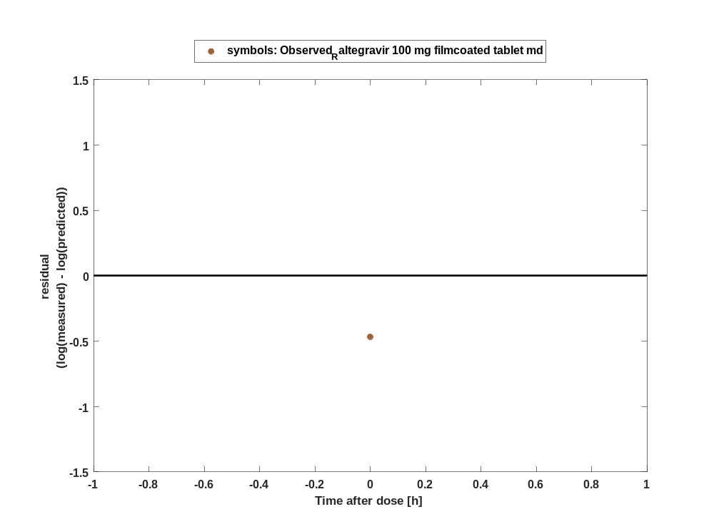

Figure 75: Logarithmic residuals vs predicted values of Raltegravir for Raltegravir 100 mg filmcoated tablet md. Data source: Observed_Raltegravir 100 mg filmcoated tablet md.
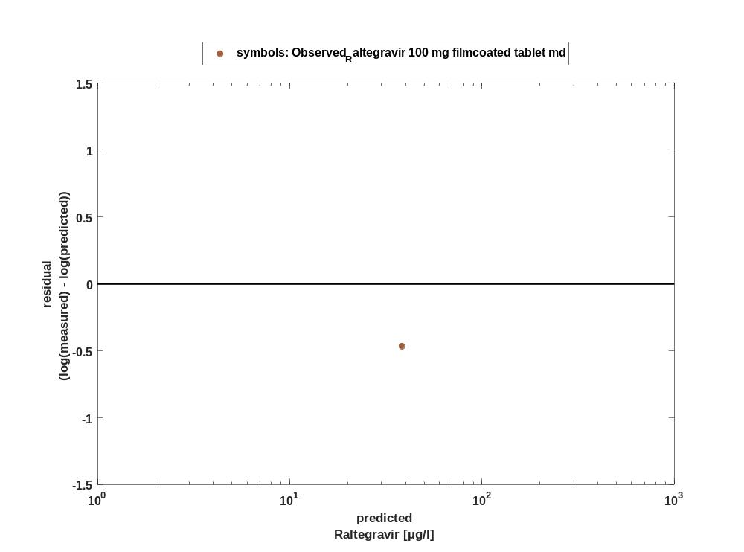

Overview on all residuals

Figure 76: Distribution of residuals for Raltegravir 100 mg filmcoated tablet md
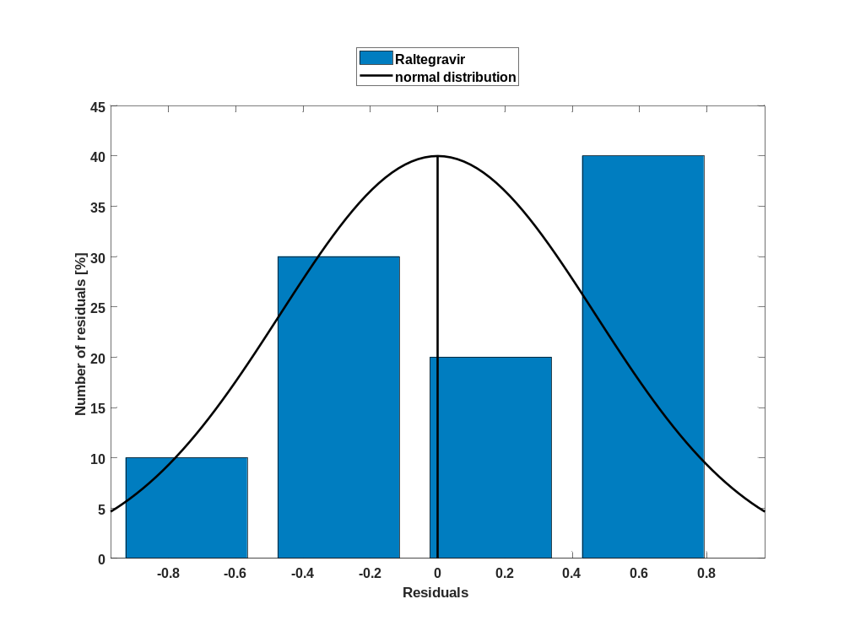

Figure 77: Residuals for Raltegravir 100 mg filmcoated tablet md as quantile-quantile plot.
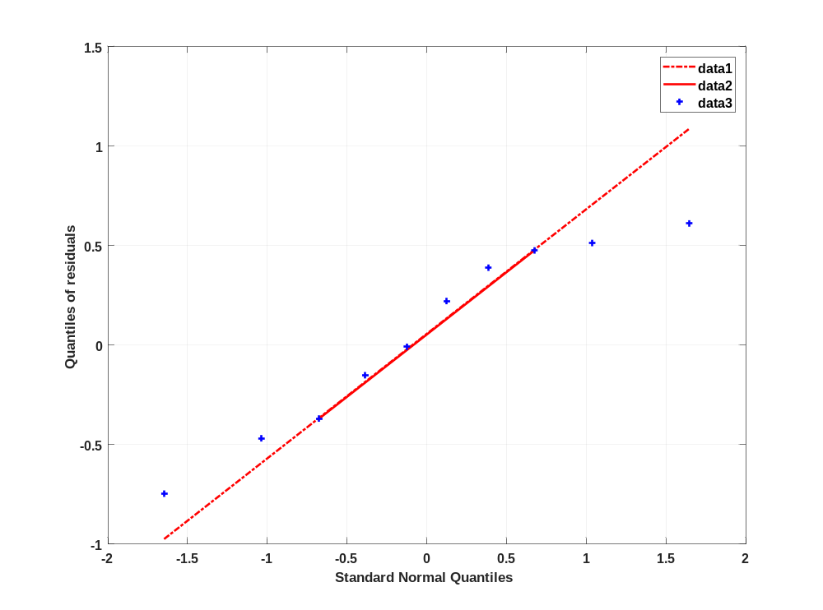

Time profiles for Raltegravir 200 mg filmcoated tablet md

Time profiles of Raltegravir

For total simulation time range

Figure 78: Time profiles of Raltegravir for Raltegravir 200 mg filmcoated tablet md for total simulation time range. Data source: Observed_Raltegravir 200 mg filmcoated tablet md. Time profiles are plotted in a linear scale.
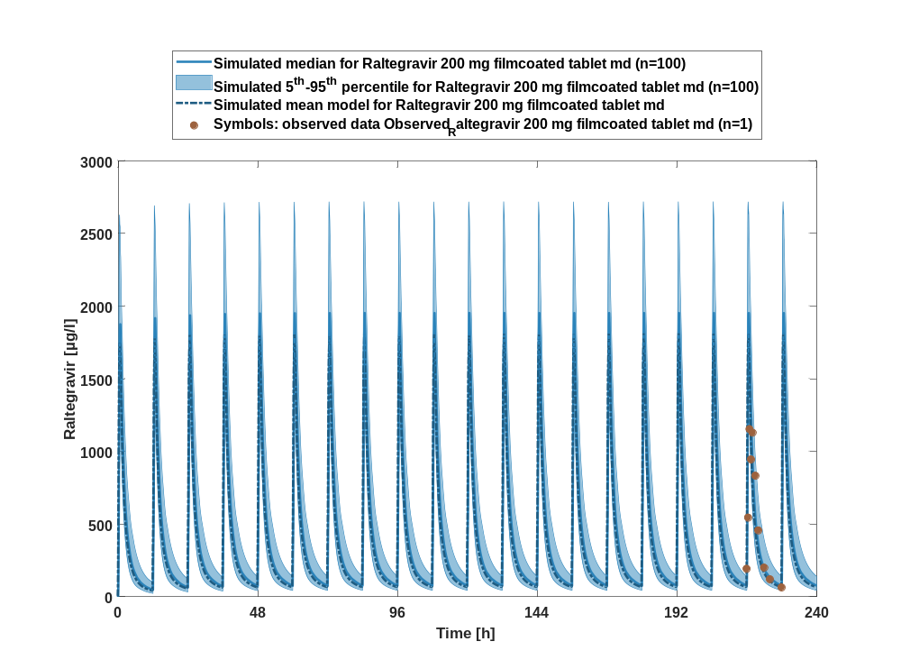

Figure 79: Time profiles of Raltegravir for Raltegravir 200 mg filmcoated tablet md for total simulation time range. Data source: Observed_Raltegravir 200 mg filmcoated tablet md. Time profiles are plotted in a logarithmic scale.
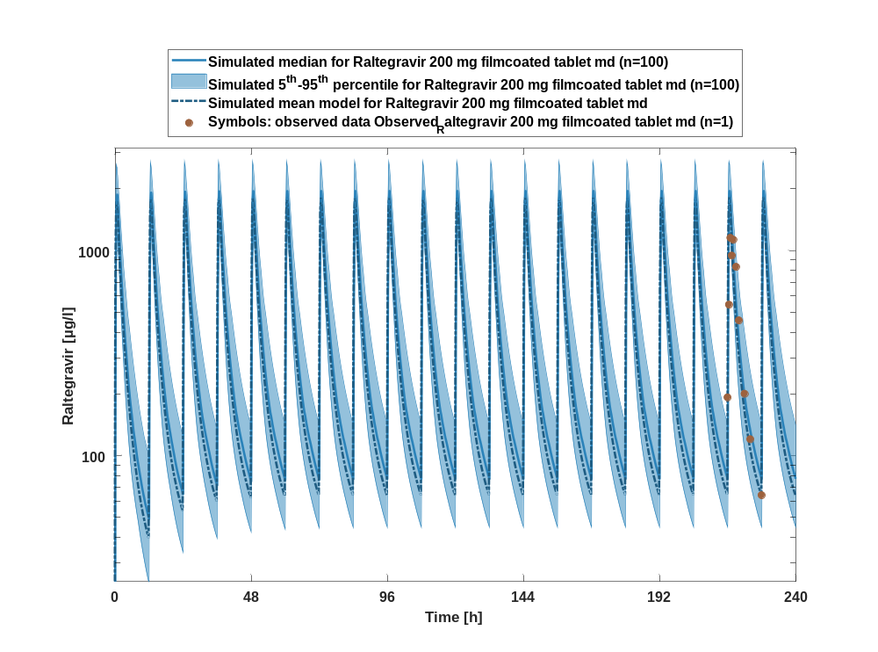

Figure 80: Predicted vs observed of Raltegravir for Raltegravir 200 mg filmcoated tablet md. Data source: Observed_Raltegravir 200 mg filmcoated tablet md. Prediction and observations are plotted in a logarithmic scale.
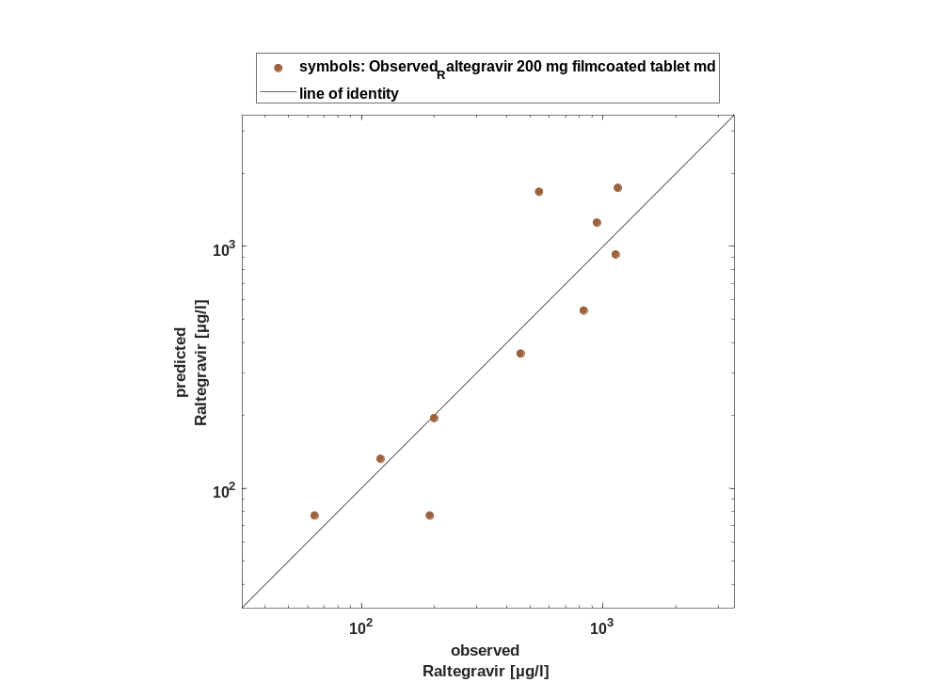

Figure 81: Logarithmic residuals vs time of Raltegravir for Raltegravir 200 mg filmcoated tablet md. Data source: Observed_Raltegravir 200 mg filmcoated tablet md.
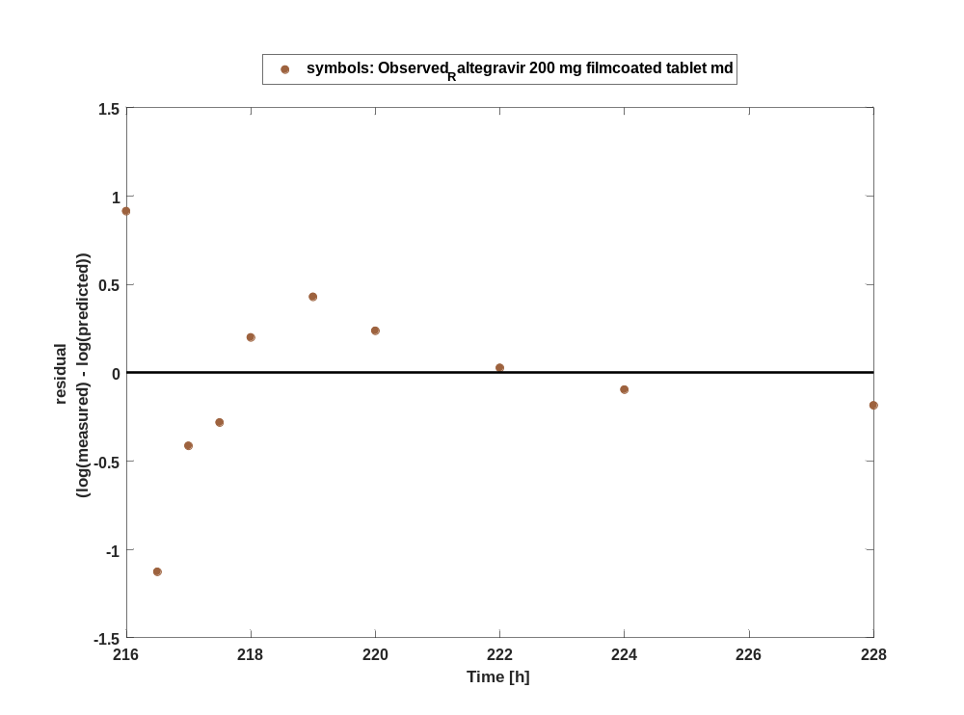

Figure 82: Logarithmic residuals vs predicted values of Raltegravir for Raltegravir 200 mg filmcoated tablet md. Data source: Observed_Raltegravir 200 mg filmcoated tablet md.
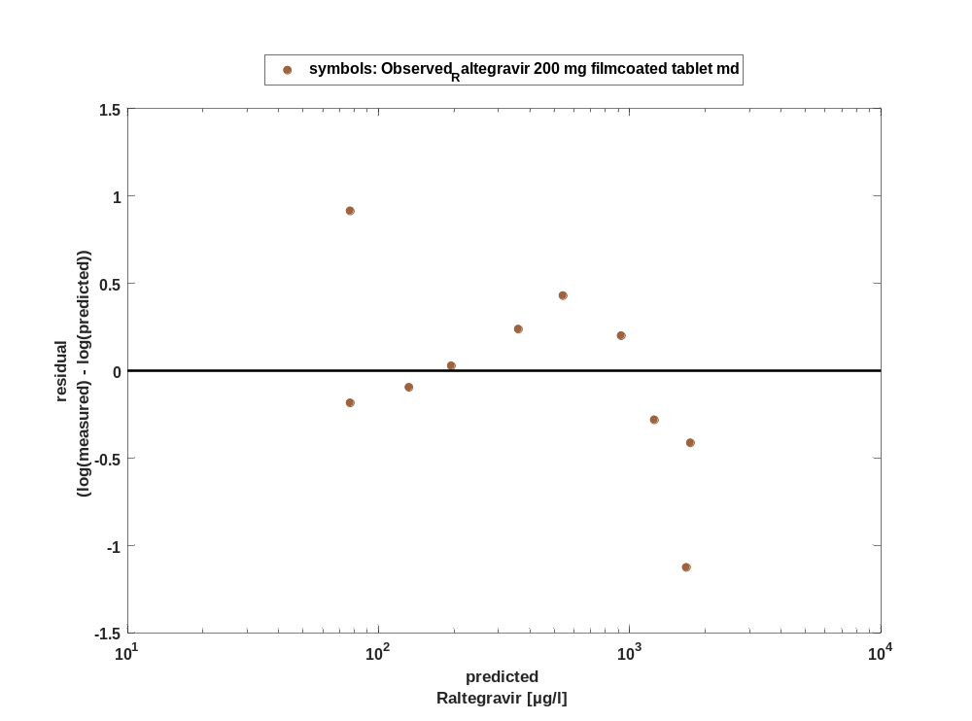

For first application range

Figure 83: Time profiles of Raltegravir for Raltegravir 200 mg filmcoated tablet md for first application range. Data source: Observed_Raltegravir 200 mg filmcoated tablet md. Time profiles are plotted in a linear scale.
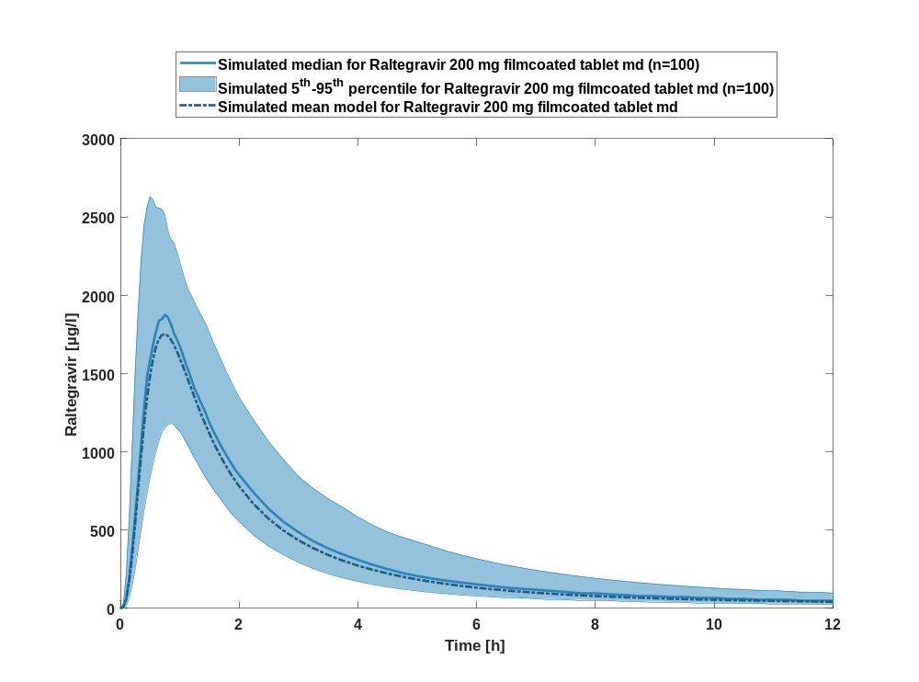

Figure 84: Time profiles of Raltegravir for Raltegravir 200 mg filmcoated tablet md for first application range. Data source: Observed_Raltegravir 200 mg filmcoated tablet md. Time profiles are plotted in a logarithmic scale.
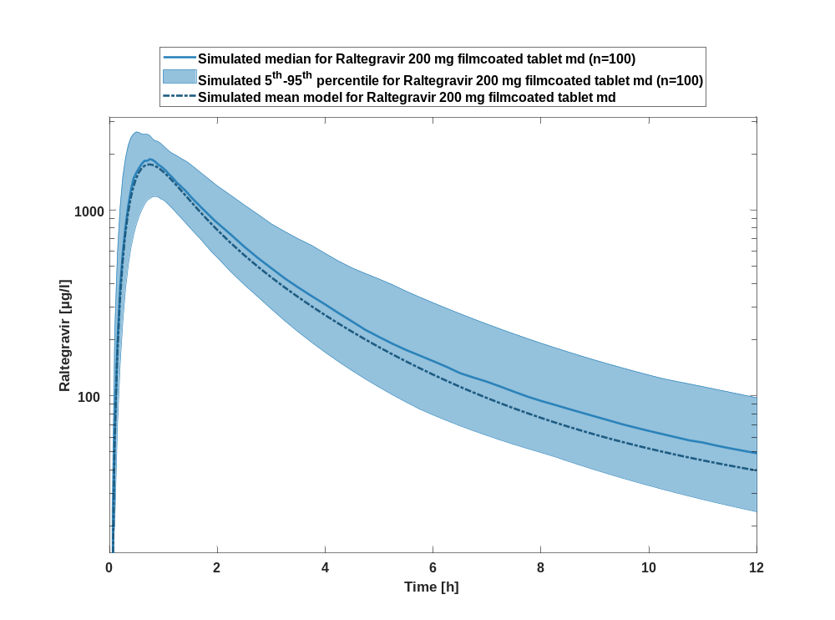

For last application range

Figure 85: Time profiles of Raltegravir for Raltegravir 200 mg filmcoated tablet md for last application range. Data source: Observed_Raltegravir 200 mg filmcoated tablet md. Time profiles are plotted in a linear scale.
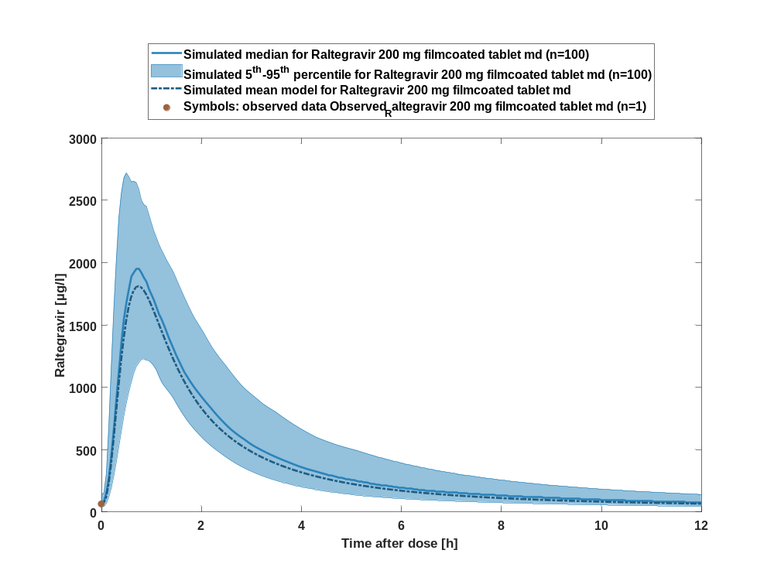

Figure 86: Time profiles of Raltegravir for Raltegravir 200 mg filmcoated tablet md for last application range. Data source: Observed_Raltegravir 200 mg filmcoated tablet md. Time profiles are plotted in a logarithmic scale.
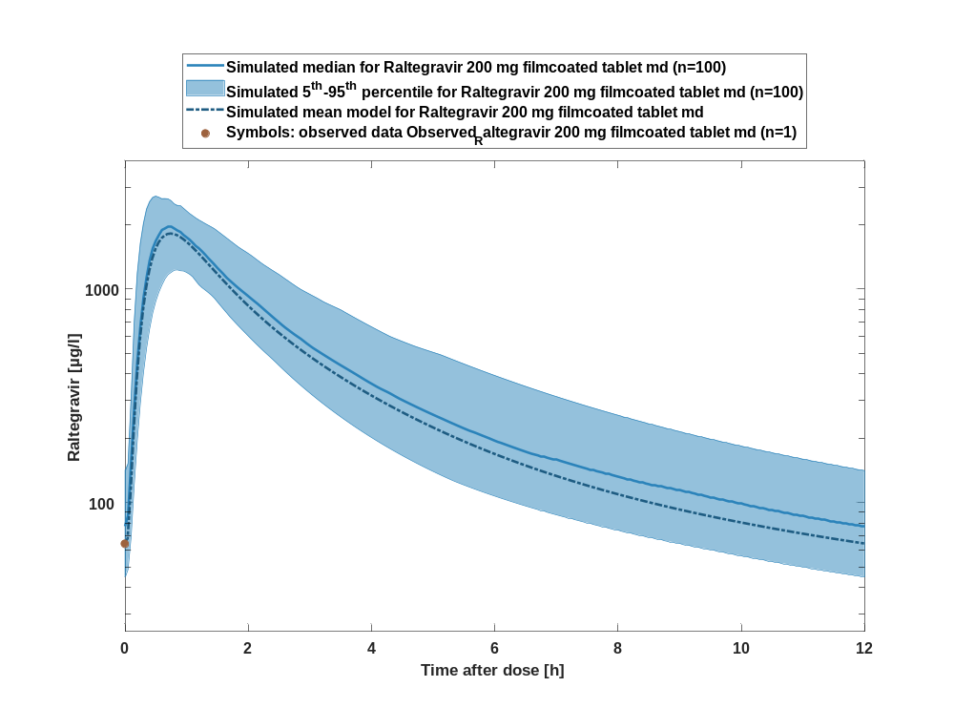

Figure 87: Predicted vs observed of Raltegravir for Raltegravir 200 mg filmcoated tablet md. Data source: Observed_Raltegravir 200 mg filmcoated tablet md. Prediction and observations are plotted in a logarithmic scale.
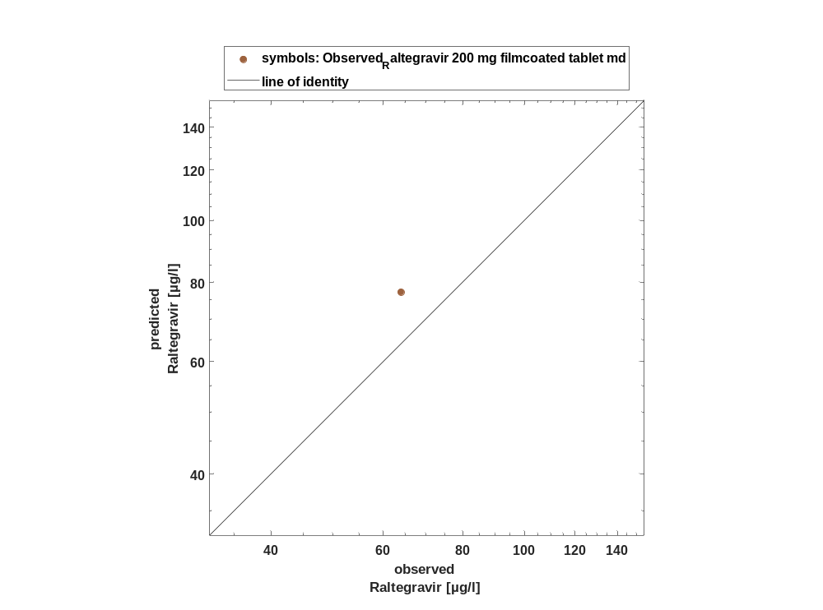

Figure 88: Logarithmic residuals vs time of Raltegravir for Raltegravir 200 mg filmcoated tablet md. Data source: Observed_Raltegravir 200 mg filmcoated tablet md.
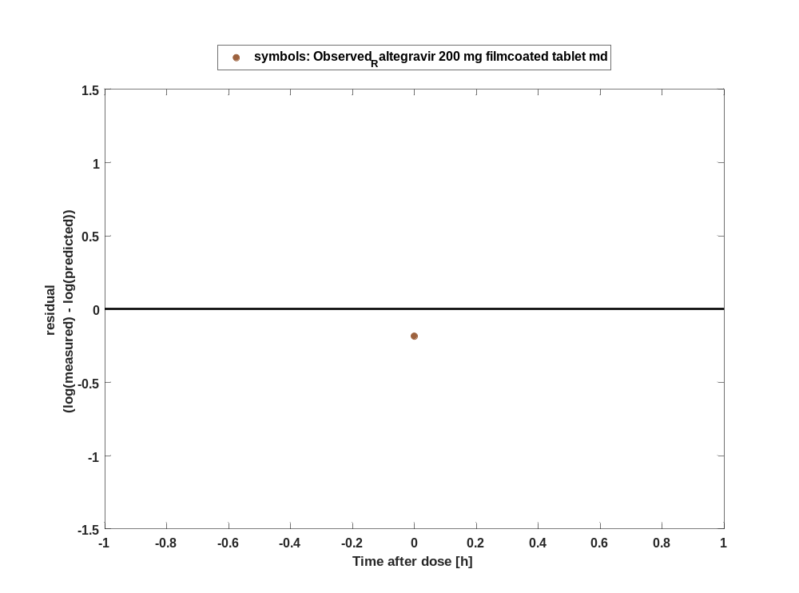

Figure 89: Logarithmic residuals vs predicted values of Raltegravir for Raltegravir 200 mg filmcoated tablet md. Data source: Observed_Raltegravir 200 mg filmcoated tablet md.
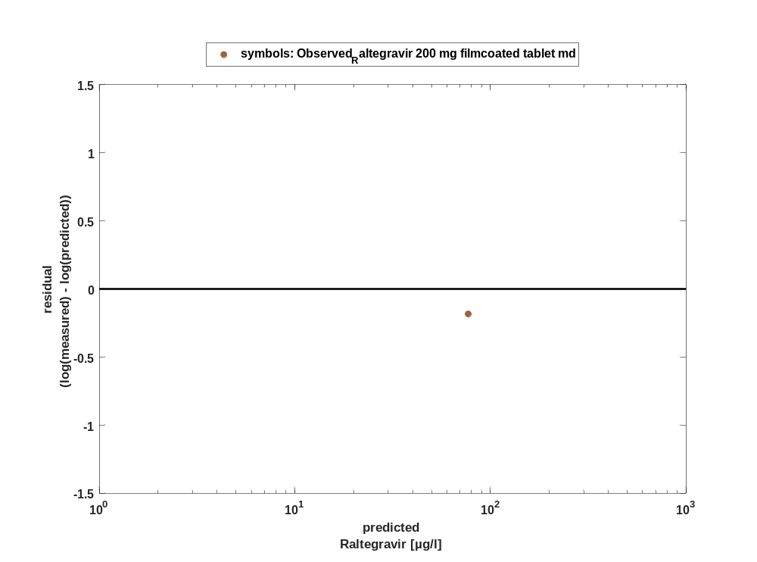

Overview on all residuals

Figure 90: Distribution of residuals for Raltegravir 200 mg filmcoated tablet md
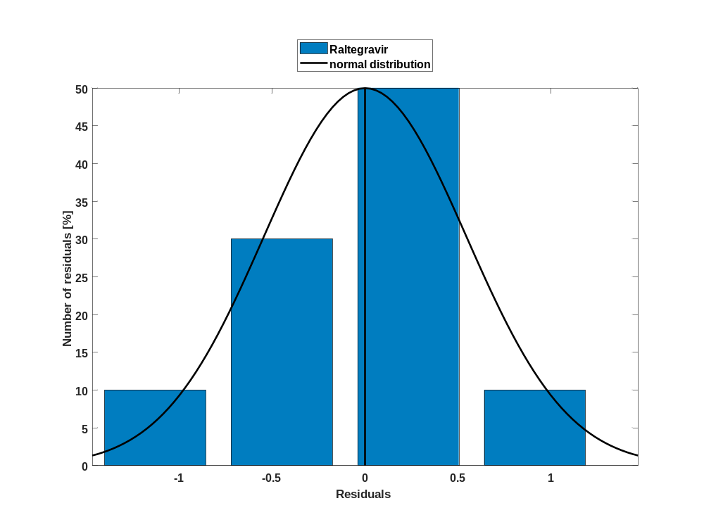

Figure 91: Residuals for Raltegravir 200 mg filmcoated tablet md as quantile-quantile plot.
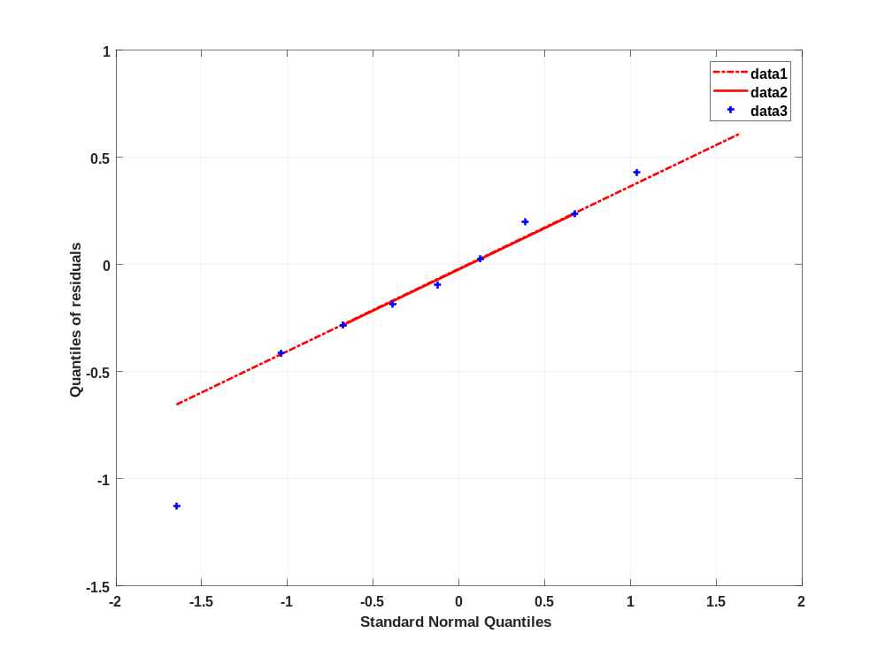

Time profiles for Filmcoated_tablet_400mg_sd

Time profiles of Raltegravir

Figure 92: Time profiles of Raltegravir for Filmcoated_tablet_400mg_sd. Data source: Observed_Raltegravir 400mg filmcoated tablet. Time profiles are plotted in a linear scale.
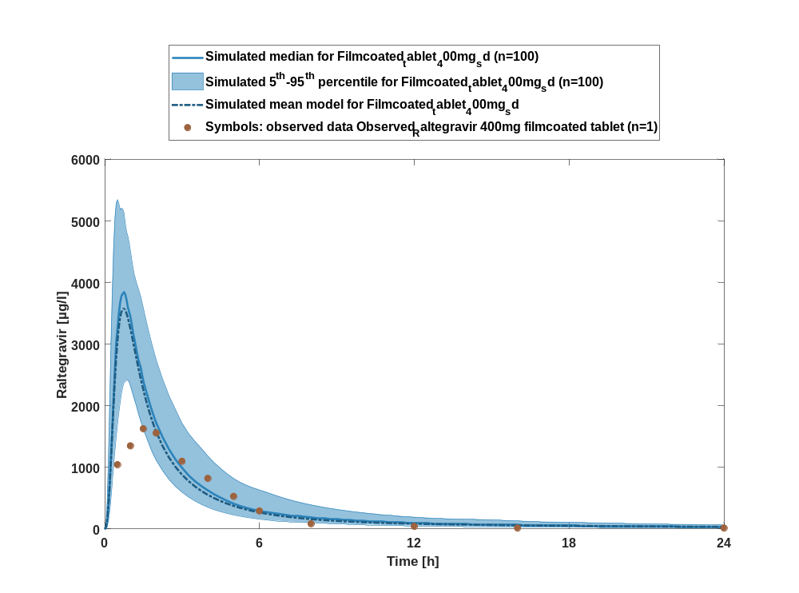

Figure 93: Time profiles of Raltegravir for Filmcoated_tablet_400mg_sd. Data source: Observed_Raltegravir 400mg filmcoated tablet. Time profiles are plotted in a logarithmic scale.
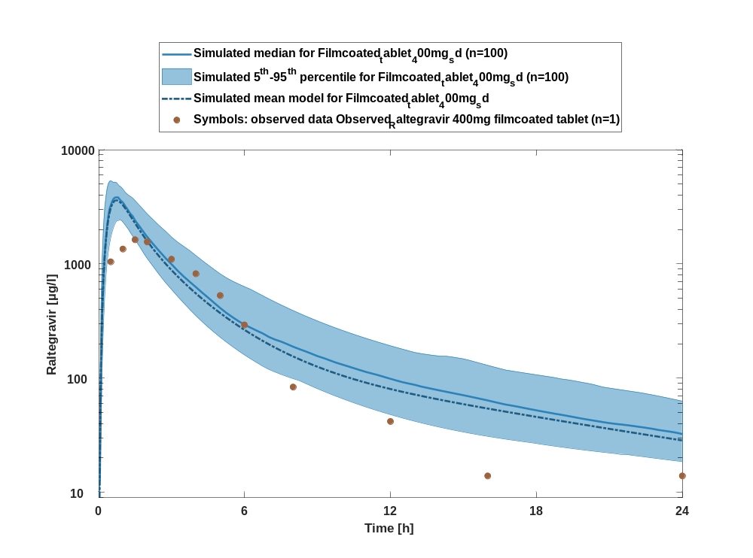

Figure 94: Predicted vs observed of Raltegravir for Filmcoated_tablet_400mg_sd. Data source: Observed_Raltegravir 400mg filmcoated tablet. Prediction and observations are plotted in a logarithmic scale.
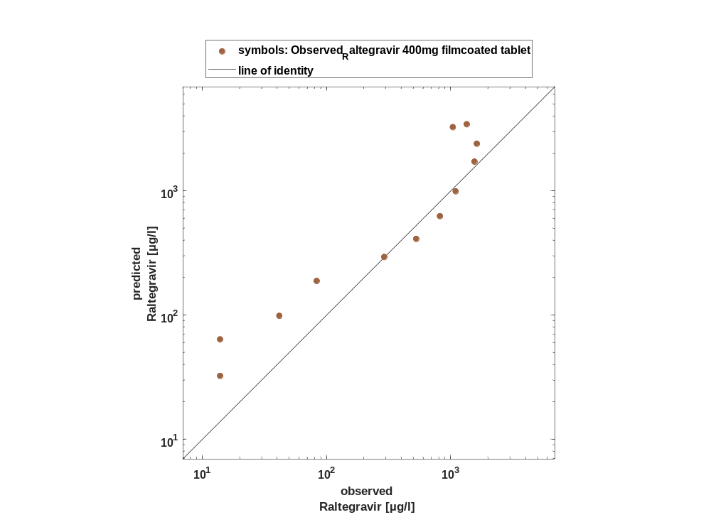

Figure 95: Logarithmic residuals vs time of Raltegravir for Filmcoated_tablet_400mg_sd. Data source: Observed_Raltegravir 400mg filmcoated tablet.
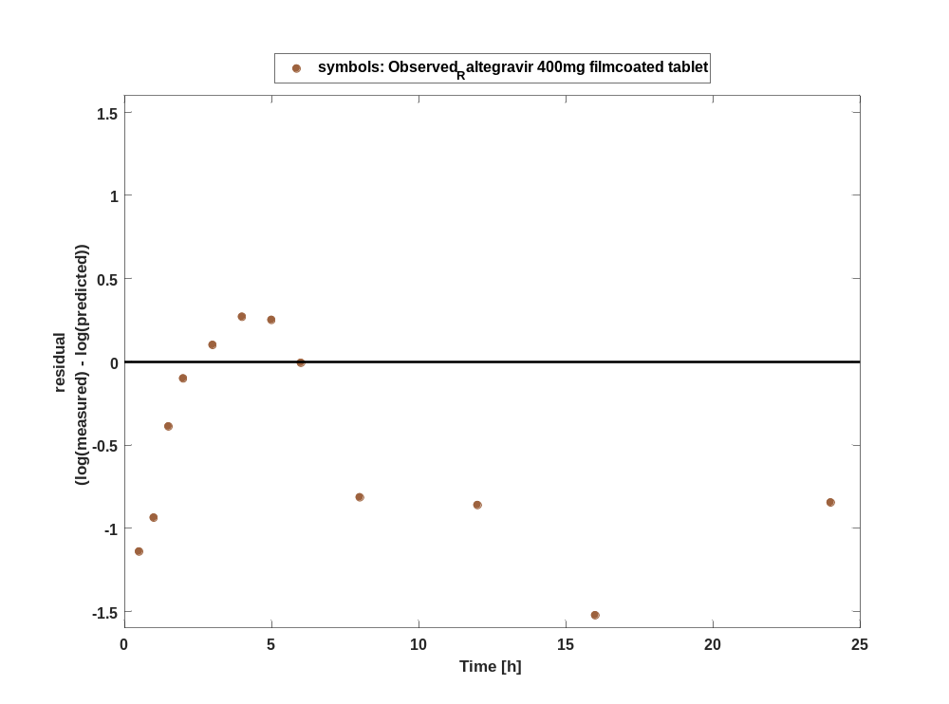

Figure 96: Logarithmic residuals vs predicted values of Raltegravir for Filmcoated_tablet_400mg_sd. Data source: Observed_Raltegravir 400mg filmcoated tablet.
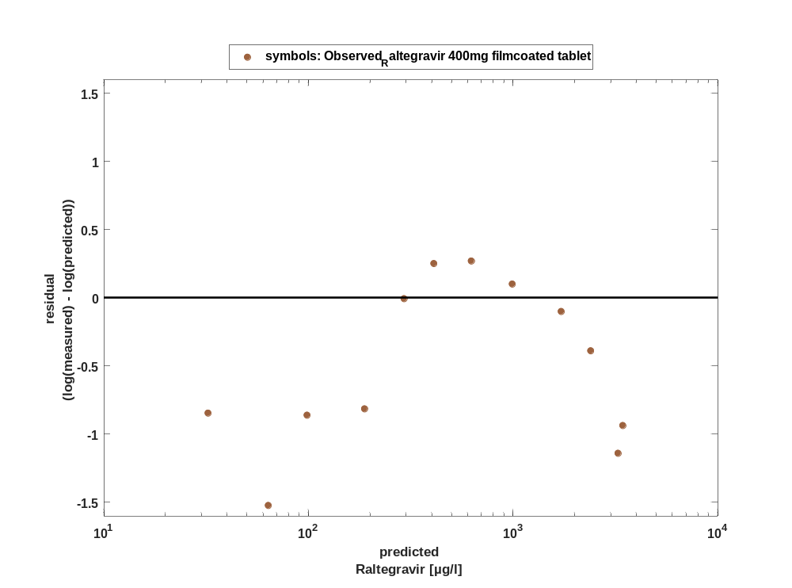

Overview on all residuals

Figure 97: Distribution of residuals for Filmcoated_tablet_400mg_sd
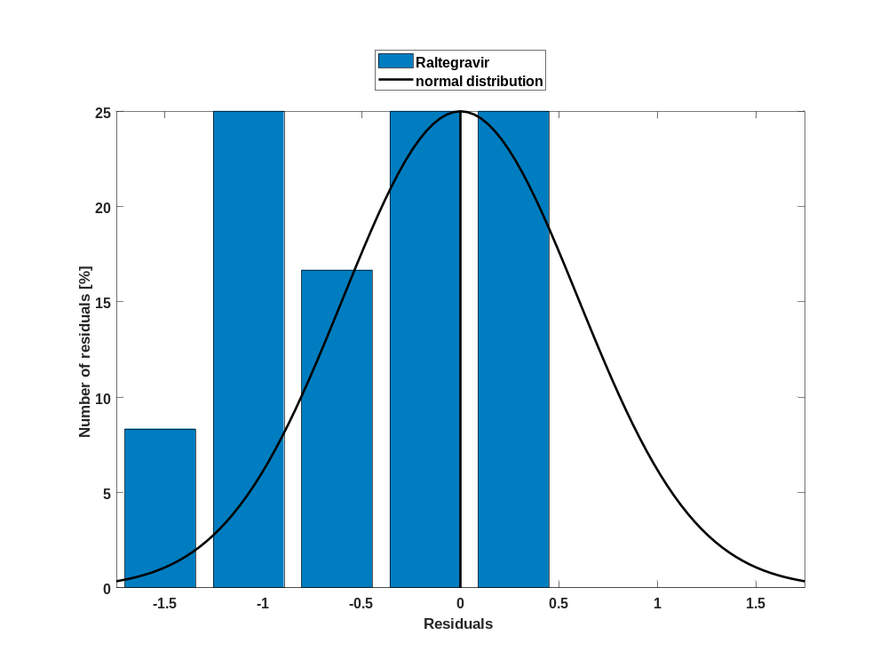

Figure 98: Residuals for Filmcoated_tablet_400mg_sd as quantile-quantile plot.
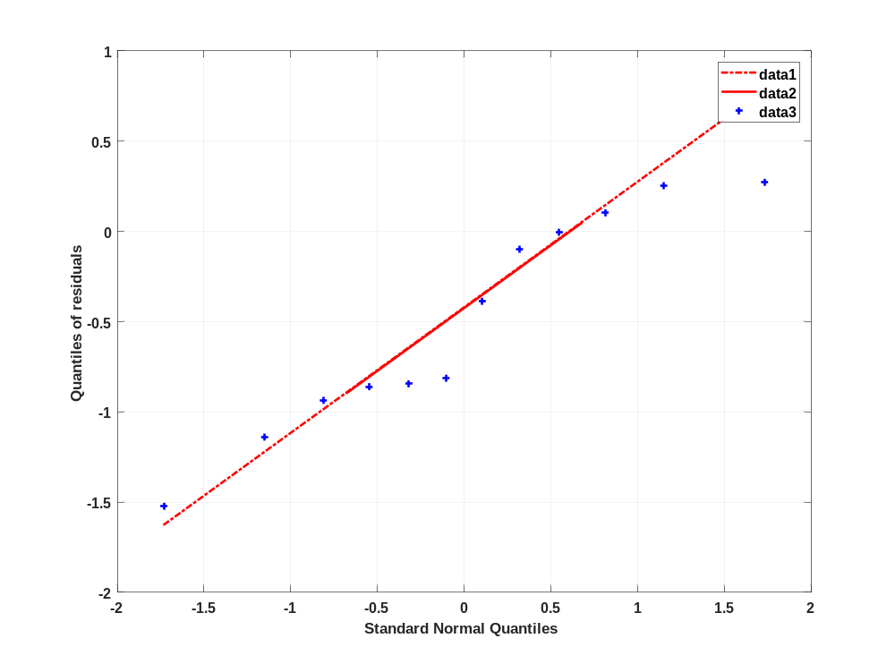

Time profiles for Raltegravir 400 mg filmcoated tablet md

Time profiles of Raltegravir

For total simulation time range

Figure 99: Time profiles of Raltegravir for Raltegravir 400 mg filmcoated tablet md for total simulation time range. Data source: Observed_Raltegravir 400 mg filmcoated tablet md. Time profiles are plotted in a linear scale.
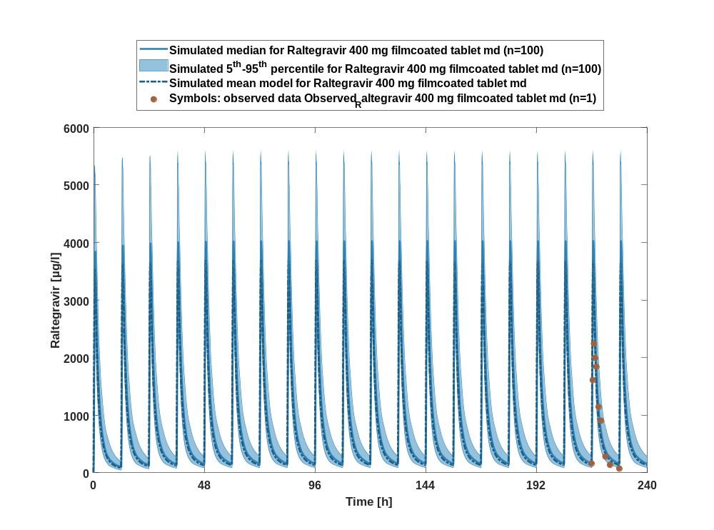

Figure 100: Time profiles of Raltegravir for Raltegravir 400 mg filmcoated tablet md for total simulation time range. Data source: Observed_Raltegravir 400 mg filmcoated tablet md. Time profiles are plotted in a logarithmic scale.
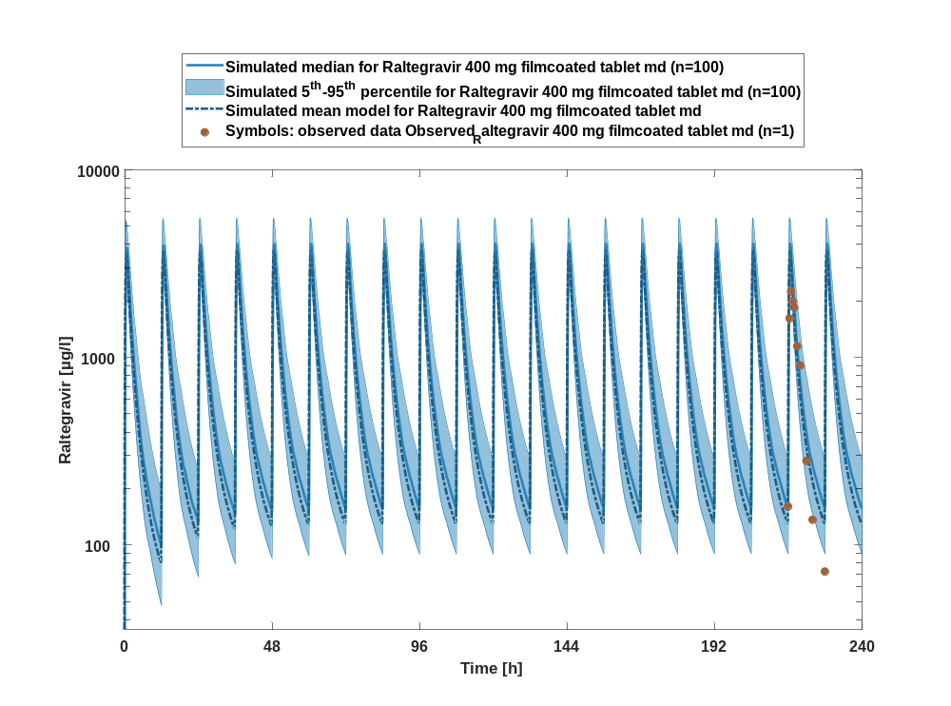

Figure 101: Predicted vs observed of Raltegravir for Raltegravir 400 mg filmcoated tablet md. Data source: Observed_Raltegravir 400 mg filmcoated tablet md. Prediction and observations are plotted in a logarithmic scale.
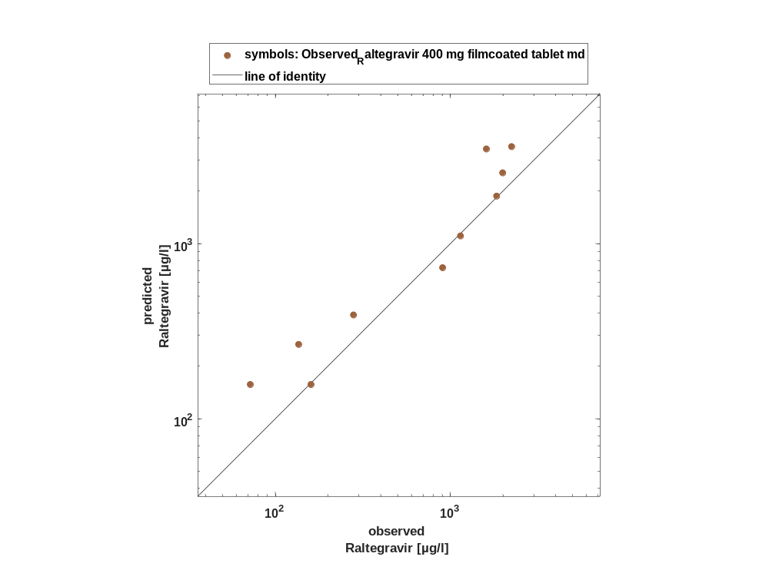

Figure 102: Logarithmic residuals vs time of Raltegravir for Raltegravir 400 mg filmcoated tablet md. Data source: Observed_Raltegravir 400 mg filmcoated tablet md.
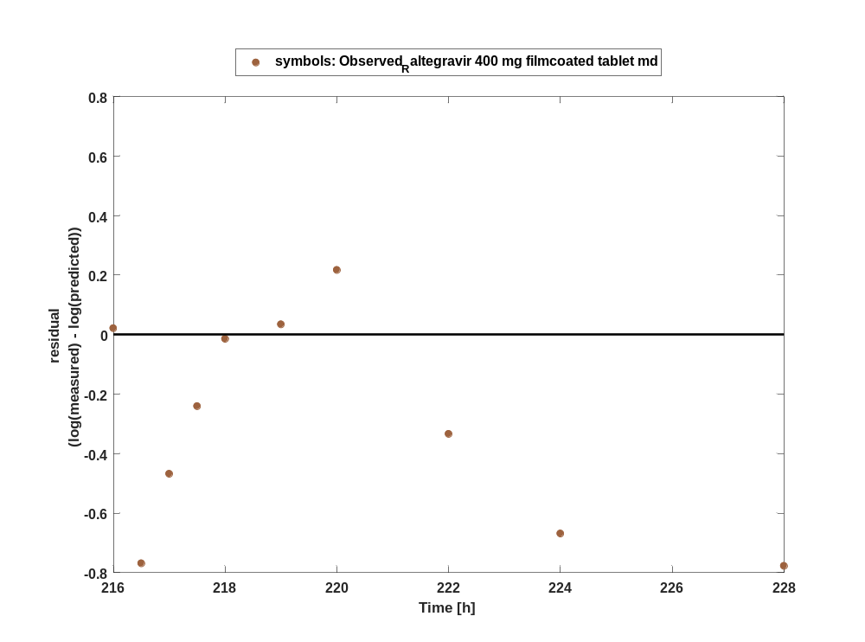

Figure 103: Logarithmic residuals vs predicted values of Raltegravir for Raltegravir 400 mg filmcoated tablet md. Data source: Observed_Raltegravir 400 mg filmcoated tablet md.
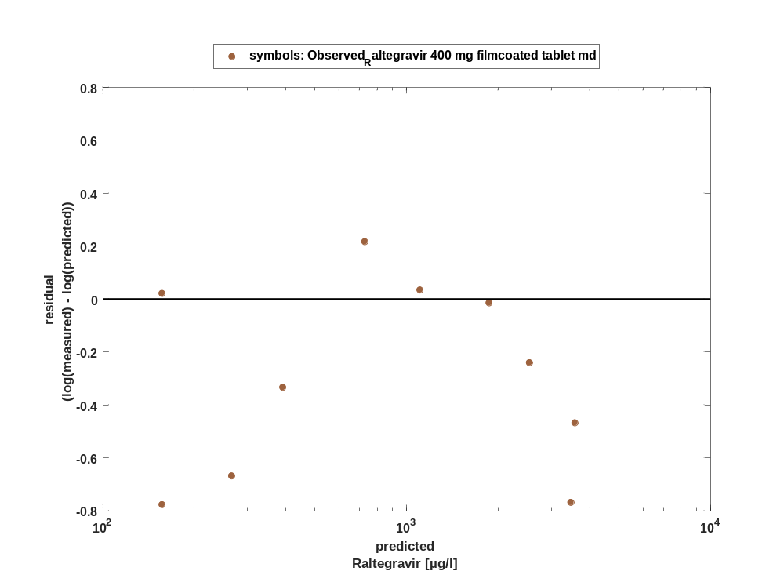

For first application range

Figure 104: Time profiles of Raltegravir for Raltegravir 400 mg filmcoated tablet md for first application range. Data source: Observed_Raltegravir 400 mg filmcoated tablet md. Time profiles are plotted in a linear scale.
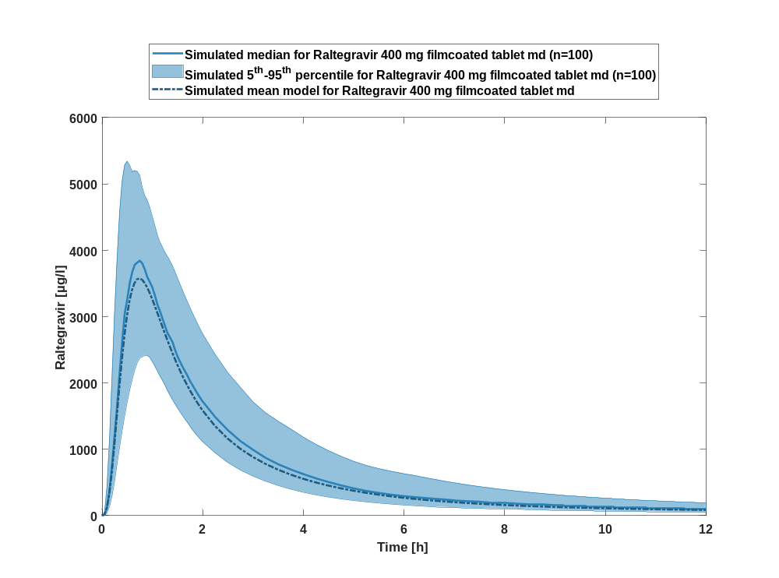

Figure 105: Time profiles of Raltegravir for Raltegravir 400 mg filmcoated tablet md for first application range. Data source: Observed_Raltegravir 400 mg filmcoated tablet md. Time profiles are plotted in a logarithmic scale.
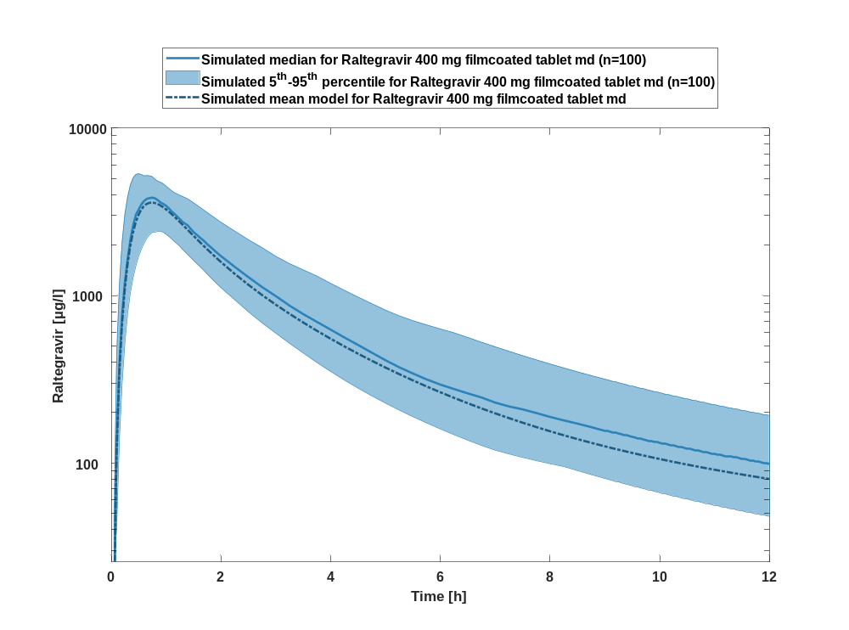

For last application range

Figure 106: Time profiles of Raltegravir for Raltegravir 400 mg filmcoated tablet md for last application range. Data source: Observed_Raltegravir 400 mg filmcoated tablet md. Time profiles are plotted in a linear scale.
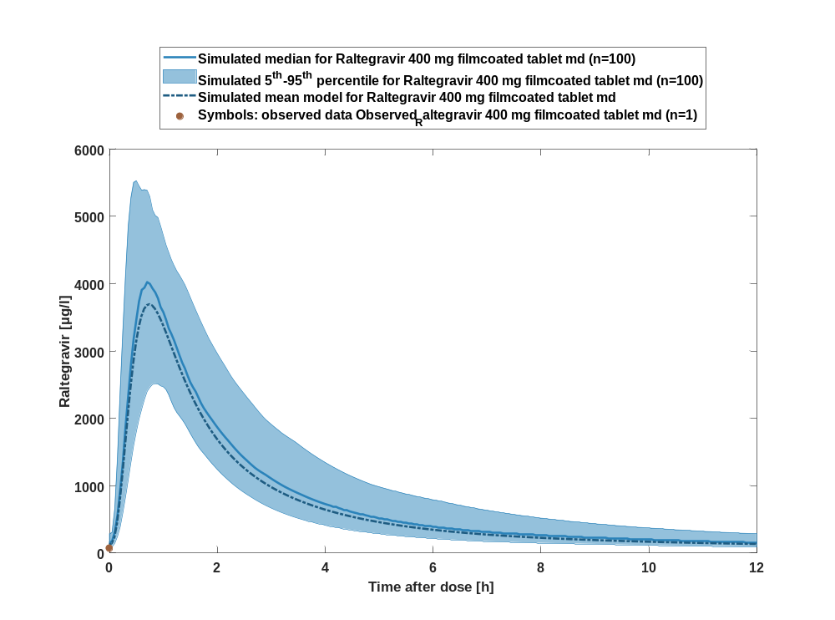

Figure 107: Time profiles of Raltegravir for Raltegravir 400 mg filmcoated tablet md for last application range. Data source: Observed_Raltegravir 400 mg filmcoated tablet md. Time profiles are plotted in a logarithmic scale.
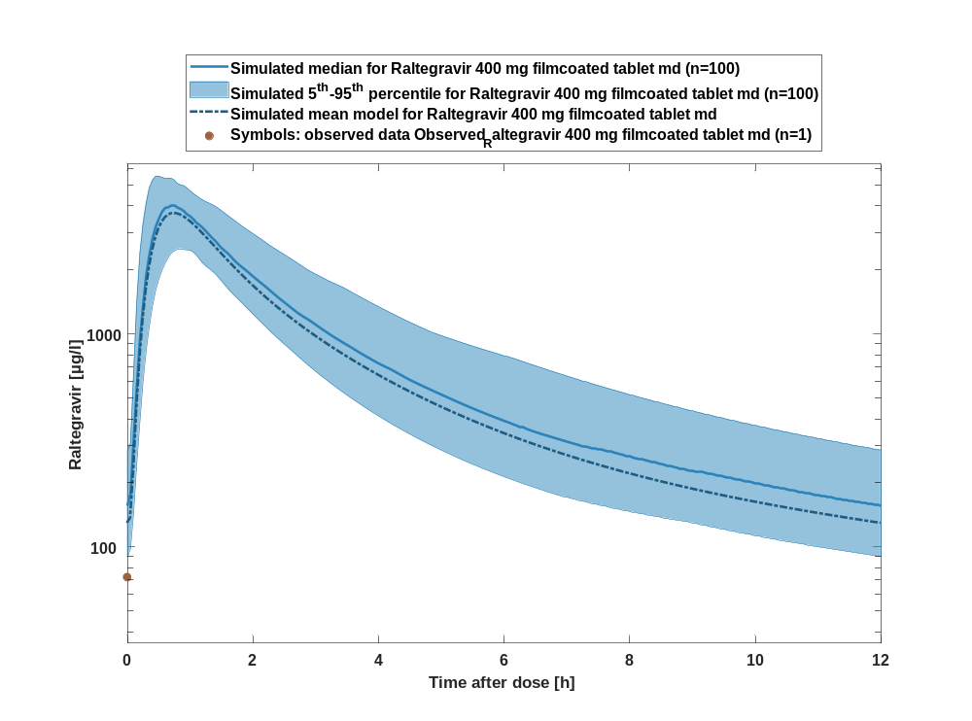

Figure 108: Predicted vs observed of Raltegravir for Raltegravir 400 mg filmcoated tablet md. Data source: Observed_Raltegravir 400 mg filmcoated tablet md. Prediction and observations are plotted in a logarithmic scale.
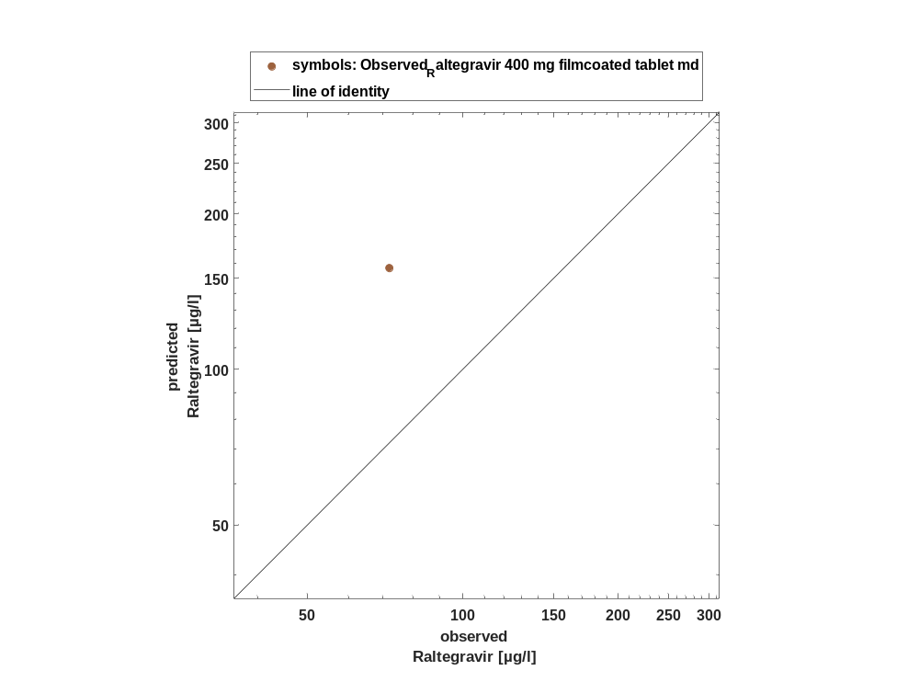

Figure 109: Logarithmic residuals vs time of Raltegravir for Raltegravir 400 mg filmcoated tablet md. Data source: Observed_Raltegravir 400 mg filmcoated tablet md.
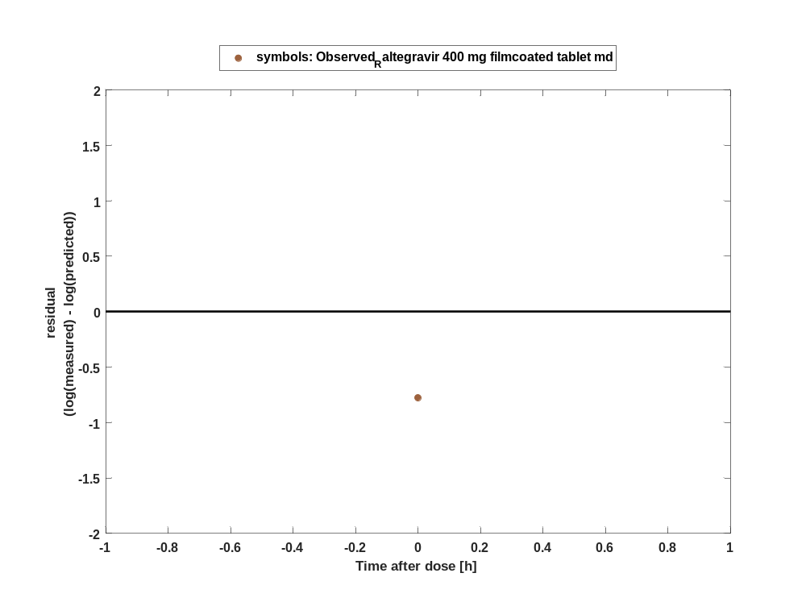

Figure 110: Logarithmic residuals vs predicted values of Raltegravir for Raltegravir 400 mg filmcoated tablet md. Data source: Observed_Raltegravir 400 mg filmcoated tablet md.
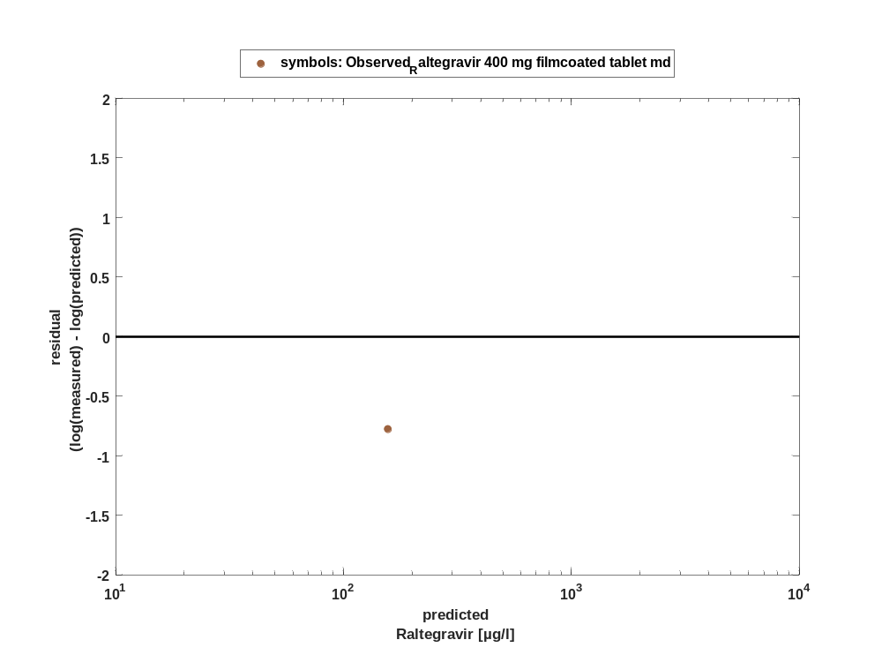

Overview on all residuals

Figure 111: Distribution of residuals for Raltegravir 400 mg filmcoated tablet md
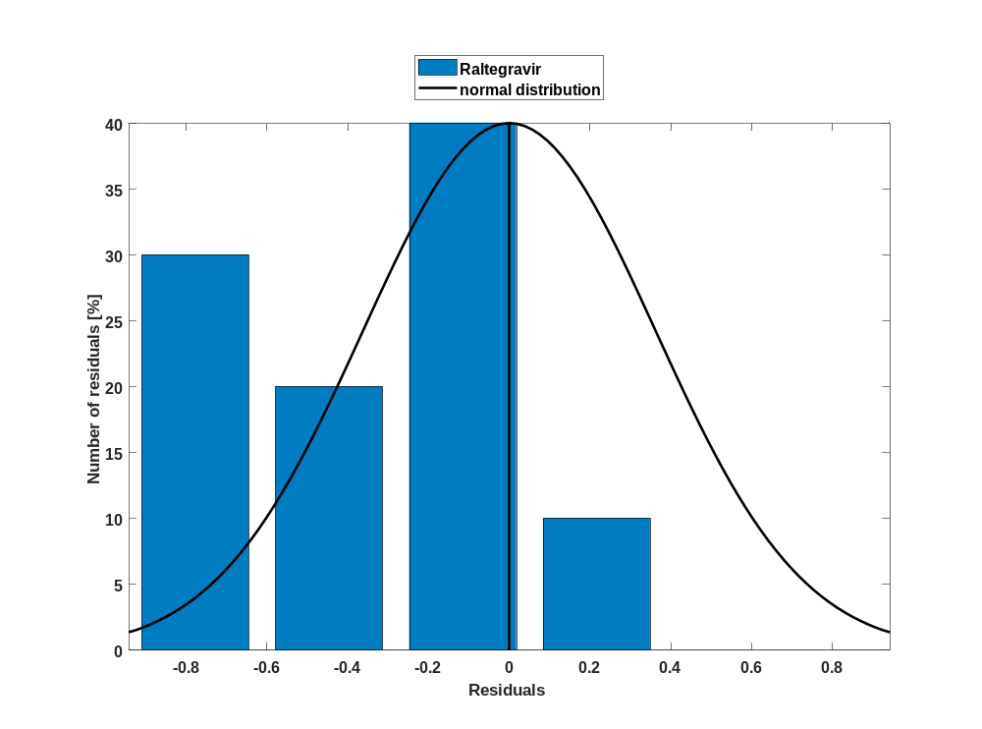

Figure 112: Residuals for Raltegravir 400 mg filmcoated tablet md as quantile-quantile plot.
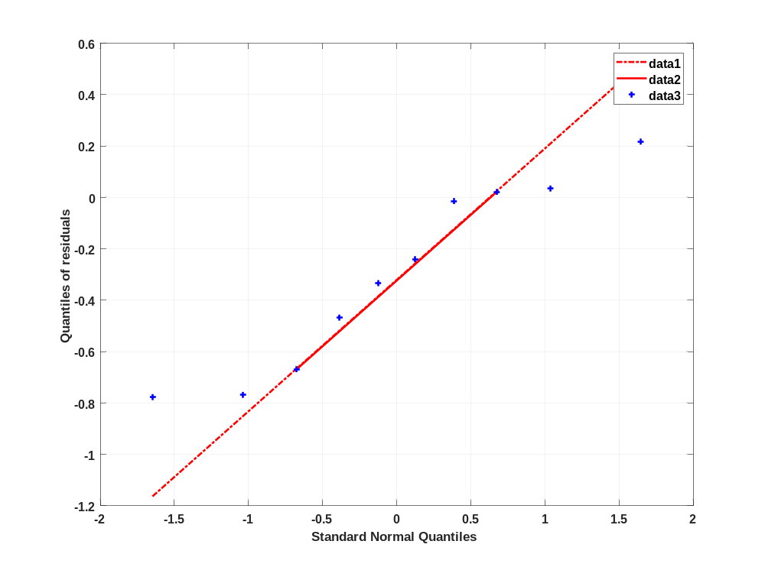

Time profiles for Raltegravir 400mg chewable fasted

Time profiles of Raltegravir

Figure 113: Time profiles of Raltegravir for Raltegravir 400mg chewable fasted. Data source: Observed_Raltegravir 400mg chewable fasted. Time profiles are plotted in a linear scale.
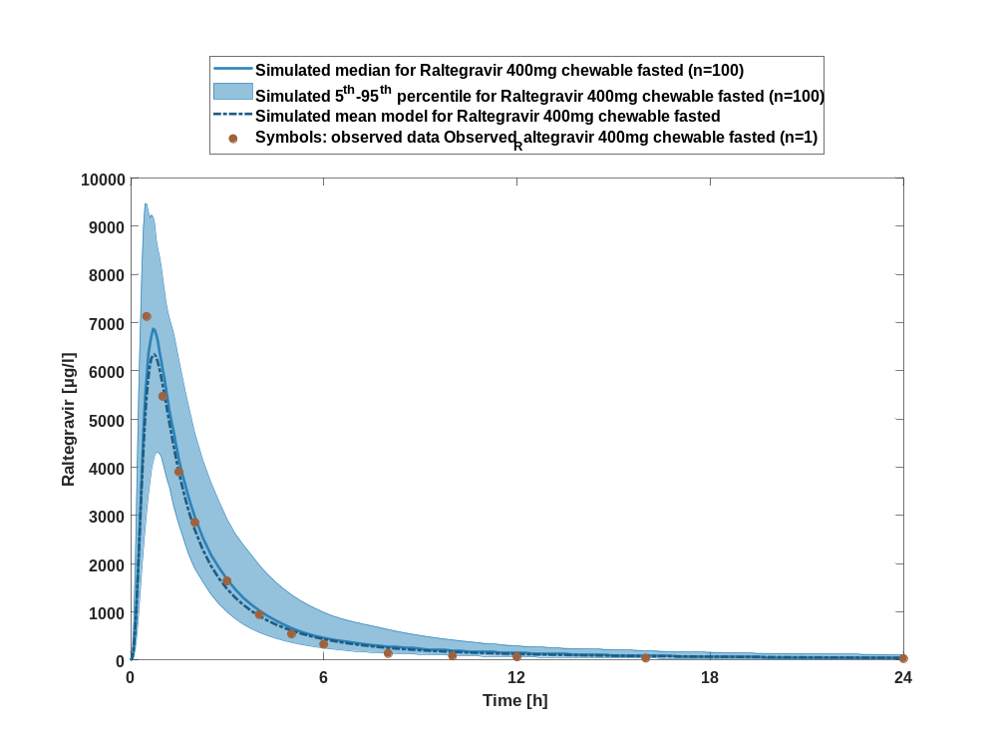

Figure 114: Time profiles of Raltegravir for Raltegravir 400mg chewable fasted. Data source: Observed_Raltegravir 400mg chewable fasted. Time profiles are plotted in a logarithmic scale.
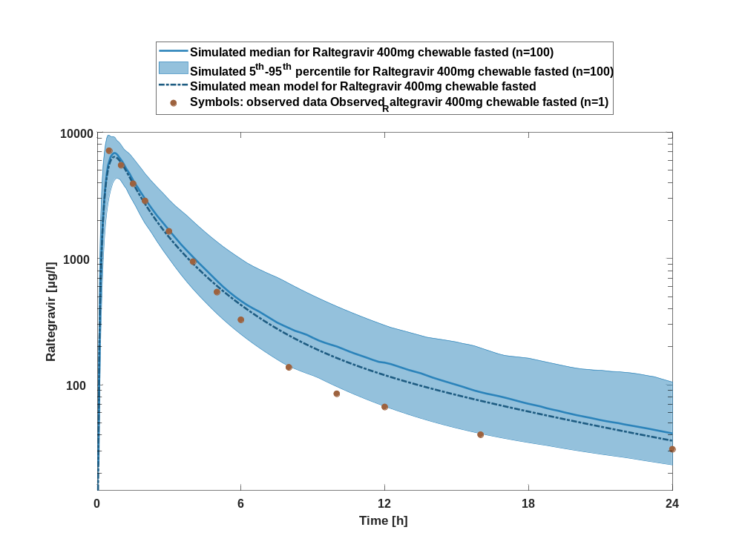

Figure 115: Predicted vs observed of Raltegravir for Raltegravir 400mg chewable fasted. Data source: Observed_Raltegravir 400mg chewable fasted. Prediction and observations are plotted in a logarithmic scale.
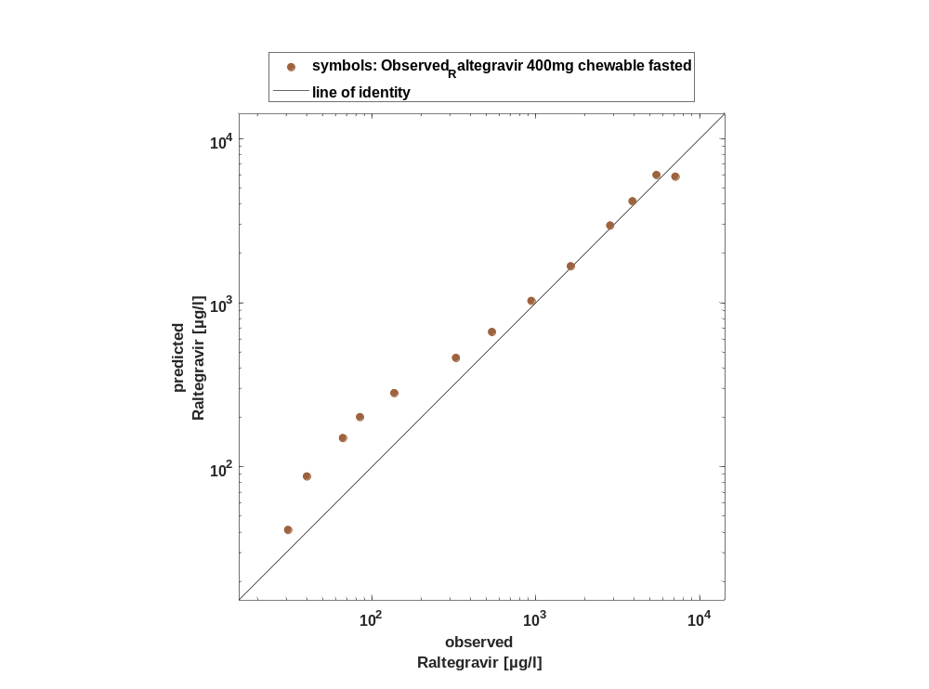

Figure 116: Logarithmic residuals vs time of Raltegravir for Raltegravir 400mg chewable fasted. Data source: Observed_Raltegravir 400mg chewable fasted.
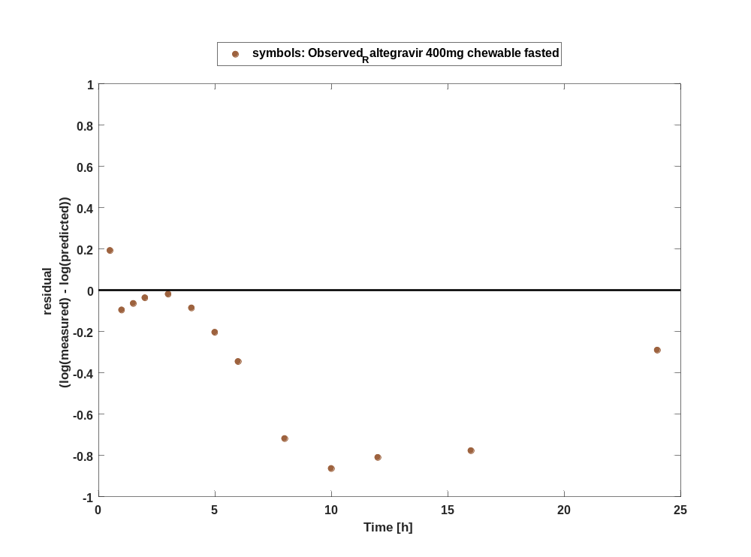

Figure 117: Logarithmic residuals vs predicted values of Raltegravir for Raltegravir 400mg chewable fasted. Data source: Observed_Raltegravir 400mg chewable fasted.
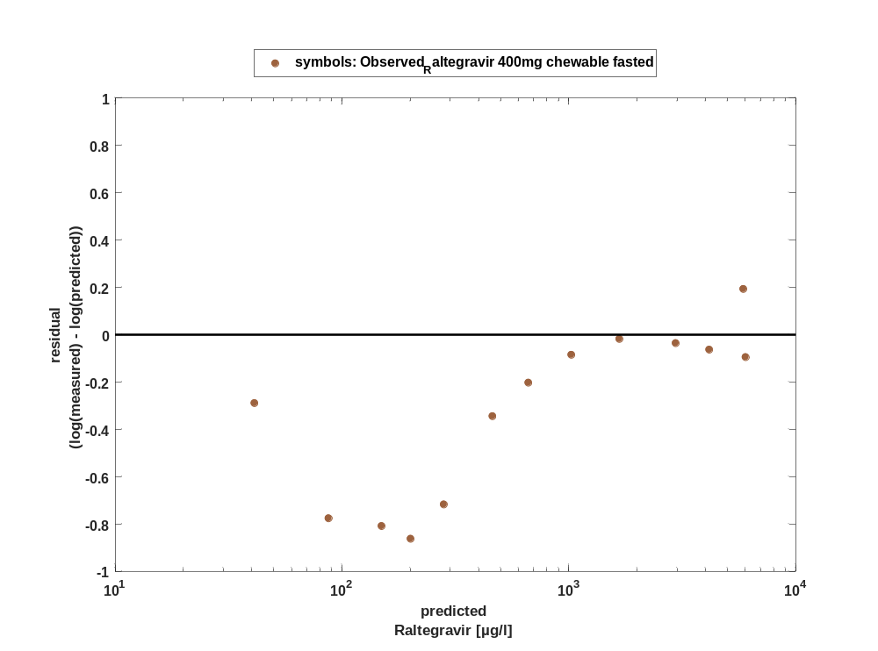

Overview on all residuals

Figure 118: Distribution of residuals for Raltegravir 400mg chewable fasted
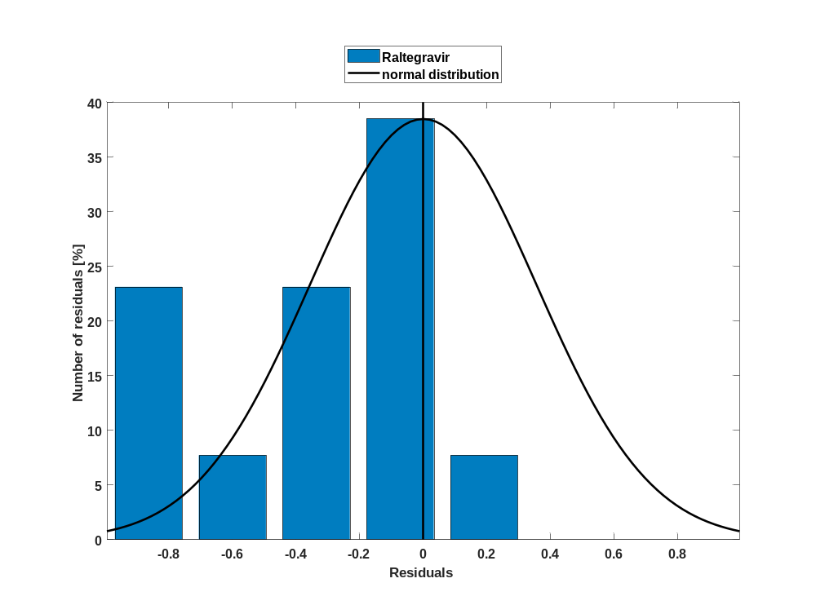

Figure 119: Residuals for Raltegravir 400mg chewable fasted as quantile-quantile plot.
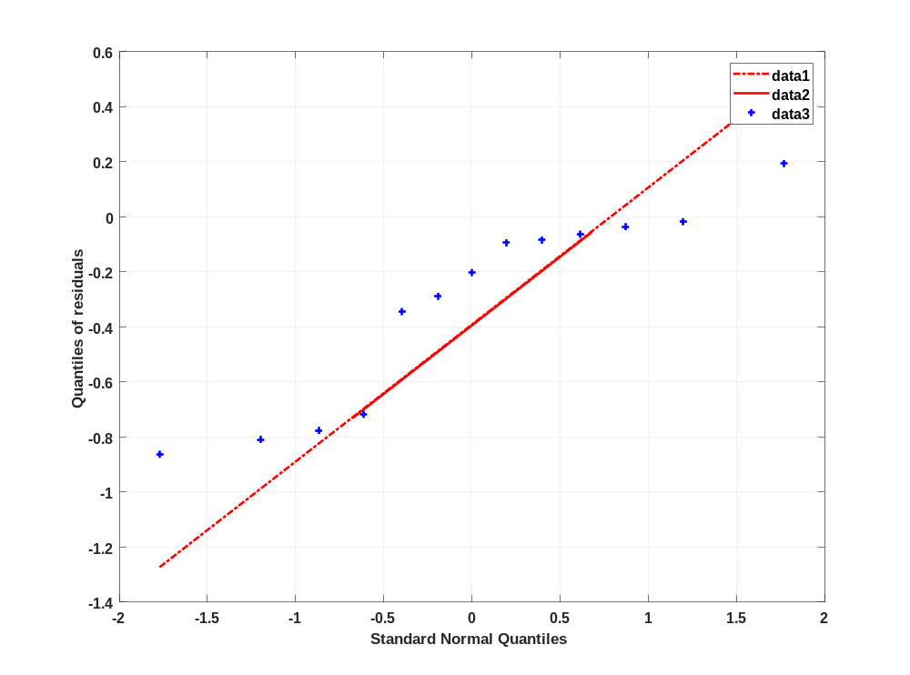

Time profiles for Raltegravir 400mg chewable fed

Time profiles of Raltegravir

Figure 120: Time profiles of Raltegravir for Raltegravir 400mg chewable fed. Data source: Observed_Raltegravir 400mg chewable fed. Time profiles are plotted in a linear scale.
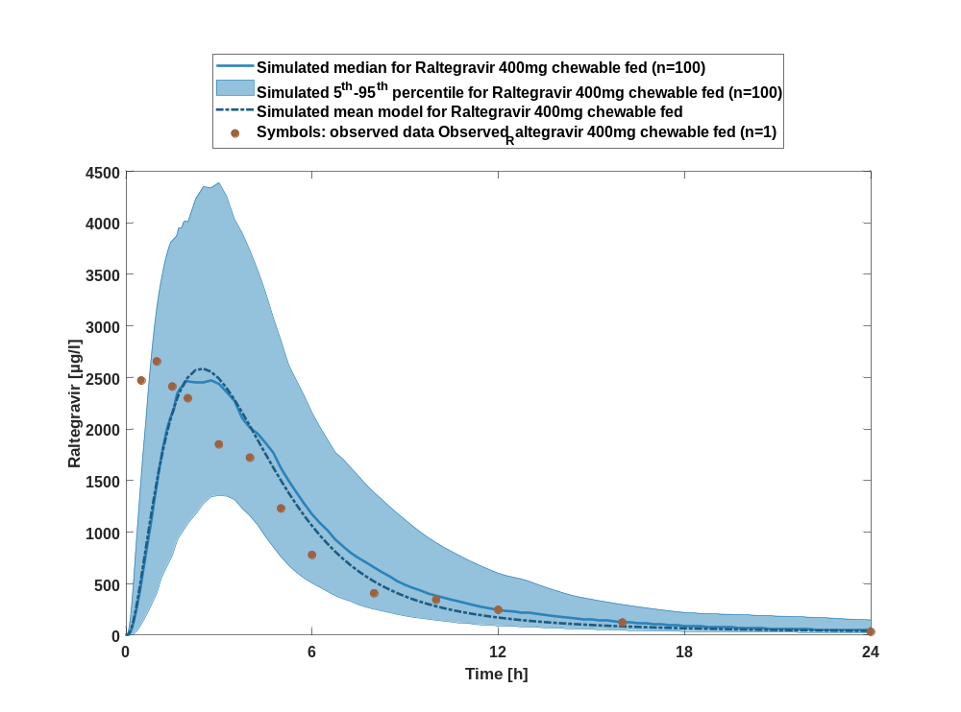

Figure 121: Time profiles of Raltegravir for Raltegravir 400mg chewable fed. Data source: Observed_Raltegravir 400mg chewable fed. Time profiles are plotted in a logarithmic scale.
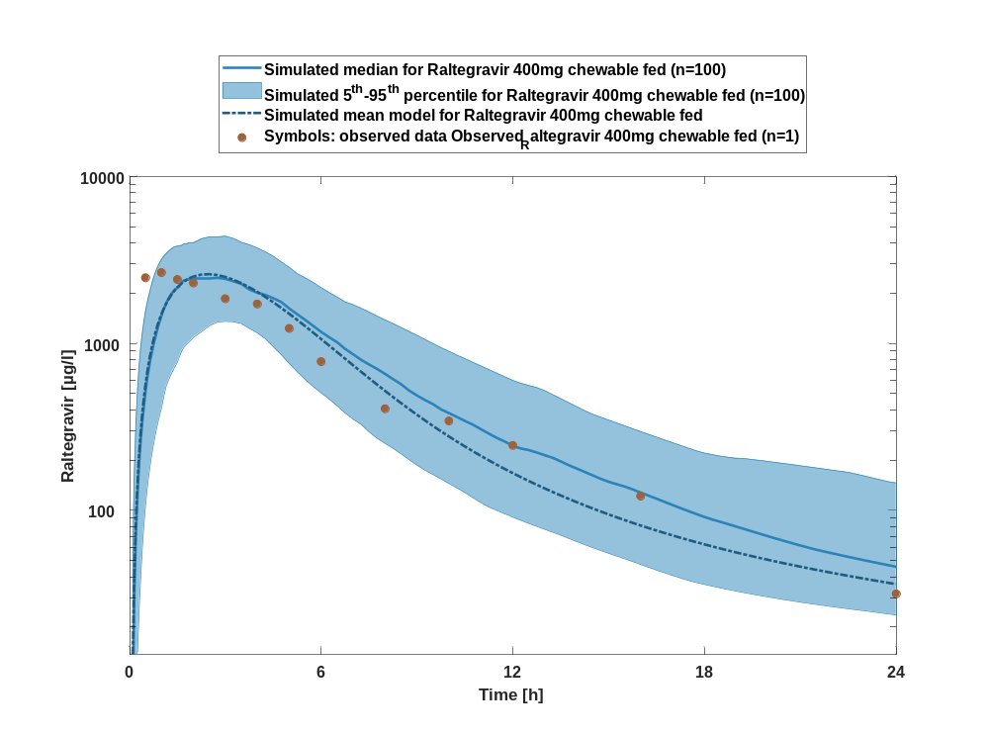

Figure 122: Predicted vs observed of Raltegravir for Raltegravir 400mg chewable fed. Data source: Observed_Raltegravir 400mg chewable fed. Prediction and observations are plotted in a logarithmic scale.
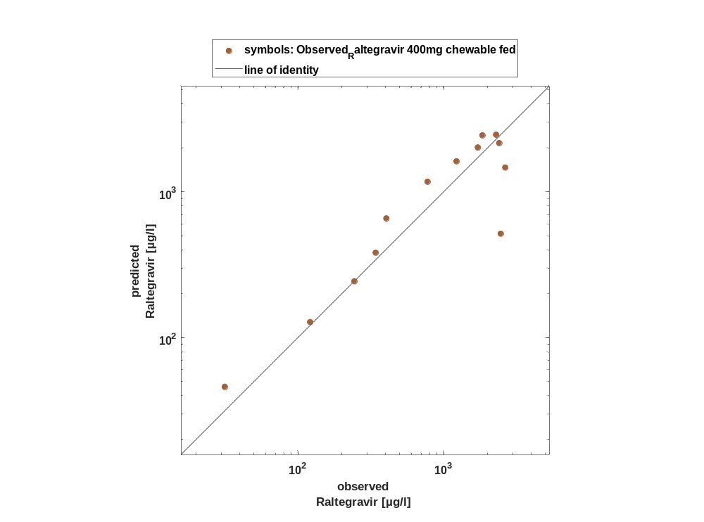

Figure 123: Logarithmic residuals vs time of Raltegravir for Raltegravir 400mg chewable fed. Data source: Observed_Raltegravir 400mg chewable fed.
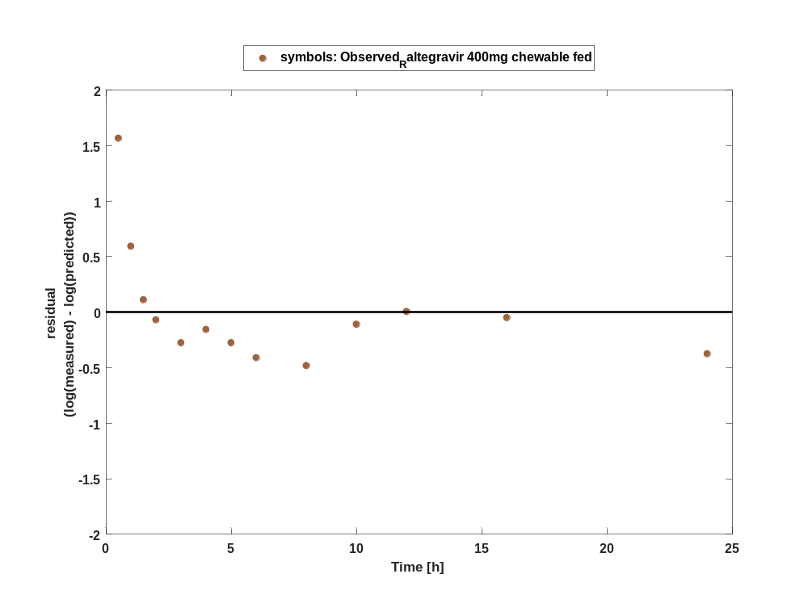

Figure 124: Logarithmic residuals vs predicted values of Raltegravir for Raltegravir 400mg chewable fed. Data source: Observed_Raltegravir 400mg chewable fed.
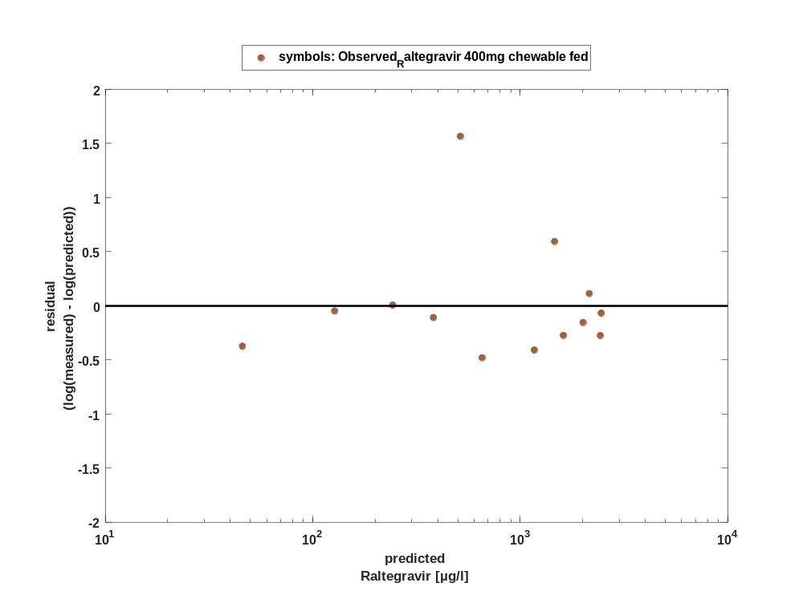

Overview on all residuals

Figure 125: Distribution of residuals for Raltegravir 400mg chewable fed
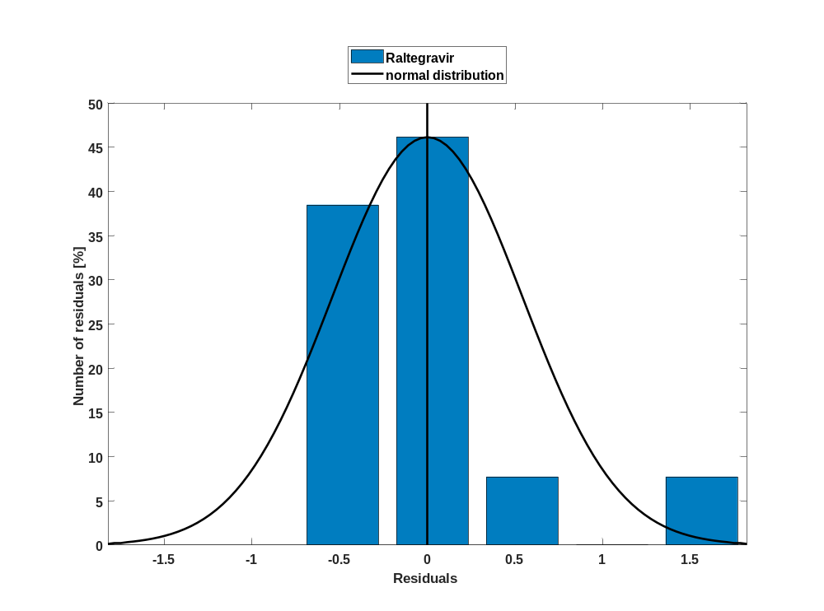

Figure 126: Residuals for Raltegravir 400mg chewable fed as quantile-quantile plot.
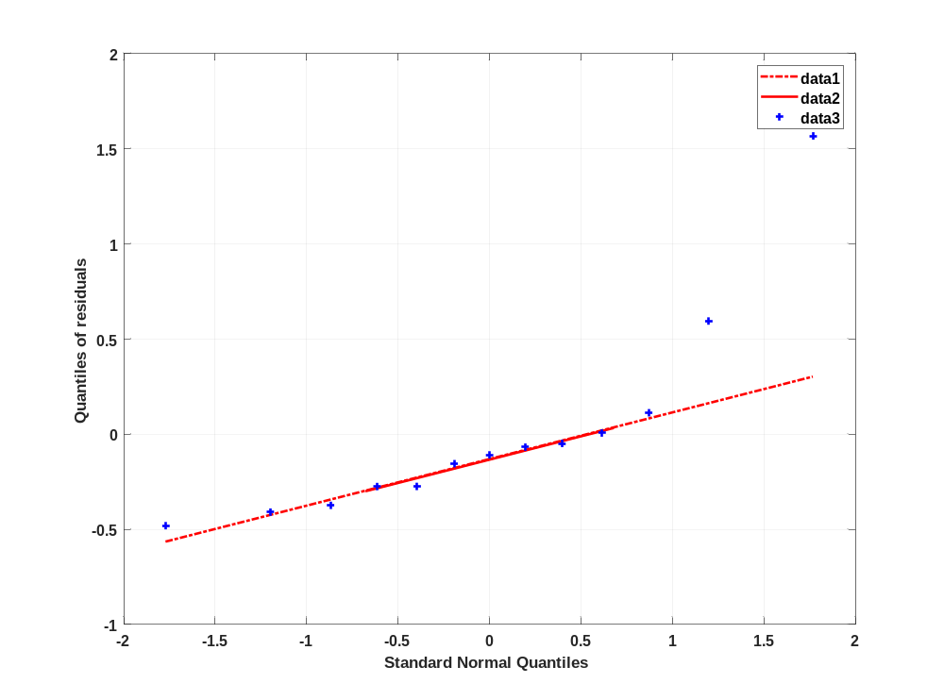

Time profiles for Raltegravir 400mg (granules in suspension)

Time profiles of Raltegravir

Figure 127: Time profiles of Raltegravir for Raltegravir 400mg (granules in suspension). Data source: Observed_Raltegravir 400mg (granules in suspension). Time profiles are plotted in a linear scale.
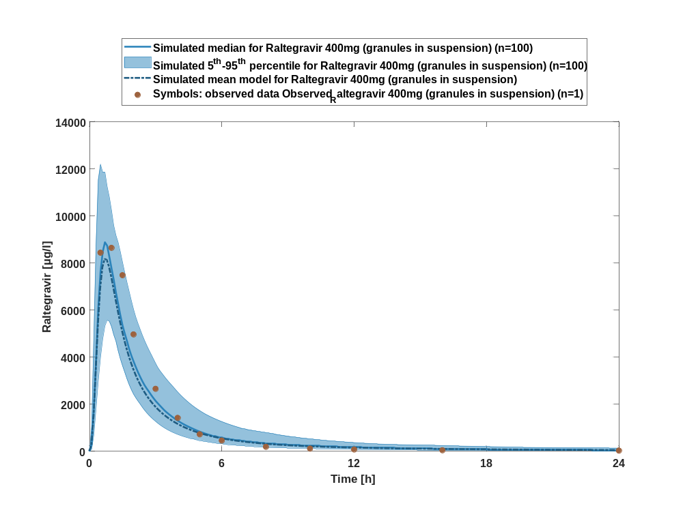

Figure 128: Time profiles of Raltegravir for Raltegravir 400mg (granules in suspension). Data source: Observed_Raltegravir 400mg (granules in suspension). Time profiles are plotted in a logarithmic scale.
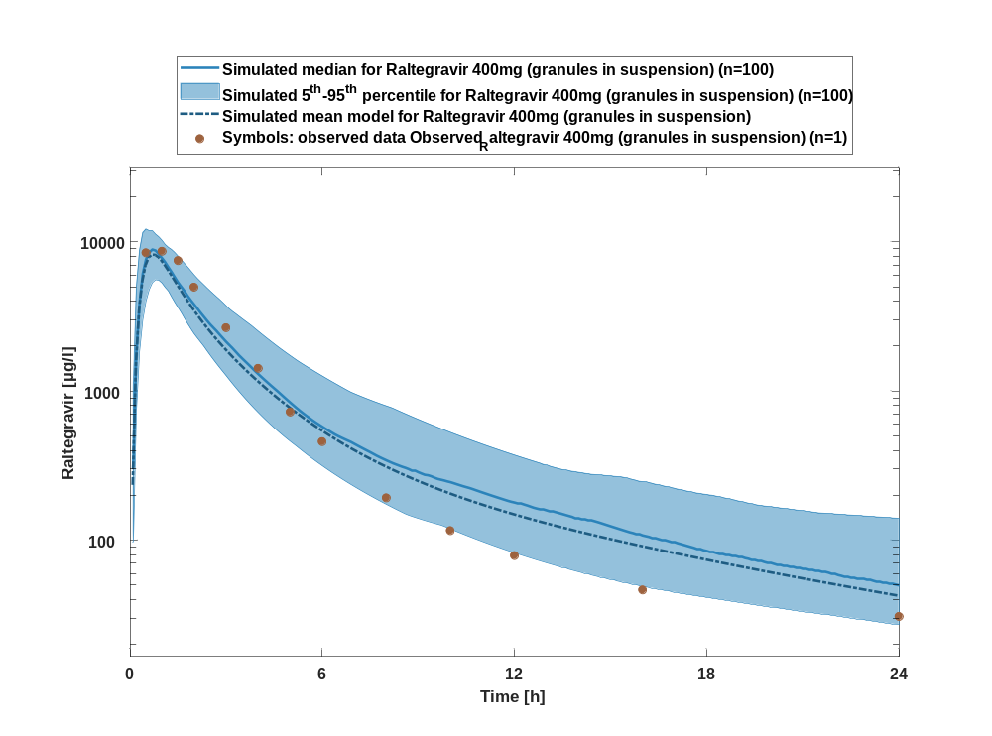

Figure 129: Predicted vs observed of Raltegravir for Raltegravir 400mg (granules in suspension). Data source: Observed_Raltegravir 400mg (granules in suspension). Prediction and observations are plotted in a logarithmic scale.
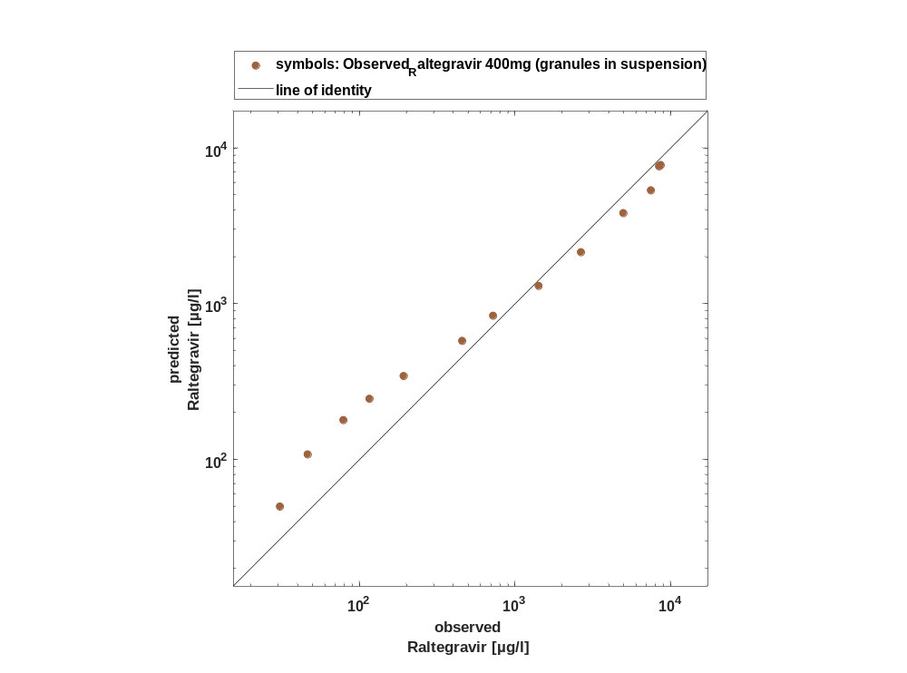

Figure 130: Logarithmic residuals vs time of Raltegravir for Raltegravir 400mg (granules in suspension). Data source: Observed_Raltegravir 400mg (granules in suspension).
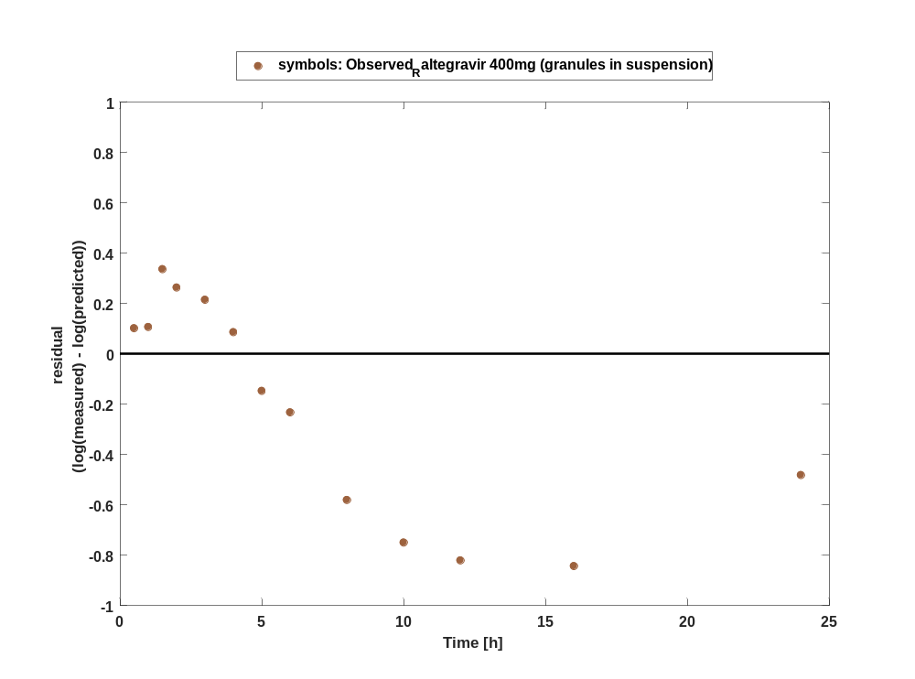

Figure 131: Logarithmic residuals vs predicted values of Raltegravir for Raltegravir 400mg (granules in suspension). Data source: Observed_Raltegravir 400mg (granules in suspension).
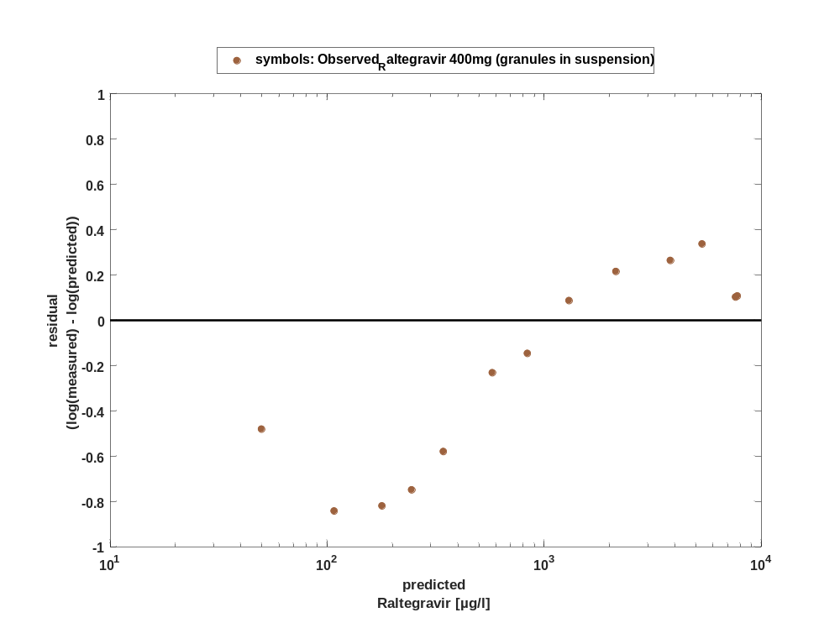

Overview on all residuals

Figure 132: Distribution of residuals for Raltegravir 400mg (granules in suspension)
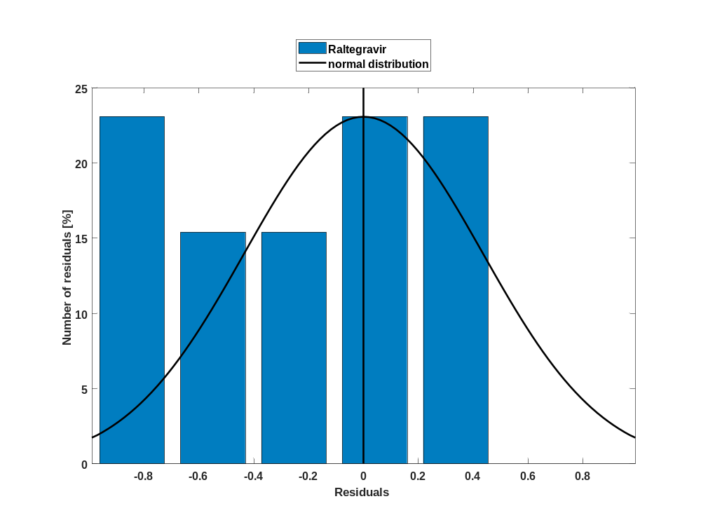

Figure 133: Residuals for Raltegravir 400mg (granules in suspension) as quantile-quantile plot.
