Sensitivity

Sensitivity analysis of C_{max} for Raltegravir

Figure 1: Individual sensitivity vs mean sensitivity for C_{max} for Raltegravir
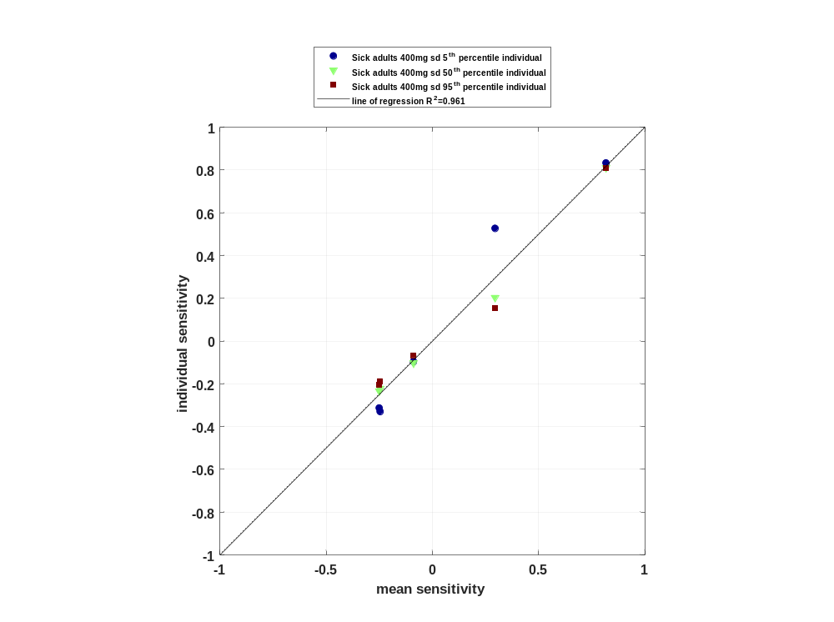

Figure 2: Sorted absolute sensitivity for C_{max} for Raltegravir
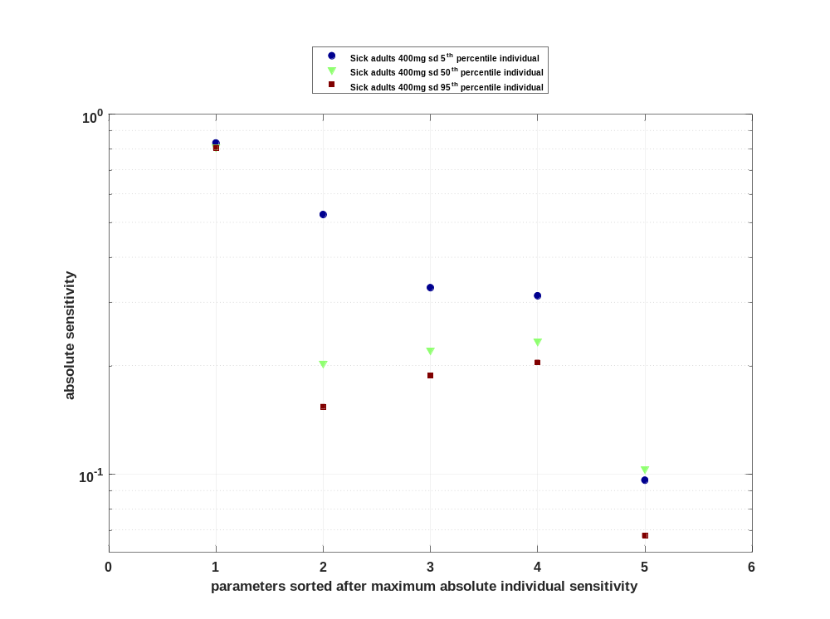

Figure 3: Cumulated sorted absolute sensitivity for C_{max} for Raltegravir
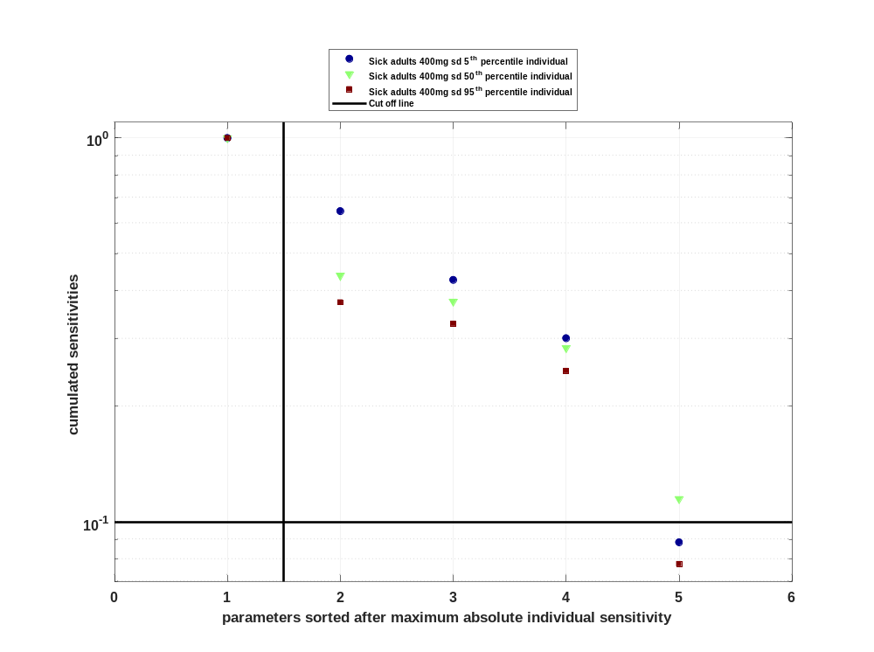

Figure 4: Most sensitive parameter for C_{max} for Raltegravir
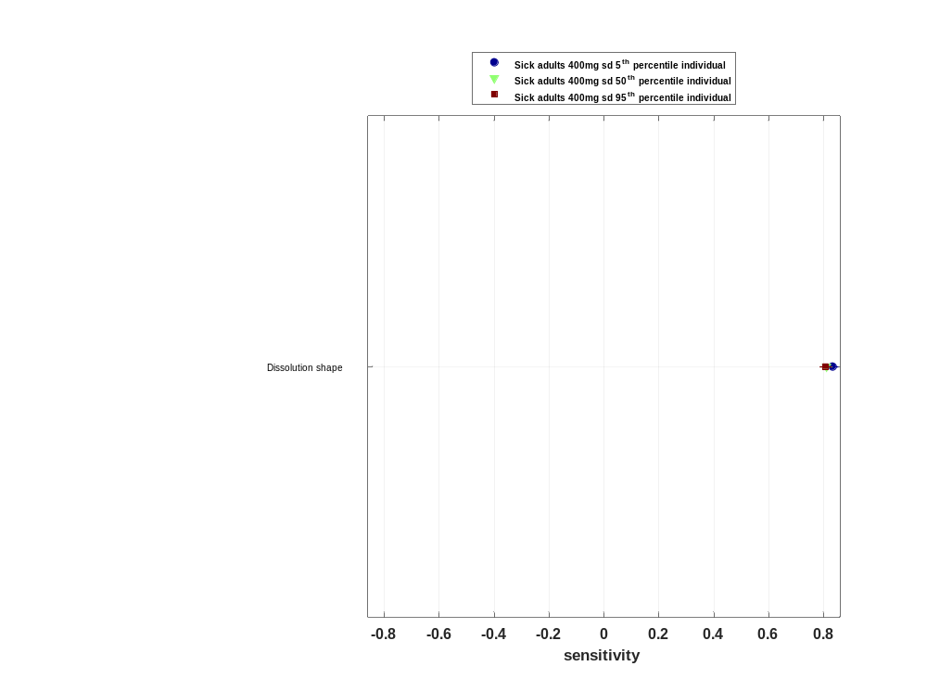

Sensitivity analysis of C_{max} norm for Raltegravir

Figure 5: Individual sensitivity vs mean sensitivity for C_{max} norm for Raltegravir
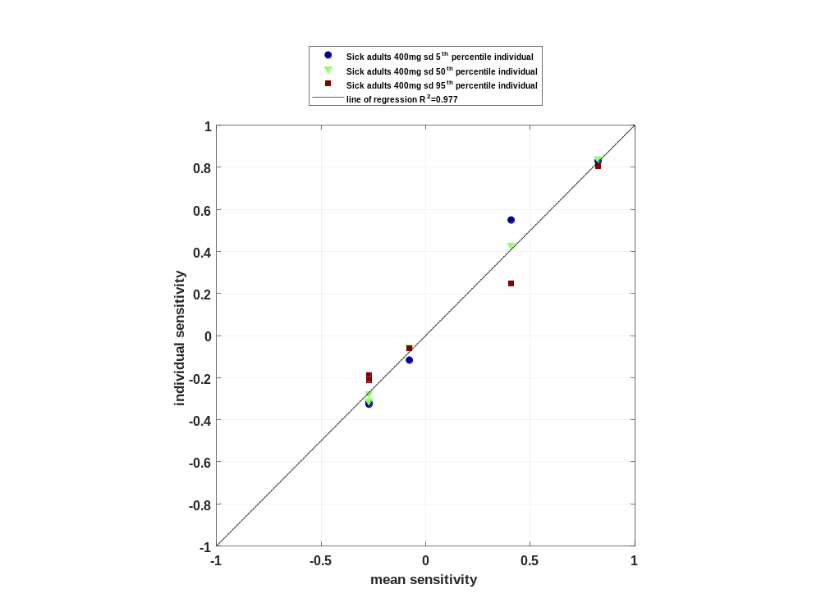

Figure 6: Sorted absolute sensitivity for C_{max} norm for Raltegravir
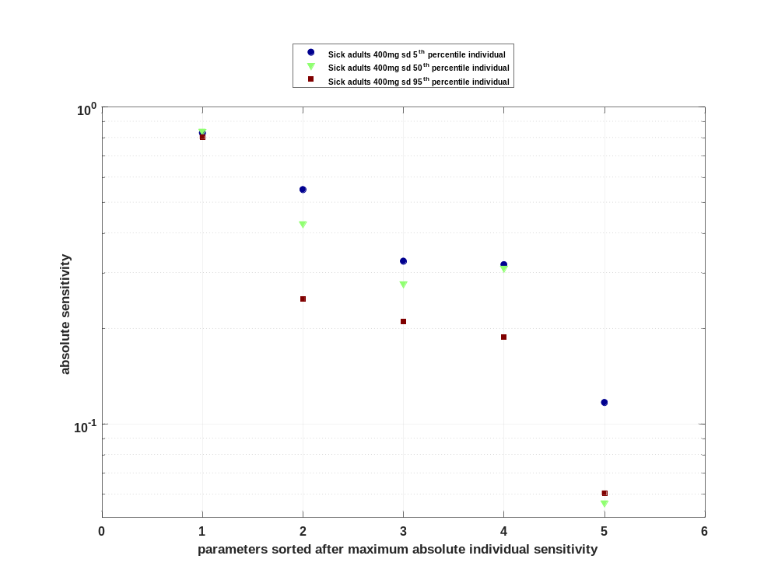

Figure 7: Cumulated sorted absolute sensitivity for C_{max} norm for Raltegravir
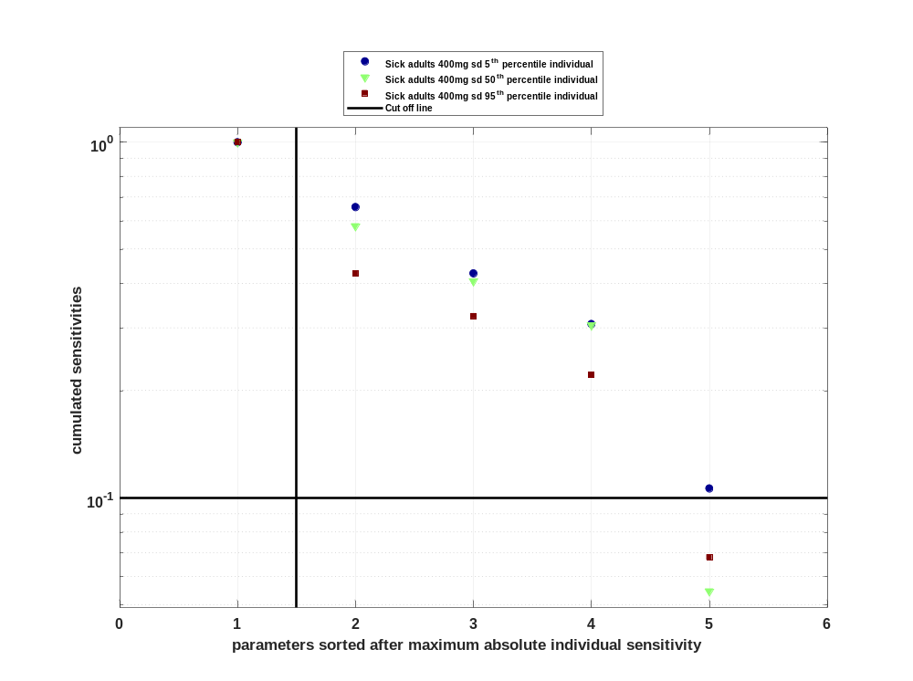

Figure 8: Most sensitive parameter for C_{max} norm for Raltegravir
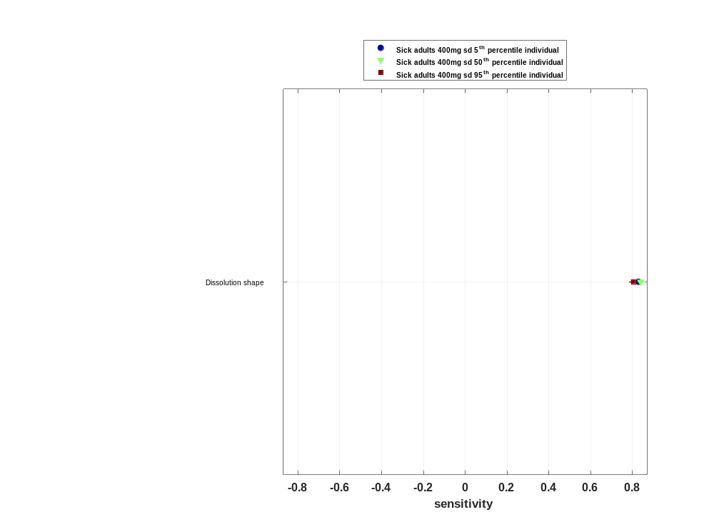

Sensitivity analysis of t_{max} for Raltegravir

Figure 9: Individual sensitivity vs mean sensitivity for t_{max} for Raltegravir
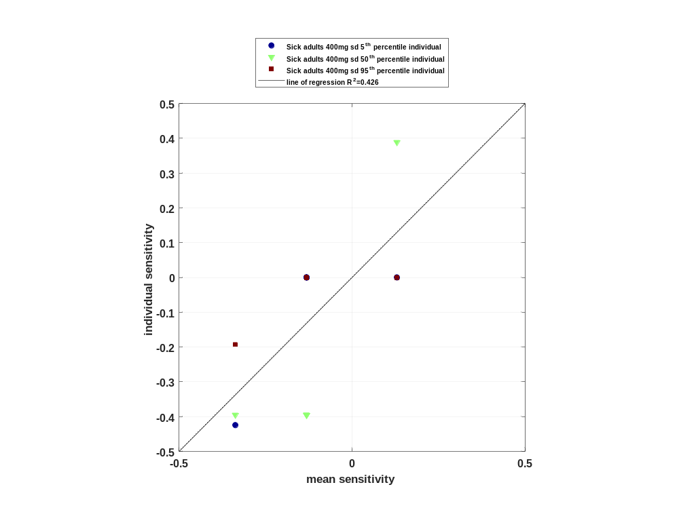

Figure 10: Sorted absolute sensitivity for t_{max} for Raltegravir
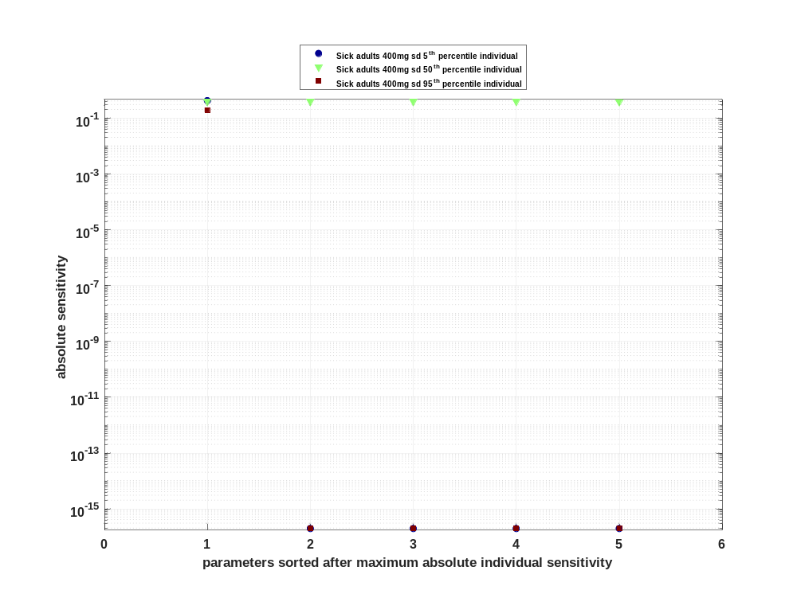

Figure 11: Cumulated sorted absolute sensitivity for t_{max} for Raltegravir
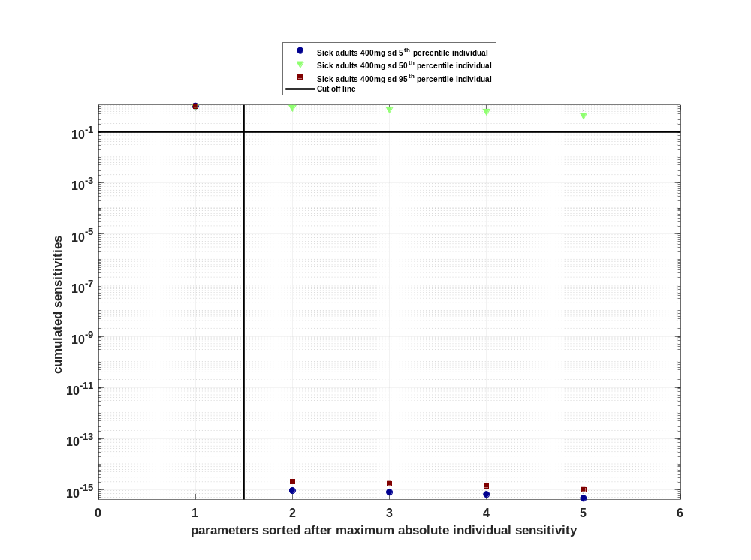

Figure 12: Most sensitive parameter for t_{max} for Raltegravir
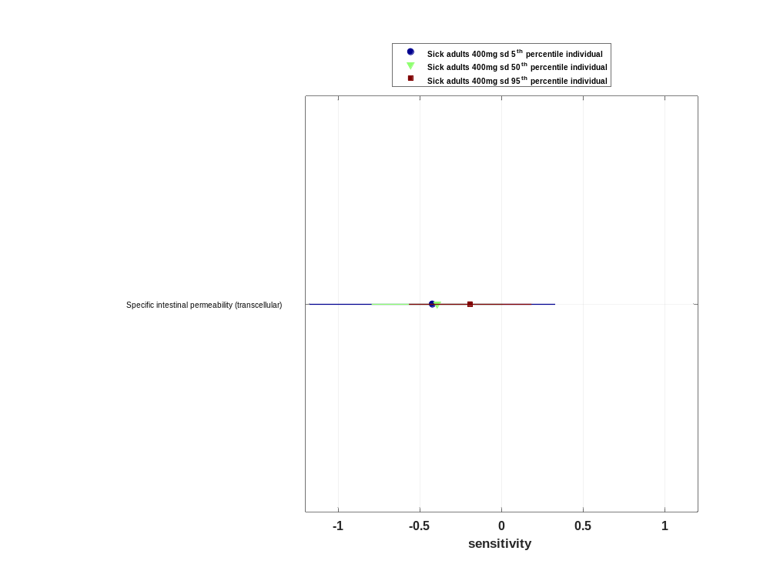

Sensitivity analysis of C_{tEnd} for Raltegravir

Figure 13: Individual sensitivity vs mean sensitivity for C_{tEnd} for Raltegravir
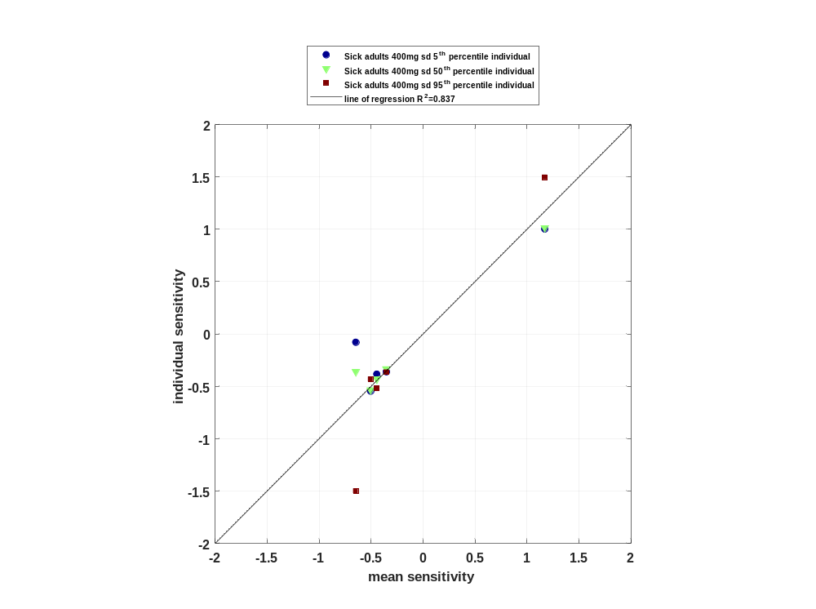

Figure 14: Sorted absolute sensitivity for C_{tEnd} for Raltegravir
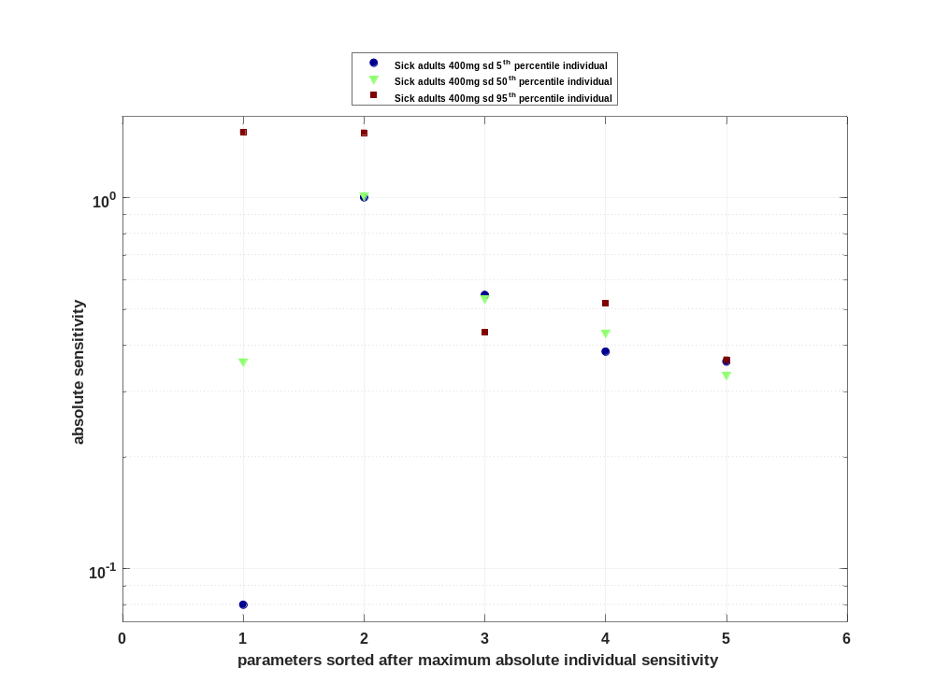

Figure 15: Cumulated sorted absolute sensitivity for C_{tEnd} for Raltegravir
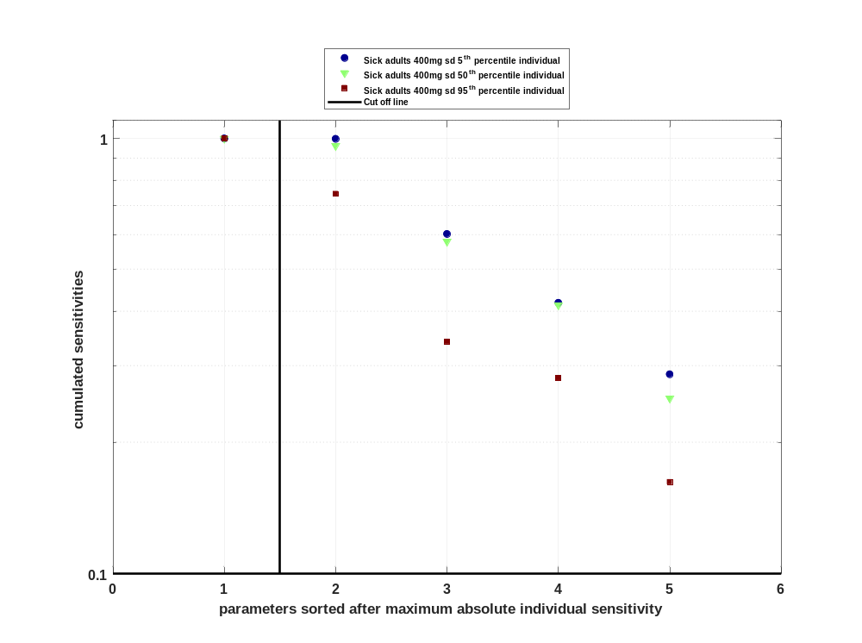

Figure 16: Most sensitive parameter for C_{tEnd} for Raltegravir
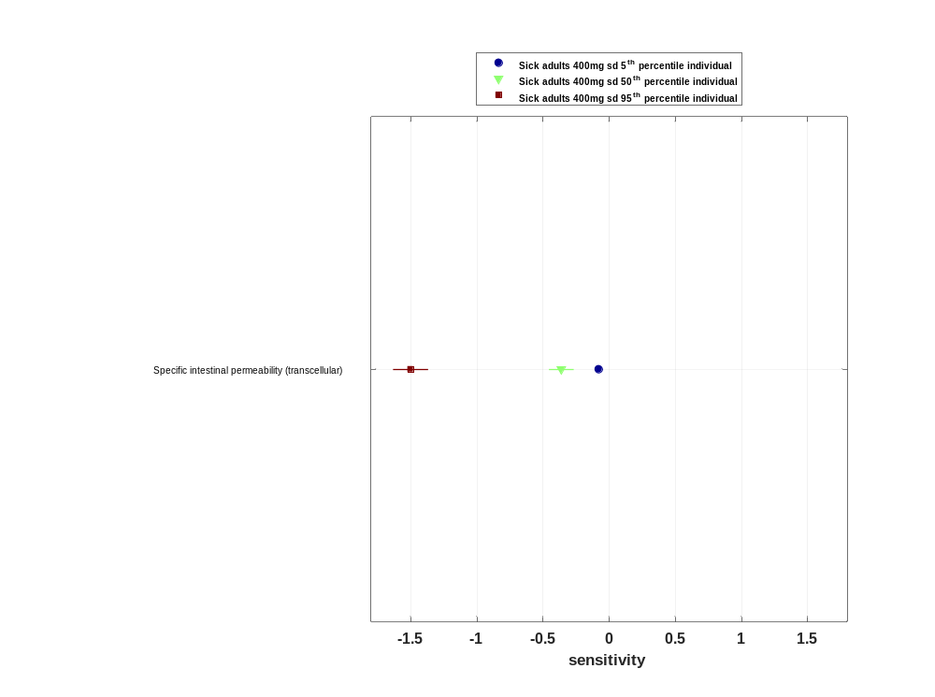

Sensitivity analysis of AUC_{last} for Raltegravir

Figure 17: Individual sensitivity vs mean sensitivity for AUC_{last} for Raltegravir
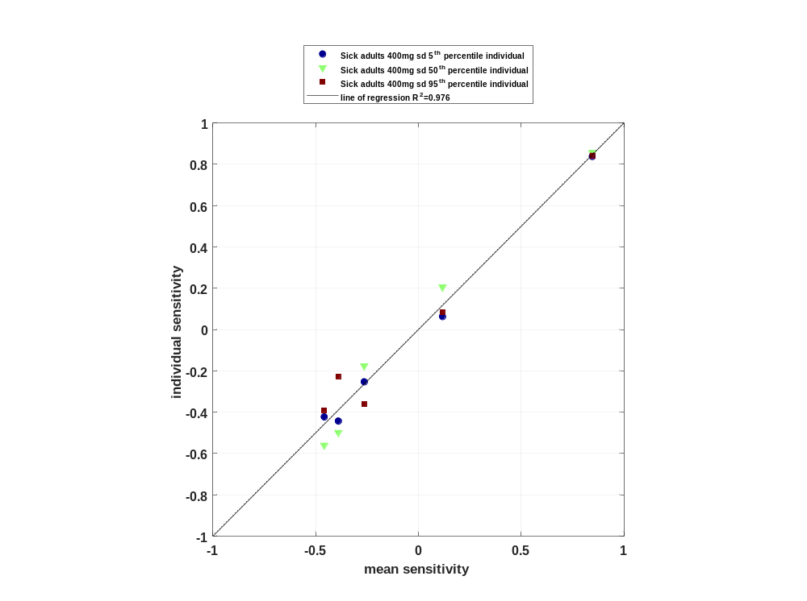

Figure 18: Sorted absolute sensitivity for AUC_{last} for Raltegravir
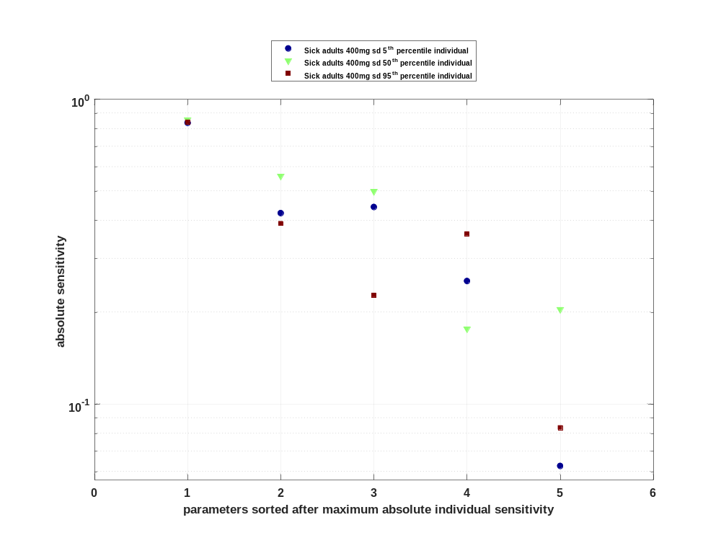

Figure 19: Cumulated sorted absolute sensitivity for AUC_{last} for Raltegravir
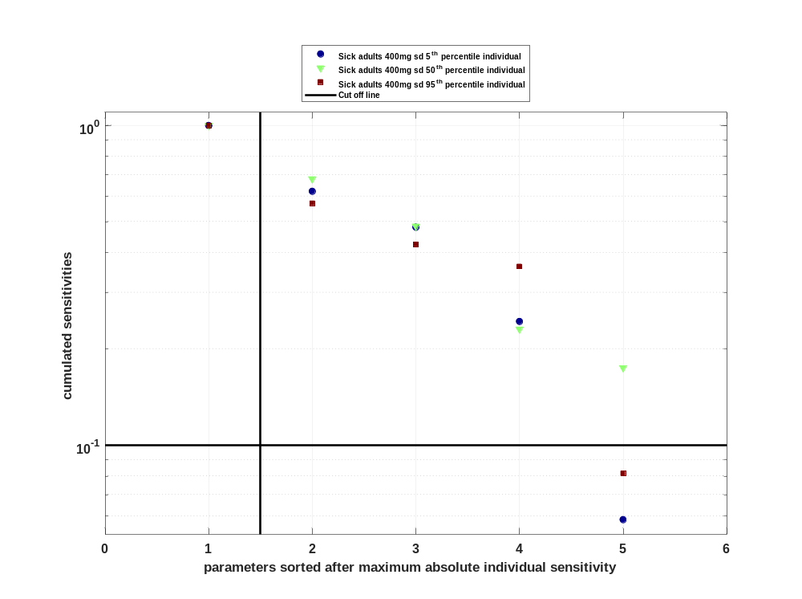

Figure 20: Most sensitive parameter for AUC_{last} for Raltegravir
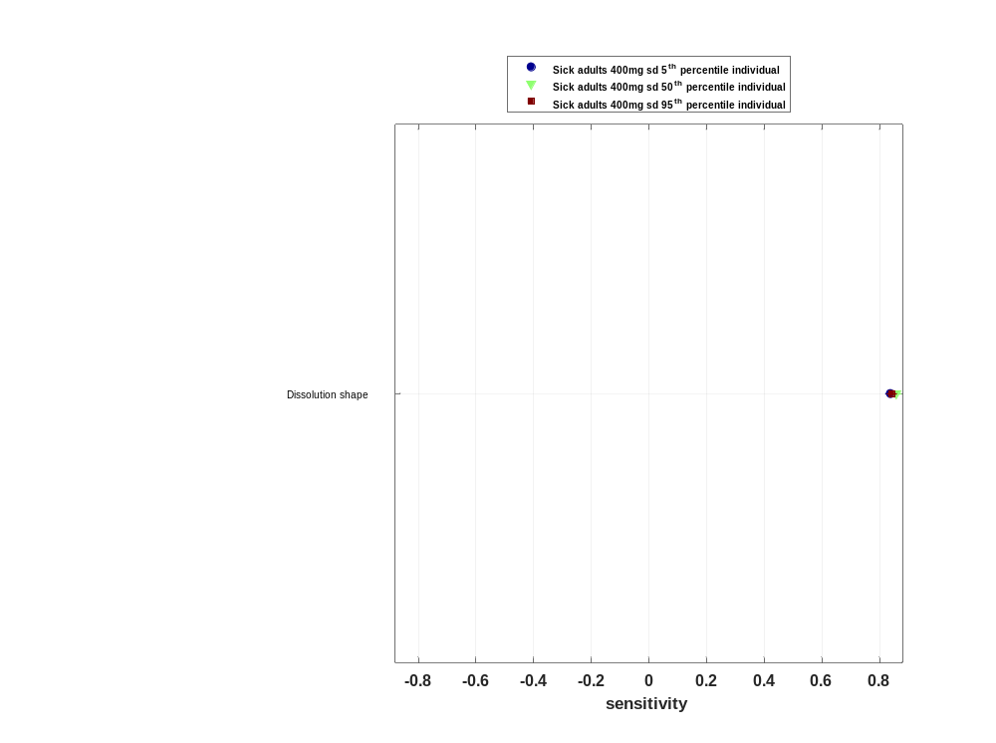

Sensitivity analysis of AUC_{last} norm for Raltegravir

Figure 21: Individual sensitivity vs mean sensitivity for AUC_{last} norm for Raltegravir
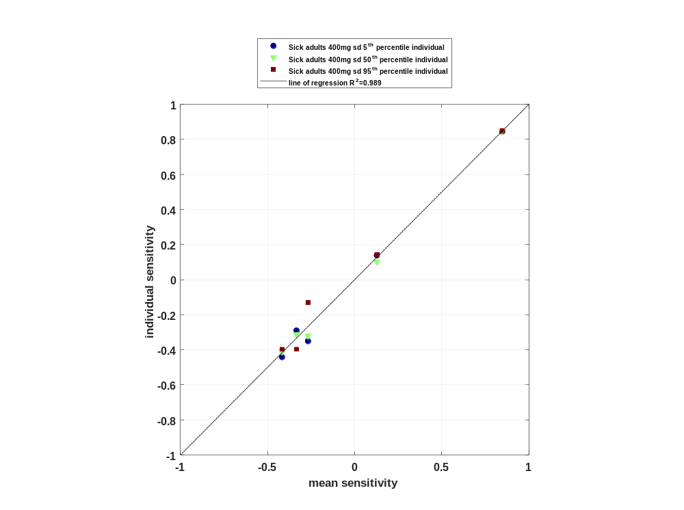

Figure 22: Sorted absolute sensitivity for AUC_{last} norm for Raltegravir
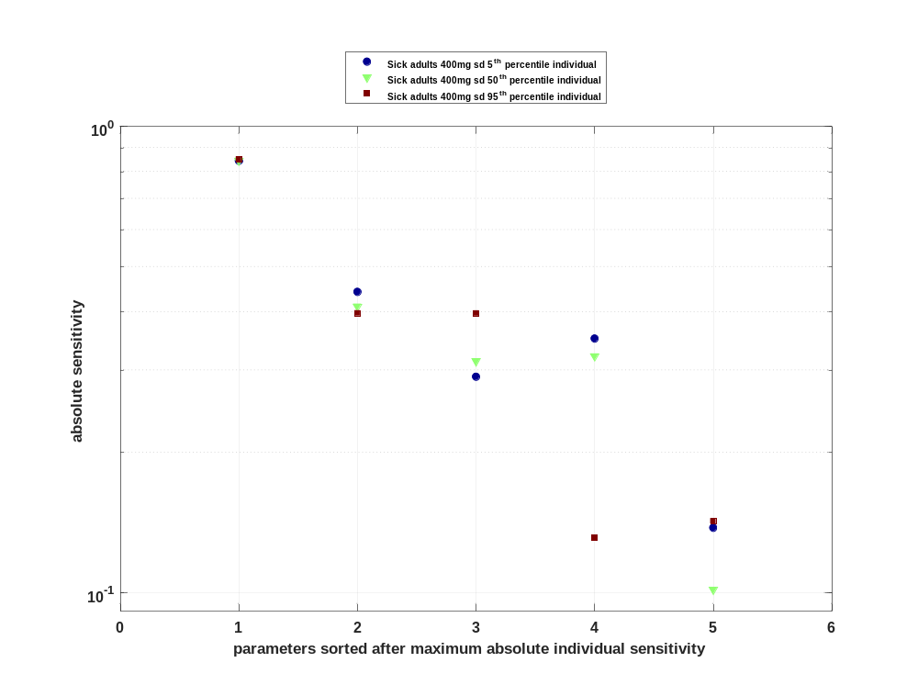

Figure 23: Cumulated sorted absolute sensitivity for AUC_{last} norm for Raltegravir
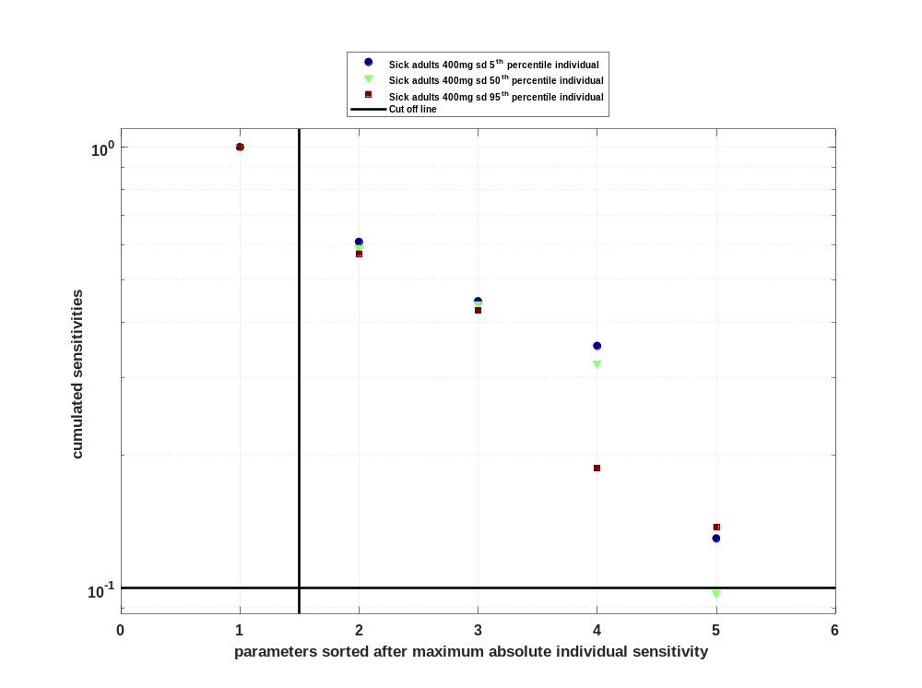

Figure 24: Most sensitive parameter for AUC_{last} norm for Raltegravir
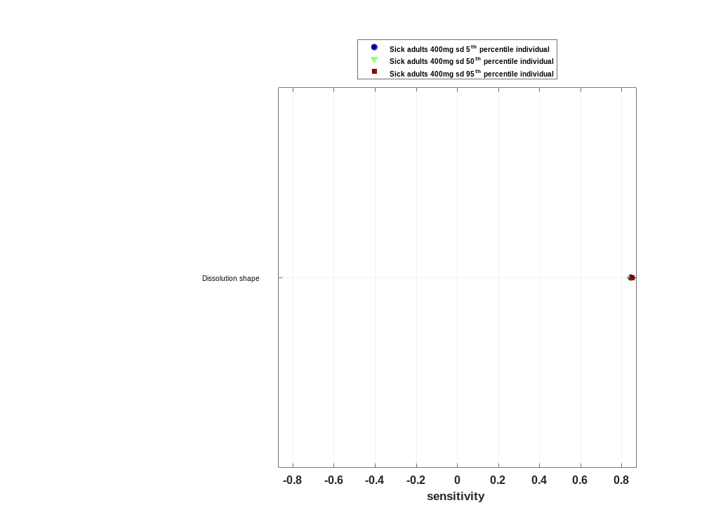

Sensitivity analysis of AUC_{inf} for Raltegravir

Figure 25: Individual sensitivity vs mean sensitivity for AUC_{inf} for Raltegravir
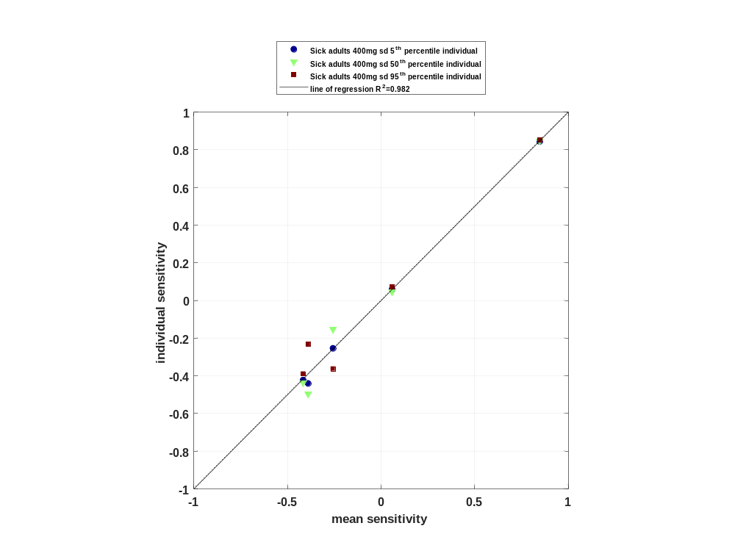

Figure 26: Sorted absolute sensitivity for AUC_{inf} for Raltegravir
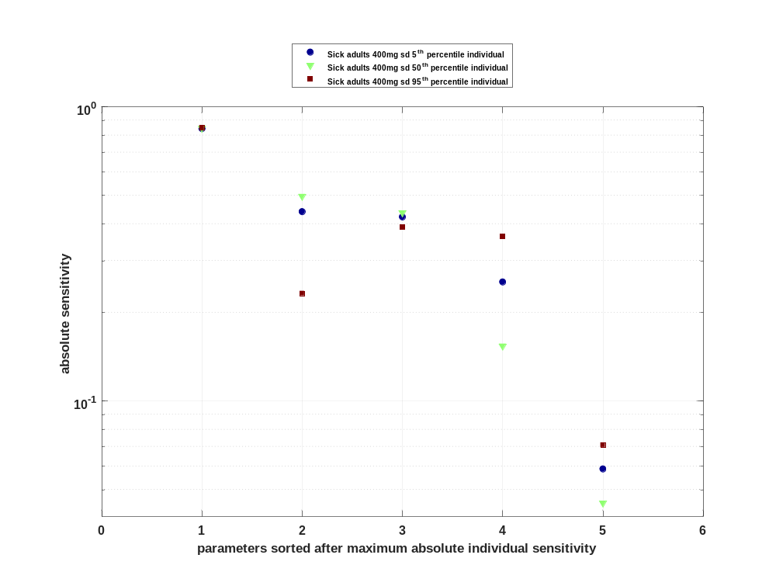

Figure 27: Cumulated sorted absolute sensitivity for AUC_{inf} for Raltegravir
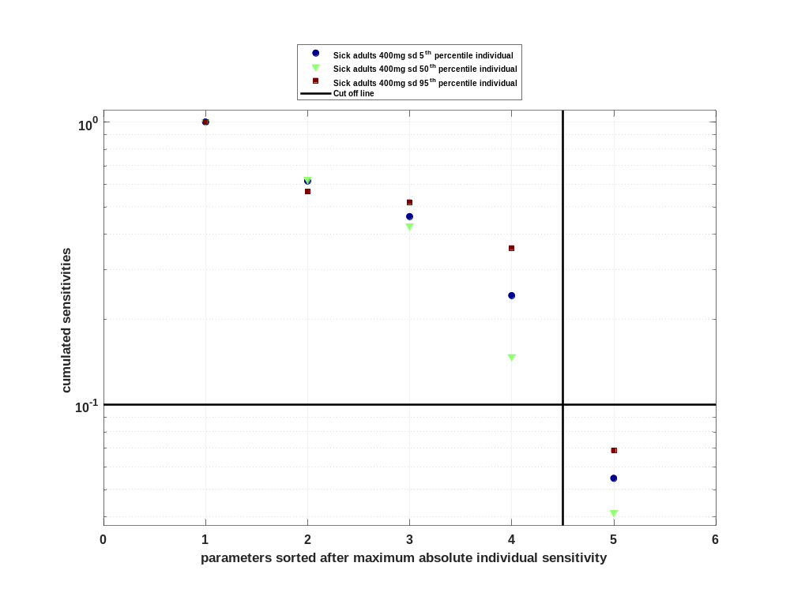

Figure 28: Most sensitive parameter for AUC_{inf} for Raltegravir
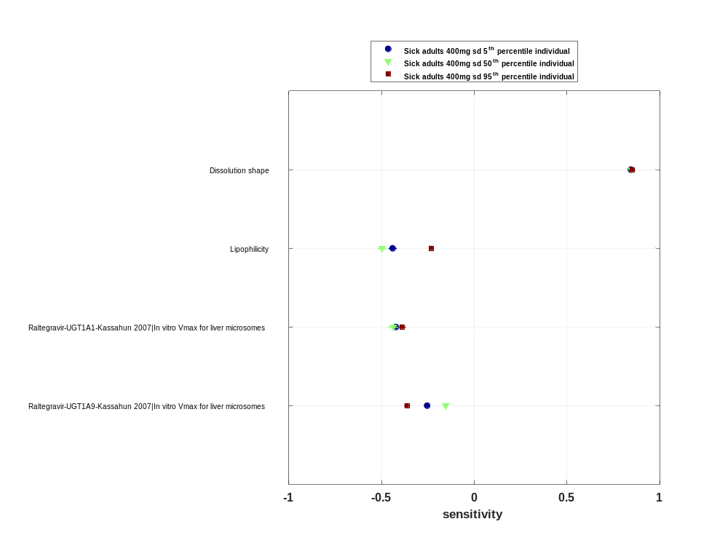

Sensitivity analysis of AUC_{inf} norm for Raltegravir

Figure 29: Individual sensitivity vs mean sensitivity for AUC_{inf} norm for Raltegravir
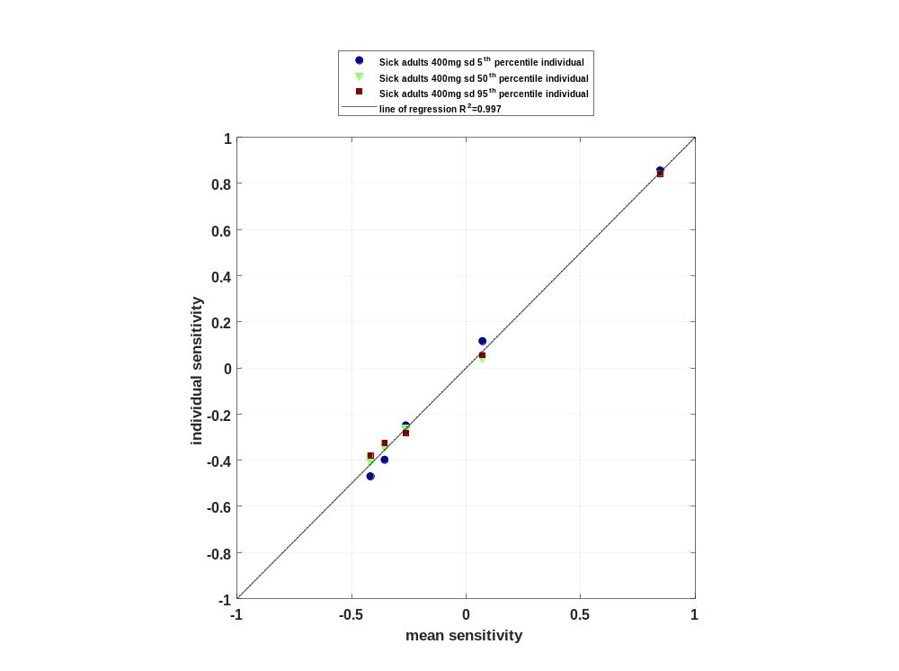

Figure 30: Sorted absolute sensitivity for AUC_{inf} norm for Raltegravir
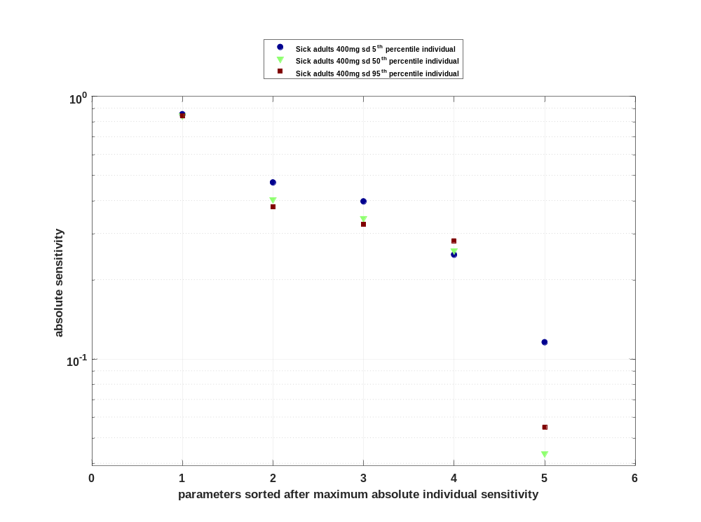

Figure 31: Cumulated sorted absolute sensitivity for AUC_{inf} norm for Raltegravir
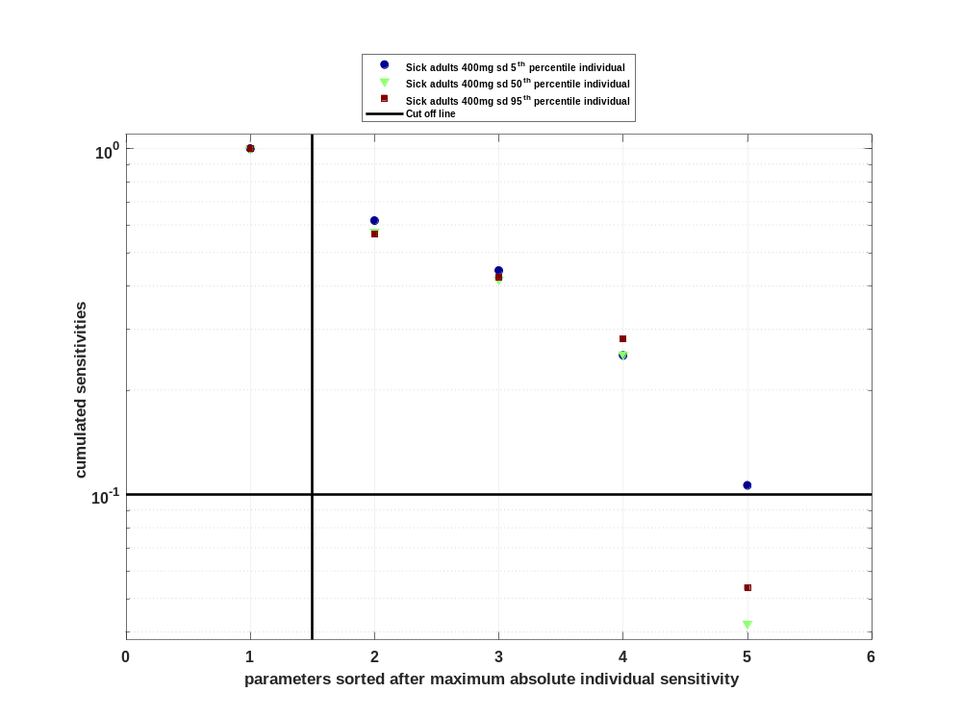

Figure 32: Most sensitive parameter for AUC_{inf} norm for Raltegravir
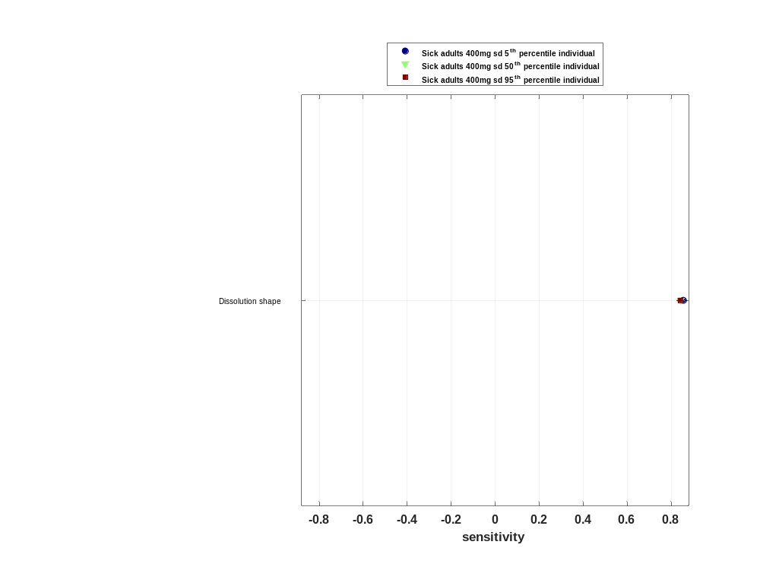

Sensitivity analysis of MRT for Raltegravir

Figure 33: Individual sensitivity vs mean sensitivity for MRT for Raltegravir
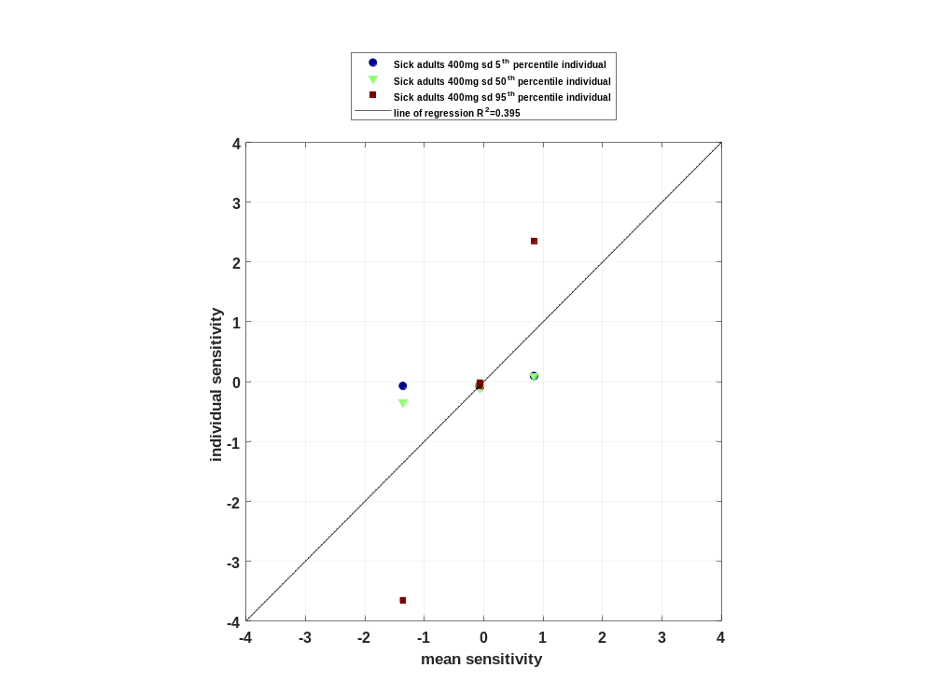

Figure 34: Sorted absolute sensitivity for MRT for Raltegravir
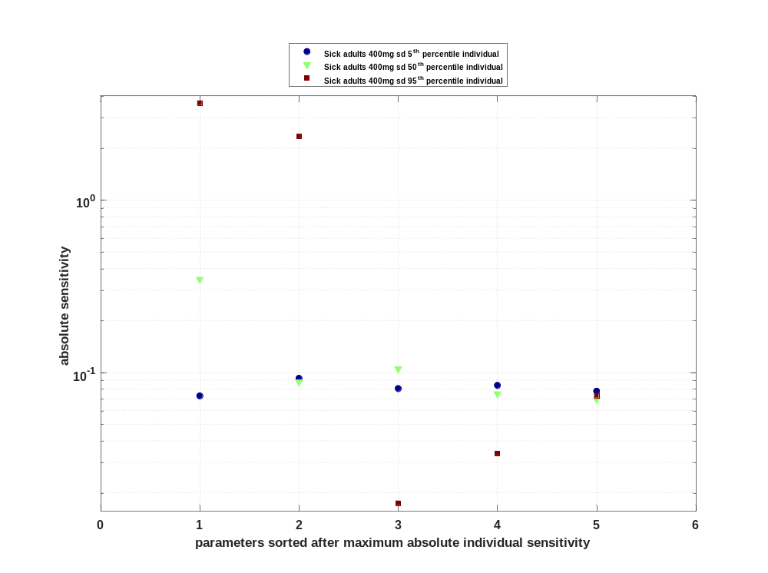

Figure 35: Cumulated sorted absolute sensitivity for MRT for Raltegravir
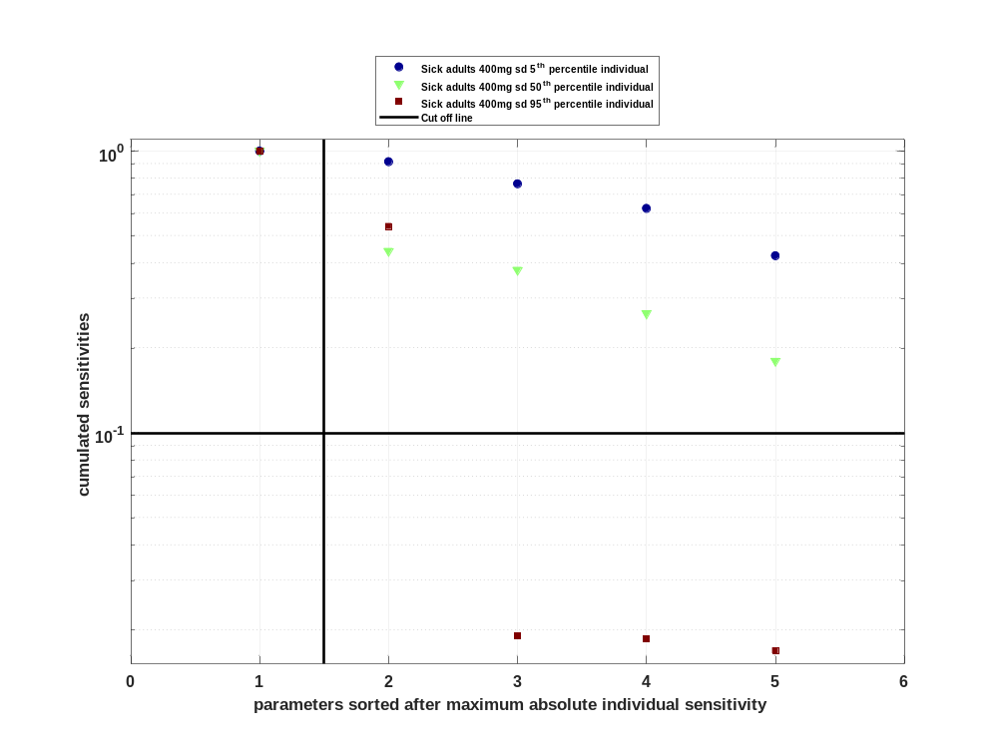

Figure 36: Most sensitive parameter for MRT for Raltegravir
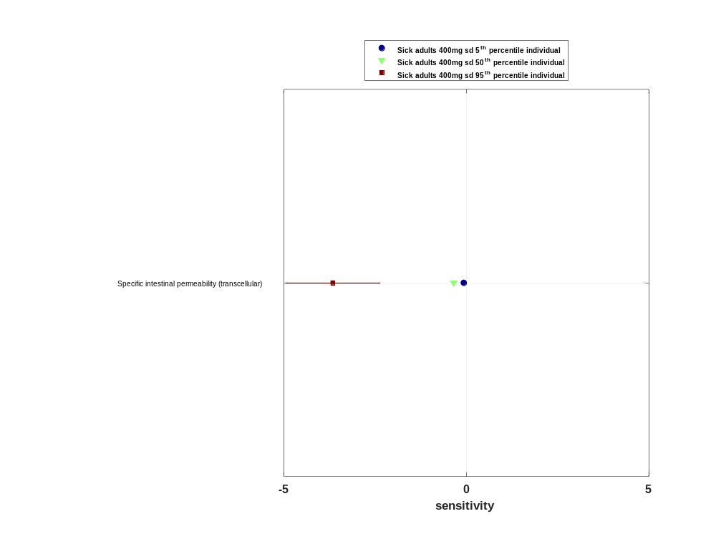

Sensitivity analysis of Thalf for Raltegravir

Figure 37: Individual sensitivity vs mean sensitivity for Thalf for Raltegravir
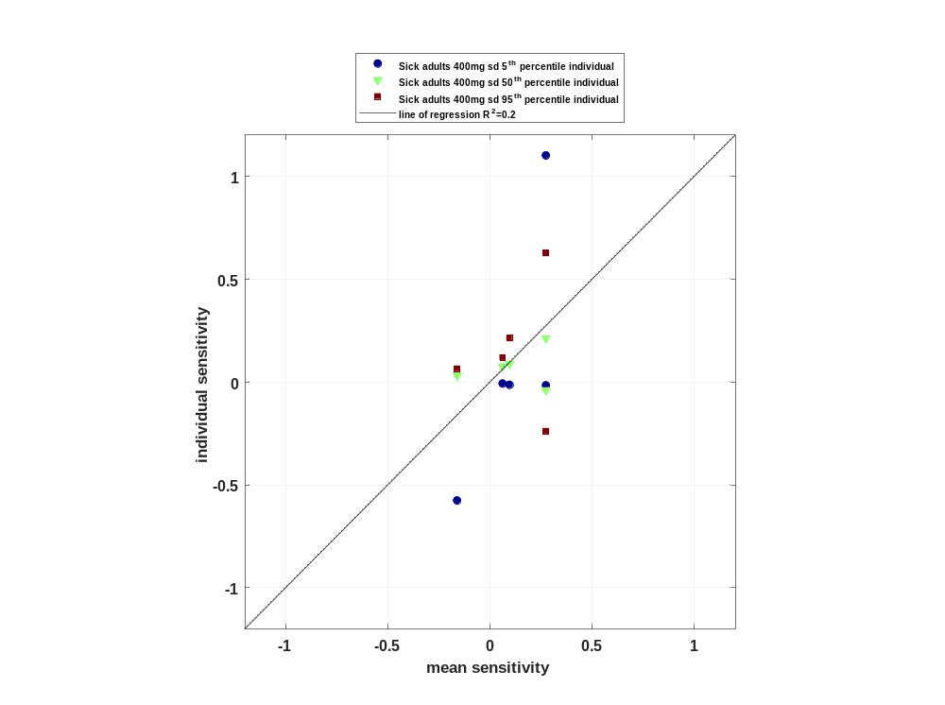

Figure 38: Sorted absolute sensitivity for Thalf for Raltegravir
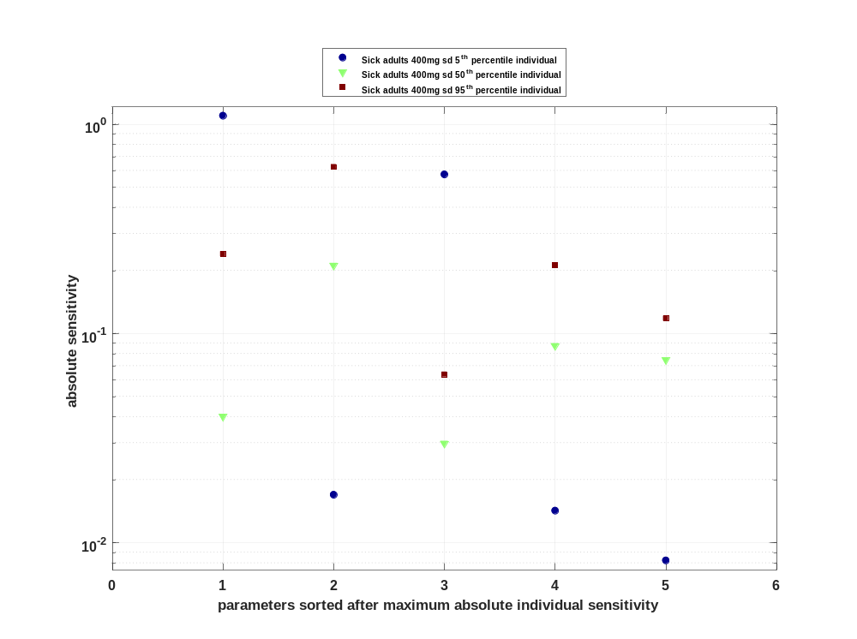

Figure 39: Cumulated sorted absolute sensitivity for Thalf for Raltegravir
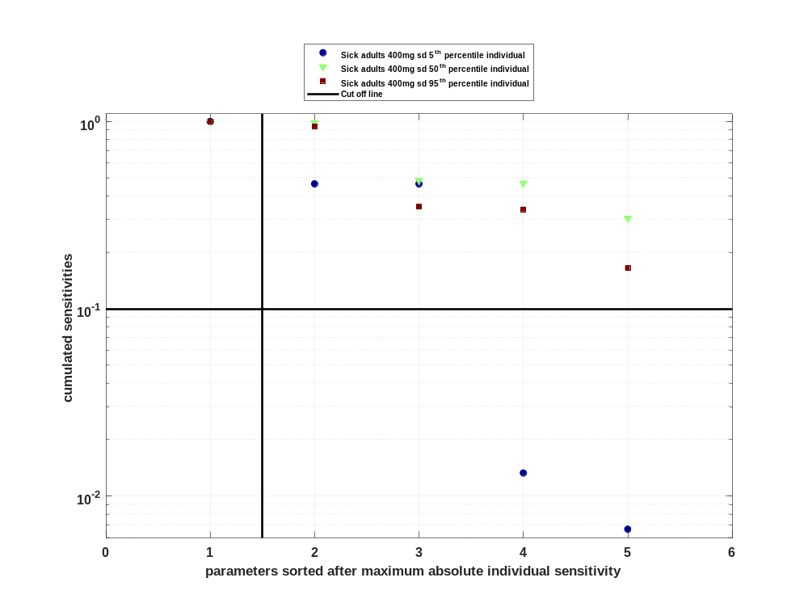

Figure 40: Most sensitive parameter for Thalf for Raltegravir
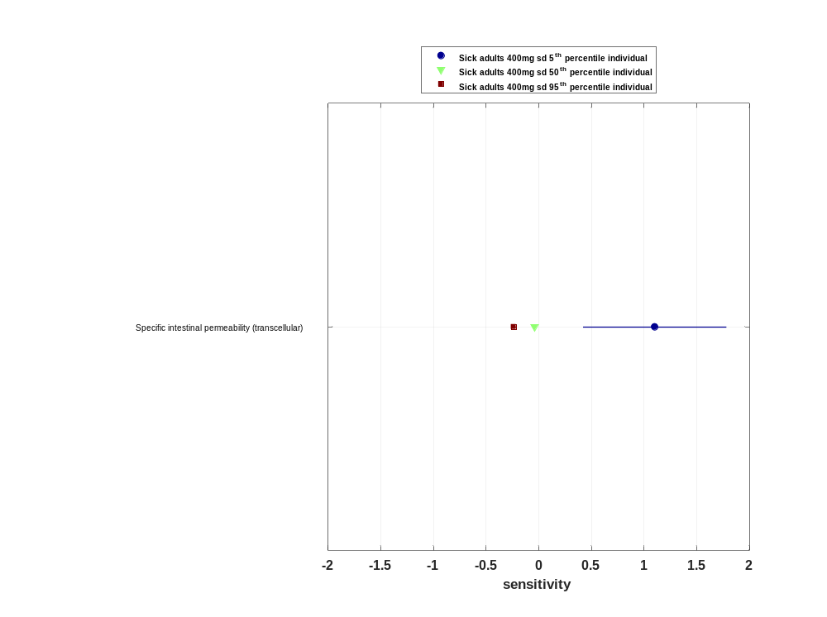

Sensitivity analysis of CL for Raltegravir

Figure 41: Individual sensitivity vs mean sensitivity for CL for Raltegravir
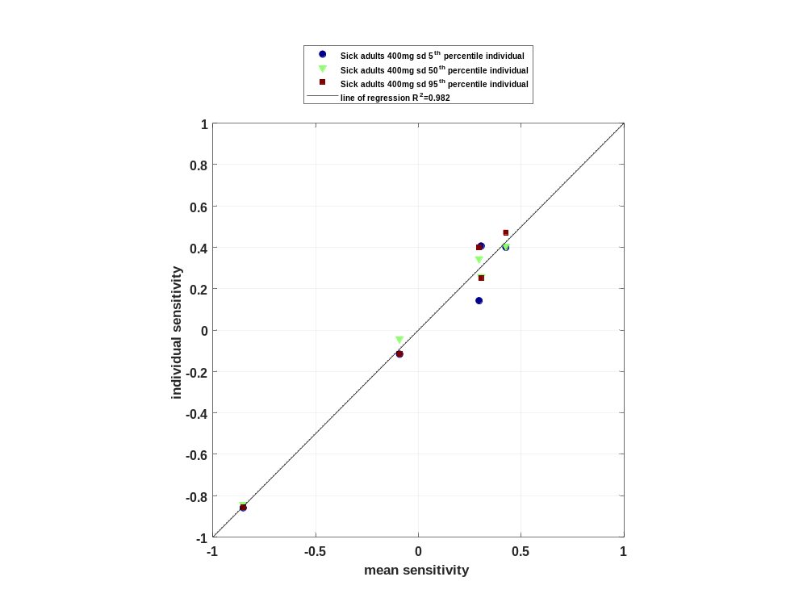

Figure 42: Sorted absolute sensitivity for CL for Raltegravir
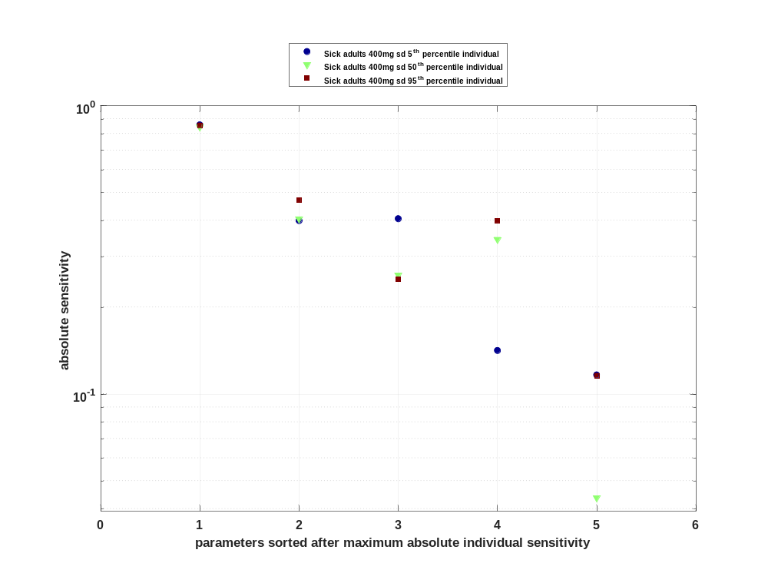

Figure 43: Cumulated sorted absolute sensitivity for CL for Raltegravir
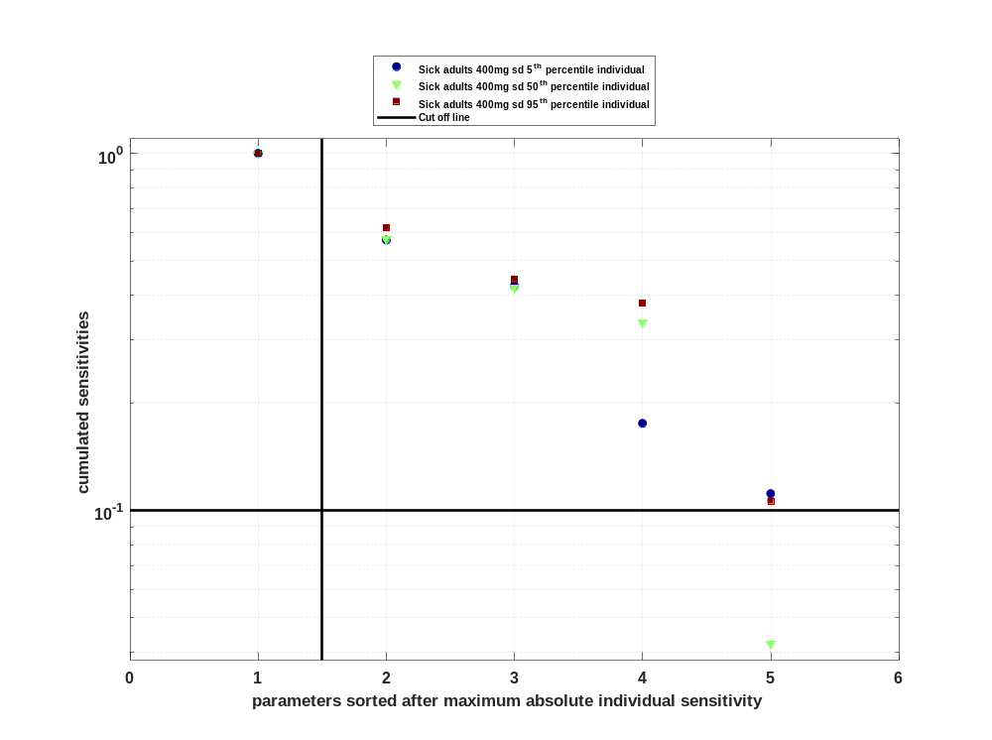

Figure 44: Most sensitive parameter for CL for Raltegravir
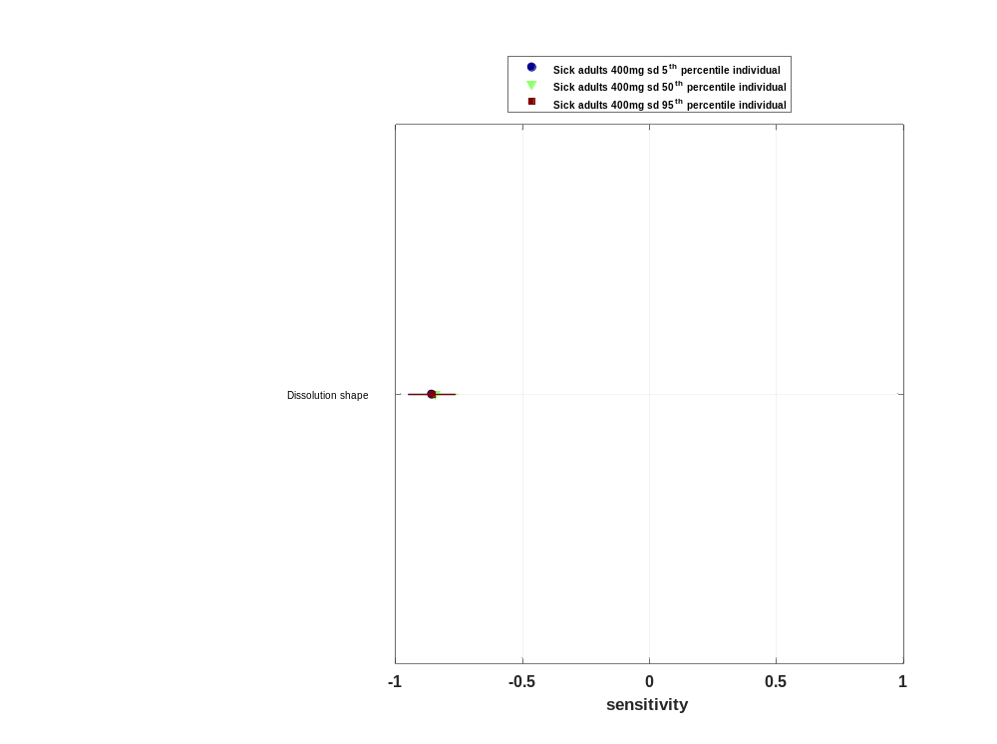

Sensitivity analysis of Vss for Raltegravir

Figure 45: Individual sensitivity vs mean sensitivity for Vss for Raltegravir
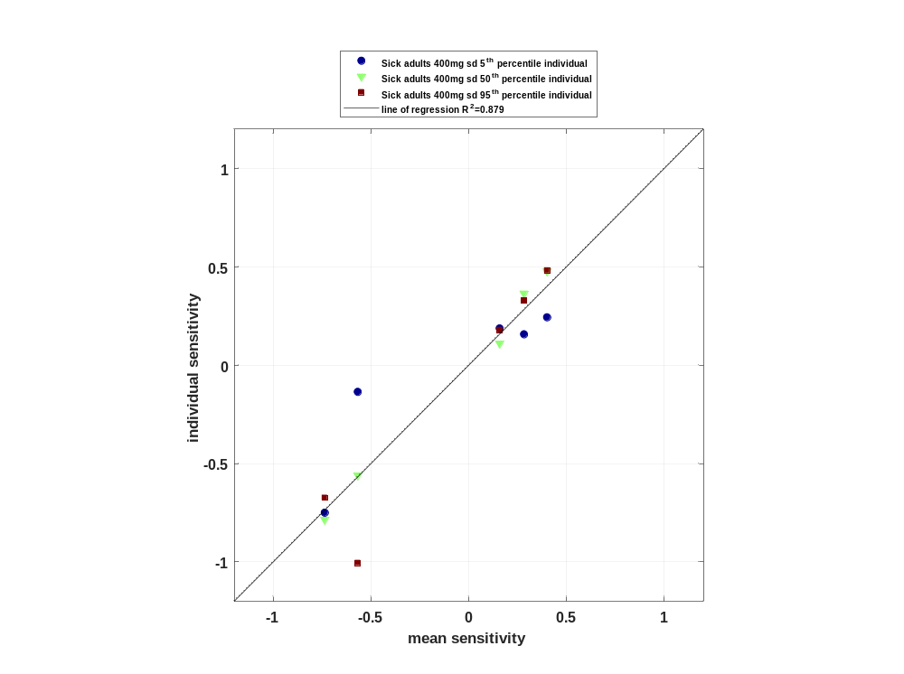

Figure 46: Sorted absolute sensitivity for Vss for Raltegravir
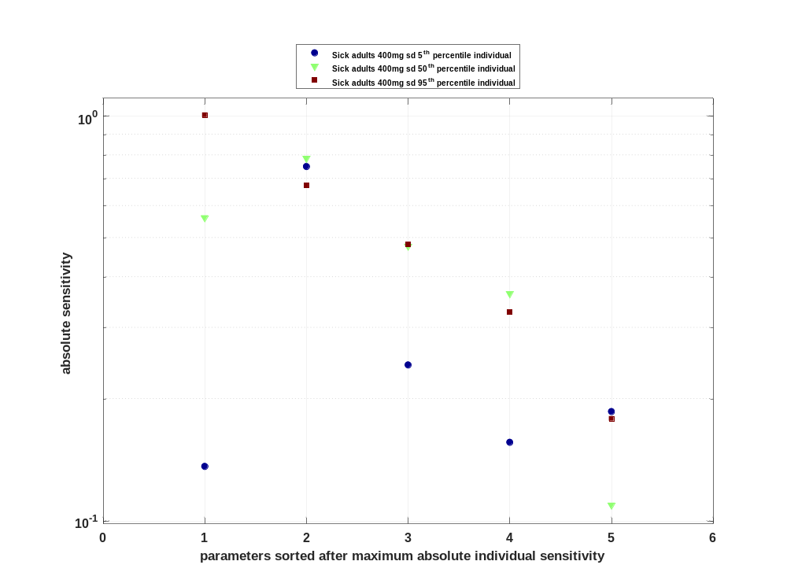

Figure 47: Cumulated sorted absolute sensitivity for Vss for Raltegravir
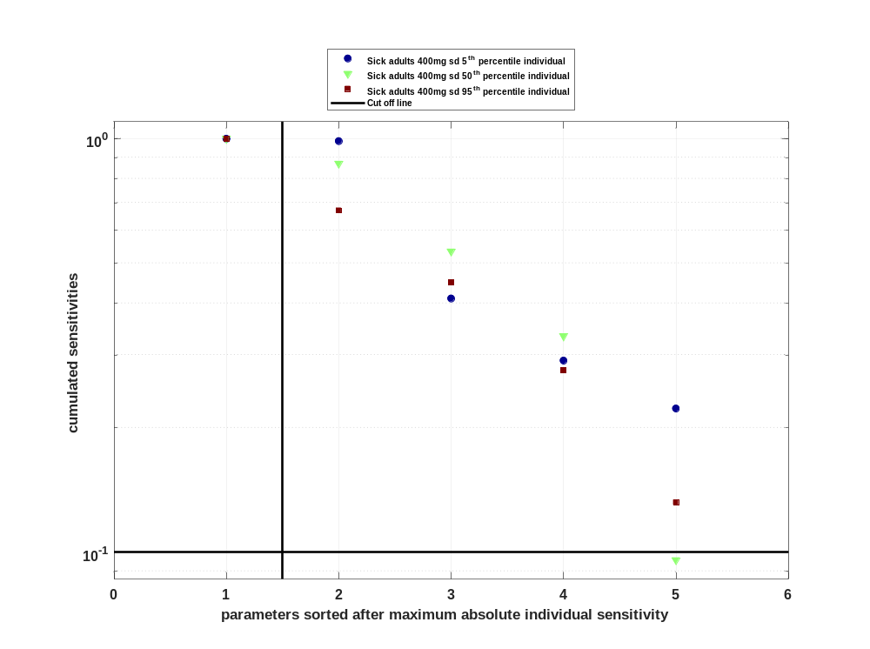

Figure 48: Most sensitive parameter for Vss for Raltegravir
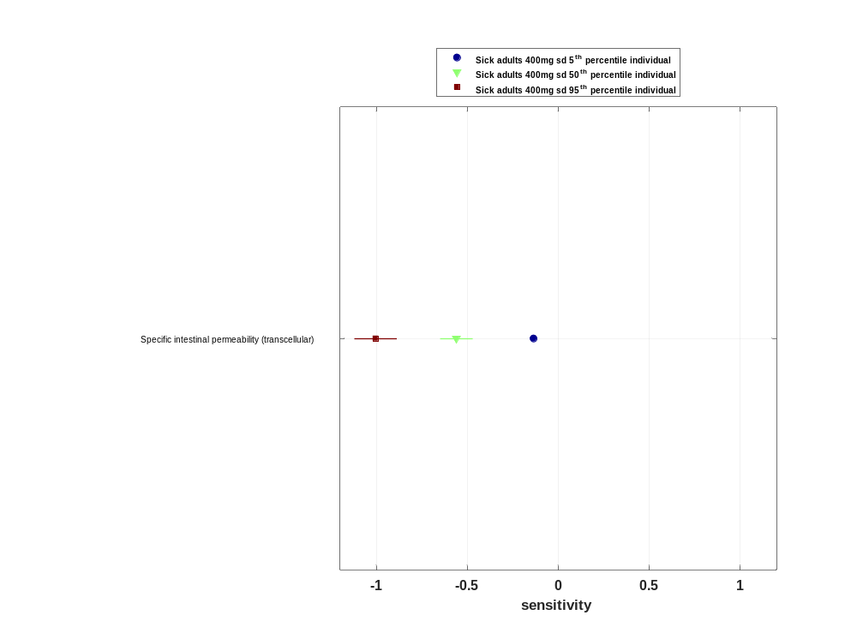

Sensitivity analysis of Vd for Raltegravir

Figure 49: Individual sensitivity vs mean sensitivity for Vd for Raltegravir
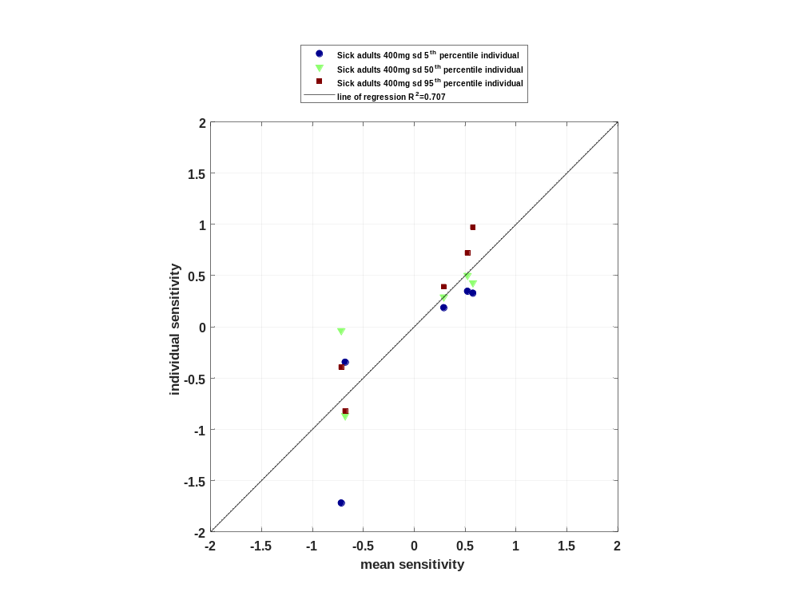

Figure 50: Sorted absolute sensitivity for Vd for Raltegravir
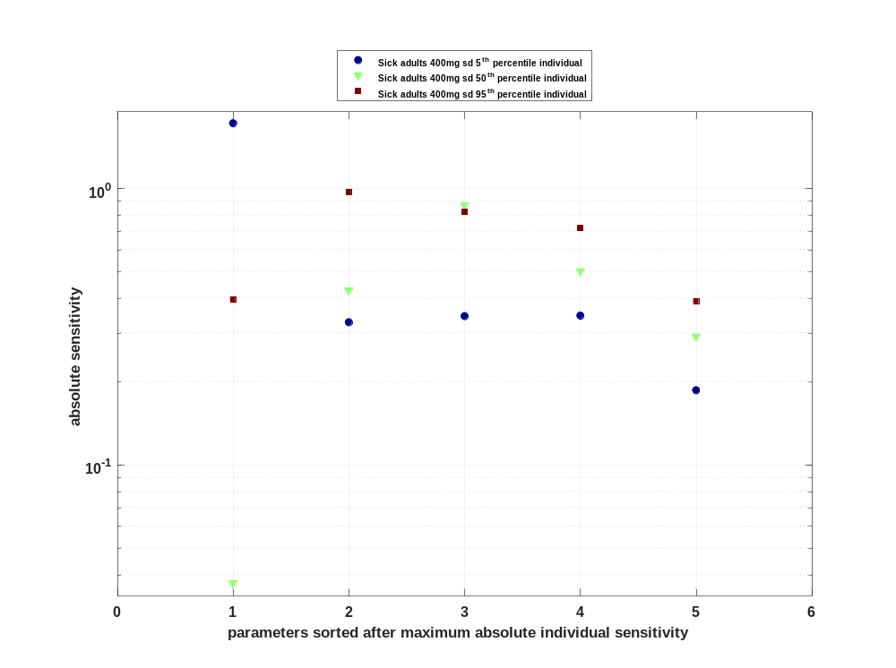

Figure 51: Cumulated sorted absolute sensitivity for Vd for Raltegravir
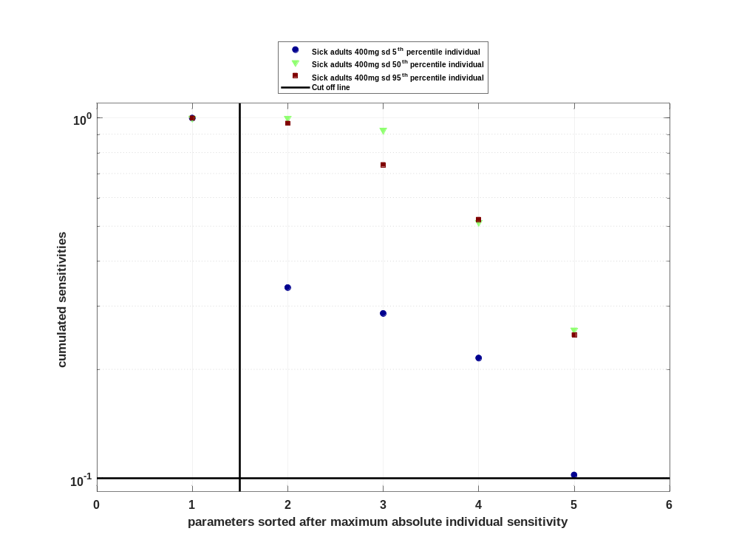

Figure 52: Most sensitive parameter for Vd for Raltegravir
