Physiology

Demography of Sick adults 400mg sd vs. simulated Sick Adult Population

Figure 1: Distribution of age for simulated Sick Adult Population.
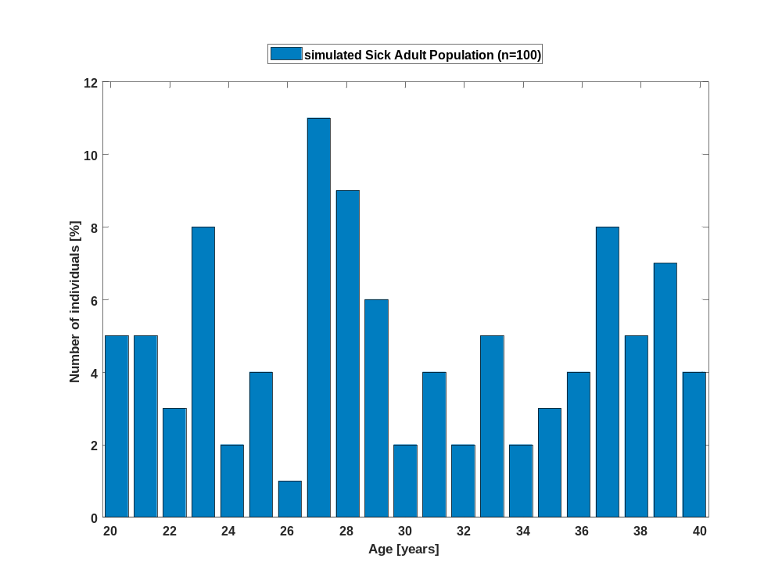

Figure 2: Distribution of body weight for simulated Sick Adult Population.
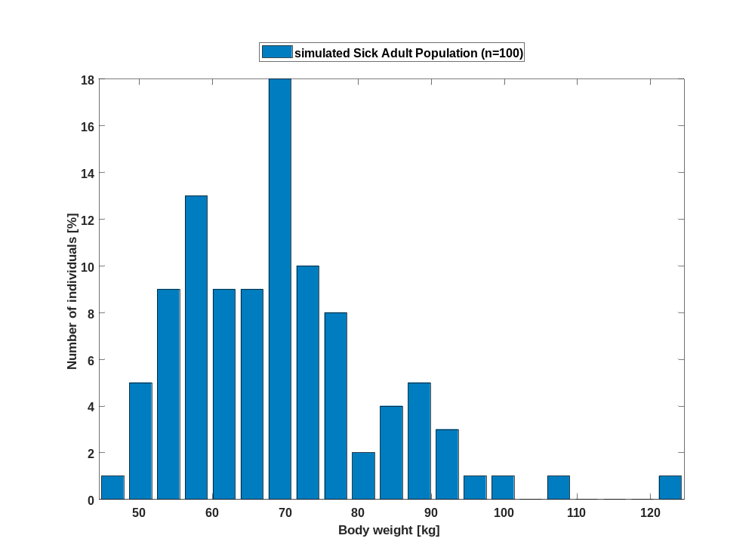

Figure 3: Distribution of body height for simulated Sick Adult Population.
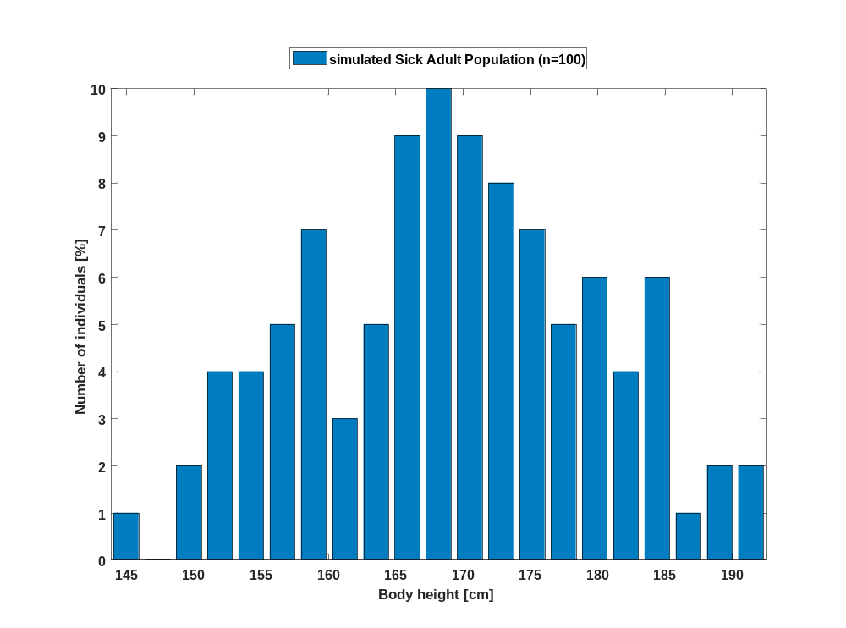

Figure 4: Distribution of BMI for simulated Sick Adult Population.
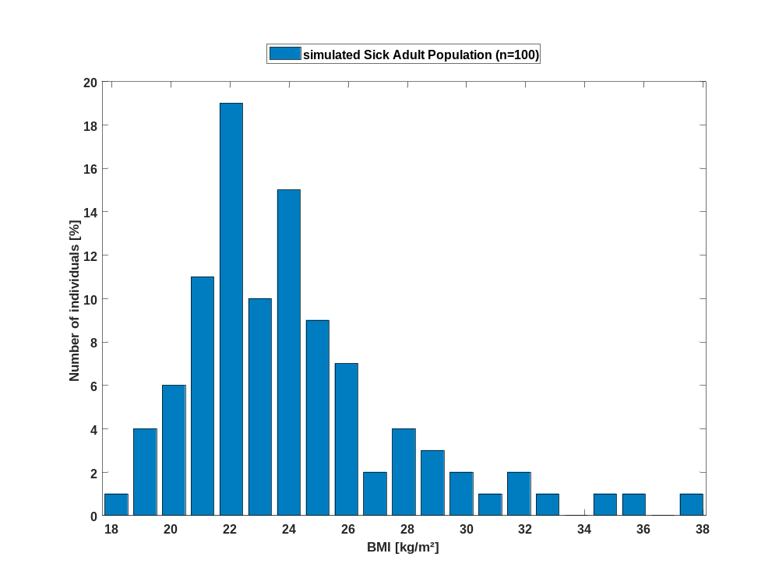

Figure 5: Distribution of body surface area for simulated Sick Adult Population.
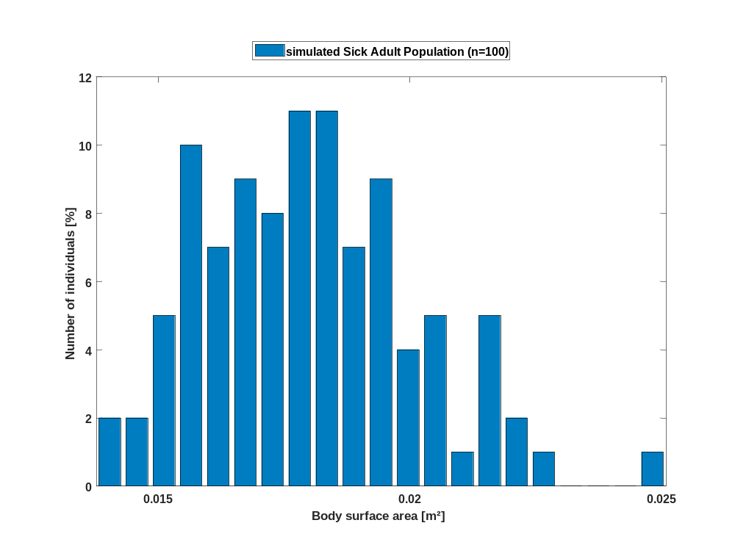

Figure 6: Distribution of gender for simulated Sick Adult Population.
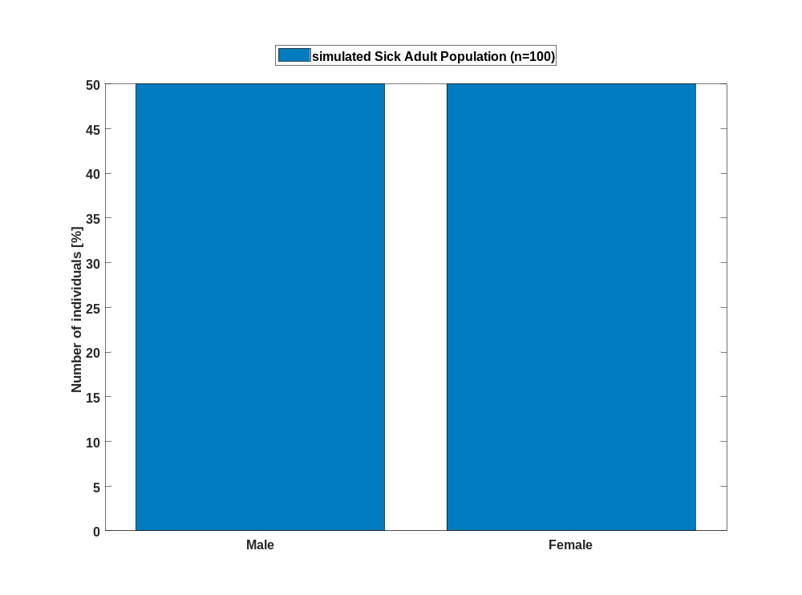

Demography of Healthy adults 400mg sd vs. simulated Healthy Adult Population

Figure 7: Distribution of age for simulated Healthy Adult Population.
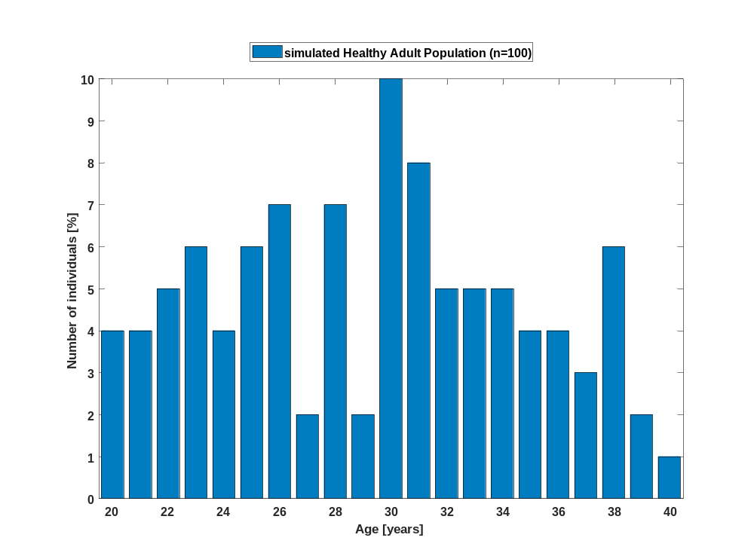

Figure 8: Distribution of body weight for simulated Healthy Adult Population.
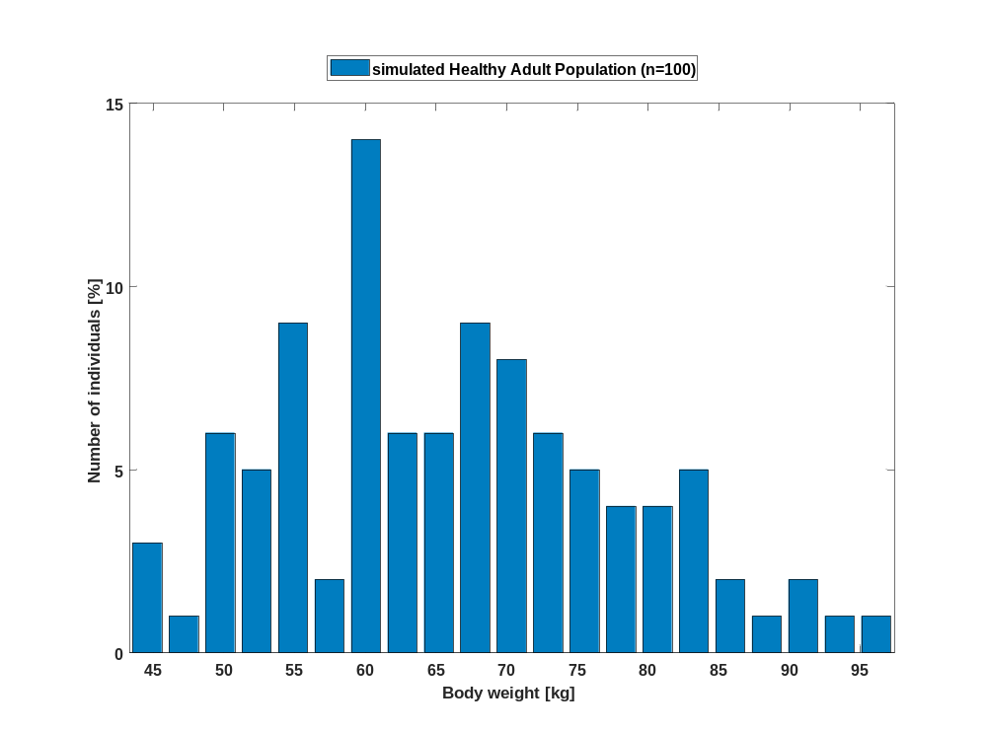

Figure 9: Distribution of body height for simulated Healthy Adult Population.
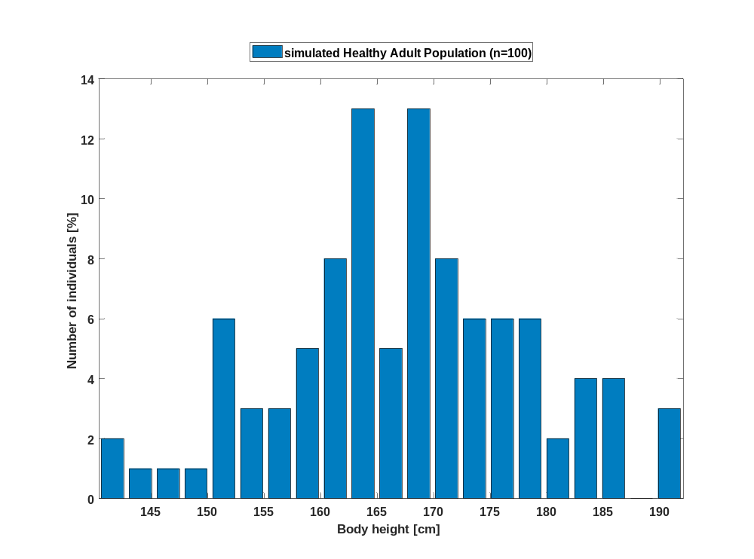

Figure 10: Distribution of BMI for simulated Healthy Adult Population.
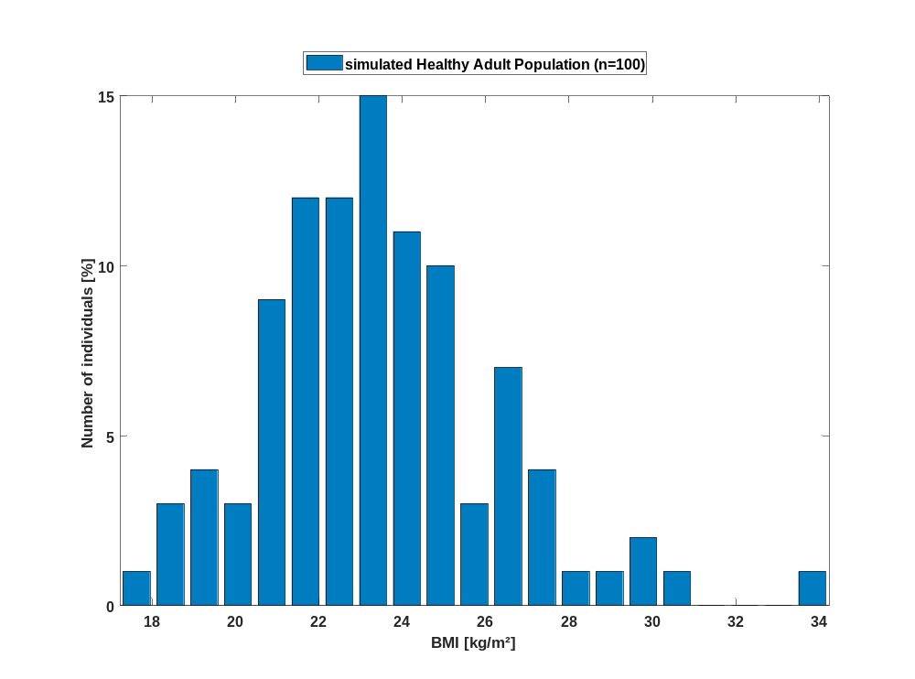

Figure 11: Distribution of body surface area for simulated Healthy Adult Population.
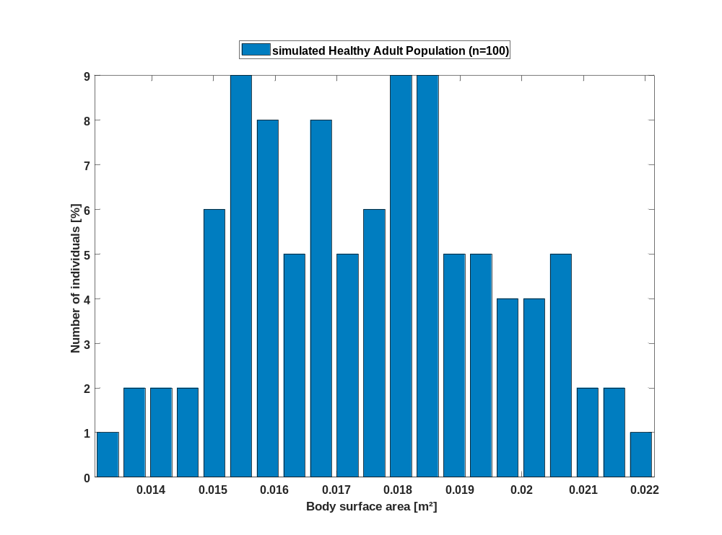

Figure 12: Distribution of gender for simulated Healthy Adult Population.
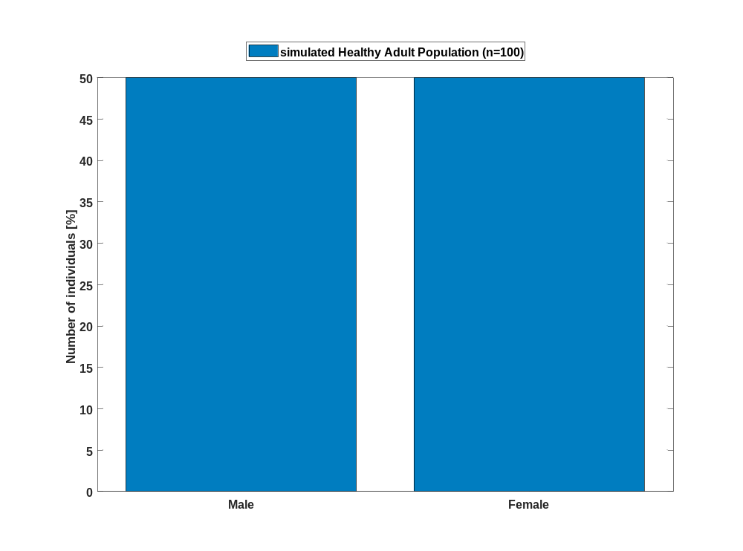

Pkparameter

PK parameter of Raltegravir

C_{max}

Figure 1: C_{max} of Raltegravir shown as box whisker plot, which indicate the 5th, 25th, 50th, 75th, and 95th percentiles in a linear scale.
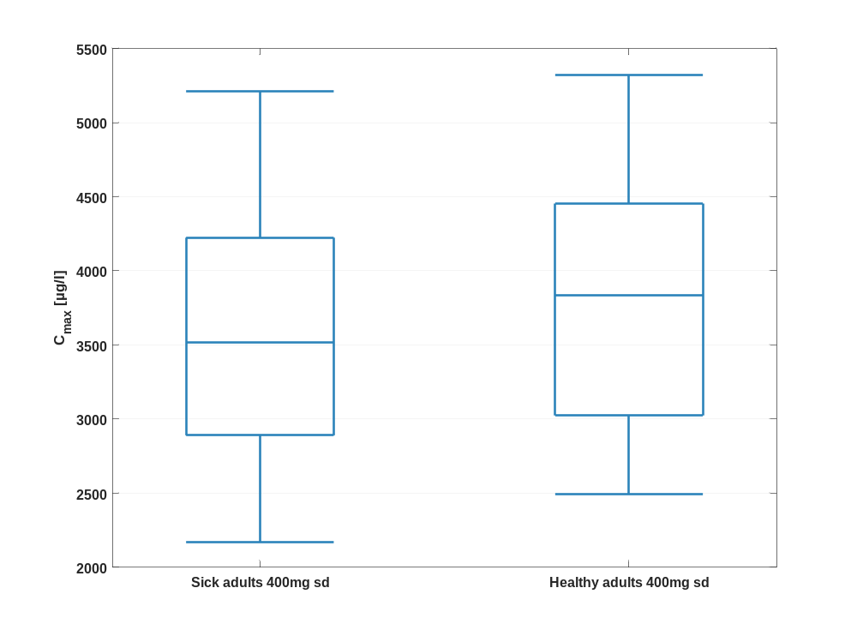

Figure 2: C_{max} of Raltegravir shown as box whisker plot, which indicate the 5th, 25th, 50th, 75th, and 95th percentiles in a logarithmic scale.
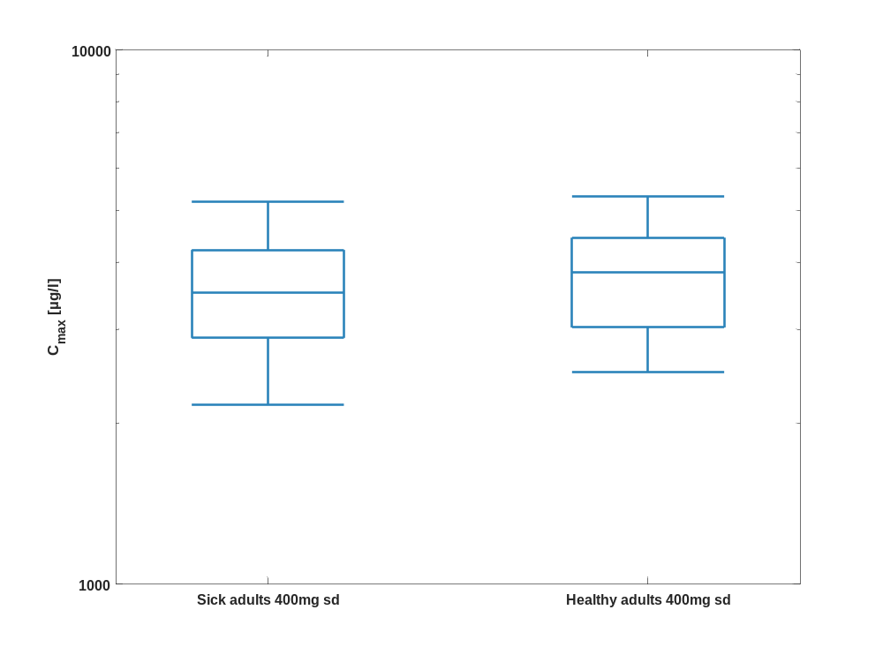

Table 1-1:Percentile of C_{max} of Raltegravir.
C_{max} [µg/l]
 | 5th prctl. | 25th prctl. | 50th prctl. | 75th prctl. | 95th prctl. | arith. mean | std | geo. mean | geo. CV
Sick adults 400mg sd | 2170.07 | 2890.76 | 3518.52 | 4223.81 | 5208.24 | 3588.82 | 933.06 | 3464.35 | 0.28
Healthy adults 400mg sd | 2491.37 | 3024.72 | 3833.93 | 4453.89 | 5322.23 | 3812.11 | 909.05 | 3703.45 | 0.25

C_{max} norm

Figure 3: C_{max} norm of Raltegravir shown as box whisker plot, which indicate the 5th, 25th, 50th, 75th, and 95th percentiles in a linear scale.
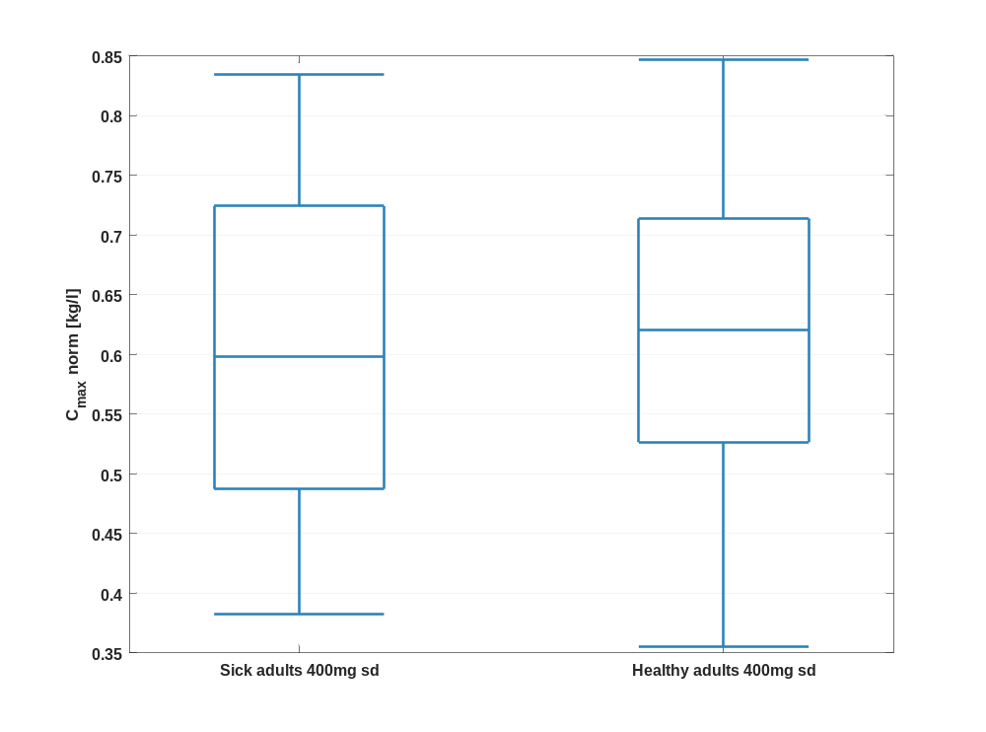

Figure 4: C_{max} norm of Raltegravir shown as box whisker plot, which indicate the 5th, 25th, 50th, 75th, and 95th percentiles in a logarithmic scale.
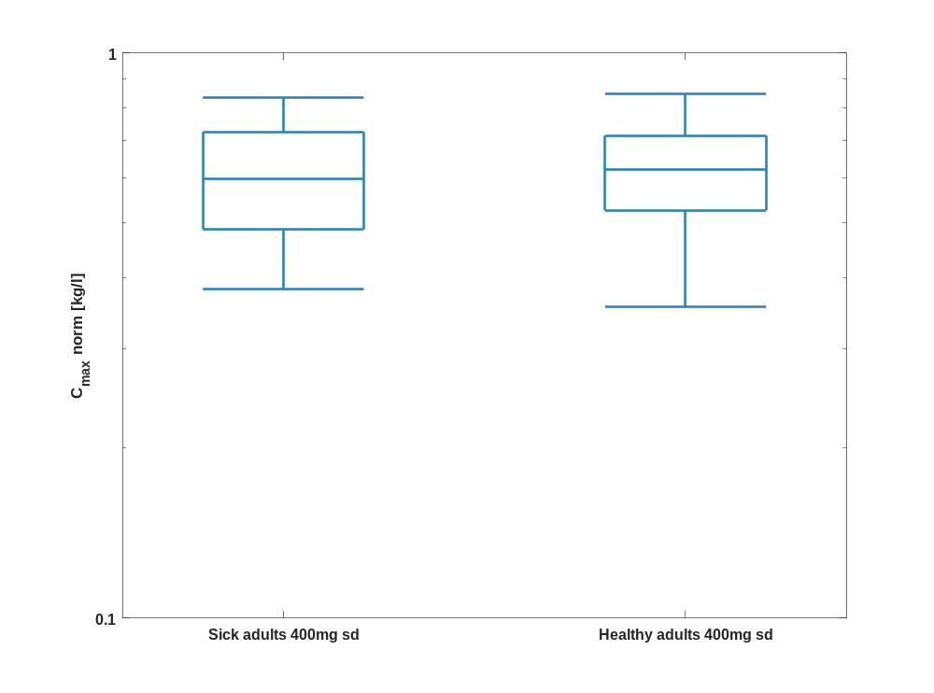

Table 1-2:Percentile of C_{max} norm of Raltegravir.
C_{max} norm [kg/l]
 | 5th prctl. | 25th prctl. | 50th prctl. | 75th prctl. | 95th prctl. | arith. mean | std | geo. mean | geo. CV
Sick adults 400mg sd | 0.38 | 0.49 | 0.60 | 0.72 | 0.83 | 0.61 | 0.15 | 0.59 | 0.26
Healthy adults 400mg sd | 0.35 | 0.53 | 0.62 | 0.71 | 0.85 | 0.62 | 0.14 | 0.60 | 0.24

t_{max}

Figure 5: t_{max} of Raltegravir shown as box whisker plot, which indicate the 5th, 25th, 50th, 75th, and 95th percentiles in a linear scale.
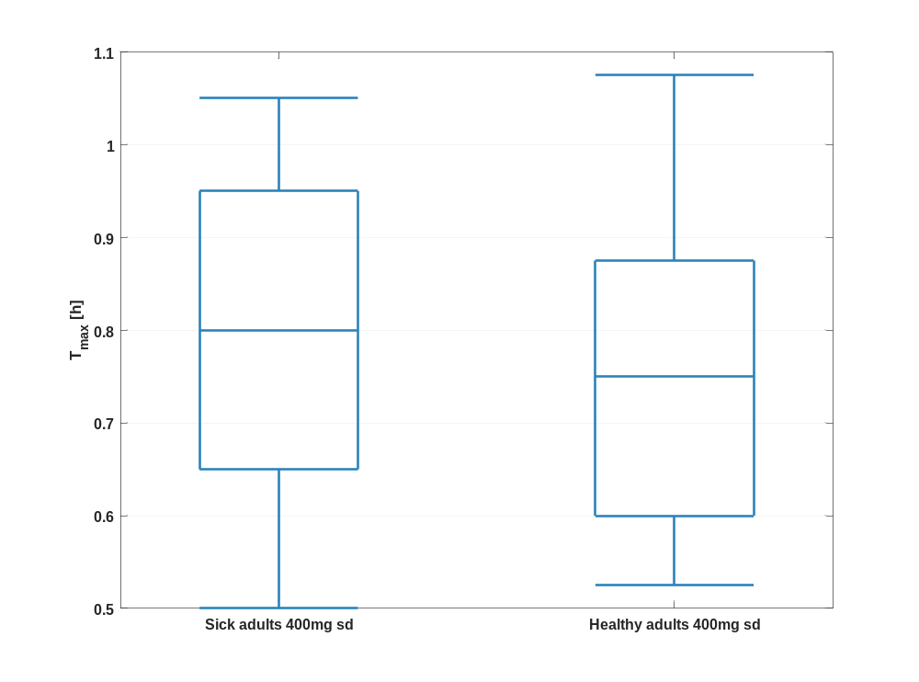

Figure 6: t_{max} of Raltegravir shown as box whisker plot, which indicate the 5th, 25th, 50th, 75th, and 95th percentiles in a logarithmic scale.
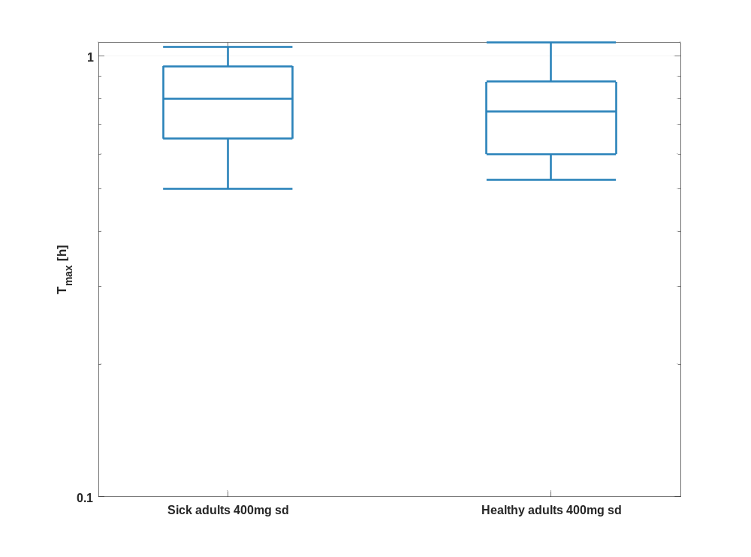

Table 1-3:Percentile of t_{max} of Raltegravir.
T_{max} [h]
 | 5th prctl. | 25th prctl. | 50th prctl. | 75th prctl. | 95th prctl. | arith. mean | std | geo. mean | geo. CV
Sick adults 400mg sd | 0.50 | 0.65 | 0.80 | 0.95 | 1.05 | 0.79 | 0.18 | 0.77 | 0.24
Healthy adults 400mg sd | 0.53 | 0.60 | 0.75 | 0.88 | 1.08 | 0.76 | 0.17 | 0.74 | 0.23

C_{tEnd}

Figure 7: C_{tEnd} of Raltegravir shown as box whisker plot, which indicate the 5th, 25th, 50th, 75th, and 95th percentiles in a linear scale.
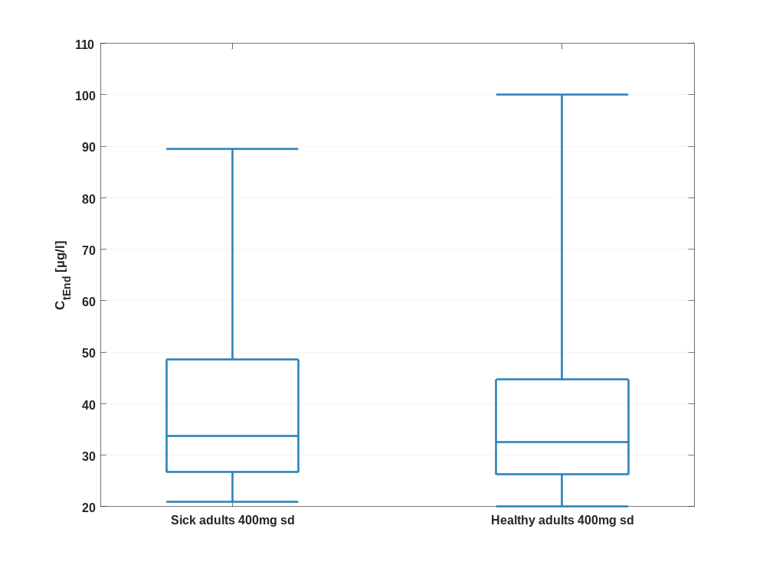

Figure 8: C_{tEnd} of Raltegravir shown as box whisker plot, which indicate the 5th, 25th, 50th, 75th, and 95th percentiles in a logarithmic scale.
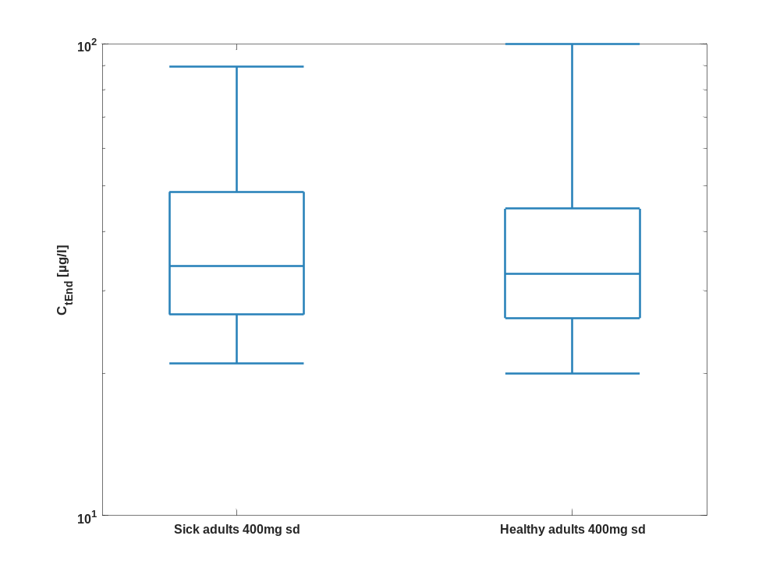

Table 1-4:Percentile of C_{tEnd} of Raltegravir.
C_{tEnd} [µg/l]
 | 5th prctl. | 25th prctl. | 50th prctl. | 75th prctl. | 95th prctl. | arith. mean | std | geo. mean | geo. CV
Sick adults 400mg sd | 21.02 | 26.70 | 33.80 | 48.59 | 89.50 | 42.52 | 26.89 | 37.37 | 0.50
Healthy adults 400mg sd | 20.02 | 26.23 | 32.62 | 44.74 | 100.01 | 41.00 | 28.37 | 35.86 | 0.49

AUC_{last}

Figure 9: AUC_{last} of Raltegravir shown as box whisker plot, which indicate the 5th, 25th, 50th, 75th, and 95th percentiles in a linear scale.
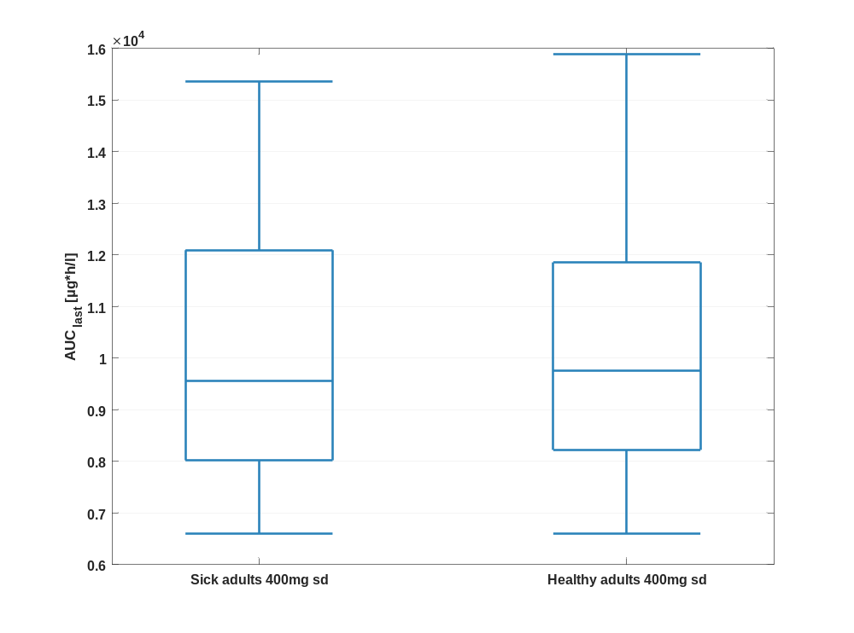

Figure 10: AUC_{last} of Raltegravir shown as box whisker plot, which indicate the 5th, 25th, 50th, 75th, and 95th percentiles in a logarithmic scale.
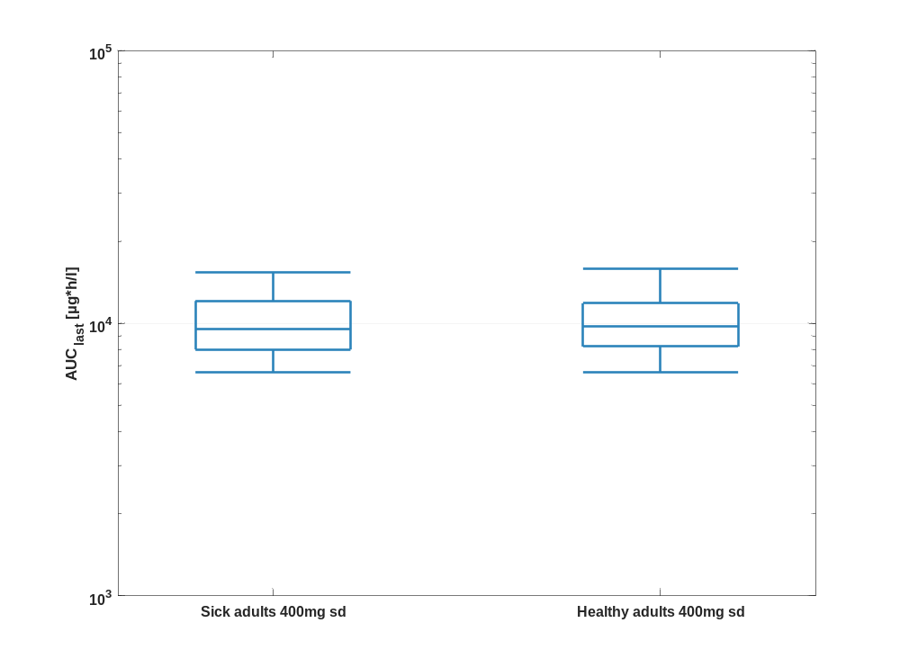

Table 1-5:Percentile of AUC_{last} of Raltegravir.
AUC_{last} [µg*h/l]
 | 5th prctl. | 25th prctl. | 50th prctl. | 75th prctl. | 95th prctl. | arith. mean | std | geo. mean | geo. CV
Sick adults 400mg sd | 6605.82 | 8021.28 | 9559.78 | 12089.12 | 15359.84 | 10032.68 | 2669.60 | 9693.97 | 0.27
Healthy adults 400mg sd | 6603.74 | 8223.13 | 9760.54 | 11853.28 | 15888.00 | 10257.53 | 2720.04 | 9917.85 | 0.26

AUC_{last} norm

Figure 11: AUC_{last} norm of Raltegravir shown as box whisker plot, which indicate the 5th, 25th, 50th, 75th, and 95th percentiles in a linear scale.
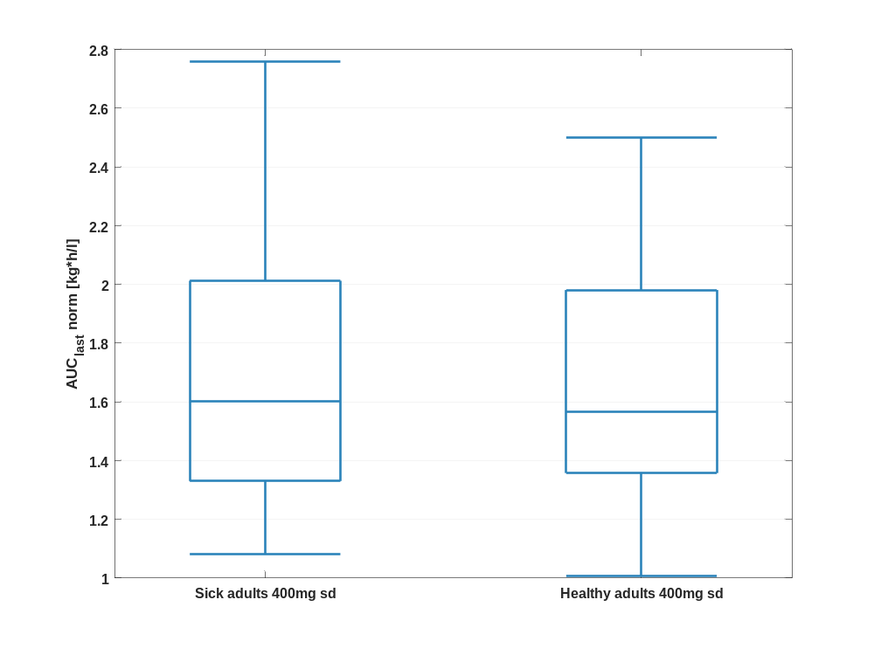

Figure 12: AUC_{last} norm of Raltegravir shown as box whisker plot, which indicate the 5th, 25th, 50th, 75th, and 95th percentiles in a logarithmic scale.
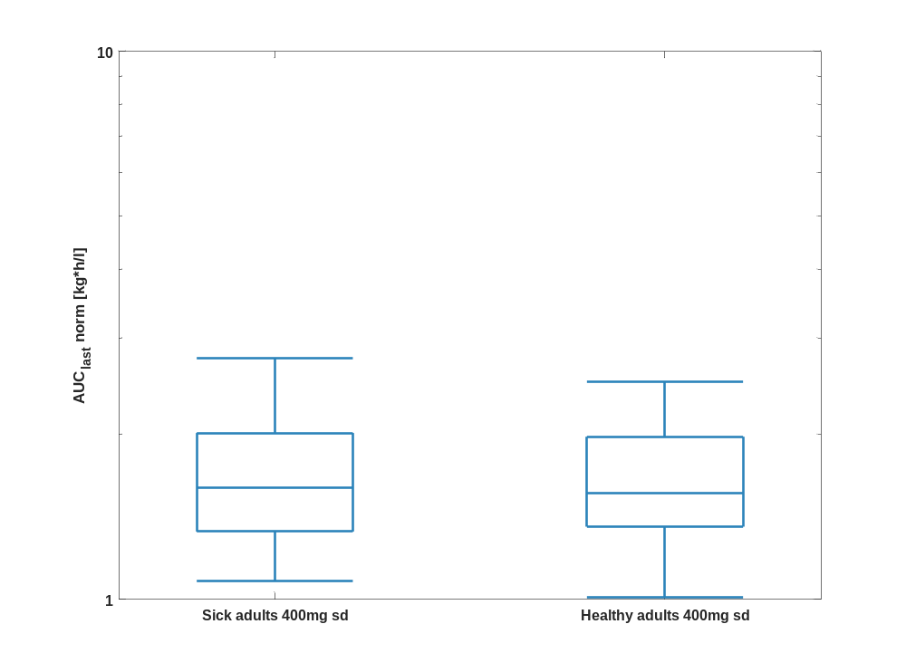

Table 1-6:Percentile of AUC_{last} norm of Raltegravir.
AUC_{last} norm [kg*h/l]
 | 5th prctl. | 25th prctl. | 50th prctl. | 75th prctl. | 95th prctl. | arith. mean | std | geo. mean | geo. CV
Sick adults 400mg sd | 1.08 | 1.33 | 1.60 | 2.01 | 2.76 | 1.72 | 0.54 | 1.65 | 0.30
Healthy adults 400mg sd | 1.01 | 1.36 | 1.57 | 1.98 | 2.50 | 1.68 | 0.45 | 1.62 | 0.28

AUC_{inf}

Figure 13: AUC_{inf} of Raltegravir shown as box whisker plot, which indicate the 5th, 25th, 50th, 75th, and 95th percentiles in a linear scale.
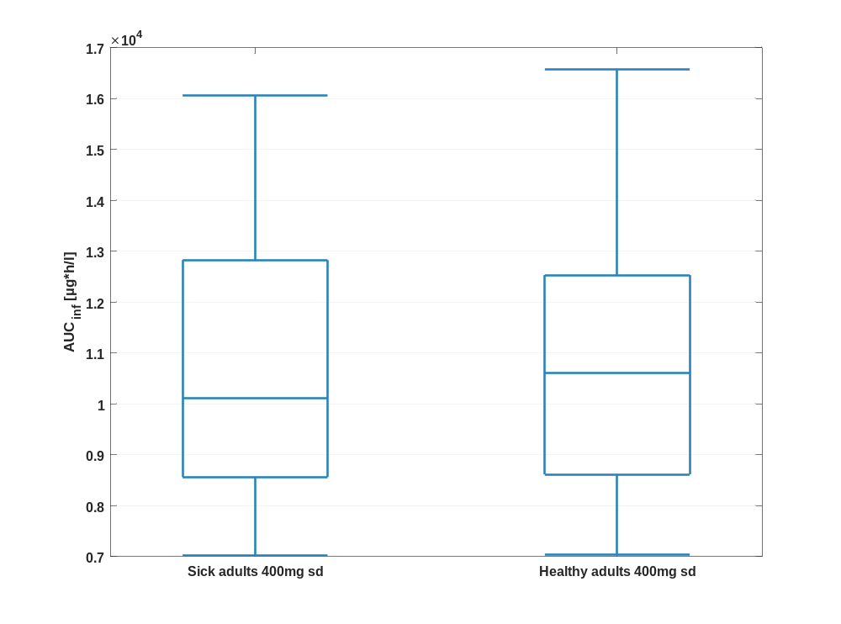

Figure 14: AUC_{inf} of Raltegravir shown as box whisker plot, which indicate the 5th, 25th, 50th, 75th, and 95th percentiles in a logarithmic scale.
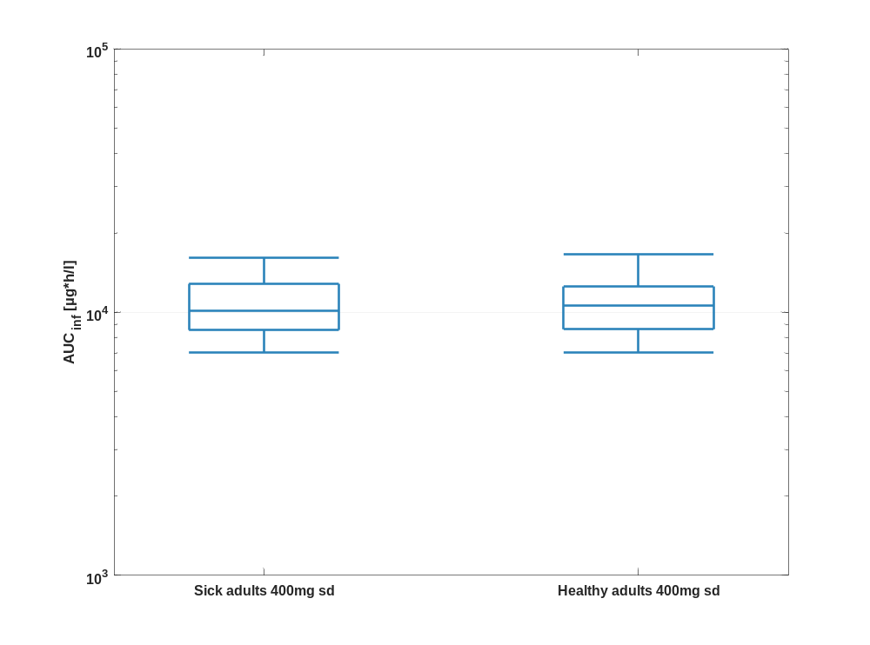

Table 1-7:Percentile of AUC_{inf} of Raltegravir.
AUC_{inf} [µg*h/l]
 | 5th prctl. | 25th prctl. | 50th prctl. | 75th prctl. | 95th prctl. | arith. mean | std | geo. mean | geo. CV
Sick adults 400mg sd | 7016.08 | 8564.96 | 10105.45 | 12824.73 | 16054.00 | 10623.25 | 2755.50 | 10288.34 | 0.26
Healthy adults 400mg sd | 7045.52 | 8615.76 | 10604.55 | 12531.41 | 16576.68 | 10889.30 | 2831.51 | 10536.57 | 0.26

AUC_{inf} norm

Figure 15: AUC_{inf} norm of Raltegravir shown as box whisker plot, which indicate the 5th, 25th, 50th, 75th, and 95th percentiles in a linear scale.
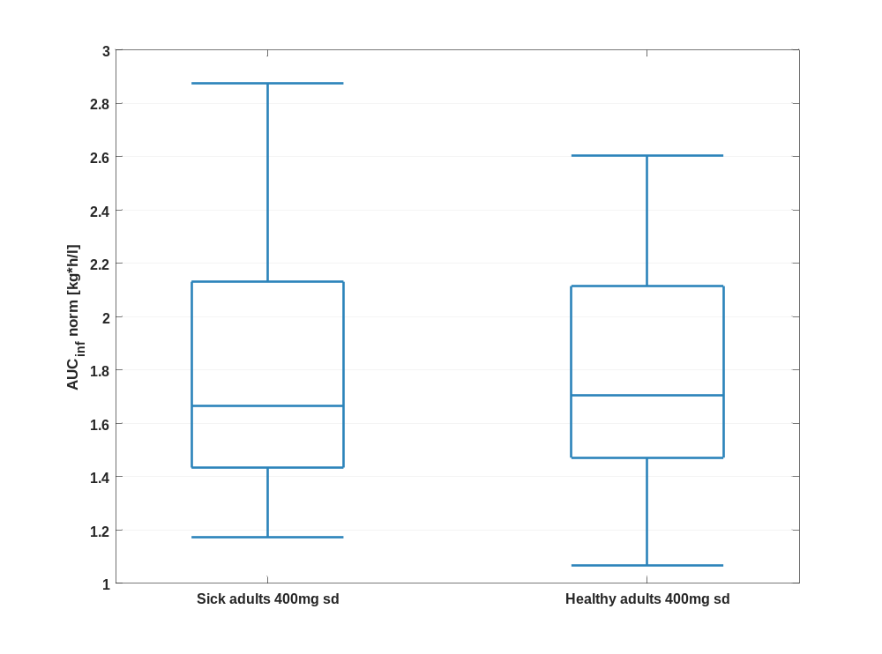

Figure 16: AUC_{inf} norm of Raltegravir shown as box whisker plot, which indicate the 5th, 25th, 50th, 75th, and 95th percentiles in a logarithmic scale.
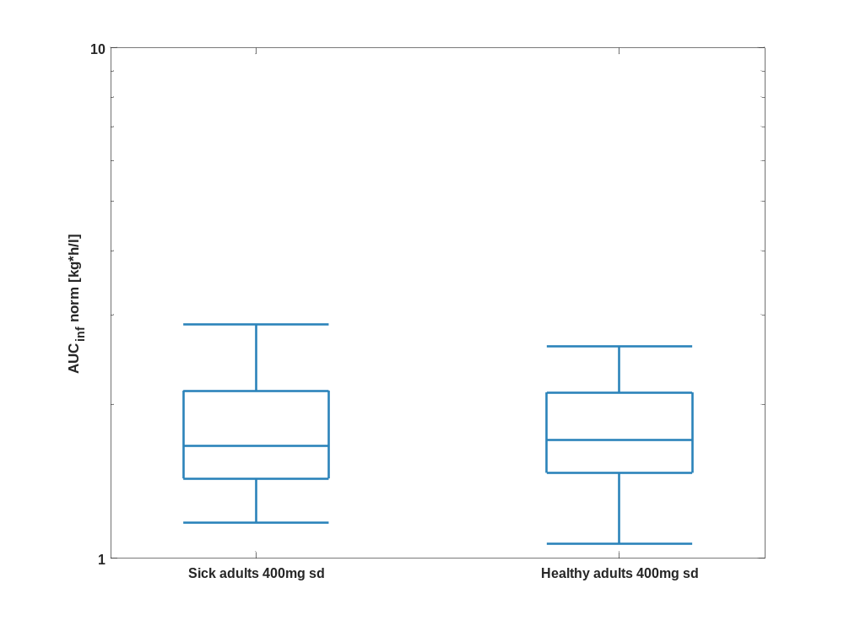

Table 1-8:Percentile of AUC_{inf} norm of Raltegravir.
AUC_{inf} norm [kg*h/l]
 | 5th prctl. | 25th prctl. | 50th prctl. | 75th prctl. | 95th prctl. | arith. mean | std | geo. mean | geo. CV
Sick adults 400mg sd | 1.17 | 1.43 | 1.66 | 2.13 | 2.88 | 1.83 | 0.56 | 1.75 | 0.29
Healthy adults 400mg sd | 1.07 | 1.47 | 1.71 | 2.11 | 2.60 | 1.78 | 0.47 | 1.72 | 0.27

MRT

Figure 17: MRT of Raltegravir shown as box whisker plot, which indicate the 5th, 25th, 50th, 75th, and 95th percentiles in a linear scale.
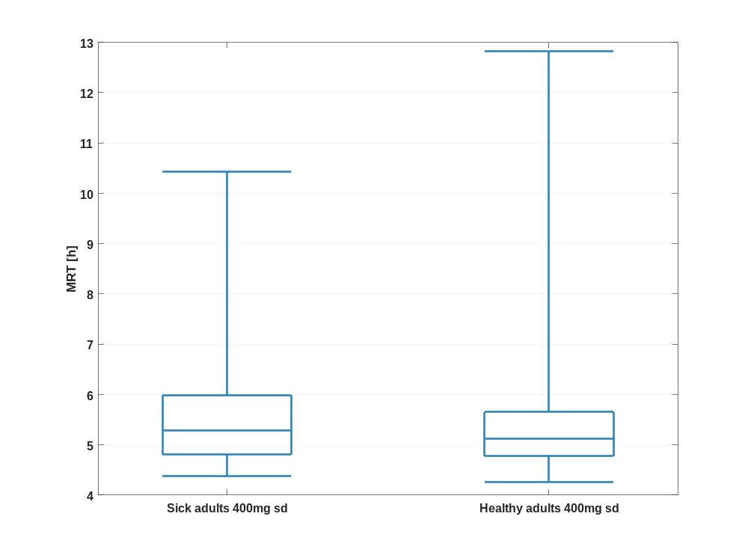

Figure 18: MRT of Raltegravir shown as box whisker plot, which indicate the 5th, 25th, 50th, 75th, and 95th percentiles in a logarithmic scale.
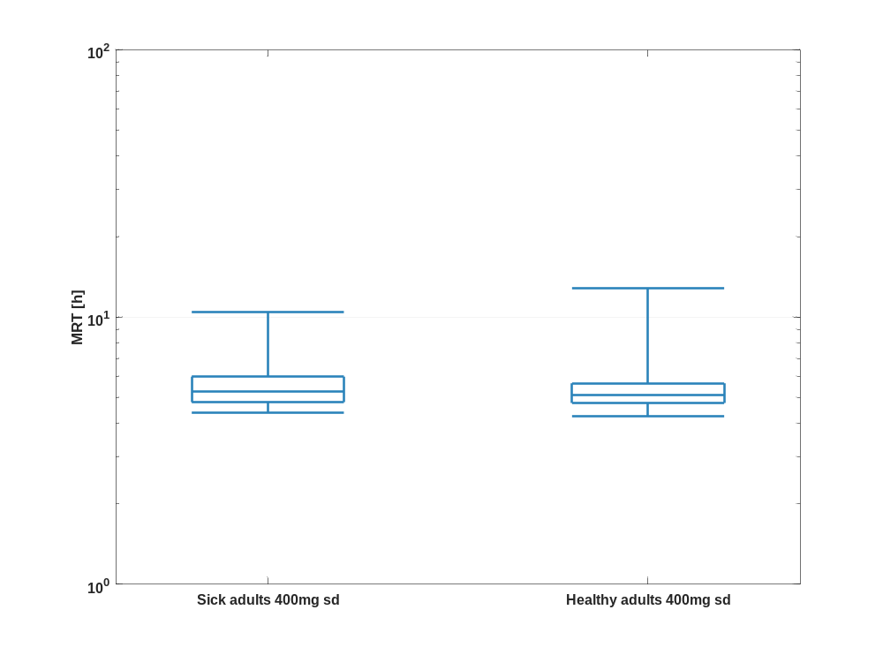

Table 1-9:Percentile of MRT of Raltegravir.
MRT [h]
 | 5th prctl. | 25th prctl. | 50th prctl. | 75th prctl. | 95th prctl. | arith. mean | std | geo. mean | geo. CV
Sick adults 400mg sd | 4.38 | 4.81 | 5.28 | 5.99 | 10.42 | 6.07 | 2.78 | 5.74 | 0.30
Healthy adults 400mg sd | 4.25 | 4.77 | 5.13 | 5.65 | 12.82 | 5.98 | 3.12 | 5.58 | 0.33

Thalf

Figure 19: Thalf of Raltegravir shown as box whisker plot, which indicate the 5th, 25th, 50th, 75th, and 95th percentiles in a linear scale.
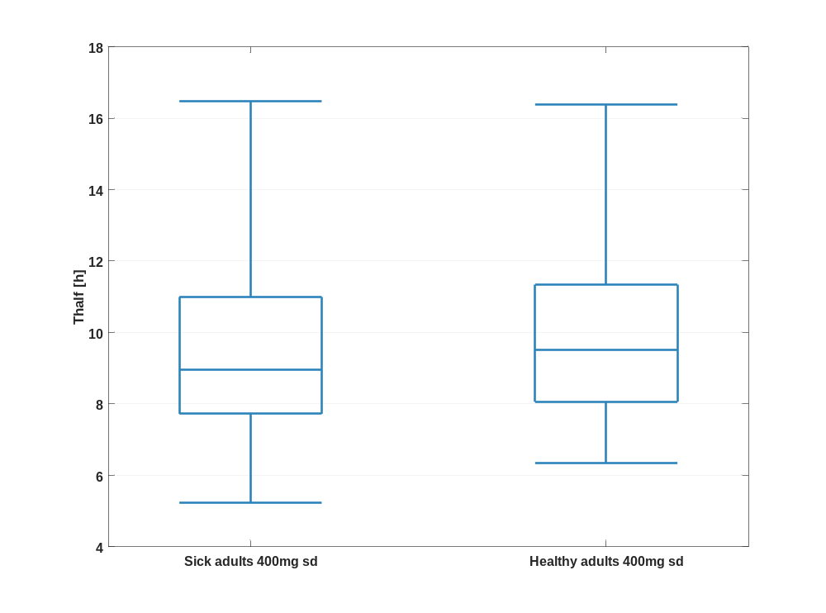

Figure 20: Thalf of Raltegravir shown as box whisker plot, which indicate the 5th, 25th, 50th, 75th, and 95th percentiles in a logarithmic scale.
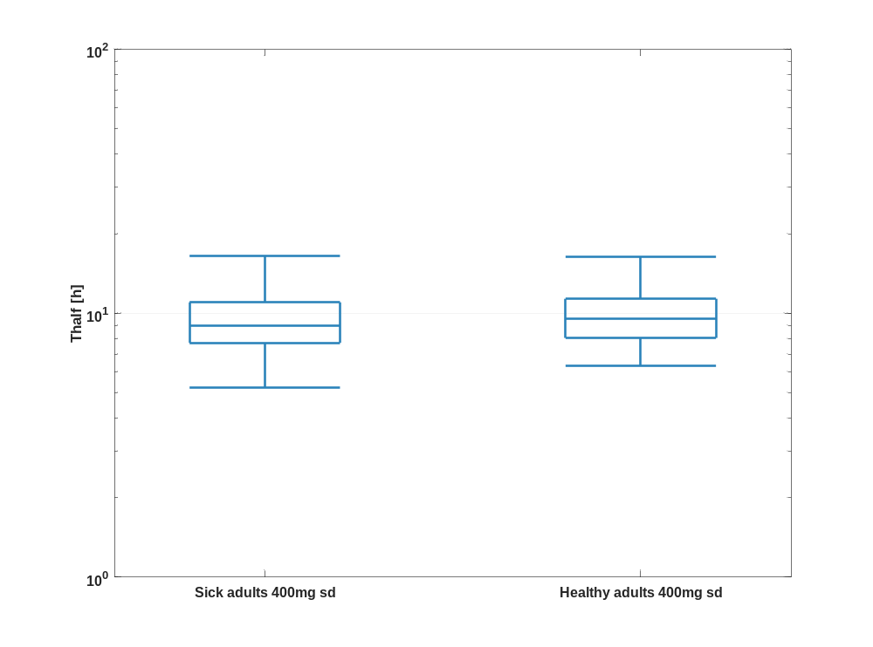

Table 1-10:Percentile of Thalf of Raltegravir.
Thalf [h]
 | 5th prctl. | 25th prctl. | 50th prctl. | 75th prctl. | 95th prctl. | arith. mean | std | geo. mean | geo. CV
Sick adults 400mg sd | 5.23 | 7.72 | 8.96 | 10.99 | 16.46 | 9.62 | 3.19 | 9.18 | 0.31
Healthy adults 400mg sd | 6.34 | 8.06 | 9.51 | 11.34 | 16.38 | 10.05 | 3.10 | 9.65 | 0.28

CL

Figure 21: CL of Raltegravir shown as box whisker plot, which indicate the 5th, 25th, 50th, 75th, and 95th percentiles in a linear scale.
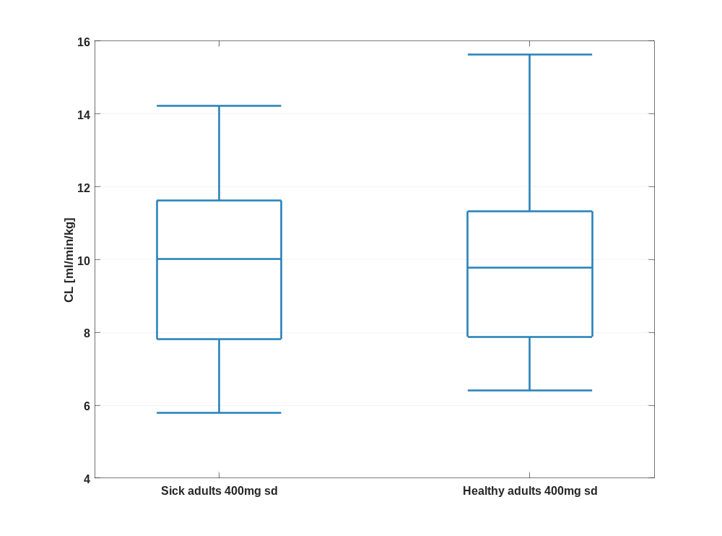

Figure 22: CL of Raltegravir shown as box whisker plot, which indicate the 5th, 25th, 50th, 75th, and 95th percentiles in a logarithmic scale.
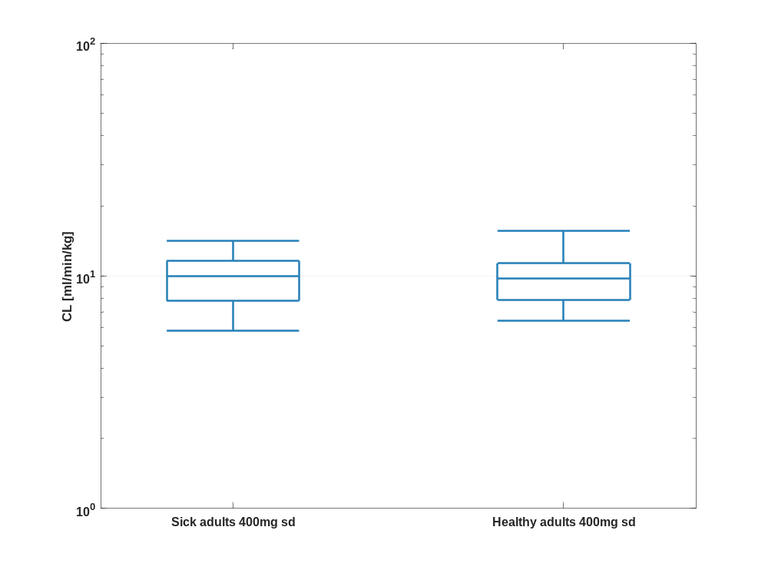

Table 1-11:Percentile of CL of Raltegravir.
CL [ml/min/kg]
 | 5th prctl. | 25th prctl. | 50th prctl. | 75th prctl. | 95th prctl. | arith. mean | std | geo. mean | geo. CV
Sick adults 400mg sd | 5.80 | 7.82 | 10.02 | 11.62 | 14.21 | 9.91 | 2.72 | 9.53 | 0.29
Healthy adults 400mg sd | 6.40 | 7.88 | 9.77 | 11.33 | 15.62 | 10.05 | 2.78 | 9.70 | 0.27

Vss

Figure 23: Vss of Raltegravir shown as box whisker plot, which indicate the 5th, 25th, 50th, 75th, and 95th percentiles in a linear scale.
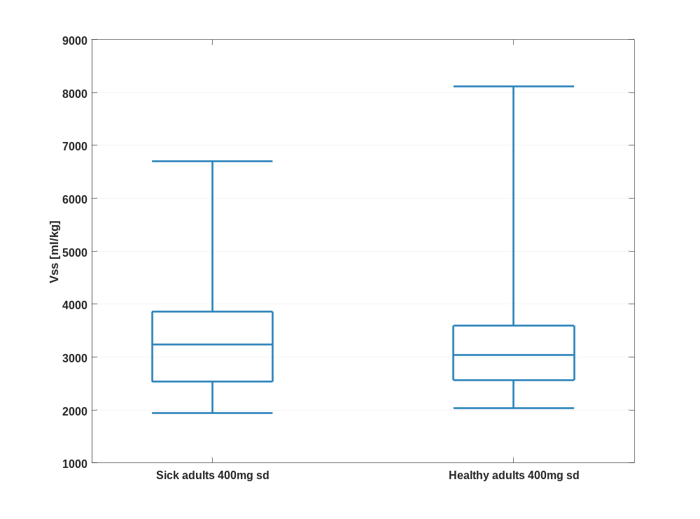

Figure 24: Vss of Raltegravir shown as box whisker plot, which indicate the 5th, 25th, 50th, 75th, and 95th percentiles in a logarithmic scale.
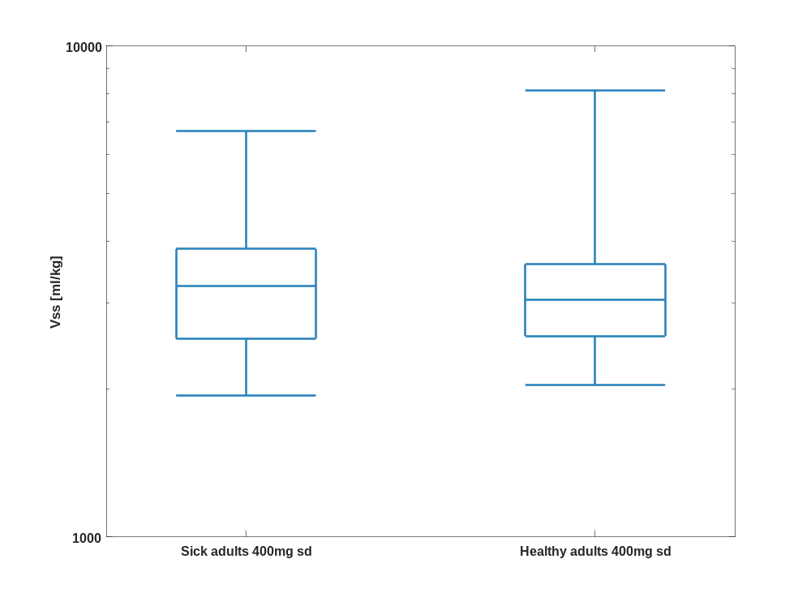

Table 1-12:Percentile of Vss of Raltegravir.
Vss [ml/kg]
 | 5th prctl. | 25th prctl. | 50th prctl. | 75th prctl. | 95th prctl. | arith. mean | std | geo. mean | geo. CV
Sick adults 400mg sd | 1943.85 | 2535.85 | 3238.75 | 3858.09 | 6701.23 | 3592.19 | 2126.19 | 3278.98 | 0.40
Healthy adults 400mg sd | 2041.95 | 2565.38 | 3040.82 | 3595.30 | 8114.22 | 3539.45 | 1827.93 | 3248.12 | 0.39

Vd

Figure 25: Vd of Raltegravir shown as box whisker plot, which indicate the 5th, 25th, 50th, 75th, and 95th percentiles in a linear scale.
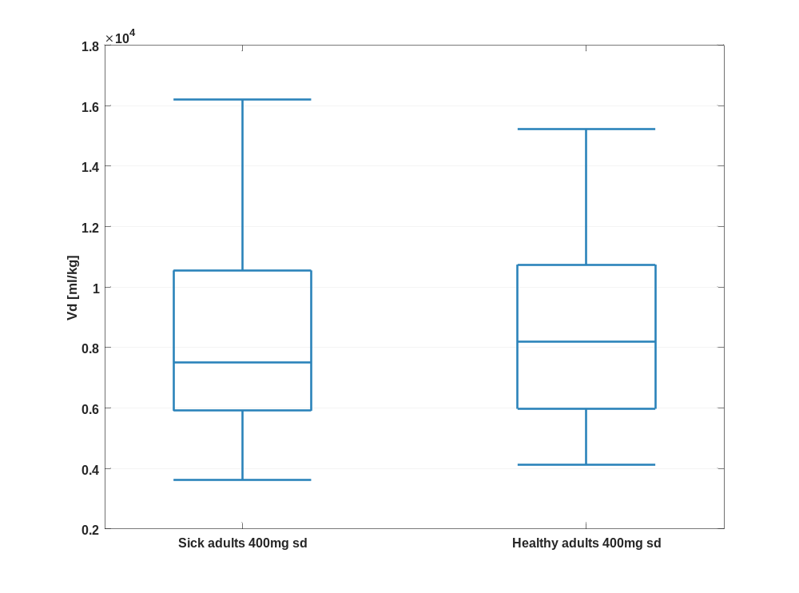

Figure 26: Vd of Raltegravir shown as box whisker plot, which indicate the 5th, 25th, 50th, 75th, and 95th percentiles in a logarithmic scale.
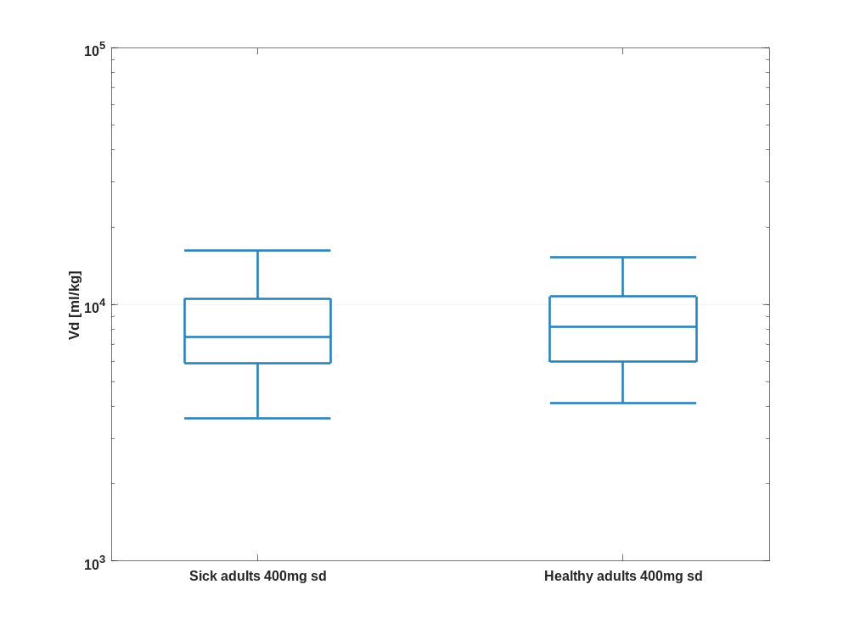

Table 1-13:Percentile of Vd of Raltegravir.
Vd [ml/kg]
 | 5th prctl. | 25th prctl. | 50th prctl. | 75th prctl. | 95th prctl. | arith. mean | std | geo. mean | geo. CV
Sick adults 400mg sd | 3612.28 | 5910.83 | 7500.63 | 10552.35 | 16212.23 | 8465.13 | 4277.77 | 7567.89 | 0.50
Healthy adults 400mg sd | 4115.50 | 5974.29 | 8186.87 | 10743.88 | 15233.47 | 8799.38 | 3606.14 | 8105.17 | 0.43

PK parameter of Raltegravir as fraction of healthy adults 400mg sd

C_{max}

Figure 27: C_{max} of Raltegravir shown as box whisker plot, which indicate the 5, 25, 50, 75, and 95 percentiles in a linear scale.
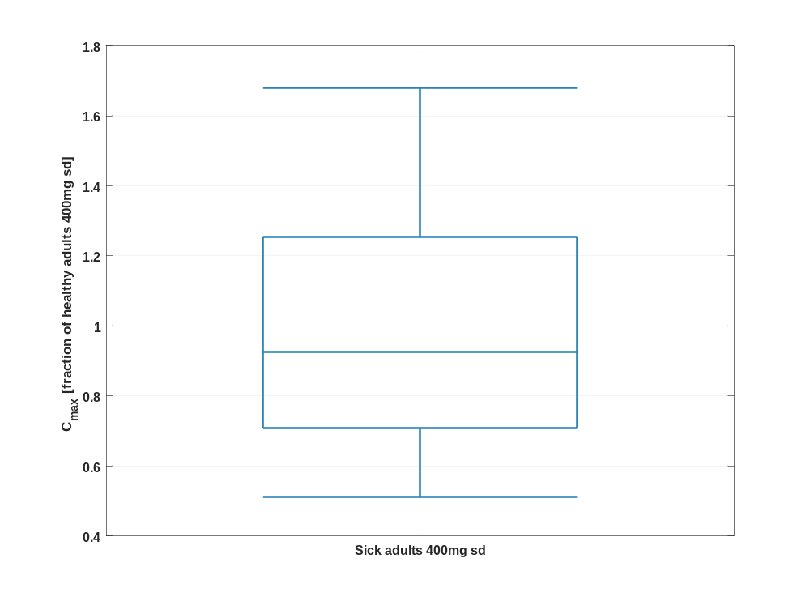

Figure 28: C_{max} of Raltegravir shown as box whisker plot, which indicate the 5, 25, 50, 75, and 95 percentiles in a logarithmic scale.
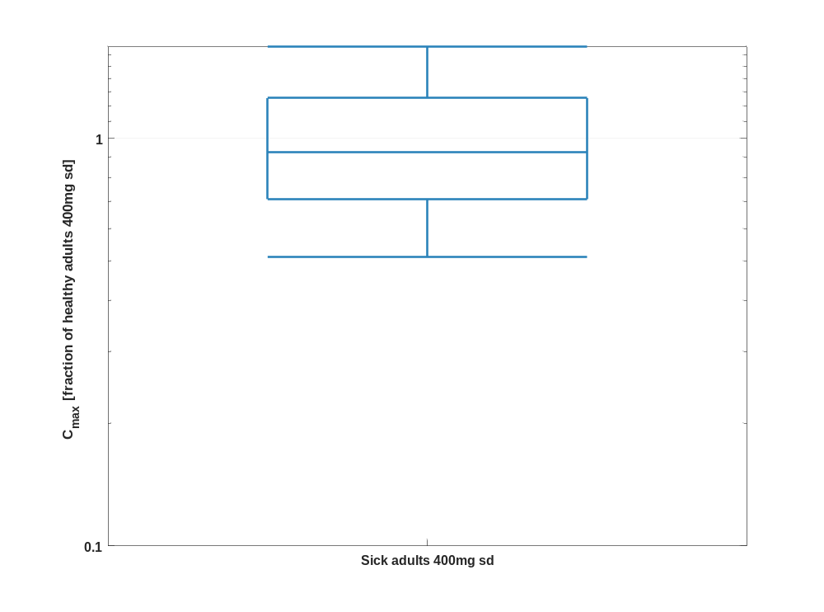

Table 1-14:Percentile of C_{max} of Raltegravir normalized to individuals of Healthy adults 400mg sd.
C_{max} [fraction of healthy adults 400mg sd]
 | 5th prctl. | 25th prctl. | 50th prctl. | 75th prctl. | 95th prctl. | arith. mean | std | geo. mean | geo. CV
Sick adults 400mg sd | 0.51 | 0.71 | 0.93 | 1.26 | 1.68 | 1.01 | 0.42 | 0.94 | 0.42

C_{max} norm

Figure 29: C_{max} norm of Raltegravir shown as box whisker plot, which indicate the 5, 25, 50, 75, and 95 percentiles in a linear scale.
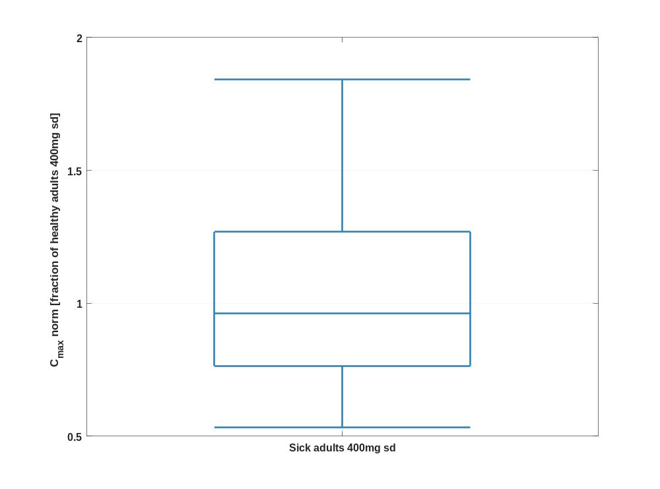

Figure 30: C_{max} norm of Raltegravir shown as box whisker plot, which indicate the 5, 25, 50, 75, and 95 percentiles in a logarithmic scale.
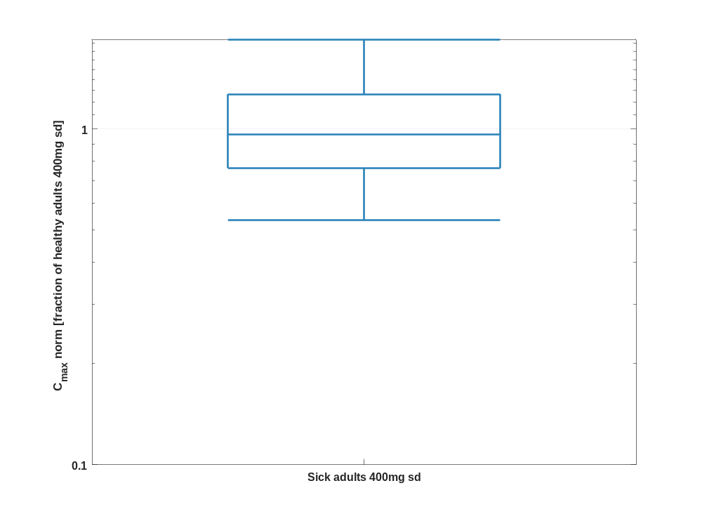

Table 1-15:Percentile of C_{max} norm of Raltegravir normalized to individuals of Healthy adults 400mg sd.
C_{max} norm [fraction of healthy adults 400mg sd]
 | 5th prctl. | 25th prctl. | 50th prctl. | 75th prctl. | 95th prctl. | arith. mean | std | geo. mean | geo. CV
Sick adults 400mg sd | 0.53 | 0.76 | 0.96 | 1.27 | 1.84 | 1.04 | 0.39 | 0.98 | 0.38

t_{max}

Figure 31: t_{max} of Raltegravir shown as box whisker plot, which indicate the 5, 25, 50, 75, and 95 percentiles in a linear scale.
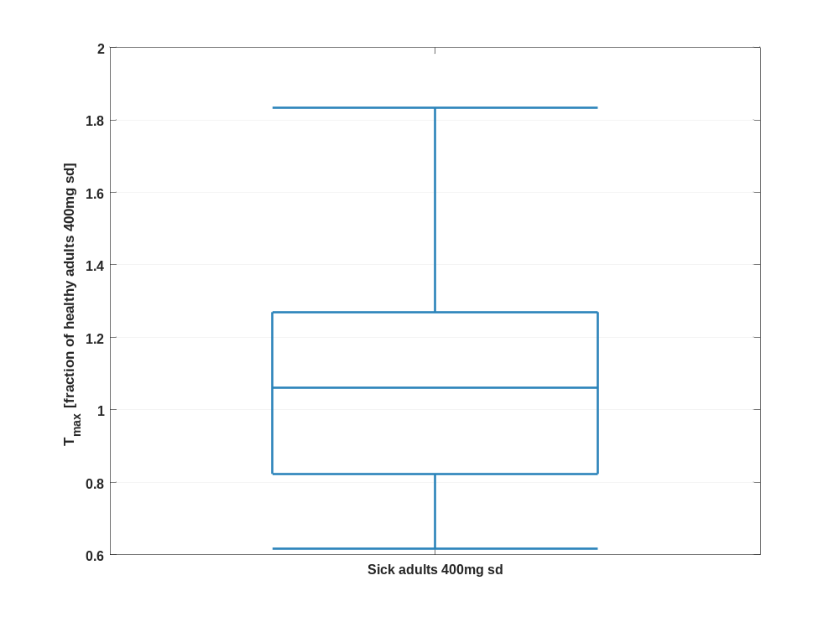

Figure 32: t_{max} of Raltegravir shown as box whisker plot, which indicate the 5, 25, 50, 75, and 95 percentiles in a logarithmic scale.
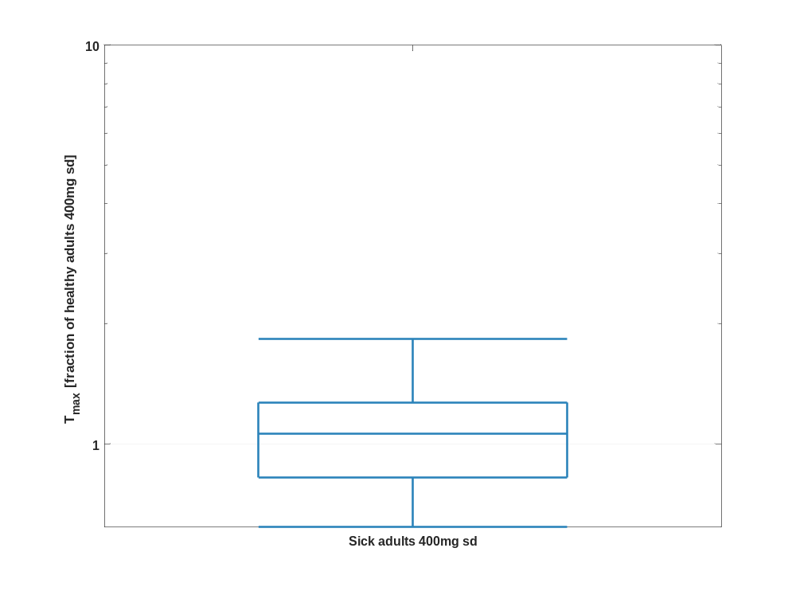

Table 1-16:Percentile of t_{max} of Raltegravir normalized to individuals of Healthy adults 400mg sd.
T_{max} [fraction of healthy adults 400mg sd]
 | 5th prctl. | 25th prctl. | 50th prctl. | 75th prctl. | 95th prctl. | arith. mean | std | geo. mean | geo. CV
Sick adults 400mg sd | 0.62 | 0.82 | 1.06 | 1.27 | 1.83 | 1.10 | 0.37 | 1.04 | 0.35

C_{tEnd}

Figure 33: C_{tEnd} of Raltegravir shown as box whisker plot, which indicate the 5, 25, 50, 75, and 95 percentiles in a linear scale.
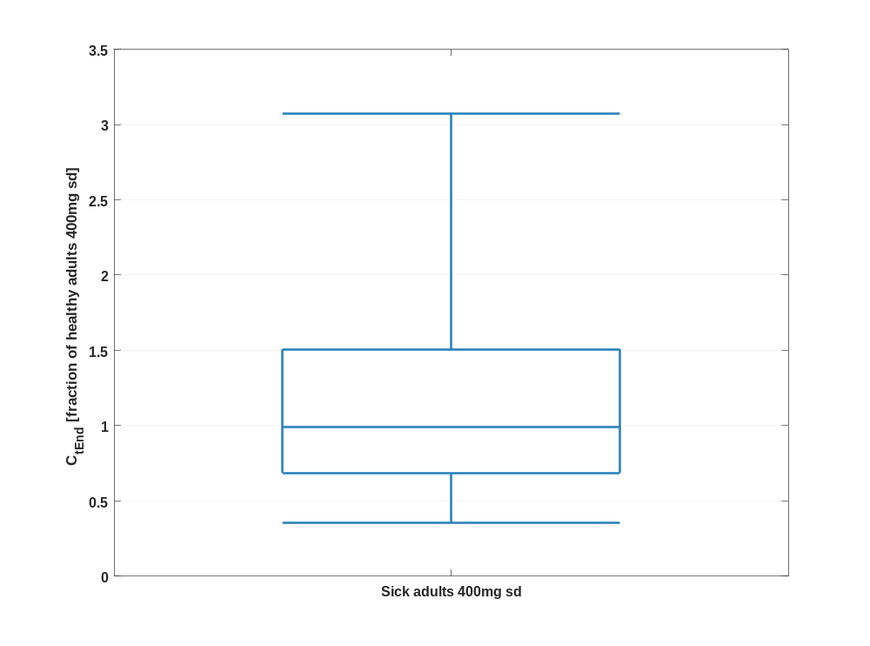

Figure 34: C_{tEnd} of Raltegravir shown as box whisker plot, which indicate the 5, 25, 50, 75, and 95 percentiles in a logarithmic scale.
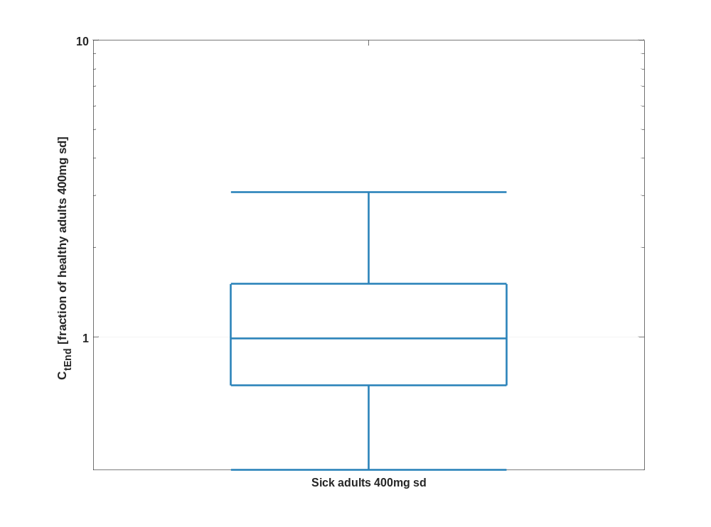

Table 1-17:Percentile of C_{tEnd} of Raltegravir normalized to individuals of Healthy adults 400mg sd.
C_{tEnd} [fraction of healthy adults 400mg sd]
 | 5th prctl. | 25th prctl. | 50th prctl. | 75th prctl. | 95th prctl. | arith. mean | std | geo. mean | geo. CV
Sick adults 400mg sd | 0.36 | 0.69 | 0.99 | 1.51 | 3.07 | 1.28 | 0.92 | 1.04 | 0.73

AUC_{last}

Figure 35: AUC_{last} of Raltegravir shown as box whisker plot, which indicate the 5, 25, 50, 75, and 95 percentiles in a linear scale.
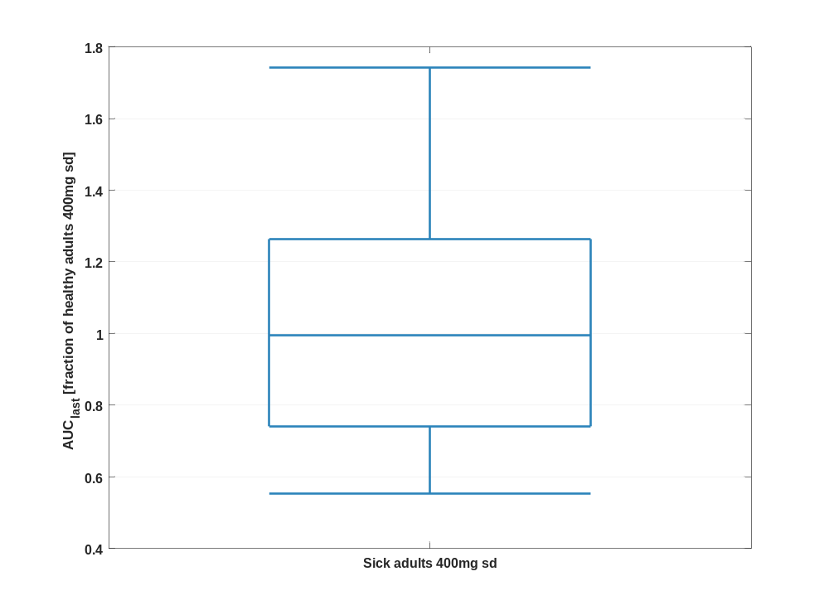

Figure 36: AUC_{last} of Raltegravir shown as box whisker plot, which indicate the 5, 25, 50, 75, and 95 percentiles in a logarithmic scale.
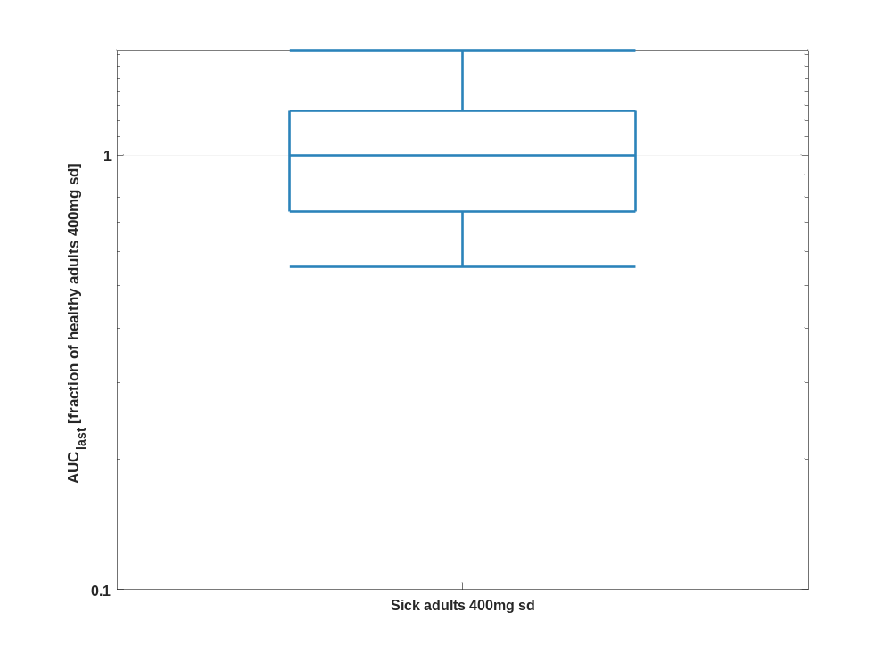

Table 1-18:Percentile of AUC_{last} of Raltegravir normalized to individuals of Healthy adults 400mg sd.
AUC_{last} [fraction of healthy adults 400mg sd]
 | 5th prctl. | 25th prctl. | 50th prctl. | 75th prctl. | 95th prctl. | arith. mean | std | geo. mean | geo. CV
Sick adults 400mg sd | 0.55 | 0.74 | 1.00 | 1.26 | 1.74 | 1.04 | 0.38 | 0.98 | 0.38

AUC_{last} norm

Figure 37: AUC_{last} norm of Raltegravir shown as box whisker plot, which indicate the 5, 25, 50, 75, and 95 percentiles in a linear scale.
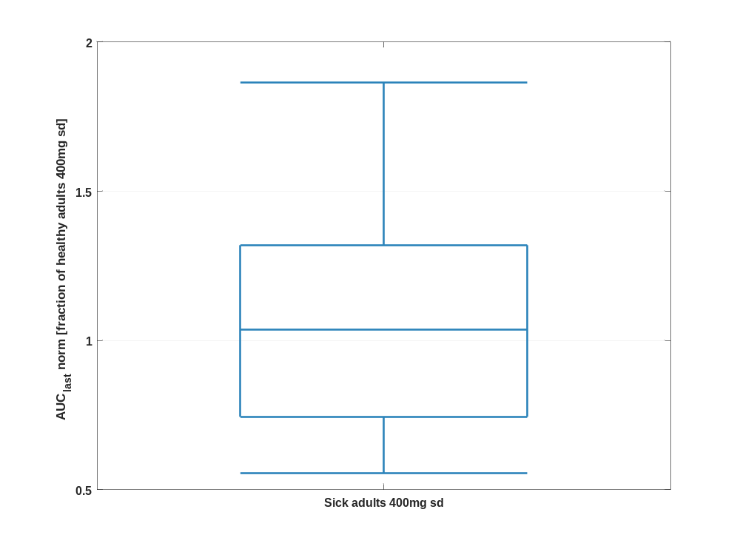

Figure 38: AUC_{last} norm of Raltegravir shown as box whisker plot, which indicate the 5, 25, 50, 75, and 95 percentiles in a logarithmic scale.
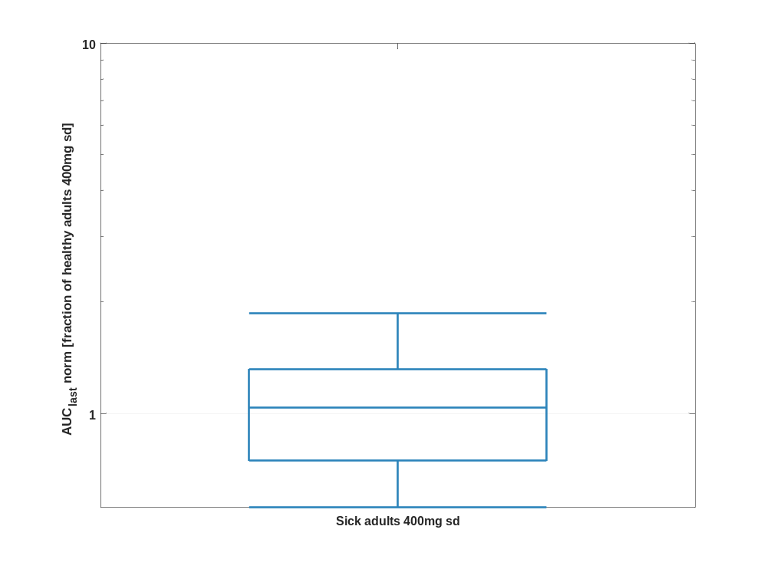

Table 1-19:Percentile of AUC_{last} norm of Raltegravir normalized to individuals of Healthy adults 400mg sd.
AUC_{last} norm [fraction of healthy adults 400mg sd]
 | 5th prctl. | 25th prctl. | 50th prctl. | 75th prctl. | 95th prctl. | arith. mean | std | geo. mean | geo. CV
Sick adults 400mg sd | 0.56 | 0.74 | 1.04 | 1.32 | 1.86 | 1.10 | 0.41 | 1.02 | 0.41

AUC_{inf}

Figure 39: AUC_{inf} of Raltegravir shown as box whisker plot, which indicate the 5, 25, 50, 75, and 95 percentiles in a linear scale.
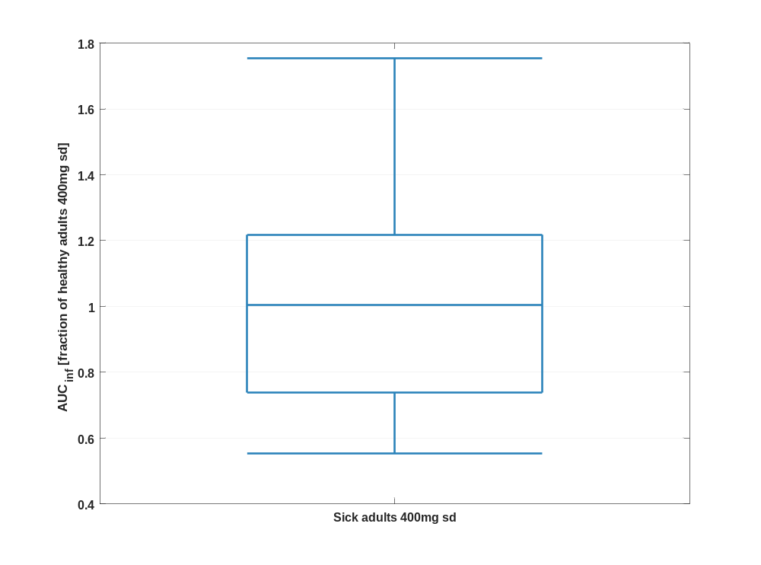

Figure 40: AUC_{inf} of Raltegravir shown as box whisker plot, which indicate the 5, 25, 50, 75, and 95 percentiles in a logarithmic scale.
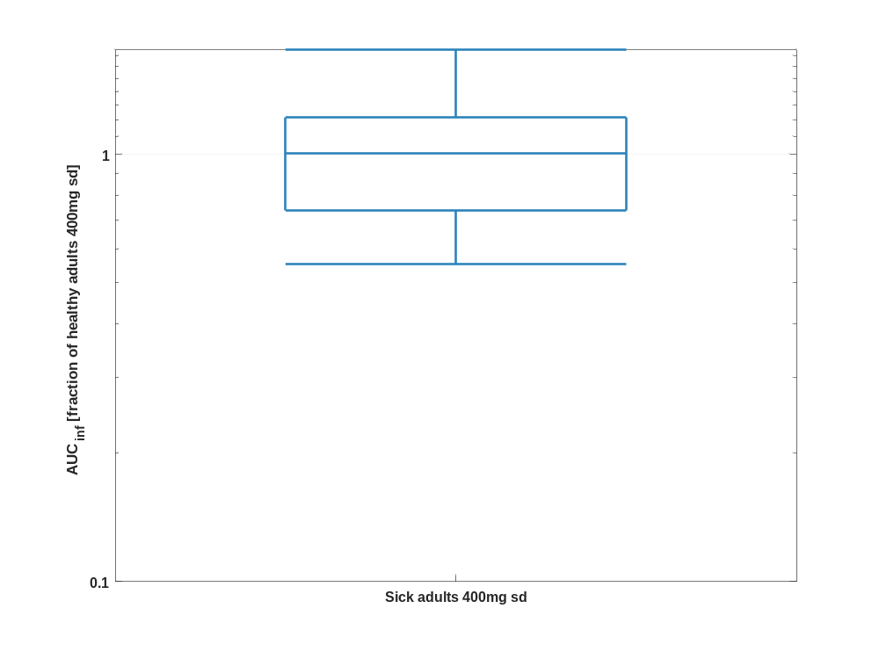

Table 1-20:Percentile of AUC_{inf} of Raltegravir normalized to individuals of Healthy adults 400mg sd.
AUC_{inf} [fraction of healthy adults 400mg sd]
 | 5th prctl. | 25th prctl. | 50th prctl. | 75th prctl. | 95th prctl. | arith. mean | std | geo. mean | geo. CV
Sick adults 400mg sd | 0.55 | 0.74 | 1.01 | 1.22 | 1.75 | 1.04 | 0.37 | 0.98 | 0.36

AUC_{inf} norm

Figure 41: AUC_{inf} norm of Raltegravir shown as box whisker plot, which indicate the 5, 25, 50, 75, and 95 percentiles in a linear scale.
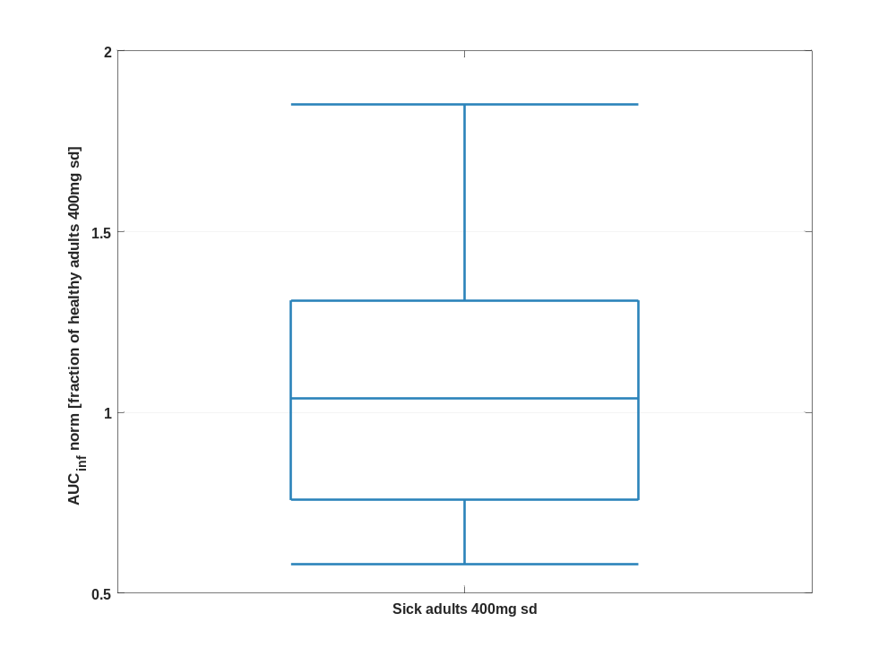

Figure 42: AUC_{inf} norm of Raltegravir shown as box whisker plot, which indicate the 5, 25, 50, 75, and 95 percentiles in a logarithmic scale.
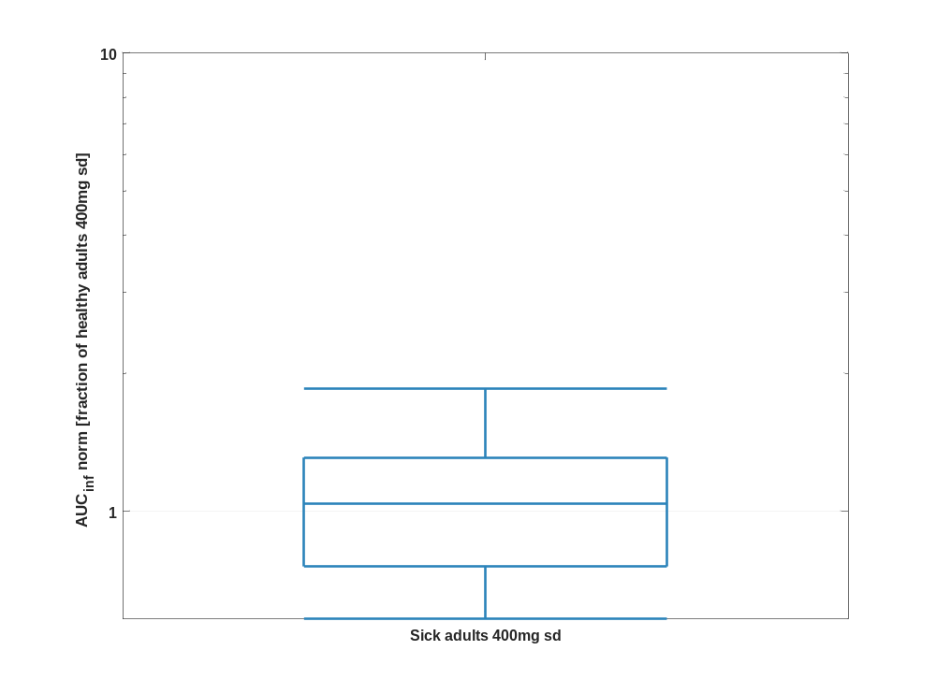

Table 1-21:Percentile of AUC_{inf} norm of Raltegravir normalized to individuals of Healthy adults 400mg sd.
AUC_{inf} norm [fraction of healthy adults 400mg sd]
 | 5th prctl. | 25th prctl. | 50th prctl. | 75th prctl. | 95th prctl. | arith. mean | std | geo. mean | geo. CV
Sick adults 400mg sd | 0.58 | 0.76 | 1.04 | 1.31 | 1.85 | 1.09 | 0.42 | 1.02 | 0.40

MRT

Figure 43: MRT of Raltegravir shown as box whisker plot, which indicate the 5, 25, 50, 75, and 95 percentiles in a linear scale.
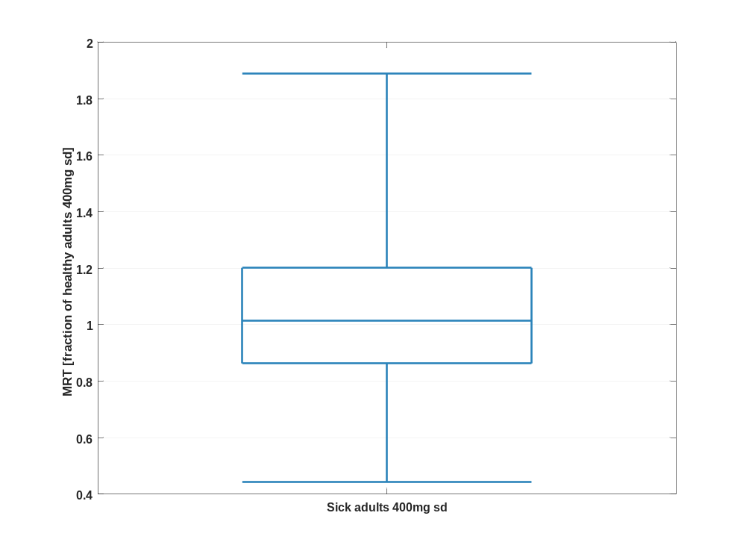

Figure 44: MRT of Raltegravir shown as box whisker plot, which indicate the 5, 25, 50, 75, and 95 percentiles in a logarithmic scale.
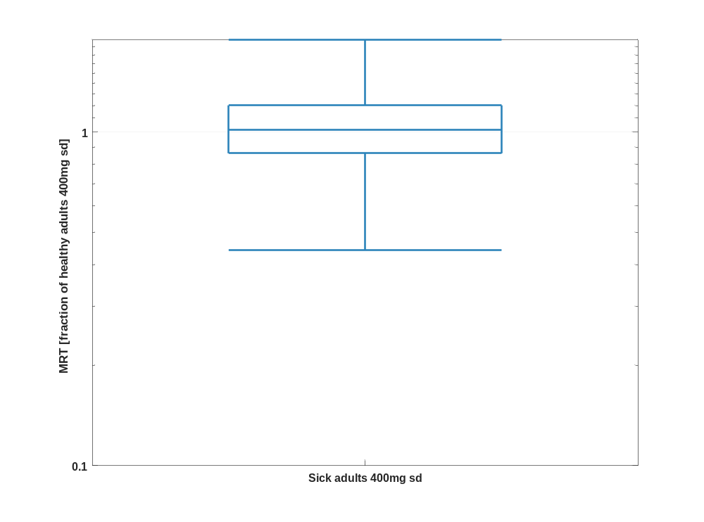

Table 1-22:Percentile of MRT of Raltegravir normalized to individuals of Healthy adults 400mg sd.
MRT [fraction of healthy adults 400mg sd]
 | 5th prctl. | 25th prctl. | 50th prctl. | 75th prctl. | 95th prctl. | arith. mean | std | geo. mean | geo. CV
Sick adults 400mg sd | 0.44 | 0.86 | 1.01 | 1.20 | 1.89 | 1.14 | 0.61 | 1.03 | 0.48

Thalf

Figure 45: Thalf of Raltegravir shown as box whisker plot, which indicate the 5, 25, 50, 75, and 95 percentiles in a linear scale.
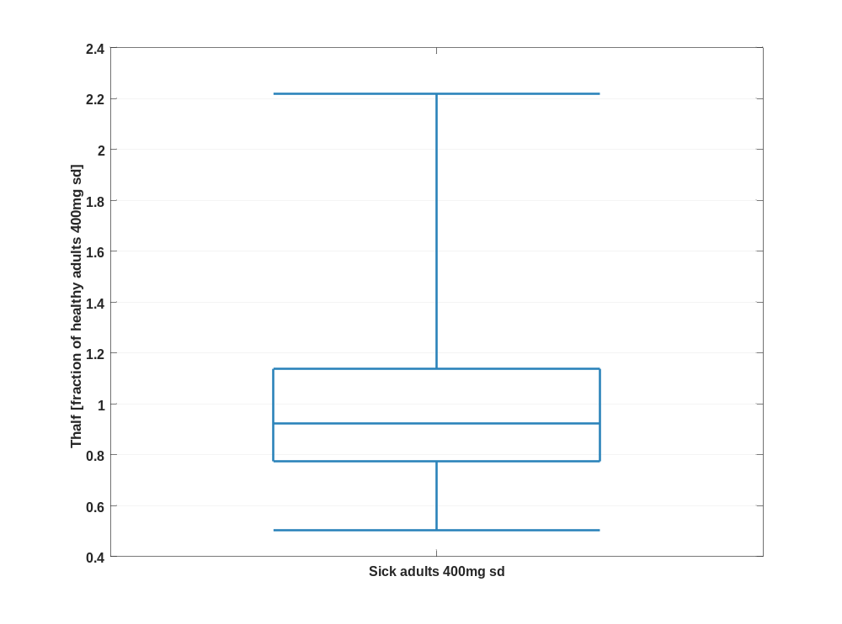

Figure 46: Thalf of Raltegravir shown as box whisker plot, which indicate the 5, 25, 50, 75, and 95 percentiles in a logarithmic scale.
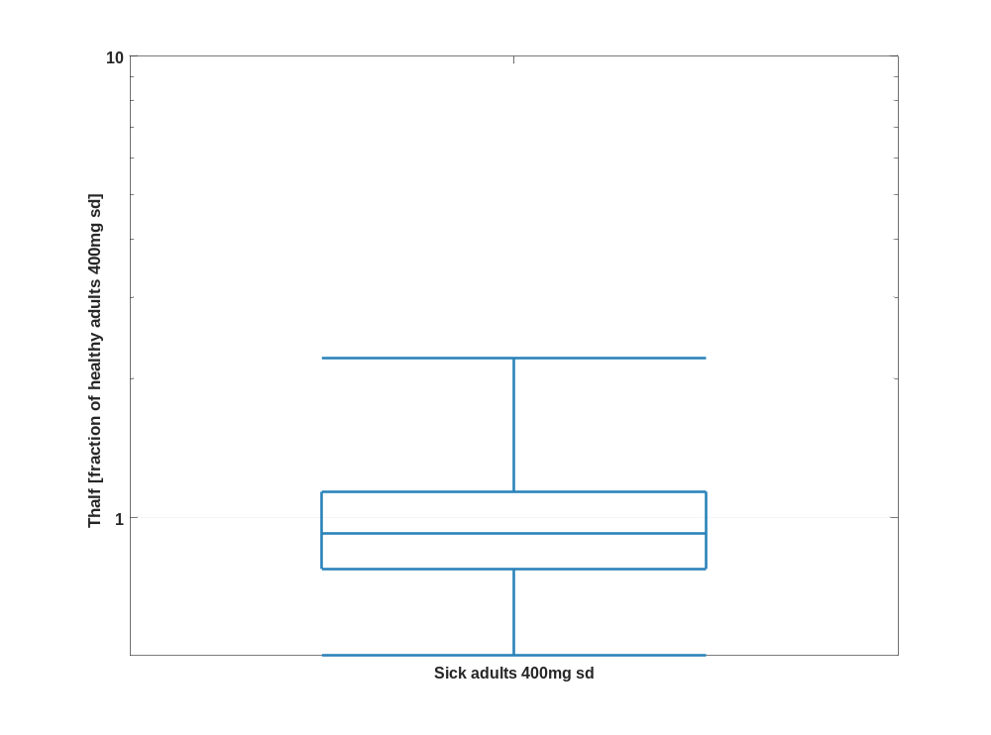

Table 1-23:Percentile of Thalf of Raltegravir normalized to individuals of Healthy adults 400mg sd.
Thalf [fraction of healthy adults 400mg sd]
 | 5th prctl. | 25th prctl. | 50th prctl. | 75th prctl. | 95th prctl. | arith. mean | std | geo. mean | geo. CV
Sick adults 400mg sd | 0.50 | 0.77 | 0.92 | 1.14 | 2.22 | 1.03 | 0.45 | 0.95 | 0.41

CL

Figure 47: CL of Raltegravir shown as box whisker plot, which indicate the 5, 25, 50, 75, and 95 percentiles in a linear scale.
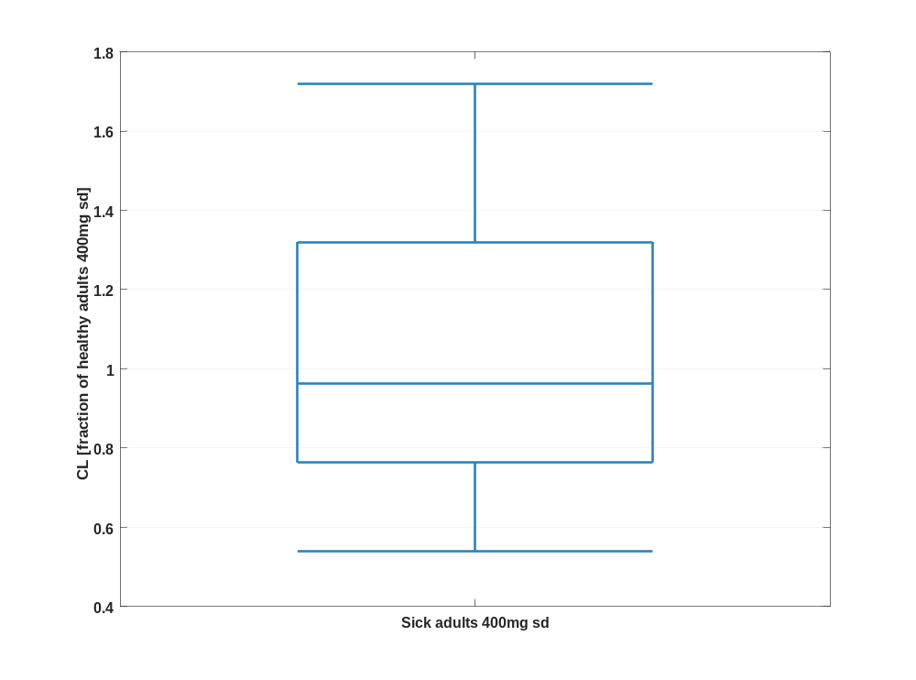

Figure 48: CL of Raltegravir shown as box whisker plot, which indicate the 5, 25, 50, 75, and 95 percentiles in a logarithmic scale.
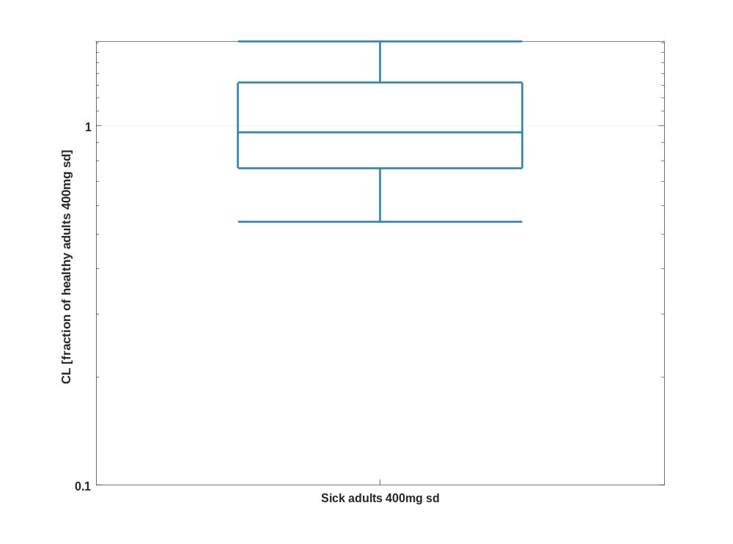

Table 1-24:Percentile of CL of Raltegravir normalized to individuals of Healthy adults 400mg sd.
CL [fraction of healthy adults 400mg sd]
 | 5th prctl. | 25th prctl. | 50th prctl. | 75th prctl. | 95th prctl. | arith. mean | std | geo. mean | geo. CV
Sick adults 400mg sd | 0.54 | 0.76 | 0.96 | 1.32 | 1.72 | 1.06 | 0.41 | 0.98 | 0.40

Vss

Figure 49: Vss of Raltegravir shown as box whisker plot, which indicate the 5, 25, 50, 75, and 95 percentiles in a linear scale.
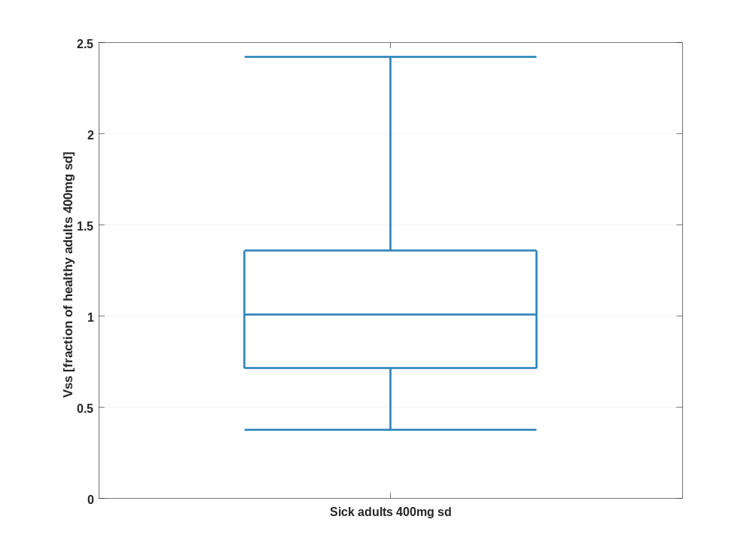

Figure 50: Vss of Raltegravir shown as box whisker plot, which indicate the 5, 25, 50, 75, and 95 percentiles in a logarithmic scale.
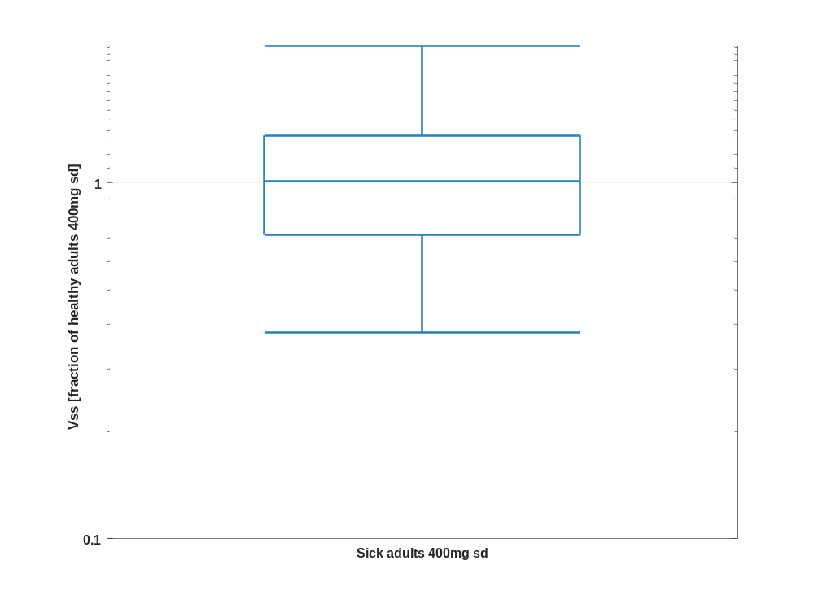

Table 1-25:Percentile of Vss of Raltegravir normalized to individuals of Healthy adults 400mg sd.
Vss [fraction of healthy adults 400mg sd]
 | 5th prctl. | 25th prctl. | 50th prctl. | 75th prctl. | 95th prctl. | arith. mean | std | geo. mean | geo. CV
Sick adults 400mg sd | 0.38 | 0.71 | 1.01 | 1.36 | 2.42 | 1.19 | 0.98 | 1.01 | 0.59

Vd

Figure 51: Vd of Raltegravir shown as box whisker plot, which indicate the 5, 25, 50, 75, and 95 percentiles in a linear scale.
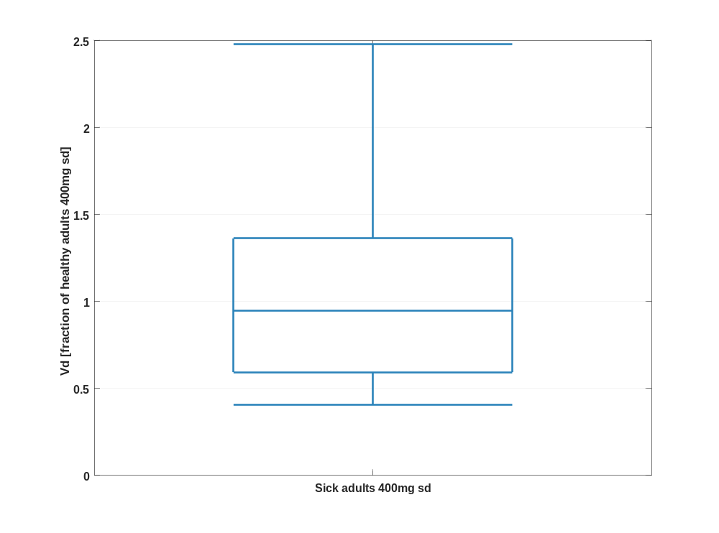

Figure 52: Vd of Raltegravir shown as box whisker plot, which indicate the 5, 25, 50, 75, and 95 percentiles in a logarithmic scale.
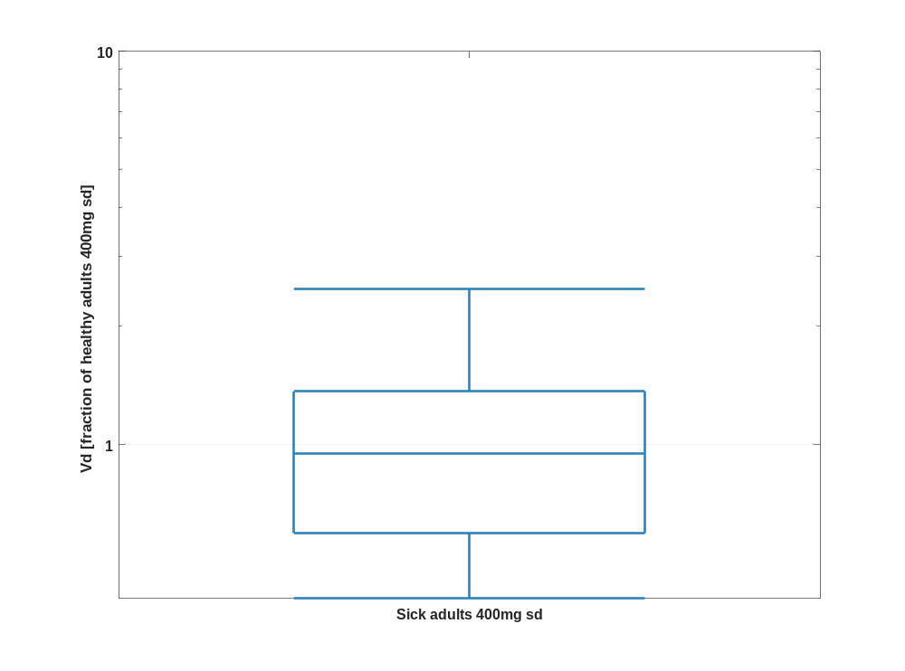

Table 1-26:Percentile of Vd of Raltegravir normalized to individuals of Healthy adults 400mg sd.
Vd [fraction of healthy adults 400mg sd]
 | 5th prctl. | 25th prctl. | 50th prctl. | 75th prctl. | 95th prctl. | arith. mean | std | geo. mean | geo. CV
Sick adults 400mg sd | 0.40 | 0.59 | 0.95 | 1.36 | 2.48 | 1.10 | 0.74 | 0.93 | 0.61

Sensitivity

Sensitivity analysis of C_{max} for Raltegravir

Figure 1: Individual sensitivity vs mean sensitivity for C_{max} for Raltegravir
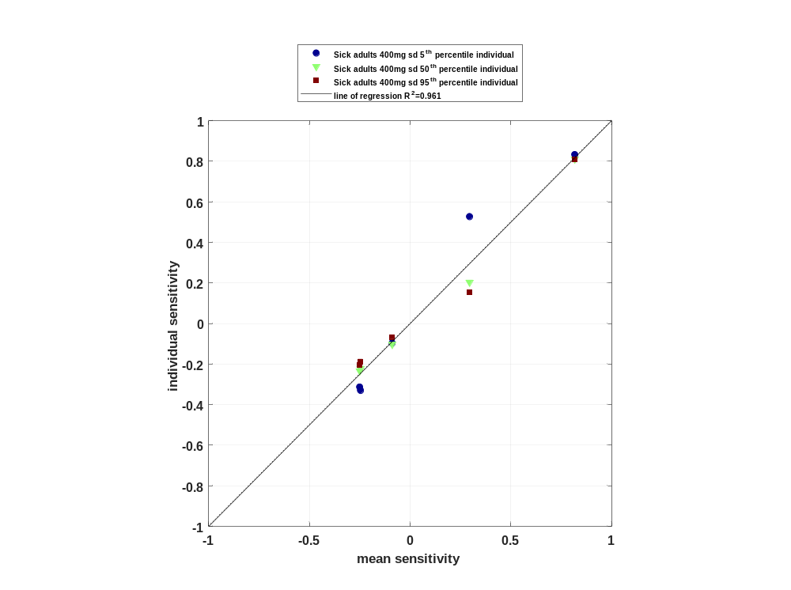

Figure 2: Sorted absolute sensitivity for C_{max} for Raltegravir
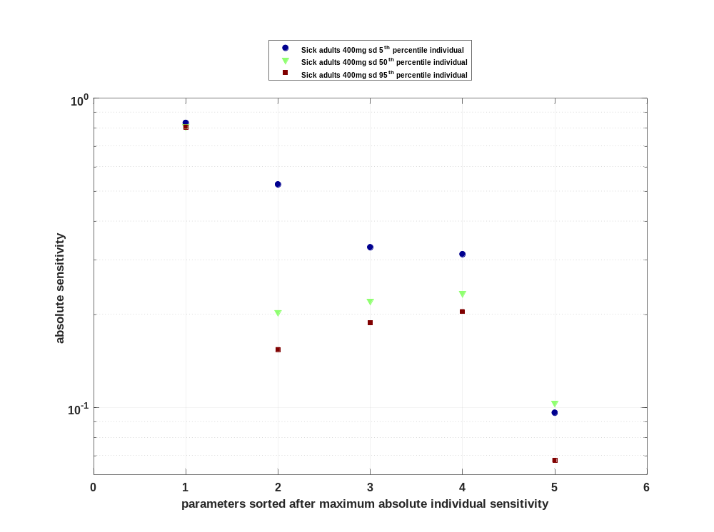

Figure 3: Cumulated sorted absolute sensitivity for C_{max} for Raltegravir
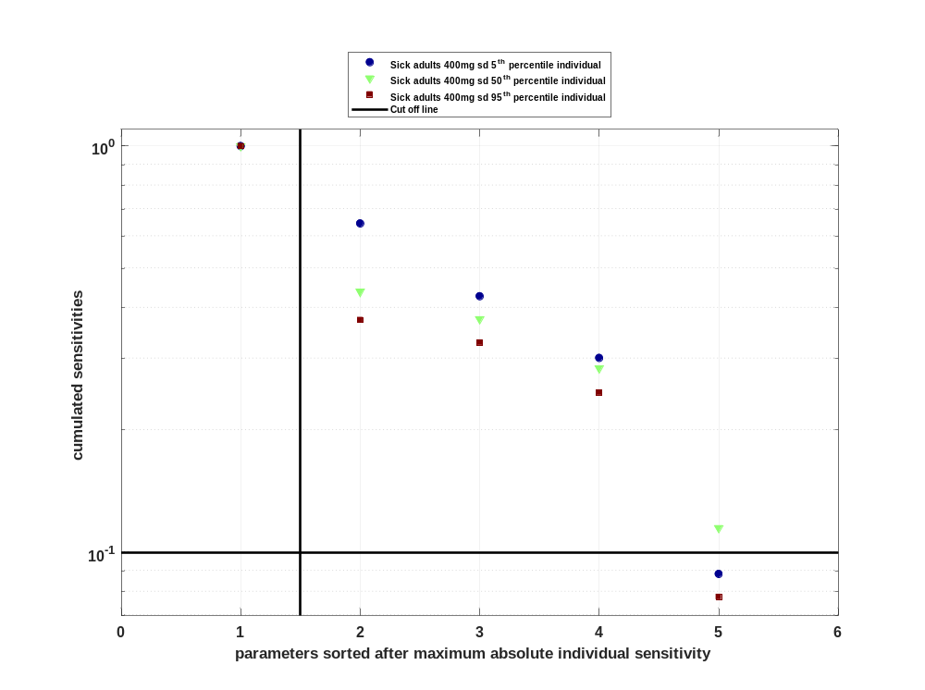

Figure 4: Most sensitive parameter for C_{max} for Raltegravir
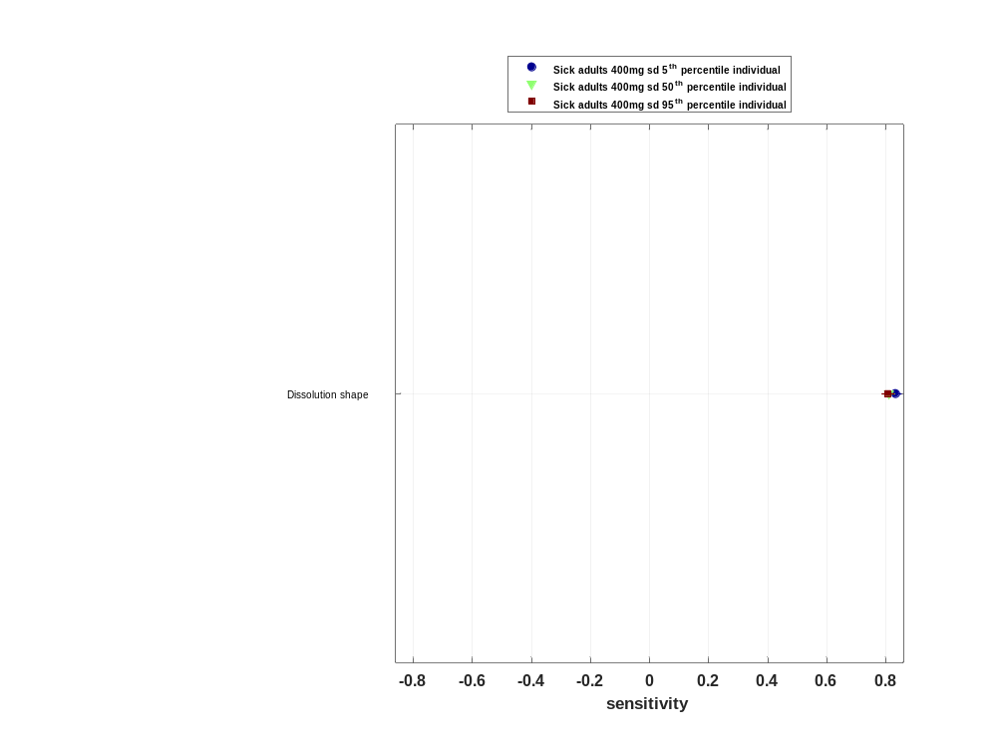

Sensitivity analysis of C_{max} norm for Raltegravir

Figure 5: Individual sensitivity vs mean sensitivity for C_{max} norm for Raltegravir
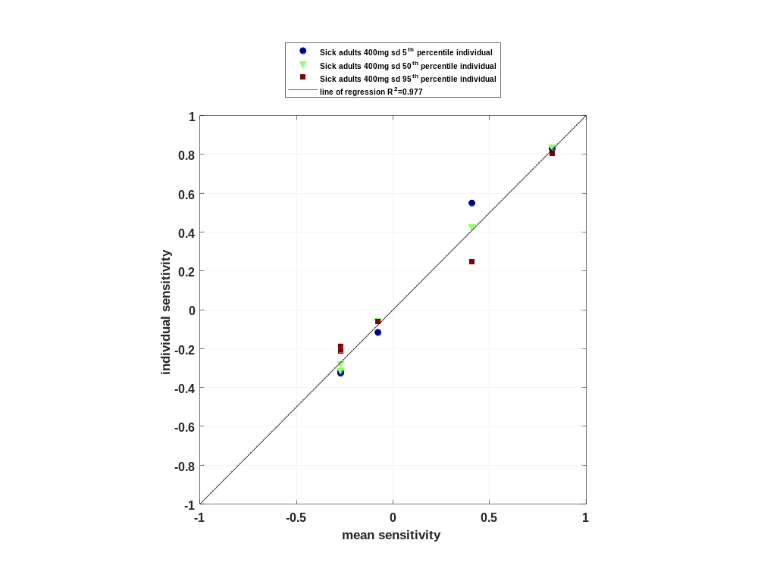

Figure 6: Sorted absolute sensitivity for C_{max} norm for Raltegravir
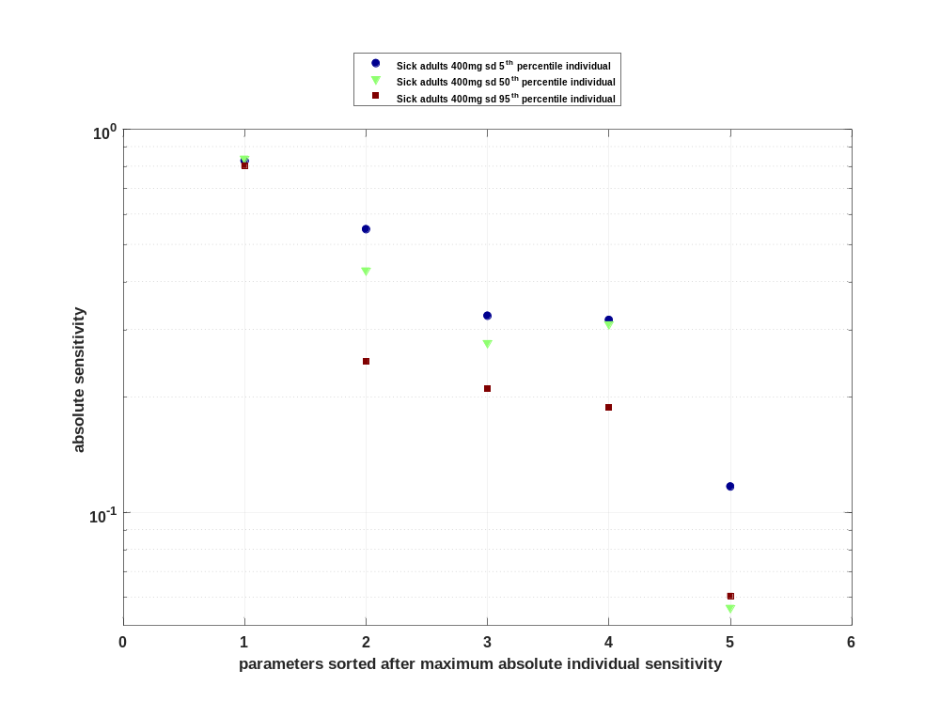

Figure 7: Cumulated sorted absolute sensitivity for C_{max} norm for Raltegravir
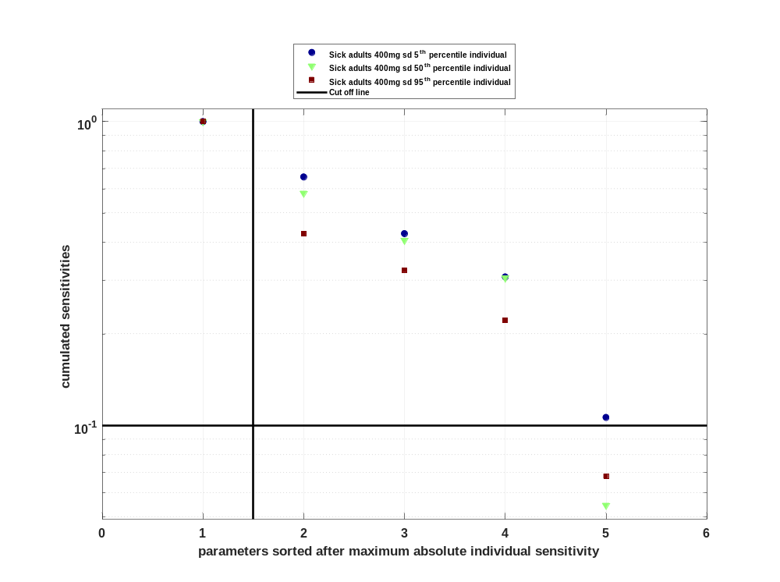

Figure 8: Most sensitive parameter for C_{max} norm for Raltegravir
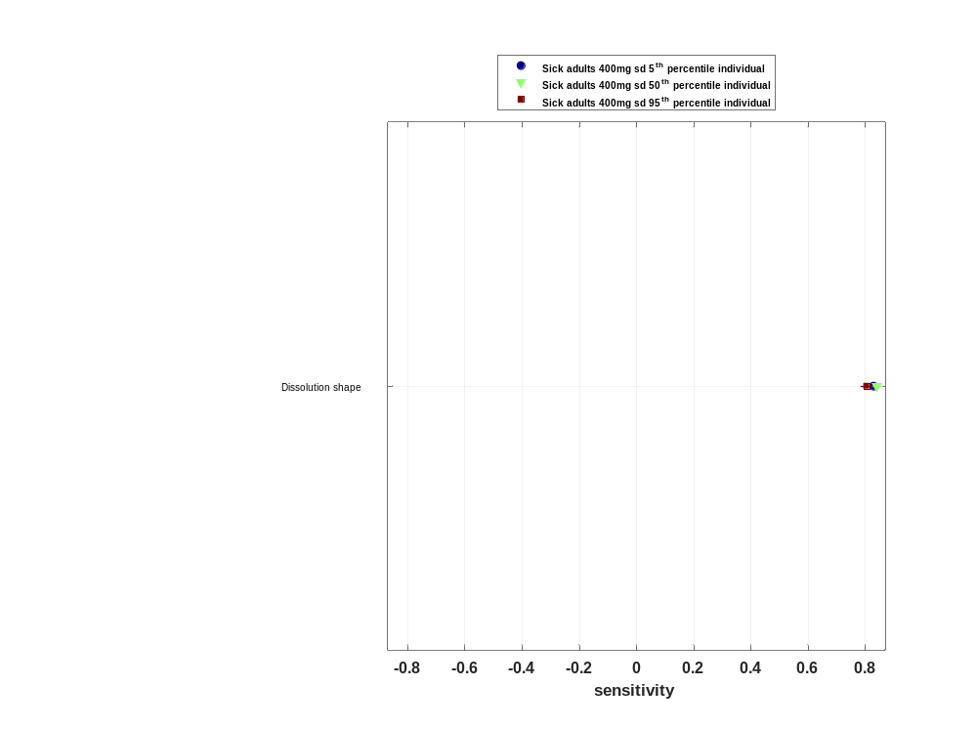

Sensitivity analysis of t_{max} for Raltegravir

Figure 9: Individual sensitivity vs mean sensitivity for t_{max} for Raltegravir
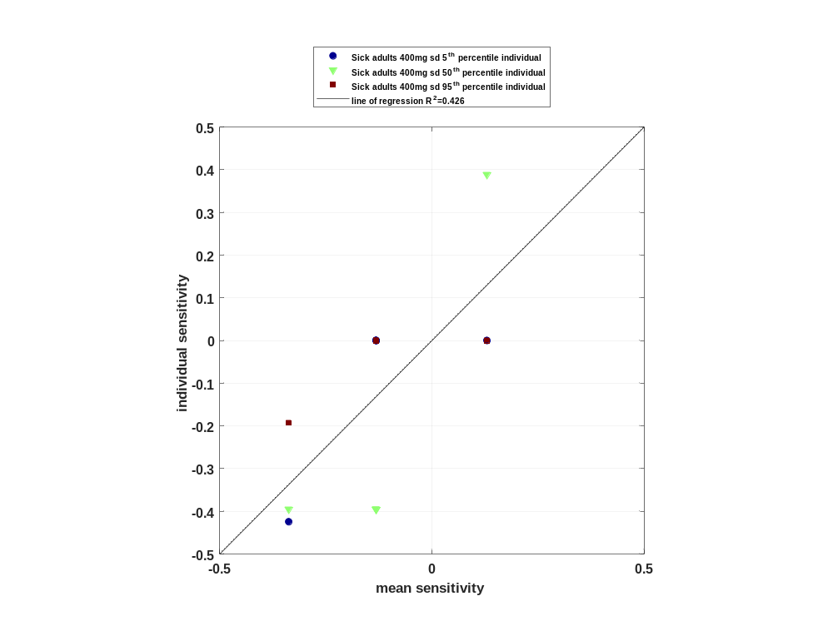

Figure 10: Sorted absolute sensitivity for t_{max} for Raltegravir
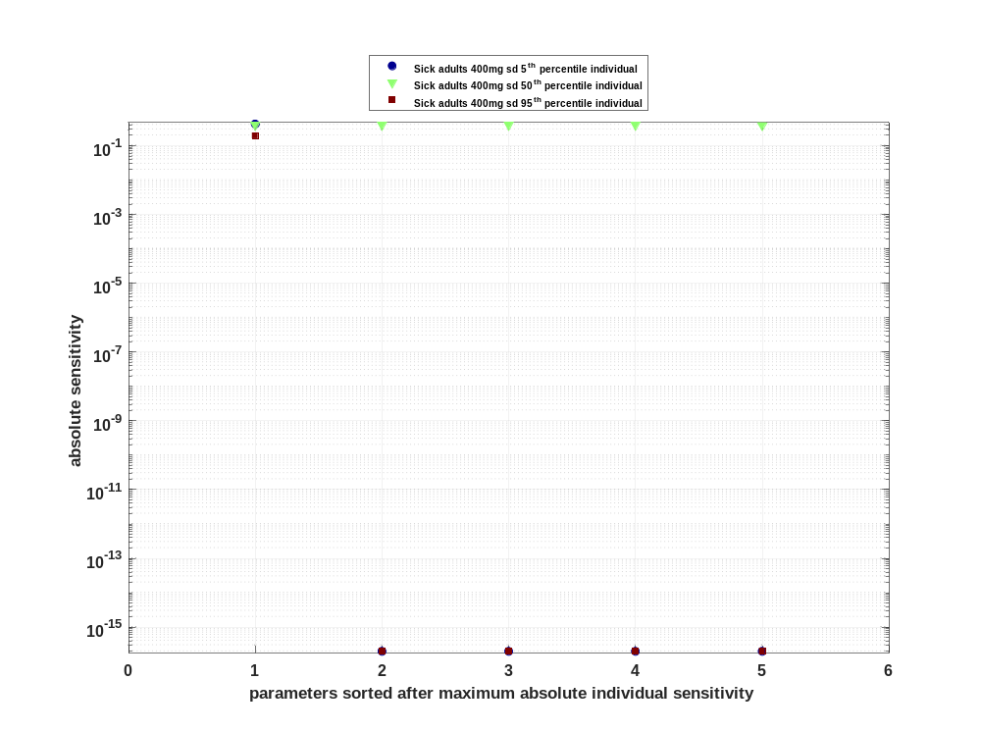

Figure 11: Cumulated sorted absolute sensitivity for t_{max} for Raltegravir
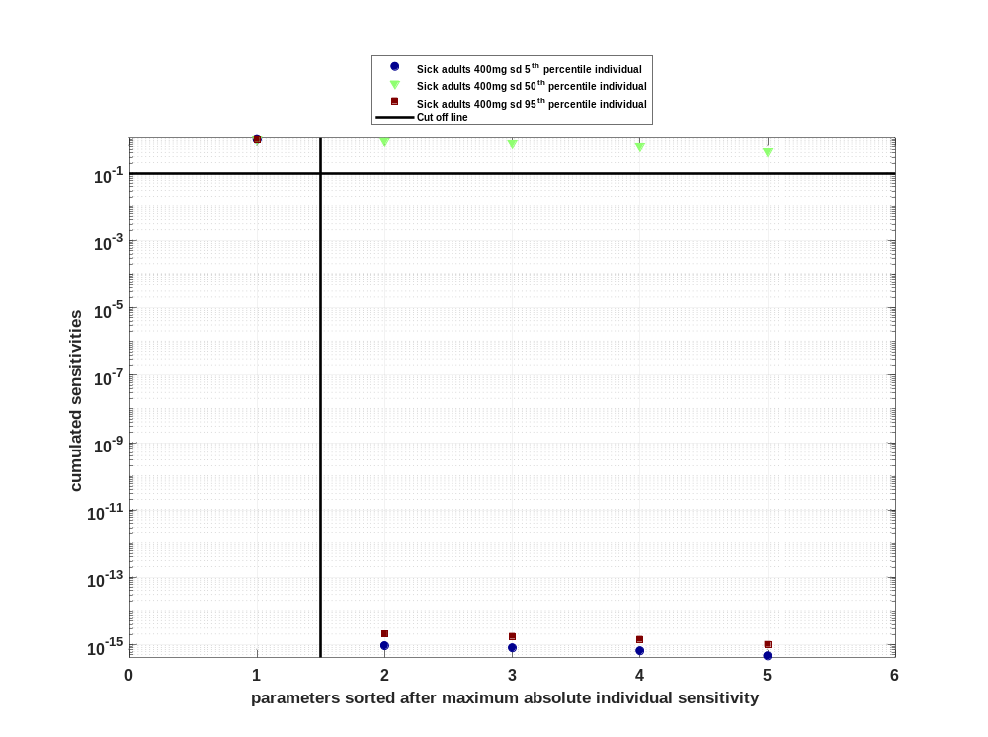

Figure 12: Most sensitive parameter for t_{max} for Raltegravir
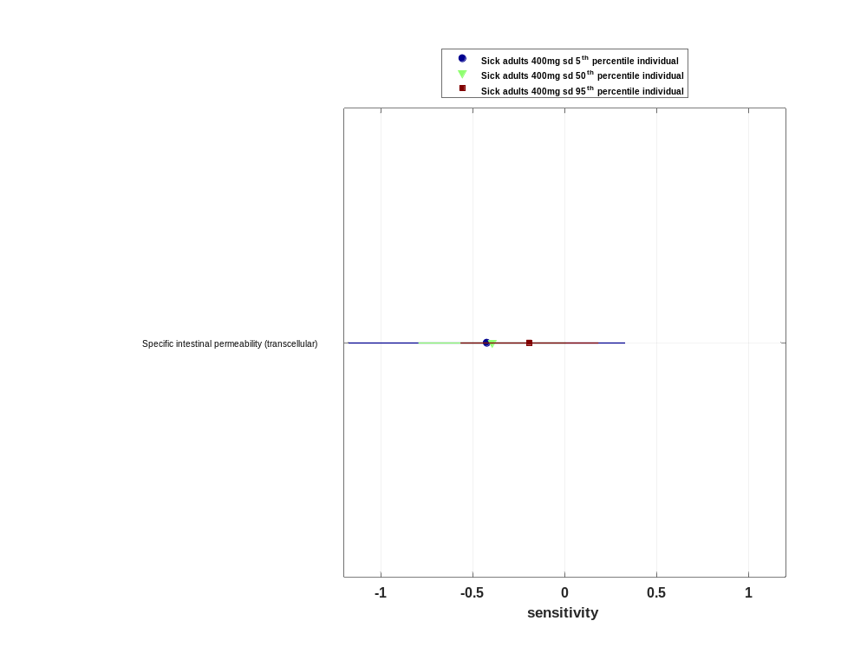

Sensitivity analysis of C_{tEnd} for Raltegravir

Figure 13: Individual sensitivity vs mean sensitivity for C_{tEnd} for Raltegravir
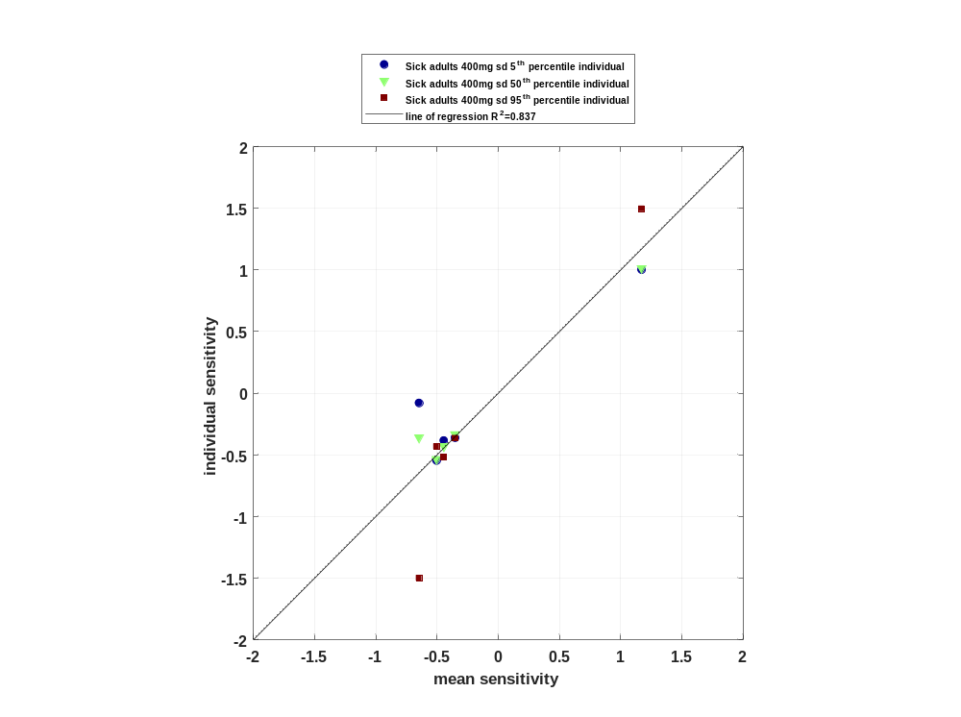

Figure 14: Sorted absolute sensitivity for C_{tEnd} for Raltegravir
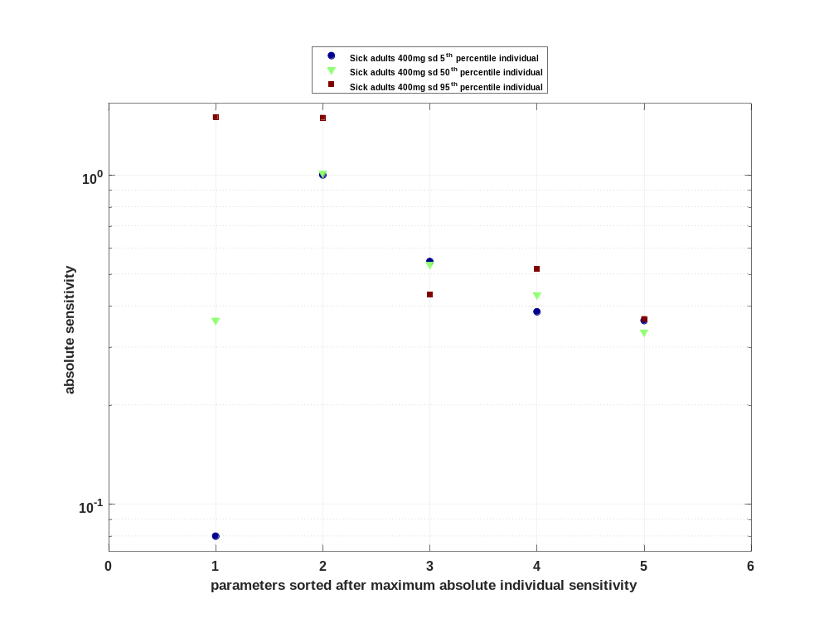

Figure 15: Cumulated sorted absolute sensitivity for C_{tEnd} for Raltegravir
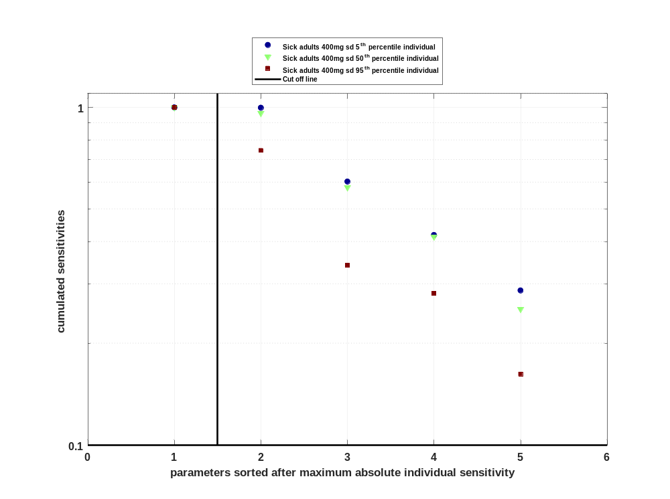

Figure 16: Most sensitive parameter for C_{tEnd} for Raltegravir
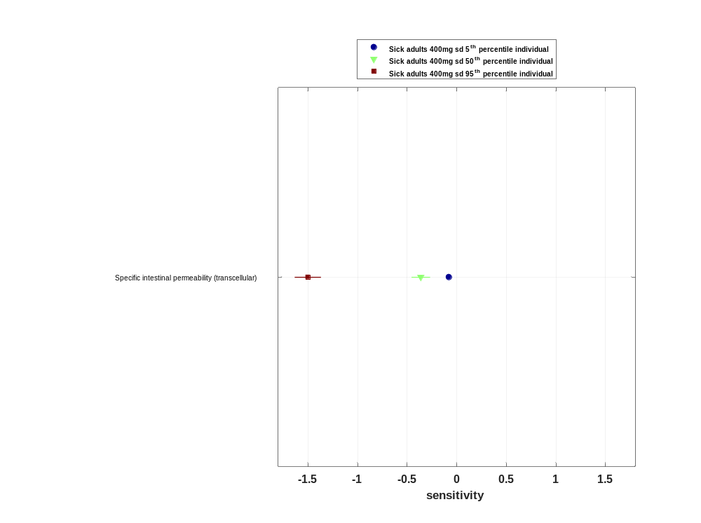

Sensitivity analysis of AUC_{last} for Raltegravir

Figure 17: Individual sensitivity vs mean sensitivity for AUC_{last} for Raltegravir
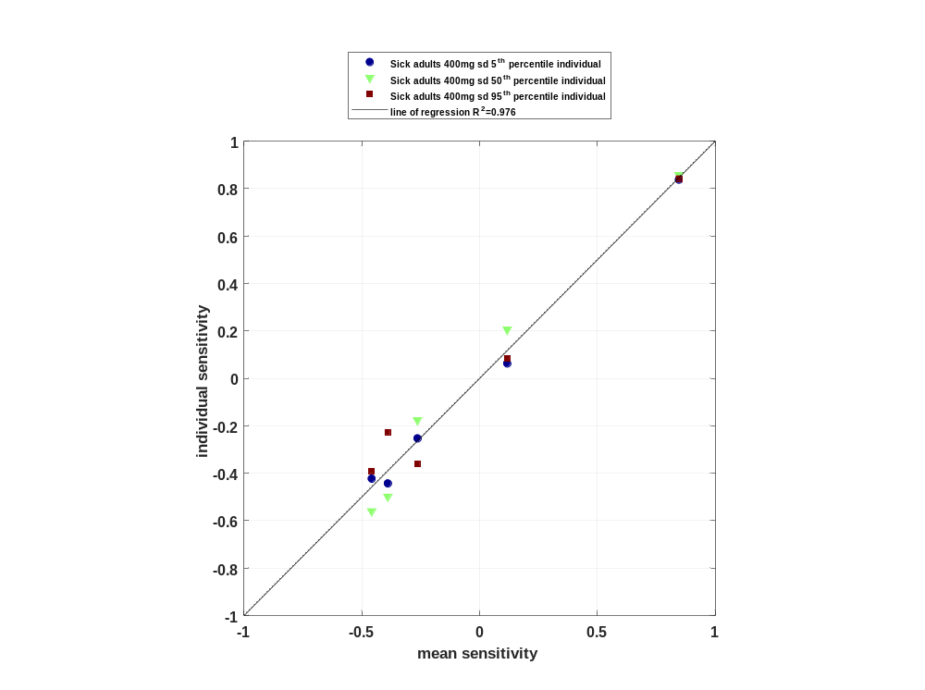

Figure 18: Sorted absolute sensitivity for AUC_{last} for Raltegravir
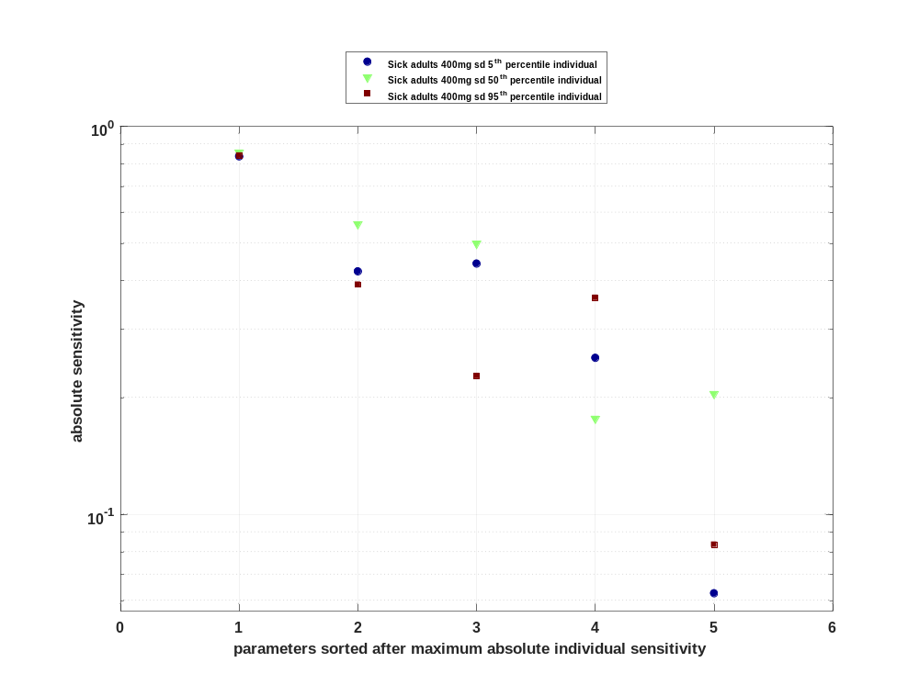

Figure 19: Cumulated sorted absolute sensitivity for AUC_{last} for Raltegravir
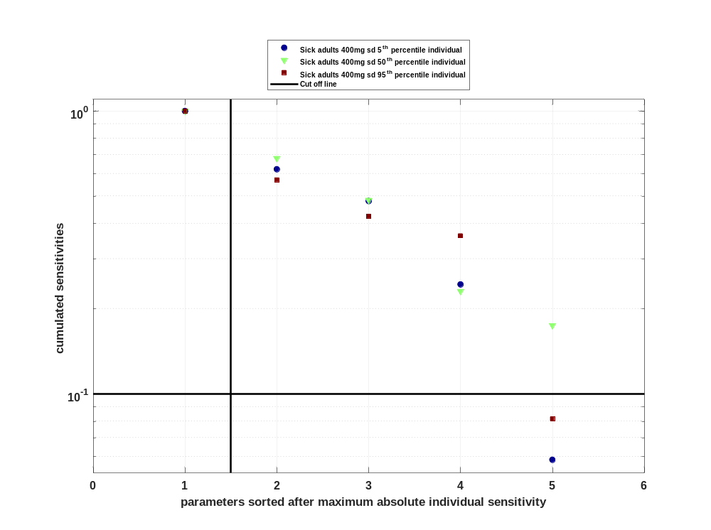

Figure 20: Most sensitive parameter for AUC_{last} for Raltegravir
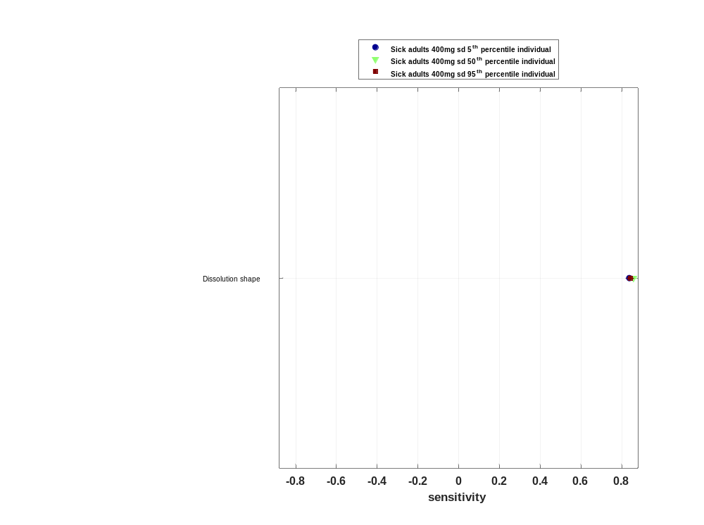

Sensitivity analysis of AUC_{last} norm for Raltegravir

Figure 21: Individual sensitivity vs mean sensitivity for AUC_{last} norm for Raltegravir
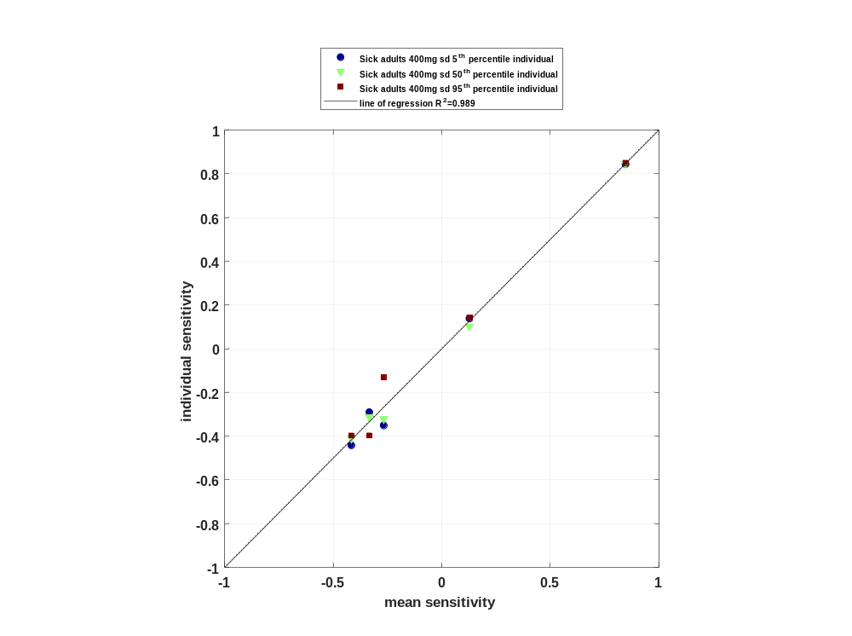

Figure 22: Sorted absolute sensitivity for AUC_{last} norm for Raltegravir
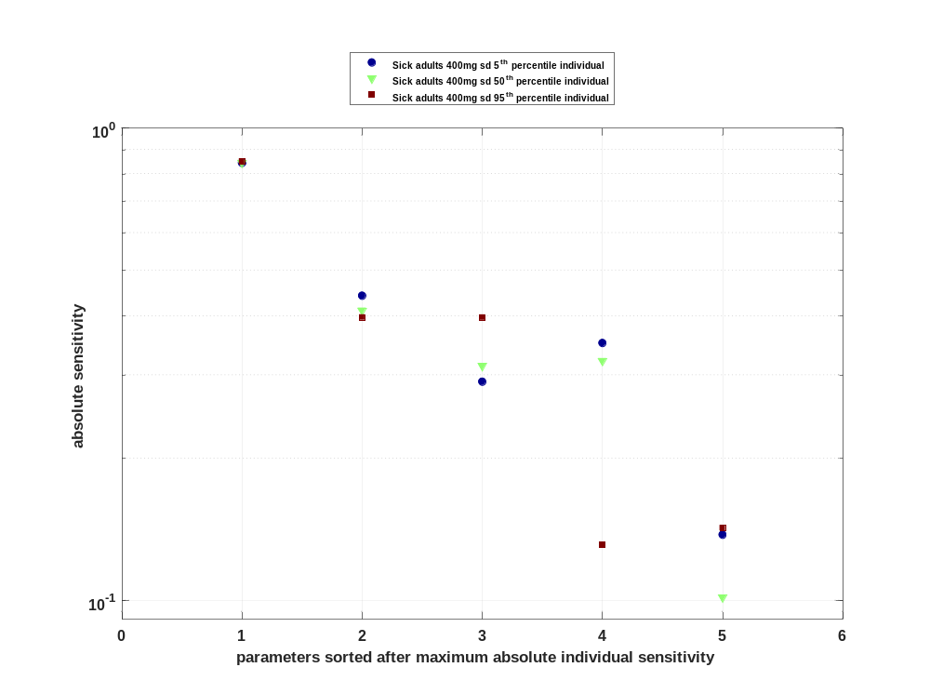

Figure 23: Cumulated sorted absolute sensitivity for AUC_{last} norm for Raltegravir
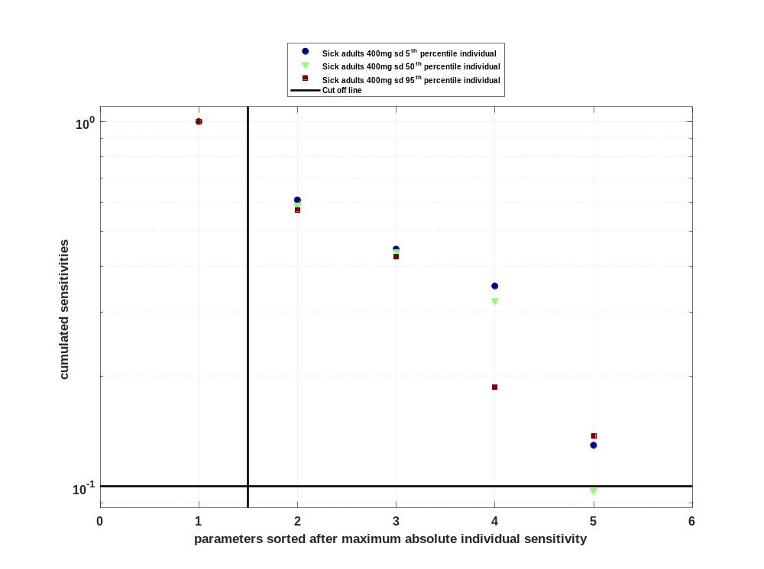

Figure 24: Most sensitive parameter for AUC_{last} norm for Raltegravir
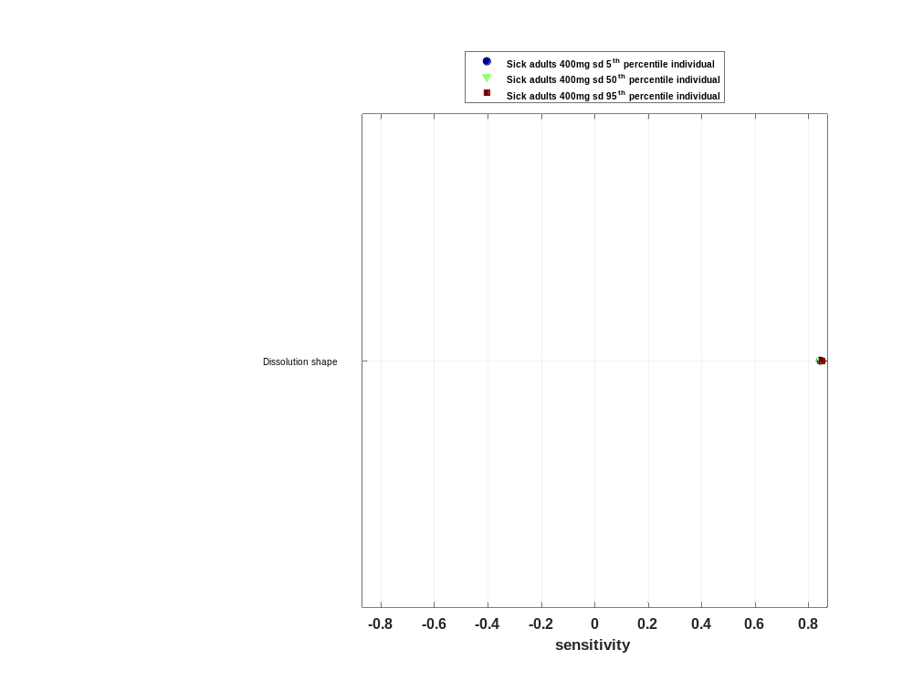

Sensitivity analysis of AUC_{inf} for Raltegravir

Figure 25: Individual sensitivity vs mean sensitivity for AUC_{inf} for Raltegravir
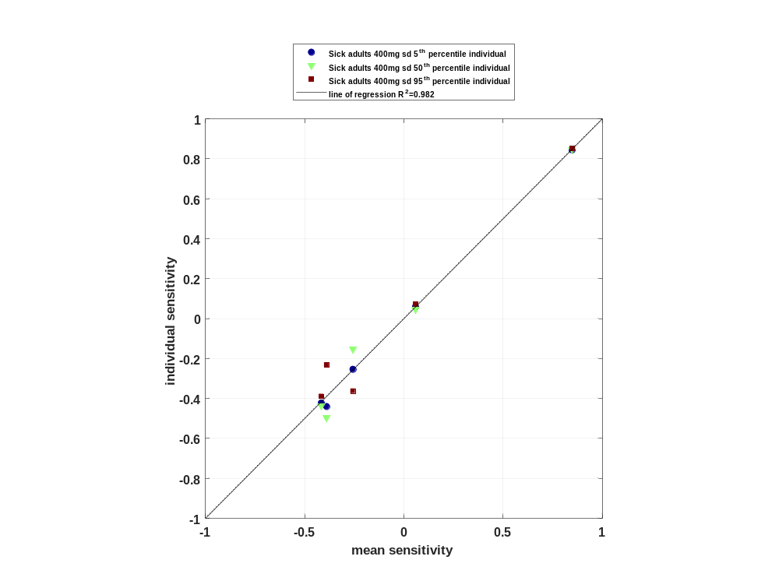

Figure 26: Sorted absolute sensitivity for AUC_{inf} for Raltegravir
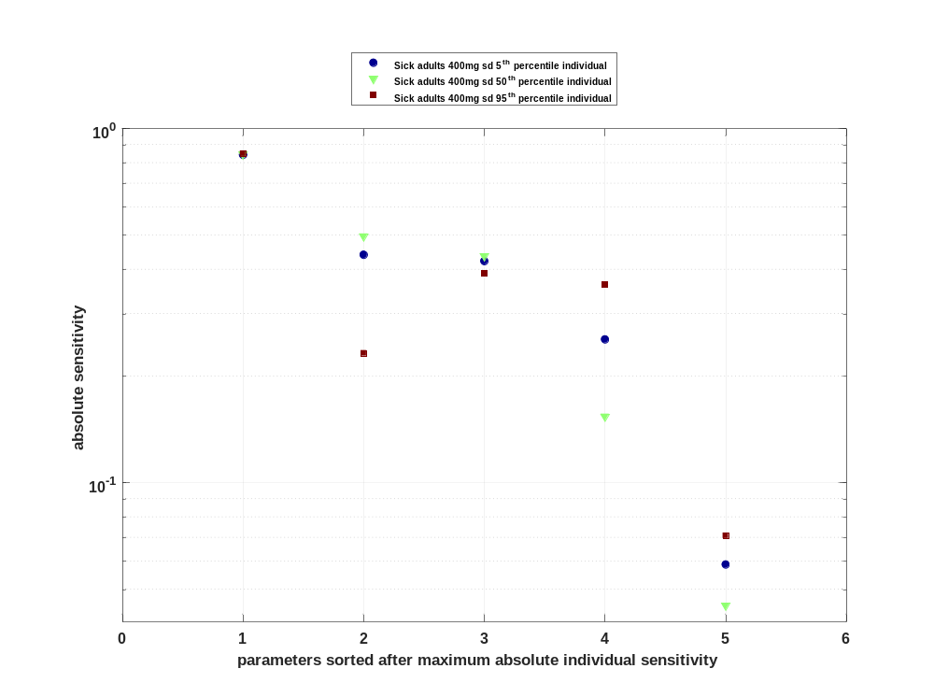

Figure 27: Cumulated sorted absolute sensitivity for AUC_{inf} for Raltegravir
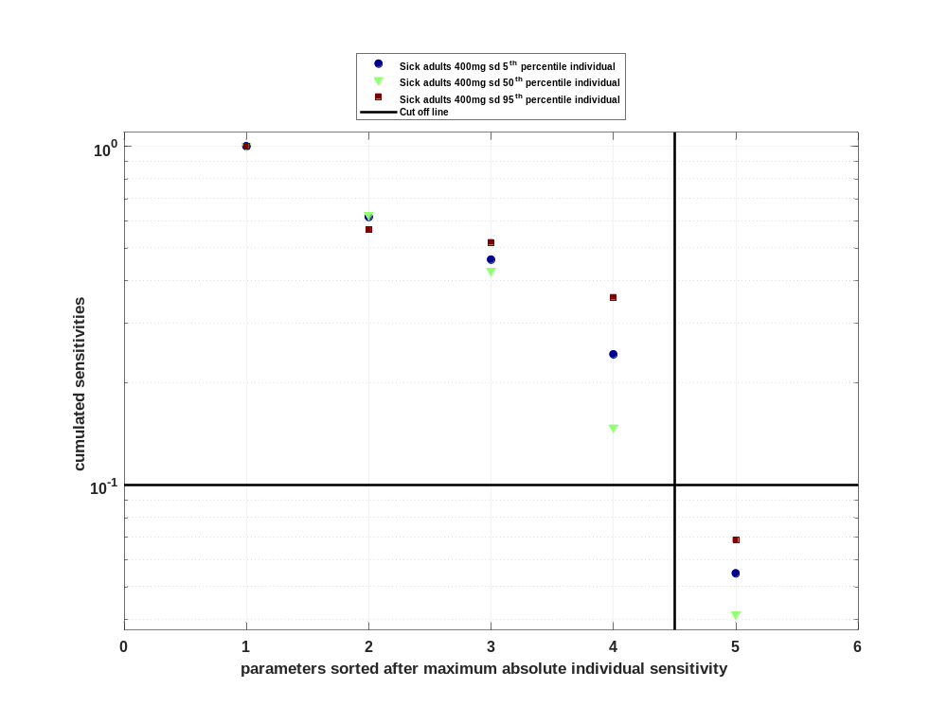

Figure 28: Most sensitive parameter for AUC_{inf} for Raltegravir
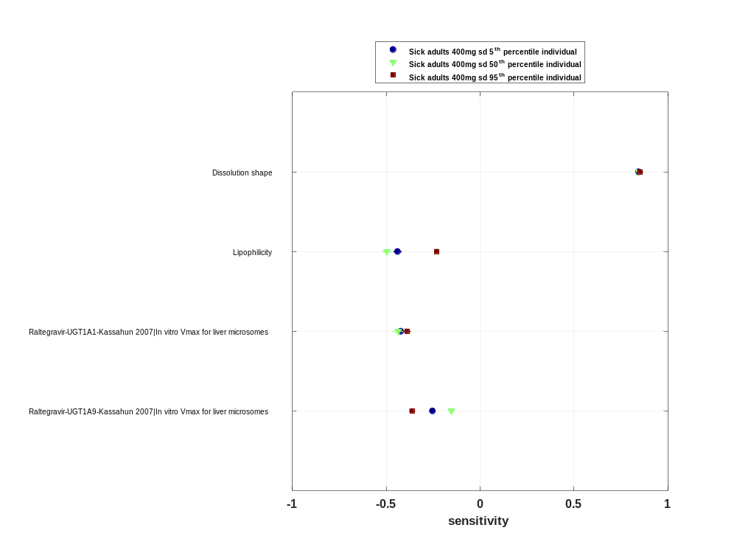

Sensitivity analysis of AUC_{inf} norm for Raltegravir

Figure 29: Individual sensitivity vs mean sensitivity for AUC_{inf} norm for Raltegravir
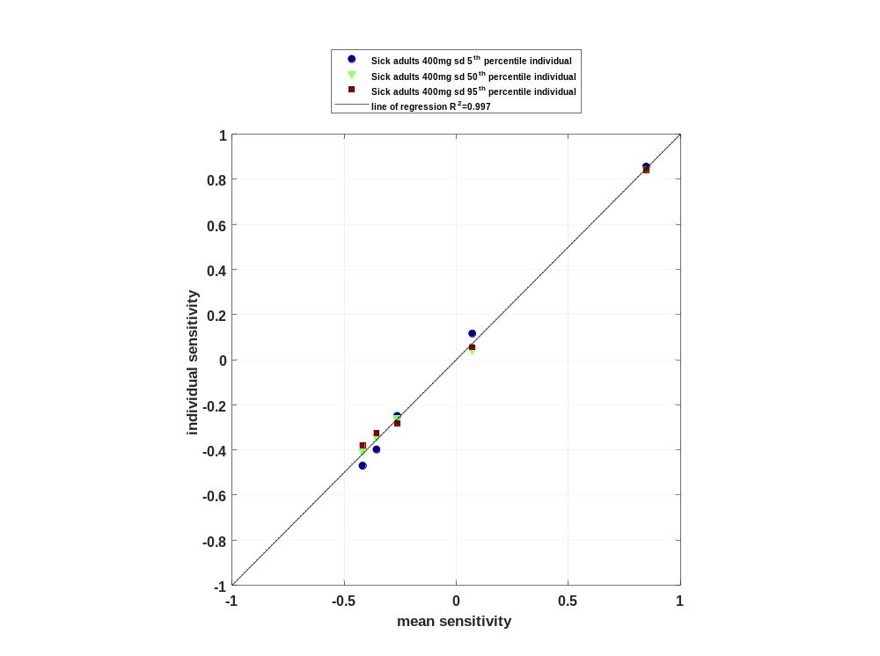

Figure 30: Sorted absolute sensitivity for AUC_{inf} norm for Raltegravir
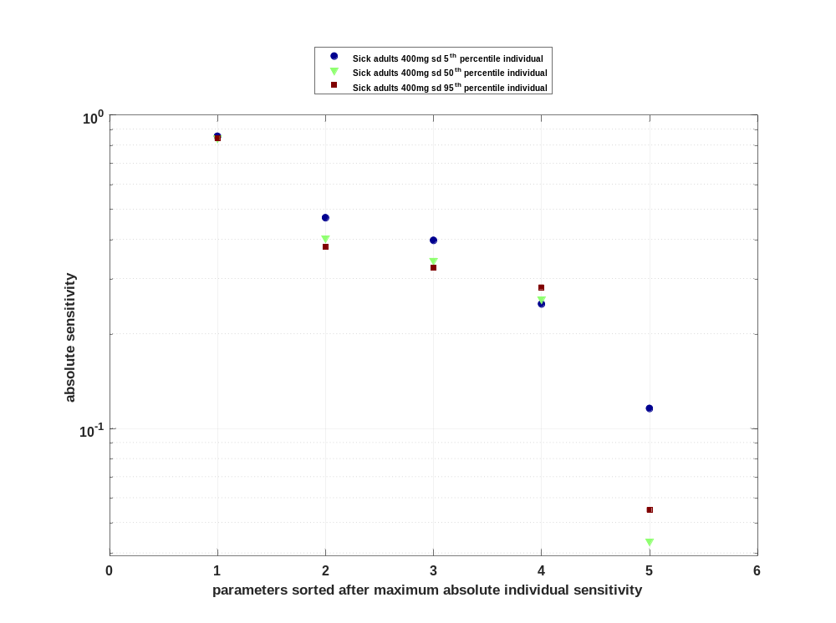

Figure 31: Cumulated sorted absolute sensitivity for AUC_{inf} norm for Raltegravir
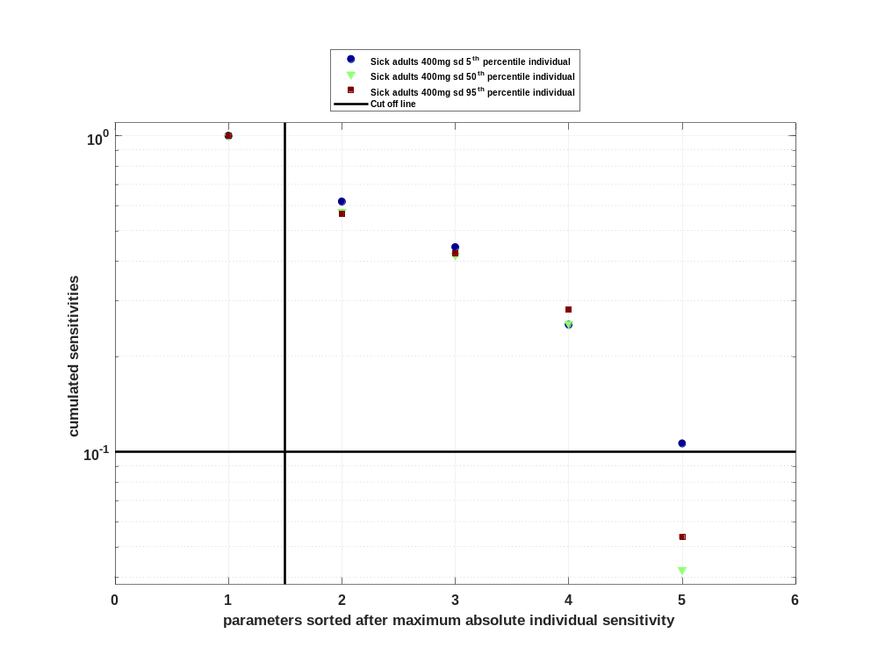

Figure 32: Most sensitive parameter for AUC_{inf} norm for Raltegravir
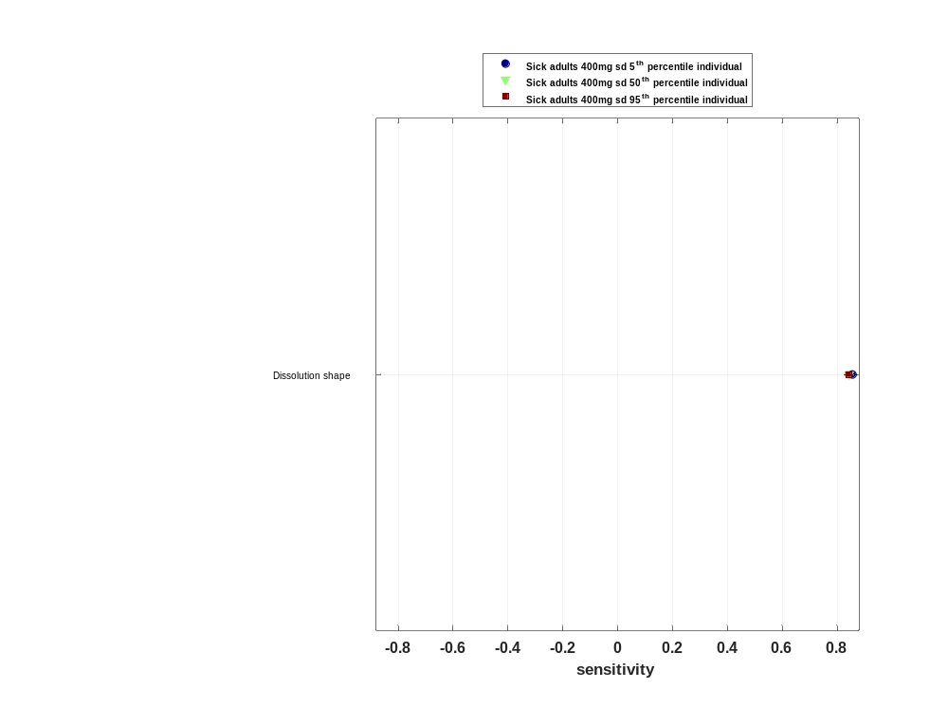

Sensitivity analysis of MRT for Raltegravir

Figure 33: Individual sensitivity vs mean sensitivity for MRT for Raltegravir
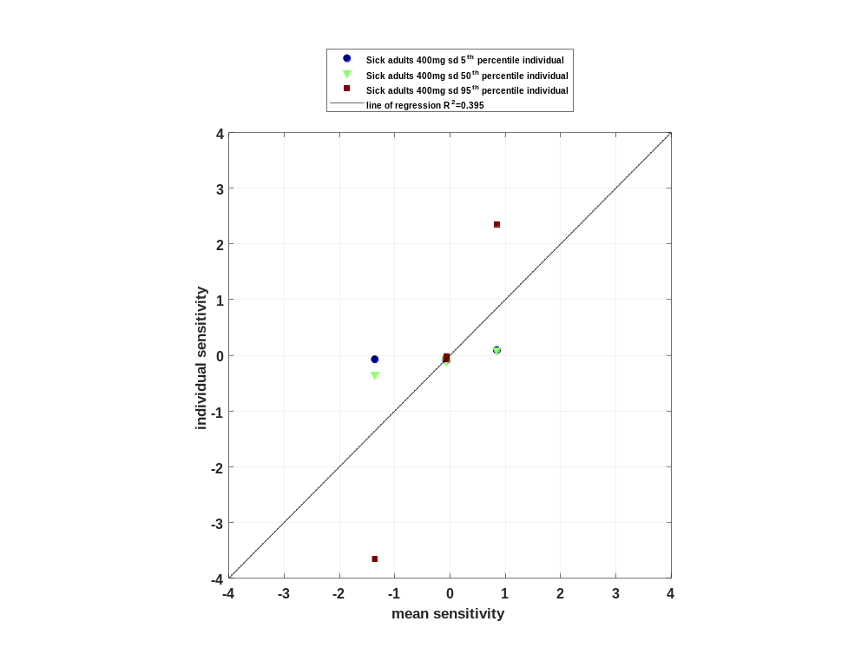

Figure 34: Sorted absolute sensitivity for MRT for Raltegravir
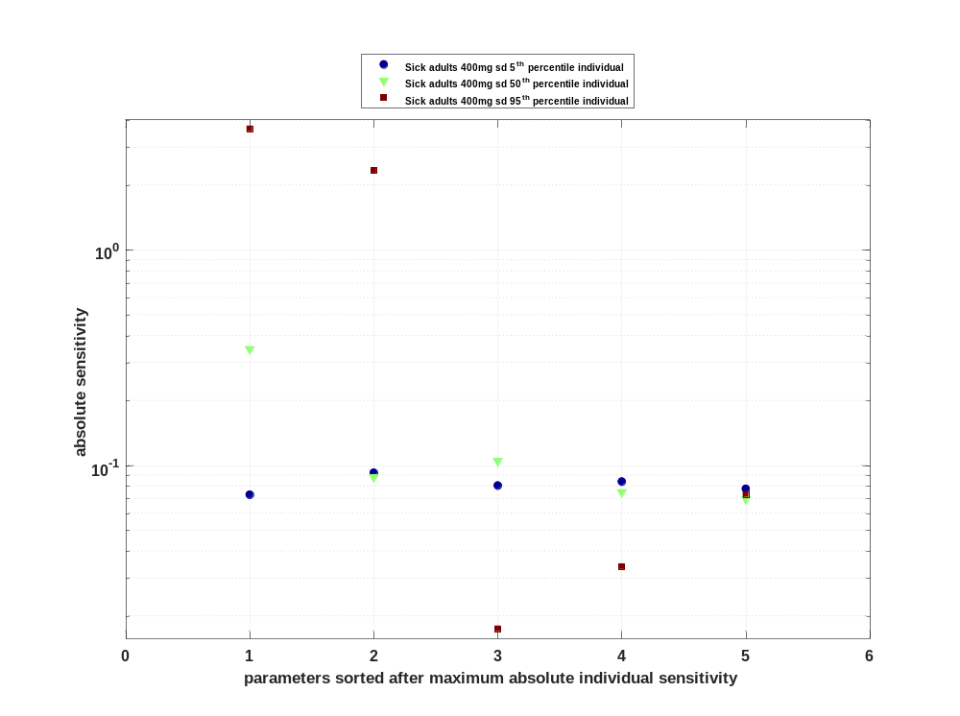

Figure 35: Cumulated sorted absolute sensitivity for MRT for Raltegravir
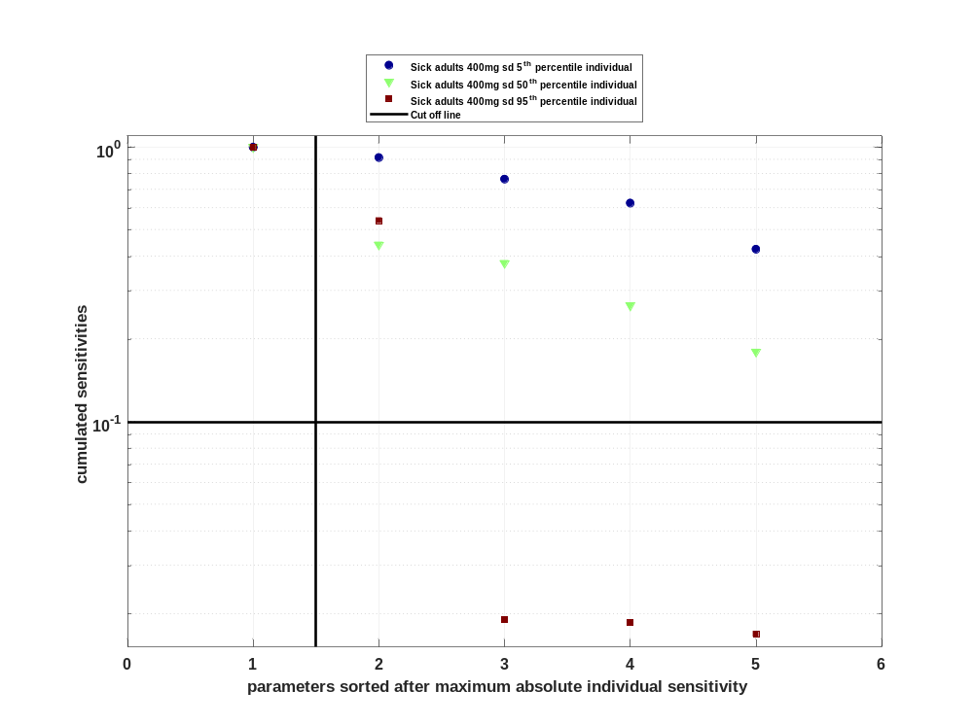

Figure 36: Most sensitive parameter for MRT for Raltegravir
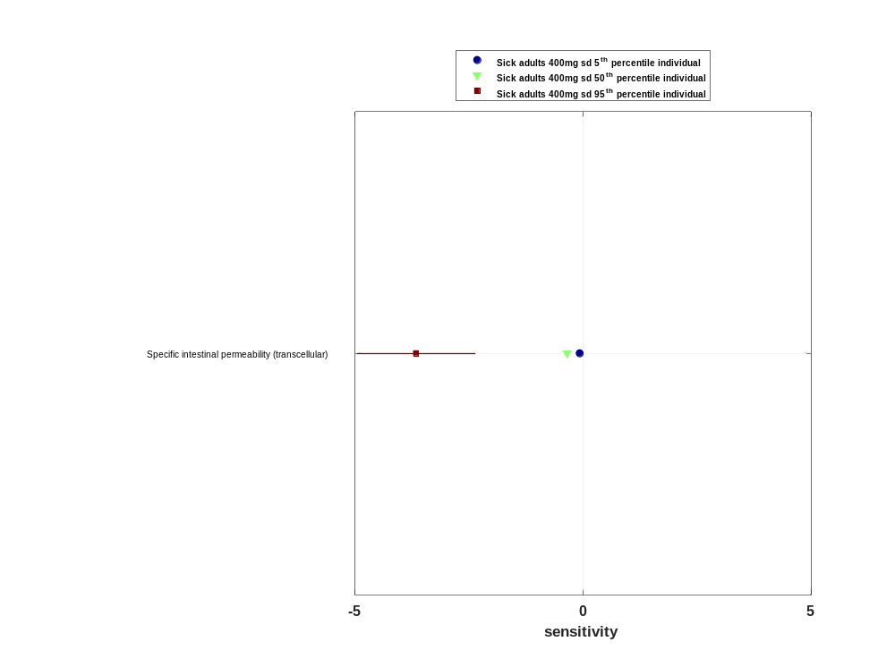

Sensitivity analysis of Thalf for Raltegravir

Figure 37: Individual sensitivity vs mean sensitivity for Thalf for Raltegravir
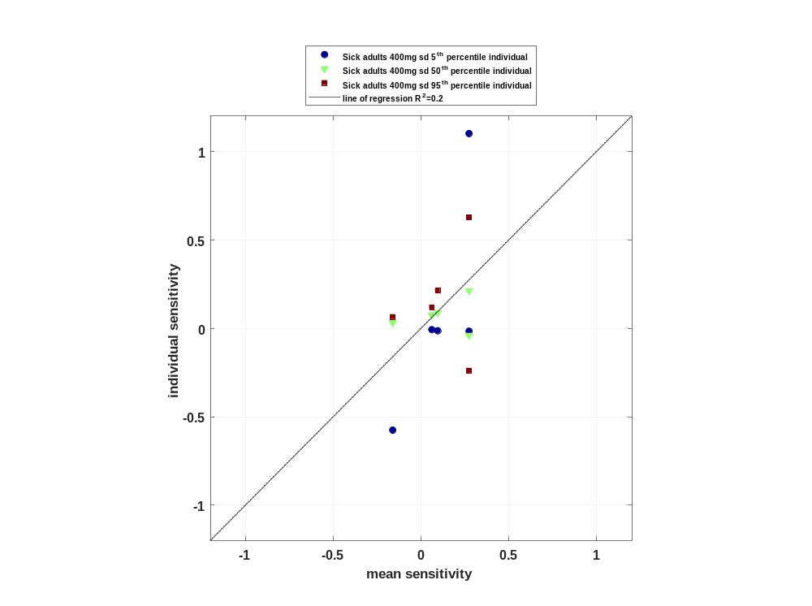

Figure 38: Sorted absolute sensitivity for Thalf for Raltegravir
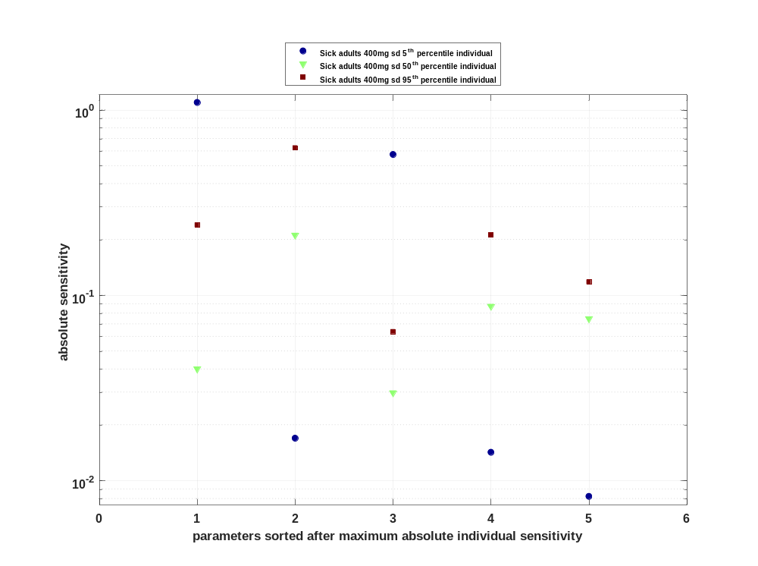

Figure 39: Cumulated sorted absolute sensitivity for Thalf for Raltegravir
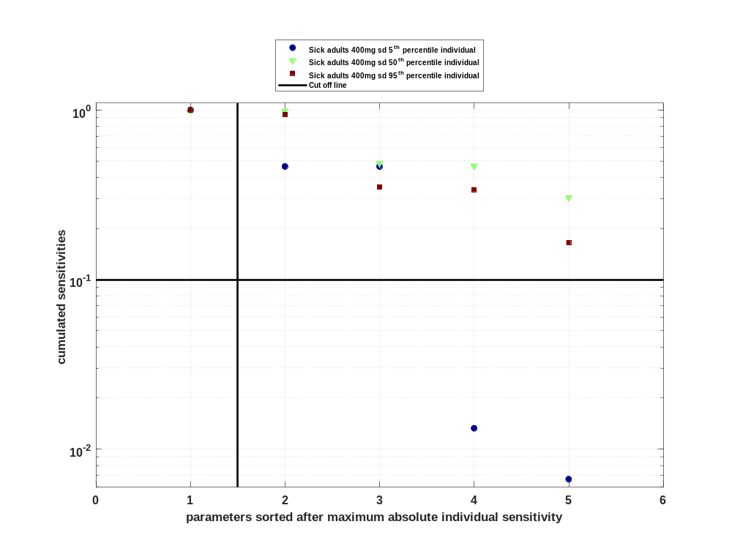

Figure 40: Most sensitive parameter for Thalf for Raltegravir
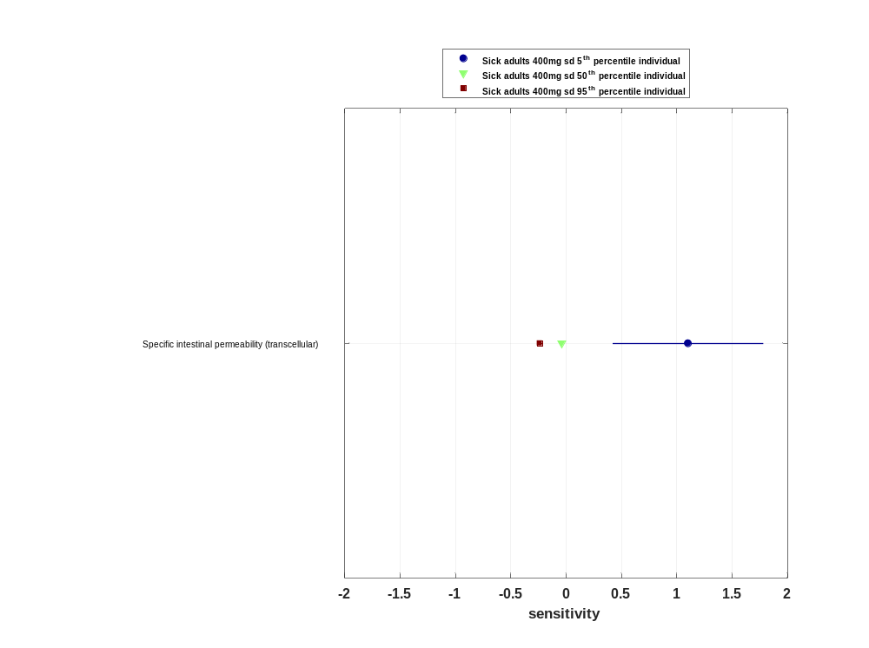

Sensitivity analysis of CL for Raltegravir

Figure 41: Individual sensitivity vs mean sensitivity for CL for Raltegravir
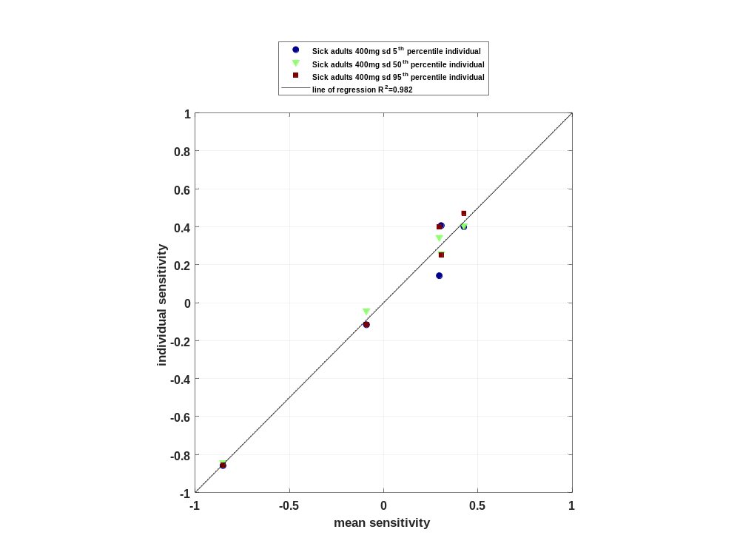

Figure 42: Sorted absolute sensitivity for CL for Raltegravir
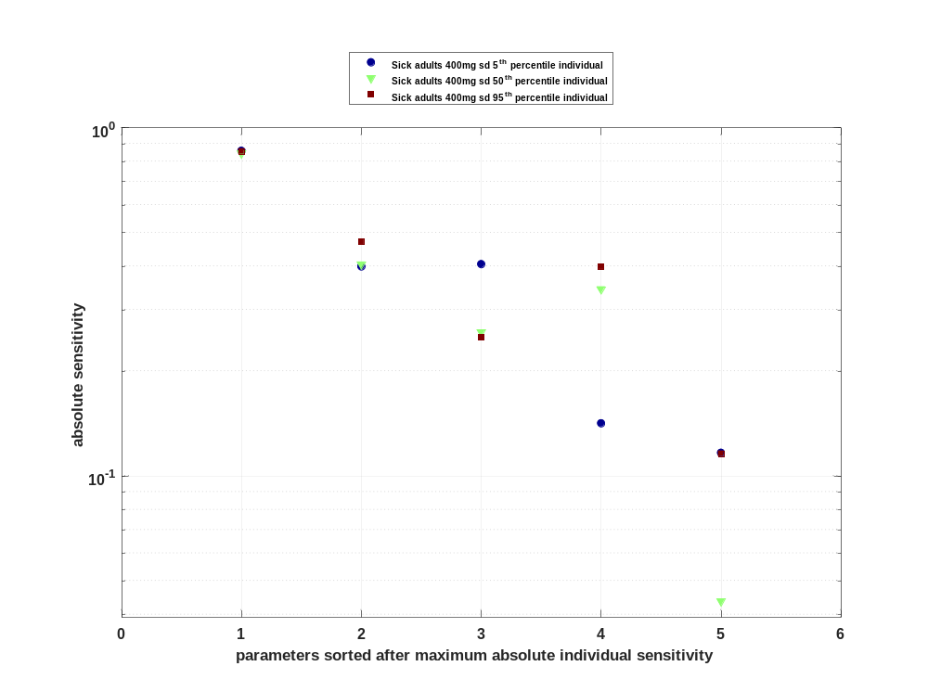

Figure 43: Cumulated sorted absolute sensitivity for CL for Raltegravir
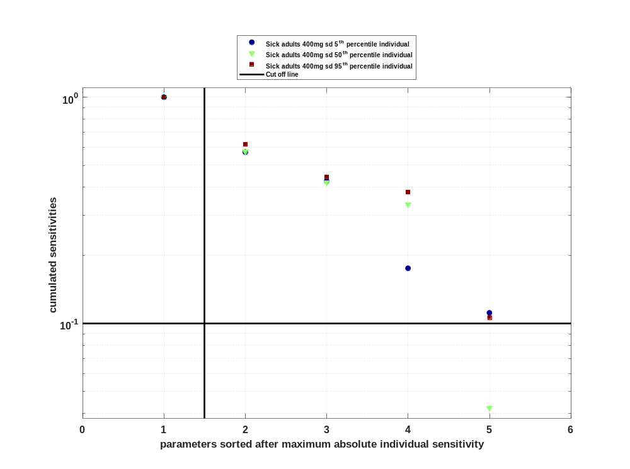

Figure 44: Most sensitive parameter for CL for Raltegravir
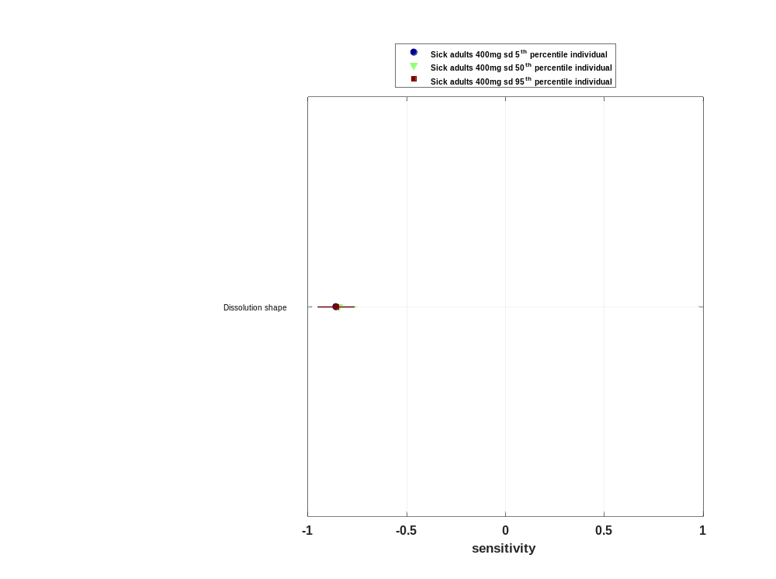

Sensitivity analysis of Vss for Raltegravir

Figure 45: Individual sensitivity vs mean sensitivity for Vss for Raltegravir
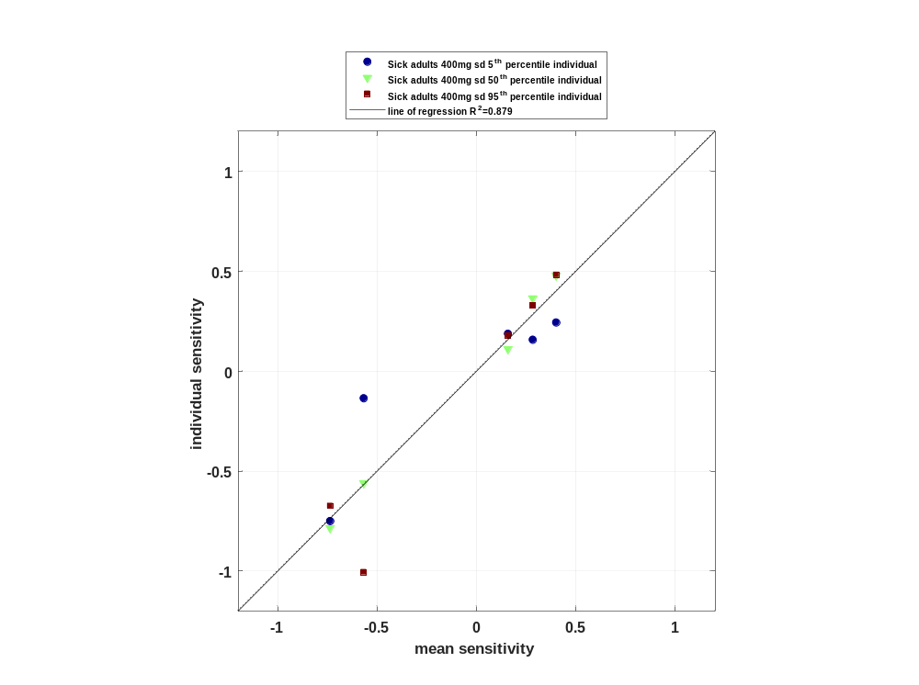

Figure 46: Sorted absolute sensitivity for Vss for Raltegravir
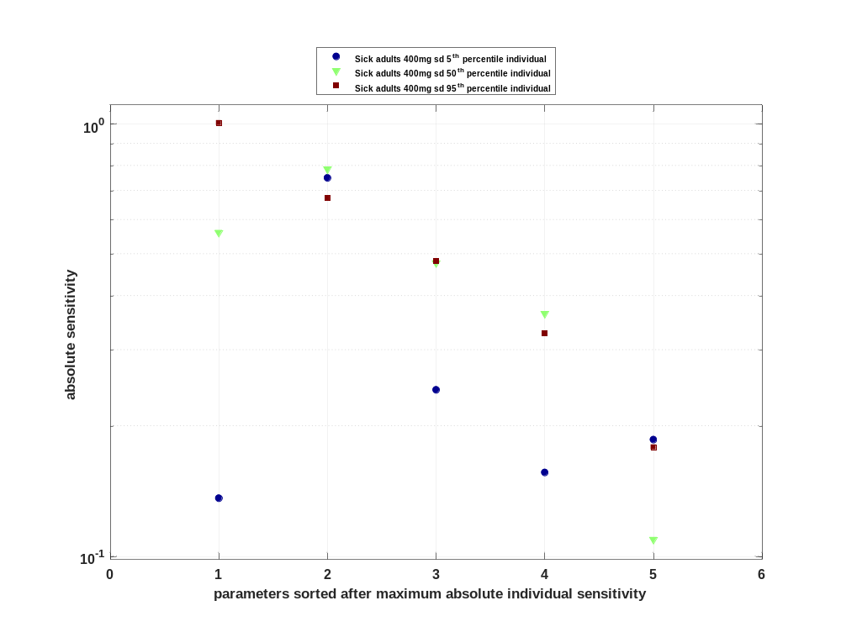

Figure 47: Cumulated sorted absolute sensitivity for Vss for Raltegravir
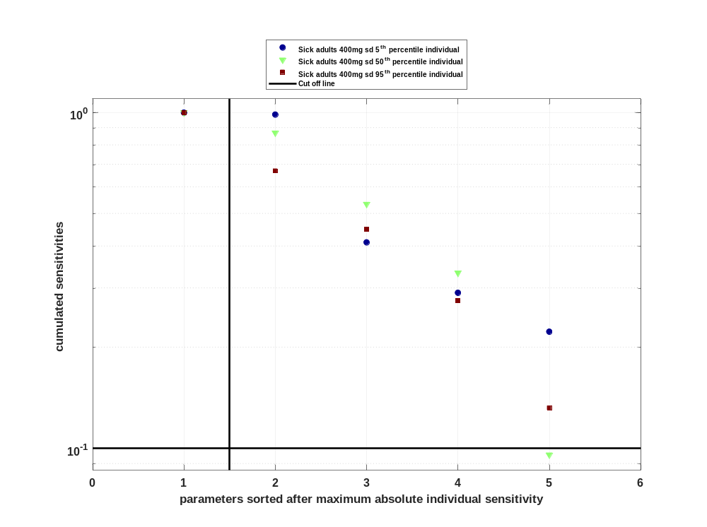

Figure 48: Most sensitive parameter for Vss for Raltegravir
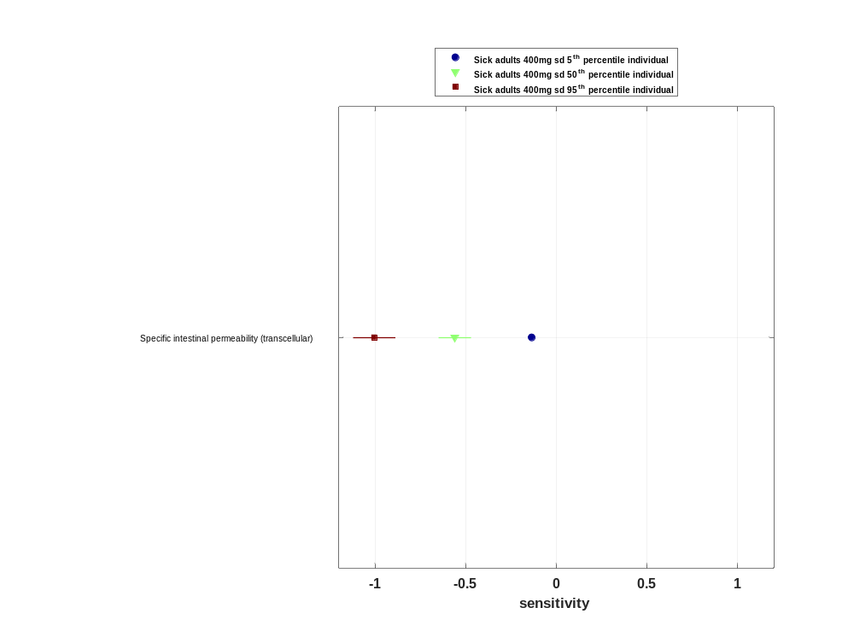

Sensitivity analysis of Vd for Raltegravir

Figure 49: Individual sensitivity vs mean sensitivity for Vd for Raltegravir
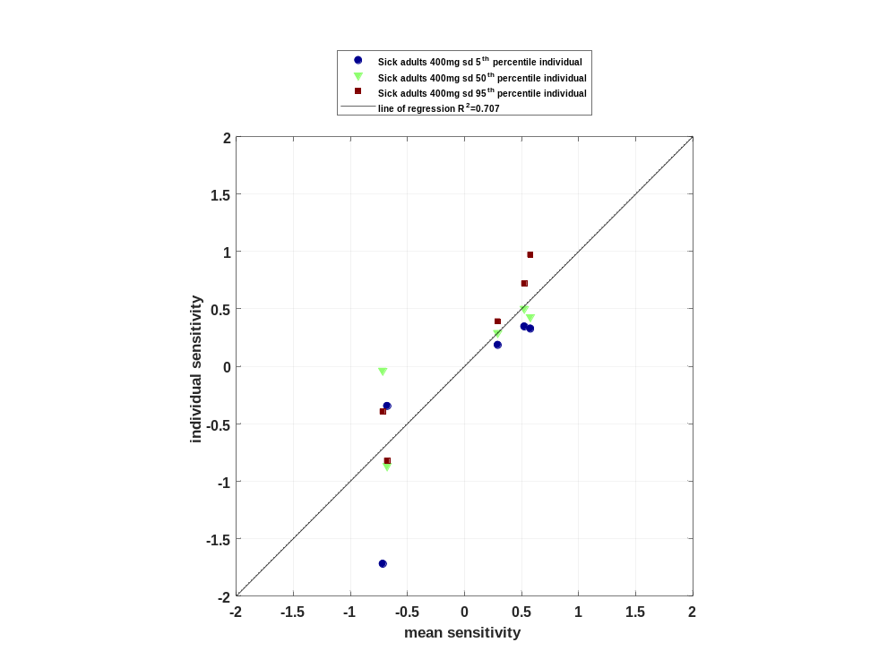

Figure 50: Sorted absolute sensitivity for Vd for Raltegravir
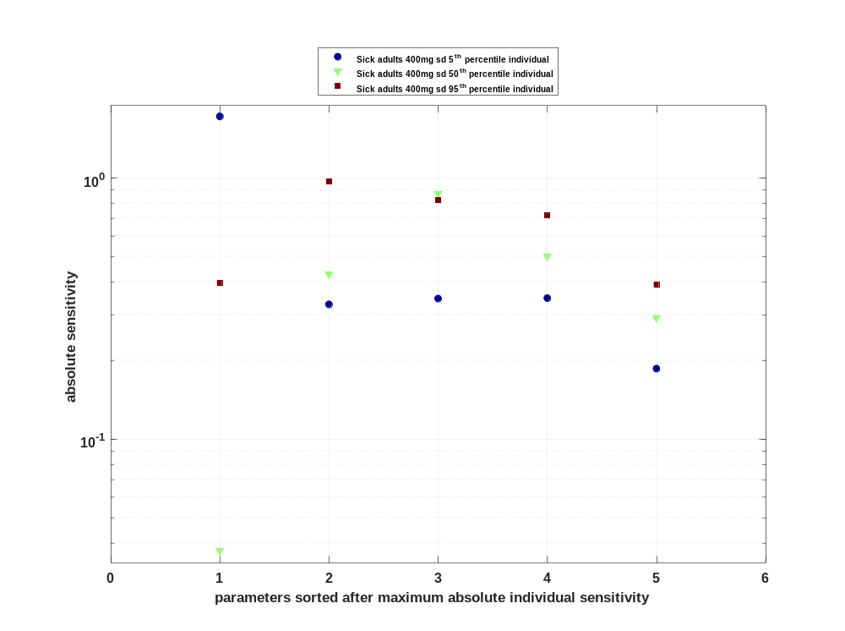

Figure 51: Cumulated sorted absolute sensitivity for Vd for Raltegravir
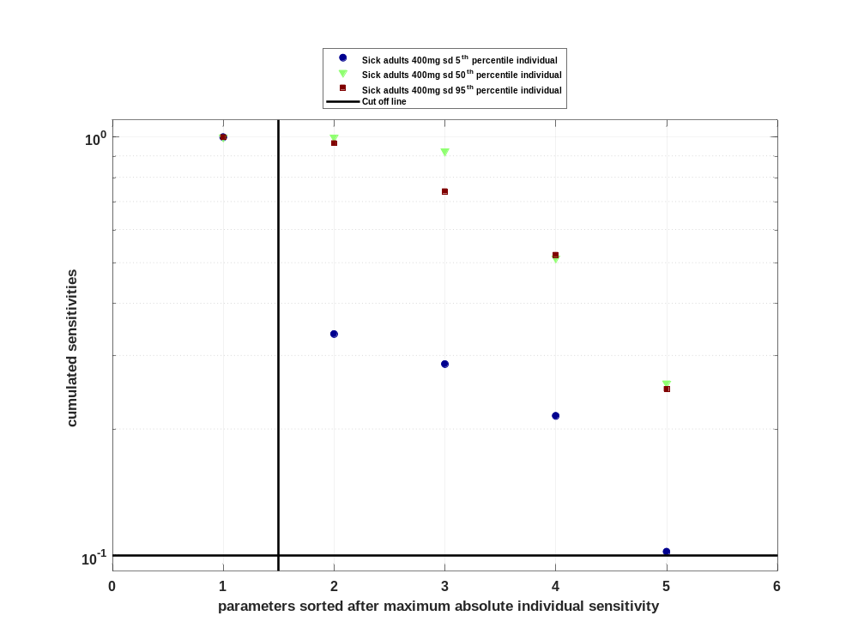

Figure 52: Most sensitive parameter for Vd for Raltegravir
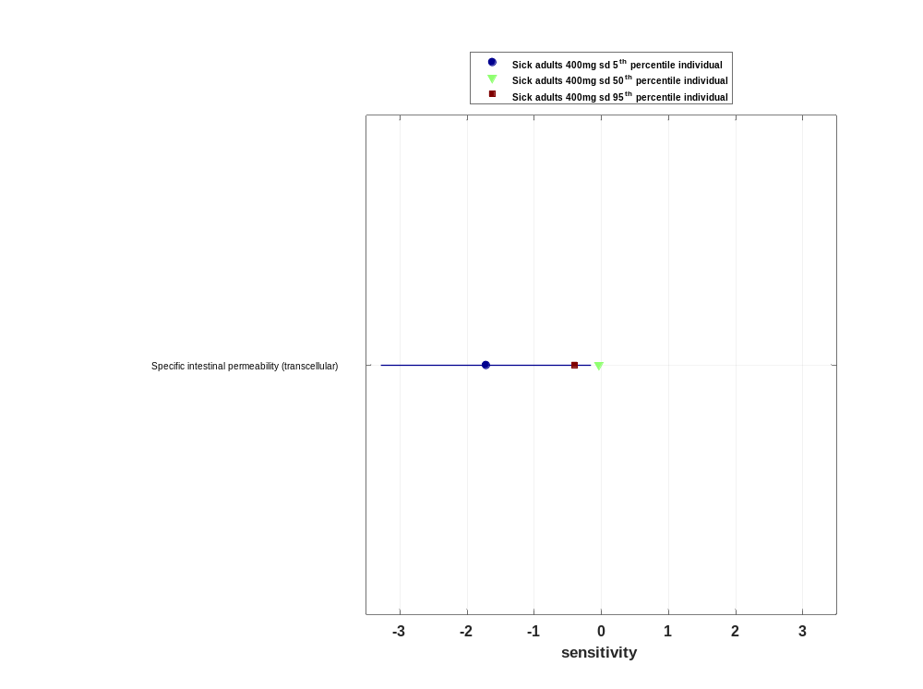

Timeprofile

Time profiles for Healthy adults 400mg sd

Time profiles of Raltegravir

Figure 1: Time profiles of Raltegravir for Healthy adults 400mg sd. Time profiles are plotted in a linear scale.
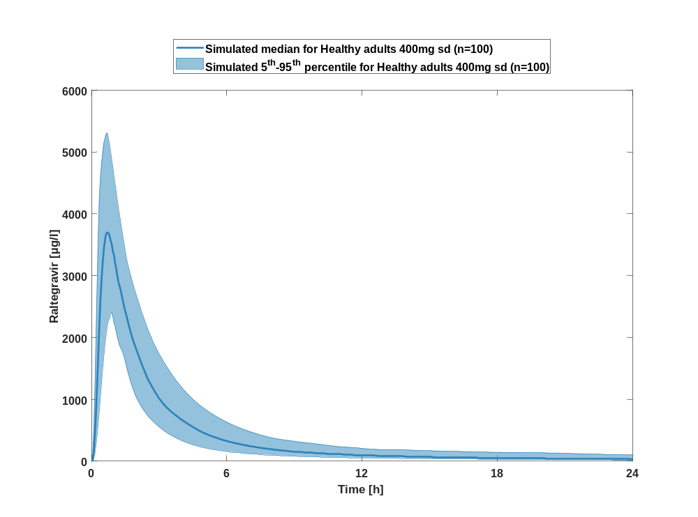

Figure 2: Time profiles of Raltegravir for Healthy adults 400mg sd. Time profiles are plotted in a logarithmic scale.
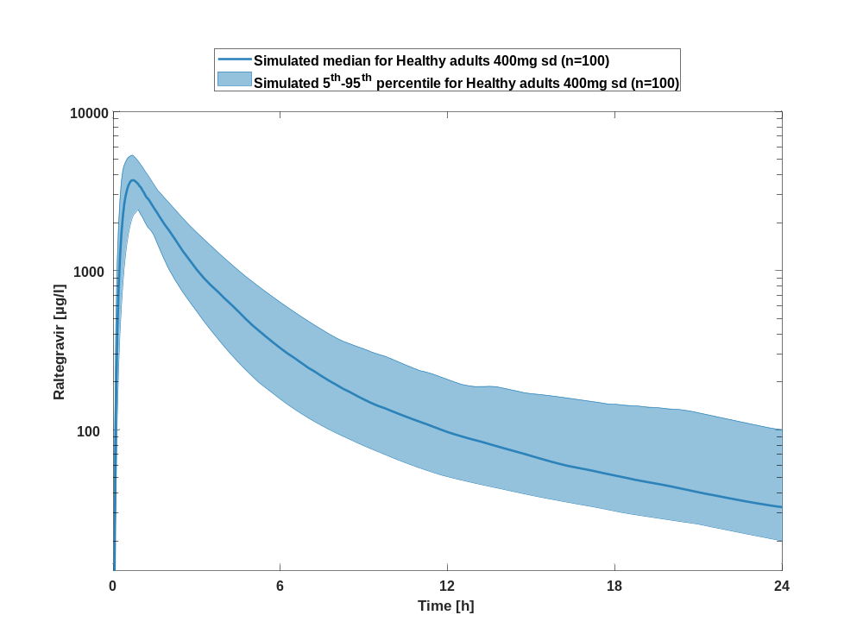

Time profiles for Sick adults 400mg sd

Time profiles of Raltegravir

Figure 3: Time profiles of Raltegravir for Sick adults 400mg sd compared to simulated Raltegravir for Healthy adults 400mg sd. Time profiles are plotted in a linear scale.
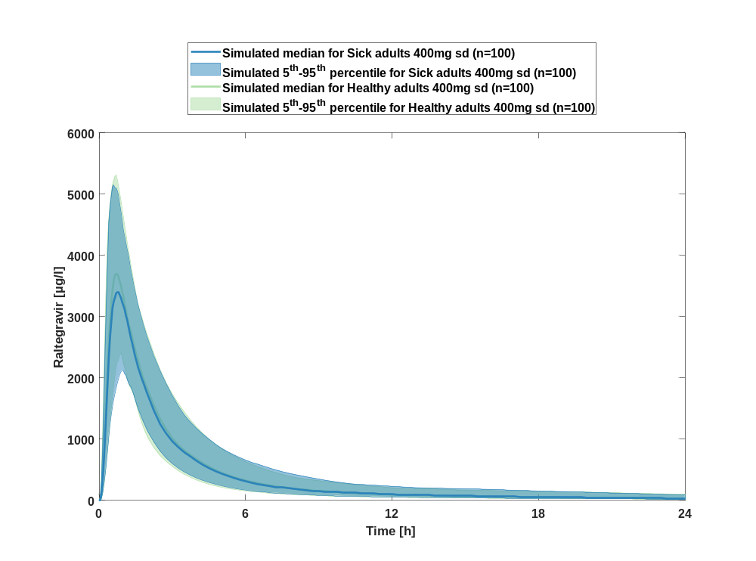

Figure 4: Time profiles of Raltegravir for Sick adults 400mg sd compared to simulated Raltegravir for Healthy adults 400mg sd. Time profiles are plotted in a logarithmic scale.
