Report

Concentration time profiles

Setting Up the Project and Basic Simulations
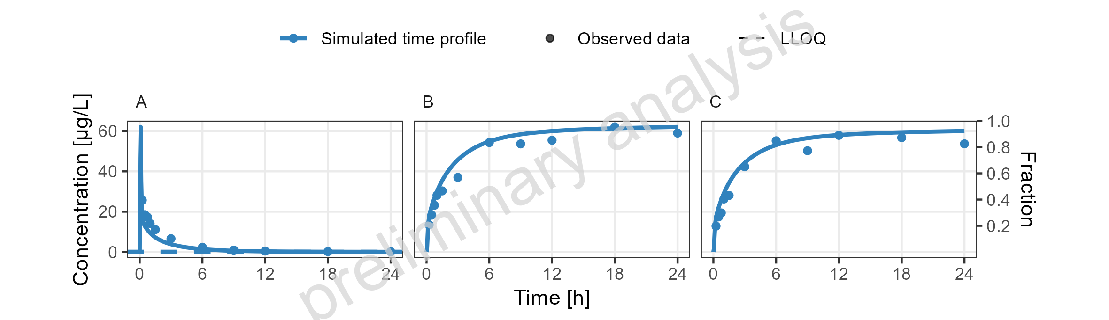
Figure 1: Simulated Concentration-time profiles for drugX metabolized by CYP3A4 (B), drugX metabolized by CYP3A4 in liver (C) and drugX plasma concentration (A) for simulation of an 1mg iv application for individual id 13 study 1234 on a linear y-scale. DrugX was administered as a 1mg Iv application with an infusion time of 5 minutes.

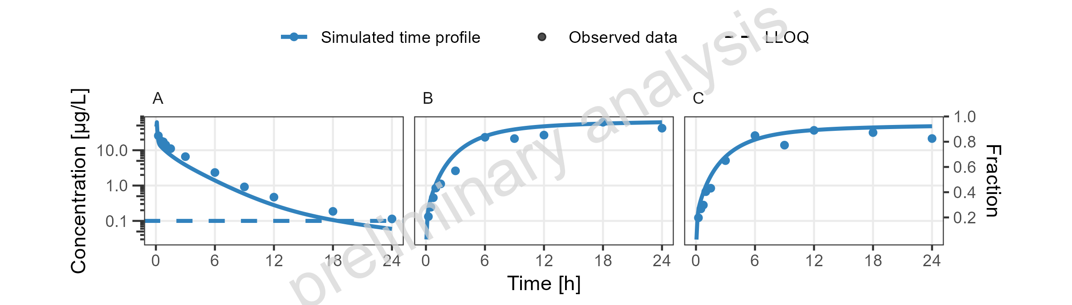
Figure 2: Simulated Concentration-time profiles for drugX metabolized by CYP3A4 (B), drugX metabolized by CYP3A4 in liver (C) and drugX plasma concentration (A) for simulation of an 1mg iv application for individual id 13 study 1234 on a logarithmic y-scale. DrugX was administered as a 1mg Iv application with an infusion time of 5 minutes.

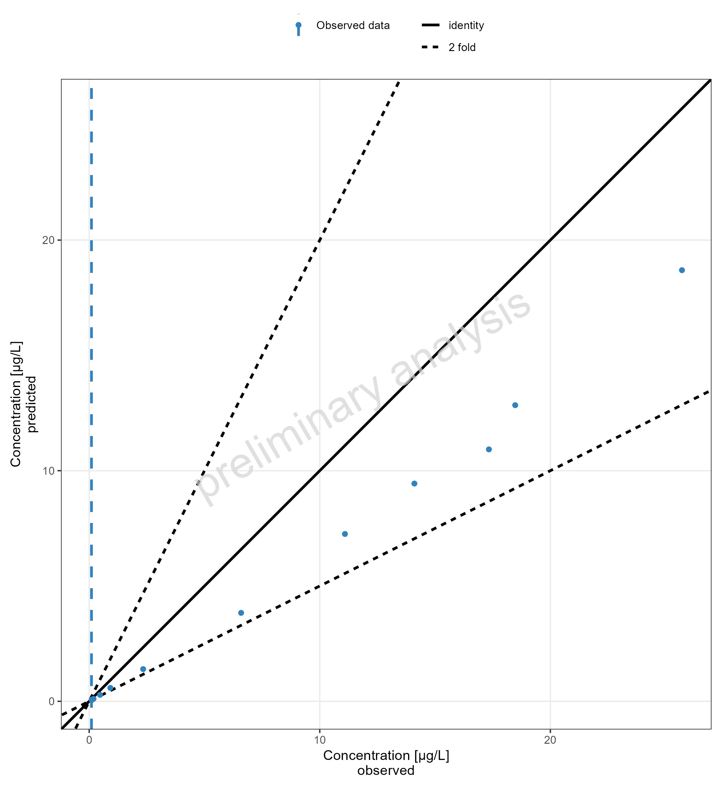
Figure 3: Simulated Predicted vs Observed for drugX plasma concentration for simulation of an 1mg iv application for individual id 13 study 1234 on a linear x and y-scale. DrugX was administered as a 1mg Iv application with an infusion time of 5 minutes.

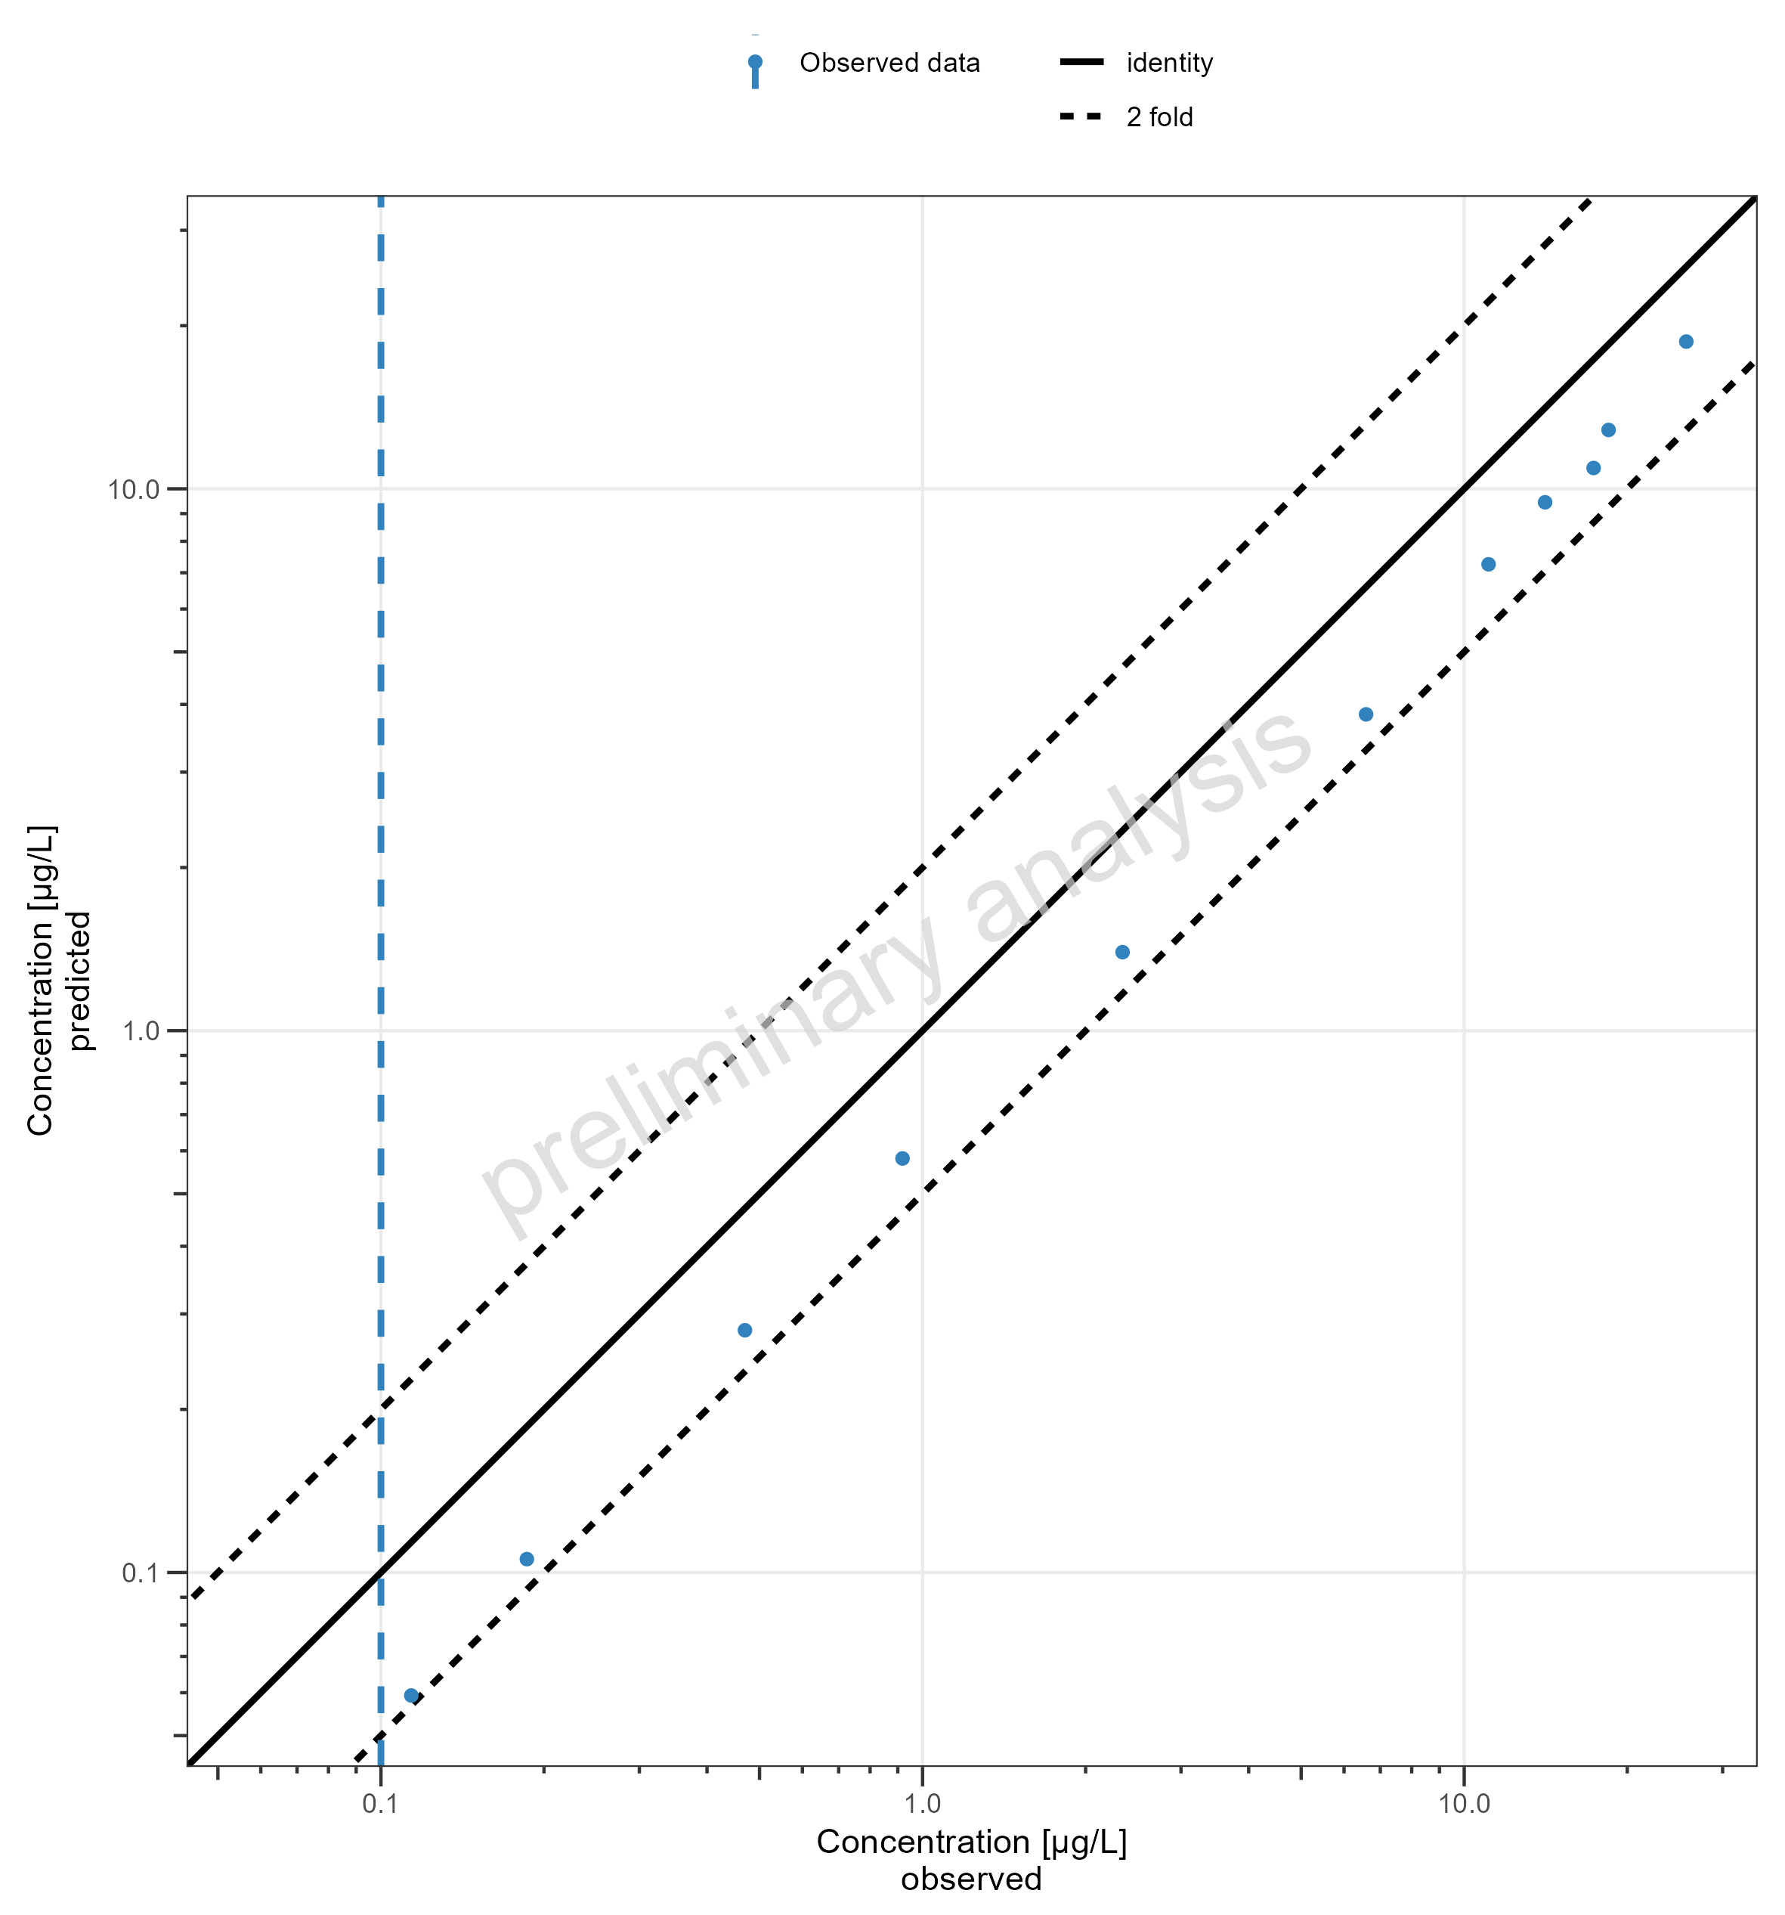
Figure 4: Simulated Predicted vs Observed for drugX plasma concentration for simulation of an 1mg iv application for individual id 13 study 1234 on a logarithmic x and y-scale. DrugX was administered as a 1mg Iv application with an infusion time of 5 minutes.

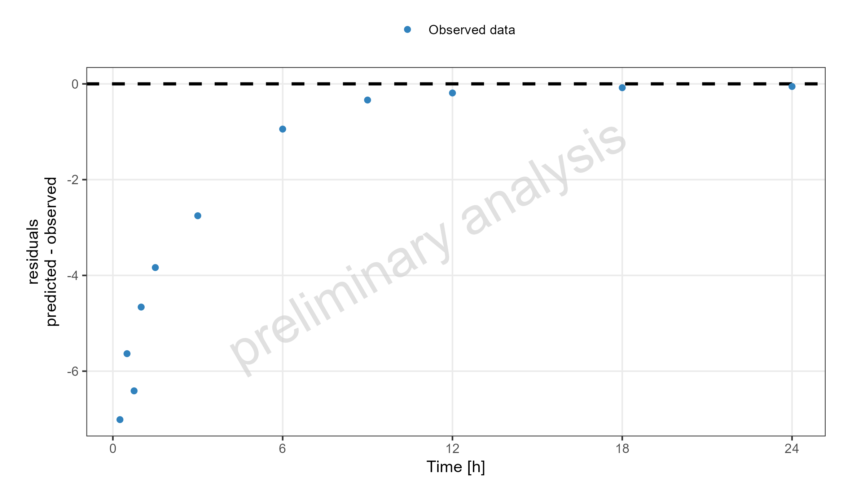
Figure 5: Simulated Residuals vs time values for drugX plasma concentration for simulation of an 1mg iv application for individual id 13 study 1234. DrugX was administered as a 1mg Iv application with an infusion time of 5 minutes.

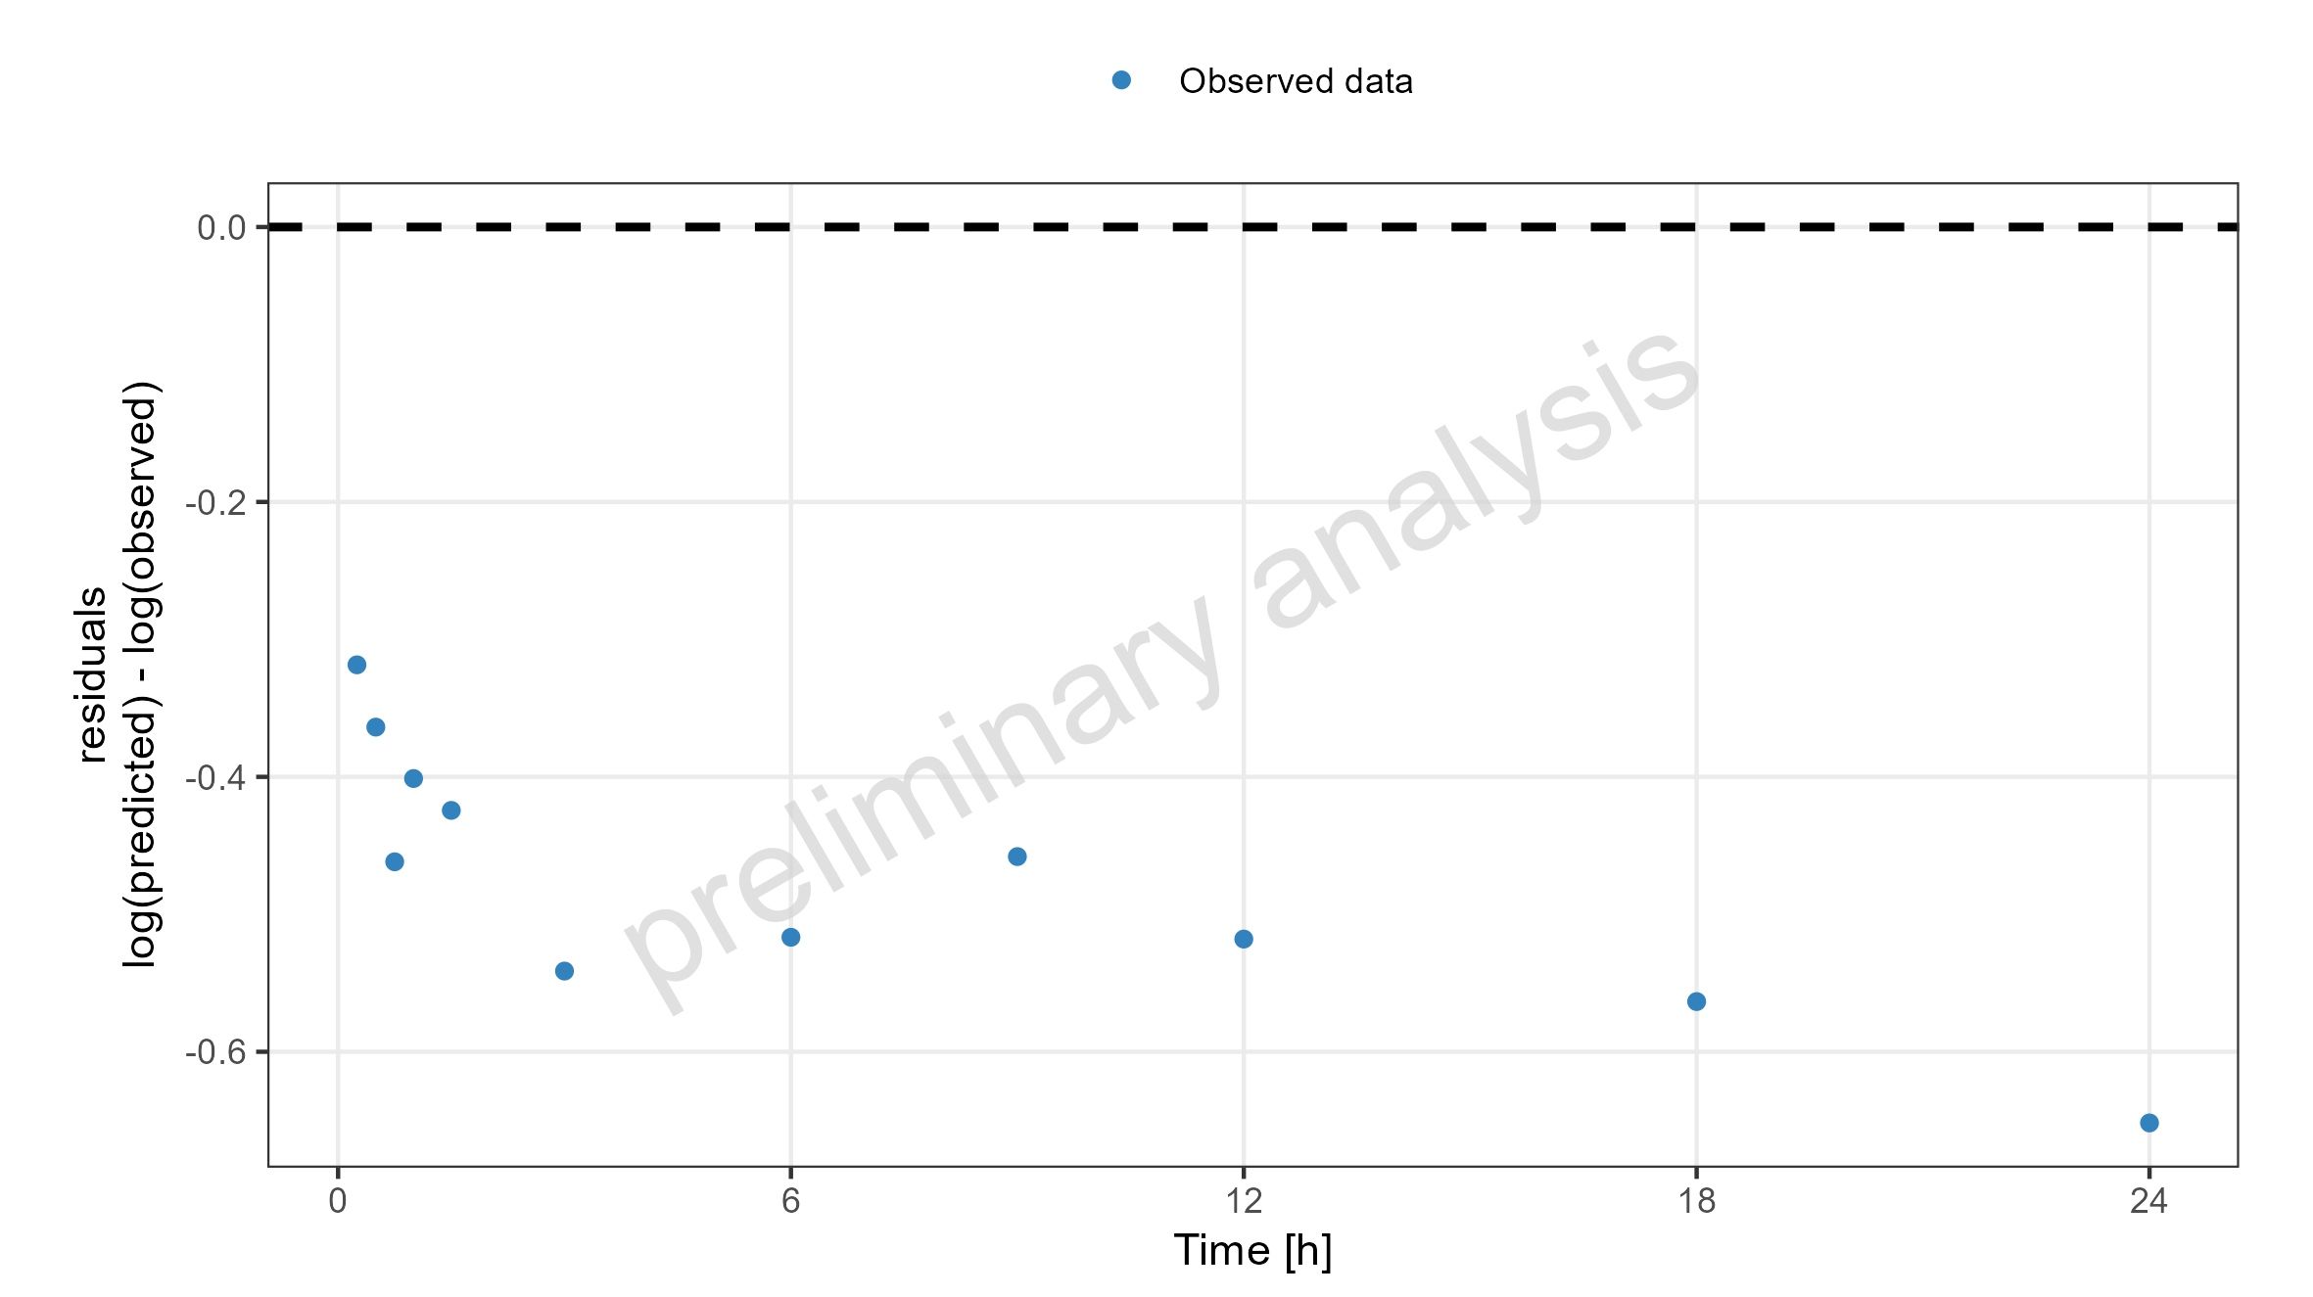
Figure 6: Simulated Residuals vs time values for drugX plasma concentration for simulation of an 1mg iv application for individual id 13 study 1234. DrugX was administered as a 1mg Iv application with an infusion time of 5 minutes.

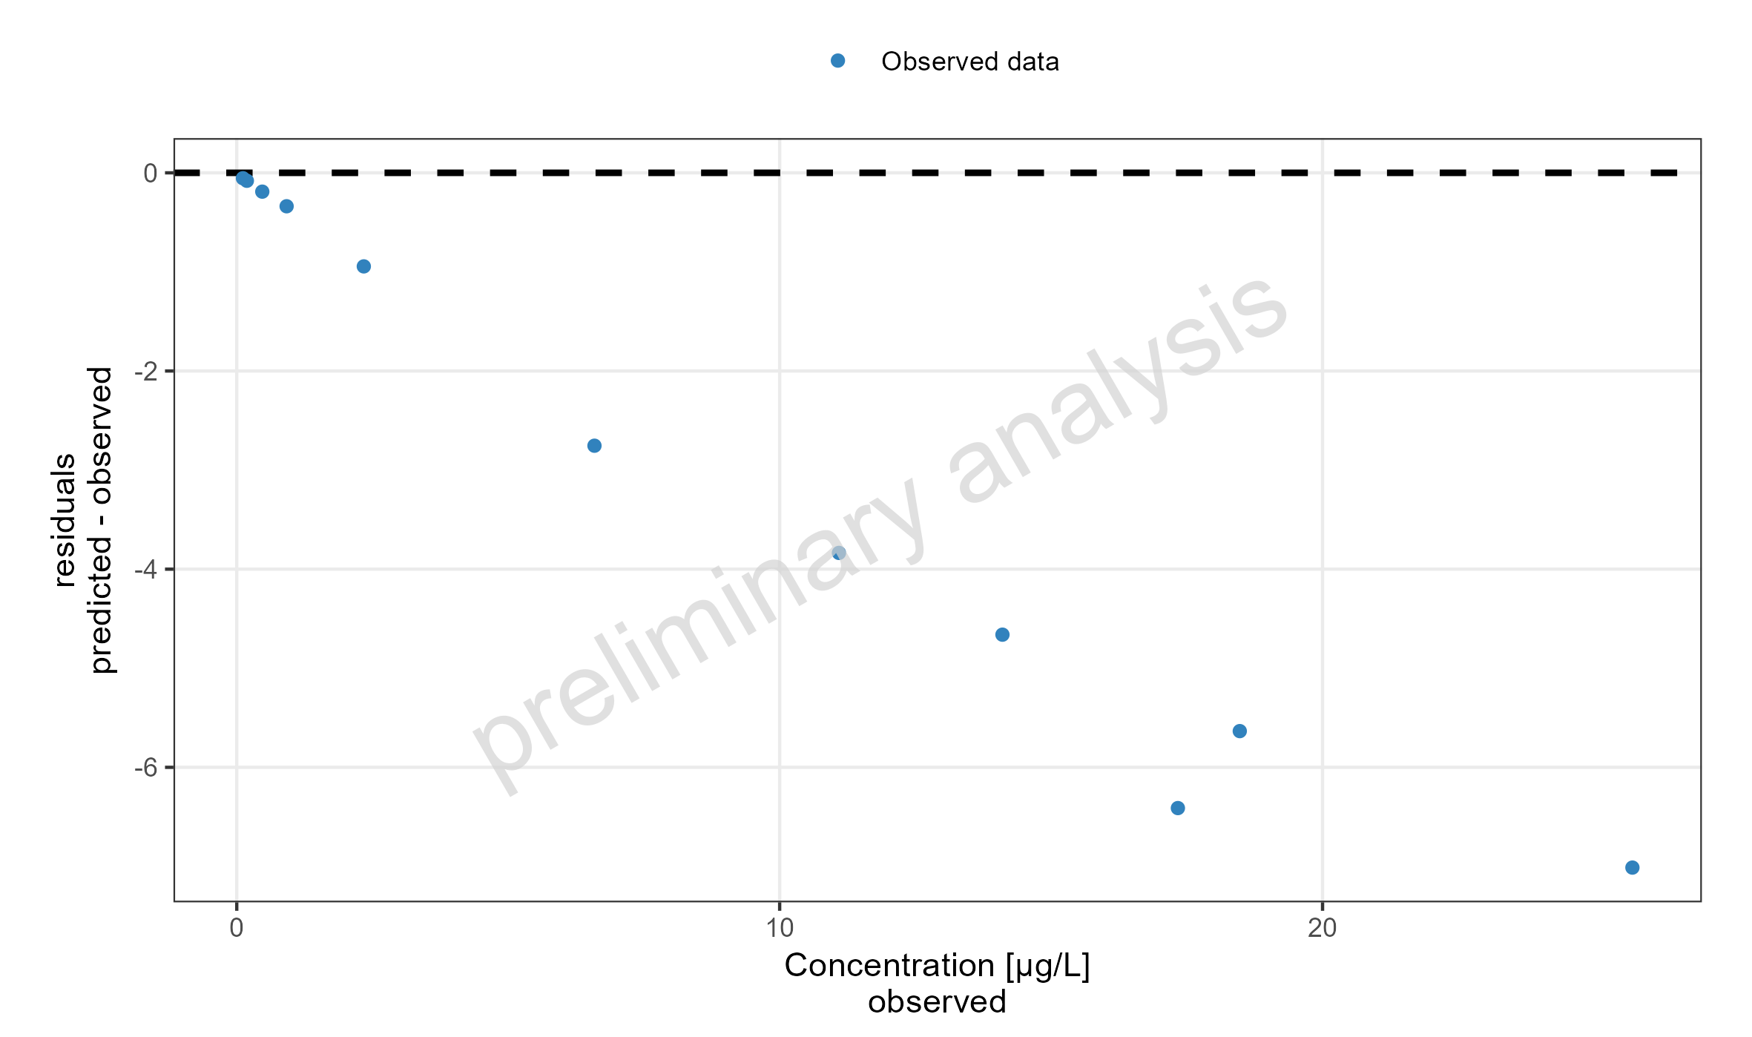
Figure 7: Simulated Residuals vs observed values for drugX plasma concentration for simulation of an 1mg iv application for individual id 13 study 1234. DrugX was administered as a 1mg Iv application with an infusion time of 5 minutes.

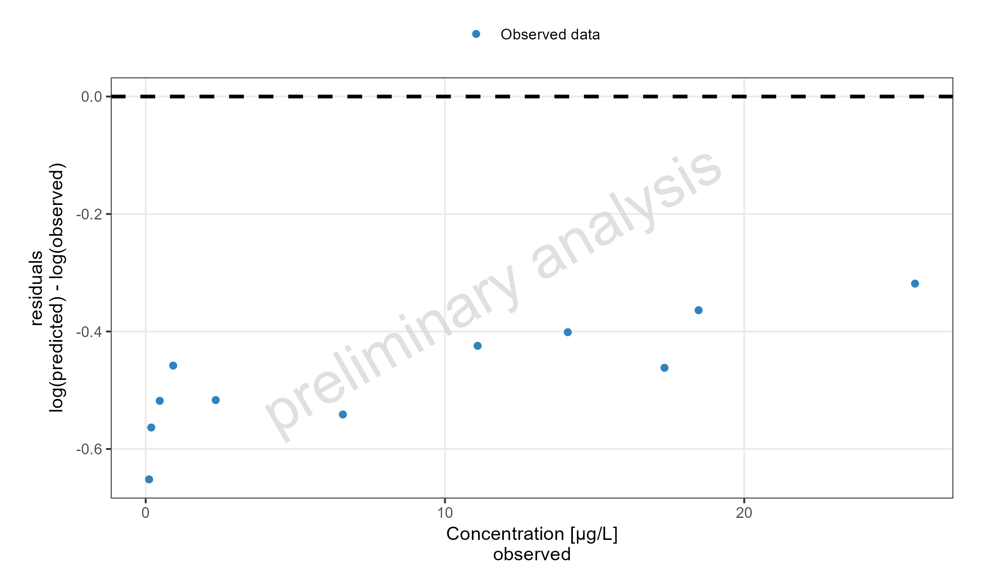
Figure 8: Simulated Residuals vs observed values for drugX plasma concentration for simulation of an 1mg iv application for individual id 13 study 1234. DrugX was administered as a 1mg Iv application with an infusion time of 5 minutes.

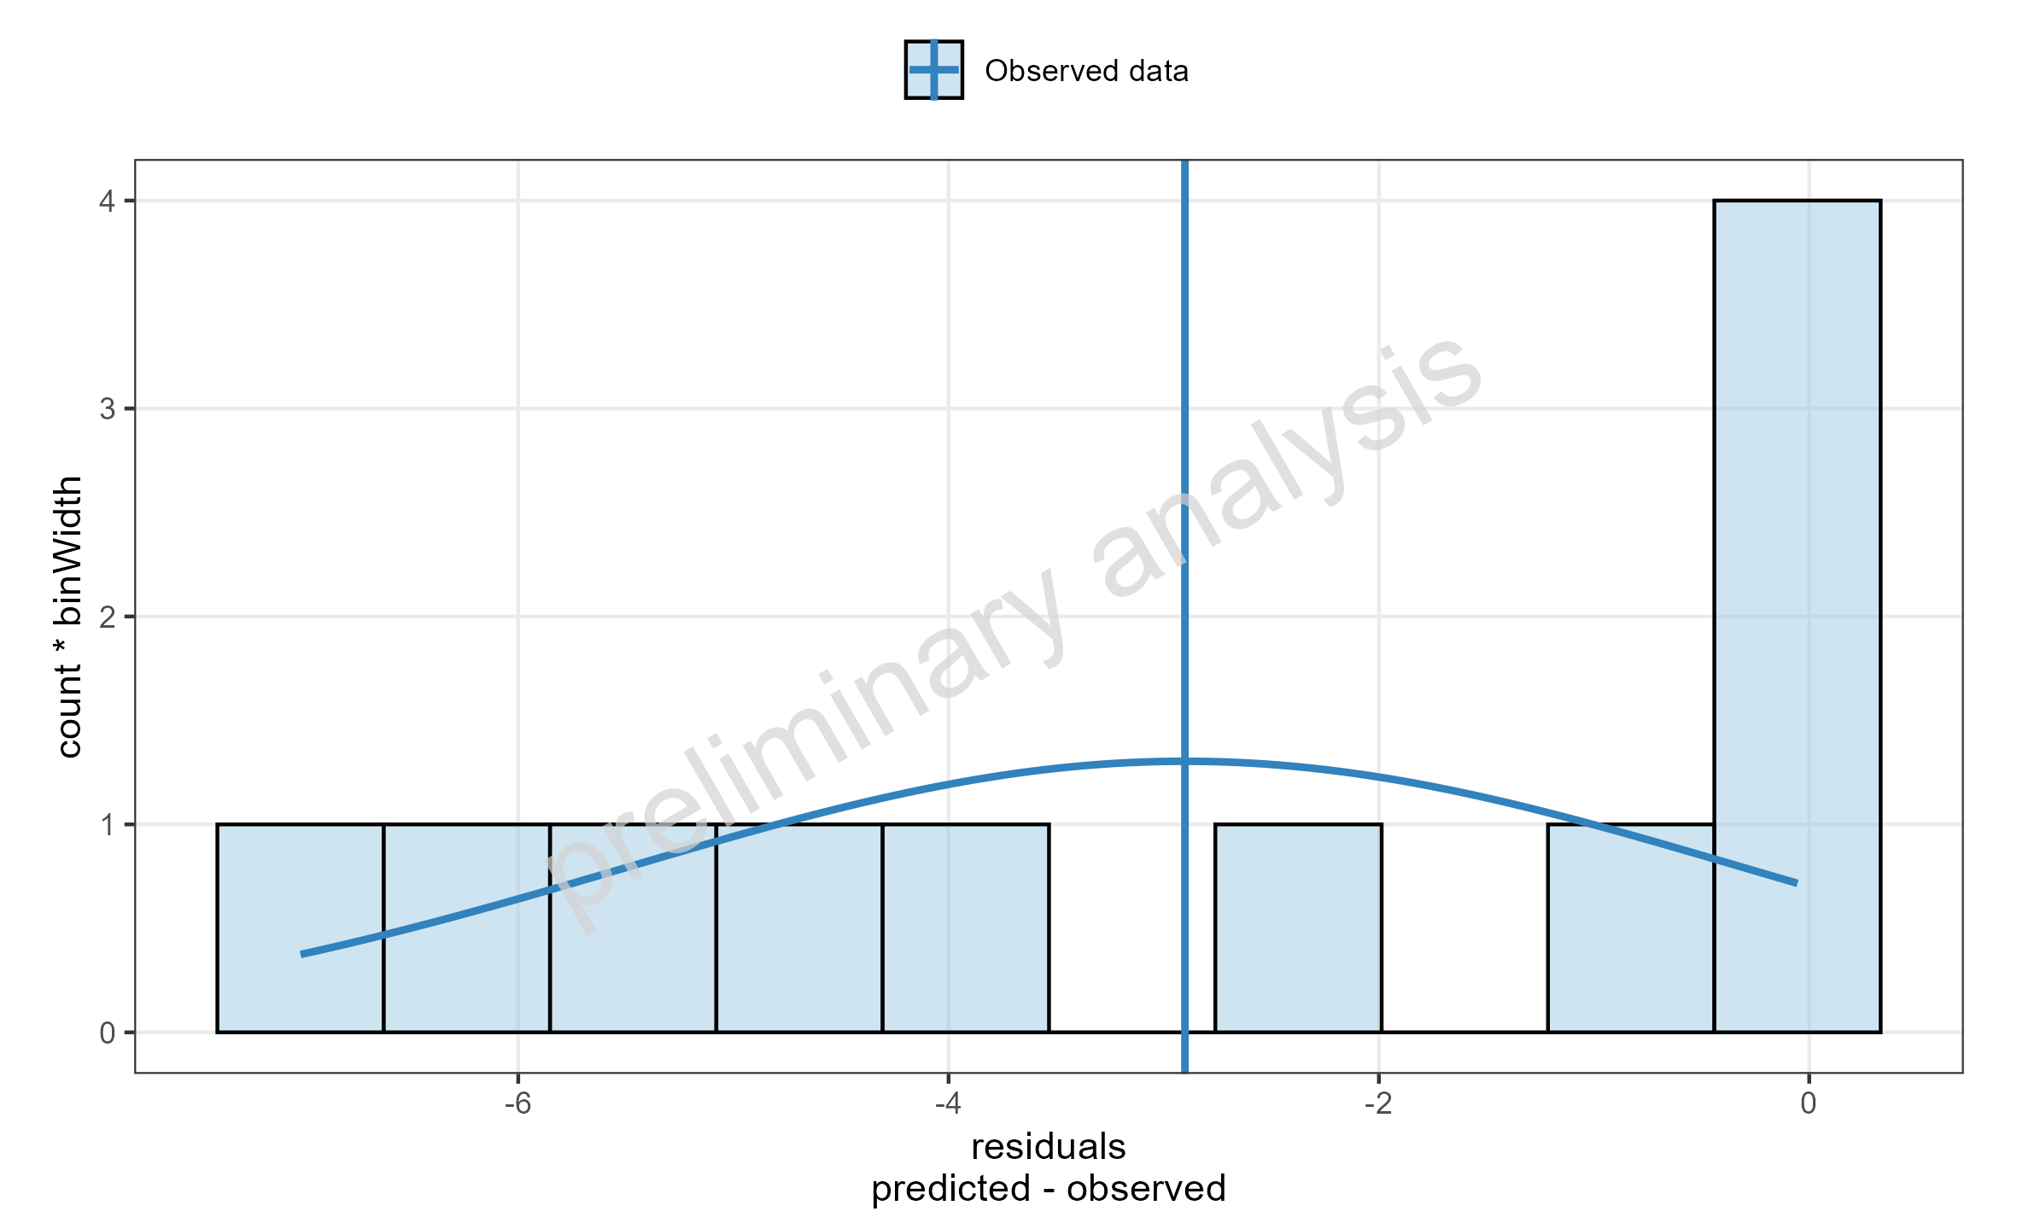
Figure 9: Simulated Residuals distribution for drugX plasma concentration for simulation of an 1mg iv application for individual id 13 study 1234. DrugX was administered as a 1mg Iv application with an infusion time of 5 minutes.

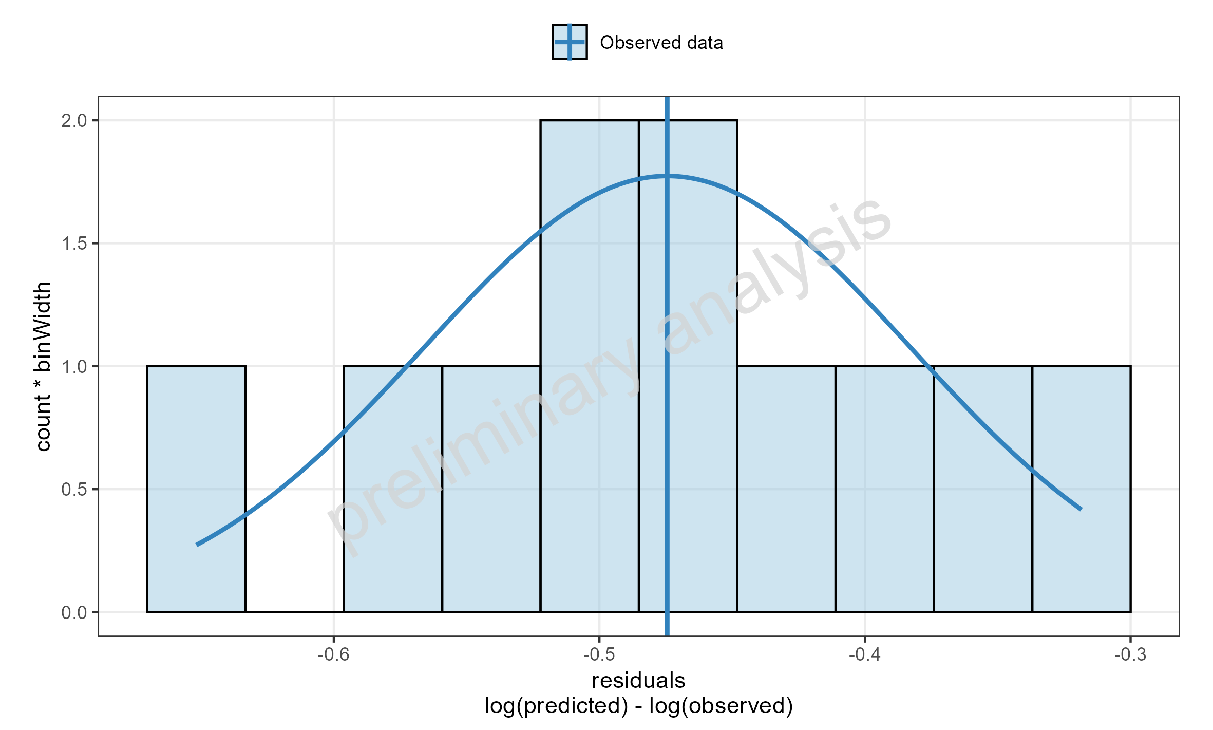
Figure 10: Simulated Residuals distribution for drugX plasma concentration for simulation of an 1mg iv application for individual id 13 study 1234. DrugX was administered as a 1mg Iv application with an infusion time of 5 minutes.

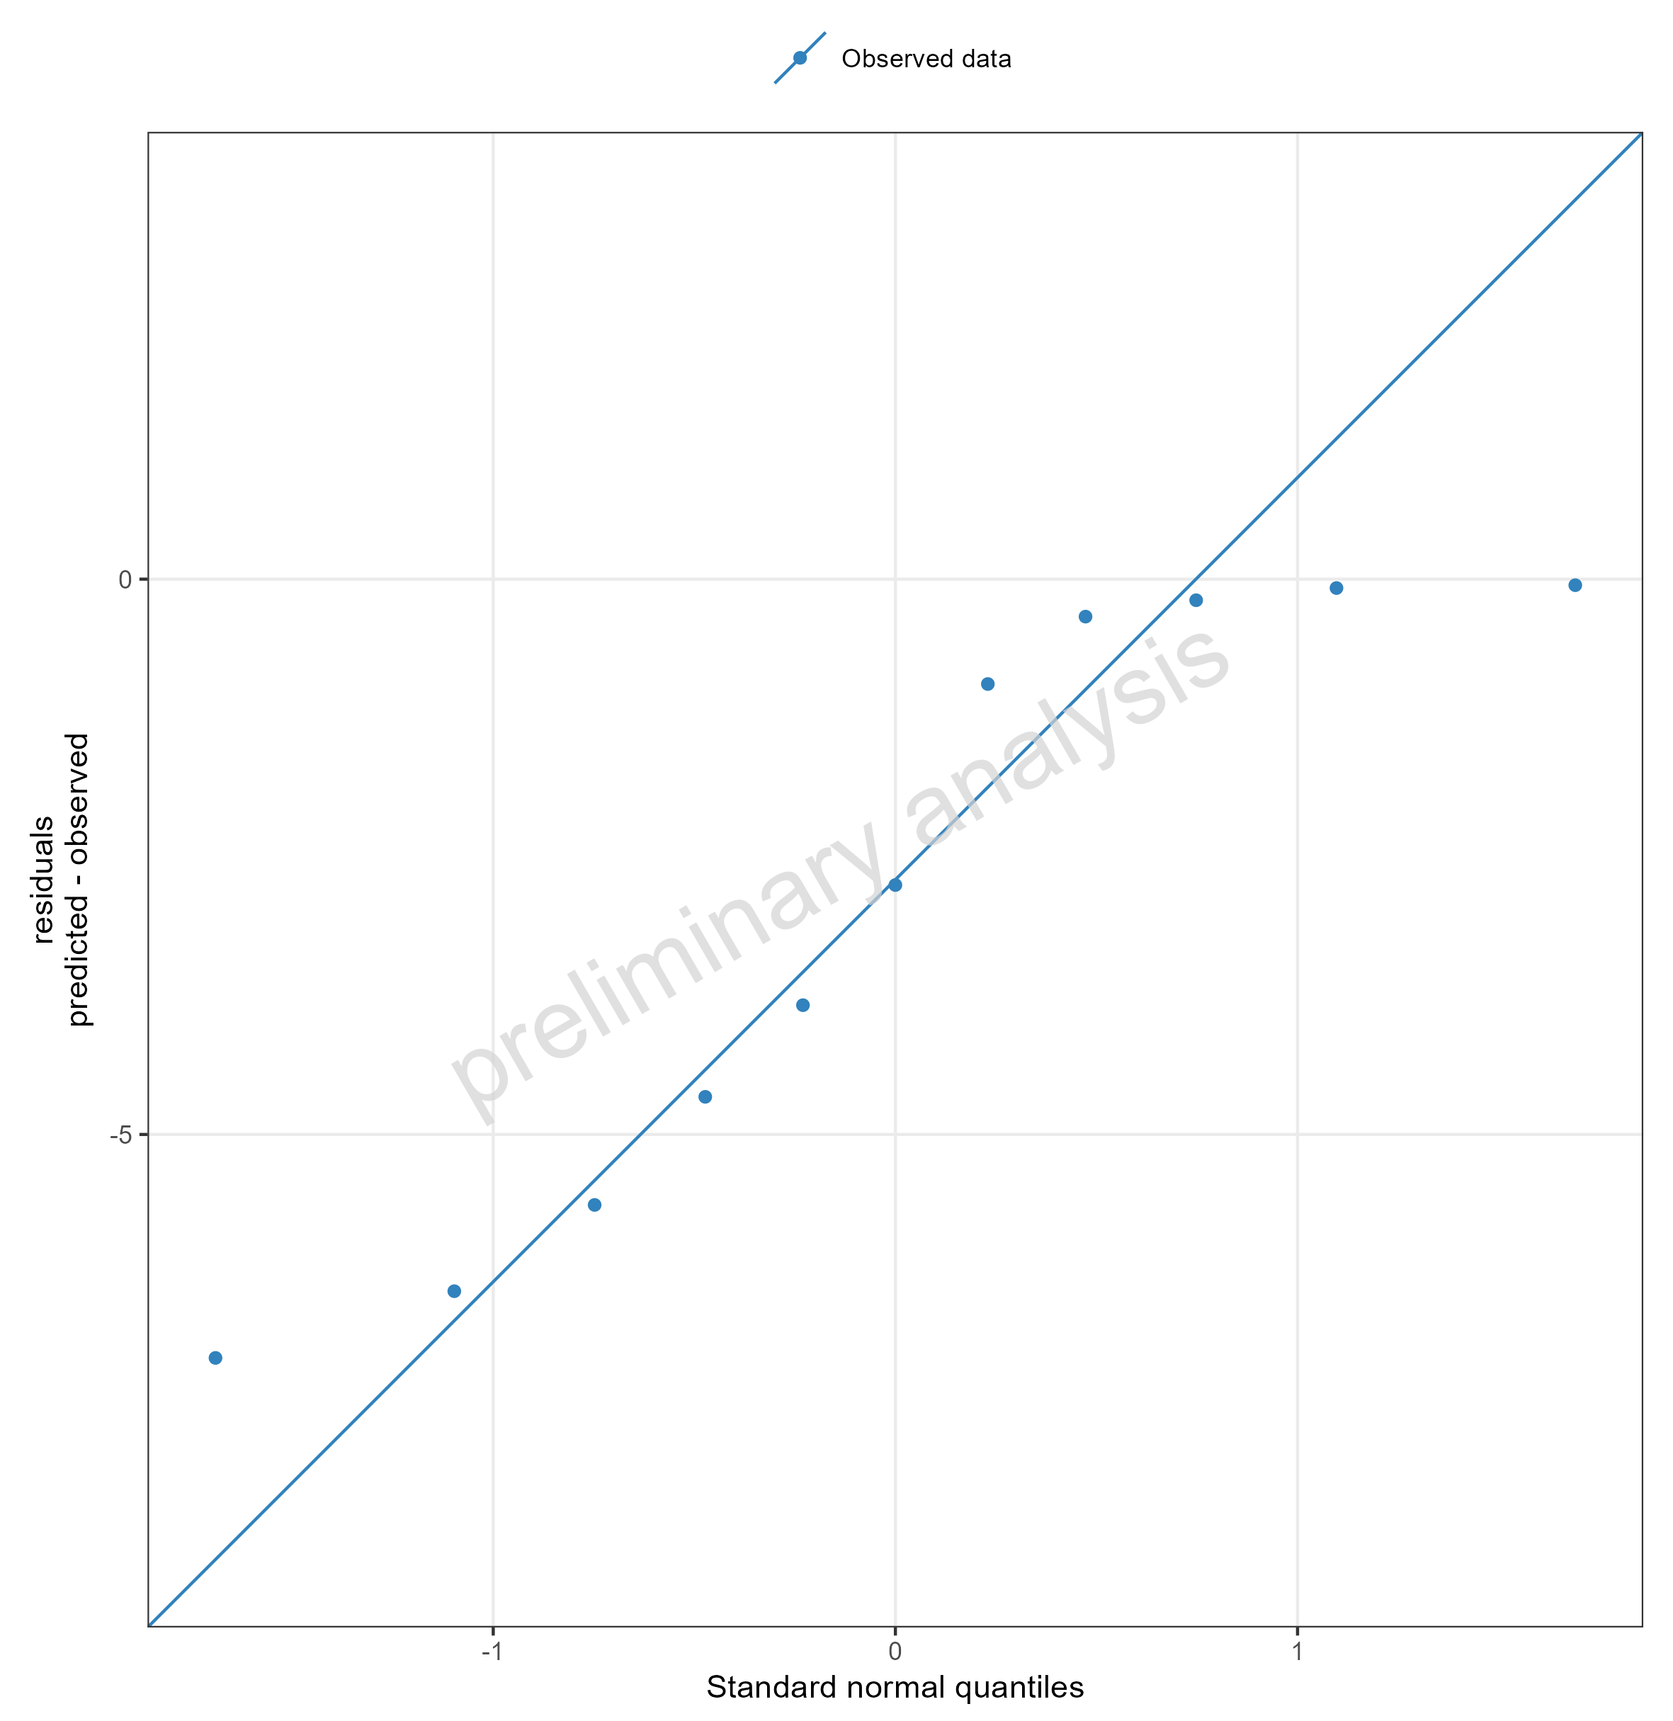
Figure 11: Simulated Residuals as quantile-quantile plot for drugX plasma concentration for simulation of an 1mg iv application for individual id 13 study 1234. DrugX was administered as a 1mg Iv application with an infusion time of 5 minutes.

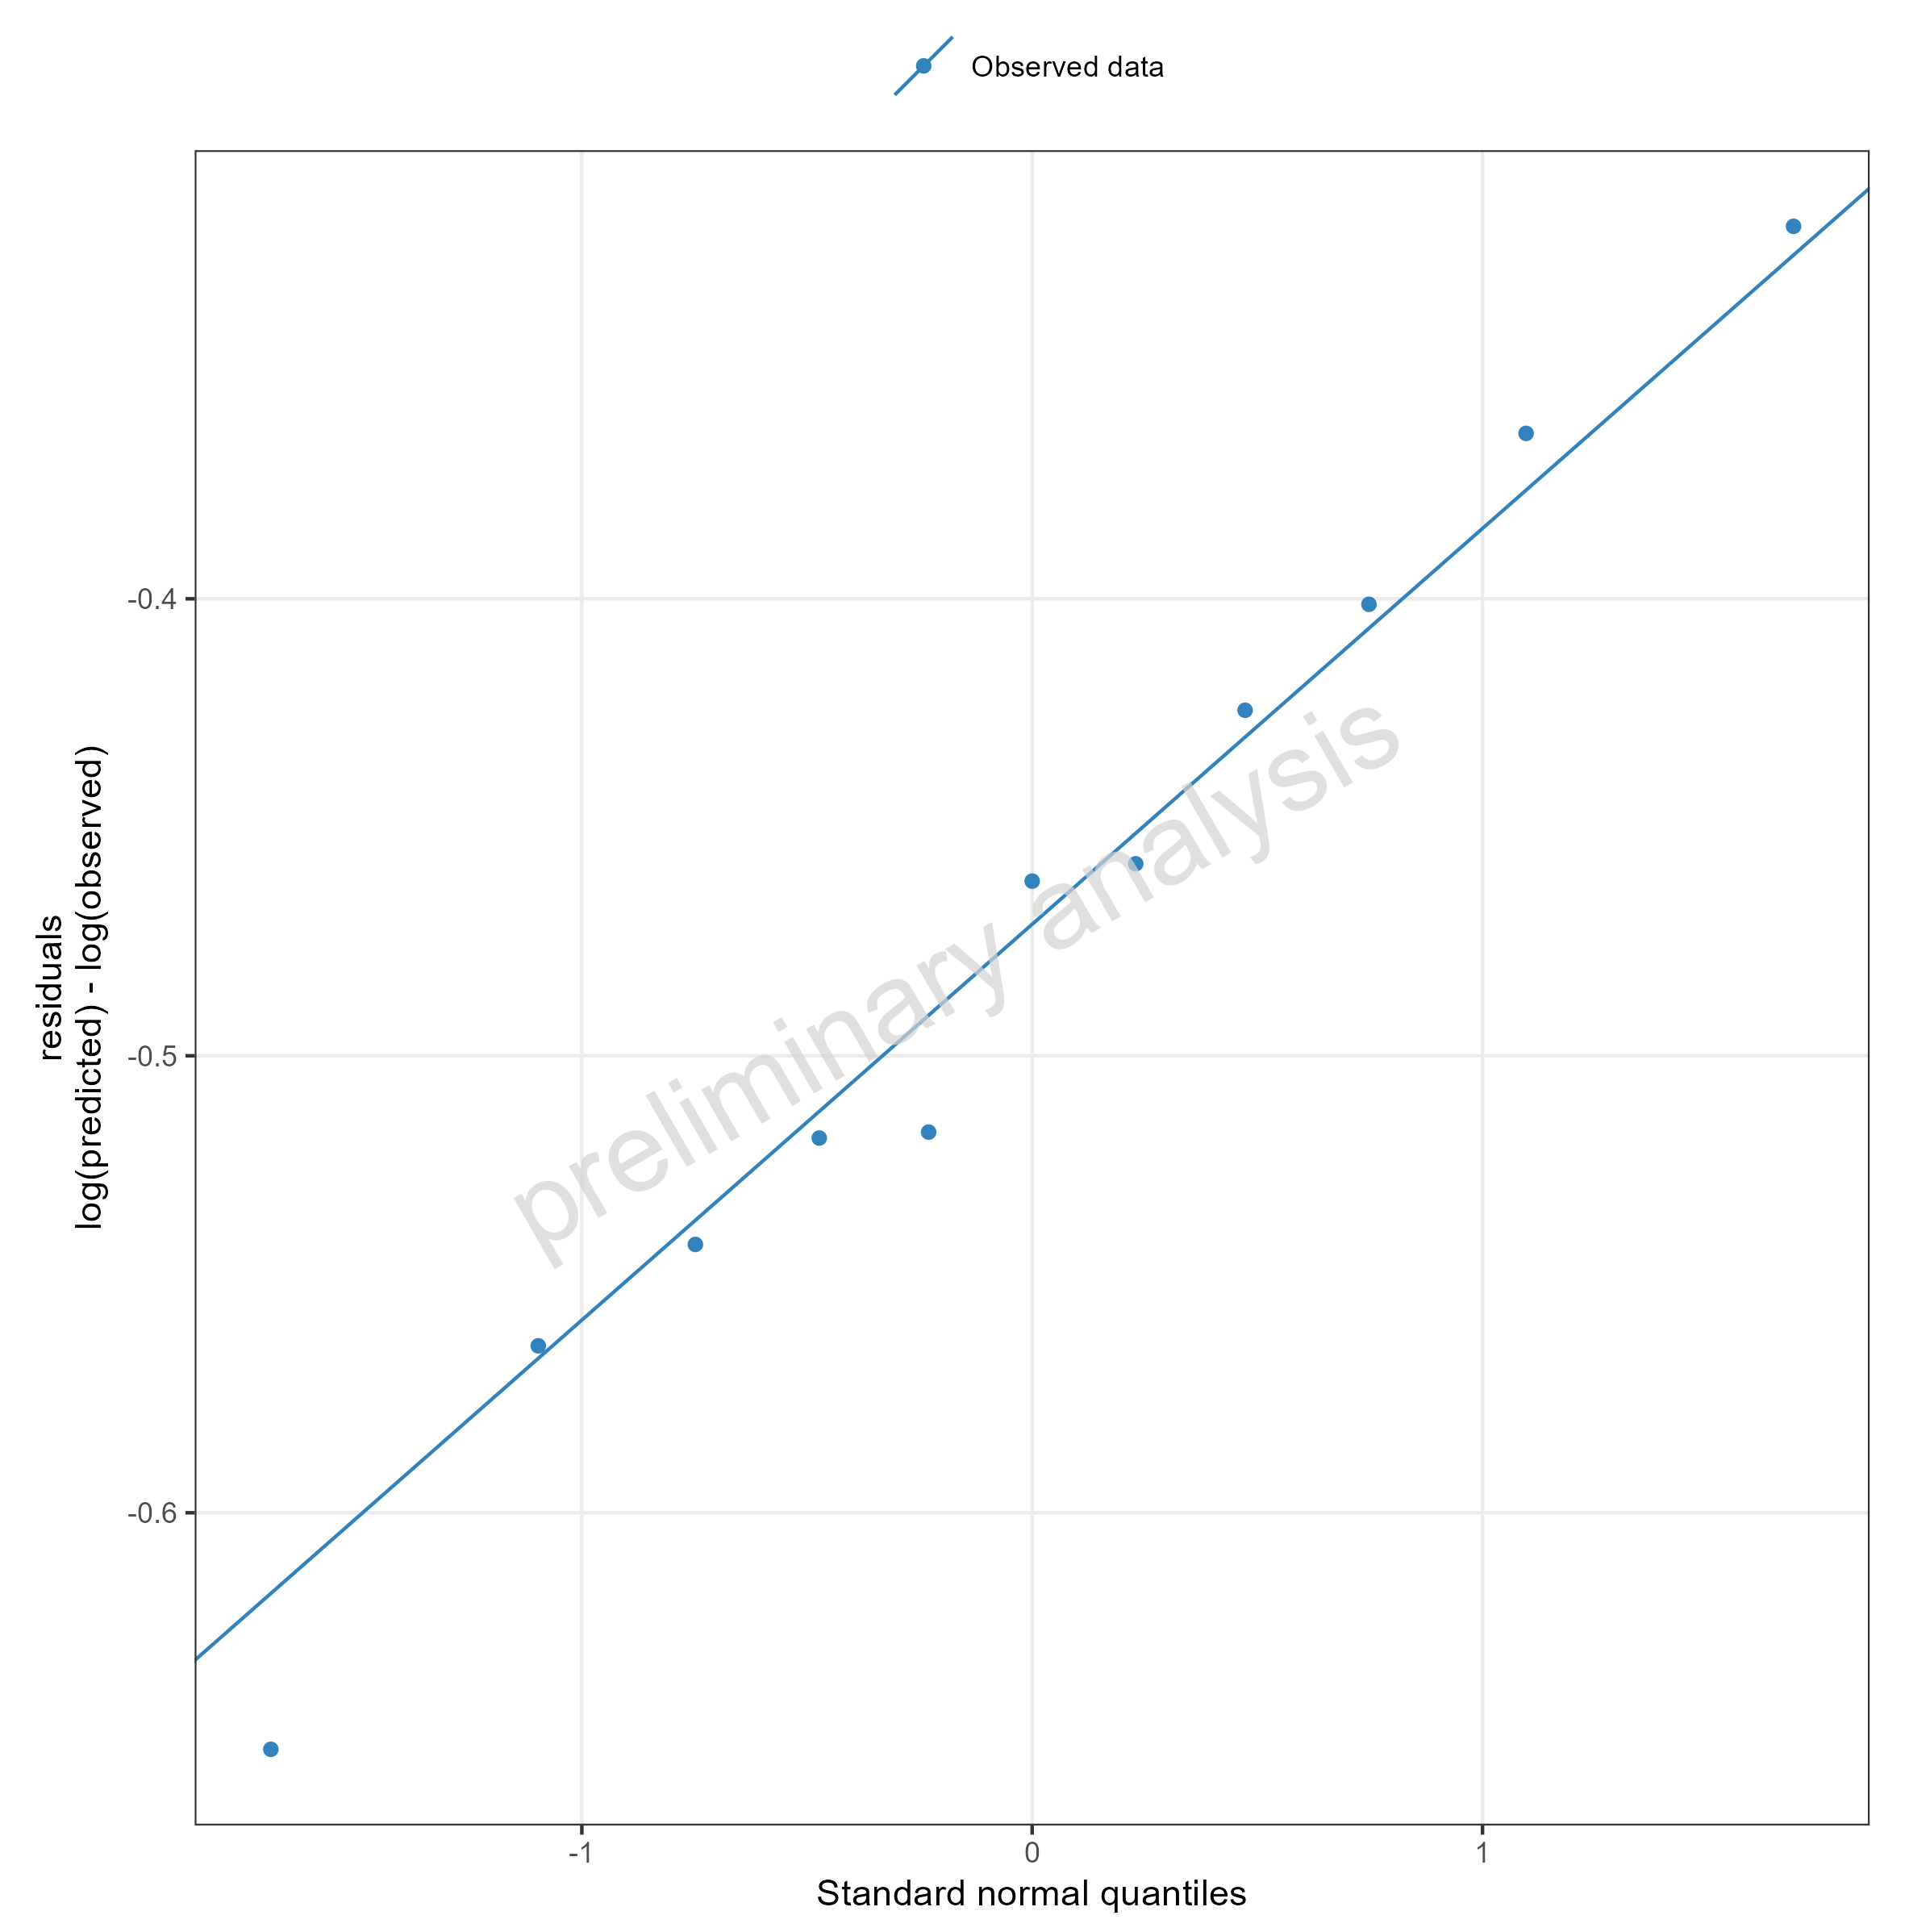
Figure 12: Simulated Residuals as quantile-quantile plot for drugX plasma concentration for simulation of an 1mg iv application for individual id 13 study 1234. DrugX was administered as a 1mg Iv application with an infusion time of 5 minutes.

Adding Virtual Twin Populations

filtered individual
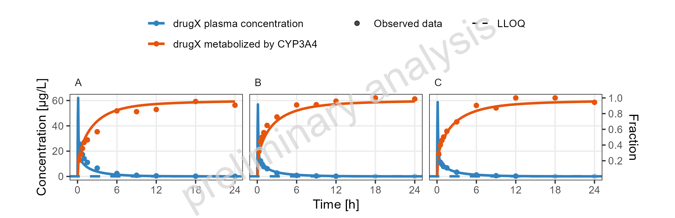
Figure 13: Simulated Concentration-time profiles for drugX metabolized by CYP3A4 and drugX plasma concentration for simulation of an 1mg iv application for individuals of study 1234 for subject I123413 (A), I123430 (B) and I123441 (C) on a linear y-scale. DrugX was administered as a 1mg Iv application with an infusion time of 5 minutes.

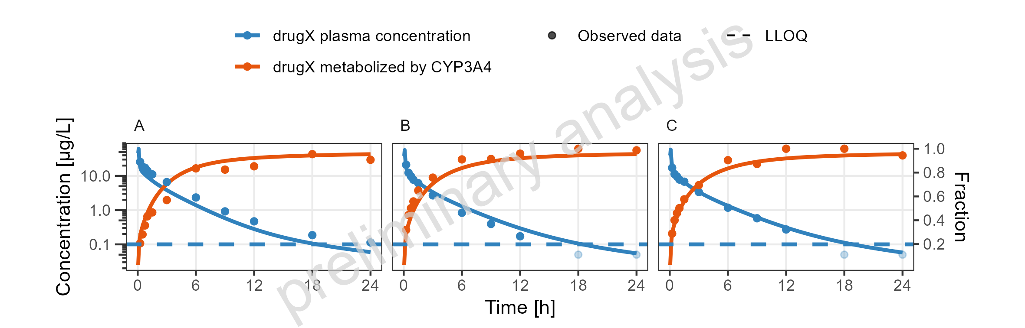
Figure 14: Simulated Concentration-time profiles for drugX metabolized by CYP3A4 and drugX plasma concentration for simulation of an 1mg iv application for individuals of study 1234 for subject I123413 (A), I123430 (B) and I123441 (C) on a logarithmic y-scale. DrugX was administered as a 1mg Iv application with an infusion time of 5 minutes.

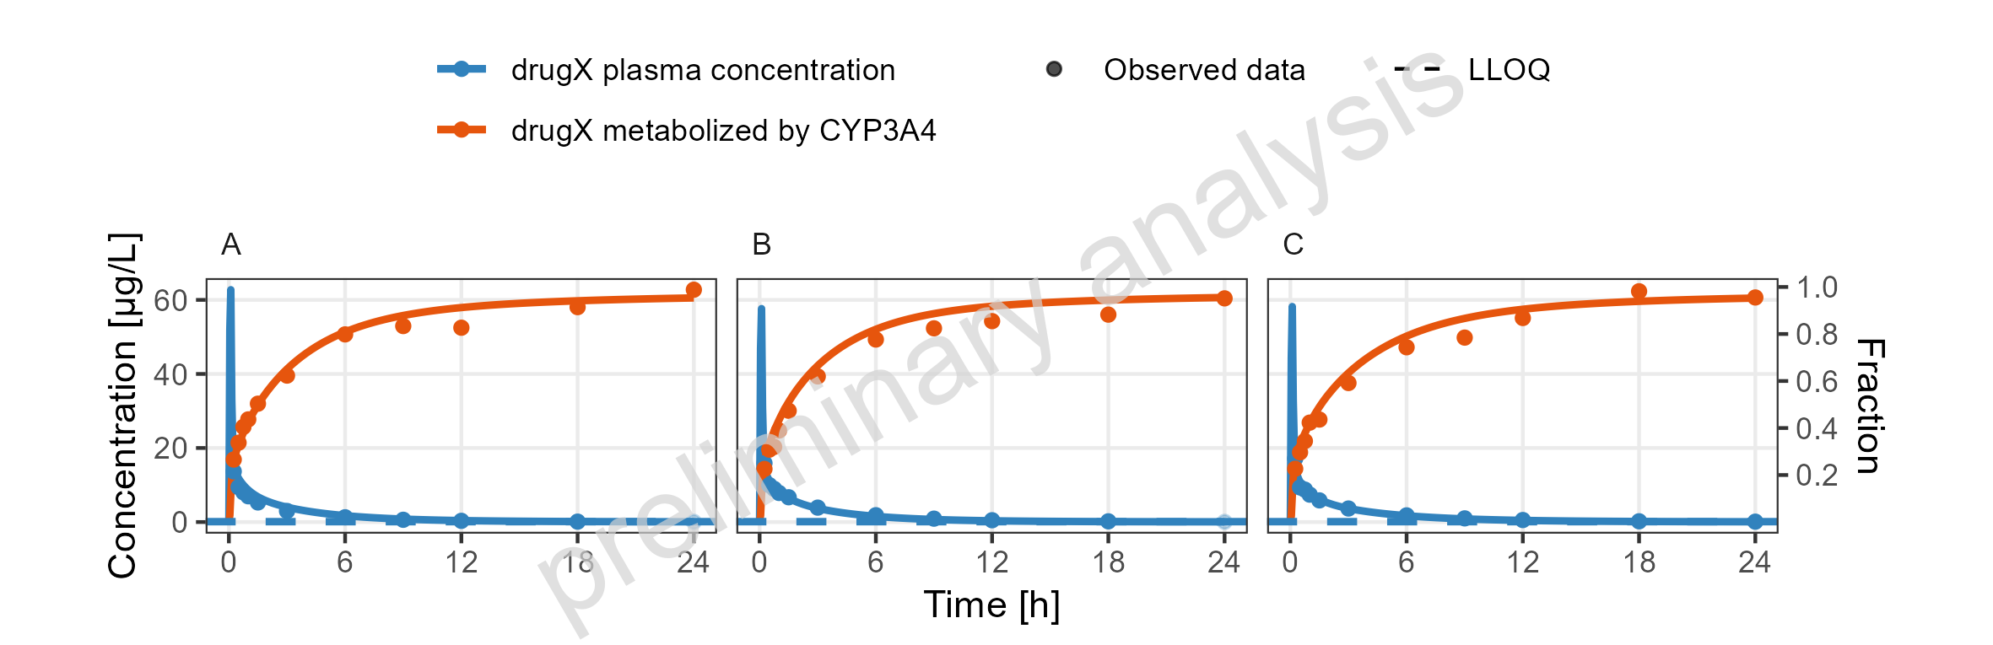
Figure 15: Simulated Concentration-time profiles for drugX metabolized by CYP3A4 and drugX plasma concentration for simulation of an 1mg iv application for individuals of study 1234 for subject I123450 (A), I123466 (B) and I123478 (C) on a linear y-scale. DrugX was administered as a 1mg Iv application with an infusion time of 5 minutes.

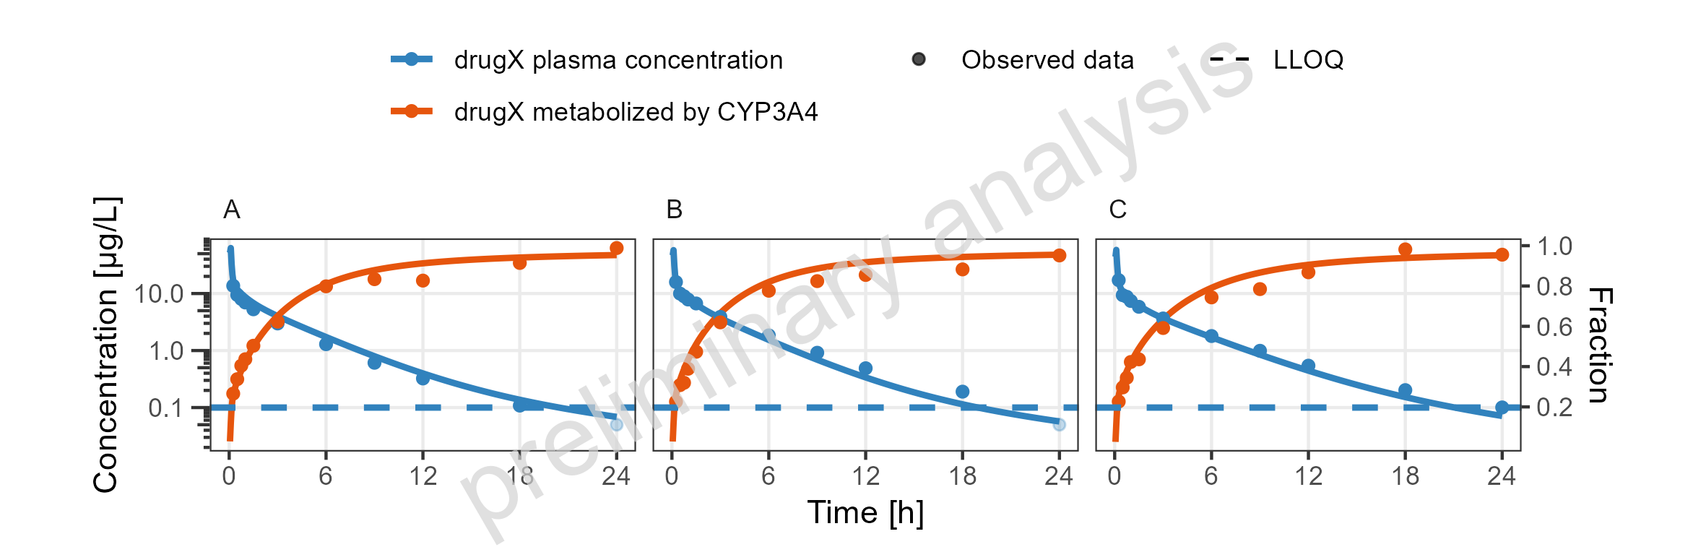
Figure 16: Simulated Concentration-time profiles for drugX metabolized by CYP3A4 and drugX plasma concentration for simulation of an 1mg iv application for individuals of study 1234 for subject I123450 (A), I123466 (B) and I123478 (C) on a logarithmic y-scale. DrugX was administered as a 1mg Iv application with an infusion time of 5 minutes.

shortcut for individual filter
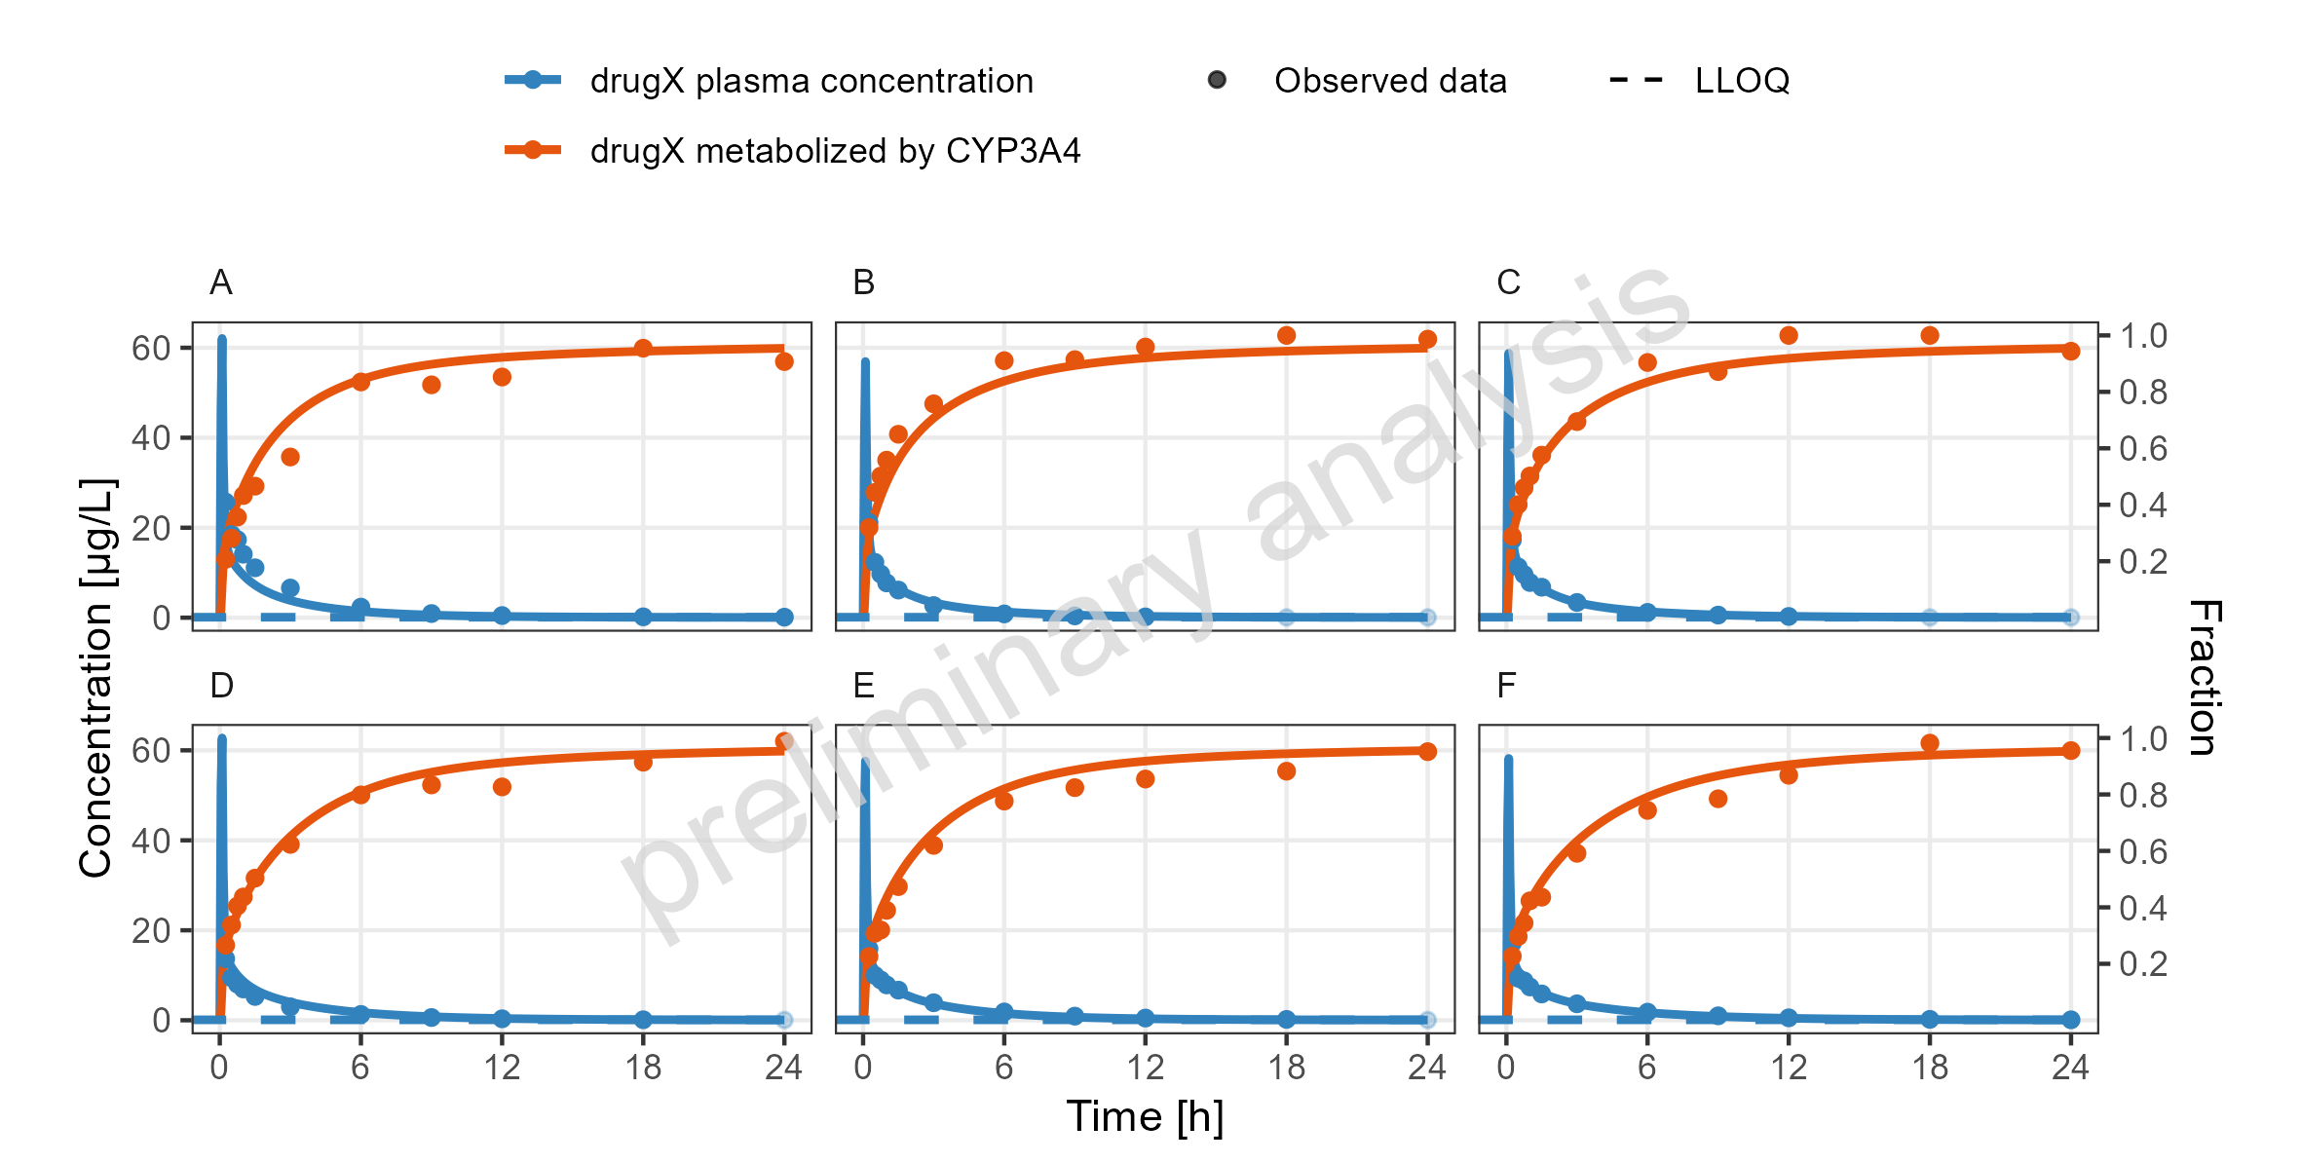
Figure 17: Simulated Concentration-time profiles for drugX metabolized by CYP3A4 and drugX plasma concentration for simulation of an 1mg iv application for individuals of study 1234 for subject I123413 (A), I123430 (B), I123441 (C), I123450 (D), I123466 (E) and I123478 (F) on a linear y-scale. DrugX was administered as a 1mg Iv application with an infusion time of 5 minutes.

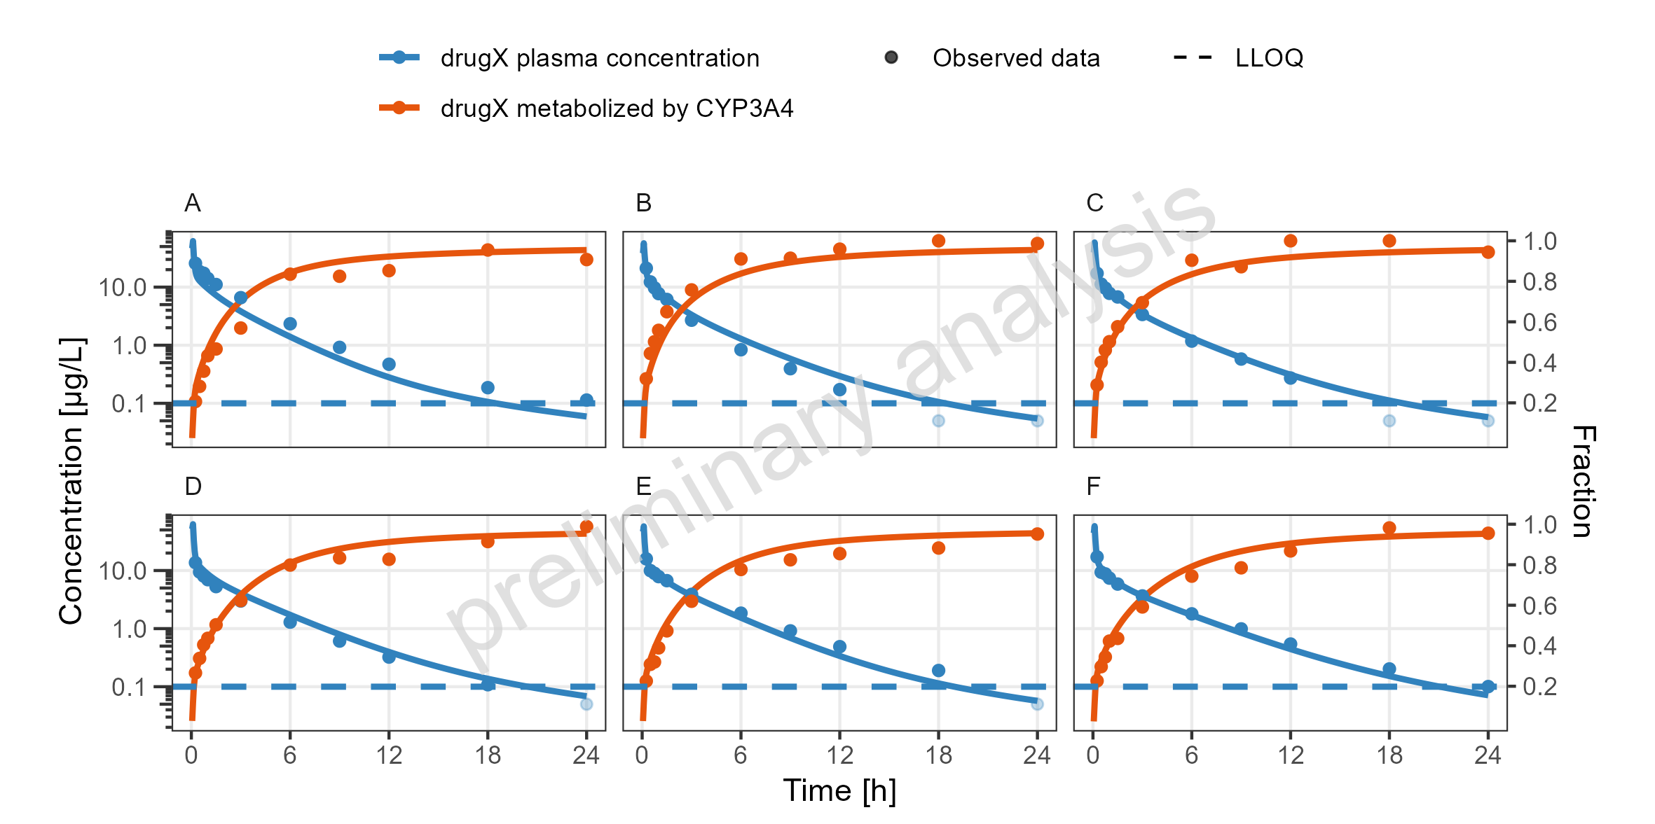
Figure 18: Simulated Concentration-time profiles for drugX metabolized by CYP3A4 and drugX plasma concentration for simulation of an 1mg iv application for individuals of study 1234 for subject I123413 (A), I123430 (B), I123441 (C), I123450 (D), I123466 (E) and I123478 (F) on a logarithmic y-scale. DrugX was administered as a 1mg Iv application with an infusion time of 5 minutes.

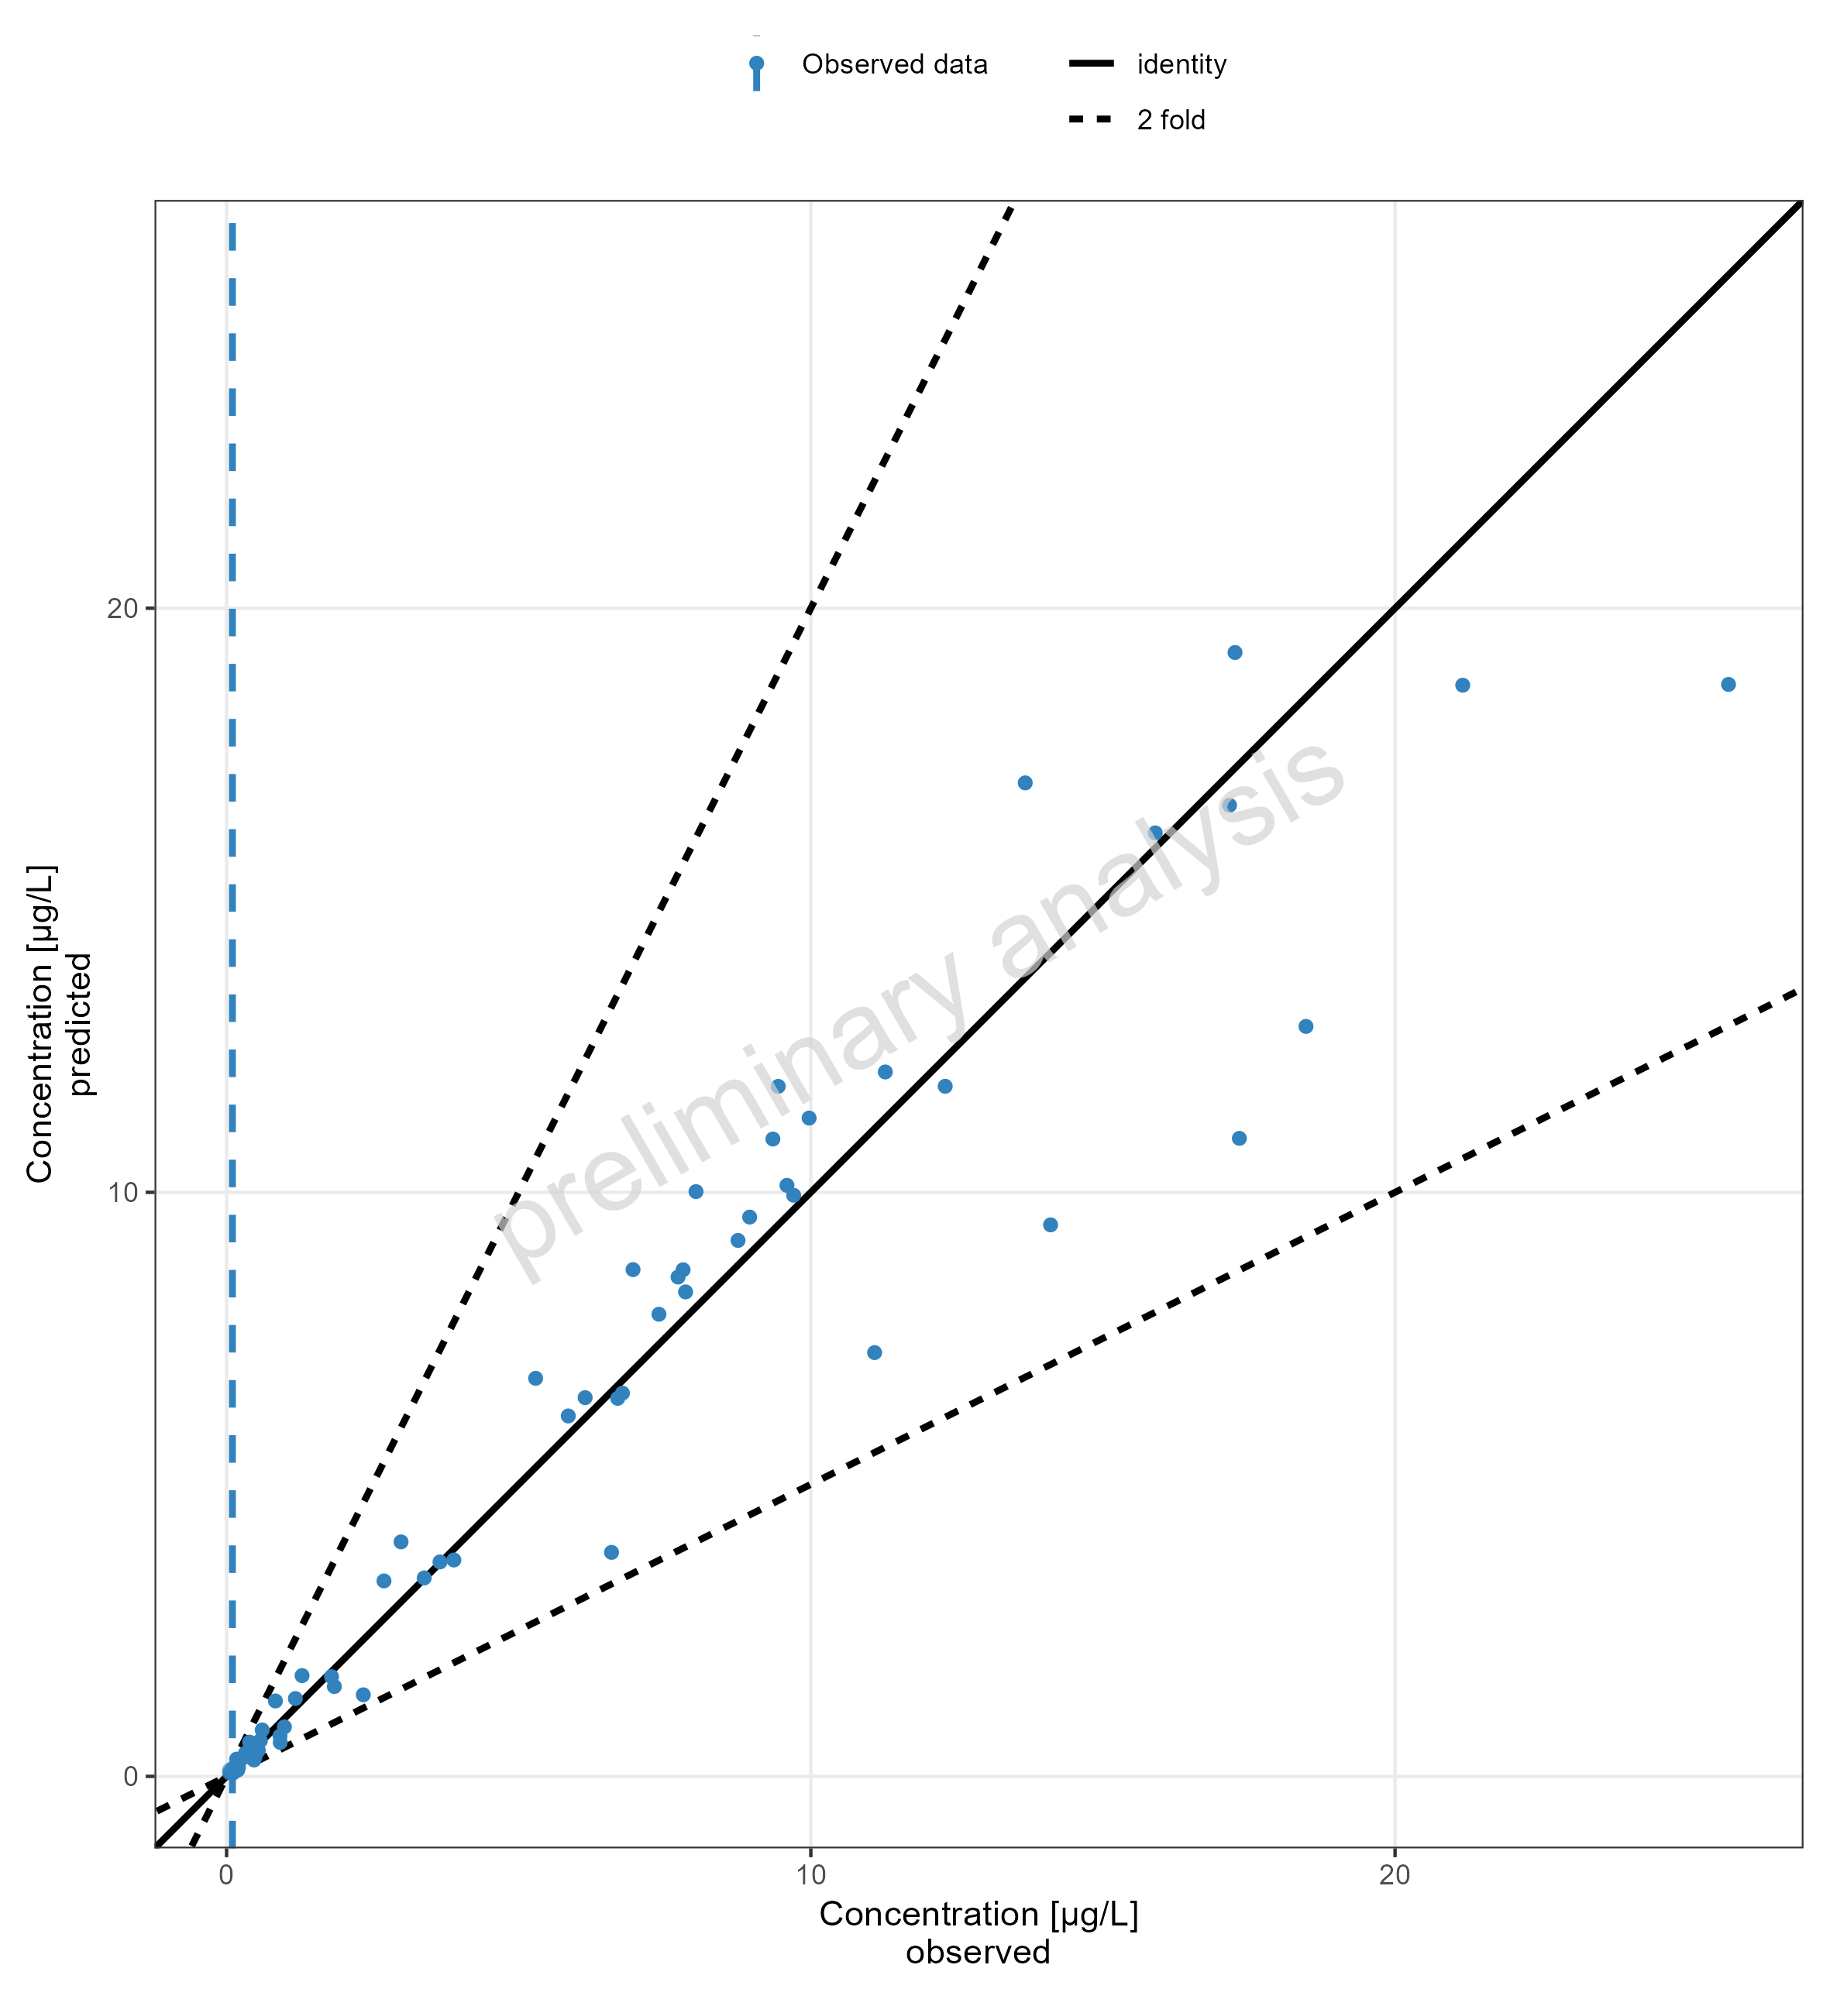
Figure 19: Simulated Predicted vs Observed for drugX plasma concentration for simulation of an 1mg iv application for individuals of study 1234 on a linear x and y-scale. DrugX was administered as a 1mg Iv application with an infusion time of 5 minutes.

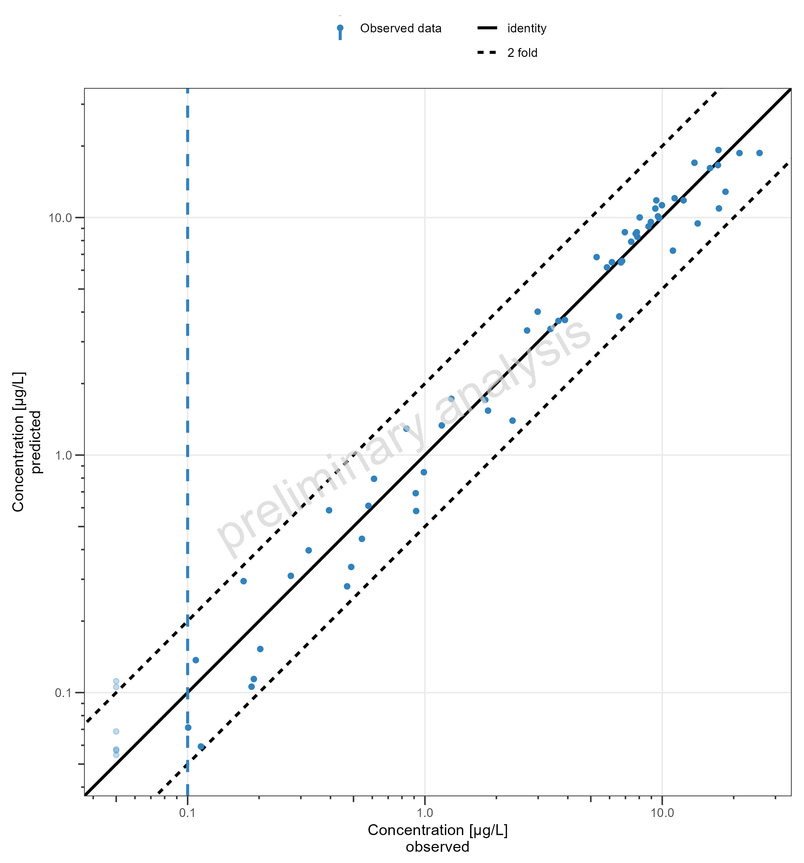
Figure 20: Simulated Predicted vs Observed for drugX plasma concentration for simulation of an 1mg iv application for individuals of study 1234 on a logarithmic x and y-scale. DrugX was administered as a 1mg Iv application with an infusion time of 5 minutes.

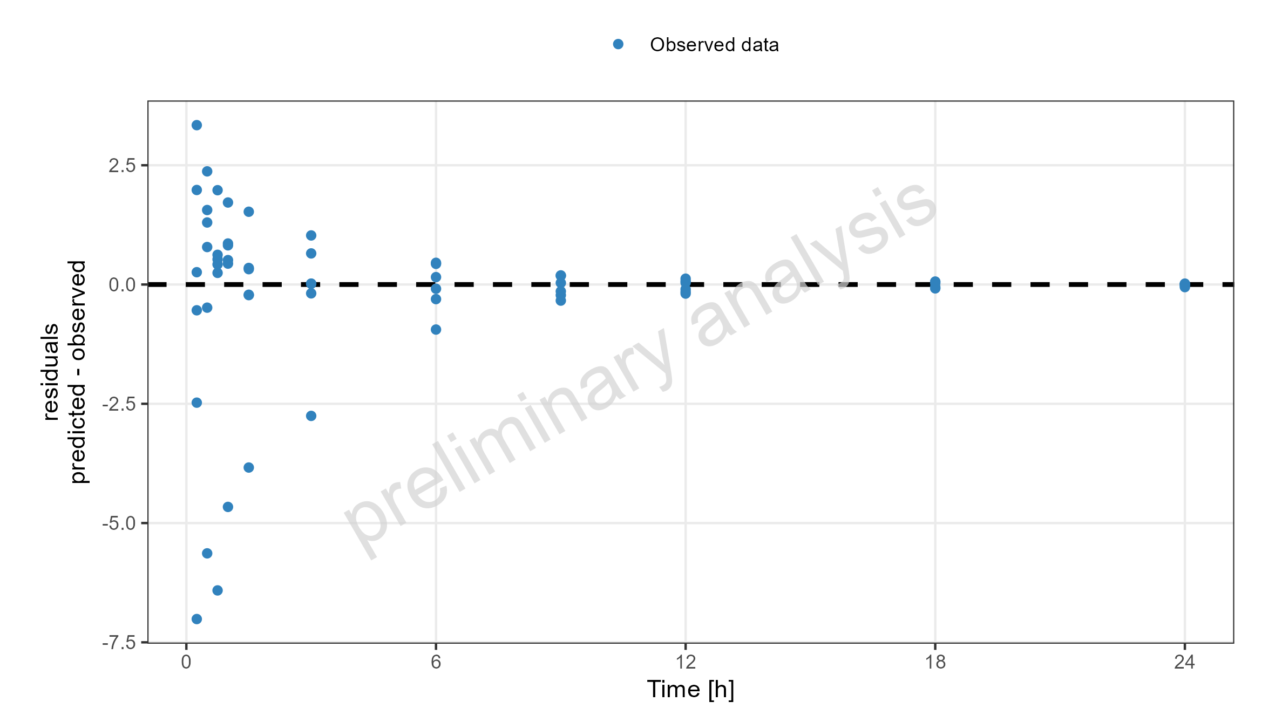
Figure 21: Simulated Residuals vs time values for drugX plasma concentration for simulation of an 1mg iv application for individuals of study 1234. DrugX was administered as a 1mg Iv application with an infusion time of 5 minutes.

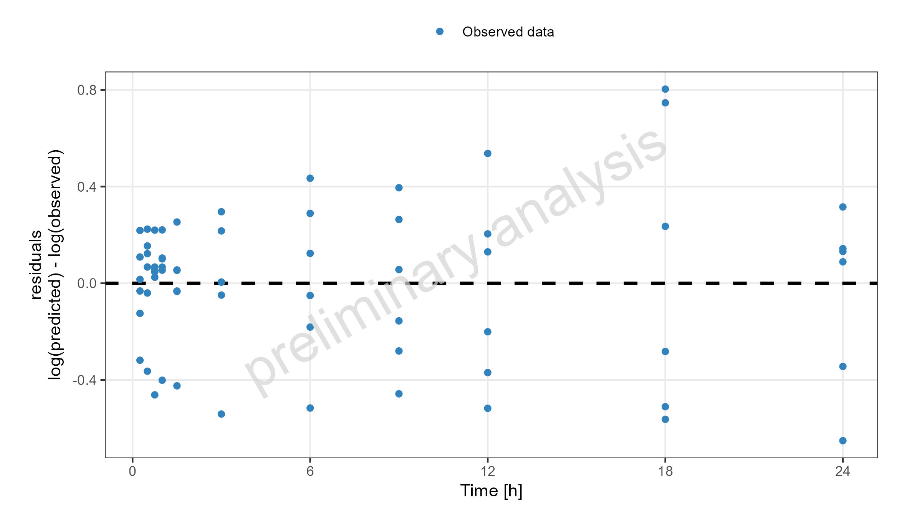
Figure 22: Simulated Residuals vs time values for drugX plasma concentration for simulation of an 1mg iv application for individuals of study 1234. DrugX was administered as a 1mg Iv application with an infusion time of 5 minutes.

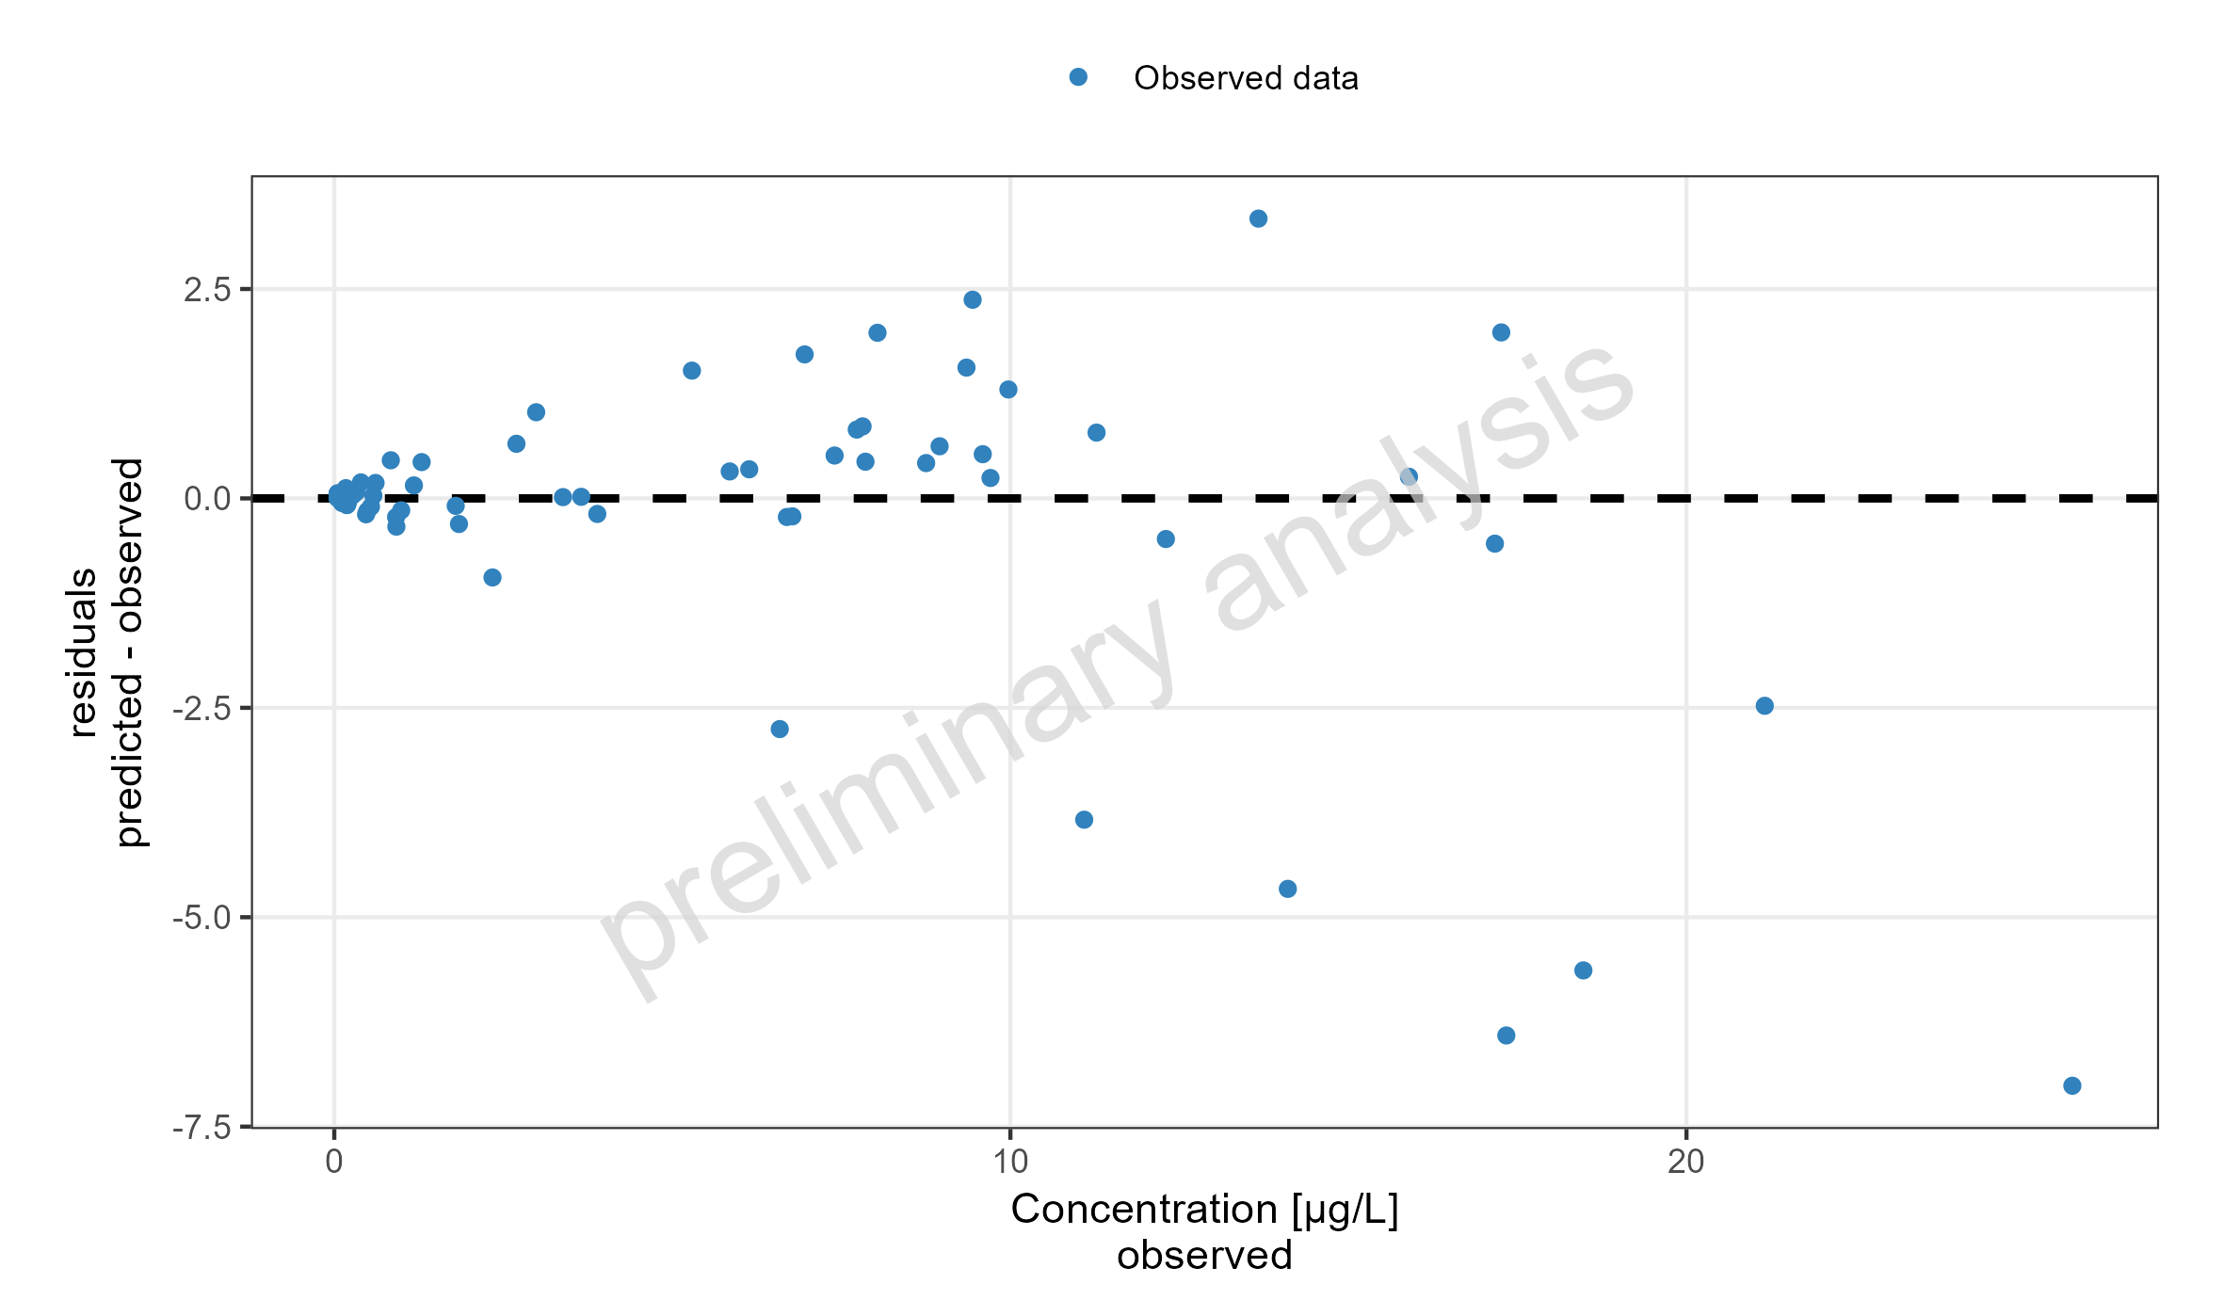
Figure 23: Simulated Residuals vs observed values for drugX plasma concentration for simulation of an 1mg iv application for individuals of study 1234. DrugX was administered as a 1mg Iv application with an infusion time of 5 minutes.

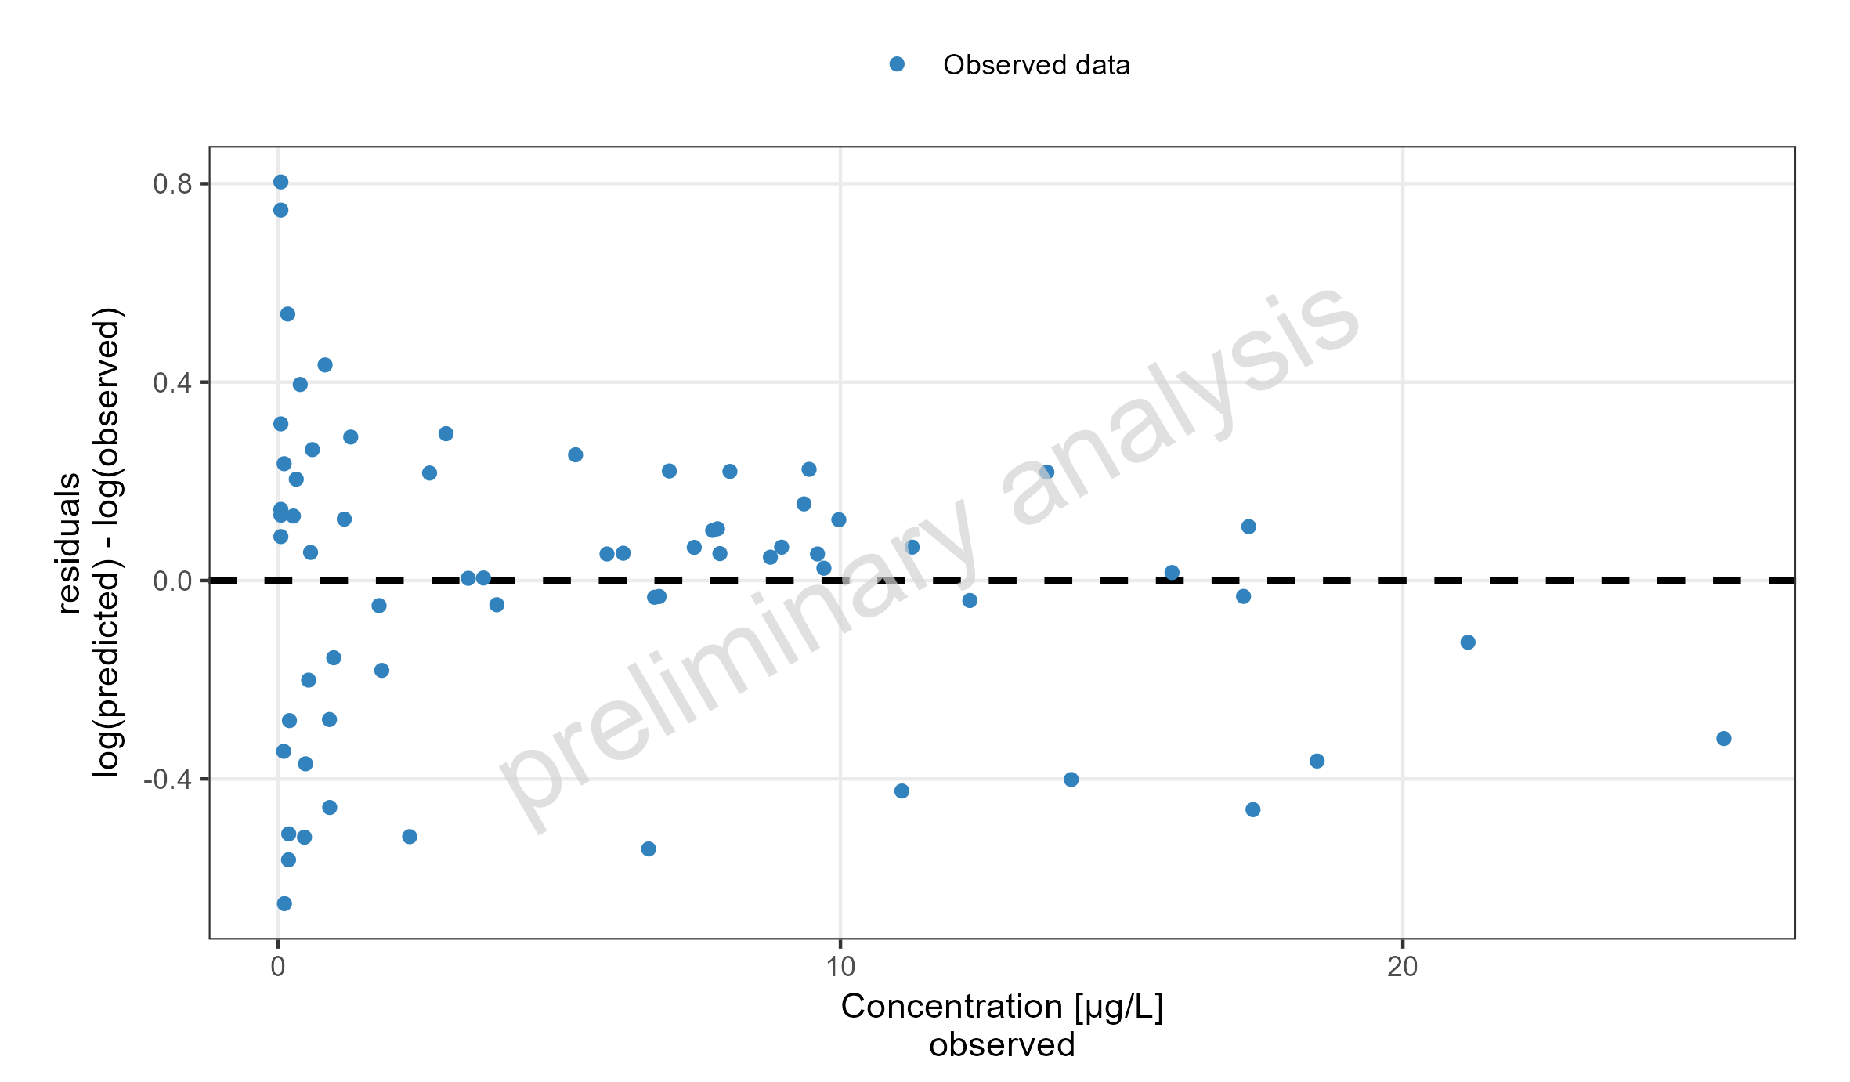
Figure 24: Simulated Residuals vs observed values for drugX plasma concentration for simulation of an 1mg iv application for individuals of study 1234. DrugX was administered as a 1mg Iv application with an infusion time of 5 minutes.

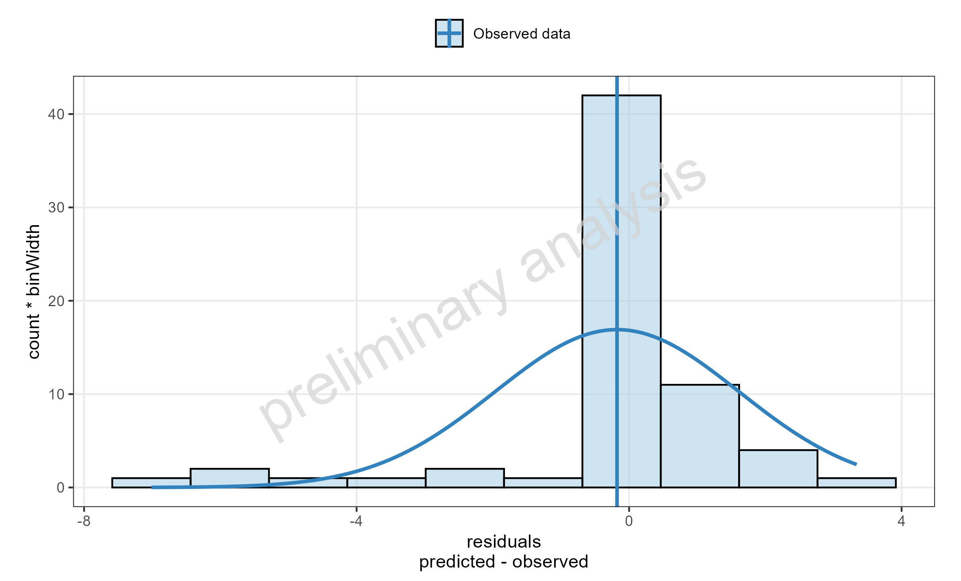
Figure 25: Simulated Residuals distribution for drugX plasma concentration for simulation of an 1mg iv application for individuals of study 1234. DrugX was administered as a 1mg Iv application with an infusion time of 5 minutes.

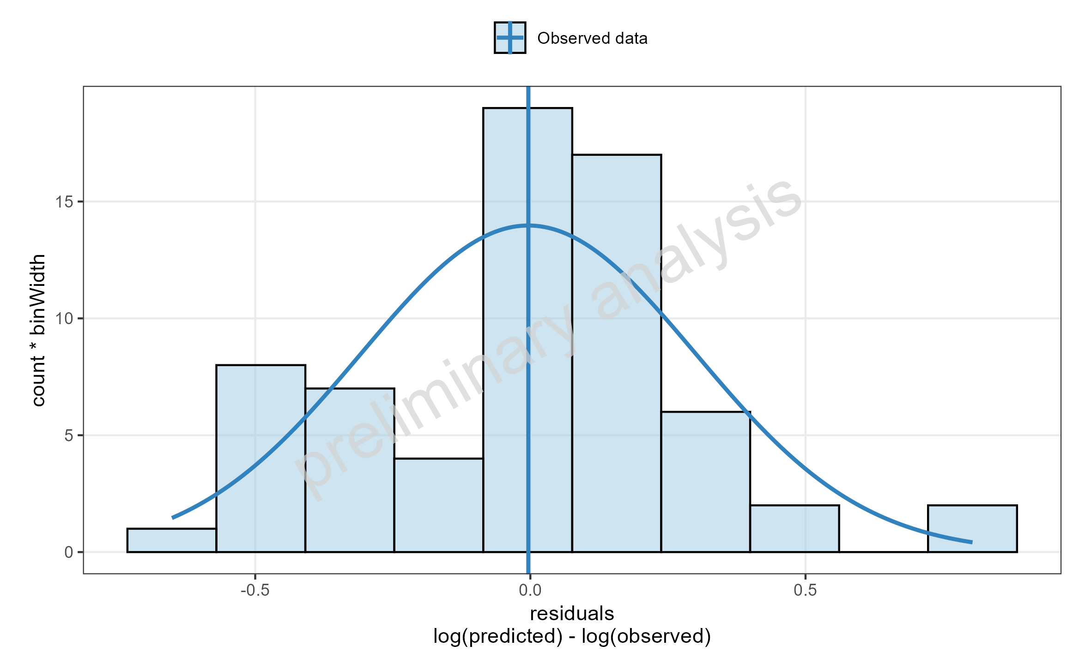
Figure 26: Simulated Residuals distribution for drugX plasma concentration for simulation of an 1mg iv application for individuals of study 1234. DrugX was administered as a 1mg Iv application with an infusion time of 5 minutes.

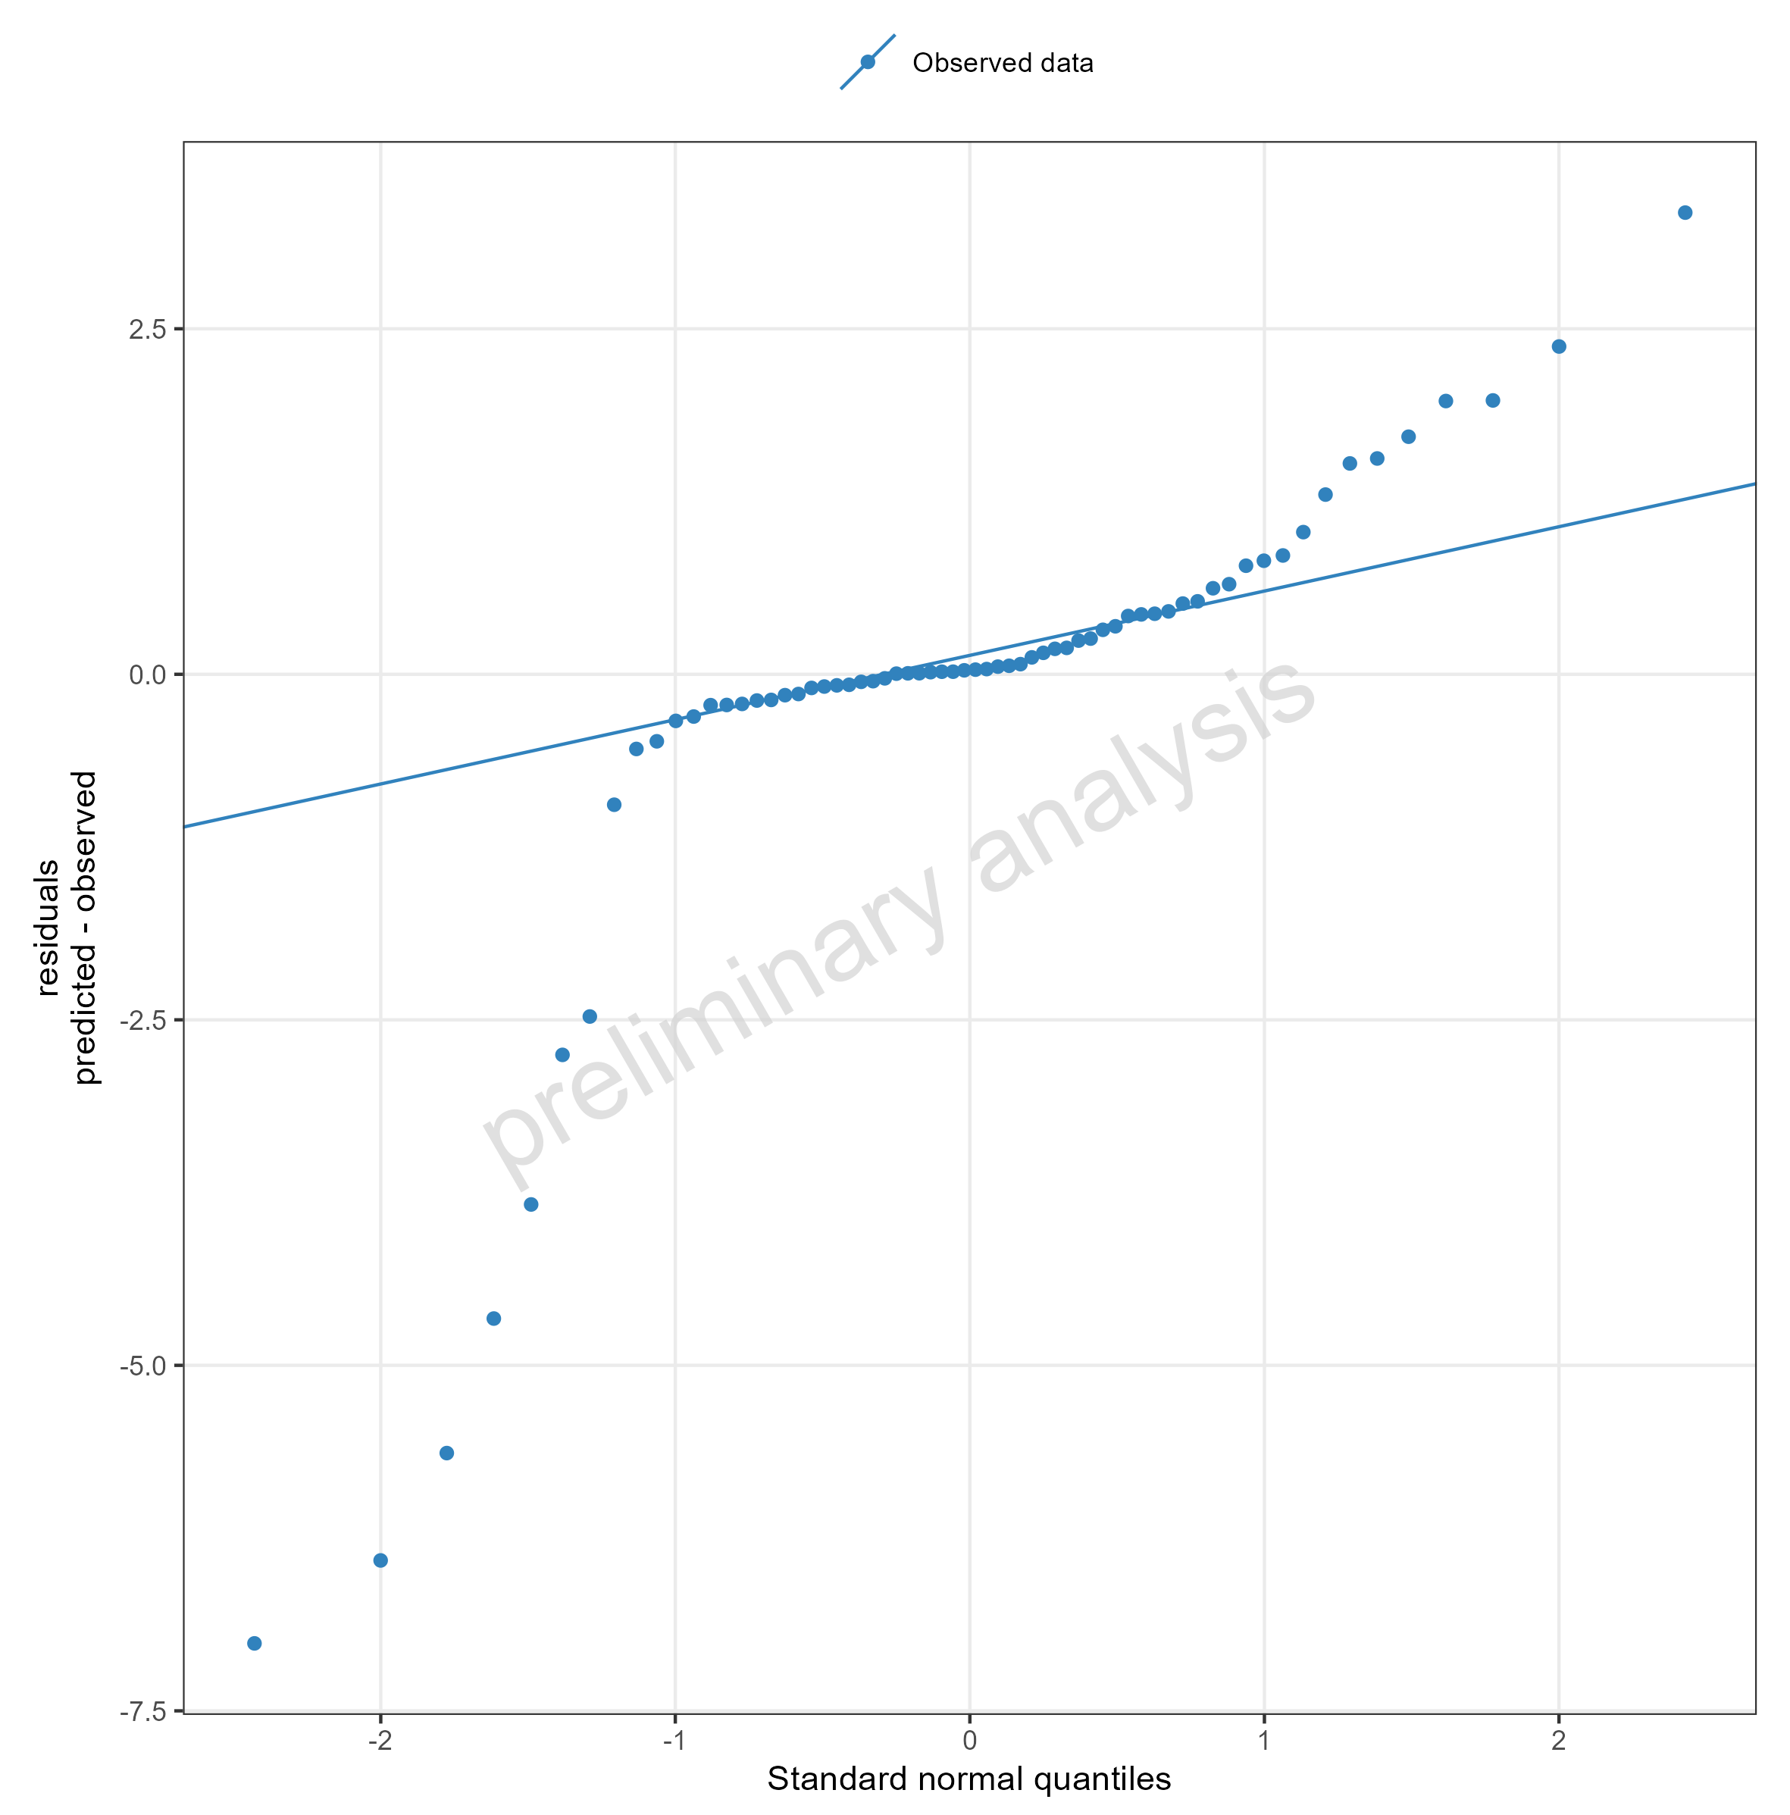
Figure 27: Simulated Residuals as quantile-quantile plot for drugX plasma concentration for simulation of an 1mg iv application for individuals of study 1234. DrugX was administered as a 1mg Iv application with an infusion time of 5 minutes.

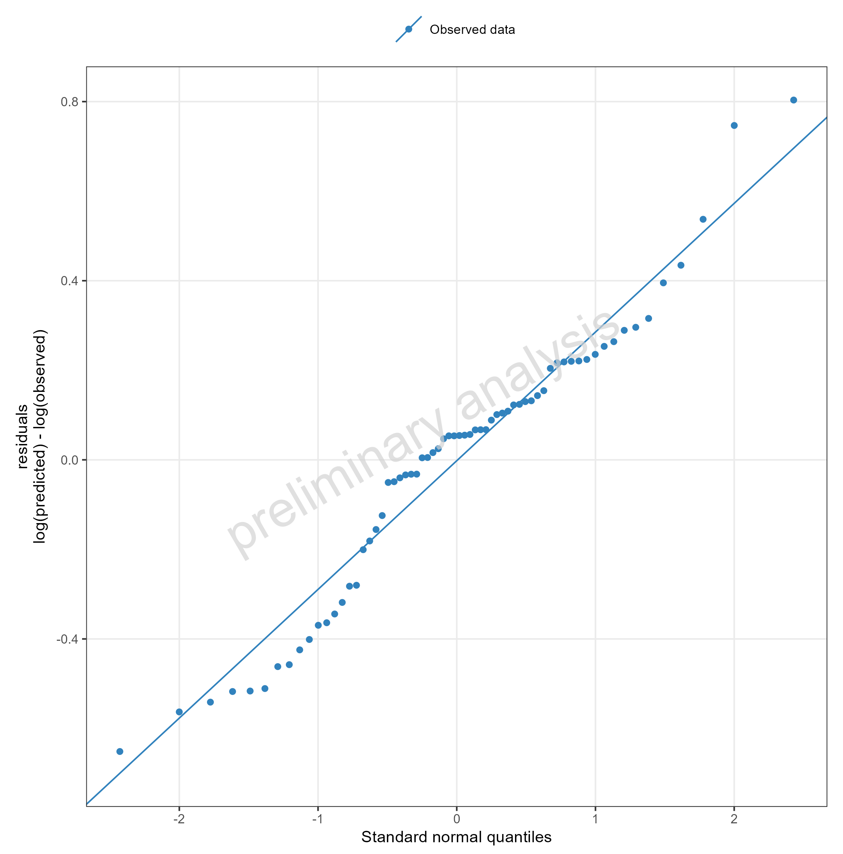
Figure 28: Simulated Residuals as quantile-quantile plot for drugX plasma concentration for simulation of an 1mg iv application for individuals of study 1234. DrugX was administered as a 1mg Iv application with an infusion time of 5 minutes.

Adding Random Populations and use of aggregated data
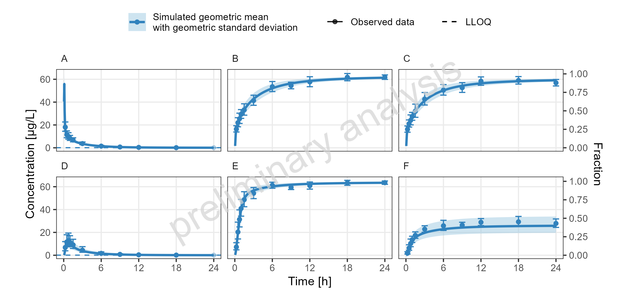
Figure 29: Simulated Concentration-time profiles for drugX metabolized by CYP3A4 (B, E), drugX metabolized by CYP3A4 in liver (C, F) and drugX plasma concentration (A, D) for simulation of an 1mg iv application for an adult population (A, B, C) and simulation of an 5mg oral application for an adult population (D, E, F) on a linear y-scale.
Observed data is displayed as geometric mean and geometric standard deviation

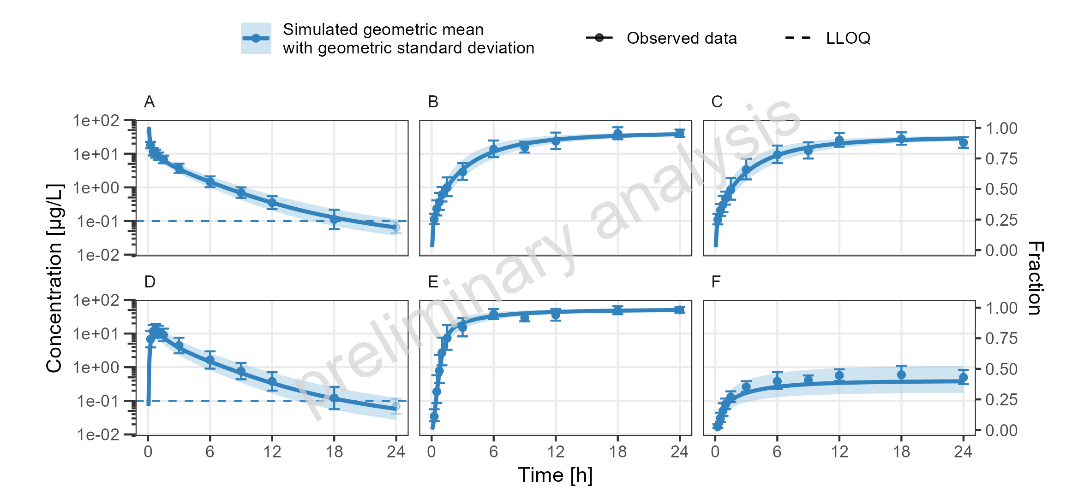
Figure 30: Simulated Concentration-time profiles for drugX metabolized by CYP3A4 (B, E), drugX metabolized by CYP3A4 in liver (C, F) and drugX plasma concentration (A, D) for simulation of an 1mg iv application for an adult population (A, B, C) and simulation of an 5mg oral application for an adult population (D, E, F) on a logarithmic y-scale.
Observed data is displayed as geometric mean and geometric standard deviation

Adding Reference Populations
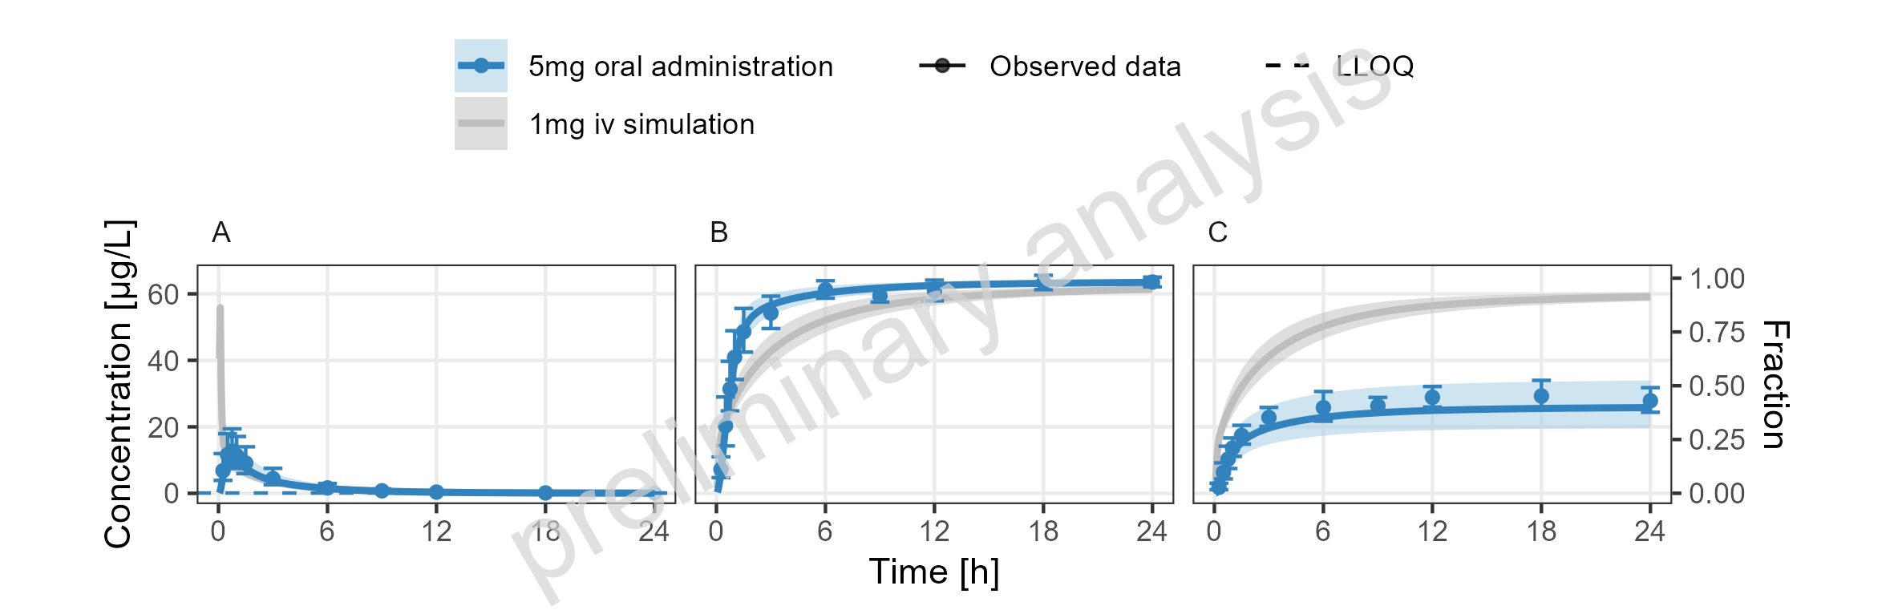
Figure 31: Simulated Concentration-time profiles for drugX metabolized by CYP3A4 (B), drugX metabolized by CYP3A4 in liver (C) and drugX plasma concentration (A) for simulation of a 5mg oral administration vs 1mg iv simulation on a linear y-scale.
Observed data is displayed as geometric mean and geometric standard deviation

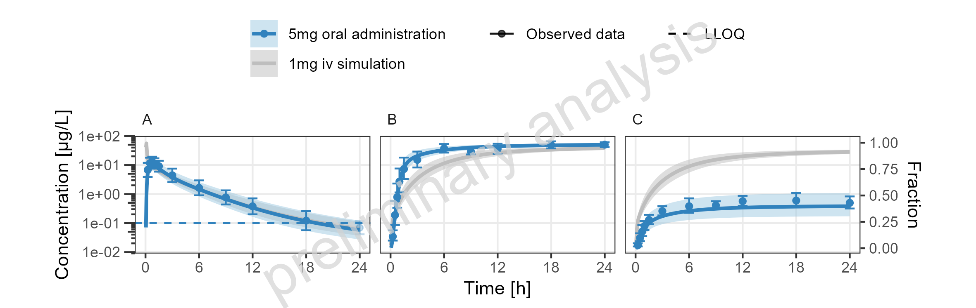
Figure 32: Simulated Concentration-time profiles for drugX metabolized by CYP3A4 (B), drugX metabolized by CYP3A4 in liver (C) and drugX plasma concentration (A) for simulation of a 5mg oral administration vs 1mg iv simulation on a logarithmic y-scale.
Observed data is displayed as geometric mean and geometric standard deviation

Adding Plots with different Time Ranges
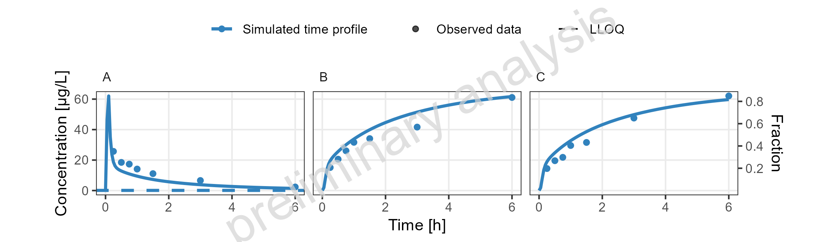
Figure 33: Simulated Concentration-time profiles for drugX metabolized by CYP3A4 (B), drugX metabolized by CYP3A4 in liver (C) and drugX plasma concentration (A) for simulation of an 1mg iv application for individual id 13 study 1234 on a linear y-scale Zoom on first 6 hours. DrugX was administered as a 1mg Iv application with an infusion time of 5 minutes.

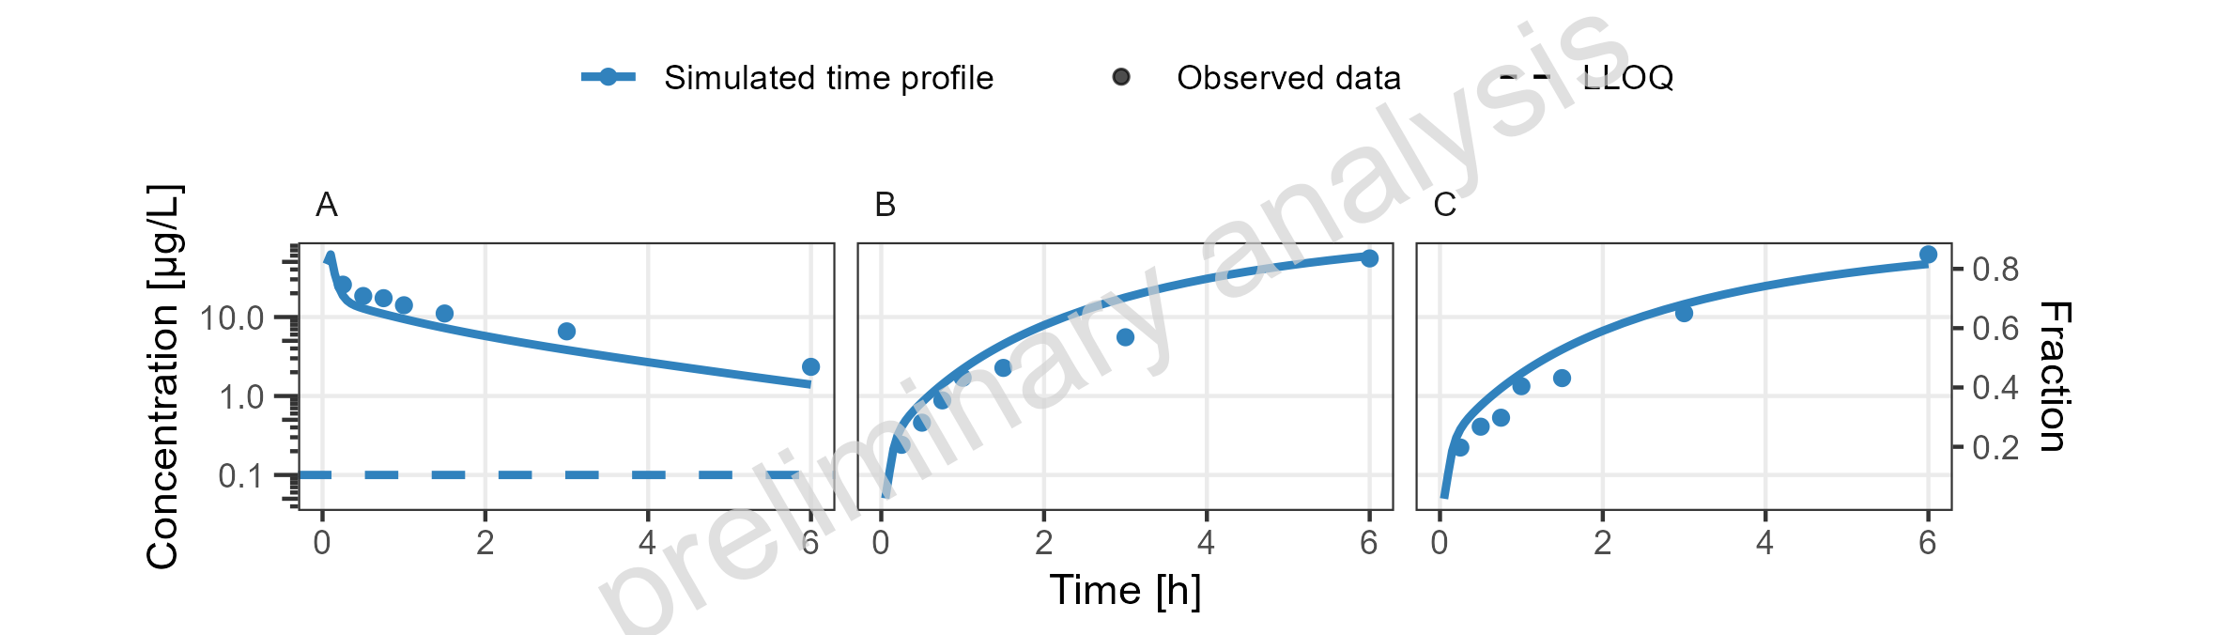
Figure 34: Simulated Concentration-time profiles for drugX metabolized by CYP3A4 (B), drugX metabolized by CYP3A4 in liver (C) and drugX plasma concentration (A) for simulation of an 1mg iv application for individual id 13 study 1234 on a logarithmic y-scale Zoom on first 6 hours. DrugX was administered as a 1mg Iv application with an infusion time of 5 minutes.

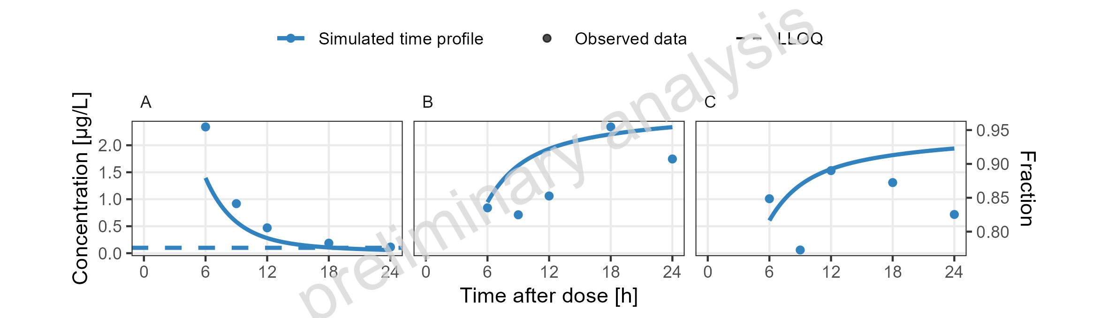
Figure 35: Simulated Concentration-time profiles for drugX metabolized by CYP3A4 (B), drugX metabolized by CYP3A4 in liver (C) and drugX plasma concentration (A) for simulation of an 1mg iv application for individual id 13 study 1234 on a linear y-scale Zoom on time range 6 to 24 hours. DrugX was administered as a 1mg Iv application with an infusion time of 5 minutes.

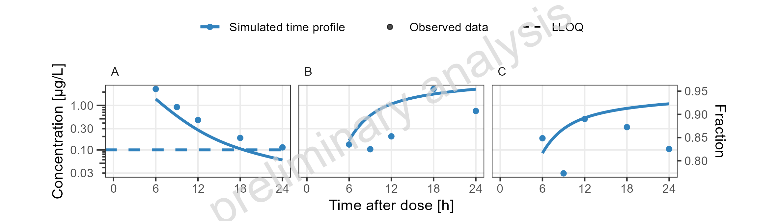
Figure 36: Simulated Concentration-time profiles for drugX metabolized by CYP3A4 (B), drugX metabolized by CYP3A4 in liver (C) and drugX plasma concentration (A) for simulation of an 1mg iv application for individual id 13 study 1234 on a logarithmic y-scale Zoom on time range 6 to 24 hours. DrugX was administered as a 1mg Iv application with an infusion time of 5 minutes.

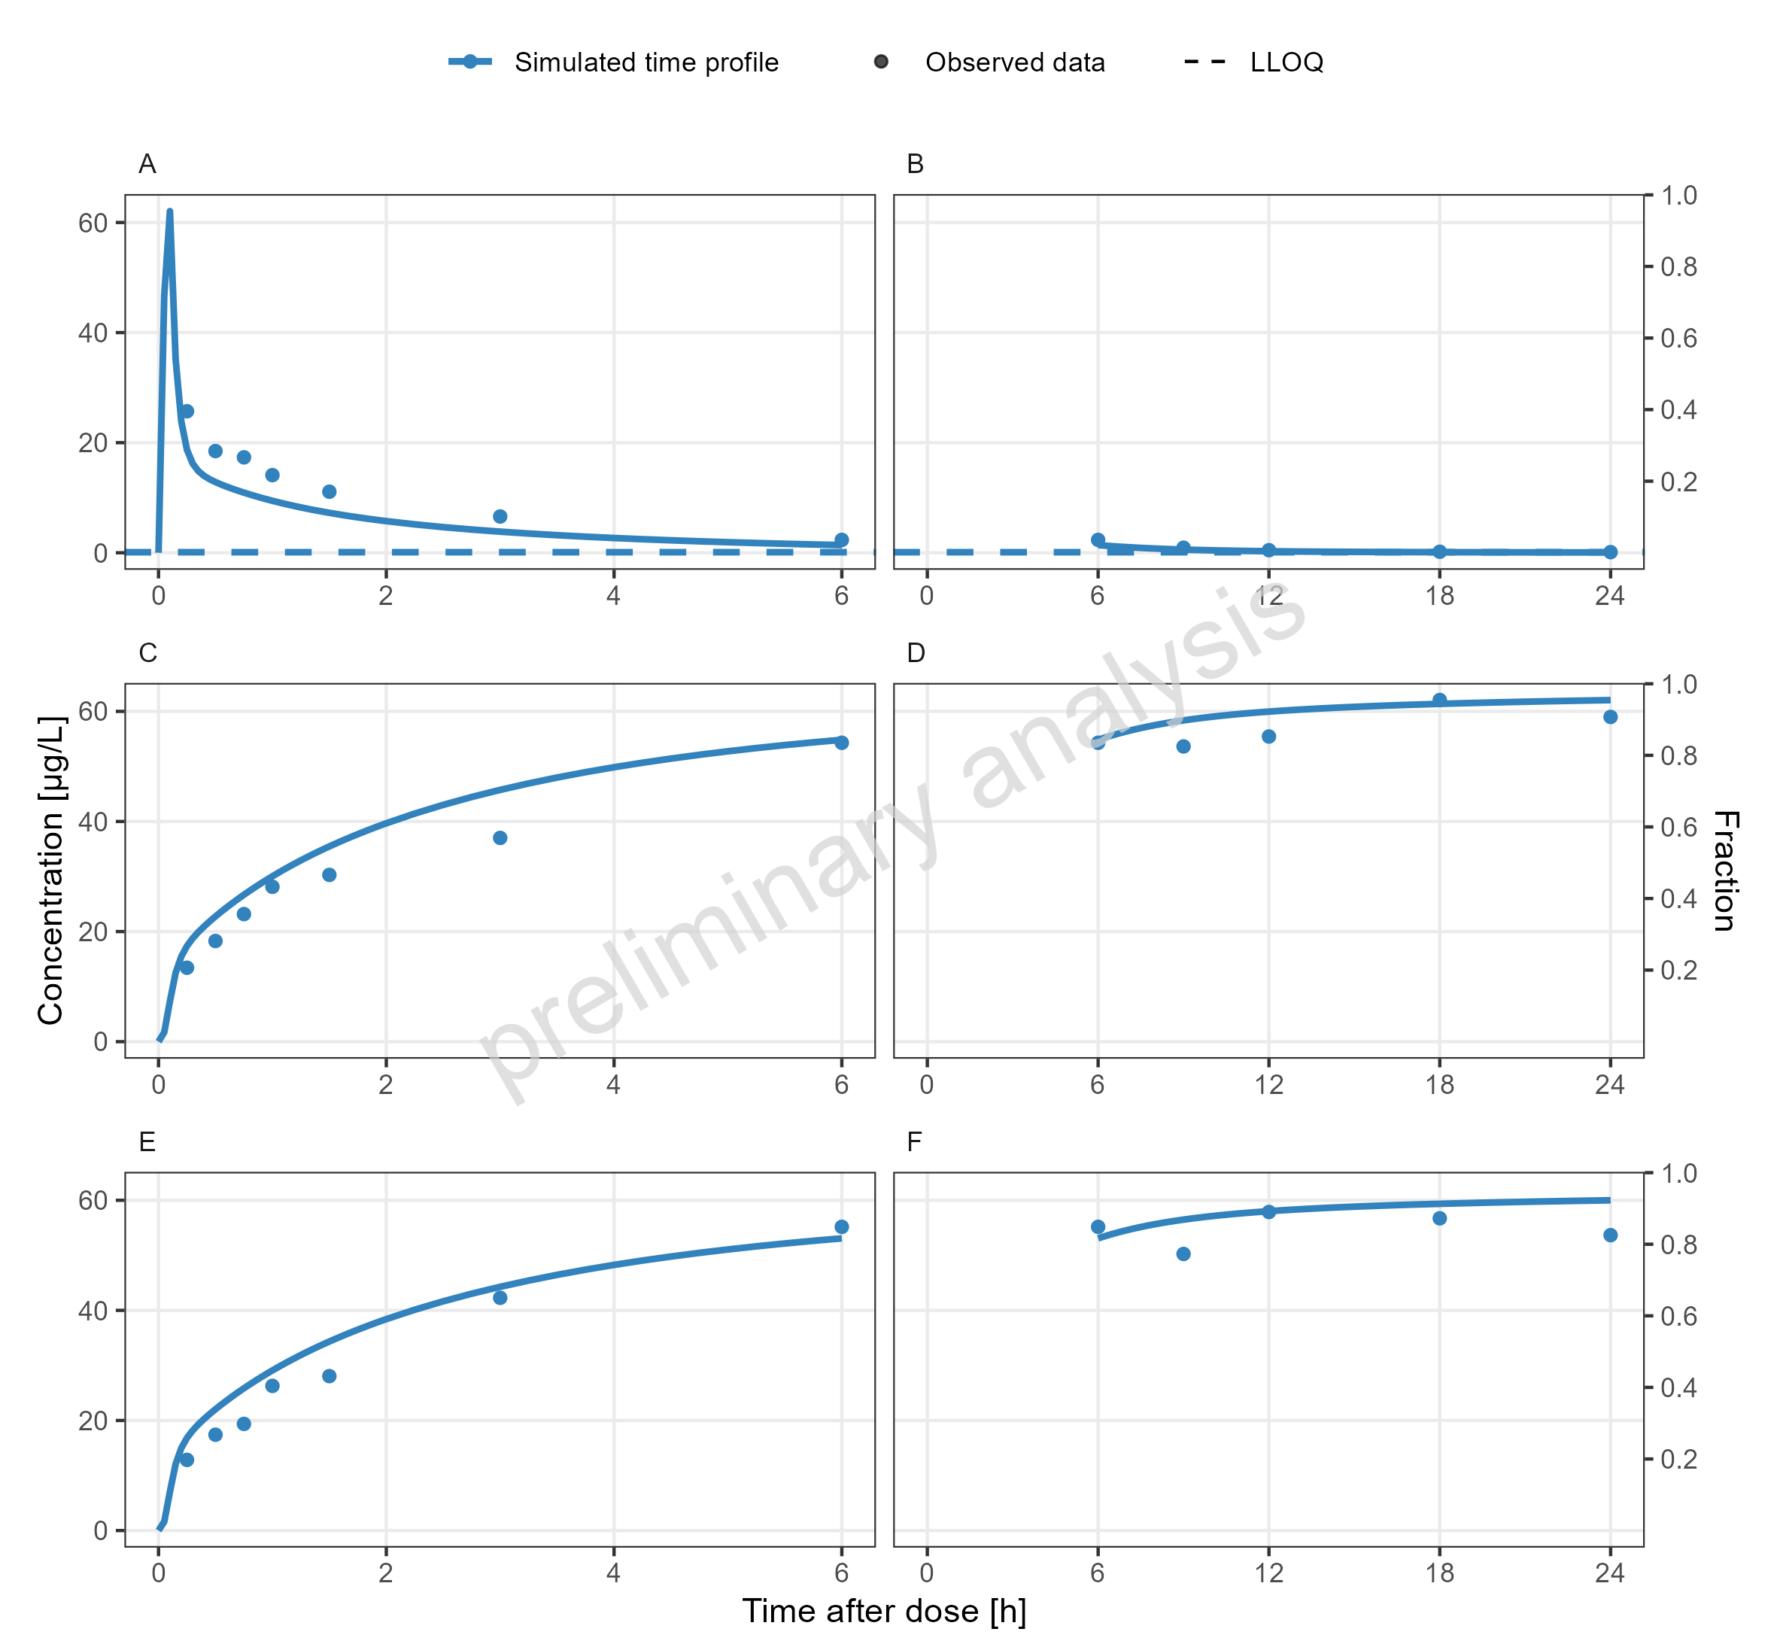
Figure 37: Simulated Concentration-time profiles for drugX metabolized by CYP3A4 (C, D), drugX metabolized by CYP3A4 in liver (E, F) and drugX plasma concentration (A, B) for simulation of an 1mg iv application for individual id 13 study 1234 on a linear y-scale Zoom on first 6 hours (A, C, E) and Zoom on time range 6 to 24 hours (B, D, F). DrugX was administered as a 1mg Iv application with an infusion time of 5 minutes.

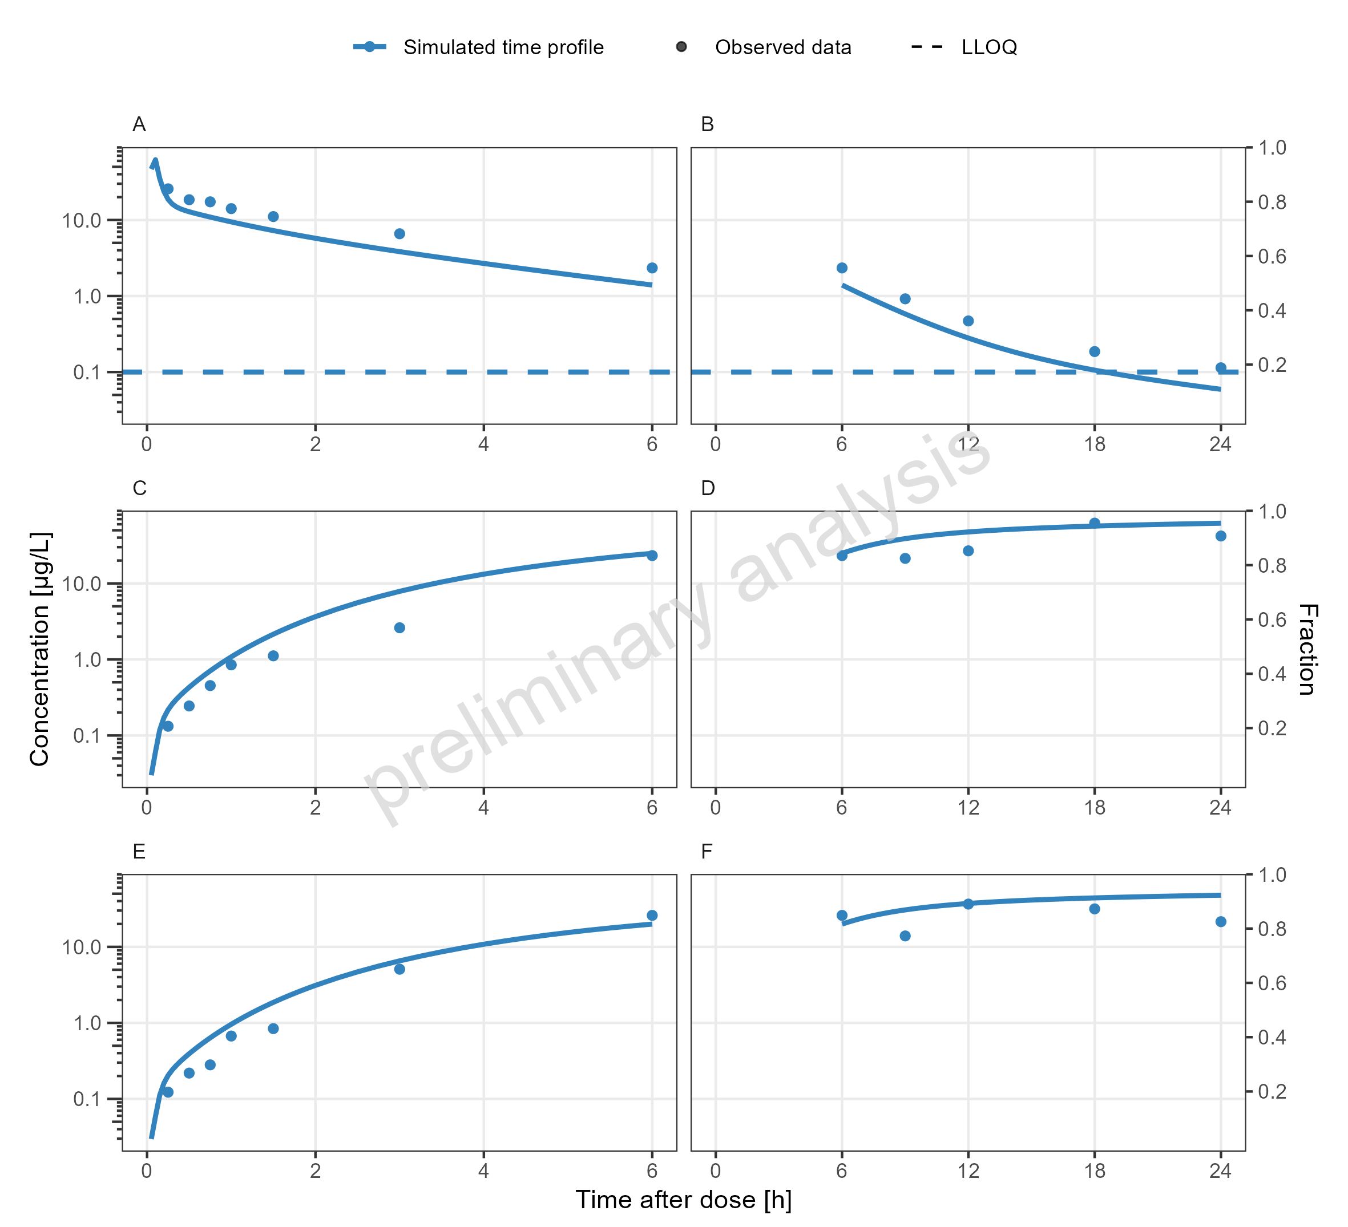
Figure 38: Simulated Concentration-time profiles for drugX metabolized by CYP3A4 (C, D), drugX metabolized by CYP3A4 in liver (E, F) and drugX plasma concentration (A, B) for simulation of an 1mg iv application for individual id 13 study 1234 on a logarithmic y-scale Zoom on first 6 hours (A, C, E) and Zoom on time range 6 to 24 hours (B, D, F). DrugX was administered as a 1mg Iv application with an infusion time of 5 minutes.

