Musical Glove with Tilt Sensors

With this you will be creating a musical instrument with your hand using an arduino, speaker and tilt switches. This device can be attached to your fingers where the movement of each finger results in a different note to be played. This is only one example; this model can be used by any sensor which uses binary such as a button or pressure pad.

Hardware List:

* Arduino UNO
* Speaker
* Breadboard
* Jump wires (regular single core wires are acceptable)
* 5x 10kΩ resistors
* 5x tilt switches
* USB 1.0 cable

Software List:

* Arduino software (<http://www.arduino.cc/>)
* List of defined notes (see appendix)

Method:

1. Using appropriate connectors and jumper wires, attach the tilt switch sensors to connector leads and jumper leads. (one each for the anode and cathode)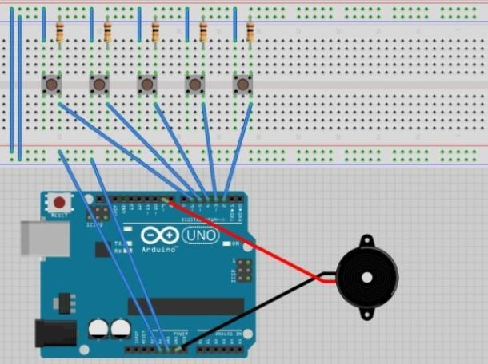
2. Using the diagram set up the wiring of the sensors and speakers on the arduino and breadboard.

(Note that the tilt switches are in place of the push buttons on the diagram, tilt switches are connected to the same row as the resistors.)

1. Using the arduino software, define the tones which you would use for each tilt switch. Each note differs with the frequency which is associates with it.

Here are example tones which I used (Note that the number after each note corresponds to the frequency associated with that note):

*“#define NOTE_C4 262*

*#define NOTE_CS4 277*

*#define NOTE_D4 294*

*#define NOTE_DS4 311*

*#define NOTE_E4 330*

*#define NOTE_F4 349*

*#define NOTE_FS4 370*

*#define NOTE_G4 392*

*#define NOTE_GS4 415*

*#define NOTE_A4 440”*

1. Next you need to create constants for the speaker and tilt switches. You also need to create the variable which will change. 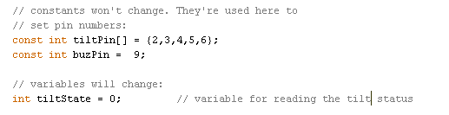
2. Setup the speaker pin as an output pin.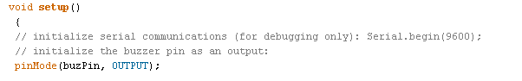
3. Next, create variables to digitally read each input for the tilt switches (remember the tilts are connected to the digital pins on the arduino)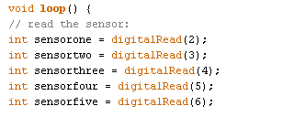
4. You need to write an ‘if’ statement to read the sensors and play the tone when activated. The must also be a delay to stabilise the read.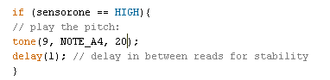
5. Repeat for all five sensors.
6. Finally verify the code and upload it to the ardunio.

