Schema order.xsd

schema location: | ..\schemas\order.xsd
attributeFormDefault: | unqualified
elementFormDefault: | qualified

Elements | Complex types | Simple types
order | Order | PackageType

schema location: | ..\schemas\common.xsd
attributeFormDefault: | unqualified
elementFormDefault: | qualified

Complex types | Simple types
AdTag | Channel
AdUnit | CostMethod
AudienceProfile | EmailAddress
Company | IndexedValue
Dimension | Name
Discount | Note
DocumentSource | PaymentTerms
File | Percentage
FinancialTerms | PhoneNumber
Identifier | TagType
LegalTerms | UnitOfLength
Money | UnitOfMeasurement
Person
PostalAddress
Quantity
Rate
SummaryStatistic
System
TimeSpan
Transactor

schema location: | ..\schemas\program.xsd
attributeFormDefault: | unqualified
elementFormDefault: | qualified

Elements | Complex types | Simple types
program | Placement | Category
 | Program

schema location: | ..\schemas\currencyCode.xsd
attributeFormDefault: | unqualified
elementFormDefault: | qualified

Simple types
CurrencyCode

schema location: | ..\schemas\mediaType.xsd
attributeFormDefault: | unqualified
elementFormDefault: | qualified

Simple types
MediaType

element order
diagram | 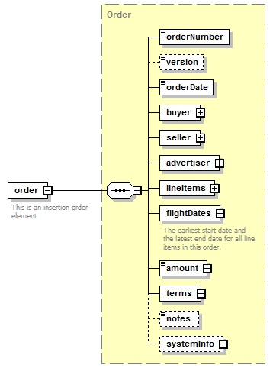
type | Order
properties
  content | complex
children | orderNumber version orderDate buyer seller advertiser lineItems flightDates amount terms notes systemInfo
annotation
  documentation
  This is an insertion order element
source | <xs:element name="order" type="Order">  <xs:annotation>  <xs:documentation>This is an insertion order element</xs:documentation>  </xs:annotation>  </xs:element>

complexType Order
diagram | 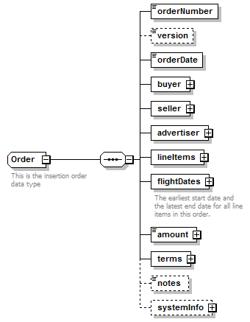
children | orderNumber version orderDate buyer seller advertiser lineItems flightDates amount terms notes systemInfo
used by
  element | order
annotation
  documentation
  This is the insertion order data type
source | <xs:complexType name="Order">  <xs:annotation>  <xs:documentation>This is the insertion order data type</xs:documentation>  </xs:annotation>  <xs:sequence>  <xs:element name="orderNumber">  <xs:simpleType>  <xs:restriction base="xs:string">  <xs:maxLength value="25"/>  </xs:restriction>  </xs:simpleType>  </xs:element>  <xs:element name="version" type="xs:short" minOccurs="0"/>  <xs:element name="orderDate" type="xs:date"/>  <xs:element name="buyer" type="Transactor"/>  <xs:element name="seller" type="Transactor"/>  <xs:element name="advertiser" type="Transactor"/>  <xs:element name="lineItems">  <xs:complexType>  <xs:sequence>  <xs:element name="lineItem" maxOccurs="unbounded">  <xs:complexType>  <xs:sequence>  <xs:element name="sequenceNumber" type="xs:int">  <xs:annotation>  <xs:documentation>The order in which this line appear in the order</xs:documentation>  </xs:annotation>  </xs:element>  <xs:element name="name" type="Name"/>  <xs:choice>  <xs:element name="placement">  <xs:complexType>  <xs:sequence>  <xs:element name="program">  <xs:annotation>  <xs:documentation>The advertising program. E.g. "AutoTrader.com"</xs:documentation>  </xs:annotation>  <xs:complexType>  <xs:sequence>  <xs:element name="id" type="xs:IDREF" minOccurs="0"/>  <xs:element name="name"/>  </xs:sequence>  </xs:complexType>  </xs:element>  <xs:element name="placement" type="Placement">  <xs:annotation>  <xs:documentation>The Program's placement. E.g. "Sedan's section 300x250"</xs:documentation>  </xs:annotation>  </xs:element>  <xs:element name="targeting" minOccurs="0">  <xs:annotation>  <xs:documentation>Additional targeting options. E.g. "gender=female" and "income>$100,000" TODO: data structure.</xs:documentation>  </xs:annotation>  </xs:element>  <xs:element name="creative" minOccurs="0">  <xs:annotation>  <xs:documentation>creative tags or assets can optionally be included in the order.</xs:documentation>  </xs:annotation>  <xs:complexType>  <xs:sequence>  <xs:element name="tag" type="AdTag" minOccurs="0" maxOccurs="unbounded"/>  <xs:element name="file" type="File" minOccurs="0" maxOccurs="unbounded"/>  </xs:sequence>  </xs:complexType>  </xs:element>  <xs:element name="package" minOccurs="0">  <xs:annotation>  <xs:documentation>If this placement is part of a package</xs:documentation>  </xs:annotation>  </xs:element>  </xs:sequence>  </xs:complexType>  </xs:element>  <xs:element name="package"/>  </xs:choice>  <xs:element name="testingStartDate" type="xs:dateTime" minOccurs="0">  <xs:annotation>  <xs:documentation>During the testing period, the ad server serves impressions to the placement as if it your ads were already running on the publisher's site. However, reports for the testing period will show the associated media cost and eCPM for these impressions as zero.</xs:documentation>  </xs:annotation>  </xs:element>  <xs:element name="flightDates" type="TimeSpan">  <xs:annotation>  <xs:documentation>The earliest start date and latest end date for this line item.</xs:documentation>  </xs:annotation>  </xs:element>  <xs:element name="flights" minOccurs="0">  <xs:annotation>  <xs:documentation>Optional for flighting.</xs:documentation>  </xs:annotation>  <xs:complexType>  <xs:sequence>  <xs:element name="flight">  <xs:complexType>  <xs:sequence>  <xs:element name="flightDates" type="TimeSpan" maxOccurs="unbounded"/>  <xs:element name="quantity"/>  <xs:element name="rate" type="Rate"/>  <xs:element name="amount" type="Money"/>  <xs:element name="notes" type="Note" minOccurs="0"/>  </xs:sequence>  </xs:complexType>  </xs:element>  </xs:sequence>  </xs:complexType>  </xs:element>  <xs:element name="quantity" type="Quantity" minOccurs="0">  <xs:annotation>  <xs:documentation>optional if placement is part of package</xs:documentation>  </xs:annotation>  </xs:element>  <xs:element name="rate" type="Rate" minOccurs="0">  <xs:annotation>  <xs:documentation>optional if placement is part of package</xs:documentation>  </xs:annotation>  </xs:element>  <xs:element name="amount" type="Money" minOccurs="0">  <xs:annotation>  <xs:documentation>optional if placement is part of package</xs:documentation>  </xs:annotation>  </xs:element>  <xs:element name="isGuaranteed" type="xs:boolean">  <xs:annotation>  <xs:documentation>True if this line item's quantity is guaranteed. False otherwise. Optional if placement is part of package.</xs:documentation>  </xs:annotation>  </xs:element>  <xs:element name="notes" type="Note" minOccurs="0"/>  <xs:element name="identifiers" type="Identifier" minOccurs="0" maxOccurs="unbounded"/>  </xs:sequence>  </xs:complexType>  </xs:element>  </xs:sequence>  </xs:complexType>  </xs:element>  <xs:element name="flightDates" type="TimeSpan">  <xs:annotation>  <xs:documentation>The earliest start date and the latest end date for all line items in this order.</xs:documentation>  </xs:annotation>  </xs:element>  <xs:element name="amount" type="Money"/>  <xs:element name="terms">  <xs:complexType>  <xs:sequence>  <xs:element name="financial">  <xs:complexType>  <xs:sequence>  <xs:element name="paymentTerms" type="PaymentTerms"/>  <xs:element name="billingFrequency" default="monthly">  <xs:simpleType>  <xs:restriction base="xs:string">  <xs:enumeration value="weekly"/>  <xs:enumeration value="monthly"/>  <xs:enumeration value="quarterly"/>  </xs:restriction>  </xs:simpleType>  </xs:element>  <xs:element name="systemOfRecord" default="advertiser">  <xs:simpleType>  <xs:restriction base="xs:string">  <xs:enumeration value="advertiser"/>  <xs:enumeration value="publisher"/>  </xs:restriction>  </xs:simpleType>  </xs:element>  <xs:element name="agencyCommission" type="Discount" minOccurs="0"/>  <xs:element name="discount" type="Discount" minOccurs="0" maxOccurs="unbounded"/>  <xs:element name="notes" type="Note" minOccurs="0"/>  </xs:sequence>  </xs:complexType>  </xs:element>  <xs:element name="legal" type="LegalTerms"/>  </xs:sequence>  </xs:complexType>  </xs:element>  <xs:element name="notes" type="Note" minOccurs="0"/>  <xs:element name="systemInfo" minOccurs="0">  <xs:complexType>  <xs:sequence>  <xs:element name="created" type="DocumentSource"/>  <xs:element name="updated" type="DocumentSource"/>  <xs:element name="id" type="Identifier" minOccurs="0" maxOccurs="unbounded"/>  </xs:sequence>  </xs:complexType>  </xs:element>  </xs:sequence>  </xs:complexType>

element Order/orderNumber
diagram | 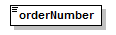
type | restriction of xs:string
properties
  content | simple
facets
  Kind | Value | Annotation
  maxLength | 25
source | <xs:element name="orderNumber">  <xs:simpleType>  <xs:restriction base="xs:string">  <xs:maxLength value="25"/>  </xs:restriction>  </xs:simpleType>  </xs:element>

element Order/version
diagram | 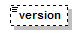
type | xs:short
properties
  minOcc | 0
  maxOcc | 1
  content | simple
source | <xs:element name="version" type="xs:short" minOccurs="0"/>

element Order/orderDate
diagram | 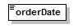
type | xs:date
properties
  content | simple
source | <xs:element name="orderDate" type="xs:date"/>

element Order/buyer
diagram | 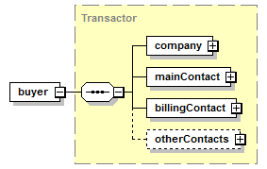
type | Transactor
properties
  content | complex
children | company mainContact billingContact otherContacts
source | <xs:element name="buyer" type="Transactor"/>

element Order/seller
diagram | 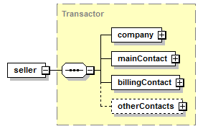
type | Transactor
properties
  content | complex
children | company mainContact billingContact otherContacts
source | <xs:element name="seller" type="Transactor"/>

element Order/advertiser
diagram | 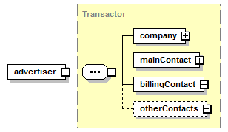
type | Transactor
properties
  content | complex
children | company mainContact billingContact otherContacts
source | <xs:element name="advertiser" type="Transactor"/>

element Order/lineItems
diagram | 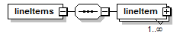
properties
  content | complex
children | lineItem
source | <xs:element name="lineItems">  <xs:complexType>  <xs:sequence>  <xs:element name="lineItem" maxOccurs="unbounded">  <xs:complexType>  <xs:sequence>  <xs:element name="sequenceNumber" type="xs:int">  <xs:annotation>  <xs:documentation>The order in which this line appear in the order</xs:documentation>  </xs:annotation>  </xs:element>  <xs:element name="name" type="Name"/>  <xs:choice>  <xs:element name="placement">  <xs:complexType>  <xs:sequence>  <xs:element name="program">  <xs:annotation>  <xs:documentation>The advertising program. E.g. "AutoTrader.com"</xs:documentation>  </xs:annotation>  <xs:complexType>  <xs:sequence>  <xs:element name="id" type="xs:IDREF" minOccurs="0"/>  <xs:element name="name"/>  </xs:sequence>  </xs:complexType>  </xs:element>  <xs:element name="placement" type="Placement">  <xs:annotation>  <xs:documentation>The Program's placement. E.g. "Sedan's section 300x250"</xs:documentation>  </xs:annotation>  </xs:element>  <xs:element name="targeting" minOccurs="0">  <xs:annotation>  <xs:documentation>Additional targeting options. E.g. "gender=female" and "income>$100,000" TODO: data structure.</xs:documentation>  </xs:annotation>  </xs:element>  <xs:element name="creative" minOccurs="0">  <xs:annotation>  <xs:documentation>creative tags or assets can optionally be included in the order.</xs:documentation>  </xs:annotation>  <xs:complexType>  <xs:sequence>  <xs:element name="tag" type="AdTag" minOccurs="0" maxOccurs="unbounded"/>  <xs:element name="file" type="File" minOccurs="0" maxOccurs="unbounded"/>  </xs:sequence>  </xs:complexType>  </xs:element>  <xs:element name="package" minOccurs="0">  <xs:annotation>  <xs:documentation>If this placement is part of a package</xs:documentation>  </xs:annotation>  </xs:element>  </xs:sequence>  </xs:complexType>  </xs:element>  <xs:element name="package"/>  </xs:choice>  <xs:element name="testingStartDate" type="xs:dateTime" minOccurs="0">  <xs:annotation>  <xs:documentation>During the testing period, the ad server serves impressions to the placement as if it your ads were already running on the publisher's site. However, reports for the testing period will show the associated media cost and eCPM for these impressions as zero.</xs:documentation>  </xs:annotation>  </xs:element>  <xs:element name="flightDates" type="TimeSpan">  <xs:annotation>  <xs:documentation>The earliest start date and latest end date for this line item.</xs:documentation>  </xs:annotation>  </xs:element>  <xs:element name="flights" minOccurs="0">  <xs:annotation>  <xs:documentation>Optional for flighting.</xs:documentation>  </xs:annotation>  <xs:complexType>  <xs:sequence>  <xs:element name="flight">  <xs:complexType>  <xs:sequence>  <xs:element name="flightDates" type="TimeSpan" maxOccurs="unbounded"/>  <xs:element name="quantity"/>  <xs:element name="rate" type="Rate"/>  <xs:element name="amount" type="Money"/>  <xs:element name="notes" type="Note" minOccurs="0"/>  </xs:sequence>  </xs:complexType>  </xs:element>  </xs:sequence>  </xs:complexType>  </xs:element>  <xs:element name="quantity" type="Quantity" minOccurs="0">  <xs:annotation>  <xs:documentation>optional if placement is part of package</xs:documentation>  </xs:annotation>  </xs:element>  <xs:element name="rate" type="Rate" minOccurs="0">  <xs:annotation>  <xs:documentation>optional if placement is part of package</xs:documentation>  </xs:annotation>  </xs:element>  <xs:element name="amount" type="Money" minOccurs="0">  <xs:annotation>  <xs:documentation>optional if placement is part of package</xs:documentation>  </xs:annotation>  </xs:element>  <xs:element name="isGuaranteed" type="xs:boolean">  <xs:annotation>  <xs:documentation>True if this line item's quantity is guaranteed. False otherwise. Optional if placement is part of package.</xs:documentation>  </xs:annotation>  </xs:element>  <xs:element name="notes" type="Note" minOccurs="0"/>  <xs:element name="identifiers" type="Identifier" minOccurs="0" maxOccurs="unbounded"/>  </xs:sequence>  </xs:complexType>  </xs:element>  </xs:sequence>  </xs:complexType>  </xs:element>

element Order/lineItems/lineItem
diagram | 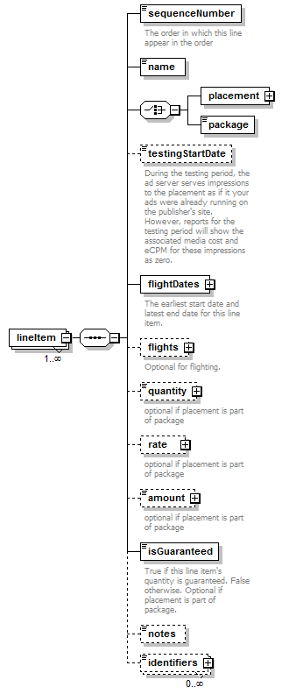
properties
  minOcc | 1
  maxOcc | unbounded
  content | complex
children | sequenceNumber name placement package testingStartDate flightDates flights quantity rate amount isGuaranteed notes identifiers
source | <xs:element name="lineItem" maxOccurs="unbounded">  <xs:complexType>  <xs:sequence>  <xs:element name="sequenceNumber" type="xs:int">  <xs:annotation>  <xs:documentation>The order in which this line appear in the order</xs:documentation>  </xs:annotation>  </xs:element>  <xs:element name="name" type="Name"/>  <xs:choice>  <xs:element name="placement">  <xs:complexType>  <xs:sequence>  <xs:element name="program">  <xs:annotation>  <xs:documentation>The advertising program. E.g. "AutoTrader.com"</xs:documentation>  </xs:annotation>  <xs:complexType>  <xs:sequence>  <xs:element name="id" type="xs:IDREF" minOccurs="0"/>  <xs:element name="name"/>  </xs:sequence>  </xs:complexType>  </xs:element>  <xs:element name="placement" type="Placement">  <xs:annotation>  <xs:documentation>The Program's placement. E.g. "Sedan's section 300x250"</xs:documentation>  </xs:annotation>  </xs:element>  <xs:element name="targeting" minOccurs="0">  <xs:annotation>  <xs:documentation>Additional targeting options. E.g. "gender=female" and "income>$100,000" TODO: data structure.</xs:documentation>  </xs:annotation>  </xs:element>  <xs:element name="creative" minOccurs="0">  <xs:annotation>  <xs:documentation>creative tags or assets can optionally be included in the order.</xs:documentation>  </xs:annotation>  <xs:complexType>  <xs:sequence>  <xs:element name="tag" type="AdTag" minOccurs="0" maxOccurs="unbounded"/>  <xs:element name="file" type="File" minOccurs="0" maxOccurs="unbounded"/>  </xs:sequence>  </xs:complexType>  </xs:element>  <xs:element name="package" minOccurs="0">  <xs:annotation>  <xs:documentation>If this placement is part of a package</xs:documentation>  </xs:annotation>  </xs:element>  </xs:sequence>  </xs:complexType>  </xs:element>  <xs:element name="package"/>  </xs:choice>  <xs:element name="testingStartDate" type="xs:dateTime" minOccurs="0">  <xs:annotation>  <xs:documentation>During the testing period, the ad server serves impressions to the placement as if it your ads were already running on the publisher's site. However, reports for the testing period will show the associated media cost and eCPM for these impressions as zero.</xs:documentation>  </xs:annotation>  </xs:element>  <xs:element name="flightDates" type="TimeSpan">  <xs:annotation>  <xs:documentation>The earliest start date and latest end date for this line item.</xs:documentation>  </xs:annotation>  </xs:element>  <xs:element name="flights" minOccurs="0">  <xs:annotation>  <xs:documentation>Optional for flighting.</xs:documentation>  </xs:annotation>  <xs:complexType>  <xs:sequence>  <xs:element name="flight">  <xs:complexType>  <xs:sequence>  <xs:element name="flightDates" type="TimeSpan" maxOccurs="unbounded"/>  <xs:element name="quantity"/>  <xs:element name="rate" type="Rate"/>  <xs:element name="amount" type="Money"/>  <xs:element name="notes" type="Note" minOccurs="0"/>  </xs:sequence>  </xs:complexType>  </xs:element>  </xs:sequence>  </xs:complexType>  </xs:element>  <xs:element name="quantity" type="Quantity" minOccurs="0">  <xs:annotation>  <xs:documentation>optional if placement is part of package</xs:documentation>  </xs:annotation>  </xs:element>  <xs:element name="rate" type="Rate" minOccurs="0">  <xs:annotation>  <xs:documentation>optional if placement is part of package</xs:documentation>  </xs:annotation>  </xs:element>  <xs:element name="amount" type="Money" minOccurs="0">  <xs:annotation>  <xs:documentation>optional if placement is part of package</xs:documentation>  </xs:annotation>  </xs:element>  <xs:element name="isGuaranteed" type="xs:boolean">  <xs:annotation>  <xs:documentation>True if this line item's quantity is guaranteed. False otherwise. Optional if placement is part of package.</xs:documentation>  </xs:annotation>  </xs:element>  <xs:element name="notes" type="Note" minOccurs="0"/>  <xs:element name="identifiers" type="Identifier" minOccurs="0" maxOccurs="unbounded"/>  </xs:sequence>  </xs:complexType>  </xs:element>

element Order/lineItems/lineItem/sequenceNumber
diagram | 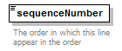
type | xs:int
properties
  content | simple
annotation
  documentation
  The order in which this line appear in the order
source | <xs:element name="sequenceNumber" type="xs:int">  <xs:annotation>  <xs:documentation>The order in which this line appear in the order</xs:documentation>  </xs:annotation>  </xs:element>

element Order/lineItems/lineItem/name
diagram | 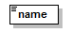
type | Name
properties
  content | simple
facets
  Kind | Value | Annotation
  minLength | 1
  maxLength | 80
  whiteSpace | collapse
source | <xs:element name="name" type="Name"/>

element Order/lineItems/lineItem/placement
diagram | 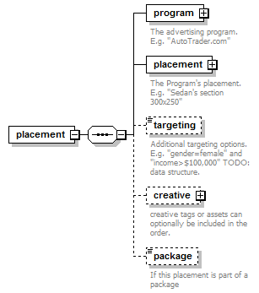
properties
  content | complex
children | program placement targeting creative package
source | <xs:element name="placement">  <xs:complexType>  <xs:sequence>  <xs:element name="program">  <xs:annotation>  <xs:documentation>The advertising program. E.g. "AutoTrader.com"</xs:documentation>  </xs:annotation>  <xs:complexType>  <xs:sequence>  <xs:element name="id" type="xs:IDREF" minOccurs="0"/>  <xs:element name="name"/>  </xs:sequence>  </xs:complexType>  </xs:element>  <xs:element name="placement" type="Placement">  <xs:annotation>  <xs:documentation>The Program's placement. E.g. "Sedan's section 300x250"</xs:documentation>  </xs:annotation>  </xs:element>  <xs:element name="targeting" minOccurs="0">  <xs:annotation>  <xs:documentation>Additional targeting options. E.g. "gender=female" and "income>$100,000" TODO: data structure.</xs:documentation>  </xs:annotation>  </xs:element>  <xs:element name="creative" minOccurs="0">  <xs:annotation>  <xs:documentation>creative tags or assets can optionally be included in the order.</xs:documentation>  </xs:annotation>  <xs:complexType>  <xs:sequence>  <xs:element name="tag" type="AdTag" minOccurs="0" maxOccurs="unbounded"/>  <xs:element name="file" type="File" minOccurs="0" maxOccurs="unbounded"/>  </xs:sequence>  </xs:complexType>  </xs:element>  <xs:element name="package" minOccurs="0">  <xs:annotation>  <xs:documentation>If this placement is part of a package</xs:documentation>  </xs:annotation>  </xs:element>  </xs:sequence>  </xs:complexType>  </xs:element>

element Order/lineItems/lineItem/placement/program
diagram | 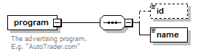
properties
  content | complex
children | id name
annotation
  documentation
  The advertising program. E.g. "AutoTrader.com"
source | <xs:element name="program">  <xs:annotation>  <xs:documentation>The advertising program. E.g. "AutoTrader.com"</xs:documentation>  </xs:annotation>  <xs:complexType>  <xs:sequence>  <xs:element name="id" type="xs:IDREF" minOccurs="0"/>  <xs:element name="name"/>  </xs:sequence>  </xs:complexType>  </xs:element>

element Order/lineItems/lineItem/placement/program/id
diagram | 
type | xs:IDREF
properties
  minOcc | 0
  maxOcc | 1
  content | simple
source | <xs:element name="id" type="xs:IDREF" minOccurs="0"/>

element Order/lineItems/lineItem/placement/program/name
diagram
source | <xs:element name="name"/>

element Order/lineItems/lineItem/placement/placement
diagram | 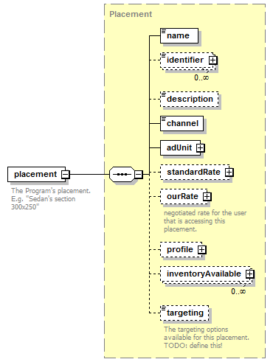
type | Placement
properties
  content | complex
children | name identifier description channel adUnit standardRate ourRate profile inventoryAvailable targeting
annotation
  documentation
  The Program's placement. E.g. "Sedan's section 300x250"
source | <xs:element name="placement" type="Placement">  <xs:annotation>  <xs:documentation>The Program's placement. E.g. "Sedan's section 300x250"</xs:documentation>  </xs:annotation>  </xs:element>

element Order/lineItems/lineItem/placement/targeting
diagram | 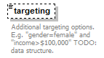
properties
  minOcc | 0
  maxOcc | 1
annotation
  documentation
  Additional targeting options. E.g. "gender=female" and "income>$100,000" TODO: data structure.
source | <xs:element name="targeting" minOccurs="0">  <xs:annotation>  <xs:documentation>Additional targeting options. E.g. "gender=female" and "income>$100,000" TODO: data structure.</xs:documentation>  </xs:annotation>  </xs:element>

element Order/lineItems/lineItem/placement/creative
diagram | 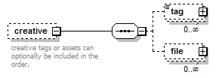
properties
  minOcc | 0
  maxOcc | 1
  content | complex
children | tag file
annotation
  documentation
  creative tags or assets can optionally be included in the order.
source | <xs:element name="creative" minOccurs="0">  <xs:annotation>  <xs:documentation>creative tags or assets can optionally be included in the order.</xs:documentation>  </xs:annotation>  <xs:complexType>  <xs:sequence>  <xs:element name="tag" type="AdTag" minOccurs="0" maxOccurs="unbounded"/>  <xs:element name="file" type="File" minOccurs="0" maxOccurs="unbounded"/>  </xs:sequence>  </xs:complexType>  </xs:element>

element Order/lineItems/lineItem/placement/creative/tag
diagram | 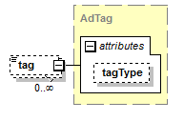
type | AdTag
properties
  minOcc | 0
  maxOcc | unbounded
  content | complex
attributes
  Name | Type | Use | Default | Fixed | Annotation
  tagType | TagType
source | <xs:element name="tag" type="AdTag" minOccurs="0" maxOccurs="unbounded"/>

element Order/lineItems/lineItem/placement/creative/file
diagram | 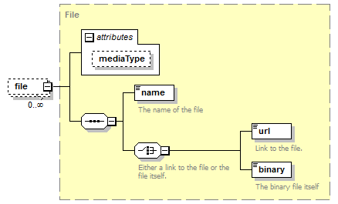
type | File
properties
  minOcc | 0
  maxOcc | unbounded
  content | complex
children | name url binary
attributes
  Name | Type | Use | Default | Fixed | Annotation
  mediaType | MediaType
source | <xs:element name="file" type="File" minOccurs="0" maxOccurs="unbounded"/>

element Order/lineItems/lineItem/placement/package
diagram | 
properties
  minOcc | 0
  maxOcc | 1
annotation
  documentation
  If this placement is part of a package
source | <xs:element name="package" minOccurs="0">  <xs:annotation>  <xs:documentation>If this placement is part of a package</xs:documentation>  </xs:annotation>  </xs:element>

element Order/lineItems/lineItem/package
diagram | 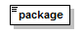
source | <xs:element name="package"/>

element Order/lineItems/lineItem/testingStartDate
diagram | 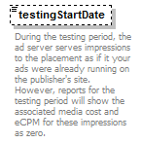
type | xs:dateTime
properties
  minOcc | 0
  maxOcc | 1
  content | simple
annotation
  documentation
  During the testing period, the ad server serves impressions to the placement as if it your ads were already running on the publisher's site. However, reports for the testing period will show the associated media cost and eCPM for these impressions as zero.
source | <xs:element name="testingStartDate" type="xs:dateTime" minOccurs="0">  <xs:annotation>  <xs:documentation>During the testing period, the ad server serves impressions to the placement as if it your ads were already running on the publisher's site. However, reports for the testing period will show the associated media cost and eCPM for these impressions as zero.</xs:documentation>  </xs:annotation>  </xs:element>

element Order/lineItems/lineItem/flightDates
diagram | 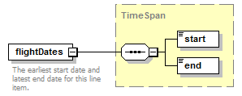
type | TimeSpan
properties
  content | complex
children | start end
annotation
  documentation
  The earliest start date and latest end date for this line item.
source | <xs:element name="flightDates" type="TimeSpan">  <xs:annotation>  <xs:documentation>The earliest start date and latest end date for this line item.</xs:documentation>  </xs:annotation>  </xs:element>

element Order/lineItems/lineItem/flights
diagram | 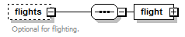
properties
  minOcc | 0
  maxOcc | 1
  content | complex
children | flight
annotation
  documentation
  Optional for flighting.
source | <xs:element name="flights" minOccurs="0">  <xs:annotation>  <xs:documentation>Optional for flighting.</xs:documentation>  </xs:annotation>  <xs:complexType>  <xs:sequence>  <xs:element name="flight">  <xs:complexType>  <xs:sequence>  <xs:element name="flightDates" type="TimeSpan" maxOccurs="unbounded"/>  <xs:element name="quantity"/>  <xs:element name="rate" type="Rate"/>  <xs:element name="amount" type="Money"/>  <xs:element name="notes" type="Note" minOccurs="0"/>  </xs:sequence>  </xs:complexType>  </xs:element>  </xs:sequence>  </xs:complexType>  </xs:element>

element Order/lineItems/lineItem/flights/flight
diagram | 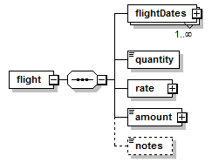
properties
  content | complex
children | flightDates quantity rate amount notes
source | <xs:element name="flight">  <xs:complexType>  <xs:sequence>  <xs:element name="flightDates" type="TimeSpan" maxOccurs="unbounded"/>  <xs:element name="quantity"/>  <xs:element name="rate" type="Rate"/>  <xs:element name="amount" type="Money"/>  <xs:element name="notes" type="Note" minOccurs="0"/>  </xs:sequence>  </xs:complexType>  </xs:element>

element Order/lineItems/lineItem/flights/flight/flightDates
diagram | 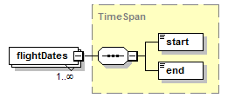
type | TimeSpan
properties
  minOcc | 1
  maxOcc | unbounded
  content | complex
children | start end
source | <xs:element name="flightDates" type="TimeSpan" maxOccurs="unbounded"/>

element Order/lineItems/lineItem/flights/flight/quantity
diagram | 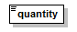
source | <xs:element name="quantity"/>

element Order/lineItems/lineItem/flights/flight/rate
diagram | 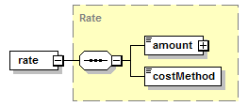
type | Rate
properties
  content | complex
children | amount costMethod
source | <xs:element name="rate" type="Rate"/>

element Order/lineItems/lineItem/flights/flight/amount
diagram | 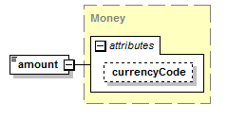
type | Money
properties
  content | complex
attributes
  Name | Type | Use | Default | Fixed | Annotation
  currencyCode | CurrencyCode |  | USD
source | <xs:element name="amount" type="Money"/>

element Order/lineItems/lineItem/flights/flight/notes
diagram | 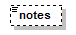
type | Note
properties
  minOcc | 0
  maxOcc | 1
  content | simple
facets
  Kind | Value | Annotation
  whiteSpace | preserve
source | <xs:element name="notes" type="Note" minOccurs="0"/>

element Order/lineItems/lineItem/quantity
diagram | 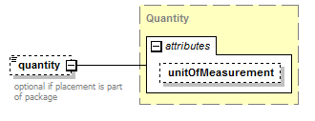
type | Quantity
properties
  minOcc | 0
  maxOcc | 1
  content | complex
attributes
  Name | Type | Use | Default | Fixed | Annotation
  unitOfMeasurement | UnitOfMeasurement
annotation
  documentation
  optional if placement is part of package
source | <xs:element name="quantity" type="Quantity" minOccurs="0">  <xs:annotation>  <xs:documentation>optional if placement is part of package</xs:documentation>  </xs:annotation>  </xs:element>

element Order/lineItems/lineItem/rate
diagram | 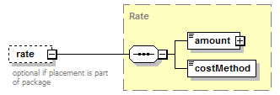
type | Rate
properties
  minOcc | 0
  maxOcc | 1
  content | complex
children | amount costMethod
annotation
  documentation
  optional if placement is part of package
source | <xs:element name="rate" type="Rate" minOccurs="0">  <xs:annotation>  <xs:documentation>optional if placement is part of package</xs:documentation>  </xs:annotation>  </xs:element>

element Order/lineItems/lineItem/amount
diagram | 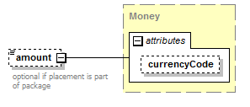
type | Money
properties
  minOcc | 0
  maxOcc | 1
  content | complex
attributes
  Name | Type | Use | Default | Fixed | Annotation
  currencyCode | CurrencyCode |  | USD
annotation
  documentation
  optional if placement is part of package
source | <xs:element name="amount" type="Money" minOccurs="0">  <xs:annotation>  <xs:documentation>optional if placement is part of package</xs:documentation>  </xs:annotation>  </xs:element>

element Order/lineItems/lineItem/isGuaranteed
diagram | 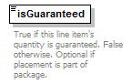
type | xs:boolean
properties
  content | simple
annotation
  documentation
  True if this line item's quantity is guaranteed. False otherwise. Optional if placement is part of package.
source | <xs:element name="isGuaranteed" type="xs:boolean">  <xs:annotation>  <xs:documentation>True if this line item's quantity is guaranteed. False otherwise. Optional if placement is part of package.</xs:documentation>  </xs:annotation>  </xs:element>

element Order/lineItems/lineItem/notes
diagram
type | Note
properties
  minOcc | 0
  maxOcc | 1
  content | simple
facets
  Kind | Value | Annotation
  whiteSpace | preserve
source | <xs:element name="notes" type="Note" minOccurs="0"/>

element Order/lineItems/lineItem/identifiers
diagram | 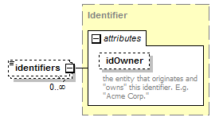
type | Identifier
properties
  minOcc | 0
  maxOcc | unbounded
  content | complex
attributes
  Name | Type | Use | Default | Fixed | Annotation
  idOwner | Name
    documentation
    the entity that originates and "owns" this identifier. E.g. "Acme Corp."
source | <xs:element name="identifiers" type="Identifier" minOccurs="0" maxOccurs="unbounded"/>

element Order/flightDates
diagram | 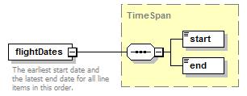
type | TimeSpan
properties
  content | complex
children | start end
annotation
  documentation
  The earliest start date and the latest end date for all line items in this order.
source | <xs:element name="flightDates" type="TimeSpan">  <xs:annotation>  <xs:documentation>The earliest start date and the latest end date for all line items in this order.</xs:documentation>  </xs:annotation>  </xs:element>

element Order/amount
diagram
type | Money
properties
  content | complex
attributes
  Name | Type | Use | Default | Fixed | Annotation
  currencyCode | CurrencyCode |  | USD
source | <xs:element name="amount" type="Money"/>

element Order/terms
diagram | 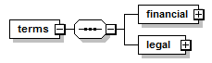
properties
  content | complex
children | financial legal
source | <xs:element name="terms">  <xs:complexType>  <xs:sequence>  <xs:element name="financial">  <xs:complexType>  <xs:sequence>  <xs:element name="paymentTerms" type="PaymentTerms"/>  <xs:element name="billingFrequency" default="monthly">  <xs:simpleType>  <xs:restriction base="xs:string">  <xs:enumeration value="weekly"/>  <xs:enumeration value="monthly"/>  <xs:enumeration value="quarterly"/>  </xs:restriction>  </xs:simpleType>  </xs:element>  <xs:element name="systemOfRecord" default="advertiser">  <xs:simpleType>  <xs:restriction base="xs:string">  <xs:enumeration value="advertiser"/>  <xs:enumeration value="publisher"/>  </xs:restriction>  </xs:simpleType>  </xs:element>  <xs:element name="agencyCommission" type="Discount" minOccurs="0"/>  <xs:element name="discount" type="Discount" minOccurs="0" maxOccurs="unbounded"/>  <xs:element name="notes" type="Note" minOccurs="0"/>  </xs:sequence>  </xs:complexType>  </xs:element>  <xs:element name="legal" type="LegalTerms"/>  </xs:sequence>  </xs:complexType>  </xs:element>

element Order/terms/financial
diagram | 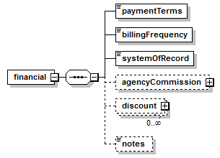
properties
  content | complex
children | paymentTerms billingFrequency systemOfRecord agencyCommission discount notes
source | <xs:element name="financial">  <xs:complexType>  <xs:sequence>  <xs:element name="paymentTerms" type="PaymentTerms"/>  <xs:element name="billingFrequency" default="monthly">  <xs:simpleType>  <xs:restriction base="xs:string">  <xs:enumeration value="weekly"/>  <xs:enumeration value="monthly"/>  <xs:enumeration value="quarterly"/>  </xs:restriction>  </xs:simpleType>  </xs:element>  <xs:element name="systemOfRecord" default="advertiser">  <xs:simpleType>  <xs:restriction base="xs:string">  <xs:enumeration value="advertiser"/>  <xs:enumeration value="publisher"/>  </xs:restriction>  </xs:simpleType>  </xs:element>  <xs:element name="agencyCommission" type="Discount" minOccurs="0"/>  <xs:element name="discount" type="Discount" minOccurs="0" maxOccurs="unbounded"/>  <xs:element name="notes" type="Note" minOccurs="0"/>  </xs:sequence>  </xs:complexType>  </xs:element>

element Order/terms/financial/paymentTerms
diagram | 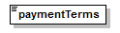
type | PaymentTerms
properties
  content | simple
facets
  Kind | Value | Annotation
  enumeration | Advance
  enumeration | Net15
  enumeration | Net30
  enumeration | Net60
  enumeration | EndOfContract
source | <xs:element name="paymentTerms" type="PaymentTerms"/>

element Order/terms/financial/billingFrequency
diagram | 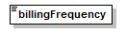
type | restriction of xs:string
properties
  content | simple
  default | monthly
facets
  Kind | Value | Annotation
  enumeration | weekly
  enumeration | monthly
  enumeration | quarterly
source | <xs:element name="billingFrequency" default="monthly">  <xs:simpleType>  <xs:restriction base="xs:string">  <xs:enumeration value="weekly"/>  <xs:enumeration value="monthly"/>  <xs:enumeration value="quarterly"/>  </xs:restriction>  </xs:simpleType>  </xs:element>

element Order/terms/financial/systemOfRecord
diagram | 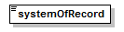
type | restriction of xs:string
properties
  content | simple
  default | advertiser
facets
  Kind | Value | Annotation
  enumeration | advertiser
  enumeration | publisher
source | <xs:element name="systemOfRecord" default="advertiser">  <xs:simpleType>  <xs:restriction base="xs:string">  <xs:enumeration value="advertiser"/>  <xs:enumeration value="publisher"/>  </xs:restriction>  </xs:simpleType>  </xs:element>

element Order/terms/financial/agencyCommission
diagram | 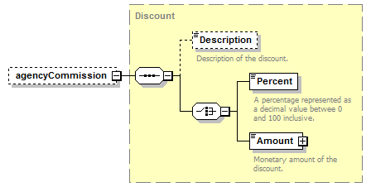
type | Discount
properties
  minOcc | 0
  maxOcc | 1
  content | complex
children | Description Percent Amount
source | <xs:element name="agencyCommission" type="Discount" minOccurs="0"/>

element Order/terms/financial/discount
diagram | 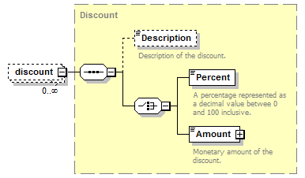
type | Discount
properties
  minOcc | 0
  maxOcc | unbounded
  content | complex
children | Description Percent Amount
source | <xs:element name="discount" type="Discount" minOccurs="0" maxOccurs="unbounded"/>

element Order/terms/financial/notes
diagram
type | Note
properties
  minOcc | 0
  maxOcc | 1
  content | simple
facets
  Kind | Value | Annotation
  whiteSpace | preserve
source | <xs:element name="notes" type="Note" minOccurs="0"/>

element Order/terms/legal
diagram | 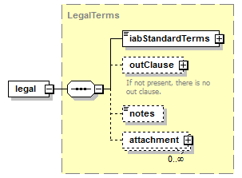
type | LegalTerms
properties
  content | complex
children | iabStandardTerms outClause notes attachment
source | <xs:element name="legal" type="LegalTerms"/>

element Order/notes
diagram
type | Note
properties
  minOcc | 0
  maxOcc | 1
  content | simple
facets
  Kind | Value | Annotation
  whiteSpace | preserve
source | <xs:element name="notes" type="Note" minOccurs="0"/>

element Order/systemInfo
diagram | 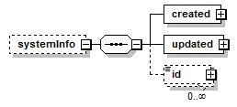
properties
  minOcc | 0
  maxOcc | 1
  content | complex
children | created updated id
source | <xs:element name="systemInfo" minOccurs="0">  <xs:complexType>  <xs:sequence>  <xs:element name="created" type="DocumentSource"/>  <xs:element name="updated" type="DocumentSource"/>  <xs:element name="id" type="Identifier" minOccurs="0" maxOccurs="unbounded"/>  </xs:sequence>  </xs:complexType>  </xs:element>

element Order/systemInfo/created
diagram | 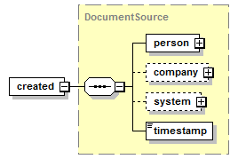
type | DocumentSource
properties
  content | complex
children | person company system timestamp
source | <xs:element name="created" type="DocumentSource"/>

element Order/systemInfo/updated
diagram | 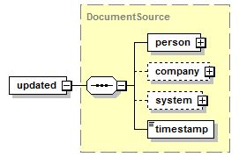
type | DocumentSource
properties
  content | complex
children | person company system timestamp
source | <xs:element name="updated" type="DocumentSource"/>

element Order/systemInfo/id
diagram | 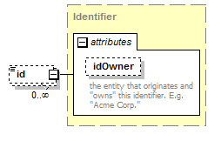
type | Identifier
properties
  minOcc | 0
  maxOcc | unbounded
  content | complex
attributes
  Name | Type | Use | Default | Fixed | Annotation
  idOwner | Name
    documentation
    the entity that originates and "owns" this identifier. E.g. "Acme Corp."
source | <xs:element name="id" type="Identifier" minOccurs="0" maxOccurs="unbounded"/>

simpleType PackageType
type | restriction of xs:string
properties
  base | xs:string
facets
  Kind | Value | Annotation
  enumeration | standard
    documentation
    A standard package can be used to group any placements in a cost strategy together. Cost will be attributed identically across all impressions within the Package, regardless of which placement received the impression.
  enumeration | roadblock
    documentation
    A roadblock placement is typically a group of placements that are all served on a webpage together. Cost information will be associated whenever any or all placements in the Roadblock receive an impression.
source | <xs:simpleType name="PackageType">  <xs:restriction base="xs:string">  <xs:enumeration value="standard">  <xs:annotation>  <xs:documentation>A standard package can be used to group any placements in a cost strategy together. Cost will be attributed identically across all impressions within the Package, regardless of which placement received the impression.</xs:documentation>  </xs:annotation>  </xs:enumeration>  <xs:enumeration value="roadblock">  <xs:annotation>  <xs:documentation>A roadblock placement is typically a group of placements that are all served on a webpage together. Cost information will be associated whenever any or all placements in the Roadblock receive an impression.</xs:documentation>  </xs:annotation>  </xs:enumeration>  </xs:restriction>  </xs:simpleType>

complexType AdTag
diagram | 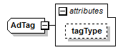
type | extension of xs:string
properties
  base | xs:string
used by
  element | Order/lineItems/lineItem/placement/creative/tag
attributes
  Name | Type | Use | Default | Fixed | Annotation
  tagType | TagType
source | <xs:complexType name="AdTag">  <xs:simpleContent>  <xs:extension base="xs:string">  <xs:attribute name="tagType" type="TagType"/>  </xs:extension>  </xs:simpleContent>  </xs:complexType>

attribute AdTag/@tagType
type | TagType
facets
  Kind | Value | Annotation
  enumeration | Standard
    documentation
    Only able to serve static images (no flash)
  enumeration | Iframe/Javascript
    documentation
    The most commonly used tag type. It can serve both static and flash creative units.
  enumeration | Internal Redirect
    documentation
    Only used to serve DFA ads on sites that also use the Doubleclick for Publishers platform. These tags are considered the most efficient to traffic and typically result in very few discrepancies.
  enumeration | JavaScript/Standard
    documentation
    Can deliver both static and rich media creative units. Useful for complex sites and/or sites that do not wish to use iFrames
  enumeration | Click Tracker
    documentation
    Used only to record clicks. Used on text links, links in emails or other elements on a website.
source | <xs:attribute name="tagType" type="TagType"/>

complexType AdUnit
diagram | 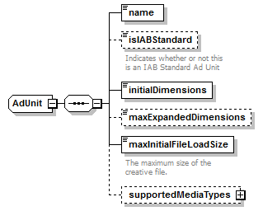
children | name isIABStandard initialDimensions maxExpandedDimensions maxInitialFileLoadSize supportedMediaTypes
used by
  element | Placement/adUnit
source | <xs:complexType name="AdUnit">  <xs:sequence>  <xs:element name="name"/>  <xs:element name="isIABStandard" type="xs:boolean" minOccurs="0">  <xs:annotation>  <xs:documentation>Indicates whether or not this is an IAB Standard Ad Unit</xs:documentation>  </xs:annotation>  </xs:element>  <xs:element name="initialDimensions"/>  <xs:element name="maxExpandedDimensions" minOccurs="0"/>  <xs:element name="maxInitialFileLoadSize">  <xs:annotation>  <xs:documentation>The maximum size of the creative file.</xs:documentation>  </xs:annotation>  </xs:element>  <xs:element name="supportedMediaTypes" minOccurs="0">  <xs:complexType>  <xs:sequence>  <xs:element name="mediaType" type="MediaType" minOccurs="0" maxOccurs="unbounded"/>  </xs:sequence>  </xs:complexType>  </xs:element>  </xs:sequence>  </xs:complexType>

element AdUnit/name
diagram
source | <xs:element name="name"/>

element AdUnit/isIABStandard
diagram | 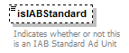
type | xs:boolean
properties
  minOcc | 0
  maxOcc | 1
  content | simple
annotation
  documentation
  Indicates whether or not this is an IAB Standard Ad Unit
source | <xs:element name="isIABStandard" type="xs:boolean" minOccurs="0">  <xs:annotation>  <xs:documentation>Indicates whether or not this is an IAB Standard Ad Unit</xs:documentation>  </xs:annotation>  </xs:element>

element AdUnit/initialDimensions
diagram | 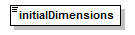
source | <xs:element name="initialDimensions"/>

element AdUnit/maxExpandedDimensions
diagram | 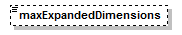
properties
  minOcc | 0
  maxOcc | 1
source | <xs:element name="maxExpandedDimensions" minOccurs="0"/>

element AdUnit/maxInitialFileLoadSize
diagram | 
annotation
  documentation
  The maximum size of the creative file.
source | <xs:element name="maxInitialFileLoadSize">  <xs:annotation>  <xs:documentation>The maximum size of the creative file.</xs:documentation>  </xs:annotation>  </xs:element>

element AdUnit/supportedMediaTypes
diagram | 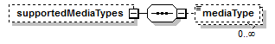
properties
  minOcc | 0
  maxOcc | 1
  content | complex
children | mediaType
source | <xs:element name="supportedMediaTypes" minOccurs="0">  <xs:complexType>  <xs:sequence>  <xs:element name="mediaType" type="MediaType" minOccurs="0" maxOccurs="unbounded"/>  </xs:sequence>  </xs:complexType>  </xs:element>

element AdUnit/supportedMediaTypes/mediaType
diagram | 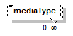
type | MediaType
properties
  minOcc | 0
  maxOcc | unbounded
  content | simple
facets
  Kind | Value | Annotation
  enumeration | image/gif
    documentation
    GIF image; Defined in RFC 2045 and RFC 2046
  enumeration | image/jpeg
    documentation
    JPEG JFIF image; Defined in RFC 2045 and RFC 2046
  enumeration | image/pjpeg
    documentation
    JPEG JFIF image; Associated with Internet Explorer; Listed in ms775147(v=vs.85) - Progressive JPEG, initiated before global browser support for progressive JPEGs (Microsoft and Firefox).
  enumeration | image/png
    documentation
    Portable Network Graphics; Registered,[10] Defined in RFC 2083
  enumeration | image/svg+xml
    documentation
    SVG vector image; Defined in SVG Tiny 1.2 Specification Appendix M
  enumeration | image/tiff
    documentation
    Tag Image File Format (only for Baseline TIFF); Defined in RFC 3302
  enumeration | audio/basic
    documentation
    μ-law audio at 8 kHz, 1 channel; Defined in RFC 2046
  enumeration | audio/L24
    documentation
    24bit Linear PCM audio at 8–48 kHz, 1-N channels; Defined in RFC 3190
  enumeration | audio/mp4
    documentation
    MP4 audio
  enumeration | audio/mpeg
    documentation
    MP3 or other MPEG audio; Defined in RFC 3003
  enumeration | audio/ogg
    documentation
    Ogg Vorbis, Speex, Flac and other audio; Defined in RFC 5334
  enumeration | audio/vorbis
    documentation
    Vorbis encoded audio; Defined in RFC 5215
  enumeration | audio/vnd.rn-realaudio
    documentation
    RealAudio; Documented in RealPlayer Help[9]
  enumeration | audio/vnd.wave
    documentation
    WAV audio; Defined in RFC 2361
  enumeration | audio/webm
    documentation
    WebM open media format
  enumeration | video/mpeg
    documentation
    MPEG-1 video with multiplexed audio; Defined in RFC 2045 and RFC 2046
  enumeration | video/mp4
    documentation
    MP4 video; Defined in RFC 4337
  enumeration | video/ogg
    documentation
    Ogg Theora or other video (with audio); Defined in RFC 5334
  enumeration | video/quicktime
    documentation
    QuickTime video; Registered[11]
  enumeration | video/webm
    documentation
    WebM Matroska-based open media format
  enumeration | video/x-matroska
    documentation
    Matroska open media format
  enumeration | video/x-ms-wmv
    documentation
    Windows Media Video; Documented in Microsoft KB 288102
  enumeration | video/x-flv
    documentation
    Flash video (FLV files)
  enumeration | application/atom+xml
    documentation
    Atom feeds
  enumeration | application/ecmascript
    documentation
    ECMAScript/JavaScript; Defined in RFC 4329 (equivalent to application/javascript but with stricter processing rules)
  enumeration | application/EDI-X12
    documentation
    EDI X12 data; Defined in RFC 1767
  enumeration | application/EDIFACT
    documentation
    EDI EDIFACT data; Defined in RFC 1767
  enumeration | application/json
    documentation
    JavaScript Object Notation JSON; Defined in RFC 4627
  enumeration | application/javascript
    documentation
    ECMAScript/JavaScript; Defined in RFC 4329 (equivalent to application/ecmascript but with looser processing rules) It is not accepted in IE 8 or earlier - text/javascript is accepted but it is defined as obsolete in RFC 4329. The "type" attribute of the script tag in HTML5 is optional. In practice, omitting the media type of JavaScript programs is the most interoperable solution, since all browsers have always assumed the correct default even before HTML5.
  enumeration | application/octet-stream
    documentation
    Arbitrary binary data.[6] Generally speaking this type identifies files that are not associated with a specific application. Contrary to past assumptions by software packages such as Apache this is not a type that should be applied to unknown files. In such a case, a server or application should not indicate a content type, as it may be incorrect, but rather, should omit the type in order to allow the recipient to guess the type.[7]
  enumeration | application/ogg
    documentation
    Ogg, a multimedia bitstream container format; Defined in RFC 5334
  enumeration | application/pdf
    documentation
    Portable Document Format, PDF has been in use for document exchange on the Internet since 1993; Defined in RFC 3778
  enumeration | application/postscript
    documentation
    PostScript; Defined in RFC 2046
  enumeration | application/rdf+xml
    documentation
    Resource Description Framework; Defined by RFC 3870
  enumeration | application/rss+xml
    documentation
    RSS feeds
  enumeration | application/soap+xml
    documentation
    SOAP; Defined by RFC 3902
  enumeration | application/font-woff
    documentation
    Web Open Font Format; (candidate recommendation; use application/x-font-woff until standard is official)
  enumeration | application/xhtml+xml
    documentation
    XHTML; Defined by RFC 3236
  enumeration | application/xml
    documentation
    XML files; Defined by RFC 3023
  enumeration | application/xml-dtd
    documentation
    DTD files; Defined by RFC 3023
  enumeration | application/xop+xml
    documentation
    XOP
  enumeration | application/zip
    documentation
    ZIP archive files; Registered[8]
  enumeration | application/gzip
    documentation
    Gzip, Defined in RFC 6713
  enumeration | message/http
    documentation
    Defined in RFC 2616
  enumeration | message/imdn+xml
    documentation
    IMDN Instant Message Disposition Notification; Defined in RFC 5438
  enumeration | message/partial
    documentation
    Email; Defined in RFC 2045 and RFC 2046
  enumeration | message/rfc822
    documentation
    Email; EML files, MIME files, MHT files, MHTML files; Defined in RFC 2045 and RFC 2046
  enumeration | model/iges
    documentation
    IGS files, IGES files; Defined in RFC 2077
  enumeration | model/mesh
    documentation
    MSH files, MESH files; Defined in RFC 2077, SILO files
  enumeration | model/vrml
    documentation
    WRL files, VRML files; Defined in RFC 2077
  enumeration | model/x3d+binary
    documentation
    X3D ISO standard for representing 3D computer graphics, X3DB binary files - never Internet Assigned Numbers Authority approved
  enumeration | model/x3d+fastinfoset
    documentation
    X3D ISO standard for representing 3D computer graphics, X3DB binary files (application in process, this replaces any use of model/x3d+binary)
  enumeration | model/x3d-vrml
    documentation
    X3D ISO standard for representing 3D computer graphics, X3DV VRML files (application in process, previous uses may have been model/x3d+vrml)
  enumeration | model/x3d+xml
    documentation
    X3D ISO standard for representing 3D computer graphics, X3D XML files
  enumeration | multipart/mixed
    documentation
    MIME Email; Defined in RFC 2045 and RFC 2046
  enumeration | multipart/alternative
    documentation
    MIME Email; Defined in RFC 2045 and RFC 2046
  enumeration | multipart/related
    documentation
    MIME Email; Defined in RFC 2387 and used by MHTML (HTML mail)
  enumeration | multipart/form-data
    documentation
    MIME Webform; Defined in RFC 2388
  enumeration | multipart/signed
    documentation
    Defined in RFC 1847
  enumeration | multipart/encrypted
    documentation
    Defined in RFC 1847
  enumeration | text/cmd
    documentation
    commands; subtype resident in Gecko browsers like Firefox 3.5
  enumeration | text/css
    documentation
    Cascading Style Sheets; Defined in RFC 2318
  enumeration | text/csv
    documentation
    Comma-separated values; Defined in RFC 4180
  enumeration | text/html
    documentation
    HTML; Defined in RFC 2854
  enumeration | text/javascript (Obsolete)
    documentation
    JavaScript; Defined in and made obsolete in RFC 4329 in order to discourage its usage in favor of application/javascript. However, text/javascript is allowed in HTML 4 and 5 and, unlike application/javascript, has cross-browser support. The "type" attribute of the script tag in HTML5 is optional and there is no need to use it at all since all browsers have always assumed the correct default (even in HTML 4 where it was required by the specification).
  enumeration | text/plain
    documentation
    Textual data; Defined in RFC 2046 and RFC 3676
  enumeration | text/vcard
    documentation
    vCard (contact information); Defined in RFC 6350
  enumeration | text/xml
    documentation
    Extensible Markup Language; Defined in RFC 3023
  enumeration | application/vnd.oasis.opendocument.text
    documentation
    OpenDocument Text; Registered[12]
  enumeration | application/vnd.oasis.opendocument.spreadsheet
    documentation
    OpenDocument Spreadsheet; Registered[13]
  enumeration | application/vnd.oasis.opendocument.presentation
    documentation
    OpenDocument Presentation; Registered[14]
  enumeration | application/vnd.oasis.opendocument.graphics
    documentation
    OpenDocument Graphics; Registered[15]
  enumeration | application/vnd.ms-excel
    documentation
    Microsoft Excel files
  enumeration | application/vnd.openxmlformats-officedocument.spreadsheetml.sheet
    documentation
    Microsoft Excel 2007 files
  enumeration | application/vnd.ms-powerpoint
    documentation
    Microsoft Powerpoint files
  enumeration | application/vnd.openxmlformats-officedocument.presentationml.presentation
    documentation
    Microsoft Powerpoint 2007 files
  enumeration | application/vnd.openxmlformats-officedocument.wordprocessingml.document
    documentation
    Microsoft Word 2007 files
  enumeration | application/vnd.mozilla.xul+xml
    documentation
    Mozilla XUL files
  enumeration | application/vnd.google-earth.kml+xml
    documentation
    KML files (e.g. for Google Earth)[16]
  enumeration | application/vnd.google-earth.kmz
    documentation
    KMZ files (e.g. for Google Earth)[17]
  enumeration | application/vnd.dart
    documentation
    Dart files [18]
  enumeration | application/vnd.android.package-archive
    documentation
    For download apk files.
  enumeration | application/vnd.ms-xpsdocument
    documentation
    XPS document[19]
  enumeration | application/x-7z-compressed
    documentation
    7-Zip compression format.
  enumeration | application/x-deb
    documentation
    deb (file format), a software package format used by the Debian project
  enumeration | application/x-dvi
    documentation
    device-independent document in DVI format
  enumeration | application/x-font-ttf
    documentation
    TrueType Font No registered MIME type, but this is the most commonly used
  enumeration | application/x-javascript
  enumeration | application/x-latex
    documentation
    LaTeX files
  enumeration | application/x-mpegURL
    documentation
    .m3u8 variant playlist
  enumeration | application/x-rar-compressed
    documentation
    RAR archive files
  enumeration | application/x-shockwave-flash
    documentation
    Adobe Flash files for example with the extension .swf
  enumeration | application/x-stuffit
    documentation
    StuffIt archive files
  enumeration | application/x-tar
    documentation
    Tarball files
  enumeration | application/x-www-form-urlencoded
    documentation
    Form Encoded Data; Documented in HTML 4.01 Specification, Section 17.13.4.1
  enumeration | application/x-xpinstall
    documentation
    Add-ons to Mozilla applications (Firefox, Thunderbird, SeaMonkey, and the discontinued Sunbird)
  enumeration | audio/x-aac
    documentation
    .aac audio files
  enumeration | audio/x-caf
    documentation
    Apple's CAF audio files
  enumeration | image/x-xcf
    documentation
    GIMP image file
  enumeration | text/x-gwt-rpc
    documentation
    GoogleWebToolkit data
  enumeration | text/x-jquery-tmpl
    documentation
    jQuery template data
  enumeration | text/x-markdown
    documentation
    Markdown formatted text
  enumeration | application/x-pkcs12
    documentation
    a variant of PKCS standard files
source | <xs:element name="mediaType" type="MediaType" minOccurs="0" maxOccurs="unbounded"/>

complexType AudienceProfile
diagram | 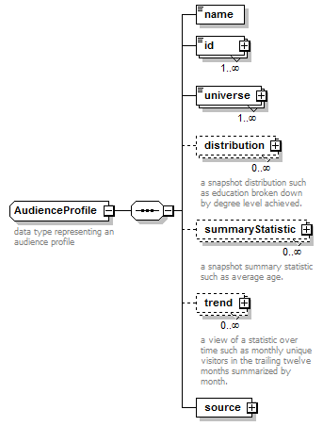
children | name id universe distribution summaryStatistic trend source
used by
  elements | Program/profile Placement/profile
annotation
  documentation
  data type representing an audience profile
source | <xs:complexType name="AudienceProfile">  <xs:annotation>  <xs:documentation>data type representing an audience profile</xs:documentation>  </xs:annotation>  <xs:sequence>  <xs:element name="name" type="Name"/>  <xs:element name="id" type="Identifier" maxOccurs="unbounded"/>  <xs:element name="universe" type="Quantity" maxOccurs="unbounded"/>  <xs:element name="distribution" minOccurs="0" maxOccurs="unbounded">  <xs:annotation>  <xs:documentation>a snapshot distribution such as education broken down by degree level achieved.</xs:documentation>  </xs:annotation>  <xs:complexType>  <xs:sequence>  <xs:element name="name" type="Name">  <xs:annotation>  <xs:documentation>The name of the dimension. E.g. "Education"</xs:documentation>  </xs:annotation>  </xs:element>  <xs:element name="value" maxOccurs="unbounded">  <xs:annotation>  <xs:documentation>Each dimension can have many values.</xs:documentation>  </xs:annotation>  <xs:complexType>  <xs:sequence>  <xs:element name="name" type="Name">  <xs:annotation>  <xs:documentation>The name of the value E.g. "College Graduate"</xs:documentation>  </xs:annotation>  </xs:element>  <xs:element name="percent" type="Percentage" minOccurs="0">  <xs:annotation>  <xs:documentation>The percentage of the universe represented by this value.</xs:documentation>  </xs:annotation>  </xs:element>  <xs:element name="index" type="IndexedValue" minOccurs="0"/>  <xs:element name="quantity" type="Quantity" minOccurs="0" maxOccurs="unbounded"/>  </xs:sequence>  </xs:complexType>  </xs:element>  </xs:sequence>  </xs:complexType>  </xs:element>  <xs:element name="summaryStatistic" type="SummaryStatistic" minOccurs="0" maxOccurs="unbounded">  <xs:annotation>  <xs:documentation>a snapshot summary statistic such as average age.</xs:documentation>  </xs:annotation>  </xs:element>  <xs:element name="trend" minOccurs="0" maxOccurs="unbounded">  <xs:annotation>  <xs:documentation>a view of a statistic over time such as monthly unique visitors in the trailing twelve months summarized by month.</xs:documentation>  </xs:annotation>  <xs:complexType>  <xs:sequence>  <xs:element name="name" type="Name">  <xs:annotation>  <xs:documentation>The name of the statistic in the trend. E.g. monthly unique visitors.</xs:documentation>  </xs:annotation>  </xs:element>  <xs:element name="granularity">  <xs:annotation>  <xs:documentation>The granularity of the trend. E.g. monthly.</xs:documentation>  </xs:annotation>  <xs:simpleType>  <xs:restriction base="xs:string">  <xs:enumeration value="hourly"/>  <xs:enumeration value="daily"/>  <xs:enumeration value="weekly"/>  <xs:enumeration value="monthly"/>  <xs:enumeration value="quarterly"/>  <xs:enumeration value="annually"/>  </xs:restriction>  </xs:simpleType>  </xs:element>  <xs:element name="dataPoint">  <xs:complexType>  <xs:sequence>  <xs:element name="timePeriod" type="TimeSpan"/>  <xs:element name="summaryStatistic" type="SummaryStatistic"/>  </xs:sequence>  </xs:complexType>  </xs:element>  </xs:sequence>  </xs:complexType>  </xs:element>  <xs:element name="source" type="DocumentSource"/>  </xs:sequence>  </xs:complexType>

element AudienceProfile/name
diagram
type | Name
properties
  content | simple
facets
  Kind | Value | Annotation
  minLength | 1
  maxLength | 80
  whiteSpace | collapse
source | <xs:element name="name" type="Name"/>

element AudienceProfile/id
diagram | 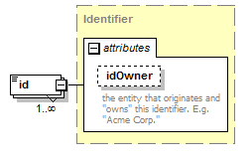
type | Identifier
properties
  minOcc | 1
  maxOcc | unbounded
  content | complex
attributes
  Name | Type | Use | Default | Fixed | Annotation
  idOwner | Name
    documentation
    the entity that originates and "owns" this identifier. E.g. "Acme Corp."
source | <xs:element name="id" type="Identifier" maxOccurs="unbounded"/>

element AudienceProfile/universe
diagram | 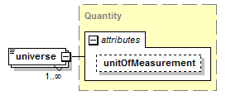
type | Quantity
properties
  minOcc | 1
  maxOcc | unbounded
  content | complex
attributes
  Name | Type | Use | Default | Fixed | Annotation
  unitOfMeasurement | UnitOfMeasurement
source | <xs:element name="universe" type="Quantity" maxOccurs="unbounded"/>

element AudienceProfile/distribution
diagram | 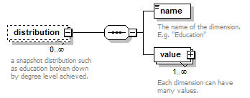
properties
  minOcc | 0
  maxOcc | unbounded
  content | complex
children | name value
annotation
  documentation
  a snapshot distribution such as education broken down by degree level achieved.
source | <xs:element name="distribution" minOccurs="0" maxOccurs="unbounded">  <xs:annotation>  <xs:documentation>a snapshot distribution such as education broken down by degree level achieved.</xs:documentation>  </xs:annotation>  <xs:complexType>  <xs:sequence>  <xs:element name="name" type="Name">  <xs:annotation>  <xs:documentation>The name of the dimension. E.g. "Education"</xs:documentation>  </xs:annotation>  </xs:element>  <xs:element name="value" maxOccurs="unbounded">  <xs:annotation>  <xs:documentation>Each dimension can have many values.</xs:documentation>  </xs:annotation>  <xs:complexType>  <xs:sequence>  <xs:element name="name" type="Name">  <xs:annotation>  <xs:documentation>The name of the value E.g. "College Graduate"</xs:documentation>  </xs:annotation>  </xs:element>  <xs:element name="percent" type="Percentage" minOccurs="0">  <xs:annotation>  <xs:documentation>The percentage of the universe represented by this value.</xs:documentation>  </xs:annotation>  </xs:element>  <xs:element name="index" type="IndexedValue" minOccurs="0"/>  <xs:element name="quantity" type="Quantity" minOccurs="0" maxOccurs="unbounded"/>  </xs:sequence>  </xs:complexType>  </xs:element>  </xs:sequence>  </xs:complexType>  </xs:element>

element AudienceProfile/distribution/name
diagram | 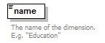
type | Name
properties
  content | simple
facets
  Kind | Value | Annotation
  minLength | 1
  maxLength | 80
  whiteSpace | collapse
annotation
  documentation
  The name of the dimension. E.g. "Education"
source | <xs:element name="name" type="Name">  <xs:annotation>  <xs:documentation>The name of the dimension. E.g. "Education"</xs:documentation>  </xs:annotation>  </xs:element>

element AudienceProfile/distribution/value
diagram | 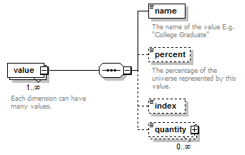
properties
  minOcc | 1
  maxOcc | unbounded
  content | complex
children | name percent index quantity
annotation
  documentation
  Each dimension can have many values.
source | <xs:element name="value" maxOccurs="unbounded">  <xs:annotation>  <xs:documentation>Each dimension can have many values.</xs:documentation>  </xs:annotation>  <xs:complexType>  <xs:sequence>  <xs:element name="name" type="Name">  <xs:annotation>  <xs:documentation>The name of the value E.g. "College Graduate"</xs:documentation>  </xs:annotation>  </xs:element>  <xs:element name="percent" type="Percentage" minOccurs="0">  <xs:annotation>  <xs:documentation>The percentage of the universe represented by this value.</xs:documentation>  </xs:annotation>  </xs:element>  <xs:element name="index" type="IndexedValue" minOccurs="0"/>  <xs:element name="quantity" type="Quantity" minOccurs="0" maxOccurs="unbounded"/>  </xs:sequence>  </xs:complexType>  </xs:element>

element AudienceProfile/distribution/value/name
diagram | 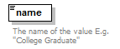
type | Name
properties
  content | simple
facets
  Kind | Value | Annotation
  minLength | 1
  maxLength | 80
  whiteSpace | collapse
annotation
  documentation
  The name of the value E.g. "College Graduate"
source | <xs:element name="name" type="Name">  <xs:annotation>  <xs:documentation>The name of the value E.g. "College Graduate"</xs:documentation>  </xs:annotation>  </xs:element>

element AudienceProfile/distribution/value/percent
diagram | 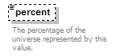
type | Percentage
properties
  minOcc | 0
  maxOcc | 1
  content | simple
facets
  Kind | Value | Annotation
  minInclusive | 0
  maxInclusive | 100
  totalDigits | 5
  fractionDigits | 2
annotation
  documentation
  The percentage of the universe represented by this value.
source | <xs:element name="percent" type="Percentage" minOccurs="0">  <xs:annotation>  <xs:documentation>The percentage of the universe represented by this value.</xs:documentation>  </xs:annotation>  </xs:element>

element AudienceProfile/distribution/value/index
diagram | 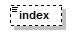
type | IndexedValue
properties
  minOcc | 0
  maxOcc | 1
  content | simple
source | <xs:element name="index" type="IndexedValue" minOccurs="0"/>

element AudienceProfile/distribution/value/quantity
diagram | 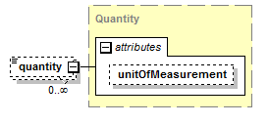
type | Quantity
properties
  minOcc | 0
  maxOcc | unbounded
  content | complex
attributes
  Name | Type | Use | Default | Fixed | Annotation
  unitOfMeasurement | UnitOfMeasurement
source | <xs:element name="quantity" type="Quantity" minOccurs="0" maxOccurs="unbounded"/>

element AudienceProfile/summaryStatistic
diagram | 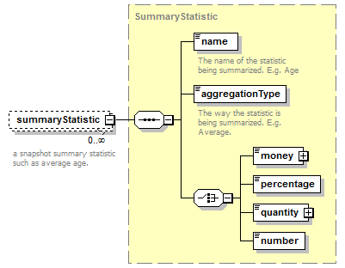
type | SummaryStatistic
properties
  minOcc | 0
  maxOcc | unbounded
  content | complex
children | name aggregationType money percentage quantity number
annotation
  documentation
  a snapshot summary statistic such as average age.
source | <xs:element name="summaryStatistic" type="SummaryStatistic" minOccurs="0" maxOccurs="unbounded">  <xs:annotation>  <xs:documentation>a snapshot summary statistic such as average age.</xs:documentation>  </xs:annotation>  </xs:element>

element AudienceProfile/trend
diagram | 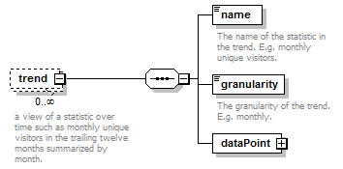
properties
  minOcc | 0
  maxOcc | unbounded
  content | complex
children | name granularity dataPoint
annotation
  documentation
  a view of a statistic over time such as monthly unique visitors in the trailing twelve months summarized by month.
source | <xs:element name="trend" minOccurs="0" maxOccurs="unbounded">  <xs:annotation>  <xs:documentation>a view of a statistic over time such as monthly unique visitors in the trailing twelve months summarized by month.</xs:documentation>  </xs:annotation>  <xs:complexType>  <xs:sequence>  <xs:element name="name" type="Name">  <xs:annotation>  <xs:documentation>The name of the statistic in the trend. E.g. monthly unique visitors.</xs:documentation>  </xs:annotation>  </xs:element>  <xs:element name="granularity">  <xs:annotation>  <xs:documentation>The granularity of the trend. E.g. monthly.</xs:documentation>  </xs:annotation>  <xs:simpleType>  <xs:restriction base="xs:string">  <xs:enumeration value="hourly"/>  <xs:enumeration value="daily"/>  <xs:enumeration value="weekly"/>  <xs:enumeration value="monthly"/>  <xs:enumeration value="quarterly"/>  <xs:enumeration value="annually"/>  </xs:restriction>  </xs:simpleType>  </xs:element>  <xs:element name="dataPoint">  <xs:complexType>  <xs:sequence>  <xs:element name="timePeriod" type="TimeSpan"/>  <xs:element name="summaryStatistic" type="SummaryStatistic"/>  </xs:sequence>  </xs:complexType>  </xs:element>  </xs:sequence>  </xs:complexType>  </xs:element>

element AudienceProfile/trend/name
diagram | 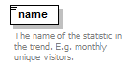
type | Name
properties
  content | simple
facets
  Kind | Value | Annotation
  minLength | 1
  maxLength | 80
  whiteSpace | collapse
annotation
  documentation
  The name of the statistic in the trend. E.g. monthly unique visitors.
source | <xs:element name="name" type="Name">  <xs:annotation>  <xs:documentation>The name of the statistic in the trend. E.g. monthly unique visitors.</xs:documentation>  </xs:annotation>  </xs:element>

element AudienceProfile/trend/granularity
diagram | 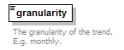
type | restriction of xs:string
properties
  content | simple
facets
  Kind | Value | Annotation
  enumeration | hourly
  enumeration | daily
  enumeration | weekly
  enumeration | monthly
  enumeration | quarterly
  enumeration | annually
annotation
  documentation
  The granularity of the trend. E.g. monthly.
source | <xs:element name="granularity">  <xs:annotation>  <xs:documentation>The granularity of the trend. E.g. monthly.</xs:documentation>  </xs:annotation>  <xs:simpleType>  <xs:restriction base="xs:string">  <xs:enumeration value="hourly"/>  <xs:enumeration value="daily"/>  <xs:enumeration value="weekly"/>  <xs:enumeration value="monthly"/>  <xs:enumeration value="quarterly"/>  <xs:enumeration value="annually"/>  </xs:restriction>  </xs:simpleType>  </xs:element>

element AudienceProfile/trend/dataPoint
diagram | 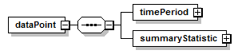
properties
  content | complex
children | timePeriod summaryStatistic
source | <xs:element name="dataPoint">  <xs:complexType>  <xs:sequence>  <xs:element name="timePeriod" type="TimeSpan"/>  <xs:element name="summaryStatistic" type="SummaryStatistic"/>  </xs:sequence>  </xs:complexType>  </xs:element>

element AudienceProfile/trend/dataPoint/timePeriod
diagram | 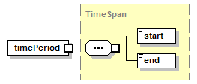
type | TimeSpan
properties
  content | complex
children | start end
source | <xs:element name="timePeriod" type="TimeSpan"/>

element AudienceProfile/trend/dataPoint/summaryStatistic
diagram | 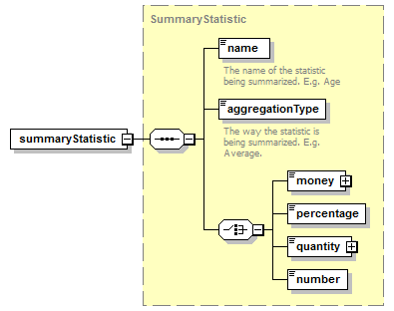
type | SummaryStatistic
properties
  content | complex
children | name aggregationType money percentage quantity number
source | <xs:element name="summaryStatistic" type="SummaryStatistic"/>

element AudienceProfile/source
diagram | 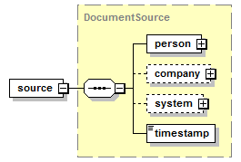
type | DocumentSource
properties
  content | complex
children | person company system timestamp
source | <xs:element name="source" type="DocumentSource"/>

complexType Company
diagram | 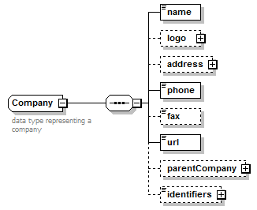
children | name logo address phone fax url parentCompany identifiers
used by
  elements | Transactor/company DocumentSource/company System/vendor
annotation
  documentation
  data type representing a company
source | <xs:complexType name="Company">  <xs:annotation>  <xs:documentation>data type representing a company</xs:documentation>  </xs:annotation>  <xs:sequence>  <xs:element name="name" type="Name"/>  <xs:element name="logo" type="File" minOccurs="0"/>  <xs:element name="address" type="PostalAddress" minOccurs="0"/>  <xs:element name="phone" type="PhoneNumber"/>  <xs:element name="fax" type="PhoneNumber" minOccurs="0"/>  <xs:element name="url" type="xs:anyURI"/>  <xs:element name="parentCompany" minOccurs="0">  <xs:complexType>  <xs:sequence>  <xs:element name="name" type="Name"/>  <xs:element name="id" type="Identifier" minOccurs="0"/>  </xs:sequence>  </xs:complexType>  </xs:element>  <xs:element name="identifiers" type="Identifier" minOccurs="0"/>  </xs:sequence>  </xs:complexType>

element Company/name
diagram
type | Name
properties
  content | simple
facets
  Kind | Value | Annotation
  minLength | 1
  maxLength | 80
  whiteSpace | collapse
source | <xs:element name="name" type="Name"/>

element Company/logo
diagram | 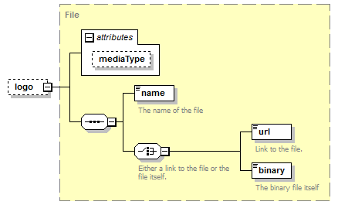
type | File
properties
  minOcc | 0
  maxOcc | 1
  content | complex
children | name url binary
attributes
  Name | Type | Use | Default | Fixed | Annotation
  mediaType | MediaType
source | <xs:element name="logo" type="File" minOccurs="0"/>

element Company/address
diagram | 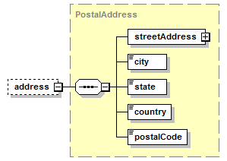
type | PostalAddress
properties
  minOcc | 0
  maxOcc | 1
  content | complex
children | streetAddress city state country postalCode
source | <xs:element name="address" type="PostalAddress" minOccurs="0"/>

element Company/phone
diagram | 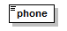
type | PhoneNumber
properties
  content | simple
source | <xs:element name="phone" type="PhoneNumber"/>

element Company/fax
diagram | 
type | PhoneNumber
properties
  minOcc | 0
  maxOcc | 1
  content | simple
source | <xs:element name="fax" type="PhoneNumber" minOccurs="0"/>

element Company/url
diagram | 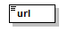
type | xs:anyURI
properties
  content | simple
source | <xs:element name="url" type="xs:anyURI"/>

element Company/parentCompany
diagram | 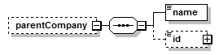
properties
  minOcc | 0
  maxOcc | 1
  content | complex
children | name id
source | <xs:element name="parentCompany" minOccurs="0">  <xs:complexType>  <xs:sequence>  <xs:element name="name" type="Name"/>  <xs:element name="id" type="Identifier" minOccurs="0"/>  </xs:sequence>  </xs:complexType>  </xs:element>

element Company/parentCompany/name
diagram
type | Name
properties
  content | simple
facets
  Kind | Value | Annotation
  minLength | 1
  maxLength | 80
  whiteSpace | collapse
source | <xs:element name="name" type="Name"/>

element Company/parentCompany/id
diagram | 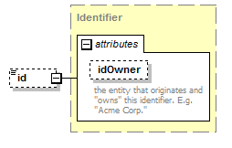
type | Identifier
properties
  minOcc | 0
  maxOcc | 1
  content | complex
attributes
  Name | Type | Use | Default | Fixed | Annotation
  idOwner | Name
    documentation
    the entity that originates and "owns" this identifier. E.g. "Acme Corp."
source | <xs:element name="id" type="Identifier" minOccurs="0"/>

element Company/identifiers
diagram | 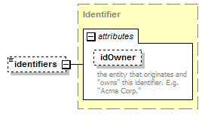
type | Identifier
properties
  minOcc | 0
  maxOcc | 1
  content | complex
attributes
  Name | Type | Use | Default | Fixed | Annotation
  idOwner | Name
    documentation
    the entity that originates and "owns" this identifier. E.g. "Acme Corp."
source | <xs:element name="identifiers" type="Identifier" minOccurs="0"/>

complexType Dimension
diagram | 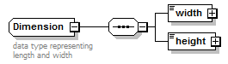
children | width height
annotation
  documentation
  data type representing length and width
source | <xs:complexType name="Dimension">  <xs:annotation>  <xs:documentation>data type representing length and width</xs:documentation>  </xs:annotation>  <xs:sequence>  <xs:element name="width">  <xs:complexType>  <xs:simpleContent>  <xs:extension base="xs:decimal">  <xs:attribute name="unitOfLength" type="UnitOfLength" default="pixels"/>  </xs:extension>  </xs:simpleContent>  </xs:complexType>  </xs:element>  <xs:element name="height">  <xs:complexType>  <xs:simpleContent>  <xs:extension base="xs:decimal">  <xs:attribute name="unitOfLength" type="UnitOfLength" default="pixels"/>  </xs:extension>  </xs:simpleContent>  </xs:complexType>  </xs:element>  </xs:sequence>  </xs:complexType>

element Dimension/width
diagram | 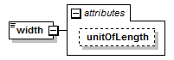
type | extension of xs:decimal
properties
  content | complex
attributes
  Name | Type | Use | Default | Fixed | Annotation
  unitOfLength | UnitOfLength |  | pixels
source | <xs:element name="width">  <xs:complexType>  <xs:simpleContent>  <xs:extension base="xs:decimal">  <xs:attribute name="unitOfLength" type="UnitOfLength" default="pixels"/>  </xs:extension>  </xs:simpleContent>  </xs:complexType>  </xs:element>

attribute Dimension/width/@unitOfLength
type | UnitOfLength
properties
  default | pixels
facets
  Kind | Value | Annotation
  enumeration | pixels
  enumeration | inches
  enumeration | centimeters
  enumeration | millimeters
  enumeration | feet
source | <xs:attribute name="unitOfLength" type="UnitOfLength" default="pixels"/>

element Dimension/height
diagram | 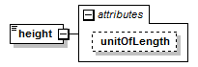
type | extension of xs:decimal
properties
  content | complex
attributes
  Name | Type | Use | Default | Fixed | Annotation
  unitOfLength | UnitOfLength |  | pixels
source | <xs:element name="height">  <xs:complexType>  <xs:simpleContent>  <xs:extension base="xs:decimal">  <xs:attribute name="unitOfLength" type="UnitOfLength" default="pixels"/>  </xs:extension>  </xs:simpleContent>  </xs:complexType>  </xs:element>

attribute Dimension/height/@unitOfLength
type | UnitOfLength
properties
  default | pixels
facets
  Kind | Value | Annotation
  enumeration | pixels
  enumeration | inches
  enumeration | centimeters
  enumeration | millimeters
  enumeration | feet
source | <xs:attribute name="unitOfLength" type="UnitOfLength" default="pixels"/>

complexType Discount
diagram | 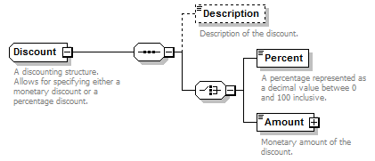
children | Description Percent Amount
used by
  elements | Order/terms/financial/agencyCommission FinancialTerms/agencyCommission Order/terms/financial/discount FinancialTerms/discount
annotation
  documentation
  A discounting structure. Allows for specifying either a monetary discount or a percentage discount.
source | <xs:complexType name="Discount">  <xs:annotation>  <xs:documentation>A discounting structure. Allows for specifying either a monetary discount or a percentage discount.</xs:documentation>  </xs:annotation>  <xs:sequence>  <xs:element name="Description" type="xs:string" minOccurs="0">  <xs:annotation>  <xs:documentation>Description of the discount.</xs:documentation>  </xs:annotation>  </xs:element>  <xs:choice>  <xs:element name="Percent" type="Percentage">  <xs:annotation>  <xs:documentation>A percentage represented as a decimal value betwee 0 and 100 inclusive.</xs:documentation>  </xs:annotation>  </xs:element>  <xs:element name="Amount" type="Money">  <xs:annotation>  <xs:documentation>Monetary amount of the discount.</xs:documentation>  </xs:annotation>  </xs:element>  </xs:choice>  </xs:sequence>  </xs:complexType>

element Discount/Description
diagram | 
type | xs:string
properties
  minOcc | 0
  maxOcc | 1
  content | simple
annotation
  documentation
  Description of the discount.
source | <xs:element name="Description" type="xs:string" minOccurs="0">  <xs:annotation>  <xs:documentation>Description of the discount.</xs:documentation>  </xs:annotation>  </xs:element>

element Discount/Percent
diagram | 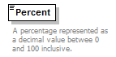
type | Percentage
properties
  content | simple
facets
  Kind | Value | Annotation
  minInclusive | 0
  maxInclusive | 100
  totalDigits | 5
  fractionDigits | 2
annotation
  documentation
  A percentage represented as a decimal value betwee 0 and 100 inclusive.
source | <xs:element name="Percent" type="Percentage">  <xs:annotation>  <xs:documentation>A percentage represented as a decimal value betwee 0 and 100 inclusive.</xs:documentation>  </xs:annotation>  </xs:element>

element Discount/Amount
diagram | 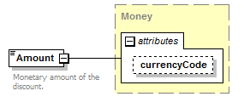
type | Money
properties
  content | complex
attributes
  Name | Type | Use | Default | Fixed | Annotation
  currencyCode | CurrencyCode |  | USD
annotation
  documentation
  Monetary amount of the discount.
source | <xs:element name="Amount" type="Money">  <xs:annotation>  <xs:documentation>Monetary amount of the discount.</xs:documentation>  </xs:annotation>  </xs:element>

complexType DocumentSource
diagram | 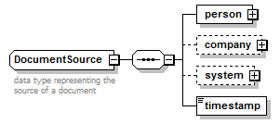
children | person company system timestamp
used by
  elements | Order/systemInfo/created AudienceProfile/source Order/systemInfo/updated
annotation
  documentation
  data type representing the source of a document
source | <xs:complexType name="DocumentSource">  <xs:annotation>  <xs:documentation>data type representing the source of a document</xs:documentation>  </xs:annotation>  <xs:sequence>  <xs:element name="person" type="Person"/>  <xs:element name="company" type="Company" minOccurs="0"/>  <xs:element name="system" type="System" minOccurs="0"/>  <xs:element name="timestamp" type="xs:dateTime"/>  </xs:sequence>  </xs:complexType>

element DocumentSource/person
diagram | 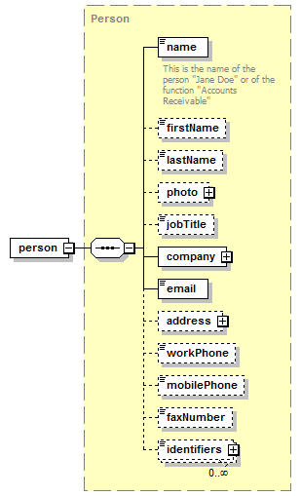
type | Person
properties
  content | complex
children | name firstName lastName photo jobTitle company email address workPhone mobilePhone faxNumber identifiers
source | <xs:element name="person" type="Person"/>

element DocumentSource/company
diagram | 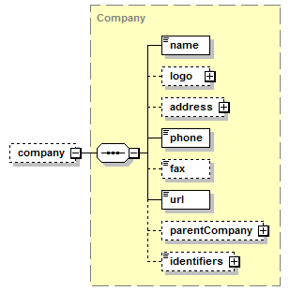
type | Company
properties
  minOcc | 0
  maxOcc | 1
  content | complex
children | name logo address phone fax url parentCompany identifiers
source | <xs:element name="company" type="Company" minOccurs="0"/>

element DocumentSource/system
diagram | 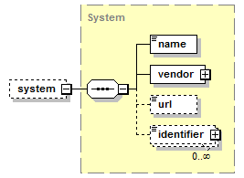
type | System
properties
  minOcc | 0
  maxOcc | 1
  content | complex
children | name vendor url identifier
source | <xs:element name="system" type="System" minOccurs="0"/>

element DocumentSource/timestamp
diagram | 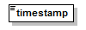
type | xs:dateTime
properties
  content | simple
source | <xs:element name="timestamp" type="xs:dateTime"/>

complexType File
diagram | 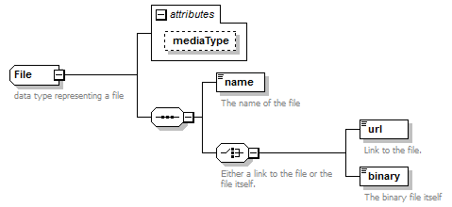
children | name url binary
used by
  elements | LegalTerms/attachment Program/document Order/lineItems/lineItem/placement/creative/file Company/logo Person/photo
attributes
  Name | Type | Use | Default | Fixed | Annotation
  mediaType | MediaType
annotation
  documentation
  data type representing a file
source | <xs:complexType name="File">  <xs:annotation>  <xs:documentation>data type representing a file</xs:documentation>  </xs:annotation>  <xs:sequence>  <xs:element name="name" type="Name">  <xs:annotation>  <xs:documentation>The name of the file</xs:documentation>  </xs:annotation>  </xs:element>  <xs:choice>  <xs:annotation>  <xs:documentation>Either a link to the file or the file itself.</xs:documentation>  </xs:annotation>  <xs:element name="url" type="xs:anyURI">  <xs:annotation>  <xs:documentation>Link to the file.</xs:documentation>  </xs:annotation>  </xs:element>  <xs:element name="binary" type="xs:base64Binary">  <xs:annotation>  <xs:documentation>The binary file itself</xs:documentation>  </xs:annotation>  </xs:element>  </xs:choice>  </xs:sequence>  <xs:attribute name="mediaType" type="MediaType"/>  </xs:complexType>

attribute File/@mediaType
type | MediaType
facets
  Kind | Value | Annotation
  enumeration | image/gif
    documentation
    GIF image; Defined in RFC 2045 and RFC 2046
  enumeration | image/jpeg
    documentation
    JPEG JFIF image; Defined in RFC 2045 and RFC 2046
  enumeration | image/pjpeg
    documentation
    JPEG JFIF image; Associated with Internet Explorer; Listed in ms775147(v=vs.85) - Progressive JPEG, initiated before global browser support for progressive JPEGs (Microsoft and Firefox).
  enumeration | image/png
    documentation
    Portable Network Graphics; Registered,[10] Defined in RFC 2083
  enumeration | image/svg+xml
    documentation
    SVG vector image; Defined in SVG Tiny 1.2 Specification Appendix M
  enumeration | image/tiff
    documentation
    Tag Image File Format (only for Baseline TIFF); Defined in RFC 3302
  enumeration | audio/basic
    documentation
    μ-law audio at 8 kHz, 1 channel; Defined in RFC 2046
  enumeration | audio/L24
    documentation
    24bit Linear PCM audio at 8–48 kHz, 1-N channels; Defined in RFC 3190
  enumeration | audio/mp4
    documentation
    MP4 audio
  enumeration | audio/mpeg
    documentation
    MP3 or other MPEG audio; Defined in RFC 3003
  enumeration | audio/ogg
    documentation
    Ogg Vorbis, Speex, Flac and other audio; Defined in RFC 5334
  enumeration | audio/vorbis
    documentation
    Vorbis encoded audio; Defined in RFC 5215
  enumeration | audio/vnd.rn-realaudio
    documentation
    RealAudio; Documented in RealPlayer Help[9]
  enumeration | audio/vnd.wave
    documentation
    WAV audio; Defined in RFC 2361
  enumeration | audio/webm
    documentation
    WebM open media format
  enumeration | video/mpeg
    documentation
    MPEG-1 video with multiplexed audio; Defined in RFC 2045 and RFC 2046
  enumeration | video/mp4
    documentation
    MP4 video; Defined in RFC 4337
  enumeration | video/ogg
    documentation
    Ogg Theora or other video (with audio); Defined in RFC 5334
  enumeration | video/quicktime
    documentation
    QuickTime video; Registered[11]
  enumeration | video/webm
    documentation
    WebM Matroska-based open media format
  enumeration | video/x-matroska
    documentation
    Matroska open media format
  enumeration | video/x-ms-wmv
    documentation
    Windows Media Video; Documented in Microsoft KB 288102
  enumeration | video/x-flv
    documentation
    Flash video (FLV files)
  enumeration | application/atom+xml
    documentation
    Atom feeds
  enumeration | application/ecmascript
    documentation
    ECMAScript/JavaScript; Defined in RFC 4329 (equivalent to application/javascript but with stricter processing rules)
  enumeration | application/EDI-X12
    documentation
    EDI X12 data; Defined in RFC 1767
  enumeration | application/EDIFACT
    documentation
    EDI EDIFACT data; Defined in RFC 1767
  enumeration | application/json
    documentation
    JavaScript Object Notation JSON; Defined in RFC 4627
  enumeration | application/javascript
    documentation
    ECMAScript/JavaScript; Defined in RFC 4329 (equivalent to application/ecmascript but with looser processing rules) It is not accepted in IE 8 or earlier - text/javascript is accepted but it is defined as obsolete in RFC 4329. The "type" attribute of the script tag in HTML5 is optional. In practice, omitting the media type of JavaScript programs is the most interoperable solution, since all browsers have always assumed the correct default even before HTML5.
  enumeration | application/octet-stream
    documentation
    Arbitrary binary data.[6] Generally speaking this type identifies files that are not associated with a specific application. Contrary to past assumptions by software packages such as Apache this is not a type that should be applied to unknown files. In such a case, a server or application should not indicate a content type, as it may be incorrect, but rather, should omit the type in order to allow the recipient to guess the type.[7]
  enumeration | application/ogg
    documentation
    Ogg, a multimedia bitstream container format; Defined in RFC 5334
  enumeration | application/pdf
    documentation
    Portable Document Format, PDF has been in use for document exchange on the Internet since 1993; Defined in RFC 3778
  enumeration | application/postscript
    documentation
    PostScript; Defined in RFC 2046
  enumeration | application/rdf+xml
    documentation
    Resource Description Framework; Defined by RFC 3870
  enumeration | application/rss+xml
    documentation
    RSS feeds
  enumeration | application/soap+xml
    documentation
    SOAP; Defined by RFC 3902
  enumeration | application/font-woff
    documentation
    Web Open Font Format; (candidate recommendation; use application/x-font-woff until standard is official)
  enumeration | application/xhtml+xml
    documentation
    XHTML; Defined by RFC 3236
  enumeration | application/xml
    documentation
    XML files; Defined by RFC 3023
  enumeration | application/xml-dtd
    documentation
    DTD files; Defined by RFC 3023
  enumeration | application/xop+xml
    documentation
    XOP
  enumeration | application/zip
    documentation
    ZIP archive files; Registered[8]
  enumeration | application/gzip
    documentation
    Gzip, Defined in RFC 6713
  enumeration | message/http
    documentation
    Defined in RFC 2616
  enumeration | message/imdn+xml
    documentation
    IMDN Instant Message Disposition Notification; Defined in RFC 5438
  enumeration | message/partial
    documentation
    Email; Defined in RFC 2045 and RFC 2046
  enumeration | message/rfc822
    documentation
    Email; EML files, MIME files, MHT files, MHTML files; Defined in RFC 2045 and RFC 2046
  enumeration | model/iges
    documentation
    IGS files, IGES files; Defined in RFC 2077
  enumeration | model/mesh
    documentation
    MSH files, MESH files; Defined in RFC 2077, SILO files
  enumeration | model/vrml
    documentation
    WRL files, VRML files; Defined in RFC 2077
  enumeration | model/x3d+binary
    documentation
    X3D ISO standard for representing 3D computer graphics, X3DB binary files - never Internet Assigned Numbers Authority approved
  enumeration | model/x3d+fastinfoset
    documentation
    X3D ISO standard for representing 3D computer graphics, X3DB binary files (application in process, this replaces any use of model/x3d+binary)
  enumeration | model/x3d-vrml
    documentation
    X3D ISO standard for representing 3D computer graphics, X3DV VRML files (application in process, previous uses may have been model/x3d+vrml)
  enumeration | model/x3d+xml
    documentation
    X3D ISO standard for representing 3D computer graphics, X3D XML files
  enumeration | multipart/mixed
    documentation
    MIME Email; Defined in RFC 2045 and RFC 2046
  enumeration | multipart/alternative
    documentation
    MIME Email; Defined in RFC 2045 and RFC 2046
  enumeration | multipart/related
    documentation
    MIME Email; Defined in RFC 2387 and used by MHTML (HTML mail)
  enumeration | multipart/form-data
    documentation
    MIME Webform; Defined in RFC 2388
  enumeration | multipart/signed
    documentation
    Defined in RFC 1847
  enumeration | multipart/encrypted
    documentation
    Defined in RFC 1847
  enumeration | text/cmd
    documentation
    commands; subtype resident in Gecko browsers like Firefox 3.5
  enumeration | text/css
    documentation
    Cascading Style Sheets; Defined in RFC 2318
  enumeration | text/csv
    documentation
    Comma-separated values; Defined in RFC 4180
  enumeration | text/html
    documentation
    HTML; Defined in RFC 2854
  enumeration | text/javascript (Obsolete)
    documentation
    JavaScript; Defined in and made obsolete in RFC 4329 in order to discourage its usage in favor of application/javascript. However, text/javascript is allowed in HTML 4 and 5 and, unlike application/javascript, has cross-browser support. The "type" attribute of the script tag in HTML5 is optional and there is no need to use it at all since all browsers have always assumed the correct default (even in HTML 4 where it was required by the specification).
  enumeration | text/plain
    documentation
    Textual data; Defined in RFC 2046 and RFC 3676
  enumeration | text/vcard
    documentation
    vCard (contact information); Defined in RFC 6350
  enumeration | text/xml
    documentation
    Extensible Markup Language; Defined in RFC 3023
  enumeration | application/vnd.oasis.opendocument.text
    documentation
    OpenDocument Text; Registered[12]
  enumeration | application/vnd.oasis.opendocument.spreadsheet
    documentation
    OpenDocument Spreadsheet; Registered[13]
  enumeration | application/vnd.oasis.opendocument.presentation
    documentation
    OpenDocument Presentation; Registered[14]
  enumeration | application/vnd.oasis.opendocument.graphics
    documentation
    OpenDocument Graphics; Registered[15]
  enumeration | application/vnd.ms-excel
    documentation
    Microsoft Excel files
  enumeration | application/vnd.openxmlformats-officedocument.spreadsheetml.sheet
    documentation
    Microsoft Excel 2007 files
  enumeration | application/vnd.ms-powerpoint
    documentation
    Microsoft Powerpoint files
  enumeration | application/vnd.openxmlformats-officedocument.presentationml.presentation
    documentation
    Microsoft Powerpoint 2007 files
  enumeration | application/vnd.openxmlformats-officedocument.wordprocessingml.document
    documentation
    Microsoft Word 2007 files
  enumeration | application/vnd.mozilla.xul+xml
    documentation
    Mozilla XUL files
  enumeration | application/vnd.google-earth.kml+xml
    documentation
    KML files (e.g. for Google Earth)[16]
  enumeration | application/vnd.google-earth.kmz
    documentation
    KMZ files (e.g. for Google Earth)[17]
  enumeration | application/vnd.dart
    documentation
    Dart files [18]
  enumeration | application/vnd.android.package-archive
    documentation
    For download apk files.
  enumeration | application/vnd.ms-xpsdocument
    documentation
    XPS document[19]
  enumeration | application/x-7z-compressed
    documentation
    7-Zip compression format.
  enumeration | application/x-deb
    documentation
    deb (file format), a software package format used by the Debian project
  enumeration | application/x-dvi
    documentation
    device-independent document in DVI format
  enumeration | application/x-font-ttf
    documentation
    TrueType Font No registered MIME type, but this is the most commonly used
  enumeration | application/x-javascript
  enumeration | application/x-latex
    documentation
    LaTeX files
  enumeration | application/x-mpegURL
    documentation
    .m3u8 variant playlist
  enumeration | application/x-rar-compressed
    documentation
    RAR archive files
  enumeration | application/x-shockwave-flash
    documentation
    Adobe Flash files for example with the extension .swf
  enumeration | application/x-stuffit
    documentation
    StuffIt archive files
  enumeration | application/x-tar
    documentation
    Tarball files
  enumeration | application/x-www-form-urlencoded
    documentation
    Form Encoded Data; Documented in HTML 4.01 Specification, Section 17.13.4.1
  enumeration | application/x-xpinstall
    documentation
    Add-ons to Mozilla applications (Firefox, Thunderbird, SeaMonkey, and the discontinued Sunbird)
  enumeration | audio/x-aac
    documentation
    .aac audio files
  enumeration | audio/x-caf
    documentation
    Apple's CAF audio files
  enumeration | image/x-xcf
    documentation
    GIMP image file
  enumeration | text/x-gwt-rpc
    documentation
    GoogleWebToolkit data
  enumeration | text/x-jquery-tmpl
    documentation
    jQuery template data
  enumeration | text/x-markdown
    documentation
    Markdown formatted text
  enumeration | application/x-pkcs12
    documentation
    a variant of PKCS standard files
source | <xs:attribute name="mediaType" type="MediaType"/>

element File/name
diagram | 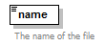
type | Name
properties
  content | simple
facets
  Kind | Value | Annotation
  minLength | 1
  maxLength | 80
  whiteSpace | collapse
annotation
  documentation
  The name of the file
source | <xs:element name="name" type="Name">  <xs:annotation>  <xs:documentation>The name of the file</xs:documentation>  </xs:annotation>  </xs:element>

element File/url
diagram | 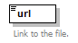
type | xs:anyURI
properties
  content | simple
annotation
  documentation
  Link to the file.
source | <xs:element name="url" type="xs:anyURI">  <xs:annotation>  <xs:documentation>Link to the file.</xs:documentation>  </xs:annotation>  </xs:element>

element File/binary
diagram | 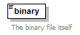
type | xs:base64Binary
properties
  content | simple
annotation
  documentation
  The binary file itself
source | <xs:element name="binary" type="xs:base64Binary">  <xs:annotation>  <xs:documentation>The binary file itself</xs:documentation>  </xs:annotation>  </xs:element>

complexType FinancialTerms
diagram | 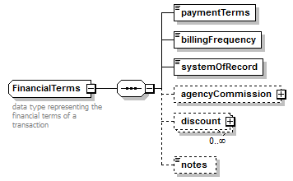
children | paymentTerms billingFrequency systemOfRecord agencyCommission discount notes
annotation
  documentation
  data type representing the financial terms of a transaction
source | <xs:complexType name="FinancialTerms">  <xs:annotation>  <xs:documentation>data type representing the financial terms of a transaction</xs:documentation>  </xs:annotation>  <xs:sequence>  <xs:element name="paymentTerms" type="PaymentTerms"/>  <xs:element name="billingFrequency" default="monthly">  <xs:simpleType>  <xs:restriction base="xs:string">  <xs:enumeration value="weekly"/>  <xs:enumeration value="monthly"/>  <xs:enumeration value="quarterly"/>  </xs:restriction>  </xs:simpleType>  </xs:element>  <xs:element name="systemOfRecord" default="advertiser">  <xs:simpleType>  <xs:restriction base="xs:string">  <xs:enumeration value="advertiser"/>  <xs:enumeration value="publisher"/>  </xs:restriction>  </xs:simpleType>  </xs:element>  <xs:element name="agencyCommission" type="Discount" minOccurs="0"/>  <xs:element name="discount" type="Discount" minOccurs="0" maxOccurs="unbounded"/>  <xs:element name="notes" type="Note" minOccurs="0"/>  </xs:sequence>  </xs:complexType>

element FinancialTerms/paymentTerms
diagram
type | PaymentTerms
properties
  content | simple
facets
  Kind | Value | Annotation
  enumeration | Advance
  enumeration | Net15
  enumeration | Net30
  enumeration | Net60
  enumeration | EndOfContract
source | <xs:element name="paymentTerms" type="PaymentTerms"/>

element FinancialTerms/billingFrequency
diagram
type | restriction of xs:string
properties
  content | simple
  default | monthly
facets
  Kind | Value | Annotation
  enumeration | weekly
  enumeration | monthly
  enumeration | quarterly
source | <xs:element name="billingFrequency" default="monthly">  <xs:simpleType>  <xs:restriction base="xs:string">  <xs:enumeration value="weekly"/>  <xs:enumeration value="monthly"/>  <xs:enumeration value="quarterly"/>  </xs:restriction>  </xs:simpleType>  </xs:element>

element FinancialTerms/systemOfRecord
diagram
type | restriction of xs:string
properties
  content | simple
  default | advertiser
facets
  Kind | Value | Annotation
  enumeration | advertiser
  enumeration | publisher
source | <xs:element name="systemOfRecord" default="advertiser">  <xs:simpleType>  <xs:restriction base="xs:string">  <xs:enumeration value="advertiser"/>  <xs:enumeration value="publisher"/>  </xs:restriction>  </xs:simpleType>  </xs:element>

element FinancialTerms/agencyCommission
diagram
type | Discount
properties
  minOcc | 0
  maxOcc | 1
  content | complex
children | Description Percent Amount
source | <xs:element name="agencyCommission" type="Discount" minOccurs="0"/>

element FinancialTerms/discount
diagram
type | Discount
properties
  minOcc | 0
  maxOcc | unbounded
  content | complex
children | Description Percent Amount
source | <xs:element name="discount" type="Discount" minOccurs="0" maxOccurs="unbounded"/>

element FinancialTerms/notes
diagram
type | Note
properties
  minOcc | 0
  maxOcc | 1
  content | simple
facets
  Kind | Value | Annotation
  whiteSpace | preserve
source | <xs:element name="notes" type="Note" minOccurs="0"/>

complexType Identifier
diagram | 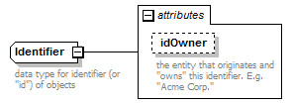
type | extension of xs:string
properties
  base | xs:string
used by
  elements | Order/systemInfo/id Person/company/id Company/parentCompany/id AudienceProfile/id System/identifier Program/identifier Placement/identifier Order/lineItems/lineItem/identifiers Person/identifiers Company/identifiers
attributes
  Name | Type | Use | Default | Fixed | Annotation
  idOwner | Name
    documentation
    the entity that originates and "owns" this identifier. E.g. "Acme Corp."
annotation
  documentation
  data type for identifier (or "id") of objects
source | <xs:complexType name="Identifier">  <xs:annotation>  <xs:documentation>data type for identifier (or "id") of objects</xs:documentation>  </xs:annotation>  <xs:simpleContent>  <xs:extension base="xs:string">  <xs:attribute name="idOwner" type="Name">  <xs:annotation>  <xs:documentation>the entity that originates and "owns" this identifier. E.g. "Acme Corp."</xs:documentation>  </xs:annotation>  </xs:attribute>  </xs:extension>  </xs:simpleContent>  </xs:complexType>

attribute Identifier/@idOwner
type | Name
facets
  Kind | Value | Annotation
  minLength | 1
  maxLength | 80
  whiteSpace | collapse
annotation
  documentation
  the entity that originates and "owns" this identifier. E.g. "Acme Corp."
source | <xs:attribute name="idOwner" type="Name">  <xs:annotation>  <xs:documentation>the entity that originates and "owns" this identifier. E.g. "Acme Corp."</xs:documentation>  </xs:annotation>  </xs:attribute>

complexType LegalTerms
diagram | 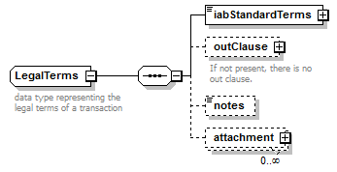
children | iabStandardTerms outClause notes attachment
used by
  elements | Order/terms/legal Program/standardTerms/legal
annotation
  documentation
  data type representing the legal terms of a transaction
source | <xs:complexType name="LegalTerms">  <xs:annotation>  <xs:documentation>data type representing the legal terms of a transaction</xs:documentation>  </xs:annotation>  <xs:sequence>  <xs:element name="iabStandardTerms">  <xs:complexType>  <xs:simpleContent>  <xs:extension base="xs:boolean">  <xs:attribute name="version" type="xs:decimal" default="3.0"/>  </xs:extension>  </xs:simpleContent>  </xs:complexType>  </xs:element>  <xs:element name="outClause" minOccurs="0">  <xs:annotation>  <xs:documentation>If not present, there is no out clause.</xs:documentation>  </xs:annotation>  <xs:complexType>  <xs:sequence>  <xs:element name="isOutClause" type="xs:boolean">  <xs:annotation>  <xs:documentation>True if there is an out clause. False otherwise.</xs:documentation>  </xs:annotation>  </xs:element>  <xs:element name="numberOfDays" type="xs:short">  <xs:annotation>  <xs:documentation>Number of days notice required on a cancellation.</xs:documentation>  </xs:annotation>  </xs:element>  </xs:sequence>  </xs:complexType>  </xs:element>  <xs:element name="notes" type="Note" minOccurs="0"/>  <xs:element name="attachment" type="File" minOccurs="0" maxOccurs="unbounded"/>  </xs:sequence>  </xs:complexType>

element LegalTerms/iabStandardTerms
diagram | 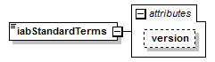
type | extension of xs:boolean
properties
  content | complex
attributes
  Name | Type | Use | Default | Fixed | Annotation
  version | xs:decimal |  | 3.0
source | <xs:element name="iabStandardTerms">  <xs:complexType>  <xs:simpleContent>  <xs:extension base="xs:boolean">  <xs:attribute name="version" type="xs:decimal" default="3.0"/>  </xs:extension>  </xs:simpleContent>  </xs:complexType>  </xs:element>

attribute LegalTerms/iabStandardTerms/@version
type | xs:decimal
properties
  default | 3.0
source | <xs:attribute name="version" type="xs:decimal" default="3.0"/>

element LegalTerms/outClause
diagram | 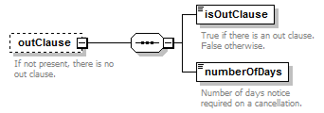
properties
  minOcc | 0
  maxOcc | 1
  content | complex
children | isOutClause numberOfDays
annotation
  documentation
  If not present, there is no out clause.
source | <xs:element name="outClause" minOccurs="0">  <xs:annotation>  <xs:documentation>If not present, there is no out clause.</xs:documentation>  </xs:annotation>  <xs:complexType>  <xs:sequence>  <xs:element name="isOutClause" type="xs:boolean">  <xs:annotation>  <xs:documentation>True if there is an out clause. False otherwise.</xs:documentation>  </xs:annotation>  </xs:element>  <xs:element name="numberOfDays" type="xs:short">  <xs:annotation>  <xs:documentation>Number of days notice required on a cancellation.</xs:documentation>  </xs:annotation>  </xs:element>  </xs:sequence>  </xs:complexType>  </xs:element>

element LegalTerms/outClause/isOutClause
diagram | 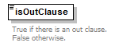
type | xs:boolean
properties
  content | simple
annotation
  documentation
  True if there is an out clause. False otherwise.
source | <xs:element name="isOutClause" type="xs:boolean">  <xs:annotation>  <xs:documentation>True if there is an out clause. False otherwise.</xs:documentation>  </xs:annotation>  </xs:element>

element LegalTerms/outClause/numberOfDays
diagram | 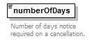
type | xs:short
properties
  content | simple
annotation
  documentation
  Number of days notice required on a cancellation.
source | <xs:element name="numberOfDays" type="xs:short">  <xs:annotation>  <xs:documentation>Number of days notice required on a cancellation.</xs:documentation>  </xs:annotation>  </xs:element>

element LegalTerms/notes
diagram
type | Note
properties
  minOcc | 0
  maxOcc | 1
  content | simple
facets
  Kind | Value | Annotation
  whiteSpace | preserve
source | <xs:element name="notes" type="Note" minOccurs="0"/>

element LegalTerms/attachment
diagram | 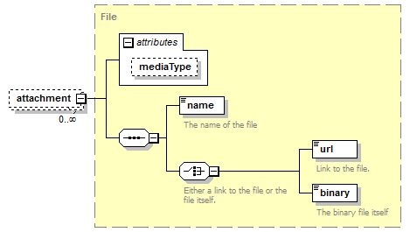
type | File
properties
  minOcc | 0
  maxOcc | unbounded
  content | complex
children | name url binary
attributes
  Name | Type | Use | Default | Fixed | Annotation
  mediaType | MediaType
source | <xs:element name="attachment" type="File" minOccurs="0" maxOccurs="unbounded"/>

complexType Money
diagram | 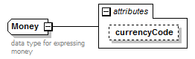
type | extension of xs:decimal
properties
  base | xs:decimal
used by
  elements | Order/lineItems/lineItem/flights/flight/amount Order/lineItems/lineItem/amount Order/amount Rate/amount Discount/Amount Program/standardTerms/cancellationFee Program/standardTerms/minimumBuy SummaryStatistic/money
attributes
  Name | Type | Use | Default | Fixed | Annotation
  currencyCode | CurrencyCode |  | USD
annotation
  documentation
  data type for expressing money
source | <xs:complexType name="Money">  <xs:annotation>  <xs:documentation>data type for expressing money</xs:documentation>  </xs:annotation>  <xs:simpleContent>  <xs:extension base="xs:decimal">  <xs:attribute name="currencyCode" type="CurrencyCode" default="USD"/>  </xs:extension>  </xs:simpleContent>  </xs:complexType>

attribute Money/@currencyCode
type | CurrencyCode
properties
  default | USD
facets
  Kind | Value | Annotation
  length | 3
  enumeration | AED
    documentation
    United Arab Emirates Dirham
  enumeration | AFN
    documentation
    Afghanistan Afghani
  enumeration | ALL
    documentation
    Albania Lek
  enumeration | AMD
    documentation
    Armenia Dram
  enumeration | ANG
    documentation
    Netherlands Antilles Guilder
  enumeration | AOA
    documentation
    Angola Kwanza
  enumeration | ARS
    documentation
    Argentina Peso
  enumeration | AUD
    documentation
    Australia Dollar
  enumeration | AWG
    documentation
    Aruba Guilder
  enumeration | AZN
    documentation
    Azerbaijan New Manat
  enumeration | BAM
    documentation
    Bosnia and Herzegovina Convertible Marka
  enumeration | BBD
    documentation
    Barbados Dollar
  enumeration | BDT
    documentation
    Bangladesh Taka
  enumeration | BGN
    documentation
    Bulgaria Lev
  enumeration | BHD
    documentation
    Bahrain Dinar
  enumeration | BIF
    documentation
    Burundi Franc
  enumeration | BMD
    documentation
    Bermuda Dollar
  enumeration | BND
    documentation
    Brunei Darussalam Dollar
  enumeration | BOB
    documentation
    Bolivia Boliviano
  enumeration | BRL
    documentation
    Brazil Real
  enumeration | BSD
    documentation
    Bahamas Dollar
  enumeration | BTN
    documentation
    Bhutan Ngultrum
  enumeration | BWP
    documentation
    Botswana Pula
  enumeration | BYR
    documentation
    Belarus Ruble
  enumeration | BZD
    documentation
    Belize Dollar
  enumeration | CAD
    documentation
    Canada Dollar
  enumeration | CDF
    documentation
    Congo/Kinshasa Franc
  enumeration | CHF
    documentation
    Switzerland Franc
  enumeration | CLP
    documentation
    Chile Peso
  enumeration | CNY
    documentation
    China Yuan Renminbi
  enumeration | COP
    documentation
    Colombia Peso
  enumeration | CRC
    documentation
    Costa Rica Colon
  enumeration | CUC
    documentation
    Cuba Convertible Peso
  enumeration | CUP
    documentation
    Cuba Peso
  enumeration | CVE
    documentation
    Cape Verde Escudo
  enumeration | CZK
    documentation
    Czech Republic Koruna
  enumeration | DJF
    documentation
    Djibouti Franc
  enumeration | DKK
    documentation
    Denmark Krone
  enumeration | DOP
    documentation
    Dominican Republic Peso
  enumeration | DZD
    documentation
    Algeria Dinar
  enumeration | EGP
    documentation
    Egypt Pound
  enumeration | ERN
    documentation
    Eritrea Nakfa
  enumeration | ETB
    documentation
    Ethiopia Birr
  enumeration | EUR
    documentation
    Euro Member Countries
  enumeration | FJD
    documentation
    Fiji Dollar
  enumeration | FKP
    documentation
    Falkland Islands (Malvinas) Pound
  enumeration | GBP
    documentation
    United Kingdom Pound
  enumeration | GEL
    documentation
    Georgia Lari
  enumeration | GGP
    documentation
    Guernsey Pound
  enumeration | GHS
    documentation
    Ghana Cedi
  enumeration | GIP
    documentation
    Gibraltar Pound
  enumeration | GMD
    documentation
    Gambia Dalasi
  enumeration | GNF
    documentation
    Guinea Franc
  enumeration | GTQ
    documentation
    Guatemala Quetzal
  enumeration | GYD
    documentation
    Guyana Dollar
  enumeration | HKD
    documentation
    Hong Kong Dollar
  enumeration | HNL
    documentation
    Honduras Lempira
  enumeration | HRK
    documentation
    Croatia Kuna
  enumeration | HTG
    documentation
    Haiti Gourde
  enumeration | HUF
    documentation
    Hungary Forint
  enumeration | IDR
    documentation
    Indonesia Rupiah
  enumeration | ILS
    documentation
    Israel Shekel
  enumeration | IMP
    documentation
    Isle of Man Pound
  enumeration | INR
    documentation
    India Rupee
  enumeration | IQD
    documentation
    Iraq Dinar
  enumeration | IRR
    documentation
    Iran Rial
  enumeration | ISK
    documentation
    Iceland Krona
  enumeration | JEP
    documentation
    Jersey Pound
  enumeration | JMD
    documentation
    Jamaica Dollar
  enumeration | JOD
    documentation
    Jordan Dinar
  enumeration | JPY
    documentation
    Japan Yen
  enumeration | KES
    documentation
    Kenya Shilling
  enumeration | KGS
    documentation
    Kyrgyzstan Som
  enumeration | KHR
    documentation
    Cambodia Riel
  enumeration | KMF
    documentation
    Comoros Franc
  enumeration | KPW
    documentation
    Korea (North) Won
  enumeration | KRW
    documentation
    Korea (South) Won
  enumeration | KWD
    documentation
    Kuwait Dinar
  enumeration | KYD
    documentation
    Cayman Islands Dollar
  enumeration | KZT
    documentation
    Kazakhstan Tenge
  enumeration | LAK
    documentation
    Laos Kip
  enumeration | LBP
    documentation
    Lebanon Pound
  enumeration | LKR
    documentation
    Sri Lanka Rupee
  enumeration | LRD
    documentation
    Liberia Dollar
  enumeration | LSL
    documentation
    Lesotho Loti
  enumeration | LTL
    documentation
    Lithuania Litas
  enumeration | LVL
    documentation
    Latvia Lat
  enumeration | LYD
    documentation
    Libya Dinar
  enumeration | MAD
    documentation
    Morocco Dirham
  enumeration | MDL
    documentation
    Moldova Leu
  enumeration | MGA
    documentation
    Madagascar Ariary
  enumeration | MKD
    documentation
    Macedonia Denar
  enumeration | MMK
    documentation
    Myanmar (Burma) Kyat
  enumeration | MNT
    documentation
    Mongolia Tughrik
  enumeration | MOP
    documentation
    Macau Pataca
  enumeration | MRO
    documentation
    Mauritania Ouguiya
  enumeration | MUR
    documentation
    Mauritius Rupee
  enumeration | MVR
    documentation
    Maldives (Maldive Islands) Rufiyaa
  enumeration | MWK
    documentation
    Malawi Kwacha
  enumeration | MXN
    documentation
    Mexico Peso
  enumeration | MYR
    documentation
    Malaysia Ringgit
  enumeration | MZN
    documentation
    Mozambique Metical
  enumeration | NAD
    documentation
    Namibia Dollar
  enumeration | NGN
    documentation
    Nigeria Naira
  enumeration | NIO
    documentation
    Nicaragua Cordoba
  enumeration | NOK
    documentation
    Norway Krone
  enumeration | NPR
    documentation
    Nepal Rupee
  enumeration | NZD
    documentation
    New Zealand Dollar
  enumeration | OMR
    documentation
    Oman Rial
  enumeration | PAB
    documentation
    Panama Balboa
  enumeration | PEN
    documentation
    Peru Nuevo Sol
  enumeration | PGK
    documentation
    Papua New Guinea Kina
  enumeration | PHP
    documentation
    Philippines Peso
  enumeration | PKR
    documentation
    Pakistan Rupee
  enumeration | PLN
    documentation
    Poland Zloty
  enumeration | PYG
    documentation
    Paraguay Guarani
  enumeration | QAR
    documentation
    Qatar Riyal
  enumeration | RON
    documentation
    Romania New Leu
  enumeration | RSD
    documentation
    Serbia Dinar
  enumeration | RUB
    documentation
    Russia Ruble
  enumeration | RWF
    documentation
    Rwanda Franc
  enumeration | SAR
    documentation
    Saudi Arabia Riyal
  enumeration | SBD
    documentation
    Solomon Islands Dollar
  enumeration | SCR
    documentation
    Seychelles Rupee
  enumeration | SDG
    documentation
    Sudan Pound
  enumeration | SEK
    documentation
    Sweden Krona
  enumeration | SGD
    documentation
    Singapore Dollar
  enumeration | SHP
    documentation
    Saint Helena Pound
  enumeration | SLL
    documentation
    Sierra Leone Leone
  enumeration | SOS
    documentation
    Somalia Shilling
  enumeration | SPL*
    documentation
    Seborga Luigino
  enumeration | SRD
    documentation
    Suriname Dollar
  enumeration | STD
    documentation
    São Tomé and Príncipe Dobra
  enumeration | SVC
    documentation
    El Salvador Colon
  enumeration | SYP
    documentation
    Syria Pound
  enumeration | SZL
    documentation
    Swaziland Lilangeni
  enumeration | THB
    documentation
    Thailand Baht
  enumeration | TJS
    documentation
    Tajikistan Somoni
  enumeration | TMT
    documentation
    Turkmenistan Manat
  enumeration | TND
    documentation
    Tunisia Dinar
  enumeration | TOP
    documentation
    Tonga Pa'anga
  enumeration | TRY
    documentation
    Turkey Lira
  enumeration | TTD
    documentation
    Trinidad and Tobago Dollar
  enumeration | TVD
    documentation
    Tuvalu Dollar
  enumeration | TWD
    documentation
    Taiwan New Dollar
  enumeration | TZS
    documentation
    Tanzania Shilling
  enumeration | UAH
    documentation
    Ukraine Hryvna
  enumeration | UGX
    documentation
    Uganda Shilling
  enumeration | USD
    documentation
    United States Dollar
  enumeration | UYU
    documentation
    Uruguay Peso
  enumeration | UZS
    documentation
    Uzbekistan Som
  enumeration | VEF
    documentation
    Venezuela Bolivar
  enumeration | VND
    documentation
    Viet Nam Dong
  enumeration | VUV
    documentation
    Vanuatu Vatu
  enumeration | WST
    documentation
    Samoa Tala
  enumeration | XAF
    documentation
    Communauté Financière Africaine (BEAC) CFA Franc BEAC
  enumeration | XCD
    documentation
    East Caribbean Dollar
  enumeration | XDR
    documentation
    International Monetary Fund (IMF) Special Drawing Rights
  enumeration | XOF
    documentation
    Communauté Financière Africaine (BCEAO) Franc
  enumeration | XPF
    documentation
    Comptoirs Français du Pacifique (CFP) Franc
  enumeration | YER
    documentation
    Yemen Rial
  enumeration | ZAR
    documentation
    South Africa Rand
  enumeration | ZMW
    documentation
    Zambia Kwacha
  enumeration | ZWD
    documentation
    Zimbabwe Dollar
source | <xs:attribute name="currencyCode" type="CurrencyCode" default="USD"/>

complexType Person
diagram | 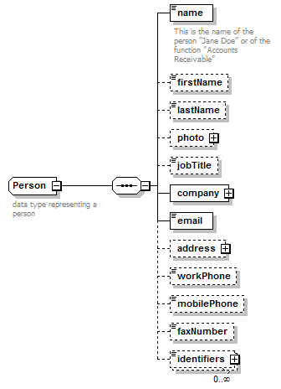
children | name firstName lastName photo jobTitle company email address workPhone mobilePhone faxNumber identifiers
used by
  elements | Transactor/billingContact Transactor/otherContacts/contact Program/endorsement/endorser Transactor/mainContact DocumentSource/person
annotation
  documentation
  data type representing a person
source | <xs:complexType name="Person">  <xs:annotation>  <xs:documentation>data type representing a person</xs:documentation>  </xs:annotation>  <xs:sequence>  <xs:element name="name" type="Name">  <xs:annotation>  <xs:documentation>This is the name of the person "Jane Doe" or of the function "Accounts Receivable"</xs:documentation>  </xs:annotation>  </xs:element>  <xs:element name="firstName" minOccurs="0"/>  <xs:element name="lastName" minOccurs="0"/>  <xs:element name="photo" type="File" minOccurs="0"/>  <xs:element name="jobTitle" minOccurs="0"/>  <xs:element name="company">  <xs:complexType>  <xs:sequence>  <xs:element name="name" type="Name"/>  <xs:element name="id" type="Identifier" minOccurs="0"/>  </xs:sequence>  </xs:complexType>  </xs:element>  <xs:element name="email" type="EmailAddress"/>  <xs:element name="address" type="PostalAddress" minOccurs="0"/>  <xs:element name="workPhone" type="PhoneNumber" minOccurs="0"/>  <xs:element name="mobilePhone" type="PhoneNumber" minOccurs="0"/>  <xs:element name="faxNumber" type="PhoneNumber" minOccurs="0"/>  <xs:element name="identifiers" type="Identifier" minOccurs="0" maxOccurs="unbounded"/>  </xs:sequence>  </xs:complexType>

element Person/name
diagram | 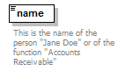
type | Name
properties
  content | simple
facets
  Kind | Value | Annotation
  minLength | 1
  maxLength | 80
  whiteSpace | collapse
annotation
  documentation
  This is the name of the person "Jane Doe" or of the function "Accounts Receivable"
source | <xs:element name="name" type="Name">  <xs:annotation>  <xs:documentation>This is the name of the person "Jane Doe" or of the function "Accounts Receivable"</xs:documentation>  </xs:annotation>  </xs:element>

element Person/firstName
diagram | 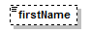
properties
  minOcc | 0
  maxOcc | 1
source | <xs:element name="firstName" minOccurs="0"/>

element Person/lastName
diagram | 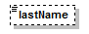
properties
  minOcc | 0
  maxOcc | 1
source | <xs:element name="lastName" minOccurs="0"/>

element Person/photo
diagram | 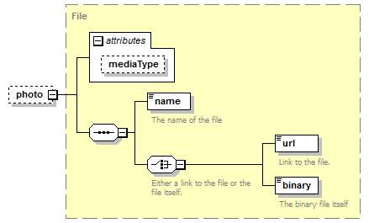
type | File
properties
  minOcc | 0
  maxOcc | 1
  content | complex
children | name url binary
attributes
  Name | Type | Use | Default | Fixed | Annotation
  mediaType | MediaType
source | <xs:element name="photo" type="File" minOccurs="0"/>

element Person/jobTitle
diagram | 
properties
  minOcc | 0
  maxOcc | 1
source | <xs:element name="jobTitle" minOccurs="0"/>

element Person/company
diagram | 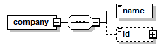
properties
  content | complex
children | name id
source | <xs:element name="company">  <xs:complexType>  <xs:sequence>  <xs:element name="name" type="Name"/>  <xs:element name="id" type="Identifier" minOccurs="0"/>  </xs:sequence>  </xs:complexType>  </xs:element>

element Person/company/name
diagram
type | Name
properties
  content | simple
facets
  Kind | Value | Annotation
  minLength | 1
  maxLength | 80
  whiteSpace | collapse
source | <xs:element name="name" type="Name"/>

element Person/company/id
diagram
type | Identifier
properties
  minOcc | 0
  maxOcc | 1
  content | complex
attributes
  Name | Type | Use | Default | Fixed | Annotation
  idOwner | Name
    documentation
    the entity that originates and "owns" this identifier. E.g. "Acme Corp."
source | <xs:element name="id" type="Identifier" minOccurs="0"/>

element Person/email
diagram | 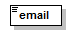
type | EmailAddress
properties
  content | simple
facets
  Kind | Value | Annotation
  pattern | ^([0-9a-zA-Z]([-.\w]*[0-9a-zA-Z])*@([0-9a-zA-Z][-\w]*[0-9a-zA-Z]\.)+[a-zA-Z]{2,9})$
source | <xs:element name="email" type="EmailAddress"/>

element Person/address
diagram
type | PostalAddress
properties
  minOcc | 0
  maxOcc | 1
  content | complex
children | streetAddress city state country postalCode
source | <xs:element name="address" type="PostalAddress" minOccurs="0"/>

element Person/workPhone
diagram | 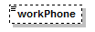
type | PhoneNumber
properties
  minOcc | 0
  maxOcc | 1
  content | simple
source | <xs:element name="workPhone" type="PhoneNumber" minOccurs="0"/>

element Person/mobilePhone
diagram | 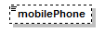
type | PhoneNumber
properties
  minOcc | 0
  maxOcc | 1
  content | simple
source | <xs:element name="mobilePhone" type="PhoneNumber" minOccurs="0"/>

element Person/faxNumber
diagram | 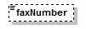
type | PhoneNumber
properties
  minOcc | 0
  maxOcc | 1
  content | simple
source | <xs:element name="faxNumber" type="PhoneNumber" minOccurs="0"/>

element Person/identifiers
diagram
type | Identifier
properties
  minOcc | 0
  maxOcc | unbounded
  content | complex
attributes
  Name | Type | Use | Default | Fixed | Annotation
  idOwner | Name
    documentation
    the entity that originates and "owns" this identifier. E.g. "Acme Corp."
source | <xs:element name="identifiers" type="Identifier" minOccurs="0" maxOccurs="unbounded"/>

complexType PostalAddress
diagram | 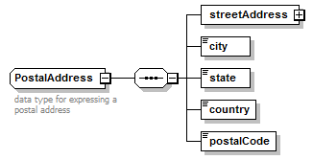
children | streetAddress city state country postalCode
used by
  elements | Person/address Company/address
annotation
  documentation
  data type for expressing a postal address
source | <xs:complexType name="PostalAddress">  <xs:annotation>  <xs:documentation>data type for expressing a postal address</xs:documentation>  </xs:annotation>  <xs:sequence>  <xs:element name="streetAddress">  <xs:complexType>  <xs:sequence maxOccurs="unbounded">  <xs:element name="streetLine"/>  </xs:sequence>  </xs:complexType>  </xs:element>  <xs:element name="city"/>  <xs:element name="state"/>  <xs:element name="country"/>  <xs:element name="postalCode"/>  </xs:sequence>  </xs:complexType>

element PostalAddress/streetAddress
diagram | 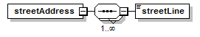
properties
  content | complex
children | streetLine
source | <xs:element name="streetAddress">  <xs:complexType>  <xs:sequence maxOccurs="unbounded">  <xs:element name="streetLine"/>  </xs:sequence>  </xs:complexType>  </xs:element>

element PostalAddress/streetAddress/streetLine
diagram | 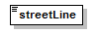
source | <xs:element name="streetLine"/>

element PostalAddress/city
diagram | 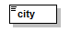
source | <xs:element name="city"/>

element PostalAddress/state
diagram | 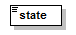
source | <xs:element name="state"/>

element PostalAddress/country
diagram | 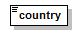
source | <xs:element name="country"/>

element PostalAddress/postalCode
diagram | 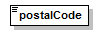
source | <xs:element name="postalCode"/>

complexType Quantity
diagram | 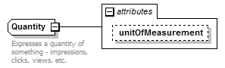
type | extension of xs:long
properties
  base | xs:long
used by
  elements | Order/lineItems/lineItem/quantity AudienceProfile/distribution/value/quantity SummaryStatistic/quantity Placement/inventoryAvailable/quantity AudienceProfile/universe
attributes
  Name | Type | Use | Default | Fixed | Annotation
  unitOfMeasurement | UnitOfMeasurement
annotation
  documentation
  Expresses a quantity of something - impressions, clicks, views, etc.
source | <xs:complexType name="Quantity">  <xs:annotation>  <xs:documentation>Expresses a quantity of something - impressions, clicks, views, etc.</xs:documentation>  </xs:annotation>  <xs:simpleContent>  <xs:extension base="xs:long">  <xs:attribute name="unitOfMeasurement" type="UnitOfMeasurement"/>  </xs:extension>  </xs:simpleContent>  </xs:complexType>

attribute Quantity/@unitOfMeasurement
type | UnitOfMeasurement
facets
  Kind | Value | Annotation
  enumeration | Impressions
  enumeration | Clicks
  enumeration | Actions
  enumeration | Uniques
  enumeration | ShareOfVoice
  enumeration | Downloads
  enumeration | Emails
  enumeration | Leads
source | <xs:attribute name="unitOfMeasurement" type="UnitOfMeasurement"/>

complexType Rate
diagram | 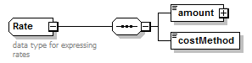
children | amount costMethod
used by
  elements | Placement/ourRate Order/lineItems/lineItem/flights/flight/rate Order/lineItems/lineItem/rate Placement/standardRate
annotation
  documentation
  data type for expressing rates
source | <xs:complexType name="Rate">  <xs:annotation>  <xs:documentation>data type for expressing rates</xs:documentation>  </xs:annotation>  <xs:sequence>  <xs:element name="amount" type="Money"/>  <xs:element name="costMethod" type="CostMethod"/>  </xs:sequence>  </xs:complexType>

element Rate/amount
diagram
type | Money
properties
  content | complex
attributes
  Name | Type | Use | Default | Fixed | Annotation
  currencyCode | CurrencyCode |  | USD
source | <xs:element name="amount" type="Money"/>

element Rate/costMethod
diagram | 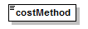
type | CostMethod
properties
  content | simple
facets
  Kind | Value | Annotation
  enumeration | CPM
  enumeration | CPC
  enumeration | CPA
  enumeration | Flat rate - impressions
  enumeration | Flat rate - clicks
  enumeration | Makegood
  enumeration | ValueAdd
source | <xs:element name="costMethod" type="CostMethod"/>

complexType SummaryStatistic
diagram | 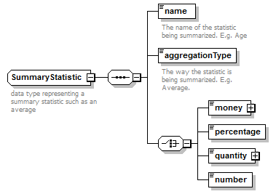
children | name aggregationType money percentage quantity number
used by
  elements | AudienceProfile/summaryStatistic AudienceProfile/trend/dataPoint/summaryStatistic
annotation
  documentation
  data type representing a summary statistic such as an average
source | <xs:complexType name="SummaryStatistic">  <xs:annotation>  <xs:documentation>data type representing a summary statistic such as an average</xs:documentation>  </xs:annotation>  <xs:sequence>  <xs:element name="name" type="Name">  <xs:annotation>  <xs:documentation>The name of the statistic being summarized. E.g. Age</xs:documentation>  </xs:annotation>  </xs:element>  <xs:element name="aggregationType">  <xs:annotation>  <xs:documentation>The way the statistic is being summarized. E.g. Average.</xs:documentation>  </xs:annotation>  <xs:simpleType>  <xs:restriction base="xs:string">  <xs:enumeration value="Average"/>  <xs:enumeration value="Minimum"/>  <xs:enumeration value="Maximum"/>  <xs:enumeration value="Median"/>  <xs:enumeration value="Mode"/>  <xs:enumeration value="Sum"/>  <xs:enumeration value="Count"/>  <xs:enumeration value="First"/>  <xs:enumeration value="Last"/>  </xs:restriction>  </xs:simpleType>  </xs:element>  <xs:choice>  <xs:element name="money" type="Money"/>  <xs:element name="percentage" type="Percentage"/>  <xs:element name="quantity" type="Quantity"/>  <xs:element name="number" type="xs:decimal"/>  </xs:choice>  </xs:sequence>  </xs:complexType>

element SummaryStatistic/name
diagram | 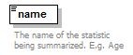
type | Name
properties
  content | simple
facets
  Kind | Value | Annotation
  minLength | 1
  maxLength | 80
  whiteSpace | collapse
annotation
  documentation
  The name of the statistic being summarized. E.g. Age
source | <xs:element name="name" type="Name">  <xs:annotation>  <xs:documentation>The name of the statistic being summarized. E.g. Age</xs:documentation>  </xs:annotation>  </xs:element>

element SummaryStatistic/aggregationType
diagram | 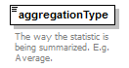
type | restriction of xs:string
properties
  content | simple
facets
  Kind | Value | Annotation
  enumeration | Average
  enumeration | Minimum
  enumeration | Maximum
  enumeration | Median
  enumeration | Mode
  enumeration | Sum
  enumeration | Count
  enumeration | First
  enumeration | Last
annotation
  documentation
  The way the statistic is being summarized. E.g. Average.
source | <xs:element name="aggregationType">  <xs:annotation>  <xs:documentation>The way the statistic is being summarized. E.g. Average.</xs:documentation>  </xs:annotation>  <xs:simpleType>  <xs:restriction base="xs:string">  <xs:enumeration value="Average"/>  <xs:enumeration value="Minimum"/>  <xs:enumeration value="Maximum"/>  <xs:enumeration value="Median"/>  <xs:enumeration value="Mode"/>  <xs:enumeration value="Sum"/>  <xs:enumeration value="Count"/>  <xs:enumeration value="First"/>  <xs:enumeration value="Last"/>  </xs:restriction>  </xs:simpleType>  </xs:element>

element SummaryStatistic/money
diagram | 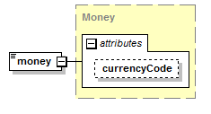
type | Money
properties
  content | complex
attributes
  Name | Type | Use | Default | Fixed | Annotation
  currencyCode | CurrencyCode |  | USD
source | <xs:element name="money" type="Money"/>

element SummaryStatistic/percentage
diagram | 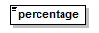
type | Percentage
properties
  content | simple
facets
  Kind | Value | Annotation
  minInclusive | 0
  maxInclusive | 100
  totalDigits | 5
  fractionDigits | 2
source | <xs:element name="percentage" type="Percentage"/>

element SummaryStatistic/quantity
diagram | 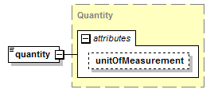
type | Quantity
properties
  content | complex
attributes
  Name | Type | Use | Default | Fixed | Annotation
  unitOfMeasurement | UnitOfMeasurement
source | <xs:element name="quantity" type="Quantity"/>

element SummaryStatistic/number
diagram | 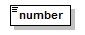
type | xs:decimal
properties
  content | simple
source | <xs:element name="number" type="xs:decimal"/>

complexType System
diagram | 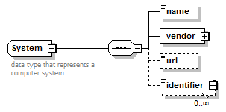
children | name vendor url identifier
used by
  element | DocumentSource/system
annotation
  documentation
  data type that represents a computer system
source | <xs:complexType name="System">  <xs:annotation>  <xs:documentation>data type that represents a computer system</xs:documentation>  </xs:annotation>  <xs:sequence>  <xs:element name="name" type="Name"/>  <xs:element name="vendor" type="Company"/>  <xs:element name="url" type="xs:anyURI" minOccurs="0"/>  <xs:element name="identifier" type="Identifier" minOccurs="0" maxOccurs="unbounded"/>  </xs:sequence>  </xs:complexType>

element System/name
diagram
type | Name
properties
  content | simple
facets
  Kind | Value | Annotation
  minLength | 1
  maxLength | 80
  whiteSpace | collapse
source | <xs:element name="name" type="Name"/>

element System/vendor
diagram | 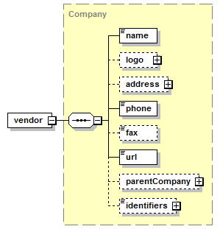
type | Company
properties
  content | complex
children | name logo address phone fax url parentCompany identifiers
source | <xs:element name="vendor" type="Company"/>

element System/url
diagram | 
type | xs:anyURI
properties
  minOcc | 0
  maxOcc | 1
  content | simple
source | <xs:element name="url" type="xs:anyURI" minOccurs="0"/>

element System/identifier
diagram | 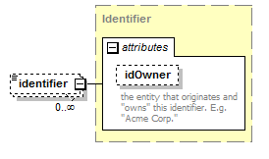
type | Identifier
properties
  minOcc | 0
  maxOcc | unbounded
  content | complex
attributes
  Name | Type | Use | Default | Fixed | Annotation
  idOwner | Name
    documentation
    the entity that originates and "owns" this identifier. E.g. "Acme Corp."
source | <xs:element name="identifier" type="Identifier" minOccurs="0" maxOccurs="unbounded"/>

complexType TimeSpan
diagram | 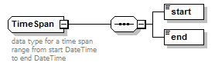
children | start end
used by
  elements | Order/lineItems/lineItem/flightDates Order/lineItems/lineItem/flights/flight/flightDates Order/flightDates Placement/inventoryAvailable/period AudienceProfile/trend/dataPoint/timePeriod
annotation
  documentation
  data type for a time span range from start DateTime to end DateTime
source | <xs:complexType name="TimeSpan">  <xs:annotation>  <xs:documentation>data type for a time span range from start DateTime to end DateTime</xs:documentation>  </xs:annotation>  <xs:sequence>  <xs:element name="start" type="xs:dateTime"/>  <xs:element name="end" type="xs:dateTime"/>  </xs:sequence>  </xs:complexType>

element TimeSpan/start
diagram | 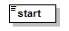
type | xs:dateTime
properties
  content | simple
source | <xs:element name="start" type="xs:dateTime"/>

element TimeSpan/end
diagram | 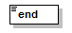
type | xs:dateTime
properties
  content | simple
source | <xs:element name="end" type="xs:dateTime"/>

complexType Transactor
diagram | 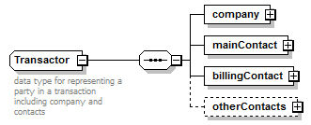
children | company mainContact billingContact otherContacts
used by
  elements | Order/advertiser Order/buyer Order/seller Program/seller
annotation
  documentation
  data type for representing a party in a transaction including company and contacts
source | <xs:complexType name="Transactor">  <xs:annotation>  <xs:documentation>data type for representing a party in a transaction including company and contacts</xs:documentation>  </xs:annotation>  <xs:sequence>  <xs:element name="company" type="Company"/>  <xs:element name="mainContact" type="Person"/>  <xs:element name="billingContact" type="Person"/>  <xs:element name="otherContacts" minOccurs="0">  <xs:complexType>  <xs:sequence minOccurs="0" maxOccurs="unbounded">  <xs:element name="contact" type="Person"/>  <xs:element name="role">  <xs:simpleType>  <xs:restriction base="xs:string">  <xs:maxLength value="25"/>  </xs:restriction>  </xs:simpleType>  </xs:element>  </xs:sequence>  </xs:complexType>  </xs:element>  </xs:sequence>  </xs:complexType>

element Transactor/company
diagram | 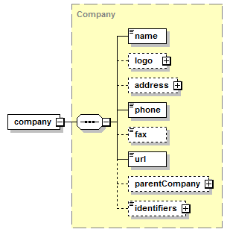
type | Company
properties
  content | complex
children | name logo address phone fax url parentCompany identifiers
source | <xs:element name="company" type="Company"/>

element Transactor/mainContact
diagram | 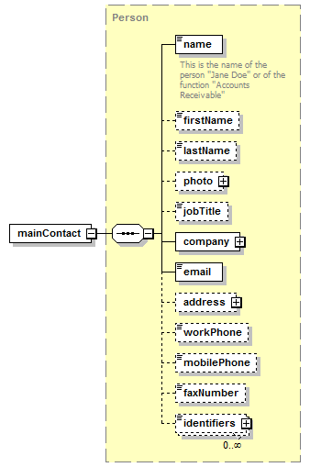
type | Person
properties
  content | complex
children | name firstName lastName photo jobTitle company email address workPhone mobilePhone faxNumber identifiers
source | <xs:element name="mainContact" type="Person"/>

element Transactor/billingContact
diagram | 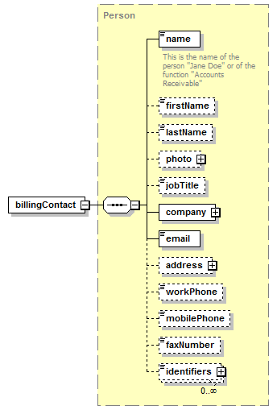
type | Person
properties
  content | complex
children | name firstName lastName photo jobTitle company email address workPhone mobilePhone faxNumber identifiers
source | <xs:element name="billingContact" type="Person"/>

element Transactor/otherContacts
diagram | 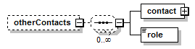
properties
  minOcc | 0
  maxOcc | 1
  content | complex
children | contact role
source | <xs:element name="otherContacts" minOccurs="0">  <xs:complexType>  <xs:sequence minOccurs="0" maxOccurs="unbounded">  <xs:element name="contact" type="Person"/>  <xs:element name="role">  <xs:simpleType>  <xs:restriction base="xs:string">  <xs:maxLength value="25"/>  </xs:restriction>  </xs:simpleType>  </xs:element>  </xs:sequence>  </xs:complexType>  </xs:element>

element Transactor/otherContacts/contact
diagram | 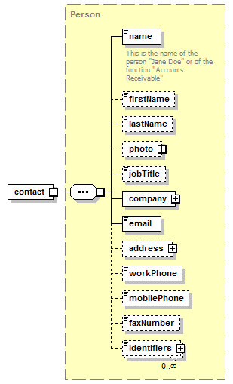
type | Person
properties
  content | complex
children | name firstName lastName photo jobTitle company email address workPhone mobilePhone faxNumber identifiers
source | <xs:element name="contact" type="Person"/>

element Transactor/otherContacts/role
diagram | 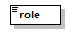
type | restriction of xs:string
properties
  content | simple
facets
  Kind | Value | Annotation
  maxLength | 25
source | <xs:element name="role">  <xs:simpleType>  <xs:restriction base="xs:string">  <xs:maxLength value="25"/>  </xs:restriction>  </xs:simpleType>  </xs:element>

simpleType Channel
type | restriction of xs:string
properties
  base | xs:string
used by
  elements | Program/channel Placement/channel
facets
  Kind | Value | Annotation
  enumeration | email
  enumeration | onlineDisplay
annotation
  documentation
  the type of channel
source | <xs:simpleType name="Channel">  <xs:annotation>  <xs:documentation>the type of channel</xs:documentation>  </xs:annotation>  <xs:restriction base="xs:string">  <xs:enumeration value="email"/>  <xs:enumeration value="onlineDisplay"/>  </xs:restriction>  </xs:simpleType>

simpleType CostMethod
type | restriction of xs:string
properties
  base | xs:string
used by
  element | Rate/costMethod
facets
  Kind | Value | Annotation
  enumeration | CPM
  enumeration | CPC
  enumeration | CPA
  enumeration | Flat rate - impressions
  enumeration | Flat rate - clicks
  enumeration | Makegood
  enumeration | ValueAdd
annotation
  documentation
  data type representing costing methods e.g. CPM, CPA, CPC, etc.
source | <xs:simpleType name="CostMethod">  <xs:annotation>  <xs:documentation>data type representing costing methods e.g. CPM, CPA, CPC, etc.</xs:documentation>  </xs:annotation>  <xs:restriction base="xs:string">  <xs:enumeration value="CPM"/>  <xs:enumeration value="CPC"/>  <xs:enumeration value="CPA"/>  <xs:enumeration value="Flat rate - impressions"/>  <xs:enumeration value="Flat rate - clicks"/>  <xs:enumeration value="Makegood"/>  <xs:enumeration value="ValueAdd"/>  </xs:restriction>  </xs:simpleType>

simpleType EmailAddress
type | restriction of xs:string
properties
  base | xs:string
used by
  element | Person/email
facets
  Kind | Value | Annotation
  pattern | ^([0-9a-zA-Z]([-.\w]*[0-9a-zA-Z])*@([0-9a-zA-Z][-\w]*[0-9a-zA-Z]\.)+[a-zA-Z]{2,9})$
annotation
  documentation
  This is the data type for email addresses. The pattern is a regular expression that validates the email address.
source | <xs:simpleType name="EmailAddress">  <xs:annotation>  <xs:documentation>This is the data type for email addresses. The pattern is a regular expression that validates the email address.</xs:documentation>  </xs:annotation>  <xs:restriction base="xs:string">  <xs:pattern value="^([0-9a-zA-Z]([-.\w]*[0-9a-zA-Z])*@([0-9a-zA-Z][-\w]*[0-9a-zA-Z]\.)+[a-zA-Z]{2,9})$"/>  </xs:restriction>  </xs:simpleType>

simpleType IndexedValue
type | xs:decimal
properties
  base | xs:decimal
used by
  element | AudienceProfile/distribution/value/index
annotation
  documentation
  data type representing a quantity compared against a baseline value expressed as 100 times the ratio to the base value. I.e. an index of 100 means the quanity equals the baseline.
source | <xs:simpleType name="IndexedValue">  <xs:annotation>  <xs:documentation>data type representing a quantity compared against a baseline value expressed as 100 times the ratio to the base value. I.e. an index of 100 means the quanity equals the baseline.</xs:documentation>  </xs:annotation>  <xs:restriction base="xs:decimal"/>  </xs:simpleType>

simpleType Name
type | restriction of xs:string
properties
  base | xs:string
used by
  elements | Order/lineItems/lineItem/name Person/name Person/company/name Company/name Company/parentCompany/name System/name File/name AudienceProfile/name AudienceProfile/distribution/name AudienceProfile/distribution/value/name AudienceProfile/trend/name SummaryStatistic/name Program/name Placement/name
  attribute | Identifier/@idOwner
facets
  Kind | Value | Annotation
  minLength | 1
  maxLength | 80
  whiteSpace | collapse
annotation
  documentation
  data type representing the name of an item
source | <xs:simpleType name="Name">  <xs:annotation>  <xs:documentation>data type representing the name of an item</xs:documentation>  </xs:annotation>  <xs:restriction base="xs:string">  <xs:maxLength value="80"/>  <xs:minLength value="1"/>  <xs:whiteSpace value="collapse"/>  </xs:restriction>  </xs:simpleType>

simpleType Note
type | restriction of xs:string
properties
  base | xs:string
used by
  elements | Program/description Placement/description Order/lineItems/lineItem/flights/flight/notes Order/lineItems/lineItem/notes Order/terms/financial/notes Order/notes LegalTerms/notes FinancialTerms/notes Program/standardTerms/orderInstructions
facets
  Kind | Value | Annotation
  whiteSpace | preserve
annotation
  documentation
  data type representing a note. Should be implemented as a CLOB field in the database.
source | <xs:simpleType name="Note">  <xs:annotation>  <xs:documentation>data type representing a note. Should be implemented as a CLOB field in the database.</xs:documentation>  </xs:annotation>  <xs:restriction base="xs:string">  <xs:whiteSpace value="preserve"/>  </xs:restriction>  </xs:simpleType>

simpleType PaymentTerms
type | restriction of xs:string
properties
  base | xs:string
used by
  elements | Order/terms/financial/paymentTerms FinancialTerms/paymentTerms
facets
  Kind | Value | Annotation
  enumeration | Advance
  enumeration | Net15
  enumeration | Net30
  enumeration | Net60
  enumeration | EndOfContract
annotation
  documentation
  Payment terms for an order (e.g. Net30)
source | <xs:simpleType name="PaymentTerms">  <xs:annotation>  <xs:documentation>Payment terms for an order (e.g. Net30)</xs:documentation>  </xs:annotation>  <xs:restriction base="xs:string">  <xs:enumeration value="Advance"/>  <xs:enumeration value="Net15"/>  <xs:enumeration value="Net30"/>  <xs:enumeration value="Net60"/>  <xs:enumeration value="EndOfContract"/>  </xs:restriction>  </xs:simpleType>

simpleType Percentage
type | restriction of xs:decimal
properties
  base | xs:decimal
used by
  elements | Discount/Percent AudienceProfile/distribution/value/percent SummaryStatistic/percentage
facets
  Kind | Value | Annotation
  minInclusive | 0
  maxInclusive | 100
  totalDigits | 5
  fractionDigits | 2
annotation
  documentation
  A percentage represented as a decimal value betwee 0 and 100 inclusive.
source | <xs:simpleType name="Percentage">  <xs:annotation>  <xs:documentation>A percentage represented as a decimal value betwee 0 and 100 inclusive.</xs:documentation>  </xs:annotation>  <xs:restriction base="xs:decimal">  <xs:minInclusive value="0"/>  <xs:maxInclusive value="100"/>  <xs:totalDigits value="5"/>  <xs:fractionDigits value="2"/>  </xs:restriction>  </xs:simpleType>

simpleType PhoneNumber
type | xs:string
properties
  base | xs:string
used by
  elements | Company/fax Person/faxNumber Person/mobilePhone Company/phone Person/workPhone
source | <xs:simpleType name="PhoneNumber">  <xs:restriction base="xs:string"/>  </xs:simpleType>

simpleType TagType
type | restriction of xs:string
properties
  base | xs:string
used by
  attribute | AdTag/@tagType
facets
  Kind | Value | Annotation
  enumeration | Standard
    documentation
    Only able to serve static images (no flash)
  enumeration | Iframe/Javascript
    documentation
    The most commonly used tag type. It can serve both static and flash creative units.
  enumeration | Internal Redirect
    documentation
    Only used to serve DFA ads on sites that also use the Doubleclick for Publishers platform. These tags are considered the most efficient to traffic and typically result in very few discrepancies.
  enumeration | JavaScript/Standard
    documentation
    Can deliver both static and rich media creative units. Useful for complex sites and/or sites that do not wish to use iFrames
  enumeration | Click Tracker
    documentation
    Used only to record clicks. Used on text links, links in emails or other elements on a website.
source | <xs:simpleType name="TagType">  <xs:restriction base="xs:string">  <xs:enumeration value="Standard">  <xs:annotation>  <xs:documentation>Only able to serve static images (no flash)</xs:documentation>  </xs:annotation>  </xs:enumeration>  <xs:enumeration value="Iframe/Javascript">  <xs:annotation>  <xs:documentation>The most commonly used tag type. It can serve both static and flash creative units.</xs:documentation>  </xs:annotation>  </xs:enumeration>  <xs:enumeration value="Internal Redirect">  <xs:annotation>  <xs:documentation>Only used to serve DFA ads on sites that also use the Doubleclick for Publishers platform. These tags are considered the most efficient to traffic and typically result in very few discrepancies.</xs:documentation>  </xs:annotation>  </xs:enumeration>  <xs:enumeration value="JavaScript/Standard">  <xs:annotation>  <xs:documentation>Can deliver both static and rich media creative units. Useful for complex sites and/or sites that do not wish to use iFrames</xs:documentation>  </xs:annotation>  </xs:enumeration>  <xs:enumeration value="Click Tracker">  <xs:annotation>  <xs:documentation>Used only to record clicks. Used on text links, links in emails or other elements on a website.</xs:documentation>  </xs:annotation>  </xs:enumeration>  </xs:restriction>  </xs:simpleType>

simpleType UnitOfLength
type | restriction of xs:string
properties
  base | xs:string
used by
  attributes | Dimension/width/@unitOfLength Dimension/height/@unitOfLength
facets
  Kind | Value | Annotation
  enumeration | pixels
  enumeration | inches
  enumeration | centimeters
  enumeration | millimeters
  enumeration | feet
source | <xs:simpleType name="UnitOfLength">  <xs:restriction base="xs:string">  <xs:enumeration value="pixels"/>  <xs:enumeration value="inches"/>  <xs:enumeration value="centimeters"/>  <xs:enumeration value="millimeters"/>  <xs:enumeration value="feet"/>  </xs:restriction>  </xs:simpleType>

simpleType UnitOfMeasurement
type | restriction of xs:string
properties
  base | xs:string
used by
  attribute | Quantity/@unitOfMeasurement
facets
  Kind | Value | Annotation
  enumeration | Impressions
  enumeration | Clicks
  enumeration | Actions
  enumeration | Uniques
  enumeration | ShareOfVoice
  enumeration | Downloads
  enumeration | Emails
  enumeration | Leads
annotation
  documentation
  Enumeration of standard unit types used in the industry.
source | <xs:simpleType name="UnitOfMeasurement">  <xs:annotation>  <xs:documentation>Enumeration of standard unit types used in the industry.</xs:documentation>  </xs:annotation>  <xs:restriction base="xs:string">  <xs:enumeration value="Impressions"/>  <xs:enumeration value="Clicks"/>  <xs:enumeration value="Actions"/>  <xs:enumeration value="Uniques"/>  <xs:enumeration value="ShareOfVoice"/>  <xs:enumeration value="Downloads"/>  <xs:enumeration value="Emails"/>  <xs:enumeration value="Leads"/>  </xs:restriction>  </xs:simpleType>

element program
diagram | 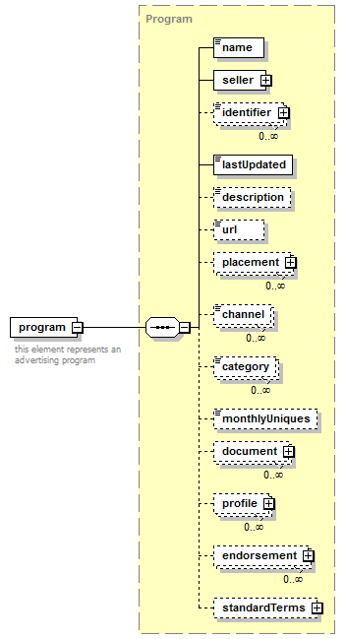
type | Program
properties
  content | complex
children | name seller identifier lastUpdated description url placement channel category monthlyUniques document profile endorsement standardTerms
annotation
  documentation
  this element represents an advertising program
source | <xs:element name="program" type="Program">  <xs:annotation>  <xs:documentation>this element represents an advertising program</xs:documentation>  </xs:annotation>  </xs:element>

complexType Placement
diagram | 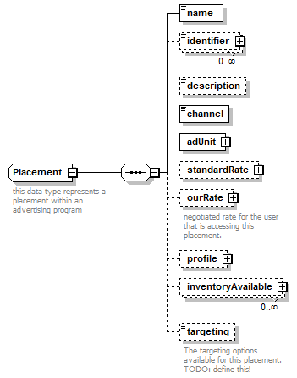
children | name identifier description channel adUnit standardRate ourRate profile inventoryAvailable targeting
used by
  elements | Order/lineItems/lineItem/placement/placement Program/placement
annotation
  documentation
  this data type represents a placement within an advertising program
source | <xs:complexType name="Placement">  <xs:annotation>  <xs:documentation>this data type represents a placement within an advertising program</xs:documentation>  </xs:annotation>  <xs:sequence minOccurs="1" maxOccurs="1">  <xs:element name="name" type="Name"/>  <xs:element name="identifier" type="Identifier" minOccurs="0" maxOccurs="unbounded"/>  <xs:element name="description" type="Note" minOccurs="0"/>  <xs:element name="channel" type="Channel"/>  <xs:element name="adUnit" type="AdUnit"/>  <xs:element name="standardRate" type="Rate" minOccurs="0"/>  <xs:element name="ourRate" type="Rate" minOccurs="0">  <xs:annotation>  <xs:documentation>negotiated rate for the user that is accessing this placement.</xs:documentation>  </xs:annotation>  </xs:element>  <xs:element name="profile" type="AudienceProfile" minOccurs="0"/>  <xs:element name="inventoryAvailable" minOccurs="0" maxOccurs="unbounded">  <xs:complexType>  <xs:sequence>  <xs:element name="period" type="TimeSpan" minOccurs="0"/>  <xs:element name="quantity" type="Quantity" maxOccurs="unbounded"/>  </xs:sequence>  </xs:complexType>  </xs:element>  <xs:element name="targeting" minOccurs="0">  <xs:annotation>  <xs:documentation>The targeting options available for this placement. TODO: define this!</xs:documentation>  </xs:annotation>  </xs:element>  </xs:sequence>  </xs:complexType>

element Placement/name
diagram
type | Name
properties
  content | simple
facets
  Kind | Value | Annotation
  minLength | 1
  maxLength | 80
  whiteSpace | collapse
source | <xs:element name="name" type="Name"/>

element Placement/identifier
diagram
type | Identifier
properties
  minOcc | 0
  maxOcc | unbounded
  content | complex
attributes
  Name | Type | Use | Default | Fixed | Annotation
  idOwner | Name
    documentation
    the entity that originates and "owns" this identifier. E.g. "Acme Corp."
source | <xs:element name="identifier" type="Identifier" minOccurs="0" maxOccurs="unbounded"/>

element Placement/description
diagram | 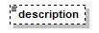
type | Note
properties
  minOcc | 0
  maxOcc | 1
  content | simple
facets
  Kind | Value | Annotation
  whiteSpace | preserve
source | <xs:element name="description" type="Note" minOccurs="0"/>

element Placement/channel
diagram | 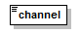
type | Channel
properties
  content | simple
facets
  Kind | Value | Annotation
  enumeration | email
  enumeration | onlineDisplay
source | <xs:element name="channel" type="Channel"/>

element Placement/adUnit
diagram | 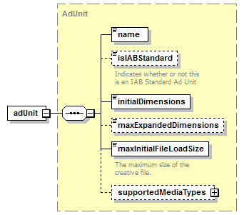
type | AdUnit
properties
  content | complex
children | name isIABStandard initialDimensions maxExpandedDimensions maxInitialFileLoadSize supportedMediaTypes
source | <xs:element name="adUnit" type="AdUnit"/>

element Placement/standardRate
diagram | 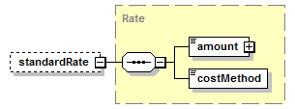
type | Rate
properties
  minOcc | 0
  maxOcc | 1
  content | complex
children | amount costMethod
source | <xs:element name="standardRate" type="Rate" minOccurs="0"/>

element Placement/ourRate
diagram | 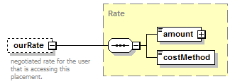
type | Rate
properties
  minOcc | 0
  maxOcc | 1
  content | complex
children | amount costMethod
annotation
  documentation
  negotiated rate for the user that is accessing this placement.
source | <xs:element name="ourRate" type="Rate" minOccurs="0">  <xs:annotation>  <xs:documentation>negotiated rate for the user that is accessing this placement.</xs:documentation>  </xs:annotation>  </xs:element>

element Placement/profile
diagram | 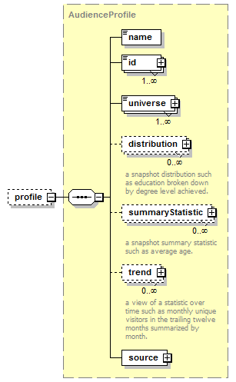
type | AudienceProfile
properties
  minOcc | 0
  maxOcc | 1
  content | complex
children | name id universe distribution summaryStatistic trend source
source | <xs:element name="profile" type="AudienceProfile" minOccurs="0"/>

element Placement/inventoryAvailable
diagram | 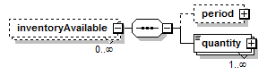
properties
  minOcc | 0
  maxOcc | unbounded
  content | complex
children | period quantity
source | <xs:element name="inventoryAvailable" minOccurs="0" maxOccurs="unbounded">  <xs:complexType>  <xs:sequence>  <xs:element name="period" type="TimeSpan" minOccurs="0"/>  <xs:element name="quantity" type="Quantity" maxOccurs="unbounded"/>  </xs:sequence>  </xs:complexType>  </xs:element>

element Placement/inventoryAvailable/period
diagram | 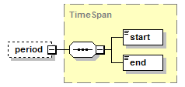
type | TimeSpan
properties
  minOcc | 0
  maxOcc | 1
  content | complex
children | start end
source | <xs:element name="period" type="TimeSpan" minOccurs="0"/>

element Placement/inventoryAvailable/quantity
diagram | 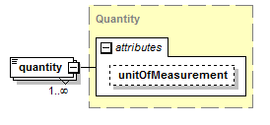
type | Quantity
properties
  minOcc | 1
  maxOcc | unbounded
  content | complex
attributes
  Name | Type | Use | Default | Fixed | Annotation
  unitOfMeasurement | UnitOfMeasurement
source | <xs:element name="quantity" type="Quantity" maxOccurs="unbounded"/>

element Placement/targeting
diagram | 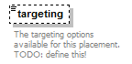
properties
  minOcc | 0
  maxOcc | 1
annotation
  documentation
  The targeting options available for this placement. TODO: define this!
source | <xs:element name="targeting" minOccurs="0">  <xs:annotation>  <xs:documentation>The targeting options available for this placement. TODO: define this!</xs:documentation>  </xs:annotation>  </xs:element>

complexType Program
diagram | 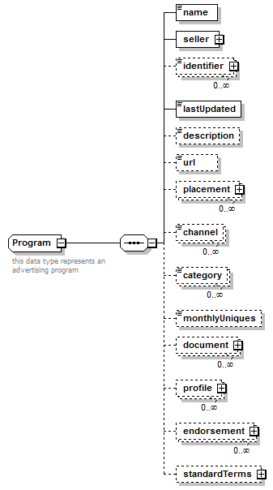
children | name seller identifier lastUpdated description url placement channel category monthlyUniques document profile endorsement standardTerms
used by
  element | program
annotation
  documentation
  this data type represents an advertising program
source | <xs:complexType name="Program">  <xs:annotation>  <xs:documentation>this data type represents an advertising program</xs:documentation>  </xs:annotation>  <xs:sequence>  <xs:element name="name" type="Name"/>  <xs:element name="seller" type="Transactor"/>  <xs:element name="identifier" type="Identifier" minOccurs="0" maxOccurs="unbounded"/>  <xs:element name="lastUpdated" type="xs:dateTime"/>  <xs:element name="description" type="Note" minOccurs="0"/>  <xs:element name="url" type="xs:anyURI" minOccurs="0"/>  <xs:element name="placement" type="Placement" minOccurs="0" maxOccurs="unbounded"/>  <xs:element name="channel" type="Channel" minOccurs="0" maxOccurs="unbounded"/>  <xs:element name="category" type="Category" minOccurs="0" maxOccurs="unbounded"/>  <xs:element name="monthlyUniques" type="xs:long" minOccurs="0"/>  <xs:element name="document" type="File" minOccurs="0" maxOccurs="unbounded"/>  <xs:element name="profile" type="AudienceProfile" minOccurs="0" maxOccurs="unbounded"/>  <xs:element name="endorsement" minOccurs="0" maxOccurs="unbounded">  <xs:complexType>  <xs:sequence>  <xs:element name="endorser" type="Person"/>  <xs:element name="timestamp" type="xs:dateTime"/>  <xs:element name="notes" minOccurs="0"/>  </xs:sequence>  </xs:complexType>  </xs:element>  <xs:element name="standardTerms" minOccurs="0">  <xs:complexType>  <xs:sequence>  <xs:element name="legal" type="LegalTerms" minOccurs="0"/>  <xs:element name="minimumBuy" type="Money" minOccurs="0"/>  <xs:element name="cancellationFee" type="Money" minOccurs="0"/>  <xs:element name="leadTime" type="xs:short" minOccurs="0">  <xs:annotation>  <xs:documentation>The number of days of lead time required for this order in advance of start date</xs:documentation>  </xs:annotation>  </xs:element>  <xs:element name="orderInstructions" type="Note"/>  </xs:sequence>  </xs:complexType>  </xs:element>  </xs:sequence>  </xs:complexType>

element Program/name
diagram
type | Name
properties
  content | simple
facets
  Kind | Value | Annotation
  minLength | 1
  maxLength | 80
  whiteSpace | collapse
source | <xs:element name="name" type="Name"/>

element Program/seller
diagram
type | Transactor
properties
  content | complex
children | company mainContact billingContact otherContacts
source | <xs:element name="seller" type="Transactor"/>

element Program/identifier
diagram
type | Identifier
properties
  minOcc | 0
  maxOcc | unbounded
  content | complex
attributes
  Name | Type | Use | Default | Fixed | Annotation
  idOwner | Name
    documentation
    the entity that originates and "owns" this identifier. E.g. "Acme Corp."
source | <xs:element name="identifier" type="Identifier" minOccurs="0" maxOccurs="unbounded"/>

element Program/lastUpdated
diagram | 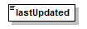
type | xs:dateTime
properties
  content | simple
source | <xs:element name="lastUpdated" type="xs:dateTime"/>

element Program/description
diagram
type | Note
properties
  minOcc | 0
  maxOcc | 1
  content | simple
facets
  Kind | Value | Annotation
  whiteSpace | preserve
source | <xs:element name="description" type="Note" minOccurs="0"/>

element Program/url
diagram
type | xs:anyURI
properties
  minOcc | 0
  maxOcc | 1
  content | simple
source | <xs:element name="url" type="xs:anyURI" minOccurs="0"/>

element Program/placement
diagram | 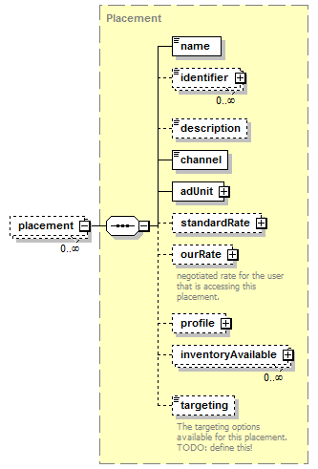
type | Placement
properties
  minOcc | 0
  maxOcc | unbounded
  content | complex
children | name identifier description channel adUnit standardRate ourRate profile inventoryAvailable targeting
source | <xs:element name="placement" type="Placement" minOccurs="0" maxOccurs="unbounded"/>

element Program/channel
diagram | 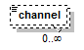
type | Channel
properties
  minOcc | 0
  maxOcc | unbounded
  content | simple
facets
  Kind | Value | Annotation
  enumeration | email
  enumeration | onlineDisplay
source | <xs:element name="channel" type="Channel" minOccurs="0" maxOccurs="unbounded"/>

element Program/category
diagram | 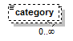
type | Category
properties
  minOcc | 0
  maxOcc | unbounded
  content | simple
facets
  Kind | Value | Annotation
  enumeration | [...iab standard categories to be entered ...]
source | <xs:element name="category" type="Category" minOccurs="0" maxOccurs="unbounded"/>

element Program/monthlyUniques
diagram | 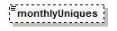
type | xs:long
properties
  minOcc | 0
  maxOcc | 1
  content | simple
source | <xs:element name="monthlyUniques" type="xs:long" minOccurs="0"/>

element Program/document
diagram | 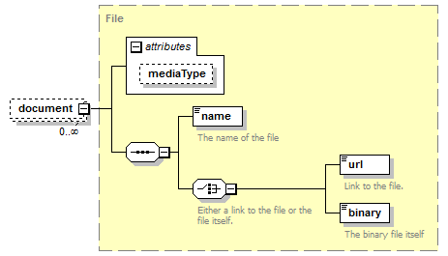
type | File
properties
  minOcc | 0
  maxOcc | unbounded
  content | complex
children | name url binary
attributes
  Name | Type | Use | Default | Fixed | Annotation
  mediaType | MediaType
source | <xs:element name="document" type="File" minOccurs="0" maxOccurs="unbounded"/>

element Program/profile
diagram | 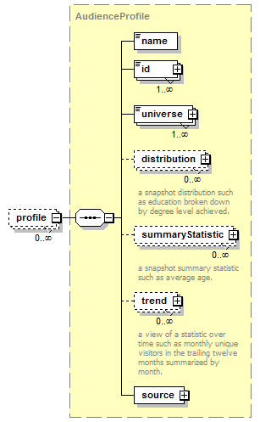
type | AudienceProfile
properties
  minOcc | 0
  maxOcc | unbounded
  content | complex
children | name id universe distribution summaryStatistic trend source
source | <xs:element name="profile" type="AudienceProfile" minOccurs="0" maxOccurs="unbounded"/>

element Program/endorsement
diagram | 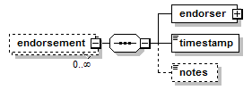
properties
  minOcc | 0
  maxOcc | unbounded
  content | complex
children | endorser timestamp notes
source | <xs:element name="endorsement" minOccurs="0" maxOccurs="unbounded">  <xs:complexType>  <xs:sequence>  <xs:element name="endorser" type="Person"/>  <xs:element name="timestamp" type="xs:dateTime"/>  <xs:element name="notes" minOccurs="0"/>  </xs:sequence>  </xs:complexType>  </xs:element>

element Program/endorsement/endorser
diagram | 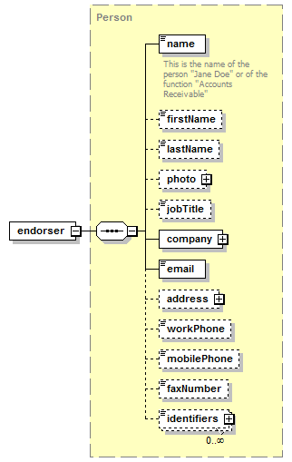
type | Person
properties
  content | complex
children | name firstName lastName photo jobTitle company email address workPhone mobilePhone faxNumber identifiers
source | <xs:element name="endorser" type="Person"/>

element Program/endorsement/timestamp
diagram
type | xs:dateTime
properties
  content | simple
source | <xs:element name="timestamp" type="xs:dateTime"/>

element Program/endorsement/notes
diagram
properties
  minOcc | 0
  maxOcc | 1
source | <xs:element name="notes" minOccurs="0"/>

element Program/standardTerms
diagram | 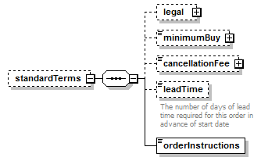
properties
  minOcc | 0
  maxOcc | 1
  content | complex
children | legal minimumBuy cancellationFee leadTime orderInstructions
source | <xs:element name="standardTerms" minOccurs="0">  <xs:complexType>  <xs:sequence>  <xs:element name="legal" type="LegalTerms" minOccurs="0"/>  <xs:element name="minimumBuy" type="Money" minOccurs="0"/>  <xs:element name="cancellationFee" type="Money" minOccurs="0"/>  <xs:element name="leadTime" type="xs:short" minOccurs="0">  <xs:annotation>  <xs:documentation>The number of days of lead time required for this order in advance of start date</xs:documentation>  </xs:annotation>  </xs:element>  <xs:element name="orderInstructions" type="Note"/>  </xs:sequence>  </xs:complexType>  </xs:element>

element Program/standardTerms/legal
diagram | 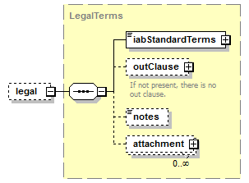
type | LegalTerms
properties
  minOcc | 0
  maxOcc | 1
  content | complex
children | iabStandardTerms outClause notes attachment
source | <xs:element name="legal" type="LegalTerms" minOccurs="0"/>

element Program/standardTerms/minimumBuy
diagram | 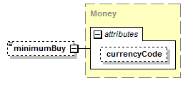
type | Money
properties
  minOcc | 0
  maxOcc | 1
  content | complex
attributes
  Name | Type | Use | Default | Fixed | Annotation
  currencyCode | CurrencyCode |  | USD
source | <xs:element name="minimumBuy" type="Money" minOccurs="0"/>

element Program/standardTerms/cancellationFee
diagram | 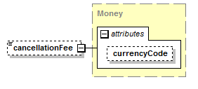
type | Money
properties
  minOcc | 0
  maxOcc | 1
  content | complex
attributes
  Name | Type | Use | Default | Fixed | Annotation
  currencyCode | CurrencyCode |  | USD
source | <xs:element name="cancellationFee" type="Money" minOccurs="0"/>

element Program/standardTerms/leadTime
diagram | 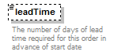
type | xs:short
properties
  minOcc | 0
  maxOcc | 1
  content | simple
annotation
  documentation
  The number of days of lead time required for this order in advance of start date
source | <xs:element name="leadTime" type="xs:short" minOccurs="0">  <xs:annotation>  <xs:documentation>The number of days of lead time required for this order in advance of start date</xs:documentation>  </xs:annotation>  </xs:element>

element Program/standardTerms/orderInstructions
diagram | 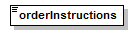
type | Note
properties
  content | simple
facets
  Kind | Value | Annotation
  whiteSpace | preserve
source | <xs:element name="orderInstructions" type="Note"/>

simpleType Category
type | restriction of xs:string
properties
  base | xs:string
used by
  element | Program/category
facets
  Kind | Value | Annotation
  enumeration | [...iab standard categories to be entered ...]
annotation
  documentation
  Enumeration of IAB standard categories
source | <xs:simpleType name="Category">  <xs:annotation>  <xs:documentation>Enumeration of IAB standard categories</xs:documentation>  </xs:annotation>  <xs:restriction base="xs:string">  <xs:enumeration value="[...iab standard categories to be entered ...]"/>  </xs:restriction>  </xs:simpleType>

simpleType CurrencyCode
type | restriction of xs:string
properties
  base | xs:string
used by
  attribute | Money/@currencyCode
facets
  Kind | Value | Annotation
  length | 3
  enumeration | AED
    documentation
    United Arab Emirates Dirham
  enumeration | AFN
    documentation
    Afghanistan Afghani
  enumeration | ALL
    documentation
    Albania Lek
  enumeration | AMD
    documentation
    Armenia Dram
  enumeration | ANG
    documentation
    Netherlands Antilles Guilder
  enumeration | AOA
    documentation
    Angola Kwanza
  enumeration | ARS
    documentation
    Argentina Peso
  enumeration | AUD
    documentation
    Australia Dollar
  enumeration | AWG
    documentation
    Aruba Guilder
  enumeration | AZN
    documentation
    Azerbaijan New Manat
  enumeration | BAM
    documentation
    Bosnia and Herzegovina Convertible Marka
  enumeration | BBD
    documentation
    Barbados Dollar
  enumeration | BDT
    documentation
    Bangladesh Taka
  enumeration | BGN
    documentation
    Bulgaria Lev
  enumeration | BHD
    documentation
    Bahrain Dinar
  enumeration | BIF
    documentation
    Burundi Franc
  enumeration | BMD
    documentation
    Bermuda Dollar
  enumeration | BND
    documentation
    Brunei Darussalam Dollar
  enumeration | BOB
    documentation
    Bolivia Boliviano
  enumeration | BRL
    documentation
    Brazil Real
  enumeration | BSD
    documentation
    Bahamas Dollar
  enumeration | BTN
    documentation
    Bhutan Ngultrum
  enumeration | BWP
    documentation
    Botswana Pula
  enumeration | BYR
    documentation
    Belarus Ruble
  enumeration | BZD
    documentation
    Belize Dollar
  enumeration | CAD
    documentation
    Canada Dollar
  enumeration | CDF
    documentation
    Congo/Kinshasa Franc
  enumeration | CHF
    documentation
    Switzerland Franc
  enumeration | CLP
    documentation
    Chile Peso
  enumeration | CNY
    documentation
    China Yuan Renminbi
  enumeration | COP
    documentation
    Colombia Peso
  enumeration | CRC
    documentation
    Costa Rica Colon
  enumeration | CUC
    documentation
    Cuba Convertible Peso
  enumeration | CUP
    documentation
    Cuba Peso
  enumeration | CVE
    documentation
    Cape Verde Escudo
  enumeration | CZK
    documentation
    Czech Republic Koruna
  enumeration | DJF
    documentation
    Djibouti Franc
  enumeration | DKK
    documentation
    Denmark Krone
  enumeration | DOP
    documentation
    Dominican Republic Peso
  enumeration | DZD
    documentation
    Algeria Dinar
  enumeration | EGP
    documentation
    Egypt Pound
  enumeration | ERN
    documentation
    Eritrea Nakfa
  enumeration | ETB
    documentation
    Ethiopia Birr
  enumeration | EUR
    documentation
    Euro Member Countries
  enumeration | FJD
    documentation
    Fiji Dollar
  enumeration | FKP
    documentation
    Falkland Islands (Malvinas) Pound
  enumeration | GBP
    documentation
    United Kingdom Pound
  enumeration | GEL
    documentation
    Georgia Lari
  enumeration | GGP
    documentation
    Guernsey Pound
  enumeration | GHS
    documentation
    Ghana Cedi
  enumeration | GIP
    documentation
    Gibraltar Pound
  enumeration | GMD
    documentation
    Gambia Dalasi
  enumeration | GNF
    documentation
    Guinea Franc
  enumeration | GTQ
    documentation
    Guatemala Quetzal
  enumeration | GYD
    documentation
    Guyana Dollar
  enumeration | HKD
    documentation
    Hong Kong Dollar
  enumeration | HNL
    documentation
    Honduras Lempira
  enumeration | HRK
    documentation
    Croatia Kuna
  enumeration | HTG
    documentation
    Haiti Gourde
  enumeration | HUF
    documentation
    Hungary Forint
  enumeration | IDR
    documentation
    Indonesia Rupiah
  enumeration | ILS
    documentation
    Israel Shekel
  enumeration | IMP
    documentation
    Isle of Man Pound
  enumeration | INR
    documentation
    India Rupee
  enumeration | IQD
    documentation
    Iraq Dinar
  enumeration | IRR
    documentation
    Iran Rial
  enumeration | ISK
    documentation
    Iceland Krona
  enumeration | JEP
    documentation
    Jersey Pound
  enumeration | JMD
    documentation
    Jamaica Dollar
  enumeration | JOD
    documentation
    Jordan Dinar
  enumeration | JPY
    documentation
    Japan Yen
  enumeration | KES
    documentation
    Kenya Shilling
  enumeration | KGS
    documentation
    Kyrgyzstan Som
  enumeration | KHR
    documentation
    Cambodia Riel
  enumeration | KMF
    documentation
    Comoros Franc
  enumeration | KPW
    documentation
    Korea (North) Won
  enumeration | KRW
    documentation
    Korea (South) Won
  enumeration | KWD
    documentation
    Kuwait Dinar
  enumeration | KYD
    documentation
    Cayman Islands Dollar
  enumeration | KZT
    documentation
    Kazakhstan Tenge
  enumeration | LAK
    documentation
    Laos Kip
  enumeration | LBP
    documentation
    Lebanon Pound
  enumeration | LKR
    documentation
    Sri Lanka Rupee
  enumeration | LRD
    documentation
    Liberia Dollar
  enumeration | LSL
    documentation
    Lesotho Loti
  enumeration | LTL
    documentation
    Lithuania Litas
  enumeration | LVL
    documentation
    Latvia Lat
  enumeration | LYD
    documentation
    Libya Dinar
  enumeration | MAD
    documentation
    Morocco Dirham
  enumeration | MDL
    documentation
    Moldova Leu
  enumeration | MGA
    documentation
    Madagascar Ariary
  enumeration | MKD
    documentation
    Macedonia Denar
  enumeration | MMK
    documentation
    Myanmar (Burma) Kyat
  enumeration | MNT
    documentation
    Mongolia Tughrik
  enumeration | MOP
    documentation
    Macau Pataca
  enumeration | MRO
    documentation
    Mauritania Ouguiya
  enumeration | MUR
    documentation
    Mauritius Rupee
  enumeration | MVR
    documentation
    Maldives (Maldive Islands) Rufiyaa
  enumeration | MWK
    documentation
    Malawi Kwacha
  enumeration | MXN
    documentation
    Mexico Peso
  enumeration | MYR
    documentation
    Malaysia Ringgit
  enumeration | MZN
    documentation
    Mozambique Metical
  enumeration | NAD
    documentation
    Namibia Dollar
  enumeration | NGN
    documentation
    Nigeria Naira
  enumeration | NIO
    documentation
    Nicaragua Cordoba
  enumeration | NOK
    documentation
    Norway Krone
  enumeration | NPR
    documentation
    Nepal Rupee
  enumeration | NZD
    documentation
    New Zealand Dollar
  enumeration | OMR
    documentation
    Oman Rial
  enumeration | PAB
    documentation
    Panama Balboa
  enumeration | PEN
    documentation
    Peru Nuevo Sol
  enumeration | PGK
    documentation
    Papua New Guinea Kina
  enumeration | PHP
    documentation
    Philippines Peso
  enumeration | PKR
    documentation
    Pakistan Rupee
  enumeration | PLN
    documentation
    Poland Zloty
  enumeration | PYG
    documentation
    Paraguay Guarani
  enumeration | QAR
    documentation
    Qatar Riyal
  enumeration | RON
    documentation
    Romania New Leu
  enumeration | RSD
    documentation
    Serbia Dinar
  enumeration | RUB
    documentation
    Russia Ruble
  enumeration | RWF
    documentation
    Rwanda Franc
  enumeration | SAR
    documentation
    Saudi Arabia Riyal
  enumeration | SBD
    documentation
    Solomon Islands Dollar
  enumeration | SCR
    documentation
    Seychelles Rupee
  enumeration | SDG
    documentation
    Sudan Pound
  enumeration | SEK
    documentation
    Sweden Krona
  enumeration | SGD
    documentation
    Singapore Dollar
  enumeration | SHP
    documentation
    Saint Helena Pound
  enumeration | SLL
    documentation
    Sierra Leone Leone
  enumeration | SOS
    documentation
    Somalia Shilling
  enumeration | SPL*
    documentation
    Seborga Luigino
  enumeration | SRD
    documentation
    Suriname Dollar
  enumeration | STD
    documentation
    São Tomé and Príncipe Dobra
  enumeration | SVC
    documentation
    El Salvador Colon
  enumeration | SYP
    documentation
    Syria Pound
  enumeration | SZL
    documentation
    Swaziland Lilangeni
  enumeration | THB
    documentation
    Thailand Baht
  enumeration | TJS
    documentation
    Tajikistan Somoni
  enumeration | TMT
    documentation
    Turkmenistan Manat
  enumeration | TND
    documentation
    Tunisia Dinar
  enumeration | TOP
    documentation
    Tonga Pa'anga
  enumeration | TRY
    documentation
    Turkey Lira
  enumeration | TTD
    documentation
    Trinidad and Tobago Dollar
  enumeration | TVD
    documentation
    Tuvalu Dollar
  enumeration | TWD
    documentation
    Taiwan New Dollar
  enumeration | TZS
    documentation
    Tanzania Shilling
  enumeration | UAH
    documentation
    Ukraine Hryvna
  enumeration | UGX
    documentation
    Uganda Shilling
  enumeration | USD
    documentation
    United States Dollar
  enumeration | UYU
    documentation
    Uruguay Peso
  enumeration | UZS
    documentation
    Uzbekistan Som
  enumeration | VEF
    documentation
    Venezuela Bolivar
  enumeration | VND
    documentation
    Viet Nam Dong
  enumeration | VUV
    documentation
    Vanuatu Vatu
  enumeration | WST
    documentation
    Samoa Tala
  enumeration | XAF
    documentation
    Communauté Financière Africaine (BEAC) CFA Franc BEAC
  enumeration | XCD
    documentation
    East Caribbean Dollar
  enumeration | XDR
    documentation
    International Monetary Fund (IMF) Special Drawing Rights
  enumeration | XOF
    documentation
    Communauté Financière Africaine (BCEAO) Franc
  enumeration | XPF
    documentation
    Comptoirs Français du Pacifique (CFP) Franc
  enumeration | YER
    documentation
    Yemen Rial
  enumeration | ZAR
    documentation
    South Africa Rand
  enumeration | ZMW
    documentation
    Zambia Kwacha
  enumeration | ZWD
    documentation
    Zimbabwe Dollar
annotation
  documentation
  ISO 4217 Currency Code.
source | <xs:simpleType name="CurrencyCode">  <xs:annotation>  <xs:documentation>ISO 4217 Currency Code.</xs:documentation>  </xs:annotation>  <xs:restriction base="xs:string">  <xs:length value="3"/>  <xs:enumeration value="AED">  <xs:annotation>  <xs:documentation>United Arab Emirates Dirham</xs:documentation>  </xs:annotation>  </xs:enumeration>  <xs:enumeration value="AFN">  <xs:annotation>  <xs:documentation>Afghanistan Afghani</xs:documentation>  </xs:annotation>  </xs:enumeration>  <xs:enumeration value="ALL">  <xs:annotation>  <xs:documentation>Albania Lek</xs:documentation>  </xs:annotation>  </xs:enumeration>  <xs:enumeration value="AMD">  <xs:annotation>  <xs:documentation>Armenia Dram</xs:documentation>  </xs:annotation>  </xs:enumeration>  <xs:enumeration value="ANG">  <xs:annotation>  <xs:documentation>Netherlands Antilles Guilder</xs:documentation>  </xs:annotation>  </xs:enumeration>  <xs:enumeration value="AOA">  <xs:annotation>  <xs:documentation>Angola Kwanza</xs:documentation>  </xs:annotation>  </xs:enumeration>  <xs:enumeration value="ARS">  <xs:annotation>  <xs:documentation>Argentina Peso</xs:documentation>  </xs:annotation>  </xs:enumeration>  <xs:enumeration value="AUD">  <xs:annotation>  <xs:documentation>Australia Dollar</xs:documentation>  </xs:annotation>  </xs:enumeration>  <xs:enumeration value="AWG">  <xs:annotation>  <xs:documentation>Aruba Guilder</xs:documentation>  </xs:annotation>  </xs:enumeration>  <xs:enumeration value="AZN">  <xs:annotation>  <xs:documentation>Azerbaijan New Manat</xs:documentation>  </xs:annotation>  </xs:enumeration>  <xs:enumeration value="BAM">  <xs:annotation>  <xs:documentation>Bosnia and Herzegovina Convertible Marka</xs:documentation>  </xs:annotation>  </xs:enumeration>  <xs:enumeration value="BBD">  <xs:annotation>  <xs:documentation>Barbados Dollar</xs:documentation>  </xs:annotation>  </xs:enumeration>  <xs:enumeration value="BDT">  <xs:annotation>  <xs:documentation>Bangladesh Taka</xs:documentation>  </xs:annotation>  </xs:enumeration>  <xs:enumeration value="BGN">  <xs:annotation>  <xs:documentation>Bulgaria Lev</xs:documentation>  </xs:annotation>  </xs:enumeration>  <xs:enumeration value="BHD">  <xs:annotation>  <xs:documentation>Bahrain Dinar</xs:documentation>  </xs:annotation>  </xs:enumeration>  <xs:enumeration value="BIF">  <xs:annotation>  <xs:documentation>Burundi Franc</xs:documentation>  </xs:annotation>  </xs:enumeration>  <xs:enumeration value="BMD">  <xs:annotation>  <xs:documentation>Bermuda Dollar</xs:documentation>  </xs:annotation>  </xs:enumeration>  <xs:enumeration value="BND">  <xs:annotation>  <xs:documentation>Brunei Darussalam Dollar</xs:documentation>  </xs:annotation>  </xs:enumeration>  <xs:enumeration value="BOB">  <xs:annotation>  <xs:documentation>Bolivia Boliviano</xs:documentation>  </xs:annotation>  </xs:enumeration>  <xs:enumeration value="BRL">  <xs:annotation>  <xs:documentation>Brazil Real</xs:documentation>  </xs:annotation>  </xs:enumeration>  <xs:enumeration value="BSD">  <xs:annotation>  <xs:documentation>Bahamas Dollar</xs:documentation>  </xs:annotation>  </xs:enumeration>  <xs:enumeration value="BTN">  <xs:annotation>  <xs:documentation>Bhutan Ngultrum</xs:documentation>  </xs:annotation>  </xs:enumeration>  <xs:enumeration value="BWP">  <xs:annotation>  <xs:documentation>Botswana Pula</xs:documentation>  </xs:annotation>  </xs:enumeration>  <xs:enumeration value="BYR">  <xs:annotation>  <xs:documentation>Belarus Ruble</xs:documentation>  </xs:annotation>  </xs:enumeration>  <xs:enumeration value="BZD">  <xs:annotation>  <xs:documentation>Belize Dollar</xs:documentation>  </xs:annotation>  </xs:enumeration>  <xs:enumeration value="CAD">  <xs:annotation>  <xs:documentation>Canada Dollar</xs:documentation>  </xs:annotation>  </xs:enumeration>  <xs:enumeration value="CDF">  <xs:annotation>  <xs:documentation>Congo/Kinshasa Franc</xs:documentation>  </xs:annotation>  </xs:enumeration>  <xs:enumeration value="CHF">  <xs:annotation>  <xs:documentation>Switzerland Franc</xs:documentation>  </xs:annotation>  </xs:enumeration>  <xs:enumeration value="CLP">  <xs:annotation>  <xs:documentation>Chile Peso</xs:documentation>  </xs:annotation>  </xs:enumeration>  <xs:enumeration value="CNY">  <xs:annotation>  <xs:documentation>China Yuan Renminbi</xs:documentation>  </xs:annotation>  </xs:enumeration>  <xs:enumeration value="COP">  <xs:annotation>  <xs:documentation>Colombia Peso</xs:documentation>  </xs:annotation>  </xs:enumeration>  <xs:enumeration value="CRC">  <xs:annotation>  <xs:documentation>Costa Rica Colon</xs:documentation>  </xs:annotation>  </xs:enumeration>  <xs:enumeration value="CUC">  <xs:annotation>  <xs:documentation>Cuba Convertible Peso</xs:documentation>  </xs:annotation>  </xs:enumeration>  <xs:enumeration value="CUP">  <xs:annotation>  <xs:documentation>Cuba Peso</xs:documentation>  </xs:annotation>  </xs:enumeration>  <xs:enumeration value="CVE">  <xs:annotation>  <xs:documentation>Cape Verde Escudo</xs:documentation>  </xs:annotation>  </xs:enumeration>  <xs:enumeration value="CZK">  <xs:annotation>  <xs:documentation>Czech Republic Koruna</xs:documentation>  </xs:annotation>  </xs:enumeration>  <xs:enumeration value="DJF">  <xs:annotation>  <xs:documentation>Djibouti Franc</xs:documentation>  </xs:annotation>  </xs:enumeration>  <xs:enumeration value="DKK">  <xs:annotation>  <xs:documentation>Denmark Krone</xs:documentation>  </xs:annotation>  </xs:enumeration>  <xs:enumeration value="DOP">  <xs:annotation>  <xs:documentation>Dominican Republic Peso</xs:documentation>  </xs:annotation>  </xs:enumeration>  <xs:enumeration value="DZD">  <xs:annotation>  <xs:documentation>Algeria Dinar</xs:documentation>  </xs:annotation>  </xs:enumeration>  <xs:enumeration value="EGP">  <xs:annotation>  <xs:documentation>Egypt Pound</xs:documentation>  </xs:annotation>  </xs:enumeration>  <xs:enumeration value="ERN">  <xs:annotation>  <xs:documentation>Eritrea Nakfa</xs:documentation>  </xs:annotation>  </xs:enumeration>  <xs:enumeration value="ETB">  <xs:annotation>  <xs:documentation>Ethiopia Birr</xs:documentation>  </xs:annotation>  </xs:enumeration>  <xs:enumeration value="EUR">  <xs:annotation>  <xs:documentation>Euro Member Countries</xs:documentation>  </xs:annotation>  </xs:enumeration>  <xs:enumeration value="FJD">  <xs:annotation>  <xs:documentation>Fiji Dollar</xs:documentation>  </xs:annotation>  </xs:enumeration>  <xs:enumeration value="FKP">  <xs:annotation>  <xs:documentation>Falkland Islands (Malvinas) Pound</xs:documentation>  </xs:annotation>  </xs:enumeration>  <xs:enumeration value="GBP">  <xs:annotation>  <xs:documentation>United Kingdom Pound</xs:documentation>  </xs:annotation>  </xs:enumeration>  <xs:enumeration value="GEL">  <xs:annotation>  <xs:documentation>Georgia Lari</xs:documentation>  </xs:annotation>  </xs:enumeration>  <xs:enumeration value="GGP">  <xs:annotation>  <xs:documentation>Guernsey Pound</xs:documentation>  </xs:annotation>  </xs:enumeration>  <xs:enumeration value="GHS">  <xs:annotation>  <xs:documentation>Ghana Cedi</xs:documentation>  </xs:annotation>  </xs:enumeration>  <xs:enumeration value="GIP">  <xs:annotation>  <xs:documentation>Gibraltar Pound</xs:documentation>  </xs:annotation>  </xs:enumeration>  <xs:enumeration value="GMD">  <xs:annotation>  <xs:documentation>Gambia Dalasi</xs:documentation>  </xs:annotation>  </xs:enumeration>  <xs:enumeration value="GNF">  <xs:annotation>  <xs:documentation>Guinea Franc</xs:documentation>  </xs:annotation>  </xs:enumeration>  <xs:enumeration value="GTQ">  <xs:annotation>  <xs:documentation>Guatemala Quetzal</xs:documentation>  </xs:annotation>  </xs:enumeration>  <xs:enumeration value="GYD">  <xs:annotation>  <xs:documentation>Guyana Dollar</xs:documentation>  </xs:annotation>  </xs:enumeration>  <xs:enumeration value="HKD">  <xs:annotation>  <xs:documentation>Hong Kong Dollar</xs:documentation>  </xs:annotation>  </xs:enumeration>  <xs:enumeration value="HNL">  <xs:annotation>  <xs:documentation>Honduras Lempira</xs:documentation>  </xs:annotation>  </xs:enumeration>  <xs:enumeration value="HRK">  <xs:annotation>  <xs:documentation>Croatia Kuna</xs:documentation>  </xs:annotation>  </xs:enumeration>  <xs:enumeration value="HTG">  <xs:annotation>  <xs:documentation>Haiti Gourde</xs:documentation>  </xs:annotation>  </xs:enumeration>  <xs:enumeration value="HUF">  <xs:annotation>  <xs:documentation>Hungary Forint</xs:documentation>  </xs:annotation>  </xs:enumeration>  <xs:enumeration value="IDR">  <xs:annotation>  <xs:documentation>Indonesia Rupiah</xs:documentation>  </xs:annotation>  </xs:enumeration>  <xs:enumeration value="ILS">  <xs:annotation>  <xs:documentation>Israel Shekel</xs:documentation>  </xs:annotation>  </xs:enumeration>  <xs:enumeration value="IMP">  <xs:annotation>  <xs:documentation>Isle of Man Pound</xs:documentation>  </xs:annotation>  </xs:enumeration>  <xs:enumeration value="INR">  <xs:annotation>  <xs:documentation>India Rupee</xs:documentation>  </xs:annotation>  </xs:enumeration>  <xs:enumeration value="IQD">  <xs:annotation>  <xs:documentation>Iraq Dinar</xs:documentation>  </xs:annotation>  </xs:enumeration>  <xs:enumeration value="IRR">  <xs:annotation>  <xs:documentation>Iran Rial</xs:documentation>  </xs:annotation>  </xs:enumeration>  <xs:enumeration value="ISK">  <xs:annotation>  <xs:documentation>Iceland Krona</xs:documentation>  </xs:annotation>  </xs:enumeration>  <xs:enumeration value="JEP">  <xs:annotation>  <xs:documentation>Jersey Pound</xs:documentation>  </xs:annotation>  </xs:enumeration>  <xs:enumeration value="JMD">  <xs:annotation>  <xs:documentation>Jamaica Dollar</xs:documentation>  </xs:annotation>  </xs:enumeration>  <xs:enumeration value="JOD">  <xs:annotation>  <xs:documentation>Jordan Dinar</xs:documentation>  </xs:annotation>  </xs:enumeration>  <xs:enumeration value="JPY">  <xs:annotation>  <xs:documentation>Japan Yen</xs:documentation>  </xs:annotation>  </xs:enumeration>  <xs:enumeration value="KES">  <xs:annotation>  <xs:documentation>Kenya Shilling</xs:documentation>  </xs:annotation>  </xs:enumeration>  <xs:enumeration value="KGS">  <xs:annotation>  <xs:documentation>Kyrgyzstan Som</xs:documentation>  </xs:annotation>  </xs:enumeration>  <xs:enumeration value="KHR">  <xs:annotation>  <xs:documentation>Cambodia Riel</xs:documentation>  </xs:annotation>  </xs:enumeration>  <xs:enumeration value="KMF">  <xs:annotation>  <xs:documentation>Comoros Franc</xs:documentation>  </xs:annotation>  </xs:enumeration>  <xs:enumeration value="KPW">  <xs:annotation>  <xs:documentation>Korea (North) Won</xs:documentation>  </xs:annotation>  </xs:enumeration>  <xs:enumeration value="KRW">  <xs:annotation>  <xs:documentation>Korea (South) Won</xs:documentation>  </xs:annotation>  </xs:enumeration>  <xs:enumeration value="KWD">  <xs:annotation>  <xs:documentation>Kuwait Dinar</xs:documentation>  </xs:annotation>  </xs:enumeration>  <xs:enumeration value="KYD">  <xs:annotation>  <xs:documentation>Cayman Islands Dollar</xs:documentation>  </xs:annotation>  </xs:enumeration>  <xs:enumeration value="KZT">  <xs:annotation>  <xs:documentation>Kazakhstan Tenge</xs:documentation>  </xs:annotation>  </xs:enumeration>  <xs:enumeration value="LAK">  <xs:annotation>  <xs:documentation>Laos Kip</xs:documentation>  </xs:annotation>  </xs:enumeration>  <xs:enumeration value="LBP">  <xs:annotation>  <xs:documentation>Lebanon Pound</xs:documentation>  </xs:annotation>  </xs:enumeration>  <xs:enumeration value="LKR">  <xs:annotation>  <xs:documentation>Sri Lanka Rupee</xs:documentation>  </xs:annotation>  </xs:enumeration>  <xs:enumeration value="LRD">  <xs:annotation>  <xs:documentation>Liberia Dollar</xs:documentation>  </xs:annotation>  </xs:enumeration>  <xs:enumeration value="LSL">  <xs:annotation>  <xs:documentation>Lesotho Loti</xs:documentation>  </xs:annotation>  </xs:enumeration>  <xs:enumeration value="LTL">  <xs:annotation>  <xs:documentation>Lithuania Litas</xs:documentation>  </xs:annotation>  </xs:enumeration>  <xs:enumeration value="LVL">  <xs:annotation>  <xs:documentation>Latvia Lat</xs:documentation>  </xs:annotation>  </xs:enumeration>  <xs:enumeration value="LYD">  <xs:annotation>  <xs:documentation>Libya Dinar</xs:documentation>  </xs:annotation>  </xs:enumeration>  <xs:enumeration value="MAD">  <xs:annotation>  <xs:documentation>Morocco Dirham</xs:documentation>  </xs:annotation>  </xs:enumeration>  <xs:enumeration value="MDL">  <xs:annotation>  <xs:documentation>Moldova Leu</xs:documentation>  </xs:annotation>  </xs:enumeration>  <xs:enumeration value="MGA">  <xs:annotation>  <xs:documentation>Madagascar Ariary</xs:documentation>  </xs:annotation>  </xs:enumeration>  <xs:enumeration value="MKD">  <xs:annotation>  <xs:documentation>Macedonia Denar</xs:documentation>  </xs:annotation>  </xs:enumeration>  <xs:enumeration value="MMK">  <xs:annotation>  <xs:documentation>Myanmar (Burma) Kyat</xs:documentation>  </xs:annotation>  </xs:enumeration>  <xs:enumeration value="MNT">  <xs:annotation>  <xs:documentation>Mongolia Tughrik</xs:documentation>  </xs:annotation>  </xs:enumeration>  <xs:enumeration value="MOP">  <xs:annotation>  <xs:documentation>Macau Pataca</xs:documentation>  </xs:annotation>  </xs:enumeration>  <xs:enumeration value="MRO">  <xs:annotation>  <xs:documentation>Mauritania Ouguiya</xs:documentation>  </xs:annotation>  </xs:enumeration>  <xs:enumeration value="MUR">  <xs:annotation>  <xs:documentation>Mauritius Rupee</xs:documentation>  </xs:annotation>  </xs:enumeration>  <xs:enumeration value="MVR">  <xs:annotation>  <xs:documentation>Maldives (Maldive Islands) Rufiyaa</xs:documentation>  </xs:annotation>  </xs:enumeration>  <xs:enumeration value="MWK">  <xs:annotation>  <xs:documentation>Malawi Kwacha</xs:documentation>  </xs:annotation>  </xs:enumeration>  <xs:enumeration value="MXN">  <xs:annotation>  <xs:documentation>Mexico Peso</xs:documentation>  </xs:annotation>  </xs:enumeration>  <xs:enumeration value="MYR">  <xs:annotation>  <xs:documentation>Malaysia Ringgit</xs:documentation>  </xs:annotation>  </xs:enumeration>  <xs:enumeration value="MZN">  <xs:annotation>  <xs:documentation>Mozambique Metical</xs:documentation>  </xs:annotation>  </xs:enumeration>  <xs:enumeration value="NAD">  <xs:annotation>  <xs:documentation>Namibia Dollar</xs:documentation>  </xs:annotation>  </xs:enumeration>  <xs:enumeration value="NGN">  <xs:annotation>  <xs:documentation>Nigeria Naira</xs:documentation>  </xs:annotation>  </xs:enumeration>  <xs:enumeration value="NIO">  <xs:annotation>  <xs:documentation>Nicaragua Cordoba</xs:documentation>  </xs:annotation>  </xs:enumeration>  <xs:enumeration value="NOK">  <xs:annotation>  <xs:documentation>Norway Krone</xs:documentation>  </xs:annotation>  </xs:enumeration>  <xs:enumeration value="NPR">  <xs:annotation>  <xs:documentation>Nepal Rupee</xs:documentation>  </xs:annotation>  </xs:enumeration>  <xs:enumeration value="NZD">  <xs:annotation>  <xs:documentation>New Zealand Dollar</xs:documentation>  </xs:annotation>  </xs:enumeration>  <xs:enumeration value="OMR">  <xs:annotation>  <xs:documentation>Oman Rial</xs:documentation>  </xs:annotation>  </xs:enumeration>  <xs:enumeration value="PAB">  <xs:annotation>  <xs:documentation>Panama Balboa</xs:documentation>  </xs:annotation>  </xs:enumeration>  <xs:enumeration value="PEN">  <xs:annotation>  <xs:documentation>Peru Nuevo Sol</xs:documentation>  </xs:annotation>  </xs:enumeration>  <xs:enumeration value="PGK">  <xs:annotation>  <xs:documentation>Papua New Guinea Kina</xs:documentation>  </xs:annotation>  </xs:enumeration>  <xs:enumeration value="PHP">  <xs:annotation>  <xs:documentation>Philippines Peso</xs:documentation>  </xs:annotation>  </xs:enumeration>  <xs:enumeration value="PKR">  <xs:annotation>  <xs:documentation>Pakistan Rupee</xs:documentation>  </xs:annotation>  </xs:enumeration>  <xs:enumeration value="PLN">  <xs:annotation>  <xs:documentation>Poland Zloty</xs:documentation>  </xs:annotation>  </xs:enumeration>  <xs:enumeration value="PYG">  <xs:annotation>  <xs:documentation>Paraguay Guarani</xs:documentation>  </xs:annotation>  </xs:enumeration>  <xs:enumeration value="QAR">  <xs:annotation>  <xs:documentation>Qatar Riyal</xs:documentation>  </xs:annotation>  </xs:enumeration>  <xs:enumeration value="RON">  <xs:annotation>  <xs:documentation>Romania New Leu</xs:documentation>  </xs:annotation>  </xs:enumeration>  <xs:enumeration value="RSD">  <xs:annotation>  <xs:documentation>Serbia Dinar</xs:documentation>  </xs:annotation>  </xs:enumeration>  <xs:enumeration value="RUB">  <xs:annotation>  <xs:documentation>Russia Ruble</xs:documentation>  </xs:annotation>  </xs:enumeration>  <xs:enumeration value="RWF">  <xs:annotation>  <xs:documentation>Rwanda Franc</xs:documentation>  </xs:annotation>  </xs:enumeration>  <xs:enumeration value="SAR">  <xs:annotation>  <xs:documentation>Saudi Arabia Riyal</xs:documentation>  </xs:annotation>  </xs:enumeration>  <xs:enumeration value="SBD">  <xs:annotation>  <xs:documentation>Solomon Islands Dollar</xs:documentation>  </xs:annotation>  </xs:enumeration>  <xs:enumeration value="SCR">  <xs:annotation>  <xs:documentation>Seychelles Rupee</xs:documentation>  </xs:annotation>  </xs:enumeration>  <xs:enumeration value="SDG">  <xs:annotation>  <xs:documentation>Sudan Pound</xs:documentation>  </xs:annotation>  </xs:enumeration>  <xs:enumeration value="SEK">  <xs:annotation>  <xs:documentation>Sweden Krona</xs:documentation>  </xs:annotation>  </xs:enumeration>  <xs:enumeration value="SGD">  <xs:annotation>  <xs:documentation>Singapore Dollar</xs:documentation>  </xs:annotation>  </xs:enumeration>  <xs:enumeration value="SHP">  <xs:annotation>  <xs:documentation>Saint Helena Pound</xs:documentation>  </xs:annotation>  </xs:enumeration>  <xs:enumeration value="SLL">  <xs:annotation>  <xs:documentation>Sierra Leone Leone</xs:documentation>  </xs:annotation>  </xs:enumeration>  <xs:enumeration value="SOS">  <xs:annotation>  <xs:documentation>Somalia Shilling</xs:documentation>  </xs:annotation>  </xs:enumeration>  <xs:enumeration value="SPL*">  <xs:annotation>  <xs:documentation>Seborga Luigino</xs:documentation>  </xs:annotation>  </xs:enumeration>  <xs:enumeration value="SRD">  <xs:annotation>  <xs:documentation>Suriname Dollar</xs:documentation>  </xs:annotation>  </xs:enumeration>  <xs:enumeration value="STD">  <xs:annotation>  <xs:documentation>São Tomé and Príncipe Dobra</xs:documentation>  </xs:annotation>  </xs:enumeration>  <xs:enumeration value="SVC">  <xs:annotation>  <xs:documentation>El Salvador Colon</xs:documentation>  </xs:annotation>  </xs:enumeration>  <xs:enumeration value="SYP">  <xs:annotation>  <xs:documentation>Syria Pound</xs:documentation>  </xs:annotation>  </xs:enumeration>  <xs:enumeration value="SZL">  <xs:annotation>  <xs:documentation>Swaziland Lilangeni</xs:documentation>  </xs:annotation>  </xs:enumeration>  <xs:enumeration value="THB">  <xs:annotation>  <xs:documentation>Thailand Baht</xs:documentation>  </xs:annotation>  </xs:enumeration>  <xs:enumeration value="TJS">  <xs:annotation>  <xs:documentation>Tajikistan Somoni</xs:documentation>  </xs:annotation>  </xs:enumeration>  <xs:enumeration value="TMT">  <xs:annotation>  <xs:documentation>Turkmenistan Manat</xs:documentation>  </xs:annotation>  </xs:enumeration>  <xs:enumeration value="TND">  <xs:annotation>  <xs:documentation>Tunisia Dinar</xs:documentation>  </xs:annotation>  </xs:enumeration>  <xs:enumeration value="TOP">  <xs:annotation>  <xs:documentation>Tonga Pa'anga</xs:documentation>  </xs:annotation>  </xs:enumeration>  <xs:enumeration value="TRY">  <xs:annotation>  <xs:documentation>Turkey Lira</xs:documentation>  </xs:annotation>  </xs:enumeration>  <xs:enumeration value="TTD">  <xs:annotation>  <xs:documentation>Trinidad and Tobago Dollar</xs:documentation>  </xs:annotation>  </xs:enumeration>  <xs:enumeration value="TVD">  <xs:annotation>  <xs:documentation>Tuvalu Dollar</xs:documentation>  </xs:annotation>  </xs:enumeration>  <xs:enumeration value="TWD">  <xs:annotation>  <xs:documentation>Taiwan New Dollar</xs:documentation>  </xs:annotation>  </xs:enumeration>  <xs:enumeration value="TZS">  <xs:annotation>  <xs:documentation>Tanzania Shilling</xs:documentation>  </xs:annotation>  </xs:enumeration>  <xs:enumeration value="UAH">  <xs:annotation>  <xs:documentation>Ukraine Hryvna</xs:documentation>  </xs:annotation>  </xs:enumeration>  <xs:enumeration value="UGX">  <xs:annotation>  <xs:documentation>Uganda Shilling</xs:documentation>  </xs:annotation>  </xs:enumeration>  <xs:enumeration value="USD">  <xs:annotation>  <xs:documentation>United States Dollar</xs:documentation>  </xs:annotation>  </xs:enumeration>  <xs:enumeration value="UYU">  <xs:annotation>  <xs:documentation>Uruguay Peso</xs:documentation>  </xs:annotation>  </xs:enumeration>  <xs:enumeration value="UZS">  <xs:annotation>  <xs:documentation>Uzbekistan Som</xs:documentation>  </xs:annotation>  </xs:enumeration>  <xs:enumeration value="VEF">  <xs:annotation>  <xs:documentation>Venezuela Bolivar</xs:documentation>  </xs:annotation>  </xs:enumeration>  <xs:enumeration value="VND">  <xs:annotation>  <xs:documentation>Viet Nam Dong</xs:documentation>  </xs:annotation>  </xs:enumeration>  <xs:enumeration value="VUV">  <xs:annotation>  <xs:documentation>Vanuatu Vatu</xs:documentation>  </xs:annotation>  </xs:enumeration>  <xs:enumeration value="WST">  <xs:annotation>  <xs:documentation>Samoa Tala</xs:documentation>  </xs:annotation>  </xs:enumeration>  <xs:enumeration value="XAF">  <xs:annotation>  <xs:documentation>Communauté Financière Africaine (BEAC) CFA Franc BEAC</xs:documentation>  </xs:annotation>  </xs:enumeration>  <xs:enumeration value="XCD">  <xs:annotation>  <xs:documentation>East Caribbean Dollar</xs:documentation>  </xs:annotation>  </xs:enumeration>  <xs:enumeration value="XDR">  <xs:annotation>  <xs:documentation>International Monetary Fund (IMF) Special Drawing Rights</xs:documentation>  </xs:annotation>  </xs:enumeration>  <xs:enumeration value="XOF">  <xs:annotation>  <xs:documentation>Communauté Financière Africaine (BCEAO) Franc</xs:documentation>  </xs:annotation>  </xs:enumeration>  <xs:enumeration value="XPF">  <xs:annotation>  <xs:documentation>Comptoirs Français du Pacifique (CFP) Franc</xs:documentation>  </xs:annotation>  </xs:enumeration>  <xs:enumeration value="YER">  <xs:annotation>  <xs:documentation>Yemen Rial</xs:documentation>  </xs:annotation>  </xs:enumeration>  <xs:enumeration value="ZAR">  <xs:annotation>  <xs:documentation>South Africa Rand</xs:documentation>  </xs:annotation>  </xs:enumeration>  <xs:enumeration value="ZMW">  <xs:annotation>  <xs:documentation>Zambia Kwacha</xs:documentation>  </xs:annotation>  </xs:enumeration>  <xs:enumeration value="ZWD">  <xs:annotation>  <xs:documentation>Zimbabwe Dollar</xs:documentation>  </xs:annotation>  </xs:enumeration>  </xs:restriction>  </xs:simpleType>

simpleType MediaType
type | restriction of xs:string
properties
  base | xs:string
used by
  element | AdUnit/supportedMediaTypes/mediaType
  attribute | File/@mediaType
facets
  Kind | Value | Annotation
  enumeration | image/gif
    documentation
    GIF image; Defined in RFC 2045 and RFC 2046
  enumeration | image/jpeg
    documentation
    JPEG JFIF image; Defined in RFC 2045 and RFC 2046
  enumeration | image/pjpeg
    documentation
    JPEG JFIF image; Associated with Internet Explorer; Listed in ms775147(v=vs.85) - Progressive JPEG, initiated before global browser support for progressive JPEGs (Microsoft and Firefox).
  enumeration | image/png
    documentation
    Portable Network Graphics; Registered,[10] Defined in RFC 2083
  enumeration | image/svg+xml
    documentation
    SVG vector image; Defined in SVG Tiny 1.2 Specification Appendix M
  enumeration | image/tiff
    documentation
    Tag Image File Format (only for Baseline TIFF); Defined in RFC 3302
  enumeration | audio/basic
    documentation
    μ-law audio at 8 kHz, 1 channel; Defined in RFC 2046
  enumeration | audio/L24
    documentation
    24bit Linear PCM audio at 8–48 kHz, 1-N channels; Defined in RFC 3190
  enumeration | audio/mp4
    documentation
    MP4 audio
  enumeration | audio/mpeg
    documentation
    MP3 or other MPEG audio; Defined in RFC 3003
  enumeration | audio/ogg
    documentation
    Ogg Vorbis, Speex, Flac and other audio; Defined in RFC 5334
  enumeration | audio/vorbis
    documentation
    Vorbis encoded audio; Defined in RFC 5215
  enumeration | audio/vnd.rn-realaudio
    documentation
    RealAudio; Documented in RealPlayer Help[9]
  enumeration | audio/vnd.wave
    documentation
    WAV audio; Defined in RFC 2361
  enumeration | audio/webm
    documentation
    WebM open media format
  enumeration | video/mpeg
    documentation
    MPEG-1 video with multiplexed audio; Defined in RFC 2045 and RFC 2046
  enumeration | video/mp4
    documentation
    MP4 video; Defined in RFC 4337
  enumeration | video/ogg
    documentation
    Ogg Theora or other video (with audio); Defined in RFC 5334
  enumeration | video/quicktime
    documentation
    QuickTime video; Registered[11]
  enumeration | video/webm
    documentation
    WebM Matroska-based open media format
  enumeration | video/x-matroska
    documentation
    Matroska open media format
  enumeration | video/x-ms-wmv
    documentation
    Windows Media Video; Documented in Microsoft KB 288102
  enumeration | video/x-flv
    documentation
    Flash video (FLV files)
  enumeration | application/atom+xml
    documentation
    Atom feeds
  enumeration | application/ecmascript
    documentation
    ECMAScript/JavaScript; Defined in RFC 4329 (equivalent to application/javascript but with stricter processing rules)
  enumeration | application/EDI-X12
    documentation
    EDI X12 data; Defined in RFC 1767
  enumeration | application/EDIFACT
    documentation
    EDI EDIFACT data; Defined in RFC 1767
  enumeration | application/json
    documentation
    JavaScript Object Notation JSON; Defined in RFC 4627
  enumeration | application/javascript
    documentation
    ECMAScript/JavaScript; Defined in RFC 4329 (equivalent to application/ecmascript but with looser processing rules) It is not accepted in IE 8 or earlier - text/javascript is accepted but it is defined as obsolete in RFC 4329. The "type" attribute of the script tag in HTML5 is optional. In practice, omitting the media type of JavaScript programs is the most interoperable solution, since all browsers have always assumed the correct default even before HTML5.
  enumeration | application/octet-stream
    documentation
    Arbitrary binary data.[6] Generally speaking this type identifies files that are not associated with a specific application. Contrary to past assumptions by software packages such as Apache this is not a type that should be applied to unknown files. In such a case, a server or application should not indicate a content type, as it may be incorrect, but rather, should omit the type in order to allow the recipient to guess the type.[7]
  enumeration | application/ogg
    documentation
    Ogg, a multimedia bitstream container format; Defined in RFC 5334
  enumeration | application/pdf
    documentation
    Portable Document Format, PDF has been in use for document exchange on the Internet since 1993; Defined in RFC 3778
  enumeration | application/postscript
    documentation
    PostScript; Defined in RFC 2046
  enumeration | application/rdf+xml
    documentation
    Resource Description Framework; Defined by RFC 3870
  enumeration | application/rss+xml
    documentation
    RSS feeds
  enumeration | application/soap+xml
    documentation
    SOAP; Defined by RFC 3902
  enumeration | application/font-woff
    documentation
    Web Open Font Format; (candidate recommendation; use application/x-font-woff until standard is official)
  enumeration | application/xhtml+xml
    documentation
    XHTML; Defined by RFC 3236
  enumeration | application/xml
    documentation
    XML files; Defined by RFC 3023
  enumeration | application/xml-dtd
    documentation
    DTD files; Defined by RFC 3023
  enumeration | application/xop+xml
    documentation
    XOP
  enumeration | application/zip
    documentation
    ZIP archive files; Registered[8]
  enumeration | application/gzip
    documentation
    Gzip, Defined in RFC 6713
  enumeration | message/http
    documentation
    Defined in RFC 2616
  enumeration | message/imdn+xml
    documentation
    IMDN Instant Message Disposition Notification; Defined in RFC 5438
  enumeration | message/partial
    documentation
    Email; Defined in RFC 2045 and RFC 2046
  enumeration | message/rfc822
    documentation
    Email; EML files, MIME files, MHT files, MHTML files; Defined in RFC 2045 and RFC 2046
  enumeration | model/iges
    documentation
    IGS files, IGES files; Defined in RFC 2077
  enumeration | model/mesh
    documentation
    MSH files, MESH files; Defined in RFC 2077, SILO files
  enumeration | model/vrml
    documentation
    WRL files, VRML files; Defined in RFC 2077
  enumeration | model/x3d+binary
    documentation
    X3D ISO standard for representing 3D computer graphics, X3DB binary files - never Internet Assigned Numbers Authority approved
  enumeration | model/x3d+fastinfoset
    documentation
    X3D ISO standard for representing 3D computer graphics, X3DB binary files (application in process, this replaces any use of model/x3d+binary)
  enumeration | model/x3d-vrml
    documentation
    X3D ISO standard for representing 3D computer graphics, X3DV VRML files (application in process, previous uses may have been model/x3d+vrml)
  enumeration | model/x3d+xml
    documentation
    X3D ISO standard for representing 3D computer graphics, X3D XML files
  enumeration | multipart/mixed
    documentation
    MIME Email; Defined in RFC 2045 and RFC 2046
  enumeration | multipart/alternative
    documentation
    MIME Email; Defined in RFC 2045 and RFC 2046
  enumeration | multipart/related
    documentation
    MIME Email; Defined in RFC 2387 and used by MHTML (HTML mail)
  enumeration | multipart/form-data
    documentation
    MIME Webform; Defined in RFC 2388
  enumeration | multipart/signed
    documentation
    Defined in RFC 1847
  enumeration | multipart/encrypted
    documentation
    Defined in RFC 1847
  enumeration | text/cmd
    documentation
    commands; subtype resident in Gecko browsers like Firefox 3.5
  enumeration | text/css
    documentation
    Cascading Style Sheets; Defined in RFC 2318
  enumeration | text/csv
    documentation
    Comma-separated values; Defined in RFC 4180
  enumeration | text/html
    documentation
    HTML; Defined in RFC 2854
  enumeration | text/javascript (Obsolete)
    documentation
    JavaScript; Defined in and made obsolete in RFC 4329 in order to discourage its usage in favor of application/javascript. However, text/javascript is allowed in HTML 4 and 5 and, unlike application/javascript, has cross-browser support. The "type" attribute of the script tag in HTML5 is optional and there is no need to use it at all since all browsers have always assumed the correct default (even in HTML 4 where it was required by the specification).
  enumeration | text/plain
    documentation
    Textual data; Defined in RFC 2046 and RFC 3676
  enumeration | text/vcard
    documentation
    vCard (contact information); Defined in RFC 6350
  enumeration | text/xml
    documentation
    Extensible Markup Language; Defined in RFC 3023
  enumeration | application/vnd.oasis.opendocument.text
    documentation
    OpenDocument Text; Registered[12]
  enumeration | application/vnd.oasis.opendocument.spreadsheet
    documentation
    OpenDocument Spreadsheet; Registered[13]
  enumeration | application/vnd.oasis.opendocument.presentation
    documentation
    OpenDocument Presentation; Registered[14]
  enumeration | application/vnd.oasis.opendocument.graphics
    documentation
    OpenDocument Graphics; Registered[15]
  enumeration | application/vnd.ms-excel
    documentation
    Microsoft Excel files
  enumeration | application/vnd.openxmlformats-officedocument.spreadsheetml.sheet
    documentation
    Microsoft Excel 2007 files
  enumeration | application/vnd.ms-powerpoint
    documentation
    Microsoft Powerpoint files
  enumeration | application/vnd.openxmlformats-officedocument.presentationml.presentation
    documentation
    Microsoft Powerpoint 2007 files
  enumeration | application/vnd.openxmlformats-officedocument.wordprocessingml.document
    documentation
    Microsoft Word 2007 files
  enumeration | application/vnd.mozilla.xul+xml
    documentation
    Mozilla XUL files
  enumeration | application/vnd.google-earth.kml+xml
    documentation
    KML files (e.g. for Google Earth)[16]
  enumeration | application/vnd.google-earth.kmz
    documentation
    KMZ files (e.g. for Google Earth)[17]
  enumeration | application/vnd.dart
    documentation
    Dart files [18]
  enumeration | application/vnd.android.package-archive
    documentation
    For download apk files.
  enumeration | application/vnd.ms-xpsdocument
    documentation
    XPS document[19]
  enumeration | application/x-7z-compressed
    documentation
    7-Zip compression format.
  enumeration | application/x-deb
    documentation
    deb (file format), a software package format used by the Debian project
  enumeration | application/x-dvi
    documentation
    device-independent document in DVI format
  enumeration | application/x-font-ttf
    documentation
    TrueType Font No registered MIME type, but this is the most commonly used
  enumeration | application/x-javascript
  enumeration | application/x-latex
    documentation
    LaTeX files
  enumeration | application/x-mpegURL
    documentation
    .m3u8 variant playlist
  enumeration | application/x-rar-compressed
    documentation
    RAR archive files
  enumeration | application/x-shockwave-flash
    documentation
    Adobe Flash files for example with the extension .swf
  enumeration | application/x-stuffit
    documentation
    StuffIt archive files
  enumeration | application/x-tar
    documentation
    Tarball files
  enumeration | application/x-www-form-urlencoded
    documentation
    Form Encoded Data; Documented in HTML 4.01 Specification, Section 17.13.4.1
  enumeration | application/x-xpinstall
    documentation
    Add-ons to Mozilla applications (Firefox, Thunderbird, SeaMonkey, and the discontinued Sunbird)
  enumeration | audio/x-aac
    documentation
    .aac audio files
  enumeration | audio/x-caf
    documentation
    Apple's CAF audio files
  enumeration | image/x-xcf
    documentation
    GIMP image file
  enumeration | text/x-gwt-rpc
    documentation
    GoogleWebToolkit data
  enumeration | text/x-jquery-tmpl
    documentation
    jQuery template data
  enumeration | text/x-markdown
    documentation
    Markdown formatted text
  enumeration | application/x-pkcs12
    documentation
    a variant of PKCS standard files
annotation
  documentation
  IANA-standard Internet Media Types
source | <xs:simpleType name="MediaType">  <xs:annotation>  <xs:documentation>IANA-standard Internet Media Types</xs:documentation>  </xs:annotation>  <xs:restriction base="xs:string">  <xs:enumeration value="image/gif">  <xs:annotation>  <xs:documentation> GIF image; Defined in RFC 2045 and RFC 2046</xs:documentation>  </xs:annotation>  </xs:enumeration>  <xs:enumeration value="image/jpeg">  <xs:annotation>  <xs:documentation> JPEG JFIF image; Defined in RFC 2045 and RFC 2046</xs:documentation>  </xs:annotation>  </xs:enumeration>  <xs:enumeration value="image/pjpeg">  <xs:annotation>  <xs:documentation> JPEG JFIF image; Associated with Internet Explorer; Listed in ms775147(v=vs.85) - Progressive JPEG, initiated before global browser support for progressive JPEGs (Microsoft and Firefox).</xs:documentation>  </xs:annotation>  </xs:enumeration>  <xs:enumeration value="image/png">  <xs:annotation>  <xs:documentation> Portable Network Graphics; Registered,[10] Defined in RFC 2083</xs:documentation>  </xs:annotation>  </xs:enumeration>  <xs:enumeration value="image/svg+xml">  <xs:annotation>  <xs:documentation> SVG vector image; Defined in SVG Tiny 1.2 Specification Appendix M</xs:documentation>  </xs:annotation>  </xs:enumeration>  <xs:enumeration value="image/tiff">  <xs:annotation>  <xs:documentation> Tag Image File Format (only for Baseline TIFF); Defined in RFC 3302</xs:documentation>  </xs:annotation>  </xs:enumeration>  <xs:enumeration value="audio/basic">  <xs:annotation>  <xs:documentation> μ-law audio at 8 kHz, 1 channel; Defined in RFC 2046</xs:documentation>  </xs:annotation>  </xs:enumeration>  <xs:enumeration value="audio/L24">  <xs:annotation>  <xs:documentation> 24bit Linear PCM audio at 8–48 kHz, 1-N channels; Defined in RFC 3190</xs:documentation>  </xs:annotation>  </xs:enumeration>  <xs:enumeration value="audio/mp4">  <xs:annotation>  <xs:documentation> MP4 audio</xs:documentation>  </xs:annotation>  </xs:enumeration>  <xs:enumeration value="audio/mpeg">  <xs:annotation>  <xs:documentation> MP3 or other MPEG audio; Defined in RFC 3003</xs:documentation>  </xs:annotation>  </xs:enumeration>  <xs:enumeration value="audio/ogg">  <xs:annotation>  <xs:documentation> Ogg Vorbis, Speex, Flac and other audio; Defined in RFC 5334</xs:documentation>  </xs:annotation>  </xs:enumeration>  <xs:enumeration value="audio/vorbis">  <xs:annotation>  <xs:documentation> Vorbis encoded audio; Defined in RFC 5215</xs:documentation>  </xs:annotation>  </xs:enumeration>  <xs:enumeration value="audio/vnd.rn-realaudio">  <xs:annotation>  <xs:documentation> RealAudio; Documented in RealPlayer Help[9]</xs:documentation>  </xs:annotation>  </xs:enumeration>  <xs:enumeration value="audio/vnd.wave">  <xs:annotation>  <xs:documentation> WAV audio; Defined in RFC 2361</xs:documentation>  </xs:annotation>  </xs:enumeration>  <xs:enumeration value="audio/webm">  <xs:annotation>  <xs:documentation> WebM open media format</xs:documentation>  </xs:annotation>  </xs:enumeration>  <xs:enumeration value="video/mpeg">  <xs:annotation>  <xs:documentation> MPEG-1 video with multiplexed audio; Defined in RFC 2045 and RFC 2046</xs:documentation>  </xs:annotation>  </xs:enumeration>  <xs:enumeration value="video/mp4">  <xs:annotation>  <xs:documentation> MP4 video; Defined in RFC 4337</xs:documentation>  </xs:annotation>  </xs:enumeration>  <xs:enumeration value="video/ogg">  <xs:annotation>  <xs:documentation> Ogg Theora or other video (with audio); Defined in RFC 5334</xs:documentation>  </xs:annotation>  </xs:enumeration>  <xs:enumeration value="video/quicktime">  <xs:annotation>  <xs:documentation> QuickTime video; Registered[11]</xs:documentation>  </xs:annotation>  </xs:enumeration>  <xs:enumeration value="video/webm">  <xs:annotation>  <xs:documentation> WebM Matroska-based open media format</xs:documentation>  </xs:annotation>  </xs:enumeration>  <xs:enumeration value="video/x-matroska">  <xs:annotation>  <xs:documentation> Matroska open media format</xs:documentation>  </xs:annotation>  </xs:enumeration>  <xs:enumeration value="video/x-ms-wmv">  <xs:annotation>  <xs:documentation> Windows Media Video; Documented in Microsoft KB 288102</xs:documentation>  </xs:annotation>  </xs:enumeration>  <xs:enumeration value="video/x-flv">  <xs:annotation>  <xs:documentation> Flash video (FLV files)</xs:documentation>  </xs:annotation>  </xs:enumeration>  <xs:enumeration value="application/atom+xml">  <xs:annotation>  <xs:documentation> Atom feeds</xs:documentation>  </xs:annotation>  </xs:enumeration>  <xs:enumeration value="application/ecmascript">  <xs:annotation>  <xs:documentation> ECMAScript/JavaScript; Defined in RFC 4329 (equivalent to application/javascript but with stricter processing rules)</xs:documentation>  </xs:annotation>  </xs:enumeration>  <xs:enumeration value="application/EDI-X12">  <xs:annotation>  <xs:documentation> EDI X12 data; Defined in RFC 1767</xs:documentation>  </xs:annotation>  </xs:enumeration>  <xs:enumeration value="application/EDIFACT">  <xs:annotation>  <xs:documentation> EDI EDIFACT data; Defined in RFC 1767</xs:documentation>  </xs:annotation>  </xs:enumeration>  <xs:enumeration value="application/json">  <xs:annotation>  <xs:documentation> JavaScript Object Notation JSON; Defined in RFC 4627</xs:documentation>  </xs:annotation>  </xs:enumeration>  <xs:enumeration value="application/javascript">  <xs:annotation>  <xs:documentation> ECMAScript/JavaScript; Defined in RFC 4329 (equivalent to application/ecmascript but with looser processing rules) It is not accepted in IE 8 or earlier - text/javascript is accepted but it is defined as obsolete in RFC 4329. The "type" attribute of the script tag in HTML5 is optional. In practice, omitting the media type of JavaScript programs is the most interoperable solution, since all browsers have always assumed the correct default even before HTML5.</xs:documentation>  </xs:annotation>  </xs:enumeration>  <xs:enumeration value="application/octet-stream">  <xs:annotation>  <xs:documentation> Arbitrary binary data.[6] Generally speaking this type identifies files that are not associated with a specific application. Contrary to past assumptions by software packages such as Apache this is not a type that should be applied to unknown files. In such a case, a server or application should not indicate a content type, as it may be incorrect, but rather, should omit the type in order to allow the recipient to guess the type.[7]</xs:documentation>  </xs:annotation>  </xs:enumeration>  <xs:enumeration value="application/ogg">  <xs:annotation>  <xs:documentation> Ogg, a multimedia bitstream container format; Defined in RFC 5334</xs:documentation>  </xs:annotation>  </xs:enumeration>  <xs:enumeration value="application/pdf">  <xs:annotation>  <xs:documentation> Portable Document Format, PDF has been in use for document exchange on the Internet since 1993; Defined in RFC 3778</xs:documentation>  </xs:annotation>  </xs:enumeration>  <xs:enumeration value="application/postscript">  <xs:annotation>  <xs:documentation> PostScript; Defined in RFC 2046</xs:documentation>  </xs:annotation>  </xs:enumeration>  <xs:enumeration value="application/rdf+xml">  <xs:annotation>  <xs:documentation> Resource Description Framework; Defined by RFC 3870</xs:documentation>  </xs:annotation>  </xs:enumeration>  <xs:enumeration value="application/rss+xml">  <xs:annotation>  <xs:documentation> RSS feeds</xs:documentation>  </xs:annotation>  </xs:enumeration>  <xs:enumeration value="application/soap+xml">  <xs:annotation>  <xs:documentation> SOAP; Defined by RFC 3902</xs:documentation>  </xs:annotation>  </xs:enumeration>  <xs:enumeration value="application/font-woff">  <xs:annotation>  <xs:documentation> Web Open Font Format; (candidate recommendation; use application/x-font-woff until standard is official)</xs:documentation>  </xs:annotation>  </xs:enumeration>  <xs:enumeration value="application/xhtml+xml">  <xs:annotation>  <xs:documentation> XHTML; Defined by RFC 3236</xs:documentation>  </xs:annotation>  </xs:enumeration>  <xs:enumeration value="application/xml">  <xs:annotation>  <xs:documentation> XML files; Defined by RFC 3023</xs:documentation>  </xs:annotation>  </xs:enumeration>  <xs:enumeration value="application/xml-dtd">  <xs:annotation>  <xs:documentation> DTD files; Defined by RFC 3023</xs:documentation>  </xs:annotation>  </xs:enumeration>  <xs:enumeration value="application/xop+xml">  <xs:annotation>  <xs:documentation> XOP</xs:documentation>  </xs:annotation>  </xs:enumeration>  <xs:enumeration value="application/zip">  <xs:annotation>  <xs:documentation> ZIP archive files; Registered[8]</xs:documentation>  </xs:annotation>  </xs:enumeration>  <xs:enumeration value="application/gzip">  <xs:annotation>  <xs:documentation> Gzip, Defined in RFC 6713</xs:documentation>  </xs:annotation>  </xs:enumeration>  <xs:enumeration value="message/http">  <xs:annotation>  <xs:documentation> Defined in RFC 2616</xs:documentation>  </xs:annotation>  </xs:enumeration>  <xs:enumeration value="message/imdn+xml">  <xs:annotation>  <xs:documentation> IMDN Instant Message Disposition Notification; Defined in RFC 5438</xs:documentation>  </xs:annotation>  </xs:enumeration>  <xs:enumeration value="message/partial">  <xs:annotation>  <xs:documentation> Email; Defined in RFC 2045 and RFC 2046</xs:documentation>  </xs:annotation>  </xs:enumeration>  <xs:enumeration value="message/rfc822">  <xs:annotation>  <xs:documentation> Email; EML files, MIME files, MHT files, MHTML files; Defined in RFC 2045 and RFC 2046</xs:documentation>  </xs:annotation>  </xs:enumeration>  <xs:enumeration value="model/iges">  <xs:annotation>  <xs:documentation> IGS files, IGES files; Defined in RFC 2077</xs:documentation>  </xs:annotation>  </xs:enumeration>  <xs:enumeration value="model/mesh">  <xs:annotation>  <xs:documentation> MSH files, MESH files; Defined in RFC 2077, SILO files</xs:documentation>  </xs:annotation>  </xs:enumeration>  <xs:enumeration value="model/vrml">  <xs:annotation>  <xs:documentation> WRL files, VRML files; Defined in RFC 2077</xs:documentation>  </xs:annotation>  </xs:enumeration>  <xs:enumeration value="model/x3d+binary">  <xs:annotation>  <xs:documentation> X3D ISO standard for representing 3D computer graphics, X3DB binary files - never Internet Assigned Numbers Authority approved</xs:documentation>  </xs:annotation>  </xs:enumeration>  <xs:enumeration value="model/x3d+fastinfoset">  <xs:annotation>  <xs:documentation> X3D ISO standard for representing 3D computer graphics, X3DB binary files (application in process, this replaces any use of model/x3d+binary)</xs:documentation>  </xs:annotation>  </xs:enumeration>  <xs:enumeration value="model/x3d-vrml">  <xs:annotation>  <xs:documentation> X3D ISO standard for representing 3D computer graphics, X3DV VRML files (application in process, previous uses may have been model/x3d+vrml)</xs:documentation>  </xs:annotation>  </xs:enumeration>  <xs:enumeration value="model/x3d+xml">  <xs:annotation>  <xs:documentation> X3D ISO standard for representing 3D computer graphics, X3D XML files</xs:documentation>  </xs:annotation>  </xs:enumeration>  <xs:enumeration value="multipart/mixed">  <xs:annotation>  <xs:documentation> MIME Email; Defined in RFC 2045 and RFC 2046</xs:documentation>  </xs:annotation>  </xs:enumeration>  <xs:enumeration value="multipart/alternative">  <xs:annotation>  <xs:documentation> MIME Email; Defined in RFC 2045 and RFC 2046</xs:documentation>  </xs:annotation>  </xs:enumeration>  <xs:enumeration value="multipart/related">  <xs:annotation>  <xs:documentation> MIME Email; Defined in RFC 2387 and used by MHTML (HTML mail)</xs:documentation>  </xs:annotation>  </xs:enumeration>  <xs:enumeration value="multipart/form-data">  <xs:annotation>  <xs:documentation> MIME Webform; Defined in RFC 2388</xs:documentation>  </xs:annotation>  </xs:enumeration>  <xs:enumeration value="multipart/signed">  <xs:annotation>  <xs:documentation> Defined in RFC 1847</xs:documentation>  </xs:annotation>  </xs:enumeration>  <xs:enumeration value="multipart/encrypted">  <xs:annotation>  <xs:documentation> Defined in RFC 1847</xs:documentation>  </xs:annotation>  </xs:enumeration>  <xs:enumeration value="text/cmd">  <xs:annotation>  <xs:documentation> commands; subtype resident in Gecko browsers like Firefox 3.5</xs:documentation>  </xs:annotation>  </xs:enumeration>  <xs:enumeration value="text/css">  <xs:annotation>  <xs:documentation> Cascading Style Sheets; Defined in RFC 2318</xs:documentation>  </xs:annotation>  </xs:enumeration>  <xs:enumeration value="text/csv">  <xs:annotation>  <xs:documentation> Comma-separated values; Defined in RFC 4180</xs:documentation>  </xs:annotation>  </xs:enumeration>  <xs:enumeration value="text/html">  <xs:annotation>  <xs:documentation> HTML; Defined in RFC 2854</xs:documentation>  </xs:annotation>  </xs:enumeration>  <xs:enumeration value="text/javascript (Obsolete)">  <xs:annotation>  <xs:documentation> JavaScript; Defined in and made obsolete in RFC 4329 in order to discourage its usage in favor of application/javascript. However, text/javascript is allowed in HTML 4 and 5 and, unlike application/javascript, has cross-browser support. The "type" attribute of the script tag in HTML5 is optional and there is no need to use it at all since all browsers have always assumed the correct default (even in HTML 4 where it was required by the specification).</xs:documentation>  </xs:annotation>  </xs:enumeration>  <xs:enumeration value="text/plain">  <xs:annotation>  <xs:documentation> Textual data; Defined in RFC 2046 and RFC 3676</xs:documentation>  </xs:annotation>  </xs:enumeration>  <xs:enumeration value="text/vcard">  <xs:annotation>  <xs:documentation> vCard (contact information); Defined in RFC 6350</xs:documentation>  </xs:annotation>  </xs:enumeration>  <xs:enumeration value="text/xml">  <xs:annotation>  <xs:documentation> Extensible Markup Language; Defined in RFC 3023</xs:documentation>  </xs:annotation>  </xs:enumeration>  <xs:enumeration value="application/vnd.oasis.opendocument.text">  <xs:annotation>  <xs:documentation> OpenDocument Text; Registered[12]</xs:documentation>  </xs:annotation>  </xs:enumeration>  <xs:enumeration value="application/vnd.oasis.opendocument.spreadsheet">  <xs:annotation>  <xs:documentation> OpenDocument Spreadsheet; Registered[13]</xs:documentation>  </xs:annotation>  </xs:enumeration>  <xs:enumeration value="application/vnd.oasis.opendocument.presentation">  <xs:annotation>  <xs:documentation> OpenDocument Presentation; Registered[14]</xs:documentation>  </xs:annotation>  </xs:enumeration>  <xs:enumeration value="application/vnd.oasis.opendocument.graphics">  <xs:annotation>  <xs:documentation> OpenDocument Graphics; Registered[15]</xs:documentation>  </xs:annotation>  </xs:enumeration>  <xs:enumeration value="application/vnd.ms-excel">  <xs:annotation>  <xs:documentation> Microsoft Excel files</xs:documentation>  </xs:annotation>  </xs:enumeration>  <xs:enumeration value="application/vnd.openxmlformats-officedocument.spreadsheetml.sheet">  <xs:annotation>  <xs:documentation> Microsoft Excel 2007 files</xs:documentation>  </xs:annotation>  </xs:enumeration>  <xs:enumeration value="application/vnd.ms-powerpoint">  <xs:annotation>  <xs:documentation> Microsoft Powerpoint files</xs:documentation>  </xs:annotation>  </xs:enumeration>  <xs:enumeration value="application/vnd.openxmlformats-officedocument.presentationml.presentation">  <xs:annotation>  <xs:documentation> Microsoft Powerpoint 2007 files</xs:documentation>  </xs:annotation>  </xs:enumeration>  <xs:enumeration value="application/vnd.openxmlformats-officedocument.wordprocessingml.document">  <xs:annotation>  <xs:documentation> Microsoft Word 2007 files</xs:documentation>  </xs:annotation>  </xs:enumeration>  <xs:enumeration value="application/vnd.mozilla.xul+xml">  <xs:annotation>  <xs:documentation> Mozilla XUL files</xs:documentation>  </xs:annotation>  </xs:enumeration>  <xs:enumeration value="application/vnd.google-earth.kml+xml">  <xs:annotation>  <xs:documentation> KML files (e.g. for Google Earth)[16]</xs:documentation>  </xs:annotation>  </xs:enumeration>  <xs:enumeration value="application/vnd.google-earth.kmz">  <xs:annotation>  <xs:documentation> KMZ files (e.g. for Google Earth)[17]</xs:documentation>  </xs:annotation>  </xs:enumeration>  <xs:enumeration value="application/vnd.dart">  <xs:annotation>  <xs:documentation> Dart files [18]</xs:documentation>  </xs:annotation>  </xs:enumeration>  <xs:enumeration value="application/vnd.android.package-archive">  <xs:annotation>  <xs:documentation> For download apk files.</xs:documentation>  </xs:annotation>  </xs:enumeration>  <xs:enumeration value="application/vnd.ms-xpsdocument">  <xs:annotation>  <xs:documentation> XPS document[19]</xs:documentation>  </xs:annotation>  </xs:enumeration>  <xs:enumeration value="application/x-7z-compressed">  <xs:annotation>  <xs:documentation> 7-Zip compression format.</xs:documentation>  </xs:annotation>  </xs:enumeration>  <xs:enumeration value="application/x-deb">  <xs:annotation>  <xs:documentation> deb (file format), a software package format used by the Debian project</xs:documentation>  </xs:annotation>  </xs:enumeration>  <xs:enumeration value="application/x-dvi">  <xs:annotation>  <xs:documentation> device-independent document in DVI format</xs:documentation>  </xs:annotation>  </xs:enumeration>  <xs:enumeration value="application/x-font-ttf">  <xs:annotation>  <xs:documentation> TrueType Font No registered MIME type, but this is the most commonly used</xs:documentation>  </xs:annotation>  </xs:enumeration>  <xs:enumeration value="application/x-javascript">  <xs:annotation>  <xs:documentation/>  </xs:annotation>  </xs:enumeration>  <xs:enumeration value="application/x-latex">  <xs:annotation>  <xs:documentation> LaTeX files</xs:documentation>  </xs:annotation>  </xs:enumeration>  <xs:enumeration value="application/x-mpegURL">  <xs:annotation>  <xs:documentation> .m3u8 variant playlist</xs:documentation>  </xs:annotation>  </xs:enumeration>  <xs:enumeration value="application/x-rar-compressed">  <xs:annotation>  <xs:documentation> RAR archive files</xs:documentation>  </xs:annotation>  </xs:enumeration>  <xs:enumeration value="application/x-shockwave-flash">  <xs:annotation>  <xs:documentation> Adobe Flash files for example with the extension .swf</xs:documentation>  </xs:annotation>  </xs:enumeration>  <xs:enumeration value="application/x-stuffit">  <xs:annotation>  <xs:documentation> StuffIt archive files</xs:documentation>  </xs:annotation>  </xs:enumeration>  <xs:enumeration value="application/x-tar">  <xs:annotation>  <xs:documentation> Tarball files</xs:documentation>  </xs:annotation>  </xs:enumeration>  <xs:enumeration value="application/x-www-form-urlencoded">  <xs:annotation>  <xs:documentation>Form Encoded Data; Documented in HTML 4.01 Specification, Section 17.13.4.1</xs:documentation>  </xs:annotation>  </xs:enumeration>  <xs:enumeration value="application/x-xpinstall">  <xs:annotation>  <xs:documentation> Add-ons to Mozilla applications (Firefox, Thunderbird, SeaMonkey, and the discontinued Sunbird)</xs:documentation>  </xs:annotation>  </xs:enumeration>  <xs:enumeration value="audio/x-aac">  <xs:annotation>  <xs:documentation> .aac audio files</xs:documentation>  </xs:annotation>  </xs:enumeration>  <xs:enumeration value="audio/x-caf">  <xs:annotation>  <xs:documentation> Apple's CAF audio files</xs:documentation>  </xs:annotation>  </xs:enumeration>  <xs:enumeration value="image/x-xcf">  <xs:annotation>  <xs:documentation> GIMP image file</xs:documentation>  </xs:annotation>  </xs:enumeration>  <xs:enumeration value="text/x-gwt-rpc">  <xs:annotation>  <xs:documentation> GoogleWebToolkit data</xs:documentation>  </xs:annotation>  </xs:enumeration>  <xs:enumeration value="text/x-jquery-tmpl">  <xs:annotation>  <xs:documentation> jQuery template data</xs:documentation>  </xs:annotation>  </xs:enumeration>  <xs:enumeration value="text/x-markdown">  <xs:annotation>  <xs:documentation> Markdown formatted text</xs:documentation>  </xs:annotation>  </xs:enumeration>  <xs:enumeration value="application/x-pkcs12">  <xs:annotation>  <xs:documentation> a variant of PKCS standard files</xs:documentation>  </xs:annotation>  </xs:enumeration>  </xs:restriction>  </xs:simpleType>

XML Schema documentation generated by XMLSpy Schema Editor http://www.altova.com/xmlspy

