Schema invoice.xsd

schema location: | ..\schemas\invoice.xsd
attributeFormDefault: | unqualified
elementFormDefault: | qualified

Elements | Complex types
invoice | Invoice
 | InvoiceLineItem

element invoice
diagram | 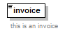
annotation
  documentation
  this is an invoice
source | <xs:element name="invoice">  <xs:annotation>  <xs:documentation>this is an invoice</xs:documentation>  </xs:annotation>  </xs:element>

complexType Invoice
diagram | 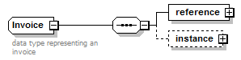
children | reference instance
annotation
  documentation
  data type representing an invoice
source | <xs:complexType name="Invoice">  <xs:annotation>  <xs:documentation>data type representing an invoice</xs:documentation>  </xs:annotation>  <xs:sequence>  <xs:element name="reference" type="ObjectReference"/>  <xs:element name="instance" minOccurs="0">  <xs:complexType>  <xs:sequence>  <xs:element name="invoiceDate" type="xs:date"/>  <xs:element name="billTo" type="Person"/>  <xs:element name="billingPeriod" type="TimeSpan"/>  <xs:element name="seller" type="Transactor"/>  <xs:element name="buyer" type="Transactor"/>  <xs:element name="advertiser" type="Transactor"/>  <xs:element name="campaignName" type="Name"/>  <xs:element name="flightDates" type="TimeSpan"/>  <xs:element name="insertionOrder" type="Order">  <xs:annotation>  <xs:documentation>TODO: should we enable more than one IO to be billed in an invoice?</xs:documentation>  </xs:annotation>  </xs:element>  <xs:element name="lineItems">  <xs:complexType>  <xs:sequence>  <xs:element name="lineItem" type="InvoiceLineItem" maxOccurs="unbounded"/>  </xs:sequence>  </xs:complexType>  </xs:element>  <xs:element name="buyerCommission" type="Money" minOccurs="0"/>  <xs:element name="discountAmount" type="Money" minOccurs="0"/>  <xs:element name="adServingFee" type="Money" minOccurs="0"/>  <xs:element name="taxAmount" type="Tax" minOccurs="0" maxOccurs="unbounded"/>  <xs:element name="totalGrossAmount" type="Money" minOccurs="0"/>  <xs:element name="totalNetAmount" type="Money" minOccurs="0"/>  <xs:element name="totalAmountDue" type="Money"/>  <xs:element name="paymentTerms" type="PaymentTerms" minOccurs="0"/>  <xs:element name="paymentDueDate" type="xs:date"/>  <xs:element name="paymentInstructions">  <xs:complexType>  <xs:sequence>  <xs:element name="payee" type="Name"/>  <xs:element name="paymentAddress" type="PostalAddress"/>  <xs:element name="wireTransferInformation" minOccurs="0">  <xs:complexType>  <xs:sequence>  <xs:element name="accountNumber"/>  <xs:element name="bankName"/>  <xs:choice>  <xs:element name="abaNumber"/>  <xs:element name="swiftCode"/>  </xs:choice>  </xs:sequence>  </xs:complexType>  </xs:element>  </xs:sequence>  </xs:complexType>  </xs:element>  <xs:element name="notes" type="Note" minOccurs="0"/>  </xs:sequence>  </xs:complexType>  </xs:element>  </xs:sequence>  </xs:complexType>

element Invoice/reference
diagram | 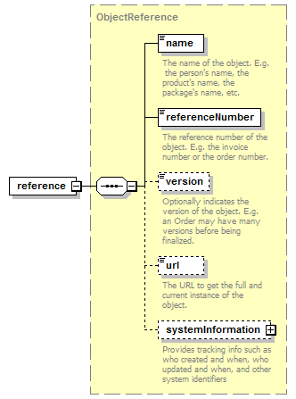
type | ObjectReference
properties
  content | complex
children | name referenceNumber version url systemInformation
source | <xs:element name="reference" type="ObjectReference"/>

element Invoice/instance
diagram | 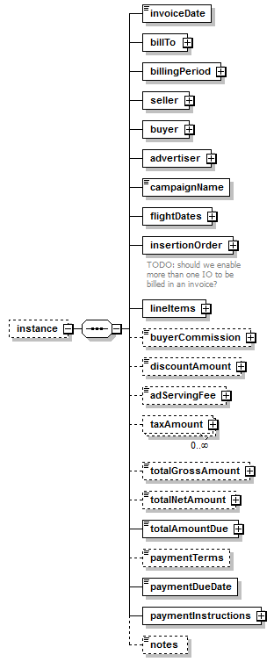
properties
  minOcc | 0
  maxOcc | 1
  content | complex
children | invoiceDate billTo billingPeriod seller buyer advertiser campaignName flightDates insertionOrder lineItems buyerCommission discountAmount adServingFee taxAmount totalGrossAmount totalNetAmount totalAmountDue paymentTerms paymentDueDate paymentInstructions notes
source | <xs:element name="instance" minOccurs="0">  <xs:complexType>  <xs:sequence>  <xs:element name="invoiceDate" type="xs:date"/>  <xs:element name="billTo" type="Person"/>  <xs:element name="billingPeriod" type="TimeSpan"/>  <xs:element name="seller" type="Transactor"/>  <xs:element name="buyer" type="Transactor"/>  <xs:element name="advertiser" type="Transactor"/>  <xs:element name="campaignName" type="Name"/>  <xs:element name="flightDates" type="TimeSpan"/>  <xs:element name="insertionOrder" type="Order">  <xs:annotation>  <xs:documentation>TODO: should we enable more than one IO to be billed in an invoice?</xs:documentation>  </xs:annotation>  </xs:element>  <xs:element name="lineItems">  <xs:complexType>  <xs:sequence>  <xs:element name="lineItem" type="InvoiceLineItem" maxOccurs="unbounded"/>  </xs:sequence>  </xs:complexType>  </xs:element>  <xs:element name="buyerCommission" type="Money" minOccurs="0"/>  <xs:element name="discountAmount" type="Money" minOccurs="0"/>  <xs:element name="adServingFee" type="Money" minOccurs="0"/>  <xs:element name="taxAmount" type="Tax" minOccurs="0" maxOccurs="unbounded"/>  <xs:element name="totalGrossAmount" type="Money" minOccurs="0"/>  <xs:element name="totalNetAmount" type="Money" minOccurs="0"/>  <xs:element name="totalAmountDue" type="Money"/>  <xs:element name="paymentTerms" type="PaymentTerms" minOccurs="0"/>  <xs:element name="paymentDueDate" type="xs:date"/>  <xs:element name="paymentInstructions">  <xs:complexType>  <xs:sequence>  <xs:element name="payee" type="Name"/>  <xs:element name="paymentAddress" type="PostalAddress"/>  <xs:element name="wireTransferInformation" minOccurs="0">  <xs:complexType>  <xs:sequence>  <xs:element name="accountNumber"/>  <xs:element name="bankName"/>  <xs:choice>  <xs:element name="abaNumber"/>  <xs:element name="swiftCode"/>  </xs:choice>  </xs:sequence>  </xs:complexType>  </xs:element>  </xs:sequence>  </xs:complexType>  </xs:element>  <xs:element name="notes" type="Note" minOccurs="0"/>  </xs:sequence>  </xs:complexType>  </xs:element>

element Invoice/instance/invoiceDate
diagram | 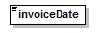
type | xs:date
properties
  content | simple
source | <xs:element name="invoiceDate" type="xs:date"/>

element Invoice/instance/billTo
diagram | 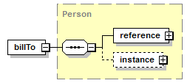
type | Person
properties
  content | complex
children | reference instance
source | <xs:element name="billTo" type="Person"/>

element Invoice/instance/billingPeriod
diagram | 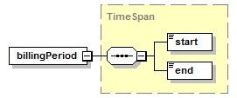
type | TimeSpan
properties
  content | complex
children | start end
source | <xs:element name="billingPeriod" type="TimeSpan"/>

element Invoice/instance/seller
diagram | 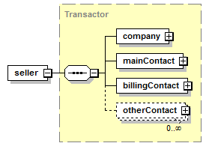
type | Transactor
properties
  content | complex
children | company mainContact billingContact otherContact
source | <xs:element name="seller" type="Transactor"/>

element Invoice/instance/buyer
diagram | 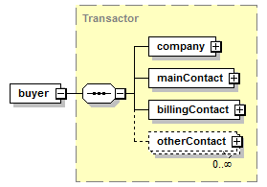
type | Transactor
properties
  content | complex
children | company mainContact billingContact otherContact
source | <xs:element name="buyer" type="Transactor"/>

element Invoice/instance/advertiser
diagram | 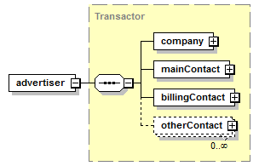
type | Transactor
properties
  content | complex
children | company mainContact billingContact otherContact
source | <xs:element name="advertiser" type="Transactor"/>

element Invoice/instance/campaignName
diagram | 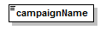
type | Name
properties
  content | simple
facets
  Kind | Value | Annotation
  minLength | 1
  maxLength | 80
  whiteSpace | collapse
source | <xs:element name="campaignName" type="Name"/>

element Invoice/instance/flightDates
diagram | 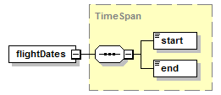
type | TimeSpan
properties
  content | complex
children | start end
source | <xs:element name="flightDates" type="TimeSpan"/>

element Invoice/instance/insertionOrder
diagram | 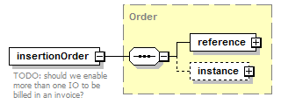
type | Order
properties
  content | complex
children | reference instance
annotation
  documentation
  TODO: should we enable more than one IO to be billed in an invoice?
source | <xs:element name="insertionOrder" type="Order">  <xs:annotation>  <xs:documentation>TODO: should we enable more than one IO to be billed in an invoice?</xs:documentation>  </xs:annotation>  </xs:element>

element Invoice/instance/lineItems
diagram | 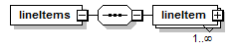
properties
  content | complex
children | lineItem
source | <xs:element name="lineItems">  <xs:complexType>  <xs:sequence>  <xs:element name="lineItem" type="InvoiceLineItem" maxOccurs="unbounded"/>  </xs:sequence>  </xs:complexType>  </xs:element>

element Invoice/instance/lineItems/lineItem
diagram | 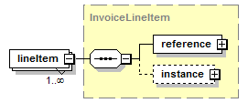
type | InvoiceLineItem
properties
  minOcc | 1
  maxOcc | unbounded
  content | complex
children | reference instance
source | <xs:element name="lineItem" type="InvoiceLineItem" maxOccurs="unbounded"/>

element Invoice/instance/buyerCommission
diagram | 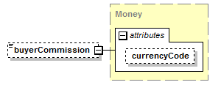
type | Money
properties
  minOcc | 0
  maxOcc | 1
  content | complex
attributes
  Name | Type | Use | Default | Fixed | Annotation
  currencyCode | CurrencyCode |  | USD
source | <xs:element name="buyerCommission" type="Money" minOccurs="0"/>

element Invoice/instance/discountAmount
diagram | 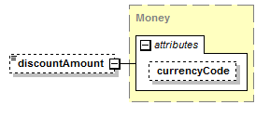
type | Money
properties
  minOcc | 0
  maxOcc | 1
  content | complex
attributes
  Name | Type | Use | Default | Fixed | Annotation
  currencyCode | CurrencyCode |  | USD
source | <xs:element name="discountAmount" type="Money" minOccurs="0"/>

element Invoice/instance/adServingFee
diagram | 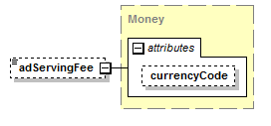
type | Money
properties
  minOcc | 0
  maxOcc | 1
  content | complex
attributes
  Name | Type | Use | Default | Fixed | Annotation
  currencyCode | CurrencyCode |  | USD
source | <xs:element name="adServingFee" type="Money" minOccurs="0"/>

element Invoice/instance/taxAmount
diagram | 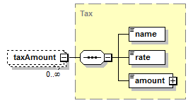
type | Tax
properties
  minOcc | 0
  maxOcc | unbounded
  content | complex
children | name rate amount
source | <xs:element name="taxAmount" type="Tax" minOccurs="0" maxOccurs="unbounded"/>

element Invoice/instance/totalGrossAmount
diagram | 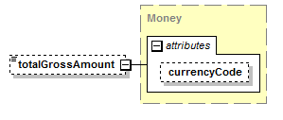
type | Money
properties
  minOcc | 0
  maxOcc | 1
  content | complex
attributes
  Name | Type | Use | Default | Fixed | Annotation
  currencyCode | CurrencyCode |  | USD
source | <xs:element name="totalGrossAmount" type="Money" minOccurs="0"/>

element Invoice/instance/totalNetAmount
diagram | 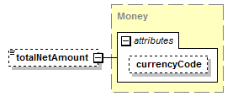
type | Money
properties
  minOcc | 0
  maxOcc | 1
  content | complex
attributes
  Name | Type | Use | Default | Fixed | Annotation
  currencyCode | CurrencyCode |  | USD
source | <xs:element name="totalNetAmount" type="Money" minOccurs="0"/>

element Invoice/instance/totalAmountDue
diagram | 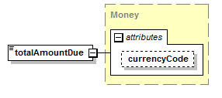
type | Money
properties
  content | complex
attributes
  Name | Type | Use | Default | Fixed | Annotation
  currencyCode | CurrencyCode |  | USD
source | <xs:element name="totalAmountDue" type="Money"/>

element Invoice/instance/paymentTerms
diagram | 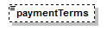
type | PaymentTerms
properties
  minOcc | 0
  maxOcc | 1
  content | simple
facets
  Kind | Value | Annotation
  enumeration | Advance
  enumeration | Net15
  enumeration | Net30
  enumeration | Net60
  enumeration | EndOfContract
source | <xs:element name="paymentTerms" type="PaymentTerms" minOccurs="0"/>

element Invoice/instance/paymentDueDate
diagram | 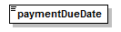
type | xs:date
properties
  content | simple
source | <xs:element name="paymentDueDate" type="xs:date"/>

element Invoice/instance/paymentInstructions
diagram | 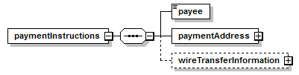
properties
  content | complex
children | payee paymentAddress wireTransferInformation
source | <xs:element name="paymentInstructions">  <xs:complexType>  <xs:sequence>  <xs:element name="payee" type="Name"/>  <xs:element name="paymentAddress" type="PostalAddress"/>  <xs:element name="wireTransferInformation" minOccurs="0">  <xs:complexType>  <xs:sequence>  <xs:element name="accountNumber"/>  <xs:element name="bankName"/>  <xs:choice>  <xs:element name="abaNumber"/>  <xs:element name="swiftCode"/>  </xs:choice>  </xs:sequence>  </xs:complexType>  </xs:element>  </xs:sequence>  </xs:complexType>  </xs:element>

element Invoice/instance/paymentInstructions/payee
diagram | 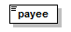
type | Name
properties
  content | simple
facets
  Kind | Value | Annotation
  minLength | 1
  maxLength | 80
  whiteSpace | collapse
source | <xs:element name="payee" type="Name"/>

element Invoice/instance/paymentInstructions/paymentAddress
diagram | 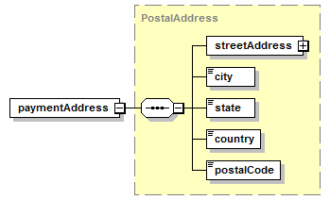
type | PostalAddress
properties
  content | complex
children | streetAddress city state country postalCode
source | <xs:element name="paymentAddress" type="PostalAddress"/>

element Invoice/instance/paymentInstructions/wireTransferInformation
diagram | 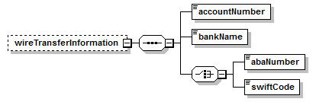
properties
  minOcc | 0
  maxOcc | 1
  content | complex
children | accountNumber bankName abaNumber swiftCode
source | <xs:element name="wireTransferInformation" minOccurs="0">  <xs:complexType>  <xs:sequence>  <xs:element name="accountNumber"/>  <xs:element name="bankName"/>  <xs:choice>  <xs:element name="abaNumber"/>  <xs:element name="swiftCode"/>  </xs:choice>  </xs:sequence>  </xs:complexType>  </xs:element>

element Invoice/instance/paymentInstructions/wireTransferInformation/accountNumber
diagram | 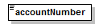
source | <xs:element name="accountNumber"/>

element Invoice/instance/paymentInstructions/wireTransferInformation/bankName
diagram | 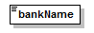
source | <xs:element name="bankName"/>

element Invoice/instance/paymentInstructions/wireTransferInformation/abaNumber
diagram | 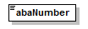
source | <xs:element name="abaNumber"/>

element Invoice/instance/paymentInstructions/wireTransferInformation/swiftCode
diagram | 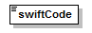
source | <xs:element name="swiftCode"/>

element Invoice/instance/notes
diagram | 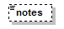
type | Note
properties
  minOcc | 0
  maxOcc | 1
  content | simple
facets
  Kind | Value | Annotation
  whiteSpace | preserve
source | <xs:element name="notes" type="Note" minOccurs="0"/>

complexType InvoiceLineItem
diagram | 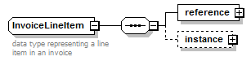
children | reference instance
used by
  element | Invoice/instance/lineItems/lineItem
annotation
  documentation
  data type representing a line item in an invoice
source | <xs:complexType name="InvoiceLineItem">  <xs:annotation>  <xs:documentation>data type representing a line item in an invoice</xs:documentation>  </xs:annotation>  <xs:sequence>  <xs:element name="reference" type="ObjectReference"/>  <xs:element name="instance" minOccurs="0">  <xs:complexType>  <xs:sequence>  <xs:element name="sequenceNumber" type="xs:nonNegativeInteger"/>  <xs:element name="billingPeriod" type="TimeSpan"/>  <xs:element name="orderLineItem" type="OrderLineItem"/>  <xs:element name="rate">  <xs:complexType>  <xs:complexContent>  <xs:extension base="Rate">  <xs:sequence/>  </xs:extension>  </xs:complexContent>  </xs:complexType>  </xs:element>  <xs:element name="contractedUnits" type="Quantity"/>  <xs:element name="isGuaranteed" type="xs:boolean"/>  <xs:element name="deliveredUnits" type="Quantity"/>  <xs:element name="billableUnits" type="Quantity"/>  <xs:element name="grossAmount" type="Money" minOccurs="0"/>  <xs:element name="netAmount" type="Money"/>  <xs:element name="adServingFee" type="Money" minOccurs="0"/>  <xs:element name="taxAmount" type="Tax" minOccurs="0" maxOccurs="unbounded"/>  <xs:element name="notes" type="Note" minOccurs="0"/>  </xs:sequence>  </xs:complexType>  </xs:element>  </xs:sequence>  </xs:complexType>

element InvoiceLineItem/reference
diagram
type | ObjectReference
properties
  content | complex
children | name referenceNumber version url systemInformation
source | <xs:element name="reference" type="ObjectReference"/>

element InvoiceLineItem/instance
diagram | 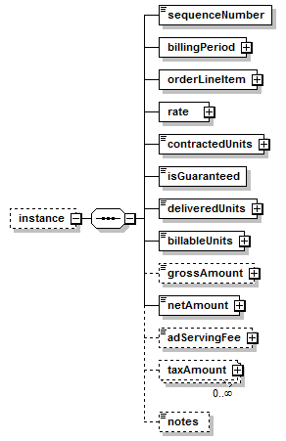
properties
  minOcc | 0
  maxOcc | 1
  content | complex
children | sequenceNumber billingPeriod orderLineItem rate contractedUnits isGuaranteed deliveredUnits billableUnits grossAmount netAmount adServingFee taxAmount notes
source | <xs:element name="instance" minOccurs="0">  <xs:complexType>  <xs:sequence>  <xs:element name="sequenceNumber" type="xs:nonNegativeInteger"/>  <xs:element name="billingPeriod" type="TimeSpan"/>  <xs:element name="orderLineItem" type="OrderLineItem"/>  <xs:element name="rate">  <xs:complexType>  <xs:complexContent>  <xs:extension base="Rate">  <xs:sequence/>  </xs:extension>  </xs:complexContent>  </xs:complexType>  </xs:element>  <xs:element name="contractedUnits" type="Quantity"/>  <xs:element name="isGuaranteed" type="xs:boolean"/>  <xs:element name="deliveredUnits" type="Quantity"/>  <xs:element name="billableUnits" type="Quantity"/>  <xs:element name="grossAmount" type="Money" minOccurs="0"/>  <xs:element name="netAmount" type="Money"/>  <xs:element name="adServingFee" type="Money" minOccurs="0"/>  <xs:element name="taxAmount" type="Tax" minOccurs="0" maxOccurs="unbounded"/>  <xs:element name="notes" type="Note" minOccurs="0"/>  </xs:sequence>  </xs:complexType>  </xs:element>

element InvoiceLineItem/instance/sequenceNumber
diagram | 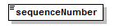
type | xs:nonNegativeInteger
properties
  content | simple
source | <xs:element name="sequenceNumber" type="xs:nonNegativeInteger"/>

element InvoiceLineItem/instance/billingPeriod
diagram
type | TimeSpan
properties
  content | complex
children | start end
source | <xs:element name="billingPeriod" type="TimeSpan"/>

element InvoiceLineItem/instance/orderLineItem
diagram | 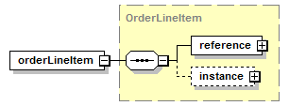
type | OrderLineItem
properties
  content | complex
children | reference instance
source | <xs:element name="orderLineItem" type="OrderLineItem"/>

element InvoiceLineItem/instance/rate
diagram | 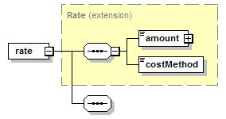
type | extension of Rate
properties
  content | complex
children | amount costMethod
source | <xs:element name="rate">  <xs:complexType>  <xs:complexContent>  <xs:extension base="Rate">  <xs:sequence/>  </xs:extension>  </xs:complexContent>  </xs:complexType>  </xs:element>

element InvoiceLineItem/instance/contractedUnits
diagram | 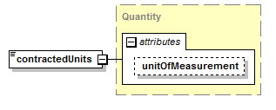
type | Quantity
properties
  content | complex
attributes
  Name | Type | Use | Default | Fixed | Annotation
  unitOfMeasurement | UnitOfMeasurement
source | <xs:element name="contractedUnits" type="Quantity"/>

element InvoiceLineItem/instance/isGuaranteed
diagram | 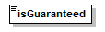
type | xs:boolean
properties
  content | simple
source | <xs:element name="isGuaranteed" type="xs:boolean"/>

element InvoiceLineItem/instance/deliveredUnits
diagram | 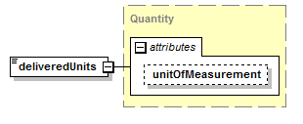
type | Quantity
properties
  content | complex
attributes
  Name | Type | Use | Default | Fixed | Annotation
  unitOfMeasurement | UnitOfMeasurement
source | <xs:element name="deliveredUnits" type="Quantity"/>

element InvoiceLineItem/instance/billableUnits
diagram | 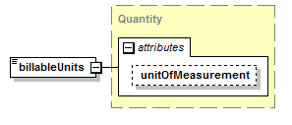
type | Quantity
properties
  content | complex
attributes
  Name | Type | Use | Default | Fixed | Annotation
  unitOfMeasurement | UnitOfMeasurement
source | <xs:element name="billableUnits" type="Quantity"/>

element InvoiceLineItem/instance/grossAmount
diagram | 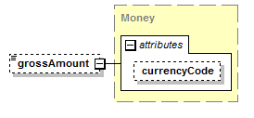
type | Money
properties
  minOcc | 0
  maxOcc | 1
  content | complex
attributes
  Name | Type | Use | Default | Fixed | Annotation
  currencyCode | CurrencyCode |  | USD
source | <xs:element name="grossAmount" type="Money" minOccurs="0"/>

element InvoiceLineItem/instance/netAmount
diagram | 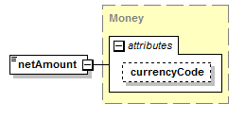
type | Money
properties
  content | complex
attributes
  Name | Type | Use | Default | Fixed | Annotation
  currencyCode | CurrencyCode |  | USD
source | <xs:element name="netAmount" type="Money"/>

element InvoiceLineItem/instance/adServingFee
diagram
type | Money
properties
  minOcc | 0
  maxOcc | 1
  content | complex
attributes
  Name | Type | Use | Default | Fixed | Annotation
  currencyCode | CurrencyCode |  | USD
source | <xs:element name="adServingFee" type="Money" minOccurs="0"/>

element InvoiceLineItem/instance/taxAmount
diagram
type | Tax
properties
  minOcc | 0
  maxOcc | unbounded
  content | complex
children | name rate amount
source | <xs:element name="taxAmount" type="Tax" minOccurs="0" maxOccurs="unbounded"/>

element InvoiceLineItem/instance/notes
diagram
type | Note
properties
  minOcc | 0
  maxOcc | 1
  content | simple
facets
  Kind | Value | Annotation
  whiteSpace | preserve
source | <xs:element name="notes" type="Note" minOccurs="0"/>

XML Schema documentation generated by XMLSpy Schema Editor http://www.altova.com/xmlspy

