Schema payment.xsd

schema location: | ..\schemas\payment.xsd
attributeFormDefault: | unqualified
elementFormDefault: | qualified

Elements | Complex types
payment | BankAccount
 | Check
 | Credit
 | Payment
 | WireTransfer

element payment
diagram | 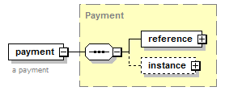
type | Payment
properties
  content | complex
children | reference instance
annotation
  documentation
  a payment
source | <xs:element name="payment" type="Payment">  <xs:annotation>  <xs:documentation>a payment</xs:documentation>  </xs:annotation>  </xs:element>

complexType BankAccount
diagram | 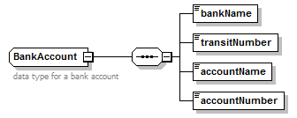
children | bankName transitNumber accountName accountNumber
used by
  element | Check/bankAccount
annotation
  documentation
  data type for a bank account
source | <xs:complexType name="BankAccount">  <xs:annotation>  <xs:documentation>data type for a bank account</xs:documentation>  </xs:annotation>  <xs:sequence>  <xs:element name="bankName" type="Name"/>  <xs:element name="transitNumber" type="xs:int"/>  <xs:element name="accountName" type="Name"/>  <xs:element name="accountNumber">  <xs:simpleType>  <xs:restriction base="xs:string">  <xs:maxLength value="20"/>  </xs:restriction>  </xs:simpleType>  </xs:element>  </xs:sequence>  </xs:complexType>

element BankAccount/bankName
diagram | 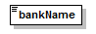
type | Name
properties
  content | simple
facets
  Kind | Value | Annotation
  minLength | 1
  maxLength | 80
  whiteSpace | collapse
source | <xs:element name="bankName" type="Name"/>

element BankAccount/transitNumber
diagram | 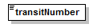
type | xs:int
properties
  content | simple
source | <xs:element name="transitNumber" type="xs:int"/>

element BankAccount/accountName
diagram | 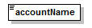
type | Name
properties
  content | simple
facets
  Kind | Value | Annotation
  minLength | 1
  maxLength | 80
  whiteSpace | collapse
source | <xs:element name="accountName" type="Name"/>

element BankAccount/accountNumber
diagram | 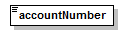
type | restriction of xs:string
properties
  content | simple
facets
  Kind | Value | Annotation
  maxLength | 20
source | <xs:element name="accountNumber">  <xs:simpleType>  <xs:restriction base="xs:string">  <xs:maxLength value="20"/>  </xs:restriction>  </xs:simpleType>  </xs:element>

complexType Check
diagram | 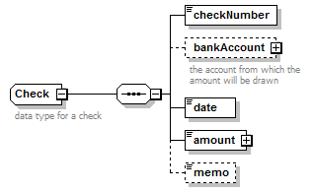
children | checkNumber bankAccount date amount memo
used by
  element | Payment/instance/cash/check
annotation
  documentation
  data type for a check
source | <xs:complexType name="Check">  <xs:annotation>  <xs:documentation>data type for a check</xs:documentation>  </xs:annotation>  <xs:sequence>  <xs:element name="checkNumber">  <xs:simpleType>  <xs:restriction base="xs:string">  <xs:maxLength value="20"/>  </xs:restriction>  </xs:simpleType>  </xs:element>  <xs:element name="bankAccount" type="BankAccount" minOccurs="0">  <xs:annotation>  <xs:documentation>the account from which the amount will be drawn</xs:documentation>  </xs:annotation>  </xs:element>  <xs:element name="date" type="xs:date"/>  <xs:element name="amount" type="Money"/>  <xs:element name="memo" minOccurs="0">  <xs:simpleType>  <xs:restriction base="xs:string">  <xs:maxLength value="100"/>  </xs:restriction>  </xs:simpleType>  </xs:element>  </xs:sequence>  </xs:complexType>

element Check/checkNumber
diagram | 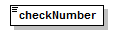
type | restriction of xs:string
properties
  content | simple
facets
  Kind | Value | Annotation
  maxLength | 20
source | <xs:element name="checkNumber">  <xs:simpleType>  <xs:restriction base="xs:string">  <xs:maxLength value="20"/>  </xs:restriction>  </xs:simpleType>  </xs:element>

element Check/bankAccount
diagram | 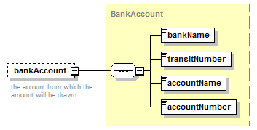
type | BankAccount
properties
  minOcc | 0
  maxOcc | 1
  content | complex
children | bankName transitNumber accountName accountNumber
annotation
  documentation
  the account from which the amount will be drawn
source | <xs:element name="bankAccount" type="BankAccount" minOccurs="0">  <xs:annotation>  <xs:documentation>the account from which the amount will be drawn</xs:documentation>  </xs:annotation>  </xs:element>

element Check/date
diagram | 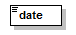
type | xs:date
properties
  content | simple
source | <xs:element name="date" type="xs:date"/>

element Check/amount
diagram | 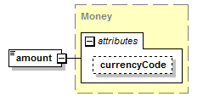
type | Money
properties
  content | complex
attributes
  Name | Type | Use | Default | Fixed | Annotation
  currencyCode | CurrencyCode |  | USD
source | <xs:element name="amount" type="Money"/>

element Check/memo
diagram | 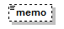
type | restriction of xs:string
properties
  minOcc | 0
  maxOcc | 1
  content | simple
facets
  Kind | Value | Annotation
  maxLength | 100
source | <xs:element name="memo" minOccurs="0">  <xs:simpleType>  <xs:restriction base="xs:string">  <xs:maxLength value="100"/>  </xs:restriction>  </xs:simpleType>  </xs:element>

complexType Credit
diagram | 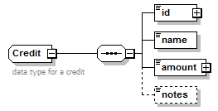
children | id name amount notes
used by
  element | Payment/instance/credit
annotation
  documentation
  data type for a credit
source | <xs:complexType name="Credit">  <xs:annotation>  <xs:documentation>data type for a credit</xs:documentation>  </xs:annotation>  <xs:sequence>  <xs:element name="id" type="Identifier"/>  <xs:element name="name" type="Name"/>  <xs:element name="amount" type="Money"/>  <xs:element name="notes" type="Note" minOccurs="0"/>  </xs:sequence>  </xs:complexType>

element Credit/id
diagram | 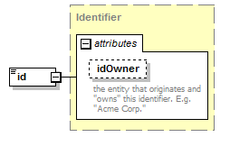
type | Identifier
properties
  content | complex
attributes
  Name | Type | Use | Default | Fixed | Annotation
  idOwner | Name
    documentation
    the entity that originates and "owns" this identifier. E.g. "Acme Corp."
source | <xs:element name="id" type="Identifier"/>

element Credit/name
diagram | 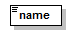
type | Name
properties
  content | simple
facets
  Kind | Value | Annotation
  minLength | 1
  maxLength | 80
  whiteSpace | collapse
source | <xs:element name="name" type="Name"/>

element Credit/amount
diagram
type | Money
properties
  content | complex
attributes
  Name | Type | Use | Default | Fixed | Annotation
  currencyCode | CurrencyCode |  | USD
source | <xs:element name="amount" type="Money"/>

element Credit/notes
diagram | 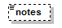
type | Note
properties
  minOcc | 0
  maxOcc | 1
  content | simple
facets
  Kind | Value | Annotation
  whiteSpace | preserve
source | <xs:element name="notes" type="Note" minOccurs="0"/>

complexType Payment
diagram | 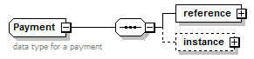
children | reference instance
used by
  element | payment
annotation
  documentation
  data type for a payment
source | <xs:complexType name="Payment">  <xs:annotation>  <xs:documentation>data type for a payment</xs:documentation>  </xs:annotation>  <xs:sequence>  <xs:element name="reference" type="ObjectReference"/>  <xs:element name="instance" minOccurs="0">  <xs:complexType>  <xs:sequence>  <xs:element name="notes" type="Note" minOccurs="0">  <xs:annotation>  <xs:documentation>optional notes on this payment</xs:documentation>  </xs:annotation>  </xs:element>  <xs:element name="paymentDate" type="xs:date">  <xs:annotation>  <xs:documentation>the date this payment is being applied. e.g. the date the check was received.</xs:documentation>  </xs:annotation>  </xs:element>  <xs:element name="maker" type="Transactor">  <xs:annotation>  <xs:documentation>The party making the payment. Most often the buyer.</xs:documentation>  </xs:annotation>  </xs:element>  <xs:element name="payee" type="Transactor">  <xs:annotation>  <xs:documentation>The party rgetting paid. Most often the seller.</xs:documentation>  </xs:annotation>  </xs:element>  <xs:element name="cash" minOccurs="0">  <xs:annotation>  <xs:documentation>cash is optional if this payment is just using credits</xs:documentation>  </xs:annotation>  <xs:complexType>  <xs:choice>  <xs:element name="check" type="Check"/>  <xs:element name="wireTransfer" type="WireTransfer"/>  </xs:choice>  </xs:complexType>  </xs:element>  <xs:element name="credit" type="Credit" minOccurs="0" maxOccurs="unbounded">  <xs:annotation>  <xs:documentation>credits can also be applied in a payment</xs:documentation>  </xs:annotation>  </xs:element>  <xs:element name="paymentAmount" type="Money">  <xs:annotation>  <xs:documentation>the total amount of the payment which is the sum of the cash (if any) and all credits to be applied.</xs:documentation>  </xs:annotation>  </xs:element>  <xs:element name="applicationOfPayment" minOccurs="0" maxOccurs="unbounded">  <xs:annotation>  <xs:documentation>a payment can be applied to many invoices</xs:documentation>  </xs:annotation>  <xs:complexType>  <xs:sequence>  <xs:element name="invoiceNumber" type="Identifier">  <xs:annotation>  <xs:documentation>the invoice to which this payment is being applied.</xs:documentation>  </xs:annotation>  </xs:element>  <xs:element name="amount" type="Money">  <xs:annotation>  <xs:documentation>the amount being appied to this invoice</xs:documentation>  </xs:annotation>  </xs:element>  </xs:sequence>  </xs:complexType>  </xs:element>  </xs:sequence>  </xs:complexType>  </xs:element>  </xs:sequence>  </xs:complexType>

element Payment/reference
diagram | 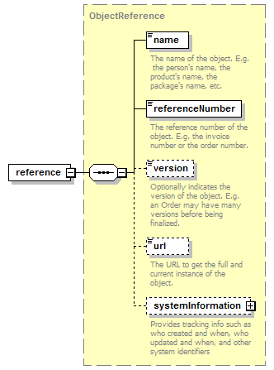
type | ObjectReference
properties
  content | complex
children | name referenceNumber version url systemInformation
source | <xs:element name="reference" type="ObjectReference"/>

element Payment/instance
diagram | 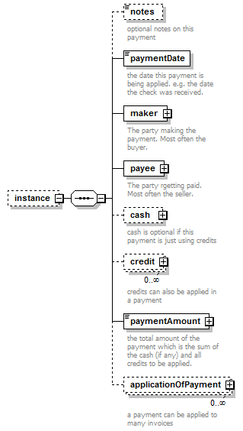
properties
  minOcc | 0
  maxOcc | 1
  content | complex
children | notes paymentDate maker payee cash credit paymentAmount applicationOfPayment
source | <xs:element name="instance" minOccurs="0">  <xs:complexType>  <xs:sequence>  <xs:element name="notes" type="Note" minOccurs="0">  <xs:annotation>  <xs:documentation>optional notes on this payment</xs:documentation>  </xs:annotation>  </xs:element>  <xs:element name="paymentDate" type="xs:date">  <xs:annotation>  <xs:documentation>the date this payment is being applied. e.g. the date the check was received.</xs:documentation>  </xs:annotation>  </xs:element>  <xs:element name="maker" type="Transactor">  <xs:annotation>  <xs:documentation>The party making the payment. Most often the buyer.</xs:documentation>  </xs:annotation>  </xs:element>  <xs:element name="payee" type="Transactor">  <xs:annotation>  <xs:documentation>The party rgetting paid. Most often the seller.</xs:documentation>  </xs:annotation>  </xs:element>  <xs:element name="cash" minOccurs="0">  <xs:annotation>  <xs:documentation>cash is optional if this payment is just using credits</xs:documentation>  </xs:annotation>  <xs:complexType>  <xs:choice>  <xs:element name="check" type="Check"/>  <xs:element name="wireTransfer" type="WireTransfer"/>  </xs:choice>  </xs:complexType>  </xs:element>  <xs:element name="credit" type="Credit" minOccurs="0" maxOccurs="unbounded">  <xs:annotation>  <xs:documentation>credits can also be applied in a payment</xs:documentation>  </xs:annotation>  </xs:element>  <xs:element name="paymentAmount" type="Money">  <xs:annotation>  <xs:documentation>the total amount of the payment which is the sum of the cash (if any) and all credits to be applied.</xs:documentation>  </xs:annotation>  </xs:element>  <xs:element name="applicationOfPayment" minOccurs="0" maxOccurs="unbounded">  <xs:annotation>  <xs:documentation>a payment can be applied to many invoices</xs:documentation>  </xs:annotation>  <xs:complexType>  <xs:sequence>  <xs:element name="invoiceNumber" type="Identifier">  <xs:annotation>  <xs:documentation>the invoice to which this payment is being applied.</xs:documentation>  </xs:annotation>  </xs:element>  <xs:element name="amount" type="Money">  <xs:annotation>  <xs:documentation>the amount being appied to this invoice</xs:documentation>  </xs:annotation>  </xs:element>  </xs:sequence>  </xs:complexType>  </xs:element>  </xs:sequence>  </xs:complexType>  </xs:element>

element Payment/instance/notes
diagram | 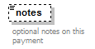
type | Note
properties
  minOcc | 0
  maxOcc | 1
  content | simple
facets
  Kind | Value | Annotation
  whiteSpace | preserve
annotation
  documentation
  optional notes on this payment
source | <xs:element name="notes" type="Note" minOccurs="0">  <xs:annotation>  <xs:documentation>optional notes on this payment</xs:documentation>  </xs:annotation>  </xs:element>

element Payment/instance/paymentDate
diagram | 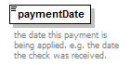
type | xs:date
properties
  content | simple
annotation
  documentation
  the date this payment is being applied. e.g. the date the check was received.
source | <xs:element name="paymentDate" type="xs:date">  <xs:annotation>  <xs:documentation>the date this payment is being applied. e.g. the date the check was received.</xs:documentation>  </xs:annotation>  </xs:element>

element Payment/instance/maker
diagram | 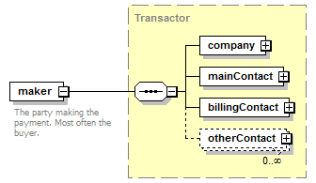
type | Transactor
properties
  content | complex
children | company mainContact billingContact otherContact
annotation
  documentation
  The party making the payment. Most often the buyer.
source | <xs:element name="maker" type="Transactor">  <xs:annotation>  <xs:documentation>The party making the payment. Most often the buyer.</xs:documentation>  </xs:annotation>  </xs:element>

element Payment/instance/payee
diagram | 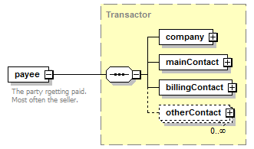
type | Transactor
properties
  content | complex
children | company mainContact billingContact otherContact
annotation
  documentation
  The party rgetting paid. Most often the seller.
source | <xs:element name="payee" type="Transactor">  <xs:annotation>  <xs:documentation>The party rgetting paid. Most often the seller.</xs:documentation>  </xs:annotation>  </xs:element>

element Payment/instance/cash
diagram | 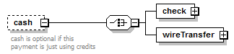
properties
  minOcc | 0
  maxOcc | 1
  content | complex
children | check wireTransfer
annotation
  documentation
  cash is optional if this payment is just using credits
source | <xs:element name="cash" minOccurs="0">  <xs:annotation>  <xs:documentation>cash is optional if this payment is just using credits</xs:documentation>  </xs:annotation>  <xs:complexType>  <xs:choice>  <xs:element name="check" type="Check"/>  <xs:element name="wireTransfer" type="WireTransfer"/>  </xs:choice>  </xs:complexType>  </xs:element>

element Payment/instance/cash/check
diagram | 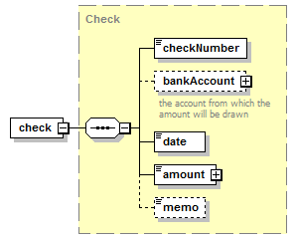
type | Check
properties
  content | complex
children | checkNumber bankAccount date amount memo
source | <xs:element name="check" type="Check"/>

element Payment/instance/cash/wireTransfer
diagram | 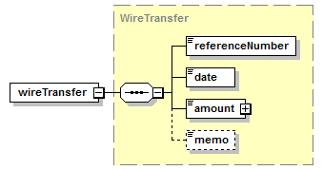
type | WireTransfer
properties
  content | complex
children | referenceNumber date amount memo
source | <xs:element name="wireTransfer" type="WireTransfer"/>

element Payment/instance/credit
diagram | 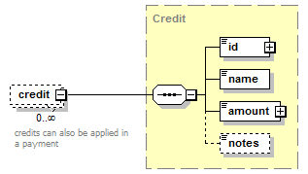
type | Credit
properties
  minOcc | 0
  maxOcc | unbounded
  content | complex
children | id name amount notes
annotation
  documentation
  credits can also be applied in a payment
source | <xs:element name="credit" type="Credit" minOccurs="0" maxOccurs="unbounded">  <xs:annotation>  <xs:documentation>credits can also be applied in a payment</xs:documentation>  </xs:annotation>  </xs:element>

element Payment/instance/paymentAmount
diagram | 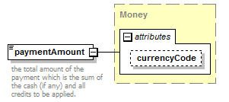
type | Money
properties
  content | complex
attributes
  Name | Type | Use | Default | Fixed | Annotation
  currencyCode | CurrencyCode |  | USD
annotation
  documentation
  the total amount of the payment which is the sum of the cash (if any) and all credits to be applied.
source | <xs:element name="paymentAmount" type="Money">  <xs:annotation>  <xs:documentation>the total amount of the payment which is the sum of the cash (if any) and all credits to be applied.</xs:documentation>  </xs:annotation>  </xs:element>

element Payment/instance/applicationOfPayment
diagram | 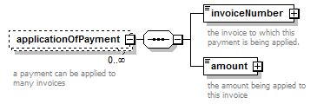
properties
  minOcc | 0
  maxOcc | unbounded
  content | complex
children | invoiceNumber amount
annotation
  documentation
  a payment can be applied to many invoices
source | <xs:element name="applicationOfPayment" minOccurs="0" maxOccurs="unbounded">  <xs:annotation>  <xs:documentation>a payment can be applied to many invoices</xs:documentation>  </xs:annotation>  <xs:complexType>  <xs:sequence>  <xs:element name="invoiceNumber" type="Identifier">  <xs:annotation>  <xs:documentation>the invoice to which this payment is being applied.</xs:documentation>  </xs:annotation>  </xs:element>  <xs:element name="amount" type="Money">  <xs:annotation>  <xs:documentation>the amount being appied to this invoice</xs:documentation>  </xs:annotation>  </xs:element>  </xs:sequence>  </xs:complexType>  </xs:element>

element Payment/instance/applicationOfPayment/invoiceNumber
diagram | 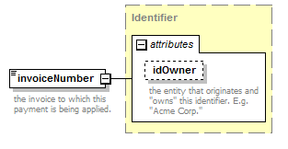
type | Identifier
properties
  content | complex
attributes
  Name | Type | Use | Default | Fixed | Annotation
  idOwner | Name
    documentation
    the entity that originates and "owns" this identifier. E.g. "Acme Corp."
annotation
  documentation
  the invoice to which this payment is being applied.
source | <xs:element name="invoiceNumber" type="Identifier">  <xs:annotation>  <xs:documentation>the invoice to which this payment is being applied.</xs:documentation>  </xs:annotation>  </xs:element>

element Payment/instance/applicationOfPayment/amount
diagram | 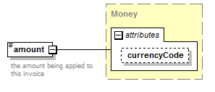
type | Money
properties
  content | complex
attributes
  Name | Type | Use | Default | Fixed | Annotation
  currencyCode | CurrencyCode |  | USD
annotation
  documentation
  the amount being appied to this invoice
source | <xs:element name="amount" type="Money">  <xs:annotation>  <xs:documentation>the amount being appied to this invoice</xs:documentation>  </xs:annotation>  </xs:element>

complexType WireTransfer
diagram | 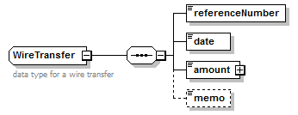
children | referenceNumber date amount memo
used by
  element | Payment/instance/cash/wireTransfer
annotation
  documentation
  data type for a wire transfer
source | <xs:complexType name="WireTransfer">  <xs:annotation>  <xs:documentation>data type for a wire transfer</xs:documentation>  </xs:annotation>  <xs:sequence>  <xs:element name="referenceNumber">  <xs:simpleType>  <xs:restriction base="xs:string">  <xs:maxLength value="20"/>  </xs:restriction>  </xs:simpleType>  </xs:element>  <xs:element name="date" type="xs:date"/>  <xs:element name="amount" type="Money"/>  <xs:element name="memo" minOccurs="0">  <xs:simpleType>  <xs:restriction base="xs:string">  <xs:maxLength value="100"/>  </xs:restriction>  </xs:simpleType>  </xs:element>  </xs:sequence>  </xs:complexType>

element WireTransfer/referenceNumber
diagram | 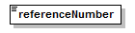
type | restriction of xs:string
properties
  content | simple
facets
  Kind | Value | Annotation
  maxLength | 20
source | <xs:element name="referenceNumber">  <xs:simpleType>  <xs:restriction base="xs:string">  <xs:maxLength value="20"/>  </xs:restriction>  </xs:simpleType>  </xs:element>

element WireTransfer/date
diagram
type | xs:date
properties
  content | simple
source | <xs:element name="date" type="xs:date"/>

element WireTransfer/amount
diagram
type | Money
properties
  content | complex
attributes
  Name | Type | Use | Default | Fixed | Annotation
  currencyCode | CurrencyCode |  | USD
source | <xs:element name="amount" type="Money"/>

element WireTransfer/memo
diagram
type | restriction of xs:string
properties
  minOcc | 0
  maxOcc | 1
  content | simple
facets
  Kind | Value | Annotation
  maxLength | 100
source | <xs:element name="memo" minOccurs="0">  <xs:simpleType>  <xs:restriction base="xs:string">  <xs:maxLength value="100"/>  </xs:restriction>  </xs:simpleType>  </xs:element>

XML Schema documentation generated by XMLSpy Schema Editor http://www.altova.com/xmlspy

