Schema program.xsd

schema location: | ..\schemas\program.xsd
attributeFormDefault: | unqualified
elementFormDefault: | qualified

Elements | Complex types | Simple types
program | DiscountCode | Category
 | Product
 | Program
 | Targeting

element program
diagram | 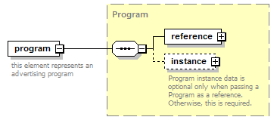
type | Program
properties
  content | complex
children | reference instance
annotation
  documentation
  this element represents an advertising program
source | <xs:element name="program" type="Program">  <xs:annotation>  <xs:documentation>this element represents an advertising program</xs:documentation>  </xs:annotation>  </xs:element>

complexType DiscountCode
diagram | 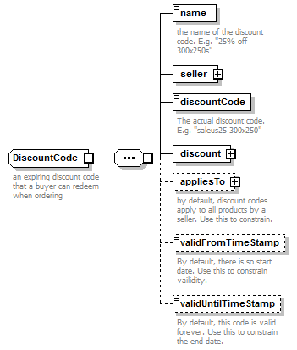
children | name seller discountCode discount appliesTo validFromTimeStamp validUntilTimeStamp
annotation
  documentation
  an expiring discount code that a buyer can redeem when ordering
source | <xs:complexType name="DiscountCode">  <xs:annotation>  <xs:documentation>an expiring discount code that a buyer can redeem when ordering</xs:documentation>  </xs:annotation>  <xs:sequence>  <xs:element name="name" type="Name">  <xs:annotation>  <xs:documentation>the name of the discount code. E.g. "25% off 300x250s"</xs:documentation>  </xs:annotation>  </xs:element>  <xs:element name="seller" type="Company"/>  <xs:element name="discountCode">  <xs:annotation>  <xs:documentation>The actual discount code. E.g. "saleus25-300x250"</xs:documentation>  </xs:annotation>  <xs:simpleType>  <xs:restriction base="xs:string">  <xs:maxLength value="20"/>  </xs:restriction>  </xs:simpleType>  </xs:element>  <xs:element name="discount" type="Discount"/>  <xs:element name="appliesTo" minOccurs="0">  <xs:annotation>  <xs:documentation>by default, discount codes apply to all products by a seller. Use this to constrain.</xs:documentation>  </xs:annotation>  <xs:complexType>  <xs:choice>  <xs:element name="allProducts"/>  <xs:element name="specifiedProducts">  <xs:complexType>  <xs:sequence>  <xs:element name="program" type="Program" minOccurs="0" maxOccurs="unbounded"/>  <xs:element name="product" type="Product" minOccurs="0" maxOccurs="unbounded"/>  </xs:sequence>  </xs:complexType>  </xs:element>  </xs:choice>  </xs:complexType>  </xs:element>  <xs:element name="validFromTimeStamp" type="xs:dateTimeStamp" minOccurs="0">  <xs:annotation>  <xs:documentation>By default, there is so start date. Use this to constrain vailidity.</xs:documentation>  </xs:annotation>  </xs:element>  <xs:element name="validUntilTimeStamp" type="xs:dateTimeStamp" minOccurs="0">  <xs:annotation>  <xs:documentation>By default, this code is valid forever. Use this to constrain the end date.</xs:documentation>  </xs:annotation>  </xs:element>  </xs:sequence>  </xs:complexType>

element DiscountCode/name
diagram | 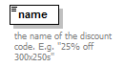
type | Name
properties
  content | simple
facets
  Kind | Value | Annotation
  minLength | 1
  maxLength | 80
  whiteSpace | collapse
annotation
  documentation
  the name of the discount code. E.g. "25% off 300x250s"
source | <xs:element name="name" type="Name">  <xs:annotation>  <xs:documentation>the name of the discount code. E.g. "25% off 300x250s"</xs:documentation>  </xs:annotation>  </xs:element>

element DiscountCode/seller
diagram | 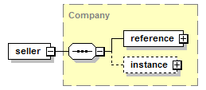
type | Company
properties
  content | complex
children | reference instance
source | <xs:element name="seller" type="Company"/>

element DiscountCode/discountCode
diagram | 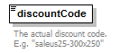
type | restriction of xs:string
properties
  content | simple
facets
  Kind | Value | Annotation
  maxLength | 20
annotation
  documentation
  The actual discount code. E.g. "saleus25-300x250"
source | <xs:element name="discountCode">  <xs:annotation>  <xs:documentation>The actual discount code. E.g. "saleus25-300x250"</xs:documentation>  </xs:annotation>  <xs:simpleType>  <xs:restriction base="xs:string">  <xs:maxLength value="20"/>  </xs:restriction>  </xs:simpleType>  </xs:element>

element DiscountCode/discount
diagram | 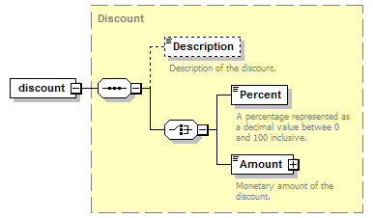
type | Discount
properties
  content | complex
children | Description Percent Amount
source | <xs:element name="discount" type="Discount"/>

element DiscountCode/appliesTo
diagram | 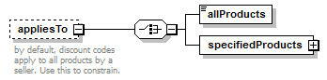
properties
  minOcc | 0
  maxOcc | 1
  content | complex
children | allProducts specifiedProducts
annotation
  documentation
  by default, discount codes apply to all products by a seller. Use this to constrain.
source | <xs:element name="appliesTo" minOccurs="0">  <xs:annotation>  <xs:documentation>by default, discount codes apply to all products by a seller. Use this to constrain.</xs:documentation>  </xs:annotation>  <xs:complexType>  <xs:choice>  <xs:element name="allProducts"/>  <xs:element name="specifiedProducts">  <xs:complexType>  <xs:sequence>  <xs:element name="program" type="Program" minOccurs="0" maxOccurs="unbounded"/>  <xs:element name="product" type="Product" minOccurs="0" maxOccurs="unbounded"/>  </xs:sequence>  </xs:complexType>  </xs:element>  </xs:choice>  </xs:complexType>  </xs:element>

element DiscountCode/appliesTo/allProducts
diagram | 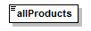
source | <xs:element name="allProducts"/>

element DiscountCode/appliesTo/specifiedProducts
diagram | 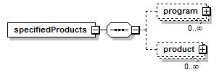
properties
  content | complex
children | program product
source | <xs:element name="specifiedProducts">  <xs:complexType>  <xs:sequence>  <xs:element name="program" type="Program" minOccurs="0" maxOccurs="unbounded"/>  <xs:element name="product" type="Product" minOccurs="0" maxOccurs="unbounded"/>  </xs:sequence>  </xs:complexType>  </xs:element>

element DiscountCode/appliesTo/specifiedProducts/program
diagram | 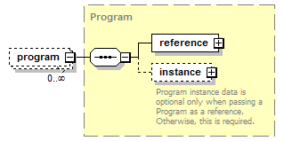
type | Program
properties
  minOcc | 0
  maxOcc | unbounded
  content | complex
children | reference instance
source | <xs:element name="program" type="Program" minOccurs="0" maxOccurs="unbounded"/>

element DiscountCode/appliesTo/specifiedProducts/product
diagram | 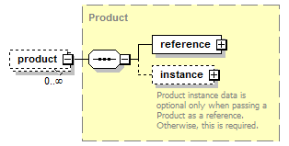
type | Product
properties
  minOcc | 0
  maxOcc | unbounded
  content | complex
children | reference instance
source | <xs:element name="product" type="Product" minOccurs="0" maxOccurs="unbounded"/>

element DiscountCode/validFromTimeStamp
diagram | 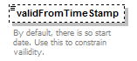
type | xs:dateTimeStamp
properties
  minOcc | 0
  maxOcc | 1
  content | simple
annotation
  documentation
  By default, there is so start date. Use this to constrain vailidity.
source | <xs:element name="validFromTimeStamp" type="xs:dateTimeStamp" minOccurs="0">  <xs:annotation>  <xs:documentation>By default, there is so start date. Use this to constrain vailidity.</xs:documentation>  </xs:annotation>  </xs:element>

element DiscountCode/validUntilTimeStamp
diagram | 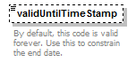
type | xs:dateTimeStamp
properties
  minOcc | 0
  maxOcc | 1
  content | simple
annotation
  documentation
  By default, this code is valid forever. Use this to constrain the end date.
source | <xs:element name="validUntilTimeStamp" type="xs:dateTimeStamp" minOccurs="0">  <xs:annotation>  <xs:documentation>By default, this code is valid forever. Use this to constrain the end date.</xs:documentation>  </xs:annotation>  </xs:element>

complexType Product
diagram | 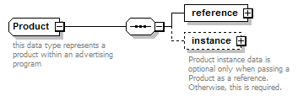
children | reference instance
used by
  elements | Program/instance/product DiscountCode/appliesTo/specifiedProducts/product
annotation
  documentation
  this data type represents a product within an advertising program
source | <xs:complexType name="Product">  <xs:annotation>  <xs:documentation>this data type represents a product within an advertising program</xs:documentation>  </xs:annotation>  <xs:sequence minOccurs="1" maxOccurs="1">  <xs:element name="reference" type="ObjectReference"/>  <xs:element name="instance" minOccurs="0">  <xs:annotation>  <xs:documentation>Product instance data is optional only when passing a Product as a reference. Otherwise, this is required.</xs:documentation>  </xs:annotation>  <xs:complexType>  <xs:sequence>  <xs:element name="minimumLeadTimeDays" minOccurs="0">  <xs:annotation>  <xs:documentation>The number of days the order has to be finalized in advance of the delivery start date.</xs:documentation>  </xs:annotation>  </xs:element>  <xs:element name="description" type="Note" minOccurs="0"/>  <xs:element name="channel" type="Channel"/>  <xs:element name="category" type="Category" minOccurs="0" maxOccurs="unbounded"/>  <xs:element name="profile" type="AudienceProfile" minOccurs="0" maxOccurs="unbounded"/>  <xs:element name="adUnit" type="AdUnit" maxOccurs="unbounded"/>  <xs:element name="standardRate" type="Rate" minOccurs="0"/>  <xs:element name="ourRate" type="Rate" minOccurs="0">  <xs:annotation>  <xs:documentation>negotiated rate for the user that is accessing this placement.</xs:documentation>  </xs:annotation>  </xs:element>  <xs:element name="inventoryAvailable" minOccurs="0" maxOccurs="unbounded">  <xs:complexType>  <xs:sequence>  <xs:element name="period" type="TimeSpan" minOccurs="0"/>  <xs:element name="quantity" type="Quantity" maxOccurs="unbounded"/>  </xs:sequence>  </xs:complexType>  </xs:element>  <xs:element name="profile" type="AudienceProfile" minOccurs="0" maxOccurs="unbounded"/>  <xs:element name="targeting" minOccurs="0">  <xs:annotation>  <xs:documentation>The targeting options available for this placement. TODO: define this!</xs:documentation>  </xs:annotation>  </xs:element>  <xs:element name="minimumPurchase" type="Money" minOccurs="0">  <xs:annotation>  <xs:documentation>The minimum amount this product can be purchased for.</xs:documentation>  </xs:annotation>  </xs:element>  <xs:element name="minimumDurationDays" minOccurs="0">  <xs:annotation>  <xs:documentation>The minimum number of days in the duration of delivery start date to end date.</xs:documentation>  </xs:annotation>  </xs:element>  </xs:sequence>  </xs:complexType>  </xs:element>  </xs:sequence>  </xs:complexType>

element Product/reference
diagram | 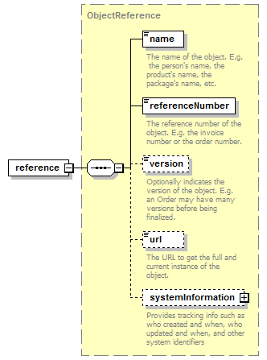
type | ObjectReference
properties
  content | complex
children | name referenceNumber version url systemInformation
source | <xs:element name="reference" type="ObjectReference"/>

element Product/instance
diagram | 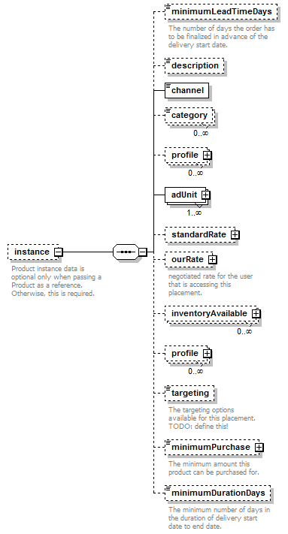
properties
  minOcc | 0
  maxOcc | 1
  content | complex
children | minimumLeadTimeDays description channel category profile adUnit standardRate ourRate inventoryAvailable profile targeting minimumPurchase minimumDurationDays
annotation
  documentation
  Product instance data is optional only when passing a Product as a reference. Otherwise, this is required.
source | <xs:element name="instance" minOccurs="0">  <xs:annotation>  <xs:documentation>Product instance data is optional only when passing a Product as a reference. Otherwise, this is required.</xs:documentation>  </xs:annotation>  <xs:complexType>  <xs:sequence>  <xs:element name="minimumLeadTimeDays" minOccurs="0">  <xs:annotation>  <xs:documentation>The number of days the order has to be finalized in advance of the delivery start date.</xs:documentation>  </xs:annotation>  </xs:element>  <xs:element name="description" type="Note" minOccurs="0"/>  <xs:element name="channel" type="Channel"/>  <xs:element name="category" type="Category" minOccurs="0" maxOccurs="unbounded"/>  <xs:element name="profile" type="AudienceProfile" minOccurs="0" maxOccurs="unbounded"/>  <xs:element name="adUnit" type="AdUnit" maxOccurs="unbounded"/>  <xs:element name="standardRate" type="Rate" minOccurs="0"/>  <xs:element name="ourRate" type="Rate" minOccurs="0">  <xs:annotation>  <xs:documentation>negotiated rate for the user that is accessing this placement.</xs:documentation>  </xs:annotation>  </xs:element>  <xs:element name="inventoryAvailable" minOccurs="0" maxOccurs="unbounded">  <xs:complexType>  <xs:sequence>  <xs:element name="period" type="TimeSpan" minOccurs="0"/>  <xs:element name="quantity" type="Quantity" maxOccurs="unbounded"/>  </xs:sequence>  </xs:complexType>  </xs:element>  <xs:element name="profile" type="AudienceProfile" minOccurs="0" maxOccurs="unbounded"/>  <xs:element name="targeting" minOccurs="0">  <xs:annotation>  <xs:documentation>The targeting options available for this placement. TODO: define this!</xs:documentation>  </xs:annotation>  </xs:element>  <xs:element name="minimumPurchase" type="Money" minOccurs="0">  <xs:annotation>  <xs:documentation>The minimum amount this product can be purchased for.</xs:documentation>  </xs:annotation>  </xs:element>  <xs:element name="minimumDurationDays" minOccurs="0">  <xs:annotation>  <xs:documentation>The minimum number of days in the duration of delivery start date to end date.</xs:documentation>  </xs:annotation>  </xs:element>  </xs:sequence>  </xs:complexType>  </xs:element>

element Product/instance/minimumLeadTimeDays
diagram | 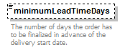
properties
  minOcc | 0
  maxOcc | 1
annotation
  documentation
  The number of days the order has to be finalized in advance of the delivery start date.
source | <xs:element name="minimumLeadTimeDays" minOccurs="0">  <xs:annotation>  <xs:documentation>The number of days the order has to be finalized in advance of the delivery start date.</xs:documentation>  </xs:annotation>  </xs:element>

element Product/instance/description
diagram | 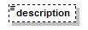
type | Note
properties
  minOcc | 0
  maxOcc | 1
  content | simple
facets
  Kind | Value | Annotation
  whiteSpace | preserve
source | <xs:element name="description" type="Note" minOccurs="0"/>

element Product/instance/channel
diagram | 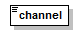
type | Channel
properties
  content | simple
facets
  Kind | Value | Annotation
  enumeration | email
  enumeration | onlineDisplay
source | <xs:element name="channel" type="Channel"/>

element Product/instance/category
diagram | 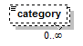
type | Category
properties
  minOcc | 0
  maxOcc | unbounded
  content | simple
facets
  Kind | Value | Annotation
  enumeration | [...iab standard categories to be entered ...]
source | <xs:element name="category" type="Category" minOccurs="0" maxOccurs="unbounded"/>

element Product/instance/profile
diagram | 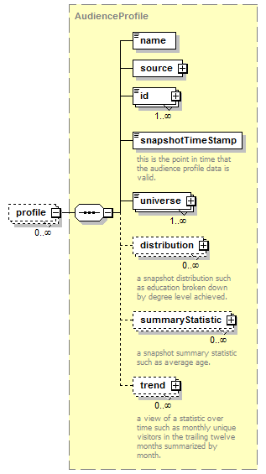
type | AudienceProfile
properties
  minOcc | 0
  maxOcc | unbounded
  content | complex
children | name source id snapshotTimeStamp universe distribution summaryStatistic trend
source | <xs:element name="profile" type="AudienceProfile" minOccurs="0" maxOccurs="unbounded"/>

element Product/instance/adUnit
diagram | 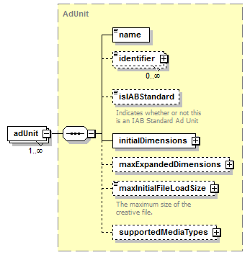
type | AdUnit
properties
  minOcc | 1
  maxOcc | unbounded
  content | complex
children | name identifier isIABStandard initialDimensions maxExpandedDimensions maxInitialFileLoadSize supportedMediaTypes
source | <xs:element name="adUnit" type="AdUnit" maxOccurs="unbounded"/>

element Product/instance/standardRate
diagram | 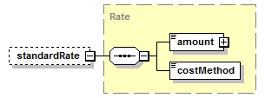
type | Rate
properties
  minOcc | 0
  maxOcc | 1
  content | complex
children | amount costMethod
source | <xs:element name="standardRate" type="Rate" minOccurs="0"/>

element Product/instance/ourRate
diagram | 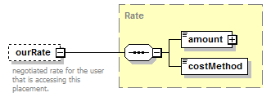
type | Rate
properties
  minOcc | 0
  maxOcc | 1
  content | complex
children | amount costMethod
annotation
  documentation
  negotiated rate for the user that is accessing this placement.
source | <xs:element name="ourRate" type="Rate" minOccurs="0">  <xs:annotation>  <xs:documentation>negotiated rate for the user that is accessing this placement.</xs:documentation>  </xs:annotation>  </xs:element>

element Product/instance/inventoryAvailable
diagram | 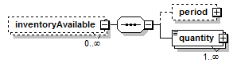
properties
  minOcc | 0
  maxOcc | unbounded
  content | complex
children | period quantity
source | <xs:element name="inventoryAvailable" minOccurs="0" maxOccurs="unbounded">  <xs:complexType>  <xs:sequence>  <xs:element name="period" type="TimeSpan" minOccurs="0"/>  <xs:element name="quantity" type="Quantity" maxOccurs="unbounded"/>  </xs:sequence>  </xs:complexType>  </xs:element>

element Product/instance/inventoryAvailable/period
diagram | 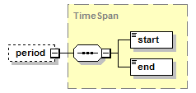
type | TimeSpan
properties
  minOcc | 0
  maxOcc | 1
  content | complex
children | start end
source | <xs:element name="period" type="TimeSpan" minOccurs="0"/>

element Product/instance/inventoryAvailable/quantity
diagram | 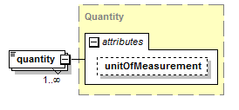
type | Quantity
properties
  minOcc | 1
  maxOcc | unbounded
  content | complex
attributes
  Name | Type | Use | Default | Fixed | Annotation
  unitOfMeasurement | UnitOfMeasurement
source | <xs:element name="quantity" type="Quantity" maxOccurs="unbounded"/>

element Product/instance/profile
diagram
type | AudienceProfile
properties
  minOcc | 0
  maxOcc | unbounded
  content | complex
children | name source id snapshotTimeStamp universe distribution summaryStatistic trend
source | <xs:element name="profile" type="AudienceProfile" minOccurs="0" maxOccurs="unbounded"/>

element Product/instance/targeting
diagram | 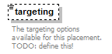
properties
  minOcc | 0
  maxOcc | 1
annotation
  documentation
  The targeting options available for this placement. TODO: define this!
source | <xs:element name="targeting" minOccurs="0">  <xs:annotation>  <xs:documentation>The targeting options available for this placement. TODO: define this!</xs:documentation>  </xs:annotation>  </xs:element>

element Product/instance/minimumPurchase
diagram | 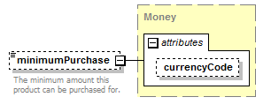
type | Money
properties
  minOcc | 0
  maxOcc | 1
  content | complex
attributes
  Name | Type | Use | Default | Fixed | Annotation
  currencyCode | CurrencyCode |  | USD
annotation
  documentation
  The minimum amount this product can be purchased for.
source | <xs:element name="minimumPurchase" type="Money" minOccurs="0">  <xs:annotation>  <xs:documentation>The minimum amount this product can be purchased for.</xs:documentation>  </xs:annotation>  </xs:element>

element Product/instance/minimumDurationDays
diagram | 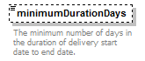
properties
  minOcc | 0
  maxOcc | 1
annotation
  documentation
  The minimum number of days in the duration of delivery start date to end date.
source | <xs:element name="minimumDurationDays" minOccurs="0">  <xs:annotation>  <xs:documentation>The minimum number of days in the duration of delivery start date to end date.</xs:documentation>  </xs:annotation>  </xs:element>

complexType Program
diagram | 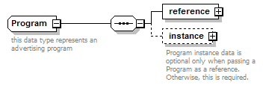
children | reference instance
used by
  elements | program DiscountCode/appliesTo/specifiedProducts/program
annotation
  documentation
  this data type represents an advertising program
source | <xs:complexType name="Program">  <xs:annotation>  <xs:documentation>this data type represents an advertising program</xs:documentation>  </xs:annotation>  <xs:sequence>  <xs:element name="reference" type="ObjectReference"/>  <xs:element name="instance" minOccurs="0">  <xs:annotation>  <xs:documentation>Program instance data is optional only when passing a Program as a reference. Otherwise, this is required.</xs:documentation>  </xs:annotation>  <xs:complexType>  <xs:sequence>  <xs:element name="seller" type="Transactor"/>  <xs:element name="description" type="Note" minOccurs="0"/>  <xs:element name="url" type="xs:anyURI" minOccurs="0">  <xs:annotation>  <xs:documentation>The URL of the website if this is an online display program.</xs:documentation>  </xs:annotation>  </xs:element>  <xs:element name="product" type="Product" minOccurs="0" maxOccurs="unbounded"/>  <xs:element name="channel" type="Channel" minOccurs="0" maxOccurs="unbounded"/>  <xs:element name="category" type="Category" minOccurs="0" maxOccurs="unbounded"/>  <xs:element name="monthlyUniques" type="xs:long" minOccurs="0"/>  <xs:element name="profile" type="AudienceProfile" minOccurs="0" maxOccurs="unbounded"/>  <xs:element name="document" type="File" minOccurs="0" maxOccurs="unbounded"/>  <xs:element name="endorsement" minOccurs="0" maxOccurs="unbounded">  <xs:complexType>  <xs:sequence>  <xs:element name="endorser" type="Person"/>  <xs:element name="timestamp" type="xs:dateTime"/>  <xs:element name="notes" minOccurs="0"/>  </xs:sequence>  </xs:complexType>  </xs:element>  <xs:element name="standardTerms" minOccurs="0">  <xs:complexType>  <xs:sequence>  <xs:element name="legal" type="LegalTerms" minOccurs="0"/>  <xs:element name="minimumBuy" type="Money" minOccurs="0"/>  <xs:element name="cancellationFee" type="Money" minOccurs="0"/>  <xs:element name="leadTime" type="xs:short" minOccurs="0">  <xs:annotation>  <xs:documentation>The number of days of lead time required for this order in advance of start date</xs:documentation>  </xs:annotation>  </xs:element>  <xs:element name="orderInstructions" type="Note"/>  </xs:sequence>  </xs:complexType>  </xs:element>  </xs:sequence>  </xs:complexType>  </xs:element>  </xs:sequence>  </xs:complexType>

element Program/reference
diagram
type | ObjectReference
properties
  content | complex
children | name referenceNumber version url systemInformation
source | <xs:element name="reference" type="ObjectReference"/>

element Program/instance
diagram | 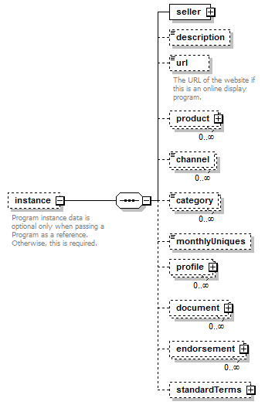
properties
  minOcc | 0
  maxOcc | 1
  content | complex
children | seller description url product channel category monthlyUniques profile document endorsement standardTerms
annotation
  documentation
  Program instance data is optional only when passing a Program as a reference. Otherwise, this is required.
source | <xs:element name="instance" minOccurs="0">  <xs:annotation>  <xs:documentation>Program instance data is optional only when passing a Program as a reference. Otherwise, this is required.</xs:documentation>  </xs:annotation>  <xs:complexType>  <xs:sequence>  <xs:element name="seller" type="Transactor"/>  <xs:element name="description" type="Note" minOccurs="0"/>  <xs:element name="url" type="xs:anyURI" minOccurs="0">  <xs:annotation>  <xs:documentation>The URL of the website if this is an online display program.</xs:documentation>  </xs:annotation>  </xs:element>  <xs:element name="product" type="Product" minOccurs="0" maxOccurs="unbounded"/>  <xs:element name="channel" type="Channel" minOccurs="0" maxOccurs="unbounded"/>  <xs:element name="category" type="Category" minOccurs="0" maxOccurs="unbounded"/>  <xs:element name="monthlyUniques" type="xs:long" minOccurs="0"/>  <xs:element name="profile" type="AudienceProfile" minOccurs="0" maxOccurs="unbounded"/>  <xs:element name="document" type="File" minOccurs="0" maxOccurs="unbounded"/>  <xs:element name="endorsement" minOccurs="0" maxOccurs="unbounded">  <xs:complexType>  <xs:sequence>  <xs:element name="endorser" type="Person"/>  <xs:element name="timestamp" type="xs:dateTime"/>  <xs:element name="notes" minOccurs="0"/>  </xs:sequence>  </xs:complexType>  </xs:element>  <xs:element name="standardTerms" minOccurs="0">  <xs:complexType>  <xs:sequence>  <xs:element name="legal" type="LegalTerms" minOccurs="0"/>  <xs:element name="minimumBuy" type="Money" minOccurs="0"/>  <xs:element name="cancellationFee" type="Money" minOccurs="0"/>  <xs:element name="leadTime" type="xs:short" minOccurs="0">  <xs:annotation>  <xs:documentation>The number of days of lead time required for this order in advance of start date</xs:documentation>  </xs:annotation>  </xs:element>  <xs:element name="orderInstructions" type="Note"/>  </xs:sequence>  </xs:complexType>  </xs:element>  </xs:sequence>  </xs:complexType>  </xs:element>

element Program/instance/seller
diagram | 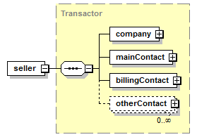
type | Transactor
properties
  content | complex
children | company mainContact billingContact otherContact
source | <xs:element name="seller" type="Transactor"/>

element Program/instance/description
diagram
type | Note
properties
  minOcc | 0
  maxOcc | 1
  content | simple
facets
  Kind | Value | Annotation
  whiteSpace | preserve
source | <xs:element name="description" type="Note" minOccurs="0"/>

element Program/instance/url
diagram | 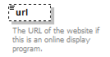
type | xs:anyURI
properties
  minOcc | 0
  maxOcc | 1
  content | simple
annotation
  documentation
  The URL of the website if this is an online display program.
source | <xs:element name="url" type="xs:anyURI" minOccurs="0">  <xs:annotation>  <xs:documentation>The URL of the website if this is an online display program.</xs:documentation>  </xs:annotation>  </xs:element>

element Program/instance/product
diagram
type | Product
properties
  minOcc | 0
  maxOcc | unbounded
  content | complex
children | reference instance
source | <xs:element name="product" type="Product" minOccurs="0" maxOccurs="unbounded"/>

element Program/instance/channel
diagram | 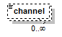
type | Channel
properties
  minOcc | 0
  maxOcc | unbounded
  content | simple
facets
  Kind | Value | Annotation
  enumeration | email
  enumeration | onlineDisplay
source | <xs:element name="channel" type="Channel" minOccurs="0" maxOccurs="unbounded"/>

element Program/instance/category
diagram
type | Category
properties
  minOcc | 0
  maxOcc | unbounded
  content | simple
facets
  Kind | Value | Annotation
  enumeration | [...iab standard categories to be entered ...]
source | <xs:element name="category" type="Category" minOccurs="0" maxOccurs="unbounded"/>

element Program/instance/monthlyUniques
diagram | 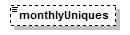
type | xs:long
properties
  minOcc | 0
  maxOcc | 1
  content | simple
source | <xs:element name="monthlyUniques" type="xs:long" minOccurs="0"/>

element Program/instance/profile
diagram
type | AudienceProfile
properties
  minOcc | 0
  maxOcc | unbounded
  content | complex
children | name source id snapshotTimeStamp universe distribution summaryStatistic trend
source | <xs:element name="profile" type="AudienceProfile" minOccurs="0" maxOccurs="unbounded"/>

element Program/instance/document
diagram | 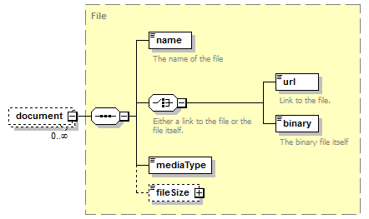
type | File
properties
  minOcc | 0
  maxOcc | unbounded
  content | complex
children | name url binary mediaType fileSize
source | <xs:element name="document" type="File" minOccurs="0" maxOccurs="unbounded"/>

element Program/instance/endorsement
diagram | 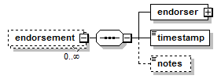
properties
  minOcc | 0
  maxOcc | unbounded
  content | complex
children | endorser timestamp notes
source | <xs:element name="endorsement" minOccurs="0" maxOccurs="unbounded">  <xs:complexType>  <xs:sequence>  <xs:element name="endorser" type="Person"/>  <xs:element name="timestamp" type="xs:dateTime"/>  <xs:element name="notes" minOccurs="0"/>  </xs:sequence>  </xs:complexType>  </xs:element>

element Program/instance/endorsement/endorser
diagram | 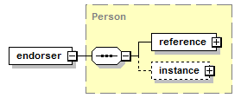
type | Person
properties
  content | complex
children | reference instance
source | <xs:element name="endorser" type="Person"/>

element Program/instance/endorsement/timestamp
diagram | 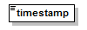
type | xs:dateTime
properties
  content | simple
source | <xs:element name="timestamp" type="xs:dateTime"/>

element Program/instance/endorsement/notes
diagram | 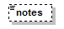
properties
  minOcc | 0
  maxOcc | 1
source | <xs:element name="notes" minOccurs="0"/>

element Program/instance/standardTerms
diagram | 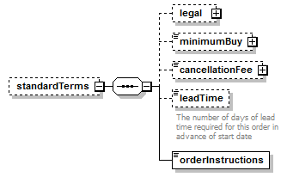
properties
  minOcc | 0
  maxOcc | 1
  content | complex
children | legal minimumBuy cancellationFee leadTime orderInstructions
source | <xs:element name="standardTerms" minOccurs="0">  <xs:complexType>  <xs:sequence>  <xs:element name="legal" type="LegalTerms" minOccurs="0"/>  <xs:element name="minimumBuy" type="Money" minOccurs="0"/>  <xs:element name="cancellationFee" type="Money" minOccurs="0"/>  <xs:element name="leadTime" type="xs:short" minOccurs="0">  <xs:annotation>  <xs:documentation>The number of days of lead time required for this order in advance of start date</xs:documentation>  </xs:annotation>  </xs:element>  <xs:element name="orderInstructions" type="Note"/>  </xs:sequence>  </xs:complexType>  </xs:element>

element Program/instance/standardTerms/legal
diagram | 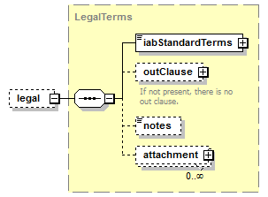
type | LegalTerms
properties
  minOcc | 0
  maxOcc | 1
  content | complex
children | iabStandardTerms outClause notes attachment
source | <xs:element name="legal" type="LegalTerms" minOccurs="0"/>

element Program/instance/standardTerms/minimumBuy
diagram | 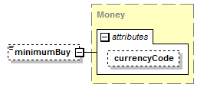
type | Money
properties
  minOcc | 0
  maxOcc | 1
  content | complex
attributes
  Name | Type | Use | Default | Fixed | Annotation
  currencyCode | CurrencyCode |  | USD
source | <xs:element name="minimumBuy" type="Money" minOccurs="0"/>

element Program/instance/standardTerms/cancellationFee
diagram | 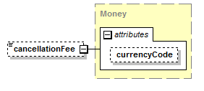
type | Money
properties
  minOcc | 0
  maxOcc | 1
  content | complex
attributes
  Name | Type | Use | Default | Fixed | Annotation
  currencyCode | CurrencyCode |  | USD
source | <xs:element name="cancellationFee" type="Money" minOccurs="0"/>

element Program/instance/standardTerms/leadTime
diagram | 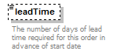
type | xs:short
properties
  minOcc | 0
  maxOcc | 1
  content | simple
annotation
  documentation
  The number of days of lead time required for this order in advance of start date
source | <xs:element name="leadTime" type="xs:short" minOccurs="0">  <xs:annotation>  <xs:documentation>The number of days of lead time required for this order in advance of start date</xs:documentation>  </xs:annotation>  </xs:element>

element Program/instance/standardTerms/orderInstructions
diagram | 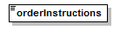
type | Note
properties
  content | simple
facets
  Kind | Value | Annotation
  whiteSpace | preserve
source | <xs:element name="orderInstructions" type="Note"/>

complexType Targeting
diagram | 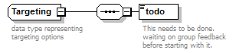
children | todo
annotation
  documentation
  data type representing targeting options
source | <xs:complexType name="Targeting">  <xs:annotation>  <xs:documentation>data type representing targeting options</xs:documentation>  </xs:annotation>  <xs:sequence>  <xs:element name="todo">  <xs:annotation>  <xs:documentation>This needs to be done. waiting on group feedback before starting with it.</xs:documentation>  </xs:annotation>  </xs:element>  </xs:sequence>  </xs:complexType>

element Targeting/todo
diagram | 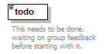
annotation
  documentation
  This needs to be done. waiting on group feedback before starting with it.
source | <xs:element name="todo">  <xs:annotation>  <xs:documentation>This needs to be done. waiting on group feedback before starting with it.</xs:documentation>  </xs:annotation>  </xs:element>

simpleType Category
type | restriction of xs:string
properties
  base | xs:string
used by
  elements | Program/instance/category Product/instance/category
facets
  Kind | Value | Annotation
  enumeration | [...iab standard categories to be entered ...]
annotation
  documentation
  Enumeration of IAB standard categories
source | <xs:simpleType name="Category">  <xs:annotation>  <xs:documentation>Enumeration of IAB standard categories</xs:documentation>  </xs:annotation>  <xs:restriction base="xs:string">  <xs:enumeration value="[...iab standard categories to be entered ...]"/>  </xs:restriction>  </xs:simpleType>

XML Schema documentation generated by XMLSpy Schema Editor http://www.altova.com/xmlspy

