Schema proposal.xsd

schema location: | ..\schemas\proposal.xsd
attributeFormDefault: | unqualified
elementFormDefault: | qualified

Elements | Complex types
proposal | Proposal

element proposal
diagram | 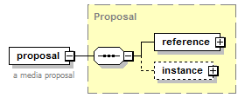
type | Proposal
properties
  content | complex
children | reference instance
annotation
  documentation
  a media proposal
source | <xs:element name="proposal" type="Proposal">  <xs:annotation>  <xs:documentation>a media proposal</xs:documentation>  </xs:annotation>  </xs:element>

complexType Proposal
diagram | 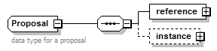
children | reference instance
used by
  element | proposal
annotation
  documentation
  data type for a proposal
source | <xs:complexType name="Proposal">  <xs:annotation>  <xs:documentation>data type for a proposal</xs:documentation>  </xs:annotation>  <xs:sequence>  <xs:element name="reference" type="ObjectReference"/>  <xs:element name="instance" minOccurs="0">  <xs:complexType>  <xs:sequence>  <xs:element name="buyer" type="Transactor"/>  <xs:element name="seller" type="Transactor"/>  <xs:element name="advertiser" type="Transactor" minOccurs="0"/>  <xs:element name="campaignName" type="Name"/>  <xs:element name="rfp" type="RFP" minOccurs="0">  <xs:annotation>  <xs:documentation>identifies the RFP this proposal is in response to. Not required if unsolicited.</xs:documentation>  </xs:annotation>  </xs:element>  <xs:element name="lineItem" type="OrderLineItem" minOccurs="0" maxOccurs="unbounded"/>  <xs:element name="totalAmount" type="Money">  <xs:annotation>  <xs:documentation>The total amount of the proposal</xs:documentation>  </xs:annotation>  </xs:element>  <xs:element name="totalQuantity" type="Quantity" maxOccurs="unbounded">  <xs:annotation>  <xs:documentation>The total quanitity of impressions, clicks, etc. represented in this proposal.</xs:documentation>  </xs:annotation>  </xs:element>  <xs:element name="eCPM" type="Rate" minOccurs="0">  <xs:annotation>  <xs:documentation>The effective cost per thousand impressions in this proposal (optional).</xs:documentation>  </xs:annotation>  </xs:element>  <xs:element name="rationale" type="Note" minOccurs="0">  <xs:annotation>  <xs:documentation>Explains the basis for this proposal. Why do the products represented in this proposal deserve to be ordered for the campaign?</xs:documentation>  </xs:annotation>  </xs:element>  <xs:element name="attachment" type="File" minOccurs="0" maxOccurs="unbounded">  <xs:annotation>  <xs:documentation>attachments that support the rational such as media kits, screen shots, spread sheets, powerpoints.</xs:documentation>  </xs:annotation>  </xs:element>  <xs:element name="expiryDate" type="xs:date" minOccurs="0">  <xs:annotation>  <xs:documentation>optionally indicates the date on which this propoal expires</xs:documentation>  </xs:annotation>  </xs:element>  </xs:sequence>  </xs:complexType>  </xs:element>  </xs:sequence>  </xs:complexType>

element Proposal/reference
diagram | 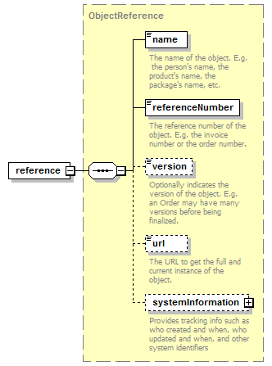
type | ObjectReference
properties
  content | complex
children | name referenceNumber version url systemInformation
source | <xs:element name="reference" type="ObjectReference"/>

element Proposal/instance
diagram | 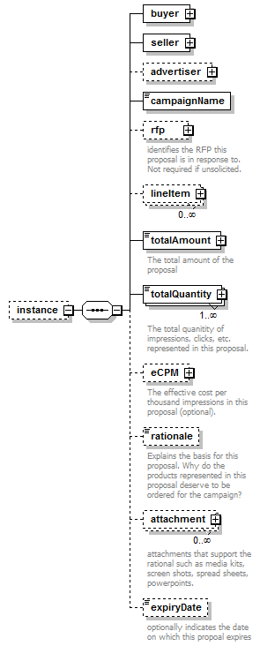
properties
  minOcc | 0
  maxOcc | 1
  content | complex
children | buyer seller advertiser campaignName rfp lineItem totalAmount totalQuantity eCPM rationale attachment expiryDate
source | <xs:element name="instance" minOccurs="0">  <xs:complexType>  <xs:sequence>  <xs:element name="buyer" type="Transactor"/>  <xs:element name="seller" type="Transactor"/>  <xs:element name="advertiser" type="Transactor" minOccurs="0"/>  <xs:element name="campaignName" type="Name"/>  <xs:element name="rfp" type="RFP" minOccurs="0">  <xs:annotation>  <xs:documentation>identifies the RFP this proposal is in response to. Not required if unsolicited.</xs:documentation>  </xs:annotation>  </xs:element>  <xs:element name="lineItem" type="OrderLineItem" minOccurs="0" maxOccurs="unbounded"/>  <xs:element name="totalAmount" type="Money">  <xs:annotation>  <xs:documentation>The total amount of the proposal</xs:documentation>  </xs:annotation>  </xs:element>  <xs:element name="totalQuantity" type="Quantity" maxOccurs="unbounded">  <xs:annotation>  <xs:documentation>The total quanitity of impressions, clicks, etc. represented in this proposal.</xs:documentation>  </xs:annotation>  </xs:element>  <xs:element name="eCPM" type="Rate" minOccurs="0">  <xs:annotation>  <xs:documentation>The effective cost per thousand impressions in this proposal (optional).</xs:documentation>  </xs:annotation>  </xs:element>  <xs:element name="rationale" type="Note" minOccurs="0">  <xs:annotation>  <xs:documentation>Explains the basis for this proposal. Why do the products represented in this proposal deserve to be ordered for the campaign?</xs:documentation>  </xs:annotation>  </xs:element>  <xs:element name="attachment" type="File" minOccurs="0" maxOccurs="unbounded">  <xs:annotation>  <xs:documentation>attachments that support the rational such as media kits, screen shots, spread sheets, powerpoints.</xs:documentation>  </xs:annotation>  </xs:element>  <xs:element name="expiryDate" type="xs:date" minOccurs="0">  <xs:annotation>  <xs:documentation>optionally indicates the date on which this propoal expires</xs:documentation>  </xs:annotation>  </xs:element>  </xs:sequence>  </xs:complexType>  </xs:element>

element Proposal/instance/buyer
diagram | 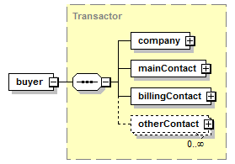
type | Transactor
properties
  content | complex
children | company mainContact billingContact otherContact
source | <xs:element name="buyer" type="Transactor"/>

element Proposal/instance/seller
diagram | 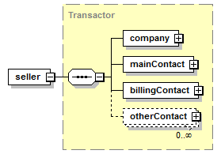
type | Transactor
properties
  content | complex
children | company mainContact billingContact otherContact
source | <xs:element name="seller" type="Transactor"/>

element Proposal/instance/advertiser
diagram | 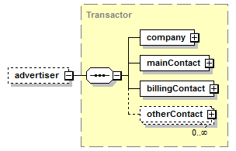
type | Transactor
properties
  minOcc | 0
  maxOcc | 1
  content | complex
children | company mainContact billingContact otherContact
source | <xs:element name="advertiser" type="Transactor" minOccurs="0"/>

element Proposal/instance/campaignName
diagram | 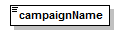
type | Name
properties
  content | simple
facets
  Kind | Value | Annotation
  minLength | 1
  maxLength | 80
  whiteSpace | collapse
source | <xs:element name="campaignName" type="Name"/>

element Proposal/instance/rfp
diagram | 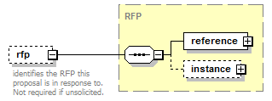
type | RFP
properties
  minOcc | 0
  maxOcc | 1
  content | complex
children | reference instance
annotation
  documentation
  identifies the RFP this proposal is in response to. Not required if unsolicited.
source | <xs:element name="rfp" type="RFP" minOccurs="0">  <xs:annotation>  <xs:documentation>identifies the RFP this proposal is in response to. Not required if unsolicited.</xs:documentation>  </xs:annotation>  </xs:element>

element Proposal/instance/lineItem
diagram | 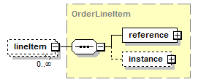
type | OrderLineItem
properties
  minOcc | 0
  maxOcc | unbounded
  content | complex
children | reference instance
source | <xs:element name="lineItem" type="OrderLineItem" minOccurs="0" maxOccurs="unbounded"/>

element Proposal/instance/totalAmount
diagram | 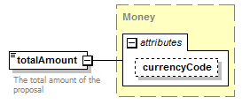
type | Money
properties
  content | complex
attributes
  Name | Type | Use | Default | Fixed | Annotation
  currencyCode | CurrencyCode |  | USD
annotation
  documentation
  The total amount of the proposal
source | <xs:element name="totalAmount" type="Money">  <xs:annotation>  <xs:documentation>The total amount of the proposal</xs:documentation>  </xs:annotation>  </xs:element>

element Proposal/instance/totalQuantity
diagram | 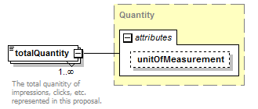
type | Quantity
properties
  minOcc | 1
  maxOcc | unbounded
  content | complex
attributes
  Name | Type | Use | Default | Fixed | Annotation
  unitOfMeasurement | UnitOfMeasurement
annotation
  documentation
  The total quanitity of impressions, clicks, etc. represented in this proposal.
source | <xs:element name="totalQuantity" type="Quantity" maxOccurs="unbounded">  <xs:annotation>  <xs:documentation>The total quanitity of impressions, clicks, etc. represented in this proposal.</xs:documentation>  </xs:annotation>  </xs:element>

element Proposal/instance/eCPM
diagram | 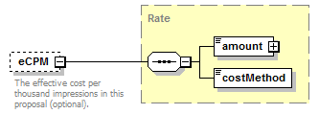
type | Rate
properties
  minOcc | 0
  maxOcc | 1
  content | complex
children | amount costMethod
annotation
  documentation
  The effective cost per thousand impressions in this proposal (optional).
source | <xs:element name="eCPM" type="Rate" minOccurs="0">  <xs:annotation>  <xs:documentation>The effective cost per thousand impressions in this proposal (optional).</xs:documentation>  </xs:annotation>  </xs:element>

element Proposal/instance/rationale
diagram | 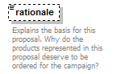
type | Note
properties
  minOcc | 0
  maxOcc | 1
  content | simple
facets
  Kind | Value | Annotation
  whiteSpace | preserve
annotation
  documentation
  Explains the basis for this proposal. Why do the products represented in this proposal deserve to be ordered for the campaign?
source | <xs:element name="rationale" type="Note" minOccurs="0">  <xs:annotation>  <xs:documentation>Explains the basis for this proposal. Why do the products represented in this proposal deserve to be ordered for the campaign?</xs:documentation>  </xs:annotation>  </xs:element>

element Proposal/instance/attachment
diagram | 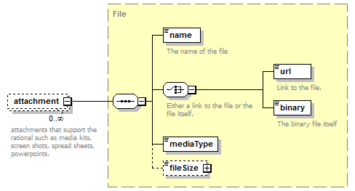
type | File
properties
  minOcc | 0
  maxOcc | unbounded
  content | complex
children | name url binary mediaType fileSize
annotation
  documentation
  attachments that support the rational such as media kits, screen shots, spread sheets, powerpoints.
source | <xs:element name="attachment" type="File" minOccurs="0" maxOccurs="unbounded">  <xs:annotation>  <xs:documentation>attachments that support the rational such as media kits, screen shots, spread sheets, powerpoints.</xs:documentation>  </xs:annotation>  </xs:element>

element Proposal/instance/expiryDate
diagram | 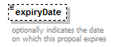
type | xs:date
properties
  minOcc | 0
  maxOcc | 1
  content | simple
annotation
  documentation
  optionally indicates the date on which this propoal expires
source | <xs:element name="expiryDate" type="xs:date" minOccurs="0">  <xs:annotation>  <xs:documentation>optionally indicates the date on which this propoal expires</xs:documentation>  </xs:annotation>  </xs:element>

XML Schema documentation generated by XMLSpy Schema Editor http://www.altova.com/xmlspy

