Schema rfp.xsd

schema location: | ..\schemas\rfp.xsd
attributeFormDefault: | unqualified
elementFormDefault: | qualified

Elements | Complex types
rfp | RFP

element rfp
diagram | 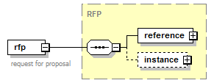
type | RFP
properties
  content | complex
children | reference instance
annotation
  documentation
  request for proposal
source | <xs:element name="rfp" type="RFP">  <xs:annotation>  <xs:documentation>request for proposal</xs:documentation>  </xs:annotation>  </xs:element>

complexType RFP
diagram | 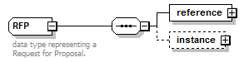
children | reference instance
used by
  element | rfp
annotation
  documentation
  data type representing a Request for Proposal.
source | <xs:complexType name="RFP">  <xs:annotation>  <xs:documentation>data type representing a Request for Proposal.</xs:documentation>  </xs:annotation>  <xs:sequence>  <xs:element name="reference" type="ObjectReference"/>  <xs:element name="instance" minOccurs="0">  <xs:complexType>  <xs:sequence>  <xs:element name="campaignName" type="Name"/>  <xs:element name="requestSent" type="xs:dateTimeStamp">  <xs:annotation>  <xs:documentation>the timestamp when this RFP was first sent</xs:documentation>  </xs:annotation>  </xs:element>  <xs:element name="buyer" type="Transactor"/>  <xs:element name="seller" type="Transactor"/>  <xs:element name="advertiser" type="Transactor" minOccurs="0">  <xs:annotation>  <xs:documentation>buyer can optionally reveal the advertiser in the RFP process</xs:documentation>  </xs:annotation>  </xs:element>  <xs:element name="sellerBudget" type="Money" minOccurs="0" maxOccurs="unbounded">  <xs:annotation>  <xs:documentation>Buyer may ask for proposals at multiple budget levels</xs:documentation>  </xs:annotation>  </xs:element>  <xs:element name="category" type="Category" minOccurs="0" maxOccurs="unbounded">  <xs:annotation>  <xs:documentation>Buyer may indicate the categories for the campaign</xs:documentation>  </xs:annotation>  </xs:element>  <xs:element name="channel" maxOccurs="unbounded">  <xs:annotation>  <xs:documentation>buyer must indicate which channels they are advertising in.</xs:documentation>  </xs:annotation>  </xs:element>  <xs:element name="targeting" type="Targeting" minOccurs="0">  <xs:annotation>  <xs:documentation>targeting requirements: geotargeting, demographics, etc.</xs:documentation>  </xs:annotation>  </xs:element>  <xs:element name="requirements" type="Note">  <xs:annotation>  <xs:documentation>free form description of buyer requirements.</xs:documentation>  </xs:annotation>  </xs:element>  <xs:element name="attachment" type="File" minOccurs="0" maxOccurs="unbounded">  <xs:annotation>  <xs:documentation>optional file attachments such as an RFP doc, response template, etc.</xs:documentation>  </xs:annotation>  </xs:element>  <xs:element name="proposalDueDate" type="xs:date">  <xs:annotation>  <xs:documentation>the date on which the seller's proposal is due back to the buyer to be considered for the campaign.</xs:documentation>  </xs:annotation>  </xs:element>  </xs:sequence>  </xs:complexType>  </xs:element>  </xs:sequence>  </xs:complexType>

element RFP/reference
diagram | 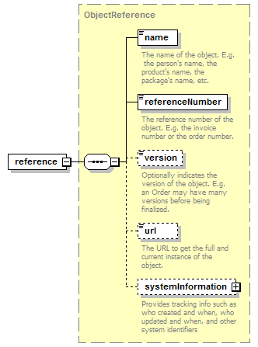
type | ObjectReference
properties
  content | complex
children | name referenceNumber version url systemInformation
source | <xs:element name="reference" type="ObjectReference"/>

element RFP/instance
diagram | 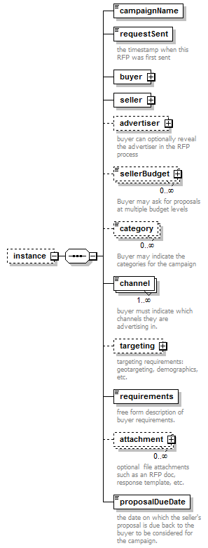
properties
  minOcc | 0
  maxOcc | 1
  content | complex
children | campaignName requestSent buyer seller advertiser sellerBudget category channel targeting requirements attachment proposalDueDate
source | <xs:element name="instance" minOccurs="0">  <xs:complexType>  <xs:sequence>  <xs:element name="campaignName" type="Name"/>  <xs:element name="requestSent" type="xs:dateTimeStamp">  <xs:annotation>  <xs:documentation>the timestamp when this RFP was first sent</xs:documentation>  </xs:annotation>  </xs:element>  <xs:element name="buyer" type="Transactor"/>  <xs:element name="seller" type="Transactor"/>  <xs:element name="advertiser" type="Transactor" minOccurs="0">  <xs:annotation>  <xs:documentation>buyer can optionally reveal the advertiser in the RFP process</xs:documentation>  </xs:annotation>  </xs:element>  <xs:element name="sellerBudget" type="Money" minOccurs="0" maxOccurs="unbounded">  <xs:annotation>  <xs:documentation>Buyer may ask for proposals at multiple budget levels</xs:documentation>  </xs:annotation>  </xs:element>  <xs:element name="category" type="Category" minOccurs="0" maxOccurs="unbounded">  <xs:annotation>  <xs:documentation>Buyer may indicate the categories for the campaign</xs:documentation>  </xs:annotation>  </xs:element>  <xs:element name="channel" maxOccurs="unbounded">  <xs:annotation>  <xs:documentation>buyer must indicate which channels they are advertising in.</xs:documentation>  </xs:annotation>  </xs:element>  <xs:element name="targeting" type="Targeting" minOccurs="0">  <xs:annotation>  <xs:documentation>targeting requirements: geotargeting, demographics, etc.</xs:documentation>  </xs:annotation>  </xs:element>  <xs:element name="requirements" type="Note">  <xs:annotation>  <xs:documentation>free form description of buyer requirements.</xs:documentation>  </xs:annotation>  </xs:element>  <xs:element name="attachment" type="File" minOccurs="0" maxOccurs="unbounded">  <xs:annotation>  <xs:documentation>optional file attachments such as an RFP doc, response template, etc.</xs:documentation>  </xs:annotation>  </xs:element>  <xs:element name="proposalDueDate" type="xs:date">  <xs:annotation>  <xs:documentation>the date on which the seller's proposal is due back to the buyer to be considered for the campaign.</xs:documentation>  </xs:annotation>  </xs:element>  </xs:sequence>  </xs:complexType>  </xs:element>

element RFP/instance/campaignName
diagram | 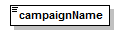
type | Name
properties
  content | simple
facets
  Kind | Value | Annotation
  minLength | 1
  maxLength | 80
  whiteSpace | collapse
source | <xs:element name="campaignName" type="Name"/>

element RFP/instance/requestSent
diagram | 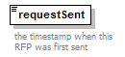
type | xs:dateTimeStamp
properties
  content | simple
annotation
  documentation
  the timestamp when this RFP was first sent
source | <xs:element name="requestSent" type="xs:dateTimeStamp">  <xs:annotation>  <xs:documentation>the timestamp when this RFP was first sent</xs:documentation>  </xs:annotation>  </xs:element>

element RFP/instance/buyer
diagram | 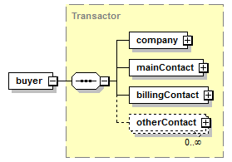
type | Transactor
properties
  content | complex
children | company mainContact billingContact otherContact
source | <xs:element name="buyer" type="Transactor"/>

element RFP/instance/seller
diagram | 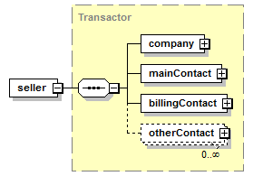
type | Transactor
properties
  content | complex
children | company mainContact billingContact otherContact
source | <xs:element name="seller" type="Transactor"/>

element RFP/instance/advertiser
diagram | 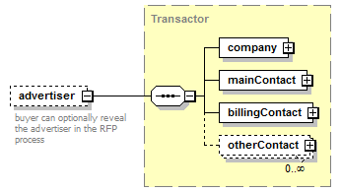
type | Transactor
properties
  minOcc | 0
  maxOcc | 1
  content | complex
children | company mainContact billingContact otherContact
annotation
  documentation
  buyer can optionally reveal the advertiser in the RFP process
source | <xs:element name="advertiser" type="Transactor" minOccurs="0">  <xs:annotation>  <xs:documentation>buyer can optionally reveal the advertiser in the RFP process</xs:documentation>  </xs:annotation>  </xs:element>

element RFP/instance/sellerBudget
diagram | 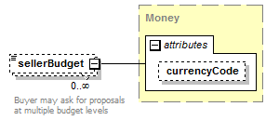
type | Money
properties
  minOcc | 0
  maxOcc | unbounded
  content | complex
attributes
  Name | Type | Use | Default | Fixed | Annotation
  currencyCode | CurrencyCode |  | USD
annotation
  documentation
  Buyer may ask for proposals at multiple budget levels
source | <xs:element name="sellerBudget" type="Money" minOccurs="0" maxOccurs="unbounded">  <xs:annotation>  <xs:documentation>Buyer may ask for proposals at multiple budget levels</xs:documentation>  </xs:annotation>  </xs:element>

element RFP/instance/category
diagram | 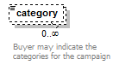
type | Category
properties
  minOcc | 0
  maxOcc | unbounded
  content | simple
facets
  Kind | Value | Annotation
  enumeration | [...iab standard categories to be entered ...]
annotation
  documentation
  Buyer may indicate the categories for the campaign
source | <xs:element name="category" type="Category" minOccurs="0" maxOccurs="unbounded">  <xs:annotation>  <xs:documentation>Buyer may indicate the categories for the campaign</xs:documentation>  </xs:annotation>  </xs:element>

element RFP/instance/channel
diagram | 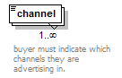
properties
  minOcc | 1
  maxOcc | unbounded
annotation
  documentation
  buyer must indicate which channels they are advertising in.
source | <xs:element name="channel" maxOccurs="unbounded">  <xs:annotation>  <xs:documentation>buyer must indicate which channels they are advertising in.</xs:documentation>  </xs:annotation>  </xs:element>

element RFP/instance/targeting
diagram | 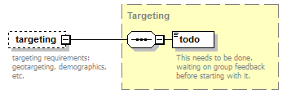
type | Targeting
properties
  minOcc | 0
  maxOcc | 1
  content | complex
children | todo
annotation
  documentation
  targeting requirements: geotargeting, demographics, etc.
source | <xs:element name="targeting" type="Targeting" minOccurs="0">  <xs:annotation>  <xs:documentation>targeting requirements: geotargeting, demographics, etc.</xs:documentation>  </xs:annotation>  </xs:element>

element RFP/instance/requirements
diagram | 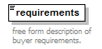
type | Note
properties
  content | simple
facets
  Kind | Value | Annotation
  whiteSpace | preserve
annotation
  documentation
  free form description of buyer requirements.
source | <xs:element name="requirements" type="Note">  <xs:annotation>  <xs:documentation>free form description of buyer requirements.</xs:documentation>  </xs:annotation>  </xs:element>

element RFP/instance/attachment
diagram | 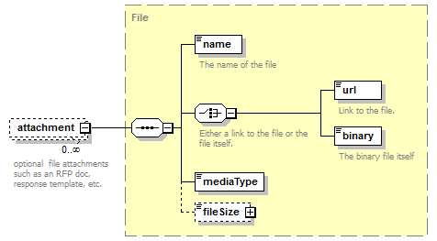
type | File
properties
  minOcc | 0
  maxOcc | unbounded
  content | complex
children | name url binary mediaType fileSize
annotation
  documentation
  optional file attachments such as an RFP doc, response template, etc.
source | <xs:element name="attachment" type="File" minOccurs="0" maxOccurs="unbounded">  <xs:annotation>  <xs:documentation>optional file attachments such as an RFP doc, response template, etc.</xs:documentation>  </xs:annotation>  </xs:element>

element RFP/instance/proposalDueDate
diagram | 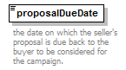
type | xs:date
properties
  content | simple
annotation
  documentation
  the date on which the seller's proposal is due back to the buyer to be considered for the campaign.
source | <xs:element name="proposalDueDate" type="xs:date">  <xs:annotation>  <xs:documentation>the date on which the seller's proposal is due back to the buyer to be considered for the campaign.</xs:documentation>  </xs:annotation>  </xs:element>

XML Schema documentation generated by XMLSpy Schema Editor http://www.altova.com/xmlspy

