POWERLINK IP-Core
Xilinx FPGA Documentation
Date: | January 9, 2012
Project Number: | AT-xx-xxxxxx

- Versions
 | Version | Date | Comment | Edited by
 | 0.1 | Dec 14, 2011 | First Edition | Zelenka Joerg
 | 0.2 | Jan 4, 2012 | Added FPGA Resource Utilization | Zelenka Joerg
Table 1: Versions

- Safety Notices
Safety notices in this document are organized as follows:

 | Safety notice | Description
 | Danger! | Disregarding the safety regulations and guidelines can be life-threatening.
 | Warning! | Disregarding the safety regulations and guidelines can result in severe injury or heavy damage to material.
 | Caution! | Disregarding the safety regulations and guidelines can result in injury or damage to material.
 | Information: | Important information used to prevent errors.
 | Example: | Functionality is described with an example to prevent errors.
Table 2: Safety notices

- Table of Contents
1 Introduction 4
2 Figure Index 12
3 Table Index 13
4 Listing Index 14
5 Index 15

Introduction

Xilinx Platform Studio (XPS) Integration

Timing Consideration

Software Interface

FPGA Resource Utilization
The POWERLINK IP-core is used in combination with other components in an FPGA, hence the resource utilization and the circuit’s performance (f_{max}) given in this section is an estimation only. The BRAM utilization is not given since it depends on several parameters given in the GUI. Note that the parameters not given in the table are set to default values (not changed in GUI).

Tab. 1: Resource utilization on Spartan 6 FPGA (XC6SLX45T-FGG484-2)
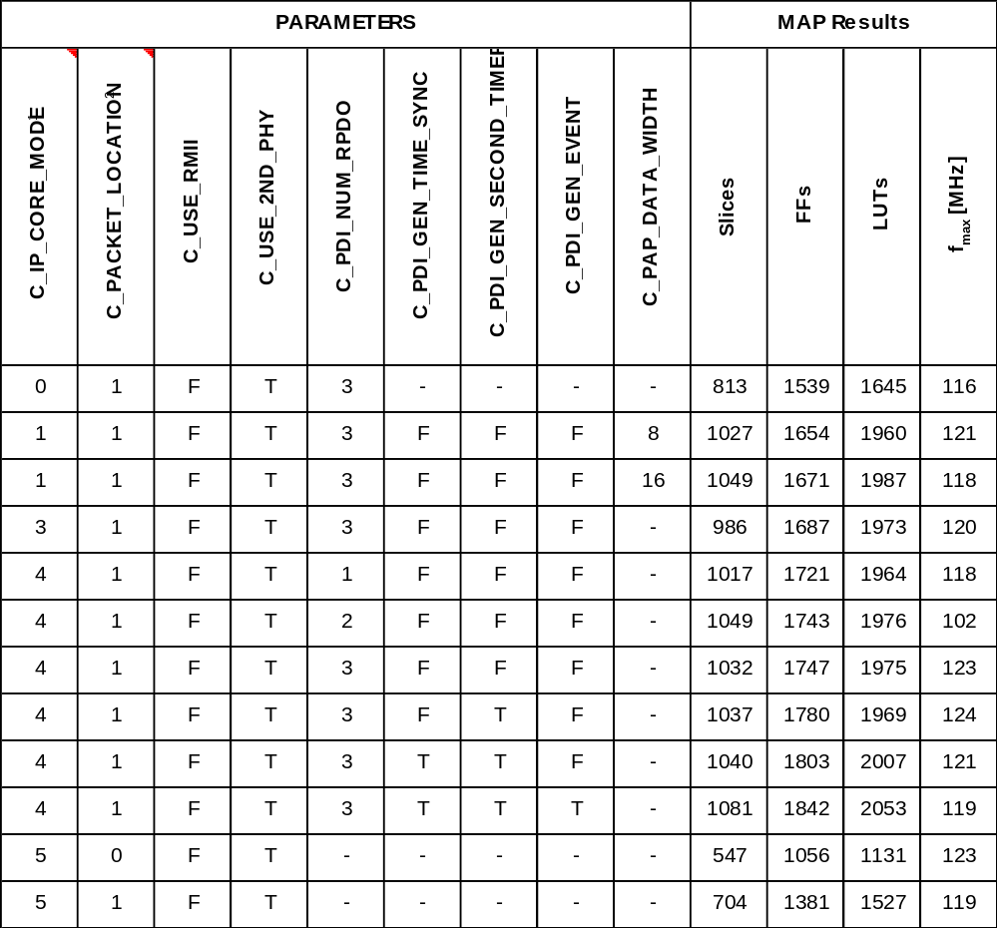
Table note:
- The IP-Core Mode determines the available features (0 = “Direct I/O”, 1 = “Parallel Interface”, 3 = “SPI”, 4 = “PLB” or 5 = “openMAC only”).
- The Packet Location determines the location of the openMAC’s packet buffers (0 = “TX and RX into DPRAM”, 1 = “TX into DPRAM and RX over PLB” or 2 = “TX and RX over PLB”)
- Boolean parameters are set to TRUE (“T”) or FALSE (“F”).
- Unused parameters are identified with a hyphen (“-“)

Files

Definitions and Abbreviations
AP | Application Processor
BUF | MAC-internal packet buffer
CMD | Command
CMP | Compare Unit
CN | POWERLINK Controlled Node
DPR | Dual Ported RAM
DPRAM | Dual Ported RAM
FF | Flip Flop
FPGA | Field Programmable Gate Array
FSM | Finite State Machine
GUI | Graphical User Interface
IP | Intellectual Property
IRQ | Interrupt Request
MII | Media Independent Interface
MN | POWERLINK Managing Node
PCB | Printed Circuit Board
PCP | Powerlink Communication Processor
PDI | Process Data Interface
PDO | Process Data Object
PReq | Poll Request (POWERLINK frame type)
PRes | Poll Response (POWERLINK frame type)
RD | Read
RDY | Ready
RMII | Reduced Media Independent Interface
RO | Read Only
SDO | Service Data Object
SMI | Serial Management Interface (Ethernet phy register access)
SMP | Simple I/O Port
SoA | Start of Asynchronous (POWERLINK frame type)
SoC | Start of Cyclic (POWERLINK frame type)
SPI | Serial Peripheral Interface
SYNC | Synchronization (Clock Domain Crossing)
WR | Write

References
- ???

Figure Index
Fehler! Es konnten keine Einträge für ein Abbildungsverzeichnis gefunden werden.

Table Index
Table 1: Versions 2
Table 2: Distribution Fehler! Textmarke nicht definiert.
Table 3: Safety notices 2

Listing Index
Fehler! Es konnten keine Einträge für ein Abbildungsverzeichnis gefunden werden.

Index

D
Distribution 2
F
Figure Index 5
I
Introduction 4
L
Listing Index 7, 8
S
Safety Notices 2
T
Table Index 6
Table of Contents 3
V
Versions 2

