openMAC & Components
Documentation
Date: | September 7, 2011

- Versions
 | Version | Date | Comment | Edited by
 | 1.0 | --/04/2009 | Creation | Zelenka Joerg
 | 1.1 | --/05/2009 | Phy Management Core, Register structure | Zelenka Joerg
 | 1.2 | --/09/2009 | Completely reworked chapter 1 – 3  Deleted chapter 4 (Ethernet driver), added chapter Application note | Zelenka Joerg
 | 1.3 | 09/02/2010 | Changed template | Zelenka Joerg
 | 1.4 | 15/06/2010 | Changes in Avalon bus interface (2.6)  Added Packet buffer management (3.2.3)  Added Get TX/RX buffer base (3.2.7.5/6) | Zelenka Joerg
 | 1.5 | 19/08/2010 | Changed Requirements to Features (2.1)  Added features (2.1)  Added generics “TxDel” and “TxSyncOn” (Tab. 8)  Avalon slave interface mapping | Zelenka Joerg
 | 1.6 | 07/09/2011 | Removed Avalon bus specific content (moved to POWERLINK IP-core documentation)  Changed openMAC block diagram | Zelenka Joerg
Table 1: Versions

- License
Copyright (c) 2010, B&R
All rights reserved.
Redistribution and use in source and binary forms, with or without modification, are permitted provided that the following conditions are met:
- Redistributions of source code must retain the above copyright notice, this list of conditions and the following disclaimer.
- Redistributions in binary form must reproduce the above copyright notice, this list of conditions and the following disclaimer in the documentation and/or other materials provided with the distribution.
- Neither the name of B&R, Eggelsberg nor the names of its contributors may be used to endorse or promote products derived from this software without specific prior written permission.
THIS SOFTWARE IS PROVIDED BY THE COPYRIGHT HOLDERS AND CONTRIBUTORS "AS IS" AND ANY EXPRESS OR IMPLIED WARRANTIES, INCLUDING, BUT NOT LIMITED TO, THE IMPLIED WARRANTIES OF MERCHANTABILITY AND FITNESS FOR A PARTICULAR PURPOSE ARE DISCLAIMED. IN NO EVENT SHALL THE COPYRIGHT HOLDER OR CONTRIBUTORS BE LIABLE FOR ANY DIRECT, INDIRECT, INCIDENTAL, SPECIAL, EXEMPLARY, OR CONSEQUENTIAL DAMAGES (INCLUDING, BUT NOT LIMITED TO, PROCUREMENT OF SUBSTITUTE GOODS OR SERVICES; LOSS OF USE, DATA, OR PROFITS; OR BUSINESS INTERRUPTION) HOWEVER CAUSED AND ON ANY THEORY OF LIABILITY, WHETHER IN CONTRACT, STRICT LIABILITY, OR TORT (INCLUDING NEGLIGENCE OR OTHERWISE) ARISING IN ANY WAY OUT OF THE USE OF THIS SOFTWARE, EVEN IF ADVISED OF THE POSSIBILITY OF SUCH DAMAGE.

- Table of Contents
1 Introduction 5
1.1 About this document 5
1.2 About openMAC 5
2 IP-Cores 7
2.1 Features 7
2.2 OpenMAC 7
2.2.1 Interface 7
2.2.1.1 Descriptor block 7
2.2.1.2 TX/RX control/status registers 10
2.2.2 Receive filters 11
2.2.3 Timing 13
2.2.3.1 Slave interface 13
2.2.3.2 Master interface (DMA) 14
2.2.4 Port/generic map 14
2.3 Phy management core 15
2.3.1 Serial management interface (SMI) 16
2.3.2 Interface 16
2.3.3 Timing 17
2.3.4 Port map 18
2.4 OpenHUB 18
2.4.1 Port/generic map 19
2.5 OpenFILTER 20
2.5.1 Port map 20
3 HAL Ethernet driver 21
3.1 Features 21
3.1.1 Time stamp 21
3.1.2 Packet filters 21
3.1.3 Auto response 22
3.2 Ethernet driver 23
3.2.1 Files 23
3.2.2 IRQ subroutines 24
3.2.3 Basic API functions 24
3.2.3.1 omethMiiControl 24
3.2.3.2 omethInit 24
3.2.3.3 omethCreate 24
3.2.3.4 omethHookCreate 26
3.2.3.5 omethFilterCreate 27
3.2.3.6 omethTransmit 27
3.2.3.7 omethStart 27
3.2.3.8 omethStop 27
3.2.3.9 omethPeriodic 27
3.2.3.10 omethDestroy 28
3.2.4 Filter manipulation 28
3.2.4.1 omethFilterSetPattern 28
3.2.4.2 omethFilterSetArgument 28
3.2.5 Auto response functionality 28
3.2.5.1 omethResponseInit 28
3.2.5.2 omethResponseSet 28
3.2.5.3 omethResponseDisable 28
3.2.5.4 omethResponseEnable 28
3.2.6 Other API functions 28
3.2.6.1 omethGetHandler 28
3.2.6.2 omethPhyInfo 29
3.2.6.3 omethHookSetFunction 29
3.2.6.4 omethGetTimestamp 29
3.2.6.5 omethGetTxBufBase 29
3.2.6.6 omethGetRxBufBase 29
3.2.6.7 omethStatistics 29
3.2.6.8 omethSetSCNM 29
3.2.7 Ethernet packet structure 30
4 Application note 31
4.1 FPGA design with two soft-core CPUs 31
4.2 FPGA for communication tasks only 31
5 Figure Index 35
6 Table Index 36
7 Index 37

Introduction

About this document
This document describes structure and function of the openMAC, openFILTER, openHUB and its HAL driver (HAL ... Hardware Abstraction Layer).

Important:
This documentation only describes the IP-Core openMAC from a generic view. If you require further information for the specific usage with Altera Nios II or Xilinx Microblaze, please refer to the corresponding documentation of the POWERLINK IP-Core!

Using the specific features of this MAC allow very short response times in EPL networks.
In chapter 4 there are given some examples to show how to integrate the whole openMAC-solution into common applications.

About openMAC
This chapter gives an overview on the MAC’s features and itself. At Fig. 1 you can see the openMAC’s structure (OpenMAC.vhd), ports to a processor bus and to the Reduced Media Independent Interface (RMII). The Mac includes a full transmitter (TX) and receiver (RX) – therefore its full-duplex ability is enabled. All frames will be fetched or stored from or into a memory via the included DMA. The Mac’s descriptors are located in a Dual Port Ram (DPR, 16/16) to set the frame buffer’s locations. This memory is accessible over a memory mapped slave interface.
To enable the hardware acceleration ability, a packet filter is included. This component compares the first 31 Bytes of a received packet and starts a transmission of a defined frame from the memory after the Inter Package Gap (960ns, 100Mbps) or a configured delay. It is possible to configure 16 different packet filters and set for every filter the “Auto-Response Feature”.
Every received and transmitted packet gets a time stamp from a 32 Bit Counter and can be read from the descriptor-memory. The Counter value can be used to generate time-dependent interrupts.
The openMAC is equipped with one RMII and can be connected to an external Phy directly. Optionally a three-port (or bigger) hub can be used (OpenHUB.vhd) to attach more Phys.
Every used Phy can be configured and monitored via the Serial Management Interface with the Phy Management Interface Core (OpenMAC_PHYMI.vhd). The HAL driver automatically detects the connected Phys on the SMI bus-line.
It is recommended to use the provided distortion filter (OpenFILTER.vhd) to lock out noise from the connected network. This core should be positioned between the Mac and the Phy or between the Mac and the Hub.

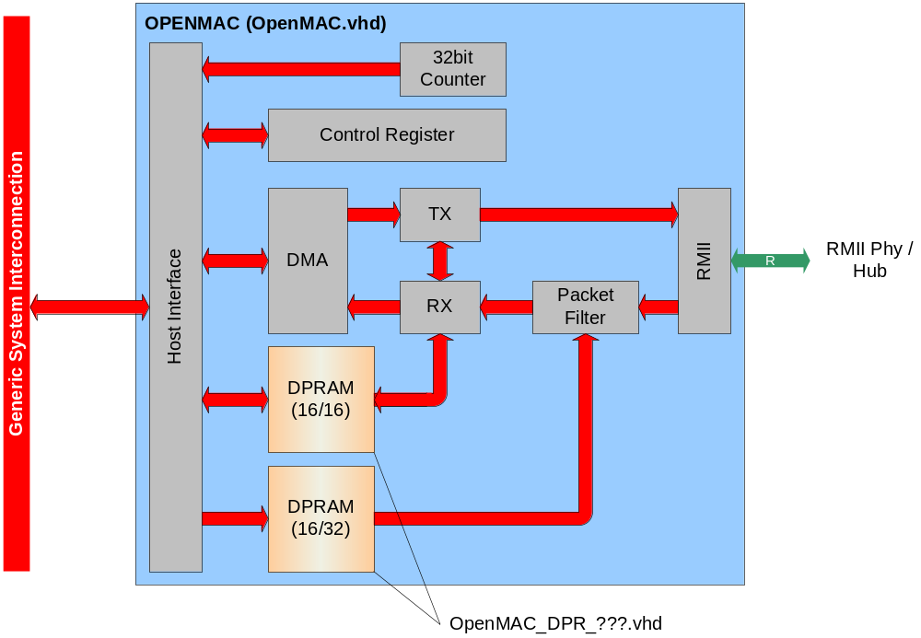
Fig. 1: Block diagram openMAC

IP-Cores
This chapter should give an overview on the free IP-Cores
OpenMAC.vhd (openMAC, 2.2)
OpenMAC_PHYMI.vhd (Phy Management, 2.3)
OpenHUB.vhd (openHub, 2.4)
OpenMAC_DPR_???.vhd (Dual Port RAM for MAC, depends on your chip-architecture Altera/Xilinx)

Features
The following requirements are fulfilled by the IP-Cores:
- sparse resources in FPGA
- full- and half- duplex 100Mbps MAC
- RMII (reduced media independent interface)
- 3-port hub (openHUB)
- 16 RX filters with the ability to start a transmission
- First 31 bytes are filtered by the RX filters
- auto-response feature
- low through-put time
- 32bit free-running timer for time-stamps (RX and TX) and IRQ generation
- Distortion filter (openFILTER)
The following features are added:
- IPG of auto-response packets are adjustable (necessary for Poll-Response Chaining)
- FPGA-internal TX/RX packet buffer (Altera Nios II systems only)
- Timer-triggered packet transmission (beneficial for low SoC jitter by POWERLINK MN)

OpenMAC

Interface
The openMAC’s interface to the CPU includes descriptors, one status and one command register. It is important to connect the Mac’s Clk port to a 50MHz Clk-signal.

Descriptor block
Every descriptor includes information about the received- or (to be) transmitted packets, like the address to the buffer, the packets length and some status flags. The TX- and RX-descriptors are located in the MAC’s dual-port-RAM, which enables fast access (without CPU-control) by the MAC with the RMII Ref-CLK (50MHz). This block has a size of 512 Bytes and is divided into TX- and RX-descriptors (refer to Tab. 1). The openMAC supports 16 TX- and 16 RX-descriptors.

Tab. 1: DPR TX- and RX-descriptor block
Ram_Base + 0x5fc | Tx Desc. 15 | Time Stamp
Ram_Base + 0x5f8 | Tx Desc. 15 | Tx Start time
Ram_Base + 0x5f4 | Tx Desc. 15 | Frame Pointer
Ram_Base + 0x5f0 | Tx Desc. 15 | Tx Status | Tx Frame length
…
Ram_Base + 0x50C | Tx Desc. 0 | Time Stamp
Ram_Base + 0x508 | Tx Desc. 0 | Tx Start time
Ram_Base + 0x504 | Tx Desc. 0 | Frame Pointer
Ram_Base + 0x500 | Tx Desc. 0 | Tx Status | Tx Frame length
Ram_Base + 0x4FC | Rx Desc. 15 | Time Stamp
Ram_Base + 0x4F8 | Rx Desc. 15 | -
Ram_Base + 0x4F4 | Rx Desc. 15 | Frame Pointer
Ram_Base + 0x4F0 | Rx Desc. 15 | Rx Status | Rx Frame length
….
Ram_Base + 0x40C | Rx Desc. 0 | Time Stamp
Ram_Base + 0x408 | Rx Desc. 0 | -
Ram_Base + 0x404 | Rx Desc. 0 | Frame Pointer
Ram_Base + 0x400 | Rx Desc. 0 | Rx Status | Rx Frame length
The TX start time (in TX descriptor) is used to start a transmission at a given time (32bit MAC time).

Tab. 2: TX-descriptor status register
15 | 14 | 13 | 12 | 11 | 10 | 9 | 8 | 7 | 6 | 5 | 4 | 3..0
- | Start  Time | - | Del | - | Written | Last | Owner | - | - | - | - | Tx  Collision Count
Start Time … If this bit is set to one, TX starts at the given time.
Del … frame is delayed by the value in Tx Start time (plus the IPG)
Written ... Is one, if transmission is finished and the MAC is ready.
Last ... Is one, if this descriptor is the last one in list (of the 16 descriptors).
Owner ... Is one, if MAC is the owner of this descriptor. Otherwise (zero) the MAC has no access.
Tx Collisions Count ... Includes the MAC’s tries on sending a packet.

Tab. 3: RX-descriptor status register
15 | 14 | 13 | 12 | 11 | 10 | 9 | 8 | 7 | 6 | 5 | 4 | 3 | 2 | 1 | 0
- | - | - | Align  Error | Hub-Port |  | Last | Owner | Filter Number |  |  |  | Noise  Error | Preamb  Error | Over  Size | Crc  Error
Align Error … Is one, if the Ethernet frame ending was not aligned to a byte.
Last, Owner ... refer to Tab. 2: TX-descriptor status register
Filter Number ... links to the filter, which passes through the packet
Hub-Port … If the openHub is connected to the Mac, then these 2 Bits represents the Hub’s port, where the packet was received.
Noise Error ... Is one, if the MAC notices invalid signals on the RX data line (Crs_Dv was asserted shorter than 64 Bits!)
Preamb Error ... Is one, if the preamble was not correct.
Over Size ... Is one, if the received frame was cut, because the buffer was smaller than the message.
Crc Error ... Is one, if a check sum error occurs.
The Hub-Port value can be as follows:
1 to 3 … packet was received on this port (should not be the internal port to the Mac)
0 … error / no hub connected

The available buffer length of a RX-descriptor may be set to maximal 1518 Bytes (Basic Ethernet) or 2048, because of the receive counter. It should be set to an even number and before using this descriptor. The RX-length includes the CRC-field (4 Bytes), so the CPU needs to subtract by itself.
If the RX-length was exceeded (e.g. length was set to 512 Bytes, but a packet with 1024 Bytes was received) the status flag OvMax (in the RX-descriptor’s status register) will be set. The odd data won’t be written to the RAM, but the MAC performs a CRC control and sets the CRC-Error bit if necessary.
The application needs to pay attention on the TX-packet-length. In case of Tx Frame Length shorter than 60 Bytes, the MAC sends an invalid frame with the set length. Thus, the application must set the minimum length of 60 Bytes and set the padding bytes to zero.
The frame pointer (valid for TX and RX) needs to point on a word address (word alignment!).
After transmission the TX frame length is set to the sent bytes or to the byte number, when the collision occurs (e.g. collision with the first byte => Col = 0).
The time stamp register will be set by starting the TX preamble or receiving the SOF (start of frame). The value’s source is a free-running 32 bit counter (50MHz). When collisions are allowed the time of the last try is recorded in the time stamp.
In the TX-descriptor status register the bits 8 and 9 (and also 11 to 15) will be set to zero, after successfully sending a frame. When writing on the descriptor the bit “Written” will be set. So it is possible to recognize the TX-packets end independent of the Owner bit.

TX/RX control/status registers
TX control/status registers (all addresses access to the same register with different functions)

Tab. 4: TX control/status registers
Register Base + 0 Rd Read TX Status
15 | 14 | 13 | 12 | 11..8 | 7 | 6 | 5 | 4 | 3..0
IE | - | Half | - | Int. Pending | Run | - | Tx Idle | - | Descriptor Pointer
Register Base + 0 Wr TX Control
15 | 14 | 13 | 12 | 11..8 | 7 | 6 | 5 | 4 | 3..0
IE | - | Half | - | - | Run | - | - | - | -
Register Base + 2 Wr Set Bit sets Bits to one
15 | 14 | 13 | 12 | 11..8 | 7 | 6 | 5 | 4 | 3..0
IE | - | Half | - | - | Run | - | - | - | -
Register Base + 4 Wr Clr Bit clears Bits to zero
15 | 14 | 13 | 12 | 11..9 | 8 | 7 | 6 | 5 | 4 | 3..0
IE | - | Half | - | - | Dec  Int | Run | - | - | - | -
Register Base + 6 Wr set TX descriptor pointer
15 | 14 | 13 … 8 | 7 | 6 | 5 | 4 | 3..0
- | Set IPG | Inter Package Gap / 20ns | - | - | - | - | Descriptor Pointer
Assert “Set IPG” bit when setting the IPG Value!
RX control/status registers (all addresses access to the same register with different functions)

Tab. 5: RX control/status registers
Register Base + 8 Rd Read RX Status
15 | 14 | 13 | 12 | 11..8 | 7 | 6 | 5 | 4 | 3..0
IE | - | - | - | Int. Pending | Run | - | Rx idle | Lost | Descriptor Pointer
Register Base + 8 Wr RX Control
15 | 14 | 13 | 12 | 11..8 | 7 | 6 | 5 | 4 | 3..0
IE | - | - | - | - | Run | - | - | - | -
Register Base + 10 Wr Set Bit sets bits to one
15 | 14 | 13 | 12 | 11..8 | 7 | 6 | 5 | 4 | 3..0
IE | - | - | - | - | Run | - | - | - | -
Register Base + 12 Wr Clear Bit clears bits to zero
15 | 14 | 13 | 12 | 11..9 | 8 | 7 | 6 | 5 | 4 | 3..0
IE | - | - | - | - | Dec  Int | Run | - | - | Lost | -
Register Base + 14 Wr set RX descriptor pointer
15 | 14 | 13 | 12 | 11..8 | 7 | 6 | 5 | 4 | 3..0
- | - | - | - | - | - | - | - | - | Descriptor Pointer

The Descriptor Pointer may only be set when the Run bit is set to zero!
To set the MAC into Half-Duplex-Mode the Half bit should be set to one. In this mode collisions are possible.
An interrupt (TX) occurs when the first transmission try was successful or 16 collisions happened. With setting the Run bit to one, the transmitter and receiver are enabled.
The IE bit should be set to one to enable interrupts. When an interrupt occurs the Int Pending field will be incremented (per interrupt). To acknowledge the interrupt, the CPU needs to access via Clear Bit and set Dec Int. this will decrement the Interrupt Pending field. The interrupt will be set until the Int Pending field is zero or the IE bit is cleared. This logic makes sure to not lose any interrupt or execute it twice.
After the Interrupt was acknowledged, the descriptor pointer will be set to the next descriptor, which may be owned by the MAC (to send the packet or copy the next received frame into its buffer).
The bit Lost will be set, when a frame was received, but the Run bit was set to zero or there was no descriptor for the MAC available (every Owner was zero).
The idle bits (TX and RX) are set to one, if there is no transmission or reception active.

Receive filters
The openMAC contains 16 different filters for filtering the incoming packets. The filter is able to compare the first 31 Bytes after the Start of Frame Delimiter (SFD).
The filtering is done with a value and a mask and will be calculated in the following way:

Match = ( rxdata[30..0] xor filterValue[30..0] ) and filterMask[30..0]

When Match is zero, the packet fits to the filter; otherwise the packet will be checked with the next filter. When the packet does not match with any given filter, the packet won’t be received by the MAC.

Tab. 6: filter structure
 | Addr + 0 | Addr + 1
 | 31..24 (+0) | 23..16 (+1)
Ram_Base + 0x1FE |  | Command 15
Ram_Base + 0x1FC | Maske_15 [30] | Wert_15 [30]
….
 | Maske_15 [n] | Wert_15 [n]
…..
Ram_Base + 0x3C0 | Maske_15 [0] | Wert_15 [0]
….
Ram_Base + 0x04E |  | Command 1
Ram_Base + 0x04C | Maske_1[30] | Wert_1 [30]
….
 | Maske_1 [n] | Wert_1 [n]
…..
Ram_Base + 0x040 | Maske_1 [0] | Wert_1 [0]
Ram_Base + 0x03E |  | Command 0
Ram_Base + 0x03C | Maske_0 [30] | Wert_0 [30]
….
 | Maske_0 [n] | Wert_0 [n]
Ram_Base + 0x002 | Maske_0 [1] | Wert_0 [1]
Ram_Base + 0x000 | Maske_0 [0] | Wert_0 [0]

The MAC is using the RMII Interface, so per Clock only two bits are transmitted. Therefore the filter needs to be executed within 4 clocks. In one clock 4 filters will be compared with the received packet.
The processing starts after the 31st received byte with filter 0. After the first match, the filter number will be set in the RX-descriptor (refer to Tab. 3), if there is a free RX-buffer.
It is impossible to read the filter image directly, so the CPU needs to read from the copy in the memory. The filter is realized with a 16x32 bit RAM block. The 16 bit site is connected to the openMAC’s core and the 32 bit site is connected to interpretation logic.
When the received message fits to the filter the command register (refer to Tab. 7) will be interpreted.

Tab. 7: filter command register (0…15)
7 | 6 | 5 | 4 | 3..0
Tx_Enable | Filter On | - | - | Tx Desc. #

Filter On is set to 1, if the filter value and mask is valid.
When the filter’s Tx_Enable bit is set, the packet of the descriptor (Tx Desc. #, bit 3 to 0) will be sent immediately, when its owner bit (refer to Tab. 2) is set to one (MAC is the owner); otherwise there won’t be a transmission.
Examples:
When the filter should pass through broadcasts, the first six bytes need to be 0xFF of the filter-value and mask.
When all filter-mask bytes are set to 0x00 and the Filter On bit is set, then the filter will pass through all received packets to the MAC. If this filter is the first entry, all packets will be executed.

Timing
The openMAC has one slave-interface that is connected to the internal DPRs (filter and descriptors) and to the control/status registers. The Mac’s DMA (direct memory access) has access over a simple master-interface. It is crucial to consider the following timing requirements!
The following figures were taken with Altera Quartus II Signal Tap and edited afterwards. X stands for don’t care or invalid!

Slave interface
When reading from openMAC the output data is valid after one cycle (refer to Fig. 2).
When performing a write instruction all signals (address, data, write, byte enable) can be asserted synchronously with Sel_Ram/Sel_Cont (refer to Fig. 3).

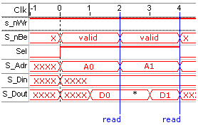
Fig. 2: read from openMAC
*) second read: one cycle S_Dout is data from last read

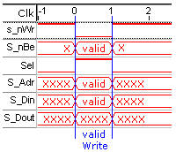
Fig. 3: write to openMAC

CAUTION:
The write cycle’s length should be only one clock, otherwise more IRQs (refer to Tab. 4 and Tab. 5 – “dec Int”) will be acknowledged within one write instruction!

Master interface (DMA)
The DMA starts the access with asserting the Dma_Req signal, Dma_Rw (Read = 1, Write = 0), Dma_Addr (word addresses!) and Dma_Dout (Write access). This condition is held until the Dma_Ack signal is set.
When the DMA performs read commands (send packet) the data (Dma_Din) should be valid one cycle after Dma_Ack was set. So, Dma_Ack should be asserted only one cycle. Please refer to Fig. 4!
In case of DMA write accesses (receive packet) the data (Dma_Dout) is valid when the Dma_Req signal is set. The data is held until the next DMA Request follows. Please refer to Fig. 5!
If using the Mac in half-duplex mode, every 8th cycle (50MHz) will be a new DMA write/read access (the first DMA Read Request starts earlier – therefore it is longer). If the Mac is set to full-duplex mode, every 4th cycle a new request starts when simultaneous read and write is necessary (send packet and receive packet at the same time).

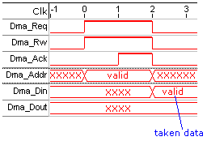
Fig. 4: DMA read access

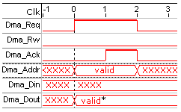
Fig. 5: DMA write access
*) out data valid till next Dma_Req

Port/generic map
Tab. 8: generic map openMAC
Generic | Description
HighAdr | The highest address bit in the Dma_Addr vector.  Note: The DMA can only address 1GB, because in case of Auto Response Packets the 30th and 31st bits will be masked alternately with zero or one (refer to 3.2.5.2).
Timer | Enables the internal Mac Timer for using time stamp feature, time-dependent IRQ generation, timer-triggered TX (TxSyncOn) and auto-response delay (TxDel)
TxSyncOn | Enables the time-triggered packet transmission (HAL: omethStartTime)  Caution: needs the Timer!
TxDel | Enables to adjust the IPG of auto-response packets (adjustable for every filter)  Caution: needs the Timer!
Simulate | Is necessary to simulate the openMAC

Tab. 9: port map openMAC
Port | Description
nRes | Low active synchronous reset signal
Clk | The Clock signal for the MAC. Must be 50MHz (±25ppm) and synchronous to the Phys RefClk.
S_nWr | Low active write signal
Sel_Ram | Selects the filter and descriptor memory range (DPR)
Sel_Cont | Selects the Mac’s status and control registers for TX and RX
S_nBe | Low active Byte Enable vector. S_nBe(1) = 0 selects s_Din(16 downto 8)
S_Adr | Word address
S_Din | In data
S_Dout | Out data
nTx_Int | Low active TX interrupt. Is ‘1’ as long as no IRQ is pending.
nRx_Int | Low active RX interrupt. Is ‘1’ as long as no IRQ is pending.
nTx_BegInt | Not yet supported.
Dma_Req | DMA access request signal
Dma_Rw | Read DMA access (TX packet) when signal is ‘1’. Otherwise Write access (RX packet)
Dma_Ack | DMA acknowledge signal
Dma_Addr | DMA address vector
Dma_Dout | DMA out data
Dma_Din | DMA in data
rRx_Dat | RMII receive half-nibble
rCrs_Dv | RMII Carrier Sense / Data Valid
rTx_Dat | RMII transmit half-nibble
rTx_En | RMII Transmit Enable
Hub_Rx | Connected to the openHub (2.4) to detect the hub port of the RX packet
Mac_Zeit | Outputs the free running 32bit MAC Timer

Phy management core
The Physical Interface (Phy) is identified, configured and controlled with SMI (serial management interface, IEEE 802.3). It is possible to address 32 different Phys.

Serial management interface (SMI)
The transmission is done over a two-wire-connection with a clock wire and a pull-up data line. So every Phy’s SMI can be connected to one line (Attention: Phys’ Hardware Address must be different to each other!). The data exchange starts with 32 bits preamble (PRE) and two start bits (ST). The operation code (OP) decides a write or read command. The next 10 bits includes the (unique) Phy’s address (PHYAD) and the register address (REGAD). After that, there are two bits for turn around (TA) and then the date will be transmitted (16 bit, MSBit first).

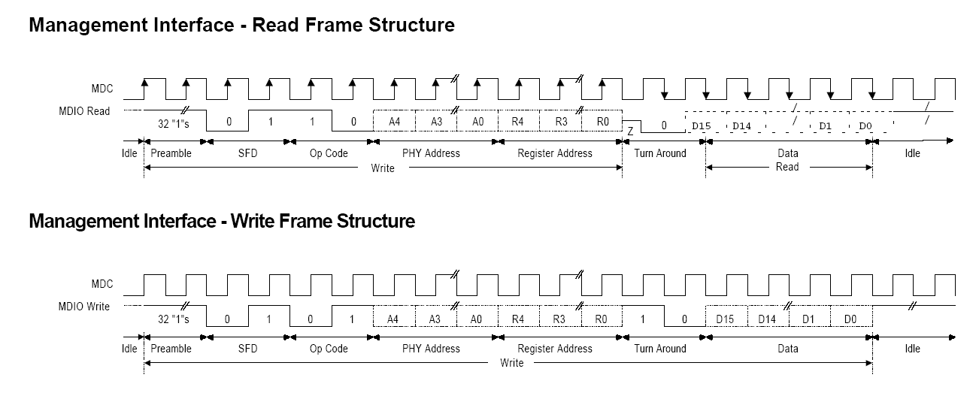
Fig. 6: Serial Management Interface

To get further information about the SMI protocol, please refer to http://www.smsc.com/main/anpdf/an79.pdf.

Interface
Before the Core writes data to the Phy, the data register, the Phy Address and Register Number need to be set to the desired values. To start a transmission set the control register to the value 0x5002 (write command) or 0x6000 (read command), masked with Phy Address and Register Number.

e.g. send to Phy 0x15 (1 0101_{bin}) Mii-Register 0x01 (0 0001_{bin}): 0x5002 OR 0x0A84 = 0x5A86

Tab. 10: Mii-core status registers (RegBase + 0) (read)
15 | 14 | 13 | 12 | 11 | 10 | 9 | 8 | 7 | 6 | 5 | 4 | 3 | 2 | 1 | 0
- | - | - | - | - | - | - | - | nRst | - | - | - | - | - | - | Busy
nRst … the Reset-Signal state (0 … reset)
Busy … If a transmission (SMI) is active, the Busy flag is 1.

Tab. 11: Mii-core control registers (RegBase + 0) (write)
15 | 14 | 13 | 12 | 11 | 10 | 9 | 8 | 7 | 6 | 5 | 4 | 3 | 2 | 1 | 0
0 | 1 | 01 Write  10 Read |  | Phy Address [4..0] |  |  |  |  | Register Number [4..0] |  |  |  |  | 1 Write  0 Read | 0

Tab. 12: Mii-core data register (RegBase + 2) (read/write)
15 | 14 | 13 | 12 | 11 | 10 | 9 | 8 | 7 | 6 | 5 | 4 | 3 | 2 | 1 | 0
MII Read /Write Data [15..0]

Tab. 13: Mii-core reset command register (RegBase + 4) (write)
15 | 14 | 13 | 12 | 11 | 10 | 9 | 8 | 7 | 6 | 5 | 4 | 3 | 2 | 1 | 0
- | - | - | - | - | - | - | - | nRst | - | - | - | - | - | - | -
nRst … Controls the nReset pin of the Phy(s) (0 … reset, 1 … active)

Timing
The Mii Core’s slave interface has the same timing requirements like the openMAC’s slave interface (refer to 2.2.3.1).

Port map
Tab. 14: port map Mii-core
Port | Description
Clk | 50MHz Clock signal
nRst | Low active synchronous reset
Addr | Word address
Sel | Select signal
nBe | Low active Byte Enable vector. nBe(1) = 0 selects Data_In(16 downto 8)
nWr | Low active write signal
Data_In | Data in
Data_Out | Data out
Mii_Clk | Clock signal to the Phys’ serial management interface
Mii_Di | Input signal from the Phys’ serial management interface
Mii_Do | Output signal to the Phys’ serial management interface
Mii_Doe | Output enable signal for tri-state buffer (‘0’ = output, ‘1’ = input)
nResetOut | Low active reset signal to Phys

OpenHUB
The openHUB can be used to connect the openMAC to more than one Ethernet port (Phy). The ports nRst and Clk can be connected to the Phy’s RMII Reference Clk (50MHz) and Reset.
The Generic Value “Ports” needs to be set to the number of needed ports. Its default and minimum value is 3, values like 0 or 1 are useless.
The following ports need to be connected to the Phys / MAC:
RxDv, RxDat0, RxDat1, TxEn, TxDat0 and TxDat1
The following ports can be left open
internPort ... Sets the port connected to the MAC. Default value is 1
TransmitMask ... Can enable / disable the associated port by one / zero. Its default value is all ones.
ReceivePort ... Outputs the active port (0 = inactive Hub, 1...n = Ports)
The openHUB + openFILTER create the following delays: Mac to Phys = 3 Cycles // Phys to Mac = 12 Cycles

Port/generic map
Tab. 15: generic map openHUB
Generic | Description
Ports | Sets the amount of hub-ports. Should be 3 in case of a 2-port-hub (one port is reserved for Mac)

Tab. 16: port map openHUB
Port | Description
nRst | Low active synchronous reset
Clk | 50MHz RMII Clock
RxDv | RMII Carrier Sense / Data Valid from every Port
RxDat0/1 | RMII RX Data from every Port
TxEn | RMII TX Enable to every Port
TxDat0/1 | RMII TX Data to every Port
internPort | Should be set to the port connected to the Mac
TransmitMask | Enable/disable the Hub’s ports (‘1’ = enabled, ‘0’ = disabled)
ReceivePort | Outputs the port number of the currently received packet (0 = idle)  Connect this signal to the Mac’s Hub_Rx Port (convert to std_logic_vector!)

OpenFILTER
The openFILTER core is used to avoid invalid Crs_Dv signals propagating to the MAC. If only one Phy is used, openFILTER has to be inserted between MAC and Phy. If two Phys are connected to the MAC via the openHUB, every Phy should be equipped with openFILTER. This approach prevents distortion propagation across the whole network.
The signals nRst and Clk should be connected to the RMII Ref_Clk and Rst. The nCheckShortFrames signal is low active.
Important:
The openFILTER is an optional (but recommended) addition to openMAC. However, please don’t confuse openFILTER with the packet filter functionality (2.2.2) of openMAC. OpenFILTER does not observes the content of Ethernet packets!

Port map
Tab. 17: port map openFILTER
Port | Description
nRst | Low active synchronous reset
Clk | 50MHz RMII Clk
nCheckShortFrames | Low active control signal. Set to ‘0’
RxDvIn | RMII Receive Carrier Sense / Data Valid (from Phy or Hub)
RxDatIn | RMII Receive Data (from Phy or Hub)
RxDvOut | RMII Receive Carrier Sense / Data Valid (to Mac)
RxDatOut | RMII Receive Data (to Mac)
TxEnIn | RMII Transmit Enable (from Mac)
TxDatIn | RMII Transmit Data (from Mac)
TxEnOut | RMII Transmit Enable (to Phy or Hub)
TxDatOut | RMII Transmit Data (to Phy or Hub)

HAL Ethernet driver
The HAL driver (=Hardware Abstraction Layer) controls the openMAC- and Mii Core, and can be used for every Ethernet application (TCP/IP, EPL, raw Ethernet …). In Fig. 7: block diagram, example for HAL usage you can see how the HAL driver can be included into an application (also have a look into chapter 4 - Application note).

Communication Stack (e.g. EPL)
openMAC
PHY
Mii
HAL Driver
TX
RX
control
IR
hook
hook
hook
hook
RX
TX
PHY
openHUB
Fig. 7: block diagram, example for HAL usage

Features

Time stamp
For each received and sent packet a 32 Bit / 20ns timestamp is generated.

Packet filters
The MAC supports 16 packet filters with 31 byte filter and 31 byte mask for each filter.

The filters can be used to…
- determine the type of received frames (like the address-filter on conventional MACs)
- transmit a dedicated packet directly after receiving a packet with defined format (with the defined inter-frame gap of 960 ns)
- transmit a packet from the transmit queue directly after a packet with defined format

Tab. 18: filter example
Byte | 0 | 1 | 2 | 3 | 4 | 5 | 6 | 7 | 8 | 9 | 10 | 11 | 12 | 13 | 14 | 15 | ... | 30
Mask | 00 | 00 | 00 | 00 | 00 | 00 | 00 | 00 | 00 | 00 | 00 | 00 | FF | FF | FF | 00 | ... | 00
Value | Xx | xx | xx | xx | xx | xx | xx | xx | xx | xx | xx | xx | 88 | AB | 01 | xx | ... | xx

Offset 12/13 = 0x88AB … Ethertype = EPL V2
Offset 14 = 0x01 … Message ID = Start Of Cyclic

Each incoming packet will be compared with all 16 filters (In the order as the filters were installed by the application).
Only the bits will be compared where the respective mask bit is set. If a matching filter was found, a specific action will be performed.

Auto response
Triggered by a defined incoming packet the MAC can automatically transmit a packet after the minimum frame gap of 960 ns.
This gives a constant and very short response time to EPL frames which require an immediate response (PollRequest, IdentRequest, …)

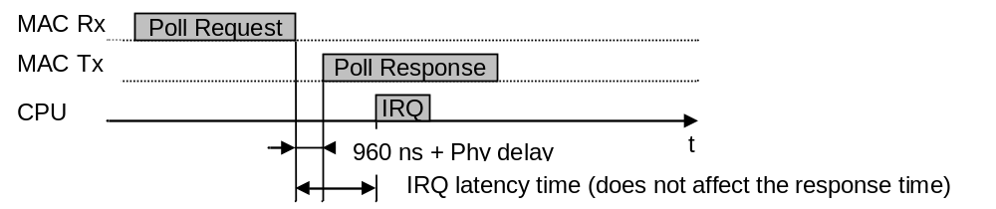
Fig. 8: auto response

Ethernet driver

Files
Tab. 19: HAL Ethernet driver files
File | Description
omethLib.c | Driver Functions (not to be changed by the user)
omethLib.h | Defines and Declarations (not to be changed by the user)
omethLib_target.h | Target specific defines  OMETH_HW_MODE  Defines the type of the used CPU, mode 0/1 are general modes for big/little endian systems  OMETH_MAKE_NONCACHABLE(ptr)  Defines a function to make a pointer ‘non-cacheable’. The file omethLib.c will use the defined function for non-cacheable access to the FPGA registers and to the receive packets.  If the CPU has no data cache no function has to be defined:  #define OMETH_MAKE_NONCACHABLE(ptr) (ptr)  !! Attention !!  Transmit packets are managed by the user. Therefore the user has to make sure that packets passed to a transmit function are non-cacheable.

IRQ subroutines
The user has to connect the Ethernet driver to the IRQ system of the CPU. Generally the RX IRQ should have the higher priority than the TX IRQ. Every received packet that matches a filter generates a RX interrupt!
Every transmitted packet (sent with omethTransmit & Co or auto response) generates a TX interrupt! If the TxIrqHandler is executing an “auto response” occurred interrupt, the user’s free function won’t be called. If the TxIrqHandler is executing an “user sent” occurred interrupt (sent with omethTransmit & Co) the user’s free function is called.

Tab. 20: IRQ handlers
omethRxIrqHandler  omethTxIrqHandler | To be used if the IRQ is generated by only 1 MAC and the used system is able to pass an user argument to the IRQ routine.  As argument the handle to the driver instance (returned by omethCreate) has to be passed to the IRQ routine.
omethRxIrqHandlerMux  omethTxIrqHandlerMux | To be used if the IRQ is generated by more than 1 MAC or the system does not support arguments to IRQ subroutines.
omethRxTxIrqHandler | Has to be used if one IRQ is used for RX and TX.  As argument the handle to the driver instance (returned by omethCreate) has to be passed to the IRQ routine. Furthermore the priority (sequence of execution) has to be set.

Basic API functions
At least this set of basic API functions is required to receive and transmit frames on the Ethernet interface. To implement Ethernet Powerlink also the extended API functions are required.

omethMiiControl
Function to activate or reset the Ethernet Phys.
(Per default the Phy nReset pin is 0 … Phys are in reset state)
Before initializing the Ethernet driver (omethCreate) the application has to make sure the used Phys are active and available. Depending on the type of Phy after activation it may take some time until the Mii interface of the Phys is ready. This delay must be implemented by the user.

omethInit
The function has to be called at start up of the system. All driver internal variables and instance references will be cleared.
(The function will not ‘free’ any previously allocated resources)

omethCreate
omethCreate initializes an Ethernet driver instance.
The parameters are passed by a structure which will be copied to internal memory (the same structure can be used to initialize other instances later) – refer to Tab. 21.

Tab. 21: instance configuration type „ometh_config_typ“
Element | Description / Value
macType | OMETH_MAC_TYPE_01
Mode | Combination of  OMETH_MODE_HALFDUPLEX  OMETH_MODE_FULLDUPLEX  OMETH_MODE_100  OMETH_MODE_DIS_AUTO_NEG  OMETH_MODE_PHY_LIST  (enables the elements phyCount and phyList)  OMETH_MODE_SET_RES_IPG
Adapter | The user defines the adapter number for the Ethernet interface. Each instance has to be initialized with an unique number.
pRamBase | Pointer to MAC Descriptor/Filter Registers
pRegBase | Pointer to MAC Control Registers
pBufBase | Pointer to MAC internal packet buffer (on-chip memory)
rxBuffers | Number of used RX buffers (up to 16)
rxMtu | Maximum MTU of incoming packets. Packets exceeding this size will be discarded.  Maximum Packet Size = MTU + 18 (DstMAC, SrcMAC, Ethertype, CRC)
pPhyBase | Pointer to phy management port:  All phys on this port are assigned to this driver instance, except the element mode contains OMETH_MODE_PHY_LIST, in this case only the listed phys will be assigned to this instance.  This dedicated phyList is required if the same pPhyBase is used for phys which do not belong to this driver instance.
phyCount | Only valid if mode contains OMETH_MODE_PHY_LIST:  Number of valid entries in phyList
phyList | Only valid if mode contains OMETH_MODE_PHY_LIST:  Array with up to 8 phy addresses of the phys which are assigned to this driver instance.
responseIpg | Inter Package Gap (available when mode contains OMETH_MODE_SET_RES_IPG):  This value changes the Mac’s IPG and should be given in [ns]. Values lower than 140ns will result in IPG = 140ns

For each used RX buffer a packet will be allocated. The next incoming frame matching one of the installed filters will be stored to the next free packet in the queue.

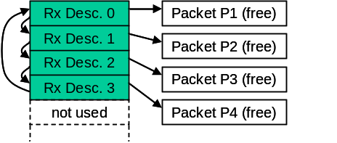
Fig. 9: receive queue after omethCreate with rxBuffers=4

omethHookCreate
To be able to receive packets the user has to create hooks (call backs) which will be called by the IRQ subroutine.
If ‘maxPending=0’ the hook is not allowed to queue the received packet. The processing of the packet data has to be done directly in the hook. After terminating the hook function the received packet will be passed back to the receive queue.
If ‘maxPending > 0’ the hook allocates its own pool of packets.
When receiving a packet which belongs to the hook the IRQ subroutine will pass the packet to the hook function.
The hook function can decide whether it wants to queue the packet (return 0) or do pass the packet directly back to the receive queue (return -1).
If the hook has queued the packet the next free packet of the hook’s packet pool will be used to replace the current descriptor in the receive queue (Because all descriptors of the receive queue have to be linked to free packets at all time!)

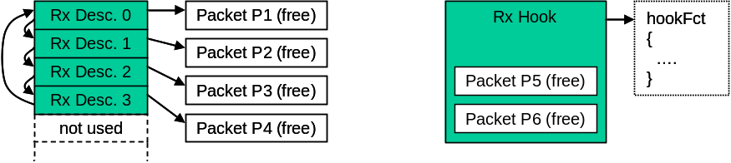
Fig. 10: buffers after omethHookCreate(…, &hookFct, 2)

The following example shows what happens if a packet for this RX hook is received and the hook function has been queued the packet:

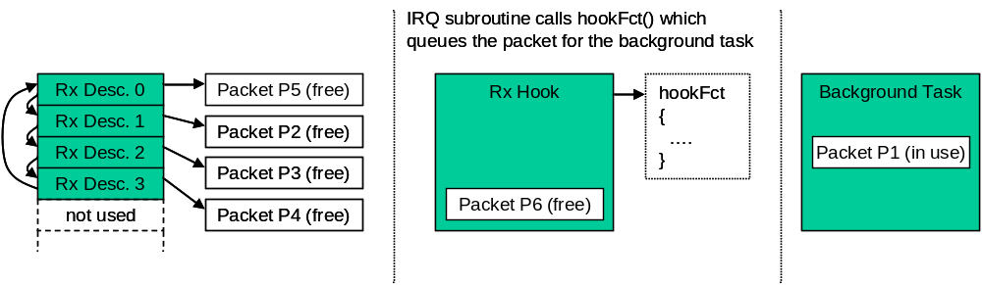
Fig. 11: buffers after a packet was queued by the background task

If the RX hook does not have free packets anymore the hook function will not be passed to the background task, the packet remains in the RX descriptor for the next received packet.
This ensures that the RX queue is always complete.
Even if the background task of one hook does not free the packets (because of an application error or because of leak of CPU performance) the other hooks still will get packets.
After processing the packet the background task has to free the packet (pass back to hook).

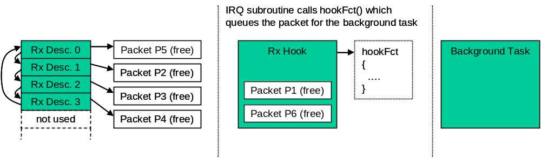
Fig. 12: buffers after a background task has processed packet

omethFilterCreate
A hook can receive packets matching one ore more packet filters. With omethFilterCreate the user has to define these filters.
The parameter ‘arg’ will be passed to the hook to allow a efficient demultiplexing if more than 1 filters are linked to the same hook.

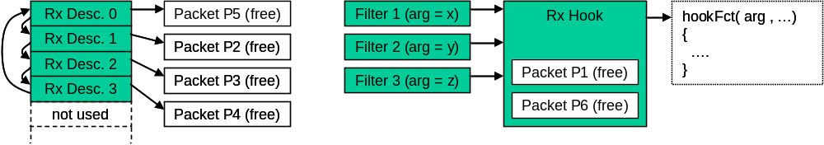
Fig. 13: filters and hooks

omethTransmit
Transmits a packet to the send queue of the MAC. The packet will be sent as soon as possible to the network.
The user has to pass a function pointer to a free-function. A packet which was passed to the send queue must not be changed until the driver has released the packet by calling the free-function.
!! Attention !!
If the CPU uses data cache the application has to make sure the packet is really transferred to the memory before calling omethTransmit.

omethStart
Start Ethernet driver. (Make sure the IRQ system is initialized before starting)

omethStop
Stop Ethernet driver.

omethPeriodic
The function must be called by the user cyclically.
It does the update of the PHY-Register image (see 3.2.6.2) and controls the Full/Half duplex mode of the MAC depending on the connected communication partner.
Every call the function will retrieve maximum 1 phy register.
Example:
The function is called every 5 ms on a system with 2 interfaces and 4 Phys on each interface.
Total Phy ports : 8
Total Phy registers : 64 (the first 8 registers of each phy will be read)
The update cycle of the function omethPeriodic will be 5ms x 64 = 320 ms

omethDestroy
Stops the Ethernet driver and releases all allocated resources. Also resources allocated with omethHookCreate, omethFilterCreate, … will be released.
After omethDestroy the interface can be initialized again with omethCreate

Filter manipulation

omethFilterSetPattern
Change filter pattern (mask and value) of an filter created with omethFilterCreate.

omethFilterSetArgument
Change the hook argument for an filter created with omethFilterCreate.

Auto response functionality
The following functions are required to handle the openMAC auto response feature.

omethResponseInit
The function has to be called before omethStart and prepares a defined filter entry for auto response frames.
The response frame will be finally activated at the first call of omethResponseSet.

omethResponseSet
Passes a packet to the Ethernet driver which will be sent to the network if a received frame matches the given filter.
After passing the packet to the driver, the packet has to be considered as ‘locked’, the user is not allowed to change it until the driver passes the packet back to the user.
The return value can have the following values:
- OMETH_INVALID_PACKET : An error occurred (invalid filter passed, invalid packet passed)
- 0 : Function call successful
- > 0 : The driver passes a packet back to the user, the packet can be reused
The packet pointer will be masked alternately with 0x80000000, 0x40000000 or 0x00000000. So, the TX packets should be located in memory space e.g. 0x00000000 - 0x3FFFFFFF!

omethResponseDisable
Disables the auto response feature. The user can continue passing packets to the driver with omethResponseSet and will still get call backs on the given filter, only the frame transmission is disabled.

omethResponseEnable
Enable the auto response feature. The last packet passed with omethResponseSet will be activated for auto response.

Other API functions

omethGetHandler
Retrieves the instance handle of an interface created with omethCreate based on the given adapter number.

omethPhyInfo
Retrieves the pointer to a PHY-Register image of the driver instance.

omethHookSetFunction
Change the call back function of a receive hook.

omethGetTimestamp
Get timestamp of a received packet (Resolution: 20ns)

omethGetTxBufBase
This function returns the MAC-internal TX buffer base address.

omethGetRxBufBase
This function returns the MAC-internal RX buffer base address.

omethStatistics
Retrieve the pointer to the statistics structure of the driver instance.

omethSetSCNM
Sets the SCNM (Slot Communication Network Mode).
By default all frames sent with omethTransmit will be sent to the network as soon as possible. The MAC runs in collision mode, if collisions occur the MAC will repeat the packet.
The parameter hFilter can have the following values:
- 0: The MAC is set to collision mode (default mode after omethCreate)
- valid filter handle: The MAC will send packets passed with omethTransmit only after an incoming frame matches the given filter. In case of collisions the MAC will NOT retry the transmission.
- OMETH_INVALID_FILTER: The send queue is disabled, packets passed with omethTransmit will be queued but will not be sent to the network.

Ethernet packet structure
The Ethernet packets for (to transmit to the network) and from the openMAC (to receive from the network) have a structure defined in the omethlib.h file (ometh_packet_typ). It is recommended to use this type to build Ethernet frames in your application. Before sending the packet with omethTransmit or setting an auto-response frame with omethResponseSet, the length member need to be set to the Ethernet frame’s length excluding the CRC field!

Tab. 22: Ethernet packet struct
Member | Description
length (4 bytes) | The packets length without the checksum in bytes.  e.g. smallest Ethernet packet with crc is 64 bytes  => set length to 60 bytes
dstMac (6 bytes) | destination MAC address
srcMac (6 bytes) | source MAC address
Ethertype (2 bytes) | Ethernet type / length field
minData (min. 46 bytes) | data field – the minimum length is 46 bytes (header is 14 bytes)
checkSum (4 bytes) | packet’s checksum field  Don’t care this field; the MAC does it for the application.

//********** packet structure for ethernet frames ***********************
typedef struct
{
unsigned long length; // frame length excluding checksum

struct ometh_packet_data_typ
{
unsigned char dstMac[6];
unsigned char srcMac[6];
unsigned char ethertype[2];
unsigned char minData[46]; // minimum number of data bytes for a standard EthFrame
unsigned char checkSum[4];
}data;
}ometh_packet_typ;

Application note
In order to show how the openMAC and its components (Hub, Filter, Drivers …) are used in an openPowerlink Controlled Node (Powerlink Slave), this chapter was inserted. It is recommended to follow this reference to achieve high performance, because of very low response delays when using the openMAC. For this reason the best way is to add a second CPU which processes application data and leave one CPU for running the openPowerlink communication-stack. In Fig. 14 a generic design is shown of a “Two-Processor System” using the openMAC (incl. openFILTER, openHUB …) as an interface to the Powerlink network. The “Communication” CPU is used to control the MAC and execute the whole openPowerlink Stack. Information can be exchanged through an interface (e.g. SPI, DPR, PCI, Mailbox, Mutex …). Sensors, actuators and other I/Os can be connected to the second CPU to complete a Powerlink Controlled Node.

FPGA design with two soft-core CPUs
If an FPGA (Field Programmable Gate Array) is used it is possible to integrate a Two-Processor System into one chip to save circuit board area. Chip manufacturer (like Altera and Xilinx) provide Tool Chains which can handle easily Multi-Processor applications.
The openMAC was designed to save area and chip resources, but the actual requirement depends on the application! Refer to Fig. 15 – the “Communication” and “Application” CPU can be e.g. Nios II (Altera), Microblaze (Xilinx) or any other soft-core processor.

FPGA for communication tasks only
If it is not possible to integrate the whole application into one chip, an external µprocessor/controller can be connected to the FPGA including the “Communication” soft-core processor and openMAC. Refer to Fig. 16.

POWERLINK NETWORK
Application CPU
Communication CPU
openPowerlink Stack
openMAC HAL driver

openMAC
Interface e.g. SPI, DPR …
Other I/Os
Actuators
Sensors
openHUB
Application section
Communication section
Fig. 14: generic design approach

POWERLINK NETWORK

FPGA
Application CPU
Communication CPU

Other I/Os
Actuators
Sensors
Interface e.g. SPI, DPR …

PHY

PHY

openHUB
openMAC
Fig. 15: FPGA design with two soft-core processors

POWERLINK NETWORK
FPGA
Application CPU
µP/C, DSP …
Interface e.g. SPI, DPR …

Other I/Os
Actuators
Sensors
PHY

PHY

openHUB
openMAC
Communication CPU

Fig. 16: FPGA design for communication tasks only

Figure Index
Fig. 1: Block diagram openMAC 6
Fig. 2: read from openMAC 13
Fig. 3: write to openMAC 13
Fig. 4: DMA read access 14
Fig. 5: DMA write access 14
Fig. 6: Serial Management Interface 16
Fig. 7: block diagram, example for HAL usage 21
Fig. 8: auto response 22
Fig. 9: receive queue after omethCreate with rxBuffers=4 25
Fig. 10: buffers after omethHookCreate(…, &hookFct, 2) 26
Fig. 11: buffers after a packet was queued by the background task 26
Fig. 12: buffers after a background task has processed packet 27
Fig. 13: filters and hooks 27
Fig. 14: generic design approach 32
Fig. 15: FPGA design with two soft-core processors 33
Fig. 16: FPGA design for communication tasks only 34

Table Index
Tab. 1: DPR TX- and RX-descriptor block 8
Tab. 2: TX-descriptor status register 8
Tab. 3: RX-descriptor status register 8
Tab. 4: TX control/status registers 10
Tab. 5: RX control/status registers 11
Tab. 6: filter structure 12
Tab. 7: filter command register (0…15) 12
Tab. 8: generic map openMAC 14
Tab. 9: port map openMAC 15
Tab. 10: Mii-core status registers (RegBase + 0) (read) 16
Tab. 11: Mii-core control registers (RegBase + 0) (write) 16
Tab. 12: Mii-core data register (RegBase + 2) (read/write) 17
Tab. 13: Mii-core reset command register (RegBase + 4) (write) 17
Tab. 14: port map Mii-core 18
Tab. 15: generic map openHUB 19
Tab. 16: port map openHUB 19
Tab. 17: port map openFILTER 20
Tab. 18: filter example 22
Tab. 19: HAL Ethernet driver files 23
Tab. 20: IRQ handlers 24
Tab. 21: instance configuration type „ometh_config_typ“ 24
Tab. 22: Ethernet packet struct 30

Index

F
Features 7
Figure Index 35
L
License 2
Listing Index 37
O
OpenFILTER 20
OpenHUB 18
OpenMAC 7
Auto Response 22
Control/Status register 10
Descriptor 7
Ethernet packet structure 30
Filter Example 22
HAL Driver 21
Hook 25, 26, 27
Port/generics 14
Receive filters 11
Timing 13
T
Table Index 36
Table of Contents 3
V
Versions 2

