POWERLINK IP-Core
Altera FPGA Documentation
Date: | December 15, 2011
Project Number: | AT-B0-000002

- Versions
 | Version | Date | Comment | Edited by
 | 0.1 | Dec 14, 2011 | First Edition | Zelenka Joerg
Table 1: Versions

- Safety Notices
Safety notices in this document are organized as follows:

 | Safety notice | Description
 | Danger! | Disregarding the safety regulations and guidelines can be life-threatening.
 | Warning! | Disregarding the safety regulations and guidelines can result in severe injury or heavy damage to material.
 | Caution! | Disregarding the safety regulations and guidelines can result in injury or damage to material.
 | Information: | Important information used to prevent errors.
 | Example: | Functionality is described with an example to prevent errors.
Table 2: Safety notices

- Table of Contents
1 Introduction 4
2 Figure Index 12
3 Table Index 13
4 Listing Index 14
5 Index 15

Introduction
The POWERLINK IP-Core is provided as ready-to-use in Altera Quartus II environment with SOPC version 10.1. This documentation presents the integration of the IP-Core into the SOPC environment, as well as timing considerations and interfacing to the software development environment.

If you require detailed information about the POWERLINK IP-Core itself, please refer to the “POWERLINK IP-Core Generic Documentation” (POWERLINK-IP-Core_Generic.pdf).

System-On-a-Programmable-Chip (SOPC) Integration
The POWERLINK IP-Core’s “Internal Bus Interface” complies with the Altera Avalon Interface Specification [1], hence there is no extra VHDL wrapper file necessary for converting purpose. The IP-Core is fully compatible to the Avalon Memory Mapped interface, hence it can be used in combination with e.g. Altera Nios II processors.
The SOPC allows easy configuration of the IP-Core, thus the user is able to define parameters depending on the application of the POWERLINK Node. Fig. 1 visualizes the block diagram of the IP-core, emphasizing the interfaces to the POWERLINK Communication Processor (PCP) and to the application with the optional Application Processor (AP).

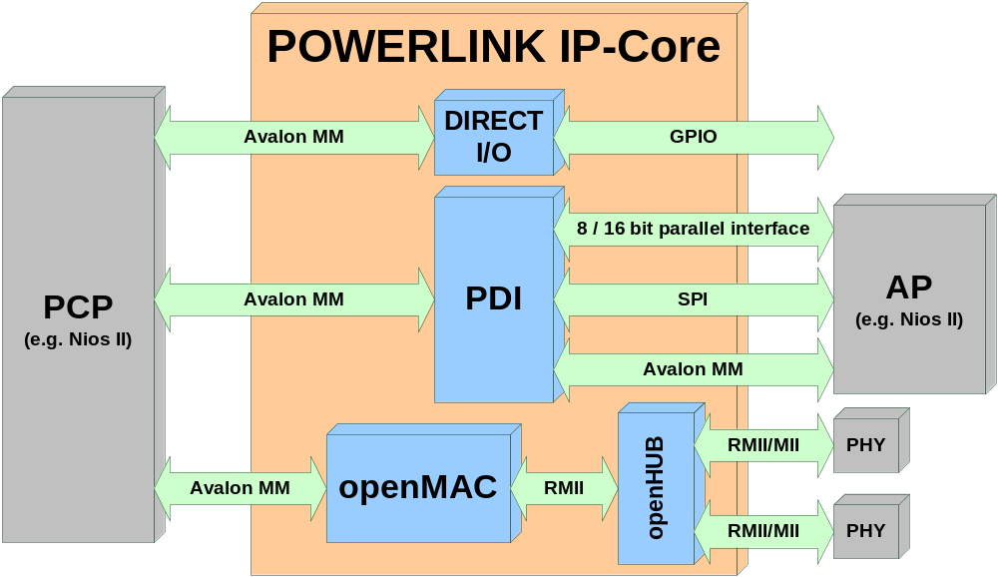
Fig. 1: POWERLINK IP-Core Block Diagram

Timing Consideration

Software Interfacing (system.h)
The POWERLINK IP-core is included into an SOPC (Altera) or any other processor environment. In order to provide vital information to the PCP a header file is used (e.g. system.h). The POWERLINK IP-core provides the following defines:

Tab. 1: System description parameters
Name | Macro | Value
MAC-internal buffer size | MACBUFSIZE | Any integer
MAC-internal RX buffer size | MACRXBUFSIZE | Any integer
MAC-internal RX buffers | MACRXBUFFERS | Any integer
MAC-internal TX buffer size | MACTXBUFSIZE | Any integer
MAC-internal TX buffers | MACTXBUFFERS | Any integer
Number of PDI RPDOs | PDIRPDOS | 1, 2 or 3
Number of PDI TPDOs | PDITPDOS | 1
POWERLINK IP-core configuration | CONFIG | 0, 1, … , 5
AP interface endianness | CONFIGAPENDIAN | 0 or 1

Two parameters mentioned in Tab. 1 must be discussed furthermore.

Tab. 2: System description parameters, details
Macro | Value | Description
CONFIG | 0 | Direct I/O (no AP intended)
CONFIG | 1 | 8bit parallel interface
CONFIG | 2 | 16bit parallel interface
CONFIG | 3 | SPI
CONFIG | 4 | Avalon bus
CONFIG | 5 | openMAC only (no PDI available)
CONFIGAPENDIAN | 0 | Little endian
CONFIGAPENDIAN | 1 | Big endian

FPGA Resource Utilization

Files
The POWERLINK IP-Core for Altera FPGA is delivered with the necessary VHDL files and the SOPC component description (*_hw.tcl). In the following the package directories are described:

Tab. 3: Directory description
Directory name | Description
doc | The doc-directory includes all IP-Core documentation files.
img | In the img-directory images for the GUI in SOPC are stored.
sdc | The sdc-directory provides different timing-constraints file usable for TimeQuest.
src  src/lib  src/openMAC_DMAmaster | The VHDL-files are stored in the src-directory.

Tab. 4: Documentation file description (doc)
File name | Description
OpenMAC.pdf | The “openMAC & Components Documentation” introduces the IP-Cores openMAC, openFILTER and openHUB, as well as the software drivers (omethlib).
POWERLINK-IP-Core_Altera.pdf | This document.
POWERLINK-IP-Core_Generic.pdf | The “POWERLINK IP-Core Generic Documentation” provides a detailed description of the IP-Core.

Tab. 5: Timing Constraints file description (sdc)
File name | Description
PLK_MII_base.sdc | Defines the timing constraints for MII phys.
PLK_RMII_base.sdc | Defines the timing constraints for RMII phys.
PLK_RMII_base_PARPDI.sdc | Defines the timing constraints for RMII phys and a parallel asynchronous 8/16 bit interface (to the AP).

Tab. 6: VHDL source files (src)
File name | Description
lib/addr_decoder.vhd | Address decoder used in several components of the POWERLINK IP-Core
lib/edge_det.vhd | Component to detect level changes of a signal
lib/memMap.vhd | Package file used in pdi.vhd
lib/req_ack.vhd | Used to generate wait- or acknowledge signals
lib/sync.vhd | Two-stage FF synchronizer
lib/slow2fastSync.vhd | Synchronizer to transfer pulse signals
OpenMAC_Ethernet.vhd | MAC-layer top-level file
OpenFILTER.vhd | RMII filter that prevents distortions to propagate
OpenHUB.vhd | Ethernet hub
OpenMAC.vhd | Media Access Controller with dedicated hardware acceleration for POWERLINK
OpenMAC_16to32conv.vhd | Converter to access with a 32 bit CPU the openMAC register interface
OpenMAC_cmp.vhd | OpenMAC high-resolution timer component
OpenMAC_DMAFifo_Altera.vhd | Dual-clocked FIFO provided to the DMA master implementation
OpenMAC_DMAmaster.vhd | DMA master top-level file
OpenMAC_DMAmaster/dma_handler.vhd | DMA handler sub-component
OpenMAC_DMAmaster/master_handler.vhd | DMA master handler sub-component
OpenMAC_DPR_Altera.vhd | Dual Ported RAM description used in OpenMAC_*.vhdl files
OpenMAC_phyAct.vhd | Component to generate phy-activity LED signal
OpenMAC_PHYMI.vhd | Component to configure the phys via SMI
OpenMAC_rmii2mii.vhd | RMII to MII converter
pdi.vhd | Process Data Interface top-level file
pdi_apIrqGen.vhd | Sub-component to generate sync-interrupts to the AP
pdi_controlStatusReg.vhd | Sub-component implementing the Status/Control register
pdi_dpr_Altera.vhd | Dual Ported RAM description used in pdi.vhd
pdi_event.vhd | Sub-component providing hardware supported event handling
pdi_led.vhd | Sub-component providing LED interface
pdi_par.vhd | Asynchronous 8/16 bit parallel interface to AP
pdi_simpleReg.vhd | Sub-component implementing e.g. asynchronous buffer in PDI
pdi_spi.vhd | SPI interface to AP
spi.vhd | SPI slave implementation used by pdi_spi.vhd
spi_sreg.vhd | SPI shift register implementation used by spi.vhd
Pdi_tripleVBufLogic.vhd | Sub-component used to generate triple-buffer management of PDOs
portio.vhd | Direct I/O top-level file
portio_cnt.vhd | Counter for direct I/O data valid signal generator
powerlink.vhd | POWERLINK IP-Core top-level file
Table note: The highlighted rows refer to top-level files.

Definitions and Abbreviations
AP | Application Processor
BUF | MAC-internal packet buffer
CMD | Command
CMP | Compare Unit
CN | POWERLINK Controlled Node
DPR | Dual Ported RAM
DPRAM | Dual Ported RAM
FF | Flip Flop
FPGA | Field Programmable Gate Array
FSM | Finite State Machine
GUI | Graphical User Interface
IP | Intellectual Property
IRQ | Interrupt Request
MII | Media Independent Interface
MN | POWERLINK Managing Node
PCB | Printed Circuit Board
PCP | Powerlink Communication Processor
PDI | Process Data Interface
PDO | Process Data Object
PReq | Poll Request (POWERLINK frame type)
PRes | Poll Response (POWERLINK frame type)
RD | Read
RDY | Ready
RMII | Reduced Media Independent Interface
RO | Read Only
SDO | Service Data Object
SMI | Serial Management Interface (Ethernet phy register access)
SMP | Simple I/O Port
SoA | Start of Asynchronous (POWERLINK frame type)
SoC | Start of Cyclic (POWERLINK frame type)
SPI | Serial Peripheral Interface
SYNC | Synchronization (Clock Domain Crossing)
WR | Write

References
- Altera: “Avalon Interface Specification”
http://www.altera.com/literature/manual/mnl_avalon_spec.pdf
Version 11.0 (May 2011)

Figure Index
Fehler! Es konnten keine Einträge für ein Abbildungsverzeichnis gefunden werden.

Table Index
Table 1: Versions 2
Table 2: Distribution Fehler! Textmarke nicht definiert.
Table 3: Safety notices 2

Listing Index
Fehler! Es konnten keine Einträge für ein Abbildungsverzeichnis gefunden werden.

Index

D
Distribution 2
F
Figure Index 5
I
Introduction 4
L
Listing Index 7, 8
S
Safety Notices 2
T
Table Index 6
Table of Contents 3
V
Versions 2

