The project “Powernet” is an initiative of Stanford Linear Accelerator Laboratory (SLAC).The main objective of “Powernet” project is to provide an end to end open source technology for economically efficient, scalable and secured coordination of grid resources. The project was started as a proof of concept to identify the potential use of information technology in the smart grid ecosystem in order to harness the information/data available and to explore data driven approach in making intelligent decision.

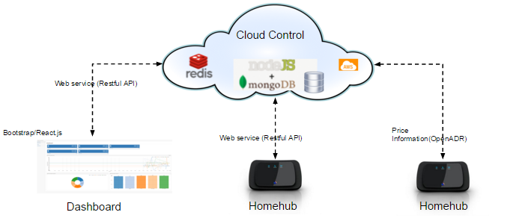

**System Overview**

As a part of the project a “Cloud Control” was designed that provided web service to the “ Homehub” and the “Dashboard”.

**Cloud Control**

The “Cloud Control” component is hosted on the cloud infrastructure (Amazon Web Service) and is intended to interface with the OpenADR for price information. It also provided a plethora of webservers for “Homehub” and “Dashboard” via RESTful API.

**Homehub**

The Homehub represents an entity to be installed in homes that would interact with the “Cloud Control” over the TCP/IP network. It receives “pricing information” and sends “power usage” information to the “Cloud Control”. The data collected from various homehubs could be utilized for retrieving useful information via advance data analytics.

**Dashboard**

The dashboard makes use of RESTful API provided by “Cloud Control” to display statistical information of power usage by homehubs to the users. Map functionality is integrated into the dashboard with location information of the “Homehub”.

|  |  |
| --- | --- |
| Yizhen Chen | Master student in CMU INI Mobility track.  Interested in mobile and IoT. |
| Praveen Gandala | Master student in CMU III .Extensive experience in embedded, diagnostics, Firmware, IoT and Cloud. |
| Cory Pruce | Master student in CMU INI Information. Interested on Cloud, Network and Security |
| Bixian Boa | Master student in CMU INI Information Security track. Interested in distributed systems and backend server development. |