***Branding***

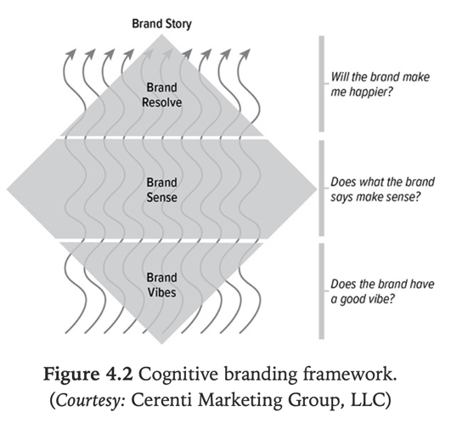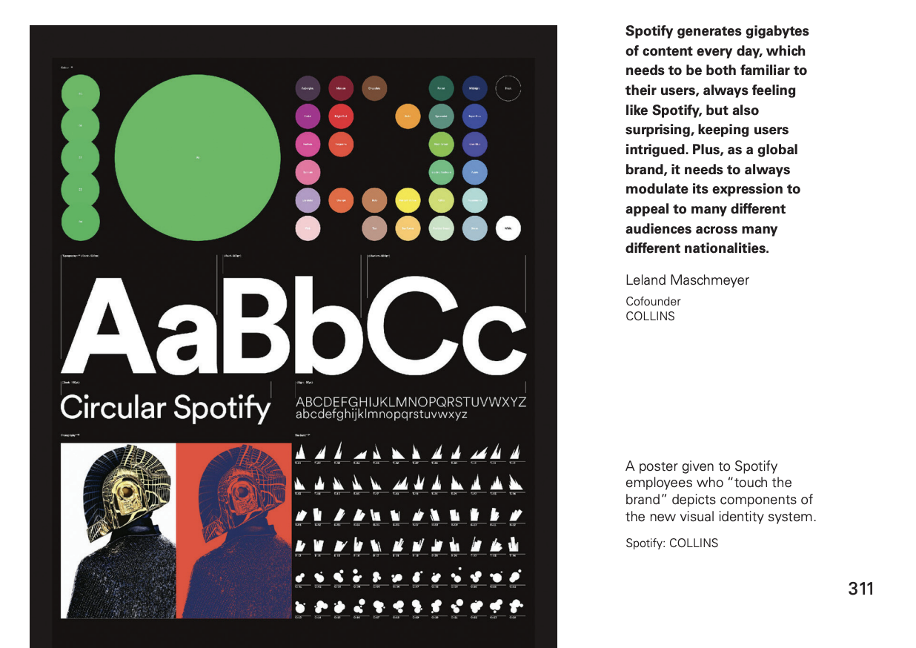

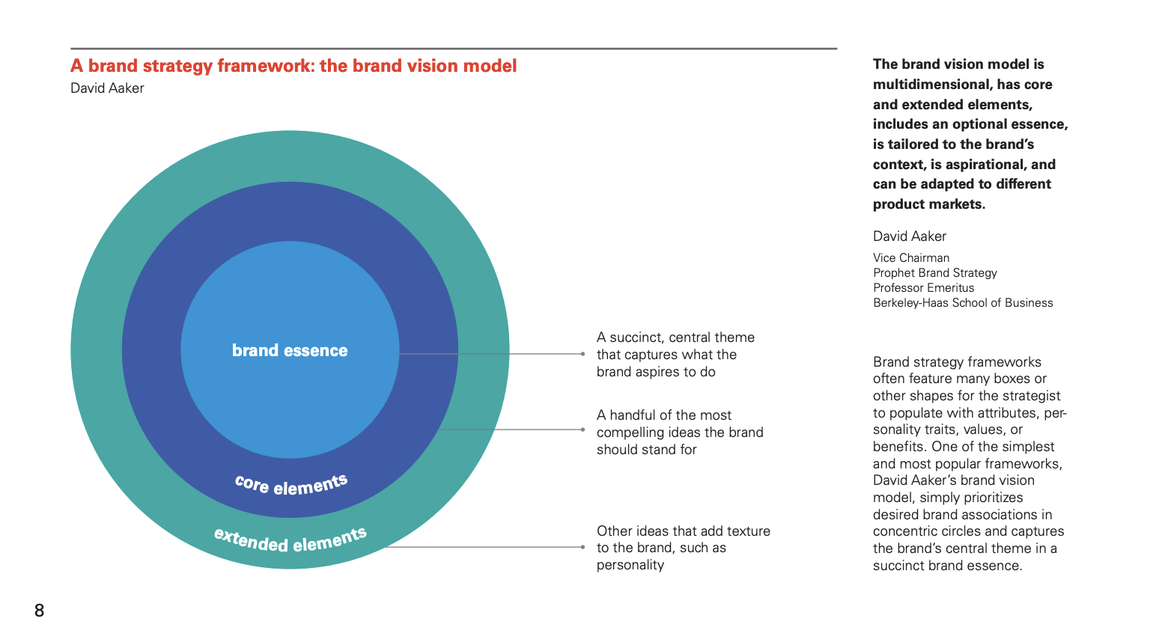

Lemmas of market out there!

We build websites with impact.

## Web design

Unique web design solutions made with love and in accordance with the newest technologies.

PopArt Studio is a full-service, interactive agency offering innovative web design & branding solutions which move the boundaries. Our sophisticated approach to the development of digital experiences exceeds all expectations.

[**Let's design and build a project together!**](https://integralvision.eu/en/contact)

# Design & Branding.

# We develop full branding and design projects for different industry categories. Over 100+ projects done in the past year.

# Web & E-commerce

# Understanding how your customers navigate and relate with your brands website is crucial. We design and develop any kind of web project

# We are Hello Monday - we create joyful digital ideas, products, experiences, and campaigns that connect the hearts of brands to the hearts of humans.

Branding text in the principal landing

# Paginas web. **Con significado de futuro e innovación**

Alternativas:

Paginas y aps:

Digital de impacto.

¿Poner mision?

Presentar proyectos:

Como?

**MAKE A D**