Branding
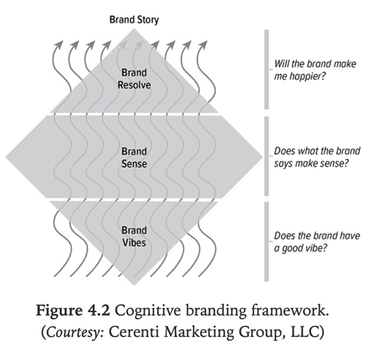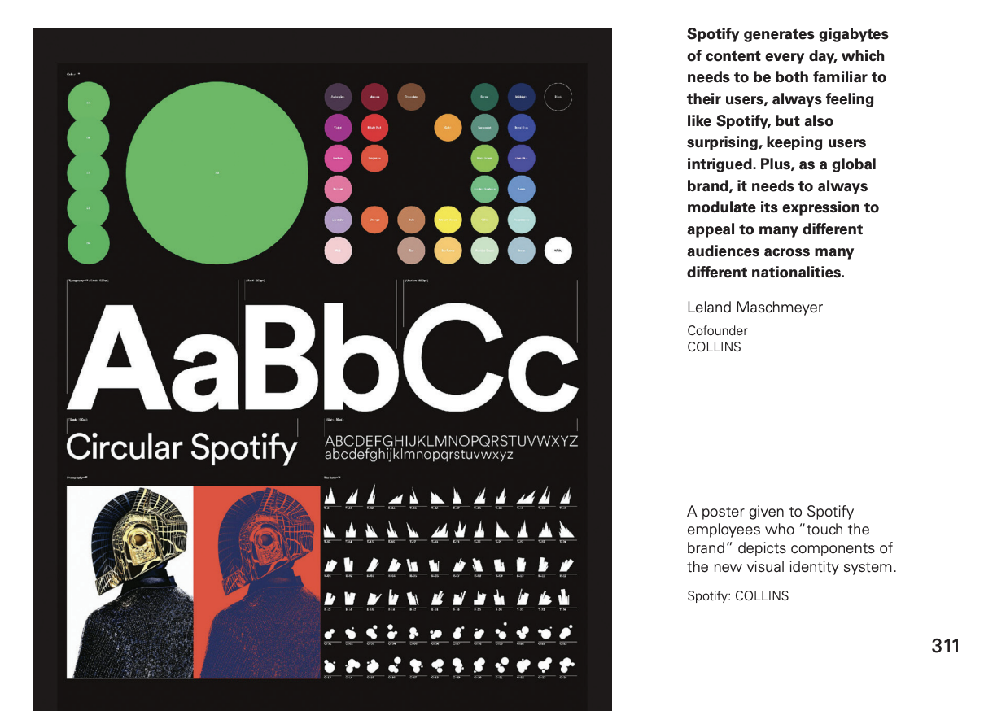
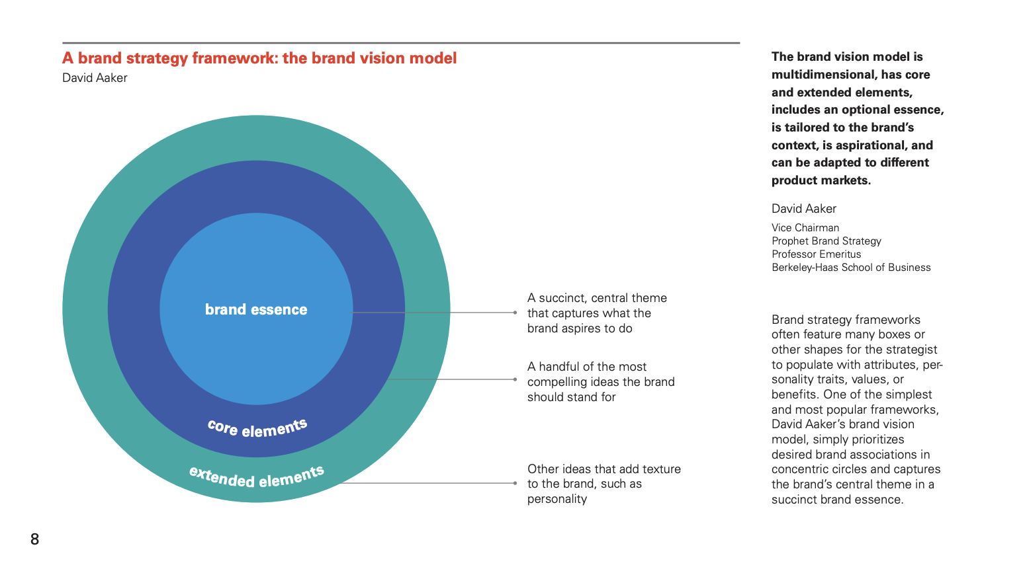
Lemmas of market out there!
We build websites with impact.

Web design
Unique web design solutions made with love and in accordance with the newest technologies.
PopArt Studio is a full-service, interactive agency offering innovative web design & branding solutions which move the boundaries. Our sophisticated approach to the development of digital experiences exceeds all expectations.
Let's design and build a project together!

Design & Branding.

We develop full branding and design projects for different industry categories. Over 100+ projects done in the past year.

Web & E-commerce

Understanding how your customers navigate and relate with your brands website is crucial. We design and develop any kind of web project

We are Hello Monday - we create joyful digital ideas, products, experiences, and campaigns that connect the hearts of brands to the hearts of humans.

Branding text in the principal landing

Paginas web. Con significado de futuro e innovación

Alternativas:
Paginas y aps:
Digital de impacto.

¿Poner mision?

Presentar proyectos:
Como?

MAKE A D

