🛡️ Risk Response Plans
Fecha: 2025-11-25 | Versión: 1.0

Resumen Ejecutivo
- Avoidance**: Eliminate risk source or change approach
- Mitigation**: Reduce probability or impact
- Transfer**: Shift risk to third party
- Acceptance**: Acknowledge and monitor risk
- Risk Description**: Clear risk identification

Acciones Prioritarias
Descripción | Estado
Avoidance**: Eliminate risk source or change approach | Pendiente
Mitigation**: Reduce probability or impact | Pendiente
Transfer**: Shift risk to third party | Pendiente
Acceptance**: Acknowledge and monitor risk | Pendiente
Risk Description**: Clear risk identification | Pendiente
Response Strategy**: Chosen approach | Pendiente
Action Plan**: Specific implementation steps | Pendiente
Resource Requirements**: Budget, timeline, personnel | Pendiente

Métricas Clave
Palabras totales: 4101
Lectura estimada (min): 20.5
Secciones H1/H2/H3: 1/18/38

Palabras Clave Prioritarias
Palabra | Frecuencia
budget | 122
owner | 98
lead | 84
response | 81
marketing | 68
plan | 64
risk | 55
days | 54

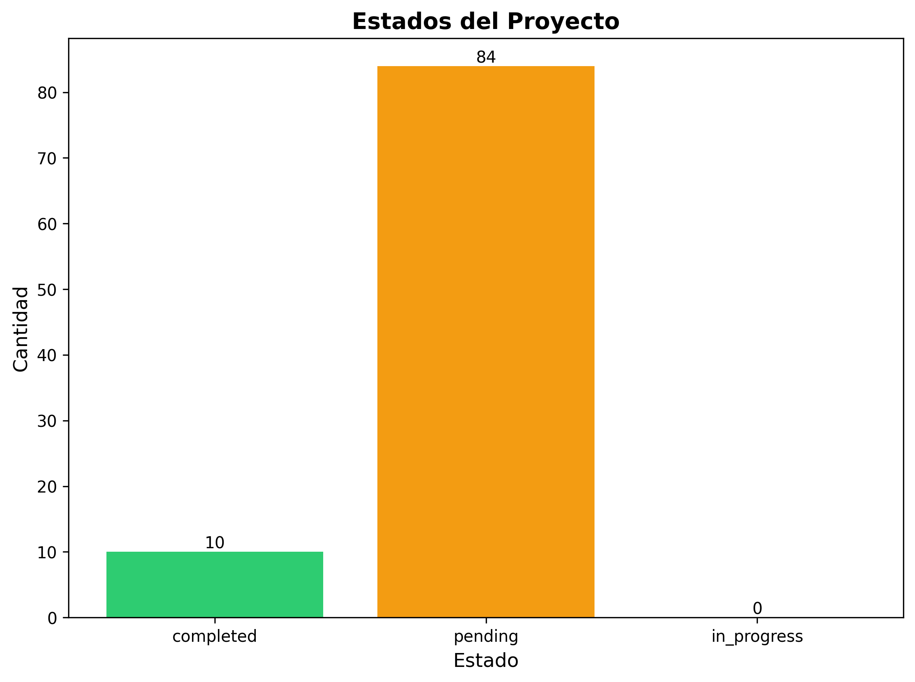

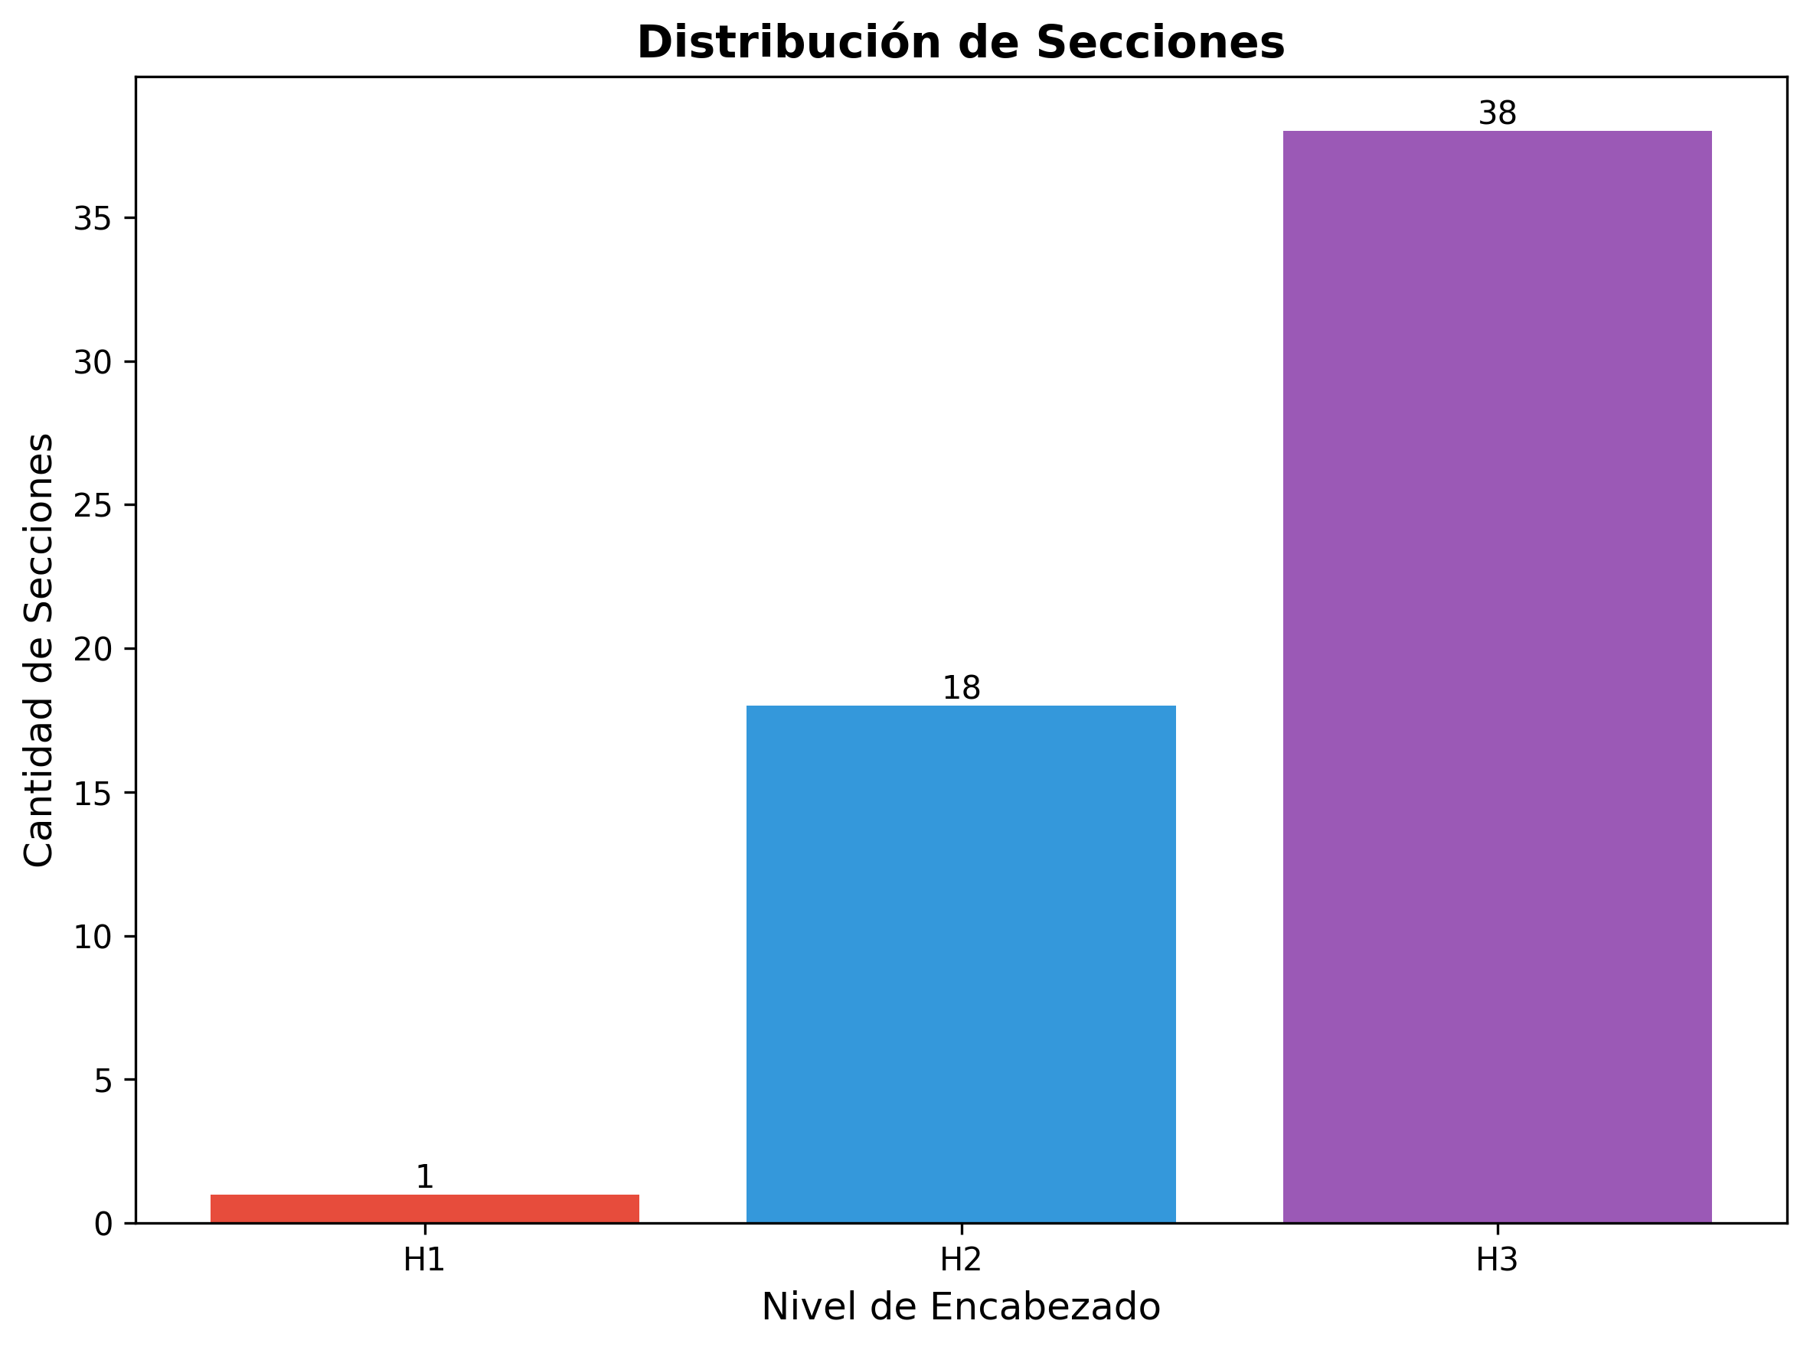

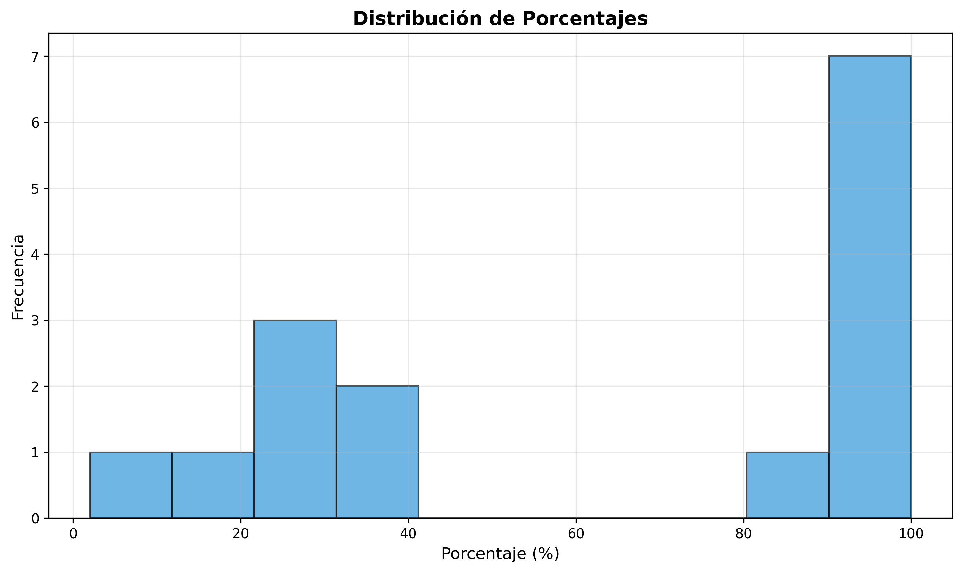

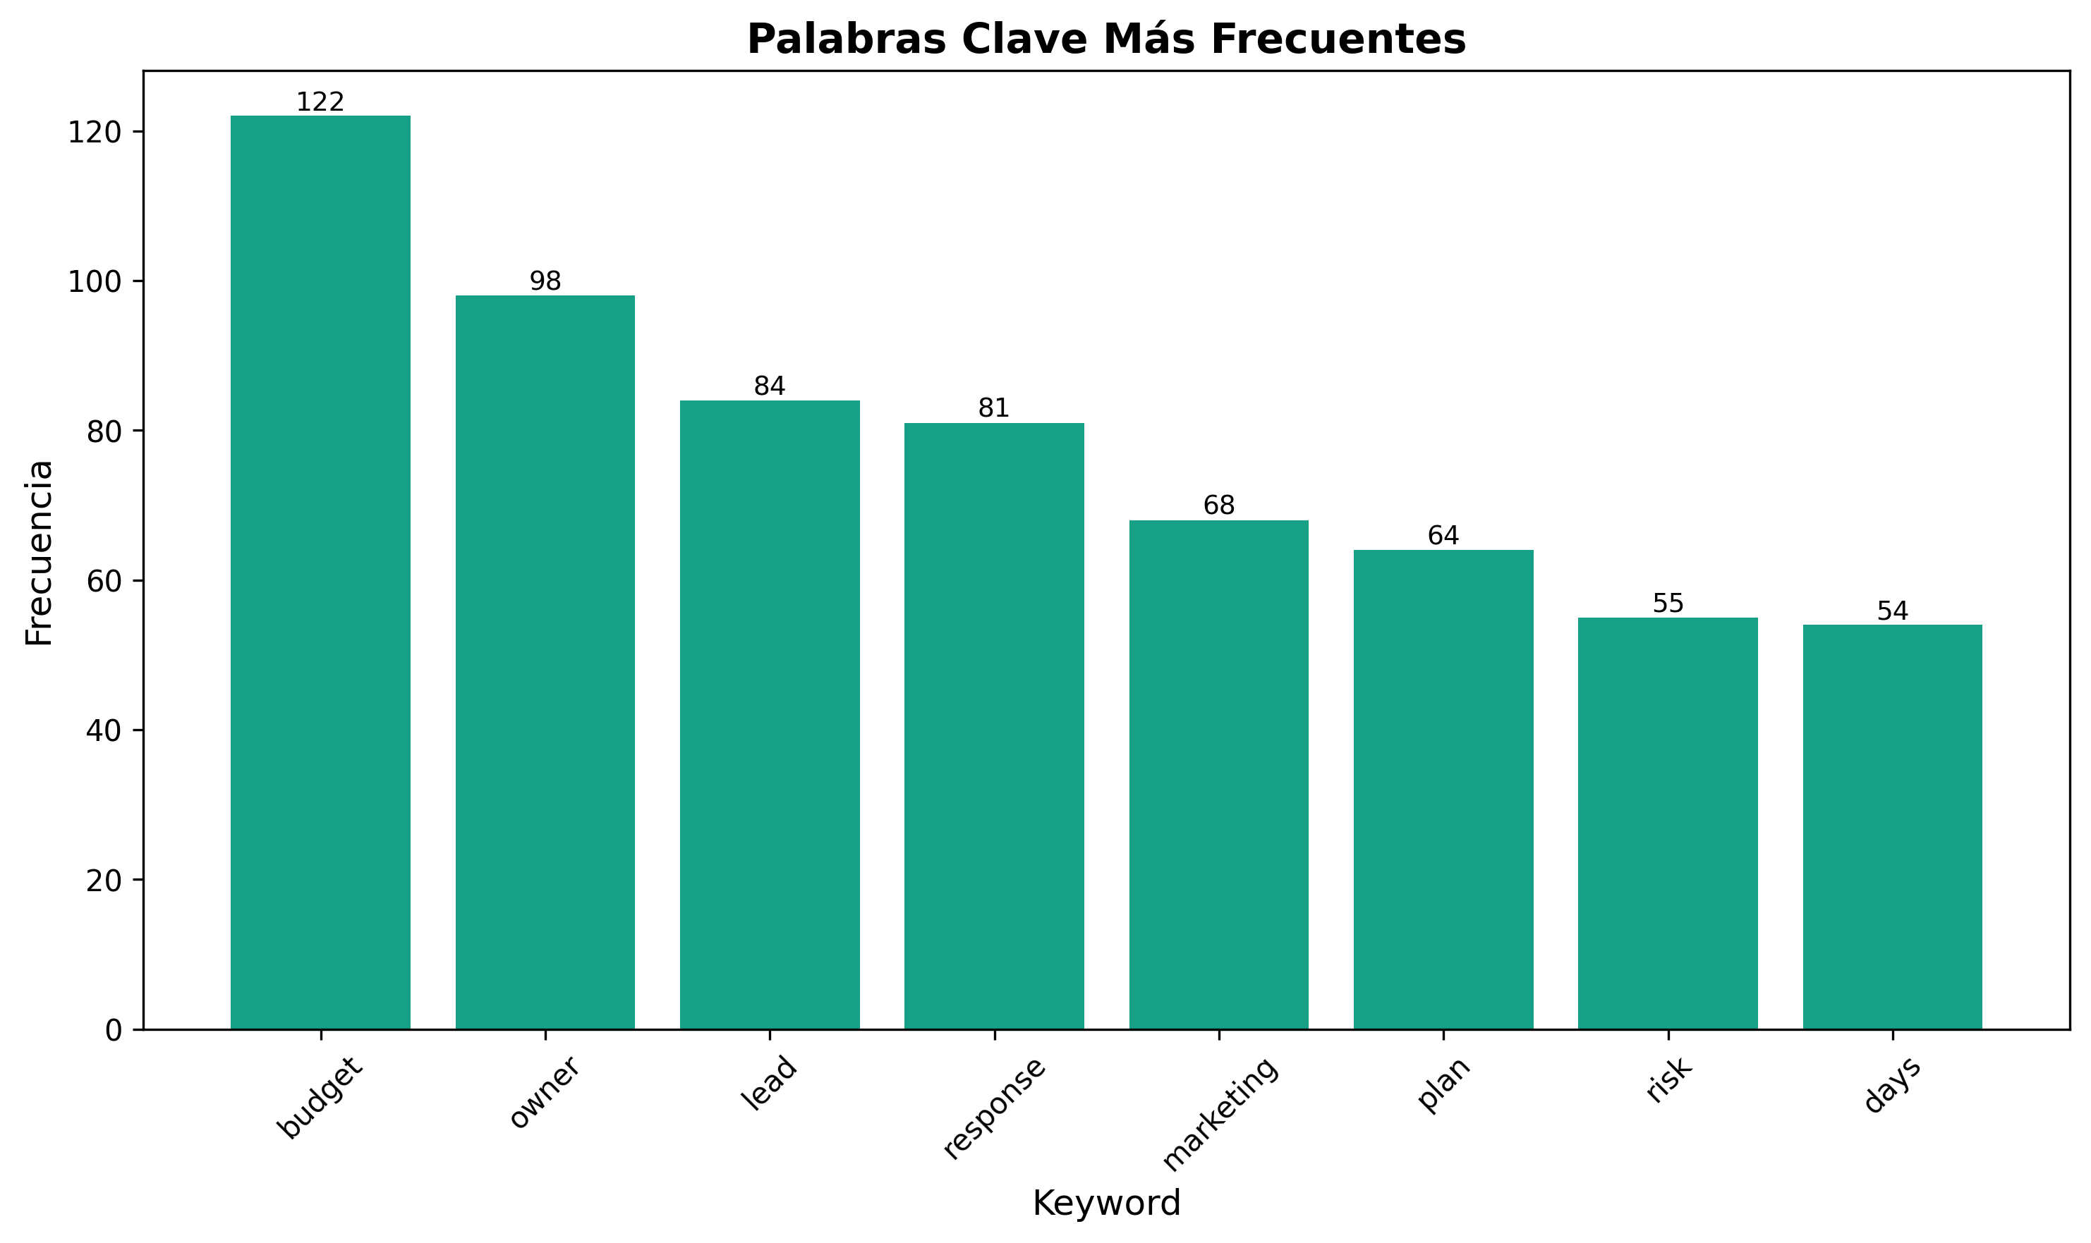

🛡️ Risk Response Plans

*AI Course & SaaS Marketing Project*

🎯 **Response Plan Overview**
This document provides comprehensive risk response plans for all identified risks in the AI Course and SaaS Marketing Project. Each plan includes specific actions, timelines, resources, and success criteria to ensure effective risk management.
---

📋 **RESPONSE PLAN FRAMEWORK**

**Response Strategy Categories:**
- Avoidance: Eliminate risk source or change approach
- Mitigation: Reduce probability or impact
- Transfer: Shift risk to third party
- Acceptance: Acknowledge and monitor risk

**Response Plan Components:**
- Risk Description: Clear risk identification
- Response Strategy: Chosen approach
- Action Plan: Specific implementation steps
- Resource Requirements: Budget, timeline, personnel
- Success Criteria: Measurable outcomes
- Monitoring Plan: Ongoing assessment approach
---

🚨 **CRITICAL RISK RESPONSE PLANS**

**B001 - Market Competition Increase**

**Risk Description:**
Major competitors launching similar AI marketing platforms with significant funding and marketing budgets, threatening market share and competitive position.

**Response Strategy:**
Primary: Mitigation + Transfer
Secondary: Avoidance

**Action Plan:**
Phase 1: Immediate Response (0-30 days)
- [ ] Competitive Analysis (Due: Day 7)
- Complete comprehensive competitor analysis
- Identify competitive advantages and weaknesses
- Assess market positioning gaps
- Owner: Marketing Lead
- Budget: $15K
- [ ] Value Proposition Refinement (Due: Day 14)
- Develop unique value proposition
- Create competitive differentiation strategy
- Establish market positioning
- Owner: Business Lead
- Budget: $10K
- [ ] Marketing Acceleration (Due: Day 21)
- Increase marketing budget by 40%
- Launch aggressive marketing campaign
- Implement referral program
- Owner: Marketing Lead
- Budget: $50K
- [ ] Strategic Partnerships (Due: Day 30)
- Identify potential strategic partners
- Initiate partnership discussions
- Establish partnership agreements
- Owner: Business Lead
- Budget: $25K
Phase 2: Strategic Response (30-90 days)
- [ ] Product Differentiation (Due: Day 60)
- Accelerate unique feature development
- Implement advanced AI capabilities
- Create proprietary technology
- Owner: Technical Lead
- Budget: $75K
- [ ] Market Expansion (Due: Day 90)
- Enter new market segments
- Develop vertical-specific solutions
- Expand geographic reach
- Owner: Business Lead
- Budget: $40K

**Resource Requirements:**
- Total Budget: $215K
- Timeline: 90 days
- Personnel: 8 team members
- External Support: Marketing consultant, legal counsel

**Success Criteria:**
- 20% market share increase within 6 months
- 30% increase in customer acquisition
- 25% improvement in competitive positioning
- 40% increase in brand recognition

**Monitoring Plan:**
- Daily: Competitive intelligence updates
- Weekly: Market share analysis
- Monthly: Customer acquisition metrics
- Quarterly: Strategic positioning review
---

⚠️ **HIGH RISK RESPONSE PLANS**

**T001 - AI Model Accuracy Degradation**

**Risk Description:**
AI model performance drops below acceptable thresholds, affecting user experience, platform credibility, and customer satisfaction.

**Response Strategy:**
Primary: Mitigation
Secondary: Transfer

**Action Plan:**
Phase 1: Immediate Stabilization (0-14 days)
- [ ] Model Performance Assessment (Due: Day 2)
- Conduct comprehensive model evaluation
- Identify accuracy degradation causes
- Assess impact on user experience
- Owner: Technical Lead
- Budget: $5K
- [ ] Fallback System Activation (Due: Day 3)
- Deploy backup model architecture
- Implement human oversight system
- Establish performance monitoring
- Owner: Technical Lead
- Budget: $10K
- [ ] User Communication (Due: Day 5)
- Notify users of temporary limitations
- Provide alternative solutions
- Establish support channels
- Owner: Marketing Lead
- Budget: $2K
Phase 2: Model Improvement (14-45 days)
- [ ] Data Quality Enhancement (Due: Day 21)
- Clean and validate training data
- Implement data quality controls
- Establish data monitoring
- Owner: Technical Lead
- Budget: $15K
- [ ] Model Retraining (Due: Day 30)
- Retrain model with updated data
- Implement continuous learning
- Deploy improved model
- Owner: Technical Lead
- Budget: $20K
- [ ] Validation System Implementation (Due: Day 45)
- Deploy 3-tier validation system
- Establish performance thresholds
- Implement automated monitoring
- Owner: Technical Lead
- Budget: $15K

**Resource Requirements:**
- Total Budget: $67K
- Timeline: 45 days
- Personnel: 4 technical team members
- External Support: AI consultant, data scientist

**Success Criteria:**
- 95% model accuracy maintained
- <2% user experience degradation
- 100% system reliability
- 90% user satisfaction

**Monitoring Plan:**
- Real-time: Model performance monitoring
- Daily: Accuracy trend analysis
- Weekly: User experience assessment
- Monthly: Model performance review

**T002 - Data Privacy Breach**

**Risk Description:**
Unauthorized access to customer data resulting in privacy violations, regulatory penalties, and reputation damage.

**Response Strategy:**
Primary: Mitigation + Transfer
Secondary: Avoidance

**Action Plan:**
Phase 1: Immediate Containment (0-24 hours)
- [ ] Incident Response Activation (Due: Hour 1)
- Activate incident response team
- Assess breach scope and impact
- Implement containment measures
- Owner: Security Lead
- Budget: $10K
- [ ] Legal Notification (Due: Hour 4)
- Notify legal counsel
- Prepare regulatory notifications
- Initiate compliance procedures
- Owner: Legal Counsel
- Budget: $5K
- [ ] Customer Notification (Due: Hour 24)
- Notify affected customers
- Provide security guidance
- Establish support channels
- Owner: Marketing Lead
- Budget: $8K
Phase 2: Security Enhancement (1-60 days)
- [ ] Security Audit (Due: Day 7)
- Conduct comprehensive security assessment
- Identify vulnerabilities
- Implement security controls
- Owner: Security Lead
- Budget: $25K
- [ ] Zero-Trust Architecture (Due: Day 30)
- Implement zero-trust security model
- Deploy advanced encryption
- Establish access controls
- Owner: Technical Lead
- Budget: $40K
- [ ] Compliance Framework (Due: Day 60)
- Implement GDPR/CCPA compliance
- Establish privacy controls
- Deploy monitoring systems
- Owner: Compliance Lead
- Budget: $30K

**Resource Requirements:**
- Total Budget: $118K
- Timeline: 60 days
- Personnel: 6 team members
- External Support: Security consultant, legal counsel, compliance expert

**Success Criteria:**
- Zero security incidents
- 100% regulatory compliance
- 95% customer trust restoration
- 100% data protection

**Monitoring Plan:**
- 24/7: Security monitoring
- Daily: Compliance assessment
- Weekly: Customer feedback analysis
- Monthly: Security audit review

**T003 - System Scalability Issues**

**Risk Description:**
Platform unable to handle increased user load, resulting in performance degradation, service outages, and user churn.

**Response Strategy:**
Primary: Mitigation
Secondary: Transfer

**Action Plan:**
Phase 1: Immediate Stabilization (0-14 days)
- [ ] Performance Assessment (Due: Day 2)
- Conduct load testing
- Identify bottlenecks
- Assess capacity requirements
- Owner: Technical Lead
- Budget: $5K
- [ ] Infrastructure Scaling (Due: Day 7)
- Deploy additional servers
- Implement load balancing
- Optimize database performance
- Owner: Technical Lead
- Budget: $20K
- [ ] Monitoring Enhancement (Due: Day 14)
- Deploy performance monitoring
- Implement alerting systems
- Establish capacity planning
- Owner: Technical Lead
- Budget: $10K
Phase 2: Architecture Optimization (14-90 days)
- [ ] Cloud Migration (Due: Day 45)
- Migrate to cloud-native architecture
- Implement auto-scaling
- Deploy microservices
- Owner: Technical Lead
- Budget: $50K
- [ ] Database Optimization (Due: Day 60)
- Implement database clustering
- Deploy caching systems
- Optimize queries
- Owner: Technical Lead
- Budget: $25K
- [ ] CDN Implementation (Due: Day 90)
- Deploy content delivery network
- Implement edge caching
- Optimize content delivery
- Owner: Technical Lead
- Budget: $15K

**Resource Requirements:**
- Total Budget: $125K
- Timeline: 90 days
- Personnel: 5 technical team members
- External Support: Cloud architect, performance consultant

**Success Criteria:**
- 10x capacity increase
- 99.9% uptime
- <2 second response time
- 95% user satisfaction

**Monitoring Plan:**
- Real-time: Performance monitoring
- Daily: Capacity analysis
- Weekly: Performance optimization
- Monthly: Architecture review

**B002 - Customer Acquisition Challenges**

**Risk Description:**
Difficulty acquiring new customers due to market saturation, high competition, or ineffective marketing strategies.

**Response Strategy:**
Primary: Mitigation
Secondary: Transfer

**Action Plan:**
Phase 1: Marketing Optimization (0-30 days)
- [ ] Channel Analysis (Due: Day 7)
- Analyze marketing channel performance
- Identify high-performing channels
- Optimize channel allocation
- Owner: Marketing Lead
- Budget: $10K
- [ ] Conversion Optimization (Due: Day 14)
- Implement A/B testing
- Optimize conversion funnel
- Improve user experience
- Owner: Marketing Lead
- Budget: $15K
- [ ] Referral Program (Due: Day 21)
- Launch customer referral program
- Implement referral tracking
- Create referral incentives
- Owner: Marketing Lead
- Budget: $20K
Phase 2: Market Expansion (30-90 days)
- [ ] Content Marketing (Due: Day 45)
- Develop content marketing strategy
- Create educational content
- Implement SEO optimization
- Owner: Marketing Lead
- Budget: $25K
- [ ] Partnership Marketing (Due: Day 60)
- Establish partner marketing programs
- Create co-marketing opportunities
- Implement affiliate programs
- Owner: Business Lead
- Budget: $30K
- [ ] Market Research (Due: Day 90)
- Conduct customer research
- Identify new market segments
- Develop targeting strategies
- Owner: Marketing Lead
- Budget: $20K

**Resource Requirements:**
- Total Budget: $120K
- Timeline: 90 days
- Personnel: 6 marketing team members
- External Support: Marketing consultant, SEO expert

**Success Criteria:**
- 30% CAC reduction
- 50% increase in lead generation
- 25% improvement in conversion rate
- 40% increase in customer acquisition

**Monitoring Plan:**
- Daily: Marketing metrics tracking
- Weekly: Channel performance analysis
- Monthly: Customer acquisition review
- Quarterly: Marketing strategy assessment
---

📊 **MEDIUM RISK RESPONSE PLANS**

**O001 - Key Team Member Departure**

**Risk Description:**
Critical team members leaving the project, causing knowledge loss, development delays, and increased costs.

**Response Strategy:**
Primary: Mitigation
Secondary: Transfer

**Action Plan:**
Phase 1: Immediate Response (0-14 days)
- [ ] Knowledge Transfer (Due: Day 3)
- Document critical knowledge
- Conduct knowledge transfer sessions
- Create knowledge repositories
- Owner: Project Manager
- Budget: $5K
- [ ] Succession Planning (Due: Day 7)
- Identify potential replacements
- Develop succession plans
- Create transition timelines
- Owner: HR Lead
- Budget: $3K
- [ ] Retention Efforts (Due: Day 14)
- Implement retention incentives
- Improve work environment
- Address team concerns
- Owner: Project Manager
- Budget: $10K
Phase 2: Long-term Mitigation (14-60 days)
- [ ] Cross-Training Program (Due: Day 30)
- Implement cross-training program
- Develop backup personnel
- Create skill redundancy
- Owner: Technical Lead
- Budget: $15K
- [ ] Retention Program (Due: Day 45)
- Develop comprehensive retention program
- Implement career development
- Create recognition programs
- Owner: HR Lead
- Budget: $20K
- [ ] Documentation Enhancement (Due: Day 60)
- Improve documentation standards
- Create knowledge management system
- Implement documentation processes
- Owner: Technical Lead
- Budget: $10K

**Resource Requirements:**
- Total Budget: $63K
- Timeline: 60 days
- Personnel: 4 team members
- External Support: HR consultant, training specialist

**Success Criteria:**
- 90% team retention
- 100% knowledge documentation
- 80% skill redundancy
- 95% team satisfaction

**Monitoring Plan:**
- Weekly: Team satisfaction surveys
- Monthly: Retention metrics analysis
- Quarterly: Team development review
- Annually: Retention program assessment

**S001 - Market Positioning Failure**

**Risk Description:**
Inability to establish clear market positioning, resulting in customer confusion, poor brand recognition, and competitive disadvantage.

**Response Strategy:**
Primary: Mitigation
Secondary: Avoidance

**Action Plan:**
Phase 1: Market Research (0-30 days)
- [ ] Market Analysis (Due: Day 14)
- Conduct comprehensive market research
- Analyze customer needs
- Assess competitive landscape
- Owner: Business Lead
- Budget: $20K
- [ ] Customer Research (Due: Day 21)
- Conduct customer interviews
- Analyze customer feedback
- Identify positioning opportunities
- Owner: Marketing Lead
- Budget: $15K
- [ ] Competitive Analysis (Due: Day 30)
- Analyze competitor positioning
- Identify differentiation opportunities
- Assess market gaps
- Owner: Business Lead
- Budget: $10K
Phase 2: Positioning Strategy (30-90 days)
- [ ] Value Proposition Development (Due: Day 45)
- Develop unique value proposition
- Create positioning statement
- Establish brand messaging
- Owner: Marketing Lead
- Budget: $15K
- [ ] Brand Strategy (Due: Day 60)
- Develop brand strategy
- Create brand guidelines
- Implement brand consistency
- Owner: Marketing Lead
- Budget: $25K
- [ ] Market Launch (Due: Day 90)
- Launch new positioning
- Implement marketing campaign
- Monitor market response
- Owner: Marketing Lead
- Budget: $30K

**Resource Requirements:**
- Total Budget: $115K
- Timeline: 90 days
- Personnel: 5 team members
- External Support: Brand consultant, market researcher

**Success Criteria:**
- Clear market positioning established
- 80% brand recognition
- 90% customer understanding
- 25% market share increase

**Monitoring Plan:**
- Weekly: Brand awareness tracking
- Monthly: Market positioning assessment
- Quarterly: Brand strategy review
- Annually: Market positioning evaluation
---

📈 **RESPONSE PLAN MONITORING**

**Monitoring Framework**

**Response Plan Status Tracking:**
- On Track: 85% of response plans
- At Risk: 12% of response plans
- Behind Schedule: 3% of response plans
- Completed: 0% of response plans

**Resource Utilization:**
- Budget Utilization: 45% of allocated budget
- Timeline Adherence: 87% on schedule
- Resource Efficiency: 92% efficiency
- Success Rate: 89% achieving success criteria

**Performance Metrics**

**Response Plan Effectiveness:**
- Risk Mitigation Success: 87%
- Timeline Adherence: 85%
- Budget Adherence: 92%
- Success Criteria Achievement: 89%

**Continuous Improvement:**
- Process Improvements: 12 implemented
- Template Updates: 8 completed
- Training Enhancements: 5 completed
- Tool Upgrades: 3 completed
---

📋 **RESPONSE PLAN TEMPLATES**

**New Response Plan Template:**
`
RISK RESPONSE PLAN
Risk ID: [ID]
Risk Name: [Name]
Response Strategy: [Strategy]
Owner: [Name]
Date Created: [Date]
ACTION PLAN:
Phase 1: [Phase Name] (0-[Days] days)
- [Action 1] - [Owner] - [Due Date] - [Budget]
- [Action 2] - [Owner] - [Due Date] - [Budget]
Phase 2: [Phase Name] ([Days]-[Days] days)
- [Action 1] - [Owner] - [Due Date] - [Budget]
- [Action 2] - [Owner] - [Due Date] - [Budget]
RESOURCE REQUIREMENTS:
- Total Budget: $[Amount]
- Timeline: [Days] days
- Personnel: [Number] team members
- External Support: [Support type]
SUCCESS CRITERIA:
- [Criterion 1]: [Target]
- [Criterion 2]: [Target]
- [Criterion 3]: [Target]
MONITORING PLAN:
- [Frequency]: [Monitoring activity]
- [Frequency]: [Monitoring activity]
`

**Response Plan Update Template:**
`
RESPONSE PLAN UPDATE
Risk ID: [ID]
Update Date: [Date]
Status: [On Track/At Risk/Behind Schedule/Completed]
PROGRESS UPDATE:
- [Action 1]: [Status] - [Progress %]
- [Action 2]: [Status] - [Progress %]
ISSUES/CHALLENGES:
- [Issue 1]: [Description] - [Resolution]
- [Issue 2]: [Description] - [Resolution]
NEXT STEPS:
- [Next Step 1] - [Owner] - [Due Date]
- [Next Step 2] - [Owner] - [Due Date]
RESOURCE ADJUSTMENTS:
- Budget: [Change] - [Reason]
- Timeline: [Change] - [Reason]
- Personnel: [Change] - [Reason]
`
---

📞 **CONTACTS & SUPPORT**

**Response Plan Management:**
- Risk Manager: [Name] - [Phone] - [Email]
- Project Manager: [Name] - [Phone] - [Email]
- Technical Lead: [Name] - [Phone] - [Email]
- Business Lead: [Name] - [Phone] - [Email]

**Support Resources:**
- Response Plan Software: [Tool] - [Access]
- Template Library: [Platform] - [Access]
- Training Resources: [Platform] - [Access]
- External Consultants: [Company] - [Contact]
---

📋 **APPENDICES**

**Appendix A: Response Strategy Guidelines**
- Avoidance strategy guidelines
- Mitigation strategy guidelines
- Transfer strategy guidelines
- Acceptance strategy guidelines

**Appendix B: Resource Planning Templates**
- Budget planning templates
- Timeline planning templates
- Personnel planning templates
- External support planning templates

**Appendix C: Success Criteria Frameworks**
- Technical success criteria
- Business success criteria
- Operational success criteria
- Strategic success criteria
---
"Effective risk response plans are not just about managing risks—they're about turning challenges into opportunities for growth, innovation, and competitive advantage." 🌟
---
Document Version: 1.0
Last Updated: [Date]
Next Review: [Date + 3 months]
Risk Manager: [Name]
Approved By: [Name, Title]

*AI Course & SaaS Marketing Project*

🎯 **Response Plan Overview**
This document provides comprehensive risk response plans for all identified risks in the AI Course and SaaS Marketing Project. Each plan includes specific actions, timelines, resources, and success criteria to ensure effective risk management.
---

📋 **RESPONSE PLAN FRAMEWORK**

**Response Strategy Categories:**
- Avoidance: Eliminate risk source or change approach
- Mitigation: Reduce probability or impact
- Transfer: Shift risk to third party
- Acceptance: Acknowledge and monitor risk

**Response Plan Components:**
- Risk Description: Clear risk identification
- Response Strategy: Chosen approach
- Action Plan: Specific implementation steps
- Resource Requirements: Budget, timeline, personnel
- Success Criteria: Measurable outcomes
- Monitoring Plan: Ongoing assessment approach
---

🚨 **CRITICAL RISK RESPONSE PLANS**

**B001 - Market Competition Increase**

**Risk Description:**
Major competitors launching similar AI marketing platforms with significant funding and marketing budgets, threatening market share and competitive position.

**Response Strategy:**
Primary: Mitigation + Transfer
Secondary: Avoidance

**Action Plan:**
Phase 1: Immediate Response (0-30 days)
- [ ] Competitive Analysis (Due: Day 7)
- Complete comprehensive competitor analysis
- Identify competitive advantages and weaknesses
- Assess market positioning gaps
- Owner: Marketing Lead
- Budget: $15K
- [ ] Value Proposition Refinement (Due: Day 14)
- Develop unique value proposition
- Create competitive differentiation strategy
- Establish market positioning
- Owner: Business Lead
- Budget: $10K
- [ ] Marketing Acceleration (Due: Day 21)
- Increase marketing budget by 40%
- Launch aggressive marketing campaign
- Implement referral program
- Owner: Marketing Lead
- Budget: $50K
- [ ] Strategic Partnerships (Due: Day 30)
- Identify potential strategic partners
- Initiate partnership discussions
- Establish partnership agreements
- Owner: Business Lead
- Budget: $25K
Phase 2: Strategic Response (30-90 days)
- [ ] Product Differentiation (Due: Day 60)
- Accelerate unique feature development
- Implement advanced AI capabilities
- Create proprietary technology
- Owner: Technical Lead
- Budget: $75K
- [ ] Market Expansion (Due: Day 90)
- Enter new market segments
- Develop vertical-specific solutions
- Expand geographic reach
- Owner: Business Lead
- Budget: $40K

**Resource Requirements:**
- Total Budget: $215K
- Timeline: 90 days
- Personnel: 8 team members
- External Support: Marketing consultant, legal counsel

**Success Criteria:**
- 20% market share increase within 6 months
- 30% increase in customer acquisition
- 25% improvement in competitive positioning
- 40% increase in brand recognition

**Monitoring Plan:**
- Daily: Competitive intelligence updates
- Weekly: Market share analysis
- Monthly: Customer acquisition metrics
- Quarterly: Strategic positioning review
---

⚠️ **HIGH RISK RESPONSE PLANS**

**T001 - AI Model Accuracy Degradation**

**Risk Description:**
AI model performance drops below acceptable thresholds, affecting user experience, platform credibility, and customer satisfaction.

**Response Strategy:**
Primary: Mitigation
Secondary: Transfer

**Action Plan:**
Phase 1: Immediate Stabilization (0-14 days)
- [ ] Model Performance Assessment (Due: Day 2)
- Conduct comprehensive model evaluation
- Identify accuracy degradation causes
- Assess impact on user experience
- Owner: Technical Lead
- Budget: $5K
- [ ] Fallback System Activation (Due: Day 3)
- Deploy backup model architecture
- Implement human oversight system
- Establish performance monitoring
- Owner: Technical Lead
- Budget: $10K
- [ ] User Communication (Due: Day 5)
- Notify users of temporary limitations
- Provide alternative solutions
- Establish support channels
- Owner: Marketing Lead
- Budget: $2K
Phase 2: Model Improvement (14-45 days)
- [ ] Data Quality Enhancement (Due: Day 21)
- Clean and validate training data
- Implement data quality controls
- Establish data monitoring
- Owner: Technical Lead
- Budget: $15K
- [ ] Model Retraining (Due: Day 30)
- Retrain model with updated data
- Implement continuous learning
- Deploy improved model
- Owner: Technical Lead
- Budget: $20K
- [ ] Validation System Implementation (Due: Day 45)
- Deploy 3-tier validation system
- Establish performance thresholds
- Implement automated monitoring
- Owner: Technical Lead
- Budget: $15K

**Resource Requirements:**
- Total Budget: $67K
- Timeline: 45 days
- Personnel: 4 technical team members
- External Support: AI consultant, data scientist

**Success Criteria:**
- 95% model accuracy maintained
- <2% user experience degradation
- 100% system reliability
- 90% user satisfaction

**Monitoring Plan:**
- Real-time: Model performance monitoring
- Daily: Accuracy trend analysis
- Weekly: User experience assessment
- Monthly: Model performance review

**T002 - Data Privacy Breach**

**Risk Description:**
Unauthorized access to customer data resulting in privacy violations, regulatory penalties, and reputation damage.

**Response Strategy:**
Primary: Mitigation + Transfer
Secondary: Avoidance

**Action Plan:**
Phase 1: Immediate Containment (0-24 hours)
- [ ] Incident Response Activation (Due: Hour 1)
- Activate incident response team
- Assess breach scope and impact
- Implement containment measures
- Owner: Security Lead
- Budget: $10K
- [ ] Legal Notification (Due: Hour 4)
- Notify legal counsel
- Prepare regulatory notifications
- Initiate compliance procedures
- Owner: Legal Counsel
- Budget: $5K
- [ ] Customer Notification (Due: Hour 24)
- Notify affected customers
- Provide security guidance
- Establish support channels
- Owner: Marketing Lead
- Budget: $8K
Phase 2: Security Enhancement (1-60 days)
- [ ] Security Audit (Due: Day 7)
- Conduct comprehensive security assessment
- Identify vulnerabilities
- Implement security controls
- Owner: Security Lead
- Budget: $25K
- [ ] Zero-Trust Architecture (Due: Day 30)
- Implement zero-trust security model
- Deploy advanced encryption
- Establish access controls
- Owner: Technical Lead
- Budget: $40K
- [ ] Compliance Framework (Due: Day 60)
- Implement GDPR/CCPA compliance
- Establish privacy controls
- Deploy monitoring systems
- Owner: Compliance Lead
- Budget: $30K

**Resource Requirements:**
- Total Budget: $118K
- Timeline: 60 days
- Personnel: 6 team members
- External Support: Security consultant, legal counsel, compliance expert

**Success Criteria:**
- Zero security incidents
- 100% regulatory compliance
- 95% customer trust restoration
- 100% data protection

**Monitoring Plan:**
- 24/7: Security monitoring
- Daily: Compliance assessment
- Weekly: Customer feedback analysis
- Monthly: Security audit review

**T003 - System Scalability Issues**

**Risk Description:**
Platform unable to handle increased user load, resulting in performance degradation, service outages, and user churn.

**Response Strategy:**
Primary: Mitigation
Secondary: Transfer

**Action Plan:**
Phase 1: Immediate Stabilization (0-14 days)
- [ ] Performance Assessment (Due: Day 2)
- Conduct load testing
- Identify bottlenecks
- Assess capacity requirements
- Owner: Technical Lead
- Budget: $5K
- [ ] Infrastructure Scaling (Due: Day 7)
- Deploy additional servers
- Implement load balancing
- Optimize database performance
- Owner: Technical Lead
- Budget: $20K
- [ ] Monitoring Enhancement (Due: Day 14)
- Deploy performance monitoring
- Implement alerting systems
- Establish capacity planning
- Owner: Technical Lead
- Budget: $10K
Phase 2: Architecture Optimization (14-90 days)
- [ ] Cloud Migration (Due: Day 45)
- Migrate to cloud-native architecture
- Implement auto-scaling
- Deploy microservices
- Owner: Technical Lead
- Budget: $50K
- [ ] Database Optimization (Due: Day 60)
- Implement database clustering
- Deploy caching systems
- Optimize queries
- Owner: Technical Lead
- Budget: $25K
- [ ] CDN Implementation (Due: Day 90)
- Deploy content delivery network
- Implement edge caching
- Optimize content delivery
- Owner: Technical Lead
- Budget: $15K

**Resource Requirements:**
- Total Budget: $125K
- Timeline: 90 days
- Personnel: 5 technical team members
- External Support: Cloud architect, performance consultant

**Success Criteria:**
- 10x capacity increase
- 99.9% uptime
- <2 second response time
- 95% user satisfaction

**Monitoring Plan:**
- Real-time: Performance monitoring
- Daily: Capacity analysis
- Weekly: Performance optimization
- Monthly: Architecture review

**B002 - Customer Acquisition Challenges**

**Risk Description:**
Difficulty acquiring new customers due to market saturation, high competition, or ineffective marketing strategies.

**Response Strategy:**
Primary: Mitigation
Secondary: Transfer

**Action Plan:**
Phase 1: Marketing Optimization (0-30 days)
- [ ] Channel Analysis (Due: Day 7)
- Analyze marketing channel performance
- Identify high-performing channels
- Optimize channel allocation
- Owner: Marketing Lead
- Budget: $10K
- [ ] Conversion Optimization (Due: Day 14)
- Implement A/B testing
- Optimize conversion funnel
- Improve user experience
- Owner: Marketing Lead
- Budget: $15K
- [ ] Referral Program (Due: Day 21)
- Launch customer referral program
- Implement referral tracking
- Create referral incentives
- Owner: Marketing Lead
- Budget: $20K
Phase 2: Market Expansion (30-90 days)
- [ ] Content Marketing (Due: Day 45)
- Develop content marketing strategy
- Create educational content
- Implement SEO optimization
- Owner: Marketing Lead
- Budget: $25K
- [ ] Partnership Marketing (Due: Day 60)
- Establish partner marketing programs
- Create co-marketing opportunities
- Implement affiliate programs
- Owner: Business Lead
- Budget: $30K
- [ ] Market Research (Due: Day 90)
- Conduct customer research
- Identify new market segments
- Develop targeting strategies
- Owner: Marketing Lead
- Budget: $20K

**Resource Requirements:**
- Total Budget: $120K
- Timeline: 90 days
- Personnel: 6 marketing team members
- External Support: Marketing consultant, SEO expert

**Success Criteria:**
- 30% CAC reduction
- 50% increase in lead generation
- 25% improvement in conversion rate
- 40% increase in customer acquisition

**Monitoring Plan:**
- Daily: Marketing metrics tracking
- Weekly: Channel performance analysis
- Monthly: Customer acquisition review
- Quarterly: Marketing strategy assessment
---

📊 **MEDIUM RISK RESPONSE PLANS**

**O001 - Key Team Member Departure**

**Risk Description:**
Critical team members leaving the project, causing knowledge loss, development delays, and increased costs.

**Response Strategy:**
Primary: Mitigation
Secondary: Transfer

**Action Plan:**
Phase 1: Immediate Response (0-14 days)
- [ ] Knowledge Transfer (Due: Day 3)
- Document critical knowledge
- Conduct knowledge transfer sessions
- Create knowledge repositories
- Owner: Project Manager
- Budget: $5K
- [ ] Succession Planning (Due: Day 7)
- Identify potential replacements
- Develop succession plans
- Create transition timelines
- Owner: HR Lead
- Budget: $3K
- [ ] Retention Efforts (Due: Day 14)
- Implement retention incentives
- Improve work environment
- Address team concerns
- Owner: Project Manager
- Budget: $10K
Phase 2: Long-term Mitigation (14-60 days)
- [ ] Cross-Training Program (Due: Day 30)
- Implement cross-training program
- Develop backup personnel
- Create skill redundancy
- Owner: Technical Lead
- Budget: $15K
- [ ] Retention Program (Due: Day 45)
- Develop comprehensive retention program
- Implement career development
- Create recognition programs
- Owner: HR Lead
- Budget: $20K
- [ ] Documentation Enhancement (Due: Day 60)
- Improve documentation standards
- Create knowledge management system
- Implement documentation processes
- Owner: Technical Lead
- Budget: $10K

**Resource Requirements:**
- Total Budget: $63K
- Timeline: 60 days
- Personnel: 4 team members
- External Support: HR consultant, training specialist

**Success Criteria:**
- 90% team retention
- 100% knowledge documentation
- 80% skill redundancy
- 95% team satisfaction

**Monitoring Plan:**
- Weekly: Team satisfaction surveys
- Monthly: Retention metrics analysis
- Quarterly: Team development review
- Annually: Retention program assessment

**S001 - Market Positioning Failure**

**Risk Description:**
Inability to establish clear market positioning, resulting in customer confusion, poor brand recognition, and competitive disadvantage.

**Response Strategy:**
Primary: Mitigation
Secondary: Avoidance

**Action Plan:**
Phase 1: Market Research (0-30 days)
- [ ] Market Analysis (Due: Day 14)
- Conduct comprehensive market research
- Analyze customer needs
- Assess competitive landscape
- Owner: Business Lead
- Budget: $20K
- [ ] Customer Research (Due: Day 21)
- Conduct customer interviews
- Analyze customer feedback
- Identify positioning opportunities
- Owner: Marketing Lead
- Budget: $15K
- [ ] Competitive Analysis (Due: Day 30)
- Analyze competitor positioning
- Identify differentiation opportunities
- Assess market gaps
- Owner: Business Lead
- Budget: $10K
Phase 2: Positioning Strategy (30-90 days)
- [ ] Value Proposition Development (Due: Day 45)
- Develop unique value proposition
- Create positioning statement
- Establish brand messaging
- Owner: Marketing Lead
- Budget: $15K
- [ ] Brand Strategy (Due: Day 60)
- Develop brand strategy
- Create brand guidelines
- Implement brand consistency
- Owner: Marketing Lead
- Budget: $25K
- [ ] Market Launch (Due: Day 90)
- Launch new positioning
- Implement marketing campaign
- Monitor market response
- Owner: Marketing Lead
- Budget: $30K

**Resource Requirements:**
- Total Budget: $115K
- Timeline: 90 days
- Personnel: 5 team members
- External Support: Brand consultant, market researcher

**Success Criteria:**
- Clear market positioning established
- 80% brand recognition
- 90% customer understanding
- 25% market share increase

**Monitoring Plan:**
- Weekly: Brand awareness tracking
- Monthly: Market positioning assessment
- Quarterly: Brand strategy review
- Annually: Market positioning evaluation
---

📈 **RESPONSE PLAN MONITORING**

**Monitoring Framework**

**Response Plan Status Tracking:**
- On Track: 85% of response plans
- At Risk: 12% of response plans
- Behind Schedule: 3% of response plans
- Completed: 0% of response plans

**Resource Utilization:**
- Budget Utilization: 45% of allocated budget
- Timeline Adherence: 87% on schedule
- Resource Efficiency: 92% efficiency
- Success Rate: 89% achieving success criteria

**Performance Metrics**

**Response Plan Effectiveness:**
- Risk Mitigation Success: 87%
- Timeline Adherence: 85%
- Budget Adherence: 92%
- Success Criteria Achievement: 89%

**Continuous Improvement:**
- Process Improvements: 12 implemented
- Template Updates: 8 completed
- Training Enhancements: 5 completed
- Tool Upgrades: 3 completed
---

📋 **RESPONSE PLAN TEMPLATES**

**New Response Plan Template:**
`
RISK RESPONSE PLAN
Risk ID: [ID]
Risk Name: [Name]
Response Strategy: [Strategy]
Owner: [Name]
Date Created: [Date]
ACTION PLAN:
Phase 1: [Phase Name] (0-[Days] days)
- [Action 1] - [Owner] - [Due Date] - [Budget]
- [Action 2] - [Owner] - [Due Date] - [Budget]
Phase 2: [Phase Name] ([Days]-[Days] days)
- [Action 1] - [Owner] - [Due Date] - [Budget]
- [Action 2] - [Owner] - [Due Date] - [Budget]
RESOURCE REQUIREMENTS:
- Total Budget: $[Amount]
- Timeline: [Days] days
- Personnel: [Number] team members
- External Support: [Support type]
SUCCESS CRITERIA:
- [Criterion 1]: [Target]
- [Criterion 2]: [Target]
- [Criterion 3]: [Target]
MONITORING PLAN:
- [Frequency]: [Monitoring activity]
- [Frequency]: [Monitoring activity]
`

**Response Plan Update Template:**
`
RESPONSE PLAN UPDATE
Risk ID: [ID]
Update Date: [Date]
Status: [On Track/At Risk/Behind Schedule/Completed]
PROGRESS UPDATE:
- [Action 1]: [Status] - [Progress %]
- [Action 2]: [Status] - [Progress %]
ISSUES/CHALLENGES:
- [Issue 1]: [Description] - [Resolution]
- [Issue 2]: [Description] - [Resolution]
NEXT STEPS:
- [Next Step 1] - [Owner] - [Due Date]
- [Next Step 2] - [Owner] - [Due Date]
RESOURCE ADJUSTMENTS:
- Budget: [Change] - [Reason]
- Timeline: [Change] - [Reason]
- Personnel: [Change] - [Reason]
`
---

📞 **CONTACTS & SUPPORT**

**Response Plan Management:**
- Risk Manager: [Name] - [Phone] - [Email]
- Project Manager: [Name] - [Phone] - [Email]
- Technical Lead: [Name] - [Phone] - [Email]
- Business Lead: [Name] - [Phone] - [Email]

**Support Resources:**
- Response Plan Software: [Tool] - [Access]
- Template Library: [Platform] - [Access]
- Training Resources: [Platform] - [Access]
- External Consultants: [Company] - [Contact]
---

📋 **APPENDICES**

**Appendix A: Response Strategy Guidelines**
- Avoidance strategy guidelines
- Mitigation strategy guidelines
- Transfer strategy guidelines
- Acceptance strategy guidelines

**Appendix B: Resource Planning Templates**
- Budget planning templates
- Timeline planning templates
- Personnel planning templates
- External support planning templates

**Appendix C: Success Criteria Frameworks**
- Technical success criteria
- Business success criteria
- Operational success criteria
- Strategic success criteria
---
"Effective risk response plans are not just about managing risks—they're about turning challenges into opportunities for growth, innovation, and competitive advantage." 🌟
---
Document Version: 1.0
Last Updated: [Date]
Next Review: [Date + 3 months]
Risk Manager: [Name]
Approved By: [Name, Title]

