COPYCAR.AI INVESTOR MARKETING STRATEGY
Fecha: 2025-11-25 | Versión: 1.0

Resumen Ejecutivo
- Strategy:** Comprehensive investor marketing strategy
- Objective:** Build brand awareness and attract investors
- Target:** VCs, angels, strategic investors, media
- Timeline:** 12-month comprehensive campaign
- Date:** December 2024

Acciones Prioritarias
Descripción | Estado
Strategy:** Comprehensive investor marketing strategy | Pendiente
Objective:** Build brand awareness and attract investors | Pendiente
Target:** VCs, angels, strategic investors, media | Pendiente
Timeline:** 12-month comprehensive campaign | Pendiente
Date:** December 2024 | Pendiente
Primary Objectives:** | Pendiente
Brand Awareness:** Build strong brand recognition | Pendiente
Investor Attraction:** Attract target investors | Pendiente

Métricas Clave
Palabras totales: 2377
Lectura estimada (min): 11.9
Secciones H1/H2/H3: 1/12/30

Palabras Clave Prioritarias
Palabra | Frecuencia
media | 64
marketing | 59
content | 56
customer | 41
industry | 35
strategy | 33
metrics | 26
budget | 21

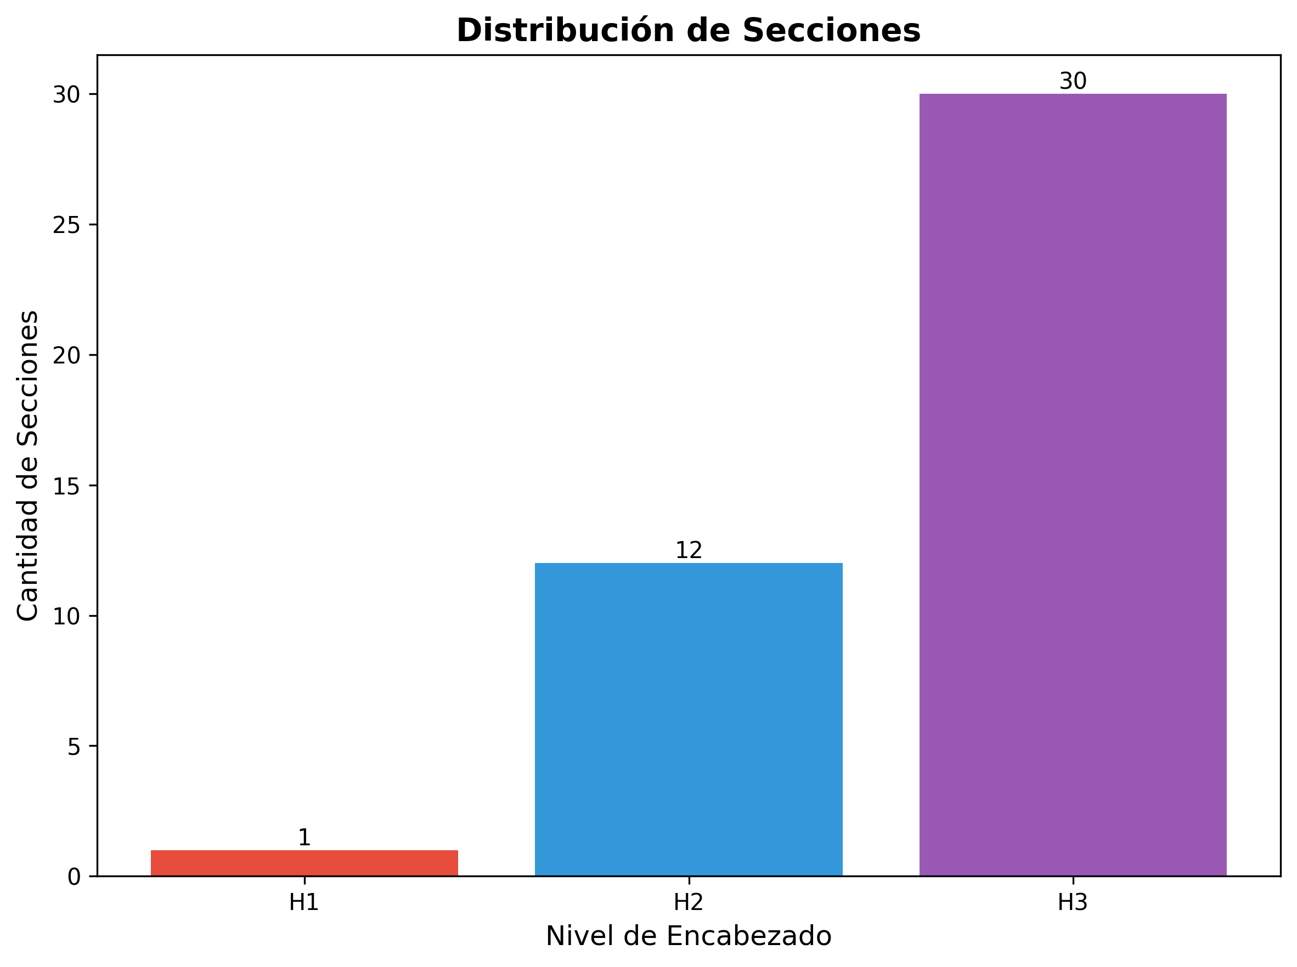

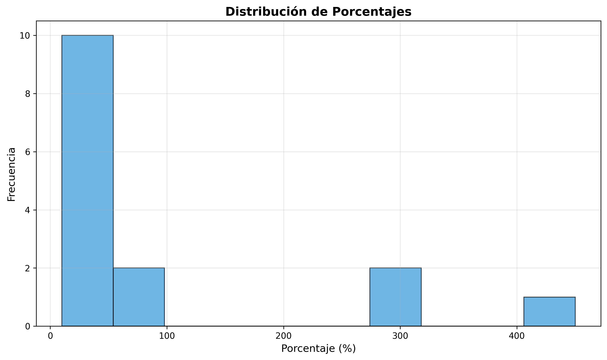

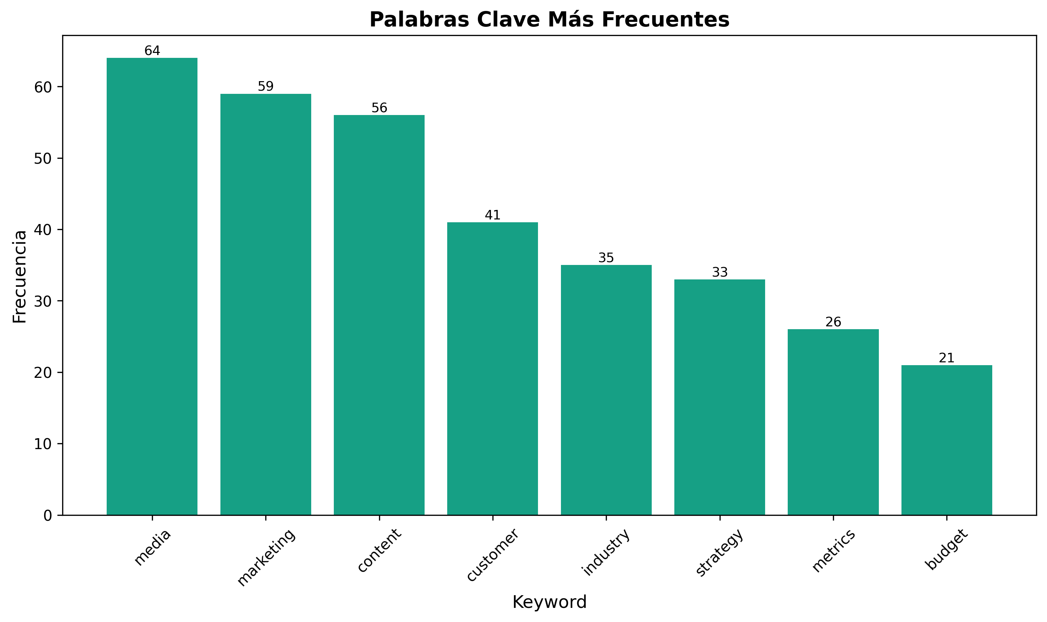

COPYCAR.AI INVESTOR MARKETING STRATEGY

EXECUTIVE SUMMARY
Strategy: Comprehensive investor marketing strategy
Objective: Build brand awareness and attract investors
Target: VCs, angels, strategic investors, media
Timeline: 12-month comprehensive campaign
Date: December 2024
---

1. MARKETING STRATEGY OVERVIEW

1.1 Marketing Objectives
Primary Objectives:
- Brand Awareness: Build strong brand recognition
- Investor Attraction: Attract target investors
- Media Coverage: Generate positive media coverage
- Thought Leadership: Establish thought leadership
- Market Positioning: Position as market leader
Secondary Objectives:
- Customer Acquisition: Support customer acquisition
- Talent Attraction: Attract top talent
- Partnership Development: Develop strategic partnerships
- Market Education: Educate market about AI copywriting
- Competitive Advantage: Build competitive moats

1.2 Target Audience
Primary Audience:
- Venture Capitalists: Series A and B VCs
- Angel Investors: High-net-worth individuals
- Strategic Investors: Corporate venture arms
- Family Offices: Family office investors
- PE Firms: Private equity firms
Secondary Audience:
- Media: Tech and business media
- Industry Analysts: Industry research analysts
- Thought Leaders: Industry thought leaders
- Potential Customers: Target customers
- Potential Employees: Top talent

1.3 Key Messages
Core Messages:
- "AI Copywriting for Latin America" - Cultural specialization
- "300% Engagement Increase" - Proven results
- "450% ROI" - Financial performance
- "First AI Platform for LATAM" - Market leadership
- "Cultural Intelligence" - Unique technology
Supporting Messages:
- "15+ Spanish Dialects" - Technical capability
- "150+ Customers" - Market validation
- "25% Monthly Growth" - Growth trajectory
- "85% Gross Margin" - Unit economics
- "92% Retention Rate" - Customer success
---

2. CONTENT MARKETING STRATEGY

2.1 Content Pillars
Thought Leadership:
- AI in Latin America: AI adoption in LATAM
- Cultural Marketing: Cultural marketing strategies
- Copywriting Trends: Copywriting industry trends
- Technology Innovation: AI technology innovation
- Market Insights: LATAM market insights
Product Education:
- How AI Copywriting Works: Technical explanations
- Use Cases: Real-world use cases
- Best Practices: Copywriting best practices
- ROI Examples: ROI case studies
- Integration Guides: Platform integration guides
Company Story:
- Founder Journey: Founder and team stories
- Company Culture: Company culture and values
- Mission and Vision: Mission and vision
- Growth Story: Company growth story
- Future Vision: Future vision and roadmap

2.2 Content Formats
Written Content:
- Blog Posts: Weekly blog posts
- White Papers: Quarterly white papers
- Case Studies: Monthly case studies
- Industry Reports: Annual industry reports
- Press Releases: Regular press releases
Visual Content:
- Infographics: Data visualization
- Videos: Product demos and tutorials
- Webinars: Educational webinars
- Podcasts: Podcast appearances
- Presentations: Conference presentations
Interactive Content:
- ROI Calculator: Interactive ROI calculator
- Demo Platform: Product demonstrations
- Assessment Tools: Marketing assessment tools
- Quizzes: Educational quizzes
- Surveys: Market research surveys

2.3 Content Distribution
Owned Channels:
- Company Website: Primary content hub
- Blog: Regular blog content
- Resource Center: Comprehensive resource center
- Newsletter: Weekly newsletter
- Social Media: Social media content
Earned Channels:
- Media Coverage: Press coverage
- Guest Content: Guest articles and posts
- Podcast Appearances: Podcast interviews
- Speaking Engagements: Conference speaking
- Industry Publications: Industry publication articles
Paid Channels:
- Content Promotion: Paid content promotion
- Social Media Ads: Social media advertising
- Search Ads: Search engine advertising
- Display Ads: Display advertising
- Sponsored Content: Sponsored content
---

3. PUBLIC RELATIONS STRATEGY

3.1 Media Relations
Target Media:
- Tech Media: TechCrunch, VentureBeat, Wired
- Business Media: Forbes, Fortune, Bloomberg
- AI Media: AI News, VentureBeat AI, MIT Technology Review
- LATAM Media: Latin American business media
- Industry Media: Marketing and advertising media
Media Strategy:
- Press Releases: Regular press releases
- Media Pitches: Targeted media pitches
- Expert Commentary: Expert commentary on industry topics
- Exclusive Stories: Exclusive story opportunities
- Media Events: Press conferences and events
Key Messages for Media:
- Market Opportunity: $2.8B LATAM opportunity
- Technology Innovation: AI cultural adaptation
- Customer Success: 300% engagement increase
- Growth Trajectory: 25% monthly growth
- Team Expertise: Experienced leadership team

3.2 Thought Leadership
Speaking Engagements:
- Industry Conferences: AI, marketing, LATAM conferences
- Webinars: Educational webinars
- Podcast Appearances: Podcast interviews
- Panel Discussions: Industry panel discussions
- Workshops: Educational workshops
Content Creation:
- Industry Reports: Annual industry reports
- Research Studies: Market research studies
- Best Practice Guides: Industry best practices
- Trend Analysis: Industry trend analysis
- Predictions: Industry predictions and forecasts
Awards and Recognition:
- Industry Awards: Apply for relevant awards
- Recognition Programs: Recognition programs
- Certifications: Industry certifications
- Accreditations: Professional accreditations
- Memberships: Industry association memberships

3.3 Crisis Management
Crisis Prevention:
- Risk Assessment: Regular risk assessments
- Crisis Planning: Crisis management planning
- Media Training: Media training for spokespeople
- Message Development: Crisis message development
- Response Procedures: Crisis response procedures
Crisis Response:
- Rapid Response: Rapid response capability
- Message Control: Message control and consistency
- Media Management: Media management during crisis
- Stakeholder Communication: Stakeholder communication
- Recovery Planning: Crisis recovery planning
---

4. DIGITAL MARKETING STRATEGY

4.1 Website Strategy
Website Optimization:
- SEO Optimization: Search engine optimization
- User Experience: Excellent user experience
- Mobile Optimization: Mobile-first design
- Page Speed: Fast loading times
- Conversion Optimization: Conversion rate optimization
Content Strategy:
- Homepage: Compelling homepage
- About Page: Company story and team
- Product Pages: Product information and demos
- Case Studies: Customer success stories
- Resources: Comprehensive resource center
Lead Generation:
- Lead Magnets: Valuable lead magnets
- Contact Forms: Optimized contact forms
- Newsletter Signup: Newsletter subscription
- Demo Requests: Product demo requests
- Trial Signups: Free trial signups

4.2 Social Media Strategy
Platform Strategy:
- LinkedIn: Professional networking and B2B
- Twitter: Real-time updates and engagement
- YouTube: Video content and tutorials
- Facebook: Community building
- Instagram: Visual content and behind-the-scenes
Content Strategy:
- Educational Content: Educational posts
- Behind-the-Scenes: Company culture content
- Customer Stories: Customer success stories
- Industry News: Industry news and commentary
- Thought Leadership: Thought leadership content
Engagement Strategy:
- Community Building: Build engaged community
- Influencer Engagement: Engage with influencers
- Customer Engagement: Engage with customers
- Industry Engagement: Engage with industry
- Media Engagement: Engage with media

4.3 Search Engine Marketing
SEO Strategy:
- Keyword Research: Comprehensive keyword research
- Content Optimization: Content optimization
- Technical SEO: Technical SEO optimization
- Link Building: Strategic link building
- Local SEO: Local search optimization
SEM Strategy:
- Google Ads: Google advertising campaigns
- Bing Ads: Bing advertising campaigns
- LinkedIn Ads: LinkedIn advertising
- Facebook Ads: Facebook advertising
- Retargeting: Retargeting campaigns
---

5. EVENT MARKETING STRATEGY

5.1 Conference Strategy
Target Conferences:
- AI Conferences: AI and machine learning conferences
- Marketing Conferences: Marketing and advertising conferences
- LATAM Conferences: Latin American business conferences
- Startup Conferences: Startup and entrepreneurship conferences
- Industry Conferences: Industry-specific conferences
Conference Participation:
- Speaking Opportunities: Secure speaking opportunities
- Panel Participation: Participate in panels
- Exhibition: Exhibit at relevant conferences
- Networking: Strategic networking
- Sponsorship: Strategic sponsorship opportunities
Conference Content:
- Presentation Materials: Professional presentation materials
- Demo Materials: Product demonstration materials
- Collateral: Marketing collateral
- Giveaways: Branded giveaways
- Follow-up Materials: Post-conference follow-up

5.2 Webinar Strategy
Webinar Topics:
- AI in Marketing: AI applications in marketing
- Cultural Marketing: Cultural marketing strategies
- Copywriting Best Practices: Copywriting best practices
- ROI Optimization: Marketing ROI optimization
- LATAM Market Insights: LATAM market insights
Webinar Format:
- Educational Webinars: Educational content
- Product Demos: Product demonstrations
- Case Study Webinars: Customer case studies
- Expert Panels: Expert panel discussions
- Q&A Sessions: Interactive Q&A sessions
Webinar Promotion:
- Email Marketing: Email promotion
- Social Media: Social media promotion
- Website Promotion: Website promotion
- Partner Promotion: Partner promotion
- Paid Promotion: Paid advertising

5.3 Virtual Events
Virtual Conference Strategy:
- Virtual Exhibitions: Virtual exhibition participation
- Virtual Speaking: Virtual speaking opportunities
- Virtual Networking: Virtual networking events
- Virtual Demos: Virtual product demonstrations
- Virtual Meetings: Virtual investor meetings
Virtual Event Technology:
- Platform Selection: Choose appropriate platforms
- Technical Setup: Professional technical setup
- Interactive Features: Interactive features
- Recording Capability: Recording and replay capability
- Analytics: Event analytics and tracking
---

6. PARTNER MARKETING STRATEGY

6.1 Strategic Partnerships
Technology Partners:
- CRM Platforms: Salesforce, HubSpot integration
- Marketing Platforms: Marketing automation platforms
- AI Platforms: AI and machine learning platforms
- Cloud Providers: AWS, Google Cloud, Azure
- Data Providers: Data and analytics providers
Channel Partners:
- Marketing Agencies: Digital marketing agencies
- Consulting Firms: Management consulting firms
- System Integrators: Technology system integrators
- Resellers: Technology resellers
- Distributors: Technology distributors
Industry Partners:
- Industry Associations: Industry association partnerships
- Trade Organizations: Trade organization partnerships
- Professional Groups: Professional group partnerships
- Academic Institutions: University partnerships
- Research Organizations: Research organization partnerships

6.2 Co-Marketing Activities
Joint Content:
- Co-authored Content: Joint white papers and reports
- Webinar Series: Joint webinar series
- Case Studies: Joint customer case studies
- Research Studies: Joint research studies
- Best Practice Guides: Joint best practice guides
Joint Events:
- Conference Presentations: Joint conference presentations
- Workshop Series: Joint workshop series
- User Groups: Joint user group meetings
- Training Programs: Joint training programs
- Networking Events: Joint networking events
Joint Campaigns:
- Email Campaigns: Joint email marketing campaigns
- Social Media Campaigns: Joint social media campaigns
- Content Campaigns: Joint content marketing campaigns
- Advertising Campaigns: Joint advertising campaigns
- PR Campaigns: Joint public relations campaigns
---

7. CUSTOMER MARKETING STRATEGY

7.1 Customer Success Marketing
Success Stories:
- Case Studies: Detailed customer case studies
- Testimonials: Customer testimonials
- Video Testimonials: Video customer testimonials
- ROI Stories: ROI success stories
- Transformation Stories: Business transformation stories
Customer Advocacy:
- Reference Program: Customer reference program
- Advocacy Program: Customer advocacy program
- User Groups: Customer user groups
- Advisory Board: Customer advisory board
- Beta Program: Customer beta program
Customer Content:
- User-Generated Content: Customer-generated content
- Community Content: Community-driven content
- Best Practices: Customer best practices
- Use Cases: Customer use cases
- Success Metrics: Customer success metrics

7.2 Customer Education
Educational Content:
- Training Materials: Comprehensive training materials
- Documentation: Detailed product documentation
- Video Tutorials: Video training tutorials
- Webinar Series: Educational webinar series
- Certification Programs: Customer certification programs
Support Resources:
- Knowledge Base: Comprehensive knowledge base
- FAQ Section: Frequently asked questions
- Support Portal: Customer support portal
- Community Forum: Customer community forum
- Help Center: Self-service help center
Onboarding Program:
- Welcome Series: Customer welcome series
- Onboarding Checklist: Step-by-step onboarding
- Success Metrics: Onboarding success metrics
- Progress Tracking: Onboarding progress tracking
- Success Coaching: Success coaching program
---

8. METRICS AND ANALYTICS

8.1 Marketing Metrics
Awareness Metrics:
- Brand Awareness: Brand awareness surveys
- Media Mentions: Media mention tracking
- Social Media Reach: Social media reach metrics
- Website Traffic: Website traffic analytics
- Search Visibility: Search engine visibility
Engagement Metrics:
- Social Media Engagement: Social media engagement rates
- Email Engagement: Email open and click rates
- Content Engagement: Content engagement metrics
- Event Attendance: Event attendance metrics
- Webinar Attendance: Webinar attendance metrics
Lead Generation Metrics:
- Lead Volume: Lead generation volume
- Lead Quality: Lead quality scores
- Conversion Rates: Lead conversion rates
- Cost per Lead: Cost per lead acquisition
- Lead Source Analysis: Lead source analysis

8.2 ROI Metrics
Revenue Metrics:
- Marketing ROI: Marketing return on investment
- Customer Acquisition Cost: Customer acquisition cost
- Lifetime Value: Customer lifetime value
- Revenue Attribution: Revenue attribution analysis
- Pipeline Impact: Marketing pipeline impact
Efficiency Metrics:
- Cost per Acquisition: Cost per customer acquisition
- Marketing Efficiency: Marketing efficiency ratios
- Channel Performance: Marketing channel performance
- Campaign Performance: Campaign performance metrics
- Budget Allocation: Marketing budget allocation

8.3 Investor-Specific Metrics
Investor Engagement:
- Investor Meetings: Investor meeting metrics
- Due Diligence Requests: Due diligence request metrics
- Investment Inquiries: Investment inquiry metrics
- Media Coverage: Investor-focused media coverage
- Thought Leadership: Thought leadership metrics
Brand Perception:
- Brand Perception Surveys: Brand perception research
- Industry Recognition: Industry recognition metrics
- Award Recognition: Award and recognition metrics
- Expert Endorsements: Expert endorsement metrics
- Peer Recognition: Peer recognition metrics
---

9. BUDGET ALLOCATION

9.1 Marketing Budget
Budget Distribution:
- Content Marketing: 30% of budget
- Digital Marketing: 25% of budget
- Public Relations: 20% of budget
- Event Marketing: 15% of budget
- Partner Marketing: 10% of budget
Channel Allocation:
- Owned Media: 40% of budget
- Earned Media: 30% of budget
- Paid Media: 30% of budget
Geographic Allocation:
- North America: 40% of budget
- Latin America: 35% of budget
- Europe: 15% of budget
- Asia: 10% of budget

9.2 Investment Priorities
High Priority:
- Content Creation: High-quality content creation
- Media Relations: Strategic media relations
- Event Participation: Key event participation
- Digital Marketing: Digital marketing optimization
- Thought Leadership: Thought leadership development
Medium Priority:
- Social Media: Social media marketing
- Partner Marketing: Strategic partner marketing
- Customer Marketing: Customer success marketing
- Webinar Series: Educational webinar series
- Awards and Recognition: Award applications
Low Priority:
- Traditional Advertising: Traditional advertising
- Print Media: Print media advertising
- Trade Publications: Trade publication advertising
- Outdoor Advertising: Outdoor advertising
- Radio Advertising: Radio advertising
---

10. IMPLEMENTATION TIMELINE

10.1 Phase 1: Foundation (Months 1-3)
Month 1:
- Strategy Development: Complete marketing strategy
- Team Assembly: Assemble marketing team
- Content Audit: Audit existing content
- Website Optimization: Optimize website
- Social Media Setup: Set up social media accounts
Month 2:
- Content Creation: Begin content creation
- Media Outreach: Start media outreach
- Event Planning: Plan key events
- Partner Outreach: Begin partner outreach
- Analytics Setup: Set up analytics tracking
Month 3:
- Content Launch: Launch content marketing
- Media Relations: Intensify media relations
- Event Participation: Participate in first events
- Partner Development: Develop key partnerships
- Performance Analysis: Analyze initial performance

10.2 Phase 2: Growth (Months 4-6)
Month 4:
- Content Scaling: Scale content production
- Media Coverage: Generate media coverage
- Event Expansion: Expand event participation
- Partner Activation: Activate partnerships
- Lead Generation: Intensify lead generation
Month 5:
- Thought Leadership: Establish thought leadership
- Industry Recognition: Seek industry recognition
- Customer Advocacy: Develop customer advocacy
- Award Applications: Apply for relevant awards
- Performance Optimization: Optimize performance
Month 6:
- Mid-Year Review: Conduct mid-year review
- Strategy Adjustment: Adjust strategy based on results
- Budget Reallocation: Reallocate budget based on performance
- Team Expansion: Expand marketing team if needed
- Next Phase Planning: Plan next phase activities

10.3 Phase 3: Optimization (Months 7-12)
Months 7-9:
- Performance Optimization: Optimize all activities
- Scale Success: Scale successful activities
- Cut Ineffective: Cut ineffective activities
- New Opportunities: Pursue new opportunities
- Team Development: Develop team capabilities
Months 10-12:
- Year-End Review: Conduct comprehensive review
- Strategy Refinement: Refine strategy for next year
- Budget Planning: Plan next year budget
- Team Planning: Plan team for next year
- Success Celebration: Celebrate marketing successes
---

11. CONCLUSION

11.1 Key Success Factors
Strategic Focus:
- Clear Objectives: Clear marketing objectives
- Target Audience: Well-defined target audience
- Key Messages: Consistent key messages
- Content Strategy: Comprehensive content strategy
- Channel Strategy: Multi-channel approach
Execution Excellence:
- Quality Content: High-quality content creation
- Professional Execution: Professional execution
- Consistent Messaging: Consistent messaging
- Performance Tracking: Comprehensive performance tracking
- Continuous Optimization: Continuous optimization

11.2 Expected Outcomes
Brand Building:
- Brand Awareness: Significant brand awareness increase
- Thought Leadership: Established thought leadership
- Industry Recognition: Industry recognition and awards
- Media Coverage: Positive media coverage
- Market Position: Strong market position
Business Impact:
- Investor Attraction: Increased investor interest
- Customer Acquisition: Customer acquisition support
- Talent Attraction: Top talent attraction
- Partnership Development: Strategic partnership development
- Revenue Growth: Revenue growth support

11.3 Next Steps
Immediate Actions:
1. Team Assembly: Assemble marketing team
2. Content Creation: Begin content creation
3. Media Outreach: Start media outreach
4. Event Planning: Plan key events
5. Analytics Setup: Set up tracking systems
Long-term Development:
1. Strategy Execution: Execute comprehensive strategy
2. Performance Optimization: Optimize performance
3. Team Development: Develop team capabilities
4. Market Leadership: Achieve market leadership
5. Business Success: Support business success
---
Document Version: 1.0
Last Updated: December 2024
Next Review: Q1 2025

