🏢 Mejoras Enterprise y Avanzadas
Fecha: 2025-11-25 | Versión: 1.0

Resumen Ejecutivo
- Dashboard web completo con visualizaciones en tiempo real**:
- Métricas en tiempo real
- Gráficos interactivos
- Comparaciones visuales
- Exportación de datos

Acciones Prioritarias
Descripción | Estado
Dashboard web completo con visualizaciones en tiempo real**: | Pendiente
Métricas en tiempo real | Pendiente
Gráficos interactivos | Pendiente
Comparaciones visuales | Pendiente
Exportación de datos | Pendiente
Filtros avanzados | Pendiente
1. **Overview Cards** | Pendiente
Total videos publicados | Pendiente

Métricas Clave
Palabras totales: 1573
Lectura estimada (min): 7.9
Secciones H1/H2/H3: 1/11/23

Palabras Clave Prioritarias
Palabra | Frecuencia
engagementhistory | 99
period | 28
competitors | 22
userprofile | 20
obtener | 20
const | 18
costs | 16
revenue | 16

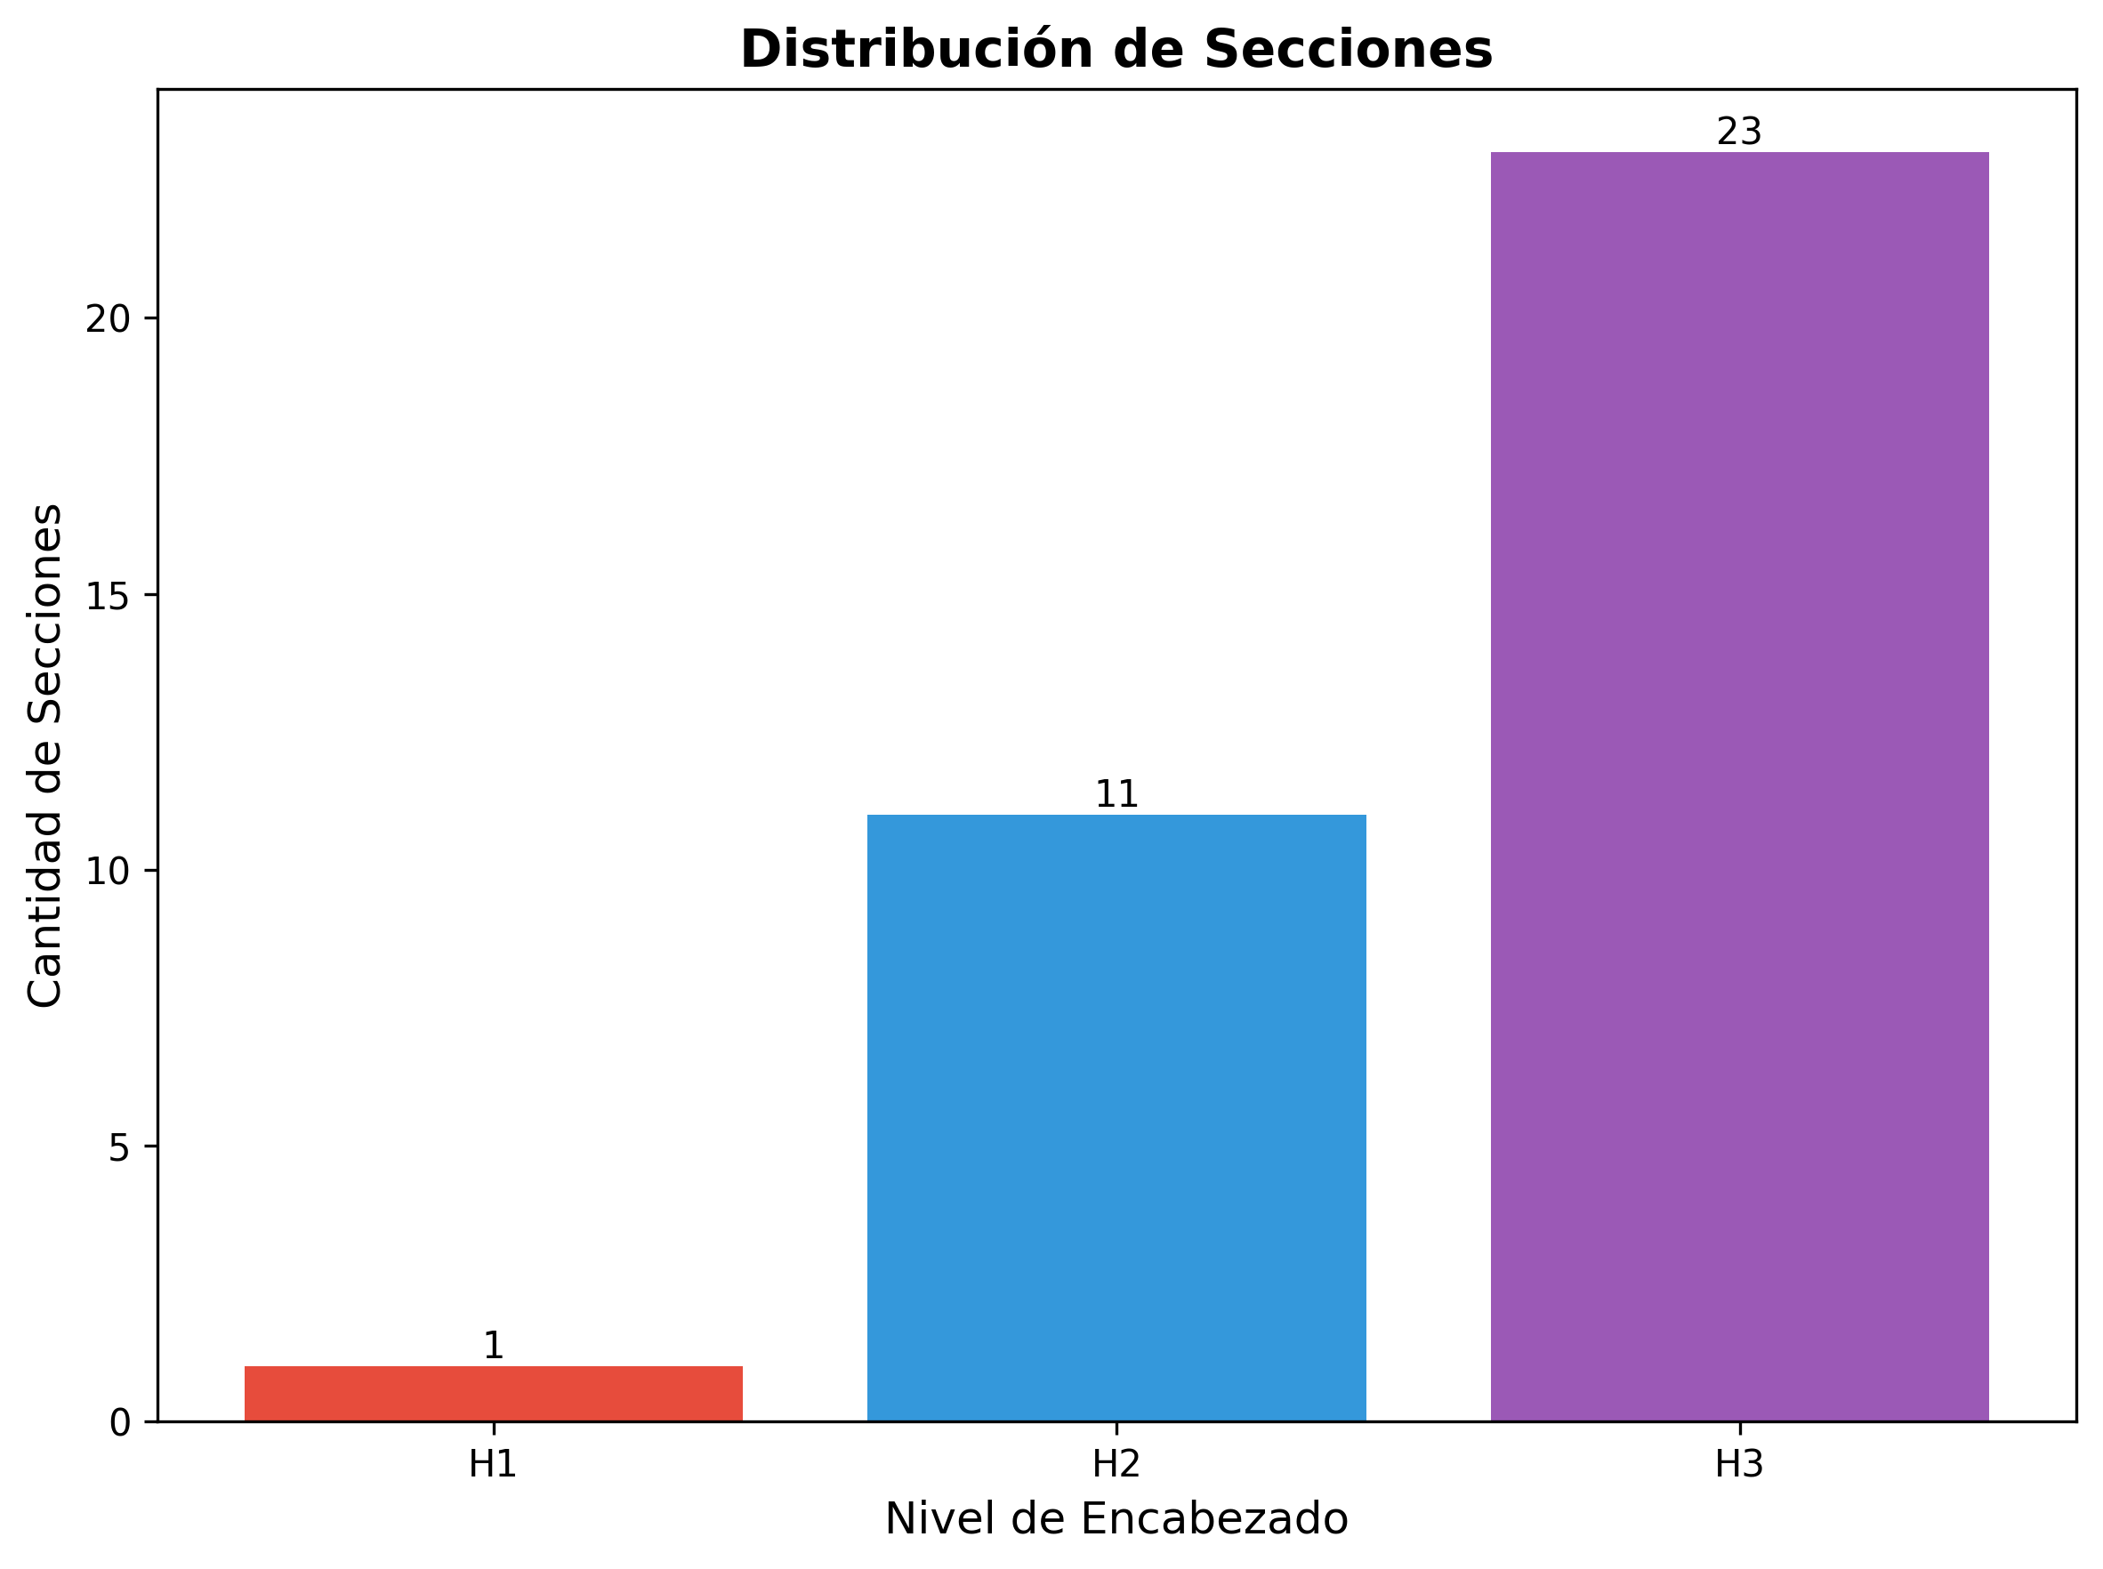

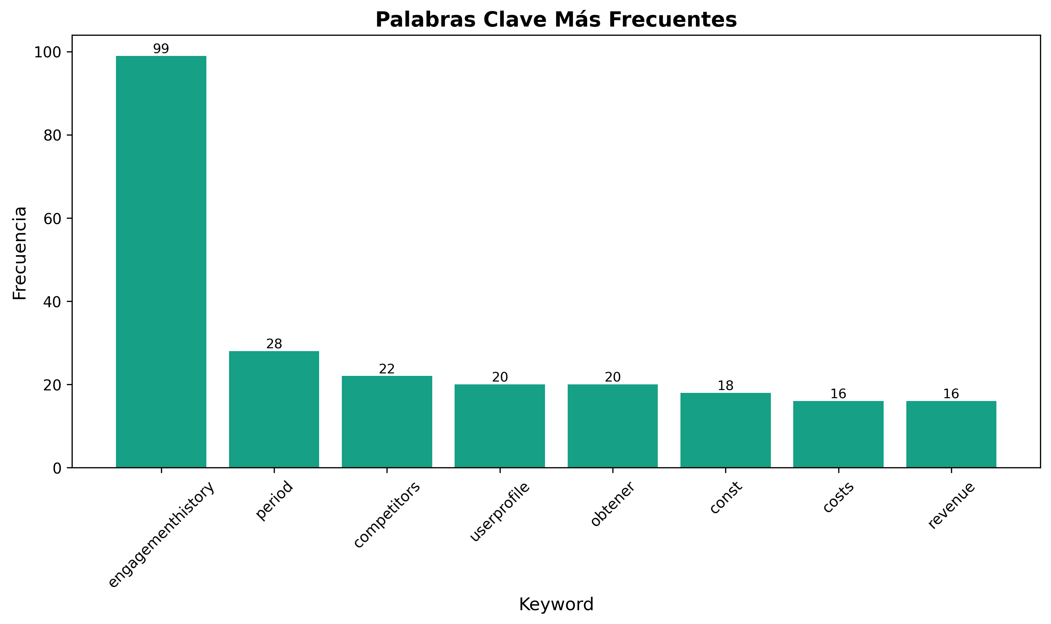

🏢 Mejoras Enterprise y Avanzadas

🎯 Sistema de Dashboard Web Interactivo

Funcionalidad
Dashboard web completo con visualizaciones en tiempo real:
- Métricas en tiempo real
- Gráficos interactivos
- Comparaciones visuales
- Exportación de datos
- Filtros avanzados

Implementación
`javascript
// Generate Dashboard Data API
function generateDashboardAPI(engagementHistory, predictions, trends) {
return {
endpoint: '/api/dashboard',
method: 'GET',
response: {
overview: {
totalVideos: engagementHistory.length,
totalEngagement: calculateTotal(engagementHistory),
avgEngagementRate: calculateAvg(engagementHistory),
viralVideos: countViral(engagementHistory),
successRate: calculateSuccessRate(engagementHistory),
lastUpdated: new Date().toISOString()
},
charts: {
engagementOverTime: generateTimeSeries(engagementHistory),
platformComparison: generatePlatformComparison(engagementHistory),
hashtagPerformance: generateHashtagChart(engagementHistory),
hourPerformance: generateHourChart(engagementHistory),
contentTypePerformance: generateContentTypeChart(engagementHistory)
},
insights: {
topPerforming: getTopPerforming(engagementHistory, 10),
underperforming: getUnderperforming(engagementHistory, 10),
recommendations: generateRecommendations(engagementHistory),
opportunities: identifyOpportunities(engagementHistory, trends)
},
predictions: {
nextVideo: predictions.nextVideo,
bestPlatform: predictions.bestPlatform,
optimalTiming: predictions.optimalTiming,
expectedEngagement: predictions.expectedEngagement
},
alerts: generateIntelligentAlerts(engagementHistory),
trends: {
emerging: trends.emerging,
hot: trends.hot,
declining: trends.declining
}
}
};
}
`

Componentes del Dashboard
1. Overview Cards
- Total videos publicados
- Total engagement acumulado
- Promedio engagement rate
- Contenido viral detectado
- Tasa de éxito
2. Gráficos Interactivos
- Engagement over time (línea)
- Platform comparison (barras)
- Hashtag performance (barras horizontales)
- Hour performance (heatmap)
- Content type performance (pie)
3. Tablas de Datos
- Top performing videos
- Underperforming videos
- Hashtags más exitosos
- Mejores horarios
4. Insights y Recomendaciones
- Recomendaciones accionables
- Oportunidades identificadas
- Alertas importantes
- Tendencias emergentes

🔍 Análisis de Competencia Avanzado

Funcionalidad
Análisis profundo de competidores:
- Monitoreo continuo de competidores
- Análisis de contenido exitoso
- Identificación de oportunidades
- Benchmarking automático
- Alertas de nuevas tendencias

Implementación
`javascript
// Advanced Competitor Analysis
async function analyzeCompetitorsAdvanced(keywords, platforms, depth = 'deep') {
const competitors = await identifyCompetitors(keywords);
const analysis = {
competitors: competitors.map(c => ({
name: c.name,
handle: c.handle,
followerCount: c.followers,
avgEngagementRate: c.avgEngagementRate,
contentFrequency: c.postsPerWeek,
bestPerformingContent: c.topPosts.slice(0, 5)
})),
contentAnalysis: {
topHashtags: analyzeCompetitorHashtags(competitors),
bestHours: analyzeCompetitorTiming(competitors),
contentTypes: analyzeCompetitorContentTypes(competitors),
captionPatterns: analyzeCompetitorCaptions(competitors),
videoLengths: analyzeCompetitorVideoLengths(competitors)
},
opportunities: {
hashtagsToTry: findNewHashtags(competitors),
optimalTiming: findOptimalTiming(competitors),
contentGaps: identifyContentGaps(competitors),
improvementAreas: identifyImprovementAreas(competitors)
},
benchmarking: {
yourPerformance: calculateYourPerformance(),
competitorAverage: calculateCompetitorAverage(competitors),
topCompetitor: findTopCompetitor(competitors),
gapAnalysis: calculateGapAnalysis(competitors)
},
alerts: {
newTrends: detectNewTrends(competitors),
competitorSuccess: detectCompetitorSuccess(competitors),
opportunities: identifyOpportunities(competitors)
}
};
return analysis;
}
`

📊 Sistema de Reportes Automáticos

Funcionalidad
Generación automática de reportes profesionales:
- Reportes diarios automáticos
- Reportes semanales detallados
- Reportes mensuales completos
- Reportes personalizados
- Exportación en múltiples formatos

Implementación
`javascript
// Auto-Generate Reports
function generateAutoReport(type, period, engagementHistory) {
const report = {
type: type, // 'daily', 'weekly', 'monthly', 'custom'
period: period,
generatedAt: new Date().toISOString(),
executiveSummary: {
totalVideos: countVideos(engagementHistory, period),
totalEngagement: calculateTotalEngagement(engagementHistory, period),
avgEngagementRate: calculateAvgEngagementRate(engagementHistory, period),
viralVideos: countViralVideos(engagementHistory, period),
bestPerformingVideo: getBestPerforming(engagementHistory, period),
keyInsights: generateKeyInsights(engagementHistory, period)
},
performanceMetrics: {
byPlatform: calculatePlatformMetrics(engagementHistory, period),
byContentType: calculateContentTypeMetrics(engagementHistory, period),
byTimeOfDay: calculateTimeMetrics(engagementHistory, period),
byDayOfWeek: calculateDayMetrics(engagementHistory, period),
trends: calculateTrends(engagementHistory, period)
},
topPerformers: {
videos: getTopVideos(engagementHistory, period, 10),
hashtags: getTopHashtags(engagementHistory, period, 20),
hours: getTopHours(engagementHistory, period, 5),
platforms: getTopPlatforms(engagementHistory, period)
},
recommendations: {
strategic: generateStrategicRecommendations(engagementHistory, period),
tactical: generateTacticalRecommendations(engagementHistory, period),
contentIdeas: generateContentIdeas(engagementHistory, period),
optimizationTips: generateOptimizationTips(engagementHistory, period)
},
comparisons: {
vsPreviousPeriod: comparePeriods(engagementHistory, period),
vsCompetitors: compareWithCompetitors(period),
vsBenchmarks: compareWithBenchmarks(period)
},
visualizations: {
charts: generateCharts(engagementHistory, period),
graphs: generateGraphs(engagementHistory, period),
tables: generateTables(engagementHistory, period)
}
};
// Exportar en múltiples formatos
exportReport(report, ['json', 'html', 'pdf', 'excel']);
return report;
}
`

🎯 Sistema de Recomendaciones Personalizado

Funcionalidad
Recomendaciones inteligentes personalizadas:
- Basadas en tu historial específico
- Adaptadas a tu nicho
- Considerando tus objetivos
- Aprendiendo de tus preferencias
- Optimizadas para tu audiencia

Implementación
`javascript
// Personalized Recommendations System
function generatePersonalizedRecommendations(userProfile, engagementHistory, goals) {
const recommendations = {
content: {
topics: suggestTopics(userProfile, engagementHistory, goals),
formats: suggestFormats(userProfile, engagementHistory, goals),
styles: suggestStyles(userProfile, engagementHistory, goals),
frequency: suggestFrequency(userProfile, engagementHistory, goals)
},
optimization: {
hashtags: suggestHashtags(userProfile, engagementHistory, goals),
timing: suggestTiming(userProfile, engagementHistory, goals),
platforms: suggestPlatforms(userProfile, engagementHistory, goals),
captions: suggestCaptionStyles(userProfile, engagementHistory, goals)
},
strategy: {
shortTerm: generateShortTermStrategy(userProfile, engagementHistory, goals),
longTerm: generateLongTermStrategy(userProfile, engagementHistory, goals),
experiments: suggestExperiments(userProfile, engagementHistory, goals),
pivots: suggestPivots(userProfile, engagementHistory, goals)
},
opportunities: {
trends: identifyTrendsForUser(userProfile, engagementHistory),
gaps: identifyContentGaps(userProfile, engagementHistory),
improvements: identifyImprovements(userProfile, engagementHistory),
collaborations: suggestCollaborations(userProfile, engagementHistory)
},
alerts: {
urgent: generateUrgentAlerts(userProfile, engagementHistory),
opportunities: generateOpportunityAlerts(userProfile, engagementHistory),
warnings: generateWarnings(userProfile, engagementHistory)
}
};
return recommendations;
}
`

💰 Análisis de ROI y Monetización

Funcionalidad
Análisis completo de ROI y oportunidades de monetización:
- Cálculo de ROI por video
- Análisis de costo por engagement
- Identificación de contenido más rentable
- Optimización de monetización
- Proyecciones financieras

Implementación
`javascript
// ROI and Monetization Analysis
function analyzeROIAndMonetization(engagementHistory, costs, revenue) {
const analysis = {
roi: {
perVideo: calculateROIPerVideo(engagementHistory, costs, revenue),
perPlatform: calculateROIPerPlatform(engagementHistory, costs, revenue),
perContentType: calculateROIPerContentType(engagementHistory, costs, revenue),
overall: calculateOverallROI(engagementHistory, costs, revenue)
},
costs: {
perVideo: calculateCostPerVideo(costs, engagementHistory.length),
perEngagement: calculateCostPerEngagement(costs, engagementHistory),
perPlatform: calculateCostPerPlatform(costs, engagementHistory),
breakdown: breakdownCosts(costs)
},
revenue: {
perVideo: calculateRevenuePerVideo(revenue, engagementHistory.length),
perEngagement: calculateRevenuePerEngagement(revenue, engagementHistory),
perPlatform: calculateRevenuePerPlatform(revenue, engagementHistory),
projections: projectRevenue(engagementHistory, revenue)
},
optimization: {
mostProfitableContent: identifyMostProfitable(engagementHistory, costs, revenue),
costReduction: suggestCostReductions(costs, engagementHistory),
revenueIncrease: suggestRevenueIncreases(revenue, engagementHistory),
efficiency: calculateEfficiency(engagementHistory, costs, revenue)
},
projections: {
nextMonth: projectNextMonth(engagementHistory, costs, revenue),
nextQuarter: projectNextQuarter(engagementHistory, costs, revenue),
scenarios: generateScenarios(engagementHistory, costs, revenue)
}
};
return analysis;
}
`

🗄️ Integración con Base de Datos

Funcionalidad
Almacenamiento persistente y análisis avanzado:
- Guardado en base de datos
- Consultas avanzadas
- Análisis histórico profundo
- Backup automático
- Sincronización

Implementación
`javascript
// Database Integration
async function integrateWithDatabase(engagementHistory, dbConfig) {
const db = await connectDatabase(dbConfig);
// Guardar engagement history
await db.engagementHistory.insertMany(engagementHistory);
// Guardar métricas calculadas
const metrics = calculateAllMetrics(engagementHistory);
await db.metrics.insertOne({
date: new Date(),
metrics: metrics,
calculatedAt: new Date()
});
// Guardar predicciones
const predictions = generatePredictions(engagementHistory);
await db.predictions.insertOne({
date: new Date(),
predictions: predictions,
confidence: calculateConfidence(predictions)
});
// Guardar recomendaciones
const recommendations = generateRecommendations(engagementHistory);
await db.recommendations.insertOne({
date: new Date(),
recommendations: recommendations,
priority: 'high'
});
// Consultas avanzadas
const advancedQueries = {
topVideosByPeriod: await db.engagementHistory.find({
publishedAt: { $gte: periodStart, $lte: periodEnd }
}).sort({ 'overallMetrics.avgEngagementRate': -1 }).limit(10),
hashtagPerformance: await db.engagementHistory.aggregate([
{ $unwind: '$hashtags' },
{ $group: {
_id: '$hashtags',
avgEngagementRate: { $avg: '$overallMetrics.avgEngagementRate' },
count: { $sum: 1 }
}},
{ $sort: { avgEngagementRate: -1 }},
{ $limit: 20 }
]),
platformComparison: await db.engagementHistory.aggregate([
{ $unwind: '$platformMetrics' },
{ $group: {
_id: '$platformMetrics.platform',
avgEngagementRate: { $avg: '$platformMetrics.engagementRate' },
totalEngagement: { $sum: '$platformMetrics.engagementTotal' }
}}
])
};
return {
saved: true,
queries: advancedQueries
};
}
`

🔌 API REST Completa

Funcionalidad
API REST completa para acceso externo:
- Endpoints para todas las funcionalidades
- Autenticación y autorización
- Rate limiting
- Documentación completa
- Webhooks

Endpoints Principales
`javascript
// REST API Endpoints
const apiEndpoints = {
// Engagement
'GET /api/engagement': 'Obtener historial de engagement',
'GET /api/engagement/:videoId': 'Obtener engagement de video específico',
'POST /api/engagement/track': 'Iniciar tracking de video',
// Analytics
'GET /api/analytics/overview': 'Obtener overview de analytics',
'GET /api/analytics/platforms': 'Obtener analytics por plataforma',
'GET /api/analytics/hashtags': 'Obtener analytics de hashtags',
'GET /api/analytics/timing': 'Obtener analytics de timing',
// Predictions
'POST /api/predictions/engagement': 'Predecir engagement',
'GET /api/predictions/best-platform': 'Obtener mejor plataforma',
'GET /api/predictions/optimal-timing': 'Obtener timing óptimo',
// Recommendations
'GET /api/recommendations': 'Obtener recomendaciones',
'GET /api/recommendations/hashtags': 'Obtener recomendaciones de hashtags',
'GET /api/recommendations/timing': 'Obtener recomendaciones de timing',
// Trends
'GET /api/trends/emerging': 'Obtener tendencias emergentes',
'GET /api/trends/hot': 'Obtener tendencias calientes',
'GET /api/trends/declining': 'Obtener tendencias en declive',
// Reports
'GET /api/reports/daily': 'Obtener reporte diario',
'GET /api/reports/weekly': 'Obtener reporte semanal',
'GET /api/reports/monthly': 'Obtener reporte mensual',
'POST /api/reports/custom': 'Generar reporte personalizado',
// Competitors
'GET /api/competitors': 'Obtener análisis de competidores',
'POST /api/competitors/analyze': 'Analizar competidores',
'GET /api/competitors/benchmark': 'Obtener benchmarking',
// Alerts
'GET /api/alerts': 'Obtener alertas',
'POST /api/alerts/subscribe': 'Suscribirse a alertas',
'DELETE /api/alerts/:alertId': 'Eliminar alerta',
// Webhooks
'POST /api/webhooks': 'Crear webhook',
'GET /api/webhooks': 'Listar webhooks',
'DELETE /api/webhooks/:webhookId': 'Eliminar webhook'
};
`

🤖 Automatización de Acciones

Funcionalidad
Acciones automáticas basadas en alertas:
- Optimización automática cuando detecta bajo performance
- Publicación automática cuando detecta oportunidad
- Ajuste automático de estrategia
- Respuesta automática a tendencias

Implementación
`javascript
// Automated Actions System
function executeAutomatedActions(alerts, engagementHistory, config) {
const actions = [];
alerts.forEach(alert => {
switch(alert.type) {
case 'low_performance':
if (config.autoOptimize) {
actions.push({
type: 'optimize_hashtags',
videoId: alert.videoId,
action: 'replace_with_top_hashtags',
priority: 'high'
});
}
break;
case 'trending_opportunity':
if (config.autoPublish) {
actions.push({
type: 'schedule_content',
content: generateTrendingContent(alert.trends),
priority: 'high',
timing: 'immediate'
});
}
break;
case 'viral_content':
if (config.autoReplicate) {
actions.push({
type: 'create_similar_content',
basedOn: alert.videoId,
action: 'analyze_and_replicate_patterns',
priority: 'high'
});
}
break;
case 'improvement_opportunity':
if (config.autoImprove) {
actions.push({
type: 'apply_improvements',
improvements: alert.recommendations,
priority: 'medium'
});
}
break;
}
});
// Ejecutar acciones
actions.forEach(action => {
executeAction(action);
});
return {
actionsExecuted: actions.length,
actions: actions
};
}
`

📱 Integración con Múltiples Plataformas

Funcionalidad
Integración extendida con más plataformas:
- LinkedIn
- Twitter/X
- Facebook
- Pinterest
- Snapchat
- Reddit

Implementación
`javascript
// Extended Platform Integration
const platformIntegrations = {
linkedin: {
upload: async (video, caption, hashtags) => {
// Implementar upload a LinkedIn
},
getMetrics: async (postId) => {
// Implementar obtención de métricas
}
},
twitter: {
upload: async (video, caption, hashtags) => {
// Implementar upload a Twitter
},
getMetrics: async (tweetId) => {
// Implementar obtención de métricas
}
},
facebook: {
upload: async (video, caption, hashtags) => {
// Implementar upload a Facebook
},
getMetrics: async (postId) => {
// Implementar obtención de métricas
}
},
pinterest: {
upload: async (video, caption, hashtags) => {
// Implementar upload a Pinterest
},
getMetrics: async (pinId) => {
// Implementar obtención de métricas
}
}
};
`

🎓 Sistema de Aprendizaje Continuo

Funcionalidad
Sistema que aprende y mejora continuamente:
- Actualización automática de modelos
- Aprendizaje de nuevos patrones
- Adaptación a cambios en plataformas
- Mejora continua de predicciones

Implementación
`javascript
// Continuous Learning System
function continuousLearning(engagementHistory, learningConfig) {
// Recalcular modelos periódicamente
const models = {
hashtagModel: retrainHashtagModel(engagementHistory),
timingModel: retrainTimingModel(engagementHistory),
contentModel: retrainContentModel(engagementHistory),
engagementModel: retrainEngagementModel(engagementHistory)
};
// Actualizar predicciones
const updatedPredictions = updatePredictions(models, engagementHistory);
// Identificar nuevos patrones
const newPatterns = identifyNewPatterns(engagementHistory);
// Ajustar recomendaciones
const adjustedRecommendations = adjustRecommendations(
engagementHistory,
newPatterns,
models
);
// Guardar aprendizaje
saveLearning({
models: models,
patterns: newPatterns,
updatedAt: new Date(),
accuracy: calculateAccuracy(models, engagementHistory)
});
return {
modelsUpdated: true,
newPatterns: newPatterns.length,
accuracy: calculateAccuracy(models, engagementHistory)
};
}
`

🔐 Seguridad y Compliance

Funcionalidad
Seguridad avanzada y cumplimiento:
- Encriptación de datos
- Autenticación robusta
- Auditoría completa
- Cumplimiento GDPR
- Backup seguro

Implementación
`javascript
// Security and Compliance
const securityFeatures = {
encryption: {
dataAtRest: encryptDataAtRest(),
dataInTransit: useTLS(),
sensitiveFields: encryptSensitiveFields()
},
authentication: {
method: 'OAuth2 + JWT',
mfa: enableMFA(),
sessionManagement: secureSessionManagement()
},
audit: {
logAllActions: true,
trackDataAccess: true,
monitorAnomalies: true
},
compliance: {
gdpr: implementGDPR(),
dataRetention: implementDataRetention(),
userRights: implementUserRights()
},
backup: {
frequency: 'daily',
retention: '90 days',
encryption: true,
offsite: true
}
};
`
---
Estado: 📋 Diseño completo, listo para implementar
Complejidad: Muy Alta
Tiempo de Desarrollo: 1-2 semanas
ROI: Extremadamente Alto
Escalabilidad: Enterprise-ready

