Cleanup Summary
Análisis y Documentación Completa
Generado el: 25 de November de 2025 a las 11:59

📊 Análisis Visual Completo

Dashboard Principal
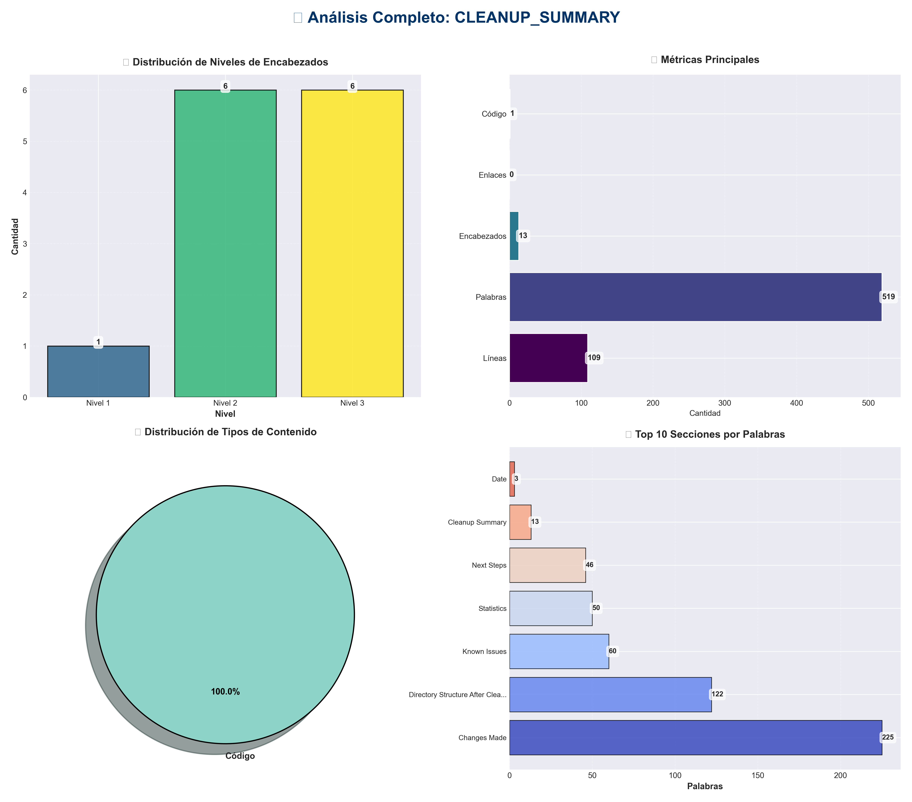

Análisis Adicionales
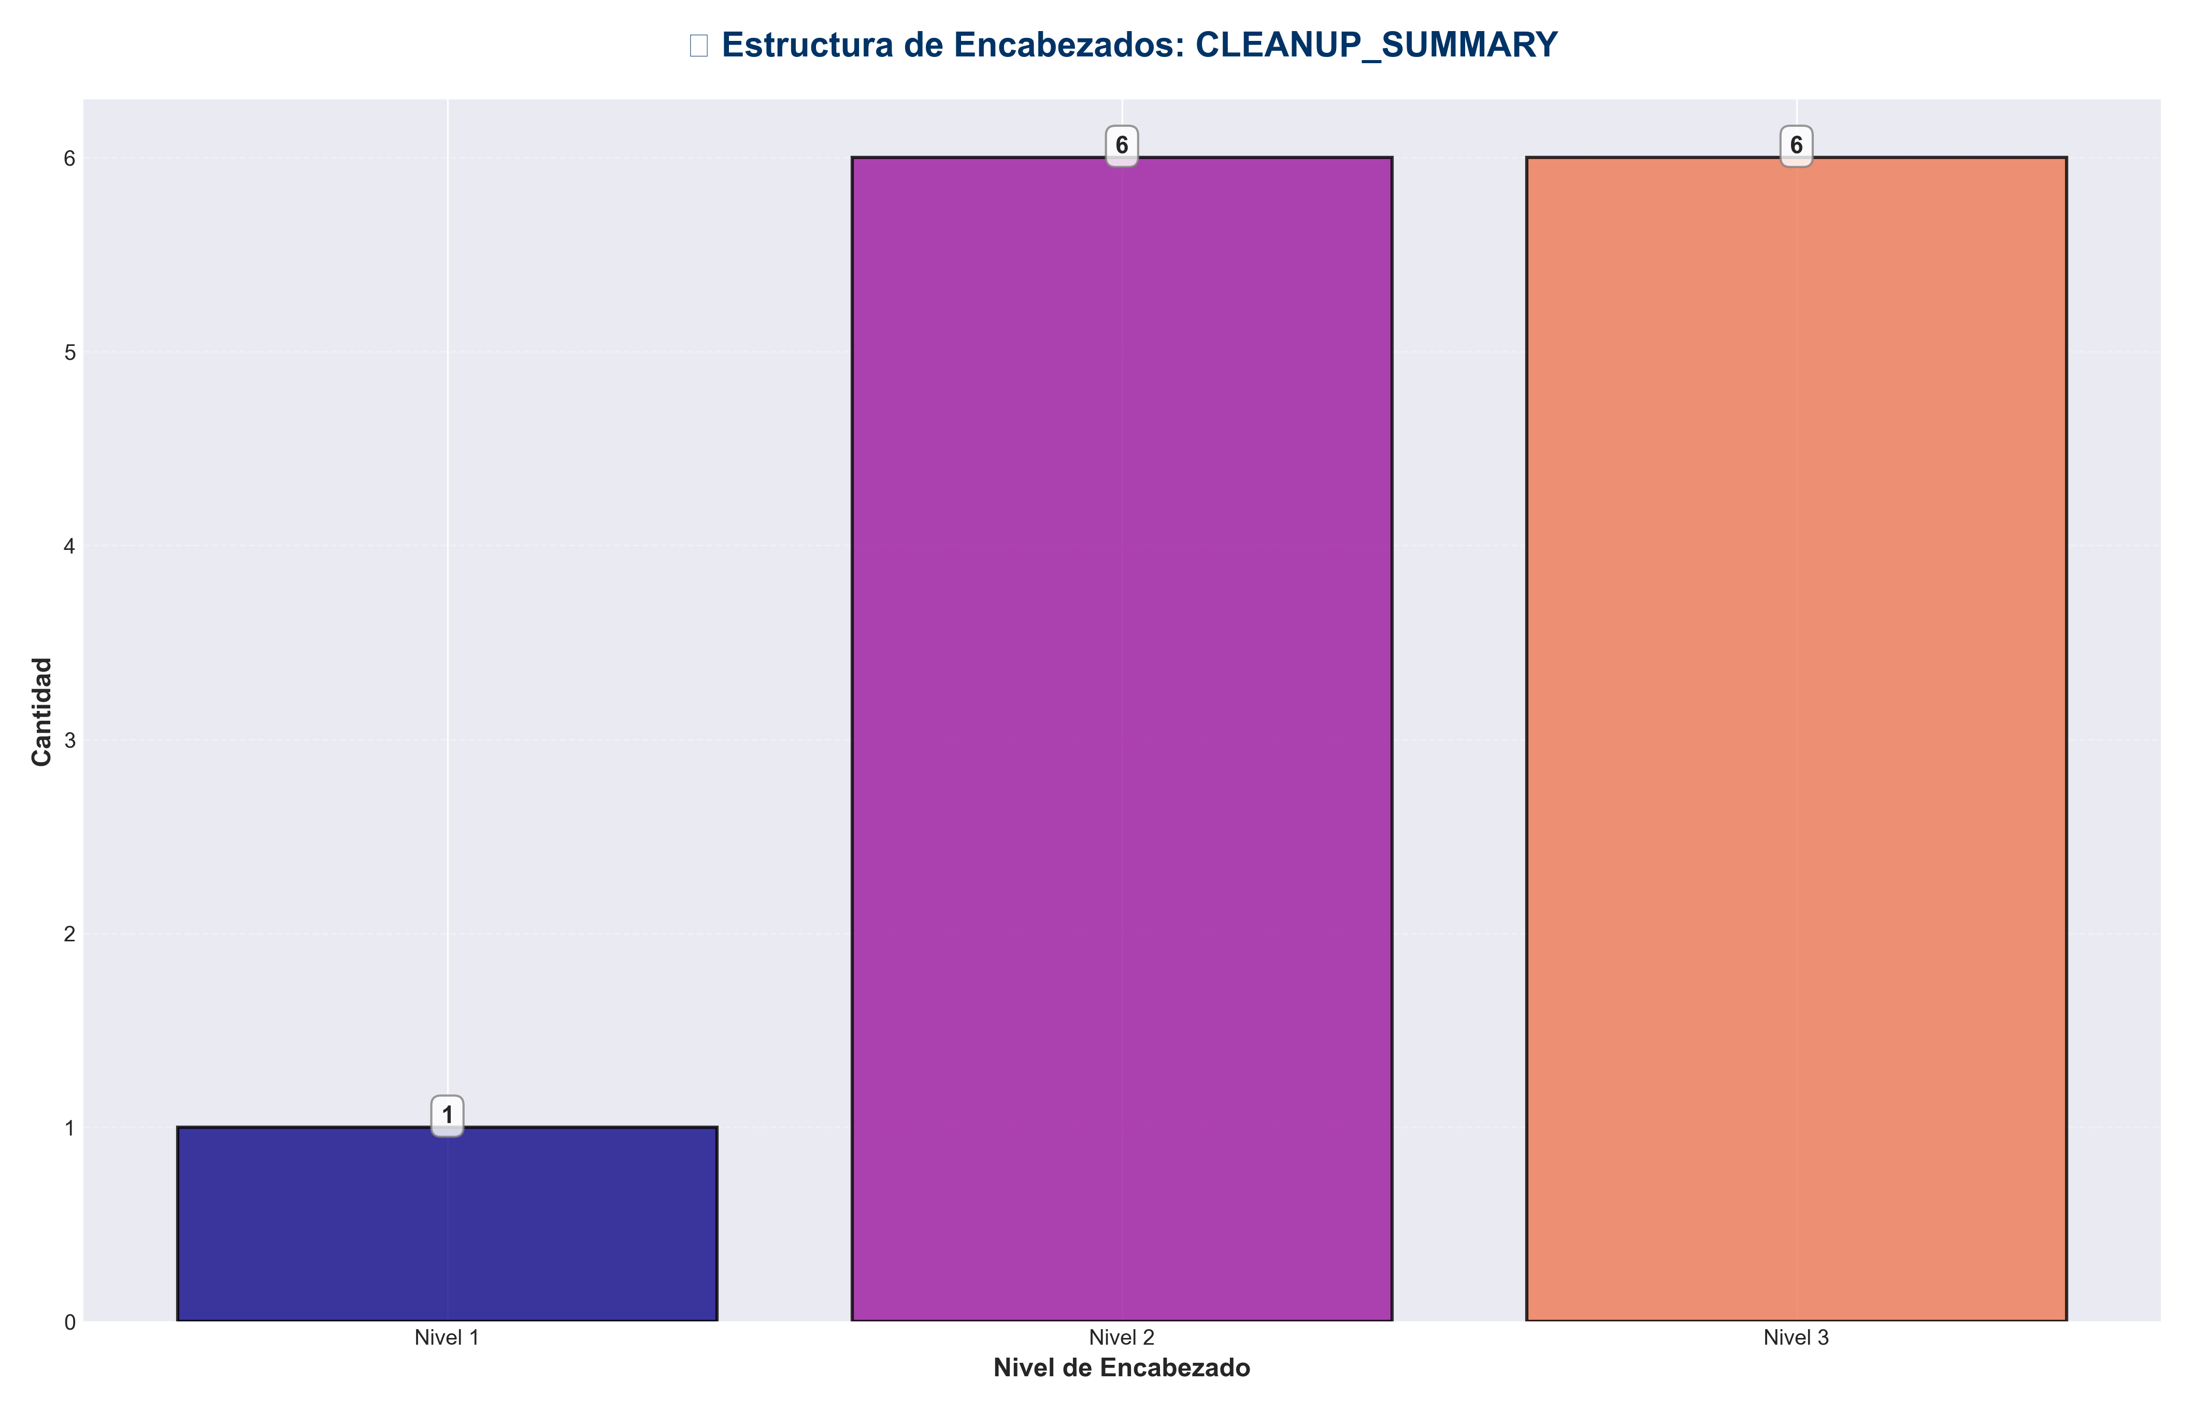

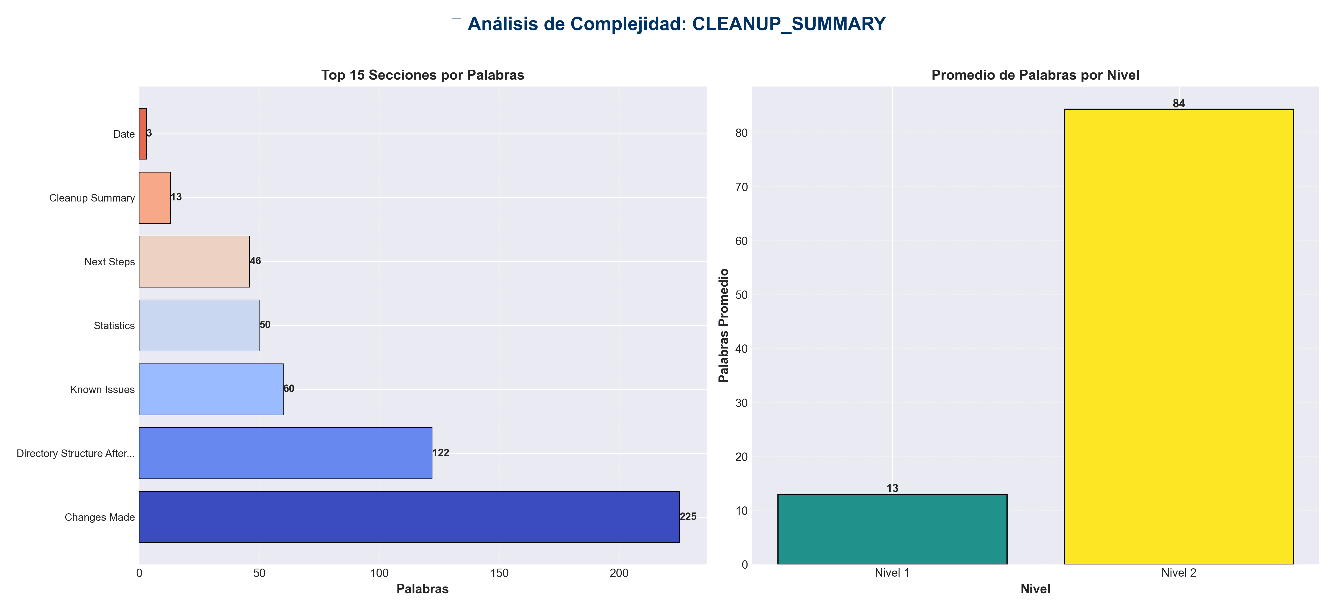

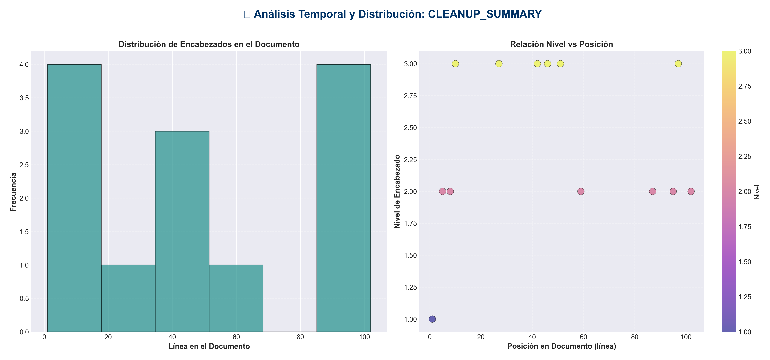

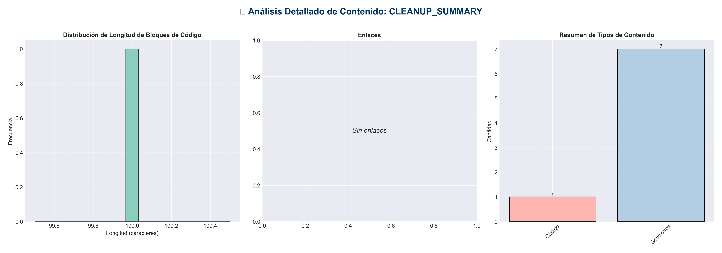

📊 Estadísticas del Documento
Resumen Ejecutivo: Este documento contiene 519 palabras distribuidas en 109 líneas, con 13 encabezados organizados en 7 secciones principales.

Métrica | Valor
Total de líneas | 109
Total de palabras | 519
Total de caracteres | 4,194
Encabezados | 13
Bloques de código | 1
Tablas | 0
Enlaces | 0
Imágenes | 0
Secciones principales | 7

📑 Índice de Secciones
Nivel | Título | Línea
1 | Cleanup Summary | 1
2 | Date | 5
2 | Changes Made | 8
2 | Directory Structure After Cleanup | 59
2 | Statistics | 87
2 | Known Issues | 95
2 | Next Steps | 102

📄 Contenido

Cleanup Summary

This document summarizes the cleanup performed on the production_code directory.

Date
2025-01-27

Changes Made

1. Documentation Organization
- - Created `docs/` directory for organized documentation
- - Created `docs/archive/` for old/redundant documentation
- - Moved 27 redundant markdown files to archive:
- - 14 REFACTORING_*.md files (kept only REFACTORING_ABSOLUTE_FINAL.md)
- - 5 MEJORAS_V*.md files (kept only MEJORAS_V6.md)
- - 2 RESUMEN_*.md files (kept RESUMEN_FINAL_COMPLETO.md and RESUMEN_COMPLETO_MEJORAS.md)
- - Moved remaining markdown files from root to docs/:
- - API_README.md
- - RESUMEN_ULTIMO.md
- - MEJORAS_MODULOS_V2.md
- - Organized active documentation in `docs/`:
- - Feature documentation (CHAT_README.md, MONITORING_README.md, etc.)
- - Improvement docs (MEJORAS_V6.md, etc.)
- - Summary docs (RESUMEN_FINAL_COMPLETO.md, etc.)
- - Reference docs (CATEGORIAS_COMPLETAS.md, etc.)

2. Example Files Organization
- - Created `examples/` directory
- - Moved 11 example files to `examples/`:
- - example_advanced_usage.py
- - example_analysis.py
- - example_chat.py
- - example_checkpointing_quality.py
- - example_config.py
- - example_integrated.py
- - example_migration.py
- - example_monitoring.py
- - example_usage_improved.py
- - example_usage.py
- - example_video_generation.py

3. File Cleanup
- - Removed Python cache files (__pycache__ directories, *.pyc files)
- - Removed backup files (*.py~)

4. Documentation Updates
- - Updated README.md to reflect new structure
- - Created docs/README.md as documentation index
- - Updated references to moved documentation files

5. Files Kept (Not Duplicates)
- - `cli.py` and `cli_unified.py` - Both serve different purposes:
- - `cli.py`: Simple CLI with Click for basic operations
- - `cli_unified.py`: Comprehensive unified CLI for all modules
- - `api_server.py` and `api_unified.py` - Both needed:
- - `api_server.py`: Simple wrapper to start the API server
- - `api_unified.py`: Full API implementation

Directory Structure After Cleanup

production_code/
├── docs/ # Organized documentation
│ ├── README.md # Documentation index
│ ├── archive/ # Old/redundant docs
│ └── [active docs] # Current documentation
├── examples/ # Example scripts
│ └── example_*.py
├── core/ # Core modules
├── research/ # Research modules
├── inference/ # Inference modules
├── memory/ # Memory modules
├── techniques/ # Technique modules
├── best/ # Best models
├── code/ # Code-related modules
├── redundancy/ # Redundancy modules
├── architecture/ # Architecture modules
├── multimodal_api/ # Multimodal API
├── sora/ # Sora module
├── model_data/ # Model data management
├── static/ # Static files
├── tests/ # Tests
├── [main scripts] # Main entry points
└── README.md # Main documentation

Statistics

- - **Files Archived**: 27 markdown files
- - **Files Organized**: 11 example files + 3 additional markdown files moved to docs/
- - **Directories Created**: 2 (docs/, examples/)
- - **Cache Files Removed**: All __pycache__ and *.pyc files
- - **Root Directory**: Reduced from 73+ markdown files to 2 (README.md and CLEANUP_SUMMARY.md)

Known Issues

Pre-existing Issue
There is a naming conflict between the `code/` directory and Python's built-in `code` module. This causes import issues when torch tries to import the built-in `code` module. This is a pre-existing issue and not caused by the cleanup.

- **Recommendation**: Consider renaming the `code/` directory to something like `code_modules/` or `code_models/` to avoid this conflict.

Next Steps

1. Consider renaming `code/` directory to avoid Python built-in conflict
2. Review archived documentation and delete truly obsolete files if needed
3. Update any external references to moved files
4. Consider adding a .gitignore entry for Python cache files if not already present

