Code Cleanup Summary
Análisis y Documentación Completa
Generado el: 25 de November de 2025 a las 11:59

📊 Análisis Visual Completo

Dashboard Principal
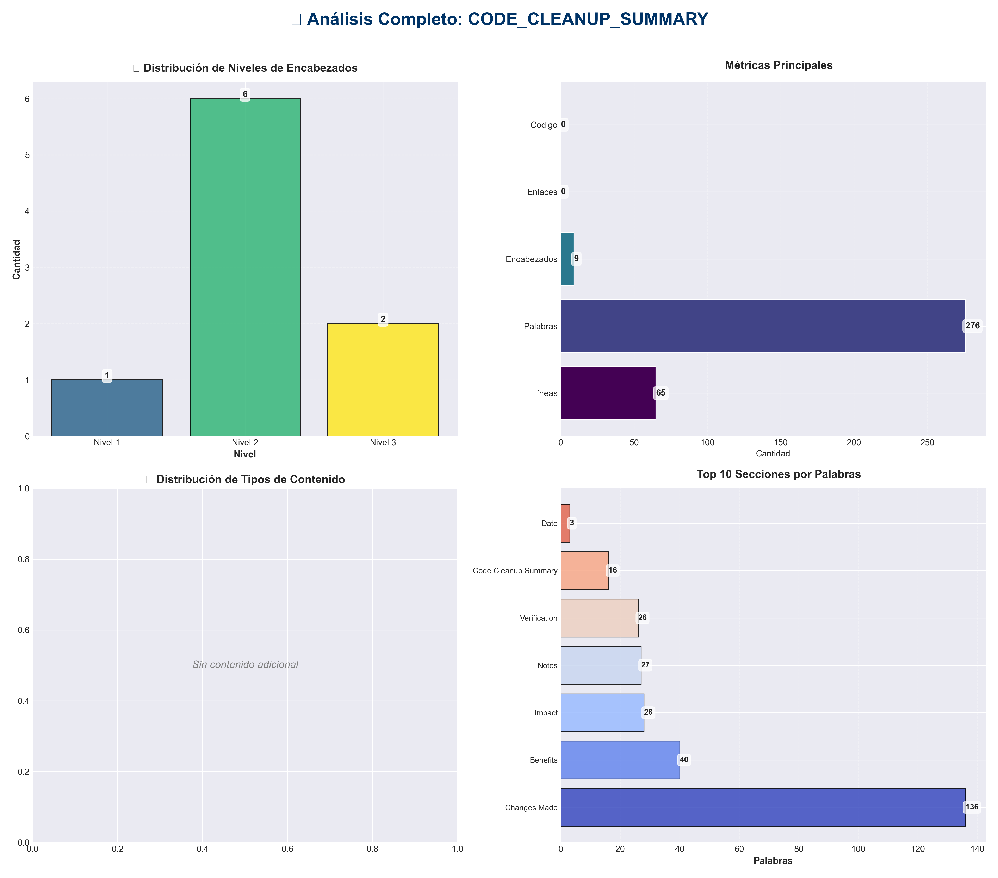

Análisis Adicionales
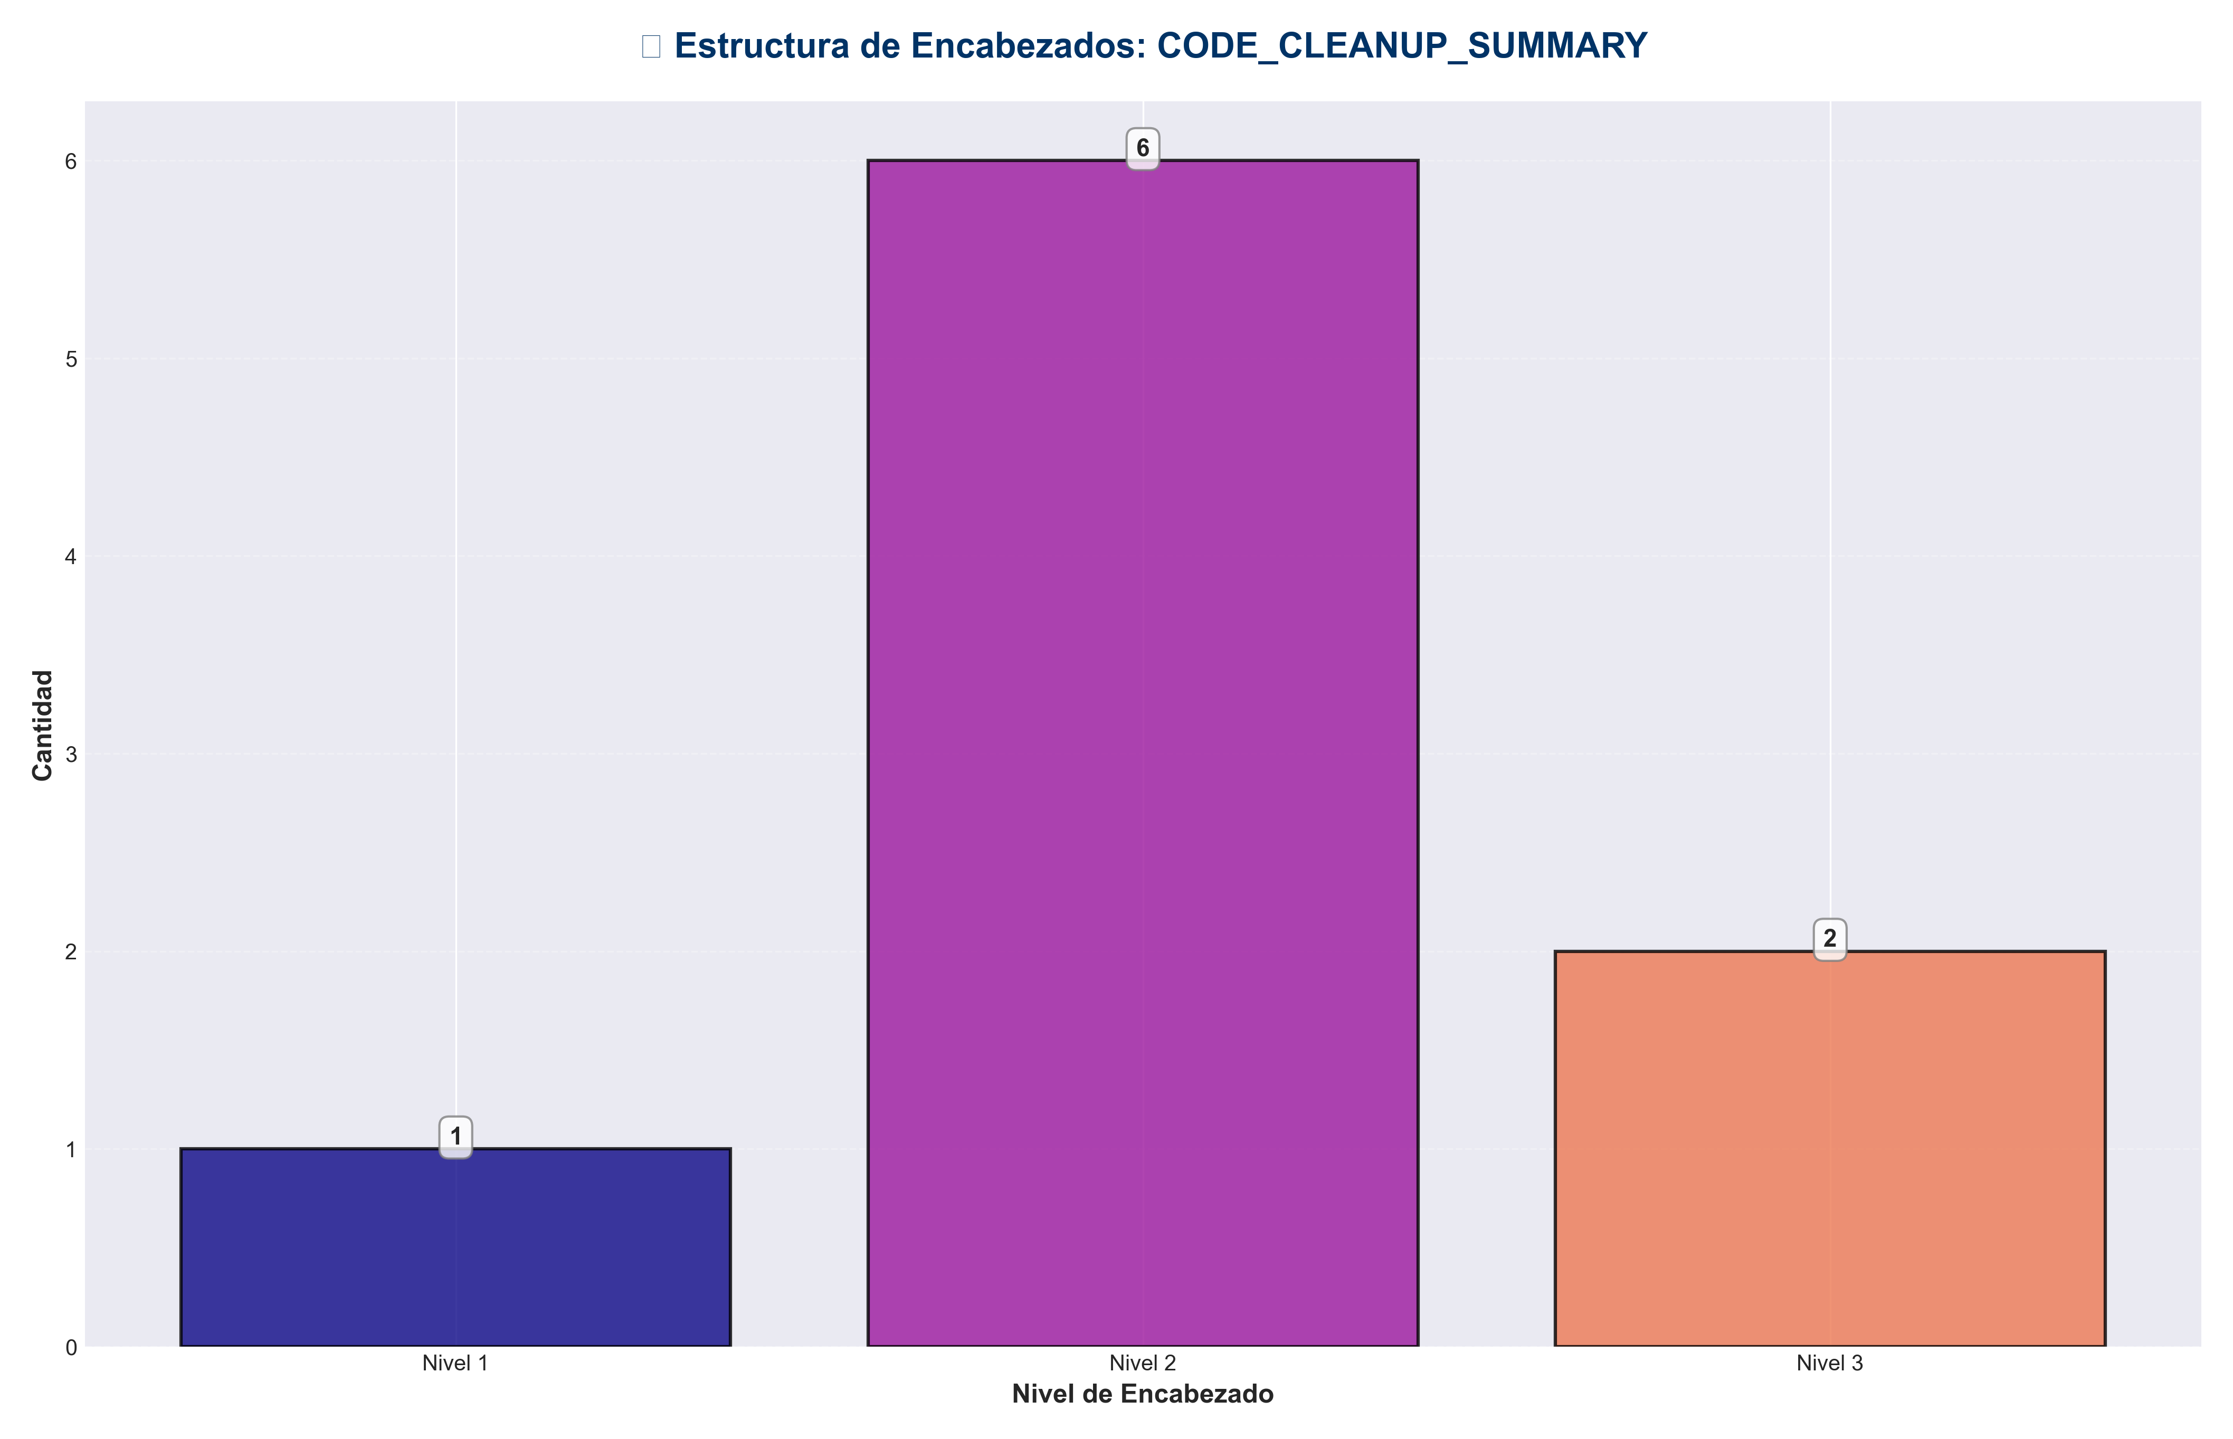

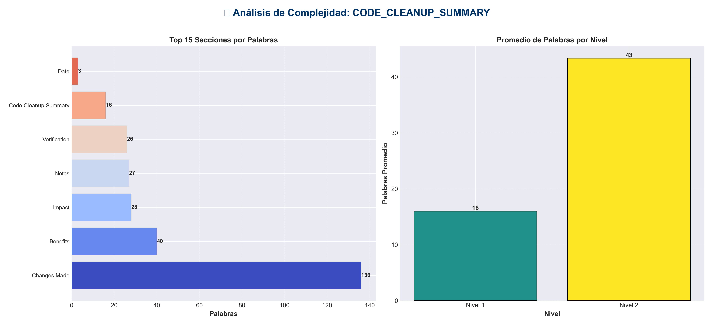

📊 Estadísticas del Documento
Resumen Ejecutivo: Este documento contiene 276 palabras distribuidas en 65 líneas, con 9 encabezados organizados en 7 secciones principales.

Métrica | Valor
Total de líneas | 65
Total de palabras | 276
Total de caracteres | 1,975
Encabezados | 9
Bloques de código | 0
Tablas | 0
Enlaces | 0
Imágenes | 0
Secciones principales | 7

📑 Índice de Secciones
Nivel | Título | Línea
1 | Code Cleanup Summary | 1
2 | Date | 5
2 | Changes Made | 8
2 | Impact | 36
2 | Benefits | 43
2 | Verification | 50
2 | Notes | 57

📄 Contenido

Code Cleanup Summary

This document summarizes the code quality cleanup performed on the production_code directory.

Date
2025-01-27

Changes Made

1. Removed Unused Imports

Removed unused `os` imports from the following files:

- - **`redundancy/redundancy_gpu.py`**
- - Removed: `import os` (line 14)
- - Reason: `os` module was imported but never used in the file

- - **`core/utils.py`**
- - Removed: `import os` (line 20)
- - Reason: `os` module was imported but never used in the file

- - **`multimodal_api/backup_recovery.py`**
- - Removed: `import os` (line 12)
- - Reason: `os` module was imported but never used in the file

2. Verified Active Imports

Confirmed that `os` imports are correctly used in:
- - `chat_server.py` - Uses `os.getenv()` for environment variables
- - `examples/example_chat.py` - Uses `os.getenv()` for API keys
- - `core/chat_api.py` - Uses `os.getenv()` for configuration
- - `core/config_manager.py` - Uses `os.getenv()` for environment variables
- - `multimodal_api/config.py` - Uses `os.getenv()` extensively for configuration
- - `improve_models.py` - Uses `os.walk()` for directory traversal

Impact

- - **Files Modified**: 3
- - **Unused Imports Removed**: 3
- - **Code Quality**: Improved by removing dead imports
- - **Compilation**: All files compile successfully (verified with `py_compile`)

Benefits

1. **Cleaner Code**: Removed unnecessary imports improve code readability
2. **Faster Imports**: Fewer imports mean slightly faster module loading
3. **Better Maintainability**: Clearer dependencies make code easier to understand
4. **Linter Compliance**: Removes warnings from static analysis tools

Verification

All modified files were verified to:
- - ✅ Compile without syntax errors
- - ✅ Pass linting checks
- - ✅ Maintain functionality (no breaking changes)

Notes

- - All changes were non-breaking
- - No functional code was modified
- - Only unused imports were removed
- - All active imports were verified before removal

