Guia Uso Utilidades
Análisis y Documentación Completa
Generado el: 25 de November de 2025 a las 11:41

📊 Análisis Visual Completo

Dashboard Principal
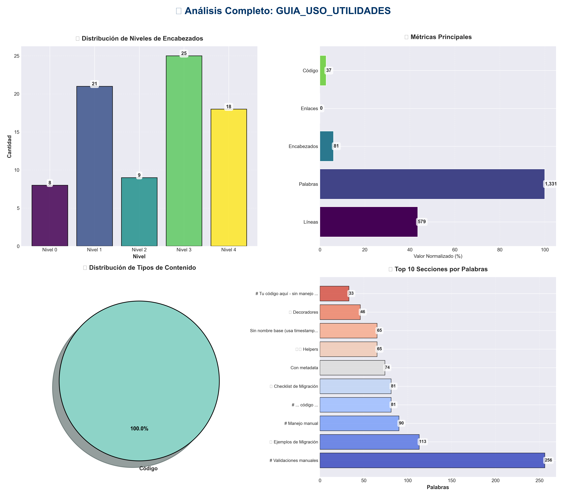

Análisis Adicionales
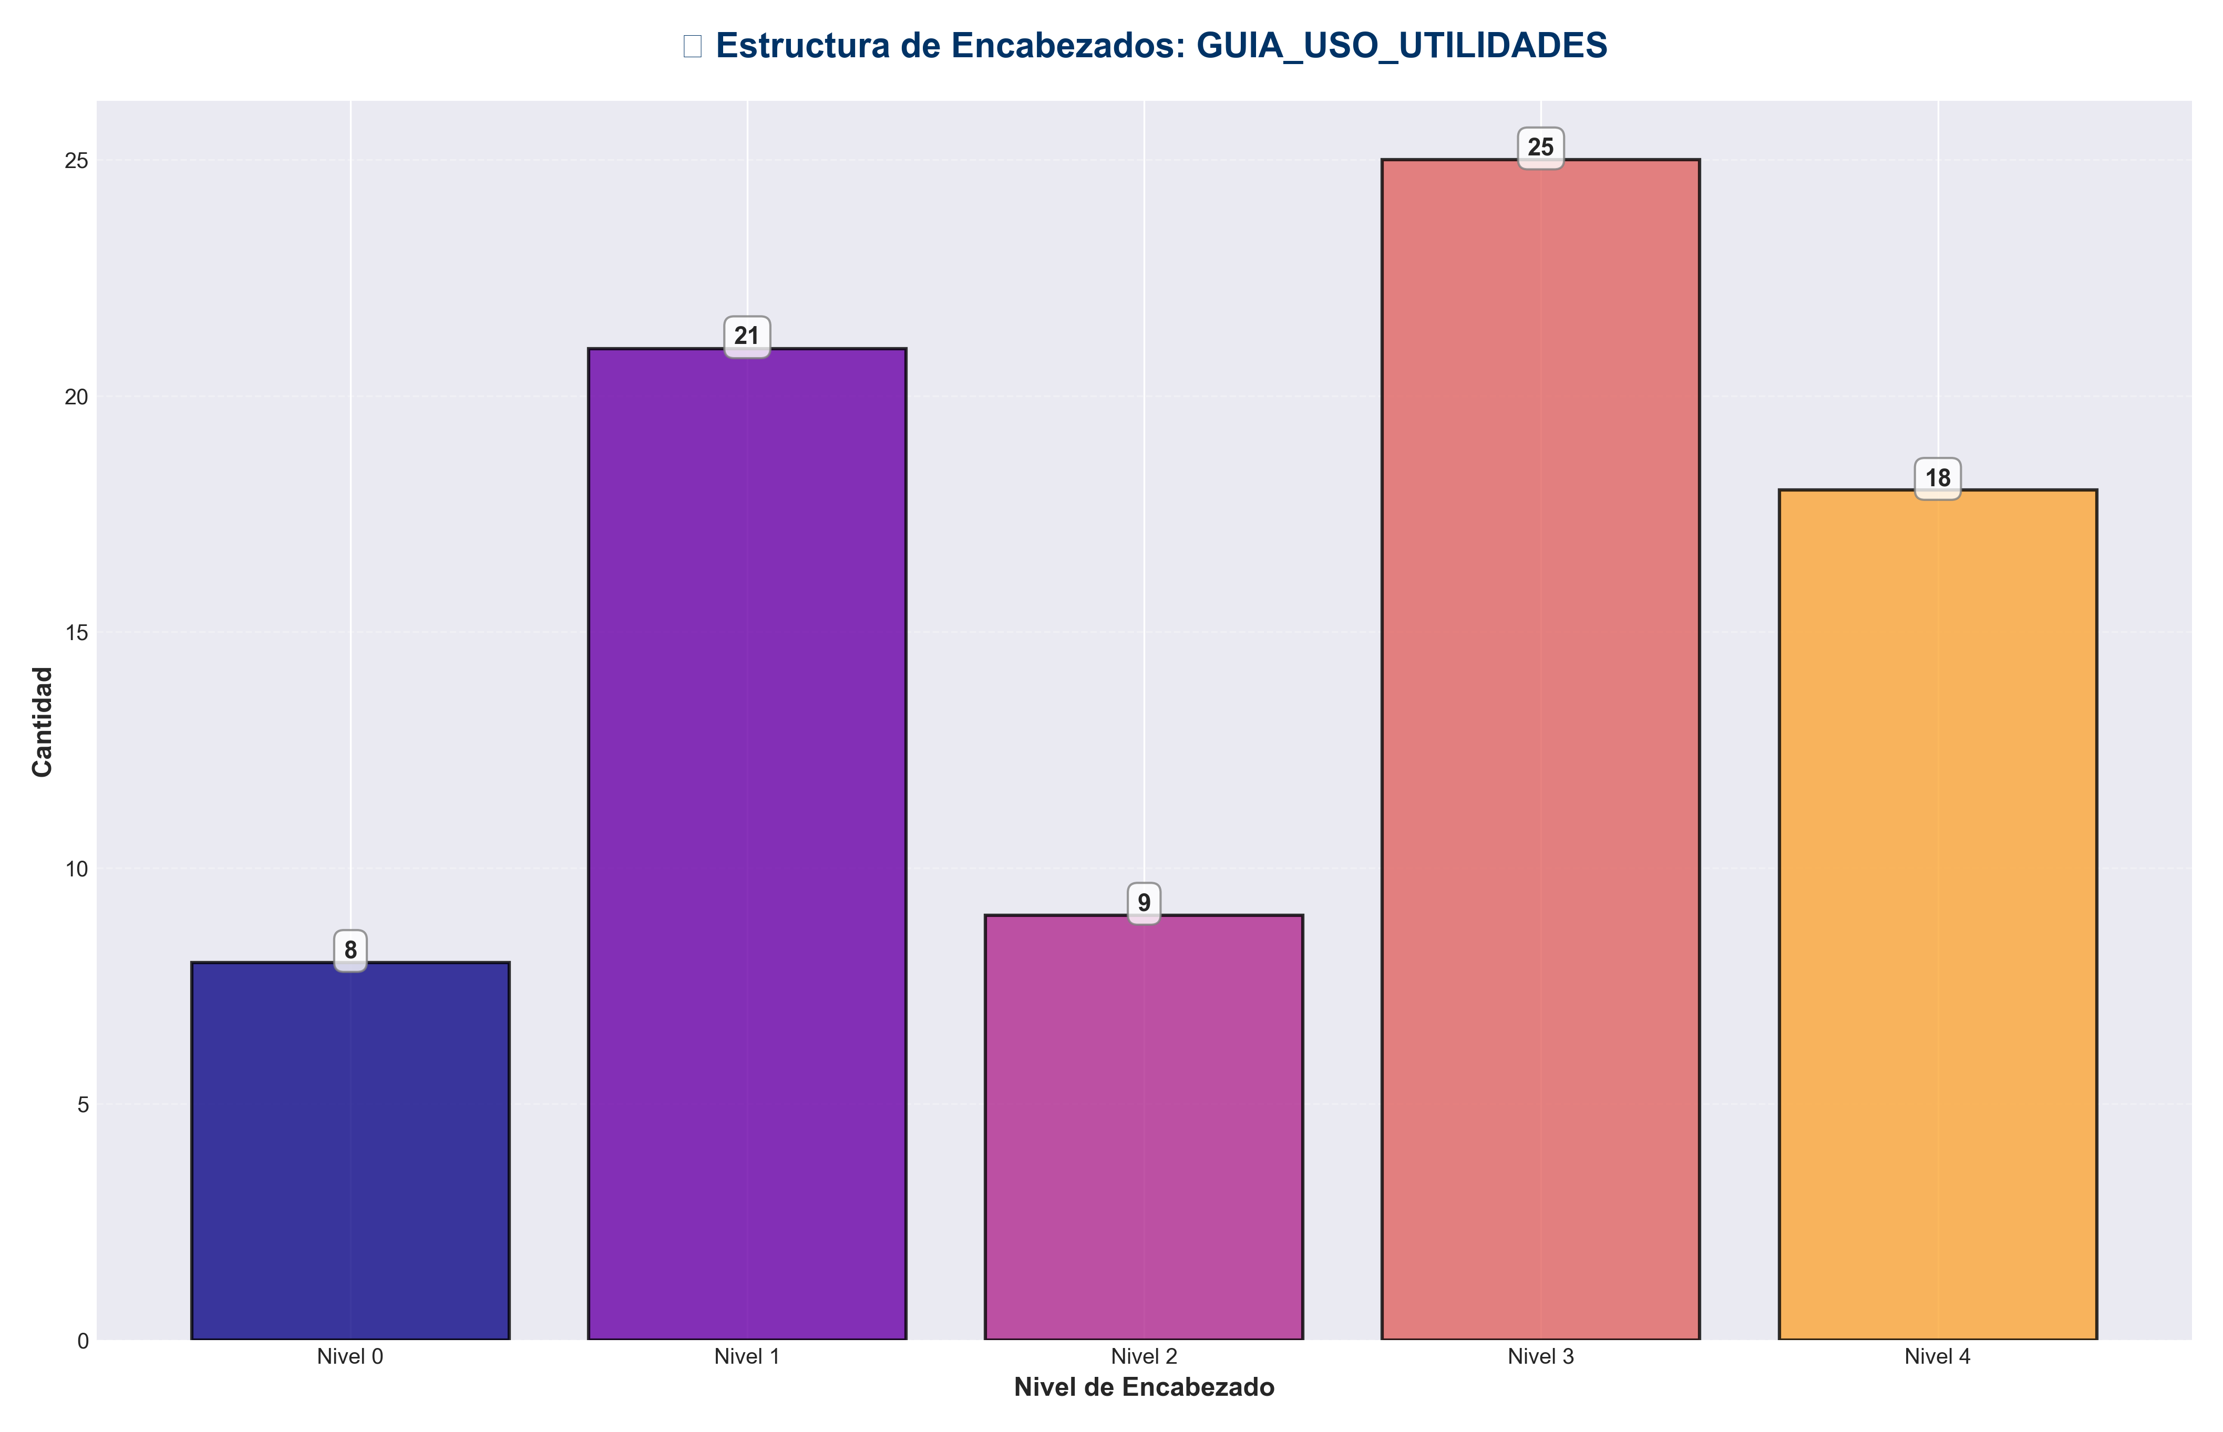

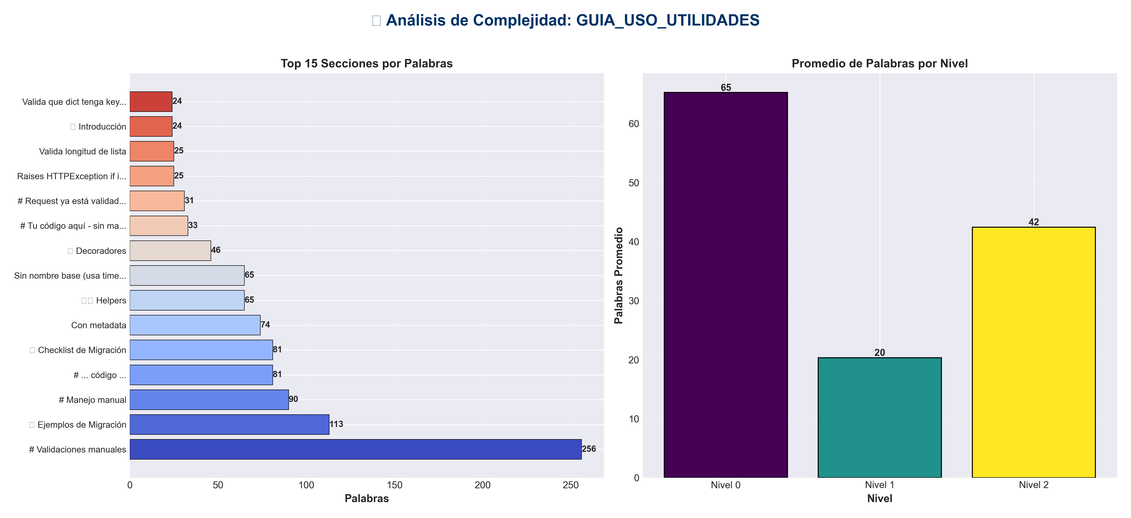

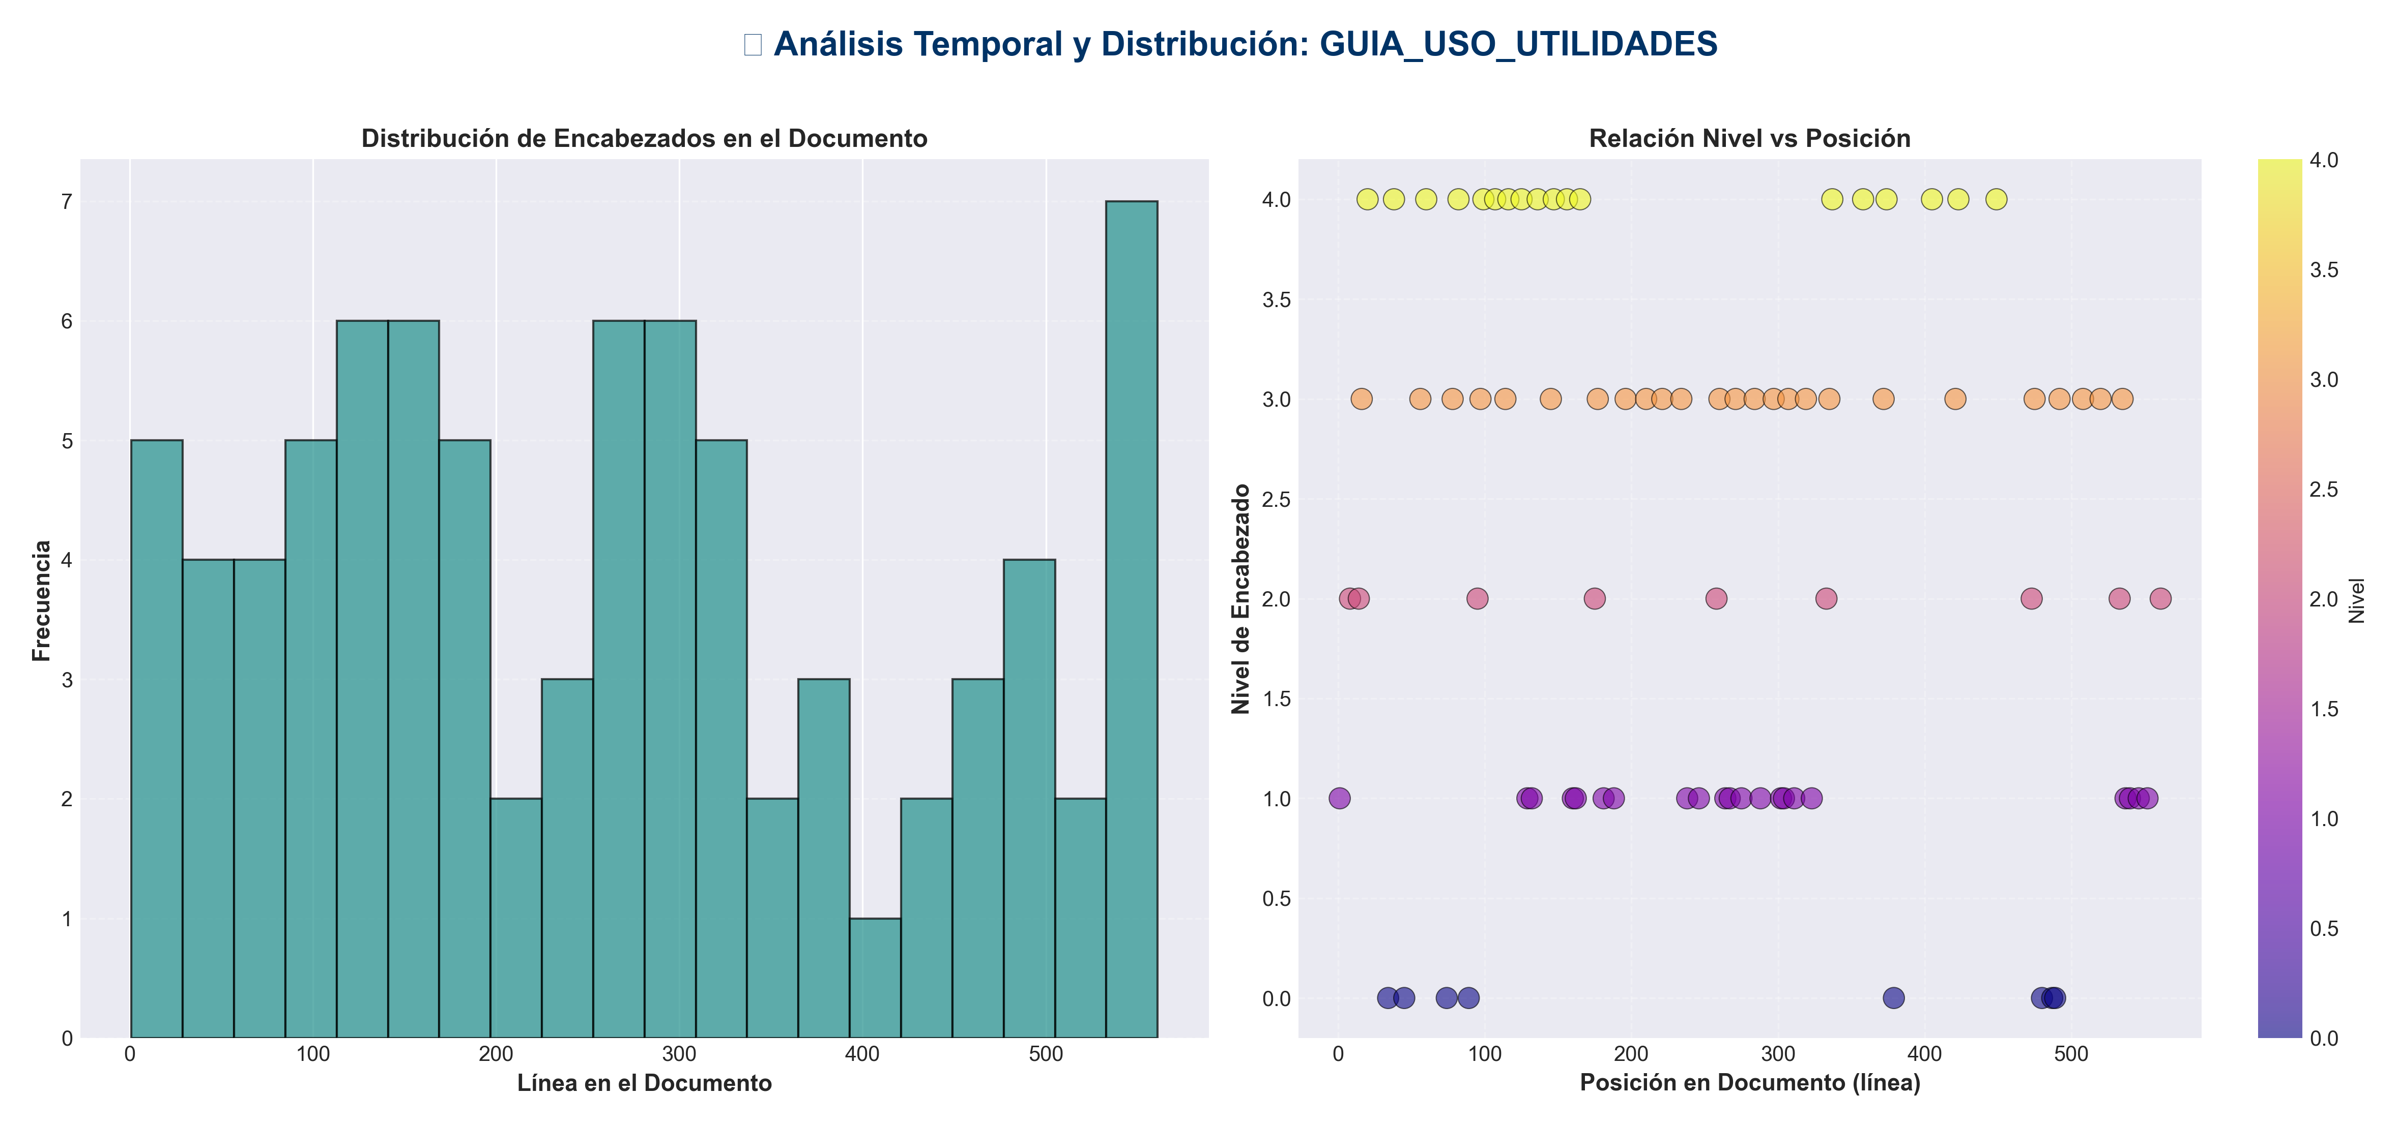

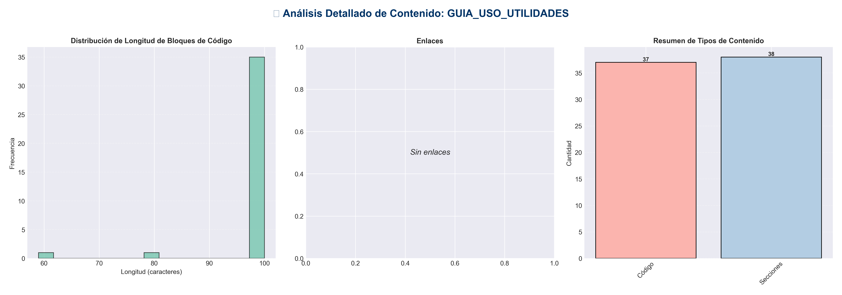

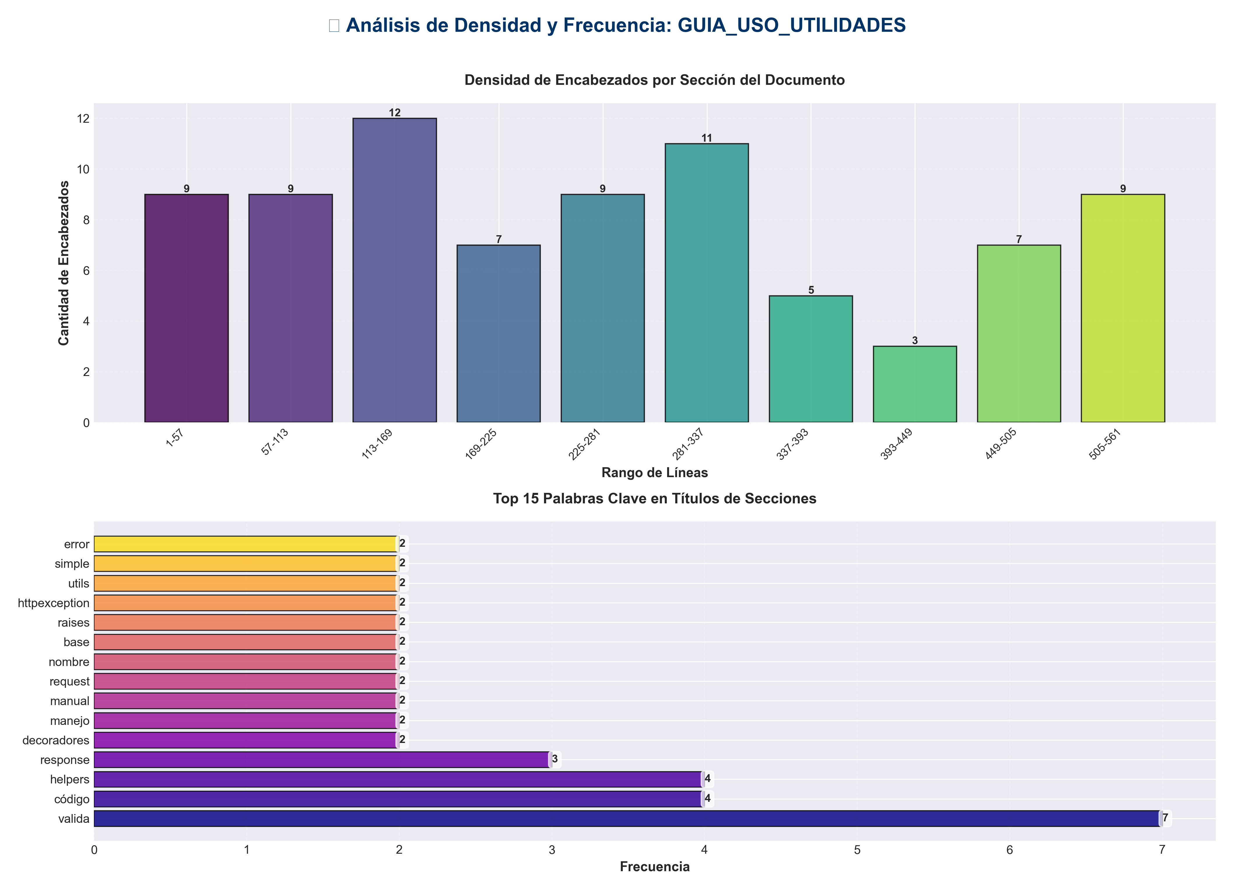

📊 Estadísticas del Documento
Resumen Ejecutivo: Este documento contiene 1,331 palabras distribuidas en 579 líneas, con 81 encabezados organizados en 38 secciones principales.

Métrica | Valor
Total de líneas | 579
Total de palabras | 1,331
Total de caracteres | 13,955
Encabezados | 81
Bloques de código | 37
Tablas | 0
Enlaces | 0
Imágenes | 0
Secciones principales | 38

📑 Índice de Secciones
Nivel | Título | Línea
1 | 📖 Guía de Uso de Utilidades | 1
2 | 📋 Introducción | 8
2 | 🎨 Decoradores | 14
0 | # Tu código aquí - sin manejo de errores manual | 34
0 | # ... código ... | 45
0 | # Request ya está validado | 74
0 | # Request y response serán logueados automáticamente | 89
2 | 🛠️ Helpers | 95
1 | Con nombre base | 129
1 | Sin nombre base (usa timestamp) | 132
1 | Valida y normaliza | 160
1 | Raises HTTPException if invalid | 162
2 | 📤 Response Utils | 175
1 | Respuesta simple | 181
1 | Con metadata | 188
1 | Error simple | 238
1 | Error con detalles | 246
2 | ✅ Validation Helpers | 258
1 | Valida que no esté vacío | 264
1 | Permite whitespace | 267
1 | Valida longitud | 275
1 | Valida longitud de lista | 288
1 | Valida que archivo exista | 302
1 | Raises HTTPException 404 if not found | 304
1 | Valida que dict tenga keys requeridas | 311
1 | Valida que valor esté en lista permitida | 323
2 | 🔄 Ejemplos de Migración | 333
0 | # Validaciones manuales | 379
2 | 💡 Mejores Prácticas | 473
0 | # Código sin try/except | 480
0 | # ... código ... | 487
0 | # Manejo manual | 489
2 | 📚 Referencia Rápida | 533
1 | Decoradores | 537
1 | Helpers | 540
1 | Response Utils | 546
1 | Validation Helpers | 552
2 | ✅ Checklist de Migración | 561

📄 Contenido

📖 Guía de Uso de Utilidades

- **Versión**: 2.0.0
- **Fecha**: 2025-01-27

- ---

📋 Introducción

Esta guía proporciona ejemplos prácticos de cómo usar las utilidades reutilizables creadas para mejorar la calidad y consistencia del código.

- ---

🎨 Decoradores

`@handle_route_errors`

Manejo consistente de errores en rutas API.

Uso Básico
from api.decorators import handle_route_errors
from fastapi import APIRouter, Request

router = APIRouter()

@router.post("/store")
@handle_route_errors("store_episode", lambda s: s.is_available(), "memory")
async def store_episode(
request: MemoryStoreRequest,
req: Request,
service: MemoryService = Depends(get_memory_service)
):

Tu código aquí - sin manejo de errores manual
return service.store(request.episode)

Sin Decorador (Antes)
@router.post("/store")
async def store_episode(request, req, service):
try:
if not service.is_available():
raise HTTPException(status_code=503, detail="Service not available")

... código ...
except HTTPException:
raise
except ValueError as e:
logger.warning(f"Validation error: {e}")
raise HTTPException(status_code=400, detail=str(e))
except Exception as e:
logger.error(f"Error: {e}", exc_info=True)
raise HTTPException(status_code=500, detail=str(e))

`@validate_request`

Validación de requests antes de ejecutar la ruta.

Uso
from api.decorators import validate_request

def validate_message(request: ChatRequest) -> tuple[bool, Optional[str]]:
if not request.message.strip():
return False, "Message cannot be empty"
if len(request.message) > 10000:
return False, "Message too long (max 10000 characters)"
return True, None

@router.post("/chat")
@validate_request(validate_message)
async def chat(request: ChatRequest):

Request ya está validado
return service.chat(request.message)

`@log_request`

Logging de requests y responses.

Uso
from api.decorators import log_request

@router.post("/process")
@log_request(log_request_body=True, log_response=False)
async def process(request: Request, data: ProcessRequest):

Request y response serán logueados automáticamente
return process_data(data)

- ---

🛠️ Helpers

Request Helpers

`get_request_id()`
from api.helpers import get_request_id

request_id = get_request_id(req)
logger.info(f"Processing request", request_id=request_id)

`log_operation()`
from api.helpers import log_operation

log_operation("convert_document", req, level="info", format="pdf")

File Helpers

`validate_file_size()`
from api.helpers import validate_file_size
from pathlib import Path

file_path = Path("document.pdf")
validate_file_size(file_path, max_size_mb=100) # Raises HTTPException if too large

`generate_filename()`
from api.helpers import generate_filename

Con nombre base
filename = generate_filename("document", "pdf") # "document.pdf"

Sin nombre base (usa timestamp)
filename = generate_filename(extension="pdf") # "file_20250127_143022.pdf"

`detect_file_type()`
from api.helpers import detect_file_type
from pathlib import Path

file_path = Path("data.json")
file_type = detect_file_type(file_path) # "json"

Format Helpers

`normalize_format()`
from api.helpers import normalize_format

format = normalize_format("word") # "docx"
format = normalize_format("excel") # "xlsx"
format = normalize_format("pdf") # "pdf"

`validate_format()`
from api.helpers import validate_format

Valida y normaliza
format = validate_format("word", ["pdf", "docx", "xlsx"]) # "docx"

Raises HTTPException if invalid

`get_media_type()`
from api.helpers import get_media_type

media_type = get_media_type("pdf") # "application/pdf"
media_type = get_media_type("docx") # "application/vnd.openxmlformats-officedocument.wordprocessingml.document"

- ---

📤 Response Utils

`create_success_response()`
from api.response_utils import create_success_response

Respuesta simple
return create_success_response(
data={"episodes": episodes},
message="Episodes retrieved successfully",
req=req
)

Con metadata
return create_success_response(
data=result,
metadata={"processing_time": 0.5, "items_processed": 100},
req=req
)

`create_paginated_response()`
from api.response_utils import create_paginated_response

return create_paginated_response(
items=results,
page=page,
page_size=page_size,
total=total_count,
req=req,
metadata={"query": search_query}
)

`create_list_response()`
from api.response_utils import create_list_response

return create_list_response(
items=items_list,
req=req,
metadata={"source": "database"}
)

`create_stats_response()`
from api.response_utils import create_stats_response

stats = {
"total_processed": 1500,
"average_time": 0.5,
"success_rate": 0.98
}

return create_stats_response(stats, req=req)

`create_error_response()`
from api.response_utils import create_error_response

Error simple
return create_error_response(
error="Invalid input data",
code="INVALID_INPUT",
status_code=400,
req=req
)

Error con detalles
return create_error_response(
error="Validation failed",
code="VALIDATION_ERROR",
status_code=400,
req=req,
details={"field": "email", "reason": "Invalid format"}
)

- ---

✅ Validation Helpers

`validate_not_empty()`
from api.validation_helpers import validate_not_empty

Valida que no esté vacío
message = validate_not_empty(request.message, name="message")

Permite whitespace
text = validate_not_empty(request.text, name="text", allow_whitespace=True)

`validate_string_length()`
from api.validation_helpers import validate_string_length

Valida longitud
message = validate_string_length(
request.message,
min_length=1,
max_length=10000,
name="message"
)

`validate_list_length()`
from api.validation_helpers import validate_list_length

Valida longitud de lista
items = validate_list_length(
request.items,
min_length=1,
max_length=1000,
name="items"
)

`validate_file_exists()`
from api.validation_helpers import validate_file_exists
from pathlib import Path

Valida que archivo exista
file_path = validate_file_exists("document.pdf")

Raises HTTPException 404 if not found

`validate_dict_keys()`
from api.validation_helpers import validate_dict_keys

Valida que dict tenga keys requeridas
config = validate_dict_keys(
request.config,
required_keys=["host", "port", "database"],
name="config"
)

`validate_one_of()`
from api.validation_helpers import validate_one_of

Valida que valor esté en lista permitida
format = validate_one_of(
request.format,
["pdf", "docx", "xlsx"],
name="format"
)

- ---

🔄 Ejemplos de Migración

Ejemplo 1: Ruta Simple

Antes
@router.post("/process")
async def process(request: ProcessRequest, req: Request):
try:
if not request.data:
raise HTTPException(status_code=400, detail="Data cannot be empty")

result = service.process(request.data)

return {
"success": True,
"data": result,
"timestamp": datetime.now().isoformat(),
"request_id": getattr(req.state, 'request_id', None)
}
except Exception as e:
logger.error(f"Error: {e}", exc_info=True)
raise HTTPException(status_code=500, detail=str(e))

Después
from api.decorators import handle_route_errors
from api.response_utils import create_success_response
from api.validation_helpers import validate_not_empty

@router.post("/process")
@handle_route_errors("process", lambda s: s.is_available(), "service")
async def process(request: ProcessRequest, req: Request, service: Service):
validate_not_empty(request.data, name="data")
result = service.process(request.data)
return create_success_response(result, req=req)

Ejemplo 2: Ruta con Validación Compleja

Antes
@router.post("/convert")
async def convert(request: ConvertRequest, req: Request):
try:

Validaciones manuales
if not request.message:
raise HTTPException(status_code=400, detail="Message cannot be empty")
if len(request.message) > 10000:
raise HTTPException(status_code=400, detail="Message too long")

format = request.format.lower()
if format == "word":
format = "docx"
if format not in ["pdf", "docx", "xlsx"]:
raise HTTPException(status_code=400, detail="Invalid format")

result = converter.convert(request.message, format)

return {
"success": True,
"data": result,
"request_id": getattr(req.state, 'request_id', None)
}
except HTTPException:
raise
except Exception as e:
logger.error(f"Error: {e}", exc_info=True)
raise HTTPException(status_code=500, detail=str(e))

Después
from api.decorators import handle_route_errors
from api.helpers import validate_format
from api.validation_helpers import validate_string_length
from api.response_utils import create_success_response

@router.post("/convert")
@handle_route_errors("convert", lambda s: s.is_available(), "converter")
async def convert(request: ConvertRequest, req: Request, converter: Converter):
validate_string_length(request.message, max_length=10000, name="message")
format = validate_format(request.format, ["pdf", "docx", "xlsx"])
result = converter.convert(request.message, format)
return create_success_response(result, req=req)

Ejemplo 3: Ruta con Paginación

Antes
@router.get("/items")
async def get_items(page: int = 1, page_size: int = 100, req: Request = None):
try:
items = service.get_all_items()
total = len(items)
start = (page - 1) * page_size
end = start + page_size

return {
"success": True,
"data": items[start:end],
"pagination": {
"page": page,
"page_size": page_size,
"total": total,
"pages": (total + page_size - 1) // page_size
},
"request_id": getattr(req.state, 'request_id', None) if req else None
}
except Exception as e:
logger.error(f"Error: {e}", exc_info=True)
raise HTTPException(status_code=500, detail=str(e))

Después
from api.decorators import handle_route_errors
from api.response_utils import create_paginated_response

@router.get("/items")
@handle_route_errors("get_items", lambda s: s.is_available(), "service")
async def get_items(
page: int = 1,
page_size: int = 100,
req: Request = None,
service: Service = Depends(get_service)
):
items = service.get_all_items()
return create_paginated_response(
items=items,
page=page,
page_size=page_size,
req=req
)

- ---

💡 Mejores Prácticas

1. Usar Decoradores para Manejo de Errores
✅ **Hacer**:
@handle_route_errors("operation_name", lambda s: s.is_available(), "service")
async def my_route(...):

Código sin try/except

❌ **Evitar**:
async def my_route(...):
try:

... código ...
except Exception as e:

Manejo manual

2. Usar Response Utils para Respuestas
✅ **Hacer**:
return create_success_response(data, req=req)

❌ **Evitar**:
return {
"success": True,
"data": data,
"timestamp": datetime.now().isoformat(),
"request_id": getattr(req.state, 'request_id', None)
}

3. Usar Validation Helpers
✅ **Hacer**:
validate_string_length(message, max_length=10000, name="message")

❌ **Evitar**:
if len(message) > 10000:
raise HTTPException(status_code=400, detail="Message too long")

4. Combinar Utilidades
✅ **Hacer**:
@handle_route_errors("convert", lambda s: s.is_available(), "converter")
@validate_request(validate_message)
async def convert(...):
format = validate_format(request.format, ["pdf", "docx"])
result = converter.convert(request.data, format)
return create_success_response(result, req=req)

- ---

📚 Referencia Rápida

Importaciones Comunes

Decoradores
from api.decorators import handle_route_errors, validate_request, log_request

Helpers
from api.helpers import (
get_request_id, validate_file_size, generate_filename,
normalize_format, validate_format, get_media_type
)

Response Utils
from api.response_utils import (
create_success_response, create_error_response,
create_paginated_response, create_list_response, create_stats_response
)

Validation Helpers
from api.validation_helpers import (
validate_not_empty, validate_string_length, validate_list_length,
validate_file_exists, validate_dict_keys, validate_one_of
)

- ---

✅ Checklist de Migración

Al migrar una ruta existente:

- - [ ] Reemplazar manejo de errores manual con `@handle_route_errors`
- - [ ] Reemplazar validaciones manuales con validation helpers
- - [ ] Reemplazar construcción de respuestas con response utils
- - [ ] Usar `get_request_id()` en lugar de `getattr(req.state, 'request_id', None)`
- - [ ] Agregar docstrings completos
- - [ ] Verificar que no hay errores de linter
- - [ ] Probar que la funcionalidad sigue igual

- ---

- **Versión**: 2.0.0
- **Última actualización**: 2025-01-27

