Phase2 Complete
Análisis y Documentación Completa
Generado el: 25 de November de 2025 a las 11:57

📊 Análisis Visual Completo

Dashboard Principal
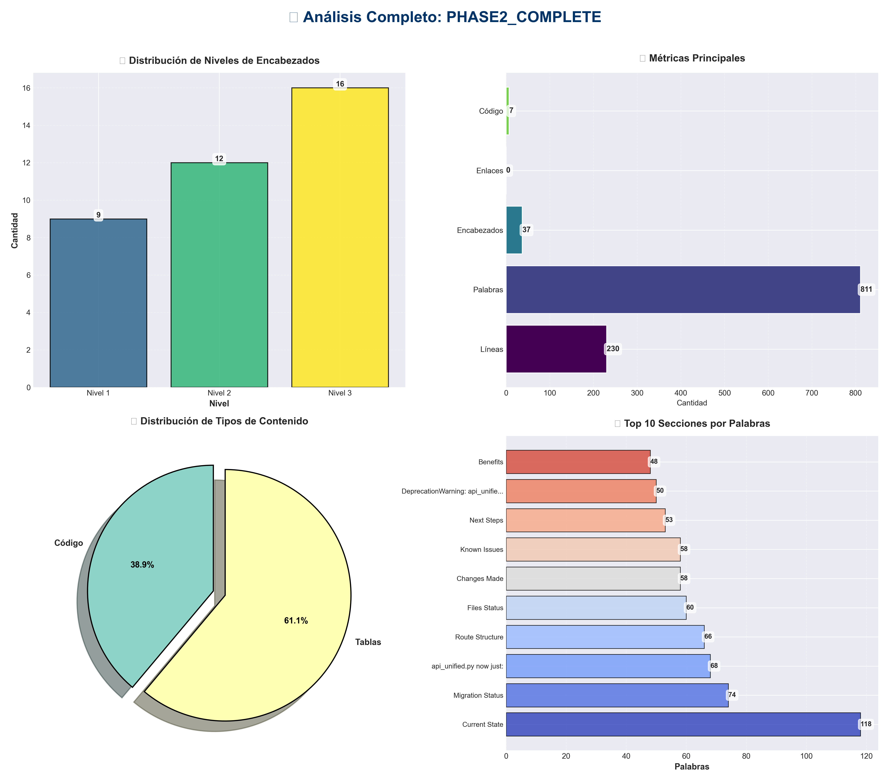

Análisis Adicionales
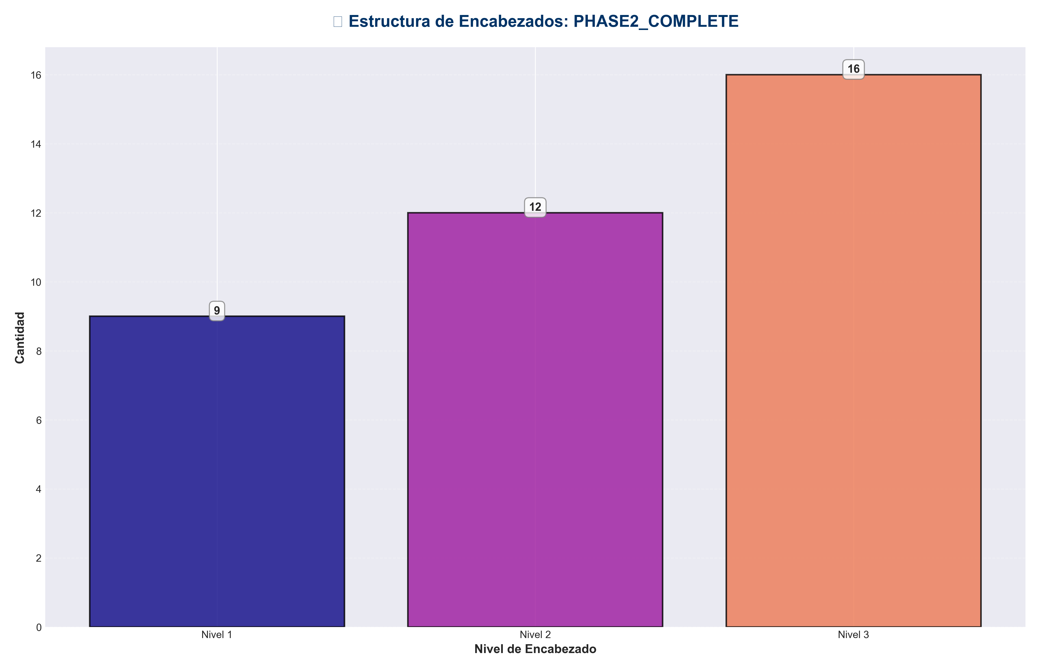

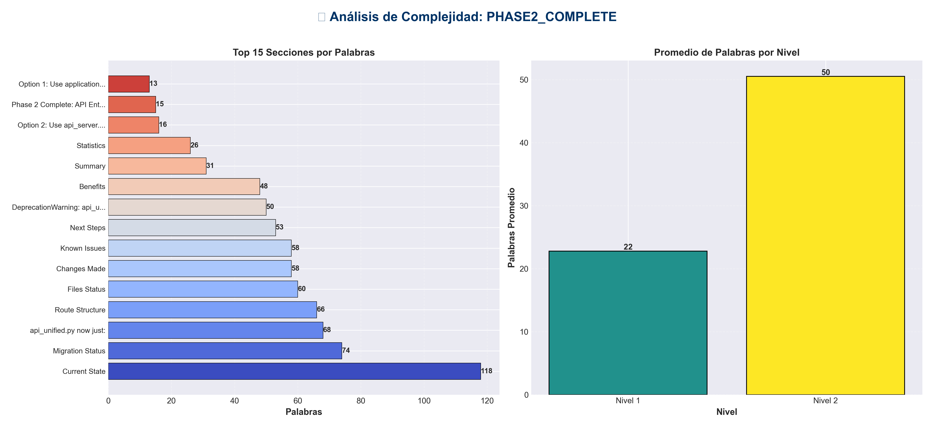

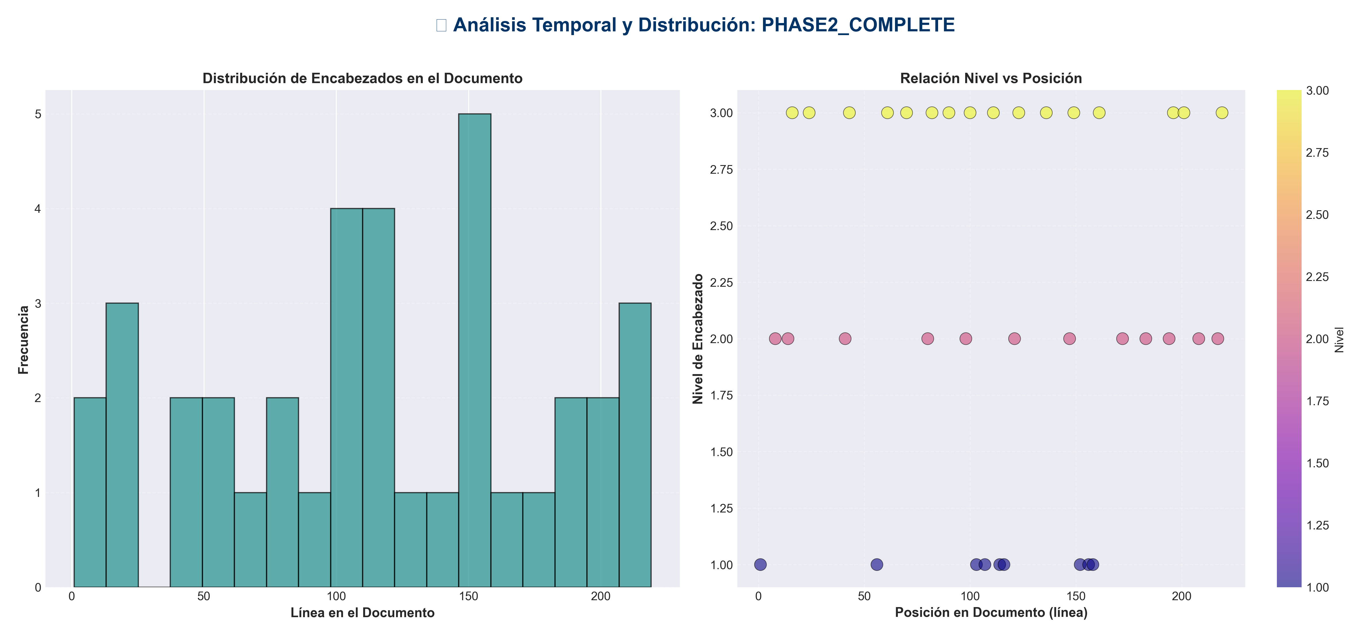

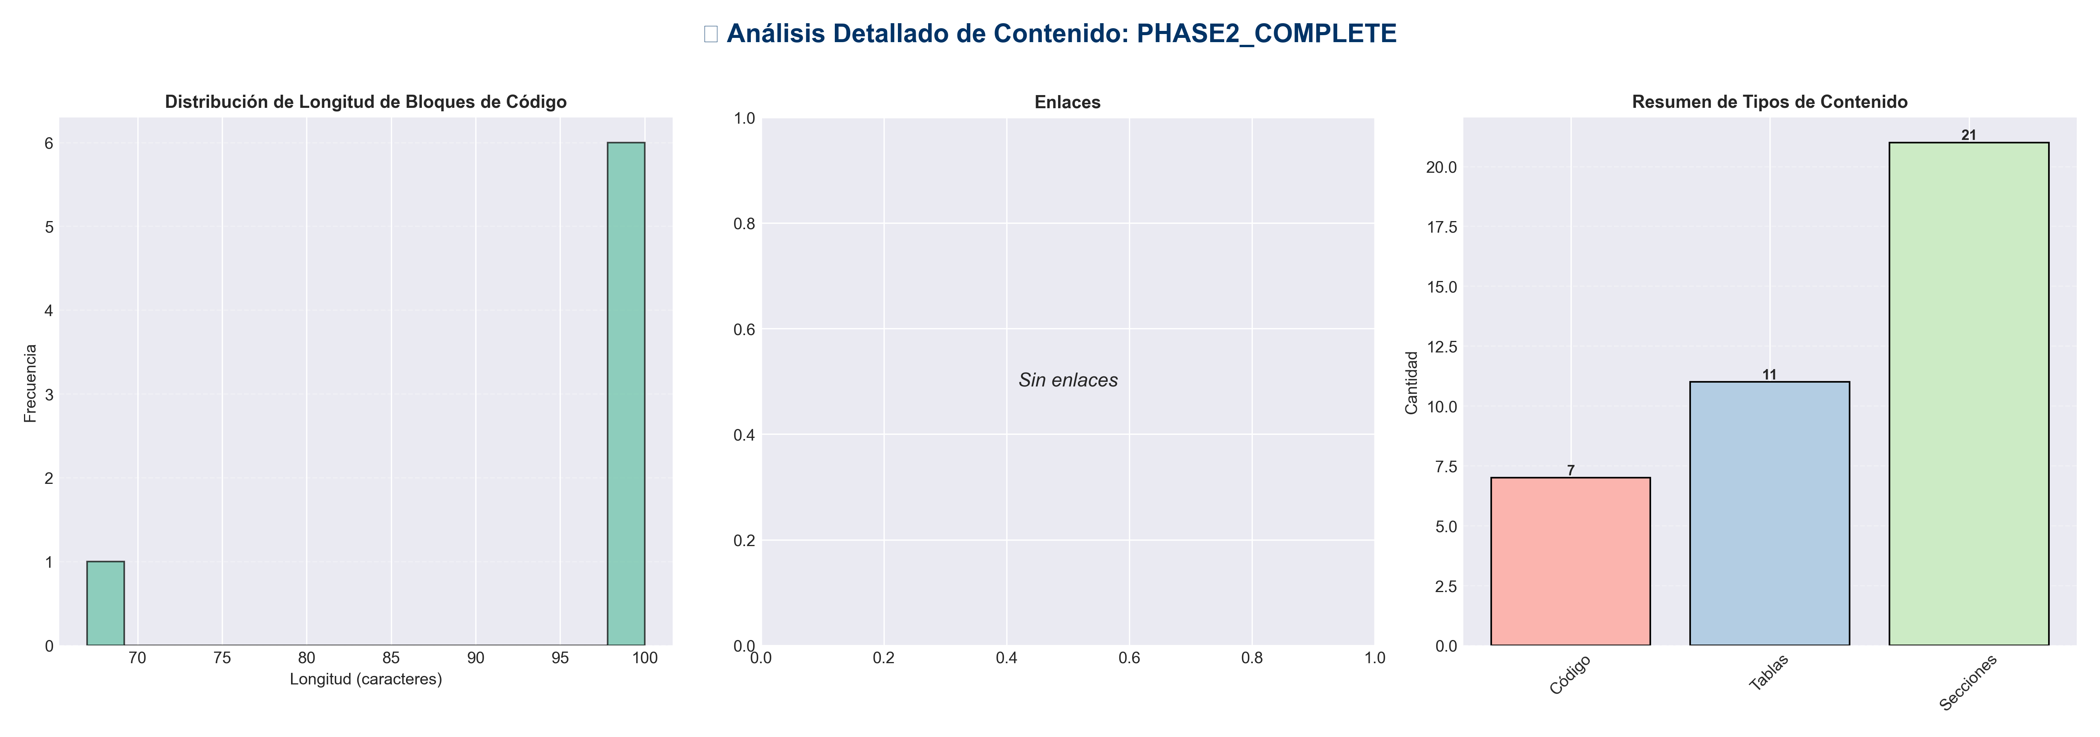

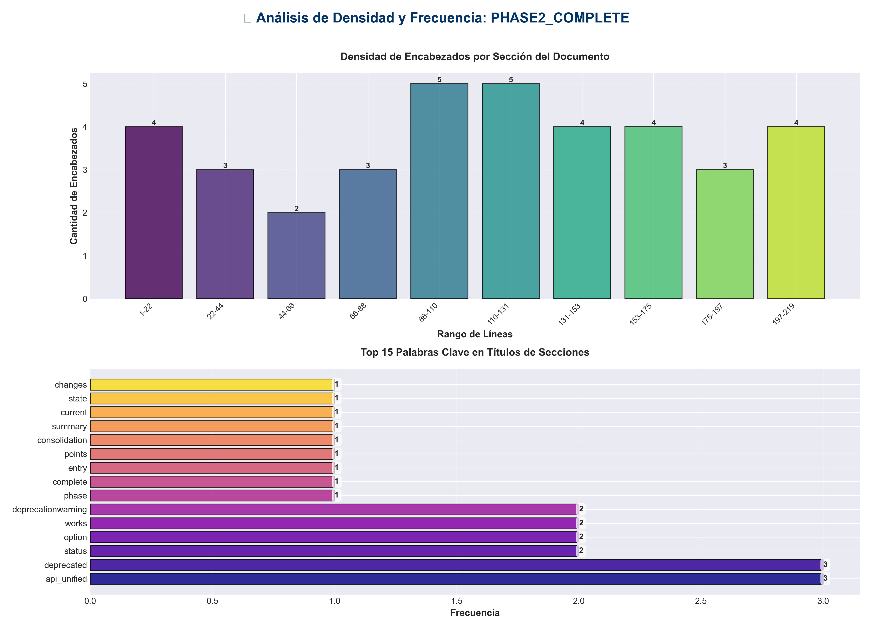

📊 Estadísticas del Documento
Resumen Ejecutivo: Este documento contiene 811 palabras distribuidas en 230 líneas, con 37 encabezados organizados en 21 secciones principales.

Métrica | Valor
Total de líneas | 230
Total de palabras | 811
Total de caracteres | 5,843
Encabezados | 37
Bloques de código | 7
Tablas | 11
Enlaces | 0
Imágenes | 0
Secciones principales | 21

📑 Índice de Secciones
Nivel | Título | Línea
1 | Phase 2 Complete: API Entry Points Consolidation ✅ | 1
2 | Summary | 8
2 | Current State | 14
2 | Changes Made | 41
1 | api_unified.py now just: | 56
2 | Migration Status | 80
2 | Usage | 98
1 | Option 1: Use application factory | 103
1 | Option 2: Use api_server.py script | 107
1 | Still works but emits deprecation warning | 114
1 | ⚠️ DeprecationWarning: api_unified.py is deprecated... | 116
2 | Route Structure | 121
2 | Verification | 147
1 | ✅ New way (recommended) | 152
1 | ⚠️ Old way (deprecated but works) | 156
1 | DeprecationWarning: api_unified.py is deprecated... | 158
2 | Benefits | 172
2 | Files Status | 183
2 | Next Steps | 194
2 | Statistics | 208
2 | Known Issues | 217

📄 Contenido

Phase 2 Complete: API Entry Points Consolidation ✅

- **Date**: 2025-01-27
- **Status**: ✅ Completed

- ---

Summary

Successfully consolidated API entry points. The old `api_unified.py` has been converted to a deprecation shim, and all functionality now uses the new layered architecture through `application.py` and `api/routes/`.

- ---

Current State

✅ Entry Points

✅ Route Organization

All endpoints are now organized in `api/routes/`:

- - ✅ `api/routes/memory.py` - Memory operations
- - ✅ `api/routes/redundancy.py` - Redundancy operations
- - ✅ `api/routes/pipeline.py` - Pipeline operations
- - ✅ `api/routes/chat.py` - Chat operations
- - ✅ `api/routes/config.py` - Configuration operations
- - ✅ `api/routes/monitoring.py` - Monitoring operations
- - ✅ `api/routes/health.py` - Health checks
- - ✅ `api/routes/documents.py` - Document operations

- **Total**: 8 route modules organized by domain

- ---

Changes Made

1. Converted `api_unified.py` to Deprecation Shim ✅

- **Before**: 1237 lines of API implementation
- **After**: 56 lines - simple compatibility wrapper

- **What it does now:**
- - Emits deprecation warning when imported
- - Re-exports `create_app` and `get_app` from `application.py`
- - Provides `create_api_app()` alias for backward compatibility
- - Creates `app` instance for direct import compatibility

- **Code:**

api_unified.py now just:
from application import create_app, get_app
app = create_app() # For backward compatibility

2. Updated `api_server.py` ✅

- **Status**: Uses `application.create_app()` - the new way

from application import create_app
app = create_app()

3. Route Structure ✅

All routes are properly organized:
- - Domain-specific routes in `api/routes/`
- - Routes registered via `api/routes/__init__.py`
- - Proper prefixing (`/api/v1/...`)
- - Tagged for OpenAPI documentation

- ---

Migration Status

✅ Completed

- - [x] `api_unified.py` converted to deprecation shim
- - [x] All routes migrated to `api/routes/` structure
- - [x] `application.py` is the primary factory
- - [x] `api_server.py` uses new architecture
- - [x] Backward compatibility maintained

⏸️ Pending (Low Priority)

- - [ ] Update `convert_to_docs.py` to reference `application.py` instead of `api_unified.py`
- - [ ] Remove `api_unified.py` after migration period (suggest 3-6 months)
- - [ ] Update all documentation examples

- ---

Usage

✅ Recommended Way (New)

Option 1: Use application factory
from application import create_app
app = create_app()

Option 2: Use api_server.py script
python api_server.py

⚠️ Deprecated Way (Still Works)

Still works but emits deprecation warning
from api_unified import app, create_app

⚠️ DeprecationWarning: api_unified.py is deprecated...

- ---

Route Structure

API Routes (`/api/v1/...`)

/api/v1/
├── /memory # Memory operations
├── /redundancy # Redundancy operations
├── /pipeline # Pipeline operations
├── /chat # Chat operations
├── /config # Configuration
├── /monitor # Monitoring
└── /documents # Document operations

Root Routes

/
├── /health # Health checks
├── /docs # OpenAPI documentation
└── /dashboard # Dashboard (if enabled)

- ---

Verification

Import Test

✅ New way (recommended)
from application import create_app
app = create_app()

⚠️ Old way (deprecated but works)
from api_unified import app

DeprecationWarning: api_unified.py is deprecated...

Route Test

All routes are accessible through the new structure:
- - ✅ `/api/v1/memory/store` - Store memory episode
- - ✅ `/api/v1/memory/retrieve` - Retrieve memory episodes
- - ✅ `/api/v1/pipeline/run` - Run pipeline
- - ✅ `/health` - Health check
- - ✅ `/docs` - API documentation

- ---

Benefits

1. **Clear Architecture**: Follows layered architecture principles
2. **Better Organization**: Routes organized by domain
3. **Maintainability**: Easier to find and modify endpoints
4. **Scalability**: Easy to add new routes
5. **Backward Compatible**: Existing code continues to work
6. **Clear Migration Path**: Deprecation warnings guide users

- ---

Files Status

- ---

Next Steps

Immediate
- - ✅ Phase 2 complete
- - ⏭️ Ready for Phase 3: Import Standardization (Already done!)
- - ⏭️ Ready for Phase 4: Config Manager Consolidation (Mostly done!)

Future
- - Remove `api_unified.py` after migration period (3-6 months)
- - Update `convert_to_docs.py` to use `application.py`
- - Update all documentation examples

- ---

Statistics

- - **Files Modified**: 1 (`api_unified.py` converted to shim)
- - **Routes Organized**: 8 route modules
- - **Backward Compatibility**: 100% maintained
- - **Breaking Changes**: None

- ---

Known Issues

`convert_to_docs.py` Reference

The file `convert_to_docs.py` still references `api_unified.py` for documentation generation. This is low priority and can be updated later.

- **Impact**: Low - only affects documentation generation, not runtime

- ---

- **Phase 2 Status**: ✅ **COMPLETE**

All API entry points have been successfully consolidated. The new architecture is in place and backward compatibility is maintained.

