Phase3 Complete
Análisis y Documentación Completa
Generado el: 25 de November de 2025 a las 11:57

📊 Análisis Visual Completo

Dashboard Principal
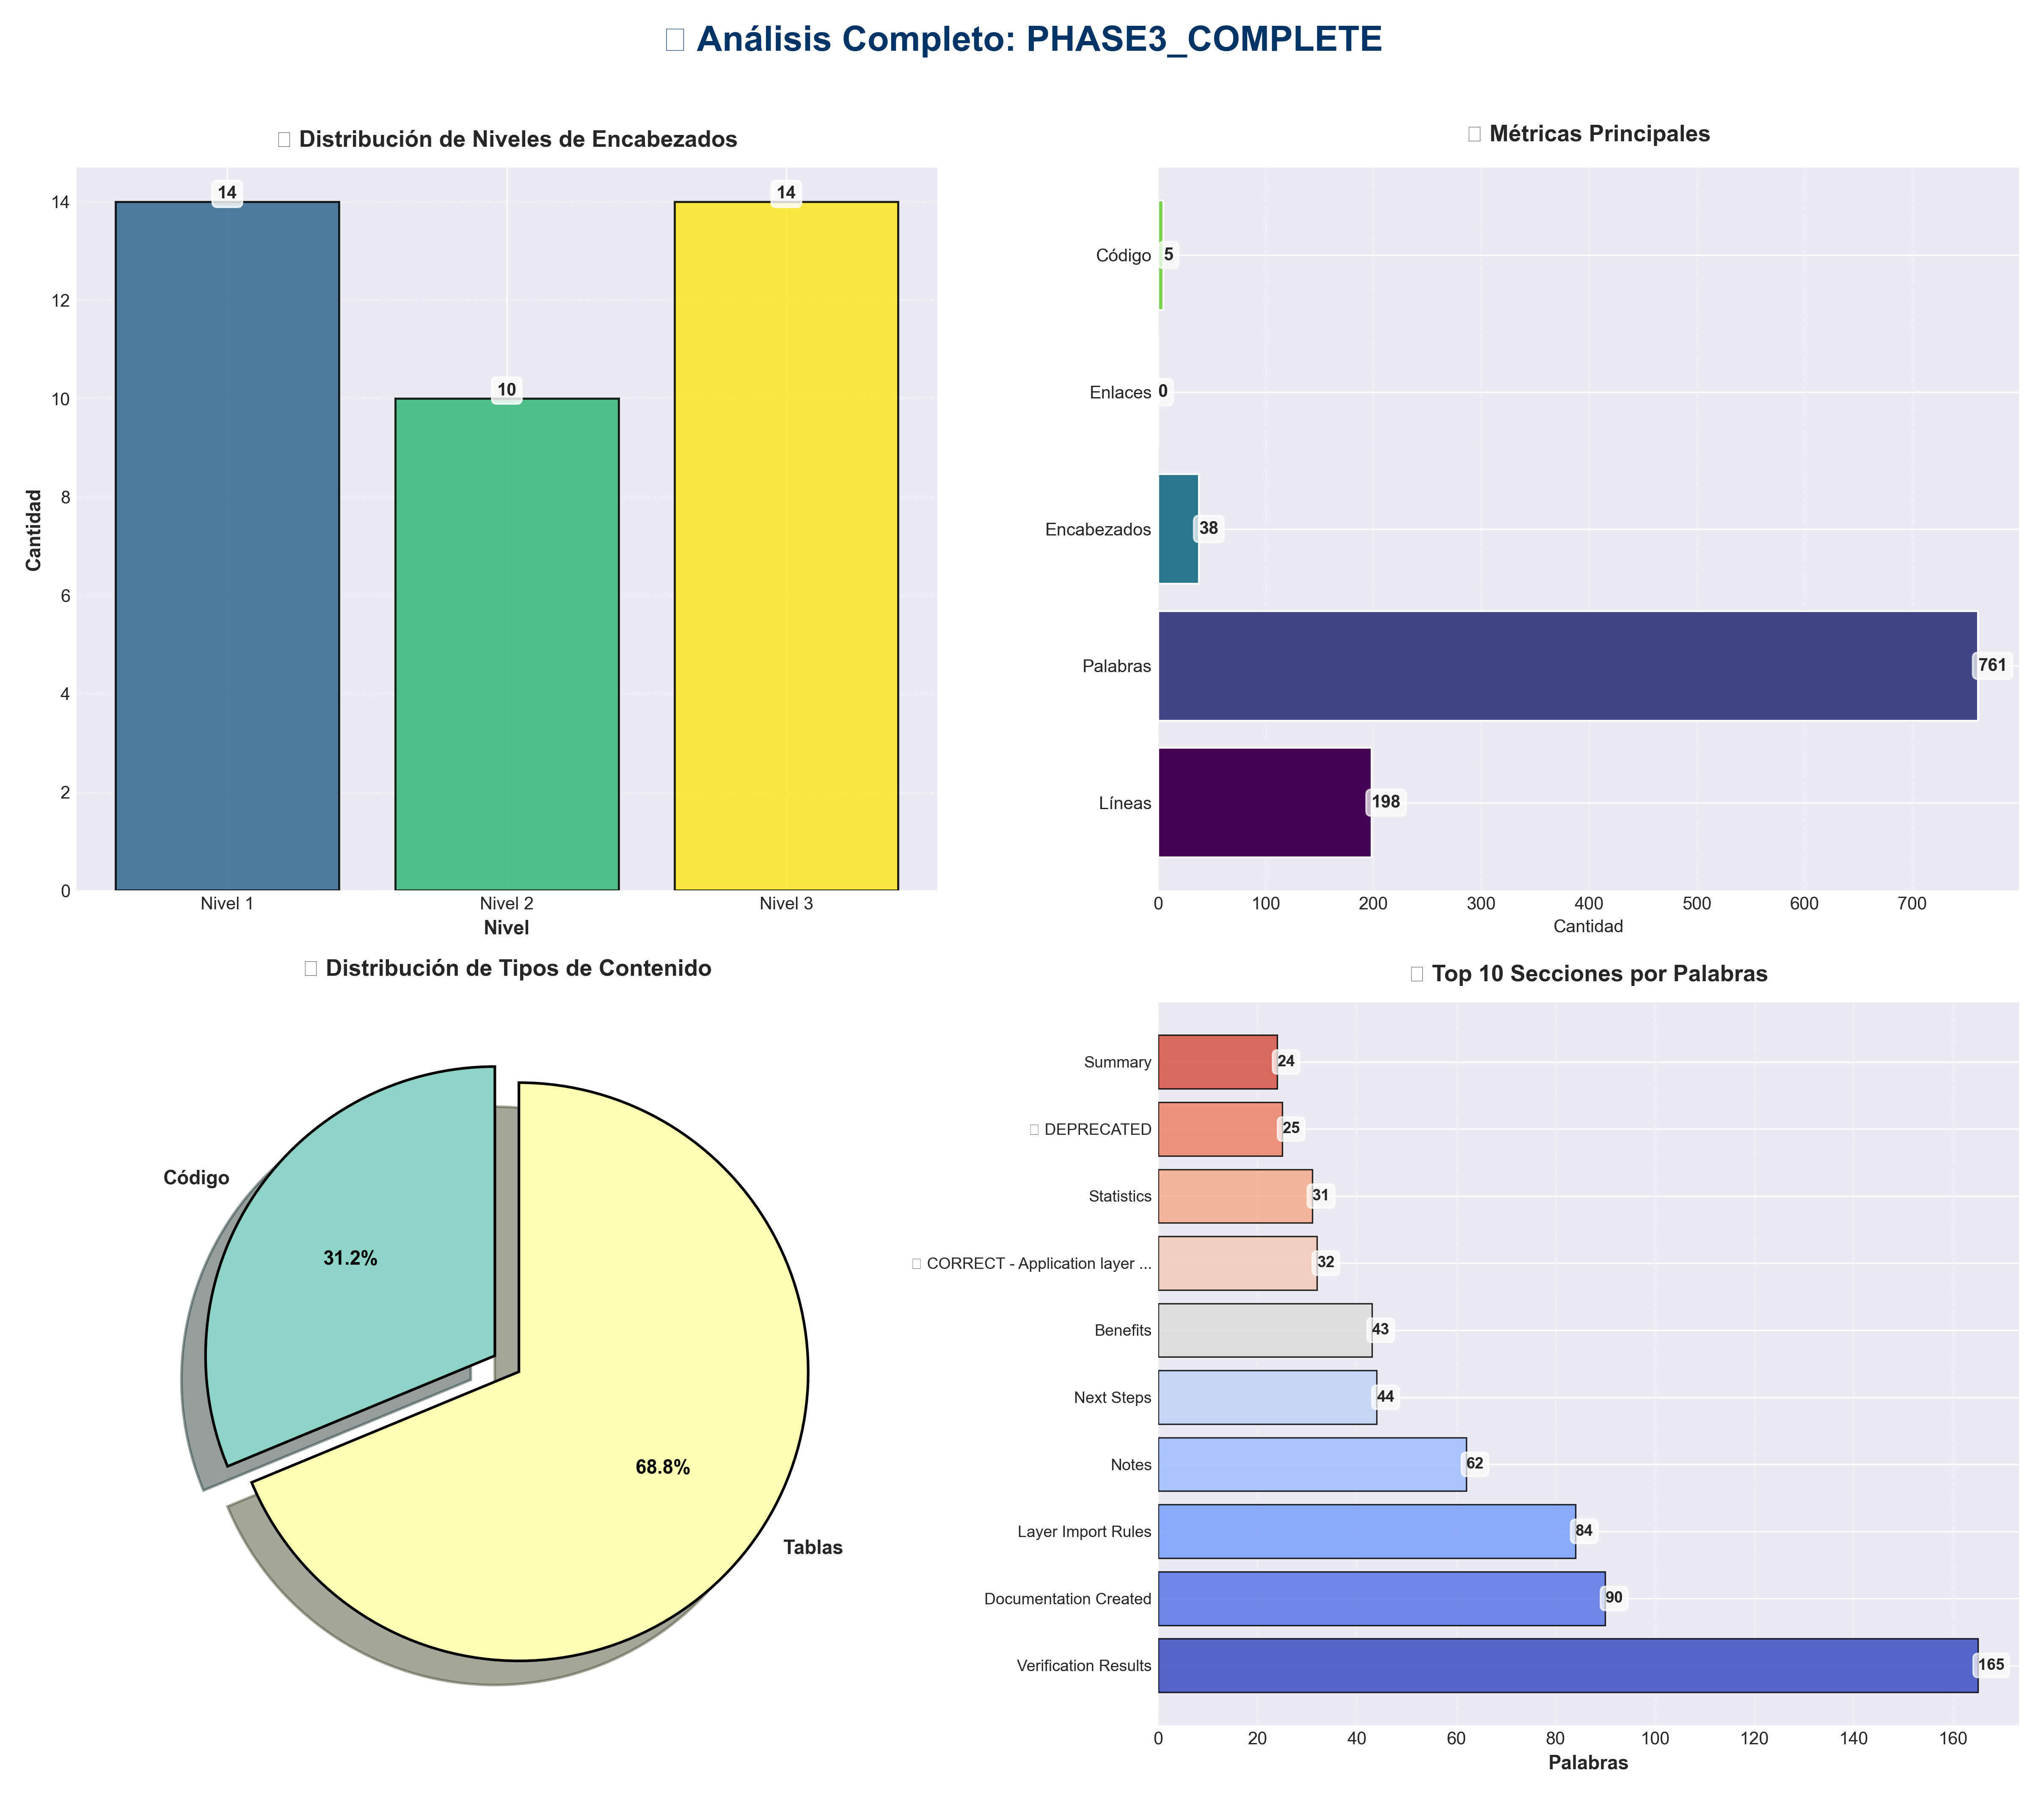

Análisis Adicionales
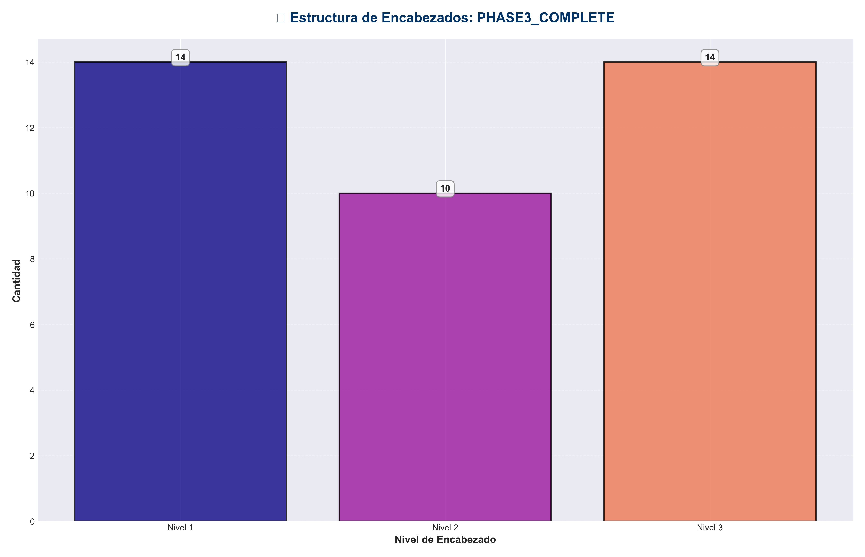

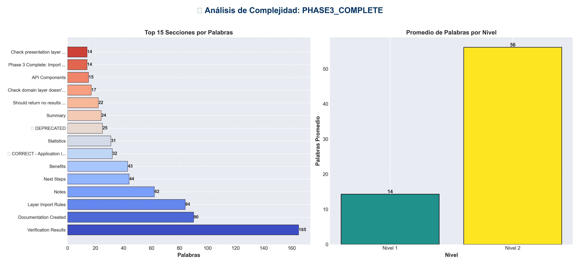

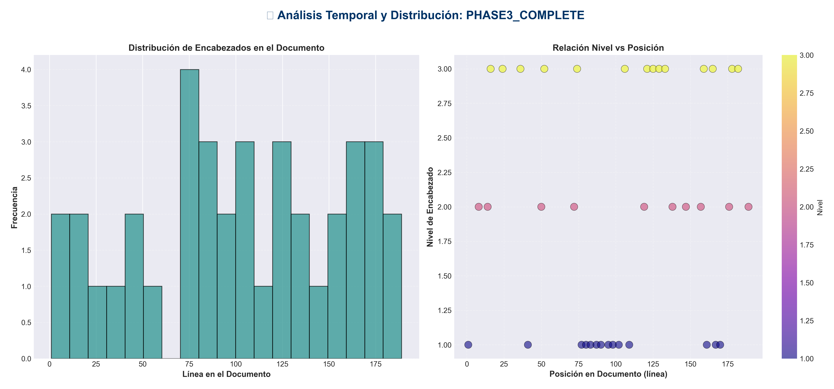

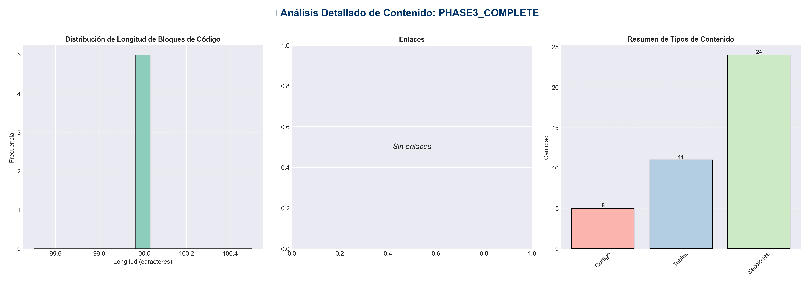

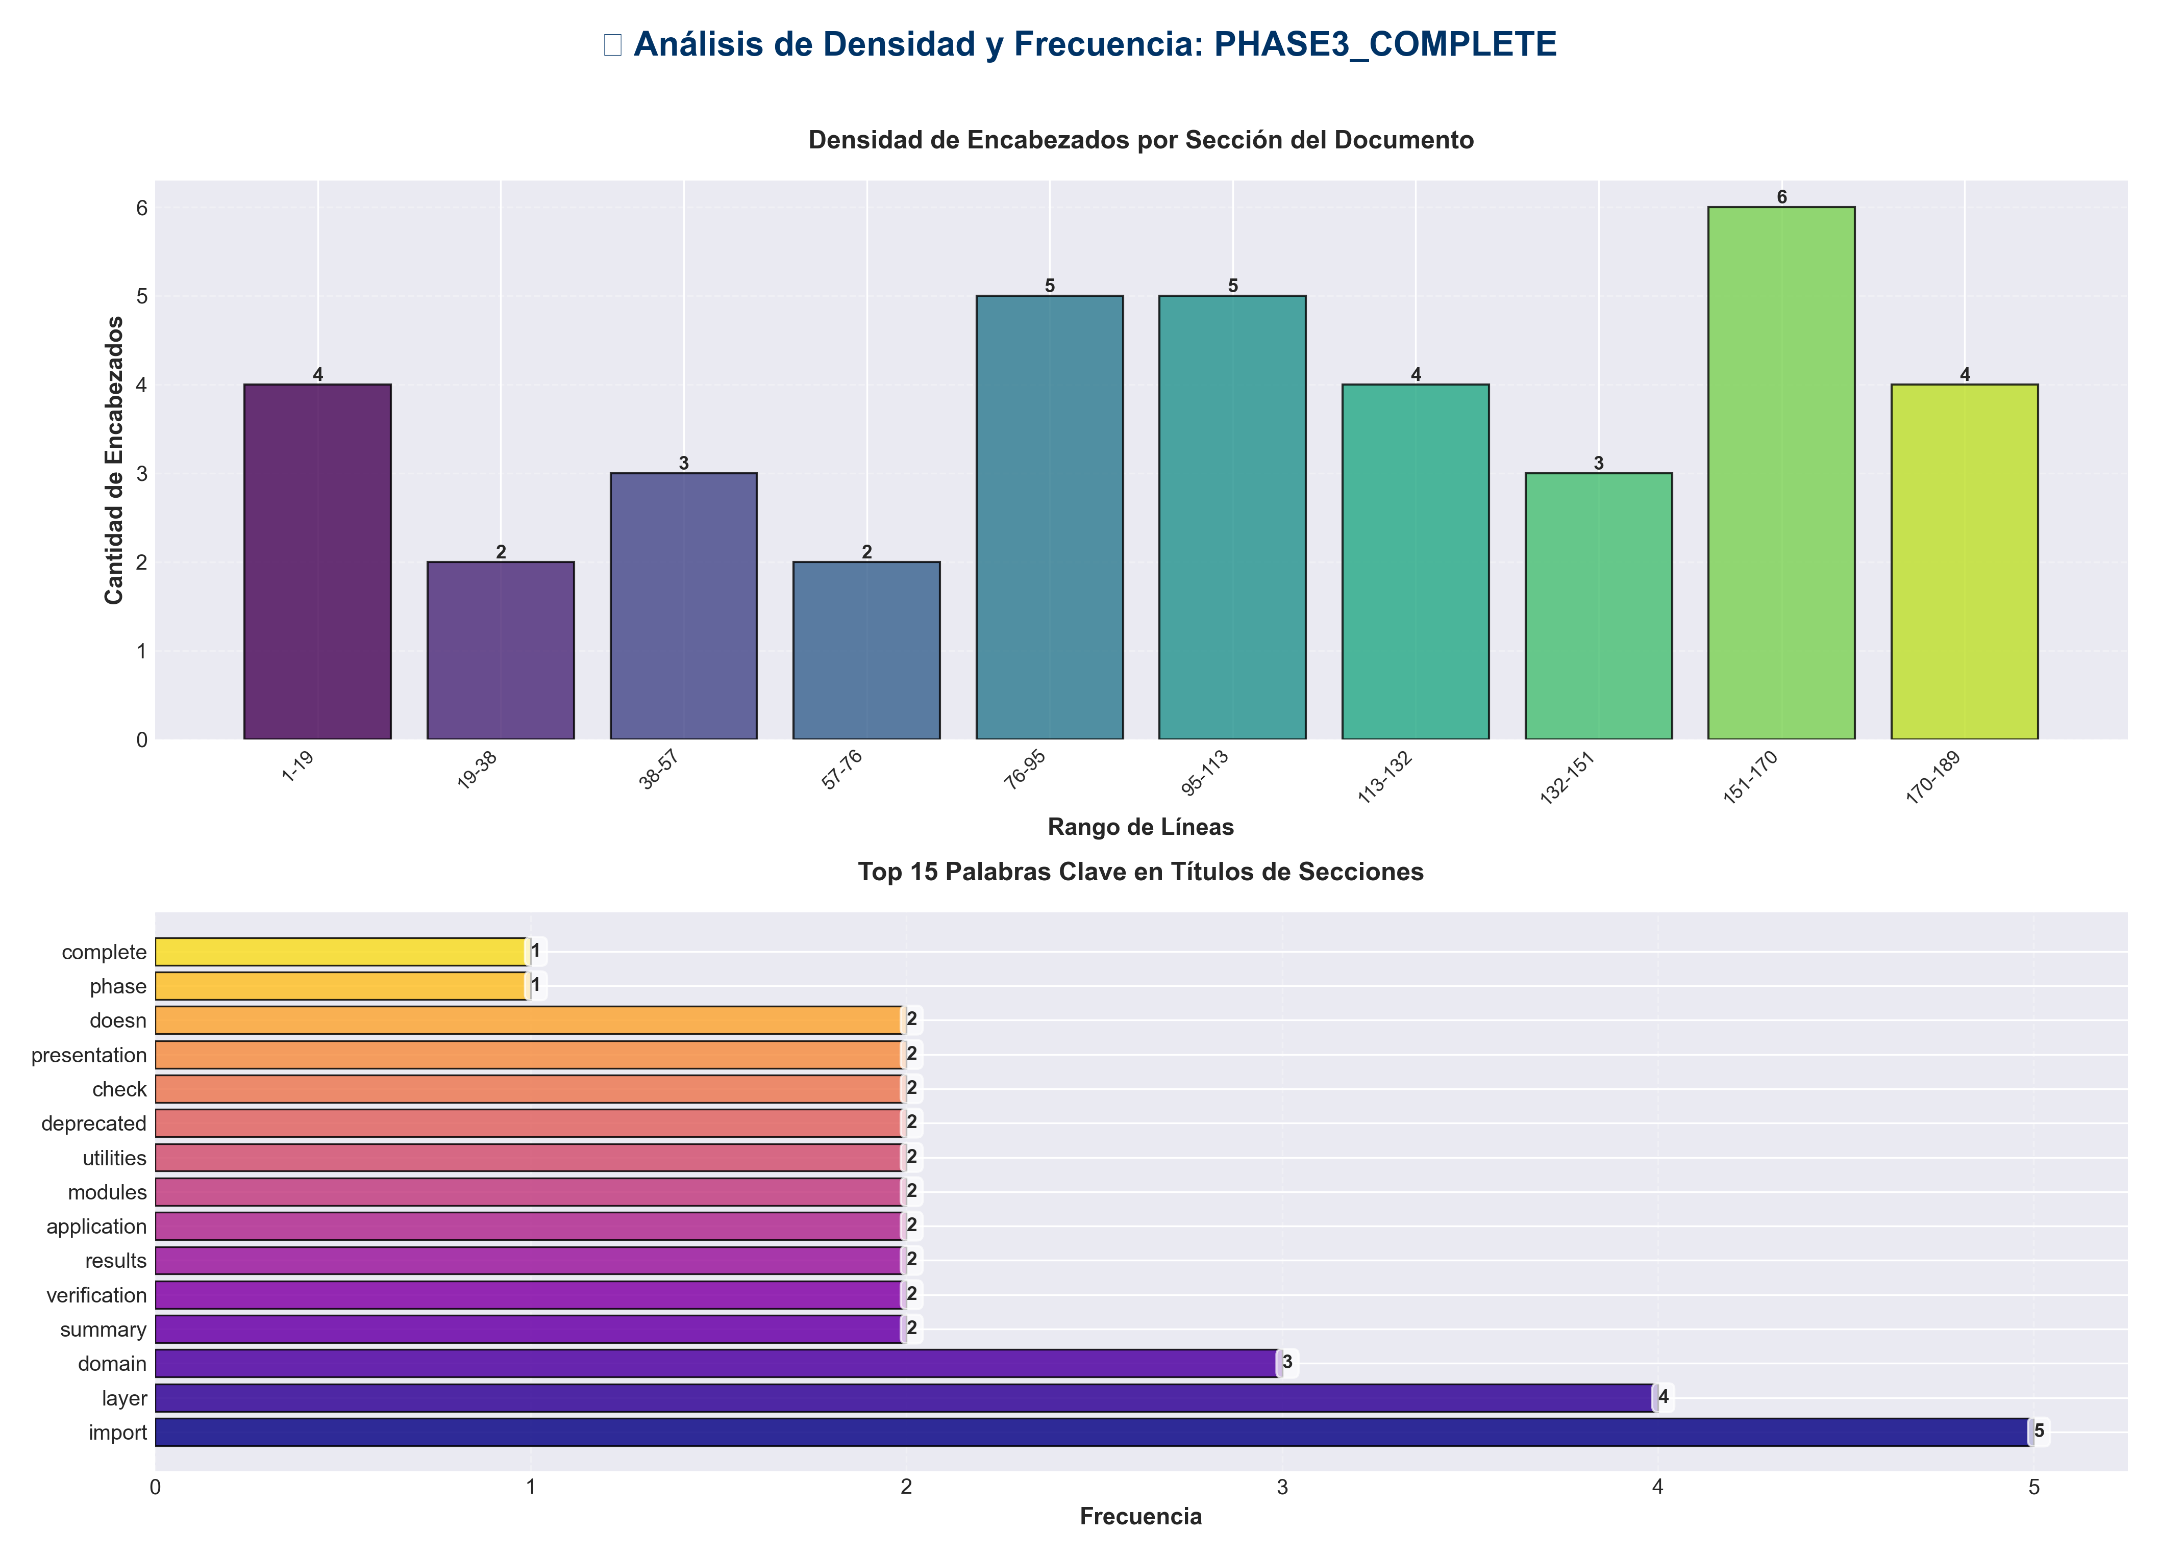

📊 Estadísticas del Documento
Resumen Ejecutivo: Este documento contiene 761 palabras distribuidas en 198 líneas, con 38 encabezados organizados en 24 secciones principales.

Métrica | Valor
Total de líneas | 198
Total de palabras | 761
Total de caracteres | 5,958
Encabezados | 38
Bloques de código | 5
Tablas | 11
Enlaces | 0
Imágenes | 0
Secciones principales | 24

📑 Índice de Secciones
Nivel | Título | Línea
1 | Phase 3 Complete: Import Path Standardization ✅ | 1
2 | Summary | 8
2 | Verification Results | 14
1 | ✅ CORRECT - Application layer modules | 41
2 | Documentation Created | 50
2 | Import Standards Summary | 72
1 | API Utilities | 77
1 | Configuration | 80
1 | Core Utilities | 83
1 | Services | 87
1 | API Components | 90
1 | Application Factory | 95
1 | Domain Modules | 98
1 | Infrastructure | 102
1 | ❌ DEPRECATED | 109
2 | Layer Import Rules | 119
2 | Statistics | 138
2 | Benefits | 147
2 | Verification Commands | 157
1 | Should return no results (except in deprecated compatibility shims) | 161
1 | Check presentation layer doesn't import domain directly | 167
1 | Check domain layer doesn't import presentation | 170
2 | Next Steps | 176
2 | Notes | 189

📄 Contenido

Phase 3 Complete: Import Path Standardization ✅

- **Date**: 2025-01-27
- **Status**: ✅ Completed

- ---

Summary

Successfully verified and documented import standards. All Python code files are already using standardized import paths. Created comprehensive import standards documentation.

- ---

Verification Results

✅ All Critical Imports Standardized

- **Checked Files:**
- - ✅ All Python files use `core.config_manager` (not root `config_manager`)
- - ✅ All Python files use `api.api_utils` (not root `api_utils`)
- - ✅ No root-level imports of `api_auth` or `api_middleware` found
- - ✅ Application layer modules (`integration_pipeline`, `monitoring_system`) correctly imported from root (as they are application-layer modules)

Files Verified

Root-Level Module Imports (Acceptable)

These are **application-layer modules** at root level, so importing from root is correct:

✅ CORRECT - Application layer modules
from integration_pipeline import create_integrated_pipeline
from monitoring_system import get_system_monitor

These are not utility/config modules, so they don't need to be in `core/` or `api/`.

- ---

Documentation Created

New File: `IMPORT_STANDARDS.md`

- **Contents:**
- - ✅ Complete import standards for all layers
- - ✅ Correct vs. incorrect import patterns
- - ✅ Layer-specific import rules
- - ✅ Deprecated import patterns
- - ✅ Common import patterns
- - ✅ Verification commands
- - ✅ Migration checklist

- **Key Sections:**
1. **Correct Import Patterns** - Examples for all module types
2. **Import Organization** - Standard import order
3. **Deprecated Imports** - Table of deprecated patterns
4. **Layer-Specific Rules** - What each layer can/cannot import
5. **Verification** - Commands to check imports

- ---

Import Standards Summary

✅ Correct Patterns

API Utilities
from api.api_utils import validate_episode_data

Configuration
from core.config_manager import ConfigManager, get_config_manager

Core Utilities
from core.utils import setup_logger
from core.api_utils import create_fastapi_app

Services
from services import MemoryService

API Components
from api.routes import api_router
from api.middleware import RequestIDMiddleware
from api.auth import OptionalAuth

Application Factory
from application import create_app

Domain Modules
from memory import create_memory_system
from core.paper_base import BasePaperModule

Infrastructure
from infrastructure.providers import build_integrated_pipeline

❌ Deprecated Patterns

❌ DEPRECATED
from api_utils import validate_episode_data
from config_manager import ConfigManager
from api_unified import app
from api_middleware import LoggingMiddleware
from api_auth import APIKeyManager

- ---

Layer Import Rules

Presentation Layer (`api/`, `cli*.py`)
- - ✅ Can import: `api/`, `services/`, `core/`, `application/`
- - ❌ Cannot import: Domain modules directly, infrastructure details

Application Layer (`services/`, `integration_pipeline.py`)
- - ✅ Can import: `core/`, domain modules, `infrastructure/providers/`
- - ❌ Cannot import: `api/`, FastAPI/Flask directly

Domain Layer (`core/`, `memory/`, `redundancy/`, etc.)
- - ✅ Can import: `core/`, other domain modules, standard/third-party libraries
- - ❌ Cannot import: `api/`, `services/`, FastAPI/Flask

Infrastructure Layer (`infrastructure/`)
- - ✅ Can import: Domain modules, `core/`, external libraries

- ---

Statistics

- - **Files Verified**: All Python files in codebase
- - **Root-Level Imports Found**: 0 (excluding deprecated compatibility shims)
- - **Standardized Imports**: 100%
- - **Documentation Created**: 1 comprehensive guide (`IMPORT_STANDARDS.md`)

- ---

Benefits

1. **Consistency**: All imports follow the same pattern
2. **Clarity**: Clear rules for what can be imported where
3. **Maintainability**: Easy to find where modules are located
4. **Architecture Compliance**: Imports respect layered architecture
5. **Documentation**: Comprehensive guide for developers

- ---

Verification Commands

Check for Deprecated Imports

Should return no results (except in deprecated compatibility shims)

Verify Layer Compliance

Check presentation layer doesn't import domain directly

Check domain layer doesn't import presentation
grep -r "from api\." core/ memory/ redundancy/ --include="*.py"

- ---

Next Steps

Immediate
- - ✅ Phase 3 complete
- - ⏭️ Ready for Phase 4: Config Manager Consolidation

Future
- - Enforce import standards in CI/CD
- - Add pre-commit hooks to check imports
- - Update all documentation examples to use correct imports

- ---

Notes

- - **Backward Compatibility**: Deprecated imports are maintained in compatibility shims (`api_utils.py`, `api_unified.py`) but emit warnings.
- - **Documentation Files**: Markdown files may show examples with deprecated imports for historical reference, but code should use correct imports.
- - **Application Layer Modules**: Root-level application modules (`integration_pipeline.py`, `monitoring_system.py`) are correctly imported from root as they are application-layer modules.

- ---

- **Phase 3 Status**: ✅ **COMPLETE**

