Phase5 Complete
Análisis y Documentación Completa
Generado el: 25 de November de 2025 a las 11:57

📊 Análisis Visual Completo

Dashboard Principal
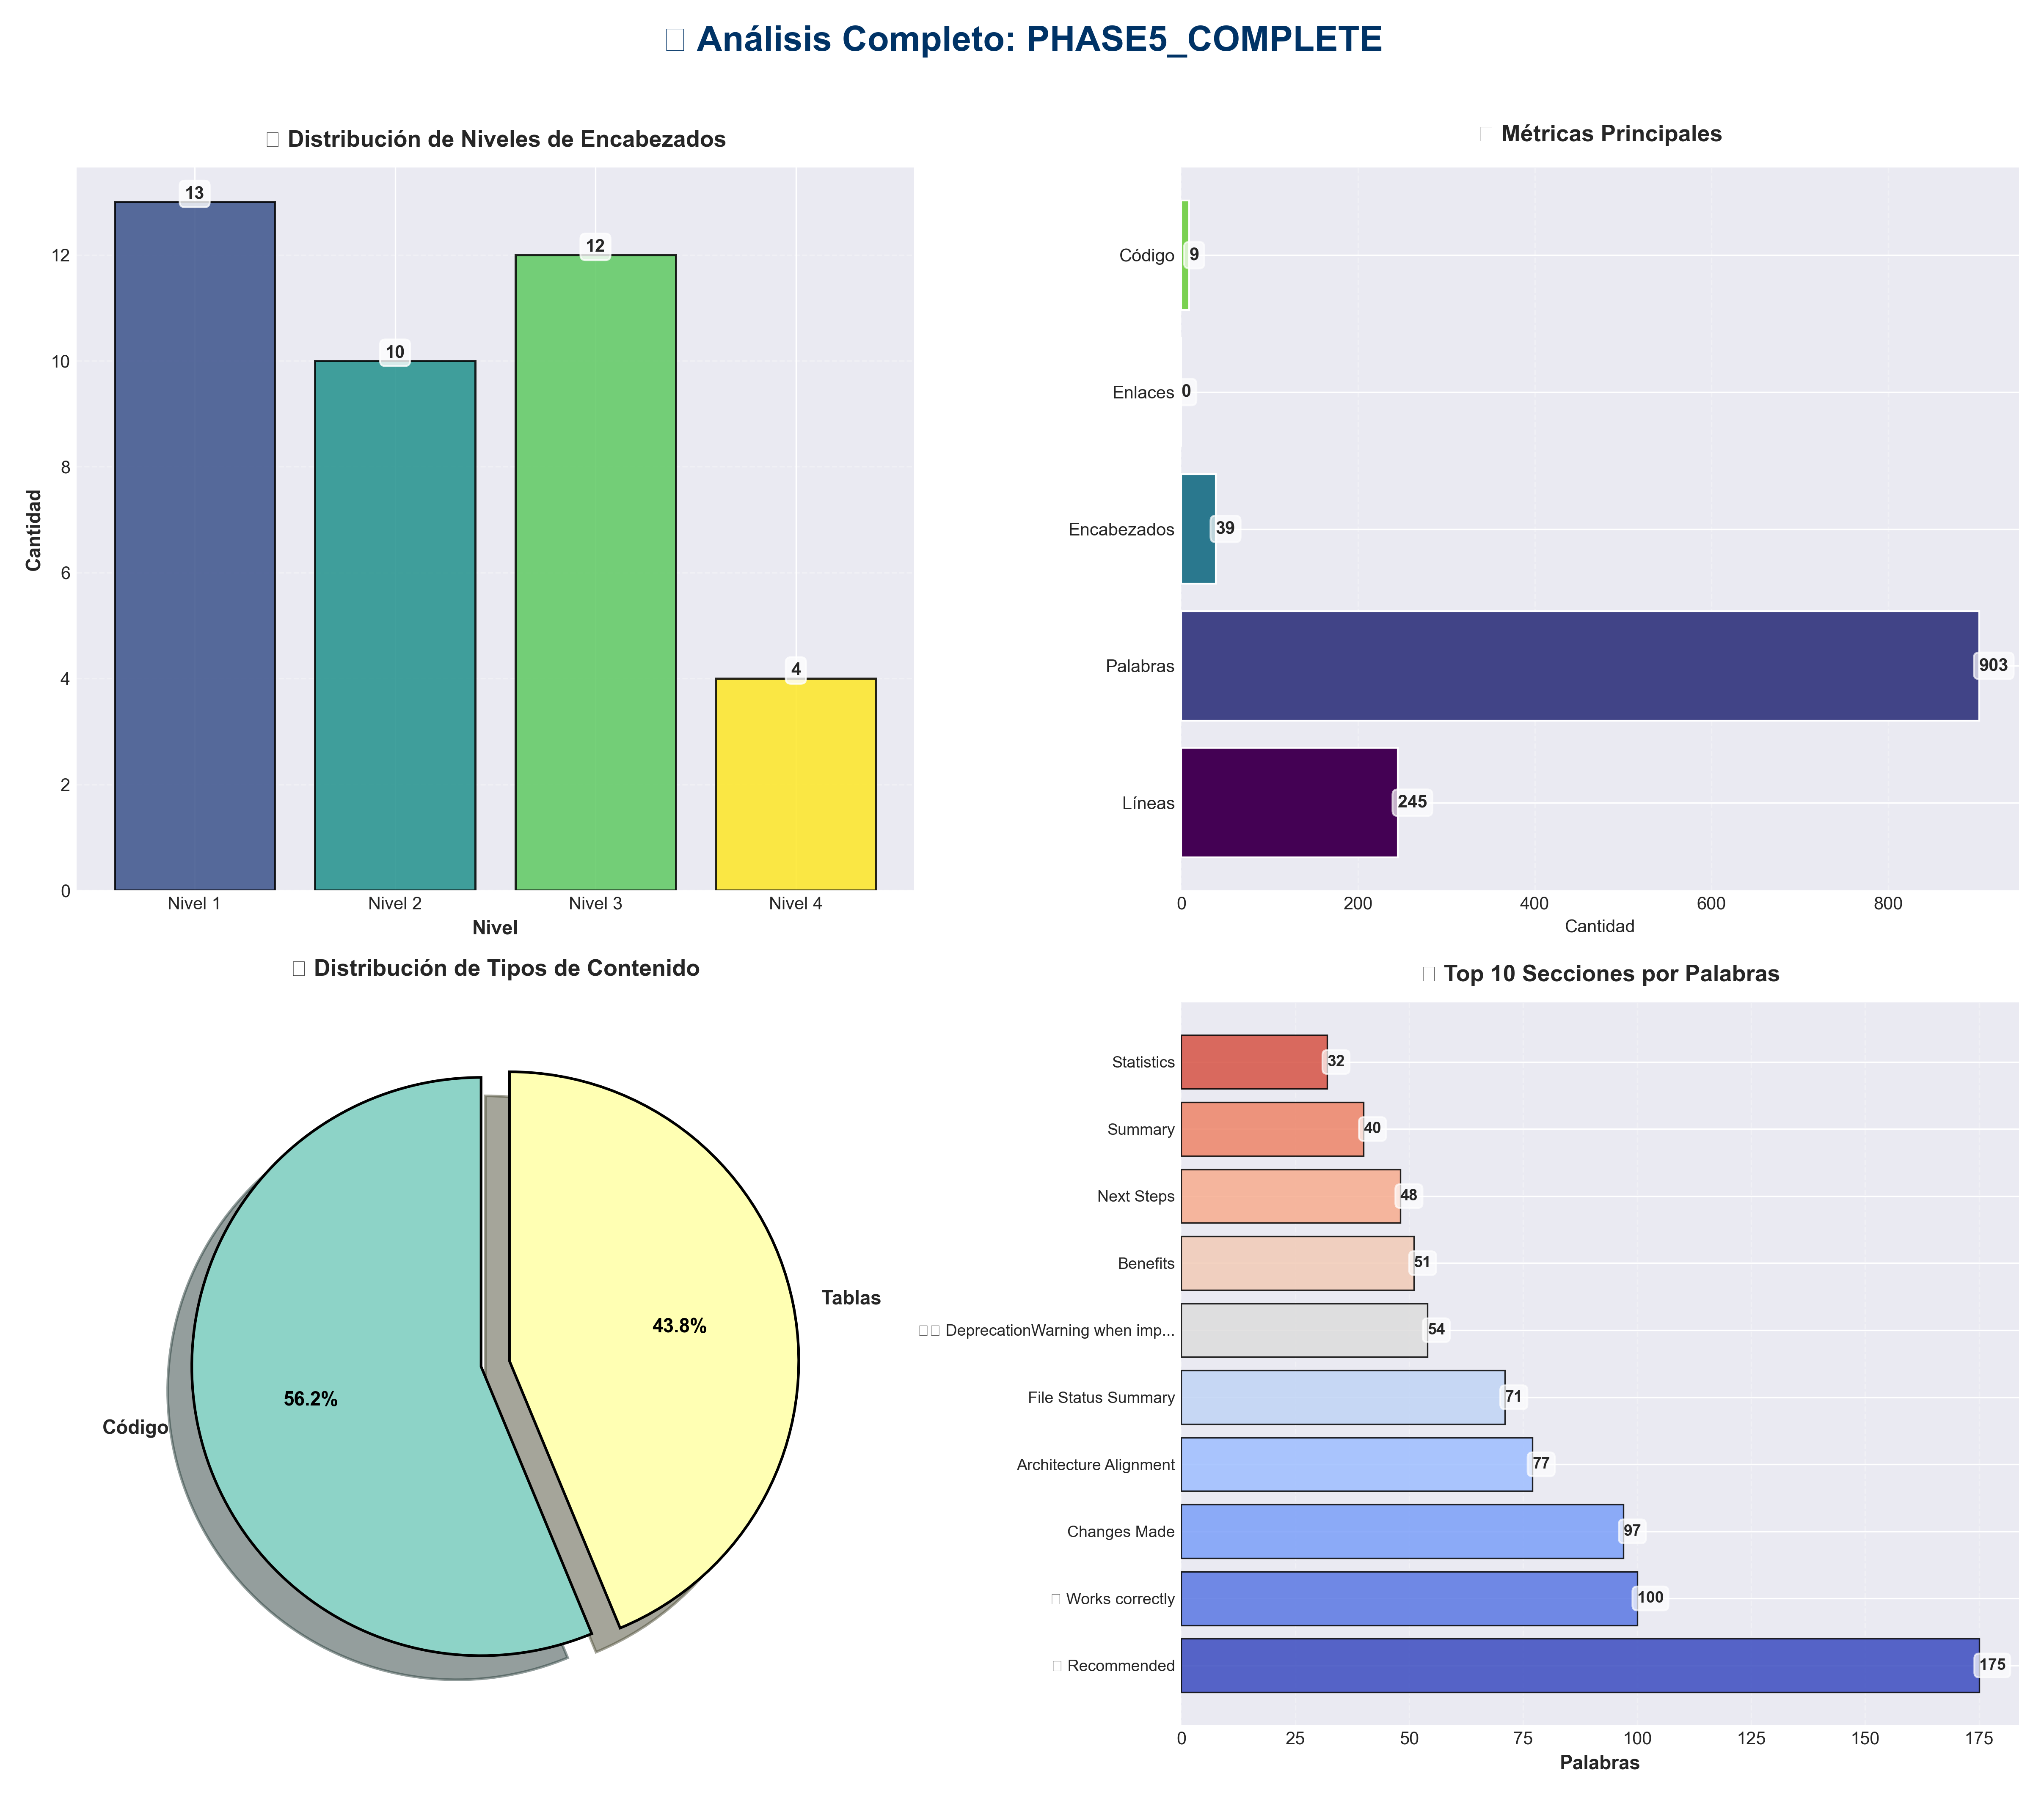

Análisis Adicionales
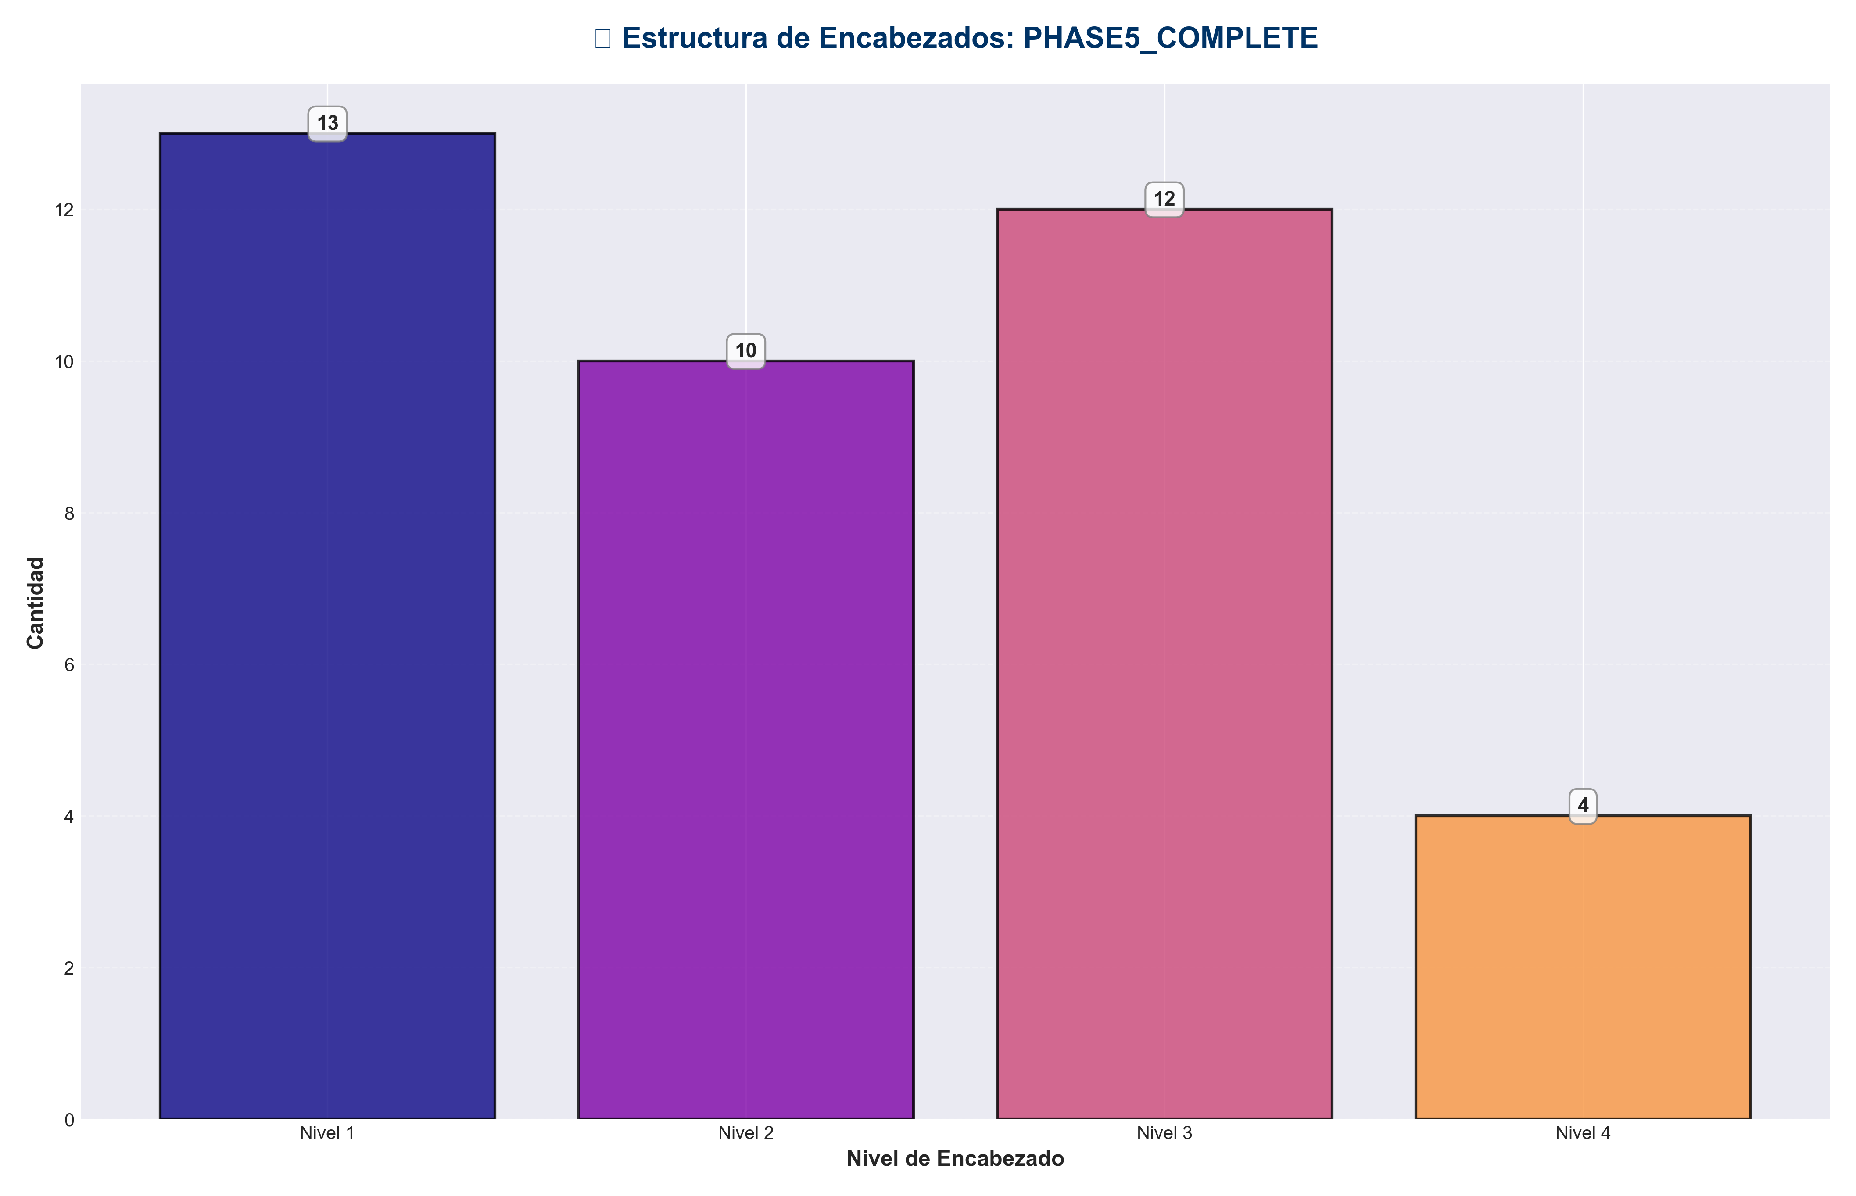

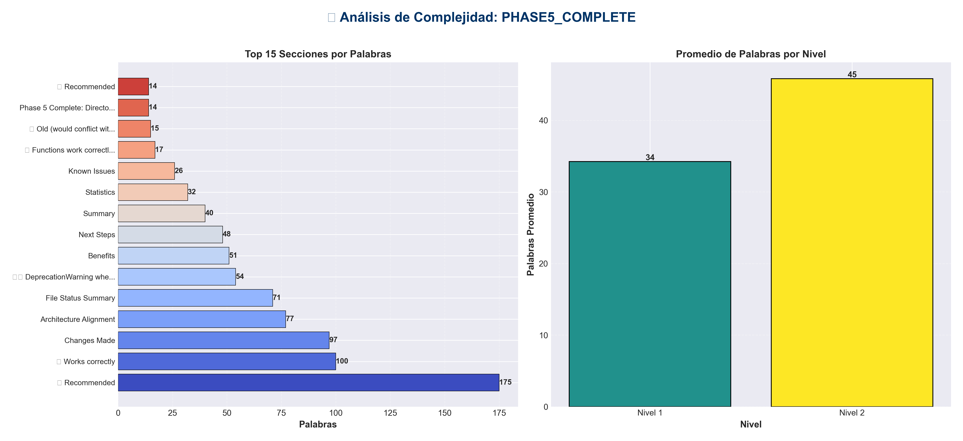

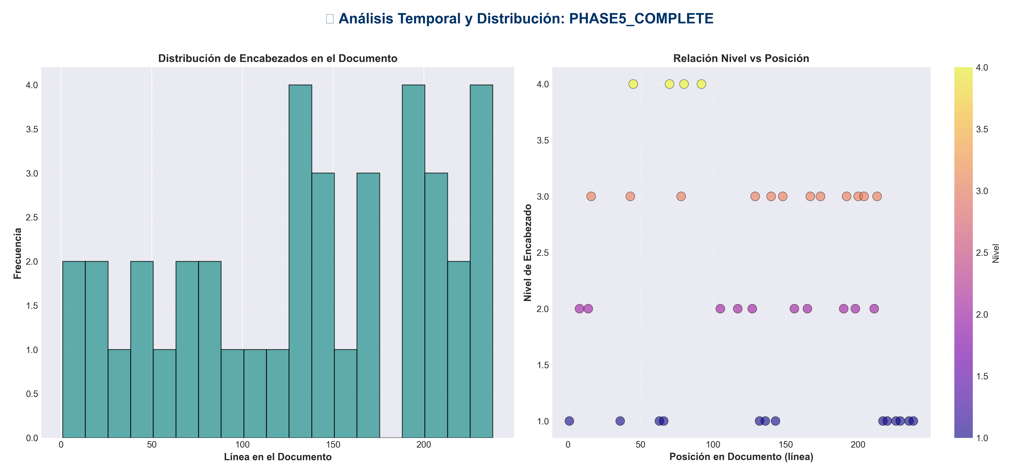

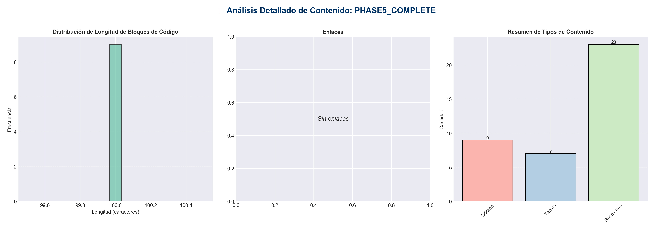

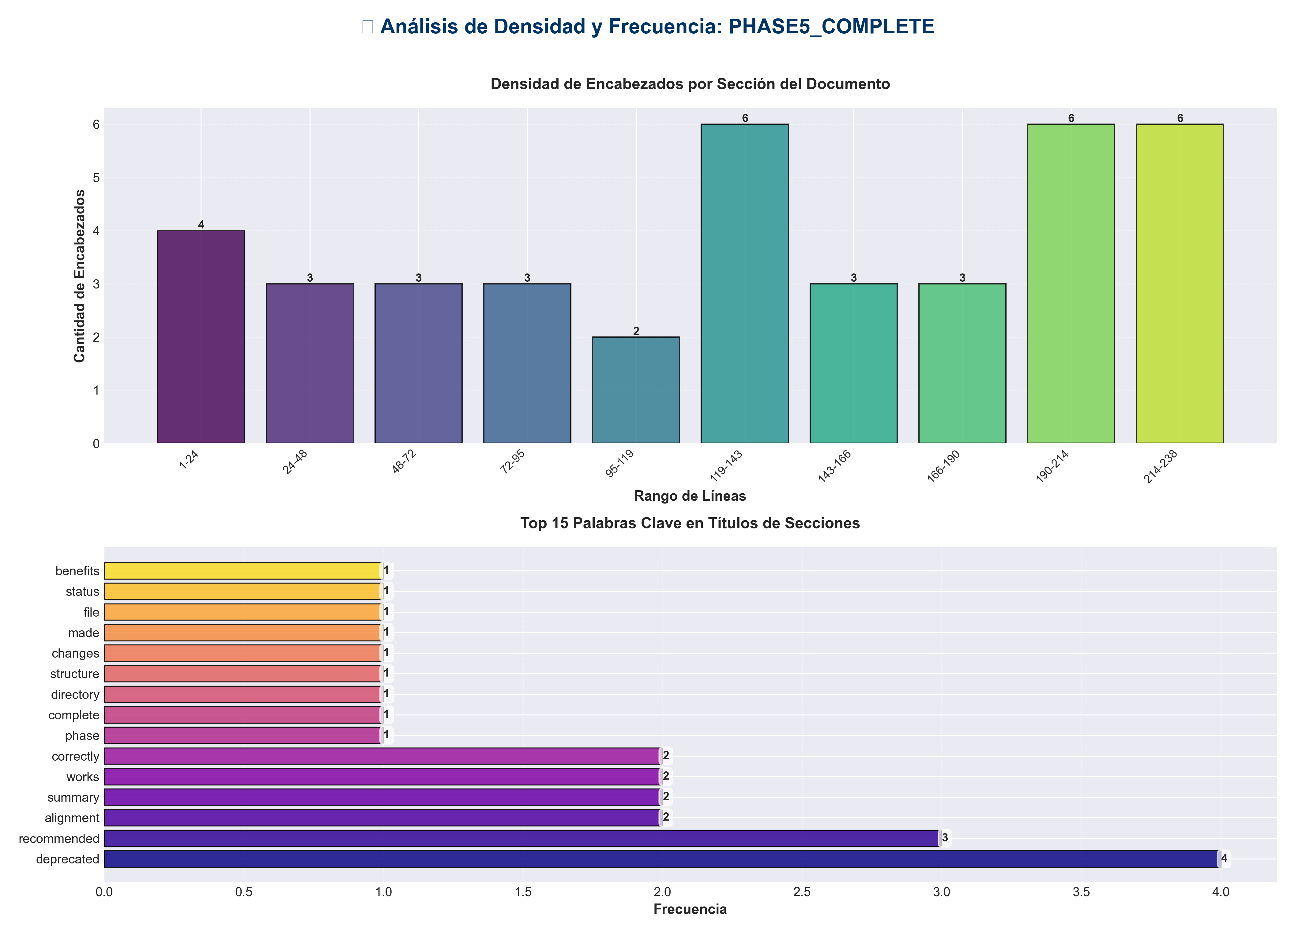

📊 Estadísticas del Documento
Resumen Ejecutivo: Este documento contiene 903 palabras distribuidas en 245 líneas, con 39 encabezados organizados en 23 secciones principales.

Métrica | Valor
Total de líneas | 245
Total de palabras | 903
Total de caracteres | 6,912
Encabezados | 39
Bloques de código | 9
Tablas | 7
Enlaces | 0
Imágenes | 0
Secciones principales | 23

📑 Índice de Secciones
Nivel | Título | Línea
1 | Phase 5 Complete: Directory Structure Alignment ✅ | 1
2 | Summary | 8
2 | Changes Made | 14
1 | ✅ Works correctly | 36
1 | ❌ Deprecated | 63
1 | ✅ Recommended | 66
2 | File Status Summary | 105
2 | Benefits | 117
2 | Verification | 127
1 | ✅ code_modules import works | 132
1 | ✅ Functions work correctly | 136
1 | ⚠️ DeprecationWarning when importing deprecated modules | 143
2 | Statistics | 156
2 | Architecture Alignment | 165
2 | Known Issues | 190
2 | Next Steps | 198
2 | Migration Guide | 211
1 | ❌ Old (would conflict with Python built-in) | 217
1 | ✅ New | 220
1 | ❌ Deprecated | 226
1 | ✅ Recommended | 229
1 | ❌ Deprecated | 235
1 | ✅ Recommended | 238

📄 Contenido

Phase 5 Complete: Directory Structure Alignment ✅

- **Date**: 2025-01-27
- **Status**: ✅ Completed

- ---

Summary

Successfully resolved directory naming conflicts and aligned root-level files with the layered architecture. The `code/` directory has been renamed to `code_modules/` to avoid conflicts with Python's built-in `code` module, and deprecated root-level files have been marked appropriately.

- ---

Changes Made

1. Resolved `code/` Directory Naming Conflict ✅

- **Problem:**
- - `code/` directory conflicted with Python's built-in `code` module
- - Caused import issues when torch tried to import built-in `code`
- - Error: `AttributeError: partially initialized module 'torch.nn' has no attribute 'Module'`

- **Solution:**
- - ✅ Renamed `code/` → `code_modules/`
- - ✅ Verified no imports needed updating (no files were importing from `code/`)
- - ✅ Tested import: `import code_modules` works correctly
- - ✅ Tested functionality: `code_modules` functions work correctly

- **Files Affected:**
- - `code/` → `code_modules/` (directory rename)
- - `code/__init__.py` → `code_modules/__init__.py`
- - `code/paper_2508_06471.py` → `code_modules/paper_2508_06471.py`

- **Verification:**

✅ Works correctly
from code_modules import create_code_module, get_available_modules
available = get_available_modules() # {'paper_2508_06471': True}

- ---

2. Deprecated Root-Level Files ✅

2.1 `api_auth.py` - Deprecated

- **Status:** ✅ Deprecated with warning

- **Reason:**
- - Current API uses `api.auth` (OptionalAuth) - simpler, optional authentication
- - `api_auth.py` provides complex APIKeyManager with permissions and rate limiting
- - **Not used anywhere** in the codebase
- - All routes use `api.auth` instead

- **Action Taken:**
- - ✅ Added deprecation warning at module level
- - ✅ Documented migration path to `api.auth`
- - ✅ Kept functionality for backward compatibility
- - ✅ Clear documentation about differences

- **Migration Guide:**

❌ Deprecated
from api_auth import APIKeyManager, verify_api_key

✅ Recommended
from api.auth import OptionalAuth, verify_api_key_optional

2.2 `api_middleware.py` - Already Deprecated ✅

- **Status:** ✅ Already deprecated (from previous phase)

- **Action:** No changes needed - already a compatibility shim

- ---

3. Root-Level Files Analysis

Files That Should Stay at Root ✅

According to the refactoring plan, these files should remain at root:

- - ✅ `api_server.py` - Entry point script
- - ✅ `application.py` - Application factory
- - ✅ `cli.py`, `cli_unified.py` - CLI entry points
- - ✅ `chat_server.py` - Chat server entry point
- - ✅ `integration_pipeline.py` - Integration pipeline (keep at root per plan)
- - ✅ `monitoring_system.py` - System monitor (different from `services/monitoring_service.py`)
- - ✅ `README.md`, `ARCHITECTURE.md` - Documentation

Files Already in Correct Location ✅

- - ✅ `api/auth.py` - Current authentication (used by all routes)
- - ✅ `api/middleware.py` - Current middleware (used by application)
- - ✅ `services/monitoring_service.py` - Service layer monitoring
- - ✅ `services/*.py` - All service layer files

- **Note:** `monitoring_system.py` (root) and `services/monitoring_service.py` are **different**:
- - `monitoring_system.py` - Low-level system monitoring (infrastructure)
- - `services/monitoring_service.py` - Service layer wrapper (application)

- ---

File Status Summary

- ---

Benefits

1. **Resolved Import Conflicts**: `code/` → `code_modules/` eliminates Python built-in conflict
2. **Clear Deprecation Path**: Users know which modules to use
3. **Better Organization**: Files aligned with layered architecture
4. **Backward Compatible**: Deprecated files still work with warnings
5. **No Breaking Changes**: All existing code continues to work

- ---

Verification

Import Tests ✅

✅ code_modules import works
import code_modules
from code_modules import create_code_module, get_available_modules

✅ Functions work correctly
available = get_available_modules() # {'paper_2508_06471': True}

Deprecation Warnings ✅

⚠️ DeprecationWarning when importing deprecated modules
import api_auth # DeprecationWarning: api_auth (root) is deprecated...
import api_middleware # DeprecationWarning: api_middleware (root) is deprecated...

No Import Updates Needed ✅

- - ✅ No files were importing from `code/` (good!)
- - ✅ All routes use `api.auth` (correct)
- - ✅ All middleware uses `api.middleware` (correct)

- ---

Statistics

- - **Directories Renamed**: 1 (`code/` → `code_modules/`)
- - **Files Deprecated**: 1 (`api_auth.py`)
- - **Import Updates Required**: 0 (no files were using `code/`)
- - **Breaking Changes**: 0 (all backward compatible)

- ---

Architecture Alignment

Before
code/ # ❌ Conflicts with Python built-in
api_auth.py # ❌ Unused, complex API
api_middleware.py # ⚠️ Deprecated

After
code_modules/ # ✅ No conflicts
api_auth.py # ⚠️ Deprecated (with warning)
api_middleware.py # ⚠️ Deprecated (compatibility shim)
api/auth.py # ✅ Current authentication
api/middleware.py # ✅ Current middleware

- **Follows Layered Architecture:**
- - **Presentation Layer**: `api/auth.py`, `api/middleware.py`
- - **Root Level**: Deprecated compatibility shims
- - **Domain Layer**: `code_modules/` (code optimization modules)

- ---

Known Issues

None Identified

All directory structure issues have been resolved. The `code/` directory conflict is fixed, and deprecated files are properly marked.

- ---

Next Steps

Immediate
- - ✅ Phase 5 complete
- - ⏭️ Ready for Phase 6: Architecture Alignment

Future
- - Remove deprecated `api_auth.py` after migration period (suggest 3-6 months)
- - Remove deprecated `api_middleware.py` after migration period
- - Update all documentation to reference `code_modules/` instead of `code/`

- ---

Migration Guide

For Developers

- **Code Modules:**

❌ Old (would conflict with Python built-in)
from code import create_code_module # Would fail

✅ New
from code_modules import create_code_module

- **Authentication:**

❌ Deprecated
from api_auth import APIKeyManager, verify_api_key

✅ Recommended
from api.auth import OptionalAuth, verify_api_key_optional

- **Middleware:**

❌ Deprecated
from api_middleware import LoggingMiddleware

✅ Recommended
from api.middleware import LoggingMiddleware

- ---

- **Phase 5 Status**: ✅ **COMPLETE**

