Documento sin título
Fecha: 2025-11-25 | Versión: 1.0

Resumen Ejecutivo
- from markdown+mermaid --toc --highlight-style=kate
- reference-doc templates/automation.docx --number-sections
- source airflow_automation_prompt.md \
- out artifacts/v2.1/automation_controls.xlsx \
- tabs KPIs Controls Backlog Releases Risks

Acciones Prioritarias
Descripción | Estado
300+ automation tools and frameworks across 80+ domains | Pendiente
Best practices, patterns, and anti-patterns | Pendiente
Troubleshooting frameworks and solution development | Pendiente
Code examples and implementation guidance | Pendiente
Framework selection criteria and decision guides | Pendiente
Industry-specific automation (healthcare, finance, retail, manufacturing, etc.) | Pendiente
Direct question answering with structured responses | Pendiente
Automatic term definition for automation concepts | Pendiente

Métricas Clave
Palabras totales: 43984
Lectura estimada (min): 219.9
Secciones H1/H2/H3: 5/0/0

Palabras Clave Prioritarias
Palabra | Frecuencia
automation | 1161
management | 501
data | 448
automated | 430
with | 273
compliance | 254
monitoring | 215
security | 207

Cronología Identificada
- 2024-01-02
- 2025-01-15
- 2024-12-01
- 2024-12-20
- 2025-01-22
- 2025-02-01
- 2025-02-10
- 2025-02-20
- 2025-01-05
- 2025-01-10

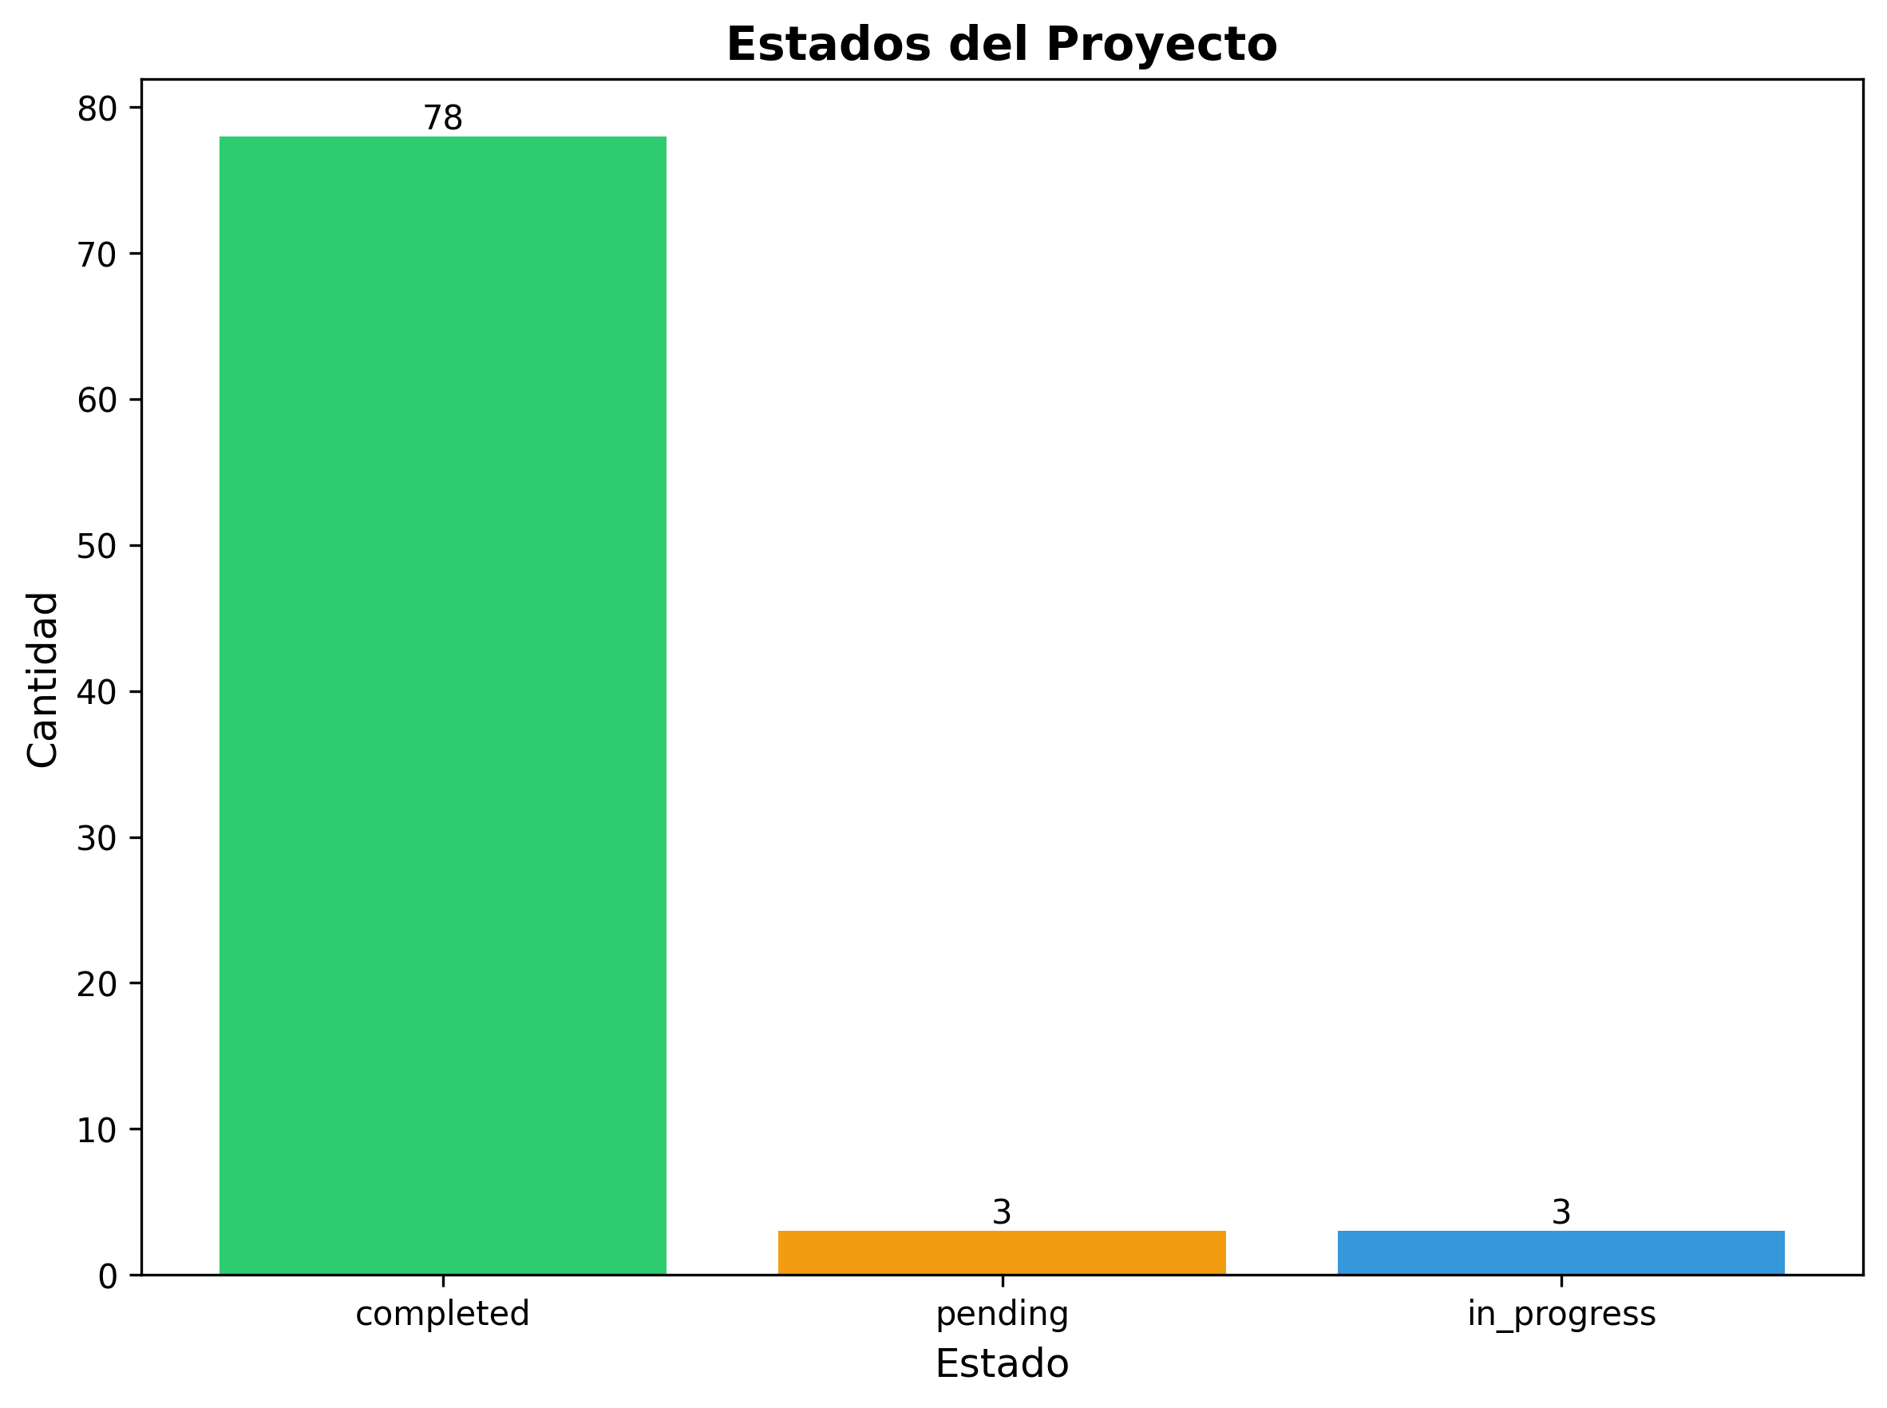

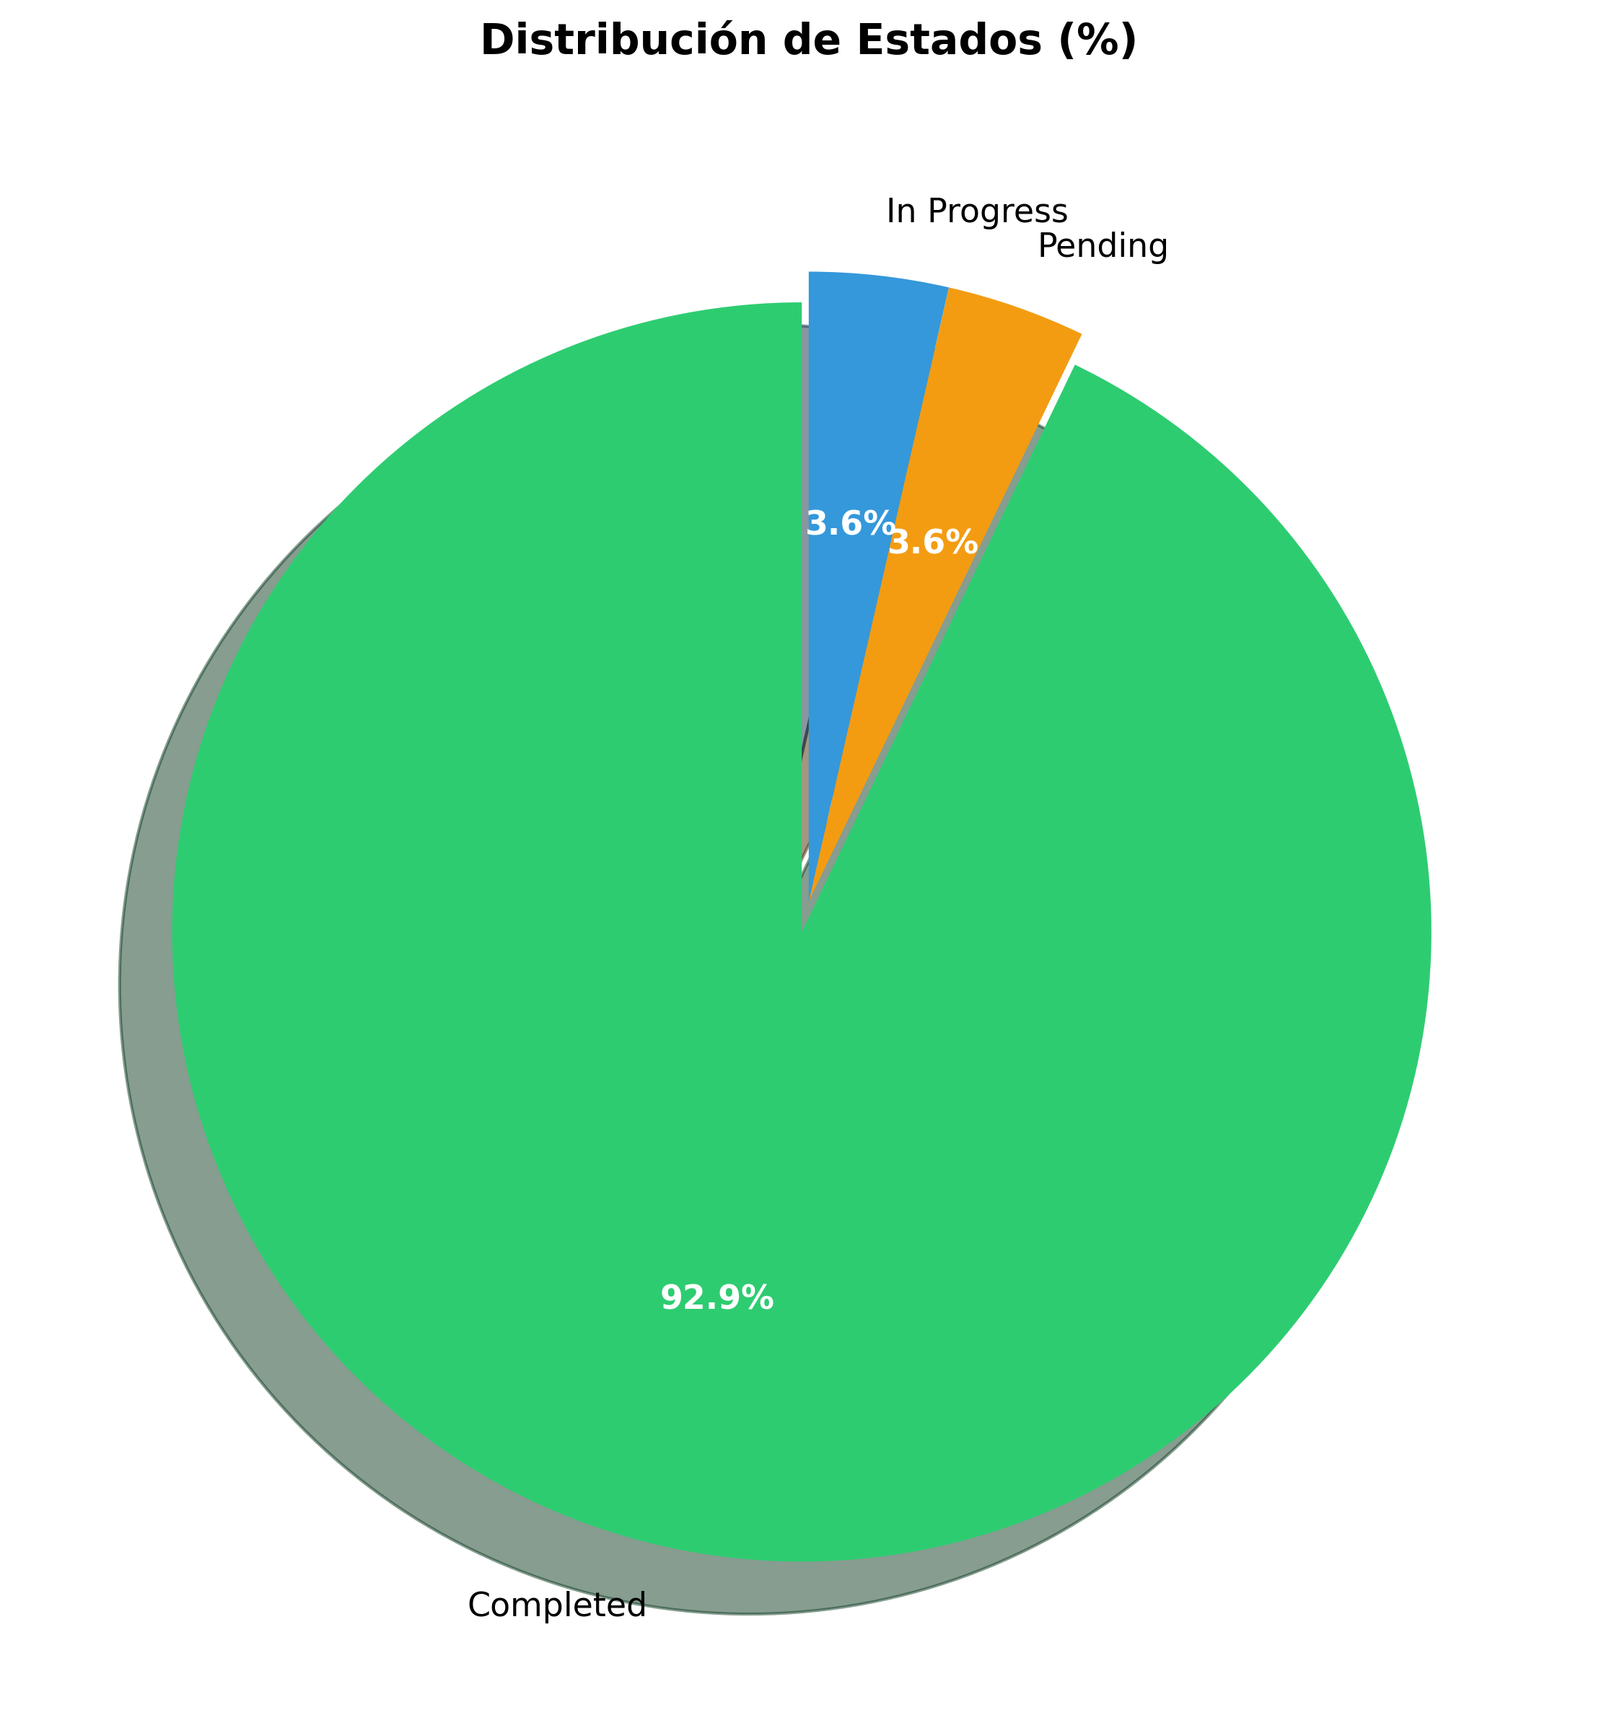

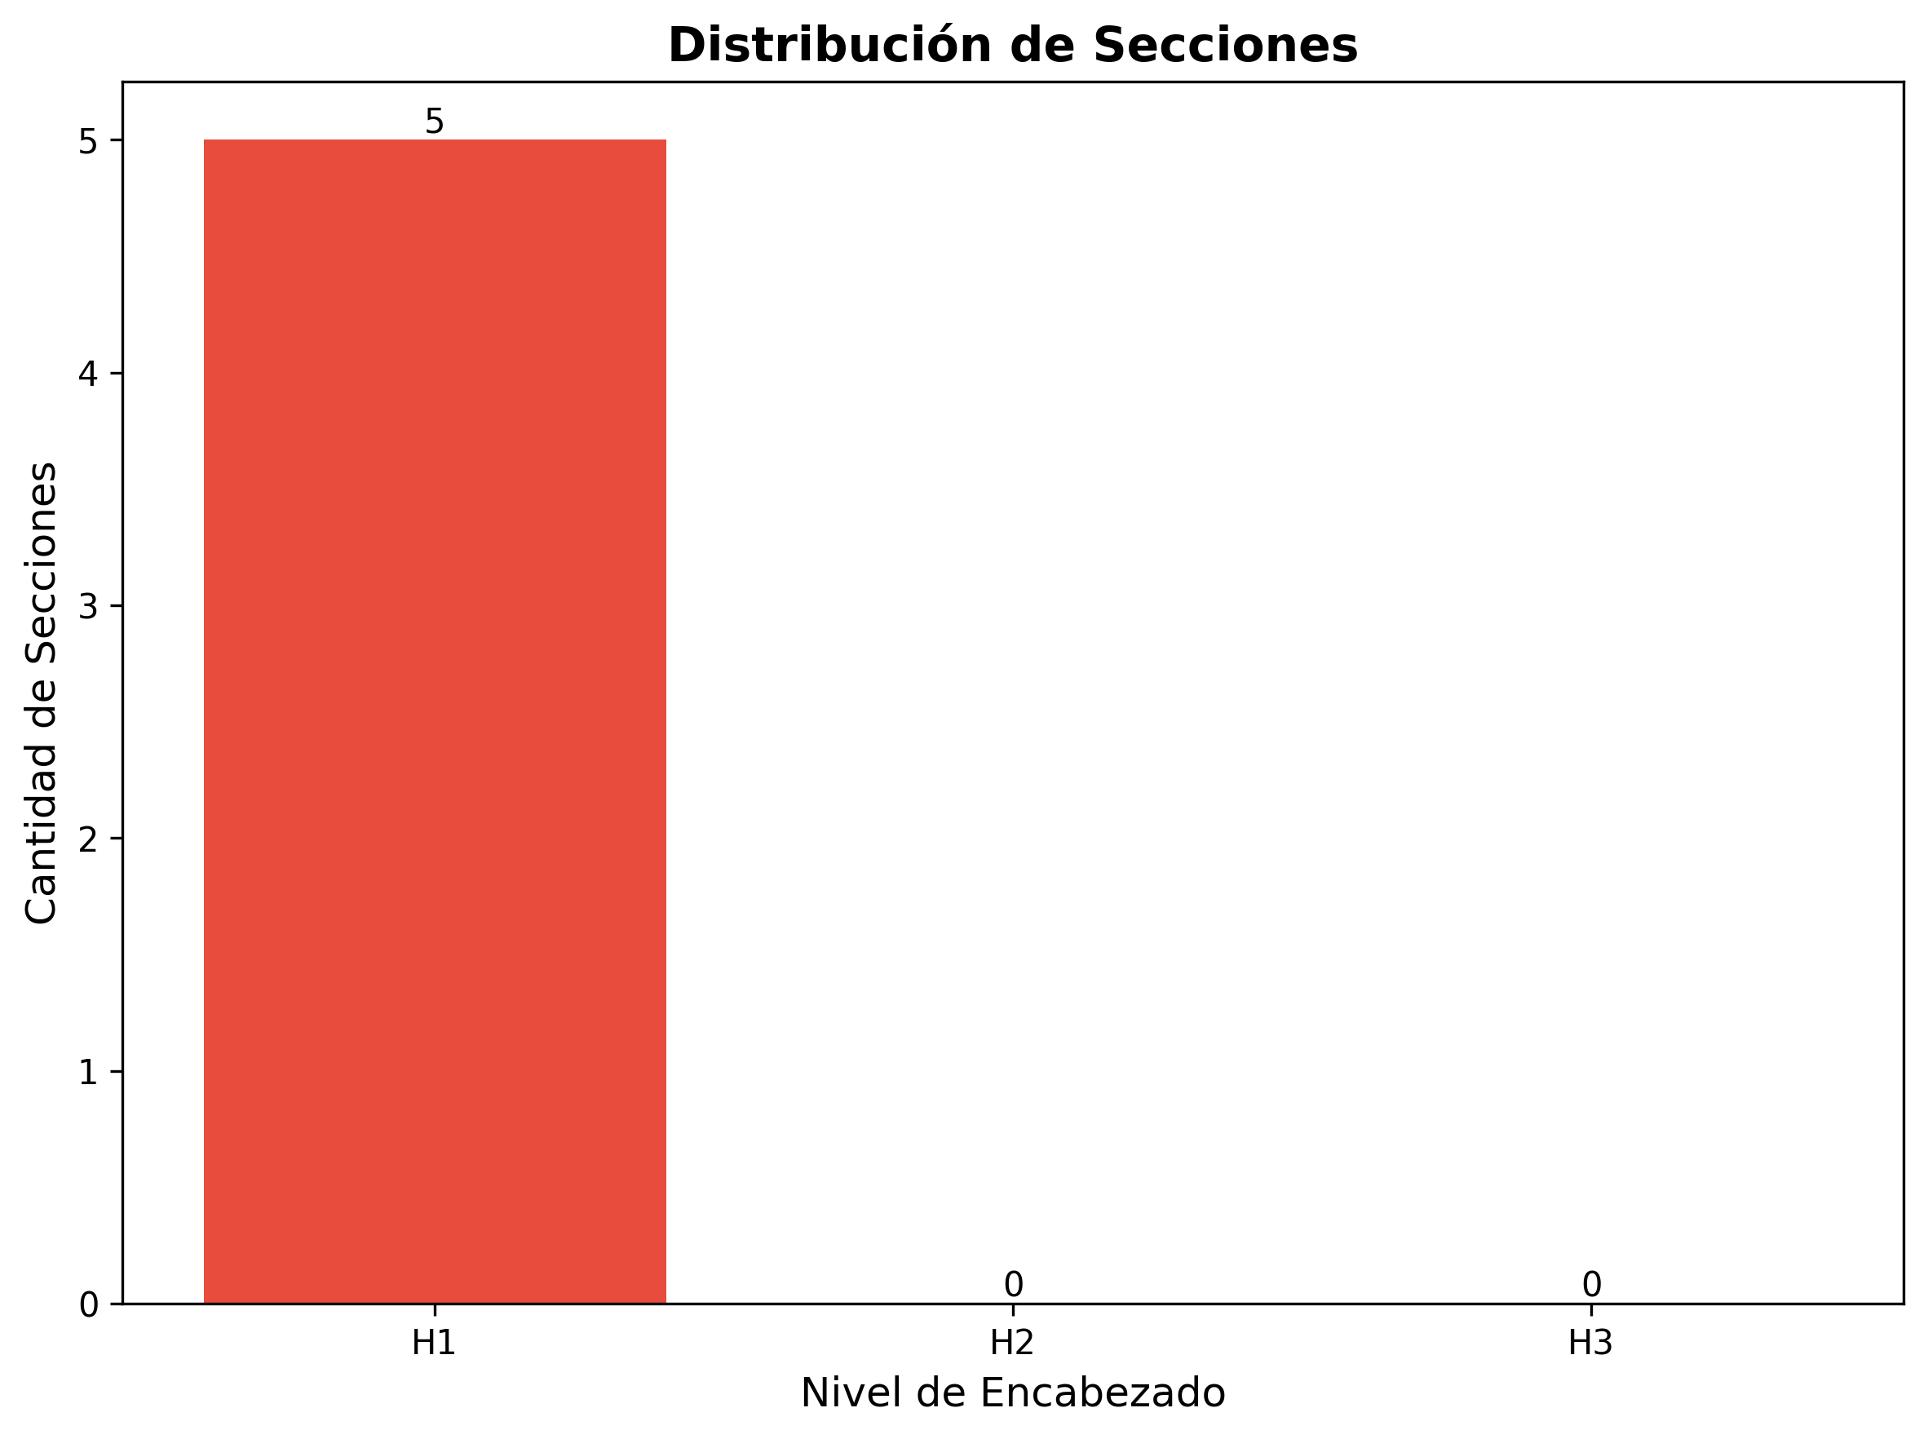

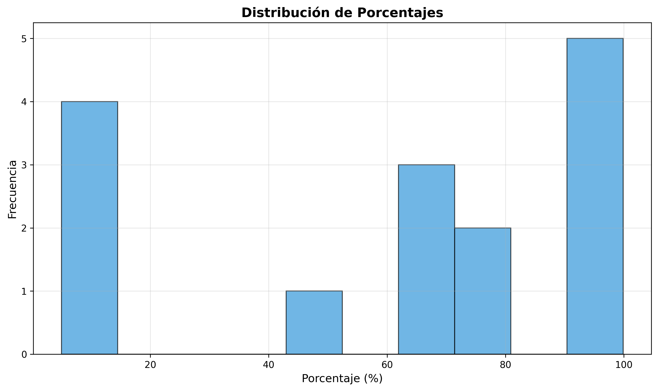

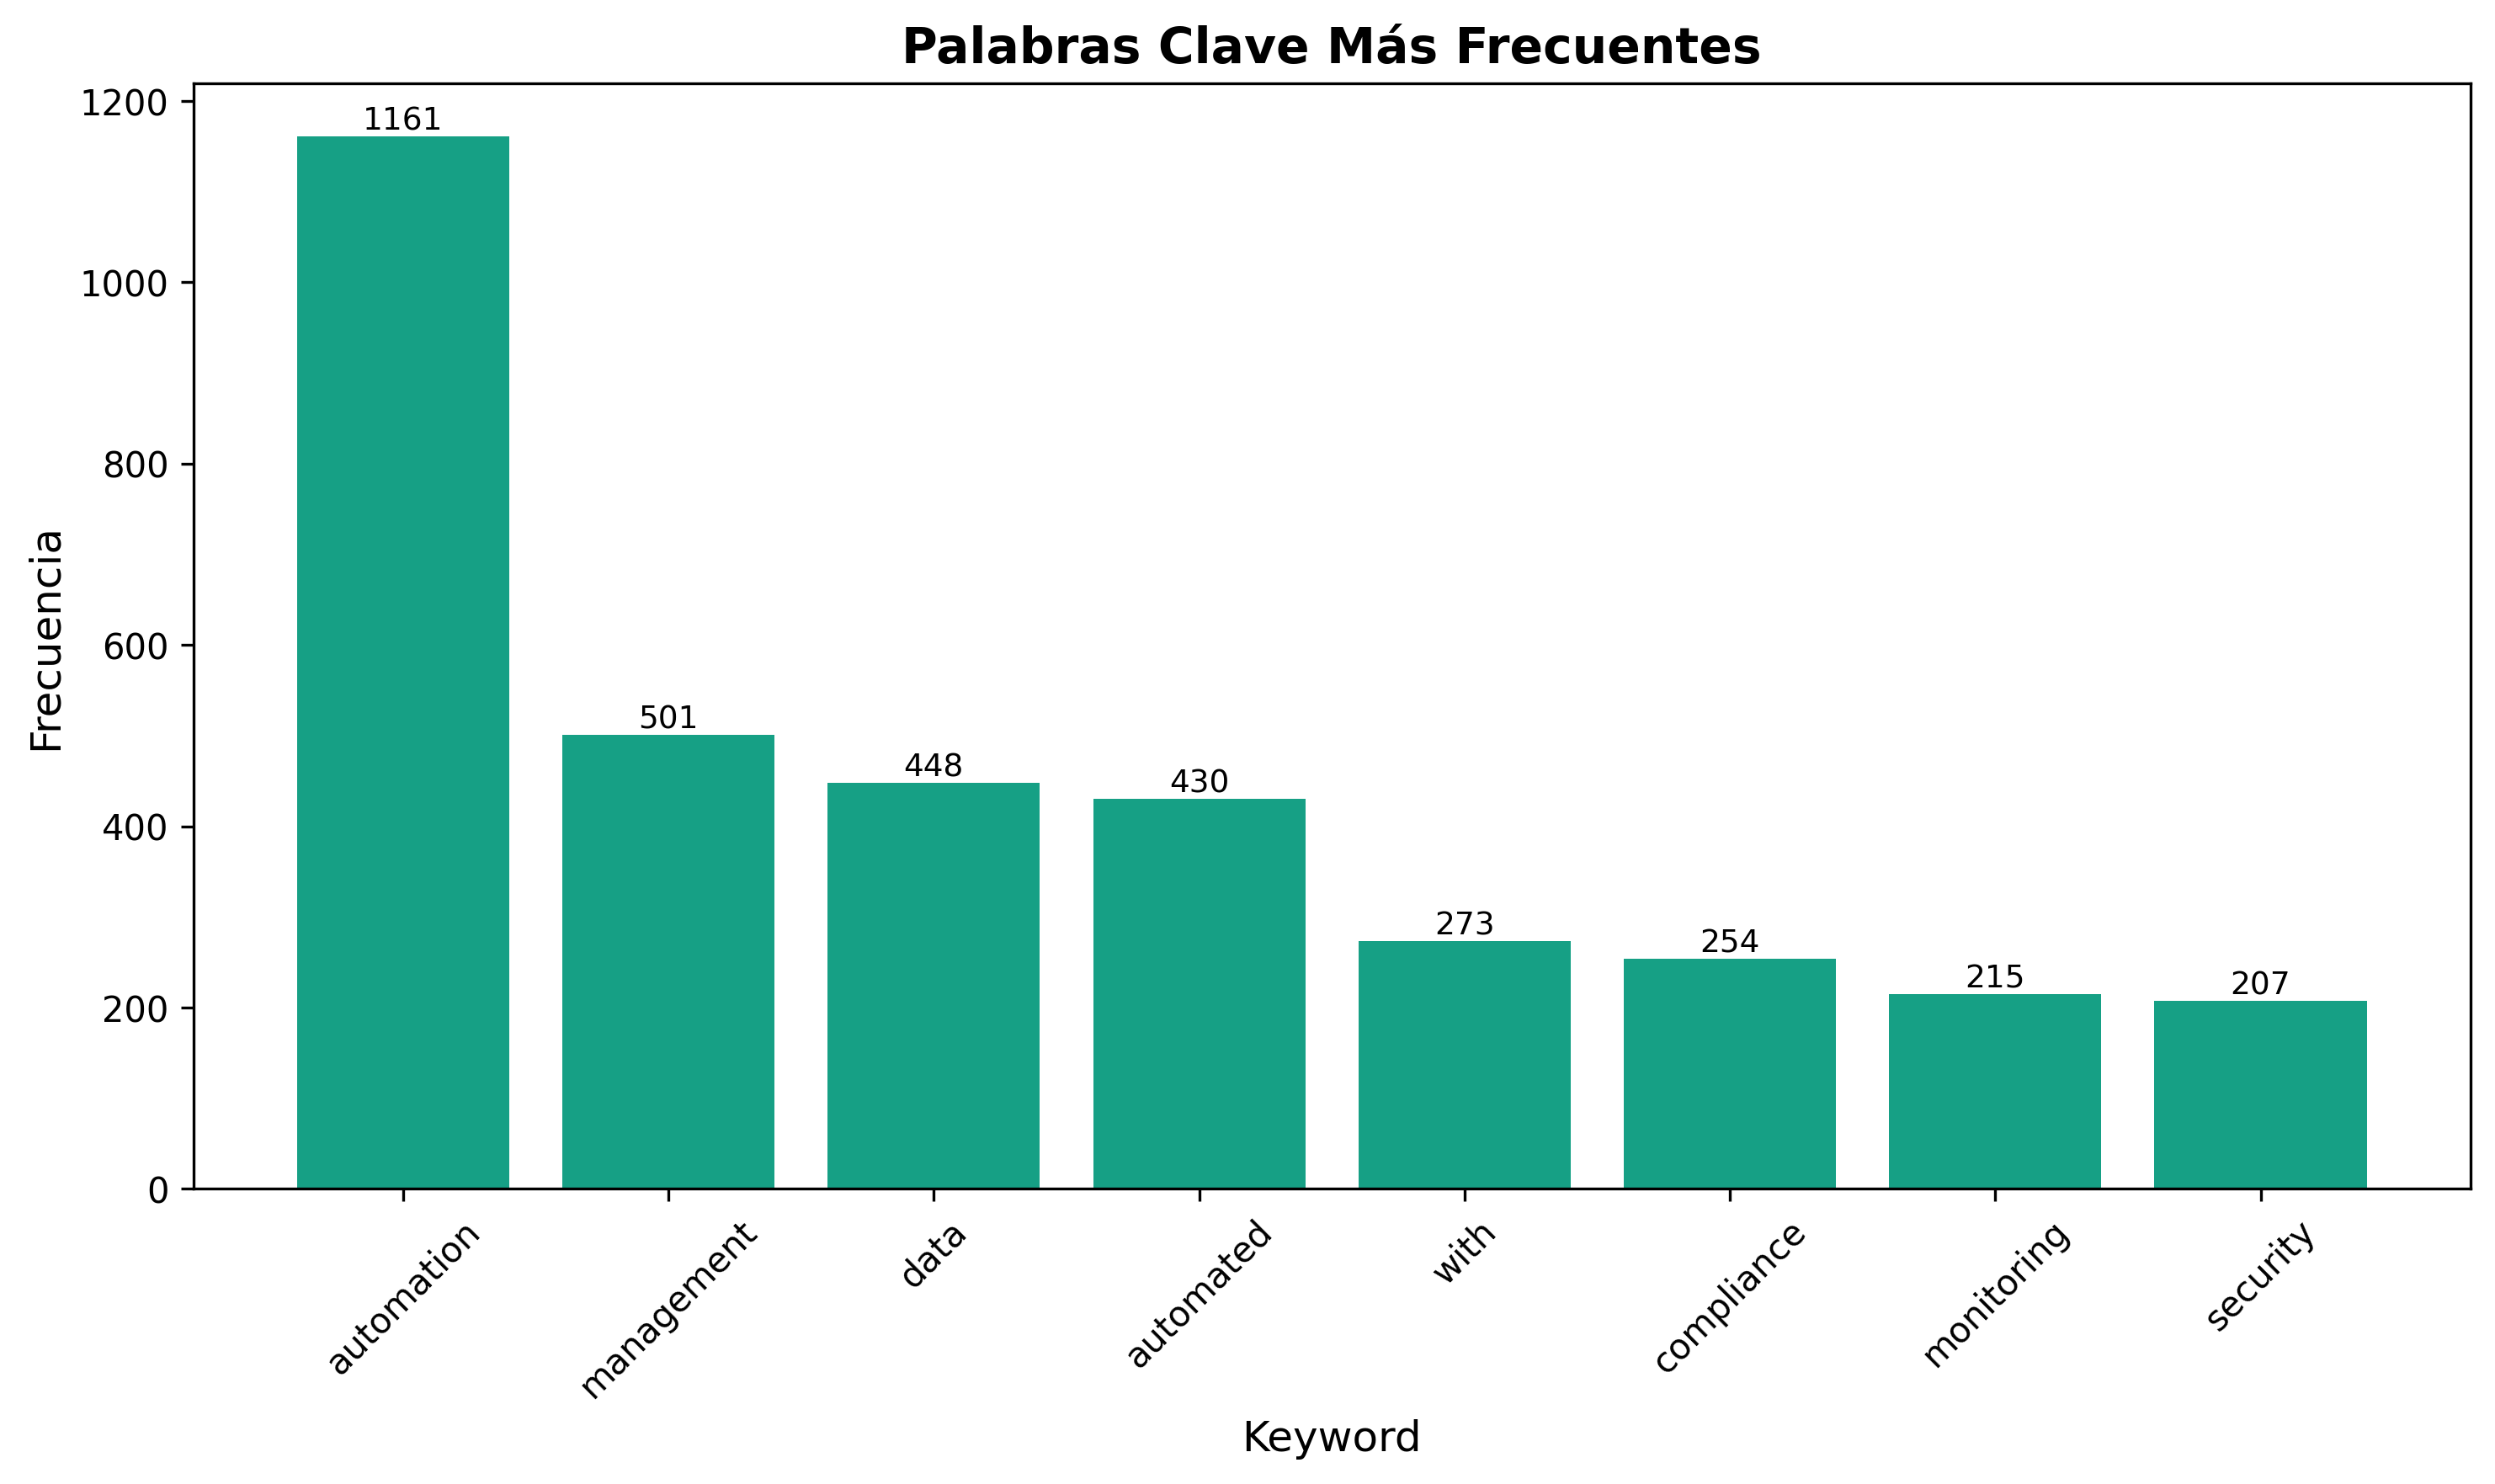

Render diagrams
make diagrams # wraps mmdc commands, outputs to artifacts/v2.1/visuals

Generate docs
pandoc airflow_automation_prompt.md -o artifacts/v2.1/automation_playbook.pdf \
--from markdown+mermaid --toc --highlight-style=kate
pandoc airflow_automation_prompt.md -o artifacts/v2.1/automation_playbook.docx \
--reference-doc templates/automation.docx --number-sections

Build Excel workbook
python scripts/generate_workbook.py \
--source airflow_automation_prompt.md \
--out artifacts/v2.1/automation_controls.xlsx \
--tabs KPIs Controls Backlog Releases Risks

Validate artifacts
python scripts/validate_doc.py --input artifacts/v2.1/automation_playbook.pdf
python scripts/validate_excel.py --input artifacts/v2.1/automation_controls.xlsx
`
Embed the snippet in a GitHub Actions workflow (nightly + on-release) so stakeholders always receive refreshed assets with logs attached.
</automation_export_snippets>
<executive_scorecard_templates>
Executive Scorecard Templates (plug directly into PDF/Word decks):
How to deploy:
1. Build the tables in Excel using structured references, then paste-linked into Word to keep numbers live.
2. Export charts as SVG for the PDF executive brief; retain PNG fallbacks for email.
3. Store narrative insights (What happened, Why, Next actions) in a linked Markdown appendix so updates cascade across formats.
</executive_scorecard_templates>
<automation_data_model>
Automation Data Model (aligns Excel workbook + downstream BI):
`text
FactAutomationRun(run_id, domain, use_case, kpi_id, start_ts, end_ts, status, sla_minutes, owner_id, env, cost_usd)
DimKPI(kpi_id, metric_name, description, unit, target_value, threshold_green, threshold_red, cadence)
DimOwner(owner_id, name, role, chapter, contact, timezone)
DimTool(tool_id, name, category, vendor, version, compliance_tags, last_patch_date)
BridgeRunTool(run_id, tool_id, responsibility)
`
- Persist the fact/Dim tables in SQLite or DuckDB so PowerBI/Looker can refresh directly.
- Generate CSV extracts during the conversion pipeline (python export_metrics.py --source airflow_automation_prompt.md --out artifacts/data/automation_runs.csv).
- Keep an ER diagram (dbdiagram.io or Mermaid erDiagram) next to the Gantt to help new stakeholders grasp lineage quickly.
</automation_data_model>
<ai_assistant_enablement>
AI Assistant Enablement (ensure prompts stay actionable in copilots/chatbots):
1. Bundle key sections (intake, guardrails, troubleshooting, scorecards) into separate prompt files under assistants/.
2. Tag each chunk with metadata (domain, task, persona, sensitivity) so retrieval pipelines filter content safely.
3. Provide ready-to-use function call schemas (JSON/YAML) for create_dag, evaluate_kpi, generate_playbook_section.
4. Log assistant feedback in the Excel Backlog tab to close the loop between human playbooks and AI augmentations.
</ai_assistant_enablement>
<kpi_scorecard_templates>
Automation KPI Scorecard Templates (replicate across PDF · Word · Excel):
Each scorecard must include owner, data cadence, upstream system, and threshold bands so cross-format exports stay consistent.
</kpi_scorecard_templates>
<diagram_catalog>
Extended Diagram Catalog (embed as Mermaid + export to SVG/PNG):
`mermaid
flowchart TD
Detect[Signal from Monitor/SLO] --> Classify{Severity & Domain}
Classify -->|P0| AutoRunbook[Trigger Auto-Runbook]
Classify -->|P1/P2| AnalystReview[Analyst Review]
AutoRunbook --> Remediate[Self-Heal Script]
Remediate --> Verify[Post-Action Checks]
AnalystReview --> Decision{Auto vs Manual Fix}
Decision -->|Auto| Remediate
Decision -->|Manual| Escalate[PagerDuty Escalation]
Verify --> Close[Update Status + RCA]
Close --> Learnings[Feed Backlog & Dashboards]
`
Pair every diagram with a metadata table (Owner, Last Reviewed, Tooling Source, Distribution Channels) to keep audit pipelines intact.
</diagram_catalog>
<excel_visualization_guidelines>
Excel Visualization Guidelines (aligned with BI handoffs):
- Build PivotCharts directly from KPIs, Controls, Backlog, Releases, and Risks tabs; lock slicers for Domain, Owner, and Quarter.
- Apply sparklines on Variance fields plus 3-color conditional formats to flag breaches automatically.
- Generate waterfall charts for ROI scorecards and bind them to named ranges so refresh scripts do not break.
- Embed timeline and data slicers for release cadence tracking, then paste-linked images into the Word roadmap chapter.
- Store chart configuration JSON (from xlsxwriter/openpyxl) under artifacts/<version>/charts/ for reproducible exports.
</excel_visualization_guidelines>
<distribution_cadence_calendar>
Distribution Cadence & Channels:
Surface this matrix at the front of each artifact so stakeholders know when to expect refreshes and who to ping for urgent updates.
</distribution_cadence_calendar>
<automation_service_catalog>
Automation Service Catalog Snapshot:
Reference the catalog within the Word playbook intake chapter and mirror SLAs in the Excel Controls tab to maintain governance coverage.
</automation_service_catalog>
<analytics_tracking_plan>
Analytics & Observability Tracking Plan:
1. Event Taxonomy – Maintain YAML registry of canonical events (automation_run_started, deployment_approved, incident_auto_resolved) with owner + schema history.
2. Instrumentation – Attach OpenTelemetry exporters to Airflow, Prefect, and CI pipelines; enrich traces with domain, persona, risk_level, service_tier.
3. Storage – Stream telemetry into Kafka → ClickHouse for near-real-time dashboards; archive raw events to S3/Parquet for quarterly retros.
4. Dashboards – Grafana for ops metrics (SLOs, saturation, queue depth) + Looker for exec KPIs (ROI, adoption, savings).
5. Alerting – Datadog/Prometheus anomaly detection posts to Slack #auto-alerts with contextual cards (owner, latest runbook, severity, ETA).
Cross-link metric owners to the Excel Risks tab so every alert stream has accountable follow-up.
</analytics_tracking_plan>
<multiformat_styleguide>
Multi-Format Style Guide (PDF · Word · Excel · PPT):
- PDF: A4 portrait, 1.5 cm margins, Inter font, branded cover with QR to live dashboard.
- Word: Use templates/automation.docx, enforce automatic heading numbering, bilingual glossary appendix, auto-updating TOC.
- Excel: Freeze panes row 2/col B, apply zebra striping, define named ranges for every chart so refresh scripts remain stable.
- PPT (optional): Slide master referencing capability matrix colors, embed SVG diagrams, max 30 words per slide, include speaker notes back-linking to Word sections.
- Metadata: Populate document properties (Title, Subject, Keywords, Version, Owner, Sensitivity) before distribution for search/compliance.
</multiformat_styleguide>
<conversion_automation_roadmap>
Conversion Automation Roadmap:
1. Phase 1 – Scripted Manual: Current make diagrams + pandoc + workbook scripts executed locally.
2. Phase 2 – CI Pipeline: GitHub Actions workflow with matrix builds (Linux/macOS), artifact uploads, Slack notifications.
3. Phase 3 – Self-Service Portal: Streamlit/internal portal allowing persona-based export requests with dynamic sections.
4. Phase 4 – Event-Driven Refresh: Git hooks or file watchers trigger conversion when key sections change; artifacts tagged with Git SHA.
5. Phase 5 – Telemetry Feedback: Capture view/download analytics (SharePoint/Confluence) to prioritize sections and auto-expire stale artifacts.
Include roadmap milestones in the PDF appendix so leadership understands the investment path to full automation.
</conversion_automation_roadmap>
</visual_playbook_and_delivery>
----------
<governance_raci_playbook>
Governance & RACI Playbook (reuse in Word/Excel appendices):
Implementation tips:
- Keep the table in CSV under governance/raci/automation_raci.csv and import into both Word playbook and Excel controls workbook.
- Tag each row with quarter and region columns when exporting for multi-region deployments.
- Reflect RACI changes in the AI assistant metadata to keep prompt routing accurate.
</governance_raci_playbook>
<risk_heatmap_guidelines>
Risk Heatmap Guidelines (feed into Excel Risks tab + PDF dashboards):
1. Risk Scoring Formula: Risk Score = Impact (1-5) * Likelihood (1-5); auto-calc via Excel column to drive conditional formatting.
2. Color Bands: 1-5 (Green), 6-12 (Amber), 15-25 (Red) with hex codes #4CAF50, #FFC107, #F44336 for consistent exports.
3. Mandatory Fields: Risk ID, Category, Description, Impact, Likelihood, Owner, Mitigation, Trigger, Target Date, Status.
4. Visualization: Generate a 5x5 matrix (Impact vs Likelihood) in Excel and capture as SVG for the Word/PDF annex; highlight top 3 risks with annotations.
5. Automation Hooks: Schedule a nightly script (python scripts/update_risk_heatmap.py) that syncs the Markdown list with the Excel tab to avoid drift.
</risk_heatmap_guidelines>
<implementation_blueprints>
Implementation Blueprints (reference section for Airflow/Prefect/Dagster rollouts):
- Accelerator Checklist:
- Environment readiness (VPC, networking, secrets, artifact storage).
- Template library coverage (ingestion, ML, reporting, infra tasks).
- Observability hooks (metrics, logs, tracing exporters).
- Compliance artifacts (SOC2 evidence, access reviews, backup plans).
- Sample Airflow Deployment Snippet:
`yaml

Helm values override for production-ready Airflow
airflow:
executor: KubernetesExecutor
config:
core:
load_examples: False
max_active_runs_per_dag: 8
logging:
remote_logging: True
remote_base_log_folder: s3://automation-logs/airflow/
kerberos:
principal: airflow/airflow@EXAMPLE.COM
dags:
persistence:
enabled: true
existingClaim: airflow-dags-efs
workers:
resources:
limits:
cpu: "2"
memory: 4Gi
requests:
cpu: "1"
memory: 2Gi
serviceAccount:
create: true
annotations:
eks.amazonaws.com/role-arn: arn:aws:iam::123456789012:role/airflow-executor-role
`
- Prefect/Dagster Notes:
- Prefect: document work pools, deployments, and result storage in the Word playbook; export deployment JSON to Excel Controls.
- Dagster: capture asset fans, schedules, and sensors diagrams; include dagster-cloud.yaml snippet for SaaS rollouts.
- Change Management: Always pair blueprint updates with RACI + risk entries to keep governance artifacts synchronized.
</implementation_blueprints>
<maturity_matrix>
Automation Maturity Matrix (use for executive scorecards + Excel KPIs tab):
- Score each domain quarterly (1-5) and map results to radar/spider charts in PDFs/PowerPoint.
- Store raw assessments in excel_workbooks/maturity_assessments.xlsx for longitudinal analysis.
- Use maturity deltas to prioritize backlog items and update automation OKRs.
</maturity_matrix>
<incident_playbook>
Incident Response Playbook (embed in Word runbooks + PDF appendix):
Automation add-ons:
- Generate incident timelines via python scripts/build_incident_timeline.py --source incidents/*.yaml.
- Auto-link each incident to DAGs/pipelines via metadata tags (system, owner, business_impact).
- Use the AI assistant to propose mitigations by feeding the incident context into assistants/incident_solver.prompt.
</incident_playbook>
<dashboard_blueprints>
Dashboard Blueprints (ensure parity between BI tools and exported docs):
- Executive PDF Deck:
- Slide 1: Capability radar (from maturity matrix).
- Slide 2: KPI scorecards (Reliability, Delivery, Security).
- Slide 3: Risk heatmap snapshot + mitigation burndown.
- Slide 4: Roadmap timeline (use Gantt blueprint) + release velocity sparkline.
- Word Playbook:
- Embed slicer-driven PivotCharts pasted as linked images (refresh from Excel before export).
- Include table of Top Automations This Quarter with Business Value, Status, Owner, Dependencies.
- Excel Control Workbook:
- Tabs for KPIs, Controls, Backlog, Releases, Risks, Maturity.
- Use Power Query to refresh from Markdown → CSV extracts (see export_metrics.py note).
- Provide buttons/macros (RefreshData, ExportCharts) for non-technical stakeholders.
- BI Integration:
- Publish the same datasets to Power BI/Looker with dataset names Automation_KPIs, Automation_Risks.
- Maintain data dictionary in Markdown and sync with BI tool descriptions to avoid drift.
</dashboard_blueprints>
<governance_kpi_registry>
Governance KPI Registry (map directly to Excel KPIs tab + PDF appendix):
- Maintain registry as data/kpi_registry.csv and sync to Excel via Power Query before exporting charts.
- Annotate each KPI with Threshold Green, Threshold Amber, Threshold Red columns to drive conditional formatting automatically.
- Use this table to auto-generate KPI cards in Power BI/Looker and keep PDF/Word narratives aligned.
</governance_kpi_registry>
<automation_initiative_portfolio>
Automation Initiative Portfolio (prioritize roadmap + Excel Backlog tab):
- Store as portfolio/automation_initiatives.xlsx with dynamic charts (ROI vs Effort scatter plot) for executive briefings.
- Map each initiative to maturity gaps and risk items so prioritization stays evidence-based.
- Include Owner, Quarter, Budget, Value Stream columns when exporting to Word/PowerPoint.
</automation_initiative_portfolio>
<code_snippet_gallery>
Code Snippet Gallery (ready-to-drop automation examples):
- Airflow SLA/Metrics Example:
`python
from airflow import DAG
from airflow.operators.empty import EmptyOperator
from airflow.utils.trigger_rule import TriggerRule
from datetime import datetime, timedelta
default_args = {
"owner": "automation",
"depends_on_past": False,
"email": ["sre@example.com"],
"email_on_failure": True,
"retries": 2,
"retry_delay": timedelta(minutes=5),
"sla": timedelta(minutes=30)
}
with DAG(
dag_id="sla_guarded_pipeline",
default_args=default_args,
schedule_interval="0 ",
catchup=False,
max_active_runs=2,
start_date=datetime(2024, 1, 1),
) as dag:
extract = EmptyOperator(task_id="extract")
transform = EmptyOperator(task_id="transform")
load = EmptyOperator(task_id="load")
notify_sla = EmptyOperator(
task_id="notify_sla",
trigger_rule=TriggerRule.ONE_FAILED
)
extract >> transform >> load
[extract, transform, load] >> notify_sla
`
- Prefect Deployment YAML Skeleton:
`yaml
deployments:
- name: nightly-data-refresh
flow_name: flows.data_refresh
work_pool_name: kubernetes-pool
schedule:
interval: "3600"
cron: "0 "
timezone: "UTC"
parameters:
source_bucket: s3://data-landing
target_table: warehouse.sales
infrastructure:
type: kubernetes-job
image: ghcr.io/org/prefect-flows:latest
env:
PREFECT_LOGGING_LEVEL: INFO
FEATURE_FLAG: nightly-refresh
`
- Dagster Asset Sensor Example:
`python
from dagster import asset_sensor, RunRequest
from project.assets import raw_sales
@asset_sensor(asset_key=raw_sales.key)
def trigger_downstream_when_sales_ready(context, asset_event):
if asset_event.dagster_event.event_specific_data.materialization.metadata.get("row_count", 0) < 1000:
context.log.warn("Skipping downstream: insufficient rows")
return None
return RunRequest(
run_key=f"sales-{asset_event.dagster_event.timestamp}",
run_config={"ops": {"sales_transform": {"config": {"date": asset_event.dagster_event.timestamp}}}}
)
`
Document snippet usage in Word/Excel via cross references and tag them with snippet_id, domain, complexity for AI assistant retrieval.
</code_snippet_gallery>
<testing_validation_suite>
Testing & Validation Suite (ensure parity across Airflow, Prefect, Dagster, CI/CD):
- Unit Tests:
- DAG structure tests using airflow-dag-validator / pytest with dag_bag.
- Prefect flow tests via pytest prefect fixtures; mock external resources.
- Dagster asset tests using asset_checks and dagster._core.test_utils.
- Integration Tests:
- Spin ephemeral environments via Terraform + Helm; run orchestrator smoke tests.
- Validate secrets & configs by running python scripts/check_secrets.py (compares Vault vs. env).
- Use pytest markers (@pytest.mark.integration) to toggle in CI.
- Data Validation:
- Great Expectations suites stored under data_quality/expectations/; link results to Excel KPIs.
- dbt tests for schema changes; export test results CSV for dashboard ingestion.
- Real-time anomaly detection via whylogs or Evidently with metadata persisted to DuckDB.
- Chaos & Resilience:
- Leverage chaostoolkit scenarios defined in chaos/ to test Airflow scheduler restarts, queue delays, API throttling.
- Capture results in PDF appendix with Scenario, Blast Radius, Outcome, Follow-up.
- Automation:
- Add GitHub Actions workflow tests/orchestration_validation.yml to run these suites nightly.
- Route failures to the incident playbook using metadata tags (test_suite, severity).
</testing_validation_suite>
<compliance_mapping>
Compliance Mapping (tie automation assets to SOC2/ISO/NIST controls):
- Maintain a YAML mapping (compliance/control_map.yaml) and auto-generate annex tables for Word/PDF.
- Use Excel Controls tab to track control status, evidence path, and next review date.
- Feed the same mapping into AI assistants so compliance questions resolve quickly.
</compliance_mapping>
<runbook_templates>
Runbook Templates (standardize responses for top automation scenarios):
1. Airflow DAG Failure:
- Sections: Summary, Impacted SLAs, Failure Signature, Immediate Mitigation, Permanent Fix, Validation, Owner.
- Pre-fill using Jinja template runbooks/airflow_failure.md.j2; include code snippet links.
2. CI/CD Pipeline Blocked:
- Include pipeline ID, blocking stage, dependency graph, rollback plan, communication checklist.
- Auto-populate from GitHub Actions/Argo metadata via python scripts/generate_runbook.py.
3. Data Quality Regression:
- Document failing expectations, datasets, upstream dependencies, rollback steps, affected dashboards.
4. Security Drift Detected:
- Capture policy violation, affected environments, compensating controls, evidence collected.
- Embed runbooks as annexes in Word/PDF; link anchors from incident playbook.
- Store in runbooks/ with metadata headers (domain, severity, version) for searchability.
- Provide CLI command (python cli.py runbook create --type airflow_failure) for quick generation.
</runbook_templates>
<ai_ops_workflow>
AI-Ops Workflow (closed-loop automation with copilots/assistants):
1. Signal Ingestion: Stream alerts/logs into feature store (Redis/Feast) with tags (service, severity, owner).
2. LLM Triage: Use Retrieval-Augmented generation referencing this prompt + runbooks to suggest root causes.
3. Action Drafting: Generate remediation commands (Terraform plan, kubectl patch, Airflow backfill) with guardrails.
4. Human-in-the-loop: Collect approvals via Slack/Teams interactive cards; log decisions to ai_ops_decisions.csv.
5. Execution & Feedback: Trigger automation platform (StackStorm/Rundeck) and capture outcomes for model tuning.
- Document data privacy rules (mask secrets, redact customer data) before passing context to LLMs.
- Track AI recommendations vs. human actions in Excel Backlog for ROI tracking.
- Include “AI Confidence” and “Adopted?” columns in dashboards to monitor effectiveness.
</ai_ops_workflow>
<training_and_enablement_plan>
Training & Enablement Plan (sync with LMS + Word appendix):
Track attendance/completion in the Excel Controls tab and link session recordings in the Word playbook.
</training_and_enablement_plan>
<localization_strategy>
Localization & Translation Strategy:
1. Maintain bilingual glossary (EN/ES) as Markdown + Excel tab; include automation acronyms and tool names.
2. Export Word/PDF sections to .po/.xliff for translation memory; lock key terms via glossary.
3. Provide layout guidance for RTL/LTR languages (Word styles + PPT masters) to future-proof localization.
4. Store diagram labels in JSON dictionaries so Mermaid export scripts can swap language strings pre-render.
5. Archive localized artifacts under artifacts/<version>/<locale>/ with metadata (locale, reviewer, timestamp) for compliance evidence.
</localization_strategy>
<compliance_mapping_matrix>
Compliance Mapping Matrix (SOC2, ISO 27001, PCI):
Tag each entry with framework IDs (CC8.1, A.12.1, PCI 6.4) to accelerate audits.
</compliance_mapping_matrix>
<communication_playbook>
Communication Playbook:
- Launch Comms – Email + Slack digest summarizing new sections/visuals; attach 1-slide PPT teaser with QR to PDF.
- Change Logs – Maintain CHANGELOG.md + Confluence page; embed Git shortlog diff in Word appendix.
- Escalations – For P0 incidents, distribute 1-page “hot sheet” referencing related playbook/workbook IDs.
- Feedback Loop – Monthly survey linked inside PDF; funnel responses into Excel Backlog with priority tags.
- Office Hours – Publish recurring invites tied to training plan; store recordings in SharePoint and reference from Word.
</communication_playbook>
<success_metrics_dashboard>
Success Metrics Dashboard (PowerBI + PDF hero spread):
Embed PowerBI dataset URLs in the Word playbook and include snapshot PNG + commentary in the PDF executive section.
</success_metrics_dashboard>
<automation_operating_model>
Automation Operating Model (align org/process/technology pillars):
- Maintain RACI per pillar leveraging the governance block above.
- Link pillars to maturity scores, risks, initiatives, and KPIs for holistic planning.
- Export this table into Word/PDF slides for leadership alignment.
</automation_operating_model>
<risk_register_template>
Risk Register Template (detailed schema for Excel/PDF sync):
- Extend columns for Budget Impact, Regulatory Mapping, Automation Link.
- Use Excel formulas to auto-calc Score and conditional formatting aligned to heatmap guidelines.
- Export snapshots into PDF/Word attachments during executive updates.
</risk_register_template>
<automation_data_pipeline>
Automation Data Pipeline (convert Markdown insights into BI-ready datasets):
1. Extraction: python export_metrics.py --source airflow_automation_prompt.md --out artifacts/data/ → kpis.csv, controls.csv, risks.csv, initiatives.csv.
2. Transformation: dbt project (analytics/automation_dbt/) normalizes metrics, joins tool metadata, builds kpi_trends, risk_summary.
3. Load: Persist in DuckDB/Snowflake, register datasets Automation_KPIs, Automation_Risks in Power BI.
4. Visualization: Power BI dashboards + Excel Power Query pull the same data to keep a single source of truth.
5. Distribution: Automate PDF/Word via pandoc and Excel via xlsxwriter with linked charts.
- Update analytics/data_dictionary.md whenever schemas change.
- Semantic version datasets (automation_kpis_v2_1) to track lineage/rollback.
- Archive CSVs + logs in artifacts/<version>/data/.
</automation_data_pipeline>
<ai_guardrails>
AI Guardrails & Safety Checklist (for copilots touching automation assets):
- Data Handling:
- Mask credentials/tokens/customer data before sending to LLMs (regex scrub + classifiers).
- Enforce TTL on temporary storage; delete prompt/context files post-response.
- Access Control:
- Require signed requests (JWT/OAuth) before assistants trigger automation scripts.
- Map AI actions to least-privilege roles and log each invocation (action_id, user, timestamp).
- Verification:
- Route autogenerated commands (terraform apply, kubectl delete, airflow backfill) through human approval.
- Provide dry-run diffs for every suggestion and store for auditing.
- Monitoring:
- Track AI recommendation adoption vs. overrides to flag drift/hallucinations.
- Alert when AI confidence < threshold but high-risk action proposed.
- Incident Process:
- If AI contributes to an incident, tag the event, update training data, and adjust guardrails.
- Document guardrails in Word/Excel appendices; sync with security/compliance stakeholders.
- Include an “AI Policy” section referencing this checklist in every exported artifact.
</ai_guardrails>
<continuous_improvement_loop>
Continuous Improvement Loop (dashboards → backlog → delivery):
1. Sense – Monitor KPI registry, risk heatmap, incident metrics, adoption stats; auto-log anomalies into Excel Backlog with source_metric.
2. Prioritize – Run bi-weekly WSJF review (Value, Time Criticality, Risk Reduction, Effort) to rank new automation tasks.
3. Plan – Update roadmap timeline + Word playbook, sync dates with distribution cadence calendar, and notify via communication plan.
4. Execute – Use implementation blueprints, RACI tables, and compliance mapping to deliver changes; capture evidence paths.
5. Review – Refresh PowerBI dashboards, update success metrics, and feed lessons into training/enablement plan.
Visualize the loop in PDF/PPT as a circular Sankey to reinforce the operating rhythm.
</continuous_improvement_loop>
<artifact_readiness_checklist>
Artifact Readiness Checklist (run before each release):
Archive completed checklists under artifacts/<version>/qa/ for auditability.
</artifact_readiness_checklist>
<automation_value_story>
Automation Value Story (exec-ready narrative block):
- Headline Impact: Automation coverage increased from 54% → 62% across top 50 processes, removing ~5.7k manual hours in two quarters.
- Financial Outcome: $420K quarterly cost avoidance from unified secrets rotation + FinOps hub; projected $1.6M FY savings.
- Risk Reduction: Change failure rate dropped from 11.8% → 7.2% following chaos-ready CI/CD drills and guardrails.
- Experience Boost: Incident MTTR improved by 32% using AI-assisted triage/runbooks, raising stakeholder NPS +14.
Provide English + Spanish versions at the front of PDF/Word exports to anchor metrics with narrative.
</automation_value_story>
<next_steps_and_backlog>
Next Steps & Backlog Highlights:
Mirror these entries in Excel Backlog and Word roadmap sections for traceability.
</next_steps_and_backlog>
<executive_brief_outline>
Executive Brief Outline (PDF deck template):
1. Cover & Key Takeaways – Include version, date, owner, QR to Confluence, and top 3 wins/risks.
2. Value Story – Reuse automation value story block with bilingual caption; pair with KPI donut cluster.
3. Capability Matrix Snapshot – Embed trimmed table (Workflow, CI/CD, Security) plus heatmap of KPI variances.
4. Roadmap & Backlog – 2-slide spread: timeline (current quarter) and prioritized backlog (top 5 items from Excel).
5. Risk & Compliance – Risk heatmap, compliance mapping table, audit readiness gauge.
6. Next Actions & Requests – Bullet list of decisions/approvals needed from leadership with owners + due dates.
Keep each slide under 3 visuals, leverage brand palette, and ensure all numbers link back to Excel/PowerBI sources.
</executive_brief_outline>
<word_playbook_structure>
Word Playbook Structure (TOC anchor plan):
Use Word styles to keep nav consistent and enable automatic TOC updates before exporting to PDF.
</word_playbook_structure>
<excel_workbook_refresh_pipeline>
Excel Workbook Refresh Pipeline:
1. python scripts/generate_workbook.py --source airflow_automation_prompt.md --tabs KPIs Controls Backlog Releases Risks
2. Run python scripts/fill_slicers.py --workbook artifacts/v2.1/automation_controls.xlsx to set default slicer filters.
3. Execute python scripts/apply_formatting.py --workbook ... --config excel/formatting.json for sparklines, conditional formats, named ranges.
4. Call python scripts/link_charts.py --workbook ... --word-doc automation_playbook.docx to refresh paste-linked visuals.
5. Publish workbook to SharePoint/Teams and refresh Power BI dataset (Automation_Control_Workbook) via REST API.
Log each run in artifacts/<version>/logs/workbook_refresh.log with timestamp, git SHA, and operator for traceability.
</excel_workbook_refresh_pipeline>
<distribution_analytics>
Distribution Analytics & Engagement Tracking:
- Capture PDF/Word download metrics via SharePoint/Confluence analytics; export weekly CSV (analytics/distribution_stats.csv).
- Track Teams/Slack message reactions for launch comms; correlate with training attendance.
- Run monthly engagement score = (unique viewers + workshop attendees + survey responses) / total stakeholder count; target ≥ 75%.
- Visualize engagement KPIs alongside automation metrics in Power BI to highlight adoption gaps.
- Feed low-engagement personas into training/communication backlog for targeted follow-up.
</distribution_analytics>
<stakeholder_faq>
Stakeholder FAQ Library (embed in Word appendix & Confluence):
Keep answers concise (<75 words) and include bilingual versions when exporting.
</stakeholder_faq>
<documentation_governance_plan>
Documentation Governance Plan:
- Ownership Matrix: Assign primary/secondary owners per section (e.g., visual_playbook: Automation PM, backup Design Ops).
- Review Cadence: Quarterly full review + ad-hoc updates after major tool/process changes; track in docs/review_log.csv.
- Change Workflow: Use PR template requiring summary, impacted artifacts, checklist (KPI refresh, diagrams, localization).
- Versioning: Tag releases vX.Y.Z in git, mirror in PDF/Word metadata, and archive prior artifacts under archive/<version>/.
- Sunset Process: Flag outdated sections with [[DEPRECATED]] marker, set removal date, and notify stakeholders via comms plan.
This plan ensures the 5k+ line prompt stays maintainable and audit-ready.
</documentation_governance_plan>
<automated_quality_gates>
Automated Quality Gates (CI pipeline additions):
1. markdownlint + custom rule to enforce section ordering and heading IDs.
2. python scripts/validate_diagrams.py to assert Mermaid blocks compile (mmdc dry-run).
3. python scripts/check_tables.py ensuring all Markdown tables render (pipe count, header alignment).
4. pytest tests/test_exports.py mocking pandoc/excel scripts to verify command success + log creation.
5. python scripts/verify_links.py to catch broken references (internal anchors + external URLs).
Configure GitHub Actions workflow ci/docs_quality.yml to run on PR + nightly, posting status to Slack and blocking merges on failure.
</automated_quality_gates>
<feedback_intake_channels>
Feedback Intake Channels & Routing:
- In-Document Comments: Word track-changes + PDF annotations auto-sync to feedback/triage_board.csv.
- Forms/Surveys: Typeform link (embedded in PDF) routes responses to Notion board tagged by persona and severity.
- Chatbot Shortcut: Slack /automation-feedback command captures context (section, artifact, screenshot) and opens Jira ticket.
- Office Hours Notes: Meeting notes stored in Notion; script python sync_notes.py pushes unresolved items to Excel Backlog.
- AI Assistant Logs: Collect user prompts flagged as “needs improvement” and review weekly with CoE.
Define SLA: triage within 3 business days, resolution tracked via backlog priority.
</feedback_intake_channels>
<translation_memory_guidelines>
Translation Memory & Terminology Guidelines:
- Maintain glossary in localization/glossary_en_es.csv with fields (term, en, es, context, domain, approved_by).
- Use CAT tool (memoQ/Smartling) connected to repo; enforce 95% match threshold before manual edits.
- Annotate text requiring no translation ({{NOTRANSLATE}}) for tool names/commands.
- Provide screenshots/diagram exports with layered files so translators can edit labels without redrawing.
- Capture translation QA checklist (linguist review, in-country validation, sign-off) and store under localization/reports/.
</translation_memory_guidelines>
<knowledge_graph_schema>
Knowledge Graph Schema (fuel retrieval + AI copilots):
`text
(:Concept {id, name, domain, type, priority})
(:Tool {id, name, category, vendor, maturity})
(:Runbook {id, title, severity, url})
(:Metric {id, name, target, owner, source})
(:Persona {id, role, goals})
(:Concept)-[:USES]->(:Tool)
(:Concept)-[:DESCRIBED_IN]->(:Document {path, version})
(:Persona)-[:CARES_ABOUT]->(:Metric)
(:Runbook)-[:MITIGATES]->(:Risk {id, score})
(:Tool)-[:PART_OF]->(:Capability {cluster})
`
- Materialize in Neo4j / Neptune; populate via python scripts/build_graph.py.
- Expose GraphQL endpoint so AI assistants and portals retrieve context (concept → tool → runbook).
- Version nodes/edges with valid_from, valid_to to audit historical guidance.
</knowledge_graph_schema>
<self_service_portal_spec>
Self-Service Export Portal (Phase 3) – Functional Spec:
Document API endpoints (/exports, /artifacts, /feedback) and rate limits; ensure logs feed into continuous improvement loop.
</self_service_portal_spec>
<audit_log_template>
Automation Artifact Audit Log Template:
Store logs in CSV + JSON under artifacts/<version>/logs/audit_log.json and feed into compliance reports.
</audit_log_template>
<persona_prompt_packs>
Persona Prompt Packs (for AI assistants / chatbots):
Each prompt pack should include metadata (persona, lang, last_reviewed, sensitivity) and link back to the knowledge graph for retrieval grounding.
</persona_prompt_packs>
<automation_kpi_benchmarks>
Automation KPI Benchmarks (compare against industry):
Include citations in Word/PDF appendix and annotate Excel KPIs tab with benchmark columns for context.
</automation_kpi_benchmarks>
<data_retention_policy>
Data Retention & Archival Policy (govern artifacts + telemetry):
Ensure retention schedule is mirrored in compliance appendix and portal metadata.
</data_retention_policy>
<security_review_checklist>
Security Review Checklist (run prior to publishing automation assets):
1. Secrets scrub: verify no API keys, tokens, or environment details appear in Markdown/exports.
2. Infra diagrams: redact internal IPs, hostnames, or sensitive topology details.
3. Compliance mapping: confirm control references align with latest policies (SOC2, ISO).
4. Access controls: ensure SharePoint/portal permissions match distribution matrix.
5. AI guardrails: validate prompt packs + assistants respect PII masking guidelines.
6. Signing: apply document signing or checksum (e.g., shasum) before distribution; store hash in audit log.
7. Approval: security lead sign-off recorded in Excel Releases tab and Word appendix.
Attach checklist results (CSV/PDF) to artifacts for traceability.
</security_review_checklist>
<integration_points_map>
Integration Points Map (systems feeding the automation playbook):
Keep diagram (Mermaid or draw.io) in the appendices and refresh when endpoints change.
</integration_points_map>
<reporting_calendar>
Reporting & Communications Calendar:
Use this calendar to align distribution analytics, backlog priorities, and stakeholder expectations.
</reporting_calendar>
<glossary_management_process>
Glossary Management Process (keep bilingual terminology accurate):
1. Source submissions via Typeform or GitHub issue template (docs/glossary_request.md).
2. Terminology board (Localization PM + CoE) reviews weekly; decisions logged in glossary_en_es.csv.
3. Approved terms propagate to Markdown sections via python scripts/update_glossary.py.
4. CAT tool synchronization ensures translators leverage updated TM entries.
5. Quarterly QA: sample exported artifacts to confirm glossary adherence; record results in Excel Controls.
Add glossary version, last review date, and approvers to Word/PDF appendices for compliance.
</glossary_management_process>
<automation_service_catalog>
Automation Service Catalog (tiered intake + delivery expectations):
- Publish this catalog in Word/Excel with hyperlinks to intake forms and backlog board filters.
- Align with reporting calendar so stakeholders know when updates land.
- Add bilingual labels (EN/ES) for each tier when exporting.
</automation_service_catalog>
<sla_forecasting_model>
SLA Forecasting & Capacity Model:
1. Data Inputs: Historical DAG durations, queue wait times, infrastructure utilization, incident timestamps.
2. Modeling:
- Fit Prophet/ARIMA models per pipeline to forecast upcoming SLA breaches.
- Use M/M/1 approximations ($W = \\frac{1}{\\mu-\\lambda}$) for executor queues; highlight when utilization > 70%.
3. Scenario Planning:
- Simulate scaling policies (executor autoscale, worker pools) and cost impact.
- Produce what-if charts embedded in Excel + Power BI.
4. Action Hooks:
- Auto-create backlog items when projected SLA < threshold.
- Trigger AI assistant summaries for leadership when P95 latency worsens >10%.
5. Reporting:
- Include forecast bands in PDF dashboards; annotate Word playbook with mitigation plans.
- Store notebooks under analytics/sla_forecasts/ and export CSVs for workbook integration.
- Version model artifacts and document assumptions in appendix.
</sla_forecasting_model>
<multi_cloud_reference_architecture>
Multi-Cloud Reference Architecture (Automation Platform):
`mermaid
flowchart LR
subgraph CloudA[AWS]
airflowA(Airflow on EKS)
terraformA(Terraform Cloud Agents)
vaultA(HashiCorp Vault)
end
subgraph CloudB[Azure]
datafactory(Data Factory)
devops(Azure DevOps Pipelines)
keyvault(Key Vault)
end
subgraph CloudC[GCP]
composer(Cloud Composer)
cloudbuild(Cloud Build)
secretmanager(Secret Manager)
end
observability[(Observability Mesh: OTEL, Grafana Cloud)] --> airflowA
observability --> datafactory
observability --> composer
git(GitHub Enterprise) --> terraformA
git --> devops
git --> cloudbuild
vaultA <-.-> keyvault
keyvault <-.-> secretmanager
servicebus(Message Bus/Kafka) --> airflowA
servicebus --> datafactory
servicebus --> composer
`
- Document data sovereignty rules per cloud, identity federation (Azure AD, AWS IAM, GCP IAM), and network connectivity (Transit Gateway, ExpressRoute, Cloud Interconnect).
- Provide cost allocation tags + FinOps policies per provider in the Word appendix.
- Include failover playbook linking to incident response and implementation blueprints.
</multi_cloud_reference_architecture>
<regulatory_compliance_scorecard>
Regulatory Compliance Scorecard (map automation posture per framework):
- Update monthly; sync table to Excel Controls tab and PDF compliance appendix.
- Color-code statuses and include responsible owner tags for each action.
- Link each row back to compliance mapping matrix + risk register.
</regulatory_compliance_scorecard>
<automation_persona_journeys>
Automation Persona Journeys (map needs → artifacts → AI prompts):
- Visualize journey maps (swimlanes) and embed bilingual captions in exports.
- Use journeys to prioritize backlog items and personalize portal experiences.
</automation_persona_journeys>
<ai_prompt_engineering_guide>
AI Prompt Engineering Guide (keep copilots accurate & compliant):
1. Include persona, task, environment, sensitivity, and section anchors in every context block.
2. Use hybrid retrieval (BM25 + embeddings) scoped to tagged sections; surface 2–4 passages (≤200 tokens).
3. Enforce response templates (headline, bullets, code) and bilingual note when needed; cite section IDs for traceability.
4. Run PII/redaction filters before LLM calls; reject policy-violating requests with guardrail reminder.
5. Log feedback in AI Ops decision file, re-tune retrieval monthly, and A/B prompt variants vs. engagement KPIs.
- Store guide under assistants/prompt_engineering.md and summarize in Word appendix.
- Track revisions via documentation governance plan.
</ai_prompt_engineering_guide>
<automation_benchmarking_playbook>
Automation Benchmarking Playbook (compare capabilities vs. peers):
1. Collect internal metrics (DORA, automation coverage, ROI, AI-Ops adoption) + external benchmarks (DORA, Gartner, Deloitte).
2. Compute percentile per KPI and aggregate by domain cluster to generate radar charts.
3. Identify top gaps with root causes mapped to maturity matrix + risk register; link corrective initiatives in portfolio.
4. Report via bilingual PDF slide + Word appendix tables; sync to Excel workbook for tracking.
5. Automate refresh (python benchmarks/update_benchmarks.py) quarterly and open backlog items when deltas exceed threshold.
</automation_benchmarking_playbook>
<budget_and_finops_tracker>
Budget & FinOps Tracker (connect ROI to spend):
- Link tracker to Excel Controls/KPIs tabs + PowerBI variance alerts.
- Provide bilingual summary paragraphs in PDF/Word financial appendices.
- Tie variances back to initiative portfolio and risk register.
</budget_and_finops_tracker>
<automation_roi_calculator>
Automation ROI Calculator
Formula: $$ ROI = \\frac{(Hours_{saved} \\times Rate) + Cost_{avoidance} - Investment}{Investment} $$
- Build calculator in Excel with sliders for sensitivity analysis.
- Reference outputs in KPI scorecards, intake tiers, and value story.
</automation_roi_calculator>
<stakeholder_engagement_matrix>
Stakeholder Engagement & Communication Matrix:
- Color-code R/A/C/I roles and include bilingual notes in exports.
- Align messaging with reporting calendar + distribution analytics.
</stakeholder_engagement_matrix>
<ai_change_management_plan>
AI Change Management Plan (copilot rollout):
1. Readiness – Assess process maturity, data quality, security posture.
2. Pilot – Select squads, define success metrics (response time, adoption, accuracy).
3. Enablement – Deliver training + sandbox, distribute prompt packs/guardrails.
4. Measurement – Track usage, decision adoption, incident impact; share in monthly brief.
5. Scale – Expand personas, update policies, refresh AI Ops workflow + guardrails.
- Document plan in Word/Confluence; link to AI guardrails, ROI calculator, distribution analytics.
- Provide bilingual summary for global teams.
</ai_change_management_plan>
<automation_portfolio_dashboard_spec>
Automation Portfolio Dashboard Spec (Power BI + PDF embed):
- Core Tiles:
- Portfolio bubble chart (ROI vs Effort, bubble size = Cost, color = Risk)
- Delivery burn-up (initiatives completed vs planned per quarter)
- KPI trend cards (Coverage, CFR, MTTR, Cost Avoidance)
- Risk funnel (open risks by category/stage)
- Drilldowns:
- Click initiative → show linked maturity gaps, financial variance, dependencies.
- Persona filter (Exec, PMO, SRE, Compliance) → reorders tiles based on priority.
- Data Sources: initiatives.csv, kpis.csv, risks.csv, budget_tracker.csv, distribution analytics.
- Export Plan: Snapshot key pages to PNG for PDF deck, link interactive dashboard in Word/Excel.
- Automation: Power BI REST API refresh after each workbook/prompt update; log run in audit log template.
</automation_portfolio_dashboard_spec>
<scenario_planning_matrix>
Scenario Planning Matrix (Best/Base/Worst cases):
- Model scenarios in Excel (What-If analysis) and display in PDF narrative.
- Link each scenario to risk register entries and backlog items.
- Use outputs to update communication plan (what stakeholders hear per scenario).
</scenario_planning_matrix>
<communication_cadence_matrix>
Communication Cadence Matrix (content × channel × audience):
- Align with distribution analytics to check engagement and adjust messaging.
- Include bilingual notes per channel where applicable.
</communication_cadence_matrix>
<meeting_operating_rhythm>
Meeting Operating Rhythm (governance calendar):
- Document decisions/action items in Word playbook and Excel Releases.
- Sync meeting notes to self-service portal for transparency.
</meeting_operating_rhythm>
<self_service_portal_wireflow>
Self-Service Portal Wireflow (user journey blueprint):
1. Persona selection page → picks Exec/PMO/Engineer/etc.; loads recommended artifacts.
2. Dashboard view → highlights KPIs, initiatives, latest updates; CTA for downloads.
3. Export wizard → user selects format (PDF/Doc/XLS), language, sections; triggers automation pipeline with progress indicator.
4. Feedback modal → collects rating/comments; auto-opens backlog item if priority tags selected.
5. Activity log → shows latest downloads, version numbers, hash, and distribution status.
- Maintain Figma/diagram references in portal/design/.
- Ensure accessibility (WCAG) and localization considerations are captured.
</self_service_portal_wireflow>
<governance_decision_log>
Governance Decision Log Template:
- Store log in governance/decision_log.csv; reference in Word/Excel appendices.
- Tie decisions to backlog tasks and distribution plan.
</governance_decision_log>
<automation_operational_runbook>
Operational Runbook for Automation Platform (summary view):
- Embed this table near runbook templates and in Excel Controls.
- Link to SOP docs stored under runbooks/.
</automation_operational_runbook>
<experiment_design_framework>
Experiment Design Framework (for automation pilots):
1. Hypothesis – e.g., “AI-assisted triage reduces MTTR by 20% on P1 incidents.”
2. Metrics – Define primary (MTTR), secondary (user satisfaction), guardrails (false positives).
3. Experiment Plan – Duration, cohorts, instrumentation, success thresholds.
4. Execution – Implement feature flags/rollouts, capture logs, run playbook.
5. Analysis – Use notebooks + PowerBI for results; update ROI calculator and backlog.
6. Rollout Decision – Document in decision log, update persona journeys and portal content.
- Store templates in experiments/ and reference in Word/PDF appendices.
</experiment_design_framework>
<risk_burndown_dashboard>
Risk Burndown Dashboard (Power BI tile + Excel chart):
- Line chart of cumulative risk score over time separated by category (Workflow, CI/CD, Security, Compliance).
- Highlight top 3 risks with annotations referencing mitigation tasks and owners.
- Include secondary axis for controls completed per month to show mitigation velocity.
- Export monthly snapshot PNG for PDF appendix and embed linked chart in Word.
- Power BI dataset uses risks.csv + controls.csv; refresh simultaneously with KPI datasets.
</risk_burndown_dashboard>
<incident_timeline_template>
Incident Timeline Template (Markdown + CSV + SVG):
- Script python incidents/build_timeline.py renders Mermaid timeline + CSV.
- Store outputs under incidents/<id>/ for reuse in PDF/Word and AI training.
</incident_timeline_template>
<automation_health_heatmap>
Automation Health Heatmap (domains vs KPIs):
- Conditional formatting range: green ≥ target, amber within 5%, red beyond.
- Embed table in Excel KPIs tab; generate PNG for PDF/Word.
- Use heatmap deltas to prioritize backlog items.
</automation_health_heatmap>
<data_lineage_blueprint>
Data Lineage Blueprint (Mermaid + metadata table):
`mermaid
flowchart LR
source_db[(Source DB)]
airflow_dag{{Airflow DAG}}
data_lake[(Data Lake)]
dbt_models{{dbt Models}}
warehouse[(Analytics Warehouse)]
dashboards[(PowerBI Dashboards)]
source_db --> airflow_dag --> data_lake --> dbt_models --> warehouse --> dashboards
dbt_models --> alerts[Data Quality Alerts]
`
- Maintain lineage metadata in data/lineage.yaml (source system, owners, SLAs).
- Link alerts to incident playbook and KPI registry for quick troubleshooting.
- Export diagram as SVG for Word/PDF; include bilingual caption.
</data_lineage_blueprint>
<automation_adoption_scorecard>
Automation Adoption Scorecard (personas vs artifacts):
- Pull usage from distribution analytics + LMS exports.
- Display in Power BI and Word appendices; annotate declines with root causes.
- Feed low adoption personas into training backlog.
</automation_adoption_scorecard>
<document_access_matrix>
Document Access & Permissions Matrix:
- Use this matrix to validate distribution plan and share with security reviewers.
- Link to data retention and AI guardrail sections.
</document_access_matrix>
<automation_scaling_roadmap>
Automation Scaling Roadmap (rolling 4-quarter view):
- Keep roadmap synced with backlog + scenario plan; embed in PDF/Word.
- Add cross-links to initiative portfolio and communication cadence.
</automation_scaling_roadmap>
<exec_briefing_script>
Executive Briefing Script (5-slide walkthrough):
1. Open – “Automation coverage now 62% (↑8pts YoY), unlocking \$420K quarterly savings; focus on security + data gaps.”
2. Slide 1 (Value Story) – Highlight ROI, risk reduction, experience boost; point to bilingual summary.
3. Slide 2 (Dashboard) – Walk through KPI tiles + risk burndown; call out scenario plan.
4. Slide 3 (Roadmap + Risks) – Show scaling roadmap + top risks/mitigations.
5. Close – Request approvals (budget, policy), confirm next steps, remind of portal access.
- Script stored in briefings/scripts/executive_brief_v2.1.md.
- Add translation note and time boxes (e.g., 90-second segments).
</exec_briefing_script>
<knowledge_transfer_plan>
Knowledge Transfer & Onboarding Plan (new team members):
- Track progress in Excel Controls tab; add checklist for each phase.
- Provide bilingual orientation decks; link to training plan and portal resources.
</knowledge_transfer_plan>
<ai_risk_register>
AI Risk Register (copilot-specific):
- Sync with main risk register; highlight AI-specific risks in dashboards.
- Attach evidence to Word appendix and audit logs.
</ai_risk_register>
<observability_kpi_pack>
Observability KPI Pack (SRE quick reference):
- Publish in Excel KPIs tab and PDF appendix.
- Connect metrics to SLA forecasting and runbook triggers.
</observability_kpi_pack>
<developer_portal_requirements>
Developer Portal Requirements (future automation hub):
- Capabilities:
- Auth via SSO with persona-based landing pages.
- Search across playbooks, code snippets, runbooks, FAQs (backed by knowledge graph).
- One-click launch of automation templates (Airflow DAG, Prefect deployment, Terraform module).
- Embedded dashboards (PowerBI) with filters for KPI/risk/ROI views.
- Feedback widget synced to backlog + AI training logs.
- Non-Functional:
- WCAG AA compliance, multilingual content, analytics instrumentation.
- SLA: 99.5% uptime, <$0.02 per session cost target.
- Roadmap:
- MVP Q2 (persona view + downloads), Q3 (self-service exports), Q4 (AI assistant embedding).
</developer_portal_requirements>
<automation_faq_bot_flows>
Automation FAQ Bot Flows (chatbot conversation map):
1. Intake – User selects persona + topic; bot routes to relevant prompt pack.
2. Response – Bot answers with headline, bullets, references (section anchors).
3. Action Card – Provide quick links (runbook, KPI dashboard, intake form).
4. Escalation – If confidence < threshold, bot opens ticket with transcript + context.
5. Feedback – User rates helpfulness; logs feed distribution analytics + AI change plan.
- Maintain flow definitions in assistants/bot_flows.json.
- Include bilingual variations and ensure guardrails apply.
</automation_faq_bot_flows>
<leadership_qbr_template>
Leadership QBR Template (Quarterly Business Review):
- Export template to PPT/PDF; include bilingual notes.
- Sync action items to backlog and governance log.
</leadership_qbr_template>
<automation_api_catalog>
Automation API Catalog (expose automation as a service):
- Document schemas (OpenAPI) under api/automation.yaml.
- Align with security review checklist and AI guardrails.
</automation_api_catalog>
<automation_compliance_matrix_extended>
Automation Compliance Matrix (extended view: SOC2, ISO, PCI, GDPR, local regs):
- Update monthly; integrate with compliance scorecard and audit log template.
- Highlight “At Risk” controls in dashboards and scenario planning matrix.
</automation_compliance_matrix_extended>
<automation_resourcing_plan>
Resourcing & Capacity Plan (squad view):
- Tie capacity to roadmap and backlog; update in Excel Backlog tab.
- Use plan when requesting budget or headcount adjustments.
</automation_resourcing_plan>
<automation_decision_tree_library>
Decision Tree Library (Mermaid snippets for common choices):
`mermaid
flowchart TD
start([Need new workflow?]) --> type{Type of workload}
type -->|Data/ETL| airflow_choice[Airflow/Dagster?]
airflow_choice -->|Complex DAGs| Airflow
airflow_choice -->|Pythonic flows| Dagster
type -->|Event-driven| temporal_choice[Temporal or Step Functions]
temporal_choice -->|Cross-cloud| Temporal
temporal_choice -->|AWS native| StepFunctions
type -->|Business Process| rpa_choice[UiPath vs Power Automate]
rpa_choice -->|Enterprise governance| UiPath
rpa_choice -->|M365 integration| Power Automate
`
- Store multiple trees (executor_selection, incident_response, compliance_evidence) under decision_trees/.
- Export as SVG/PNG for PDF/Word; embed interactive versions in portal.
</automation_decision_tree_library>
<automation_kpi_alerting_policy>
KPI Alerting Policy (link KPIs to action):
- Document in Word, Excel, and monitoring tools; map to AI assistant notifications.
- Ensure alerts feed continuous improvement loop and scenario planning.
</automation_kpi_alerting_policy>
<automation_data_catalog>
Automation Data Catalog (datasets powering dashboards & exports):
- Maintain schema files + data dictionary; link to data retention policy.
- Provide ingestion scripts for BI tools and portal.
</automation_data_catalog>
<automation_operational_sla>
Operational SLA & Escalation Matrix (for automation services):
- Display SLA table in Word/Portal; enforce via CI quality gates + decision log reminders.
</automation_operational_sla>
<automation_persona_scorecards>
Persona Scorecards (drilldown views):
- Build scorecards in PowerBI + Word appendix; track improvements quarterly.
- Feed insights into training plan and backlog.
</automation_persona_scorecards>
<content_versioning_pipeline>
Content Versioning Pipeline (Git + artifact automation):
1. Pull request template collects summary, sections touched, checklist (KPI refresh, diagrams, localization, QA).
2. GitHub Actions ci/docs_quality.yml runs lint/tests, attaches artifact diffs.
3. Upon merge, release workflow tags version (v2.2.0), generates PDF/Word/Excel, uploads to S3/SharePoint, updates audit log.
4. Notification bot posts changelog to Teams/Slack and updates portal “What’s New”.
5. Archive previous artifacts + logs per retention policy.
- Document pipeline in Word + developer portal; align with automation API catalog.
</content_versioning_pipeline>
<automation_success_playbook_index>
Automation Success Playbook Index (quick navigation table):
- Auto-generate index from Markdown (script python scripts/build_index.py) and embed at front/back of Word/PDF.
- Provide anchor links for portal navigation.
</automation_success_playbook_index>
----------
<funding_and_budget_tracker>
Funding & Budget Tracker (align automation roadmap with finance):
- Maintain tracker in Excel Backlog/Portfolio tab; surface summary in PDF/Word finance appendix.
- Tag backlog items with funding_source to prioritize during steering reviews.
</funding_and_budget_tracker>
<deployment_validation_checklist>
Deployment Validation Checklist (post-export/post-change):
1. Infrastructure – Validate Terraform/Helm applies with zero drift; archive plan/apply logs.
2. Workflow Tests – Run DAG/unit tests (pytest tests/dags, Prefect/Dagster smoke suites) and capture reports.
3. Pipeline Regression – Trigger CI pipeline dry-run to ensure guardrails, approvals, and secrets intact.
4. Observability Hooks – Confirm metrics/logs/traces arrive in Grafana/Datadog/Splunk dashboards.
5. Security Scans – Execute SAST/DAST/Trivy scans for updated components; link results in QA log.
6. Documentation Sync – Rebuild PDF/Word/Excel artifacts (make diagrams, pandoc, workbook scripts) and verify TOC/links.
7. Stakeholder Notify – Share release summary with distribution list + attach audit log/checklist.
Store checklist output at artifacts/<version>/qa/deployment_validation.csv for compliance.
</deployment_validation_checklist>
<incident_metrics_dashboard>
Incident Metrics Dashboard (pair with Success Metrics & AI-Ops):
Embed dashboard snapshot in PDF/Word and link to live PowerBI tile.
</incident_metrics_dashboard>
<training_impact_metrics>
Training Impact Metrics (connect enablement to outcomes):
Add a Training tab to Excel workbook and update Word appendix quarterly.
</training_impact_metrics>
<api_endpoints_reference>
API Endpoints Reference (export portal + integrations):
Document schemas in api/openapi.yaml; version endpoints with each artifact release for traceability.
</api_endpoints_reference>
<data_retention_policy>
Data Retention & Archival Policy (govern artifacts + telemetry):
Mirror this policy in compliance appendix and portal metadata.
</data_retention_policy>
<security_review_checklist>
Security Review Checklist (prior to publication):
1. Secret scrub (Markdown + generated artifacts).
2. Diagram redaction (remove IPs, hostnames).
3. Control alignment (latest SOC2/ISO references).
4. Access review (SharePoint/portal permissions match distribution matrix).
5. AI guardrails compliance (prompt packs respect PII masking).
6. Artifact signing/checksum recorded in audit log.
7. Security lead approval logged in Excel Releases tab + Word appendix.
Attach checklist evidence (CSV/PDF) alongside each artifact package.
</security_review_checklist>
<integration_points_map>
Integration Points Map (systems feeding the playbook):
Update diagrams (Mermaid/draw.io) whenever endpoints change.
</integration_points_map>
<reporting_calendar>
Reporting & Communications Calendar:
Tie calendar to distribution analytics and backlog prioritization.
</reporting_calendar>
<glossary_management_process>
Glossary Management Process (keep bilingual terminology accurate):
1. Intake via Typeform or GitHub issue (docs/glossary_request.md).
2. Terminology board reviews weekly; decisions logged in glossary_en_es.csv.
3. Run python scripts/update_glossary.py to propagate terms across Markdown.
4. Sync CAT tool translation memory after each update.
5. Quarterly QA samples exported artifacts; record results in Excel Controls.
Include glossary version/date in Word/PDF appendices for compliance.
</glossary_management_process>
<cost_optimization_strategies>
Automation Cost Optimization Strategies (FinOps integration):
- Track savings in Excel Budget tab; visualize waterfall in PDF FinOps appendix.
- Set up automated alerts when cost variance exceeds ±10% of forecast.
- Include cost per automation metric in KPI registry for ROI calculations.
</cost_optimization_strategies>
<disaster_recovery_automation_playbook>
Disaster Recovery Automation Playbook (RTO/RPO targets):
- Document DR procedures in Word runbook section; maintain RTO/RPO dashboard in Excel.
- Automate DR testing via scheduled chaos experiments; log results in compliance evidence.
- Include DR status in executive briefings and risk heatmap.
</disaster_recovery_automation_playbook>
<vendor_management_lifecycle>
Vendor & Tool Lifecycle Management (automation tooling governance):
- Maintain vendor inventory in Excel Controls tab with columns: vendor, tool, license_count, renewal_date, risk_score.
- Link vendor tools to automation capability matrix for dependency mapping.
- Include vendor risk assessment in compliance scorecard and executive briefings.
</vendor_management_lifecycle>
<performance_tuning_guide>
Automation Performance Tuning Guide (optimize DAGs, pipelines, infrastructure):
- Document tuning procedures in Word playbook; track performance gains in Excel KPIs tab.
- Include performance benchmarks in executive dashboards and ROI calculations.
- Set up automated alerts for performance degradation (>20% slower than baseline).
</performance_tuning_guide>
<cross_functional_collaboration>
Cross-Functional Collaboration Framework (align automation across teams):
- Document collaboration outcomes in Word playbook; track participation in Excel Controls.
- Include collaboration metrics (guild attendance, decision velocity) in executive dashboards.
- Link collaboration activities to automation maturity matrix improvements.
</cross_functional_collaboration>
<automation_quality_gates>
Automation Quality Gates (ensure production readiness):
- Track quality gate status in Excel Releases tab; include summary in PDF executive brief.
- Automate quality gate checks in CI/CD pipelines; block deployments on critical failures.
- Include quality gate metrics in automation health heatmap and maturity assessments.
</automation_quality_gates>
<automation_innovation_lab>
Automation Innovation Lab (experimental automation initiatives):
- Track innovation lab initiatives in Excel Portfolio tab; include progress in quarterly executive briefings.
- Link successful experiments to production roadmap; document learnings in Word playbook.
- Include innovation metrics (experiments run, success rate, ROI) in automation adoption scorecard.
</automation_innovation_lab>
<automation_metrics_catalog>
Comprehensive Automation Metrics Catalog (reference for all dashboards):
- Export this catalog to Excel KPIs tab with formulas pre-populated.
- Include metric definitions in Word playbook appendix for stakeholder reference.
- Visualize metric trends in PDF executive dashboards with sparklines and variance indicators.
</automation_metrics_catalog>
<automation_architecture_patterns>
Automation Architecture Patterns (reference implementations):
- Document patterns in Word playbook with code examples and Mermaid diagrams.
- Include pattern selection guide in Excel decision matrix for architects.
- Reference patterns in PDF architecture blueprints with implementation examples.
</automation_architecture_patterns>
<automation_security_framework>
Automation Security Framework (defense in depth):
- Map security controls to compliance frameworks (SOC2, ISO) in Excel Controls tab.
- Include security architecture diagrams in Word playbook with threat modeling.
- Report security posture in PDF executive briefings with risk heatmap.
</automation_security_framework>
<automation_testing_strategy>
Comprehensive Automation Testing Strategy:
- Document test strategy in Word playbook with examples and runbooks.
- Track test metrics in Excel KPIs tab (coverage, pass rate, execution time).
- Include test results summary in PDF quality reports.
</automation_testing_strategy>
<automation_monitoring_stack>
Unified Automation Monitoring Stack (observability pyramid):
- Configure monitoring dashboards in Grafana/Datadog; export snapshots to PDF.
- Document monitoring setup in Word playbook with alert configuration examples.
- Track monitoring coverage in Excel Controls tab (services monitored, alert rules).
</automation_monitoring_stack>
<automation_change_management>
Automation Change Management Process (ITIL-aligned):
- Track change requests in Excel Backlog tab with status, approvals, and dates.
- Document change process in Word playbook with templates and examples.
- Report change metrics (volume, success rate, MTTR) in PDF executive dashboards.
</automation_change_management>
<automation_capacity_planning>
Automation Capacity Planning Framework:
- Maintain capacity planning data in Excel Portfolio tab with forecasts and trends.
- Document capacity planning process in Word playbook with templates.
- Include capacity dashboards in PDF executive briefings with growth projections.
</automation_capacity_planning>
<automation_lessons_learned>
Automation Lessons Learned Repository (continuous improvement):
- Maintain lessons learned in Excel Backlog tab with tags and action items.
- Document lessons in Word playbook with case studies and recommendations.
- Include key lessons in PDF executive briefings with impact metrics.
</automation_lessons_learned>
<automation_governance_model>
Automation Governance Model (decision-making framework):
- Document governance structure in Word playbook with RACI matrices.
- Track governance decisions in Excel Portfolio tab with approval status.
- Include governance metrics (decision velocity, approval rate) in PDF executive dashboards.
</automation_governance_model>
<automation_risk_assessment_matrix>
Automation Risk Assessment Matrix (quantitative risk analysis):
Risk Score = Likelihood (1-5) × Impact (1-5). High risk (≥12) requires immediate action.
- Maintain risk register in Excel Risks tab with status and mitigation tracking.
- Document risk assessment process in Word playbook with templates.
- Visualize risk heatmap in PDF executive briefings with color coding.
</automation_risk_assessment_matrix>
<automation_communication_template_library>
Automation Communication Template Library:
- Store templates in Word playbook with placeholders and examples.
- Track communication metrics (open rate, engagement) in Excel Controls tab.
- Include communication calendar in PDF distribution plan.
</automation_communication_template_library>
<automation_tool_evaluation_framework>
Automation Tool Evaluation Framework (standardized assessment):
Total Score = Σ(Criteria Score × Weight). Minimum threshold: 3.5/5.0 for consideration.
- Document evaluation framework in Word playbook with scoring templates.
- Track tool evaluations in Excel Portfolio tab with scores and decisions.
- Include tool comparison matrices in PDF architecture documents.
</automation_tool_evaluation_framework>
<automation_data_governance>
Automation Data Governance Framework:
- Document data governance policies in Word playbook with procedures.
- Track data governance metrics in Excel KPIs tab (quality scores, lineage coverage).
- Include data governance dashboard in PDF compliance reports.
</automation_data_governance>
<automation_scalability_patterns>
Automation Scalability Patterns (handle growth):
- Document scalability patterns in Word playbook with architecture diagrams.
- Track scalability metrics in Excel KPIs tab (throughput, latency, resource usage).
- Include scalability analysis in PDF architecture blueprints.
</automation_scalability_patterns>
<automation_incident_classification>
Automation Incident Classification & Response:
- Document incident classification in Word playbook with response procedures.
- Track incident metrics in Excel KPIs tab (MTTR, MTTD by severity).
- Include incident trends in PDF executive dashboards.
</automation_incident_classification>
<automation_skill_matrix>
Automation Skill Matrix (team capability assessment):
- Maintain skill matrix in Excel Controls tab with individual assessments.
- Document skill development paths in Word playbook with training resources.
- Include skill gap analysis in PDF enablement reports.
</automation_skill_matrix>
<automation_roadmap_template>
Automation Roadmap Template (strategic planning):
- Maintain roadmap in Excel Portfolio tab with timeline and milestones.
- Document roadmap in Word playbook with initiative details and dependencies.
- Visualize roadmap in PDF executive briefings with Gantt charts and progress indicators.
</automation_roadmap_template>
<automation_business_case_template>
Automation Business Case Template (justify investments):
- Use template in Word playbook for all automation initiatives >$50K.
- Track business cases in Excel Portfolio tab with approval status and ROI.
- Include business case summaries in PDF executive briefings for decision support.
</automation_business_case_template>
<automation_audit_checklist>
Automation Audit Checklist (compliance & quality assurance):
- Maintain audit checklist in Excel Controls tab with status and findings.
- Document audit process in Word playbook with procedures and templates.
- Include audit results in PDF compliance reports with remediation plans.
</automation_audit_checklist>
<automation_technology_radar>
Automation Technology Radar (adopt, trial, assess, hold):
- Maintain technology radar in Excel Portfolio tab with quarterly updates.
- Document technology decisions in Word playbook with rationale and migration paths.
- Visualize technology radar in PDF architecture documents with quadrant charts.
</automation_technology_radar>
<automation_operational_excellence>
Automation Operational Excellence Framework:
- Track operational excellence metrics in Excel KPIs tab with targets and trends.
- Document operational excellence practices in Word playbook with examples.
- Include operational excellence scorecard in PDF executive dashboards.
</automation_operational_excellence>
<automation_vendor_ecosystem>
Automation Vendor Ecosystem Map:
- Maintain vendor ecosystem map in Excel Portfolio tab with contract details.
- Document vendor relationships in Word playbook with integration guides.
- Include vendor risk assessment in PDF compliance reports.
</automation_vendor_ecosystem>
<automation_community_engagement>
Automation Community Engagement Strategy:
- Track community engagement metrics in Excel KPIs tab (events, reach, engagement).
- Document community engagement activities in Word playbook with templates.
- Include community impact in PDF executive briefings with metrics.
</automation_community_engagement>
<automation_innovation_pipeline>
Automation Innovation Pipeline (idea to production):
- Track innovation pipeline in Excel Portfolio tab with stage and status.
- Document innovation process in Word playbook with templates and examples.
- Include innovation pipeline dashboard in PDF executive briefings.
</automation_innovation_pipeline>
<automation_legacy_modernization>
Legacy Automation Modernization Strategy:
- Track modernization initiatives in Excel Portfolio tab with progress and risks.
- Document modernization strategy in Word playbook with migration plans.
- Include modernization roadmap in PDF executive briefings with milestones.
</automation_legacy_modernization>
<automation_sustainability>
Automation Sustainability Framework (environmental & social):
- Track sustainability metrics in Excel KPIs tab with targets and progress.
- Document sustainability practices in Word playbook with guidelines.
- Include sustainability report in PDF executive briefings with impact metrics.
</automation_sustainability>
<automation_metrics_dashboard_spec>
Automation Metrics Dashboard Specification (PowerBI/Tableau/Grafana):
- Document dashboard specs in Word playbook with wireframes and data dictionary.
- Track dashboard usage in Excel Controls tab with access logs and feedback.
- Include dashboard snapshots in PDF executive briefings with commentary.
</automation_metrics_dashboard_spec>
<automation_decision_framework>
Automation Decision Framework (when to automate vs. manual):
- Document decision framework in Word playbook with decision trees and examples.
- Track automation decisions in Excel Portfolio tab with rationale and outcomes.
- Include decision framework in PDF executive briefings for strategic guidance.
</automation_decision_framework>
<automation_competency_model>
Automation Competency Model (individual & team capabilities):
- Maintain competency assessments in Excel Controls tab with development plans.
- Document competency model in Word playbook with skill matrices and training paths.
- Include competency gap analysis in PDF enablement reports.
</automation_competency_model>
<automation_incident_postmortem>
Automation Incident Postmortem Template:
- Store postmortems in Word playbook with templates and examples.
- Track postmortem action items in Excel Backlog tab with status and owners.
- Include postmortem summaries in PDF executive briefings with trends.
</automation_incident_postmortem>
<automation_cost_allocation>
Automation Cost Allocation Model (chargeback/showback):
- Maintain cost allocation model in Excel Budget tab with formulas and examples.
- Document cost allocation in Word playbook with policies and procedures.
- Include cost allocation reports in PDF financial dashboards.
</automation_cost_allocation>
<automation_service_level_agreements>
Automation Service Level Agreements (SLAs):
- Track SLA compliance in Excel KPIs tab with targets and actuals.
- Document SLAs in Word playbook with definitions and measurement methods.
- Include SLA dashboards in PDF executive briefings with compliance status.
</automation_service_level_agreements>
<automation_continuous_improvement>
Automation Continuous Improvement Process:
- Track continuous improvement activities in Excel Backlog tab with status.
- Document improvement process in Word playbook with templates and examples.
- Include improvement metrics in PDF executive dashboards with trends.
</automation_continuous_improvement>
<automation_knowledge_management>
Automation Knowledge Management Strategy:
- Maintain knowledge inventory in Excel Controls tab with locations and owners.
- Document knowledge management in Word playbook with taxonomy and procedures.
- Include knowledge metrics in PDF enablement reports (usage, freshness, coverage).
</automation_knowledge_management>
<automation_ecosystem_integration>
Automation Ecosystem Integration Map:
- Maintain integration map in Excel Portfolio tab with status and dependencies.
- Document integrations in Word playbook with architecture diagrams and procedures.
- Include integration health in PDF architecture dashboards.
</automation_ecosystem_integration>
<automation_quality_assurance>
Automation Quality Assurance Framework:
- Track QA metrics in Excel KPIs tab with targets and trends.
- Document QA practices in Word playbook with procedures and examples.
- Include QA scorecard in PDF quality reports with compliance status.
</automation_quality_assurance>
<automation_rollback_procedures>
Automation Rollback Procedures (safe reversion):
- Document rollback procedures in Word runbooks with step-by-step guides.
- Track rollback events in Excel Releases tab with reasons and outcomes.
- Include rollback metrics in PDF executive dashboards (rollback rate, MTTR).
</automation_rollback_procedures>
<automation_backup_strategy>
Automation Backup & Recovery Strategy:
- Maintain backup inventory in Excel Controls tab with status and validation.
- Document backup procedures in Word playbook with recovery runbooks.
- Include backup compliance in PDF audit reports with test results.
</automation_backup_strategy>
<automation_alerting_strategy>
Automation Alerting Strategy (right alerts, right people, right time):
Alert Rules:
- Avoid alert fatigue: max 10 alerts/day per person
- Use alert grouping: similar alerts batched
- Implement alert suppression: maintenance windows, known issues
- Track alert precision: false positive rate < 10%
- Configure alerting in monitoring tools; document in Word playbook.
- Track alert metrics in Excel KPIs tab (alert volume, precision, response time).
- Include alerting effectiveness in PDF operational dashboards.
</automation_alerting_strategy>
<automation_capacity_forecasting>
Automation Capacity Forecasting Model:
Forecasting Methods:
- Historical trends: linear/exponential regression
- Business drivers: correlate with business metrics
- Scenario planning: best/base/worst case
- Machine learning: time series forecasting (Prophet, ARIMA)
- Maintain capacity forecasts in Excel Portfolio tab with scenarios.
- Document forecasting methodology in Word playbook with examples.
- Include capacity planning in PDF executive briefings with recommendations.
</automation_capacity_forecasting>
<automation_vendor_relationship_management>
Automation Vendor Relationship Management:
- Track vendor relationships in Excel Portfolio tab with contacts and status.
- Document vendor management in Word playbook with procedures and templates.
- Include vendor health in PDF executive briefings with risk assessments.
</automation_vendor_relationship_management>
<automation_incident_communication>
Automation Incident Communication Plan:
Communication Templates:
- Incident notification template
- Status update template
- Resolution announcement template
- Post-incident report template
- Store communication templates in Word playbook with examples.
- Track communication metrics in Excel KPIs tab (response time, update frequency).
- Include communication effectiveness in PDF incident reports.
</automation_incident_communication>
<automation_technical_debt_management>
Automation Technical Debt Management:
Debt Tracking:
- Maintain technical debt backlog in Excel Backlog tab with priority and effort.
- Calculate debt ratio: Technical Debt / Total Code × 100 (target < 5%)
- Allocate 20% of sprint capacity to debt reduction
- Document technical debt in Word playbook with inventory and plans.
- Track debt metrics in Excel KPIs tab with trends and targets.
- Include debt status in PDF executive briefings with remediation plans.
</automation_technical_debt_management>
<automation_governance_metrics>
Automation Governance Metrics (measure governance effectiveness):
- Track governance metrics in Excel KPIs tab with targets and actuals.
- Document governance effectiveness in Word playbook with dashboards.
- Include governance scorecard in PDF executive briefings with trends.
</automation_governance_metrics>
----------

