🎯 Final Executive Summary
Fecha: 2025-11-25 | Versión: 1.0

Resumen Ejecutivo
- Year 1**: $2.5M ARR (Monthly: $208K)
- Year 2**: $12.5M ARR (Monthly: $1.04M)
- Year 3**: $50M ARR (Monthly: $4.17M)
- Growth Rate**: 300%+ year-over-year
- AI Education**: Top 3 globally by Year 2

Acciones Prioritarias
Descripción | Estado
1. **`ai_course_comprehensive_tutorials.md`** - 15 advanced AI education tutorials | Pendiente
10. **`advanced_templates_frameworks.md`** - Professional templates and frameworks | Pendiente
11. **`roi_calculators_measurement_tools.md`** - ROI calculators and measurement tools | Pendiente
12. **`automation_scaling_guide.md`** - Automation and scaling strategies | Pendiente
13. **`advanced_analytics_measurement_dashboard.md`** - Business intelligence dashboard | Pendiente
14. **`strategic_partnerships_ecosystem_guide.md`** - Partnership and ecosystem strategy | Pendiente
15. **`competitive_analysis_market_positioning.md`** - Competitive analysis and positioning | Pendiente
16. **`global_expansion_localization_guide.md`** - Global expansion and localization | Pendiente

Métricas Clave
Palabras totales: 1551
Lectura estimada (min): 7.8
Secciones H1/H2/H3: 1/15/46

Palabras Clave Prioritarias
Palabra | Frecuencia
content | 36
market | 32
revenue | 32
year | 26
innovation | 20
partnership | 17
team | 17
strategy | 15

Cronología Identificada
- 2025-10-29

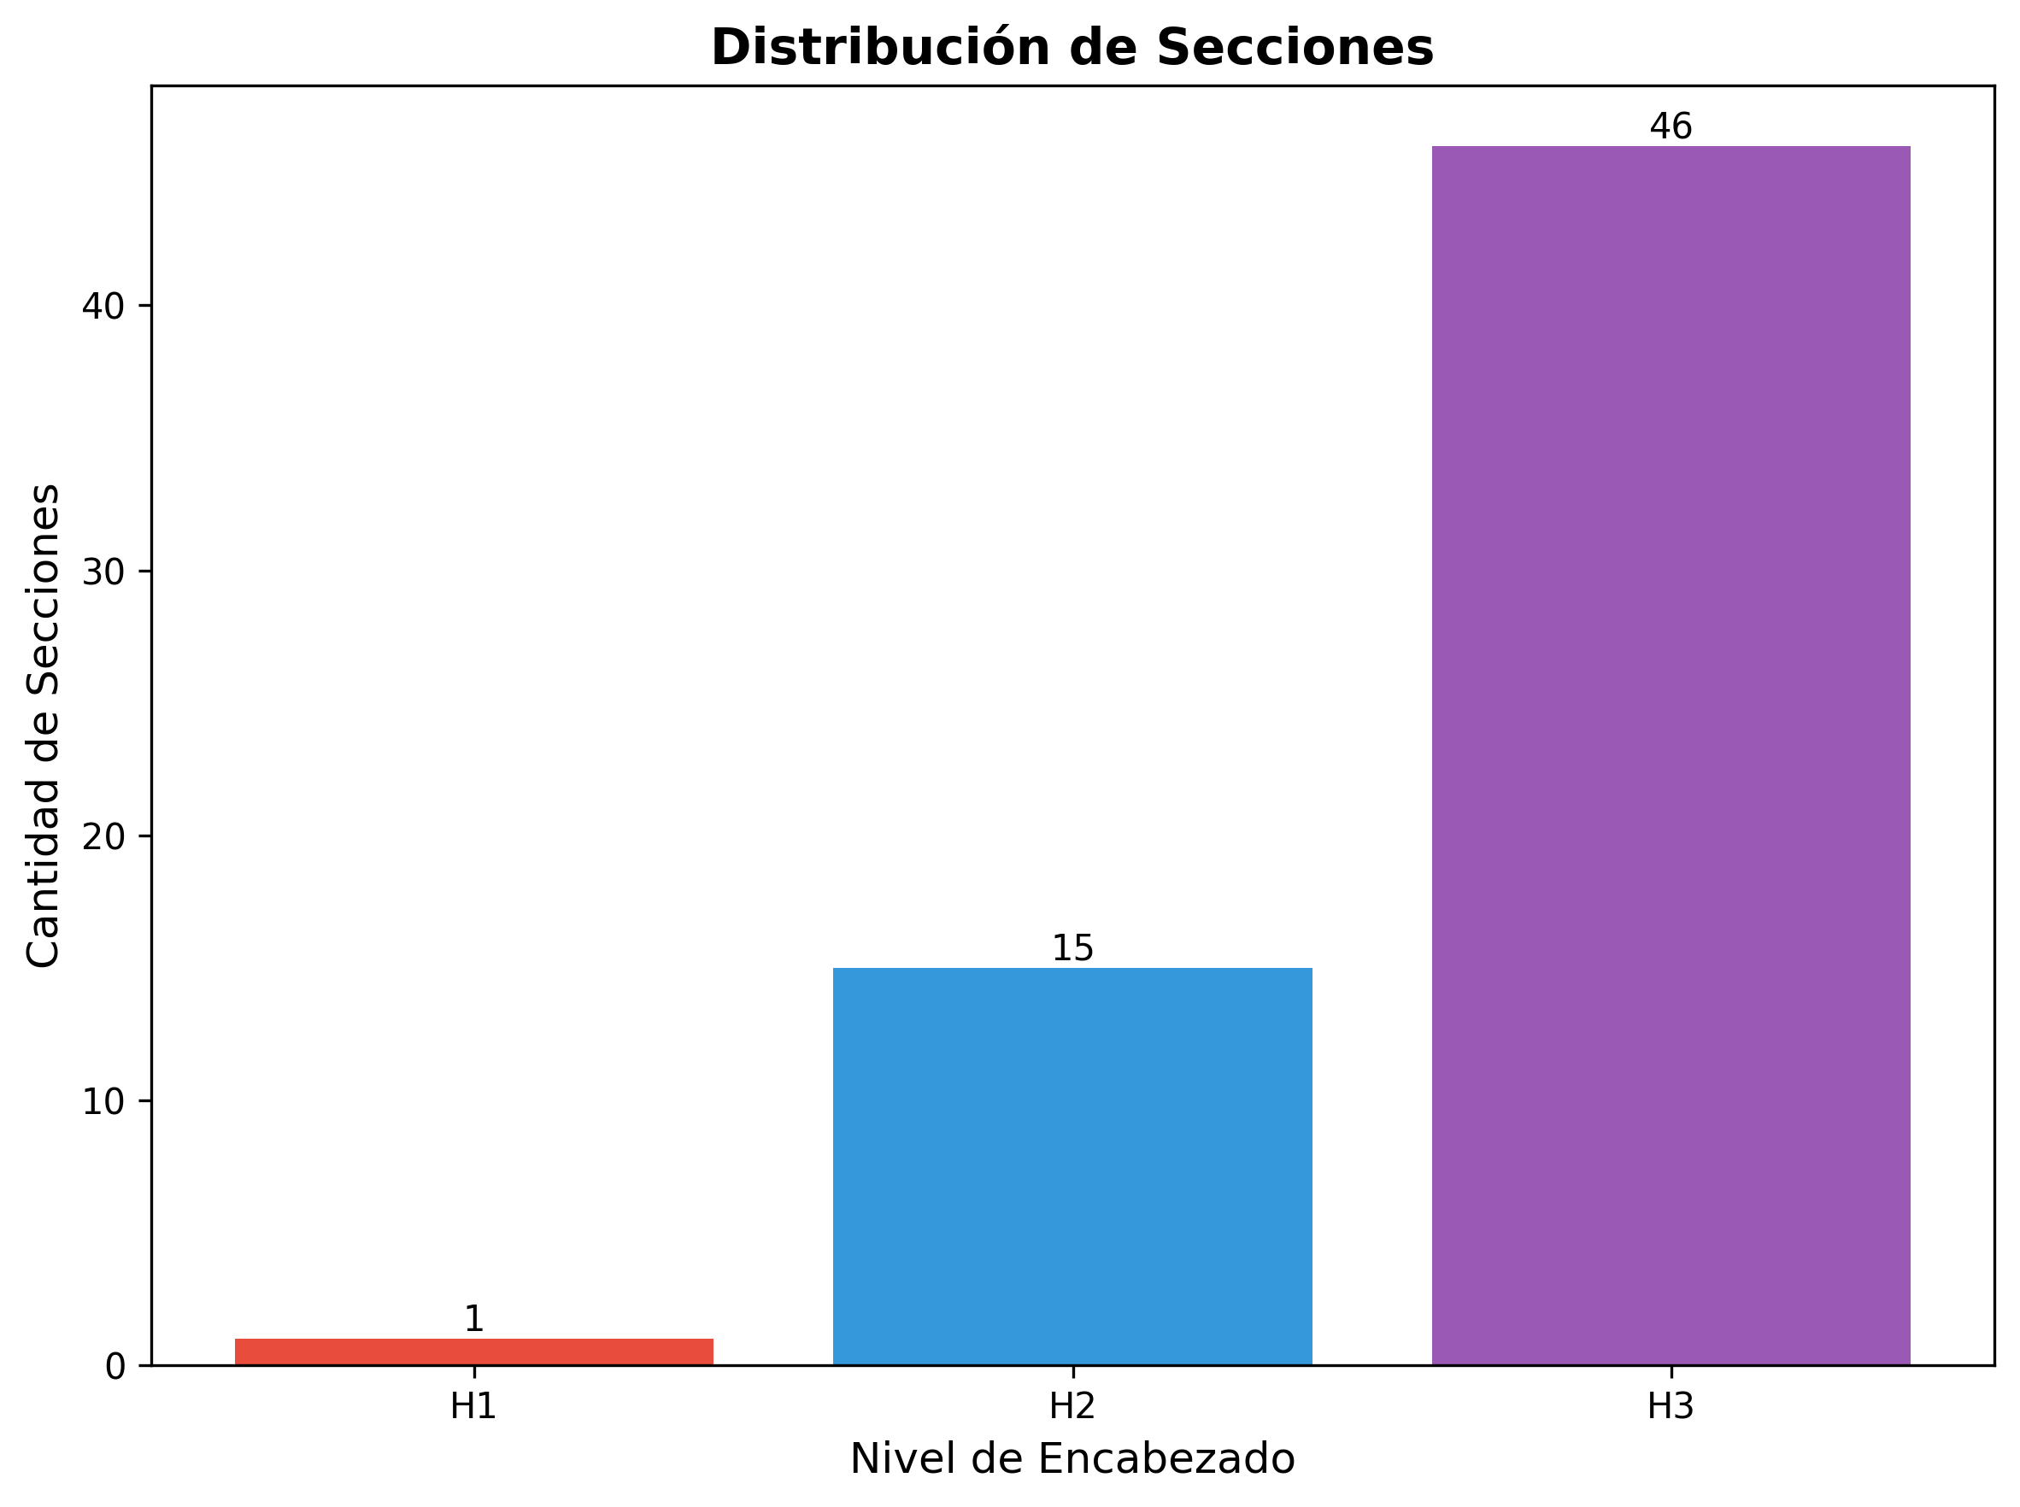

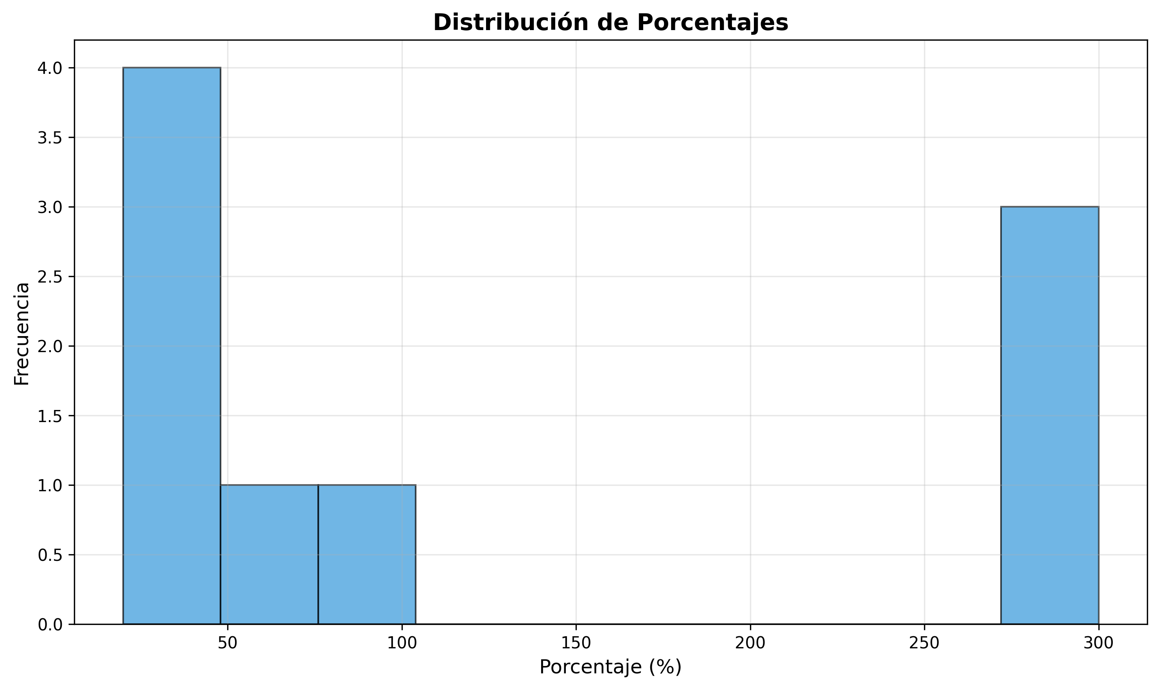

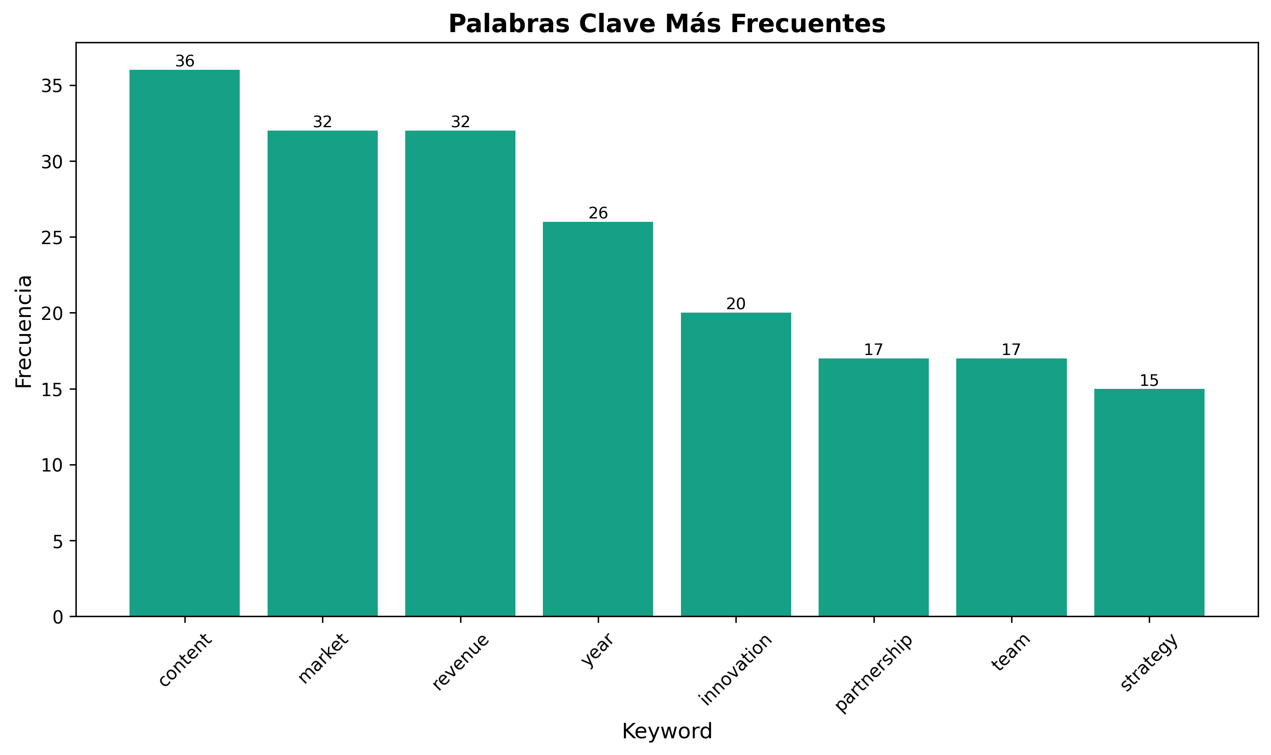

🎯 Final Executive Summary

Complete Strategic Framework for AI Education, Webinar Strategy & SaaS Marketing Success
---

📊 Project Overview

Mission Statement
"To establish global market leadership in AI education, webinar strategy, and SaaS marketing through innovative content, strategic partnerships, and data-driven optimization, generating $50M+ annual revenue while building a sustainable competitive advantage."

Vision Statement
"To become the world's most trusted authority and go-to resource for AI education, webinar strategy, and SaaS marketing, empowering businesses and individuals worldwide to achieve unprecedented success through cutting-edge knowledge and strategic implementation."
---

📚 Complete Document Library (20 Files)

Core Content Strategy (3 Files)
1. ai_course_comprehensive_tutorials.md - 15 advanced AI education tutorials
2. webinar_strategy_implementation_guide.md - 15 comprehensive webinar strategies
3. ai_saas_marketing_document_generation_guide.md - 15 SaaS marketing guides

Strategic Implementation (6 Files)
4. executive_summary_implementation_plan.md - Executive overview and plan
5. backlink_acquisition_strategy.md - Advanced backlink strategy
6. content_calendar_implementation.md - 12-month content calendar
7. implementation_checklist_master_guide.md - Master implementation checklist
8. quick_start_implementation_guide.md - 30-day quick start guide
9. master_implementation_roadmap.md - 24-month strategic roadmap

Advanced Frameworks (5 Files)
10. advanced_templates_frameworks.md - Professional templates and frameworks
11. roi_calculators_measurement_tools.md - ROI calculators and measurement tools
12. automation_scaling_guide.md - Automation and scaling strategies
13. advanced_analytics_measurement_dashboard.md - Business intelligence dashboard
14. strategic_partnerships_ecosystem_guide.md - Partnership and ecosystem strategy

Market Intelligence (3 Files)
15. competitive_analysis_market_positioning.md - Competitive analysis and positioning
16. global_expansion_localization_guide.md - Global expansion and localization
17. enterprise_solutions_b2b_strategies.md - Enterprise and B2B solutions

Innovation & Growth (3 Files)
18. advanced_monetization_revenue_optimization.md - Advanced monetization strategies
19. advanced_ai_integration_strategies.md - AI integration and future tech
20. innovation_future_proofing_framework.md - Innovation and future-proofing
---

🎯 Strategic Objectives & Targets

Revenue Targets
- Year 1: $2.5M ARR (Monthly: $208K)
- Year 2: $12.5M ARR (Monthly: $1.04M)
- Year 3: $50M ARR (Monthly: $4.17M)
- Growth Rate: 300%+ year-over-year

Market Position Targets
- AI Education: Top 3 globally by Year 2
- Webinar Strategy: Market leader by Year 2
- SaaS Marketing: Top 5 globally by Year 2
- Overall Brand: Industry thought leader by Year 3

Content & Authority Targets
- Content Volume: 500+ pieces by Year 2
- Backlinks: 10,000+ quality backlinks by Year 2
- Search Rankings: Top 3 for 100+ keywords by Year 2
- Social Following: 1M+ total followers by Year 2

Customer & Revenue Targets
- Total Customers: 100,000+ by Year 2
- Enterprise Clients: 500+ by Year 2
- Global Presence: 25+ countries by Year 2
- Partnership Network: 200+ active partners by Year 2
---

🚀 Implementation Phases

Phase 1: Foundation (Months 1-6)
Objective: Establish market presence and initial revenue
- Content Creation: 45+ comprehensive guides published
- Authority Building: 100+ backlinks acquired
- Community Building: 10,000+ email subscribers
- Revenue Target: $10K MRR by Month 6

Phase 2: Scale (Months 7-12)
Objective: Scale content and build market position
- Content Scaling: 200+ pieces of content
- Team Building: 15+ team members hired
- International Expansion: 5+ international markets
- Revenue Target: $250K MRR by Month 12

Phase 3: Growth (Months 13-18)
Objective: Achieve market leadership and significant growth
- Market Leadership: Top 3 position in each vertical
- Enterprise Focus: 50+ enterprise clients
- Global Expansion: 15+ countries served
- Revenue Target: $1M MRR by Month 18

Phase 4: Domination (Months 19-24)
Objective: Establish market dominance and ecosystem
- Market Domination: Undisputed market leadership
- Ecosystem Development: 100+ active partners
- Innovation Leadership: Industry innovation leader
- Revenue Target: $4M MRR by Month 24
---

💰 Revenue Model Architecture

Primary Revenue Streams
1. AI Education Courses: $2,000-$10,000 per course
2. Webinar Strategy Services: $2,000-$10,000 per project
3. SaaS Marketing Consulting: $150-$400 per hour
4. Enterprise Solutions: $50K-$500K per contract
5. Premium Content: $97-$297 per piece

Secondary Revenue Streams
1. Certification Programs: $500-$2,000 per certification
2. Mastermind Groups: $5,000-$15,000 per year
3. Affiliate Commissions: 20%-50% commission
4. Partnership Revenue: Revenue sharing models
5. Licensing Agreements: $1,000-$10,000 per month

Revenue Distribution Target
- AI Education: 40% of total revenue
- Webinar Strategy: 30% of total revenue
- SaaS Marketing: 30% of total revenue
---

🎯 Competitive Advantage Strategy

Content Differentiation
- 45+ Comprehensive Guides: Industry-leading depth and breadth
- AI-Powered Personalization: Next-generation content customization
- Multi-Modal Content: Text, video, interactive, and immersive content
- Global Localization: Culturally adapted content for global markets

Technology Innovation
- AI Integration: Advanced AI-powered features and personalization
- Platform Evolution: Cutting-edge platform capabilities
- Automation Systems: Comprehensive automation and scaling
- Analytics Intelligence: Advanced business intelligence and insights

Market Position
- Thought Leadership: Industry-recognized thought leadership
- Partnership Ecosystem: Comprehensive partner network
- Global Presence: Worldwide market presence
- Innovation Leadership: Industry innovation and future-proofing
---

📊 Success Metrics & KPIs

Financial Metrics
- Monthly Recurring Revenue (MRR): Primary revenue metric
- Customer Lifetime Value (CLV): Customer value optimization
- Customer Acquisition Cost (CAC): Acquisition efficiency
- Return on Investment (ROI): Investment performance

Content Metrics
- Page Views: Content reach and visibility
- Engagement Rate: Content quality and relevance
- Backlink Acquisition: Authority and credibility
- Search Rankings: Search visibility and authority

Business Metrics
- Customer Satisfaction: Customer success and retention
- Market Share: Competitive position and growth
- Brand Recognition: Brand awareness and authority
- Partnership Network: Ecosystem development and growth
---

🛠️ Resource Requirements

Human Resources
- Year 1: 15+ team members
- Year 2: 50+ team members
- Year 3: 150+ team members
- Key Roles: Content, Marketing, Sales, Technology, Operations

Technology Infrastructure
- Platform Development: Custom platform and mobile app
- AI Integration: Advanced AI capabilities and personalization
- Analytics Systems: Comprehensive business intelligence
- Automation Tools: Marketing and operational automation

Financial Investment
- Year 1: $2M investment
- Year 2: $5M investment
- Year 3: $15M investment
- ROI Target: 300%+ return on investment
---

🌐 Global Expansion Strategy

Market Entry Approach
- Tier 1 Markets: Direct entry with full localization
- Tier 2 Markets: Partnership-driven entry
- Tier 3 Markets: Digital-first approach
- Emerging Markets: Pilot programs and testing

Localization Strategy
- Content Localization: Culturally adapted content
- Language Support: Multi-language platform and content
- Cultural Adaptation: Market-specific messaging and positioning
- Regulatory Compliance: Local legal and regulatory compliance

Partnership Development
- Local Partners: Regional distribution and implementation partners
- Technology Partners: Platform and integration partners
- Content Partners: Local content and media partners
- Strategic Alliances: Market development and expansion partnerships
---

🔮 Innovation & Future-Proofing

Technology Innovation
- AI Advancement: Next-generation AI integration
- Platform Evolution: Cutting-edge platform capabilities
- Emerging Technologies: VR/AR, blockchain, quantum computing
- Future Technologies: Brain-computer interfaces, advanced robotics

Business Model Innovation
- Revenue Innovation: New revenue models and streams
- Partnership Innovation: Advanced partnership models
- Market Innovation: New market creation and development
- Ecosystem Innovation: Platform economy and ecosystem development

Market Innovation
- Industry Disruption: Industry transformation leadership
- Standard Setting: Industry standard participation and development
- Thought Leadership: Global thought leadership and influence
- Ecosystem Development: Comprehensive ecosystem building
---

📈 Implementation Timeline

Immediate Actions (Next 30 Days)
1. Content Creation: Publish first 15 comprehensive guides
2. Platform Setup: Complete website and analytics setup
3. Team Building: Hire key team members
4. Partnership Outreach: Begin strategic partnership development

Short-Term Goals (Next 90 Days)
1. Content Scaling: Publish 50+ pieces of content
2. Authority Building: Acquire 100+ quality backlinks
3. Community Building: Build 10,000+ email subscribers
4. Revenue Generation: Achieve $10K monthly revenue

Medium-Term Goals (Next 12 Months)
1. Market Position: Achieve top 10 position in each vertical
2. Team Scaling: Scale to 50+ team members
3. International Expansion: Enter 5+ international markets
4. Revenue Growth: Achieve $250K monthly revenue

Long-Term Goals (Next 24 Months)
1. Market Leadership: Achieve top 3 position globally
2. Ecosystem Development: Build 100+ partner network
3. Global Presence: Operate in 25+ countries
4. Revenue Target: Achieve $4M monthly revenue
---

🎯 Risk Management & Mitigation

Strategic Risks
- Competition: Intense competition from established players
- Market Changes: Rapid market evolution and disruption
- Technology Disruption: New technology disruption
- Economic Downturn: Economic recession impact

Mitigation Strategies
- Differentiation: Strong differentiation and competitive advantage
- Innovation: Continuous innovation and adaptation
- Diversification: Revenue stream and market diversification
- Agility: Rapid adaptation and response capability

Operational Risks
- Team Scaling: Rapid team growth challenges
- Quality Control: Maintaining quality standards
- Customer Service: Customer service scaling
- Technology Issues: Technical problems and outages

Mitigation Strategies
- Process Standardization: Robust processes and systems
- Quality Assurance: Comprehensive quality assurance
- Customer Success: Dedicated customer success programs
- Technical Support: Comprehensive technical support
---

🏆 Success Factors

Critical Success Factors
1. Content Quality: Industry-leading content quality and depth
2. Market Position: Strong market position and competitive advantage
3. Team Excellence: Exceptional team performance and culture
4. Technology Innovation: Cutting-edge technology and innovation
5. Partnership Network: Strong partnership ecosystem and relationships

Key Performance Indicators
1. Revenue Growth: 300%+ year-over-year growth
2. Market Position: Top 3 position in each vertical
3. Customer Satisfaction: 95%+ customer satisfaction
4. Brand Recognition: Industry thought leadership recognition
5. Partnership Success: 100+ active partnerships
---

📋 Next Steps & Action Items

Immediate Actions (This Week)
1. Review Documents: Complete review of all 20 strategic documents
2. Team Assembly: Begin assembling core team
3. Platform Development: Start platform development
4. Content Creation: Begin content creation process

Short-Term Actions (Next Month)
1. Content Launch: Launch first content pieces
2. Partnership Outreach: Begin partnership development
3. Marketing Campaign: Launch initial marketing campaigns
4. Team Hiring: Complete key team member hiring

Medium-Term Actions (Next Quarter)
1. Content Scaling: Scale content production
2. Market Entry: Enter first international markets
3. Partnership Development: Establish key partnerships
4. Revenue Generation: Achieve initial revenue targets
---
This comprehensive strategic framework provides the complete roadmap for building a market-leading business across AI education, webinar strategy, and SaaS marketing while achieving sustainable growth, competitive advantage, and global market leadership.

