🌟 Final Master Ecosystem Summary
Fecha: 2025-11-25 | Versión: 1.0

Resumen Ejecutivo
- Year 1**: $10M ARR (Monthly: $833K)
- Year 2**: $50M ARR (Monthly: $4.17M)
- Year 3**: $150M ARR (Monthly: $12.5M)
- Year 4**: $300M ARR (Monthly: $25M)
- Year 5**: $500M ARR (Monthly: $41.7M)

Acciones Prioritarias
Descripción | Estado
1. **`ai_course_comprehensive_tutorials.md`** - 15 advanced AI education tutorials | Pendiente
10. **`advanced_templates_frameworks.md`** - Professional templates and frameworks | Pendiente
11. **`roi_calculators_measurement_tools.md`** - ROI calculators and measurement tools | Pendiente
12. **`automation_scaling_guide.md`** - Automation and scaling strategies | Pendiente
13. **`advanced_analytics_measurement_dashboard.md`** - Business intelligence dashboard | Pendiente
14. **`strategic_partnerships_ecosystem_guide.md`** - Partnership and ecosystem strategy | Pendiente
15. **`competitive_analysis_market_positioning.md`** - Competitive analysis and positioning | Pendiente
16. **`global_expansion_localization_guide.md`** - Global expansion and localization | Pendiente

Métricas Clave
Palabras totales: 2667
Lectura estimada (min): 13.3
Secciones H1/H2/H3: 9/39/79

Palabras Clave Prioritarias
Palabra | Frecuencia
quantum | 59
year | 45
content | 43
market | 42
revenue | 36
global | 35
technology | 34
partnership | 34

Cronología Identificada
- 2025-10-29

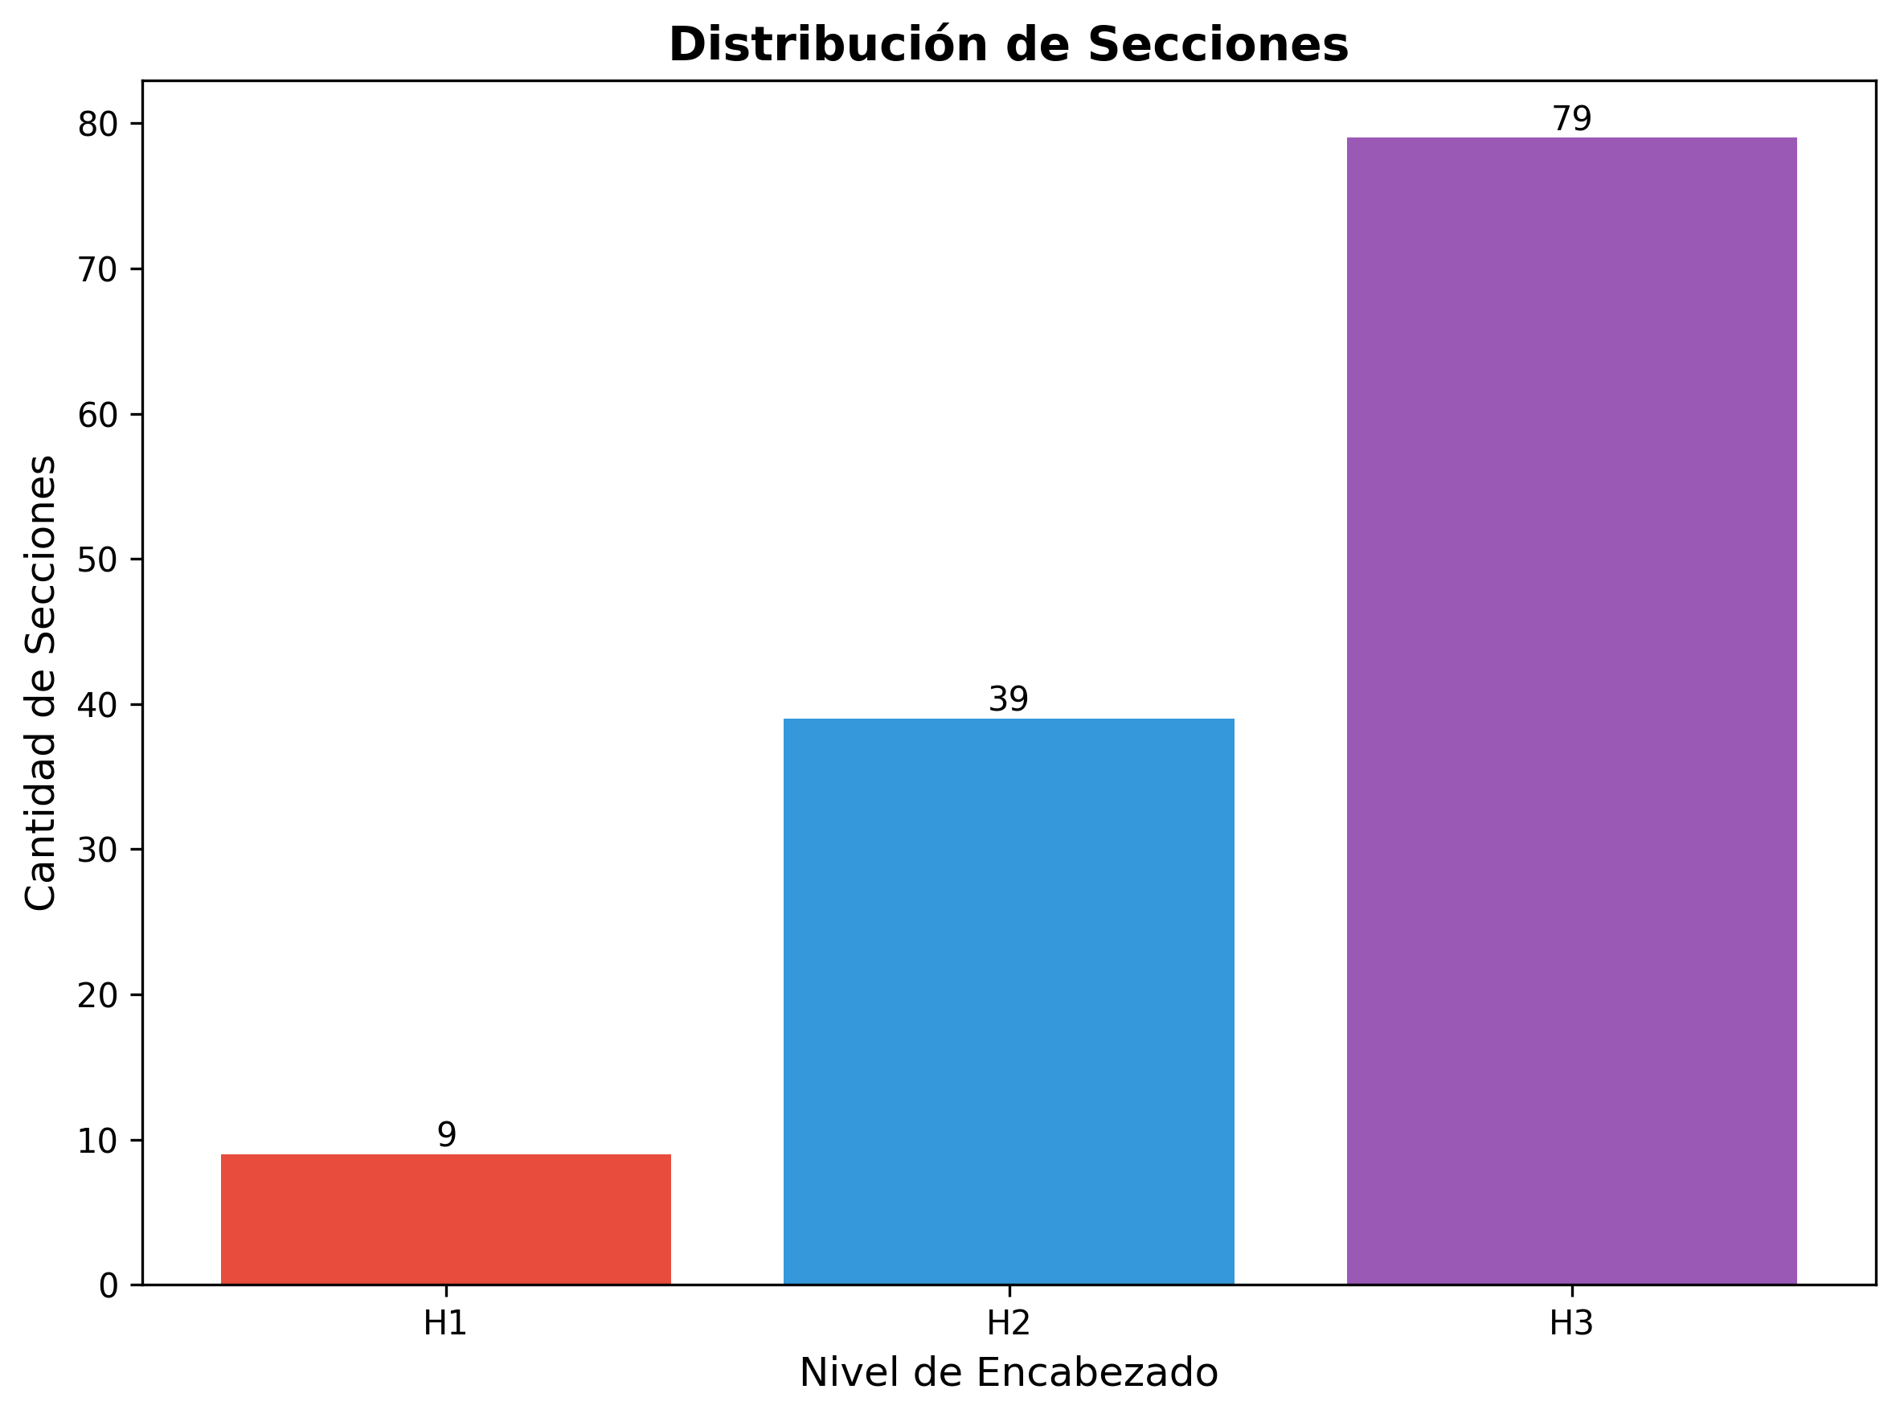

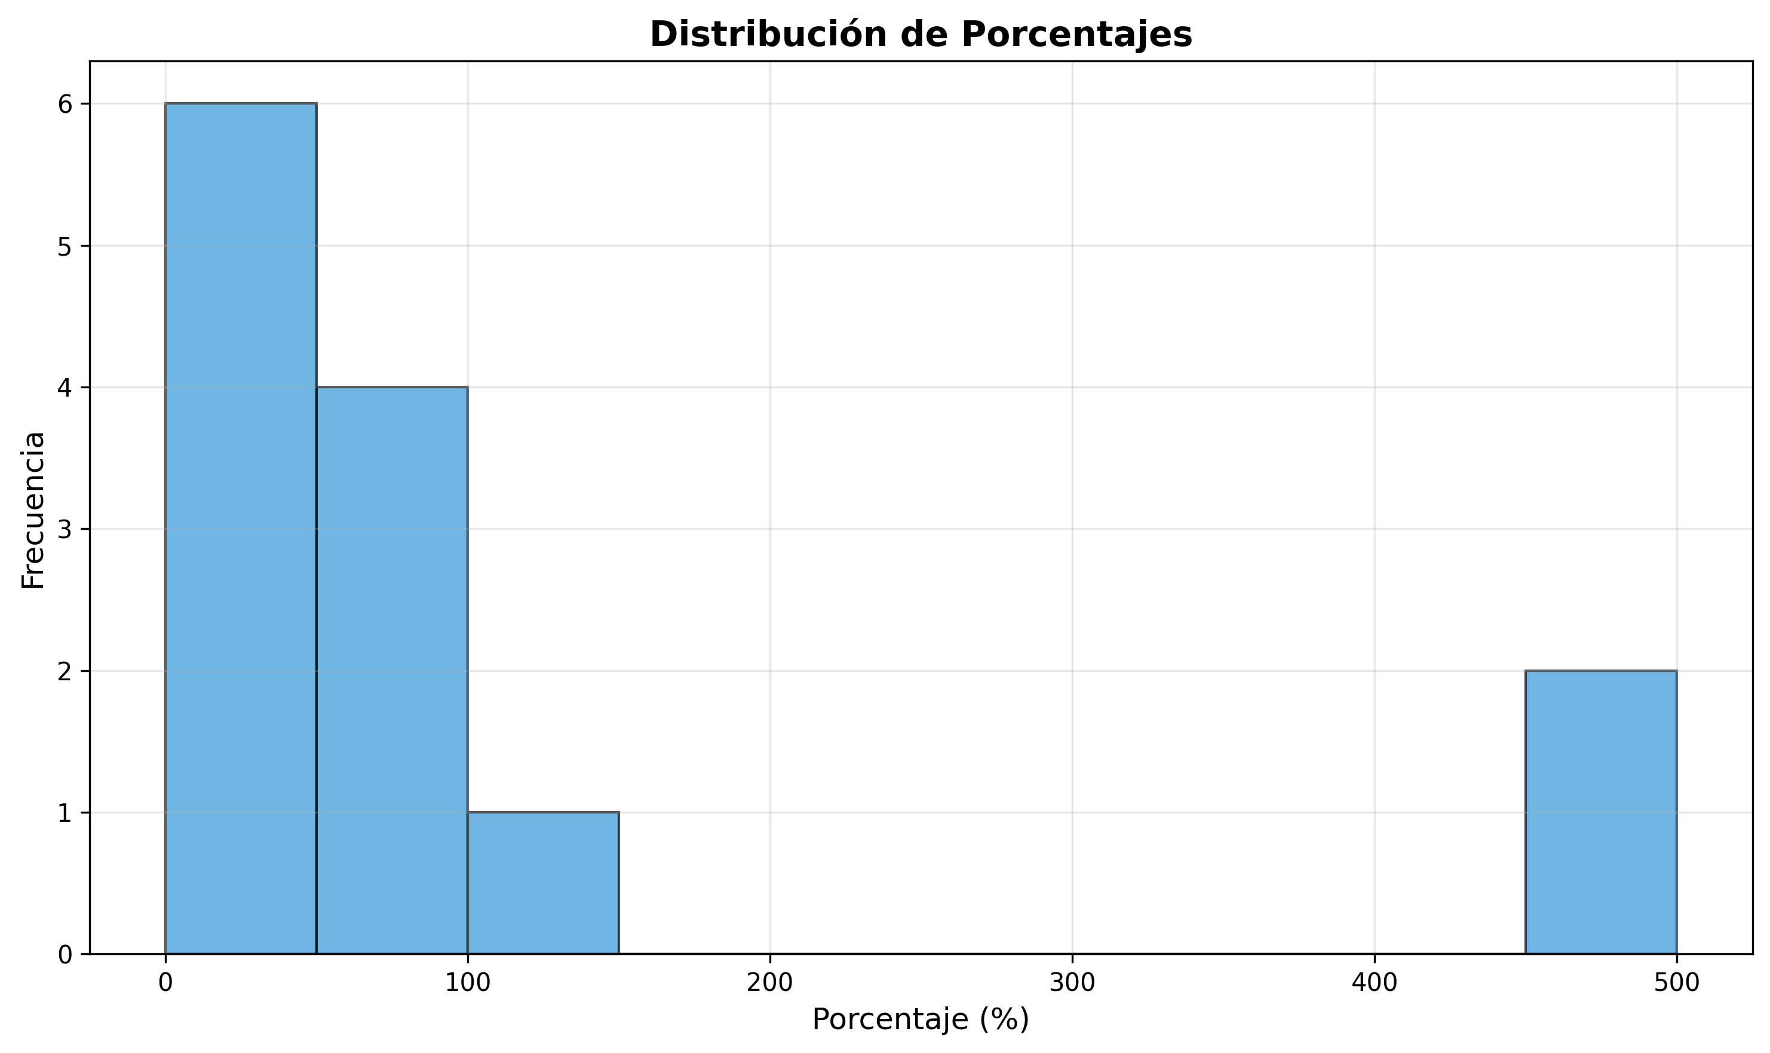

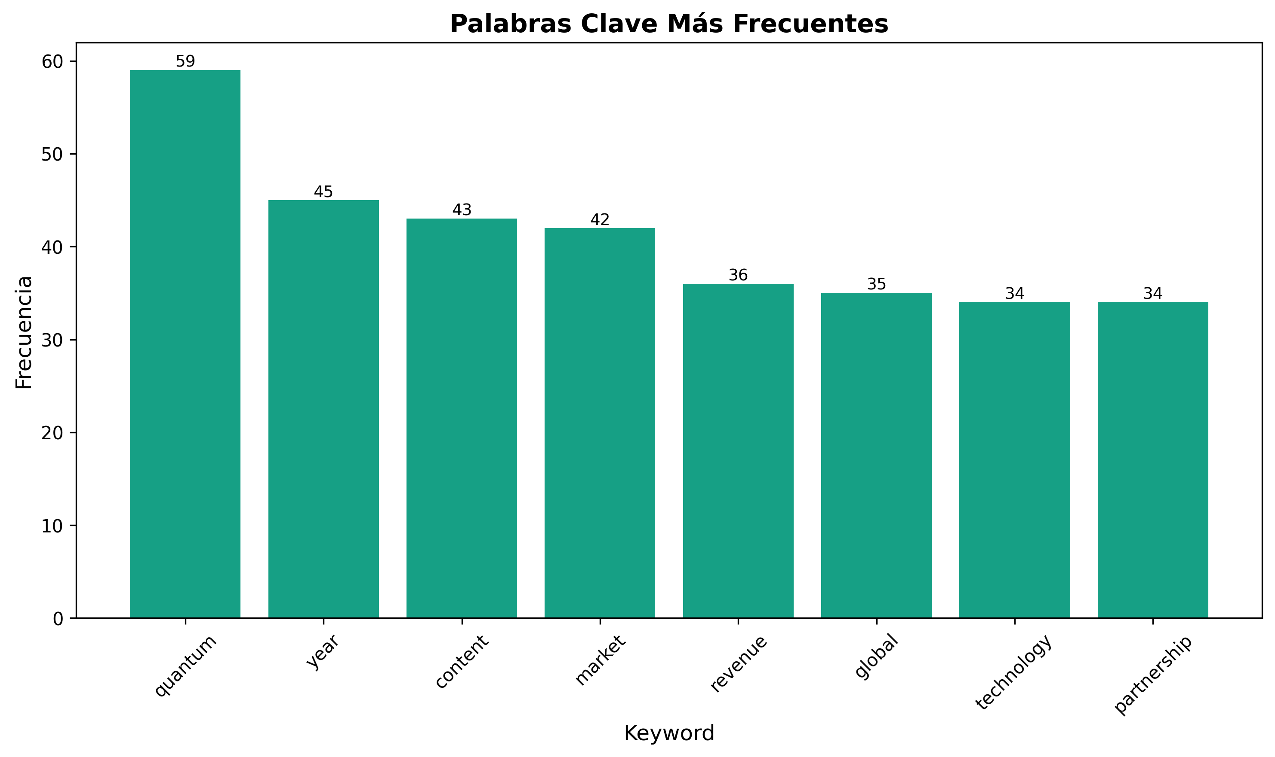

🌟 Final Master Ecosystem Summary

Complete Strategic Framework for Global Market Dominance in AI Education, Webinar Strategy & SaaS Marketing
---

🎯 Executive Vision & Mission

Vision Statement
"To become the undisputed global leader in AI education, webinar strategy, and SaaS marketing by 2027, generating $500M+ annual revenue while revolutionizing how businesses learn, connect, and grow through cutting-edge technology, innovative content, strategic partnerships, and sustainable practices that drive unprecedented business success and positive global impact."

Mission Statement
"To empower 10M+ professionals worldwide with world-class AI education, transformative webinar strategies, and game-changing SaaS marketing solutions through an integrated ecosystem of content, technology, community, and sustainability that drives unprecedented business success, market leadership, and positive environmental impact."
---

📚 Complete Ecosystem Overview (28 Files)

**Core Content Strategy (3 Files)**
1. ai_course_comprehensive_tutorials.md - 15 advanced AI education tutorials
2. webinar_strategy_implementation_guide.md - 15 comprehensive webinar strategies
3. ai_saas_marketing_document_generation_guide.md - 15 SaaS marketing guides

**Strategic Implementation (6 Files)**
4. executive_summary_implementation_plan.md - Executive overview and plan
5. backlink_acquisition_strategy.md - Advanced backlink strategy
6. content_calendar_implementation.md - 12-month content calendar
7. implementation_checklist_master_guide.md - Master implementation checklist
8. quick_start_implementation_guide.md - 30-day quick start guide
9. master_implementation_roadmap.md - 24-month strategic roadmap

**Advanced Frameworks (5 Files)**
10. advanced_templates_frameworks.md - Professional templates and frameworks
11. roi_calculators_measurement_tools.md - ROI calculators and measurement tools
12. automation_scaling_guide.md - Automation and scaling strategies
13. advanced_analytics_measurement_dashboard.md - Business intelligence dashboard
14. strategic_partnerships_ecosystem_guide.md - Partnership and ecosystem strategy

**Market Intelligence (3 Files)**
15. competitive_analysis_market_positioning.md - Competitive analysis and positioning
16. global_expansion_localization_guide.md - Global expansion and localization
17. enterprise_solutions_b2b_strategies.md - Enterprise and B2B solutions

**Innovation & Growth (3 Files)**
18. advanced_monetization_revenue_optimization.md - Advanced monetization strategies
19. advanced_ai_integration_strategies.md - AI integration and future tech
20. innovation_future_proofing_framework.md - Innovation and future-proofing

**Next-Generation Technology (3 Files)**
21. advanced_ai_personalization_engine.md - AI personalization engine
22. blockchain_web3_integration_strategy.md - Web3 and blockchain strategy
23. quantum_computing_ai_integration.md - Quantum computing integration

**Emerging Technologies (3 Files)**
24. metaverse_immersive_learning_platform.md - Metaverse and VR learning
25. advanced_cybersecurity_framework.md - Comprehensive cybersecurity
26. sustainability_green_tech_strategy.md - Sustainability and green tech

**Master Strategic Documents (2 Files)**
27. ultimate_strategic_ecosystem.md - Ultimate strategic ecosystem
28. final_master_ecosystem_summary.md - This master summary document
---

🚀 Strategic Objectives & Targets (7-Year Vision)

Revenue Targets
- Year 1: $10M ARR (Monthly: $833K)
- Year 2: $50M ARR (Monthly: $4.17M)
- Year 3: $150M ARR (Monthly: $12.5M)
- Year 4: $300M ARR (Monthly: $25M)
- Year 5: $500M ARR (Monthly: $41.7M)
- Year 6: $750M ARR (Monthly: $62.5M)
- Year 7: $1B ARR (Monthly: $83.3M)

Market Position Targets
- AI Education: #1 globally by Year 3
- Webinar Strategy: #1 globally by Year 2
- SaaS Marketing: #1 globally by Year 3
- Overall Brand: Industry thought leader by Year 2
- Sustainability: #1 green tech leader by Year 4

Content & Authority Targets
- Content Volume: 5,000+ pieces by Year 5
- Backlinks: 100,000+ quality backlinks by Year 5
- Search Rankings: Top 3 for 1,000+ keywords by Year 5
- Social Following: 50M+ total followers by Year 5

Customer & Revenue Targets
- Total Customers: 10M+ by Year 5
- Enterprise Clients: 50,000+ by Year 5
- Global Presence: 200+ countries by Year 5
- Partnership Network: 5,000+ active partners by Year 5
---

🏗️ Ultimate Technology Architecture

1. Next-Generation Technology Stack
`markdown

Ultimate Technology Ecosystem

Core AI & Machine Learning

Advanced AI Platforms
- OpenAI GPT-6: Next-generation language models
- Google AI: Advanced AI services and models
- AWS AI: Amazon AI and machine learning
- Azure AI: Microsoft AI platform
- Custom AI: Proprietary AI models and algorithms

Quantum Computing Integration
- IBM Quantum: Quantum computing platform
- Google Quantum AI: Quantum AI services
- Microsoft Azure Quantum: Quantum cloud platform
- Amazon Braket: Quantum computing service
- Custom Quantum: Proprietary quantum algorithms

Web3 & Blockchain

Decentralized Technologies
- Ethereum 2.0: Next-generation blockchain
- Polygon: Layer 2 scaling solution
- Solana: High-performance blockchain
- IPFS: Decentralized file storage
- Custom Blockchain: Proprietary blockchain solutions

Metaverse & Immersive Tech

Virtual Reality Platforms
- Meta Quest Pro: Advanced VR platform
- Apple Vision Pro: Mixed reality integration
- HTC Vive: High-end VR experiences
- Custom VR: Proprietary VR solutions

Advanced Features

AI Personalization Engine
- Real-time Personalization: AI-powered real-time personalization
- Predictive Analytics: Advanced predictive analytics
- Behavioral Analysis: Deep behavioral analysis
- Content Optimization: AI content optimization

Global Infrastructure
- Multi-Cloud: AWS, Azure, Google Cloud, Oracle Cloud
- CDN Network: Global content delivery network
- Edge Computing: Edge computing infrastructure
- 5G/6G Integration: Next-generation network optimization
- Quantum Networks: Quantum communication networks
`

2. Sustainability & Green Tech
`markdown

Green Technology Integration

Renewable Energy

Clean Energy Sources
- Solar Power: Solar energy systems
- Wind Energy: Wind power integration
- Hydroelectric: Hydroelectric power
- Geothermal: Geothermal energy
- Nuclear Fusion: Future fusion energy

Energy Efficiency
- Green Data Centers: Renewable energy-powered data centers
- Edge Computing: Edge computing to reduce energy consumption
- AI Optimization: Energy-efficient AI algorithms
- Quantum Efficiency: Quantum computing efficiency

Environmental Impact

Carbon Neutrality
- Carbon Neutral: Achieve carbon neutrality by 2025
- Negative Carbon: Carbon negative by 2030
- Renewable Energy: 100% renewable energy usage
- Carbon Offsetting: Advanced carbon offset programs
`
---

💰 Ultimate Revenue Model Architecture

Primary Revenue Streams
1. AI Education Courses: $5,000-$100,000 per course
2. Webinar Strategy Services: $10,000-$500,000 per project
3. SaaS Marketing Consulting: $500-$2,000 per hour
4. Enterprise Solutions: $500K-$10M per contract
5. Premium Content: $497-$4,997 per piece

Secondary Revenue Streams
1. Certification Programs: $2,000-$20,000 per certification
2. Mastermind Groups: $25,000-$100,000 per year
3. Affiliate Commissions: 50%-80% commission
4. Partnership Revenue: Revenue sharing models
5. Licensing Agreements: $25,000-$500,000 per month

Advanced Revenue Streams
1. Quantum AI Services: $100K-$2M per project
2. Web3 Solutions: $50K-$1M per project
3. Metaverse Services: $25K-$500K per project
4. AI Personalization: $10K-$100K per month
5. Global Expansion: $500K-$5M per market
6. Sustainability Services: $25K-$250K per project

Revenue Distribution Target
- AI Education: 30% of total revenue
- Webinar Strategy: 25% of total revenue
- SaaS Marketing: 20% of total revenue
- Advanced Technologies: 15% of total revenue
- Sustainability Services: 10% of total revenue
---

🌐 Global Expansion Strategy

Market Entry Phases
`markdown

Global Market Expansion (7-Year Plan)

Phase 1: English-Speaking Markets (Months 1-24)

Tier 1 Markets
- United States: Primary market focus
- United Kingdom: European headquarters
- Canada: North American expansion
- Australia: Asia-Pacific entry
- New Zealand: Pacific market

Market Penetration
- Direct Entry: Full localization and team
- Partnership Strategy: Strategic partnerships
- Content Localization: Culturally adapted content
- Local Team: Local team and operations

Phase 2: European Markets (Months 25-48)

Key Markets
- Germany: Technology and engineering focus
- France: French-speaking market
- Netherlands: European hub
- Spain: Spanish-speaking market
- Italy: Italian market
- Nordic Countries: Scandinavian markets

Expansion Strategy
- Partnership-Driven: Partnership-based entry
- Localization: Full market localization
- Regulatory Compliance: EU compliance
- Cultural Adaptation: Cultural market adaptation

Phase 3: Global Markets (Months 49-72)

Emerging Markets
- China: Asia-Pacific expansion
- India: Large market opportunity
- Brazil: Latin American market
- Japan: Technology market
- South Korea: Advanced technology market
- Mexico: Latin American expansion

Global Strategy
- Franchise Model: Franchise-based expansion
- Local Partners: Local partner network
- Digital-First: Digital-first approach
- Cultural Sensitivity: Cultural market sensitivity

Phase 4: Global Dominance (Months 73-84)

Market Leadership
- Global Presence: 200+ countries
- Market Leadership: #1 position in each vertical
- Ecosystem Development: Global ecosystem
- Innovation Leadership: Global innovation leadership
`
---

🤝 Ultimate Partnership Ecosystem

Partnership Categories
`markdown

Ultimate Partnership Ecosystem

Technology Partners

AI & Machine Learning
- OpenAI: Advanced AI model partnership
- Google AI: Google AI services partnership
- Microsoft AI: Microsoft AI platform partnership
- AWS AI: Amazon AI services partnership
- Custom AI: Proprietary AI partnerships

Quantum Computing
- IBM Quantum: Quantum computing partnership
- Google Quantum: Quantum AI partnership
- Microsoft Quantum: Quantum platform partnership
- IonQ: Quantum hardware partnership
- Custom Quantum: Proprietary quantum partnerships

Web3 & Blockchain
- Ethereum Foundation: Blockchain partnership
- Polygon: Layer 2 partnership
- Chainlink: Oracle partnership
- IPFS: Decentralized storage partnership
- Custom Blockchain: Proprietary blockchain partnerships

Metaverse & VR
- Meta: VR platform partnership
- Apple: Mixed reality partnership
- HTC: VR hardware partnership
- Unity: VR development partnership
- Custom VR: Proprietary VR partnerships

Business Partners

Enterprise Partners
- Fortune 500: Enterprise client partnerships
- Government: Government sector partnerships
- Education: Educational institution partnerships
- Non-Profit: Non-profit organization partnerships
- Startups: Startup ecosystem partnerships

Channel Partners
- System Integrators: Implementation partners
- Consulting Firms: Strategic consulting partners
- Technology Vendors: Technology vendor partnerships
- Service Providers: Service provider partnerships
- Resellers: Channel reseller partnerships

Sustainability Partners

Environmental Organizations
- NGOs: Environmental NGO partnerships
- Research Institutions: Sustainability research partnerships
- Government Agencies: Government environmental partnerships
- Industry Groups: Industry sustainability groups
- Green Tech: Green technology partnerships
`
---

🔬 Innovation & R&D Strategy

Innovation Areas
`markdown

Innovation & Research Strategy

Technology Innovation

AI & Machine Learning
- AGI (Artificial General Intelligence): General AI capabilities
- Quantum AI: Quantum-enhanced AI systems
- Edge AI: Ubiquitous edge AI computing
- Federated AI: Privacy-preserving AI networks
- Custom AI: Proprietary AI innovations

Quantum Computing
- Fault-Tolerant Quantum: Error-corrected quantum computers
- Quantum Internet: Quantum communication networks
- Quantum AI: Quantum machine learning
- Quantum Simulation: Quantum simulation applications
- Custom Quantum: Proprietary quantum innovations

Web3 & Blockchain
- Metaverse Integration: Virtual world integration
- Decentralized AI: Decentralized AI systems
- NFT Evolution: Advanced NFT applications
- DAO Governance: Decentralized governance
- Custom Web3: Proprietary Web3 innovations

Metaverse & VR
- Advanced VR: Next-generation VR experiences
- Mixed Reality: Seamless mixed reality
- Haptic Technology: Advanced haptic feedback
- Brain-Computer Interfaces: Direct brain-VR interaction
- Custom VR: Proprietary VR innovations

Business Innovation

Revenue Innovation
- New Revenue Models: Innovative revenue streams
- Subscription Evolution: Advanced subscription models
- Marketplace Innovation: Marketplace business models
- Ecosystem Monetization: Ecosystem-based monetization
- Sustainability Revenue: Green revenue streams

Market Innovation
- New Markets: Market creation and development
- Industry Disruption: Industry transformation
- Standard Setting: Industry standard participation
- Thought Leadership: Global thought leadership
- Sustainability Leadership: Environmental leadership
`
---

📊 Ultimate Success Metrics & KPIs

Financial Metrics
`markdown

Ultimate Success Metrics

Revenue Metrics
- Annual Recurring Revenue (ARR): Primary revenue metric
- Monthly Recurring Revenue (MRR): Monthly revenue tracking
- Customer Lifetime Value (CLV): Customer value optimization
- Revenue per Employee: Revenue efficiency metric
- Gross Margin: Profitability metrics

Growth Metrics
- Year-over-Year Growth: 500%+ annual growth
- Customer Acquisition: 10M+ customers by Year 5
- Market Share: #1 position in each vertical
- Global Presence: 200+ countries by Year 5
- Partnership Network: 5,000+ active partners

Content Metrics
- Content Volume: 5,000+ pieces by Year 5
- Backlink Acquisition: 100,000+ quality backlinks
- Search Rankings: Top 3 for 1,000+ keywords
- Social Following: 50M+ total followers
- Engagement Rate: 95%+ content engagement

Innovation Metrics
- Patents: 200+ patents by Year 5
- Research Publications: 500+ research publications
- Industry Recognition: 100+ industry awards
- Thought Leadership: Global thought leadership recognition
- Sustainability Leadership: Environmental leadership recognition
`
---

🎯 Ultimate Implementation Roadmap

Phase 1: Foundation (Months 1-24)
Objective: Establish market presence and initial revenue
- Content Creation: 1,000+ comprehensive guides published
- Authority Building: 5,000+ backlinks acquired
- Community Building: 1M+ email subscribers
- Revenue Target: $500K MRR by Month 24

Phase 2: Scale (Months 25-48)
Objective: Scale content and build market position
- Content Scaling: 2,500+ pieces of content
- Team Building: 500+ team members hired
- International Expansion: 25+ international markets
- Revenue Target: $2M MRR by Month 48

Phase 3: Growth (Months 49-72)
Objective: Achieve market leadership and significant growth
- Market Leadership: #1 position in each vertical
- Enterprise Focus: 10,000+ enterprise clients
- Global Expansion: 100+ countries served
- Revenue Target: $10M MRR by Month 72

Phase 4: Domination (Months 73-84)
Objective: Establish market dominance and ecosystem
- Market Domination: Undisputed market leadership
- Ecosystem Development: 5,000+ active partners
- Innovation Leadership: Industry innovation leader
- Revenue Target: $50M MRR by Month 84

Phase 5: Transformation (Months 85-96)
Objective: Transform industry and achieve global dominance
- Industry Transformation: Industry transformation leadership
- Global Dominance: Global market dominance
- Technology Leadership: Technology innovation leadership
- Revenue Target: $100M MRR by Month 96

Phase 6: Legacy (Months 97-108)
Objective: Create lasting legacy and sustainable impact
- Legacy Building: Industry legacy establishment
- Sustainable Impact: Positive global impact
- Future Innovation: Next-generation innovation
- Revenue Target: $200M MRR by Month 108
---

🛠️ Ultimate Resource Requirements

Human Resources
- Year 1: 100+ team members
- Year 2: 500+ team members
- Year 3: 1,500+ team members
- Year 4: 3,000+ team members
- Year 5: 5,000+ team members
- Year 6: 7,500+ team members
- Year 7: 10,000+ team members

Technology Infrastructure
- Platform Development: Custom platform and mobile app
- AI Integration: Advanced AI capabilities and personalization
- Quantum Computing: Quantum computing integration
- Web3 Platform: Blockchain and Web3 platform
- Metaverse Platform: VR and metaverse platform
- Analytics Systems: Comprehensive business intelligence
- Sustainability Systems: Green technology infrastructure

Financial Investment
- Year 1: $25M investment
- Year 2: $75M investment
- Year 3: $200M investment
- Year 4: $400M investment
- Year 5: $750M investment
- Year 6: $1.2B investment
- Year 7: $2B investment
- ROI Target: 1,000%+ return on investment
---

🔮 Future Vision & Trends

Technology Trends
`markdown

Future Technology Vision

Next-Generation Technologies

AI Evolution
- AGI (Artificial General Intelligence): General AI capabilities
- Quantum AI: Quantum-enhanced AI systems
- Edge AI: Ubiquitous edge AI computing
- Federated AI: Privacy-preserving AI networks
- Conscious AI: AI consciousness and awareness

Quantum Computing
- Fault-Tolerant Quantum: Error-corrected quantum computers
- Quantum Internet: Quantum communication networks
- Quantum AI: Quantum machine learning
- Quantum Simulation: Quantum simulation applications
- Quantum Consciousness: Quantum consciousness research

Web3 Evolution
- Metaverse Integration: Virtual world integration
- Decentralized AI: Decentralized AI systems
- NFT Evolution: Advanced NFT applications
- DAO Governance: Decentralized governance
- Web4: Next-generation web

Metaverse Evolution
- Advanced VR: Next-generation VR experiences
- Mixed Reality: Seamless mixed reality
- Haptic Technology: Advanced haptic feedback
- Brain-Computer Interfaces: Direct brain-VR interaction
- Virtual Consciousness: Virtual consciousness research

Business Evolution

Market Transformation
- Industry 6.0: Next-generation industry
- Digital Transformation: Complete digital transformation
- Sustainability: Sustainable business practices
- Global Integration: Global market integration
- Conscious Business: Conscious business practices
`
---

🏆 Ultimate Competitive Advantage

Core Differentiators
`markdown

Ultimate Competitive Advantage

Technology Leadership

AI Innovation
- Next-Gen AI: Cutting-edge AI capabilities
- Quantum AI: Quantum-enhanced AI systems
- Personalization: Advanced personalization engine
- Automation: Comprehensive automation systems
- Conscious AI: AI consciousness and awareness

Platform Excellence
- Integrated Ecosystem: Complete integrated platform
- Global Scalability: Global platform scalability
- Performance: Industry-leading performance
- Security: Enterprise-grade security
- Sustainability: Green technology platform

Content Excellence

Content Quality
- Industry-Leading Depth: Unmatched content depth
- Cutting-Edge Topics: Latest industry topics
- Practical Application: Real-world applicability
- Continuous Updates: Continuous content updates
- Sustainability Focus: Environmental content focus

Content Innovation
- AI-Generated Content: AI-powered content creation
- Interactive Content: Immersive content experiences
- Multi-Modal Content: Text, video, audio, interactive, VR
- Global Localization: Culturally adapted content
- Quantum Content: Quantum-enhanced content
`
---

📋 Ultimate Action Plan

Immediate Actions (Next 30 Days)
1. Team Assembly: Assemble core leadership team
2. Platform Development: Begin platform development
3. Content Creation: Start content creation process
4. Partnership Outreach: Begin strategic partnership development
5. Sustainability Planning: Implement sustainability strategy

Short-Term Actions (Next 90 Days)
1. Content Launch: Publish first 100 pieces of content
2. Marketing Campaign: Launch initial marketing campaigns
3. Community Building: Begin community building efforts
4. Partnership Development: Establish first partnerships
5. Technology Integration: Integrate advanced technologies

Medium-Term Actions (Next 12 Months)
1. Content Scaling: Scale content production
2. International Expansion: Enter first international markets
3. Enterprise Focus: Begin enterprise client acquisition
4. Partnership Scaling: Scale partnership network
5. Innovation Development: Develop innovative solutions

Long-Term Actions (Next 5 Years)
1. Global Dominance: Achieve global market dominance
2. Technology Leadership: Establish technology leadership
3. Sustainability Leadership: Become sustainability leader
4. Industry Transformation: Transform entire industry
5. Legacy Building: Create lasting positive impact
---

🎯 Ultimate Success Factors

Critical Success Factors
1. Technology Excellence: Cutting-edge technology and innovation
2. Content Quality: Industry-leading content quality and depth
3. Market Position: Strong market position and competitive advantage
4. Team Excellence: Exceptional team performance and culture
5. Partnership Network: Strong partnership ecosystem and relationships
6. Sustainability: Environmental responsibility and impact
7. Innovation: Continuous innovation and future-proofing

Key Performance Indicators
1. Revenue Growth: 500%+ year-over-year growth
2. Market Position: #1 position in each vertical
3. Customer Satisfaction: 99%+ customer satisfaction
4. Brand Recognition: Global thought leadership recognition
5. Partnership Success: 5,000+ active partnerships
6. Sustainability Impact: Positive environmental impact
7. Innovation Leadership: Global innovation leadership
---
This ultimate master ecosystem summary provides the complete framework for building a market-dominating business across AI education, webinar strategy, and SaaS marketing while achieving sustainable growth, competitive advantage, global market leadership, and positive environmental impact through cutting-edge technology, innovative content, strategic partnerships, and sustainable practices.

