🎯 STRATEGY MASTER INDEX
Fecha: 2025-11-25 | Versión: 1.0

Resumen Ejecutivo
- New to Strategic Planning?**
- Get started in 30 minutes
- Essential strategic questions
- Immediate action plan
- Complete modern strategy framework

Acciones Prioritarias
Descripción | Estado
New to Strategic Planning?** | Pendiente
1. Start here → [STRATEGY_QUICK_START.md](./STRATEGY_QUICK_START.md) (30 minutes) | Pendiente
1. **[STRATEGY_QUICK_START.md](./STRATEGY_QUICK_START.md)** ⚡ | Pendiente
Get started in 30 minutes | Pendiente
Essential strategic questions | Pendiente
Immediate action plan | Pendiente
Complete modern strategy framework | Pendiente
5-phase strategic process | Pendiente

Métricas Clave
Palabras totales: 1295
Lectura estimada (min): 6.5
Secciones H1/H2/H3: 1/11/40

Palabras Clave Prioritarias
Palabra | Frecuencia
strategy | 228
strategic | 119
template | 72
framework | 68
other | 48
quick | 36
analysis | 33
execution | 32

Cronología Identificada
- 2025-10-29
- 2025-01-27

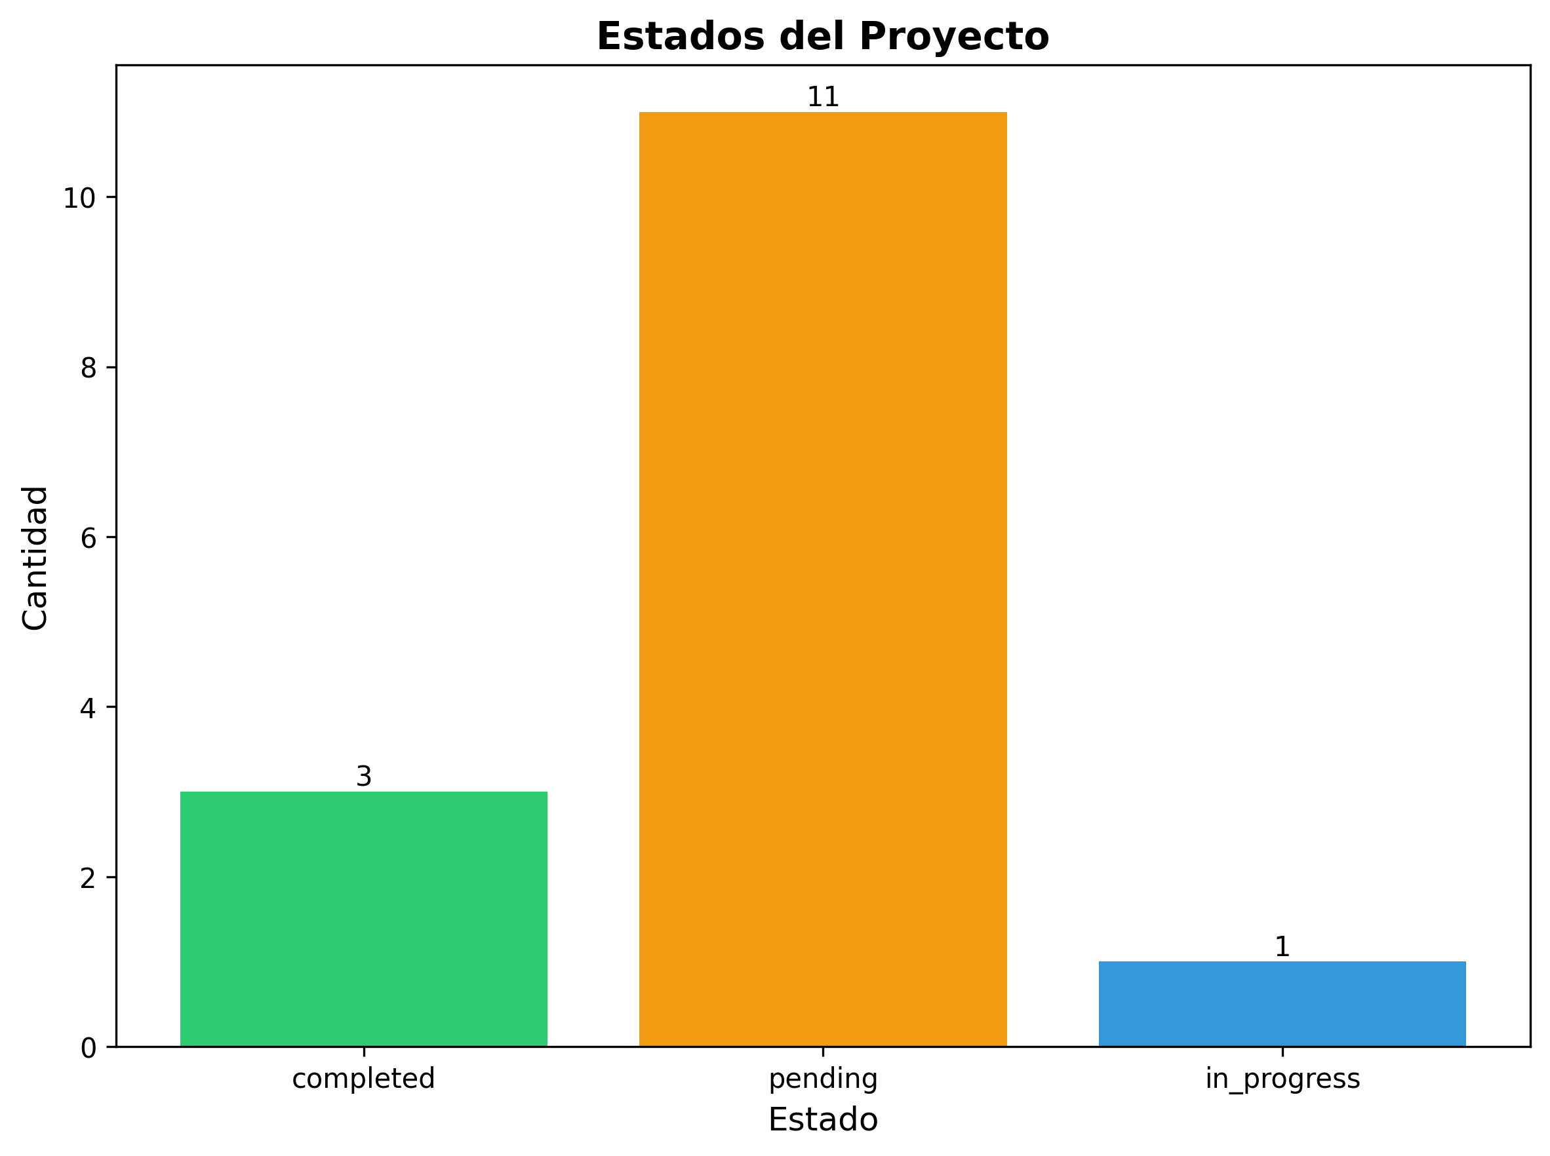

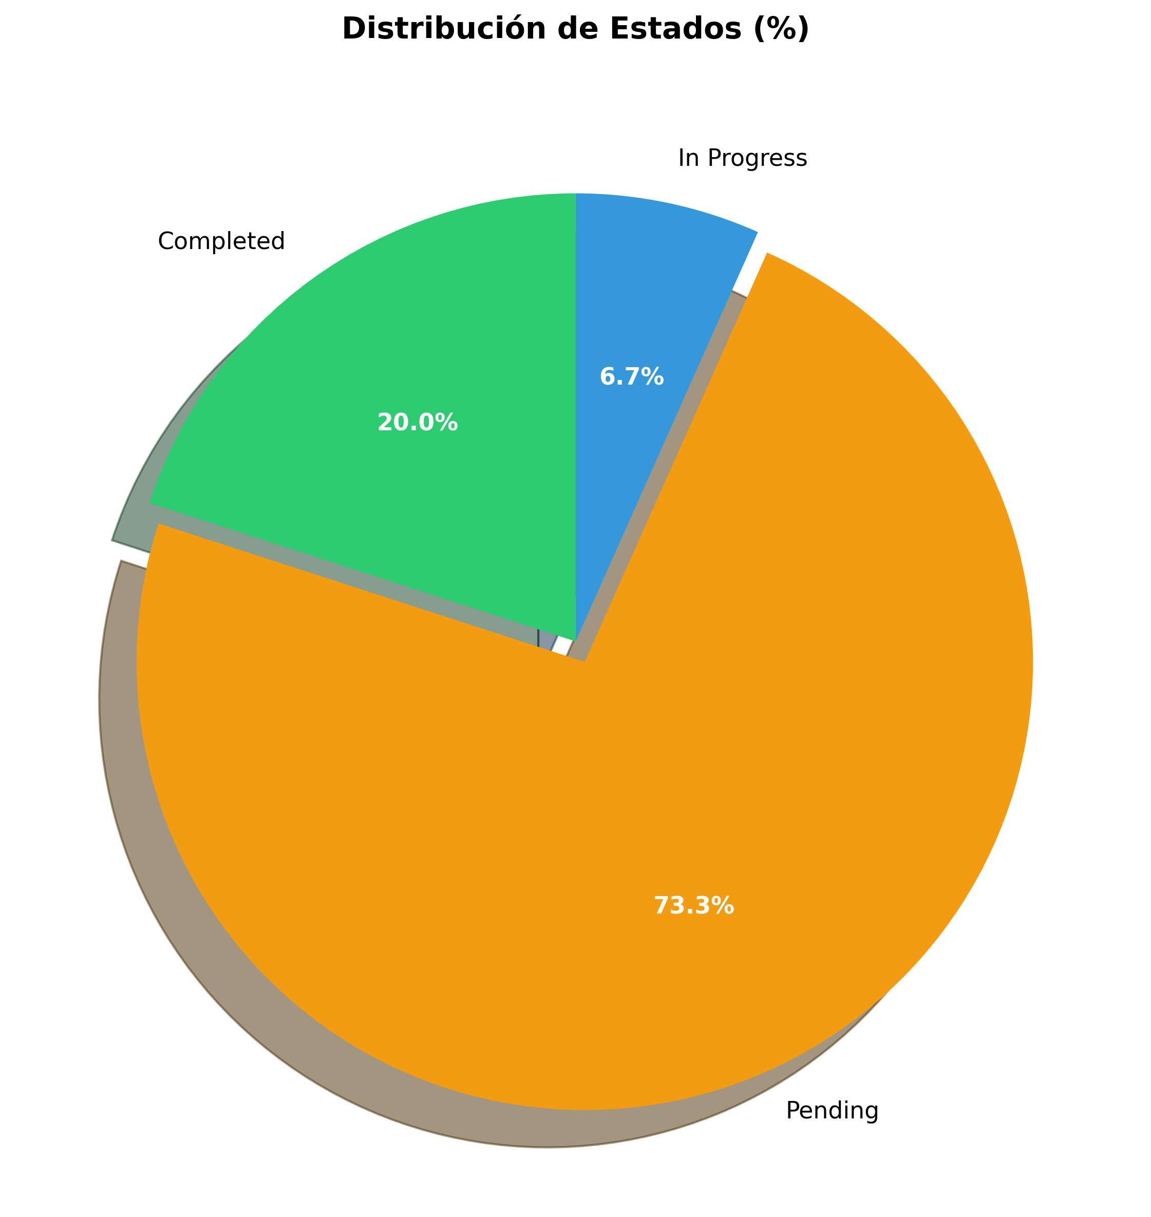

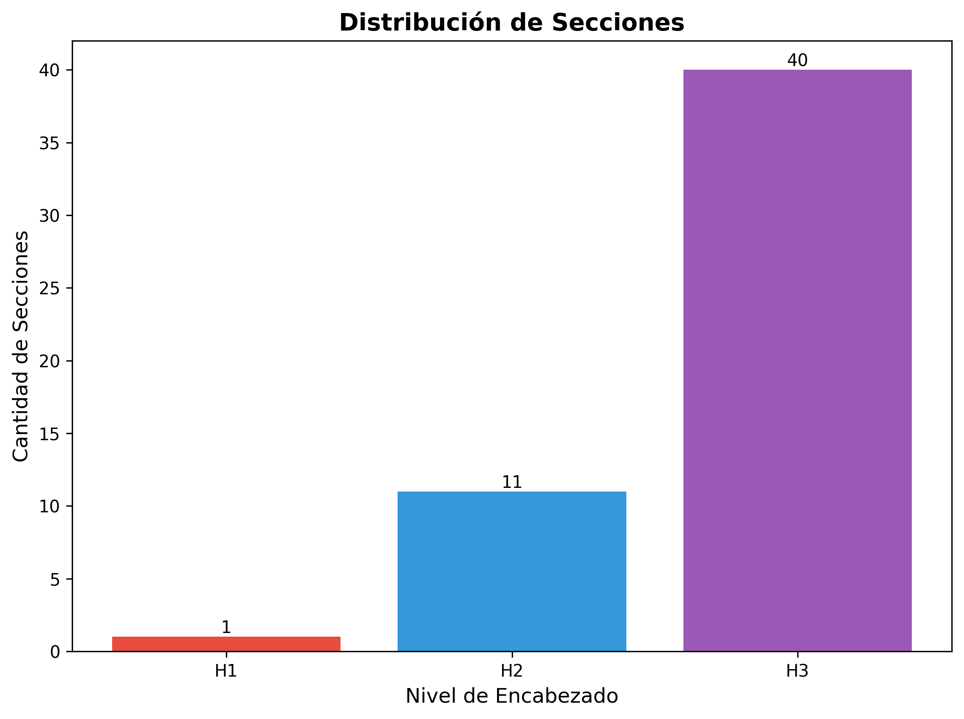

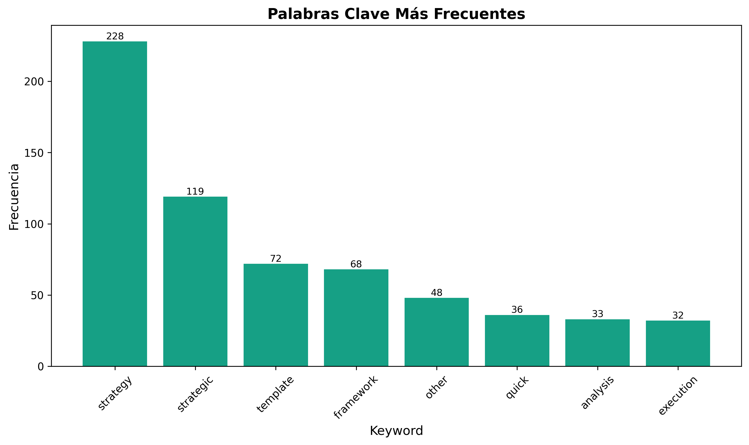

🎯 STRATEGY MASTER INDEX

*Your Complete Navigation Guide to Strategic Resources*

🚀 **QUICK START PATH**
New to Strategic Planning?
1. Start here → [STRATEGY_QUICK_START.md](./STRATEGY_QUICK_START.md) (30 minutes)
2. Then read → [MODERN_STRATEGY_FRAMEWORK_2025.md](./MODERN_STRATEGY_FRAMEWORK_2025.md)
3. Create your plan → [STRATEGIC_SWOT_TEMPLATE.md](06_strategy/Strategy_other/strategic_swot_template.md)
4. Set OKRs → [OKR_TEMPLATE.md](06_strategy/Strategy_other/okr_template.md)
5. Execute → [STRATEGY_EXECUTION_TEMPLATE.md](./STRATEGY_EXECUTION_TEMPLATE.md)
---

📚 **ALL RESOURCES BY CATEGORY**

**🆕 NEW DOCUMENTS (January 2025)**

**Core Frameworks**
1. [STRATEGY_QUICK_START.md](./STRATEGY_QUICK_START.md) ⚡
- Get started in 30 minutes
- Essential strategic questions
- Immediate action plan
2. [MODERN_STRATEGY_FRAMEWORK_2025.md](./MODERN_STRATEGY_FRAMEWORK_2025.md) 🎯
- Complete modern strategy framework
- 5-phase strategic process
- Advanced tools and templates
3. [STRATEGY_QUICK_REFERENCE.md](./STRATEGY_QUICK_REFERENCE.md) ⚡
- Quick decision-making guide
- Cheat sheets and shortcuts
- Fast reference materials

**Execution & Implementation**
4. [STRATEGY_EXECUTION_TEMPLATE.md](./STRATEGY_EXECUTION_TEMPLATE.md) 🚀
- Complete execution roadmap
- 12-week implementation plan
- KPIs and monitoring
5. [STRATEGIC_PLANNING_CALENDAR.md](06_strategy/Strategic_plans/strategic_planning_calendar.md) 📅
- Annual strategic planning calendar
- Quarterly breakdown
- Monthly and weekly activities
6. [STRATEGY_DECISION_FRAMEWORK.md](./STRATEGY_DECISION_FRAMEWORK.md) 🎯
- 5-step decision framework
- Decision matrices
- Systematic approach

**Templates & Tools**
7. [STRATEGIC_SWOT_TEMPLATE.md](06_strategy/Strategy_other/strategic_swot_template.md) 📊
- Complete SWOT analysis template
- Strategic insights framework
- Action planning
8. [OKR_TEMPLATE.md](06_strategy/Strategy_other/okr_template.md) 🎯
- Objectives & Key Results framework
- Tracking templates
- Best practices
9. [COMPETITIVE_ANALYSIS_TEMPLATE.md](06_strategy/Competitive_intelligence/competitive_analysis_template.md) 🔍
- Complete competitive analysis
- Competitor profiles
- Market positioning
10. [VISION_MISSION_BUILDER.md](06_strategy/Strategy_other/vision_mission_builder.md) 🌟
- Build powerful vision statements
- Create mission statements
- Define values

**Monitoring & Metrics**
11. [STRATEGIC_METRICS_DASHBOARD.md](06_strategy/Strategy_other/strategic_metrics_dashboard.md) 📊
- Complete KPI framework
- Metrics tracking
- Dashboard setup
12. [STRATEGIC_PERFORMANCE_REVIEW.md](06_strategy/Strategy_other/strategic_performance_review.md) 📊
- Quarterly performance assessment
- Strategic health evaluation
- Performance analysis

**Implementation & Execution**
13. [STRATEGY_IMPLEMENTATION_CHECKLIST.md](./STRATEGY_IMPLEMENTATION_CHECKLIST.md) ✅
- Complete implementation checklist
- Quality assurance
- Success measurement

**Advanced Strategic Frameworks**
16. [STRATEGIC_INNOVATION_FRAMEWORK.md](06_strategy/Strategy_other/strategic_innovation_framework.md) 🚀
- Strategic innovation and R&D
- Technology assessment
- Innovation portfolio management
17. [STRATEGIC_RISK_MANAGEMENT_FRAMEWORK.md](06_strategy/Strategy_other/strategic_risk_management_framework.md) ⚠️
- Strategic risk assessment
- Risk mitigation strategies
- Risk monitoring dashboard
18. [STRATEGIC_TRANSFORMATION_FRAMEWORK.md](06_strategy/Strategy_other/strategic_transformation_framework.md) 🔄
- Digital transformation
- Organizational change
- Business model evolution
19. [STRATEGIC_PARTNERSHIP_FRAMEWORK.md](06_strategy/Strategy_other/strategic_partnership_framework.md) 🤝
- Strategic alliances
- Partnership development
- Partnership management
20. [STRATEGIC_MARKET_INTELLIGENCE_FRAMEWORK.md](06_strategy/Market_analysis/strategic_market_intelligence_framework.md) 📊
- Market analysis
- Competitive intelligence
- Customer intelligence
21. [STRATEGIC_PERFORMANCE_OPTIMIZATION_FRAMEWORK.md](06_strategy/Strategy_other/strategic_performance_optimization_framework.md) ⚡
- Performance management
- Performance optimization
- Continuous improvement
22. [STRATEGIC_LEADERSHIP_FRAMEWORK.md](06_strategy/Strategy_other/strategic_leadership_framework.md) 👑
- Strategic leadership
- Executive excellence
- Leadership development
23. [STRATEGIC_GOVERNANCE_FRAMEWORK.md](06_strategy/Strategy_other/strategic_governance_framework.md) 🏛️
- Strategic governance
- Board excellence
- Governance best practices
24. [STRATEGIC_SUSTAINABILITY_FRAMEWORK.md](06_strategy/Strategy_other/strategic_sustainability_framework.md) 🌱
- Sustainable strategy
- ESG excellence
- Sustainability best practices
25. [STRATEGIC_FUTURE_PLANNING_FRAMEWORK.md](06_strategy/Strategic_plans/strategic_future_planning_framework.md) 🔮
- Future strategy
- Scenario planning
- Strategic foresight
26. [STRATEGIC_CULTURE_TRANSFORMATION_FRAMEWORK.md](06_strategy/Strategy_other/strategic_culture_transformation_framework.md) 🏢
- Strategic culture change
- Organizational excellence
- Culture transformation
27. [STRATEGIC_TALENT_MANAGEMENT_FRAMEWORK.md](06_strategy/Strategy_other/strategic_talent_management_framework.md) 👥
- Strategic talent management
- Talent acquisition
- Talent development
28. [STRATEGIC_DIGITAL_TRANSFORMATION_FRAMEWORK.md](06_strategy/Strategy_other/strategic_digital_transformation_framework.md) 💻
- Digital strategy
- Technology integration
- Digital transformation
29. [STRATEGIC_TECHNOLOGY_ROADMAP_FRAMEWORK.md](06_strategy/Strategy_other/strategic_technology_roadmap_framework.md) 🛠️
- Technology strategy
- Architecture planning
- Technology roadmap
30. [STRATEGIC_INDUSTRY_ANALYSIS_FRAMEWORK.md](06_strategy/Strategy_other/strategic_industry_analysis_framework.md) 🏭
- Industry-specific analysis
- Sector frameworks
- Industry trends
31. [STRATEGIC_CASE_STUDY_COLLECTION.md](06_strategy/Strategy_other/strategic_case_study_collection.md) 📚
- Strategic success stories
- Case study analysis
- Lessons learned

**Learning Resources**
32. [STRATEGY_SUCCESS_CASES.md](./STRATEGY_SUCCESS_CASES.md) 🏆
- 8 real-world case studies
- Netflix, Amazon, Apple, Tesla
- Strategic patterns
33. [STRATEGY_COMMON_MISTAKES.md](./STRATEGY_COMMON_MISTAKES.md) ⚠️
- Top 20 strategic mistakes
- How to avoid them
- Quick fixes
---

🎯 **BY STRATEGIC PHASE**

**Phase 1: Foundation & Planning**
- Start: [STRATEGY_QUICK_START.md](./STRATEGY_QUICK_START.md)
- Vision: [VISION_MISSION_BUILDER.md](06_strategy/Strategy_other/vision_mission_builder.md)
- Analysis: [STRATEGIC_SWOT_TEMPLATE.md](06_strategy/Strategy_other/strategic_swot_template.md)
- Competition: [COMPETITIVE_ANALYSIS_TEMPLATE.md](06_strategy/Competitive_intelligence/competitive_analysis_template.md)

**Phase 2: Strategy Development**
- Framework: [MODERN_STRATEGY_FRAMEWORK_2025.md](./MODERN_STRATEGY_FRAMEWORK_2025.md)
- OKRs: [OKR_TEMPLATE.md](06_strategy/Strategy_other/okr_template.md)
- Decisions: [STRATEGY_DECISION_FRAMEWORK.md](./STRATEGY_DECISION_FRAMEWORK.md)
- Calendar: [STRATEGIC_PLANNING_CALENDAR.md](06_strategy/Strategic_plans/strategic_planning_calendar.md)

**Phase 3: Execution**
- Execute: [STRATEGY_EXECUTION_TEMPLATE.md](./STRATEGY_EXECUTION_TEMPLATE.md)
- Monitor: [STRATEGIC_METRICS_DASHBOARD.md](06_strategy/Strategy_other/strategic_metrics_dashboard.md)
- Review: [STRATEGIC_PLANNING_CALENDAR.md](06_strategy/Strategic_plans/strategic_planning_calendar.md)
- Learn: [STRATEGY_SUCCESS_CASES.md](./STRATEGY_SUCCESS_CASES.md)

**Phase 4: Optimization**
- Mistakes: [STRATEGY_COMMON_MISTAKES.md](./STRATEGY_COMMON_MISTAKES.md)
- Reference: [STRATEGY_QUICK_REFERENCE.md](./STRATEGY_QUICK_REFERENCE.md)
- Decisions: [STRATEGY_DECISION_FRAMEWORK.md](./STRATEGY_DECISION_FRAMEWORK.md)
---

📋 **BY USE CASE**

**I Need to Start Strategic Planning**
1. [STRATEGY_QUICK_START.md](./STRATEGY_QUICK_START.md) - Get started in 30 min
2. [VISION_MISSION_BUILDER.md](06_strategy/Strategy_other/vision_mission_builder.md) - Define vision
3. [STRATEGIC_SWOT_TEMPLATE.md](06_strategy/Strategy_other/strategic_swot_template.md) - Analyze position
4. [MODERN_STRATEGY_FRAMEWORK_2025.md](./MODERN_STRATEGY_FRAMEWORK_2025.md) - Build strategy

**I Need to Make Strategic Decisions**
1. [STRATEGY_DECISION_FRAMEWORK.md](./STRATEGY_DECISION_FRAMEWORK.md) - Decision framework
2. [STRATEGY_QUICK_REFERENCE.md](./STRATEGY_QUICK_REFERENCE.md) - Quick tools
3. [COMPETITIVE_ANALYSIS_TEMPLATE.md](06_strategy/Competitive_intelligence/competitive_analysis_template.md) - Gather info

**I Need to Execute a Strategy**
1. [STRATEGY_EXECUTION_TEMPLATE.md](./STRATEGY_EXECUTION_TEMPLATE.md) - Execution plan
2. [OKR_TEMPLATE.md](06_strategy/Strategy_other/okr_template.md) - Set OKRs
3. [STRATEGIC_METRICS_DASHBOARD.md](06_strategy/Strategy_other/strategic_metrics_dashboard.md) - Track progress

**I Need to Monitor Progress**
1. [STRATEGIC_METRICS_DASHBOARD.md](06_strategy/Strategy_other/strategic_metrics_dashboard.md) - All metrics
2. [STRATEGIC_PLANNING_CALENDAR.md](06_strategy/Strategic_plans/strategic_planning_calendar.md) - Review schedule
3. [STRATEGY_EXECUTION_TEMPLATE.md](./STRATEGY_EXECUTION_TEMPLATE.md) - Progress tracking

**I Need to Learn from Examples**
1. [STRATEGY_SUCCESS_CASES.md](./STRATEGY_SUCCESS_CASES.md) - Real cases
2. [STRATEGY_COMMON_MISTAKES.md](./STRATEGY_COMMON_MISTAKES.md) - Avoid errors
3. [STRATEGY_QUICK_REFERENCE.md](./STRATEGY_QUICK_REFERENCE.md) - Best practices
---

🎯 **BY ROLE**

**For CEOs & Executives**
- [STRATEGY_QUICK_START.md](./STRATEGY_QUICK_START.md) - Strategic overview
- [MODERN_STRATEGY_FRAMEWORK_2025.md](./MODERN_STRATEGY_FRAMEWORK_2025.md) - Complete framework
- [VISION_MISSION_BUILDER.md](06_strategy/Strategy_other/vision_mission_builder.md) - Vision & mission
- [COMPETITIVE_ANALYSIS_TEMPLATE.md](06_strategy/Competitive_intelligence/competitive_analysis_template.md) - Market position

**For Strategy Teams**
- [STRATEGY_EXECUTION_TEMPLATE.md](./STRATEGY_EXECUTION_TEMPLATE.md) - Implementation
- [STRATEGIC_SWOT_TEMPLATE.md](06_strategy/Strategy_other/strategic_swot_template.md) - Analysis
- [OKR_TEMPLATE.md](06_strategy/Strategy_other/okr_template.md) - Goal setting
- [STRATEGIC_METRICS_DASHBOARD.md](06_strategy/Strategy_other/strategic_metrics_dashboard.md) - Monitoring

**For Project Managers**
- [STRATEGY_EXECUTION_TEMPLATE.md](./STRATEGY_EXECUTION_TEMPLATE.md) - Project plan
- [STRATEGIC_PLANNING_CALENDAR.md](06_strategy/Strategic_plans/strategic_planning_calendar.md) - Timeline
- [STRATEGIC_METRICS_DASHBOARD.md](06_strategy/Strategy_other/strategic_metrics_dashboard.md) - Tracking
- [OKR_TEMPLATE.md](06_strategy/Strategy_other/okr_template.md) - Objectives

**For Analysts**
- [STRATEGIC_SWOT_TEMPLATE.md](06_strategy/Strategy_other/strategic_swot_template.md) - SWOT analysis
- [COMPETITIVE_ANALYSIS_TEMPLATE.md](06_strategy/Competitive_intelligence/competitive_analysis_template.md) - Competitive analysis
- [STRATEGIC_METRICS_DASHBOARD.md](06_strategy/Strategy_other/strategic_metrics_dashboard.md) - Metrics analysis
---

📊 **BY TIMELINE**

**30 Minutes**
- [STRATEGY_QUICK_START.md](./STRATEGY_QUICK_START.md) - Quick start
- [STRATEGY_QUICK_REFERENCE.md](./STRATEGY_QUICK_REFERENCE.md) - Quick reference

**2 Hours**
- [STRATEGIC_SWOT_TEMPLATE.md](06_strategy/Strategy_other/strategic_swot_template.md) - SWOT analysis
- [OKR_TEMPLATE.md](06_strategy/Strategy_other/okr_template.md) - Set OKRs
- [VISION_MISSION_BUILDER.md](06_strategy/Strategy_other/vision_mission_builder.md) - Vision & mission

**1 Day**
- [MODERN_STRATEGY_FRAMEWORK_2025.md](./MODERN_STRATEGY_FRAMEWORK_2025.md) - Full framework
- [COMPETITIVE_ANALYSIS_TEMPLATE.md](06_strategy/Competitive_intelligence/competitive_analysis_template.md) - Competitive analysis
- [STRATEGY_EXECUTION_TEMPLATE.md](./STRATEGY_EXECUTION_TEMPLATE.md) - Execution plan

**1 Week**
- Complete strategic planning process
- All analyses completed
- Full implementation plan
---

🔍 **BY TOPIC**

**Strategic Planning**
- [MODERN_STRATEGY_FRAMEWORK_2025.md](./MODERN_STRATEGY_FRAMEWORK_2025.md)
- [STRATEGIC_PLANNING_CALENDAR.md](06_strategy/Strategic_plans/strategic_planning_calendar.md)
- [STRATEGIC_SWOT_TEMPLATE.md](06_strategy/Strategy_other/strategic_swot_template.md)

**Vision & Mission**
- [VISION_MISSION_BUILDER.md](06_strategy/Strategy_other/vision_mission_builder.md)

**OKRs & Goals**
- [OKR_TEMPLATE.md](06_strategy/Strategy_other/okr_template.md)

**Decision Making**
- [STRATEGY_DECISION_FRAMEWORK.md](./STRATEGY_DECISION_FRAMEWORK.md)

**Competitive Analysis**
- [COMPETITIVE_ANALYSIS_TEMPLATE.md](06_strategy/Competitive_intelligence/competitive_analysis_template.md)

**Execution**
- [STRATEGY_EXECUTION_TEMPLATE.md](./STRATEGY_EXECUTION_TEMPLATE.md)

**Metrics & KPIs**
- [STRATEGIC_METRICS_DASHBOARD.md](06_strategy/Strategy_other/strategic_metrics_dashboard.md)

**Learning**
- [STRATEGY_SUCCESS_CASES.md](./STRATEGY_SUCCESS_CASES.md)
- [STRATEGY_COMMON_MISTAKES.md](./STRATEGY_COMMON_MISTAKES.md)
---

🎯 **QUICK LINKS**

**Most Popular**
1. [STRATEGY_QUICK_START.md](./STRATEGY_QUICK_START.md) ⚡
2. [MODERN_STRATEGY_FRAMEWORK_2025.md](./MODERN_STRATEGY_FRAMEWORK_2025.md) 🎯
3. [STRATEGY_EXECUTION_TEMPLATE.md](./STRATEGY_EXECUTION_TEMPLATE.md) 🚀
4. [OKR_TEMPLATE.md](06_strategy/Strategy_other/okr_template.md) 📊
5. [STRATEGIC_SWOT_TEMPLATE.md](06_strategy/Strategy_other/strategic_swot_template.md) 🔍

**Most Practical**
- [STRATEGY_QUICK_REFERENCE.md](./STRATEGY_QUICK_REFERENCE.md)
- [STRATEGY_DECISION_FRAMEWORK.md](./STRATEGY_DECISION_FRAMEWORK.md)
- [STRATEGY_COMMON_MISTAKES.md](./STRATEGY_COMMON_MISTAKES.md)

**Most Inspirational**
- [STRATEGY_SUCCESS_CASES.md](./STRATEGY_SUCCESS_CASES.md)
- [VISION_MISSION_BUILDER.md](06_strategy/Strategy_other/vision_mission_builder.md)
---

📈 **YOUR STRATEGIC JOURNEY**

**Month 1: Foundation**
- Complete: SWOT analysis
- Define: Vision & mission
- Set: Initial OKRs
- Create: Execution plan

**Month 2: Execution**
- Launch: Strategic initiatives
- Track: KPIs and metrics
- Review: Weekly progress
- Adjust: As needed

**Month 3: Optimization**
- Review: Q1 results
- Learn: From successes
- Fix: Common mistakes
- Plan: Next quarter

**Month 4-12: Scale**
- Continue: Strategic execution
- Monitor: All metrics
- Learn: From outcomes
- Improve: Continuously
---

🎯 **SUCCESS METRICS**

**Track Your Strategic Maturity**
- [ ] SWOT analysis completed
- [ ] Vision & mission defined
- [ ] OKRs set
- [ ] Execution plan created
- [ ] Metrics dashboard active
- [ ] Regular reviews scheduled

**Strategic Capabilities Developed**
- [ ] Strategic thinking
- [ ] Decision-making framework
- [ ] Competitive awareness
- [ ] Execution discipline
- [ ] Metric tracking
---

📞 **GETTING HELP**

**Need Quick Reference?**
→ [STRATEGY_QUICK_REFERENCE.md](./STRATEGY_QUICK_REFERENCE.md)

**Need a Template?**
→ Browse Templates section above

**Need Examples?**
→ [STRATEGY_SUCCESS_CASES.md](./STRATEGY_SUCCESS_CASES.md)

**Need to Avoid Mistakes?**
→ [STRATEGY_COMMON_MISTAKES.md](./STRATEGY_COMMON_MISTAKES.md)
---
This index helps you navigate all strategic resources quickly and find exactly what you need.
Version: 1.0
Last Updated: 2025-01-27

