Estrategias y Frameworks
Estrategia

Documentación completa de estrategias y frameworks empresariales
Generado el 24 de November de 2025

📑 Índice de Contenidos
• 🎯 BUSINESS STRATEGY - Strategy Hub
- • *Your Complete Resource for Strategic Planning & Execution*
- • 📋 **Overview**
- • 🚀 **START HERE - Essential Resources**
- • **🔥 NEW (January 2025)**
- • **📚 Core Strategy Playbooks**
- • **📝 Strategic Templates**
- • 📁 **STRATEGIC PLANNING**
- • **Vision & Strategy**
- • **Market Analysis**
- • **Strategic Initiatives**
- • 🏆 **COMPETITIVE STRATEGY**
- • **Competitive Intelligence**
- • **Competitive Analysis Documents**
- • 📈 **GROWTH STRATEGIES**
- • **Growth Framework**
- • **Growth Documents**
- • 🎯 **GO-TO-MARKET & LAUNCH**
- • **Launch Strategy**
- • **Launch Documents**
- • 💰 **REVENUE & MONETIZATION**
- • **Revenue Strategy**
- • **Financial Documents**
- • 🚀 **INNOVATION & R&D**
- • **Innovation Framework**
- • **Innovation Documents**
- • 🌍 **INTERNATIONAL EXPANSION**
- • **Global Strategy**
- • **Expansion Documents**
- • 💼 **INVESTOR & VENTURE CAPITAL**

📊 Análisis Visual
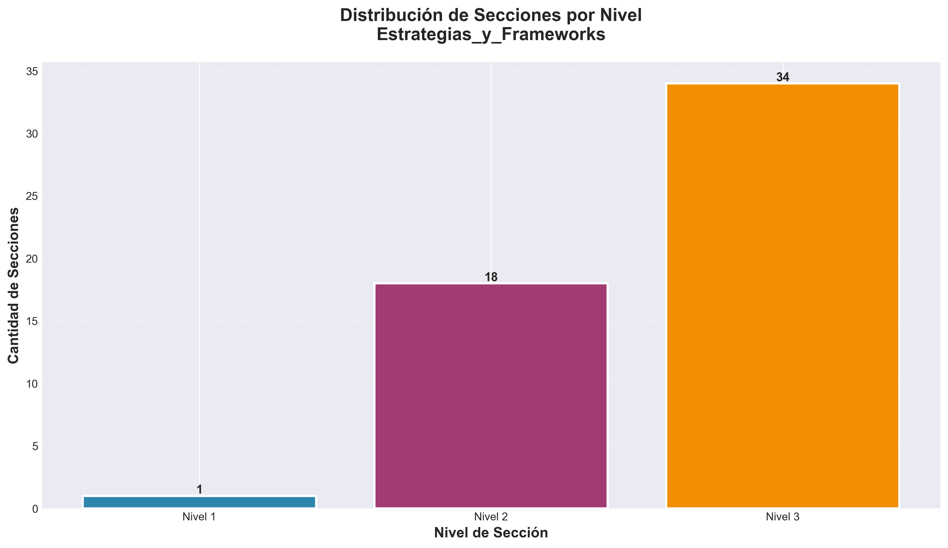

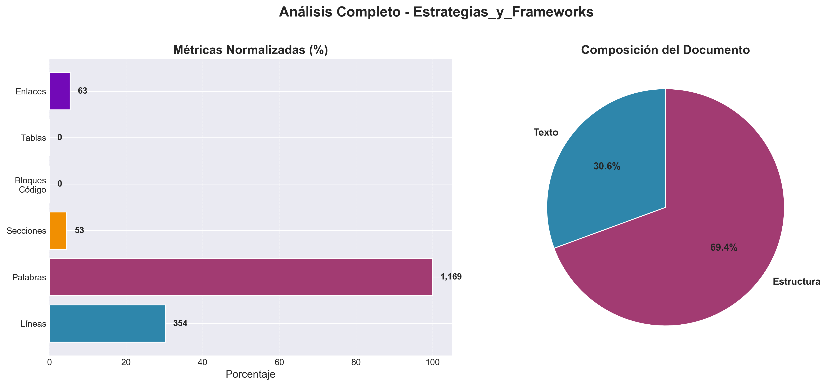

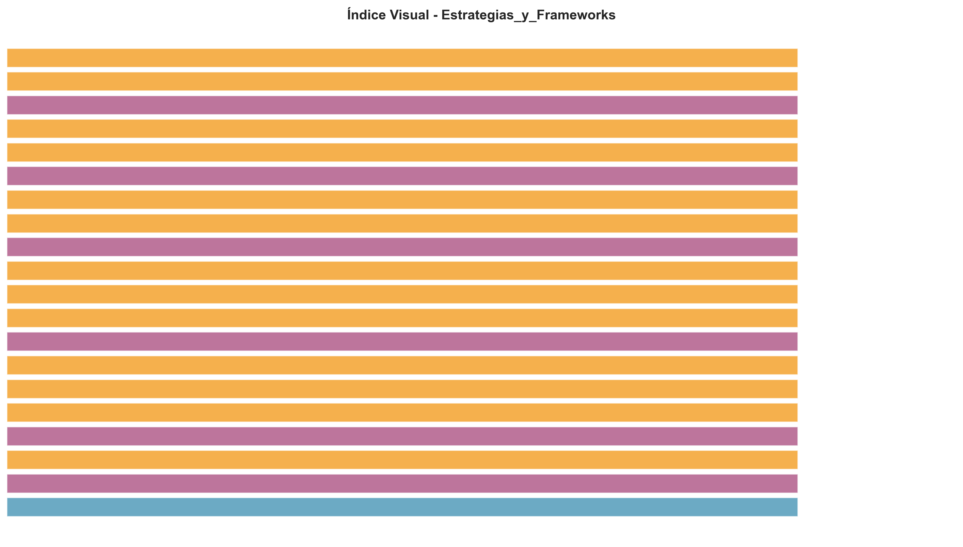

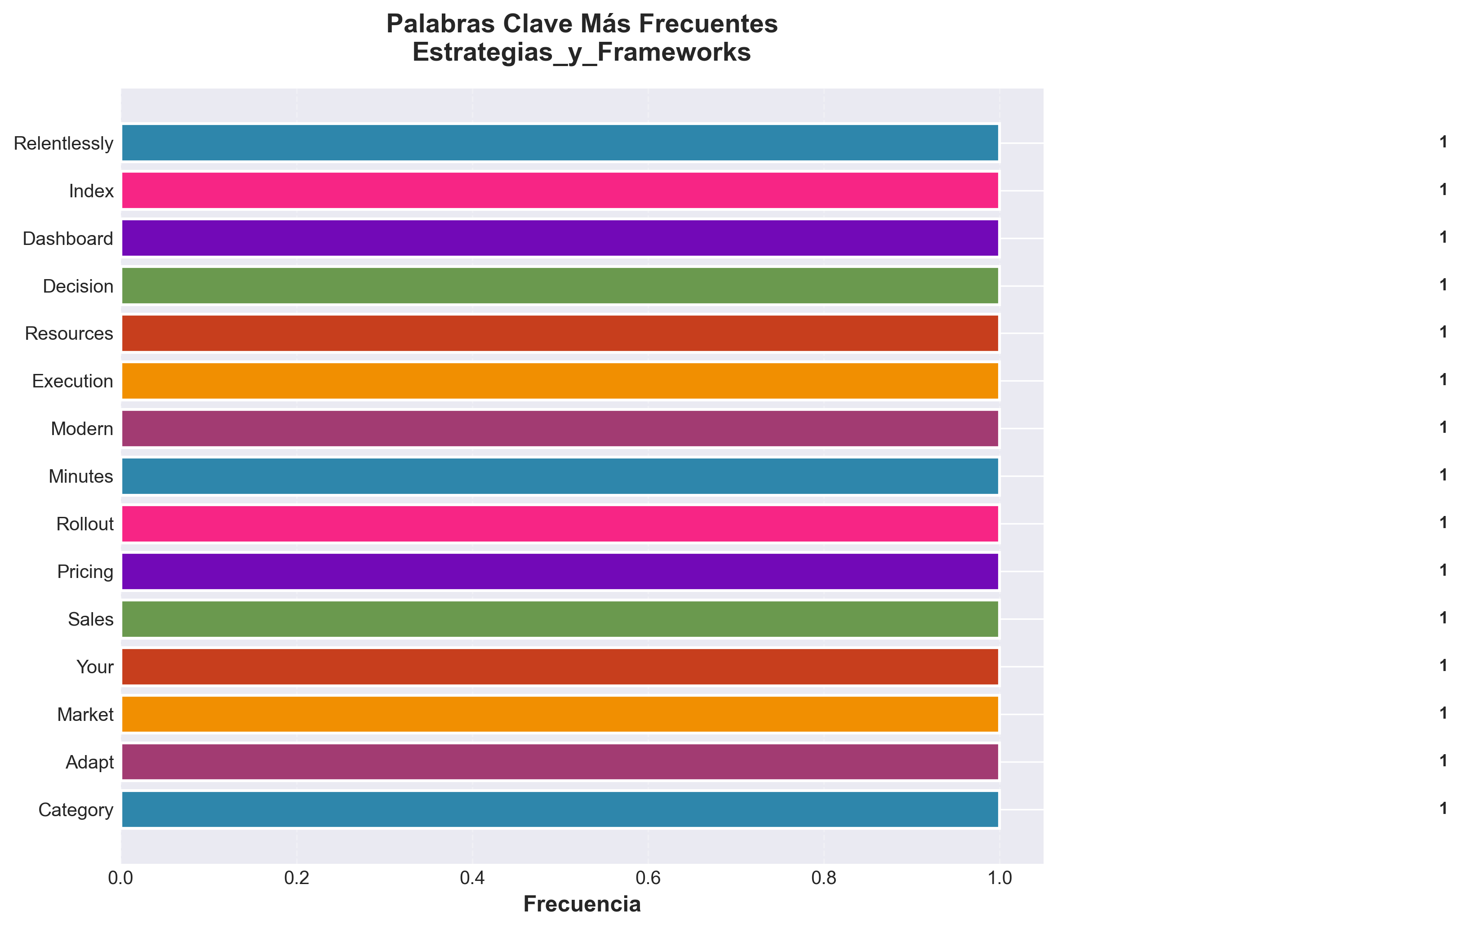

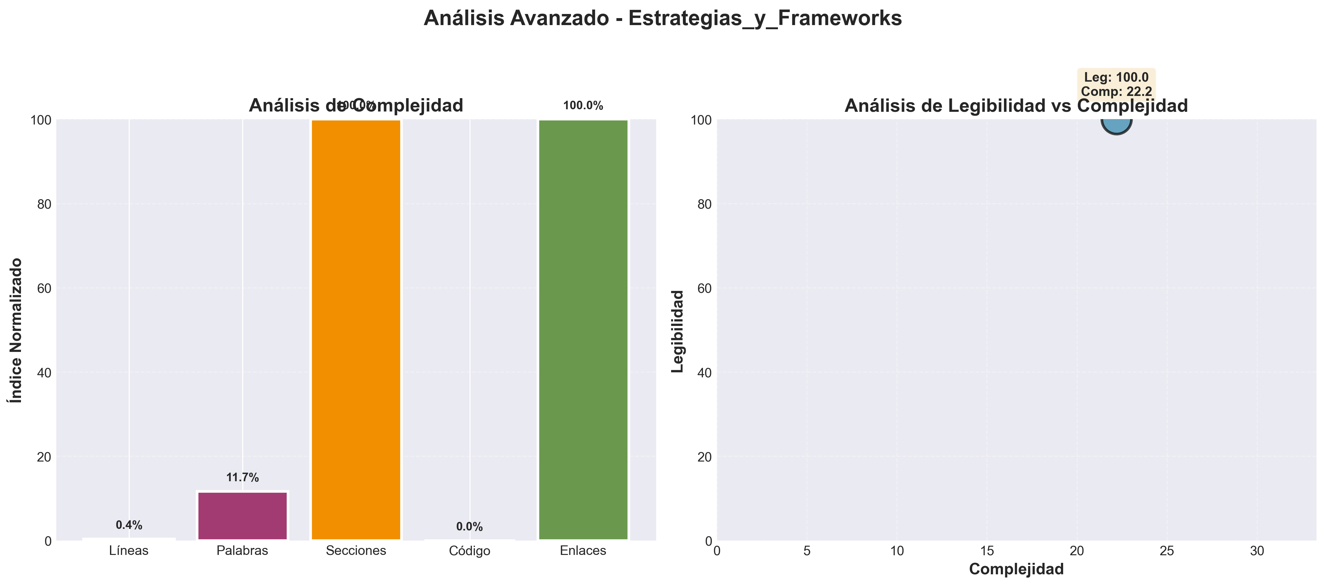

📄 Contenido
---
title: "Readme"
category: "06_strategy"
tags: []
created: "2025-10-29"
path: "06_strategy/Strategy_other/readme.md"
---

🎯 BUSINESS STRATEGY - Strategy Hub

*Your Complete Resource for Strategic Planning & Execution*

📋 **Overview**
This strategy hub contains comprehensive resources for strategic planning, competitive analysis, market research, and execution frameworks. Everything you need to build and execute winning strategies.
---

🚀 **START HERE - Essential Resources**

**🔥 NEW (January 2025)**
- **[STRATEGY_MASTER_INDEX.md](06_strategy/Business_strategies/strategy_master_index.md)** 📑 Complete navigation guide
- **[STRATEGY_QUICK_START.md](06_strategy/Business_strategies/strategy_quick_start.md)** ⚡ Start strategic planning in 30 minutes
- **[MODERN_STRATEGY_FRAMEWORK_2025.md](06_strategy/Business_strategies/modern_strategy_framework_2025.md)** - Complete modern strategy framework
- **[STRATEGY_QUICK_REFERENCE.md](06_strategy/Business_strategies/strategy_quick_reference.md)** - Quick decision-making guide
- **[STRATEGY_EXECUTION_TEMPLATE.md](06_strategy/Business_strategies/strategy_execution_template.md)** - Step-by-step execution plan
- **[STRATEGY_DECISION_FRAMEWORK.md](06_strategy/Business_strategies/strategy_decision_framework.md)** - Systematic decision-making framework
- **[STRATEGIC_METRICS_DASHBOARD.md](./STRATEGIC_METRICS_DASHBOARD.md)** - Complete KPI tracking dashboard
- **[STRATEGIC_PLANNING_CALENDAR.md](06_strategy/Strategic_plans/strategic_planning_calendar.md)** - Annual strategic planning calendar
- **[STRATEGY_SUCCESS_CASES.md](06_strategy/Business_strategies/strategy_success_cases.md)** - Real-world strategic case studies
- **[STRATEGY_COMMON_MISTAKES.md](06_strategy/Business_strategies/strategy_common_mistakes.md)** - How to avoid strategic errors
- **[STRATEGIC_INNOVATION_FRAMEWORK.md](./STRATEGIC_INNOVATION_FRAMEWORK.md)** - Strategic innovation and R&D framework
- **[STRATEGIC_RISK_MANAGEMENT_FRAMEWORK.md](./STRATEGIC_RISK_MANAGEMENT_FRAMEWORK.md)** - Complete risk assessment and mitigation
- **[STRATEGIC_TRANSFORMATION_FRAMEWORK.md](./STRATEGIC_TRANSFORMATION_FRAMEWORK.md)** - Digital and organizational transformation guide
- **[STRATEGIC_PARTNERSHIP_FRAMEWORK.md](./STRATEGIC_PARTNERSHIP_FRAMEWORK.md)** - Strategic alliances and partnerships framework
- **[STRATEGIC_MARKET_INTELLIGENCE_FRAMEWORK.md](06_strategy/Market_analysis/strategic_market_intelligence_framework.md)** - Market analysis and competitive intelligence
- **[STRATEGIC_PERFORMANCE_OPTIMIZATION_FRAMEWORK.md](./STRATEGIC_PERFORMANCE_OPTIMIZATION_FRAMEWORK.md)** - Strategic performance management and optimization
- **[STRATEGIC_LEADERSHIP_FRAMEWORK.md](./STRATEGIC_LEADERSHIP_FRAMEWORK.md)** - Strategic leadership and executive excellence
- **[STRATEGIC_GOVERNANCE_FRAMEWORK.md](./STRATEGIC_GOVERNANCE_FRAMEWORK.md)** - Strategic governance and board excellence
- **[STRATEGIC_SUSTAINABILITY_FRAMEWORK.md](./STRATEGIC_SUSTAINABILITY_FRAMEWORK.md)** - Sustainable strategy and ESG excellence
- **[STRATEGIC_FUTURE_PLANNING_FRAMEWORK.md](06_strategy/Strategic_plans/strategic_future_planning_framework.md)** - Future strategy and scenario planning
- **[STRATEGIC_CULTURE_TRANSFORMATION_FRAMEWORK.md](./STRATEGIC_CULTURE_TRANSFORMATION_FRAMEWORK.md)** - Strategic culture change and organizational excellence
- **[STRATEGIC_TALENT_MANAGEMENT_FRAMEWORK.md](./STRATEGIC_TALENT_MANAGEMENT_FRAMEWORK.md)** - Strategic talent acquisition, development, and retention
- **[STRATEGIC_DIGITAL_TRANSFORMATION_FRAMEWORK.md](./STRATEGIC_DIGITAL_TRANSFORMATION_FRAMEWORK.md)** - Digital strategy and technology integration
- **[STRATEGIC_TECHNOLOGY_ROADMAP_FRAMEWORK.md](./STRATEGIC_TECHNOLOGY_ROADMAP_FRAMEWORK.md)** - Technology strategy and architecture planning
- **[STRATEGIC_INDUSTRY_ANALYSIS_FRAMEWORK.md](./STRATEGIC_INDUSTRY_ANALYSIS_FRAMEWORK.md)** - Industry-specific strategic analysis
- **[STRATEGIC_CASE_STUDY_COLLECTION.md](./STRATEGIC_CASE_STUDY_COLLECTION.md)** - Comprehensive strategic success stories

**📚 Core Strategy Playbooks**
- **[06_Strategy_Playbook.md](06_strategy/Business_strategies/06_strategy_playbook.md)** - Neural Marketing Consciousness System playbook
- **[MASTER_STRATEGY_FRAMEWORK.md](./MASTER_STRATEGY_FRAMEWORK.md)** - Ultimate influencer marketing + AI/ML course framework
- **[Strategic_Planning_Framework.md](06_strategy/Strategic_plans/strategic_planning_framework.md)** - Comprehensive planning framework
- **[06_Strategy_Checklist.md](06_strategy/Business_strategies/06_strategy_checklist.md)** - Complete strategic planning checklist

**📝 Strategic Templates**
- **[OKR_TEMPLATE.md](./OKR_TEMPLATE.md)** - Objectives & Key Results framework
- **[STRATEGIC_SWOT_TEMPLATE.md](./STRATEGIC_SWOT_TEMPLATE.md)** - Comprehensive SWOT analysis template
- **[COMPETITIVE_ANALYSIS_TEMPLATE.md](06_strategy/Competitive_intelligence/competitive_analysis_template.md)** - Complete competitive analysis framework
- **[VISION_MISSION_BUILDER.md](./VISION_MISSION_BUILDER.md)** - Build powerful vision & mission statements
- **[STRATEGIC_ROADMAP_TEMPLATE.md](./STRATEGIC_ROADMAP_TEMPLATE.md)** - Strategic journey roadmap
- **[STRATEGIC_PERFORMANCE_REVIEW.md](./STRATEGIC_PERFORMANCE_REVIEW.md)** - Quarterly performance assessment
- **[STRATEGY_IMPLEMENTATION_CHECKLIST.md](06_strategy/Business_strategies/strategy_implementation_checklist.md)** - Complete implementation checklist
- **[STRATEGIC_WORKSHOP_GUIDE.md](06_strategy/Implementation_guides/strategic_workshop_guide.md)** - Facilitate strategic planning workshops
- **[STRATEGIC_COMMUNICATION_TEMPLATE.md](./STRATEGIC_COMMUNICATION_TEMPLATE.md)** - Strategic communication framework
---

📁 **STRATEGIC PLANNING**

**Vision & Strategy**
- Vision, Mission & Values definition
- Strategic positioning
- Long-term planning (3-5-10 years)
- Strategic objectives (OKRs)

**Market Analysis**
- Market research & intelligence
- Customer segmentation
- Competitive analysis
- SWOT analysis
- PEST analysis
- Market trends & forecasting

**Strategic Initiatives**
- Initiative planning
- Initiative execution
- Initiative monitoring
- Strategic projects
---

🏆 **COMPETITIVE STRATEGY**

**Competitive Intelligence**
- Competitor identification
- Competitive positioning
- Market share analysis
- Competitive benchmarking
- Competitive response strategies

**Competitive Analysis Documents**
- `COMPETITIVE_ANALYSIS_STRATEGIC_BATTLE_PLAN.md`
- `COMPETITIVE_LANDING_PAGES.md`
- `COMPETITIVE_MARKETING_CAMPAIGNS.md`
- `VC_Competitive_Analysis_Mastery_2024.md`
---

📈 **GROWTH STRATEGIES**

**Growth Framework**
- Market penetration strategies
- Market development
- Product development
- Diversification
- Scaling strategies

**Growth Documents**
- `10_Growth_Strategies.md`
- `VC_Advanced_Innovation_Strategy_2024.md`
- `innovation_lab_rd_strategy.md`
- `Innovation_Lab_Strategy.md`
---

🎯 **GO-TO-MARKET & LAUNCH**

**Launch Strategy**
- Product launch planning
- Market entry strategies
- Launch campaigns
- Rollout plans

**Launch Documents**
- `LAUNCH_STRATEGY.md`
- `14_Launch_Strategy_Guide.md`
- `GO_TO_MARKET_STRATEGY_DETAILED.md`
- `GO_TO_MARKET_STRATEGY_ULTRA.md`
---

💰 **REVENUE & MONETIZATION**

**Revenue Strategy**
- Pricing strategies
- Revenue models
- Monetization frameworks
- ROI optimization

**Financial Documents**
- `ROI_Calculator_Tool.md`
- `Pricing_Strategy_Calculator.md`
- `Monetization_Strategy_Business_Plan.md`
- `advanced_revenue_streams_strategy.md`
---

🚀 **INNOVATION & R&D**

**Innovation Framework**
- Innovation labs
- R&D strategies
- Technology development
- Future trends

**Innovation Documents**
- `Innovation_and_Future_Trends.md`
- `AI_Innovation_Lab.md`
- `Innovation_Lab_Strategy.md`
- `Innovation_Strategy.md`
---

🌍 **INTERNATIONAL EXPANSION**

**Global Strategy**
- Market expansion
- Localization strategies
- International partnerships
- Global operations

**Expansion Documents**
- `15_International_Expansion_Strategy.md`
- `VC_International_Expansion_Strategy_2024.md`
- `Global_Implementation_Strategies.md`
- `strategias_expansion_global_avanzadas_v4.md`
---

💼 **INVESTOR & VENTURE CAPITAL**

**VC Resources**
- Pitch decks
- Term sheets
- Due diligence
- Exit strategies

**Investor Documents**
- `07_Investor_Pitch_Deck.md`
- `VC_Advanced_Pitch_Deck_Mastery_2024.md`
- `VC_Advanced_Exit_Strategy_2024.md`
- `VC_Investor_Relations_Mastery_2024.md`
- `INVESTOR_DUE_DILIGENCE_CHECKLIST.md`
- `VALUATION_ANALYSIS_ULTRA.md`
---

📊 **ANALYTICS & METRICS**

**Strategic Metrics**
- KPI frameworks
- Performance dashboards
- Strategic reporting
- Analytics frameworks

**Analytics Documents**
- `14_Data_Analytics_Strategy.md`
- `Advanced_Data_Analytics_Intelligence.md`
- `Data_Analytics_Strategy.md`
- `analytics_business_intelligence_avanzados.md`
---

🛠️ **TOOLS & TEMPLATES**

**Strategy Tools**
- Strategic planning templates
- OKR templates
- SWOT analysis templates
- Business model canvas
- Growth frameworks

**Template Documents**
- **[OKR_TEMPLATE.md](./OKR_TEMPLATE.md)** - Set clear objectives & key results
- **[STRATEGIC_SWOT_TEMPLATE.md](./STRATEGIC_SWOT_TEMPLATE.md)** - Comprehensive SWOT analysis
- **[COMPETITIVE_ANALYSIS_TEMPLATE.md](06_strategy/Competitive_intelligence/competitive_analysis_template.md)** - Analyze competitors
- **[VISION_MISSION_BUILDER.md](./VISION_MISSION_BUILDER.md)** - Create vision & mission
- `Business_Case_Templates.md`
- `Implementation_Guides_and_Checklists.md`
- `investment_templates/`
- `plantillas_pitch_deck_personalizadas.md`
---

📋 **SPECIALIZED INDUSTRIES**

**Industry-Specific Strategies**
- AI/ML strategies
- TikTok AI strategies
- Facebook Ads strategies
- Healthcare strategies
- Finance strategies
- Education strategies

**Specialized Documents**
- `TikTok_AI_Launch_Campaign_Strategy.md`
- `TikTok_AI_Monetization_Strategy.md`
- `Facebook_Ads_Targeting_Strategy_Guide.md`
- `Facebook_Ads_Suite_Final_Summary.md`
---

🎯 **QUICK START GUIDES**

**For Strategic Planning**
1. Start with `MODERN_STRATEGY_FRAMEWORK_2025.md`
2. Use `STRATEGY_QUICK_REFERENCE.md` for quick decisions
3. Implement with `STRATEGY_EXECUTION_TEMPLATE.md`
4. Monitor with `06_Strategy_Checklist.md`

**For New Business**
1. Review `BUSINESS_PLAN_EXECUTIVE.md`
2. Use `Go_To_Market_Strategy.md`
3. Implement `LAUNCH_STRATEGY.md`
4. Track with `ROI_Calculator_Tool.md`

**For Investors**
1. Prepare `07_Investor_Pitch_Deck.md`
2. Review `VC_Advanced_Term_Sheet_Mastery_2024.md`
3. Complete `INVESTOR_DUE_DILIGENCE_CHECKLIST.md`
4. Plan exit with `VC_Advanced_Exit_Strategy_2024.md`

**For Growth Teams**
1. Analyze with `11_Competitive_Analysis.md`
2. Plan with `10_Growth_Strategies.md`
3. Execute with innovation frameworks
4. Monitor with data analytics strategies
---

📊 **STATISTICS**
- **Total Files**: 220+ strategic documents
- **Last Updated**: January 2025
- **Categories**: 15+ strategic areas
- **Frameworks**: 28+ complete frameworks
- **Templates**: 12+ ready-to-use templates
- **Case Studies**: 15+ comprehensive case studies
---

🔗 **RELATED RESOURCES**
- **Marketing**: `../01_Marketing/`
- **Operations**: `../04_Operations/`
- **Sales**: `../09_Sales/`
- **Technology**: `../05_Technology/`
---

💡 **BEST PRACTICES**
1. Start with Why: Always begin with vision and purpose
2. Data-Driven: Use metrics to guide decisions
3. Keep It Simple: Focus on 3-5 strategic priorities max
4. Measure Everything: Track leading and lagging indicators
5. Adapt Quickly: Be ready to pivot when needed
6. Communicate Clearly: Ensure everyone understands the strategy
7. Execute Relentlessly: Execution is everything
---

📞 **QUICK LINKS**

**🏆 Top Resources**
- 📖 [Complete Playbook](06_strategy/Business_strategies/06_strategy_playbook.md)
- ⚡ [Quick Reference](06_strategy/Business_strategies/strategy_quick_reference.md)
- 🚀 [Execution Template](06_strategy/Business_strategies/strategy_execution_template.md)
- ✅ [Strategic Checklist](06_strategy/Business_strategies/06_strategy_checklist.md)
- 📊 [Master Framework](./MASTER_STRATEGY_FRAMEWORK.md)

**🔧 Decision & Planning Tools**
- 📑 [Master Index](06_strategy/Business_strategies/strategy_master_index.md) - Complete navigation guide
- 🎯 [Decision Framework](06_strategy/Business_strategies/strategy_decision_framework.md) - Make better strategic decisions
- 📊 [Metrics Dashboard](./STRATEGIC_METRICS_DASHBOARD.md) - Track all KPIs
- 📅 [Planning Calendar](06_strategy/Strategic_plans/strategic_planning_calendar.md) - Annual planning timeline
- 🗺️ [Strategic Roadmap](./STRATEGIC_ROADMAP_TEMPLATE.md) - Plan your strategic journey
- 📝 [SWOT Analysis](./STRATEGIC_SWOT_TEMPLATE.md) - Strategic position analysis
- 🎯 [OKR Template](./OKR_TEMPLATE.md) - Set objectives & key results
- 🔍 [Competitive Analysis](06_strategy/Competitive_intelligence/competitive_analysis_template.md) - Analyze competition
- 🌟 [Vision & Mission Builder](./VISION_MISSION_BUILDER.md) - Create vision & mission

**🎯 Quick Access**
- ⚡ [Quick Start - 30 Minutes](06_strategy/Business_strategies/strategy_quick_start.md) - Get started now
- [Modern Strategy Framework 2025](06_strategy/Business_strategies/modern_strategy_framework_2025.md)
- [Success Cases](06_strategy/Business_strategies/strategy_success_cases.md)
- [Common Mistakes](06_strategy/Business_strategies/strategy_common_mistakes.md)
- [Strategic Planning Framework](06_strategy/Strategic_plans/strategic_planning_framework.md)
- [Go to Market Strategy](06_strategy/Business_strategies/go_to_market_strategy_detailed.md)
---
Last Updated: January 2025
Category: Business Strategy
Maintained by: Strategy Team

