Resumen del Ecosistema Empresarial
Estrategia

Resumen completo del ecosistema de estrategia empresarial
Generado el 24 de November de 2025

📑 Índice de Contenidos
• 🌟 Documentos Blatam - Ecosystem Summary
- • 📚 Complete Documentation Ecosystem Overview
- • 🎯 **Ecosystem Statistics**
- • 🚀 **Core Business Domains**
- • **🤖 AI & Machine Learning**
- • **🏢 Business Strategy & Planning**
- • **💻 Technology & Digital**
- • **⚙️ Operations & Management**
- • **📋 Project & Delivery**
- • **👥 Human Resources & Leadership**
- • **🎯 Customer & Sales**
- • **📦 Product & Marketing**
- • **💰 Finance & Compliance**
- • **🌱 Sustainability & Ethics**
- • **🔒 Security & Performance**
- • **🔮 Specialized & Future**
- • 🎯 **User-Specific Navigation**
- • **🚀 For Entrepreneurs**
- • **🏢 For Enterprises**
- • **🤖 For Developers**
- • **📈 For Marketers**
- • 🏭 **Industry-Specific Coverage**
- • **🏥 Healthcare**
- • **🏭 Manufacturing**
- • **💻 Technology**
- • **🏦 Financial Services**
- • **🛒 Retail & E-commerce**
- • 📊 **Implementation Roadmaps**
- • **Phase 1: Foundation (Months 1-3)**
- • **Phase 2: Implementation (Months 4-9)**

📊 Análisis Visual
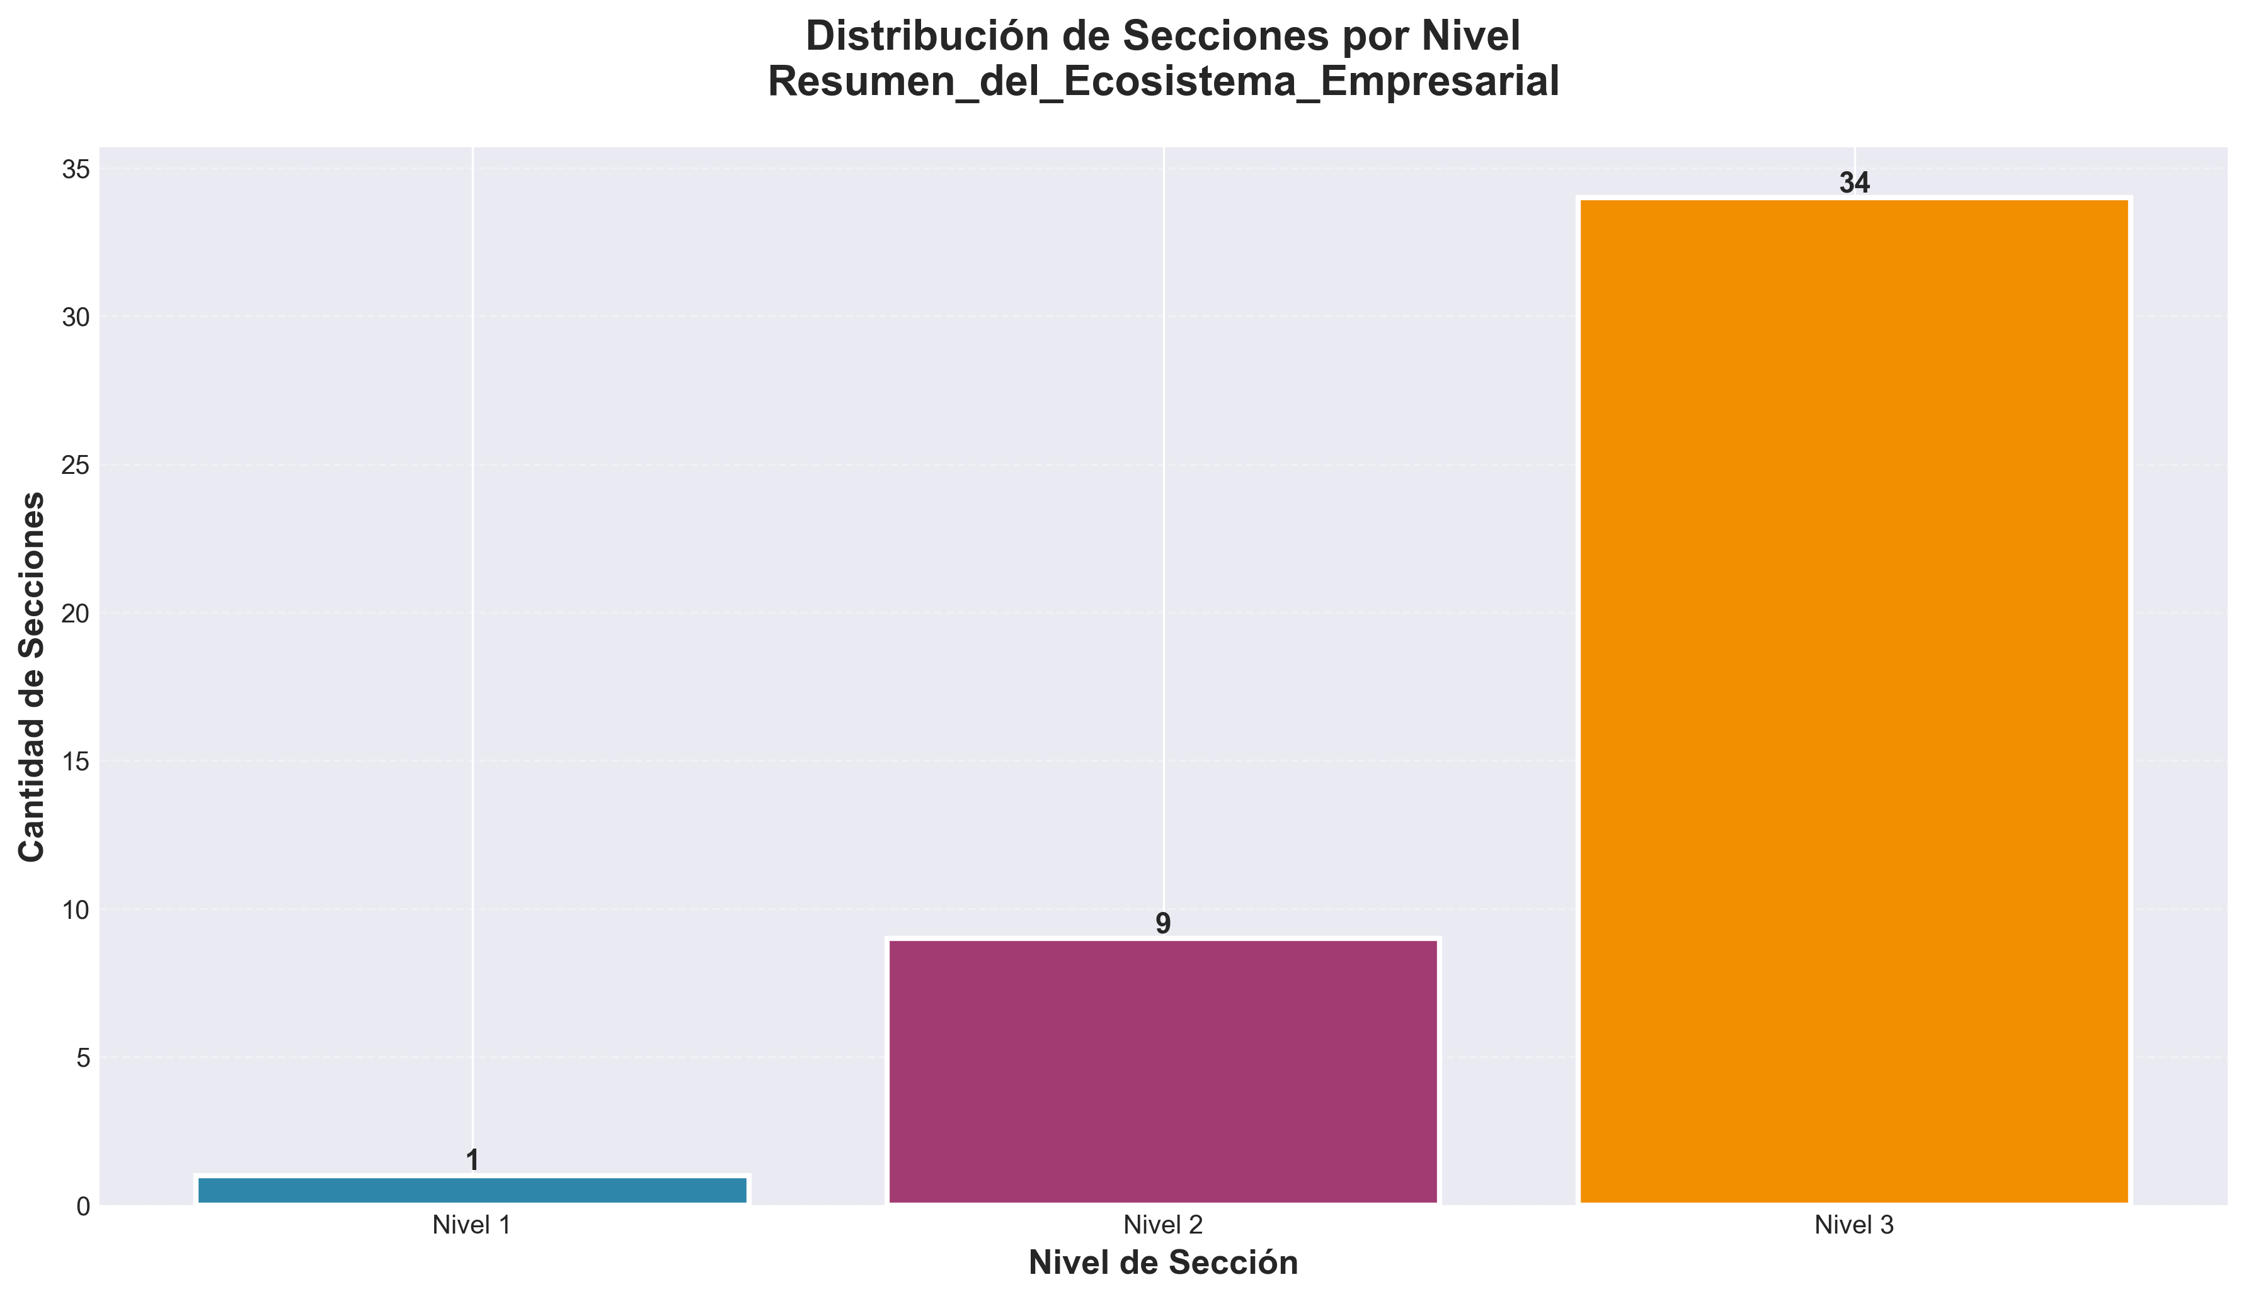

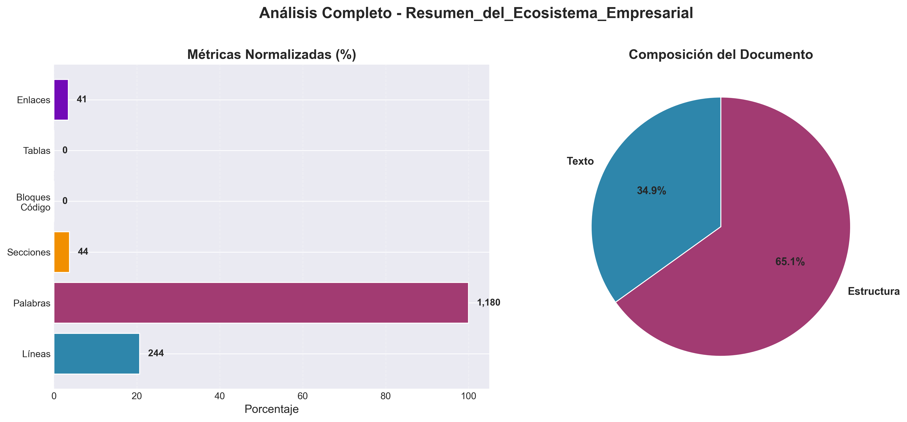

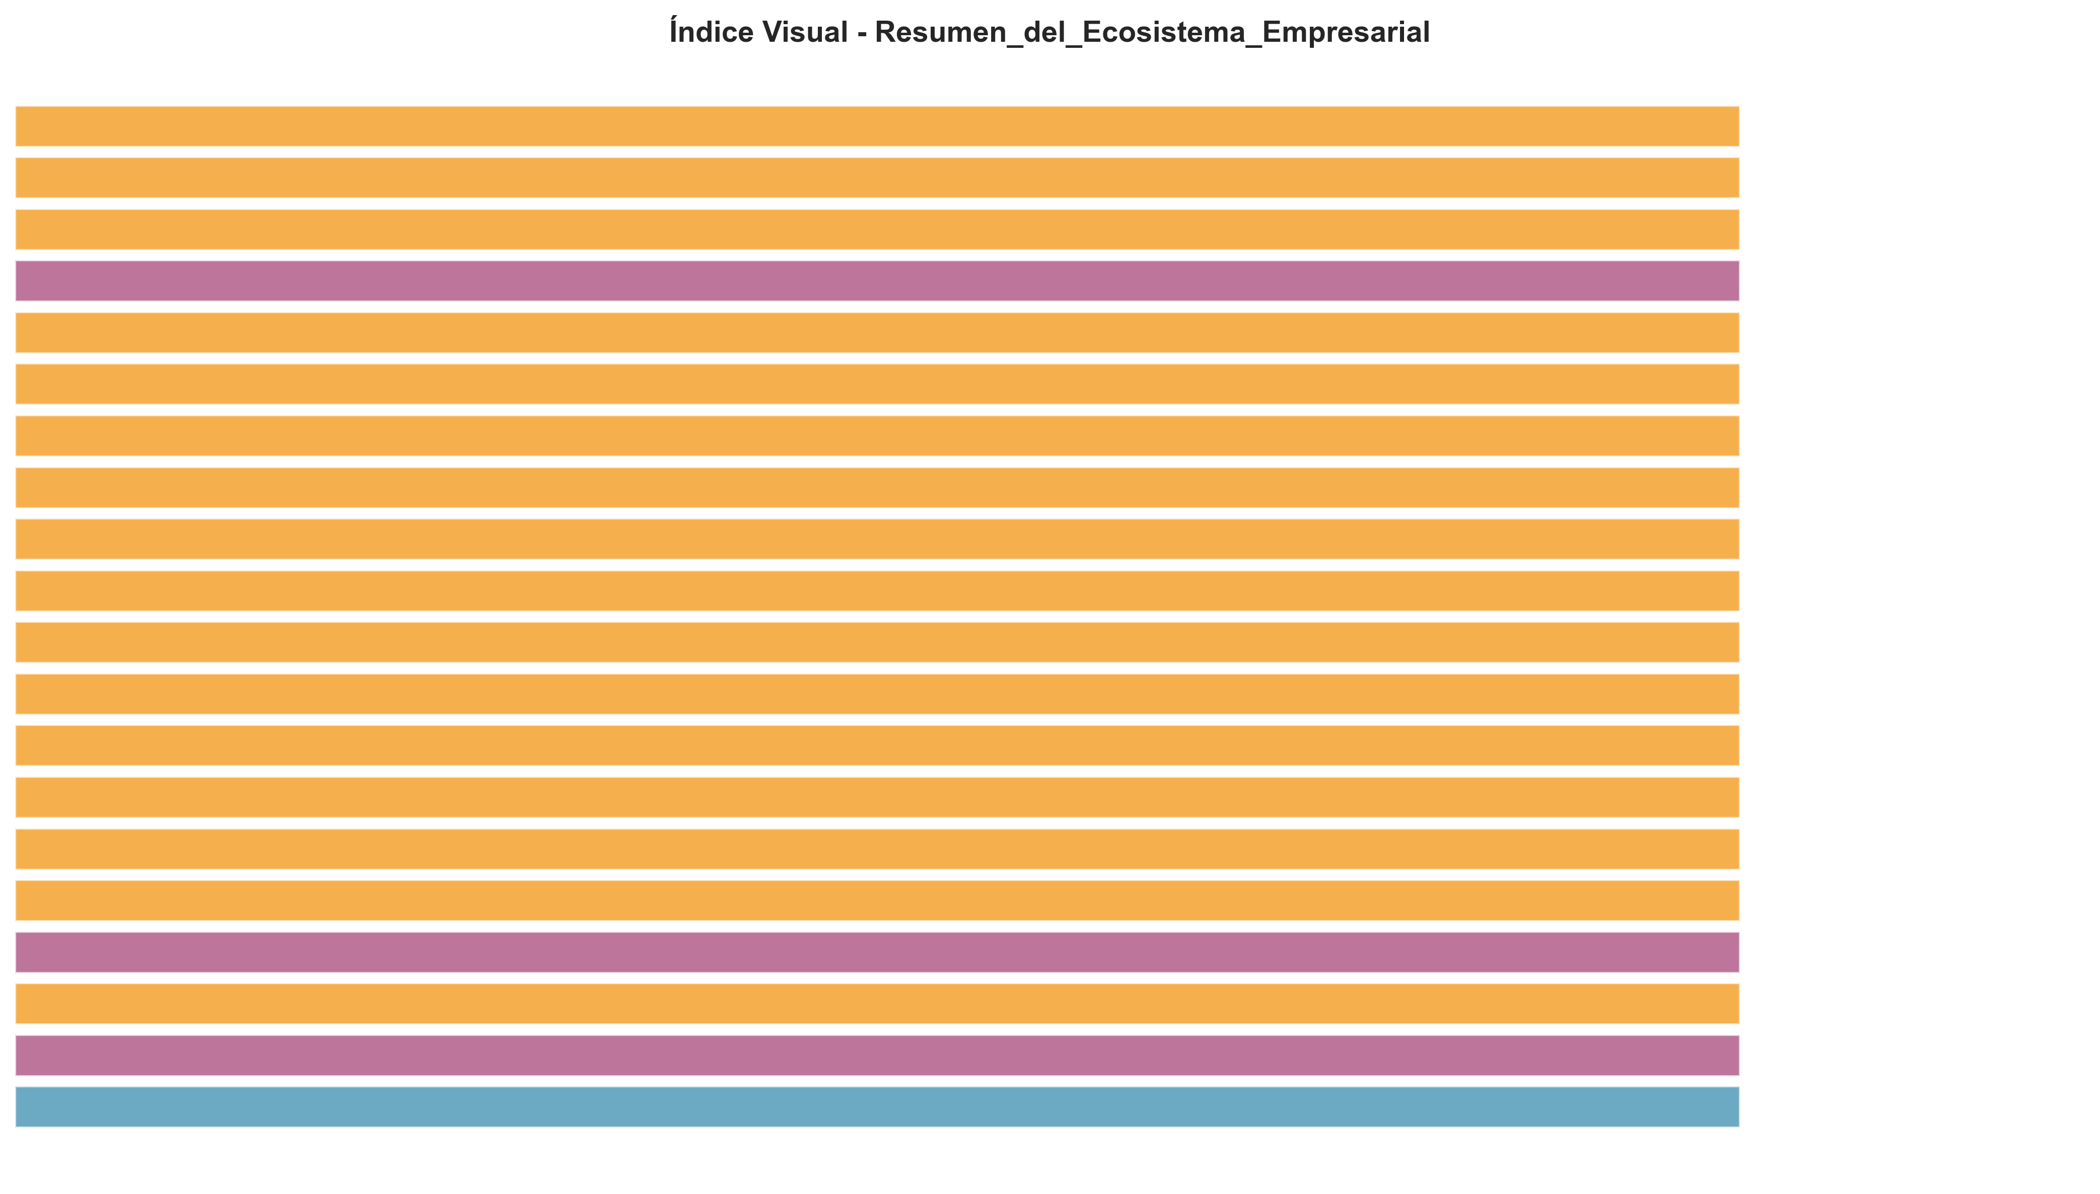

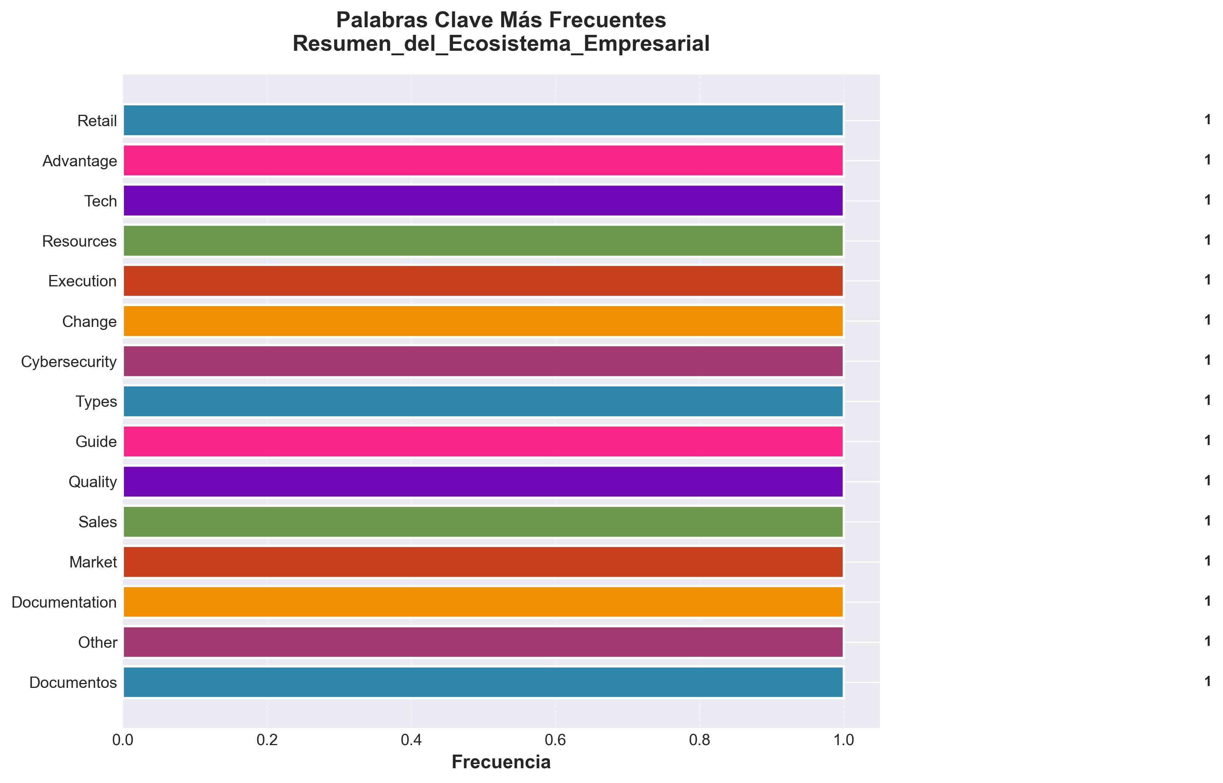

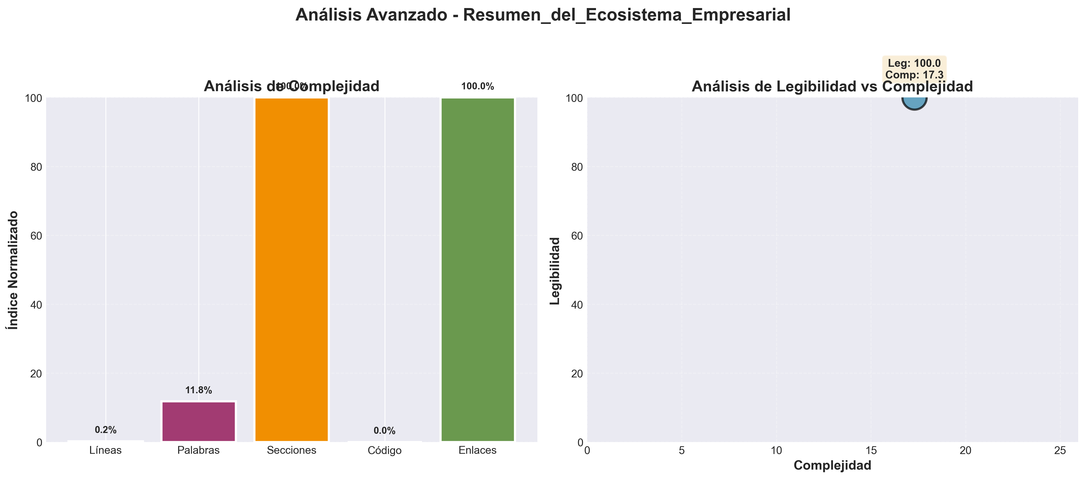

📄 Contenido
---
title: "Ecosystem Summary"
category: "04_business_strategy"
tags: []
created: "2025-10-29"
path: "04_business_strategy/Other/ecosystem_summary.md"
---

🌟 Documentos Blatam - Ecosystem Summary

📚 Complete Documentation Ecosystem Overview

🎯 **Ecosystem Statistics**
- **Total Guides**: 60+ Comprehensive Specialized Guides
- **Coverage**: Complete Business Operations Coverage
- **Industries**: All Major Industries Covered
- **User Types**: Entrepreneurs, Enterprises, Developers, Marketers
- **Languages**: Spanish & English Support
- **Format**: Markdown Documentation with Rich Formatting
---

🚀 **Core Business Domains**

**🤖 AI & Machine Learning**
- **[AI Playbook](AI_PLAYBOOK.md)** - Comprehensive AI implementation strategies
- **[AI Ethics](AI_ETHICS.md)** - Ethical AI and responsible AI practices
- **[Advanced Analytics](ADVANCED_ANALYTICS.md)** - Advanced data analytics and intelligence
- **[Data Science](DATA_SCIENCE.md)** - Data science and analytics excellence

**🏢 Business Strategy & Planning**
- **[Enterprise Guide](ENTERPRISE_GUIDE.md)** - Large enterprise implementation strategies
- **[Startup Accelerator](STARTUP_ACCELERATOR.md)** - Startup growth and acceleration
- **[Global Expansion](GLOBAL_EXPANSION.md)** - International business strategies
- **[Strategic Planning](04_business_strategy/Strategic_plans/strategic_planning.md)** - Strategic planning and business excellence

**💻 Technology & Digital**
- **[Cloud Strategy](04_business_strategy/Business_plans/cloud_strategy.md)** - Comprehensive cloud computing strategies
- **[Digital Transformation](DIGITAL_TRANSFORMATION.md)** - Digital transformation and innovation
- **[API Documentation](API_DOCUMENTATION.md)** - Complete API documentation and integration
- **[Agile Methodology](AGILE_METHODOLOGY.md)** - Agile development and management excellence

**⚙️ Operations & Management**
- **[Optimization](OPTIMIZATION.md)** - Business optimization and performance excellence
- **[Risk Management](RISK_MANAGEMENT.md)** - Comprehensive risk management strategies
- **[Innovation Management](INNOVATION_MANAGEMENT.md)** - Innovation and R&D management
- **[Quality Assurance](QUALITY_ASSURANCE.md)** - Quality management and excellence
- **[Lean Manufacturing](LEAN_MANUFACTURING.md)** - Lean manufacturing and operational excellence
- **[Operations Management](OPERATIONS_MANAGEMENT.md)** - Operations management and excellence

**📋 Project & Delivery**
- **[Project Management](PROJECT_MANAGEMENT.md)** - Project management and delivery excellence
- **[Supply Chain](SUPPLY_CHAIN.md)** - Supply chain management and optimization
- **[Vendor Management](VENDOR_MANAGEMENT.md)** - Vendor and supplier management excellence

**👥 Human Resources & Leadership**
- **[Talent Management](TALENT_MANAGEMENT.md)** - Talent acquisition and development
- **[Leadership Development](LEADERSHIP_DEVELOPMENT.md)** - Leadership and executive excellence
- **[Change Management](CHANGE_MANAGEMENT.md)** - Change management and transformation

**🎯 Customer & Sales**
- **[Customer Experience](CUSTOMER_EXPERIENCE.md)** - Customer experience excellence
- **[Customer Success](CUSTOMER_SUCCESS.md)** - Customer success and retention
- **[Sales Excellence](SALES_EXCELLENCE.md)** - Sales excellence and revenue optimization
- **[Business Intelligence](BUSINESS_INTELLIGENCE.md)** - Business intelligence and analytics

**📦 Product & Marketing**
- **[Product Management](PRODUCT_MANAGEMENT.md)** - Product management and innovation
- **[Brand Management](BRAND_MANAGEMENT.md)** - Brand management and marketing excellence
- **[Communication Management](COMMUNICATION_MANAGEMENT.md)** - Communication and stakeholder management

**💰 Finance & Compliance**
- **[Financial Management](FINANCIAL_MANAGEMENT.md)** - Financial management and business finance
- **[Compliance Management](COMPLIANCE_MANAGEMENT.md)** - Compliance and regulatory excellence

**🌱 Sustainability & Ethics**
- **[Sustainable Business](SUSTAINABLE_BUSINESS.md)** - Sustainable business and ESG excellence

**🔒 Security & Performance**
- **[Cybersecurity](CYBERSECURITY.md)** - Advanced cybersecurity strategies
- **[Security](SECURITY.md)** - Security guidelines and best practices
- **[Performance](PERFORMANCE.md)** - Performance optimization
- **[Deployment](DEPLOYMENT.md)** - Deployment guides

**🔮 Specialized & Future**
- **[Future Tech](FUTURE_TECH.md)** - Emerging technologies and future trends
- **[Industry Specific](INDUSTRY_SPECIFIC.md)** - Industry-specific implementations
- **[Innovation Lab](INNOVATION_LAB.md)** - Innovation laboratory and R&D
---

🎯 **User-Specific Navigation**

**🚀 For Entrepreneurs**
- **Startup Essentials**: Startup Accelerator, AI Playbook, Customer Success
- **Growth Strategies**: Sales Excellence, Marketing, Brand Management
- **Operations**: Project Management, Operations Management, Financial Management
- **Innovation**: Innovation Management, Future Tech, Innovation Lab

**🏢 For Enterprises**
- **Enterprise Strategy**: Enterprise Guide, Strategic Planning, Global Expansion
- **Digital Transformation**: Digital Transformation, Cloud Strategy, AI Ethics
- **Operations Excellence**: Operations Management, Quality Assurance, Lean Manufacturing
- **Compliance**: Compliance Management, Risk Management, Cybersecurity

**🤖 For Developers**
- **Technical Excellence**: API Documentation, Agile Methodology, Data Science
- **AI & ML**: AI Playbook, Advanced Analytics, AI Ethics
- **Cloud & DevOps**: Cloud Strategy, Deployment, Performance
- **Innovation**: Innovation Lab, Future Tech, Product Management

**📈 For Marketers**
- **Marketing Excellence**: Brand Management, Customer Experience, Communication Management
- **Sales & Growth**: Sales Excellence, Customer Success, Business Intelligence
- **Digital Marketing**: Digital Transformation, Advanced Analytics, Future Tech
- **Customer Focus**: Customer Experience, Customer Success, Product Management
---

🏭 **Industry-Specific Coverage**

**🏥 Healthcare**
- Healthcare-specific strategies in Customer Experience, Operations Management, Compliance Management
- Medical technology focus in AI Ethics, Data Science, Innovation Management
- Regulatory compliance in Compliance Management, Risk Management, Quality Assurance

**🏭 Manufacturing**
- Manufacturing excellence in Lean Manufacturing, Operations Management, Quality Assurance
- Supply chain optimization in Supply Chain Management, Vendor Management
- Innovation in Innovation Management, Future Tech, AI Playbook

**💻 Technology**
- Technology leadership in Cloud Strategy, Digital Transformation, AI Playbook
- Product development in Product Management, Innovation Management, Data Science
- Security in Cybersecurity, Compliance Management, Risk Management

**🏦 Financial Services**
- Financial excellence in Financial Management, Risk Management, Compliance Management
- Customer focus in Customer Experience, Customer Success, Sales Excellence
- Innovation in AI Ethics, Advanced Analytics, Future Tech

**🛒 Retail & E-commerce**
- Customer experience in Customer Experience, Customer Success, Brand Management
- Operations in Operations Management, Supply Chain Management, Vendor Management
- Digital transformation in Digital Transformation, Cloud Strategy, AI Playbook
---

📊 **Implementation Roadmaps**

**Phase 1: Foundation (Months 1-3)**
- **Assessment**: Current state analysis and gap identification
- **Strategy**: Comprehensive strategy development
- **Setup**: System and process implementation
- **Training**: Team development and capability building

**Phase 2: Implementation (Months 4-9)**
- **Execution**: Process and system deployment
- **Culture**: Culture development and change management
- **Performance**: Performance monitoring and optimization
- **Continuous Improvement**: Best practice sharing and innovation

**Phase 3: Optimization (Months 10-12)**
- **Optimization**: Performance optimization and process refinement
- **Excellence**: Excellence pursuit and innovation adoption
- **Scaling**: Scaling and expansion planning
- **Future**: Future planning and trend adoption
---

🎯 **Key Success Factors**

**📈 Performance Metrics**
- **Operational Excellence**: Efficiency, quality, and performance metrics
- **Customer Success**: Satisfaction, retention, and value metrics
- **Financial Performance**: Revenue, profitability, and ROI metrics
- **Innovation**: Innovation rate, adoption, and impact metrics

**🏆 Success Indicators**
- **Business Excellence**: High performance across all business metrics
- **Competitive Advantage**: Strong market position and differentiation
- **Stakeholder Value**: Superior value creation for all stakeholders
- **Sustainable Growth**: Long-term growth and sustainability
---

🚀 **Future Roadmap**

**🔮 Emerging Trends**
- **AI Integration**: Advanced AI and machine learning integration
- **Sustainability**: ESG and sustainability focus
- **Digital Transformation**: Complete digital transformation
- **Innovation**: Continuous innovation and R&D

**📈 Growth Opportunities**
- **Market Expansion**: New market opportunities
- **Technology Adoption**: Emerging technology adoption
- **Partnership Development**: Strategic partnership development
- **Innovation Leadership**: Innovation leadership and thought leadership
---

🎉 **Ecosystem Benefits**

**✅ Comprehensive Coverage**
- Complete business operations coverage
- Industry-specific strategies
- User-specific guidance
- Implementation roadmaps

**✅ Practical Implementation**
- Step-by-step implementation guides
- Best practices and methodologies
- Tools and technologies
- Training and support resources

**✅ Continuous Evolution**
- Regular updates and improvements
- Emerging trend integration
- Innovation adoption
- Excellence pursuit
---

📞 **Support & Resources**

**📚 Learning Resources**
- Comprehensive training materials
- Best practice guides
- Implementation templates
- Expert support services

**🤝 Community Support**
- Expert consulting services
- Training delivery
- Implementation support
- Ongoing optimization
---
This ecosystem summary provides a comprehensive overview of the complete Documentos Blatam documentation ecosystem, showcasing the extensive coverage and value proposition for all business stakeholders.

